Are Primary Health Centres Equally Distributed in Kerala? An Equity Analysis across Districts

Abstract: Equitable access to primary healthcare remains central to Kerala’s public health achievements. This study evaluates the distribution of Public Health Centres (PHCs) across the state using district-level data for 2024–25. A multipronged approach was adopted: descriptive statistics established baseline PHC density, correlation analysis assessed associations with socio-demographic indicators, Lorenz curves and Gini coefficients measured inequality, and a composite Vulnerability Index was constructed to identify structurally disadvantaged districts. Results indicate an average PHC density of 1.7 per 100,000 population, with Wayanad recording the highest (2.85) and Kollam the lowest (1.20). PHC density shows strong positive correlation with Scheduled Tribe share and moderate association with poverty and rurality, while literacy and Scheduled Caste shares reveal weak or negative relationships. The Lorenz curve lies close to the equality line, producing a Gini coefficient near 0.12, confirming low inequality in distribution. Yet, the vulnerability index highlights Palakkad, Kollam, Idukki, and Wayanad as priority districts due to overlapping socio-demographic disadvantages. These findings underline Kerala’s success in ensuring relatively equitable PHC allocation while identifying districts where demographic burdens limit accessibility. Strengthening targeted interventions in vulnerable regions is essential to further enhance healthcare equity and sustain Kerala’s reputation as a model for primary health in India.
Key words: Public Health, Primary Health Center, Universal Health Coverage, Inequality, Vulnerability
1. Introduction
Health equity has emerged as a central concern of global health systems over the past two decades. The World Health Organization (WHO, 2021) defines equity in health as the absence of systematic differences in health outcomes and access to healthcare services that are avoidable or unjust. The importance of equitable health infrastructure distribution is further underscored by the Sustainable Development Goals (SDG 3), which commit nations to achieving universal health coverage by 2030 (Chiu & Fong, 2023).
Globally, inequities in healthcare distribution remain stark. According to the World Bank (2021), sub-Saharan Africa hosts 24 percent of the global disease burden but only 3 percent of the world’s health workforce (Anyangwe & Mtonga (2007). Similarly, OECD Health Statistics (2020) report shows that physician density ranges from over 5 per 1,000 population in countries like Austria to below 0.5 in low-income nations such as Niger (OECD, 2020). These disparities extend to primary health facilities, where accessibility and spatial distribution remain uneven even in middle-income countries such as Brazil (Travassos et al., 2002).
In the Indian context, disparities are also well documented. India’s network of Sub-Centres, Primary Health Centres (PHCs), and Community Health Centres (CHCs) is designed to provide decentralized care. According to the Rural Health Statistics (Government of India, 2022), there were 24,935 PHCs across the country, yet the shortfall of PHCs relative to population norms stood at 4.3 percent. State-level variations are considerable: while Tamil Nadu reported one PHC per 30,000 people in 2021, Bihar’s ratio was nearly one per 70,000. In addition, functionality gaps exist: the National Sample Survey (2018) found that 55 percent of rural households reported PHCs as their first point of care, but 25 percent complained of inadequate infrastructure and medicines.
Kerala, located on the southwestern coast of India, has long been recognized as a model state in health. With a population of 35.3 million (Census of India, 2011; projected to 36.6 million in 2024), Kerala reports a life expectancy of 75.3 years (Sample Registration System, 2020–22), higher than the national average of 69 years. The state’s infant mortality rate (IMR) is 4 per 1,000 live births (SRS, 2020), significantly lower than the all-India IMR of 28. Literacy is almost universal, recorded at 96.2 percent in 2021 (National Statistical Office, 2022). These achievements reflect sustained investments in public health, education, and social welfare since the 1960s.
Yet beneath these aggregate indicators lie intra-state disparities. Kerala’s Rural Health Statistics (Kerala Digital Health Mission, 2025) recorded over 780 PHCs as of July 2025, but their distribution across the 14 districts varies. For example, Ernakulam district, with a projected population of 3.55 million in 2024, has 62 PHCs, while Idukki, with just 1.11 million people, has 22 PHCs. Adjusting for population size, this translates into 1.74 PHCs per 100,000 in Ernakulam compared to 1.98 in Idukki, suggesting variation even after controlling for population. Moreover, tribal-dominated districts such as Wayanad and Idukki report Scheduled Tribe shares of 18.5 percent and 15.4 percent (Census of India, 2011), much higher than the state average of 1.5 percent, raising questions about whether infrastructural distribution reflects vulnerability.
Economic disparities compound the issue. The Economic Review (Government of Kerala, 2022) reports that Below Poverty Line (BPL) households constitute 42–50 percent of the population in certain districts such as Kasaragod and Idukki, compared to below 33 percent in Ernakulam and Thiruvananthapuram. Rurality adds another dimension: 95.3 percent of Idukki’s population is rural, while Ernakulam has less than 32 percent rural share (Government of Kerala, 2023). These differences imply that equitable distribution of PHCs cannot be assessed solely on the basis of population ratios; socio-economic and geographic factors must also be considered.
The historical development of Kerala’s health system also shapes these inequities. Since the 1960s, Kerala invested in a dense network of primary health facilities, supported by community participation and local government accountability (Kutty, 2000). The decentralization reforms of the 1990s, particularly the People’s Plan Campaign, strengthened local bodies in managing health institutions (Elamon et al., 2004). While these reforms improved access overall, evidence shows that disparities remain in staffing, infrastructure quality, and availability of medicines (Sapkota et al., 2023). Urban districts benefit from the coexistence of private hospitals and higher-level public hospitals, while remote rural and tribal areas depend heavily on PHCs, making their equitable distribution even more crucial.
Comparative evidence from other southern states highlights Kerala’s relative advantage but also its limitations. Tamil Nadu, for instance, has historically emphasized strong PHC functioning through innovations such as 24-hour maternity care and referral linkages (Pandian et al., 2013). Karnataka, by contrast, has invested more in secondary hospitals, leaving rural areas relatively underserved (NITI Aayog, 2021). Kerala’s achievement lies in its density of PHCs, but unlike Tamil Nadu, less is known about whether these facilities are equitably distributed to meet the needs of vulnerable populations (Sankar et al., 2023).
From a policy perspective, Kerala’s strong performance at the macro level has often overshadowed micro-level inequities. The National Health Mission (NHM, 2021) emphasizes equitable resource allocation, but there is limited empirical work that evaluates intra-state distribution patterns of PHCs using formal measures such as Lorenz curves and Gini coefficients (Tao et al., 2014). Equity analysis in Kerala has typically focused on health outcomes such as mortality, morbidity, and immunization rates rather than on infrastructure allocation. This makes it necessary to examine how PHCs are spatially distributed and whether this distribution aligns with indicators of social vulnerability such as caste, tribe, poverty, and rurality.

1.1 The Indian Healthcare System and PHCs
India’s health system is organized in a three-tier structure: sub-centres and primary health centres (PHCs) provide first-line contact, community health centres form the secondary layer, and district and tertiary hospitals represent the referral system (National Health Mission, 2021). PHCs, in particular, are the backbone of primary care delivery, especially in rural and semi-urban regions. Each PHC is intended to cover approximately 30,000 people in plain areas and 20,000 in hilly or tribal regions (Government of India, Ministry of Health and Family Welfare, 2022). Their functions include outpatient care, preventive and promotive services, maternal and child health programs, and implementation of national health schemes. Despite these design norms, the equitable distribution of PHCs remains a persistent challenge in India. State-level variations are stark: while southern states such as Kerala and Tamil Nadu report relatively better PHC density, states such as Bihar and Uttar Pradesh lag behind in both numbers and functionality. Moreover, even within well-performing states, intra-state disparities persist due to uneven geography, economic differences, and socio-demographic diversity (NITI Aayog, 2021).

1.2 Kerala as a Model State
Kerala has long attracted scholarly attention for what is popularly described as the “Kerala model of development.” This model highlights a paradox: despite relatively modest per capita income, the state has achieved remarkable outcomes in literacy, life expectancy, maternal and child health, and social development (Kannan, 2005; Sen, 1997). Kerala’s infant mortality rate and life expectancy rival those of middle-income countries, while literacy rates approach near-universal levels. The achievements are often attributed to sustained public investment in health and education, strong community engagement, and social reform movements that reduced inequalities in access (Oommen, 1993).
However, success at the state level may conceal hidden inequities at the district level. Kerala’s 14 districts vary considerably in geography, demography, and socio-economic composition. Coastal districts such as Ernakulam and Thiruvananthapuram are more urbanized, with higher access to secondary and tertiary facilities, while hill districts such as Idukki and Wayanad host large tribal populations living in remote settlements. Kasaragod, the northernmost district, has historically been identified with higher poverty levels and weaker infrastructure (Government of Kerala, State Planning Board, 2023). Thus, the question arises: are PHCs equitably distributed across Kerala’s districts, considering both population size and vulnerability?
  - Social Determinants of Health in Kerala
Kerala’s population exhibits diversity across caste, tribe, income, literacy, and rural-urban dimensions, each of which influences health vulnerability and infrastructure needs. Scheduled Castes (SCs) constitute a significant minority in districts such as Palakkad and Kollam. Despite constitutional protections, SC populations often experience socio-economic disadvantages that may translate into health inequities. Scheduled Tribes (STs) are concentrated in districts such as Wayanad, Idukki, and Kasaragod. Their geographic isolation and limited political influence often hinder access to healthcare (Shabeer & Krishnan, 2017). Rurality remains a critical determinant of access. Districts with high rural population shares face challenges of transportation, terrain, and connectivity, which amplify the need for a denser PHC network (Government of Kerala, State Planning Board, 2023). Literacy, while universally high in Kerala, still varies slightly between districts. Paradoxically, more literate and urbanized districts may have fewer PHCs relative to population, relying instead on private or higher-level facilities (Kutty, 2000). Poverty measured by the proportion of Below Poverty Line (BPL) households, shapes health-seeking behavior and dependence on public facilities. Districts with higher BPL prevalence often rely more heavily on PHCs (Oommen, 2014). These variables provide a social determinant lens through which to evaluate PHC distribution.

1.4 Rationale and Research Gap
Although Kerala is widely celebrated as India’s health success story, there are reasons to suspect inequities in healthcare infrastructure distribution. Tribal districts face geographic isolation, poverty remains unevenly spread, and urbanized regions may enjoy indirect benefits through proximity to tertiary hospitals. Without systematic district-level equity analysis, the risk is that state averages mask disparities faced by marginalized groups. Past research on Kerala has emphasized health outcomes rather than infrastructure equity. Moreover, while descriptive studies exist, few have rigorously applied inequality measures (Lorenz curves, Gini coefficients) or combined them with vulnerability mapping. This creates a knowledge gap: we know Kerala performs well in aggregate, but we do not know whether every district shares the benefits equally.
2. Statement of the Problem
Kerala is often celebrated for its achievements in health and human development, yet the assumption of equitable distribution of healthcare infrastructure across districts remains insufficiently examined. While state averages for life expectancy, infant mortality, and literacy suggest a well-performing system, district-level disparities in population structure, tribal concentration, poverty, and rurality raise concerns about whether access to Public Health Centres (PHCs) is truly equitable. For instance, districts such as Idukki and Wayanad have large tribal populations and predominantly rural settlements, while Kasaragod faces higher poverty levels. In contrast, urbanized districts like Ernakulam benefit from better access to higher-tier hospitals and private facilities. A uniform ratio of PHCs to population may therefore conceal inequities in access for marginalized groups. Without systematic equity analysis using tools such as Lorenz curves, Gini coefficients, and vulnerability mapping, policy makers risk overlooking underserved regions, undermining Kerala’s broader commitment to inclusive health development.

3. Objectives of the Study
- To examine the relationship between PHC density and socio-demographic indicators (SC, ST, rural %, literacy, BPL).
- To measure inequality in PHC allocation using Lorenz curves and Gini coefficients.
- To construct a composite vulnerability index that identifies districts with structural disadvantages in healthcare access.

4. Research Methodology
This study adopts a cross-sectional, quantitative research design to examine the equity of Public Health Centre (PHC) distribution across Kerala’s 14 districts. The analysis is descriptive and analytical, combining measures of central tendency with inequality indices and correlation models.
  - Data Source
The dataset covers: PHC counts as of July 2025, projected population (2024), Scheduled Caste (SC) population %, Scheduled Tribe (ST) population %, Rural population %, Literacy rate, Below Poverty Line (BPL) population %. The unit of analysis is the districts Kerala.

4.2 Variables
Dependent variable: PHC density per 100,000 population
Equation: Dᵢ = ( Hᵢ / Pᵢ ) × 100,000
Where, Hᵢ = PHC count in district i, Pᵢ = population of district i
Independent variables: SC %, ST %, rural %, literacy, and BPL %.

4.3 Correlation Analysis
To measure association between PHC density (D) and a variable (X): r(D,X) = Σ (Dᵢ − D̄)(Xᵢ − X̄) ÷ √[ Σ(Dᵢ − D̄)² × Σ(Xᵢ − X̄)² ]
where D̄ = mean PHC density, X̄ = mean of X.

4.4 Inequality Measurement
Lorenz curves plot cumulative % of population vs. cumulative % of PHCs.
Gini coefficient formula: G = (1 / 2μₕ) × Σ Σ wᵢ wⱼ | hᵢ − hⱼ |
Where, hᵢ = Hᵢ / Pᵢ (PHCs per person in district i), wᵢ = Pᵢ ÷ ΣP (population share of district i), μₕ = weighted mean of hᵢ
Interpretation: G = 0 → perfect equality, G = 1 → maximum inequality

4.5 Vulnerability Index
The Vulnerability Index was constructed by combining four components: Scheduled Caste (SC) percentage, Scheduled Tribe (ST) percentage, Below Poverty Line (BPL) percentage, and low Public Health Centre (PHC) density. Each component was normalized using the min–max method so that values ranged from 0 (least vulnerable) to 1 (most vulnerable) across districts. For PHC density, the transformation was reversed (1 − normalized PHC density), so that lower availability increased vulnerability. The final index was calculated as the simple average of the four normalized scores.
Normalization: Z̃ᵢ = ( Zᵢ − Min(Z) ) ÷ ( Max(Z) − Min(Z) )
Composite index: Vᵢ = ¼ × [ Z̃(SC)ᵢ + Z̃(ST)ᵢ + Z̃(BPL)ᵢ + (1 − Z̃(D)ᵢ) ]
Where, Z̃(SC)ᵢ = normalized SC %, Z̃(ST)ᵢ = normalized ST %, Z̃(BPL)ᵢ = normalized BPL %, Z̃(D)ᵢ = normalized PHC density, Range: 0 (least vulnerable) to 1 (most vulnerable).
5. Data Analysis and Discussion
5.1. Correlation between PHC Density and Socio-Demographic Indicators
Table 1. Kerala District wise Demographic & PHC Data (2024–25)
Sl. No. | Districts | PHC Count  (As on 31.07.2025) | Projected Population (2024) | PHC per 1L | SC (%) | ST (%) | Rural (%) | Literacy Rate | BPL (%)
1 | Alappuzha | 35 | 2196214 | 1.59 | 9.46 | 0.31 | 46.03 | 0.96 | 49.73
2 | Ernakulam | 62 | 3556125 | 1.74 | 8.18 | 0.50 | 31.93 | 0.96 | 32.95
3 | Idukki | 22 | 1111540 | 1.98 | 13.12 | 5.03 | 95.31 | 0.92 | 49.51
4 | Kannur | 41 | 2707642 | 1.51 | 3.30 | 1.60 | 34.96 | 0.95 | 31.39
5 | Kasaragod | 21 | 1453294 | 1.44 | 4.08 | 3.74 | 61.06 | 0.90 | 42.51
6 | Kollam | 33 | 2750802 | 1.20 | 12.45 | 0.41 | 54.96 | 0.94 | 46.49
7 | Kottayam | 33 | 2042888 | 1.62 | 7.80 | 1.11 | 71.36 | 0.97 | 37.46
8 | Kozhikode | 48 | 3389141 | 1.42 | 6.45 | 0.49 | 32.84 | 0.95 | 41.22
9 | Malappuram | 65 | 4754774 | 1.37 | 7.50 | 0.56 | 55.83 | 0.94 | 43.15
10 | Palakkad | 45 | 3089967 | 1.46 | 14.37 | 1.74 | 75.90 | 0.89 | 49.99
11 | Pathanamthitta | 19 | 1182649 | 1.61 | 13.73 | 0.68 | 89.00 | 0.97 | 35.23
12 | Trivandrum | 79 | 3451050 | 2.29 | 11.30 | 0.81 | 46.33 | 0.93 | 50.01
13 | Thrissur | 64 | 3356313 | 1.91 | 10.39 | 0.30 | 32.83 | 0.95 | 39.64
14 | Wayanad | 25 | 877602 | 2.85 | 3.99 | 18.52 | 96.15 | 0.89 | 51.68
Source: ¹Kerala Digital Health Mission, 2025,
²Projection of district-level annual population, IIPS, Mumbai, India.
³Census of India, 2011
Table 2. Correlation between PHC Density and Socio-Demographic Indicators
Indicator | Pearson r | Direction | Strength | Interpretation
Scheduled Caste (SC) % | –0.14 | Negative | Very Weak | SC % has no meaningful association with PHC density
Scheduled Tribe (ST) % | +0.76 | Positive | Strong | PHC density increases in tribal-dominated districts
Rural Population % | +0.36 | Positive | Moderate | Districts with larger rural shares have somewhat more PHCs
Literacy Rate | –0.36 | Negative | Moderate | More literate/urbanized districts tend to have fewer PHCs per capita
Below Poverty Line (BPL) % | +0.38 | Positive | Moderate | Poorer districts tend to receive more PHCs per capita
Source: Computed data
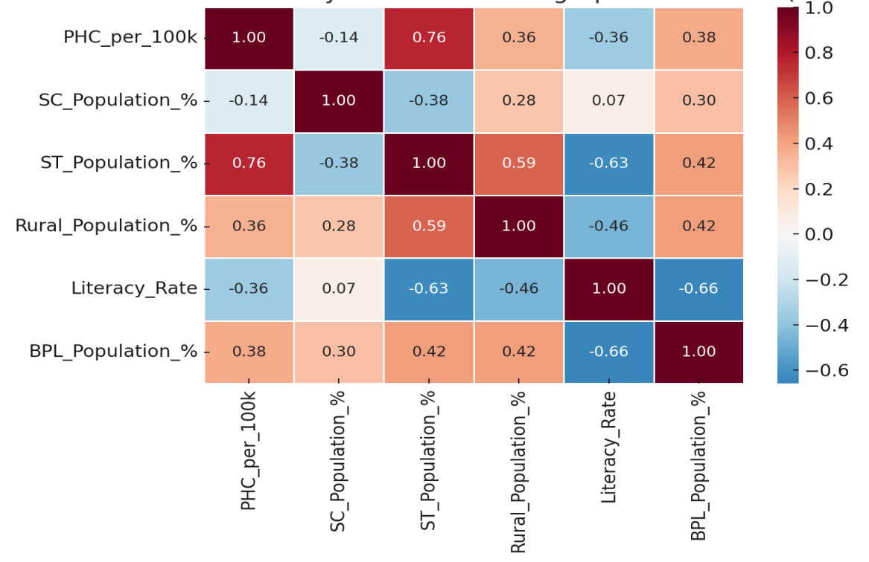
Fig.No.1. Correlation Matrix: PHC Density And Socio-Demographic Indicators (Kerala, 2024-25)
The correlation analysis between PHC density and socio-demographic indicators provides useful insights into the extent to which Kerala’s health infrastructure aligns with population vulnerabilities. The most notable finding is the strong positive correlation with Scheduled Tribe population share (r = +0.76), showing that tribal-dominated districts such as Wayanad and Idukki benefit from higher PHC density, reflecting deliberate policy attention to tribal health needs. Similarly, the moderate positive correlations with Below Poverty Line households (r = +0.38) and rural population share (r = +0.36) suggest that poorer and more rural districts are relatively better served by PHCs, consistent with Kerala’s pro-poor and welfare-oriented health policies. However, the analysis also highlights areas of concern. The moderate negative correlation with literacy rate (r = –0.36) implies that more literate and urbanized districts, including Ernakulam and Thiruvananthapuram, have fewer PHCs per capita, possibly because these regions rely more heavily on private providers and secondary or tertiary public hospitals. Finally, the very weak negative correlation with Scheduled Caste share (r = –0.14) indicates that SC-related vulnerabilities are not explicitly addressed in PHC allocation, unlike those of tribal populations. Hence it’s clear from the table that, PHC distribution shows sensitivity to certain vulnerabilities, but important equity gaps remain.
5.2. Lorenz Curve Analysis (Kerala, PHC Allocation per one Lakh)
Table 3. Lorenz Curve Table (Kerala, PHC Allocation per one Lakh)
Order | District (sorted by PHC per One Lakh) | Cumulative Population Share | Cumulative PHC Share
1 | Kollam | 0.08 | 0.07
2 | Malappuram | 0.21 | 0.17
3 | Kozhikode | 0.30 | 0.23
4 | Kasaragod | 0.34 | 0.27
5 | Palakkad | 0.42 | 0.35
6 | Kannur | 0.49 | 0.41
7 | Alappuzha | 0.55 | 0.47
8 | Pathanamthitta | 0.58 | 0.51
9 | Kottayam | 0.64 | 0.57
10 | Ernakulam | 0.73 | 0.66
11 | Thrissur | 0.82 | 0.77
12 | Idukki | 0.85 | 0.81
13 | Trivandrum | 0.95 | 0.93
14 | Wayanad | 1.00 | 1.00
Source: Computed Data
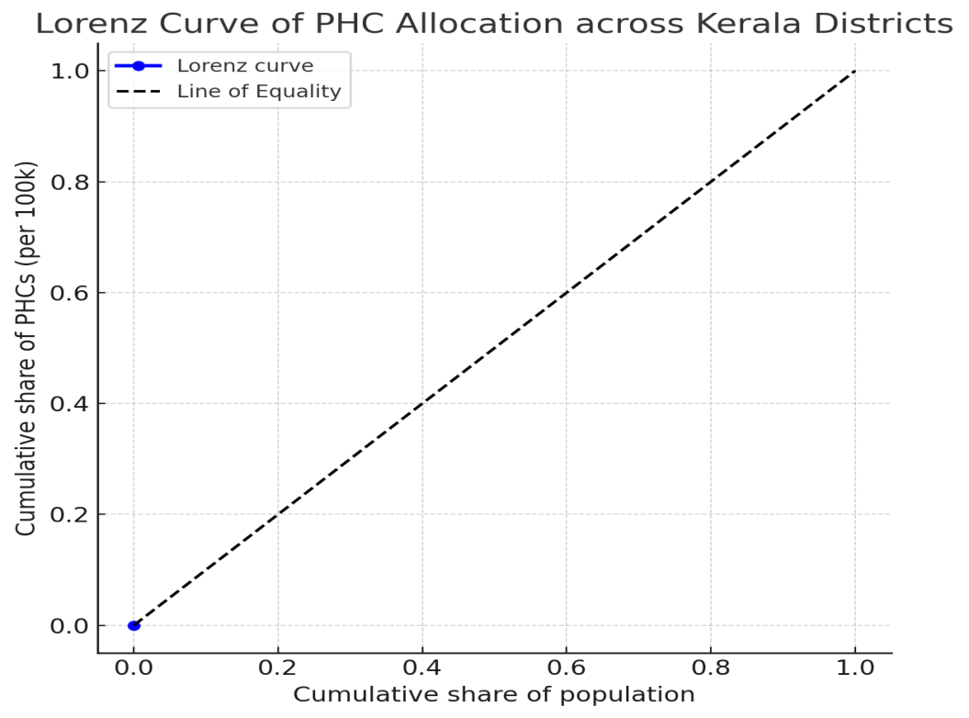
Fig. No. 2. Lorenz Curve of PHC Allocation across Kerala Districts
The Lorenz curve and cumulative distribution table provide valuable insights into the extent of inequality in the allocation of Public Health Centres (PHCs) across Kerala’s districts. Districts are ranked by PHC density, with Kollam having the lowest (1.20 per 100,000) and Wayanad the highest (2.85 per 100,000). The cumulative distribution shows that the first half of the population, concentrated in districts with lower PHC density, accounts for slightly less than half of the PHCs. For example, by the time we reach Alappuzha, covering around 55 percent of the population, only 47 percent of PHCs are included. Conversely, districts with higher PHC density, such as Idukki, Thiruvananthapuram, and Wayanad, contribute disproportionately more PHCs relative to their population shares. The Lorenz curve itself lies close to the line of equality, and the small gap between them corresponds to a Gini coefficient of around 0.12, confirming that inequality is very low. This indicates that Kerala has succeeded in ensuring an almost uniform distribution of PHCs relative to population across its districts. Nonetheless, slight disparities exist, particularly between districts at the bottom (Kollam, Malappuram) and those at the top (Wayanad, Idukki), warranting attention to regional needs despite the overall equity achievement.
5.3. Composite Vulnerability Index of Districts in Kerala Based on Socio-Demographic Indicators and PHC Density
Table 4. Composite Vulnerability Index and Ranks
District | Vulnerability Index | Rank (1 = Highest Vulnerability)
Palakkad | 0.710 | 1
Kollam | 0.644 | 2
Idukki | 0.642 | 3
Alappuzha | 0.555 | 4
Wayanad | 0.516 | 5
Thiruvananthapuram | 0.502 | 6
Pathanamthitta | 0.476 | 7
Malappuram | 0.468 | 8
Kasaragod | 0.415 | 9
Kozhikode | 0.412 | 10
Thrissur | 0.405 | 11
Kottayam | 0.375 | 12
Ernakulam | 0.300 | 13
Kannur | 0.220 | 14
Source: Computed Data
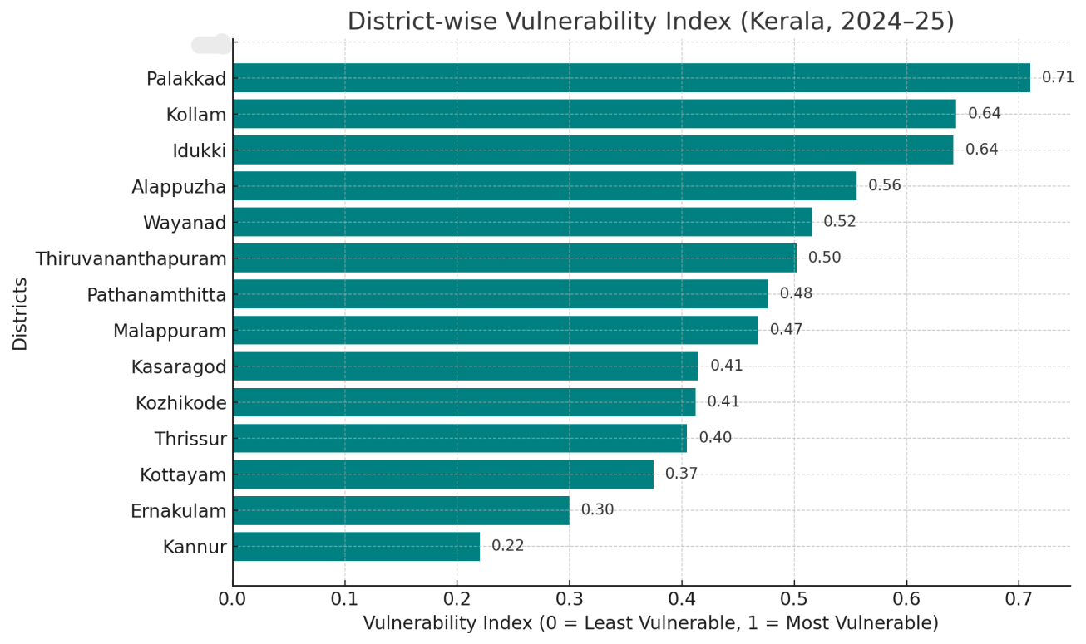
Fig.No.3. District wise Vulnerability Index (Kerala, 2024-25)
The composite Vulnerability Index, constructed from SC %, ST %, BPL %, and PHC density, shows distinct patterns across Kerala’s districts. Palakkad (0.71), Kollam (0.64), and Idukki (0.64) rank as the most vulnerable, reflect the combined effect of high Scheduled Caste and Below Poverty Line populations with comparatively lower PHC density. These districts illustrate how socio-demographic disadvantage amplifies health access challenges, even when facility numbers are not critically low. Wayanad, despite recording the highest PHC density in the state, registers a vulnerability score of 0.52 and occupies the fifth rank because of its very high Scheduled Tribe proportion and elevated poverty levels. This demonstrates that demographic and economic burdens can outweigh gains in infrastructure availability.
Districts such as Kannur (0.22), Ernakulam (0.30), and Kottayam (0.38) lie at the lower end of the vulnerability scale. These areas combine lower SC/ST proportions, moderate poverty levels, and sufficient PHC access, reducing their exposure to structural disadvantage. Middle-ranked districts including Thrissur, Kozhikode, and Kasaragod present mixed characteristics: relatively better PHC provision but persistent poverty or caste-linked vulnerabilities. The table thus underlines where policy interventions should be prioritized, with Palakkad, Kollam, Idukki, and Wayanad emerging as critical zones requiring targeted support to ensure equitable healthcare access.
7. Conclusion
This study examined the equity of Public Health Centre allocation across Kerala using PHC density, socio-demographic correlations, Lorenz curves, and a composite vulnerability index. The findings indicate that while Kerala demonstrates a largely equitable distribution, significant structural vulnerabilities persist in districts like Palakkad, Kollam, Idukki, and Wayanad. These areas combine higher proportions of marginalized populations and poverty with lower PHC density, highlighting the need for equity-focused planning. Conversely, districts such as Kannur and Ernakulam reflect stronger socio-demographic advantages and better access. Addressing these disparities is crucial to sustaining Kerala’s health equity achievements and ensuring inclusive healthcare accessibility.

6. Scope for Further Research
Future research may extend this analysis by incorporating secondary health facilities, spatial accessibility measures such as travel time, and block-level disaggregation within districts. Comparative studies across Indian states could further contextualize Kerala’s achievements and challenges, providing a broader framework for understanding equity in primary healthcare distribution.

COMPETING INTERESTS DISCLAIMER:
Authors have declared that they have no known competing financial interests OR non-financial interests OR personal relationships that could have appeared to influence the work reported in this paper.

8. References
Anyangwe, S. C., & Mtonga, C. (2007). Inequities in the global health workforce: the greatest impediment to health in sub-Saharan Africa. International journal of environmental research and public health, 4(2), 93-100.
Chiu, W. K., & Fong, B. Y. F. (2023). Sustainable development goal 3 in healthcare. In Environmental, social and governance and sustainable development in healthcare (pp. 33-45). Singapore: Springer Nature Singapore.
Elamon, J., Franke, R. W., & Ekbal, B. (2004). Decentralization of Health Services: The Kerala People’s Campaign. International Journal of Health Services, 34(4), 681–708. https://doi.org/10.2190/4l9m-8k7n-g6ac-wehn
Government of India, Ministry of Health and Family Welfare. (2022). Rural health statistics 2022. Government of India. https://main.mohfw.gov.in
Government of India, Ministry of Statistics and Programme Implementation. (2018). National Sample Survey, 75th round (2017–18). National Statistical Office. https://mospi.gov.in
Government of Kerala, Department of Health & Family Welfare. (2023). Rural health statistics, Kerala 2023. Government of Kerala.
Government of Kerala, State Planning Board. (2022). Economic review 2022. Government of Kerala. https://spb.kerala.gov.in
International Institute for Population Sciences (IIPS). (2022). Projection of District-Level Annual Population by Quinquennial Age-Group And Sex From 2012 To 2031 In India. IIPS. https://iipsindia.ac.in
Kannan, K. P. (2005). Kerala's turnaround in growth: Role of social development, remittances and reform. Economic and Political Weekly, 548-554.
Kerala Digital Health Mission. (2025). eHealth Kerala dashboard. Government of Kerala. https://dashboard.ehealth.kerala.gov.in
Kerala State Planning Board. (2023). Economic review 2023. Government of Kerala. https://spb.kerala.gov.in
Kutty, V. R. (2000). Historical analysis of the development of health care facilities in Kerala State, India. Health Policy and Planning, 15(1), 103–109. https://doi.org/10.1093/heapol/15.1.103
National Health Mission. (2021). National Health Mission annual report 2020–21. Ministry of Health and Family Welfare, Government of India. https://nhm.gov.in
NITI Aayog. (2021). Health systems for a new India: Building blocks—Potential pathways to reform. Government of India. https://www.niti.gov.in
OECD. (2020). OECD Health Statistics 2020. OECD. https://www.oecd.org/health/health-data.htm
Office of the Registrar General & Census Commissioner, India. (2011). Census of India 2011: Provisional population totals. Government of India. https://censusindia.gov.in
Oommen, M. A. (1993). Essays on Kerala economy. Oxford & IBH Publishing Company.
Oommen, M. A. (2014). Growth, inequality and well-being: revisiting fifty years of Kerala’s development trajectory. Journal of South Asian Development, 9(2), 173-205.
Pandian, J., Suresh, S., Desikachari, B., & Padmanaban, P. (2013). Increased utilization of primary health care centers for birthing care in Tamil Nadu, India: A visible impact of policies, initiatives, and innovations. Journal of Family Medicine and Primary Care, 2(4), 329. https://doi.org/10.4103/2249-4863.123781
Sankar, H., Joseph, J., Negi, J., Nair, A. B., & Nambiar, D. (2023). Monitoring the Family Health Centres in Kerala, India: Findings from a facility survey. Journal of Family Medicine and Primary Care, 12(12), 3098–3107. https://doi.org/10.4103/jfmpc.jfmpc_81_23
Sapkota, S., Dhakal, A., Rushton, S., Van Teijlingen, E., Marahatta, S. B., Balen, J., & Lee, A. C. (2023). The impact of decentralisation on health systems: a systematic review of reviews. BMJ Global Health, 8(12), e013317. https://doi.org/10.1136/bmjgh-2023-013317
Sen, A. K. (1997). Human capital and human capability. World development, 25(12), 1959-1961.
Shabeer, K. P., & Krishnan, C. (2017). Health Status of Tribal communities in Kerala. International Journal of Research in Economics and Social Science, 7 (6), 6, 17.
Tao, Y., Henry, K., Zou, Q., & Zhong, X. (2014). Methods for measuring horizontal equity in health resource allocation: a comparative study. Health Economics Review, 4(1). https://doi.org/10.1186/s13561-014-0010-x
Travassos, C., Viacava, F., Pinheiro, R., & Brito, A. (2002). Utilization of health care services in Brazil: gender, family characteristics, and social status. Revista panamericana de salud publica= Pan American journal of public health, 11(5-6), 365-373.
World Health Organization: WHO. (2021, July 7). Health equity. https://www.who.int/health-topics/health-equity#tab=tab_1

