Event-Scale Characterization of Precipitation Observed at Two Sites in West Africa: Abidjan (Côte d’Ivoire) and Nalohou (Benin)

ABSTRACT

Understanding the structure of precipitation observed in the localities of Abidjan and Nalohou as well as distinguishing between its convection and stratiform components, remains a challenge for the scientific community. Previous studies in this tropical region of Africa have typically relied on the use of a fixed rain intensity threshold to separate convective from stratiform precipitation. However, in our study the cluster approach (FPCAC) was used to automatically separate convective and stratiform precipitation without imposing a arbitrary rain intensity threshold. The rainfall data used in this study were collected at a 5-minute temporal resolution from the Abidjan (Côte d'Ivoire) and Nalohou (Benin) sites. To facilitate the application of our algorithm, we segmented our data to constitute samples of rainy events. The optimal number of clusters was determined using the silhouette method. As a result, four precipitation groups were identified at the coastal site of Abidjan, while the inland site of Nalohou exhibited only two groups. The grouping was based on the rain intensity profiles of individual events. We were able to assign a convective or stratiform nature to each group. At Abidjan, three groups (C1, C2, and C3) were classified as convective and one group (C4) as stratiform. At Nalohou, one group (C1) was convective and the other (C2) stratiform. Furthermore, the results obtained are consistent with those of previous studies, supporting the robustness of our approach.

Keywords: Floods, Convective and Stratiform Rainfall, FPCAC Clustering Approach, Abidjan, Nalohou.

1. INTRODUCTION
Natural phenomena such as floods and landslides, tangible manifestations of climate change are becoming increasingly frequent in the tropical regions of Africa (Panthou et al., 2014). Indeed, almost all countries in the West African sub-region have suffered, and continue to suffer, from these climatic hazards due to their strong economic dependence on rainfall (notably in agriculture, livestock, transport, and fishing). Moreover, these hazards pose significant risks to public health and result in considerable loss of human life (Roudier P. et al., 2011). The causes of these floods are diverse and complex, as they involve multiple factors, including the lack of rainwater drainage infrastructure, uncontrolled urbanization (such as the settlement of populations in low-lying areas or natural drainage outlets), and particularly the high occurrence of extreme rainfall events. Among these, the latter appears to be the most significant according to the scientific community, as highlighted in the recent work of Panthou et al. (2014). Their study on the evolution of precipitation patterns demonstrated that climate change is closely linked to an intensification of rainfall events and their increasing recurrence.
To this end, several research projects have been launched to better assess the overall impact of precipitation on the climate, and above all, to improve numerical models for quantitative rainfall forecasting. For example, the recent project “EVIDENCE” (Extreme Rainfall Events, Vulnerabilities, and Environmental Risks: Flooding and Water Contamination), initiated by the Precipitation and Weather Radar team of LASMES (Laboratory for Materials Science, Environment, and Solar Energy), is part of this effort to reduce the risks associated with extreme rainfall that affect the living conditions of urban populations.
Moreover, it has been recognized that intensity and duration are key characteristics of precipitation events (Panthou et al., 2014). In this context, to better understand flood risks and propose appropriate mitigation measures, Tschakert et al. (2010) recommend a thorough investigation of the mechanisms underlying precipitation formation, including the separation into convective and stratiform components. Indeed, the convective and/or stratiform components of clouds are primarily associated with distinct microphysical processes responsible for precipitation formation.
For example, convective rainfall is characterized by a rapid process that originates at the base of the cloud. It is distinguished by high intensities (up to 210 mm/h) and typically has a short duration. In contrast, the mechanisms governing stratiform precipitation are slower and generally form at the top of the cloud. This type of precipitation exhibits broad horizontal development, allowing it to cover a large spatial area. Moreover, it is marked by low intensities (less than 10 mm/h) that persist over a longer period (Testud et al., 2001; Houze, 2014).

Other authors have also developed methods to separate precipitation into convective and stratiform segments based on ground-based observational data (Llasat, 2001; Tremblay, 2005). For example, Llasat (2001) proposed a classification of rainfall events into convective and stratiform portions by defining a physical parameter β such that 0 ≤ β ≤ 1. The author considered all precipitation events with β > 0 as convective, and those with β = 0 as stratiform. As for Tremblay (2005), he identified a threshold intensity of 20 mm over 6 hours to partition precipitation into convective and stratiform components.
Cipolla et al. (2020) acknowledged that the use of a critical intensity threshold for distinguishing between convective and stratiform precipitation is widely adopted by the scientific community due to its simplicity, as it only requires a time series of precipitation data. Despite all the advances made to better understand the structure of precipitation, with the aim of addressing flood risk issues and, above all, increasing the resilience capacity of populations, the distinction between convective and stratiform precipitation remains non-trivial and continues to be a challenge. This is why Sottile et al. (2021) also investigated along the same lines. According to these authors, the use of arbitrary intensity thresholds in previous studies to classify precipitation introduces a certain degree of subjectivity into their results. To address this issue, Sottile et al. (2021) adopted an alternative approach, considered more objective, which classifies precipitation based on the following physical characteristics: intensity, duration, and total event-based accumulation. Their new classification criterion relies on the precipitation grouping approach derived from similar microphysical mechanisms, commonly known as the Functional Principal Component Analysis Clustering (FPCAC) method, which was first introduced by Adelfio et al. (2011).
Sottile et al. (2021) demonstrated that applying this method to their sample of rainfall events collected in Sicily (Italy), located in a temperate region, enabled them to identify four distinct groups. These groups can be associated with the convective and stratiform components of precipitation, based on their hyetographs and average intensities. Their analysis was conducted seasonally. They showed that stratiform precipitation occurs more frequently than convective precipitation during the winter and spring seasons. Conversely, during the summer and mid-autumn seasons, precipitation is predominantly of convective origin rather than stratiform. The results of Sottile et al. (2021) are consistent with the physical mechanisms characteristic of each type of rainfall. Moreover, their findings are particularly valuable as they are based on objective considerations.
Therefore, in this study, we propose following the approach of Sottile et al. (2021), to characterize precipitation independently of the seasons and without relying on the choice of a critical threshold parameter. As part of the "EVIDENCE" project framework, our work focuses on two sites in tropical Africa and is structured around two main objectives:
- The first objective is to build a sample of rainfall events for each site by applying the method of D’Amato and Lebel (1998). The advantage of this approach is that it allows each event to be associated with a type of precipitation (Thunderstorm, Squall Line, or Stratiform Rain) based on its hyetograph and average intensity.

- The second objective is to apply the FPCAC algorithm to the various rainfall event samples thus constituted, with the aim of distinguishing the convective and stratiform components of precipitation observed at our two study sites, which are located in different climatic zones.
To achieve these objectives, we benefited from a comprehensive rainfall dataset collected using tipping-bucket rain gauges. As previously mentioned, the measurements were conducted at two sites in West Africa: Abidjan and Nalohou.

This article is organized as follows, Section 2 presents the materials and methods used for data collection and processing, along with an explanation of the method applied in this study. Section 3 presents the various results obtained from the application of our method, followed by a discussion. In Section 4, a conclusion is provided, along with perspectives for future studies aimed at improving understanding.
2. MATERIALS AND METHODS
Numerous observation campaigns, dynamic monitoring of precipitating systems, and rainfall measurements have been conducted in West Africa, with the most recent being the international AMMA program (2006–2007). In this study, precipitation measurement is based on the event-based rainfall accumulation, which is a key variable for the application of the mathematical formalism (or algorithm). Furthermore, the instruments used for this measurement, as well as the geographical sites where the measurements were carried out, deserve special attention and are the focus of this section.

Materials
2.1.1 Description of the Study Areas: Abidjan and Nalohou
The sites under investigation in this study are the Abidjan station, located in the southeast of Côte d’Ivoire (Saley M.B. et al., 2009), and the Nalohou station, situated in the Donga River basin near Djougou (northern Benin) (Moumouni S., 2009). These two stations, both located within the broader West African region, exhibit highly distinct rainfall regimes due to their differing climates.
Abidjan (5°25N; 4°W; altitude 40 m), characterized by a coastal and equatorial climate, records an annual rainfall of approximately 1800 mm distributed throughout the year. The city experiences four main seasons: a major rainy season from mid-March to mid-July, a minor rainy season from mid-September to late November, a major dry season from December to mid-March, and a minor dry season from mid-July to the end of August (Ochou et al., 1999). The rainy seasons are marked by intense precipitation events, partly due to convective systems such as squall lines and thunderstorms.
Nalohou (9.69°N; 1.66°E; altitude 449 m), which has a continental Sudanian climate, records an average annual rainfall of approximately 1190 mm. The area is characterized by two sharply contrasting seasons: a single rainy season caused by the northward movement of the Intertropical Convergence Zone (ITCZ), and a long dry season. In this region, where the average air temperature is around 29°C and the average relative humidity is about 80%, rainfall mainly results from convective systems such as squall lines and thunderstorms. Fig. 1 shows the geographical location of the two study sites, indicated by black dots.
The white black represent the rain gauge network established between 1950 and 2010 and used in the work of Panthou et al. (2013).

2.1.2 The Tipping-Bucket Rain Gauge
This instrument is one of the tools used for the direct measurement of rainfall. It plays a crucial role in the development of decision-support tools, particularly in sectors such as meteorology, agriculture, fishing, livestock farming, civil protection, road safety, airport safety, and especially in the management of water resources for local populations. The instrument used for acquiring the rainfall data analyzed in this article is the tipping-bucket rain gauge, shown in Fig. 2a, with its operating principle illustrated in Fig. 2b. As its name suggests, it consists of small buckets that tip once they are filled with a specific volume of water. When the weight of the water reaches a predefined critical threshold, the bucket tips under the force of gravity, empties, and resets. Each tip corresponds to a known volume of water, allowing for accurate quantification of rainfall.
In other words, the tipping-bucket rain gauge contains, in its physical structure, a collecting cone with a catchment surface area of 400 cm², which serves to collect rainwater. The collected water is channeled into a small bucket located directly beneath the cone. When the amount of water in the receiving bucket reaches a mass of 20 grams, the bucket tips and empties itself. This process repeats continuously until the rainfall event ends. Moreover, it is important to note that at each tipping of the bucket, the 'HOBO' records a pulse, thereby allowing the determination of the amount of rainfall (P) using the formula below:
$P=N*0,5$
where P [mm] is the amount of rainfall or cumulative precipitation; N is the number of pulses recorded; and 0.5 is a physical parameter corresponding to each tipping."

2.1.3 Rainfall Data
The data used in this study are recent rainfall records collected from two sites in West Africa (Abidjan and Nalohou), as previously mentioned above. All data were obtained using tipping-bucket rain gauges.
Table 1 presents the main characteristics of the compiled database. It covers four years of measurements (2018 to 2021) for each site and includes an average annual rainfall total of 1674.29 mm for the Abidjan station, compared to 1483.17 mm for the Nalohou station, corresponding respectively to 279 hours 2 minutes 52 seconds and 247 hours 11 minutes 42 seconds of observation. These measurements cover different climate types (coastal-equatorial and continental-Sudanian) and, consequently, different precipitating systems, enabling a better characterization of rainfall by relating it to certain local factors that may intensify or reduce convective activity. The data originate from two major projects that benefited West Africa: the EVIDENCE project (Extreme Rainfall Events, Vulnerabilities and Environmental Risks: Flooding and Water Contamination) for the Abidjan data, and the AMMA-CATCH project (African Monsoon Multidisciplinary Analysis – Coupling the Tropical Atmosphere and the Hydrological Cycle) for the Nalohou data.

2.1.4 Data Processing: The « R » Software
The rainfall data used in this article were processed using the « R » software. Indeed, this software is a programming language widely used in the fields of statistics and data analysis. It was developed in the early 1990s by Ross Ihaka and Robert Gentleman at the University of Auckland in New Zealand. « R » operates under an Open Access model with a GNU (General Public License), which explains its widespread use across various research domains such as climate and environmental sciences, social sciences, bioinformatics, epidemiology, finance, biology, ecology, and economics, to name just a few. For optimal use, it is recommended to first install its Integrated Development Environment (IDE), known as RStudio, which offers additional features for writing code, managing packages, and visualizing results.

2.2 Methods

2.2.1 Identification of Rainfall Events: The Concept of MIT
The concept of a rainfall event is admittedly subjective, but it strongly depends on the choice of the Minimum Inter-event Time, or MIT. In this study, due to the sparse rain gauge network across our two study sites, we applied only two criteria to identify rainfall events: the temporal criterion of no rainfall (i.e., MIT) and a quantitative criterion related to a minimum amount of rainfall produced at the surface by the event. Thus, following the approach of D’Amato and Lebel (1998), the minimum threshold of cumulative rainfall used to define an event is 1 mm. As for the MIT, only the 30-minute value used by D’Amato and Lebel (1998) is applied here. Other authors have also used the Inter-Event Time, referred to as JET (Inter Event Time), in their work (Wilcox et al., 2021). However, JET is always greater than or equal to MIT. The key physical parameters used in this study to better characterize a rainfall event are:
- the average duration of the event;
- the average rainfall intensity;
- and finally, the total cumulative rainfall of the event.

2.2.2 Analytical Approach to Grouping

2.2.2.1 Principal Component Analysis: PCA
In a recent study, Sottile et al. (2021) showed that the observation of a measurable physical quantity over time can be considered as functional data, represented by the following mathematical formula:
${\{y}_{i}=x_{i}\left(t\right);i=1,2,…..,I;0≤t≤T\}$ (1)
where $y_{i}$ is the value of the observable variable x at time t over a time interval. Then, assuming that a reproduction functional i can be represented by a set of discrete measured values $y_{i1}$, $y_{i2}$, …, $y_{iI}$ The first task consists of converting these discrete values into a function $x_{i}$ , whose values $x_{i}\left(t\right)$, calculable at each instant t, are called « object functions». In this functional context, the counterpart of the observable variable values x are the functional values $x_{l}\left(t\right)$ with i = 1, 2, ..., p. The time parameter (t), which reflects the discrete nature of the functional values $x_{l}\left(t\right)$ in the multivariate context, is now replaced by the continuous parameter « s », such that:
$f_{l}=\int_{Ω_{s}}^{.}{β\left(s\right)x_{l}}\left(s\right)ds$ (2)
In this formula, $β\left(s\right)$ denotes the weight of the function $x_{l}\left(s\right)$ and $Ω_{s}$, belongs to a subset of ℝ. In the literature, the term harmonic is used to describe the variation of the principal component in curve analysis (Ramsay, 2004).

2.2.2.2 B-Spline Interpolation
In our study, B-Spline interpolation is used to give a clean and smooth shape to each rainfall profile produced by an event (or the event’s total rainfall accumulation). This technique results in continuous rainfall data for a given rainfall event. Indeed, B-Spline interpolation is a variant of Bézier curves (Guillod, 2008). n its extended form, the number of sides m of the polygon is greater than or equal to the degree (M−1) of the B-Spline function of order M. According to Gordon and Riesenfeld (1974), the set $X^{'}$ of knots on which the B-Spline functions are defined is as follows:
$X^{'}=\{x_{i}^{'}:x_{i-1}^{'}<x_{i}^{'}\}_{i=1}^{k}$ (3)
In this expression, it is clear that the components $x_{i}^{'}$ of the set $X^{'}$ s are all distinct. The B-spline function of order M and degree M-1, associated with the polygon P is defined as follows:
$S_{M}\left[P\right]=\sum_{i=0}^{m}{P_{i}{∙N}_{i,M}\left(s\right);0≤s≤x_{k}^{'}}$ (4)
There are both periodic and non-periodic B-spline functions in the literature. However, in our study, we will focus only on non-periodic B-spline functions constructed on the following knot vector: $X=\left(x_{0},x_{1},…,x_{m+M+1}\right)$.
In the application of B-spline interpolation, each rainfall event has a rainfall (or cumulative) profile that may or may not resemble those of other events. The FPCAC algorithm and the silhouette method are thus applied to this dissimilarity. Moreover, before applying the FPCAC approach to the continuous data, it is necessary to first determine the optimal number of groups using the silhouette method. An illustration of the B-spline interpolation from the work of Gordon and Riesenfeld (1974) is shown in Fig. 3. The analysis of this figure clearly shows that B-spline interpolation accurately reproduces the observations; therefore, it facilitates the generation of a continuous series of values of the measured observable.

2.2.2.3 The FPCAC Algorithm
The grouping approach based on Functional Principal Component Analysis (FPCA), commonly known as the “FPCAC algorithm,” was proposed by Adelfio et al. (2011). This algorithm seeks clusters of functions (in the direction of greatest variance) by assigning rainfall events to the most appropriate group based on a suitable distance measure. It also introduces a modification of the adjusted k-means algorithm based on the robust curve clustering (RCC) approach initiated by Garcia-Escudero and Gordaliza (2005); this algorithm is a variant of the robust version of the k-means methodology through a well-tuned procedure. In short, given a sample of q-dimensional data $X_{1},X_{2},…,X_{n}$ with $X_{i}X_{i1},X_{i2},...,X_{iq}$, and k a fixed number of clusters, the FPCAC algorithm searches for the centers $C_{1},C_{2},…,C_{k}$, which are the solutions to the minimization problem whose formulation is given below:
$O_{k}\left(α\right)=\min_{Y}\min_{C_{1},….,C_{k}}\frac{1}{\left[n\left(1-α\right)\right]}\sum_{X_{i}ϵY}{\inf_{1<j<k}{\left\|X_{i}-C_{j}\right\|}^{2}}$ (5)
In this equation, $α$ is the segmentation size and Y is the set of subsets of $X_{1},…,X_{n}$ containing $\left[n\left(1-α\right)\right]$ data points. This method assigns each observation to the group identified by its nearest center $C_{j}$, considering a given proportion a of observations that deviate from it. This curve-based grouping procedure is based on a least squares fitting of q-dimensional cubic B-spline functions. The implementation of the FPCAC approach requires knowing the number of groups k and consists in finding a linear approximation of each curve (called a harmonic), obtained from a finite p-dimensional coefficient vector.

2.2.2.4 Definition of the Number of Groups: The Silhouette Method
The silhouette method is a technique used to assess the quality of clustering when partitioning a dataset. It was proposed by Rousseeuw (1987) to select the optimal number of groups k. It remains the most widely used and accepted method within the scientific community. The main idea behind this method is to compute a silhouette score for each data point within a cluster. The silhouette score measures how well an observation fits within its assigned group compared to other groups. A high silhouette score indicates that the point is well matched to its own cluster, while a low score suggests that the point may belong to another cluster. Thus, a high silhouette score indicates that the point belongs to its group, while a low score suggests that the point might belong to another group. The silhouette score for a given point is calculated according to the following procedure:
- First, compute the average distance from the point being evaluated to all other points within the same group this is called the intra-cluster distance, denoted by (a).
- Then, compute the average distance from the point to all points in the nearest other cluster, this is the inter-cluster distance, denoted by (b).
- Finally, the silhouette score s for the point is obtained using the following formula:
$s={\left(b-a\right)}/{max}\left(a,b\right)$ (6)
For each observation i in the center group C_{i}, the silhouette method allows us to calculate the silhouette score of point i noted s(i) as follows:
$\left\{\begin{aligned}s\left(i\right)=\frac{(b\left(i\right)-a\left(i\right))}{max({a\left(i\right),b(i))}} si \left|C_{i}\right|>1 \\ s\left(i\right)=0 si \left|C_{i}\right|=1\end{aligned}\right.$ (7)

3. RESULTS AND DISCUSSION
Precipitation being both the main water resource for West African populations and the primary cause of floods and landslides in the region N has always posed a challenge for the scientific community in terms of its physical characterization. Various scientific approaches have been employed for this purpose; they generally rely on key rainfall event parameters such as: rainfall intensity R [mm/h], total accumulated rainfall [mm], and event duration (Testud et al., 2001; Llasat, 2001; Sottile et al., 2021).
In this study, following the approach of Sottile et al. (2021), we use the FPCAC algorithm to characterize the observed rainfall over the two study sites. A preliminary analysis based on the stratification of 5-minute rainfall spectra aimed at grouping them into distinct rainfall events was conducted by applying the identification criteria defined by D'Amato and Lebel (1998).

3.1 Identification of Rainfall Events: Criteria of D'Amato and Lebel (1998)

3.1.1 Application Example
An example of applying the criteria of D'Amato and Lebel (1998), excluding the criterion of spatial continuity of the rainfall field, is presented in Fig. 4. This figure displays a long time series of 5-minute rainfall totals (or depths) in the form of a histogram, covering the period from 02/06/2017 at 10:05 PM to 03/06/2017 at 3:35 AM. Using the aforementioned method, three distinct time series emerge. The first series, starting on 02/06/2017 at 10:05 PM and ending on 03/06/2017 at 12:20 AM, a duration of 2 hours and 15 minutes corresponds to a first rainfall event. The second series begins on 03/06/2017 at 12:20 AM and ends at 2:00 AM on the same day, i.e., a duration of 1 hour and 40 minutes, representing a no-rain period. Finally, the last series started on 03/06/2017 at 2:00 AM and ended at 3:35 AM on the same day, a duration of 1 hour and 35 minutes corresponding to a second rainfall event. It is clearly observed that each of the two resulting events has a total accumulation exceeding 1 mm, and the inter-event time (IET) is 1 hour and 40 minutes well above the 30-minute MIT used to separate independent rainfall events.

3.1.2 Impact of MIT on the Identification of Rainfall Events
The process of identifying rainfall events is highly dependent on the choice of the Minimum Inter-event Time (MIT). Indeed, for a given MIT, a well-defined number of rainfall events is obtained. In this exercise, we aim to assess the influence of the chosen MIT on the number of events identified, as well as the mathematical relationship that links them. Fig. 5 shows the results obtained, with the number of events on the y-axis and the number of 5-minute time steps on the x-axis. Analysis of Fig. 5 reveals that the number of events follows a decreasing power-law relationship with the MIT, regardless of the study site. However, it is important to note that this decrease is more pronounced at the Abidjan site compared to Nalohou, which consistently shows a lower number of events. Additionally, it is observed that the majority of events occur for an MIT less than or equal to 288 times the 5-minute time step (i.e., 1440 minutes, corresponding to 24 hours or 1 day). Such an observation indicates that, in order to better highlight the concept of rainfall events, it is therefore advisable to make a careful and appropriate choice of the MIT.
This is why, in this article, we adopted a 30-minute MIT in order to account for the hydrological response time of the drainage basins. Moreover, analysis of the figure shows that, for the Abidjan site, the MIT hardly exceeds 1584 times the 5-minute time step (i.e., 7920 minutes, corresponding to 132 hours or 5 days and 12 hours). In contrast, for the Nalohou site, the MIT (or dry period) reaches 2016 times the 5-minute time step (i.e., 10080 minutes, corresponding to 168 hours or 7 days). In other words, the Nalohou site, located in the Sudanian zone, allows for a longer dry period (up to a week) compared to Abidjan, located in the Guinean region, where the dry period never reaches a full week. More precisely, it can be said that it rains recurrently on a weekly basis in Abidjan, whereas this is not the case in Nalohou. In what follows, particularly in the study of the physical characteristics of the rainfall observed at the different study sites, we will apply a 30-minute MIT.

3.1.3 Physical Properties of Observed Rainfall

As previously mentioned, the rainfall events analyzed in this section were defined using a 30-minute MIT. The analysis is carried out by station and for the different years under study. The results concerning the characteristics of annual rainfall observed at the various sites are summarized in Table 2.
Analysis of the table shows that for the Abidjan station, located in the coastal zone, the average annual rainfall ranges between 1400 mm and 1800 mm. Other authors, such as Ochou et al. (1999), found annual rainfall of around 1800 mm in their studies. In terms of average annual rainfall intensity, the values are either low or moderate, ranging between 2 mm.h⁻¹ and 5 mm.h⁻¹. On average, about 194 rainfall events occur annually. These rainfall events tend to last over time, with average durations ranging between 2 and 4 hours. However, they exhibit relatively low to moderate average peak intensities, between 8 mm.h⁻¹ and 16 mm.h⁻¹. Regarding the Sudanian site of Nalohou, the average annual rainfall ranges between 1200 mm and 1700 mm. It is also noted that the average annual rainfall intensities are consistently high, ranging from 8 mm.h⁻¹ to 12 mm.h⁻¹. The number of rainfall events is low (around 111 events), and they are of short duration (between 1 and 2 hours). Unlike Abidjan, the average peak intensities are very high, ranging from 32 mm.h⁻¹ to 48 mm.h⁻¹. Based on the above observations for each study site, we note that rainfall is more abundant and extends over a longer duration in Abidjan compared to Nalohou. However, the rainfall observed in Nalohou is, on average, three times more intense than that recorded in Abidjan. Moreover, Abidjan experiences a significantly higher number of rainfall events than Nalohou.

3.1.4 Frequency Analysis of Rainfall Events
In this study, the goal is to analyze the occurrence of rainfall events according to the chronological progression of weeks for each of the years studied. The results obtained are shown in Figs. 6 and 7, respectively for the Nalohou and Abidjan stations. Their analysis reveals a generally high weekly variability in the number of rainfall events. However, specific characteristics stand out depending on the station. Thus, for the Nalohou station, we observe a weekly number of events ranging from 0 to 12, with peaks of 13 and 14 rainfall events observed in 2020 and 2018 respectively, which are considered exceptional years. Analysis of Fig. 6 reveals, for each year, three distinct phases in the weekly evolution of the number of rainfall events:
- The first phase, extending from the 5th to the 25th week, marks the beginning of the rainy season. It can be associated with the establishment phase of the monsoon.
- The second phase, between the 25th and 43rd weeks, is characterized by several peaks in the number of rainfall events. It corresponds to the peak of the rainy season and reflects the intensification phase of the monsoon.
- Finally, the third phase, from the 43rd to the 46th week, corresponds to a gradual decrease in precipitation. It represents the withdrawal phase of the monsoon in the Sudanian zone.
Moreover, this analysis shows that rainfall in Nalohou does not extend throughout the year. It generally begins around the 8th week and ends around the 46th week. As for the Abidjan station, like Nalohou, the weekly number of rainfall events generally ranges between 0 and 12. However, an exception is observed in 2020, with a weekly maximum reaching 13 rainfall events.
Analysis of Fig. 7 highlights a marked weekly variability in the number of rainfall events, regardless of the year considered. Two major peaks can clearly be identified in the distribution of events, reflecting a seasonal organization of precipitation.
The first major peak of rainfall events is observed between the 17th and 24th week, corresponding to the main rainy season. The second, more moderate peak extends from the 32nd to the 44th week and is associated with the short rainy season, typical of the Guinean coastal climate. These two rainy seasons are separated by:
- a long dry season stretching from the 44th week to the 7th week of the following year,
- an inter-storm season between the 7th and 17th weeks,
- and finally, a short dry season from the 24th to the 32nd week.
Outside the two rainy seasons, the other periods show relatively low average numbers of events.
However, the year 2020 stands out due to an atypical behavior, marked by an inversion of the rainfall event peaks. This phenomenon allows the year to be described as abnormal in terms of rainfall. Such anomalies have also been reported in the literature. For example, Bamba et al. (2020) showed that, under normal climatic conditions, the Abidjan site exhibits two characteristic peaks: a major one in June (at the heart of the main rainy season) and a minor one in October (at the heart of the short rainy season). They also observed a similar peak inversion in the year 1987. Unlike Nalohou, the rainfall observed in Abidjan spans the entire year, from the first week to the last (52nd week). The previous station-by-station observations highlight the importance of the West African monsoon regime in establishing the rainy seasons within the vast Sudano-Sahelian region. This is why several authors have examined the relationship between the monsoon regime modulated by the north-south movements of the Intertropical Convergence Zone (ITCZ) and the seasonal distribution of rainfall (Sultan and Janicot, 2003; Panthou et al., 2014). They concluded that, in the Sudano-Sahelian regions, the ground-level presence of the ITCZ known as the Intertropical Front (ITF) coincides with the onset of the first rains, which evolve through three phases: establishment, intensification, and dissipation. These findings are consistent with observations from the Sudanian site of Nalohou, which experiences a single rainy season extending from the 8th to the 46th week (approximately from March to November). In contrast, the coastal site of Abidjan, being regularly exposed to monsoon winds (or southeast trade winds), is characterized by an almost continuous presence of rainfall throughout the year. However, the intensity of these monsoon winds plays a decisive role in shaping and determining the extent of the two rainy seasons typical of the Guinean coast, as evidenced by the observed rainfall peaks.

3.2 Classification of Rainfall Events: Application of the FPCAC Approach
In this section, following the methodology proposed by Sottile et al. (2021), we will apply the FPCAC approach to our various samples of constituted rainfall events, based on the selection of a specific MIT value, namely "<30 min". As previously mentioned, this 30-minute MIT has hydrological significance, as it reflects the capacity of catchments to respond to floods. The main objective of this analysis is to distinguish types of rainfall according to their stratiform and convective components, without any prior reliance on a critical intensity threshold. We will also seek to evaluate the ratio between the different types of precipitation (squall line, stratiform rain, and thunderstorm) in relation to the aforementioned approach. The analysis is carried out for all the study sites, using a minimum cumulative threshold of 1 mm as a validation criterion, in accordance with recommendations from the literature. The samples used in this section were thus generated based on a fixed MIT of 30 minutes and a minimum cumulative rainfall of 1 mm per event.

3.2.1 Rainfall Accumulation Profile B-Spline Interpolation
B-Spline interpolation is applied to samples of rainfall events in order to smooth the discontinuous profiles of event-based rainfall accumulations. As an example, Fig. 8 presents histograms of instantaneous accumulations (with a 5-minute time step) for two rainfall events labeled as “event 40 (Fig. 8a)” and “event 33 (Fig. 8b),” taken respectively from the Abidjan and Nalohou samples. We superimposed on each histogram (represented by orange bars) the discontinuous profile of the rainfall accumulation for the studied event, shown as a green dashed curve. With this preliminary work completed, the B-Spline interpolation then consists of transforming the discontinuous profile (discrete accumulation data) into a continuous profile (continuous accumulation data). Figs. 9a and 9b illustrate the application of the B-Spline method to the discontinuous profiles (black dotted lines) of the two aforementioned events: « event 40 (Fig. 9a) » and « event 33 (Fig. 9b) ». The analysis of the figures clearly shows that the B-Spline interpolation accurately fits the discontinuous profiles. In other words, this method allows for precise reconstruction of the rainfall accumulations of the studied event.
This result confirms that the data obtained from the B-Spline fitting are suitable to be used as input for the application of the FPCAC algorithm. Indeed, the continuous representation thus obtained allows for a better characterization of rainfall profiles, which is essential for reliable classification. The choice of the number of classes (or groups) can only be made using the silhouette method.

3.2.2 Groups of Rainfall Events – Silhouette Method
As previously mentioned, determining the exact number “k” of rainfall event groups (with similar physical characteristics) relies on the silhouette method. It has been shown in the literature that the possible values of “k” always fall between 2 and 8. Fig. 10 shows the results of applying this method to our continuous rainfall profiles for the two study sites. The analysis indicates that the optimal number of rainfall groups varies depending on the site. Indeed, the coastal site of Abidjan (see Fig. 10a) presents 4 groups of rainfall events, whereas the inland site of Nalohou (see Fig. 10b) presents only two. This difference in the number of groups appears to be closely linked to the type of climate prevailing at each study site (Abidjan: Guinean climate; Nalohou: Sudanian climate). It is worth recalling that local climatic factors (specific to a site) strongly influence the physical structure of the rainfall that occurs there (Ochou et al., 1999). For comparison, Sottile et al. (2021) found, for their two study sites located in a temperate region (Palermo and Catania), a number of groups identical to that observed in Abidjan.
3.2.3 Grouping of Continuous Rainfall Profiles FPCAC Algorithm
Using the silhouette method to determine the optimal number of rainfall groups observed at each site, this section presents the results of applying the FPCAC approach to the samples of continuous cumulative rainfall profiles compiled in Abidjan (see Fig. 11a) and Nalohou (see Fig. 11b). These figures show the average continuous profiles of cumulative rainfall for each identified precipitation group. The shaded area (surrounding the mean profile) represents the confidence interval defined by the 10th and 90th percentiles of all continuous profiles contained in each group. As can be seen in Figs. 8a and 8b for the two study sites, the different groups of rainfall events are clearly distinguished by their average continuous rainfall profiles.
Consequently, for the same duration, it is observed that at the Abidjan station, the continuous rainfall profile of group C1 is systematically higher than that of group C2, which in turn is higher than that of group C3, itself always above that of group C4. In other words, the groups are clearly ranked according to the level of average cumulative rainfall. Moreover, as the event duration increases, the cumulative rainfall rises more rapidly from group C4 to group C1. Similar results were obtained at the Nalohou station, where two rainfall groups were identified. This structuring of profiles appears to be directly related to the characteristic parameters of the different groups, namely the average rainfall intensity, the total average accumulation, and the duration of the event. These elements will be analyzed in greater detail in the following section.

3.2.4 Characteristic Parameters of the Formed Groups
It is highly informative to focus on the characteristic parameters of rainfall namely, the average rainfall intensity, total average accumulation, and event duration in order to distinguish between the different groups of rainfall events within a given sample. As a reminder, after applying the FPCAC algorithm, we showed that rainfall events observed in Abidjan can be classified into four groups (C1, C2, C3, and C4), while those recorded in Nalohou form two groups (C1 and C2). Following the approach of Sottile et al. (2021), the objective here is to identify the physical characteristics specific to each rainfall group. To this end, Fig. 12 presents box plots of the statistical parameters average intensities, total average accumulations, and durations of the rainfall events for each of the identified groups. A summary of the statistical parameters, including the mean value, the standard deviation (in parentheses), and the minimum and maximum values of the three variables indicative of rainfall physical behavior, is presented in Table 3; This table provides the numerical translation of the values illustrated in Fig. 12. The joint analysis of Fig. 12 and Table 3 reveals disparities depending on the study site. For the coastal station of Abidjan (see Fig. 12a and Table 3), it appears that using average rainfall intensity as a distinguishing criterion between the four groups is relatively difficult. On the other hand, the use of total average accumulation and event duration proves to be much more relevant for characterizing the groups.
It is also observed that the average accumulation and average duration of group C1 are consistently higher than those of the other groups. In other words, these two physical quantities gradually decrease from group C1 to group C4, with the latter exhibiting the lowest values. In contrast, at the Sudanian station of Nalohou, all three studied variables clearly distinguish the two identified groups (see Fig. 12b and Table 3). In this case, the average intensity, total accumulation, and event duration of group C1 are all higher than those of group C2. The results obtained at our two study sites located in the tropical zone of Africa differ from those reported by Sottile et al. (2021) in temperate regions. Those authors identified four precipitation groups at their study stations and observed a decrease in average intensity and total accumulation from group C1 to group C4, while the event duration increased in the same order. Their attempt to associate each rainfall group with a convective or stratiform nature proved successful. For example, Sottile et al. (2021) demonstrated that the rainfall events in groups C1, C2, and C3 are convective in nature (C1: strongly convective; C2: moderately convective; C3: weakly convective), as they exhibit high average intensities and large total accumulations, but relatively short durations. In contrast, the rainfall events in group C4 are stratiform, characterized by lower intensities and accumulations but longer durations. A comparative analysis of the rainfall observed at the two studied sites reveals that the station of Nalohou, located in the Sudanian zone, shows higher rainfall intensities compared to those observed at the coastal station of Abidjan. However, Abidjan records the highest total rainfall accumulations and event durations. These contrasts reflect the influence of the climatic regime on rainfall dynamics and confirm the need to adapt the analysis of rainfall events to the regional context.
3.2.5 Convective and Stratiform Components of Precipitation Groups
Several authors have attempted to associate each precipitation group with either a convective or stratiform nature, with conclusive results. For example, Sottile et al. (2021) successfully demonstrated that the precipitation in groups C1, C2, and C3 is of convective nature (C1: strongly convective; C2: moderately convective; C3: weakly convective), due to their high average intensities and very large rainfall accumulations, combined with relatively short lifetimes. In contrast, the precipitation in group C4, characterized by low intensity and accumulation values as well as a prolonged duration, has been classified as stratiform rainfall. Similar to Sottile et al. (2021), we also attempted to assign either a convective or stratiform component to our different precipitation groups. However, this classification yielded contrasting results depending on the study site. For instance, at the Abidjan station, based on the maximum intensities as well as the maximum rainfall amounts observed in each group (see Fig. 12a and Table 3), we assigned a weakly convective nature to groups C1, C2, and C3. Moreover, their average intensity values are similar to those of group C3 identified by Sottile et al. (2021). As for group C4, whose maximum intensity and rainfall amount are relatively low, it was classified as stratiform rainfall. Its average intensity is also close to that of group C4 reported by Sottile et al. (2021). Relying on the work of Sottile et al. (2021), we can consider the C1 and C2 groups at the Nalohou site as being convective and stratiform, respectively. Indeed, the average intensity of group C1 at Nalohou is very close to that of group C2 in Sottile et al. (2021), while group C2 at Nalohou is more similar to group C4 from the same authors in terms of average intensity. However, our convective precipitation events differ from those of Sottile et al. (2021) in terms of duration. To support our results, we sought to identify, based on their ground-based signatures, the rainfall events that make up each of the precipitation groups at both study sites. For this purpose, we drew inspiration from the work of Ochou et al. (2011), who proposed a classification of precipitation into three categories: squall lines, thunderstorms, and stratiform rain. The first two categories are considered representative of convective systems.
The results of this analysis are presented in Table 4, which shows the ratios (or percentages) of precipitation types by group and by station. As an illustration, Figs. 13 and 14, corresponding to the Nalohou and Abidjan sites respectively, display examples of ground-based signatures of rainfall events belonging to each group. The analysis of Table 4 clearly confirms that groups C1, C2, and C3 in Abidjan are dominated by convective rainfall, whereas group C4 is mainly composed of stratiform rainfall. A similar pattern is observed at Nalohou, where group C1 is exclusively made up of convective rainfall, while stratiform rainfall is largely predominant in group C2.

4. CONCLUSION
This study focused on the characterization of rainfall events observed in West Africa at the event scale, using pluviograph data collected at the Abidjan and Nalohou sites. The rainfall data were acquired through pluviographs installed at these locations as part of various scientific projects, namely EVIDENCE for Abidjan and AMMA-CATCH for Nalohou. The application of the method developed by D'Amato and Lebel (1998) made it possible to extract samples of rainfall events from the pluviometric time series, which were necessary for the analysis. These rainfall event samples were then subjected to a classification approach using the FPCAC method employed by Sottile et al. (2021). This study involved a functional data analysis in order to group the different rainfall event profiles based on their similarity. This approach led to the identification of four precipitation groups (C1, C2, C3, and C4) at the Abidjan station, and two groups (C1 and C2) at the Nalohou station. The physical characterization of these groups was carried out based on three key parameters: rainfall intensity, accumulated rainfall, and event duration. The study revealed that, for the Abidjan station, the most relevant parameters for distinguishing between the groups were average accumulation and average duration, which systematically decreased from group C1 to group C4. However, for the Nalohou station, all three analyzed parameters proved effective in distinguishing between the groups. It was shown that the average intensity, average accumulation, and average duration of group C1 were systematically higher than those of group C2. Furthermore, an analysis was conducted to assign either a convective or stratiform character to the identified precipitation groups. This analysis allowed us to classify groups C1, C2, and C3 at the Abidjan station as convective, as their average intensity values were very close to those of group C3 identified by Sottile et al. (2021), which those authors considered to be strongly convective.
The perspectives of this work can be organized around the following axes:
- It would be relevant to replicate this type of analysis using data from an expanded network of pluviographs, in order to distinguish convective from stratiform precipitation, while also incorporating the seasonal variability proposed by Sottile et al. (2021).
- Another avenue would be to determine an optimal threshold that would allow the methodological approach developed by Llasat (2001) to be reproduced on this dataset

DISCLAIMER (ARTIFICIAL INTELLIGENCE)
Author(s) hereby declares that generative AI technologies such as Large Language Models, etc. have not been used during the writing or editing of this manuscript.

COMPETING INTERESTS DISCLAIMER:
Authors have declared that they have no known competing financial interests OR non-financial interests OR personal relationships that could have appeared to influence the work reported in this paper.

REFERENCES
Adelfio, G., Chiodi, M., D’Alessandro, A., & Luzio, D. (2011). FPCA Algorithm for Waveform Clustering. Journal of Communication and Computer, 8, 494-502.
Bamba, B., Zahiri, E.P., Kacou, M., Ochou, A.D., Kouadio, Y.K., Bamba, I., & Koffi, A.K. (2020). Seasonal variability of raindrop size distributions characteristics regarding to climatic parameters over coastal area of West Africa. International Journal of Innovation and Scientific Research, 49(1), 75-88.
Cipolla, G., Francipane, A., & Noto, L.V. (2020). Classification of Extreme Rainfall for a Mediterranean Region by Means of Atmospheric Circulation Patterns and Reanalysis Data. Water Resources Management, 34, 3219-3235.
D’Amato, N., & Lebel, T. (1998). On the characteristics of the rainfall events in the sahel with a view to the analysis of climatic variability. International Journal of Climatology, 18, 955-974.
Garcia-Escudero, L.A., & Gordaliza, A. (2005). A Proposal for Robust Curve Clustering. Journal of Classification, 22, 185-201.
Gordon, W.J., & Riesenfeld, R.F. (1974). B-spline curves and surfaces. Computer aided geometric design, 95-126.
Guillod, T. (2008). Interpolations, courbes de Bezier et B-Splines. Bulletin de la Societe des Enseignants Neuchatelois de Sciences, 34, 1-50.
Houze, R.A.Jr. (2014). Cloud dynamics second Edition Academic Press in an imprint Elsevier, Amsterdam (Netherlands), 496 p.
Llasat, M.C. (2001). An objective classification of rainfall events on the basis of their convective features: application to rainfall intensity in the northeast of Spain. International journal of climatology, 21, 1385-1400.
Moumouni, S. (2009). Analyse des distributions granulométriques des pluies au Bénin : caractéristiques globales, variabilité et application à la mesure radar. Thèse de doctorat en Océan, atmosphère, hydrologie à Grenoble INPG (Institut National Polytechnique de Grenoble) (France), 171p.
Ochou, A.D., Koffi, M. & Sauvageot, H. (1999). Climatologie des distributions des gouttes de pluie en zone côtière ivoirienne. Publications de l'Association internationale de climatologie, 12, 252-260.
Ochou, A. D., Zahiri, E.P., Bamba, B., Koffi, M. (2011). Understanding the Variability of Z-R Relationships Caused by Natural Variations in Raindrop Size Distributions (DSD): Implication of Drop Size and Number. Atmospheric and Climate Sciences, 1, 147-164.
Panthou, G., Vischel, T. & Lebel, T. (2014). Recent trends in the regime of extreme rainfall in the Central Sahel. International Journal of Climatology, 34, 3998-4006.
Panthou, G., Vischel, T., Lebel, T., Quantin, G., Pugin, A.C.F. & Blanchet, J. (2013). From pointwise testing to a regional vision: An integrated statistical approach to detect non stationarity in extreme daily rainfall. Application to the Sahelian region. Journal of Geophysical Research Atmospheres, 118, 8222-8237.
Ramsay, J.O. (2004). From Data to Differential Equations. In Compstat 2004-Proceedings in computational statistics 16th Symposium, 04 octobre 2004. Antoch J. (Eds.), Prague (Czech Republic), pp. 393-404.
Roudier, P., Quirion, P., Sultan, B. & Berg, A. (2011). The impact of future climate change on West African crop yields: What does the recent literature say? Global Environmental Change, 21, 1073-1083.
Rousseeuw, P.J. (1987). Silhouettes: A Graphical Aid to the Interpretation and Validation of Cluster Analysis. Journal of Computational and Applied Mathematics, 20, 53-65.
Saley, M.B., Tanoh, R., Kouame, K.F., Oga, M.S., Kouadio, B.H., Djagoua, E.V., Oulare, S., Youan, T.M., Affian, K., Jourda, J.P., Savane, I. & Biemi, J. (2009). Variabilité spatio-temporelle de la pluviométrie et son impact sur les ressources en eaux souterraines : cas du district d’Abidjan (sud de la Côte d’Ivoire). 14e colloque International en évaluation environnementale. 12-13 mars 2009, Niamey (Niger), pp. 26-29.
Sottile, G., Francipane, A., Adelfio, G. & Noto, L.V. (2021). A PCA-based clustering algorithm for the identification of stratiform and convective precipitation at the event scale: an application to the sub-hourly precipitation of Sicily, Italy. Stochastic Environmental Research and Risk Assessment, 36, 2303-2317.
Testud, J., Oury, S., Black, R.A., Amayenc, P. & Dou, X. (2001). The Concept of ‘‘Normalized’’ Distribution to Describe Raindrop Spectra: A Tool for
Cloud Physics and Cloud Remote Sensing. Journal of Applied Meteorology, 40, 1118-1140.
Tremblay, A. (2005). Stratiform and Convective Components of Surface Precipitation. Journal of the Atmospheric Sciences, 62, 1513-1528.
Tschakert, P., Sagoe, R., Ofori-Darko, G. & Codjoe, S.N. (2010). Floods in the Sahel: an analysis of anomalies, memory, and anticipatory learning. Climatic Change. 103(3-4), 471-502.
Wilcox, C., Aly, C., Vischel, T., Panthou, G., Blanchet, J., Quantin, G. & Lebel, T. (2021). A Stochastic Rainfall Simulator for Convective Storms. Journal of Hydrometeorology, 22, 387-404.

Tables list
Table 1. Acquired Rainfall Database

Sites | Coordinates | Measurement Period | Total Annual Rainfall (mm)  Total Measurement Time (min or h)
Abidjan  (Côte d’Ivoire) | 5°25N ; 4°W  altitude 40 m | 2018(Jan. to Dec.)  2019(Jan. to Dec.)  2020(Jan. to Dec.)  2021(Jan. to Dec.) | 1812,57 soit 18125,7 min (ou 302,095h)  1639,70 soit 16397,0 min (ou 273,283h)  1823,32 soit 18233,2 min (ou 303,887h)  1421,58 soit 14215,8 min (ou 236,930h)  Average annual cumulative: 1674,29 mm  (279,048h)
Nalohou  (Bénin) | 9,69°N ; 1,66°E  altitude 449 m | 2018(Mar. à Oct.)  2019(Mar. à Oct.)  2020(Mar. à Oct.)  2021(Mar. à Oct.) | 1607,65 soit 16076,5 min (or 267,942h)  1710,37 soit 17103,7 min (or 285,062h)  1236,59 soit 12365,9 min (or 206,098h)  1378,09 soit 13780,9 min (or 229,682h)  Average annual cumulative: 1483,17 mm  (247,195h)

Table 2. Statistical parameters of the physical properties of precipitation observed at the investigated sites.
Sites | Years | total rainfall [mm] | number of events | average duration [h] | average volume [mm] | average intensity [mm/h] | average maximum intensity [mm/h]
Abidjan  (Côte d’Ivoire) | 2018 | 1812.57 | 179 | 2.24 | 10.13 | 5.12 | 16.31
Abidjan  (Côte d’Ivoire) | 2019 | 1639.7 | 209 | 3.09 | 7.85 | 2.55 | 9.66
Abidjan  (Côte d’Ivoire) | 2020 | 1823.32 | 187 | 3.51 | 9.75 | 2.61 | 10.58
Abidjan  (Côte d’Ivoire) | 2021 | 1421.58 | 199 | 3.02 | 7.14 | 2.23 | 8.58
Nalohou  (Benin) | 2018 | 1607.65 | 110 | 1.78 | 14.62 | 10.80 | 38.59
Nalohou  (Benin) | 2019 | 1710.37 | 106 | 1.80 | 16.14 | 12.62 | 47.44
Nalohou  (Benin) | 2020 | 1236.59 | 107 | 1.71 | 11.56 | 8.62 | 32.38
Nalohou  (Benin) | 2021 | 1378.09 | 118 | 1.66 | 12.90 | 9.89 | 35.49
Project that provided the data : Abidjan (EVIDENCE project) in Côte d’Ivoire and Nalohou (AMMA-CATCH project) in Benin.

Table 3. Summary of the statistical parameters of the rainfall events, expressed by the mean value, the standard deviation (in parentheses), and the minimum and maximum values (in brackets) for rainfall intensity, total rainfall accumulation, and event duration. This analysis is carried out for each site and for the different rainfall groups identified.
Mean Rainfall Intensity [mm.h⁻¹]
Rain Gauge Station | C1 | C2 | C3 | C4
Abidjan | 05,39 (04,17) [1,26; 18,65] | 05,94 (04,71) [00,94; 21,92] | 03,98 (03,62) [00,09; 26,25] | 01,53 (01,90) [01,00; 11,80]
Nalohou | 11,87 (06,79) [02,69; 32,79] | 03,00 (04,84) [00,21; 50,22]
Total Rainfall Depth [mm]
Rain Gauge Station | C1 | C2 | C3 | C4
Abidjan | 73,12 (20,08) [46,40; 130,77] | 35,89 (07,31) [24,06; 51,00] | 17,43 (04,56) [10,33; 28,31] | 03,60 (02,51) [01,00; 11,80]
Nalohou | 37,74 (14,29) [20,91; 80,95] | 04,24 (05,26) [00,47; 21,80]
Event Duration [h]
Rain Gauge Station | C1 | C2 | C3 | C4
Abidjan | 11,39 (06,61) [02,50; 28,60] | 05,44 (03,21) [00,90; 16,10] | 04,04 (03,05) [00,20; 21,10] | 01,95 (01,49) [00,10; 12,10]
Nalohou | 02,81 (01,62) [00,40; 08,20] | 01,23 (00,88) [00,10; 04,80]

Table 4. Ratio (or percentage) of rainfall event types within the precipitation groups identified at the Abidjan and Nalohou sites.

Groupes | C1 | C2 | C3 | C4
Abidjan | 100% C | 97% C et 03% S | 93% C et 07% S | 22% C et 78% S
Nalohou | 100% C | 33% C et 67% S
C (convective) et S (Stratiform)

Figures list

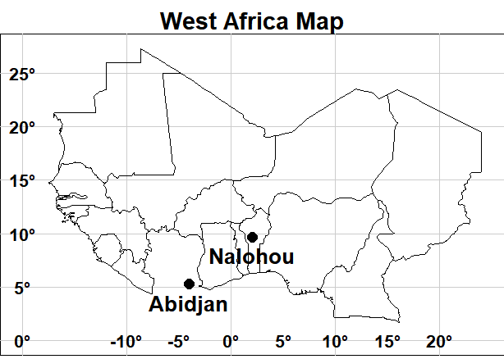
Fig. 1. Geographic location of the two study sites indicated by black dots.

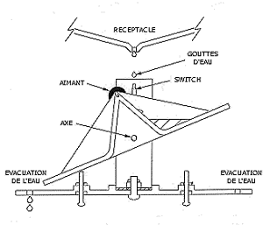
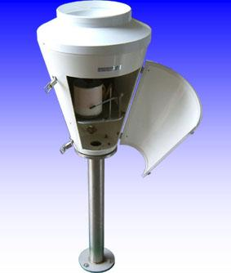
(a)
(b)

Fig. 2. (a) Image of a tipping-bucket rain gauge. (b) Schematic representation of its operating mechanism.

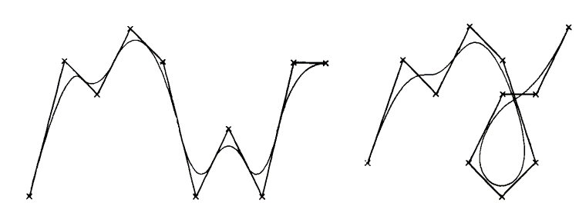

Fig. 3. Illustration of B-Spline interpolation. (Adapted from Gordon and Riesenfeld, 1974).

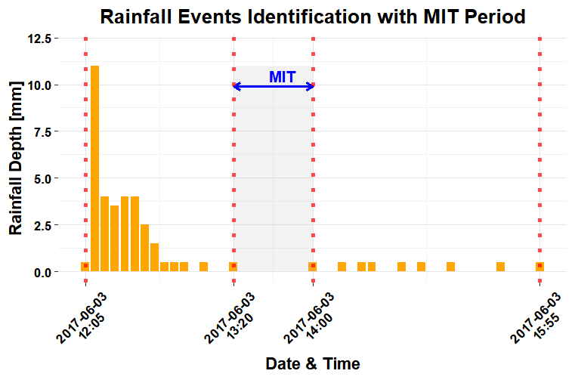

Fig. 4. Illustration of the segmentation of rainfall records into rainfall events using a 30-minute MIT and a total accumulation greater than or equal to 1 mm.

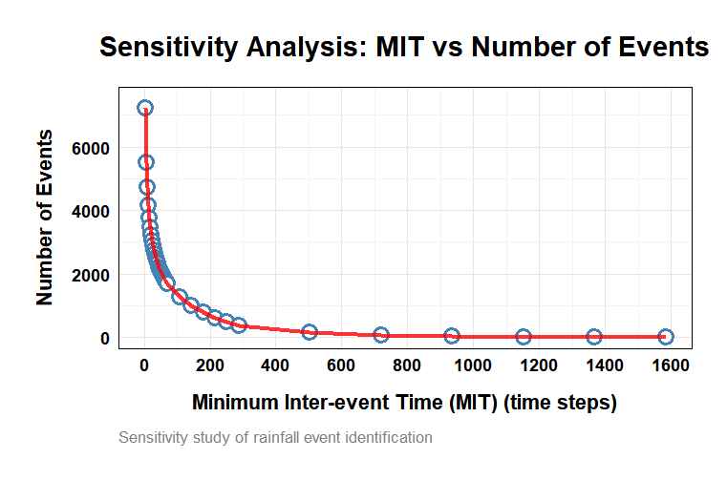
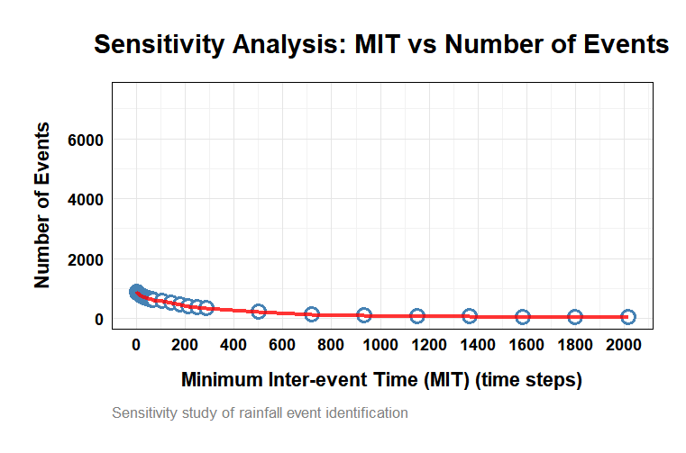
(a)
(b)
Fig. 5. Evolution curves of the number of rainfall events obtained as a function of the MIT set to 5 minutes: (a) Abidjan in Côte d'Ivoire; (b) Nalohou in Benin.

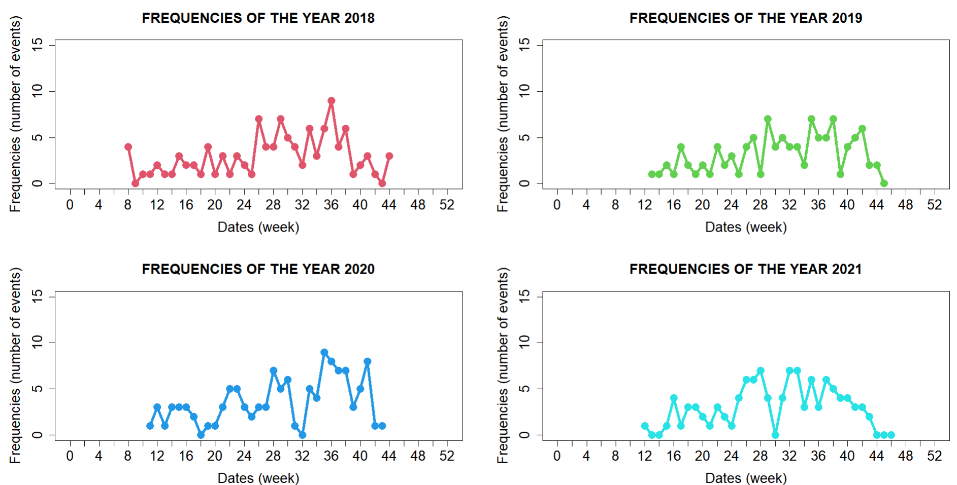

Fig. 6. Weekly variability of the number of constituted events for the different years studied (2018, 2019, 2020, and 2021): Case of Nalohou (Benin).

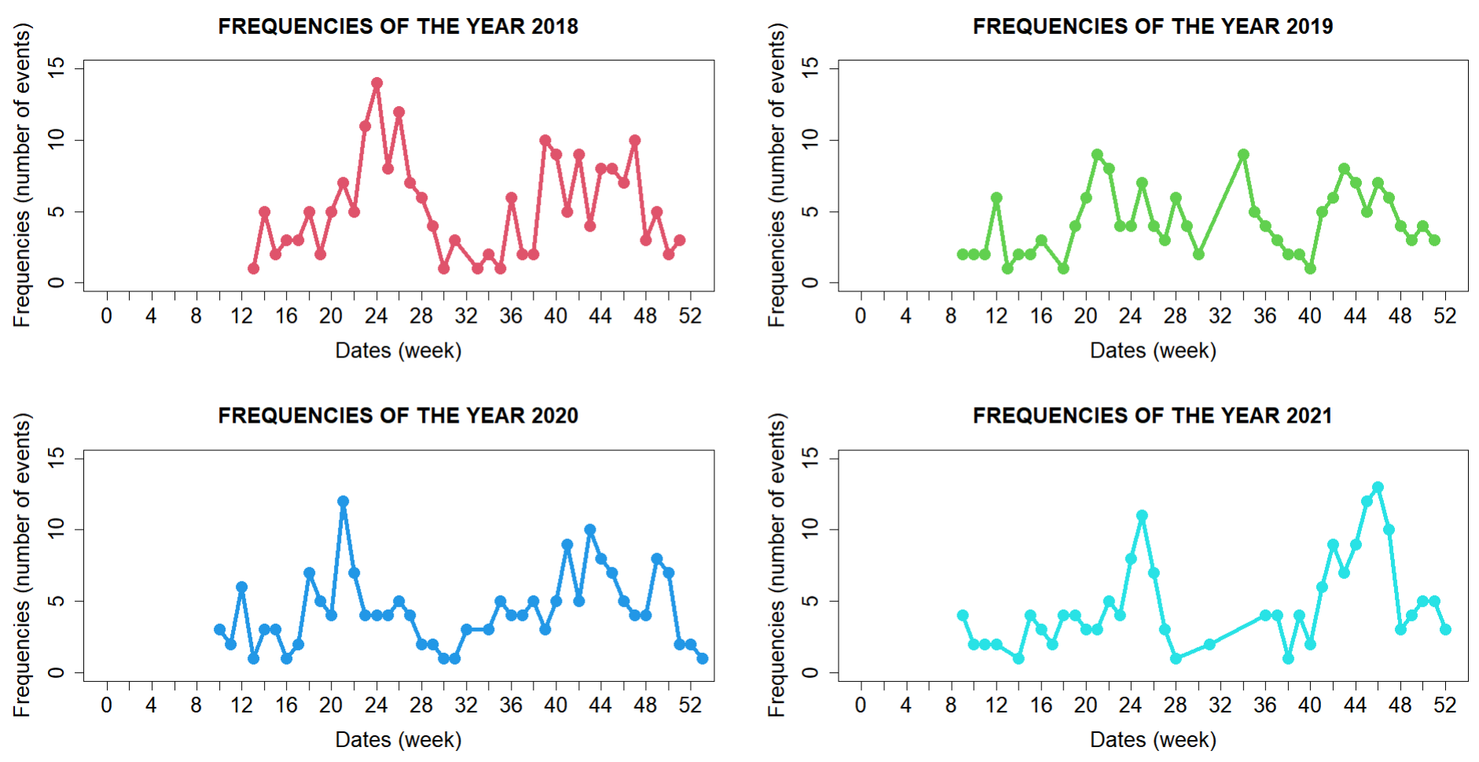

Fig. 7. Weekly variability of the number of constituted events for the different years studied (2018, 2019, 2020, and 2021): Case of Abidjan (Côte d’Ivoire).
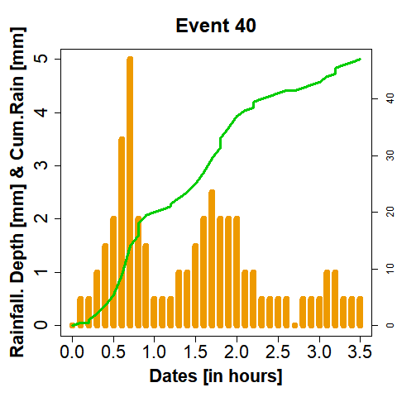
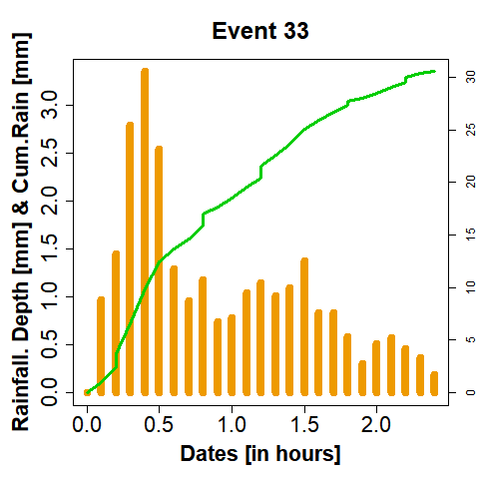
(a)
(b)

Fig. 8. Representation of instantaneous accumulations (5-minute intervals) as histograms (orange bars), with the discontinuous profile (green dashed curve) of the rainfall accumulation for the studied event superimposed. (a) “Event 40” recorded in Abidjan and (b) “Event 33” recorded in Nalohou.

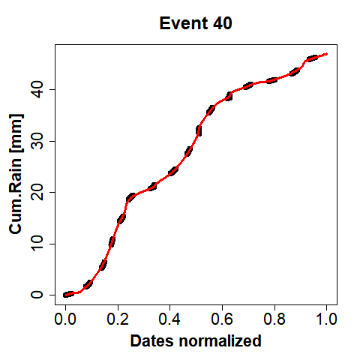
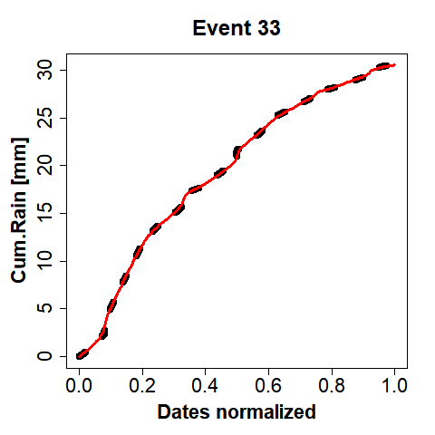
(a)
(b)

Fig. 9. Application of third-degree B-Spline interpolation (black continuous curve) to the discontinuous profile (black dotted lines) of the rainfall accumulation for the studied event. (a) “Event 40” recorded in Abidjan and (b) “Event 33” recorded in Nalohou.

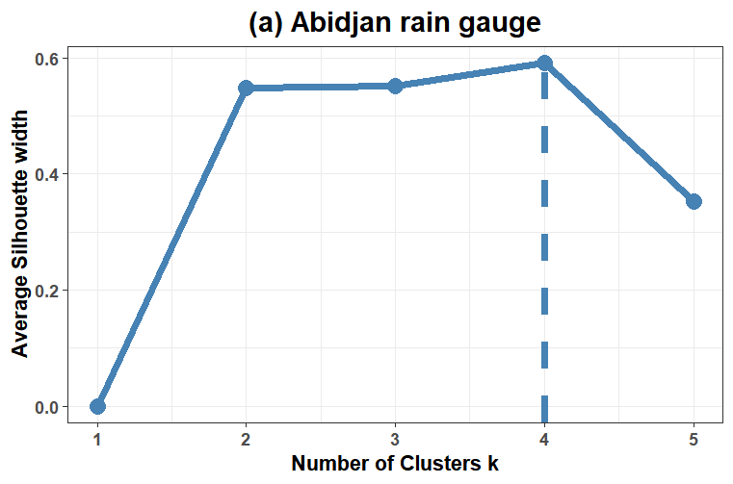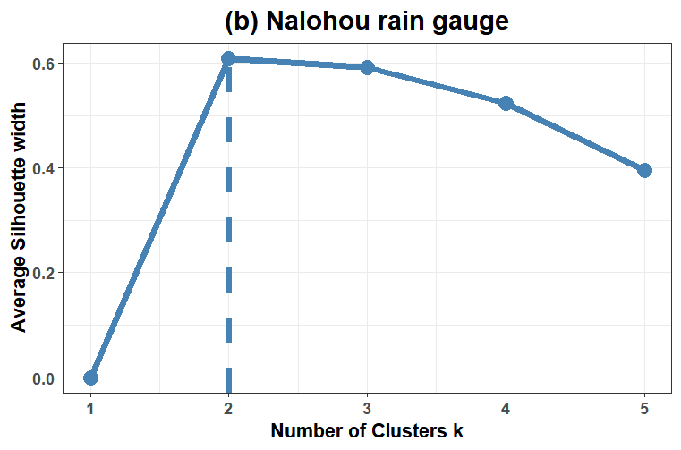
Fig. 10. Plot of the average silhouette width highlighting the selection of the optimal number of clusters (k) for the application of the FPCAC algorithm. (a) Abidjan (Côte d'Ivoire); (b) Nalohou (Benin).

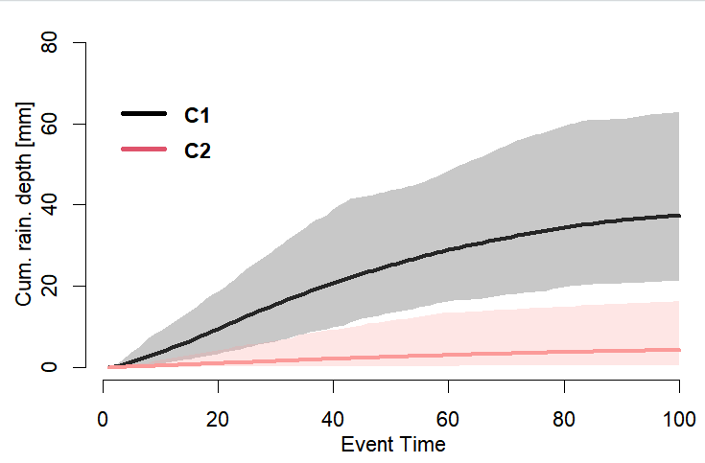
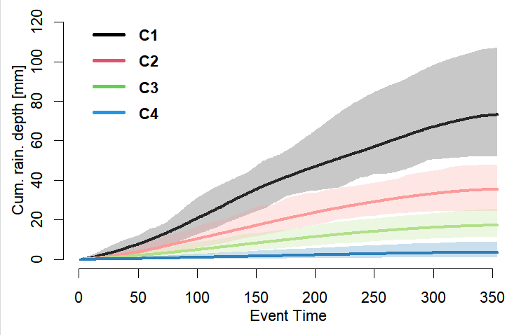
(b)
(a)

Fig. 11. Representation of the average rainfall profiles for each cluster. The hatched areas indicate the confidence bands based on the 10th and 90th percentiles of all profiles within the cluster. (a) Abidjan (Côte d’Ivoire) ; (b) Nalohou (Benin).

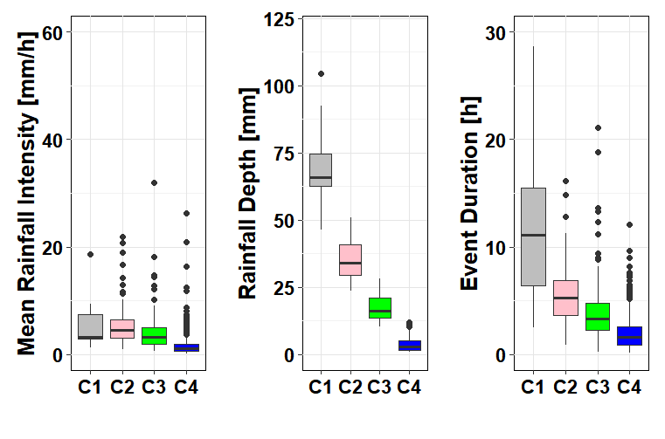
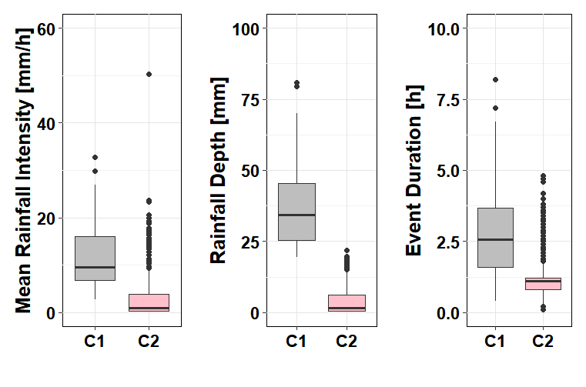
(a)
(b)

Fig. 12. Box plots of rainfall intensity, rainfall depth, and event duration based on the results of the FPCAC algorithm applied to the rainfall data from both sites. (a) Abidjan (Côte d'Ivoire); (b) Nalohou (Benin)

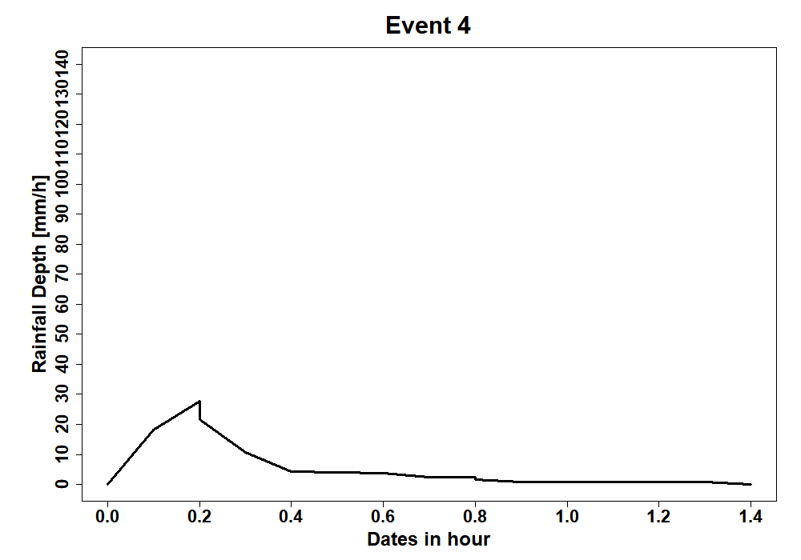
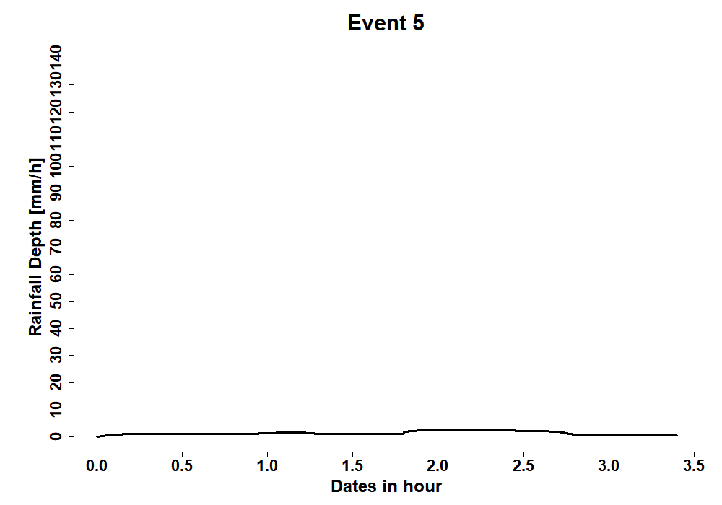
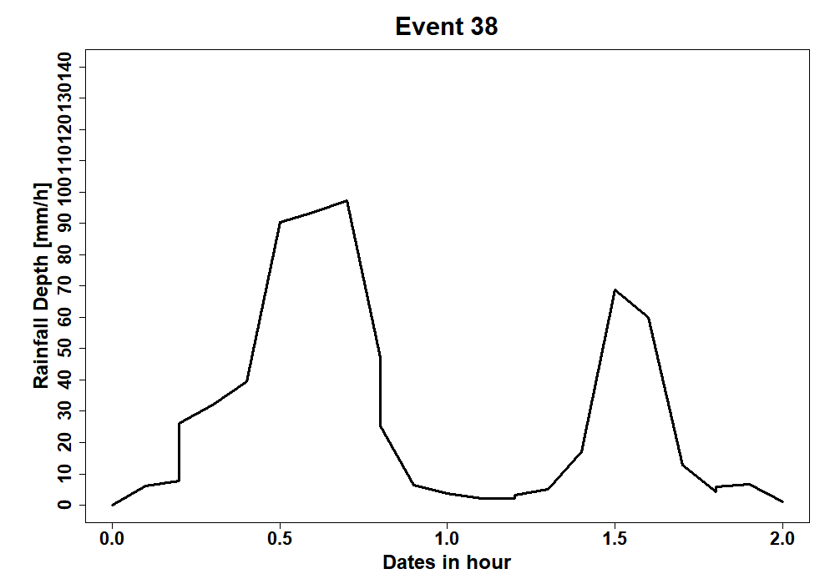
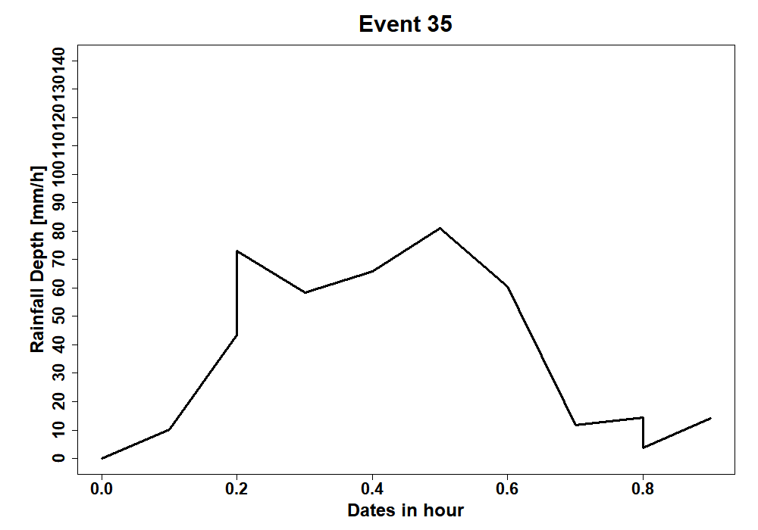
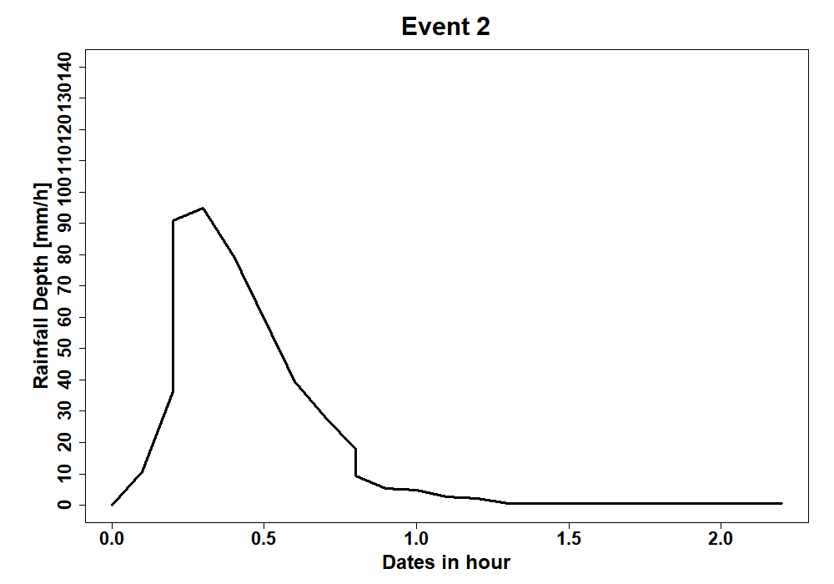
(C2)
Event 4
Event 5
(C1)
Event 2
Event 34
Event 37

Fig. 13. Hyetographs of selected rainfall events found in groups C1 and C2 at Nalohou.

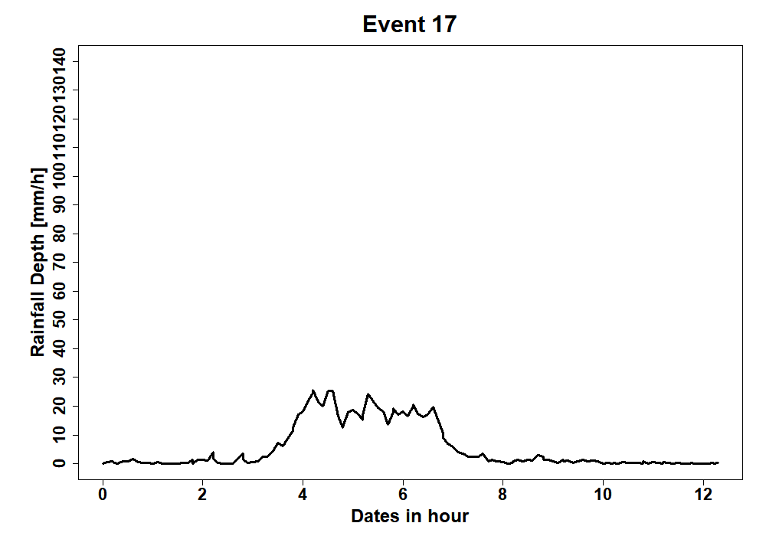
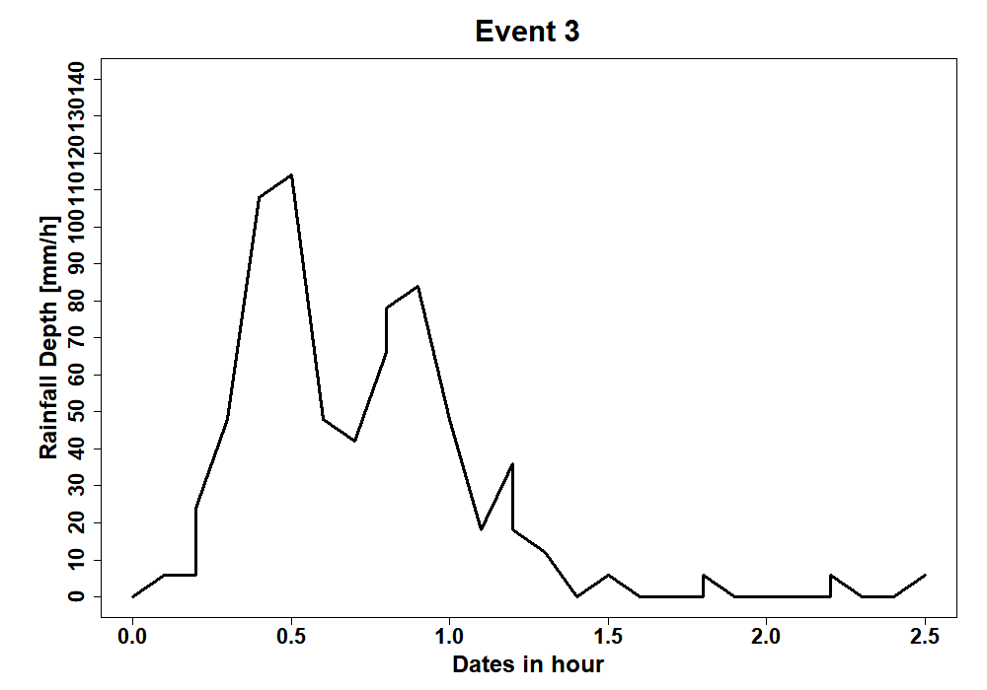
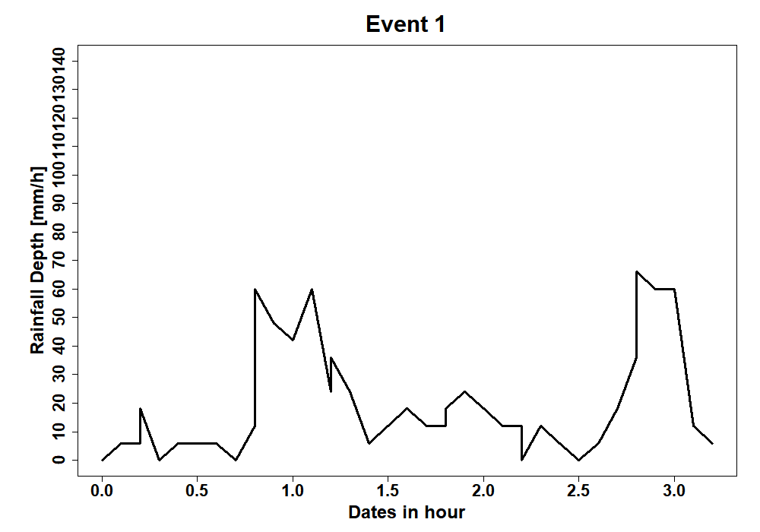
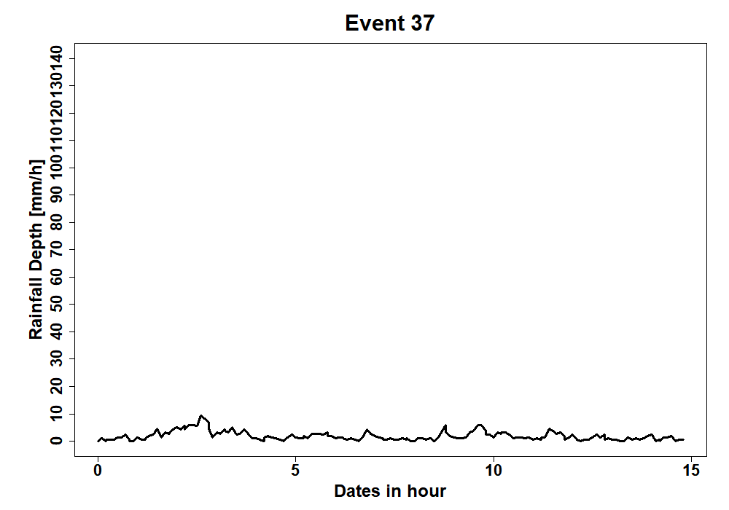
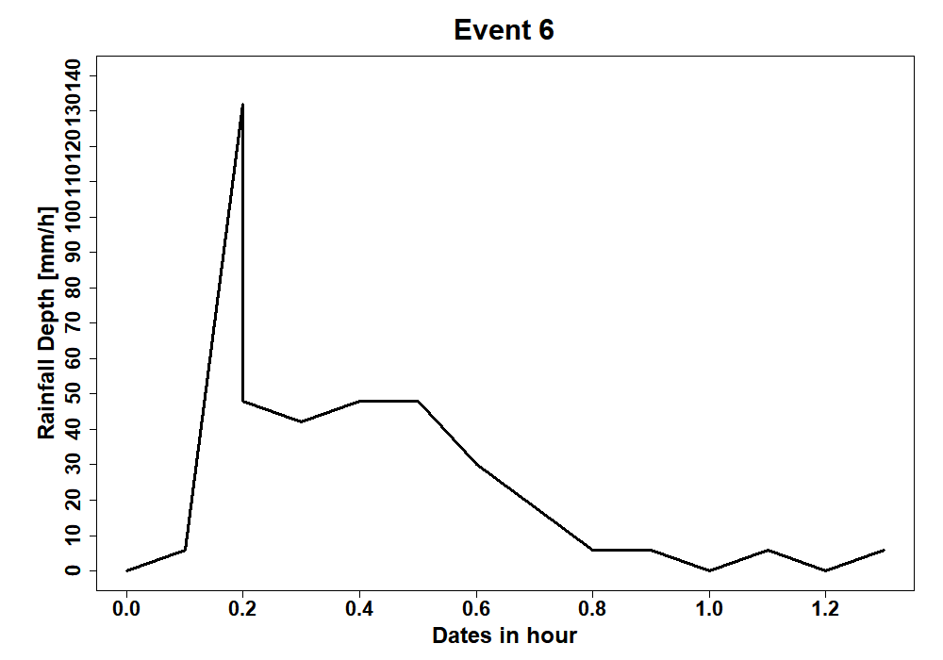
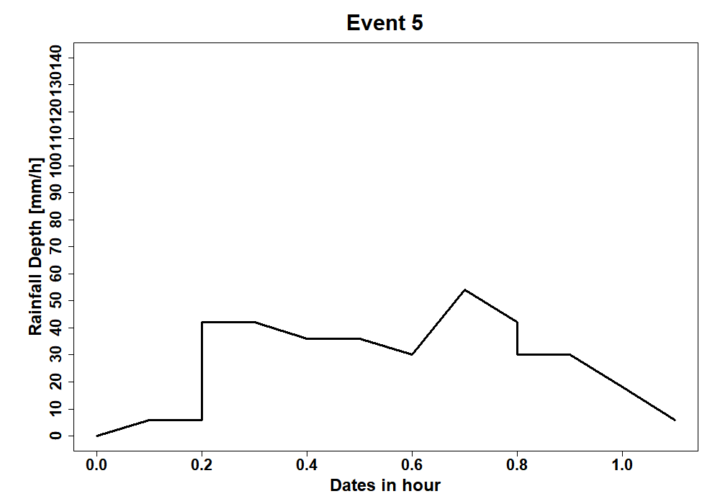
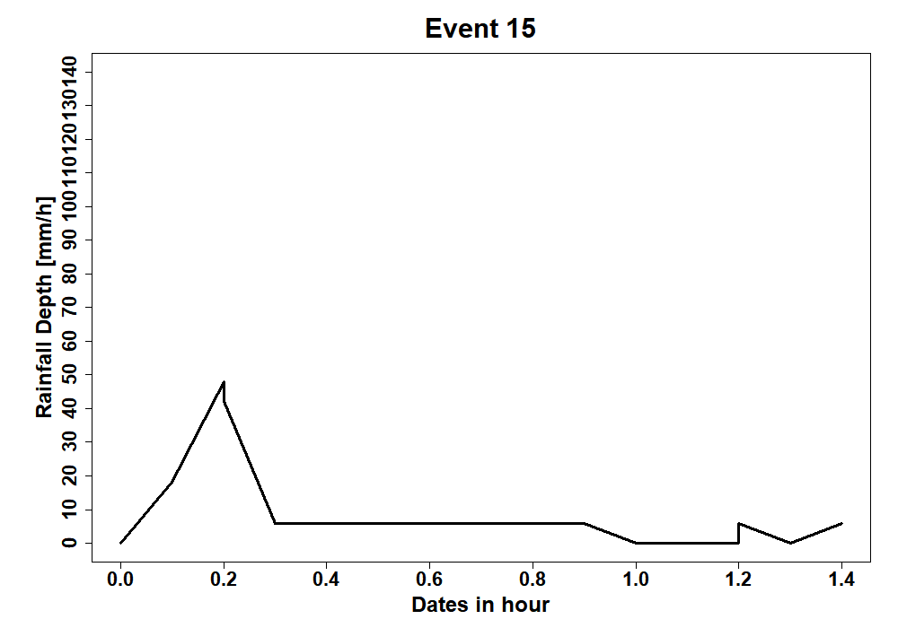
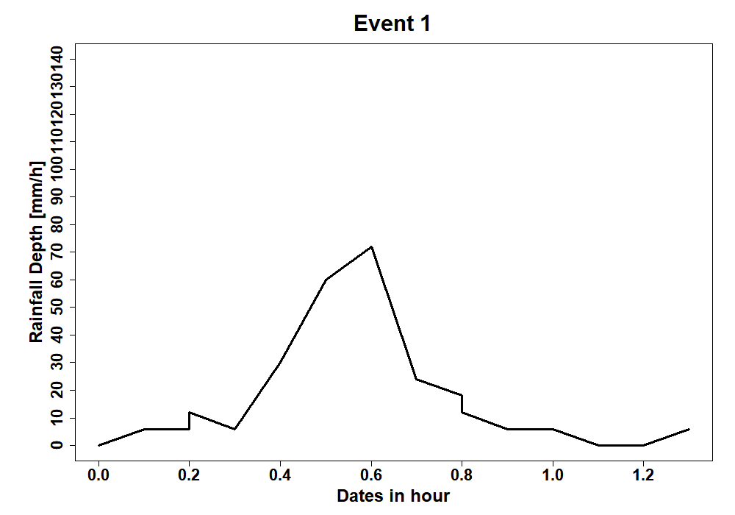
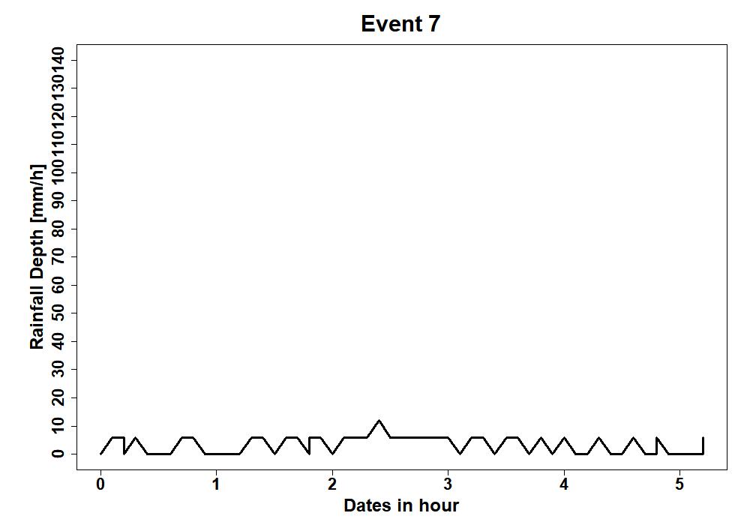
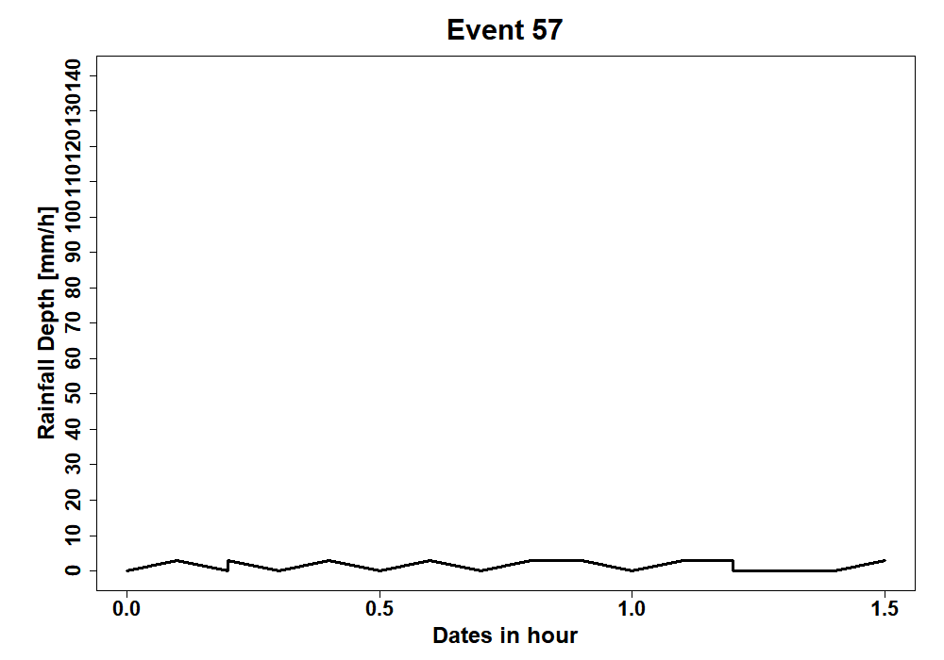
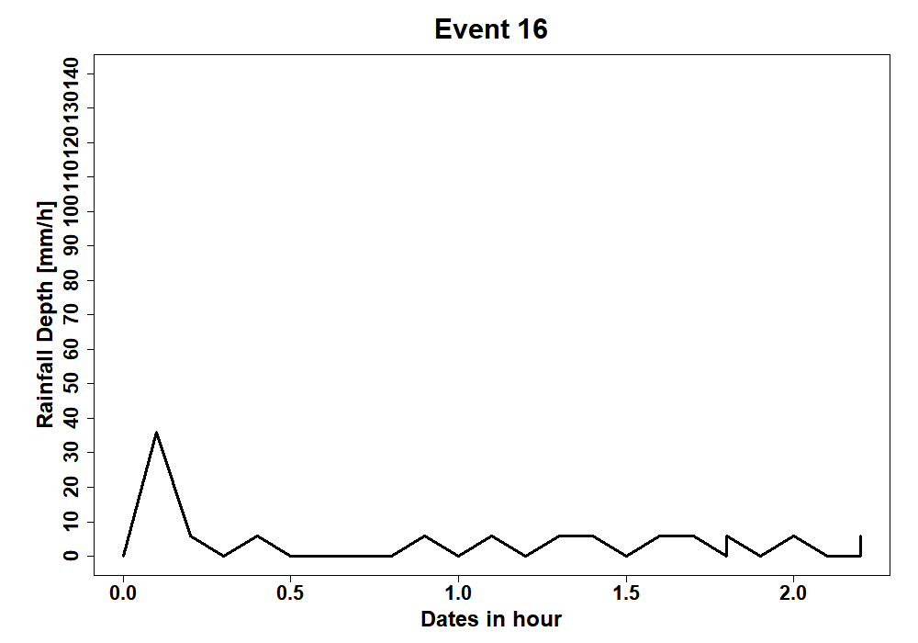
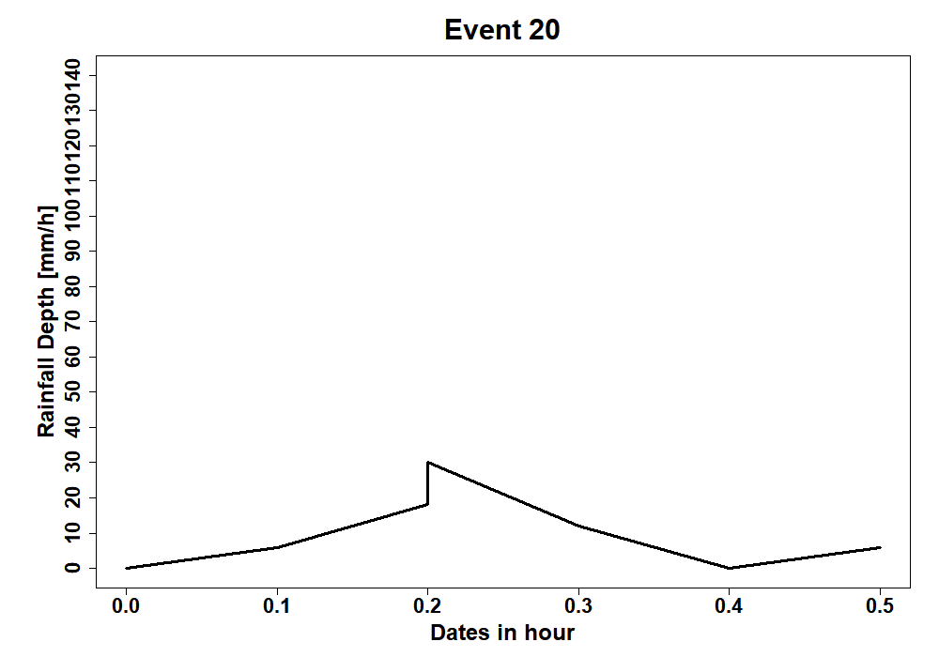
(C1)
Event 1
Event 3
Event 17
(C2)
Event 6
Event 5
Event 37
(C3)
Event 1
Event 15
Event 7
(C4)
Event 16
Event 20
Event 57

Fig. 14. Hyetographs of selected rainfall events found in groups C1, C2, C3 and C4 at Abidjan.

