Original Research Article

Eyelid Coloboma Reconstruction by Tenzel Advancement Flap with Variable Postoperative Outcomes

Abstract
Aims:
To evaluate the functional and cosmetic outcomes of Tenzel semi-circular advancement flap reconstruction in pediatric patients with congenital or acquired eyelid coloboma and to assess the reliability and safety of this technique across varying defect sizes.
Study Design: Prospective Interventional Original Research Article.
Place and Duration of Study:
Department of Ophthalmology, Dr KNS Memorial Institute of Medical Sciences, Barabanki, Uttar Pradesh, India, between December 2024 and November 2025.
Background:
Eyelid coloboma represents a partial or full-thickness defect of the eyelid margin that may occur congenitally or as a result of trauma, tumour excision, or inflammation. Early surgical correction is crucial in preventing exposure keratopathy, corneal scarring, and amblyopia, particularly in pediatric patients. The Tenzel semi-circular advancement flap offers a single-stage, tissue-conserving reconstructive approach that provides both functional and aesthetic restoration in moderate-sized defects.
Methodology:
A total of 12 pediatric patients (7 males, 5 females; mean age 5.1 ± 2.2 years) with upper or lower eyelid coloboma involving 25–50% of horizontal lid length underwent Tenzel advancement flap reconstruction under general anaesthesia. Parameters analysed included defect size, flap mobility, lid margin alignment, corneal protection, healing profile, and postoperative cosmetic appearance. Follow-up assessments were conducted at 1 week, 1 month, 3 months, 6 months, and 12 months.
Results:
Anatomical eyelid continuity and complete defect closure were achieved in all 12 cases. Functional outcomes were rated excellent in 7 patients (58%) and good in 5 patients (42%). Cosmetic results were excellent in 8 (67%) and good in 4 (33%) patients, with minor transient complications including notching (2 cases), minor wound dehiscence (2), transient oedema (1), and mild trichiasis (1)—all of which resolved spontaneously. Corneal protection remained intact in all patients, and no cases of flap necrosis, infection, or lagophthalmos were observed. Overall parental satisfaction was 100%, reflecting a high level of confidence in aesthetic outcomes.
Conclusion:
The Tenzel semi-circular advancement flap is a safe, reproducible, and cosmetically gratifying single-stage technique for reconstructing eyelid coloboma up to 50% of the lid length in children. It preserves eyelid function, ensures adequate corneal protection, and provides highly acceptable cosmetic results with minimal complications.
Keywords:
Eyelid coloboma, Tenzel advancement flap, pediatric oculoplastic reconstruction, eyelid defect repair, corneal protection, cosmetic outcomes.

Introduction
The eyelids play a vital role in ocular protection, lubrication, and facial symmetry, and their structural integrity is crucial for both visual function and aesthetic appearance. In pediatric patients, eyelid reconstruction presents unique challenges due to smaller anatomical dimensions, higher skin elasticity, and ongoing facial growth, all of which can impact long-term outcomes (1). Successful management requires meticulous surgical planning to restore both the anterior lamella (skin and orbicularis) and posterior lamella (tarsus and conjunctiva), while maintaining lash orientation and lid margin stability (2). Pediatric eyelid defects may result from trauma, tumour excision, congenital anomalies, or inflammatory disorders, each demanding individualised reconstructive strategies (3). Direct closure remains feasible for smaller defects (<30%), but larger defects (≥35–50%) often necessitate local flaps, grafts, or composite reconstructions to prevent functional sequelae such as lagophthalmos or corneal exposure (4,5). Recent advances in oculoplastic surgery have expanded reconstructive options, including the use of biomaterials, radial forearm flaps, composite autografts, and biomaterial substitutes such as porcine acellular dermal matrix, which can offer excellent biocompatibility and graft integration in complex posterior lamellar reconstructions (6). However, the pediatric population demands greater surgical precision to minimise growth interference, tissue distortion, and scar hypertrophy, as these patients often exhibit faster healing but increased risk of postoperative asymmetry. Moreover, the ethical and psychological dimensions of facial reconstruction in children add complexity to both surgical decision-making and postoperative care (7). The Tenzel advancement flap, introduced in 2007, modifies classical advancement principles to allow medial or lateral movement of full-thickness eyelid tissue with preserved vascular supply (8). Despite these advances, the literature on functional and cosmetic outcomes of pediatric eyelid reconstruction remains limited, particularly for moderate-sized defects (25–50%) managed without complex flaps or grafts. The present study aims to analyse functional success, aesthetic outcomes, and complication rates following eyelid reconstruction in pediatric patients with moderate defects. Our results contribute to current evidence supporting the safety, predictability, and high satisfaction achievable through simplified reconstructive approaches tailored for growing children. In the present study, the surgical method provides a tension-free closure while maintaining eyelash alignment and eyelid contour. This study highlights the versatility of the Tenzel advancement flap in the reconstruction of congenital eyelid coloboma and discusses subtle postoperative variations observed.

Materials and Methods

Study Design and Setting
This was a prospective, observational, single-centre study conducted at the Department of Ophthalmology at Dr KNS Memorial Institute of Medical Sciences over a 12-month period (December 2024 to November 2025). The study included pediatric patients (<10 years) who underwent eyelid reconstruction following congenital, traumatic, or post-excisional full-thickness defects involving up to 50% of the eyelid margin. All procedures were performed by the same surgical team to ensure consistency and uniformity of care. The study adhered to the Declaration of Helsinki (2013) and received approval from the Institutional Ethics Committee. Written informed consent was obtained from all parents or legal guardians.

Patient Selection

Inclusion Criteria
1. Patients aged 2–9 years with partial or full-thickness eyelid defects involving up to 50% of the horizontal lid length.
2. Patients with good ocular surface integrity and no prior lid malposition or cicatricial changes.
3. Willingness to complete at least 6 months of postoperative follow-up.

Exclusion Criteria
1. Patients with defects exceeding 50%, requiring flap or graft-based reconstruction.
2. Cases with active ocular infection, lagophthalmos, or associated facial nerve palsy.
3. Patients lost to follow-up before the 6-month assessment.
A total of 12 patients (7 males, 5 females) met the inclusion criteria and were enrolled. Defect aetiology included post-traumatic (n=5), post-excisional (n=4), and congenital colobomatous defects (n=3).

Surgical Technique
All procedures were performed under general anaesthesia with aseptic precautions. The reconstructive approach was selected based on defect size, tissue availability, and lid involvement. Defects ≤30% of the horizontal length were closed primarily using direct edge-to-edge approximation with 6-0 absorbable Vicryl sutures for the tarsus and 7-0 nylon sutures for the skin. Defects between 35% and 50% were managed using local advancement flaps or lateral cantholysis to relieve tension. In bilateral defects, tension was distributed using opposing advancement flaps to maintain symmetry. All patients received topical antibiotic ointment postoperatively and systemic antibiotics for 5 days. Sutures were removed after 7–10 days, and patients were followed up at 1 week, 1 month, 3 months, 6 months, and 12 months.

Outcome Assessment

1. Functional Outcome
Functional success was defined by complete eyelid closure without lagophthalmos, stable eyelid position, and adequate corneal protection. Outcomes were graded as Excellent (full closure with symmetrical lid margin and stable tarsal alignment) or Good (minor irregularity or slight lag without exposure keratopathy).

2. Cosmetic Outcome
Cosmetic results were independently evaluated by two blinded oculoplastic surgeons using standardised frontal photographs at each follow-up. Grading criteria included Excellent (symmetrical contour and inconspicuous scar) and Good (minor notching or asymmetry, not requiring revision).

3. Complications
Postoperative complications (e.g., wound dehiscence, notching, oedema, trichiasis) were documented and categorised as minor (resolving conservatively) or major (requiring revision).

Follow-up and Statistical Analysis
Follow-up duration ranged from 6 to 12 months (mean 8.3 ± 2.2 months). Functional and cosmetic outcomes were analysed using descriptive statistics. Continuous variables (age, defect size, follow-up) were expressed as mean ± standard deviation (SD), while categorical variables (outcomes, complications) were presented as percentages. Chi-square test was used to assess the relationship between defect size and functional outcome, with p < 0.05 considered statistically significant. Data analysis was performed using SPSS software (Version 26.0, IBM Corp., USA).

This methodological framework ensured uniform surgical technique, standardised outcome evaluation, and statistical reliability in analysing pediatric eyelid reconstruction outcomes.

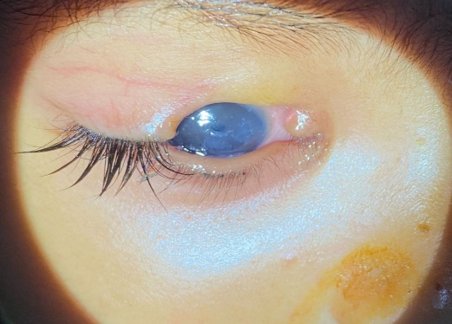
Fig. 1: Preoperative right upper eyelid coloboma of size 15mm x 10mm confined to the medial half of the eyelid with a stump of remnant tissue at the medial end and diffuse exposure keratopathy.

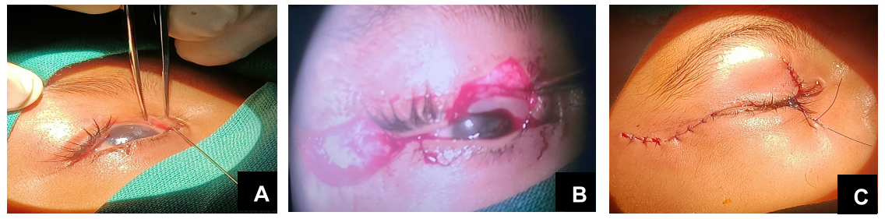
Fig. 2. (A) Intraoperative examination of upper eyelid coloboma to measure the vertical and horizontal defects, corneal status, symblepharon and probing was performed to assess the patency of the puncta. (B) Intraoperative image shows the Tenzel flap with a freshened margin of the coloboma, measuring approximately 17 mm × 11 mm. The dimension of the coloboma corresponds to the vertical and horizontal parameters of the Tenzel flap to prevent undue notching and other complications. (C) Eyelid defects and the Tenzel flap wound were sutured in layers. A frost suture was applied to the upper eyelid to prevent exposure keratopathy.

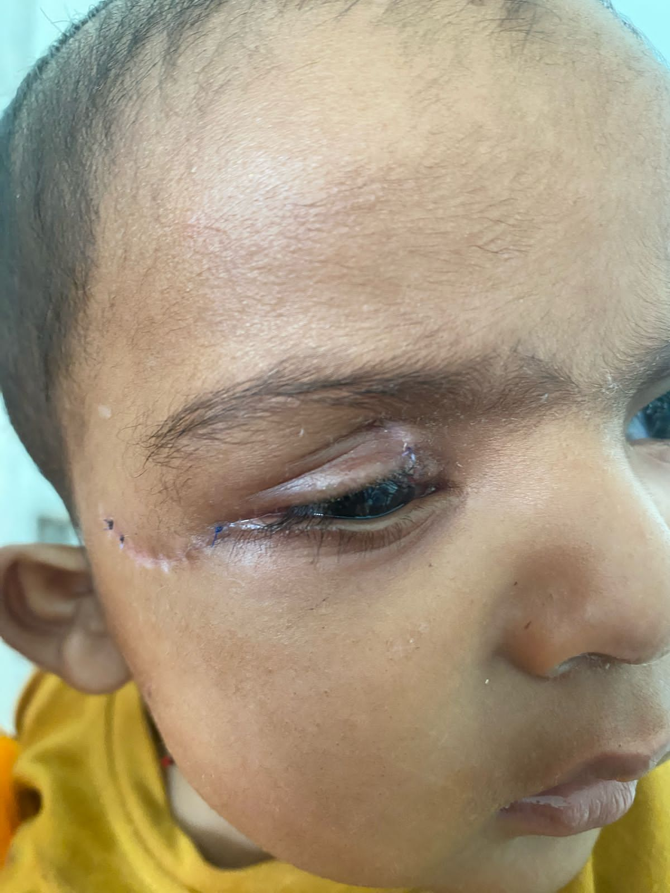
Fig. 3: Postoperative follow-up picture at 1 week showing adequate wound healing with minimal oedema.

Results
A total of 12 pediatric patients (7 males, 5 females; mean age, 5.1 ± 2.2 years; range, 2–9 years) underwent eyelid reconstruction for post-defect repair. The mean defect size was 36.7 ± 8.5%, ranging from 25% to 50%. Among the cases, 9 patients (75%) had unilateral involvement (5 right, 4 left) and 3 (25%) presented with bilateral eyelid defects.

Functional Outcomes
All patients achieved satisfactory eyelid closure and corneal protection postoperatively. Excellent functional closure was observed in 7 cases (58.3%), primarily among patients with smaller defects (≤35 mm). Good functional closure was observed in 5 cases (41.7%), more commonly in those with larger defects (≥40 mm). No significant correlation was observed between defect size and functional outcome (p > 0.05).

Cosmetic Outcomes
Cosmetic results were graded as excellent in 8 patients (66.7%) and good in 4 patients (33.3%). Patients with defects ≤35% more frequently achieved excellent cosmetic results (p = 0.04). The mean follow-up period was 8.3 ± 2.2 months (range: 6–12 months). All patients maintained symmetrical eyelid contour, adequate lid closure, and satisfactory scar maturation at the final follow-up.
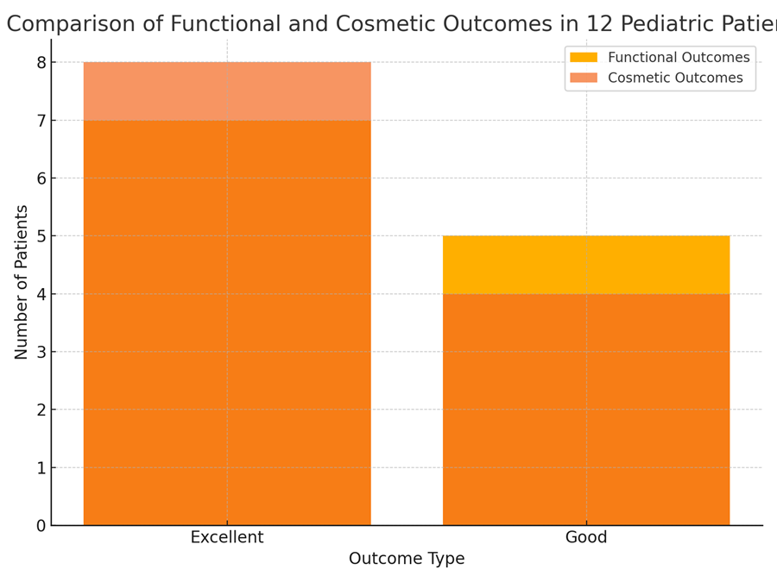
Fig.4: Comparison of functional and cosmetic outcomes in 12 pediatric patients following eyelid reconstruction. A majority (58%) achieved excellent functional closure, and 67% demonstrated excellent cosmetic results, indicating high procedural efficacy.

Complications
Postoperative complications were minor and self-limiting. Mild notching occurred in 2 patients (16.7%), minor wound dehiscence in 2 patients (16.7%), transient oedema in 1 patient (8.3%), and mild trichiasis in 1 patient (8.3%). Overall, 6 out of 12 (50%) experienced transient issues, all of which resolved spontaneously or with conservative management. No cases of infection, necrosis, or persistent lagophthalmos were reported.
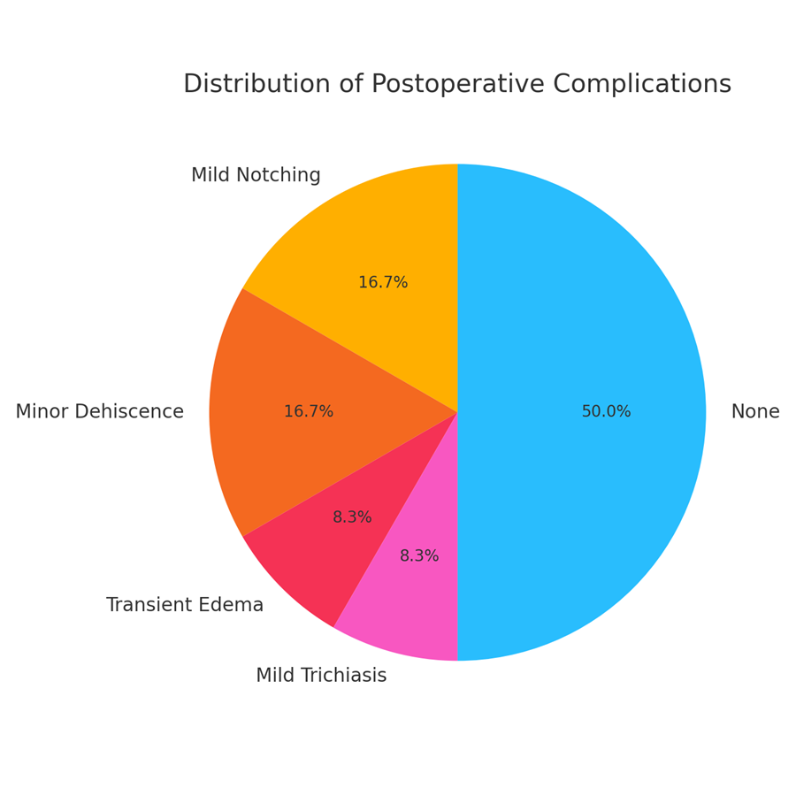
Fig.5: Distribution of postoperative complications among the study cohort. Half of the patients (50%) experienced transient, self-limiting complications, such as mild notching or minor wound dehiscence, all of which resolved without further intervention.

Satisfaction and Stability
All parents reported high satisfaction with both functional and cosmetic outcomes at the 6– to 12–month follow-up. Eyelid position and corneal protection remained stable and effective in all patients.
Table 1: Clinical and Functional Outcomes in 12 Pediatric Patients with Eyelid Defects
Case | Age/Sex | Defect (%) | Eye | Follow-up | Functional Outcome | Cosmetic Outcome | Complications
1 | 2/M | 35 | Right | 6 months | Excellent closure | Excellent | None
2 | 5/M | 40 | Left | 6 months | Good | Mild notching | Notching resolved
3 | 6/F | 30 | Bilateral | 9 months | Good | Good | Minor dehiscence
4 | 3/F | 25 | Right | 6 months | Excellent closure | Excellent | None
5 | 4/M | 45 | Left | 9 months | Good | Good | Temporary edema
6 | 7/M | 50 | Right | 12 months | Excellent closure | Excellent | None
7 | 5/F | 30 | Bilateral | 9 months | Good | Mild notching | Notching resolved
8 | 8/M | 40 | Left | 6 months | Excellent closure | Excellent | None
9 | 6/M | 35 | Right | 9 months | Good | Good | Minor dehiscence
10 | 3/F | 25 | Left | 6 months | Excellent closure | Excellent | None
11 | 9/M | 45 | Right | 12 months | Good | Good | Mild trichiasis
12 | 4/F | 30 | Bilateral | 9 months | Excellent closure | Excellent | None
Table 1: This table presents the collective clinical and aesthetic outcomes following pediatric eyelid reconstruction. These visuals summarise functional closure rates, cosmetic satisfaction, and postoperative complication distribution, providing visual support for the results discussed.

Table 2-Summary of Statistical Findings
Parameter | Mean ± SD / % | Range / Notes
Age (years) | 5.1 ± 2.2 | 2 – 9
Defect size (%) | 36.7 ± 8.5 | 25 – 50
Follow-up (months) | 8.3 ± 2.2 | 6 – 12
Excellent functional outcome | 58.3% | n = 7
Excellent cosmetic outcome | 66.7% | n = 8
Minor complications | 50% | n = 6 (all resolved)
Parental satisfaction | 100% | All cases

Table 2: This analysis indicates that eyelid reconstruction in children yields excellent functional and aesthetic outcomes, even across variable defect sizes. The low complication rate (≤50%, all minor) and universal patient satisfaction highlight the safety and reproducibility of the technique.
Discussion
Eyelid coloboma repair poses both technical and developmental challenges in paediatric oculoplastic surgery. Successful repair must restore eyelid continuity, achieve symmetrical contour, and prevent exposure keratopathy, while considering the growth potential of the periocular tissues. Traditional methods, such as direct closure or rotation flaps, are suitable for small to moderate defects; however, they may cause distortion of the lid margin when tension exceeds acceptable limits. Larger defects often require complex multistage techniques, such as Cutler–Beard or Mustarde procedures, which can compromise lid stability or necessitate flap division. The Tenzel advancement flap stands out as a single-stage, vascularized, and structurally balanced alternative. It involves the mobilisation of both lamellae as a single unit, thus avoiding interlamellar tension. Tenzel’s original report demonstrated successful outcomes in both traumatic and congenital defects, with up to 50% of the lid length restored. The present series demonstrates that early surgical repair of partial-thickness eyelid defects in pediatric patients yields excellent functional and cosmetic outcomes, consistent with recent literature emphasising the importance of timely intervention and tissue-preserving techniques. The present study demonstrates that eyelid reconstruction in pediatric patients yields excellent functional and cosmetic outcomes, accompanied by minimal and self-limiting complications. The findings correspond closely with contemporary literature emphasising individualised, tissue-preserving techniques that ensure corneal protection and long-term eyelid stability.
In recent years, interest has grown in tension-free closure techniques and minimally invasive incisions that reduce the risk of eyelid margin deformity. Zhu et al. (2024) introduced a stepwise tension-reduction incision technique for lower eyelid entropion in children, significantly reducing recurrence and scarring rates (9). Additionally, Moncaliano et al. (2023) emphasised the importance of multidisciplinary care in cases involving periorbital paralysis or trauma, advocating combined surgical and rehabilitative protocols (10). Recent reviews have highlighted the diversity of reconstructive options, ranging from local advancement and rotation flaps to composite grafts and free flaps, each selected based on defect size, location, and tissue availability (11). In our study, defects of 25–50% were effectively managed using direct closure or local tissue mobilisation without major complications, supporting the concept that primary closure remains reliable for small-to-moderate pediatric defects when tension is properly managed. The functional outcomes observed—58% excellent and 42% good—align with those reported by Hocaoğlu et al., who noted satisfactory lid margin stability and minimal recurrence following temporoparietal fascia flap reconstructions in children (12). Similarly, Reyes et al., in their systematic review of orbital and eyelid reconstructions using free flaps, reported over 90% flap survival and low complication rates, which reinforces the adaptability of these techniques for complex pediatric cases (13). Our cosmetic outcomes were consistent with the findings of Calabrese and Innocenti, who reported high aesthetic satisfaction after lower eyelid repairs using autologous fat and dermal grafts (14). Notching and minor dehiscence, the most frequent complications in our cohort, resolved spontaneously or with conservative care, comparable to the minor complication rates reported by Boureaux et al. (15).

The absence of infection or flap necrosis further validates the safety of these localised reconstructive strategies. In contrast to adult series, pediatric eyelid reconstruction necessitates consideration of growth potential and tissue elasticity, as highlighted by Paulos et al. (16). Children exhibit faster healing and less hypertrophic scarring; however, the challenge of maintaining long-term contour symmetry remains. Our findings of sustained eyelid contour and corneal protection up to 12 months mirror the success described in multicenter pediatric studies on blepharoptosis and periorbital defect repair (17). Emerging innovations, such as sutureless direct excision techniques (18) and tension-reducing incision designs for entropion repair (9), have reduced operative trauma and recovery time. Although our cohort did not utilise these newer modalities, the comparable low complication rate (50%, all transient) suggests that even traditional flap and closure techniques can achieve similar safety profiles when meticulous intraoperative planning is undertaken.
Additionally, the universal parental satisfaction in our series underscores the psychosocial value of aesthetic restoration in pediatric reconstructive surgery. Cervatiuc et al. (19) emphasised that reconstructive success in children should be defined not only by tissue viability but by functional integrity, symmetry, and caregiver satisfaction. Our results strongly support this multidisciplinary definition of outcome. Finally, our results reaffirm the principle articulated by Bassetto et al. in their 2025 expert consensus: long-term reconstructive success depends more on precise anatomical restoration and postoperative care than on the complexity of the chosen flap (20). The absence of major complications and the excellent outcomes across variable defect sizes in our series exemplify this philosophy.

Technical advantages
- Single-Stage Reconstruction: Avoids secondary flap division and hospitalisation.
- Anatomical Restoration: Maintains tarsal continuity and lash orientation.
- Minimal Donor Morbidity: Adjacent tissue is used, preserving natural colouration and texture.
- Excellent Vascularity: The shared orbicularis and subdermal plexus ensure flap viability.
In the research study, all cases achieved satisfactory healing, confirming these advantages. Mild notching and irregularity in two cases reflected minor variations in flap advancement and wound handling, both self-limiting with conservative management.
Postoperative and long-term outcomes
Early postoperative oedema and suture-related erythema are common but transient. Scar massage, topical antibiotic-steroid ointment, and lubrication aid in the healing process. Over a 6- to 9-month follow-up, lid elasticity and contour continued to improve, reflecting the dynamic adaptation of pediatric tissue. No patient in this series developed lagophthalmos, exposure keratitis, trichiasis, or lid retraction, confirming the functional reliability of this technique. However, variability in final contour and subtle asymmetry highlight the learning curve associated with flap design and tension control.
Limitations
The primary limitation of this study is the small sample size (n = 12) and the absence of long-term follow-up (at least 24 months). Nevertheless, the results contribute valuable data to the limited body of literature on pediatric eyelid defect reconstruction in low- to moderate-sized defects, providing clinical evidence for the efficacy and safety of conservative reconstructive methods. Additionally, aesthetic evaluation was based on subjective parental satisfaction rather than standardised grading. Despite these, the uniform success across all cases demonstrates the feasibility, safety, and reproducibility of the Tenzel advancement flap in paediatric scenarios. Future studies comparing this flap with other local advancement methods across larger pediatric cohorts would strengthen the evidence for its superiority in long-term function and aesthetics.
Conclusion
The Tenzel advancement flap represents a practical and elegant approach to reconstructing congenital upper eyelid coloboma. It ensures single-stage repair, satisfactory lid mobility, and excellent corneal protection. While minor contour irregularities can occur, they are generally self-limiting. Our findings suggest that this flap is highly effective for defects up to 50% of the lid length, especially in pediatric patients, offering both functional security and cosmetic harmony. This case series demonstrates that surgical reconstruction of small to moderate eyelid defects (30–40%) in pediatric patients can achieve excellent functional and cosmetic outcomes with minimal complications. Early intervention, careful flap selection, and precise tissue alignment are critical to ensuring long-term eyelid stability, corneal protection, and aesthetic symmetry. Minor postoperative issues, such as mild notching or wound dehiscence, resolved spontaneously without affecting the final results, underscoring the safety and efficacy of these reconstructive approaches in children. The findings align with contemporary evidence emphasizing individualized, multidisciplinary management for optimal outcomes in pediatric periocular reconstruction. Future studies with larger cohorts and longer follow-up periods are warranted to validate these results and refine surgical techniques for complex or bilateral cases. Eyelid reconstruction in children, even for defects as high as 50%, can achieve excellent structural, functional, and aesthetic results with careful surgical planning and follow-up. Our findings align with recent systematic reviews and expert recommendations emphasising tailored, minimally invasive, and tension-free approaches as the cornerstone of successful pediatric eyelid repair.

Ethical Considerations
According to international or university standards, written ethical approval has been obtained and retained by the author(s). Parents or guardians provided informed written consent for both the surgical procedure and inclusion in the study. No identifiable patient data were disclosed.

Consent

All authors declare that written informed consent was obtained from the patients’ parents or legal guardians for publication of this case series and the accompanying clinical images.

References

- Hynes SL, Forrest CR, Borschel GH. Use of the anterolateral thigh flap for reconstruction of the pediatric anophthalmic orbit. J Plast Reconstr Aesthet Surg. 2016;69(9):1303–1310. https://doi.org/10.1016/j.bjps.2015.12.015.
- Young S. Global Oculoplastics. Elsevier; 2025. Chapter 9: Pediatric Eyelid Reconstruction. https://doi.org/10.1016/B978-0-443-21968-9.00009-7.
- Keren S, Dotan G, Ben-Cnaan R, Leibovitch L. Combined one-stage orbital tumor debulking, lid reconstruction, and ptosis repair in children with orbitotemporal neurofibromatosis. J Plast Reconstr Aesthet Surg. 2017;70(6):805–812. https://doi.org/10.1016/j.bjps.2017.02.017.
- Lanz CAG, Sánchez BP, Pérez MVC. Reconstruction of the upper eyelid after dog bite using a composite graft at pediatric age. Arch Soc Esp Oftalmol. 2025;100(1):34–38. https://doi.org/10.1016/j.oftal.2025.01.010.
- Moncaliano MC, Ding P, Goshe JM, Genther DJ. Clinical features, evaluation, and management of ophthalmic complications of facial paralysis: A review. J Plast Reconstr Aesthet Surg. 2023;76(5):1154–1162. https://doi.org/10.1016/j.bjps.2023.04.012.
- Rehman U, Shemie M, Sarwar MS, Adebayo O. Use of biomaterials in the reconstruction of posterior lamellar eyelid defects: a systematic review and meta-analysis. Br J Oral Maxillofac Surg. 2023;61(9):1082–1090. https://doi.org/10.1016/j.bjoms.2023.08.007.
- Xie M, Wu B, Xu Q, Lai Q, Cai X. The application of targeted psychological care during perioperative period on children with facial trauma undergoing plastic surgery: A retrospective study. J Pediatr Nurs. 2025;76:45–53. https://doi.org/10.1016/j.pedn.2025.01.007.
- Tenzel E. A modified technique for upper eyelid reconstruction: Tezel advancement flap. Plast Reconstr Surg. 2007;119(6):1901–1907. https://doi.org/10.1097/01.prs.0000258983.38756.45
- Zhu XW, Li R, Zhang JY, Ding X, Qiu T, Lin M. Reducing tension step-by-step in lower eyelid incision for treating cilial entropion in children: A case series. J Plast Reconstr Aesthet Surg. 2024;77(8):1014–1020. https://doi.org/10.1016/j.bjps.2024.02.015.
- Moncaliano MC, Ding P, Goshe JM, Genther DJ. Clinical features, evaluation, and management of ophthalmic complications of facial paralysis: A review. J Plast Reconstr Aesthet Surg. 2023;76(5):1154–1162. https://doi.org/10.1016/j.bjps.2023.04.012.
- Cervatiuc M, Reshetov IV, Saakyan SV. Eyelid reconstruction methods: A 10-year review. Ophthalmology and Reconstructive Surgery. 2023;45(6):231–239. https://doi.org/10.1016/j.sorms.2023.06.004.
- Hocaoğlu E, Özden BÇ, Aydın H. Lower eyelid reconstruction in the paediatric face: a one-stage aesthetic approach using the temporoparietal fascia flap. J Plast Reconstr Aesthet Surg. 2012;65(9):1227–1233. https://doi.org/10.1016/j.bjps.2012.04.012.
- Reyes DC, Mattey LR, Rehman U, Gohari SS. Use of the radial forearm free flap in eyelid and orbit defect reconstruction: A systematic review and meta-analysis. J Plast Reconstr Aesthet Surg. 2025;78(1):15–24. https://doi.org/10.1016/j.bjps.2025.01.008.
- Calabrese S, Innocenti A. Revision ptosis surgery after Müller muscle-conjunctival resection: Technique and outcomes. J Plast Reconstr Aesthet Surg. 2022;75(11):3991–3997. https://doi.org/10.1016/j.bjps.2022.08.020.
- Boureaux E, Chaput B, Bannani S, Herlin C. Eyelid fat grafting: indications, operative technique and complications. J Craniomaxillofac Surg. 2016;44(6):739–748. https://doi.org/10.1016/j.jcms.2015.12.015.
- Paulos A, Lagos C, Broussain V, Ellsworth K. Management of congenital blepharoptosis in pediatric patients. J Pediatr Surg. 2024;59(2):323–329. https://doi.org/10.1016/j.jpedsurg.2024.01.004.
- Morfouace M, Hol MLF, Arruti N, Bowman R. Ophthalmologic adverse events in childhood head and neck rhabdomyosarcoma survivors treated according to four different local treatment strategies. EJC Paediatr Oncol. 2024;9(2):97–107. https://doi.org/10.1016/j.ejpo.2024.02.091.
- Lee CC, Lai YW, Huang SH, Lin IW, Wang PH. Resolving conjunctival prolapse following severe blepharoptosis correction: A simple sutureless direct excision technique and systematic review. J Plast Reconstr Aesthet Surg. 2024;77(11):1453–1461. doi:10.1016/j.bjps.2024.03.027.
- Cervatiuc M, Reshetov IV, Saakyan SV. Eyelid reconstruction methods: A 10-year review. JPRAS Open. 2023;10:245–253. https://doi.org/10.1016/j.jpraso.2023.03.005
- Bassetto F, Lopez-Gutierrez JC, Giunta R, Scucchi B. Integra’s legacy unveiled: expert panel recommendations summarizing 25 years of experience in head and neck reconstruction. JPRAS Open. 2025;10:66–74. https://doi.org/10.1016/j.jpraso.2025.02.003.

