Clinical and Physiological Characterization of Canine Distemper Virus Infection in Dogs from the Junagadh Region of Gujarat, India

ABSTRACT
Canine distemper virus (CDV) remains a major infectious disease of dogs worldwide, particularly in developing regions where vaccination coverage is inadequate. The present study aimed to document the clinical spectrum and alterations in vital physiological parameters associated with naturally occurring CDV infection in dogs from the Junagadh region of Gujarat, India. A total of 74 dogs showing clinical signs suggestive of CDV were examined from January to June 2025, out of which 35 were confirmed positive through rapid antigen testing and/or PCR targeting the N gene. Clinical signs were categorized into nervous, respiratory, gastrointestinal, ocular, and cutaneous forms. The nervous form was the most prevalent, affecting 91.43% of confirmed cases, followed by respiratory (71.43%), gastrointestinal (45.71%), and ocular/cutaneous forms (42.86%). Mixed-system involvement was recorded in 94.29% of dogs, with seizures (81.25%), mucopurulent nasal discharge (64%), and vomiting (66.66%) being among the most frequent manifestations. Significant increases (P < 0.0001) in rectal temperature, pulse rate, respiratory rate, and capillary refill time (CRT) were observed in CDV-positive dogs when compared with ten healthy controls, indicating systemic inflammatory and cardiorespiratory stress. The findings reaffirm the pantropic nature of CDV and highlight the diagnostic value of clinical assessment in field conditions where laboratory facilities may be limited. Early recognition of multisystemic signs, supported by rapid screening tools, is essential for improving prognosis and disease management in affected dogs.
Keywords: Canine distemper virus, clinical forms, PCR, nervous signs, physiological parameters, Gujarat, dogs.
INTRODUCTION
Canine Distemper Virus (CDV), a highly contagious and often fatal pathogen belonging to the genus Morbillivirus (Family: Paramyxoviridae), is a major global health concern for domestic dogs and a wide array of wild carnivores (Duques-Valencia et al., 2019). Despite the availability of effective vaccination programs, CDV continues to persist, particularly in developing nations, where inadequate vaccination coverage contributes to its ongoing circulation (Manandhar et al., 2023; Wilkes, 2022). The virus is primarily transmitted through the inhalation of aerosolized droplets and rapidly causes systemic infection due to its pantropic nature, replicating in the epithelial, lymphoid, and nervous tissues (Chludzinski et al., 2023; Loots et al., 2017). In India, where rising socioeconomic conditions have led to increased pet ownership (Uddin et al., 2021), CDV remains enzootic and is a significant cause of morbidity and mortality, especially in young, unvaccinated dogs (0–6 months), with infections often peaking during the cooler months (Belsare et al., 2014; Vila et al., 2018; Sarchahi et al., 2022).
The infection is characterized by a broad spectrum of clinical signs that typically progress through systemic, respiratory, gastrointestinal, and neurological phases (Evermann & Kennedy, 2010). Common systemic and respiratory signs include fever, lethargy, anorexia, and mucopurulent oculo-nasal discharge (Agnihotri et al., 2017). Gastrointestinal involvement manifests as vomiting and diarrhea (Mühlebach et al., 2011). The most severe outcome is central nervous system (CNS) involvement, leading to neurological signs such as myoclonus (muscle twitching), ataxia, and seizures, which often indicate a poor prognosis (Appel et al., 1991). Chronic cases may develop hyperkeratosis of the nasal planum and footpads, known as "hard pad disease" (Galán et al., 2014).
In field conditions, where advanced molecular diagnostic tools like PCR are often inaccessible, the accurate and systematic evaluation of this diverse clinical spectrum is a vital, practical diagnostic tool for identifying CDV infection (Sarchahi et al., 2022). The present study was therefore undertaken to document and characterize the range and frequency of clinical manifestations observed in naturally occurring CDV-infected dogs presented in the Junagadh region of Gujarat.
MATERIALS AND METHODS
The present investigation was carried out on dogs presented to the Teaching Veterinary Clinical Complex (TVCC), College of Veterinary Science and Animal Husbandry, Junagadh Agricultural University, Junagadh, Gujarat, from January to June 2025. A total of seventy-four dogs of different breeds, ages, and sexes showing clinical signs suggestive of Canine Distemper Virus (CDV) infection were included in the study. Detailed clinical examination was conducted for each animal, with particular attention to systemic, respiratory, gastrointestinal, and neurological manifestations.
Data on body temperature, pulse rate, respiratory rate, hydration status, mucous membrane color, and lymph-node enlargement were recorded. Specific clinical signs such as nasal and ocular discharge, coughing, vomiting, diarrhea, muscle tremors, convulsions, and hyperkeratosis of the nasal planum or digital pads were noted and categorized based on severity.
For laboratory confirmation, ocular and nasal swabs were collected aseptically and subjected to a rapid antigen detection test (Immunochromatographic Kit) as well as a Polymerase Chain Reaction (PCR) assay targeting the nucleoprotein (N) gene of CDV. Dogs that tested positive by either of the two methods were considered confirmed cases. The frequency and percentage of each clinical sign were calculated to determine their relative occurrence among infected dogs.
All procedures were performed following institutional ethical guidelines and with the consent of the animal owners.
RESULT
Among 35 PCR-confirmed cases of canine distemper, various clinical forms—nervous, ocular, respiratory, gastrointestinal, and cutaneous—were observed either singly or in combination.
Nervous Form
The nervous form was the most prevalent, affecting 91.43% (32/35) of CDV-positive dogs. Major neurological manifestations included seizures (81.25%), chewing gum fits (46.88%), crying (45.71%), temporal twitching (40.63%), and ataxia or myoclonus of limbs (37.50%). Myoclonus of the abdomen (15.63%), head shaking or upward extension (9.38%), and paresis (6.25%) were less frequent (Graph 1). Neurological signs were attributed to viral invasion and demyelination of the central nervous system, particularly in the temporal lobes, leading to seizures and motor dysfunction.
Ocular Form
Ocular involvement was noted in 42.56% (15/35) of cases. Mucopurulent ocular discharge was the most common sign (66.67%), followed by serous discharge (33.33%) and conjunctivitis (13.33%) (Graph 2). These signs were likely due to virus-induced inflammation and secondary bacterial infections of ocular tissues.
Respiratory Form
Respiratory manifestations were observed in 71.43% (25/35) of infected dogs. Nasal discharge (64%) and coughing (56%) were the predominant features, often occurring together (Graph 3). The nasal discharge was mostly mucopurulent, indicating secondary bacterial infection or bronchopneumonia.
Gastrointestinal Form
Gastrointestinal involvement was seen in 45.71% (16/35) of CDV-positive dogs. The main signs included vomiting (66.66%), inappetence (53.33%), diarrhea (46.66%), vomiting with diarrhea (40%), and anorexia (33.33%) (Graph 4). These symptoms were attributed to viral replication in the intestinal epithelium, leading to enteritis and secondary infections.
Cutaneous Form
Cutaneous lesions were present in 42.86% (15/35) of dogs. Hyperkeratosis of the footpads and nasal planum was the most frequent finding (60%), followed by pustules on the ventral abdomen (46.66%) and erythematous skin lesions (33.33%) (Graph 5). These were due to viral multiplication in the keratinocytes of the stratum spinosum and granulosum.
Combination of Forms
Multiple organ system involvement was common, with overlapping forms observed in several dogs (Table 1). The most frequent combinations included nervous + respiratory (17.14%), nervous + GI + respiratory + ocular + cutaneous (11.43%), and nervous + GI + respiratory + ocular (8.57%). This highlights the multisystemic nature of CDV infection. (Table 1)
Table 1. Combination of various clinical forms of CDV in affected dogs (n = 35)
Forms of disease involved | No. of cases | Percentage (%)
Nervous only | 2 | 5.71
Nervous + Respiratory | 6 | 17.14
Nervous + GI + Respiratory + Ocular + Cutaneous | 4 | 11.43
Nervous + GI + Respiratory + Ocular | 3 | 8.57
Nervous + Respiratory + Ocular + Cutaneous | 3 | 8.57
Nervous + GI + Cutaneous | 3 | 8.57
Nervous + Respiratory + Cutaneous | 2 | 5.71
GI + Respiratory | 2 | 5.71
Other combinations (less frequent) | 10 | 28.6
Total | 35 | 100.0
Overall, the findings confirm that the nervous form is the most common clinical manifestation of CDV in dogs, followed by respiratory, cutaneous, ocular, and gastrointestinal forms, frequently occurring in combination and indicating the pantropic nature of the virus.
Clinical Parameters in CDV-Affected and Healthy Dogs
Clinical vital parameters were evaluated in ten healthy control dogs (Group A) and thirty-five CDV-positive dogs to assess the physiological alterations associated with infection. The mean rectal temperatures, respiration rates, heart rates, and capillary refill times (CRT) were compared using an unpaired t-test, and the results demonstrated statistically significant differences between the groups (Graph 6).
CDV-infected dogs exhibited a markedly higher mean rectal temperature (103.3 ± 0.23 °F) compared to healthy controls (101.29 ± 0.32 °F), showing a highly significant rise (P < 0.0001).The mean respiration rate in CDV-positive dogs was significantly elevated (44.31 ± 2.25 breaths/min) compared to the control group (26.60 ± 1.92 breaths/min), indicating respiratory distress associated with infection (P = 0.0002).A pronounced increase in pulse rate was recorded in affected dogs (122.74 ± 4.48 beats/min) relative to healthy dogs (91.10 ± 3.90 beats/min), with a statistically significant difference (P < 0.0001).CDV-positive dogs showed delayed CRT (1.65 ± 0.10 sec) when compared with healthy controls (0.78 ± 0.09 sec), indicating compromised peripheral perfusion (P < 0.0001).(Table 2)
Table 2: Comparison of mean (±SE) clinical parameters in healthy and CDV-affected dogs (n = 35 total)
Parameters | Healthy dogs (n=10) | CDV affected dogs (n=35) | p
Rectal Temperature (℉) | 101.29 ± 0.32 | 103.3 ± 0.23**** | <0.0001
Respiration rate  (breaths/min) | 26.60 ± 1.92 | 44.31 ± 2.25*** | 0.0002
Heart rate (beats/min) | 91.10 ± 3.90 | 122.74 ± 4.48**** | <0.0001
Capillary refill time (sec.) | 0.78± 0.09 | 1.65± 0.10**** | <0.0001

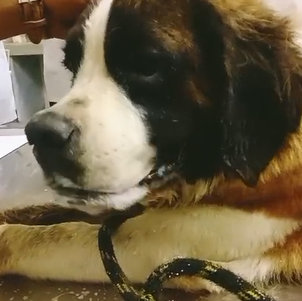 | 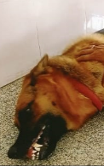
Fig. 1 Chewing gum fits | Fig. 2 Seizure
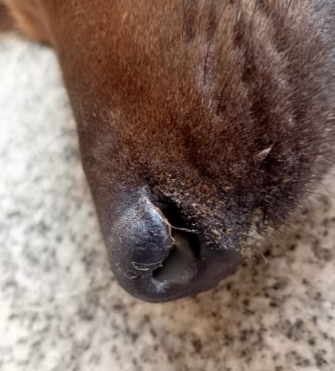 | 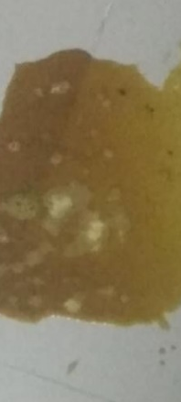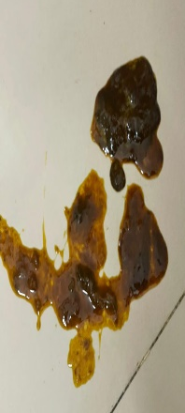
Fig. 3 Nasal discharge & coughing | Fig. 4 Vomiting and Diarrhoea
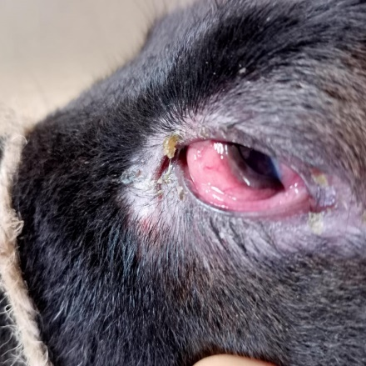 | 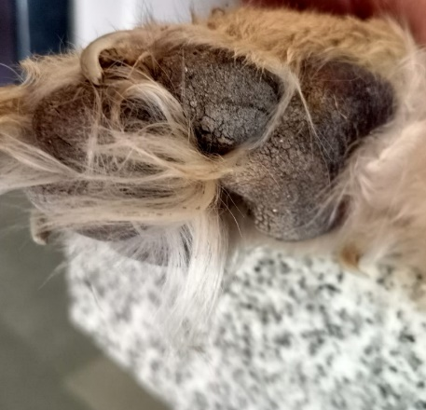
Fig. 5 Ocular discharge & Conjunctivitis | Fig. 6 Hyperkeratosis of the footpad

Graph 1: Nervous signs of canine distemper virus-infected dogs

Graph 2: Ocular signs of CDV-infected dogs (n=15)

Graph 3: Respiratory signs of CDV-positive dogs

Graph 4: Gastrointestinal form of CDV-positive dogs

Graph 5: Cutaneous signs of CDV-positive dogs
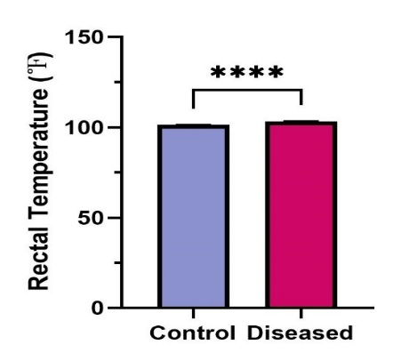a | 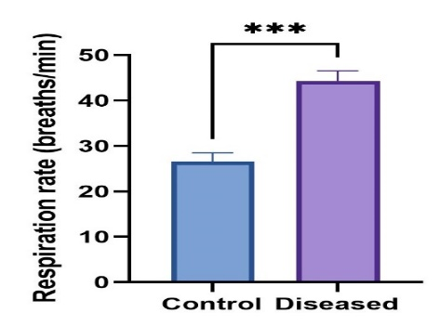b
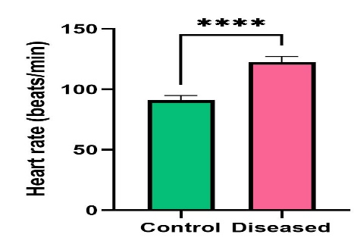c | 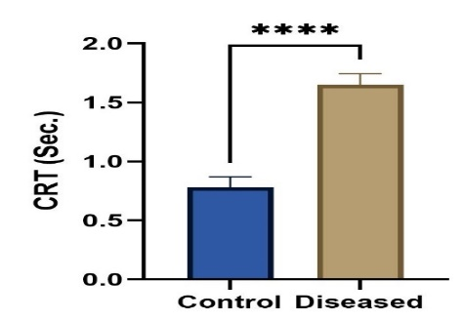d

Graph 6: (a) RT, (b) RR, (c) HR, (d) CRT: *** and **** indicate significance at (P<0.001) and (P<0.0001), respectively
DISCUSSION
Canine distemper virus (CDV) continues to be one of the most important infectious diseases of dogs, owing to its high morbidity, mortality, and its ability to affect multiple organ systems. The findings of the present study strongly reaffirm the multisystemic and pantropic nature of CDV infection. Among the 35 PCR-confirmed cases, the nervous form was the most frequently observed presentation (91.43%), followed by respiratory (71.43%), gastrointestinal (45.71%), ocular/cutaneous (42.86%), and mixed systemic involvement in 94.29% of dogs. This predominance of neurological involvement agrees with earlier reports noting that neurological signs are most consistent in the later course of disease when viral replication progresses to the CNS (Agnihotri et al., 2017; Amude et al., 2018). Seizures were the most common neurological manifestation (81.25%), followed by myoclonus, temporal twitching, chewing-gum fits, ataxia, and paresis—findings similar to Buragohain et al. (2017) and Shabbir et al. (2010), who reported encephalitis as a primary cause of neurological dysfunction in chronic CDV cases.
Respiratory involvement was observed in 71.43% of infected dogs, with mucopurulent nasal discharge and coughing being the predominant signs. Similar observations were documented by Galán et al. (2014), who reported nasal discharge and fever as major findings in naturally infected dogs. Respiratory distress results from viral replication in the respiratory epithelium, followed by secondary bacterial infections and immune suppression. Gastrointestinal signs, including vomiting, diarrhea, anorexia, and inappetence, were recorded in 45.71% of cases, which agrees with Budaszewski et al. (2014), Buragohain et al. (2017), and Shurbe (2019), who confirmed frequent gastrointestinal involvement during viremia and systemic spread.
The ocular form was noted in 42.86% of cases, with mucopurulent ocular discharge being the most common manifestation (66.67%). This finding is comparable to Saaed & Al-Obaidi (2021), who recorded oculo-nasal discharge in 55.55% of cases, and to Sarchahi et al. (2022), who reported ocular discharge in 45% of affected dogs. Conjunctivitis, serous discharge, and keratitis were also reported in earlier literature as secondary complications of CDV-related immunosuppression (Shabbir et al., 2010).
A statistically significant difference (P<0.0001) was observed in rectal temperature, respiration rate, heart rate, and capillary refill time between healthy dogs and CDV-positive dogs. The mean rectal temperature of diseased dogs (103.3 ± 0.23°F) was higher than that of healthy controls (101.29 ± 0.32°F), supporting earlier reports by Behera et al. (2014), Lal et al. (2010), and Yama et al. (2020), who noted fever in 70–80% of infected dogs. Fever is associated with viral replication in the lymphoid organs during the early viraemic phase (Carvalho et al., 2012). Respiratory rate showed a marked increase in CDV-positive dogs, confirming reports that CDV interferes with pulmonary function via viral pneumonitis and immune-mediated inflammation.
The significant elevation in heart rate of infected dogs (122.74 ± 4.48 beats/min) compared with healthy controls (91.10 ± 3.90 beats/min) may be attributed to fever, pain, respiratory distress, and systemic inflammation. Similar findings were documented by Agnihotri et al. (2017), indicating cardiovascular stress due to viral pathogenesis. Capillary refill time was also significantly delayed (P<0.0001) in affected dogs, suggesting compromised perfusion possibly due to dehydration, circulatory shock, or endothelial damage. CRT, therefore, serves as a useful clinical indicator during field diagnosis in suspected CDV outbreaks.
The high frequency of mixed-form presentation (94.29%) in the present study emphasizes that CDV infection rarely manifests as a single-system disease. Instead, it progresses as a systemic viral pathology with simultaneous respiratory, gastrointestinal, and neurological involvement—consistent with the classical description of CDV as a pantropic virus (Behera et al., 2014).
Conclusion
The findings of this study highlight that canine distemper continues to present with diverse clinical manifestations, with neurological and respiratory involvement being most dominant. Vital clinical parameters such as rectal temperature, heart rate, respiratory rate, and CRT are significantly altered in CDV-positive dogs and serve as valuable diagnostic indicators in conjunction with laboratory confirmation. The study further supports existing literature that CDV spreads rapidly and affects multiple systems, making early clinical recognition and timely diagnostic screening essential. The high rate of mixed clinical forms also reinforces the need for veterinarians to adopt a holistic diagnostic approach rather than a system-specific assessment. Overall, the study contributes to a better understanding of the clinical and physiological alterations associated with CDV infection and emphasizes the importance of early intervention to improve prognosis in affected dogs.
REFERENCES
Agnihotri, D., Singh, Y., Maan, S., Jain, V. K., Kumar, A., Sindhu, N., Jhamb, R., Goel, P., & Kumar, A. (2017). Molecular detection and clinico-haematological study of viral gastroenteritis in dogs. Haryana Veterinarian, 56(1), 72–76.
Amude, A., Alfieri, A., & Alfieri, A. (2018). The nervous form of canine distemper. Veterinária e Zootecnia, 13(2), 125–136.
Appel, M. J., Reggiardo, C., Summers, B. A., Pearce-Kelling, S., Maré, C. J., Noon, T. H., Reed, R. E., Shively, J. N., & Orvell, C. (1991). Canine distemper virus infection and encephalitis in javelinas (collared peccaries). Archives of Virology, 119, 147–152.
Behera, S. K., Bordoloi, G., & Behera, P. (2014). Clinico-hemato-biochemical and therapeutic study of canine distemper: A report from north-eastern part of India. Indian Journal of Field Veterinarian, 9(3), 18–20.
Belsare, A. V., Vanak, A. T., & Gompper, M. E. (2014). Epidemiology of viral pathogens of free-ranging dogs and Indian foxes in a human-dominated landscape in central India. Transboundary and Emerging Diseases, 61, 78–86.
Budaszewski, R. F., Pinto, L. D., Weber, M. N., Caldart, E. T., Alves, C. D. B. T., Martella, V., & Canal, C. W. (2014). Genotyping of canine distemper virus strains circulating in Brazil from 2008 to 2012. Veterinary Microbiology, 168(1), 108–113.
Buragohain, M., Goswami, S., & Kalita, D. (2017). Clinicopathological findings of canine distemper virus infection in dogs. Journal of Entomology and Zoology Studies, 5, 1817–1819.
Carvalho, O. V., Botelho, C. V., Ferreira, C. G. T., Scherer, P. O., Soares-Martins, J. A. P., Almeida, M. R., & Silva Júnior, A. (2012). Immunopathogenic and neurological mechanisms of canine distemper virus. Advances in Virology, 2012, Article 163860.
Chludzinski, E., Ciurkiewicz, M., Stoff, M., Klemens, J., Krüger, J., Shin, D. L., ... & Beineke, A. (2023). Canine distemper virus alters defense responses in an ex vivo model of pulmonary infection. Viruses, 15(4), 834.
Duque-Valencia, J., Sarute, N., Olarte-Castillo, X. A., & Ruíz-Sáenz, J. (2019). Evolution and interspecies transmission of canine distemper virus—An outlook of the diverse evolutionary landscapes of a multi-host virus. Viruses, 11(7), 582.
Evermann, J. F., & Kennedy, M. A. (2010). Viral infections. In Small Animal Pediatrics (p. 119).
Galán, A., Gamito, A., Carletti, B. E., Guisado, A., de las Mulas, J. M., Pérez, J., & Martín, E. M. (2014). Uncommon acute neurologic presentation of canine distemper in 4 adult dogs. The Canadian Veterinary Journal, 55(4), 373–378.
Lal, R., Sharma, A. K., & Singh, G. (2010). Canine distemper: A review. Indian Journal of Veterinary Medicine, 30(1), 1–4.
Loots, A. K., Mitchell, E., Dalton, D. L., Kotzé, A., & Venter, E. H. (2017). Advances in canine distemper virus pathogenesis research: A wildlife perspective. Journal of General Virology, 98(3), 311–321.
Manandhar, P., Napit, R., Pradhan, S. M., Rajbhandari, P. G., Moravek, J. A., Joshi, P. R., Shrestha, R. D., & Karmacharya, D. (2023). Phylogenetic characterization of canine distemper virus from stray dogs in Kathmandu Valley. Virology Journal, 20(1), 117.
Mühlebach, M. D., Mateo, M., Sinn, P. L., Prüfer, S., Uhlig, K. M., Leonard, V. H. J., & Cattaneo, R. (2011). Adherens junction protein nectin-4 is the epithelial receptor for measles virus. Nature, 480(7378), 530–533.
Saaed, M. M., & Al-Obaidi, Q. T. (2021). Clinical, hematological, and some biochemical changes in dogs infected with canine distemper. Journal of Agriculture and Veterinary Science, 14(5), 26–33.
Sarchahi, A. A., Arbabi, M., & Mohebalian, H. (2022). Detection of canine distemper virus in cerebrospinal fluid, whole blood, and mucosal specimens of dogs with distemper using RT-PCR and immunochromatographic assays. Veterinary Medicine and Science, 8(4), 1390–1399.
Shurbe, M. U. (2019). Isolation and characterization of canine distemper virus from clinical domestic dogs in Addis Ababa pet clinics, Ethiopia (pp. 1–17) [Preprint]. In Review.
Uddin, M. M., Talukder, H., Islam, O., Asaduzzaman, M., Das, M., Ahsan, M. I., & Islam, S. (2021). Magnitudes of diseases in dogs vary among different levels of age, gender, breed, and season: A hospital-based, retrospective cross-sectional study. Heliyon, 7(11), e08287.
Vila Nova, B., Cunha, E., Sepúlveda, N., Oliveira, M., São Braz, B., Tavares, L., Almeida, V., & Gil, S. (2018). Evaluation of the humoral immune response induced by vaccination for canine distemper and parvovirus: A pilot study. BMC Veterinary Research, 14(1), 1–8.
Wilkes, R. P. (2022). Canine distemper virus in endangered species: Species jump, clinical variations, and vaccination. Pathogens, 12(1), 57.
Yama, T., Rajesh, J. B., Prasad, H., Rajkhowa, T. K., Sarma, K., Roychoudhury, P., Deka, D., & Behera, S. K. (2020). Scholarly view of canine distemper cases in Mizoram. International Journal of Current Microbiology and Applied Sciences, 9(9), 3260–3266.

