Prevalence and phenotypic characterization of extended-spectrum β- lactamase (ESBL)-producing uropathogenic Enterobacteriaceae isolated at the Fann University Hospital

Abstract
Introduction: Urinary tract infections caused by extended-spectrum β-lactamase-producing Enterobacteriaceae (ESBL-producing Enterobacteriaceae) are a public health problem in Senegal. This study aims to determine the prevalence and resistance profiles of ESBL-producing Enterobacteriaceae isolated at the Fann University Hospital Center.
Methods: This is a retrospective study of urine samples analyzed at the bacteriology laboratory of the Fann University Hospital Center. Bacterial identification and antibiograms were performed according to CA-SFM/EUCAST recommendations.
Results: Of all the enterobacteria isolated from 20% of urine samples, 32% were ESBL-producing. ESBL-producing E. coli were mainly isolated from outpatients (71%) and elderly subjects (≥ 60 years: 44%). The main co-resistances concerned gentamicin (66%), cotrimoxazole (88%), and fluoroquinolones (75%). Good sensitivity to imipenem (80%) and chloramphenicol (80%) was observed.
Conclusion: These results confirm the high community prevalence of ESBL-producing E. coli in Dakar and the threat of multidrug resistance. The continued sensitivity to carbapenems should encourage ongoing surveillance and prudent use of antibiotics in Senegal.
Keywords: Enterobacteriaceae, Phenotypic, ESBL, CHNU Fann

INTRODUCTION
Urinary tract infections (UTIs) are one of the most common reasons for consultation and hospitalization, both in hospitals and outpatient settings [1].
Among the bacterial agents responsible, Enterobacteriaceae are predominant, both in the community and in hospitals [2].
Gram-negative bacilli are responsible for the majority of urinary tract infections, with Escherichia coli isolated in 45 to 75% of cases, followed by Klebsiella pneumoniae, Proteus mirabilis, Staphylococcus saprophyticus, and Pseudomonas aeruginosa [2,3].
A study conducted in Dakar showed that E. coli and K. pneumoniae accounted for approximately 89% of enterobacteria isolated from pathological urine samples [4].
In recent years, selective pressure linked to the widespread use of antibiotics has led to a worrying increase in multi-resistant uropathogenic strains, particularly extended-spectrum β- lactamase (ESBL)-producing enterobacteria, which are responsible for numerous treatment failures [2,3].
The rise of these ESBL-producing enterobacteria now represents a real public health challenge, compromising the efficacy of third-generation cephalosporins and limiting treatment options [4].
In West Africa, the prevalence of ESBL-producing Enterobacteriaceae (EBLSE) remains high, estimated at around 28% according to a regional meta-analysis [5].
In Senegal, hospital studies conducted in Dakar have reported ESBL-E isolation rates of 26% to 42% depending on the period and facility [2].
For example, a study conducted at the Fann University Hospital Center between January and June 2018 found a rate of 41.8% of ESBL-producing Enterobacteriaceae among uropathogenic Enterobacteriaceae [4].
Another study (2012–2014) conducted in the same institution reported 30.2% of E. coli strains and 58.2% of K. pneumoniae strains producing ESBL [2].
In light of this growing threat, it is essential to have up-to-date local data on microbiological profiles and antibiotic susceptibility. Antibiotic therapy must be guided by regular monitoring of bacterial resistance in order to optimize treatment, prevent complications, and limit the spread of resistant strains [2].
It is therefore crucial to phenotypically characterize these uropathogenic strains isolated in Senegal. Indeed, ESBL-producing uropathogenic enterobacteria are frequently associated with co-resistance (quinolones, aminoglycosides, sulfonamides) and represent an increased risk of treatment failure, longer hospital stays, and economic burden [4].
In this context, the objective of this study is to determine the prevalence of ESBL-producing uropathogenic enterobacteria isolated at the Fann University Hospital Center and to characterize them phenotypically in order to guide the strategy for combating bacterial resistance in Senegal.

METHODOLOGY

This was a prospective, descriptive study aimed at phenotypically characterizing extended- spectrum beta-lactamase-producing Enterobacteriaceae isolated from urine samples in hospitalized patients or outpatients during the period from 2021 to 2022.
This study was conducted at the Fann National University Hospital Center (CHNU) in Dakar, Senegal. The Bacteriology-Virology Laboratory at the Fann CHNU served as the main site for bacteriological analysis.

Culture and identification
All urine samples sent to the laboratory were included in our study. These were urine samples collected in sterile containers and quickly sent to the laboratory. The urine samples were analyzed using the calibrated loop method (seeding on Cystine Lactose Electrolyte Deficient (CLED) medium after dilution to 1/100). The identification of bacteria was based on the determination of morphological, cultural, and biochemical characteristics.

Antibiotic susceptibility testing
The antibiogram was performed using the agar diffusion technique (Kirby Bauer), which consists of swabbing a bacterial suspension of 0.5 MacFarland onto Muller Hinton medium and placing antibiotic discs on it using a disc dispenser. After incubation in an incubator for 18-24 hours, the diameter of the inhibition zones was measured using a caliper and interpreted according to the recommendations of the Antibiogram Committee of the French Society of Microbiology CA-SFM (2020).
Several antibiotic molecules were tested:
tetracycline (30 µg), nitrofurantoin (300 µg), erythromycin (15 µg), chloramphenicol (30 µg), gentamicin (10 µg), ciprofloxacin (5 µg), cephalothin (30 µg), doxycycline (30 µg), 30 µg), cotrimoxazole (25 µg), ceftriaxone (30 µg) and amoxycillin (10 µg).
ESBL testing was performed using the synergy test between an amoxicillin + clavulanic acid combination disc and one of the third-generation cephalosporin discs (cefotaxime 30 µg or ceftazidime 30 µg or ceftazidime 30 µg) located on either side at a distance of 20-30 mm (center to center) from the AMC disc combination. The presence of extended-spectrum beta-lactamase production is characterized by a "champagne cork" image. Other families of antibiotics were used to investigate the co-resistance of ESBL-producing Enterobacteriaceae.

Data entry and analysis
For each sample, information on sociodemographic characteristics, inpatient or outpatient status, clinical departments, culture results, and antibiotic susceptibility tests was entered into an Excel spreadsheet.
Data analysis was performed in Excel using pivot tables and visualizations. Statistical tests were also performed in Excel, including the Chi-square test, to assess the significance of the differences observed.

RESULTS

Sampling:
During the study, 2,852 urine samples were collected from patients who came for consultation or were hospitalized in the study facility.

Distribution of the population by gender
The majority of samples came from men (55%), with a sex ratio of 1.21 in favor of males(Fig.1).

  - Distribution of the population by age group
The distribution of patients by age group shows that the most represented population was that of subjects aged 60 and over, with 1,246 samples (44%). Children aged 0 to 14 accounted for 9% of the samples (Tab.I).
  - Distribution of the population by origin
In terms of the origin of the samples, the majority came from outpatients, with 2,244 urine samples, or 78.7%, while 608 samples (21.3%) were from inpatients (Fig.2)

- Frequency of uropathogenic enterobacteria
Of all the samples analyzed, 572 tested positive for at least one enterobacterial species, representing a prevalence of 20% (Fig.3).

- Prevalence of uropathogenic ESBL-producing bacteria
The study of the sensitivity of enterobacteria to antibiotics showed a prevalence of 32% of ESBL-producing E. coli with a p-value of less than 0.05 (Fig.4).

  - Distribution of ESBL-producing bacteria according to origin
The distribution of ESBL-producing bacteria according to the origin of the samples shows that 176 isolates (71%) came from outpatients. These results reflect the overall distribution of samples, 79% of which were of external origin, and show community spread of ESBL- producing bacteria (Tab. II).
  - Distribution of EBLSE according to clinical departments
The majority of EBLSE are found in infectious and tropical disease departments and neurology departments, with 10% in each department (Tab.III).
  - Co-resistance of EBLSE with other antibiotics
The study of the behavior of ESBLs to other families of antibiotics tested reveals high rates of resistance, namely 88% for tetracycline, 86% for sulfamethoxazole-trimethoprim, 81% for nalidixic acid, and over 70% for ciprofloxacin. As for aminoglycosides, we noted a resistance rate of 66% for gentamicin.
However, good sensitivity was noted with imipenem and chloramphenicol at rates of 17% and 15%, respectively (Tab. IV).
DISCUSSION
In this study conducted at Fann University Hospital, we described the epidemiological characteristics and resistance of uropathogenic enterobacteria, with a particular focus on the prevalence of extended-spectrum β-lactamase (ESBL)-producing strains.

Epidemiological profile of patients
Our results show that the majority of urine samples came from men (55%). This observation differs slightly from the trend usually reported in the literature, where urinary tract infections are more common in women due to anatomical features that favor ascending contamination [6]. However, several hospital studies have observed a male predominance among elderly patients or those with urinary catheters, which could explain our findings [7].
The age distribution reveals a high proportion of elderly subjects (≥ 60 years: 44%), confirming that aging is a major risk factor for urinary tract infection. This result is consistent with those obtained by Der and Niang in Dakar, who showed a high average age among patients with urinary tract infections [8]. Similar trends have been reported in Saint-Louis by LO and al. [9] and in Cameroun by Signing A and al. [10] confirming that age is a major determinant of ESBL-producing E. coli infections.
As for the origin of the patients, the majority of samples (79%) came from outpatients, suggesting significant community spread. This trend has also been observed in Senegal, where several studies have shown an increasing circulation of ESBL-producing Escherichia coli in the community [6].

Frequency of enterobacteria of ESBL-producing
Enterobacteria accounted for 20% of isolates, 32% of which produced ESBL. This rate is consistent with data reported in Senegal and West Africa. Indeed, Der M et al. reported a frequency of 41.8% of ESBL-producing E. coli among uropathogenic strains isolated at the Fann University Hospital [8], while Dia and al. observed 30,17% of E. coli and 58,23% of K. pneumoniae producing respectively EBSL.[6;11]. These rates reflect the high endemicity of ESBL-producing E. coli in urinary tract infections in Senegal.
Several factors may explain this situation:
- the frequent use of third-generation cephalosporins,
- the lack of systematic screening for ESBL-producing bacteria,
- and sometimes inadequate hygiene measures that promote dissemination [12].
The majority of isolates came from outpatients (71%), illustrating the growing community spread of these strains, a phenomenon already reported by Ndir and al. [7]. This community emergence is probably linked to the uncontrolled use of antibiotics and the human-to-human spread of CTX-M-15-producing E. coli clones, the most frequently reported ESBL in Senegal and West Africa [13].
The clinical departments most affected were the SMIT and Neurology (10% each), but 70% of cases came from other external structures, confirming the extra-hospital circulation of resistant strains [2]. In a Senegalese hospital study, infections due to ESBL-producing E. coli significantly increased length of stay and mortality.

Co-resistance profiles
The ESBLs in our study showed high levels of resistance: 88% to cotrimoxazole, 75% to fluoroquinolones, and 66% to gentamicin. These results are consistent with those reported in a study conducted on E.coli ESBL where resistance rates to fluoroquinolones and cotrimoxazole reahed 82 % and 76 %, respectively [4].
African studies .also documented these co- resistances, highlighting the circulation of multidrug-resistant plasmids carrying bla CTX-M, qnr, sul, and aac(6')-Ib genes [14].
On the other hand, the preserved sensitivity to imipenem (78%) is encouraging and consistent with the results of SENE NN, and al. [4] in Dakar and by study from Camara M. and al. [15] suggesting that carbapenems are still effective in our context. Hence the need for particular attention to their prudent use in severe ESBL-E. infections.

Limitations of the study
Our study has a few limitations:
- Our study is single-center and limited to the Fann University Hospital; the results cannot necessarily be extrapolated to the whole of Senegal.
- The phenotypic approach alone does not allow for the identification of resistance genes or molecular typing, which limits our understanding of the mechanisms of dissemination.
- Finally, not all clinical data (outcome, mortality, comorbidities) associated with ESBL-producing strains were collected, which limits the interpretation of the clinical impact.

Perspectives
To go further, it would be useful to:
- Perform molecular characterization of ESBL genes in uropathogenic strains in order to compare with data from other sectors in Senegal.
- Evaluate the clinical outcome (treatment duration, failure, recurrence, cost) of uropathogenic ESBL-producing infections.
- Extend the study to other healthcare facilities to obtain a national overview of the situation.

Conclusion
This study highlights a high prevalence (32%) of extended-spectrum β-lactamase-producing Enterobacteriaceae in urinary tract infections at the Fann University Hospital Center. The high proportion of affected outpatients (71%) demonstrates the community spread of resistant strains. The rates of co-resistance to fluoroquinolones, gentamicin, and cotrimoxazole limit the current treatment options, although imipenem and chloramphenicol keeping notable effisciency. These results confirm the need for a rational antibiotic use policy and continuous surveillance at the hospital and community levels.

REFERENCES
- BENHIBA, T. BOUZEKRAOUI, J. ZAHIDI, E. NOUREDDINE, L. AIT SAID, K. WARDA, K. ZAHLANE. Epidemiology and antibiotic resistance of urinary tract infections causedby Ente robacteriaceae in adults at the Marrakech University Hospital and therapeutic implications. Uro- Andro, 2015, 1(4):1–6. https://revue-uroandro.org/index.php/uro-andro/article/view/31/24
- Niang AA, Ka R , Sarr H, Diop A, Dièye B, Ba-Diallo A, Diallo F, Lo S, Ka M, Diagne R, Dia ML, Cissé MF, Sow AI Phenotypic characterization of uropathogenic bacteria isolated at the Fann University Hospital in Dakar. Uro-Andro, 2020, 2(2) : 1–6. https://revue-uroandro.org/index.php/uro-andro/article/download/331/132/697
- Hamza S., Auwal U., Abdulhadi S.k. Antibiotic susceptibility pattern of uropathogens from some selected hospitals in Kano-Nigeria. Journal of Microbiology & Experimentation, 2019; 6(2) :1–7. https://medcraveonline.com/JMEN/JMEN-06-00202.pdf
- Sene NN, Niang AA, Der M, et al. Prevalence and antibiotic susceptibility profile of ESBL-producing Enterobacteriaceae isolated from urine at the Fann University Hospital Center, Dakar. Uro-Andro, 2018, 2(2) : 1–6. https://doi.org/10.52589/AJBMR-ZHACEWRG
- Bertholom C. Epidemiology of community-acquired and nosocomial urinary tract infections. Option/Bio. 2016;27(541-542) :23-24. https://www.scirp.org/reference/referencespapers?referenceid=3406782
- Dia ML, Chabouny H, Diagne R, Kâ R, Ba-DiaLLo A., Lô S, Gassama B., CiSSé MF, Sow AI.
Profil antibiotypique des bactéries uropathogènes isolées au CHU de Dakar antibiotic susceptibility Pattern of uroPathogenic bacterial isolates in a dakar senegalese teaching hosPital. Rev Uro-Andro. 2015;1(2):22-28
https://revue-uroandro.org/index.php/uro-andro/article/view/43/34
- Ndir A, Diop A, Ka R, et al. Infections caused by ESBL-producing Enterobacteriaceae in Dakar. Antimicrob Resist Infect Control. 2016;5:13
https://aricjournal.biomedcentral.com/articles/10.1186/s13756-016-0114-7
- Der M, Niang AA. Prevalence and resistance profile of ESBL-producing Enterobacteriaceae in Dakar. Afr J Biol Med Res. 2018;4(2) :101-107.
https://doi.org/10.52589/AJBMR-Z1G94ONP
- Seynabou L. , Awa B. D. , Oumarou F. D. , Moustapha M. , Makhtar C. , Mamadou D. , Rokhaya D. , Mamadou L. D. , Gérard C. D. , Roughyatou K. , Thérèse D. , Babacar F. and Ahmad I. Profile of bacterial and parasitic urinary infections in Saint Louis Senegal between 2000 and 2010 S. Bull Soc Pathol Exot. 2019;112(4):221-228
https://doi.org/10.5897/AJMR2015.7838
- Signing A, Marbou W, Penlap Beng V, et al. (July 22, 2020) Antibiotic Resistance Profile of Uropathogenic Bacteria in Diabetic Patients at the Bafoussam Regional Hospital, West Cameroon Region. Cureus 12(7): e9345. DOI 10.7759/cureus.9345
https://pdfs.semanticscholar.org/805b/83cc78b1c37dedd6522679df2936b6d79c09.pdf
- Sarr H , Diop A , Diallo F, Niang AA, Dieye B, Diagne R , Lo S , Ka R , Dia ML and Sow AI.
Prevalence of Extended-Spectrum Beta-Lactamase Enterobacteriaceae and Resistance To Imipenem In Chnu / Fann Bacteriology And Virology Laboratory – Dakar ; Dakar Med. 2021;66(1)
https://rivieresdusud.uasz.sn/bitstream/handle/123456789/1527/sarr_article_2021.pdf?sequence=1&isAllowed=y
- Ouedraogo AS, Jean Pierre H, Banuls AL, Ouedraogo R, Godreuil S. Emergence et diffusion de la resistance aux antibiotiques en Afrique de l’Ouest : facteurs favorisants et evaluation de la menace. Med Sante Trop 2017 ; 27 : 147-154. doi : 10.1684/mst.2017.0678147
- Cissé A, Sambe BB, Sow AI. Community circulation of bla<sub>CTX-M</sub> resistance genes in Senegal. Afr J Microbiol Res. 2019;13(9):210-217.
https://doi.org/10.3390/microorganisms12112357
- Ruppé E, Woerther PL, Diop A, Sene AM, Da Costa A, Arlet G, Andremont A, Rouveix B. Carriage of CTX-M-15-producing Escherichia coli isolates among children living in a remote village in Senegal. Antimicrob Agents Chemother. 2009 Jul;53(7):3135-7. doi: 10.1128/AAC.00139-09. Epub 2009 Apr 13. PMID: 19364858; PMCID: PMC2704652.
- Camara M, Mane MT., Diallo AB., Dieng A,Ndiaye HD, Karam F., Lo S., Diagne-Samb H, Ngom-Cisse S., Toure-Kane C., Gaye-Diallo A., Mboup S. and Boye CSB. pp. 1600-1605, 28 November, 2017
https://doi.org/10.5897/AJMR2017.8716

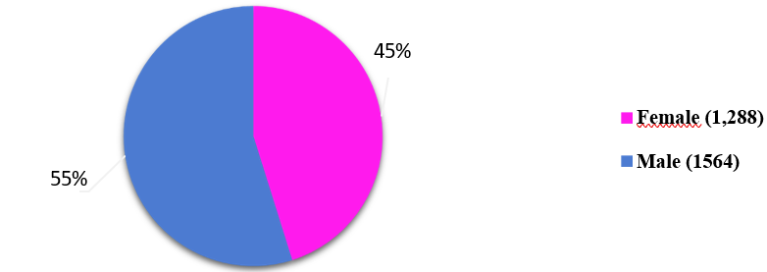

Figure 1: Population distribution by gender

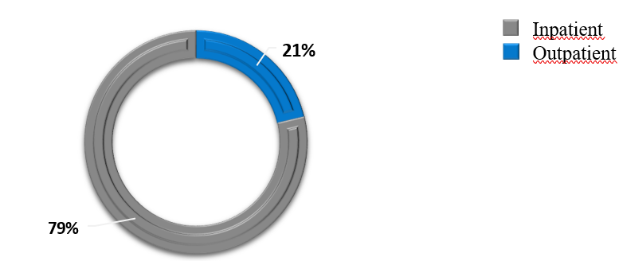
Figure 2: Distribution of the population by origin

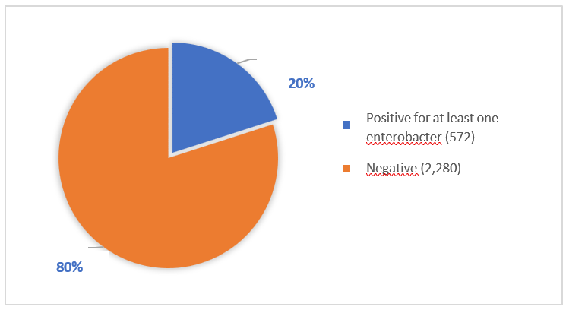
Figure 3: Frequency of uropathogenic enterobacteria

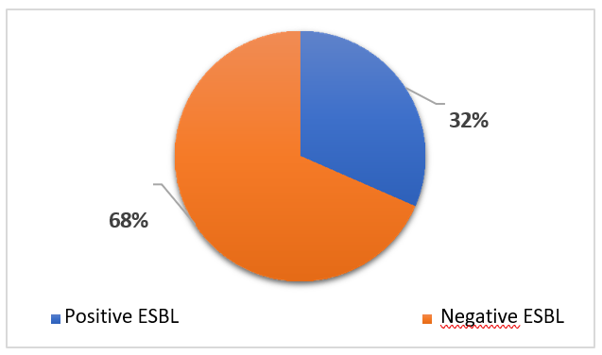
Figure 4: Prevalence of uropathogenic ESBL-producing bacteria

Figure 5 : Co-resistance of ESBL producing E.coli to other antibiotics

Figure 6 : Co-resistance of ESBL producing Klebsiella pneumoniae to other antibiotics

Figure 7 : Co-resistance of Enterobacter spp to other antiobiotics

Table I: Distribution of the population by age group
 | Age group | Number |  | Percentage
 | 0–14 | 258 |  | 9
 | 15–29 | 592 |  | 21
30–44 |  |  | 461 |  | 16
45–59 |  |  | 295 |  | 10
≥ 60 years old |  |  | 1,246 |  | 44
Total |  |  | 2852 |  | 100

Table II: Distribution of ESBL-producing bacteria according to origin
Origin | ESBL (n) | % of EBLSE | Total samples | % of total
Inpatient | 71 | 29% | 608 | 21%
Outpatient | 176 | 71% | 2244 | 79%
Total | 247 | 100% | 2852 | 100%

Table III: Distribution of EBLSE by clinical departments
Services | Nombre d’EBLSE | Pourcentage (%)
NRCH | 6 | 2%
SMIT | 24 | 10%
CTCV | 5 | 2%
NEURO | 24 | 10%
GERIATRICS | 9 | 4%
PNEUMO | 5 | 2%
CRCF | 0 | 0%
INTERNAL MED | 0 | 0%
PNEUNO | 0 | 0%
ORL | 0 | 0%
PSYCHIATRY | 0 | 0%
PNEUMOLOGY | 0 | 0%
Autres | 174 | 70%
Total | 247 | 100%

Table IV: Co-resistance of ESBL-producing E. coli to other antibiotics

Antibiotics tested | % resistance among  ESBL-producing bacteria
IMP | 17
GMN | 66
CHL | 15%
SXT | 86
TET | 88
CIP | 75
NAL | 81
IMP :Imipenem ; GMN :Gentamycin ; CHL : Chloramphenicol ; SXT : Sulfamethoxaol- Trimethoprim ; TET : Tetracyclin ; CIP : Ciprofloxacin ; NAL : Nalidixic acid.

