Short Research Article

Risk of Staphylococcus aureus Food Poisoning Associated with Pork Barbecues in Daloa, Côte d’Ivoire

.
ABSTRACT

Background: In Daloa, Côte d’Ivoire, the sale of pork barbecues has increased markedly over the past five years. The production and sale chain for these barbecues involves multiple handling steps that can introduce critical contamination points. Pork and personnel participating in preparation and sale represent potential reservoirs of microorganisms, including Staphylococcus aureus originating from skin and oral microbiota.
Aims: To evaluate the risk of S. aureus foodborne poisoning associated with pork barbecues sold in Daloa.
Methodology: A cross-sectional survey was carried out in five Daloa neighborhoods with a high density of food outlets. Five pork barbecue vendors were selected and 150 consumers frequenting these establishments were interviewed to document hygiene practices and estimate population exposure to biological hazards. Twenty pork barbecue samples were collected from vendors and analysed using culture-dependent and molecular techniques to detect and enumerate Staphylococcus species.
Results: The population of Daloa demonstrated a high level of exposure to potential biological hazards from pork barbecues, with over 80% of respondents consuming this product at least once per week. Observations revealed inconsistent personal protective clothing and inadequate meat protection among the surveyed barbecue vendors. Microbiological analysis of the samples showed Staphylococcus spp. counts ranging from 6.10² CFU/g to 3.3.10³ CFU/g, values below the established normative threshold and therefore indicative of acceptable microbiological quality. Staphylococcus aureus was not detected in any of the analysed samples.
Conclusion: Pork barbecue samples analysed in this study did not contain S. aureus. Despite microbiological results within acceptable limits, deficiencies in vendors’ hygiene practices warrant reinforced implementation of good hygiene and food-safety practices to reduce contamination risks further.

Keywords: Risk; pork barbecue; antibiotic; Staphylococcus aureus; hygiene practices
1. INTRODUCTION

Street food refers to the preparation and sale of food in streets or public spaces by mobile vendors or those installed at stalls, kiosks, carts, or food trucks (Tidjani et al., 2020). It has increased in recent years in Côte d’Ivoire and other sub-Saharan African countries, in response to urban expansion and changing dietary patterns driven by population dynamics. This form of food service, in all its variants (fast food, food courts, traditional dining in enclosed spaces, open air catering, etc.), enables household food provisioning through the purchase of ready to eat meals prepared outside the home. Offerings vary widely and include a diversity of food products ranging from traditional and local dishes (rice, foutou, garba, etc.) to grilled meats and fish (Assouni, 2021; Koffi, 2021).
Grilled meats are prepared by direct contact with a metal grill. In Daloa, a city in central western Côte d’Ivoire, pork ranks among the most frequently consumed foods and outdoor establishments specialising in grilled pork have proliferated over the past five years (Koné et al., 2019). The multi-step preparation of grilled pork creates several potential critical points for microbial contamination. Pork is a principal reservoir of human pathogens, notably Staphylococcus aureus from skin and oral flora, as well as organisms originating from the intestinal microbiota (Sineke et al., 2021). S. aureus is a common cause of foodborne disease and community acquired infections; it produces heat stable enterotoxins that can provoke severe illness and even death in young children, older adults, and immunocompromised persons (Willey et al., 2013; Okafor et al., 2022). During slaughter, pig carcasses are contaminated both by the animal’s endogenous microbiota and by exogenous sources present in the slaughterhouse environment, including water, equipment, contact surfaces, and transport containers (Braley et al., 2022). Likewise, processing pork and preparing grilled products introduce additional opportunities for microbial contamination. A study in Burkina Faso found that pork sold in markets and street restaurants often carried high microbial loads, elevating the risk of foodborne poisoning (Ouattara et al., 2021).
The potential presence of S. aureus in pork constitutes a public health risk. When hygiene and production practices from slaughter through to barbecue preparation are insufficient, pork products such as grilled pork can serve as vehicles for S. aureus transmission. The hypotheses that emerge are indicated as follows. Consumption of pork barbecues prepared and sold in Daloa is associated with a risk of foodborne illness due to contamination by S. aureus. Consumption of pork barbecues prepared and sold in Daloa is not associated with a risk of foodborne illness due to S. aureus. The objective of this study is to protect the health of consumers of pork barbecues prepared and sold in Daloa. Specifically, the objectives were estimating population exposure to S. aureus from consumption of pork barbecues sold in Daloa, evaluating hygiene and manufacturing practices employed from slaughter through barbecue preparation, detecting and quantifying S. aureus in pork barbecue samples collected from representative outdoor and street‑restaurant vendors in Daloa, characterizing antimicrobial resistance profiles of Staphylococcus aureus isolates across major antibiotic classes.

2. material and methods

2.1 Study site

This study evaluating the potential health risks linked to the consumption of pork barbecues in Daloa, a city located in the central-western region of Côte d’Ivoire, was conducted across five selected neighborhoods: Tazibouo Goudron, Tazibouo Pastorale, Acemont, 1st "Rue" Fadiga, and 2nd "Rue" Fadiga (Figure 1).
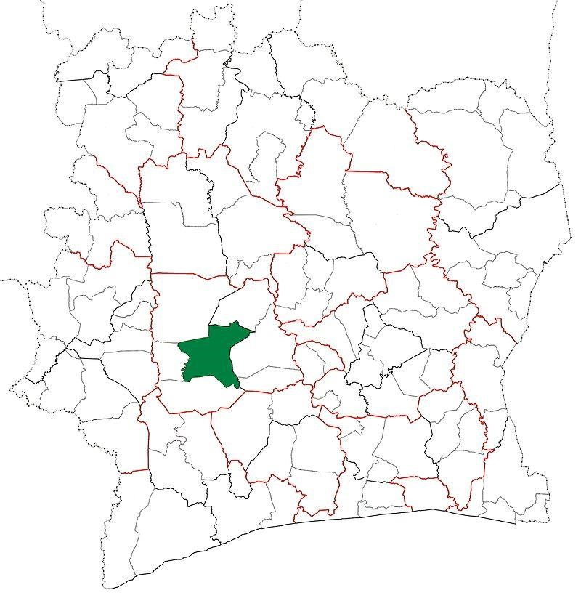
1.a- Daloa department locator map Côte d'Ivoire (Anonymous 1, 2025)

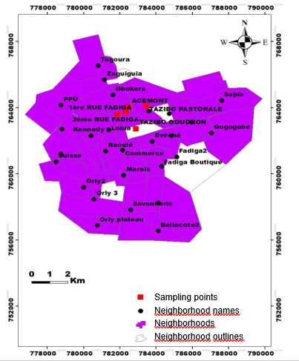

1.b- Map of the city of Daloa (ArcGIS 10.4.1)

Fig 1. Geographic distribution of survey and sampling sites
2.2 Material

The biological material examined in this study comprised barbecued (braised) pork samples obtained from multiple outdoor food stalls in Daloa.

2.3 Methods

2.3.1 Exposure assessment

A preliminary cross‑sectional survey was conducted in January 2025 among five pork barbecue vendors (V1, V2, V3, V4, V5) to quantify population exposure to Staphylococcus aureus from barbecued pork. These vendors (one per selected neighborhoods in the study site) were chosen based on intense outdoor food-service activity and high customer traffic. They were spaced at least 1 km apart and located in the neighbourhoods Tazibouo Pastorale (V1, 783484,733 ; 764100,925), Acemont (V2, 782503,176 ; 764011,303), 2nd "Rue" Fadiga (V3, 782348,831 ; 763720,389), 1st "Rue" Fadiga (V4, 781883,289 ; 763591,083), and Tazibouo Goudron (V5, 782907,163 ; 762712,711). Vendors (n = 5) and a convenience sample of consumers (n = 150) completed a structured questionnaire that collected information on (i) workforce health status and pre‑handling hygiene practices, (ii) pork distribution/transport/packaging and point‑of‑sale procedures, and (iii) frequency of consumption alongside any self‑reported health complaints.

2.3.2 Sampling

Samples were collected over a four‑week period in February 2025 from the five pork barbecue vendors investigated during the study of exposure assessment. One sample (approximately 400 g) was purchased from each vendor once per week, yielding a total of 20 barbecued pork samples. All samples were obtained under normal sales conditions and transported to the laboratory in a cooler with ice packs for microbiological analysis.

2.3.3 Isolation and enumeration of Staphylococcus sp.

Culture media used for analysis, namely buffered peptone water, Baird‑Parker agar supplemented with egg yolk and potassium tellurite, Nutrient agar and Mueller‑Hinton agar were prepared according to the manufacturers' instructions.
The stock suspension was prepared in accordance with the applicable standard methods (ISO 6887-2:2017 and "reglement" (CE) n° 2073/2005). Ten grammes (10 g) of each barbecued pork samples were aseptically mixed in 90 mL of buffered peptone water (Difco, Becton Dickinson, Sparks, MD, USA); the whole were ground and stirred for 30 minutes, then allowed to stand for 15 minutes. Tenfold serial dilutions of stock suspension were prepared, spread on Baird‑Parker agar and incubated at 37°C for 24 hours. Typical colonies of Staphylococcus were black or gray in color surrounded by a clear zone. Suspect colonies, which revealed positive results for the egg-yolk reaction (Saito et al., 2010), were subjected to enumeration and S. aureus identification procedures. Staphylococcus spp. counts from the pork barbecue samples were evaluated against the reference criteria of m = 5 × 10² CFU/g and M = 5 × 10³ CFU/g (Anonymous 2, 2018). Results were classified according to a three-class sampling plan, as recommended by the Codex Alimentarius, and interpreted as satisfactory, acceptable or unsatisfactory based on the relationship of the measured counts to the m and M thresholds (Anonymous 2, 2018).

2.3.3 Identification of Staphylococcus aureus.

Characterization of the staphylococci isolates was carried out on 7 picked-up representative isolates. Presumptive colonies of Staphylococcus isolated from Baird Parker agar with Gram-positive cocci and that were catalase-positive were selected as possibly being S. aureus and identified by PCR for the coagulase gene specific (gene coa) for S. aureus.
DNA extraction from Staphylococcus isolates was performed using the CTAB method (Huang et al 2018). The DNA was amplified for the coagulase gene by using the following primers designed in conserved regions: FORWARD = ATGGGATAACAAAGCAGATG; REVERSE = GGTTCTTCAACTTTCTTCTC (amplicon size = 900 bp). The following PCR program was used: denaturing at 95° for 2 min followed by 30 cycles with a denaturing step at 95°C for 1 min, annealing at 54°C for 1 min and extension at 72°C for 1 min, with a final extension at 72°C for 10 min (Locatelli et al., 2023). The amplification products were subjected to electrophoretic migration on agarose gel at 2% (concentration for products targeting the coagulase gene). Eight microliters (8 µL) of each PCR product were combined with 2 µL of loading buffer in 1.5 mL microcentrifuge tubes, and 10 µL of each resulting mixture were loaded into the wells of the agarose gel using a micropipette. A 100‑bp DNA ladder (3 µL) was loaded into the first well of each gel. Electrophoresis was carried out at 125 V for 45 minutes, and DNA fragments were visualized under UV illumination with a transilluminator (Tasneem et al., 2022)

2.3.4 Antimicrobial susceptibility testing

In accordance with CASFM recommendations for antibiotic sensitivity testing, a 24-hour subculture of each Staphylococcus isolate was prepared on nonselective agar. Colonies were suspended in 0.85% NaCl to a turbidity equivalent to a 0.5 McFarland standard (≈1–2 × 10⁸ CFU·mL⁻¹). Using a sterile swab, the suspension was evenly inoculated onto Mueller–Hinton agar plates to produce a uniform lawn. Within 15 minutes of seeding, antibiotic discs containing ampicillin, amoxicillin–clavulanic acid, chloramphenicol, trimethoprim–sulfamethoxazole and erythromycin were applied to the agar surface. Plates were incubated at 37 °C for 24 hours. Inhibition zones were measured in millimetres and interpreted as susceptible, intermediate or resistant according to CASFM/EUCAST breakpoints (CASFM/EUCAST, 2022).

Table 1. Characteristics of antibiotics
Antibiotic | Sigles | Charges | Critical diameter < (mm) | Critical diameter ≥ (mm)
Chloramphenicol | C30 | 30 µg | < 19 | ≥ 22
Ampicillin | AM30 | 2 µg | < 18 | ≥ 21
Amoxicillin/ clavulanic acid | AMC30 | 20/10 µg | < 14 | ≥ 21
Trimethoprim/ Sulfamethoxazole | SXT25 | 1.25/23.75 µg | < 10 | ≥ 16
Erythromycin | ERY15 | 15 UI | < 17 | ≥ 22

2.3.4 Statistical analysis

Data were collected using Excel 2016 and analysed with Statistica version 7.1. The nonparametric Kruskal–Wallis test, was applied at a significance level of α = 0.05 to compare bacterial loads (Staphylococcus sp.) in pork barbecues between vendors.

3. results

3.1 General characteristics of pork barbecue sales

A survey of pork barbecue outlets found vendors aged 18–40 of both sexes, most with some schooling (60%) and 20% having completed secondary education. Hygiene practices such as hand washing, wearing clean clothing, and maintaining tidy sales areas were observed almost universally. Pork for grilling is packaged openly at the point of sale; about 60% of vendors sell meat within two to three days. Supply comes from farms and unsold portions are kept refrigerated (Table 2).

Table 2. Hygiene characteristics of the pork barbecue sales activity
Observations | Vendors
 | V1  ("Pastorale") | V2 (Acemont) | V3 (2nd "Rue" Fatiga) | V4 (1st "Rue" Fatiga) | V5  ("Goudron")
Personal details
Gender and Age | F ; 18-30 years | F ; 18-30 years | M ; 31-40 years | F ; 18-30 years | F ; 31-40 years
Educational level | Primary | Not schooled | Not schooled | Primary | Secondary
Health and hygiene measures at sales site
Handwashing before service | + | + | + | + | +
Clean clothing | + | + | - | + | +
Cleanliness of sales areas | + | + | + | + | +
Meat packaging
- open-air | - | - | + | + | +
- wrapped in plastic | - | - | - | - | -
- in a glass display case | + | + | - | - | -
Apparently healthy | + | + | + | + | +
Meat supply
Place | Farm | Farm | Farm | Farm | Farm
Meat turnover time | Up to 3 days | 2 days | 1 day | 2 days | 1 day
Storage of unsold meat
- refrigerator | + | + | + | + | +
- cooler | - | - | - | - | -
- smoking | - | - | - | - | -
+ : observed; - : not observed
3.2 Pork barbecue consumption level

Like fish and chicken, pork is consumed by the largest share of respondents (32%) across all surveyed locations. Consumers span different age groups (adolescents, young adults, and older adults). Interest in pork barbecue is strong: 44% eat it twice or more per week, and at least 42% consume pork barbecue once a week (Figure 2).

Fig 2. Weekly frequency of pork barbecue consumption

3.3 Staphylococcus loads in pork barbecue samples

Figure 3 presents Staphylococcus counts from pork barbecue samples collected from five vendors (V1, V2, V3, V4 and V5). Vendor V5 shows the highest load, about 3.3 × 10³ CFU/g, while the other vendors have counts below 1.4 × 10³ CFU/g. Statistically, V5 and V3 do not differ significantly, nor do V1, V2, and V3 differ from one another. According to the applied quality criteria, all samples meet acceptable microbiological standards.

Fig 3. Occurrence level of Staphylococcus in pork barbecues by vendors V1–V5
3.4 Molecular characteristics of Staphylococcus isolates

Genomic DNA extracted from Staphylococcus isolates A, B, C, D, E, F and G cultured from pork barbecue samples had concentrations between 41 and 108 ng/µL. PCR amplification of the 16S rRNA region with universal 16S primers produced ~1500 bp amplicons, while amplification with coa-specific primers produced a ~900 bp product only in the positive control (Figures 4 and 5).
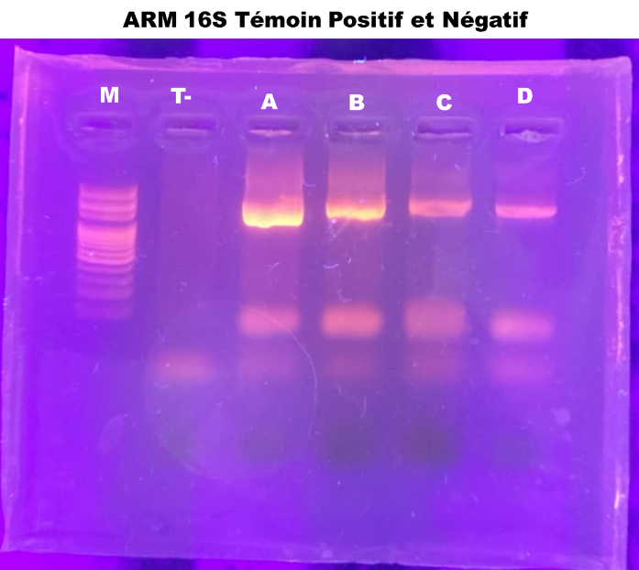
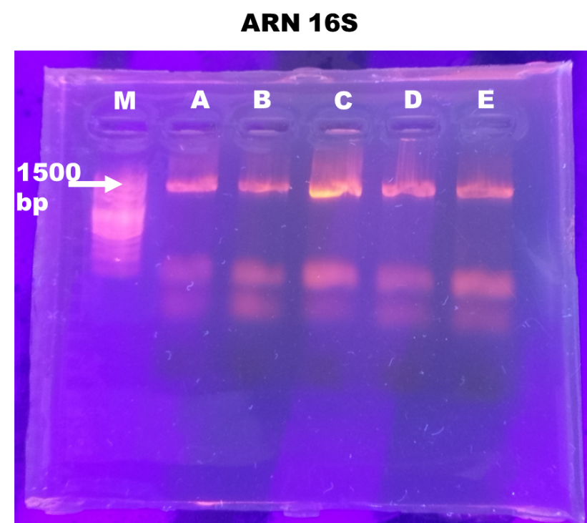
G
F
E
D
C
B
A
T+
T-
M
1500 pb

Fig 4. Photograph of the electrophoresis gel of amplicons obtained with 16S rRNA primers
T+ and T-: Positive and negative controls, M: Size marker
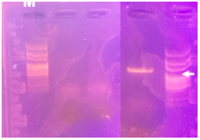
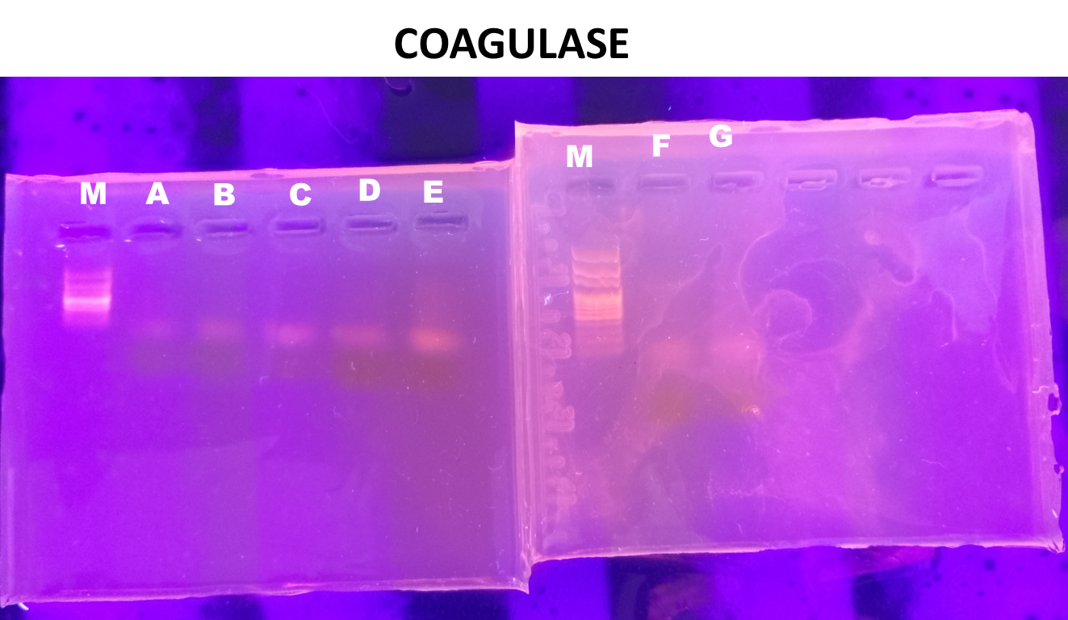
M
T+
G
F
M
900 pb
E
D
C
B
A
M
900 pb

Fig 5. Photograph of the electrophoresis gel of amplicons obtained with coa primers
T+ and T-: Positive and negative controls, M: Size marker

3.5 Distribution of Staphylococcus aureus among vendors

Table 3 presents the distribution of Staphylococcus species across pork barbecue sales outlets. All vendor samples contained bacteria of the Staphylococcus genus, but none of the isolates were identified as Staphylococcus aureus.

Table 3. Distribution of S. aureus
Bacteria | Vendors
 | V1  (Pastoral) | V2 (Acemont) | V3 (2nd "Rue" Fatiga) | V4 (1st "Rue" Fatiga) | V5  ("Goudron")
Staphylococcus sp. | + | + | + | + | +
S. aureus | - | - | - | - | -
+ : presence ; - : absence
3.6 Antibiotic susceptibility of Staphylococcus isolates

The antibiotic responses of Staphylococcus spp. isolated from pork samples are summarized in Figure 6. Sensitivity was uniform for C30 and ERY, which inhibited growth in all tested isolates. Variable resistance was observed across other antibiotics, with AMC30 showing the highest resistance rate at about 70%. Resistance to SXT25 was observed in 15% of isolates and to AM30 in 25% of isolates. Overall, the isolates display differing resistance profiles depending on the antibiotic, with AMC30 exhibiting the greatest level of resistance.

Fig 6. Antibiotic resistance profile of isolates

4. discussion

Grilled pork is widely eaten in Daloa, and its preparation includes multiple steps, some of which present critical control points. Protecting consumer health requires examining how this product is prepared and evaluating the resulting foodborne risk. An assessment of pork barbecue vendors in Daloa showing generally low educational attainment, can hinder understanding and application of basic food-hygiene practices. In the absence of training or awareness campaigns, vendors may not recognize the risks of microbial contamination, particularly from bacteria like Staphylococcus. Previous research in Côte d’Ivoire links limited education among street-food vendors to poorer hygiene practices Tonda et al. (2017). Additionally, the widespread absence of display cases or secure packaging for meat remains a serious concern. In most observed cases, meat left exposed to the open air is vulnerable to contamination from insects, dust, human contact, and temperature fluctuations. Kpan et al. (2019) reported that prolonged exposure to environmental contaminants markedly increases the risk of bacterial proliferation, a particular concern in open-air markets with low hygiene standards. The finding that 32% of respondents consume pork underscores the presence of this food in the eating habits of the population in Daloa. Consumption-frequency data show that at least 80% of surveyed individuals eat barbecued pork once, twice, or more per week, likely owing to low cost, popular taste, and the food’s social and convenient nature. This high consumption rate could be a significant factor in exposing consumers to biological, chemical, and physical hazards linked to barbecued pork (FAO/OMS, 2008). Given that hygiene practices are not consistently observed at farms or points of sale, thorough analysis of the pork barbecue sold to consumers is essential.
Microbiological analysis of pork barbecue samples showed variable Staphylococcus levels across vendors, likely reflecting differences in hygiene practices. The particularly high load from vendor V5 may result from poor meat handling, soiled equipment, or inadequate storage, and may also reflect a sales environment more prone to contamination from dust, flies, or heat. Indeed, Staphylococcus species are transmissible via cutaneous routes, primarily through direct contact with individuals—whether symptomatic or asymptomatic—or indirectly through exposure to fomites and contaminated environmental surfaces (Gweryina et al., 2024). Contamination risk is not uniform among sellers. Some vendors therefore pose a substantially greater threat to consumer health. When Staphylococcus produces enterotoxins, ingestion of the toxin already present in food can lead to severe foodborne illness (Denayer et al., 2017).
Genomic DNA concentrations were evaluated to confirm they were sufficient for reliable PCR amplification. Universal 16S rRNA primers allowed broad bacterial identification by targeting conserved and variable regions of the gene. The absence of amplification for the coa virulence gene, specific to Staphylococcus aureus, is consistent with the likely absence of S. aureus in the samples analyzed. The Staphylococcus isolates were identified molecularly using 16S rRNA and coa primers, which yield expected amplicons of ~1500 bp and ~900 bp respectively. The presence of ~1500 bp bands for isolates A to G confirms they are bacteria. The absence of the ~900 bp coa amplicon in all isolates indicates they are coagulase-negative Staphylococci (CNS), consistent with Locatelli et al. (2023). No Staphylococcus aureus was detected in any pork barbecue sample; instead, CNS were isolated from all vendors. Although generally less virulent than S. aureus, CNS can still be involved in foodborne illness and other infections under certain conditions while S. aureus remains the most well-known species often associated with severe infections such as skin disease, pneumonia, endocarditis, or osteomyelitis (Podkowik et al. 2013; Chajecka-Wierzchowska et al. 2020). Works by Okafor et al. (2022) demonstrate the presence of staphylococci enterotoxin A (SEA) gene in coagulase-negative Staphylococcus spp. isolated from commercially-available fresh snail meat in Nigeria.
The evaluation of the response of SCN isolates A, B, C, D, E, F and G isolated from pork barbecues to antibiotics enabled an antibiogram to be produced for each of the isolates. The resistance of Staphylococcus to amoxicillin-clavulanic acid could be due to the fact that the isolated strains have advanced resistance strategies, such as the production of β-lactamases or other enzymes that neutralise β-lactams. Resistance to amoxicillin alone (AM30) supports this theory and potentially indicates frequent exposure of bacteria to this type of antibiotic, which may be linked to excessive use in pig farming (Elbehiry et al., 2025; Musuka et al., 2025). The WHO (2024) recommends stricter regulation of their use in the agri-food chain. This constant selection pressure promotes the development of resistant strains, posing not only problems for animal health but also risks of transmission to humans through food. Moderate resistance to trimethoprim/sulfamethoxazole (SXT25) is encouraging because this drug, often chosen as an alternative when β-lactams do not work (Willey et al., 2013), retains some efficacy in this context, although its use must remain measured to prevent future increases in resistance. Zero resistance to erythromycin (ERY15) and chloramphenicol (C30) indicates these antibiotics remain highly effective against the isolated strains. Conversely, the high resistance observed to several commonly used antibiotics represents a serious public-health threat. Resistant Staphylococcus present in the food chain can be transmitted to humans, especially through consumption of undercooked meat or meat handled without proper precautions. Staphylococcal enterotoxin A is known to survive cooking temperature (Okafor et al., 2022)

5. Conclusion

The sale of grilled pork is a widespread activity in Daloa. To protect consumer health, this study evaluated the risk of foodborne illness associated with Staphylococcus aureus from consumption of this product at five locations: Tazibouo Goudron, Tazibouo Pastorale, Acemont, 1re Rue Fadiga, and 2e Rue Fadiga. The investigated population faces substantial exposure to potential biological hazards from grilled pork, with more than 80% of respondents consuming this food at least once per week. Pork intended for grilling is sometimes displayed uncovered at points of sale, compromising basic good-hygiene practices. The analyzed samples contained Staphylococcus spp., with bacterial loads varying between vendors. All isolates were identified as coagulase-negative Staphylococci (CNS) and were susceptible to chloramphenicol (C30) and erythromycin (ERY).

References

Anonymous 1. (2015). Daloa Department locator map, Côte d'Ivoire. https://fr.wikipedia.org/wiki/Fichier:Daloa_Department_locator_map_C%C3%B4te_d%27Ivoire.jpg
Anonymous 2. (2018). Microbiological criteria applicable to foodstuffs - Guidelines for interpretation. Luxembourg Ministry of Health. https://securite-alimentaire.public.lu/dam-assets/fr/professionnel/Denrees-alimentaires/Qualite-microbiologique/recueil_criteres_microbiologiques/F-054-05.pdf
Assouni, J. (2021). Street food: Socio-economic effects and health risks in the city of Djougou (northwest Benin). International Journal of Innovation and Applied Studies, 34(2), 276-285.

Braley, C., Fravalo, P., Gaucher, M-L., Larivière-Gauthier, G., Shedleur-Bourguignon, F., Longpré, J., & Thibodeau, A. (2022). Similar carcass surface microbiota observed following primary processing of different pig batches. Frontiers in Microbiology, 13, 849883. doi: 10.3389/fmicb.2022.849883.
CA-SFM/EUCAST (2022). French Society for Microbiology Antibiogram Committee. French Society of Microbiology_V1, https://www.sfm-microbiologie.org/wp-content/uploads/2025/07/CASFM2022_V1.0-Juin.pdf
Chajecka-Wierzchowska, W., Gajewska, J., Wi´sniewski, P., & Zadernowska, A. (2020). Enterotoxigenic potential of Coagulase-Negative Staphylococci from ready-to-eat food. Pathogens, 9.9. https://doi.org/10.3390/pathogens9090734.
Denayer, S., Delbrassinne, L., Nia, Y., & Botteldoorn, N. (2017). Food-borne outbreak investigation and molecular typing: high diversity of Staphylococcus aureus strains and importance of toxin detection, Toxins, 9,12. https://doi.org/10.3390/toxins9120407.
Elbehiry, A., Marzouk, E., Abalkhail, A., Edrees, H.M., Ellethy, A.T., Almuzaini, A.M., Ibrahem, M., Almujaidel, A., Alzaben, F., Alqrni, A., & Abu-Okail A. (2025). Microbial food safety and antimicrobial resistance in foods: A dual threat to public health. Microorganisms, 13, 1592. https://doi.org/10.3390/microorganisms13071592.
FAO/WHO (2008). Assessment of exposure to microbiological hazards in food: Guidelines. Joint FAO/WHO Secretariat.

file:///C:/Users/Dr%20OUINA/Downloads/Vol_3815_Elevage-semi-moderne-porcs.pdf
Gweryina, R.I., Kura, M.Y.K., & Ashezua T.T. (2024). Optimal control model for the infectiology of Staphylococcus aureus with dual transmission pathways. Results in Control and Optimization, 14, 100364. https://doi.org/10.1016/j.rico.2023.100364
https://www.fao.org/fileadmin/templates/agns/pdf/jemra/a0251f.pdf
Huang, X., Duan, N., Xu, H., Xie, T. N., Xue, Y.-R., & Liu, C.-H. (2018). CTAB-PEG DNA extraction from fungi with high polysaccharide content. Molecular Biology, 52, 621–628.
Koffi, K. F. (2021). Nutritional study of “Garba”: a street food made from cassava (Manihot esculenta Crantz, 1766) commonly consumed in Abidjan (Côte d’Ivoire). Doctoral thesis, Félix Houphouët-Boigny University.

Koné, B.P., Kouamé, V.K., Doukouré F.C., Yapi, D.A.C., Kouadio, A.S., Ballo, Z., & Sanogo, T.A. (2019). Health risks related to household waste on the population of Anyama (Abidjan, Côte d’Ivoire), VertigO - the electronic journal in environmental sciences, 19(1), 1492-8442.

Kpan, G.K.K., Yao, L.B., Diemeleou, C.A., N’guettia, R.K., Traore, S.K., & Dembele, A. (2019). Phytosanitary practices in peri-urban agriculture and food contamination by pesticides: the case of market gardeners in Port-Bouët (Abidjan). Journal of Animal & Plant Sciences, 41 (1), 6847–6863.
Locatelli, C., Gattolin, S., Monistero, V., Castiglioni, B., Moroni, P., Addis, M.F., & Cremonesi, P. (2023). Staphylococcus aureus coa gene sequence analysis can prevent misidentification of coagulase-negative strains and contribute to their control in dairy cow herds. Frontiers in Microbiology, 14.1120305. doi: 10.3389/fmicb.2023.1120305
Musuka, G., Machakwa, J., Mano, O., Iradukunda, P.G., Gashema, P., Moyo, E., Nsengimana, A., Manhokwe, S., Dhliwayo, T., & Dzinamarira, T. (2025). Antimicrobial Resistance and Its Impact on Food Safety Determinants Along the Beef Value Chain in Sub-Saharan Africa—A ​​Scoping Review. Tropical Medicine Infectious Disease, 10, 82. https://doi.org/10.3390/tropicalmed10030082
Okafor, A. C., Ogbo, F. C., Akharaiyi, F. C., & Oladeinde, H. B. (2022). First report of the presence of enterotoxin gene in coagulase-negative staphylococci recovered from meat of snails (Achatinaachatina). Journal of Veterinary Research, 66, 161-165.
Ouattara, B., Ouattara, H., Gragnon, B.G., Soro, D., Sylvie, N.A., Soro, Y.R., & Coulibaly, A. (2021). Pig farming in Ivory Coast and meeting their vitamin D needs. Meat & Meat Products, 3815.
Podkowika, M., Parkb, J. Y., Seob, K. S., Bystrońa, J., & Baniaa, J. (2013). Enterotoxigenic potential of coagulase-negative staphylococci. International Journal of Food Microbiology, 163(1), 34–40.
Saito, E., Yoshida, N., Junichi Kawano, J., Shimizu A., & Igimi S. (2010). Insulation o f Staphylococcus aureus from raw fish in relation to culture methods. Journal of Veterinary Medical Science, 73(3), 287–292.
Sineke, N., Asante, J., Amoako, D. G., Abia, A. L. K., Perrett, K., Bester, L. A., & Essack, S. Y. (2021). Staphylococcus aureus in intensive pig production in South Africa: Antibiotic resistance, virulence determinants, and clonality. Pathogens, 10, 317. https://doi.org/10.3390/ pathogens10030317
Tasneem, U., Majid, M., Mehmood, K., Rehman, F. U., Andleeb, S., & Jamal, M. (2022). Co-occurrence of antibiotic resistance and virulence genes in methicillin resistant Staphylococcus aureus (MRSA) isolates from Pakistan. African Health Sciences, 22(1), 486-495.
Tidjani, A., Nicolò, G.F., & Bendech, M.A. (2015). Food on the street and food security of urban populations in sub-Saharan Africa: homes of Tchad. 2nd International conference on Agriculture in an urbanizing society. https://www.cabidigitallibrary.org/doi/pdf/10.5555/20183029522
Tonda, J., Mickala, P., Mombo, L. E., Mengue, J. C. E., Mongo-Délis, A., Mbacky, K., M’batchi, B., & Bisseye, C. (2017). Seroprevalence of human immunodeficiency virus, hepatitis B and C viruses and Treponema pallidum among women living in a rural area in southeast Gabon (Koula-Moutou). Journal of Applied Biosciences, 110, 10783–10789.
WHO (2024). Stop using antibiotics in healthy animals to prevent the spread of antibiotic resistance. World Heath Organization. https://www.who.int/news/item/07-11-2017-stop-using-antibiotics-in-healthy-animals-to-prevent-the-spread-of-antibiotic-resistance
Willey, J. M., Sherwood, L. M., & Woolverton, C. J. (2013). Microbiology 4th edition. De Boeck Sup, Belgium.

