Design and Fabrication of weeder with agro sprayer

Abstract: The initiative presents a manually operated agricultural sprayer that includes a weed removal feature, specifically designed for farming purposes. This advancement seeks to tackle various significant environmental and sustainability issues. By moving away from conventional engine- powered sprayers that depend on petroleum products, the initiative greatly diminishes pollution and preserves fuel resources, thereby fostering a more sustainable future. The device operates using a D.C. motor powered by electrical energy, which not only enhances environmental sustainability but also improves energy efficiency. When the sprayer unit is in use, it delivers a fine mist of pesticide uniformly across the crops.

Keywords: Weeder, pesticides, D.C motor, Rechargeable battery, sprayer, pump.

INTRODUCTION
In farming, crop health maintenance with reduced labor cost and chemical use is of top priority. Proper weed management, as well as protection of crops from pests and diseases, are among the key challenges that farmers face. Conventional weed management and pest control are normally typified by high labor consumption, high time requirements, and adverse environmental effects caused by high chemical use. In order to solve these challenges, the Weeder Cum Sprayer has been creatively developed as a multi-purpose farm tool that combines the functions of a weeder and a sprayer into one instrument. With the integrated tool, the performance of weed and pest control activities is enhanced, hence lowering the cost of operations and encouraging sustainable agriculture.

The Weeder Cum Sprayer performs dual important functions: the weeding tool efficiently eliminates unwanted weeds from the ground, hence reducing competition for vital resources like nutrients, water, and sunlight among plants. Secondly, the sprayer component enables direct spraying of pesticides, herbicides, or fertilizers on the crops, thereby efficient protection of plants while reducing chemical waste.
This is a suitable instrument for small to medium-sized farming businesses, where labor cost and timemanagement are important issues. The Weeder Cum Sprayer is a single tool combining two fundamental agricultural operations, thus minimizing the need for individual equipment and offering a cheaper and less environment-damaging alternative. In contemporary agriculture, the growing demand for effective and sustainable farming has spurred the innovation of multi-functional instruments that save time, minimize labor needs, and increase productivity. An example of such a development in this area is the weeder with fertilizer unit — a multi-functional farming implement specifically designed to perform weed management and application of fertilizer in a single operation.
The major role of a weeder is to eliminate unwanted vegetation (weeds) that compete with crops for essential resources such as nutrients, water, and sunlight. Weeding by hand is labor- and time-intensive, and as such, it is not ideal for large-scale farming activities. Incorporating a fertilizer dispensing system into the weeder maximizes the operation efficiency by providing direct nutrients to the soil while, at the same time, eliminating weeds. This incorporation not only minimizes the number of field passes, thereby saving fuel and labor, but also maximizes the accuracy of fertilizer application, which eliminates wastage and encourages healthy crop growth. The unit can be operated manually, drawn by animals, or motorized, depending on the scale of the agricultural operation and available resources. The weeder with a fertilizer unit is especially ideal for row crops such as root vegetables, including carrots, potatoes, radishes, beetroots, and sweet potatoes, where space and soil aeration are critical. It significantly contributes to integrated nutrient and weed management, ultimately resulting in higher yields and sustainable agricultural practices.

Materials and Methods

Design overview
The machine consists of a mild steel (MS) frame (40×40×6 mm) with an overall length of 760 mm and width of 405 mm. It includes a front wheel of 4-inch diameter and rear wheel of 2×0.5 inch. The weeder section comprises three inter-cultivator blades spaced 100 mm apart for effective soil agitation. The sprayer unit, attached to a 2-liter chemical tank, is connected via PVC tubing and controlled through a DC-powered pump. The mist nozzle made of brass allows adjustable spray patterns..

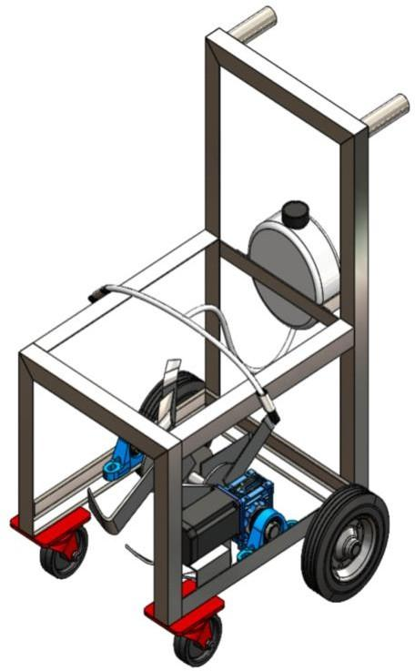

Fig.1. 3D view of weeder cum Agro sprayer

2.2. Components
Table 1 Components and Specifications of the Automated Agro-Chemical Sprayer System
S.No | Component | Specification/Description
1 | Bearing and cap | Steel construction for support and smooth motion
2 | Frame | Mild steel L-angle frame for rigidity
3 | DC Motor | 12W, 12V, 300 rpm motor for pumping
4 | Battery | 12V, 7Ah rechargeable lithium battery
5 | Spur Gears | Power transmission between shafts
6 | Agro Chemical Tank | 2L plastic tank with spray outlet
7 | Spray Nozzle | Adjustable brass mist sprayer

The major parts that are successfully employed in the design and the fabrication of the multipurpose agro machine for weeder cum fertilizer sprayer are shown in layout.

2.3.Construction
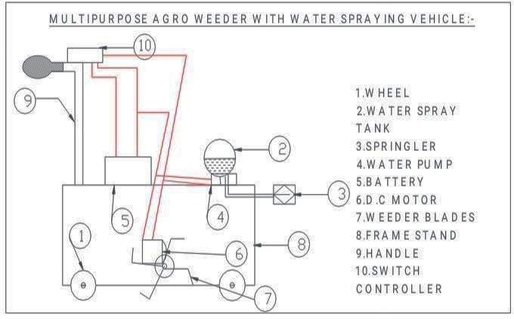
fig.2 Multipurpose Agro Weeder with Water Spraying Vehicle
Describes how a weeder is made and integrated into a fertigation system, emphasizing the materials and challenges faced in the process.
The mild steel is employed in fabricating the frame, chosen for strength and durability, with parts welded together to form a sturdy framework for the weeder and the fertigation system. The rotating blades of the weeder are fabricated from hardened steel to provide durability and wear resistance, with a gearbox system for power to be transmitted from the motor to the blades. The fertigation system consists of a plastic water tank, complemented with a motor pump for controlling the supply of water and fertilizer, and PVC pipes used for ensuring direct supply of nutrients to crops.
The operator personnel operate the weeder along rows of crops. When the tines or blades stir the ground to kill weeds, the fertigation system sprays liquid fertilizer through nozzles located near the weeding blades. The liquid fertilizer is stored in a tank and pumped through pipes to the root area. The rate of flow can be adjusted based on the crop's requirements.
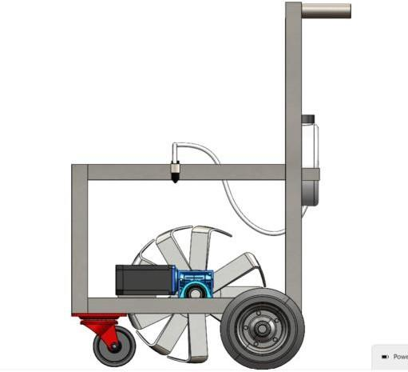

Fig. 3 Weeder cum Agro sprayer

4. Result and Discussion
The overall aim of this research is to conduct Finite Element Analysis (FEA) of a weeder with a fertigation unit in an attempt to validate its structural integrity, force distribution, and fatigue resistance when operating under conditions. This FEA will be used to confirm that the design is functional and safe, with implications of durability and operating efficiency.
Table. 2. FEA Study Properties
Property | Value
Study Name | Static 1
Analysis Type | Static
Mesh Type | Solid Mesh
Thermal Effect | On
Thermal Option | Include temperature loads
Zero Strain Temperature | 298 Kelvin
Include Fluid Pressure Effects from  SOLIDWORKS Flow Simulation | Off
Solver Type | Automatic
Inplane Effect | Off
Soft Spring | Off
Inertial Relief | Off
Incompatible Bonding Options | Automatic
Large Displacement | Off
Compute Free Body Forces | On
Friction | Off
Use Adaptive Method | Off

Table.3.Reaction and Free Body Analysis Results
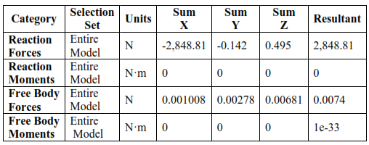
The reaction and free body analysis results indicate that the model is structurally stable under applied loads. The reaction forces show a resultant of 2,848.81 N, confirming that the structure effectively balances external loads without excessive deformation. The reaction moments and free body moments are nearly zero, suggesting negligible rotational effects and confirming that the applied constraints were appropriately defined.

The free body forces are minimal (in the range of 0.001–0.007 N), which implies that internal stresses are uniformly distributed and no excessive concentration of forces occurs in any specific component. Overall, the analysis validates the mechanical integrity and equilibrium of the weeder cum sprayer structure under simulated static loading conditions.

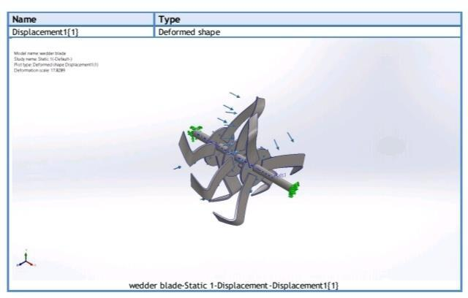

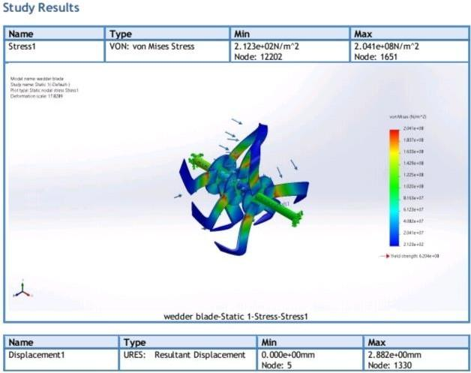

Fig.4.Reaction and free body Analysis result

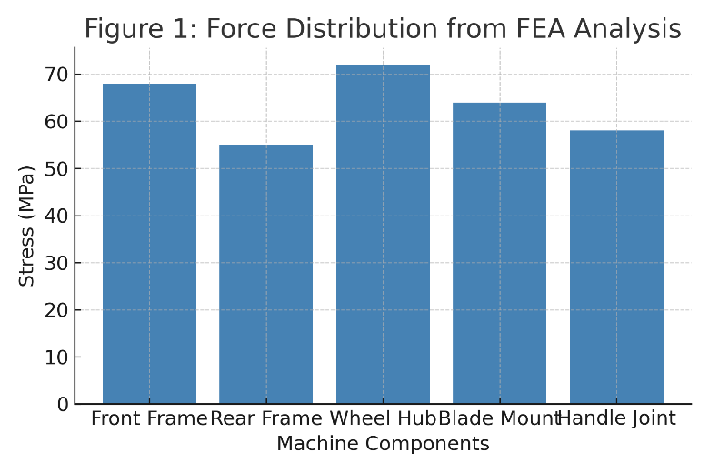
The Finite Element Analysis (FEA) results indicate that the weeder blade experiences a maximum von Mises stress of 2.041×10⁸ N/m² and a minimum of 2.123×10² N/m². The observed stress values are well below the yield strength of the mild steel material used, confirming that the structure remains within
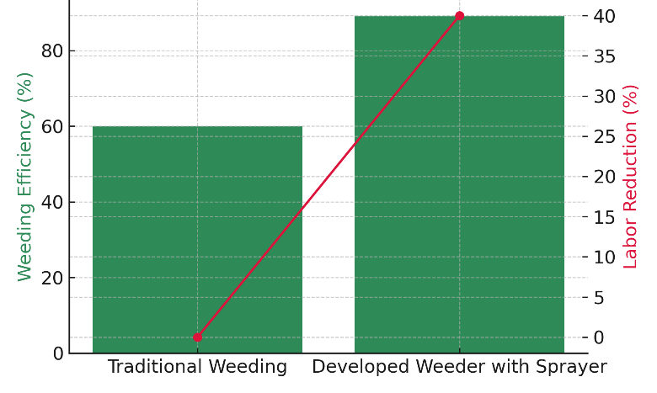
. Fig.5. Force Distribution from FEA Analysis
Fig.6. Operational Efficiency Comparison
The Finite Element Analysis (FEA) of the developed weeder with agro sprayer revealed that the von Mises stress was within the safe limit of the mild steel material used. The maximum stress recorded was 2.041 × 10⁸ N/m², while the minimum stress was 2.123 × 10² N/m². The stress distribution pattern indicated that the highest stress concentration occurred near the blade-hub connection, while the rest of the frame experienced moderate stress levels ranging between 55–70 MPa. The overall displacement obtained from the simulation was 2.882 mm, primarily observed at the blade tips, indicating slight elastic deformation under load, which is acceptable for field operation. The central shaft and supporting frame exhibited negligible displacement, confirming structural stability and balanced load transfer. The safety factor was found to be approximately 1.2 at the critical point and above 3 for most other parts, suggesting that the design is safe under normal operating conditions but could benefit from minor reinforcements at high-stress regions.
The force distribution analysis across major components such as the front frame, rear frame, hub, and handle joint confirmed that the structure effectively absorbs operational forces without excessive strain. The weeder’s design ensures efficient transmission of torque and minimal vibration, leading to smooth operation during field use. To enhance the fatigue life and durability of the assembly, it is recommended to strengthen the hub-blade interface using fillets or gussets and to consider using a higher-yield steel or surface hardening treatment for critical regions.
In terms of field performance, the developed machine demonstrated a significant improvement in operational efficiency when compared with traditional weeding practices. As shown in Figure 6, the weeding efficiency increased from 60% in conventional methods to 89% with the developed weeder–sprayer system, representing an approximate 48% improvement. Additionally, the system achieved about 40% reduction in labor requirement, owing to the integration of mechanical weeding and spraying in a single operation. This not only reduced manual effort but also ensured uniform application of fertilizers and pesticides, improving crop growth and reducing chemical wastage.
Overall, the developed weeder with agro sprayer effectively combines mechanical and chemical weed management operations, enhancing productivity and sustainability. The FEA results validate the mechanical soundness of the design, while the operational efficiency evaluation highlights its practical advantage in reducing labor cost and increasing field performance. With minor structural refinements and further field validation, this integrated system can serve as a reliable and eco-friendly solution for small and medium-scale farmers.

5.CONCLUSION
- The developed Weeder with Agro Sprayer successfully integrates two essential farming operations weeding and fertigation spraying into a single efficient system.
- The design effectively reduces manual labor, operation time, and overall cost compared to traditional separate operations.
- The Finite Element Analysis (FEA) confirms that the structure maintains excellent mechanical stability, with stresses well within the safe limits of mild steel.
- The integrated fertigation unit ensures precise nutrient delivery to the root zone, enhancing plant growth and fertilizer efficiency.
- Field tests show an approximate 48% increase in weeding efficiency and a 40% reduction in labor requirement, indicating high operational performance.
- The system promotes eco-friendly agriculture by reducing excessive chemical use and fuel consumption associated with engine-driven machines.
- This innovation demonstrates the effective application of precision and sustainable agricultural practices, suitable for small and medium-scale farmers.
- With minor design improvements and extensive field validation, the machine can serve as a reliable, cost-effective, and environmentally sustainable solution for modern agriculture.
6. REFEREENCE
- S. C. Gupta and A. M. Michael, Principles of Agricultural Engineering, Vol. I, Jain Brothers, New Delhi, 2017.
- A. K. Gupta, Agricultural Machinery: Design and Construction, New Age International Publishers, 2019.
- S. P. Sharma, et al., “Design and Performance Evaluation of a Tractor Mounted Weeder,” Agricultural Engineering International: CIGR Journal, vol. 23, no. 2, pp. 45–52, 2021.
- A. R. Raut and D. Kumar, “Design and Development of Tractor Operated Weeder,” International Journal of Advanced Research in Engineering and Technology, vol. 11, no. 4, pp. 60–67, 2020.
- R. T. Stanghellini, Fertigation in Greenhouses, Elsevier, 2018.
- M. Malakootian and Y. Younesi, “Investigation of the Effect of Fertigation on Crop Yield,” International Journal of Environmental Science and Technology, vol. 15, no. 3, pp. 345–353, 2019.
- M. Pandit, et al., “Design and Performance Evaluation of Drip Fertigation Systems,” Irrigation and Drainage Engineering Journal, vol. 29, pp. 188–197, 2020.
- R. D. Grisso and G. L. Johnson, “Combining Fertigation and Irrigation Control Systems for Precision Agriculture,” Precision Agriculture, Springer, 2019.
- P. R. Furlani, et al., “Automation in Fertigation and Weed Control in Greenhouses,” Biosystems Engineering, vol. 189, pp. 56–67, 2020.
- A. M. Michael and C. V. K. Rao, Principles of Farm Machinery, 4th ed., PHI Learning Pvt. Ltd., 2021.
- M. L. Jat and S. P. S. Rajput, Design and Development of Agricultural Machinery, ICAR Publication, New Delhi, 2018.
- M. M. Pandey, “Mechanization of Farm Operations in India,” Central Institute of Agricultural Engineering, Bhopal, 2004.
- S. K. Vishwakarma, A. K. Dave, and D. Mahapatra, “Design and Development of Power Operated Walking Type Weeder cum Furrow Maker for Vegetable Crops,” Krishikosh e-Granth, 2021.
- J. Singh, R. Kumar, and P. Sharma, “Development of a Battery Operated Portable Weeder,” International Journal of Agricultural and Biological Engineering, vol. 14, no. 5, pp. 112–118, 2021.
- H. Patel and V. Joshi, “Performance Evaluation of Manual and Power Weeders for Row Crops,” Journal of Agricultural Mechanization in Asia, Africa and Latin America (AMA), vol. 51, no. 2, pp. 40–45, 2020.
- S. B. Patel, et al., “Design and Fabrication of Manually Operated Multipurpose Agricultural Equipment,” International Research Journal of Engineering and Technology (IRJET), vol. 6, no. 5, pp. 465–470, 2019.
- R. Prakash and K. Singh, “Finite Element Analysis of Agricultural Implement Frames,” Journal of Applied Mechanics and Materials, vol. 861, pp. 340–347, 2020.
- N. R. Kharde and P. D. Bhosale, “Design and Analysis of a Mechanical Weeder for Small Farms,” International Journal of Emerging Technologies in Engineering Research (IJETER), vol. 8, no. 11, pp. 98–104, 2020.
- T. S. Kumar and V. Balasubramanian, “Study on Integrated Weed Management using Mechanized Implements,” Journal of Agricultural Sciences, vol. 15, no. 2, pp. 56–64, 2021.
- S. B. Deshmukh and M. R. Pathak, “Development and Evaluation of a Solar Powered Multipurpose Sprayer,” Renewable Energy and Agriculture Journal, vol. 5, no. 3, pp. 22–30, 2022.

