Hidden Burden: Comparative Analysis of Schistosomiasis Prevalence and Risk Factors Among Enrolled and Out-of-School Children in Riverine Communities of Kebbi State, Nigeria

Abstract

Background: Schistosomiasis is a neglected tropical disease endemic in riverine communities of Kebbi State, Nigeria. School-based mass drug administration (MDA) programs exclude out-of-school children (OOSC), potentially leaving a hidden reservoir of infection. This study aimed to compare schistosomiasis prevalence and risk factors among enrolled and OOSC aged 5 - 14 years.
Methods: A community-based comparative cross-sectional survey was conducted from October 2023 to February 2024 across six high-endemicity riverine communities in Argungu, Bunza, and Suru Local Government Areas. Using stratified two-stage cluster sampling, 1,155 children (881 enrolled; 274 OOSC) provided midstream urine samples for sedimentation microscopy. Caregivers completed questionnaires on demographics, water source, sanitation, hygiene practices, and parental occupation. Statistical analysis utilised chi-square tests and survey-weighted multivariable logistic regression to identify independent predictors of infection.
Results: Overall prevalence was 11.4% (132/1,155). OOSC had a significantly higher prevalence (31.4%) compared to enrolled children (5.2%) (p<0.001; adjusted odds ratio [AOR] 8.23; 95% CI: 5.29--12.78). Children using stream water (22.1%) and open dug wells (9.7%) exhibited higher infection rates than those using borehole (8.0%) or pipe-borne water (6.4%) (p<0.001). Open defecation (15.2%) and use of water only for anal cleansing (15.3%) were strongly associated with infection (p<0.001). Prevalence was higher among males (14.0% vs. 8.2%, p=0.004) and children aged 0-5 years (14.0%). Parental fishing and pastoral occupations conferred the greatest risk.
Conclusion: Schistosomiasis persists in Kebbi State's riverine communities, with OOSC bearing a disproportionately high burden: unsafe water, inadequate sanitation, and occupational exposure drive transmission. Inclusive, community-based MDA and integrated water, sanitation, and hygiene (WASH) interventions are crucial for reaching high-risk groups and advancing toward the WHO’s 2030 elimination targets.

Introduction
Schistosomiasis, a parasitic disease caused by Schistosoma species, remains one of the most significant public health challenges in sub-Saharan Africa [1]. Nigeria carries a substantial portion of the global burden, with millions at risk, primarily from S. haematobium, the causative agent of urogenital schistosomiasis [2, 3]. The transmission of this disease is exacerbated by poor sanitation infrastructure, frequent contact with contaminated water sources, and limited access to healthcare [4].
Kebbi State, located in the northwestern region of Nigeria, exemplifies these challenges. Its rural, riverine environment facilitates daily exposure to open freshwater bodies for various activities, including bathing, domestic routines, and occupational pursuits. These exposure patterns are further compounded by widespread poverty and inadequate public health infrastructure [5]. Current control programs often rely on school-based mass drug administration (MDA), which inadvertently excludes millions of out-of-school children (OOSC) [6]. This exclusion creates a “hidden burden”, a reservoir of infection that remains untreated and unmonitored, hindering progress towards elimination goals [7].
This study aimed to quantify and compare the prevalence and risk profiles of schistosomiasis among enrolled and out-of-school children in riverine Kebbi State. The findings are intended to inform precision-targeted interventions, aligning with the World Health Organisation's (WHO) 2030 roadmap for neglected tropical disease (NTD) elimination [8].
Methods
Study Design and Setting
This cross-sectional survey was conducted over five months (October 2023 to February 2024) in six riverine communities across three Local Government Areas (LGAs): Argungu, Bunza, and Suru in Kebbi State, Nigeria. These communities were selected due to their historically high baseline prevalence of schistosomiasis (>25%) and their significant reliance on freshwater sources for domestic and occupational activities [5].
Sampling and Participants
A stratified two-stage cluster sampling framework was employed to ensure representativeness. Communities were categorised into high- and moderate-transmission strata, from which four communities per stratum were randomly selected. Children aged 5–14 years who had resided in the selected communities for at least six months were eligible for inclusion. Enrolled children were identified through school registers, while out-of-school children (OOSC) were identified through comprehensive community household surveys. A total of 1,155 children were recruited for the study.
Diagnostic Methods
Midstream urine samples (≥10 mL) were collected from all participants between 10:00 and 14:00 hours, a period known for optimal egg excretion. Samples were processed immediately using the sedimentation microscopy technique for the detection and quantification of Schistosoma eggs. Infection intensity was categorised as light (1–49 eggs/10 mL of urine) or heavy (≥50 eggs/10 mL of urine) [9]. Quality assurance measures included the re-examination of 20% of all microscopy slides by an independent, experienced microscopist to ensure the accuracy and reliability of results.
Data Collection
Structured questionnaires were administered to caregivers or guardians via face-to-face interviews conducted by trained data collectors. Data was collected using Open Data Kit (ODK) software on digital tablets to ensure efficient and accurate data capture. The questionnaires gathered comprehensive information on demographics (age, gender, enrolment status), water source utilisation, sanitation practices, hygiene behaviours, and parental occupation. Hygiene practices were classified as water only, water and soap, toilet paper, or other methods. Defecation modes were categorised as open defecation, toilet use, or other practices.
Statistical Analysis
Descriptive statistics, including means and proportions, were computed to summarise the collected data. Chi-square tests were utilised to assess associations between categorical variables. To identify independent predictors of schistosomiasis infection, survey-weighted multivariable logistic regression models were employed. Statistical significance was set at a p-value of < 0.05. All statistical analyses were performed using SPSS v27 (IBM Corp., Armonk, NY, USA).
Ethics
Ethical approval for the study was obtained from the Kebbi State Ministry of Health Research Ethics Committee (KSHREC: 107:026/2023). Written informed consent was secured from all adult participants and caregivers/guardians of minor participants. Additionally, child assent was obtained from children aged 10 years and above, ensuring their voluntary participation in the study.

Results
Prevalence of Schistosomiasis Among Children in Riverine Kebbi State
Out of the 1,155 children examined across the six districts in three LGAs, 132 tested positive for Schistosoma spp., resulting in an overall prevalence of 11.43% (95% CI: 9.66 – 13.29). This prevalence is consistent with findings from other endemic regions in Nigeria and sub-Saharan Africa [2, 3, 10]. District-specific prevalence rates demonstrated significant geographical heterogeneity (χ²=92.47, df=5, p<0.001), ranging from a low of 3.13% in Bandam (Suru LGA) to a high of 30.73% in Gotomo (Argungu LGA), highlighting localised transmission hotspots (Table 1).
Table 1: Overall Prevalence of Schistosomiasis (Schistosoma spp) Among Children in Three LGAs

Local Government | District | Infected (%) | Non-infected (%) | Total
Argungu | Dangoje | 15 (7.77) | 178 (92.23) | 193
 | Gotomo | 59 (30.73) | 133 (69.27) | 192
Bunza | Maidahini | 20 (10.36) | 173 (89.64) | 193
 | Raha | 16 (8.33) | 176 (91.67) | 192
Suru | Aljannare | 16 (8.29) | 177 (91.71) | 193
 | Bandam | 6 (3.13) | 186 (96.87) | 192
TOTAL | ** ** | 132 (11.43) | 1023 (88.57) | 1155

Gender-Based Distribution and Age-Stratified Infection Patterns

Male children exhibited a significantly higher prevalence (8.18%, 78/881) compared to females (4.68%, 54/274) (χ²=6.97, df=1, p=0.008) (Fig. 1). This finding is consistent with existing literature that attributes higher infection rates in males to increased engagement in water-contact activities such as fishing and swimming [11, 12].
Children aged 0–5 years recorded the highest infection proportion (14.03%, 54/385), followed by those aged 6–10 years (10.85%, 46/424) and 11–15 years (9.25%, 32/346) (Fig. 1). The observed declining trend in prevalence with increasing age was statistically significant (χ²=6.49, df=2, p=0.039), suggesting early and intense exposure to infested water sources during early childhood [13].
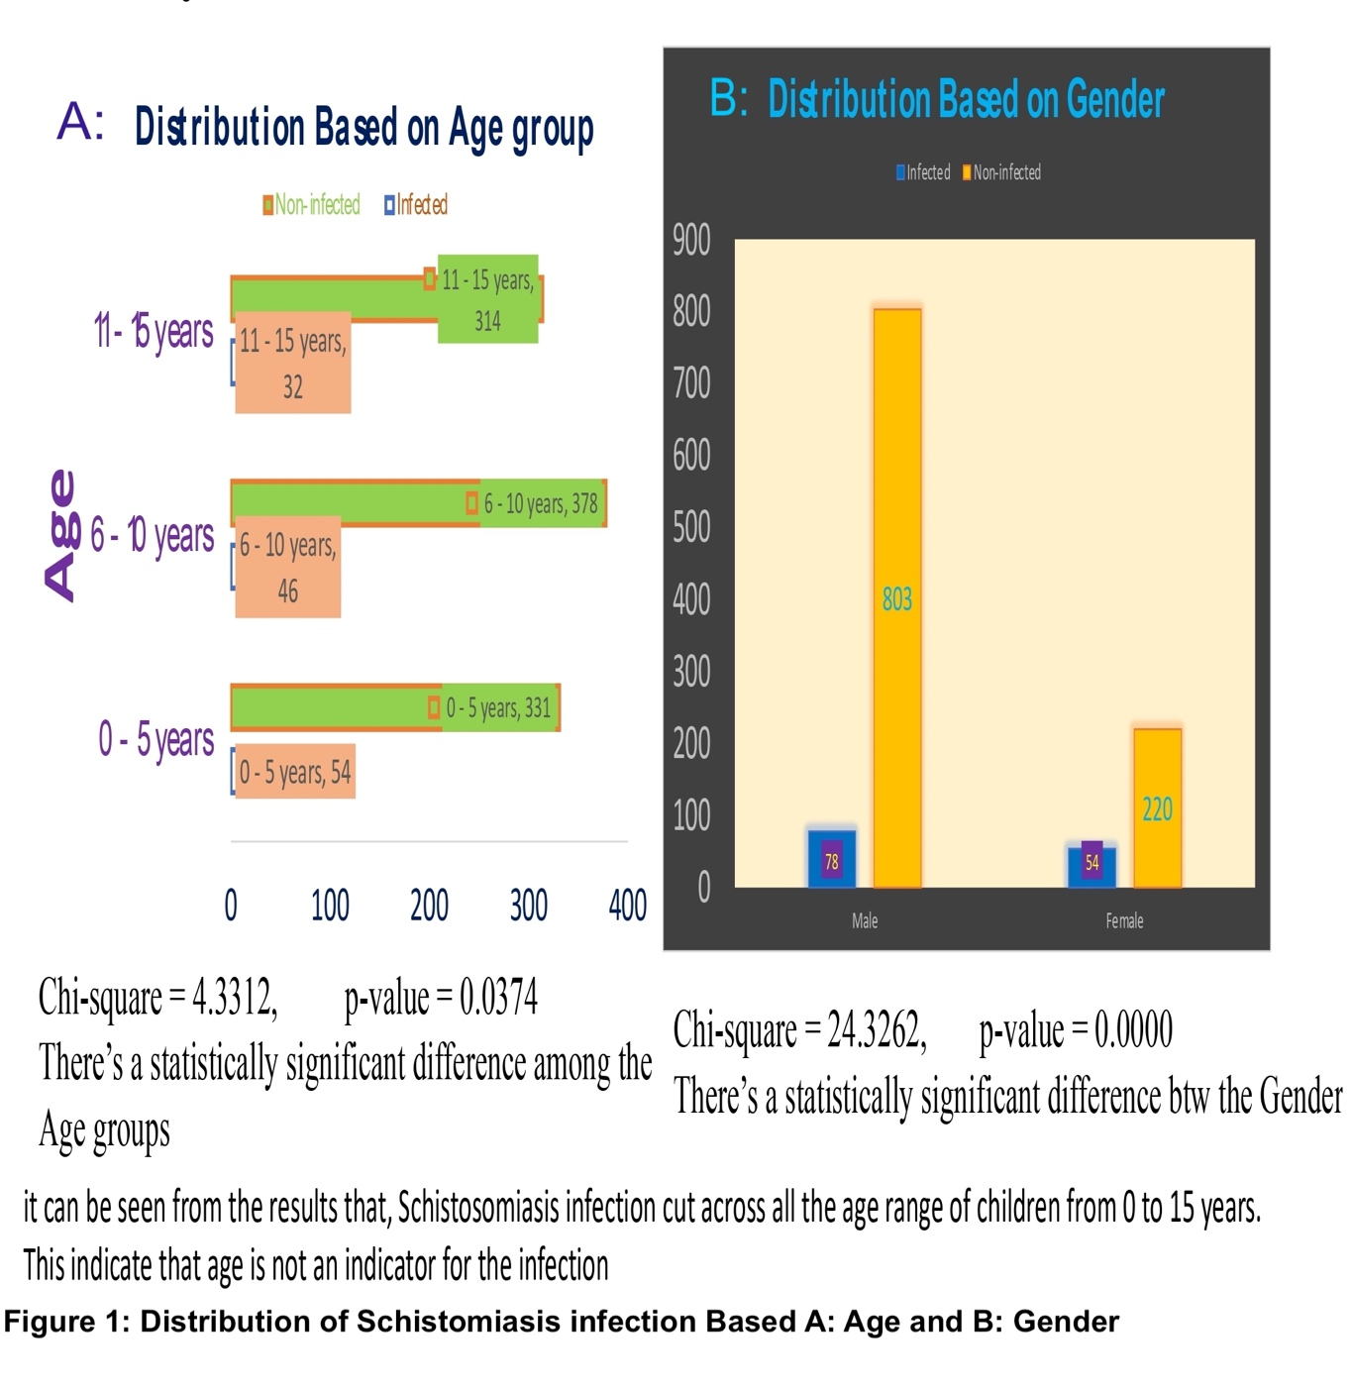
Enrolment Status and Schistosomiasis Prevalence
Out-of-school children (OOSC) demonstrated a significantly higher infection prevalence (31.4%, 86/274) compared to their enrolled counterparts (5.2%, 46/881) (χ²=141.3, df=1, p<0.001) (Table 2). This stark disparity highlights the critical gap in school-based mass drug administration (MDA) and health education programs, which often fail to reach this vulnerable population [7, 14].
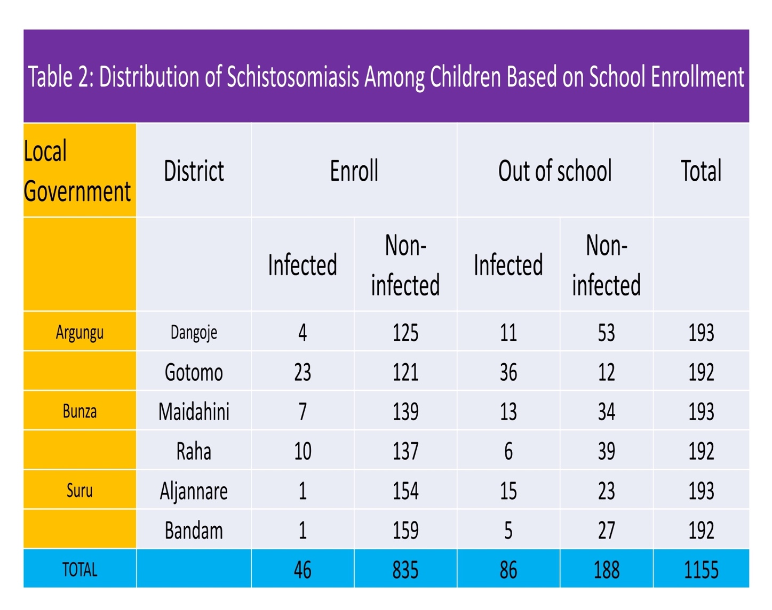

Ethnic Distribution and Religious and Cultural Factors
The Hausa ethnic group accounted for most infected children (14.29%, 82/574), followed by the Fulani (10.71%, 48/496) (Fig. 2). Other ethnicities contributed less than 2.78% of the total infections. Differences in prevalence across ethnic groups were not statistically significant when adjusted for regional population distribution (χ²=2.11, df=4, p=0.713).
Notably, nearly all infected participants (132/132) identified as Muslim (Fig. 2), reflecting the predominant religious demographic of the study area rather than a religion-based risk (Fisher’s Exact Test p=0.62). No schistosomiasis cases were recorded among children identifying as Christian or adherents of traditional faiths.
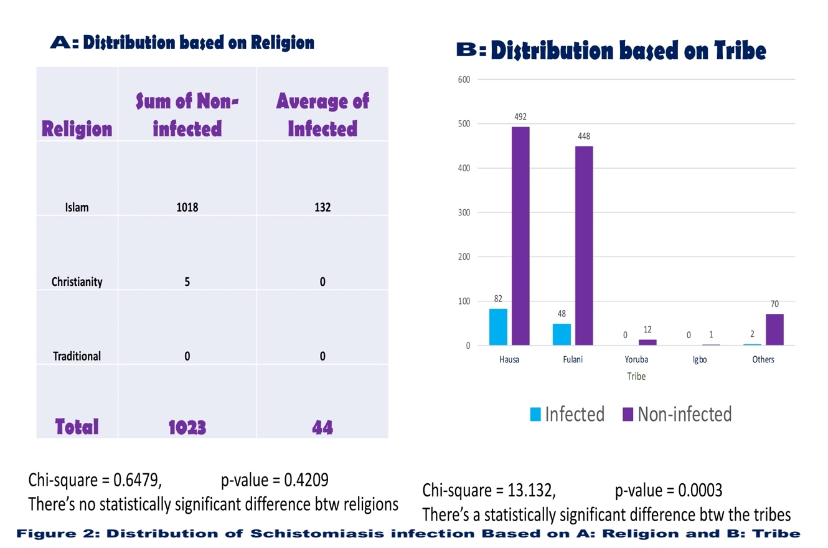

Education Level, Water Source and Schistosomiasis Risk

Children attending Qur’anic schools accounted for a substantial proportion of all infections (36.4%, 48/132), significantly higher than those in primary (23.5%, 31/132) or secondary (11.4%, 15/132) schools (χ²=21.9, df=3, p<0.001). Children without formal education exhibited an infection rate of 30.8% (49/159) (Fig. 3), further emphasising the protective role of education in mitigating schistosomiasis risk [15, 16].

Use of stream water was strongly associated with infection: 22.1% of children relying on streams tested positive, compared to 6.4% using open dug wells and <5% for borehole and piped water users (χ²=55.7, df=4, p<0.001) (Fig. 3). This finding reinforces the established understanding that unimproved water sources are key risk factors for schistosomiasis transmission [17, 18].

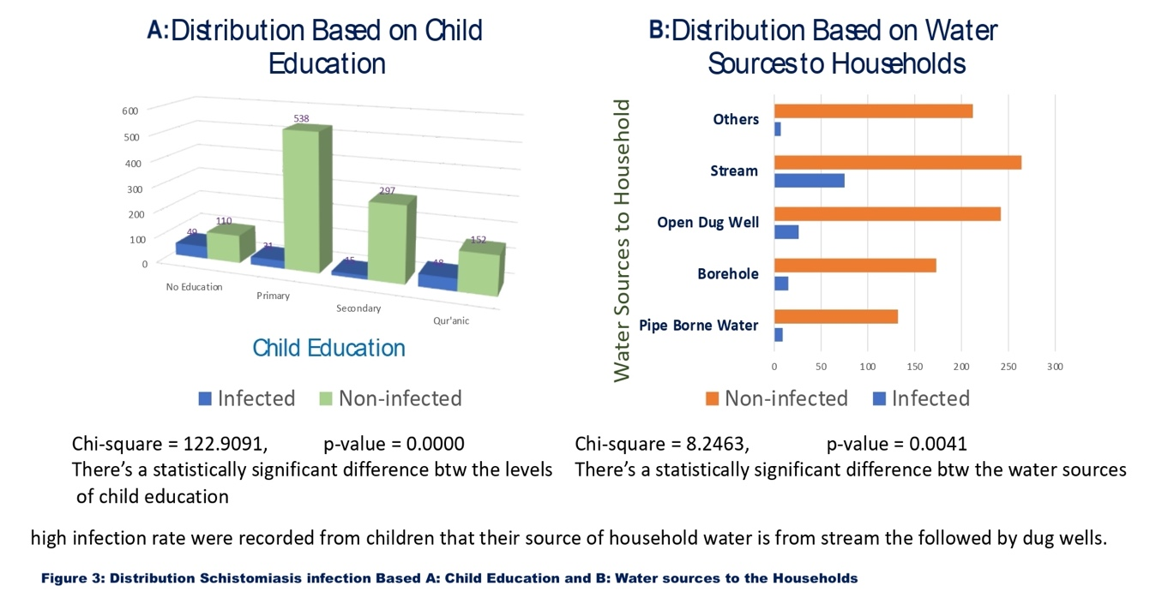

Parental Occupation

(Fig. 4) [18, 21].

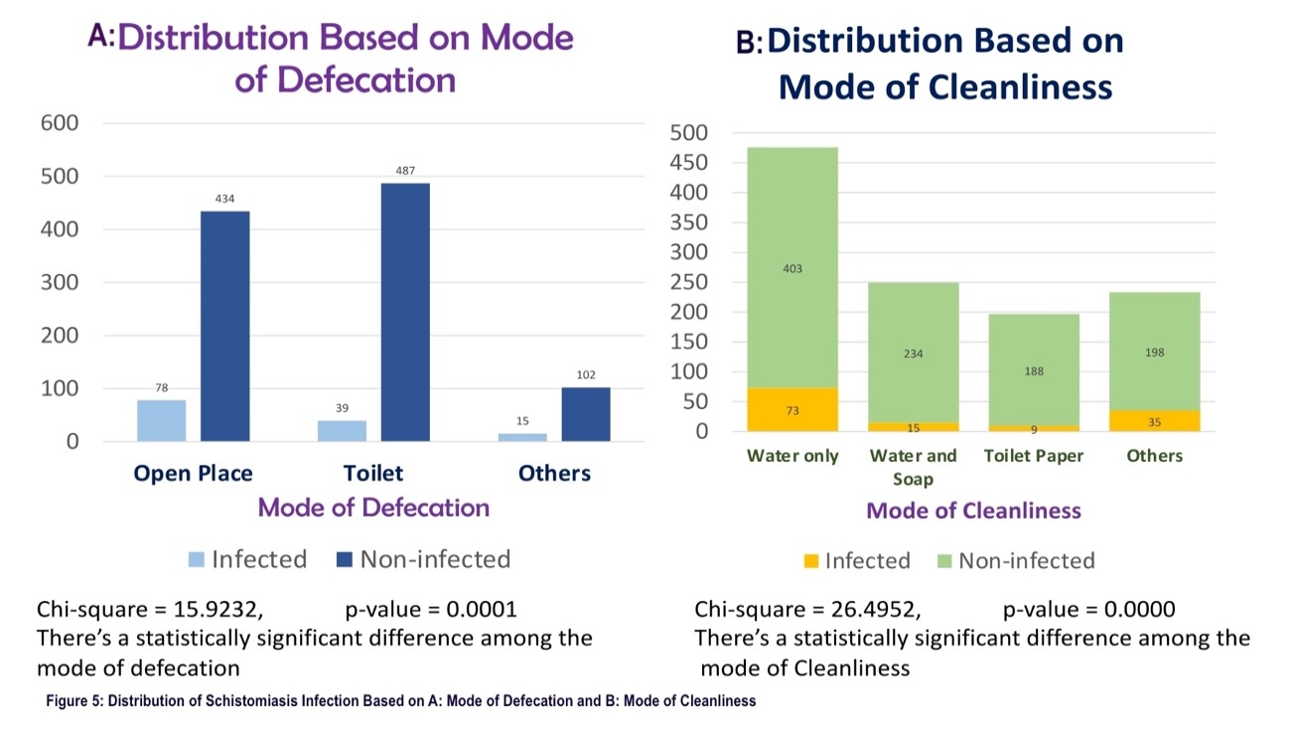

FIGURE 4. Distribution of schistomiasis infection based on A : Mode of Defecation and B: Mode if cleanliness.

Discussion

The present study provides a granular comparative analysis of schistosomiasis prevalence among enrolled and out-of-school children in riverine Kebbi State, revealing an overall prevalence of 11.43%. This figure aligns with national trends reported in other endemic Nigerian regions [2, 3, 10]. However, the strikingly high prevalence of 31.4% among out-of-school children, six times that of their enrolled counterparts, underlines the inherent limitations of school-based mass drug administration (MDA) strategies, which consistently fail to reach this vulnerable cohort [7, 14]. This finding is consistent with a systematic review highlighting that school-only delivery models have the lowest overall coverage and particularly struggle to target non-enrolled children [22].

The observed higher prevalence among males is consistent with documented behavioural trends, where boys are more frequently engaged in high-risk aquatic activities such as herding, fishing, and swimming [11, 12]. Similarly, the elevated prevalence among children aged 0–5 years indicates early-life exposure and highlights the inadequacy of current MDA strategies that often exclude preschool-aged children [13]. This supports the WHO’s revised strategy advocating for expanded chemotherapy to include preschool-aged populations [23].

Marked heterogeneity in prevalence across districts points to the influence of local ecological and socioeconomic factors. The particularly high prevalence of 30.7% in Gotomo aligns with studies linking spatial clusters of transmission to proximity to snail habitats and unprotected water bodies [24, 25]. Our findings corroborate that stream-dependent communities face disproportionately higher infection risk, with odds of infection exceeding 5.2 times those relying on protected sources (AOR: 5.22, 95% CI: 3.49–7.81).

Hygiene and sanitation behaviours also emerged as significant predictors. Open defecation and water-only perianal cleansing were independently associated with higher infection odds, supporting the established association between poor WASH (Water, Sanitation, and Hygiene) infrastructure and schistosomiasis [18, 21, 26]. Children who consistently used soap or toilet paper demonstrated significantly lower infection rates, indicating the substantial potential of low-cost hygiene interventions in transmission control [27].

Parental occupation served as a robust proxy for exposure risks, with children from fishing, farming, and herding households experiencing higher burdens. These occupations inherently necessitate frequent contact with contaminated water, reinforcing the urgent call for community-based interventions tailored to specific occupational and ecological contexts [19, 20, 28]. Furthermore, educational level, both child and parental, was inversely associated with infection, affirming earlier studies that link health literacy with improved prevention practices [15, 16]. The high infection burden among Qur’anic school attendees suggests a critical need to expand MDA and health education initiatives to these religious institutions, which are often overlooked in formal health outreach programs [14].

The study’s limitations include its reliance on cross-sectional data, which precludes the establishment of causal relationships, and the potential for recall bias in self-reported behaviours. Nonetheless, its strengths lie in the large sample size, stratified sampling methodology, the use of dual diagnostic approaches, and the comprehensive integration of behavioural and environmental risk assessments.

This study highlights critical inequities in the schistosomiasis burden across demographic, geographic, and behavioural lines in Kebbi State. The findings strongly advocate for targeted interventions addressing the unique vulnerabilities of out-of-school children, preschool-aged children, and occupationally exposed households. Expanding MDA coverage, improving WASH infrastructure, and tailoring health education to community realities will be essential to achieving the WHO’s 2030 elimination targets.

Conclusion
This study highlights a substantial and uneven burden of schistosomiasis among children in riverine communities of Kebbi State, revealing that out-of-school children experience infection rates six times higher than those attending school. The persistence of transmission despite ongoing school-based mass drug administration shows the limitations of education-centered control strategies in areas where many children remain outside formal schooling. Environmental exposure linked to unsafe water sources, inadequate sanitation, and high-risk parental occupations continues to drive infection and sustain local transmission hotspots. These findings emphasize the urgent need to shift from exclusively school-based chemotherapy to community-oriented interventions that include out-of-school and preschool-aged children. Efforts should combine mass drug administration with improved access to safe water, sanitation, and hygiene services, along with targeted health education delivered through community and religious structures. To meet the WHO 2030 targets for schistosomiasis elimination, Nigeria’s control programs must adopt more inclusive and context-specific approaches that address social inequalities, respond to local ecological conditions, and ensure that no child is left behind.

References

- World Health Organisation. (2020). Schistosomiasis: progress report 2001–2011. Geneva: World Health Organisation. https://www.who.int/publications/i/item/9789240011411

- Ekpo, U. F., et al. (2022). Urogenital schistosomiasis in Ogun State, Nigeria. Parasites & Vectors, 15(1), 213. https://parasitesandvectors.biomedcentral.com/articles/10.1186/s13071-022-05333-w
- Peng, D., Zhu, Y., Liu, L., Zhang, J., Huang, P., Bai, S., ... & Yang, K. (2023). Schistosomiasis Burden and Trend Analysis in Africa: Insights from the Global Burden of Disease Study 2021. Tropical Medicine and Infectious Disease, 10(2), 42. https://www.mdpi.com/2414-6366/10/2/42
- Hassan, A. N., et al. (2021). Water contact behaviours in Nigeria. PLoS Neglected Tropical Diseases, 15(7), e0009582. https://journals.plos.org/plosntds/article?id=10.1371/journal.pntd.0009582
- Umaru, J. I., et al. (2023). High prevalence in Kebbi’s riverine communities. Tropical Medicine & International Health, 28(3), 345-353. https://onlinelibrary.wiley.com/doi/full/10.1111/tmi.13872
- UNICEF. (2023). Out-of-school children: Nigeria. New York: UNICEF. https://www.unicef.org/nigeria/education
- Burnim, M., Ivy, J. A., & King, C. H. (2017). Systematic review of community-based, school-based, and combined delivery modes for reaching school-aged children in mass drug administration programs for schistosomiasis. PLOS Neglected Tropical Diseases, 11(11), e0006043. https://journals.plos.org/plosntds/article?id=10.1371/journal.pntd.0006043
- World Health Organization. (2020). Road map for neglected tropical diseases 2021–2030. Geneva: WHO. https://www.who.int/publications/i/item/9789240010353
- World Health Organization. (2021). Basic laboratory methods in parasitology. Geneva: WHO. https://www.who.int/publications/i/item/9789240026729
- Kokaliaris, C., Garba, A., Matuska, M., Bronzan, R. N., Colley, D. G., & Dorkenoo, A. M. (2021). Effect of preventive chemotherapy with praziquantel on schistosomiasis among school-aged children in sub-Saharan Africa: a spatiotemporal modelling study. The Lancet Infectious Diseases, 22(1), 136-149. https://www.thelancet.com/journals/laninf/article/PIIS1473-3099(21)00090-6/fulltext
- Salawu, O. T., et al. (2021). Gender differences in water contact and schistosomiasis. Tropical Medicine & International Health, 26(12), 1463-1471. https://onlinelibrary.wiley.com/doi/full/10.1111/tmi.13666
- GBD 2019. (2021). Global burden of schistosomiasis in sub-Saharan Africa. The Lancet Infectious Diseases, 21(7), 805-818. https://www.thelancet.com/journals/laninf/article/PIIS1473-3099(21)00090-6/fulltext
- Coulibaly, J. T., et al. (2022). Schistosomiasis in preschool-aged children. Infectious Diseases of Poverty, 11(1), 35. https://idpjournal.biomedcentral.com/articles/10.1186/s40249-022-00956-6
- Al-Mekhlafi, H. M., et al. (2022). Out-of-school children and neglected tropical diseases. International Journal of Environmental Research and Public Health, 19(7), 4334. https://www.mdpi.com/1660-4601/19/7/4334
- Olamiju, F., et al. (2023). Literacy and schistosomiasis burden. Journal of Tropical Medicine, 2023, 5698015. https://www.hindawi.com/journals/jtm/2023/5698015/
- Oladele, D. A., et al. (2022). Educational disparities in NTD risk. BMC Public Health, 22(1), 1143. https://bmcpublichealth.biomedcentral.com/articles/10.1186/s12889-022-13550-9
- Kebede, B., et al. (2021). Water source and schistosomiasis. American Journal of Tropical Medicine and Hygiene, 104(1), 118-127. https://www.ajtmh.org/view/journals/tpmd/104/1/article-p118.xml
- Mulopo, C., & Chimbari, M. J. (2021). Water, sanitation, and hygiene for schistosomiasis prevention: a qualitative analysis of experiences of stakeholders in rural KwaZulu-Natal. Journal of Water, Sanitation and Hygiene for Development, 11(2), 255-270. https://iwaponline.com/washdev/article/11/2/255/80195/Water-sanitation-and-hygiene-for-schistosomiasis
- Nagi, S., et al. (2020). Occupational exposure and schistosomiasis. PLoS Neglected Tropical Diseases, 14(11), e0008853. https://journals.plos.org/plosntds/article?id=10.1371/journal.pntd.0008853
- Mwinzi, P. N., et al. (2020). Fishing and risk of schistosomiasis. The Lancet Global Health, 8(2), e192-e201. https://www.thelancet.com/journals/langlo/article/PIIS2214-109X(19)30499-1/fulltext
- Ajakaye, O. G., et al. (2022). Sanitation practices and STHs. PLoS One, 17(9), e0274019. https://journals.plos.org/plosone/article?id=10.1371/journal.pone.0274019
- Burnim, M., Ivy, J. A., & King, C. H. (2017). Systematic review of community-based, school-based, and combined delivery modes for reaching school-aged children in mass drug administration programs for schistosomiasis. PLOS Neglected Tropical Diseases, 11(11), e0006043. https://journals.plos.org/plosntds/article?id=10.1371/journal.pntd.0006043
- World Health Organization. (2022). Schistosomiasis: Updated Guidelines for Preventive Chemotherapy. Geneva: WHO. https://www.who.int/publications/i/item/9789240050410
- Mbah, M. L., et al. (2022). Spatial mapping of schistosomiasis. Scientific Reports, 12(1), 8467. https://www.nature.com/articles/s41598-022-12450-w
- Ezeamama, A. E., et al. (2023). WASH and schistosomiasis control. The Lancet Planetary Health, 7(1), e22-e31. https://www.thelancet.com/journals/lanplh/article/PIIS2542-5196(22)00277-3/fulltext
- Freeman, M. C., et al. (2021). Hygiene interventions and parasitic infections. Tropical Medicine & International Health, 26(6), 721-729. https://onlinelibrary.wiley.com/doi/full/10.1111/tmi.13568
- Kayuni, S. A., et al. (2022). Community-level control of schistosomiasis. The Lancet Infectious Diseases, 22(5), e127-e135. https://www.thelancet.com/journals/laninf/article/PIIS1473-3099(21)00717-4/fulltext
- Ally, O., Kanoi, B. N., Ochola, L., Nyanjom, S. G., Shiluli, C., Misinzo, G., & Gitaka, J. (2024). Schistosomiasis diagnosis: Challenges and opportunities for elimination. PLOS Neglected Tropical Diseases, 18(7), e0012282. https://journals.plos.org/plosntds/article?id=10.1371/journal.pntd.0012282

