Physicochemical and bacteriological quality of groundwater at the point of collection and under household storage conditions in the Mendong neighborhood of Yaoundé (Cameroon)

ABSTRACT
A study was conducted in several households in the Mendong neighborhood of Yaoundé (Cameroon) to assess the level of microbiological contamination of groundwater in storage or in use in relation to physicochemical variables. Water samples were collected in sterile 500ml glass bottles for bacterial isolation and in double-sealed polyethylene bottles of 250ml and 1000ml for physicochemical parameters as recommended by standard methods. The bacteria considered were MAHB and some pathogenic bacteria. These bacteria were isolated using PCA and Salmonella-Shigella agar respectively. Pathogenic bacteria were identified using the classical gallery, followed by antibiotic susceptibility testing. Moreover, in addition to the MAHB, the waters sampled in the households and in the water supply sources harbor pathogenic bacteria such as Serratia marcescens, Citrobacter freundii, and Salmonella paratyphi. The densities of these bacteria undergo overall variations depending on the time of water collection, the household, and the water source considered. In addition, the physicochemical parameters considered were taken in situ and in the laboratory using standard techniques. It appears overall that the analyzed waters are acidic and mineralized with a conductivity that varies from 17 µS/cm to 250 µS/cm for an average of 97.59 ± 17.49 µS/cm. The water temperature ranges from 25.1°C to 28.2°C. The mineralization of the water would be due to the presence of Cl⁻, Ca²⁺, and Mg²⁺ ions present in the analyzed waters. Similarly, the variation in temperature could be explained by the period of water collection. The physicochemical parameters do not significantly influence the variation in the abundance dynamics of germs over the usage time of the waters. It is therefore recommended that populations use cleaner and better (watertight and non-porous) containers and continue to treat the water regularly before use.
Keywords: water, storage condition, microbiological quality, physiochemistry, household.

INTRODUCTION
Access to quality drinking water is a fundamental right for all populations and a major public health issue. According to the World Health Organization (WHO, 2022), approximately 2 billion people worldwide consume drinking water contaminated with fecal matter, causing more than 485,000 deaths annually due to diarrheal diseases (WHO, 2022). In sub-Saharan Africa, reliance on groundwater sources is high, particularly in urban and peri-urban areas where water distribution networks are often inadequate or nonexistent.
In large African cities like Yaoundé, the political capital of Cameroon, rapid population growth combined with uncontrolled urbanization has placed significant pressure on water resources (Njine et al., 2001). Given the insufficient coverage of the CAMWATER network, many households resort to alternative sources such as wells and boreholes that exploit groundwater. These waters are generally perceived as pure since they are protected from surface pollution (Nola et al., 2006, 2010; Noah Ewoti, 2012). However, several studies have shown that these resources are not immune to contamination, particularly of bacterial and chemical origin (Tabué Youmbi et al., 2013; Moussima Yaka et al., 2020, Noah Ewoti et al, 2021b).
Beyond the intrinsic quality of groundwater at the source, a frequently overlooked factor is household storage conditions. After being drawn, water is stored in various containers (jerrycans, buckets, clay jars…), often exposed to questionable sanitary conditions (missing lids, dirty hands, contact with non-sterile utensils, etc.). Several authors have demonstrated that the bacteriological quality of water can deteriorate significantly during domestic storage (Wright et al., 2004; Tambekar et al., 2012). Other studies suggest that despite their apparent clarity, the microbiological quality of groundwater in Yaoundé and its surroundings (Nkolafamba, Mbalmayo, Ntui, Ombessa, Mbankomo, Mfou) are questionable (Tuekam Kayo et al., 2021; Noah Ewoti et al., 2021b; 2023; 2025, Baleng et al., 2022; 2025). Other results present the test of treatments (alternative treatments using plant extracts) of these waters by the populations and by researchers respectively before their use (Lontsi Djimeli et al., 2018; Metsoheng et al., 2019 Manouore Njoya et al., 2021). despite these data, there is little information on the site of the contamination of groundwater intended for human consumption from the source of supply to its use in households. Very few studies explain the variation in the microbiological and physiochemical quality of drinking water after collection and during use in households over time. After taking into account precautions such as cleaning of water storage equipment, little is known about the origin of bacteria in water that has been collected and stored for use.
The present work aims to examine the level of bacteriological contamination of groundwater at the point of collection and under household usage conditions in some homes in the Mendong neighborhood of Yaoundé.

MATERIAL AND METHODS

Description of Sampling Points
Figure 1 shows the water sources analyzed during the study period, characterized by the presence of a specific point source of pollution. The geographical coordinates are presented in Table I. Overall, these points are located between 3°49’59.61’’ and 3°50’1.12452’’ North latitude and between 11°28’27.66’’ and 11°28’29.39304’’ East longitude.
Table I: Geographical Coordinates of the Different Sampling Locations
Stations | Latitude (N) | Longitude (E) | Altitude (m) | Distance from the source of pollution (m)
F1 | 3°49’59,61’’ | 11°28’27,66’’ | 723 | 5
F2 | 3°50’0,68017’’ | 11°28’27,94613’’ | 748 | 15
S1 | 3°50’1,12452’’ | 11°28’29,39304’’ | 747 | 0
S2 | 3°50’0,92103’’ | 11°28’28,65102’’ | 713 | 17

Figure 1 : Photograph of the Sampling Points During the Study Period (Photo by Noah Ewoti, February 2025)
For household monitoring, water was stored in the first household in a barrel (figure 2) whose lid was regularly opened for water usage. This water was used for drinking, cooking, dishwashing, and bathing. In this first household, the water supply came from borehole F1.
In the second household, water was stored in cleaned 10-liter jugs (figure 2B). This water was used for serving drinks to customers of a small food business and for the family’s drinking needs. The source of supply is station S1.
B
A
Figure 2 : Water storage containers in use in households A and B (Photo by Noah Ewoti, February 2025)

Study Period
The study was carried out in two phases. The first phase, referred to as the preliminary phase, took place in December 2024. It involved prospecting and selecting sampling sites. The second phase occurred from January to March 2025 and involved collecting and analyzing water samples. The sampling frequency was monthly.

Sampling Methods
Samples were collected using two types of containers: polyethylene bottles of 250 mL and 1000 mL, which were thoroughly washed and rinsed in advance at the laboratory, and sterile glass bottles of 500 mL. The water was sampled according to the techniques recommended by APHA (2009) and Rodier et al. (2009). For each sample, two types of parameters were considered: physicochemical and microbiological (Rodier et al., 2009).
These samples were then transported to the laboratory in a refrigerated chamber, and the analyses were conducted within hours of sampling. The water samples contained in polyethylene bottles were used for physicochemical analyses, while those in sterile glass bottles were used for bacteriological analyses.

Bacteriological Analysis
Isolation and Enumeration of Mesophilic Aerobic Heterotrophic Bacteria (MAHB)
MAHB species were isolated on the surface of PCA (Plate Count Agar) medium poured into Petri dishes using the surface spread technique. To do this, 100 µl of raw sample were taken with a sterile micropipette and deposited onto the agar surface. The sample was then spread using a sterile glass spreader within the sterile flame zone of a Bunsen burner (Marshal et al., 1991). The Petri dishes were then incubated at room temperature for 5 days. During this period, colonies with diverse cultural characteristics were counted using the direct counting method (Holt et al., 2000).
Isolation of Pathogens
Isolation was done by taking 100 µl of the raw sample using a micropipette. Near the flame of a gas-fed Bunsen burner, this volume was spread across the surface of MacConkey agar and Salmonella-Shigella (SS) agar media poured into Petri dishes. The plates were incubated at 37°C in an incubator for 24 to 36 hours (Delarras, 2007).
Enumeration of Viable Pathogens
The colonies isolated and showing the cultural characteristics of suspected strains were counted using the direct counting method. Bacterial abundances were first expressed as Colony Forming Units (CFU)/100 mL of water sample examined, then transformed into log CFU/100 mL to better represent the variation and reduce high differences in densities of the targeted bacteria (Holt et al., 2000; Noah Ewoti et al., 2011; Moungang et al., 2013).
Identification of Pathogens
After isolating the pathogens and macroscopically recognizing the colonies, the identification of different bacterial genera was conducted using microscopic descriptions of the cells based on their relevance in the medical field. Biochemical or enzymatic tests were performed after culturing pure strains on ordinary slanted agar media in test tubes.
Biochemical Identification of Pathogens
The identification of various bacterial species was based on a series of biochemical tests. After subculturing on slanted PCA medium and incubating at 37°C for 18 to 24 hours, the biochemical tests were carried out according to standard biochemical criteria, using the classic Le Minor gallery (Holt et al., 2000). This gallery includes a set of reactions whose results correspond to the phenotype and reveal the genetic configuration specific to the taxon being studied.
Evaluation of the physicochemical parameters of water at the point of collection and during use in households
Physicochemical parameters analyzed
The physicochemical parameters were analyzed using the Techniques developed by Rodier et al., (2009). Table II summarizes some parameters considered, the technique, the measurements and units of measurements.
Table II: Parameters analyzed, methods of measurement, devices and units used for each parameter
Parameters | Technique | Site | Apparatus | Units
Temperature | Direct | In situ | Thermometer | °C
pH | Direct | In situ | pH-meter | C.U
Conductivity | Direct | In situ | Conductimeter | µS.cm⁻¹
Suspended Solids | Colorimetry (810 nm) | Laboratory | Spectrophotometer | mg l⁻¹
Turbidity | Colorimetry (450 nm) | Laboratory | Spectrophotometer | NTU
Color | Colorimetry (455 nm) | Laboratory | Spectrophotometer | Pt.Co
PO₄³⁻ | Colorimetry (880 nm) | Laboratory | Spectrophotometer | mg l⁻¹
NO₃⁻ | Colorimetry (570 nm) | Laboratory | Spectrophotometer | mg l⁻¹
NH₄⁺ | Colorimetry  by Nessler (425 nm) | Laboratory | Spectrophotometer | mg l⁻¹

Calcium and magnesium
Calcium and magnesium concentrations in water were measured using the HACH DR 3900 spectrophotometer. The analytical procedure involved collecting 100 mL of the sample in a test tube. Then, 1 mL of a calcium-magnesium indicator solution was added with a 1 mL graduated dropper, followed by thorough mixing. Next, 1 mL of an alkaline solution specific to calcium and magnesium was introduced using the same dropper and mixed again. From this mixture, 25 mL was dispensed into three colorimetric cuvettes. A drop of 1 M EDTA solution was added to one of the cuvettes (designated as the control), and the contents were gently agitated. Another drop of EGTA solution was added to the test sample cuvette and mixed thoroughly. Spectrophotometric readings were then taken: magnesium levels were measured in the cuvette treated with EGTA at a wavelength of 225 nm, while calcium concentrations were assessed in the sample exposed to the alkaline solution at 220 nm. The final values were expressed in milligrams per liter (mg/L) of Ca²⁺ and Mg⁺.
Chlorine
Chlorine concentration in the water was measured using the HACH DR 2010 spectrophotometer. The analysis was conducted on a 10 mL sample using a DPD reagent capsule, with readings taken at a wavelength of 80 nm. Results were expressed in milligrams per liter (mg/L of Cl₂⁻). Total chlorine concentration in the water was measured using a HACH DR 2010 spectrophotometer. The chlorine content was assessed using a 10 mL sample and a total chlorine reagent capsule, with the reading taken at a wavelength of 515 nm. The results were expressed in milligrams per liter (mg/L of Cl₂⁻).

Evaluation of the Influence of Abiotic Variables on the Distribution and Abundance of Bacterial Species (data analysis)
The Spearman’s rank correlation coefficient was determined using SPSS 20.0 software. This coefficient made it possible to establish the correlations between biological and abiotic variables. Comparisons between the considered variables were performed using Kruskal-Wallis “H” test and Mann-Whitney “U” test via the PAST 2011 software.
RESULTS AND DISCUSSION
Results
Variation in the microbiological quality of water from supply sources and water used in households
. Identification of germs
Cells from each colony isolated on MacConkey and Salmonella-Shigella (SS) agar were re-cultured in pure form on slanted agar in test tubes. From the suspensions prepared in 5 mL of sterile physiological water, various identification tests were performed. The results are presented in Table II. On MacConkey agar, medium-sized, spherical red colonies were identified as Gram-negative, oxidase-negative bacteria capable of fermenting glucose (Table III); these were determined to be Serratia marcescens. White colonies with slightly pink centers, of medium size and with similar biochemical characteristics to S. marcescens, were identified as Citrobacter freundii (Table III). On SS agar, small, colorless colonies with black centers, unable to ferment lactose and negative in the Simmons Citrate test, were identified as Salmonella paratyphi.

Table III: Identification Tests Conducted on the Various Isolated Genera
Identification Tests Performed | Bacterial Strains
Identification Tests Performed | Medium-sized red colony | Medium-sized white colony | Small colorless colony with a black center
Gram’s coloration | - | - | -
Glucose | + | + | +
Mobility | + | + | +
Fermentation of  Mannitol | + | + | +
Lactose | - | + | -
H₂S | - | + | +/-
Gas production | +/- | + | +
Urea | +/- | - | -
Indole | - | - | -
Simmons citrate | + | + | -
Oxydase | - | - | -
Species | S. marcescens | C. freundii | S. paratyphi

Temporal variation in bacterial abundance in water from supply sources and in household use
The germs isolated on PCA, ENDO, and BEA culture media in the waters of the watercourses were also subjected to quantitative analyses. Overall, the abundances of Mesophilic Heterotrophic Aerobic Bacteria (MAHB), the Citrobacter freundii, Salmonella paratyphi and Serratia marcescens varied from one station to another and during each sampling campaign (Figure 3). In general, the MAHB were the most abundant in all stations throughout the study period (Figure 3A). The densities of MAHB fluctuated between 5 and 6.89 log CFU/100 mL of water. The lowest abundance was observed at the Spring 1pm station in February, and the highest at the Borehole 7am station in the same month. As for C. freundii, their density ranged from 3 to 5.89 log CFU/100 mL of water. The lowest value (3 log CFU/100 mL) was recorded in February at the Spring UUC 1pm station, and the highest value (5.89 log CFU/100 mL) in March at the same station (Figure 3B).
The abundances of the colonies of genus Serratia fluctuated between 3 and 5.28 log CFU/100 mL in water throughout all sampling campaigns, with an average of 3.79 ± 0.64 log CFU/100 mL. The minimum value (3 log CFU/100 mL) was recorded in March at the Borehole UCC 1pm, Spring UCC 7am, in January station and at station Borehole 7am in February while the maximum value (5.28 log CFU/100 mL) was observed in March at the Spring 7am station. Concerning the colonies of genus Salmonella, their abundance varied from 3 to 5.9 log CFU/100 mL in water. It gives an average of 4.02 ± 0.79 log CFU/100 ML. The minimum value (3 log CFU/100 mL) was recorded in February at the Borehole 7 am and Spring UCC 7am
stations; Borehole UCC 7am station and Borehole 1pm station in March while the maximum value (5.9 log CFU/100 mL) was observed in March at the Spring 7am station.

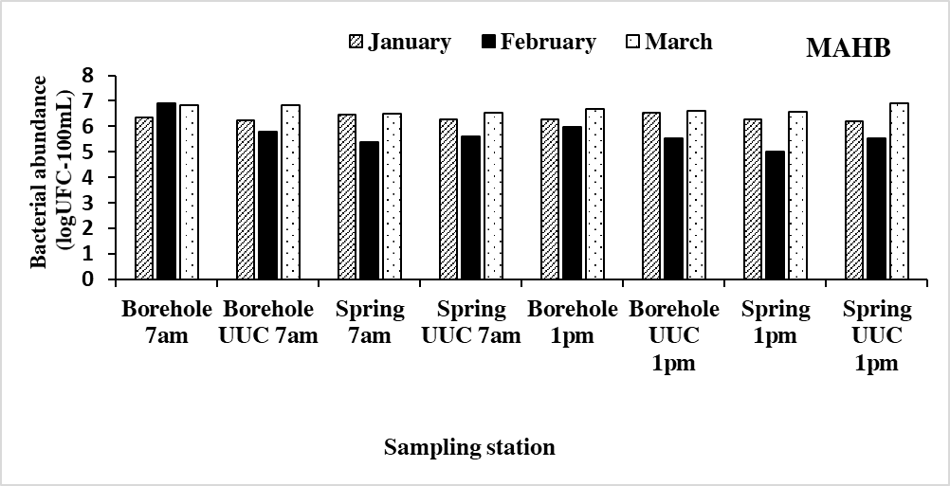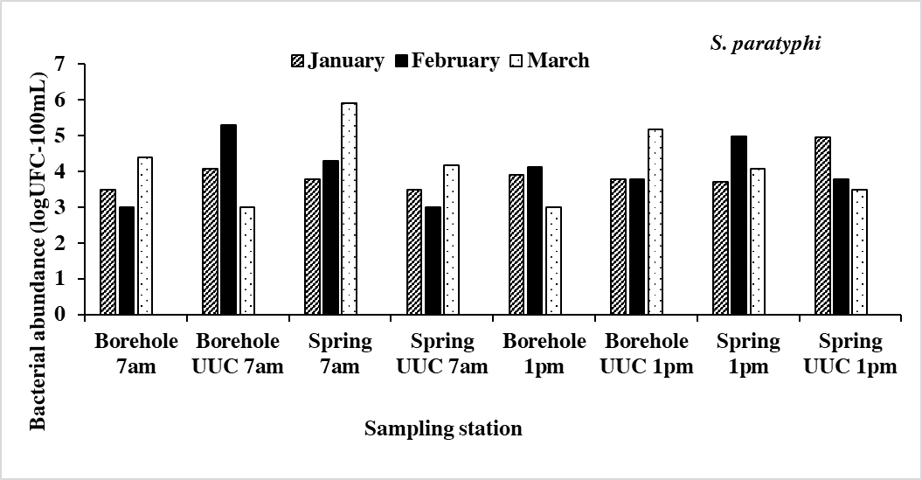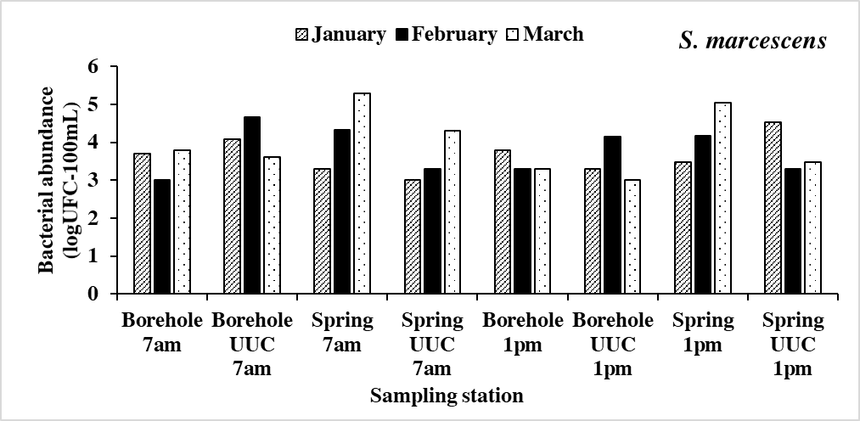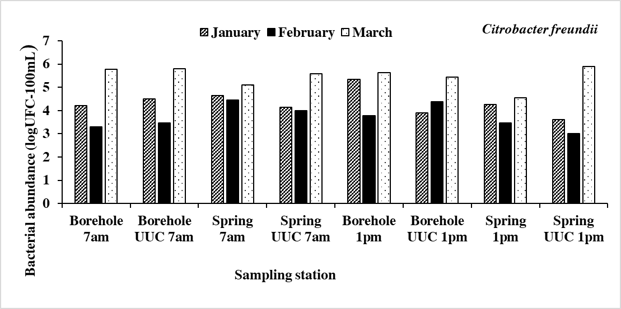
A
B
C
D

Figure 3: Spatio-temporal evolution of the abundance of bacteria isolated in the stations Borehole 7am, Borehole UUC 7am, Spring 7am, Spring UUC 7am, Borehole 1pm, Borehole UUC 1pm, Spring 1pm, and Spring UUC 1pm according to the months.

Temporal Variations in the Physicochemical Quality of Water from Supply Sources and Household Use
Physical parameters
The physical parameters considered in this study showed spatio-temporal variations overall.
Throughout the study, the water temperature varied from 25.1 to 28.2 °C with an average of 26.59 ± 0.81 °C. The highest value was recorded at station Borehole 1pm in the month of March, while the lowest value was observed at station Spring 1pm in March (Figure 4A). As for turbidity, it varied throughout the study between 0 and 5 FTU, with an average of 0.63 ± 1.31 FTU. The maximum value was observed in January at station Spring UUC 7am, while the minimum was recorded in January at stations borehole 7am, spring 7am, borehole UUC 1pm and spring UUC 1pm; in February at all stations; and finally in March at all stations except borehole 7am, spring 7am and spring UUC 1pm (Figure 4B).
Concerning total dissolved solids (TDS) recorded during the study period, values ranged from 59.2 to 125 ppm with an average of 97.59 ± 17.49 ppm. The highest value was recorded at station Borehole UUC 1pm in March while the lowest value was observed at the same station in January (Figure 4C). The color values ranged from 0 to 84 Pt.Co with an average value of 13.58± 17.75 Pt.Co. no color was observed at stations spring UCC 7am and Borehole 1pm in January and at station Spring 7am in February (Figure 4D ). With regard to suspended solids (SS) content, values fluctuated from 0 to 7 mg/L, with an average of 0.46 ± 1.47 mg/L. The maximum value was recorded at station Borehole UUC 7am in January, and the minimum value was observed at several stations in January (borehole 7am, spring 7am and borehole UUC 1pm), at all the stations in February and March (Figure 4E).
Chemical parameters
The chemical parameters considered throughout the study varied from one sampling point to another and from one month to the next. Regarding the pH, the values vary from 6,14 to 7,39 with an average of 6,76 ± 0,29. The highest pH value was at station Borehole UCC 1pm in January while the minimum value was recorded at station Spring 7am of the same month as seen in figure 5A. The electrical conductivity fluctuated between 17 µS/cm to 250 µS/cm with an average of 97,59 ± 17,49 µS/cm. the minimum value was observed at the station Spring 1pm in January while the maximum value was recorded at station Borehole UUC 1pm in March (Figure 5B).

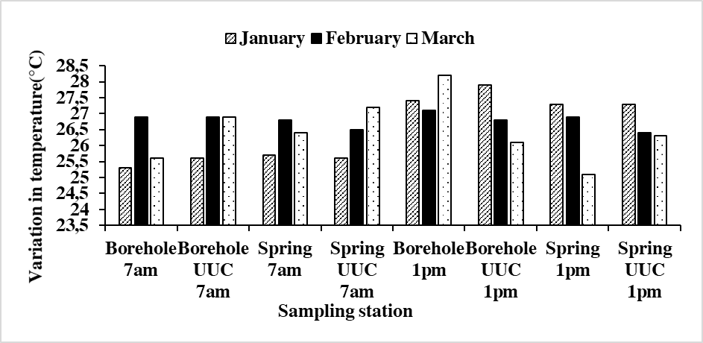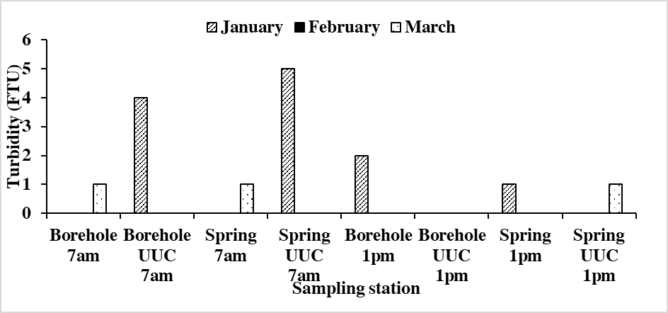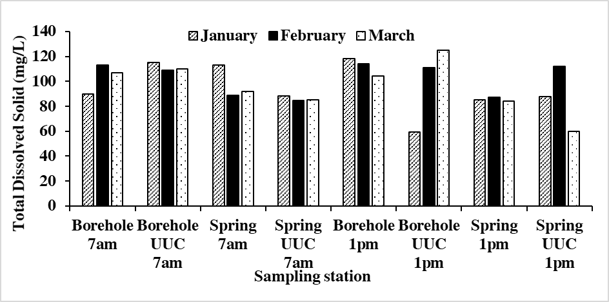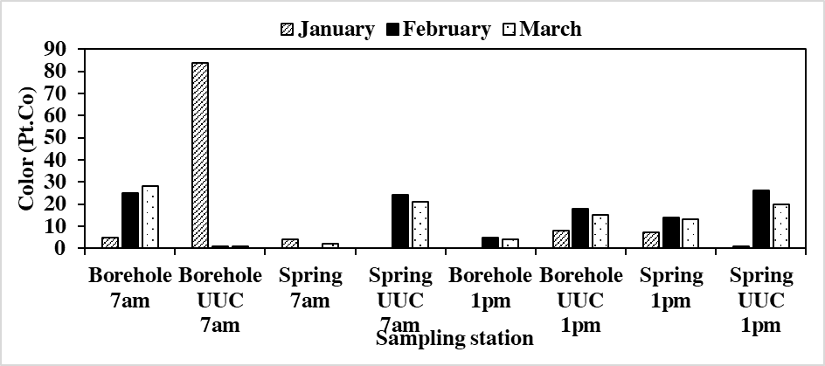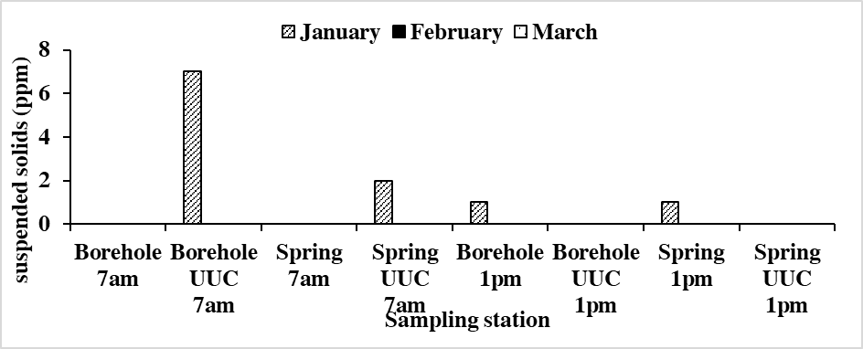
C
A
B
E
D

Figure 4: Variation of Physical Parameters Measured During the Study Period According to Stations (A): Temperature; (B): Turbidity; (C) Total Dissolved Solids (TDS); (D): Color.; (E): Suspended Solids (SS).

Orthophosphate concentrations in the water showed irregular variations, with values reaching 1.46 mg/L in February at station Borehole 1pm. The minimum value 0.11 mg/L was observed at station Borehole UUC in March with an average of 0.44± 0.39 mg/L (Figure 5C). Overall, calcium values fluctuated between 0.11 and 0.96 mg/L. The highest value was recorded at the spring UUC 7am station in January. The lowest value was obtained at the borehole 1pm station in March. However, an average value of 0.51 ± 0.27 mg/L was noted (Figure 5D).
Chlorine values fluctuated overall between 0.01 and 0.45 mg/L. The highest value was recorded at the Spring UUC 1pm station in January, and the lowest values at the Borehole 7am and Borehole 1pm stations in February and March. An average value of 0.09 ± 0.12 mg/L was observed (Figure 5F). Magnesium values ranged from 0.01 to 1.23 mg/L. They reached their maximum at the Spring 1pm station in January, and the minimum values were recorded at stations borehole 7am and borehole UUC 7am in January, Spring UUC 1pm stations in February and March. An average value of 0.27 ± 0.28 mg/L was observed (Figure 5E).
Ammoniacal nitrogen was found in trace amounts in the water, with concentrations ranging between 0. mg/L (in February and March at the Borehole 7am station) and 0.53 mg/L (in February at the Borehole UUC 7 am station). An average value of 0.08 ± 0.13 mg/L was observed (Figure 5G). Nitrate levels were highest in January at station spring UUC 7am (6.1 mg/L). The lowest value (0.02 mg/L) was recorded at the same station in February. An average value of 1.33± 1.94 Pt.Co.

Impact of Physicochemical Properties on Water Quality in Supply Sources and Households Over Time
Correlations Between Bacteriological and Physicochemical Variables
Correlations between physicochemical parameters and the densities of isolated bacteria were assessed using Spearman's rank correlation test ("r"). Overall, no correlation was observed between bacterial densities and abiotic variables.
Correlations Between Bacteriological Variables in the Water Samples Studied
Across all sampling stations, the abundance of Serratia marcescens showed a significant increase (r = 0.598) in correlation with the density of Salmonella paratyphi. Similarly, the abundance of Citrobacter freundii significantly increased (r = 0.599) in correlation with the density of Mesophilic Aerobic Heterotrophic Bacteria (MAHB), with a statistical significance of p < 0.01 (Table VI).
Table IV: Correlations Between Bacteriological Variables in the Water Samples Studied
Water samples and bacteriological variables |  | Species
Water source | Species | S. marcescens | C. freundii | S. paratyphi | BHAM
Groundwater | S. marcescens | 1,000 | 0,099 | 0,598** | -0,267
Groundwater | C. freundii | - | 1000 | -0,060 | 0,599**
Groundwater | S. paratyphi | - | - | 1,000 | -0,303
Groundwater | BHAM | - | - | - | 1,000

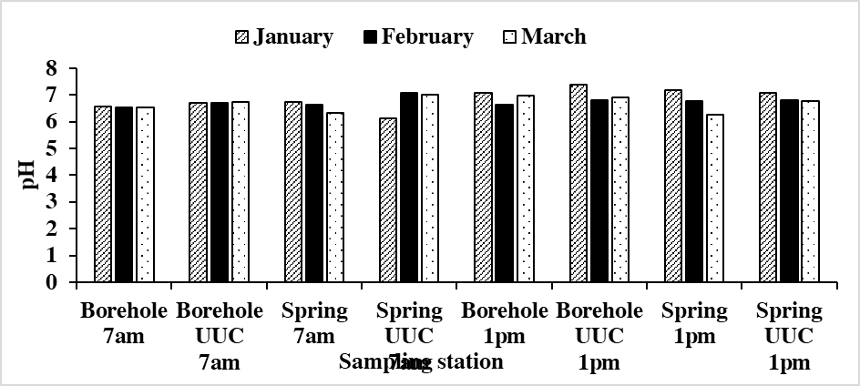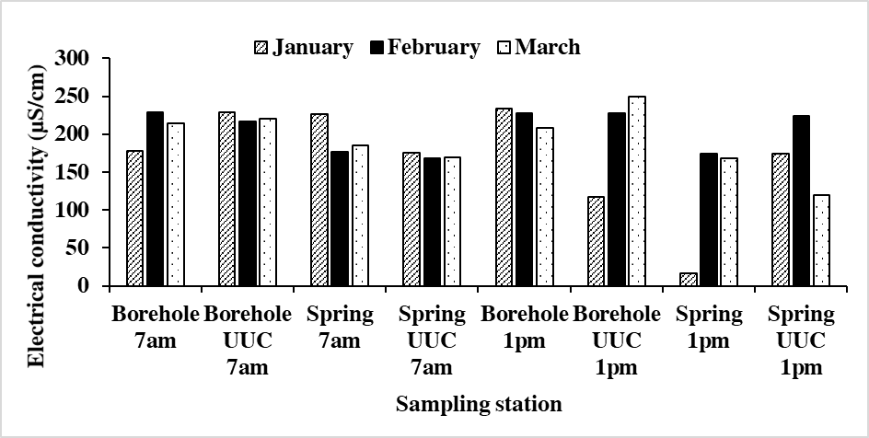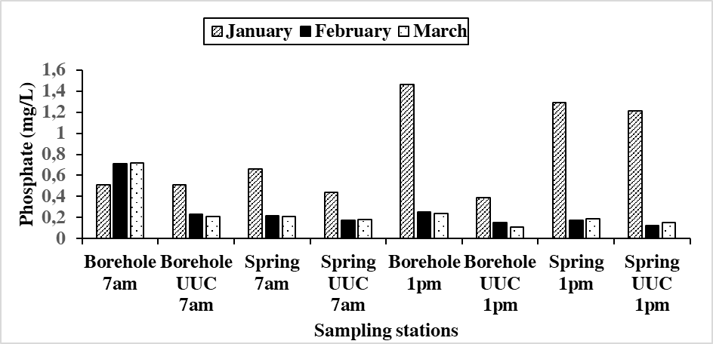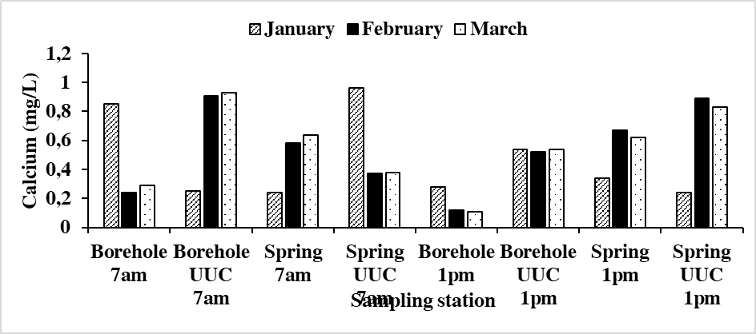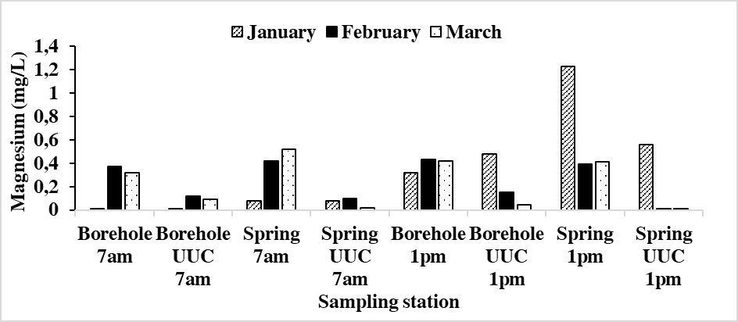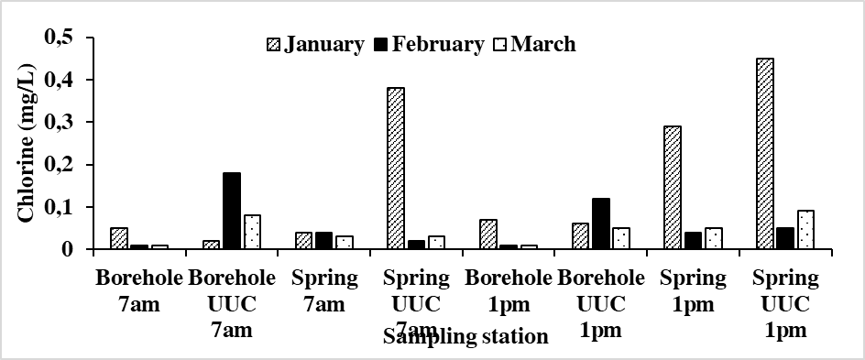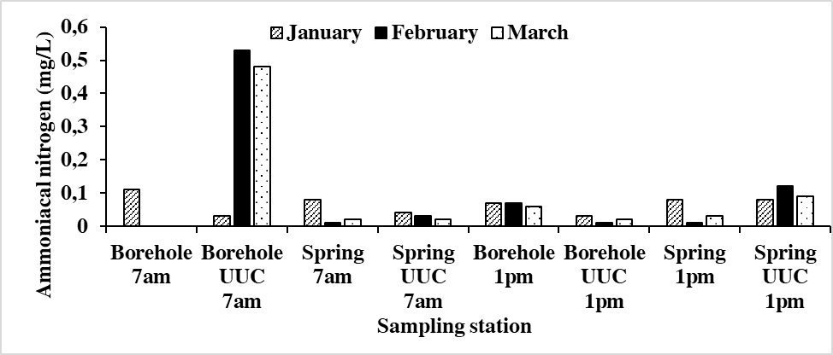
A
B
C
D
E
F
G

Figure 5: Variation of Chemical Parameters Measured During the Study Period According to Stations (A): pH; (B): Electrical conductivity; (C) Phosphate; (D): Calcium.; (E): Magnesium: (F); Chlorine: (G); ammoniacal nitrogen

Discussion

Variation of bacteriological parameters
The presence of all four bacterial indicators; MAHB, Citrobacter freundii, Salmonella paratyphi, and Serratia marcescens across all sampling stations suggests a general vulnerability of the water supply chain to microbial contamination. The fluctuations observed in bacterial abundance over the sampling period (January to March) point to both spatial and temporal influences on water quality. The consistently higher bacterial loads in spring and storage (UUC) samples, as compared to boreholes, imply a greater exposure to contamination sources, whether through environmental contact, human handling, or poor storage conditions. The elevated levels of Mesophilic Aerobic Heterotrophic Bacteria (MAHB), particularly in spring samples and household storage units, underscore the presence of organic matter and general microbial activity. Although MAHB is not directly pathogenic, it serves as a broad indicator of microbial load. Its high presence is often associated with water stagnation, poor storage hygiene, and inadequate cleaning of containers (Levallois and Levesque, 2003).
Citrobacter freundii, a facultative pathogen and indicator of environmental fecal contamination, exhibited high levels especially during January in spring water samples. This could result from runoff or direct exposure to animal or human waste, especially in communities lacking protected water sources or latrines. This observation aligns with findings by Rodier et al., who emphasize the increased risk of microbial contamination in areas with poor sanitation (Rodier et al., 2009).
The detection of Salmonella paratyphi, a known cause of enteric fevers, is of major public health concern. Its variable abundance across stations, particularly the observed peak in February in spring and UUC samples, may point to seasonal pollution events or episodic fecal contamination. According to the World Health Organization, water intended for human consumption should have zero tolerance for Salmonella (World Health Organization 2004).
Serratia marcescens concentrations were highest in UUC samples at 1 p.m., suggesting microbial proliferation during household storage. This bacterium is known for its ability to form biofilms on surfaces and grow in moist conditions, such as improperly cleaned containers. Similar findings were reported by Mouafou Tammou, who observed bacterial regrowth in groundwater stored in domestic containers due to poor hygiene and absence of regular cleaning (Mouafou Tammou, 2017).
Overall, these results highlight a progressive deterioration of bacteriological water quality from the point of collection to the point of use. This degradation is exacerbated by insufficient source protection, poor hygiene practices, and a lack of adequate sanitation infrastructure. These findings call for urgent measures including water hygiene education, regular microbiological monitoring, and the implementation of safe household storage methods to mitigate public health risks.

Variation of physicochemical parameters
The analysis of physicochemical parameters provides crucial insight into the overall water quality and its suitability for domestic use. These results are essential for understanding not only the natural variability of water properties but also the impact of human activities and storage conditions. The temperature of water samples varied across all stations and months. Spring and UUC samples tended to show higher temperatures, especially at 1 p.m., likely due to prolonged exposure to ambient conditions. The WHO recommends a temperature below 25°C for drinking water, as higher temperatures can enhance microbial growth and reduce palatability (WHO Guidelines, 2004). According to Edberg et al., elevated water temperatures can also accelerate the breakdown of chlorine residuals, potentially compromising disinfection (Edberg et al., 2000).
Turbidity showed considerable variation, with spring sources particularly at 7 a.m. in February exhibiting the highest turbidity values, reaching 5 NTU. Boreholes and UUCs generally had lower turbidity. The WHO guideline value for turbidity in drinking water is 5 NTU, above which the effectiveness of disinfection may be compromised, and aesthetic acceptability declines (WHO, 2004). Elevated turbidity is often associated with surface runoff, erosion, or resuspension of particles in unprotected water sources (Bartram and Balance, 1996). The presence of particulate matter may also shield microorganisms from disinfectants, thus increasing health risks. Total Dissolved Solids (TDS) levels in borehole water exhibiting slightly higher values, particularly in February. TDS levels were generally within acceptable WHO limits (under 500 mg/L), indicating low mineralization and minimal risk of undesirable taste or long-term health effects. However, slight differences in TDS between water collected at 7 a.m. and 1 p.m. might reflect leaching, evaporation, or container interaction during storage. According to Sawyer and McCarty, TDS levels above 1000 mg/L may lead to physiological effects, but even lower levels can influence consumer perception (Sawyer et al., 2003).
Color presented the most striking variability. The highest value was recorded in borehole UUC at 7 a.m. in February, reaching 84 Pt-Co units well above the WHO recommendation of 15 Pt-Co for drinking water (WHO, 2004). High color levels are often due to the presence of organic matter, metallic ions, or microbial pigments such as those produced by Serratia marcescens (Rodier et al., 2009). Stored water (UUC) showed consistently higher color values than source water, supporting the hypothesis that biofilm formation and organic decomposition in containers contribute to the visual deterioration of water quality (Mouafou Tammou, 2017).
The high concentration in Borehole UUC (January, 7 am) suggests possible well casing deterioration, sediment entry, or post-construction disturbances. It’s unusual for boreholes normally protected from such contamination to exhibit such elevated suspended solids levels unless structurally compromised or improperly sealed (Chapman, 1996; WHO, 2017). The general drop in values by March may be explained by a decreased sediment load due to dry season stabilization; an improved flow conditions or recharge dilution and a reduced runoff or less human activity affecting the source. The spring stations showed minimal suspended solids, likely due to natural filtration in fractured rock systems or less water stagnation. However, this can also depend on the protection of spring catchments. Elevated suspended solids reduce water clarity, affect aesthetic quality, and may harbor microbial pathogens by providing attachment surfaces (Wright et al., 2004). Though most stations remained under critical thresholds, the January peak in Borehole UUC is a red flag and suggests a possible maintenance issue or point-source intrusion.
The pH values remained between 6 and 7.5, which is within the WHO recommended range for drinking water (6.–8.5). Slight acidity was noted in spring samples at 7 am in January, while borehole values were slightly more alkaline. This near-neutral range suggests stable buffering from bicarbonates. The minor morning acidity in springs could be linked to CO₂ accumulation overnight or bioactivity, while afternoon samples stabilize as CO₂ is released (WHO, 2017). pH stability across all stations confirms general chemical safety, although acidic tendencies in some spring samples could influence corrosion and microbial growth. Electrical Conductivity readings ranged from about 120 µS/cm to 280 µS/cm, with borehole samples consistently showing higher values, especially in January. EC levels slightly declined in March. High electrical conductivity indicates greater ion concentration, typically from deeper geological interactions. Springs, fed by shallow runoff, displayed lower ion content. Similar findings are documented in peri-urban aquifers of Yaoundé, where electrical conductivity was used to trace urban pollution gradients and natural mineral loading (Noah Ewoti et al., 2022). Its variations confirm natural mineralization in boreholes. However, seasonal peaks may point to infiltration of solute-rich runoff or concentration due to reduced recharge.
Phosphate concentrations were highest in February, especially in spring samples at 1 pm, exceeding 1.5 mg/L in some stations. Boreholes maintained lower, more stable phosphate values. The February spike may stem from fertilizer runoff, detergent use, or organic waste, especially with reduced dilution during the dry season. Phosphate is a strong indicator of anthropogenic influence and can promote algal growth (Ewoti et al., 2022). Springs are vulnerable to nutrient pollution and should be prioritized for protection from domestic and agricultural contamination sources.
Calcium concentrations were generally low, between 0.2 and 1.2 mg/L, with spring water showing more seasonal fluctuation. Borehole calcium remained relatively stable. Low calcium confirms soft water conditions, which are typical of igneous or metamorphic aquifers lacking carbonate rocks. While not a direct health concern, extremely soft water may be slightly corrosive and require stabilization in distribution systems (Chapman, 1996). Water sources are chemically soft; however, seasonal variability in springs may affect pipe materials and user acceptability.
Elevated nitrate levels in February, particularly in springs, may point to surface pollution from agricultural runoff (e.g., fertilizers), latrine seepage, or organic waste, which tend to leach nitrates into shallow aquifers during the dry season (when dilution is limited). Wright et al., 2004) and Ewoti et al., 2022) both highlight nitrate as a tracer of anthropogenic pollution, especially in unprotected or surface-exposed sources. Borehole water’s relative stability is expected, as it is drawn from deeper, more protected aquifers less susceptible to direct pollution pathways (Nkeng et al., 2021).
Chloride is a conservative tracer in water and is not readily removed by natural filtration. Its elevation in springs, particularly in the dry season (February), suggests influence from wastewater discharges, domestic runoff, or latrine leaching—especially where sanitation infrastructure is poor (Chapman, 1996; Noah Ewoti et al., 2022). The pattern mirrors that of nitrate, reinforcing the likelihood of human-induced pollution in surface-connected springs. Although all chloride concentrations remained well below the WHO guideline of 250 mg/L, sudden seasonal peaks may signal contamination that can alter taste and corrosivity of water if allowed to persist. Spring protection and improved sanitation management around catchments are needed.
Ammoniacal nitrogen (NH₃-N or NH₄⁺) is typically a product of organic matter decomposition, sewage infiltration, or animal waste contamination. It can also form from urea or protein degradation in agricultural or domestic waste. The anomalous spike in Borehole UUC at 7 am in February suggests a localized pollution event, possibly from surface seepage or infiltration from a cracked casing. Although boreholes are generally protected, poor construction, maintenance issues, or proximity to latrines and septic tanks can compromise water quality (Wright et al., 2004; Chapman, 1996). The slightly higher concentrations in spring samples at 1 pm in March also suggest increased surface microbial or nitrogenous input, possibly as a result of increased microbial activity during the hotter afternoon hours. Elevated ammoniacal nitrogen levels may indicate recent organic pollution and oxygen depletion, as ammonia tends to convert to nitrates in aerobic environments. It may also indicate reduced nitrification capacity or stagnant water zones within aquifers (Noah Ewoti et al., 2022). Although concentrations remain below the WHO guideline value of 0.5 mg/L, the February exceedance warrants attention, especially since ammonia can combine with chlorine during disinfection to form chloramines, which are less effective than free chlorine and may cause taste and odor problems (WHO 2017).
CONCLUSION
At the end of this study whose objective was to examine the level of bacteriological contamination of groundwater at the point of collection and under household usage conditions in some homes in the Mendong neighborhood of Yaoundé, it would be wise to remember that in addition to the BHAM, the waters sampled in the households considered and, in the water, supply sources harbor pathogenic bacteria such as Serratia marcescens, Citrobacter freundii, and Salmonella paratyphi. The densities of these bacteria undergo overall variations depending on the time of water collection, the household, and the water source considered. The physicochemical parameters do not significantly influence the variation in the abundance dynamics of germs over the usage time of the waters. It appears overall that the analyzed waters are acidic, mineralized with a conductivity that varies from 17 µS/cm to 250 µS/cm for an average of 97.59 ± 17.49 µS/cm. The water temperature ranges from 25.1°C to 28.2°C. The mineralization of the water would be due to the presence of Cl-, Ca2+, and Mg2+ ions present in the analyzed waters. Similarly, the variation in temperature could be explained by the period of water collection.
This result suggests that the contamination may be due to storage conditions. It is therefore recommended that populations use cleaner and better (watertight and non-porous) containers and continue to treat the water regularly before use. Given this observation, it is recommended that the public authorities continue to extend the water supply to all neighborhoods and to continue informing the populations about good practices for water treatment before consumption at low costs. It is recommended for populations to use clean and suitable containers (sealed, non-porous) for water storage. To choose places that are cool and sheltered from light to limit the proliferation of germs.

REFERENCES
APHA, 2009. Standard Methods for the Examination of Water and Wastewater. America Public Health Association, APHA-AWWAWPCF (Eds.), Pennsylvania, Washington.
Baleng, Eloge Lionel Djongyang, Arnaud Wirmvem, Martha Grace Tita, and George Emile Nkeng, 2022. “Spatio-Temporal Variation of Spring Water Quality and Its Implications for Rural Water Supply in the Western Highlands of Cameroon.” Environmental Challenges, vol. 9, 2022, Article 100655. https://doi.org/10.1016/j.envc.2022.100655.
Chapman, Deborah, 1996. Water Quality Assessments: A Guide to the Use of Biota, Sediments and Water in Environmental Monitoring. 2nd ed., UNESCO/WHO/UNEP, E&FN Spon, 1996.
Delarras C., 2007. Practical microbiology for the analysis or health control laboratory. Paris: Lavoisier, 357p.
Ewoti, Olive Vivien Noah, Blandine Pulchérie Tamsa Arfao, S. D. Baleng, Luciane Marlyse Moungang, Claire Stéphane Metsopkeng, Raoul Polycarpe Tuekam‑Kayo, Yves Poutoum Yogne, D. Ebang Menye, and Moïse Nola, 2021. “Microbiological and Physicochemical Quality of Some Water Points in the Nkolafamba Subdivision (Centre Region, Cameroon).” International Journal of Biological and Chemical Sciences, vol. 15, no. 2, Apr. 2021, pp. 816–834. https://doi.org/10.4314/ijbcs.v15i2.32.
Holt J.G., Krieg N.R., Sneath P.H.A., Staley J.T. and Williams S.T.,1994. Bergey’s manual of determinative bacteriology. Williams and Wilkins. ed Philadelphia.
Lontsi Djimeli, Dieudonné C., Hilaire Nola, Olive Vivien Noah Ewoti, and Michel E. Nougang, 2018. “Evaluation of the effectiveness of plant extracts for the disinfection of groundwater intended for consumption in Cameroon.” African Journal of Environmental Science and Technology, vol. 12, no. 5, 2018, pp. 201–212. https://doi.org/10.5897/AJEST2018.2535.
Manoure Njoya, Joseph, Olive Vivien Noah Ewoti, and Hilaire Nola, 2021. “Assessment of the Efficiency of Local Coagulants in Improving Household Drinking Water Quality in Cameroon.” International Journal of Water Resources and Environmental Engineering, vol. 13, no. 1, 2021, pp. 14–24. https://doi.org/10.5897/IJWREE2021.0987.
Marchal N., Bourdon J. L. and Richard C., 1991. Culture media for the isolation and biochemical identification of bacteria. Dion-applied biology, Paris, 505 P. Mast Group, 2016b. Arginine dihydrlase (ADH) test. Manassas, Virginia, 1p.
Metsoheng, Thierry L., Hilaire Nola, Dieudonné C. Lontsi Djimeli, and Michel E. Nougang, 2019. “Impact of Traditional Household Water Treatments on Microbial Quality of Groundwater in Yaoundé, Cameroon.” Journal of Water, Sanitation and Hygiene for Development, vol. 9, no. 4, 2019, pp. 707–718. https://doi.org/10.2166/washdev.2019.101.
Mouafou Tammou, 2017. Assessment of the microbiological quality of groundwater in Soa (Cameroon). Master's thesis, University of Yaoundé I.
Moungang L. M., Nola M., Noah Ewoti O. V., Nougang M. E., Lontsi D. C., Tamsa Arfao A. et Nandjou Nguefack R.,V., 2013. Assessment of the abundance of Staphylococcus aureus and Listeria monocytogenes adhered on Granitic and Basaltic Rock-Fragments Immersed in Wells, in the Equatorial Region in Cameroon (Central Africa). International Journal of Research in Chemistry and Environment, 1 (3): 283 - 294.
Moussimba Yaka, Jean, Henri M. Nguimatsia, 2020. “Évaluation de la qualité des eaux de puits à Yaoundé VII.” International Journal of Biological and Chemical Sciences, vol. 14, no. 2.
Njine, T., D. Kemka, N. Djuikom, and N. Njikam, 2001. “Evaluation of well water quality and incidence of latrines in the city of Yaoundé (Cameroon).” African Journal of Science and Technology, vol. 3, no. 1,. 35–44.
Noah Ewoti O. V., Nola M., Moungang L. M., Nougang M. E., Krier F., and Nour-Eddine Chihib, 2012. Adhesion of Escherichia coli and Pseudomonas aeruginosa on Rock surface in aquatic Microcosm: Assessment of the influence of Dissolved Magnesium Sulfate and Monosodium Phosphate, Resources Journal of Environmental Earth Sciences.3 (4): 364-374
Nola, M., T. Ngnikam, M. Brissaud, A. Montuelle, and J. L. Bonnet, 2009. “Bacterial Contamination of Drinking Water Supplies in the Dschang Area (West Cameroon).” Science of the Total Environment, vol. 407, no. 20, 2009, pp. 5634–5638.
Noah Ewoti O. V., A. Tamsa Arfao, S. D. Balen1, L. M. Moungang1, C. S. Metsopkeng, R. P. Tuekam Kayo, Y. Poutoum Yogne, D. Ebang Menye and M. Nola. 2021b. Microbiological and physicochemical quality of some water points in the Nkolafamba Subdivision (Center Region, Cameroon). Int. J. Biol. Chem. Sci. 15(2): 816-834. http://www.ifgdg.org
Olive Vivien Noah Ewoti, Ladibé Pélagie, Luciane Marlyse Moungang, Antoine Tamsa Arfao, Baleng Samuel Davy, Raoul Polycarpe Tuekam Kayo, Ulrich Kolkossok Badouana, Yves Yogne Poutoum, Sandrine¹ Kapoho Kamdem and Moïse Nola. 2022. Relative abundance and diversity of staphylococci in some surface and underground water points in Yaoundé (Cameroon, Central Africa). World Journal of Biological and Pharmaceutical Research ; 02(01), 008-029. 10.53346/wjbpr.2022.2.1.002
Rodier ;J., Legube , B., et Merlet , N., (2009). L’analyse de l’eau. 9eme édition, DUNOD Paris, 1579.
Tabué Youmbi, Evariste, Désiré Niyitegeka, and Armel T. Kengne, 2013. “Groundwater pollution in the Mingo’o watershed (Yaoundé, Cameroon).” Comptes Rendus Biologies.
Tambekar, D. H., S. R. Hirulkar, and V. B. Gulhane, 2012 “Improving household water quality through sanitary interventions in storage practices.” Journal of Water and Health, vol. 10, no. 1.
Tuekam Kayi, Cedric S., M. G. Tita, J. T. Sumo, G. E. Nkeng, and L. Njualem, 2021. “Water Quality in Storage Containers and Its Health Implications in Bamenda, North West Region of Cameroon.” African Journal of Environmental Science and Technology, vol. 15, no. 1, 2021, pp. 15–24. https://doi.org/10.5897/AJEST2020.2961.
World Health Organization (WHO), 2022. Drinking-Water, https://www.who.int/news-room/fact- sheets/detail/drinking-water.
Wright, Jim A., Stephen Gundry, and Ronan Conroy, 2004. “Household drinking water in developing countries: a systematic review of microbiological contamination between source and point-of-use.” Tropical Medicine & International Health, vol. 9, no. 1, pp. 106–117.

