Original Research Article
Evaluation of candidal species in Oral Submucous Fibrosis and Oral Lichen Planus: a Microbiological study.

ABSTRACT
Background: Candida is opportunistic microorganisms in oral cavity, causes oral candidiasis. The presence of candida and subspecies in oral premalignant lesions may intensify the infection and transform pre malignant lesions into cancer.
Objective-To isolate various types of candida species, among Oral submucous fibrosis (OSMF) and Oral lichen Planus (OLP) patients.
Methodology: Total 60 individuals included and grouped as; OSMF (n=20) group A, Lichen Planus (n=10); group B and Controls (n=30) group C.
Results: The higher candida carriage revealed in OSMF+ OLP groups (23.3%) as compared to controls (10%).The species level findings showed 13.3% of candida albicans in OSMF+ OLP and 6.7% in controls, candida krusei 6.7% in OSMF+ OLP and 3.3% in controls and non candida albicans were 10% in OSMF+ OLP and 6.7% in control group respectively.
Conclusion: This basic understanding of candida species and their association with potentially malignant disorders will help in better interventions, so as to restrict the lesion before it transform in to malignancy.
Key words: Candida, Oral submucous fibrosis, Oral lichen planus, Oral cancer, Infection

INTRODUCTION
Oral candidiasis is an infection of the oral cavity, first documented in 1838 by paediatrician Francois Veilleux. Often referred to as "thrush," this opportunistic fungal infection typically affects the oral mucosa. ¹ The ‘Candida albicans” is a part of oral flora and an opportunistic pathogen is main causative agent². The ability of C. albicans to colonize, penetrate and damage host tissues depends on an imbalance between C. albicans virulence factors and host defence ³.Combining a Candida causative agent in the mouth with epithelial alterations such atrophy, hyperplasia, and dysplasia can result in candida infection, which compromises the mucosal barrier and allows candidal invasion.^{4,5} Some strains of Candida with high nitrosamination potential were isolated from lesions with advanced precancerous changes. Nitrosamines and N-nitrosobenzylmethylamine are two examples of the carcinogenic substances that Candida can produce. In such cases candida yeast cells non pathogenic form transform into pathogenic hyphae extends from the mucosal surface to the deeper epithelial cell layers representing transport and deposition of precursors like nitrosamines to deeper layers. This showed that certain strains of C. albicans play a key role in the development of dysplasia.⁶ Therefore candida may have a role in the etio-pathogenesis of oral premalignant lesions such as oral lichen planus (OLP) and oral submucous fibrosis (OSMF).
Oral submucous fibrosis (OSMF), the most common occurring potentially premalignant oral epithelial lesion is a chronic disorder linked with areca nut chewing. It has a relatively high potential for malignant transformation resulting in oral squamous cell carcinoma (OSCC), the most prevalent oral malignancy with a high mortality rate.⁷Paymaster reported the malignant potential of OSMF in 1956, rate of this condition has been estimated to be 7-13% with younger age groups being affected, due to alterations in habit patterns. Which lists it as one of the highly significant oro-facial healthcare issues due to chewing areca nut as a potentially malignant disease.⁸ According to WHO this is "a generalized pathological state of the oral mucosa associated with a significantly increased risk of cancer.⁹ Despite of advancing field of healthcare technology, it shows a gradual increase in graphs. This shows varied clinical presentations including; burning sensations, blanching of oral mucosa, reduced mouth opening, and decreased salivary flow rate.⁵
Lichen planus is a chronic inflammatory and autoimmune mucocutaneous disease which frequently involves the oral mucosa, that affects 1–2% of the population frequently in the fourth decade of life and affects women more than men in a ratio of 1.4:1.^{10,11}The term lichen planus (LP) stems from the Greek word “leichen,” which means “tree moss and the Latin word “planus,” which means “flat,” The term is derived from word “Lichen” which means primitive plants composed of symbiotic algae & fungi. The word ‘Planus” is Latin word which means flat. The exact cause of LP is unknown; but is thought to be an immunologically mediated disorder. An immune response presumably mediated by CD4+ and CD8+ T lymphocytes appears to develop in the oral mucosa, which produces cytokines such as interleukin-2 and tumour necrosis factor (TNF) and induces a chronic inflammatory response and apoptosis of keratinocytes. This is clinically characterized by a bilateral and symmetrical distribution, mainly affecting the buccal mucosa, the tongue, and gingiva. According to Anderson’s clinical classification distinguishes between six clinical forms: Reticular, atrophic, erosive, papular, plaque, and bullous.⁵
Materials and Method
This case-control study was conducted in the Department of Oral & Maxillofacial Pathology and Microbiology at a Dental college in (M. P.) India. The patients who visited at study centre were screened for potentially malignant disorders. A total number of 60 individuals were included of which 30 individuals had clinically diagnosed as oral ‘potentially malignant disorders’ (OPMDs), (OSMF, n=20, group A, Lichen Planus, n=10, group B) and controls (Normal, n=30, group C). Detailed clinical history and oral examinations of all the individuals with consent were carried out using diagnostic instruments. Saliva sample using a cotton swab was obtained from the representative site of OPMDs and control group patients. Selection of desired samples was done by using simple random sampling technique according to inclusion-exclusion criterion’’ and obtained data of result is analysed statically.
INCLUSION CRITERIA:
- Age group, 20-80 year
- Gender, both males and females
- Clinically diagnosed cases of Potentially Malignant Disorders such as Oral Submucous Fibrosis and Oral Lichen Planus.
EXCLUSION CRITERIA:
- Patients already on Anti-Fungal therapy.
- Patients with history of cardiac disease, diabetes, pregnant females, critically ill patients, mental disorders and other systemic illness.
Saliva Sample and Microbiological Parameters:
Saliva was collected using a sterile cotton swab from the representative site of OPMDs, control group patients and inoculated on media CHROME CANDIDA DIFFERENTIAL AGAR (Manufactured by- Himedia Laboratories, Mumbai)and plates were incubated in incubator for 48 hours at 37°C.It is a selective medium to differentiate c. albicans and non albicans species based on the colony colour. Media composition included (Peptic digest of animal tissue, Peptone special15gms/l, Malt extract, Dipotassium hydrogen posphate1.0gms/l,Yeast extract 4.0gms/l,Glucose,Chloramphenicol0.5gms/l,Chromogenic,mixture7.2gms/l,Agar15.0gms/l,Final pH (at 25°C)6.3_+ 0.2gms/l).42.72 grams of dehydrated media was weighed on digital weighing machine and suspended in 1000 ml of distilled water. It was heated to boiling to dissolve the medium completely. Autoclaving is not required. The media was cooled to 50°C and poured into sterile Petri plates.
PRINCIPLE
Perry and Miller reported that Candida albicans produces an enzyme b –N acetyl- galactosaminidase and according to Rousselle et al incorporation of Chromogenic or fluorogenic hexosaminidase substrates into the growth medium helps in identification of C.albicans isolates directly on primary isolation.
List 1 : Demonstration of Colony colour shown By Candida Species OnChromagar Media

 | Candida Species |  | Colour of the colony on CHROM Agar
Candida albicans |  | Light green
 | Candida parapsilosis |  | Cream colored
 | Candida tropicalis |  | Blue with pink halo
 | Candida krusei |  | Pink
 | Candida glabrata |  | Purple
 | Candida dubliniensis |  | Dark green
Demonstration of morphological parameters
C. albicans and C. dublinensis have capacity to create morphological traits known as chlamydospores (filamentous, cylindrical germ tube )were assessed using the germ-tube test, which is the standard laboratory method to identify and differentiate the C. albicans from other species. The test involves the induction of hyphal outgrowths (germ tubes) when subcultured in horse serum at 37◦C for 2– 4 hours. Approximately 95% of C. albicans isolates produce germ tubes. All strains of C. albicans are positive in this test and no other commonly encountered species demonstrate this reaction for C.albicans and C. dublinensis. Sample showing such germ tube was considered as positive. Samples showing absence of germ tubes or formation of germ tubes with constricted base were considered negative.

Sugar Assimilation Tests.
After application of Germ tube test, the isolates were further subjected to Sugar assimilation tests. The capacity of the sugar assimilation test to assimilate various sugars for their growth was also evaluated. The growth indicates the organism's capacity to assimilate a certain type of carbohydrate found in the disc. The lack of growth surrounding the disc indicated that the organism was unable to utilize the sugar for growth. The Positive result indicates growth near or around a particular carbohydrate differentiation disc, while Negative result shows no growth near or around a particular carbohydrate differentiation disc.
Final identification of the species was done on the basis of all above tests.
Antifungal susceptibility of each isolated species was done using disc diffusion method and for this antifungal disc (Himedia Laboratories) were used.
List 2 : Antifungal susceptibility
DRUG | CONCENTRATION | MINIMUM ZONE OF INHIBITION
Nystatin | 100 units/disc | 19-27 mm
Amphotericin B | 100 units/disc | 10-17 mm
Fluconazole | 10µgm/disc | 27-38 mm
Clotrimazole | 10µgm/disc | 18-32 mm
Media used for antifungal susceptibility testing was Muller Hinton agar with methylene blue for inhibiting bacterial growth. Zone of inhibition refers to the area around the drug discs where the micro-organism is unable to grow. The candida isolates showing zone of inhibition more than the above minimum zone of inhibition values were considered as sensitive to the particular antifungal drug. Those isolates of candida which were showing lesser zone of inhibition than the above mentioned values were considered to be resistant.
RESULTS
The study included 60 subjects, 20 (33.3%) subjects were patients of OSMF, 10 (16.7%) patients had oral lichen planus and 30 (50.0%) subjects were healthy controls. [Figure 1]
Figure1. Distribution of study subjects based on clinical types of OSMF & OLP.
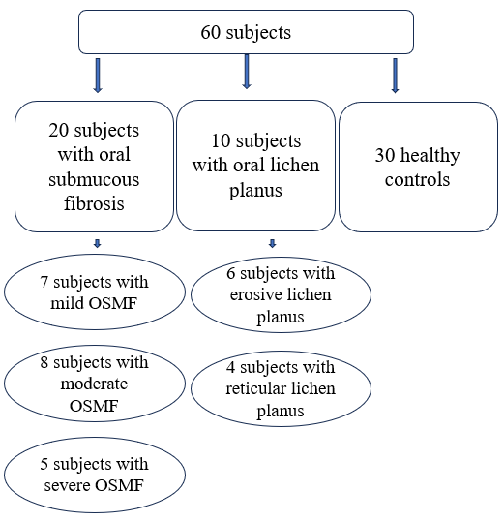

The majority (31.7%) of the subjects belonged to the age group of 41-50 years of age
[Figure 2].
Figure2. Distribution of study subjects based on age.
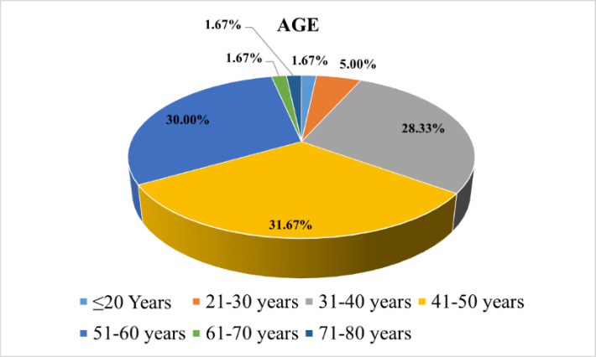

The mean age of all subjects was 45.0±10.623 years. The mean age of the subjects in the OSMF+OLP group and control group was 43.6±11.955 years and 46.66 ± 9.084 years respectively. The difference in the mean age of the subjects belonging to 2 groups was statistically non-significant (p-value= .306). Male preponderance was observed among the study subjects [male vs. female= 44 (73.3%) vs.16 (26.7%)]. However, there was no significant difference in the proportion of males and females between the two groups. The male vs. female percentage in OSMF + OLP group was 83.3% vs. 16.7% and in the control group was 63.3% vs. 36.7% [Chi-square value= 3.068, df-1, p-value= .080].
Among the study subjects, smoking prevailed among 22 (36.7%) subjects and smokeless
tobacco consumption was prevalent among 40 (66.7%) subjects. Among all the subjects with OSMF and OLP, buccal mucosa was involved.
Histopathologically, among the patients of OLP (n=10), 60.0% (6/10) had erosive lichen planus and 40.0% (4/10) had reticular lichen planus. Among the patients with OSMF (n=20), 7 (35%) patients had mild, 8 (40%) patients had moderate, and 5 (25%) patients had severe OSMF. [Figure 1]
The culture report was positive for 10 (16.7%) subjects. A greater proportion of subjects in the OSMF + OLP group had positive culture reports compared to the control group, however, the difference was statistically non-significant (p-value>.05).[Table1&Figure3]
Table1. Comparison of culture report between subjects belonging (OSMF+OLP) and Control groups.
Culture report | Oral lesion or condition |  | Total | Chi-square value | Df | p-value
Culture report | OSMF + OLP  (n=30) | Control  (n=30)
Positive | 7 (23.3%) | 3 (10.0%) | 10 (16.7%) | 1.920 | 1 | .166
Negative | 23 (76.7%) | 27 (90.0%) | 50 (83.3%) | 1.920 | 1 | .166

Figure3. Comparison of culture report between subjects belonging (OSMF+OLP) and Control groups.
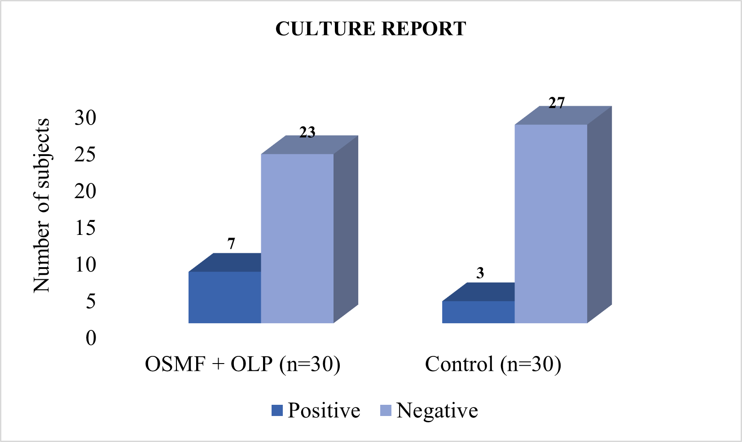
On further comparing two groups with respect to various types of candida species, it was found that no specific candida species were significantly associated with either OSMF+OLP (p-value >.05). [Table 2& Figure4]
Table2. Different types of candida species and their association among OSMF+OLP and Controls.
 | OSMF + OLP | Control | Total | Chi-square value | Df | p-value
Candida albicans | 4 (13.3%) | 2 (6.7%) | 6 (10.0%) | .741 | 1 | .389
Candida tropicalis | 0 (0.0%) | 0 (0.0%) | 0 (0.0%) | - | - | -
Candida dubliniensis | 0 (0.0%) | 0 (0.0%) | 0 (0.0%) | - | - | -
Candida krusei | 2 (6.7%) | 1 (3.3%) | 3 (5.0%) | .351 | 1 | .554
Candida parapsilosis | 0 (0.0%) | 1 (3.3%) | 1 (1.7%) | 1.017 | 1 | .313
Non-candida albicans | 3 (10.0%) | 2 (6.7%) | 5 (8.3%) | .218 | 1 | .640

Figure 4. Different types of candida species and their association among OSMF+OLP and Controls.
.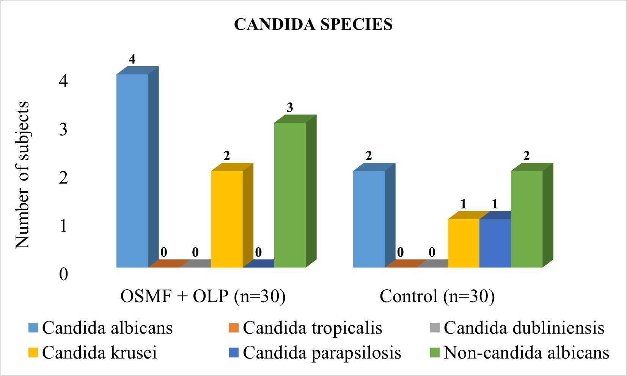
DISCUSSION:
Presently there is increasing importance and interest in Oral Candida infections and their role in oral cancer. It has been matched by an increasing number of publications related to this topic appearing in the world medical literature. But still very few studies have been undertaken till date to assess the association of candida with oral potentially malignant disorders of oral mucosa such as OSMF and OLP to the level of species identification. Till now research has largely focused on studying candida albicans but very infrequently non-candida albicans species. Various studies performed have shown rather wide range of similarities in results. Some have reported insignificant association of candida in OLP and OSMF, while few have reported significant associations.
Today, for diagnosis of oral candidiasis, very limited laboratory tests available and they are not always performed. A presumptive diagnosis is often made, based on the patient’s history, clinical presentation, and response to antifungal treatment rather than on cultural and histological methods Gonsalves et al.2008.¹² However, especially in critical patients, the characterization of yeast infection is important when choosing the appropriate therapy. Therefore, in precancer patients, the diagnosis of oral candidiasis should always be performed. Epithelial changes such as atrophy or dysplasia could improve after elimination of Candida species, and resolution of infection can prevent more aggressive candidiasis after radio-chemotherapy. According to Galle et al .2013.¹³ microbiological analysis is a reliable method to access the presence of candida species in advance and possibly establish a treatment for precancerous lesions on basis of antifungal susceptibility patterns shown by isolated organisms.
The purpose of this study was to isolate and identify various candida species, their confirmation up to species level by various microbiological methods and to evaluate its occurrence among the patients of oral potentially malignant disorders of oral mucosa such as OSMF and OLP.
In our study higher candida carriage was revealed in OSMF+ OLP patients (23.3%) were revealed higher as compared to controls (10%); (Table 1& Figure 3). Our findings were in accordance with findings of Anila et al.2011, Ariyawardana A,2007, Kumar et al.,2009.^{14,15,16} According to Ariyawardana A,2007 clinical candidal carriage of OSMF was (63.6%) and controls showed (50%)¹⁵ and findings of Kumar et al.2009 showed 40% and 15% respectively.¹⁶ Mehdipour et al. 2010 studied candidal carriage in oral lichen planus and found higher levels as compared to controls.¹⁷ The isolation of candida at species level has performed in limited studies, but our findings have similarities with findings of Kumar et al.,2009 and Dixit et al^{16,18} which shows the association between different types of candida species ( candida albicans + non candida albicans) and occurrence of OSMF+OLP ( Table 2, figure 4).
We also observed different species of candida as follows; candida albicans [OSMF+ OLP (13.3 %) ,control ( 6.7%)] , candida krusei [OSMF+ OLP (6.7%) ,control ( 3.3%)] and non candida albicans [OSMF+ OLP (10.0%) ,control (6.7%)] (Table2 & Figure4). These findings are in accordance to studies by Ariyawardana A, 2007¹⁵, Kumar et al.,2009¹⁶ and Galle et al .,2013¹³. In one study we use the germ tube test as sole method for identification and differentiate candida albicans from other species. On the basis of our above findings in OSMF+ OLP compared with control group, increased candida carriage in OSMF and OLP implies that alteration in the overlying epithelium would breach the physiological barrier, thereby favouring a conductive microenvironment that eventually increases the colonization of candida which might indicate an increased risk of developing cancer due to the inflammation and immune response triggered by the Candida overgrowth, which can promote the development of cancerous cells. Thus our study focuses on precancerous states prior to transform in malignancy, so as to strengthen further interventions.
CONCLUSION
Assessment of Candida organisms in precancerous lesions in the oral cavity is important for several reasons such as; association with oral cancer risk and indicator of local immune response. Later can also contribute to the persistence of precancerous lesions and increase the risk of malignant transformation by altering microenvironment of the oral mucosa to promote cancer development and progression. Timely therapeutic considerations of antifungal therapy can be useful to manage candida colonization to restrict further progress of precancerous lesions. So overall this provides insights into the local immune response, tissue microenvironment, and potential risk of malignant transformation, guiding therapeutic decisions and improving patient outcomes.

REFERENCES
- Vila, T., Sultan, A. S., Montelongo-Jauregui, D., & Jabra-Rizk, M. A. (2020). Oral candidiasis: A disease of opportunity. Journal of Fungi(Basel,Switzerland), 6(1), 15. doi:10.3390/jof6010015
- More, C., Peter, R., Nishma, G., Chen, Y., & Rao, N. (2018). Association ofCandidaspecies with Oral Submucous Fibrosis and Oral Leukoplakia: A Case Control study. Annals of Clinical and Laboratory Research, 06(03). doi:10.21767/2386-5180.100248
- Mohd Bakri, M., MohdHussaini, H., Rachel Holmes, A., David Cannon, R., & Mary Rich, A. (2010). Revisiting the association between candidal infection and carcinoma, particularly oral squamous cell carcinoma. Journal of Oral Microbiology, 2(1), 5780. doi:10.3402/jom.v2i0.5780
- Sitheeque, M. A. M., & Samaranayake, L. P. (2003). Chronic hyperplastic candidosis/candidiasis (candidal leukoplakia). Critical Reviews in Oral Biology and Medicine: An Official Publication of the American Association of Oral Biologists, 14(4), 253–267. doi:10.1177/154411130301400403
- Gupta, B., Chandra, S., Raj, V., & Gupta, V. (2015). Comparison of salivary flow and candidal carriage in patients with oral submucous fibrosis. Journal of Oral and Maxillofacial Pathology: JOMFP, 19(2), 158–163. doi:10.4103/0973-029X.164526
- O’Grady, J. F., & Reade, P. C. (1992). Candida albicans as a promoter of oral mucosal neoplasia. Carcinogenesis, 13(5), 783–786. doi:10.1093/carcin/13.5.783
- Phulari, R. G. S., & Dave, E. J. (2020). A systematic review on the mechanisms of malignant transformation of oral submucous fibrosis. European Journal of Cancer Prevention: The Official Journal of the European Cancer Prevention Organisation (ECP), 29(5), 470–473. doi:10.1097/CEJ.000575
- Jha, V. K., Kandula, S., NingappaChinnannavar, S., Rout, P., Mishra, S., &Bajoria, A. A. (2019). Oral submucous fibrosis: Correlation of clinical grading to various habit factors. Journal of International Society of Preventive & Community Dentistry, 9(4), 363–371. doi:10.4103/jispcd.JISPCD_92_19
- Singh, A., Pandey, A., Sharma, N., Dhiman, N., Jaiswara, C., Tiwari, P., … Singh, S. (2020). Comparative evaluation of buccal pad of fat with and without bovine collagen membrane in the management of oral submucous fibrosis:A prospective clinical study. National Journal of Maxillofacial Surgery, 11(1), 57. doi:10.4103/njms.njms_70_19
- Boorghani, M., Gholizadeh, N., TaghaviZenouz, A., Vatankhah, M., &Mehdipour, M. (2010). Oral lichen planus: clinical features, etiology, treatment and management; a review of literature. Journal of Dental Research, Dental Clinics, Dental Prospects, 4(1), 3–9. doi:10.5681/joddd.2010.002
- Lavanya, N., Jayanthi, P., Rao, U. K., & Ranganathan, K. (2011). Oral lichen planus: An update on pathogenesis and treatment. Journal of Oral and Maxillofacial Pathology: JOMFP, 15(2), 127–132. doi:10.4103/0973-029X.84474
- Gonsalves, W. C., Wrightson, A. S., & Henry, R. G. (2008). Common oral conditions in older persons. American Family Physician, 78(7), 845–852. Retrieved fromhttps://www.ncbi.nlm.nih.gov/pubmed/18841733
- Gall, F., Colella, G., Di Onofrio, V., Rossiello, R., Angelillo, I. F., & Liguori, G. (2013). Candida spp. in oral cancer and oral precancerous lesions. The New Microbiologica, 36(3), 283–288. Retrieved from https://www.ncbi.nlm.nih.gov/pubmed/23912870
- Anila, K., Hallikeri, K., Shubhada, C., Naikmasur, V. G., & Kulkarni, R. D. (2011). Comparative study of Candida in oral submucous fibrosis and healthy individuals. RevistaOdontoCiência, 26(1), 71–76. doi:10.1590/s1980-65232011000100016
- Ariyawardana, A., Panagoda, G. J., Fernando, H. N., Ellepola, A. N. B., Tilakaratne, W. M., & Samaranayake, L. P. (2007). Oral submucous fibrosis and oral yeast carriage - a case control study in Sri Lankan patients. Mycoses, 50(2), 116–120. doi:10.1111/j.1439-0507.2006.01330.x
- Kumar, R. S., Ganvir, S., &Hazarey, V. (2009). Candida and calcofluor white: Study in precancer and cancer. Journal of Oral and Maxillofacial Pathology: JOMFP, 13(1), 2–8. doi:10.4103/0973-029X.44575
- Mehdipour, M., TaghaviZenouz, A., Hekmatfar, S., Adibpour, M., Bahramian, A., &Khorshidi, R. (2010). Prevalence of Candida species in erosive oral lichen planus. Journal of Dental Research, Dental Clinics, Dental Prospects, 4(1), 14–16. doi:10.5681/joddd.2010.004
18. Dixit S, Goswami S, Dive A. Determination, distribution & phenotypic differentiation of Candida : Study in oral precancer and oral cancer. Indian Journal of Dental Research and Review. 2012

