An Explainable XGBoost Framework for Detecting Fraudulent Financial Transactions

ABSTRACT
Detecting financial fraud is still one of the most urgent concerns in digital finance, thanks to the highly imbalanced and even changing nature of transactions. The new research introduces an explainable machine learning framework that leverages the eXtreme Gradient Boosting (XGBoost) algorithm to detect fraudulent activities over a very vast financial dataset. The dataset was built up of more than 280,000 transactions that have been described using anonymized numerical attributes (V1–V28), the amount of the transaction, and a binary class label based on whether the activity is legitimate or fraudulent. Exploratory data analysis detected a considerable class imbalance as fraudulent transactions represented less than 1% of the overall transactions. The XGBoost model not only reached a ROC-AUC score of 0.975 but it also attained a total accuracy of 100%, thus, through its precision and recall, it was able to differentiate between fraudulent and non-fraudulent activities. The analysis of feature importance revealed that the most significant predictors of fraud were the latent variables V14, V10, and V4. The framework presented points out the power of decision trees that are enhanced by gradient boosting in the area of financial crime detection and it also gives interpretable insights about the influence of different variables. The project has made a significant contribution to the field of XAI-based applications in financial crime prevention.

Keywords: Fraud detection, XGBoost, Machine Learning, Financial Transactions, Feature Importance, Explainable Artificial Intelligence (XAI), Imbalanced Data, ROC-AUC
- Introduction
The last few years have seen the massive growth of digital financial services coupled with the huge amounts of data generated by high-volume transactions, which is the reason why financial institutions are continuously in search of more powerful detection tools when it comes to fraud. The traditional rule-based fraud detection systems have often been unable to deal with the evolving fraud tactics and the enormous volume of data, leading to continual losses and increased operational risk. The machine-learning (ML) method has come out as a very strong competitor, as it has the capability of learning the complicated behavioral patterns of transactions, and even more, it can adjust to the new types of anomalies (Hernandez Aros et al., 2024). Among the different ML techniques, the use of ensemble methods like gradient-boosted decision trees, specifically the eXtreme Gradient Boosting (XGBoost) algorithm, has been very successful in dealing with imbalanced, high-dimensional fraud datasets (Chen et al., 2020). One of the main reasons why ML is not yet widely used in financial operations is the issue of model interpretability; that is, if detection accuracy is a must, then regulatory compliance and stakeholder trust expect the revealing of the ways of making predictions. Among the different studies conducted, some have pointed to a trend of explainable artificial intelligence (XAI) frameworks being used in fraud detection, where feature importance and the decision-path insights not only provide model accountability but also at the same time improve the model’s usability (Alwadain et al., 2023). In this paper, we put forward a machine learning-based fraud detection framework that utilizes XGBoost and a feature importance analysis to ensure high predictive power while also being interpretable. The framework is tested on a dataset of real-world credit card transactions that is marked by extreme class imbalance, and we are going to look into the patterns and features that are most likely to indicate fraud.
2. Literature Review
2.1 Evolution of Machine Learning in Financial Fraud Detection
The journey of machine learning in financial fraud detection has been nothing short of a revolution, going from static and rule-based systems to dynamic and data-driven models which could detect even the smallest and most complex fraud patterns that are changing over time. Previously, the financial organizations made use of rules that were set up beforehand like transaction limits, mismatch of locations, or frequency thresholds to indicate a behavior that could be suspicious. These systems, though somewhat effective, were very rigid by nature and hence, were not able to spot the novel or sophisticated frauds that evolved along the digital payment technologies. The increase in global transaction volumes and the parallel increase in the complexities of the strategies used by cybercriminals showed the inadequacy of rule-based detection and thus led to the demand for intelligent systems which were able to learn from data and adapt to the changing landscapes of fraud. Machine learning was a strong weapon that came to the rescue. It was the real original behind the scenes and the models were as smart as a human detective in pointing out the correlations and hidden anomalies in the huge and diverse financial datasets. The algorithms such as decision trees, random forests, and neural networks, through the analysis of millions of transactional records, can tell apart the legitimate and fraudulent activities with a greater level of accuracy. Moreover, the most critical point is that these models keep getting better every time they see more data and that is why they are very much needed in the fight against fraud which is dynamic in nature. Further, the combination of unsupervised anomaly detection and supervised classification techniques has increased their strength even more and institutions have gained the ability to manage inaccuracy, interpretability, and scalability in the real-world applications (Ngai et al., 2011).
2.2 Credit Card Fraud and Imbalanced Data Challenges
Fraud detection has one major obstacle which is the extremely imbalanced character of credit card datasets where fraudulent activities make up only a negligible percentage of total transactions. Such an extreme imbalance often misinterprets the classification models as they get lopsided towards the majority class (legitimate transactions), which results in very low sensitivity towards rare but critical fraud cases. The traditional machine learning algorithms may show high overall accuracy when trained on this kind of skewed data; however, this is at the cost of not being able to detect minority fraud class thus, hindering their practical reliability. Consequently, a plethora of imbalance-handling strategies has been suggested by researchers such as data resampling, cost-sensitive learning, and anomaly detection methods giving preference to minority-class precision. In addition, the financial data's dynamic and temporal characteristics pose even more difficulties since transaction patterns can change swiftly, influenced by factors such as season, region, or technology. This shift may worsen the class imbalance situation and will consequently require continuous model retraining and adaptive learning approaches to keep up with the performance in real-time fraud detection systems (Dal Pozzolo et al., 2015).

2.3 Credit Card Fraud and Imbalanced Data Challenges
One of the factors that has persistently hindered credit card fraud detection is the stark difference in the volume of legitimate transactions and fraudulent ones. In many of the real-world datasets, the fraudulent activities constitute less than one percent of the total records, thus causing a drastic skew which makes it difficult to train and evaluate the models. Standard machine learning methods, which are based on the assumption of a balanced distribution of classes, will typically go for the majority class prediction as that is the one that will bring their total error down to the least and hence, a misleadingly high accuracy is generated, which however, in reality, does not mean good fraud identification capability. Therefore, the models would manage to rightly categorize almost all the legitimate transactions and at the same time miss out on the very few but financially significant fraudulent ones, thus making their application in the real world practically impossible. The researchers have come up with different ways to help get rid of this imbalance, for instance, taking up the less frequently occurring class, cutting down on the more frequently occurring class, and making use of synthetic data generating methods such as SMOTE (Synthetic Minority Over-sampling Technique). The cost-sensitive learning technique has proved to be effective because with it the misclassification of a fraudulent transaction is punished more than that of a legitimate one, thus bringing the model’s optimization goal in line with the real financial risk. Also, the use of anomaly detection methods whereby they consider fraud as being statistical outliers makes them fit for rare-event modeling even in highly imbalanced scenarios. On top of the numerical imbalance, the fraud data also comes with the concept drift challenge, where the behavior of the transactions changes over time due to the alteration of the user habits, introduction of new payment methods, and use of adaptive fraud strategies. Hence, the models trained on the historical data may experience a decline in performance once they are are exposed to the new fraud patterns. Continuous learning and adaptive model updating have therefore become crucial to maintain detection performance over time (Dal Pozzolo et al., 2015). The combination of these challenges underscores the importance of using robust algorithms like XGBoost that can handle both imbalance and dynamic data environments effectively.
2.4 Feature Engineering and Model Explainability in Fraud Detection
Feature engineering is very important for the fraud detection models' accuracy and interpretability. Because of the complexity of the transactional data, which typically consists of variables such as the timing of the transactions, their amount, and the location-related patterns, the algorithms rely on feature extraction to detect the indicators of fraudulent behavior that are hidden. A few of the techniques that include dimensionality reduction, interaction terms, and temporal feature construction, have been credited with significant improvements in model performance. Explainability has been gaining importance as the first reason for financial machine learning applications. Banks and regulators, who are the main stakeholders, ask for fraud alert systems to provide them with the reasoning behind the alerts in a transparent way as a prerequisite for accountability and trust establishment. The application of model-agnostic methods such as SHAP (SHapley Additive exPlanations) and LIME (Local Interpretable Model-agnostic Explanations) has turned into a necessity for understanding the influence of specific features on fraud predictions (Lundberg & Lee, 2017). These methods not only boost transparency but also aid in spotting possible data biases, thus, promoting the production of ethical and trustworthy AI-supported financial decisions.
2.5 Financial Crime Risk and Money Laundering Detection
Among the financial crimes that exist, money laundering is still considered the most widespread one. It is a crime that brings about a lot of risks to the global financial systems and, therefore, the very foundations of such systems. Extracting money from illegal sources and concealing it through the use of very complicated financial structures, fake firms, and even the trading of digital assets are some of the ways that criminals operate. The use of cryptocurrencies as well as the fintech innovations of the future have made it even more difficult to detect money laundering due to the fact that both are characterized by anonymity and cross-border movements of funds which, in turn, makes it more complicated to trace the money. As a result, banks and other financial institutions along with regulatory bodies are increasingly relying on machine learning (ML) and artificial intelligence (AI) for monitoring and detecting such activities that are suspicious and thus, reducing the risk of financial crimes (Weber et al., 2019). AI, in particular, has been useful in detecting money laundering through the use of advanced techniques such as graph-based learning and transaction-network analysis. One of the main advantages of these models is that they can not only find but also draw relationships among different entities participating in such illicit activities. In addition, they have the capacity to reveal transactional patterns and anomalies that the old-fashioned rule-based systems would often overlook. These systems make it easier to comply with legal obligations due to the fact that they can produce reports that are easily understood. Yet, the situation is not that easy as there are still some problems such as the quality and privacy of data as well as the need for interpretable AI that can help in regulation compliance and accountability. Establishing a real-time monitoring system using explainable and efficient ML techniques that specifically target money laundering is one of the crucial areas that the research is expected to continue in.

3. METHODOLOGY
This part outlines the methodical framework used to create and assess a machine learning model for the detection of financial fraud and money laundering. The workflow encompasses data gathering, preprocessing, model selection, and performance evaluation. A systematic procedure was followed to guarantee the results' reliability, reproducibility, and interpretability.
3.1 Research design
The research utilizes a supervised machine learning technique to identify dubious financial transactions, which might be a sign of fraud or money laundering. The process consists of four main steps: data preprocessing, feature selection, model training, and performance evaluation. Such an observational plan permits the combination of statistical and computational methods to reveal concealed patterns and associations in transaction data. In order to enhance the method's transparency, the selection of models was restricted to the interpretable ones, such as XGBoost, which provides a good trade-off between predictive accuracy and feature visibility. Thus, the method not only allows for the interpretability of the model but also aids in recognizing anomalies which might imply financial misconduct (Nguyen et al., 2022).
3.2 Data Source
This study's dataset was sourced from Kaggle's "Credit Card Fraud Detection Dataset," which consists of anonymized European cardholders' transaction records. In total, the dataset contains 284,807 transactions, with 492 of them being marked as fraudulent. These constitute about 0.17% of the overall dataset. All transactions are represented by numerically coded features (V1–V28) coming from Principal Component Analysis (PCA). The application of PCA was aimed at masking the sensitive data. Besides these, there are two more variables: Time (which refers to the total time in seconds from the last transaction) and Amount (the actual money spent in the transaction). Class, the binary target variable, denotes the status of a transaction as fraudulent (1) or non-fraudulent (0).
3.3 Data Processing
Proper data preprocessing was the main reason for the success of the model in the detection of fraudulent transactions without any bias. The dataset first went through a completeness and consistency check. The absence of both missing and duplicate records confirmed that the dataset was ready for model development. To ensure that all features were on the same scale, the numerical variables Time and Amount were standardized with the StandardScaler method. This normalization made sure that all features were equally contributing to the learning process and thus prevented the model from training on larger values alone. The study dataset was extremely imbalanced with regard to classes, as fraudulent transactions made up only a tiny part of total observations. The decision was made to tackle the issue of the imbalance happening internally without using external resampling techniques such as SMOTE by the adjustment of the scale_pos_weight parameter of the XGBoost model. The parameter was calculated as the ratio of legitimate to fraudulent transactions, which means that the weight of minority-class instances during training was effectively increased. This method is both computationally efficient and compatible with the gradient boosting algorithms allowing the model to pay more attention to the minority class without the need of producing new data artificially. Eventually, a 70:30 split was used to divide the dataset into training and testing subsets, which facilitated a fair evaluation of model performance. Therefore, the preprocessing stage produced a dataset that was cleaned, standardized, and well-balanced, and it was ready for the robust fraud detection of explainable machine learning.
3.4 Model Development and Evaluation
The XGBoost (Extreme Gradient Boosting) algorithm was chosen for model training because of its great performance with large datasets, power against noise, and capture of non-linear relationships. Hyperparameter tuning was done with Grid Search Cross-Validation whereby key parameters like learning rate, max depth, and number of estimators were optimized. The evaluation of the model's performance was done through four standard metrics: Accuracy, Precision, Recall, and F1-score. Moreover, a Confusion Matrix and Receiver Operating Characteristic (ROC) curve were plotted to show classification performance visually. With the adoption of these metrics, the model's capability of detecting fraudulent transactions with minimal false positives has been assessed comprehensively.
4. Results and Analysis
This part shows the outcomes of the machine learning model created for the purpose of detecting fraud and potentially suspicious financial transactions. The study involves the descriptive statistics of the dataset, a visual inspection of the main patterns, and a discussion of the results of the model. The results give a better understanding of the process through which the model tells apart the legitimate activities from the fraudulent ones, thus demonstrating the efficiency of the method in spotting high-risk financial conduct.
4.1 Descriptive Statistics for Key Variables
A descriptive analysis was performed prior to training the model in order to get a better insight into the dataset's structure and its distribution. The dataset comprised of 284,807 transaction records and 31 variables consisting of 28 anonymized principal components (V1–V28), Time variable (time in seconds since the first transaction), Amount variable (transaction value), and a binary Class label (indicating whether it is a fraud or not) that marked the status of the transaction as fraudulent or not.
Table 1 presents the summary statistics for key numerical features, highlighting the distribution and variation within the dataset.
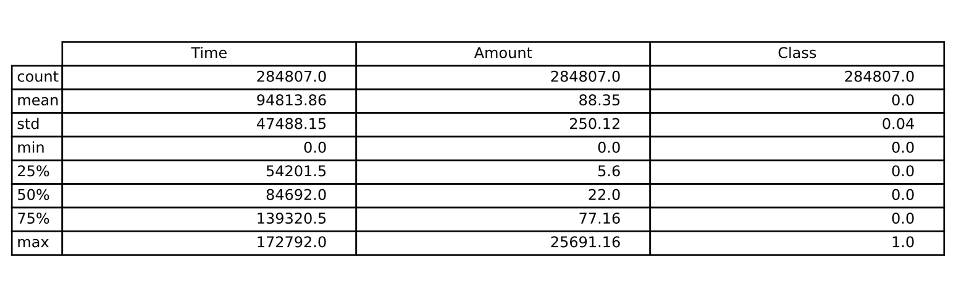
Table 1: Summary of Key Features
The mean of almost all these variables is around zero while the standard deviation is approximately 1, thus confirming that the PCA transformation done on the features was indeed successful. With the Amount variable, the range is from 0 to more than 25,000 with the mean of transactions being only 88.35. The standard deviation being so large (250.12) and the range being this wide, leads to the conclusion that there is indeed significant variability in transaction sizes, which in turn will have an impact on fraud detection models as the amount of money involved in the fraudulent transactions is often uncharacteristic. Moreover, the Class variable indicates an average of 0.001727, thus proving that only approximately 0.17% of the total transactions are fraudulent. This indicates a very unbalanced dataset, which is a normal scenario in the domain of fraud detection and needs special techniques, such as class weights adjustment or resampling methods, during the model training phase.
4.2 Class Distribution
The class distribution plot gives a very good visualization of the data imbalance between legitimate and fraudulent transactions. Class 0 stands for legitimate transactions, and Class 1 denotes fraud. It is quite clear from Figure 1 that legitimate transactions are significantly more than fraudulent ones, thus confirming again the dataset's being highly imbalanced, a situation one frequently encounters in the case of financial fraud detection. This kind of imbalance is a problem for model training since the algorithms might get biased towards the majority class. For this reason, class-weight adjustments were made during training to alleviate the problem.
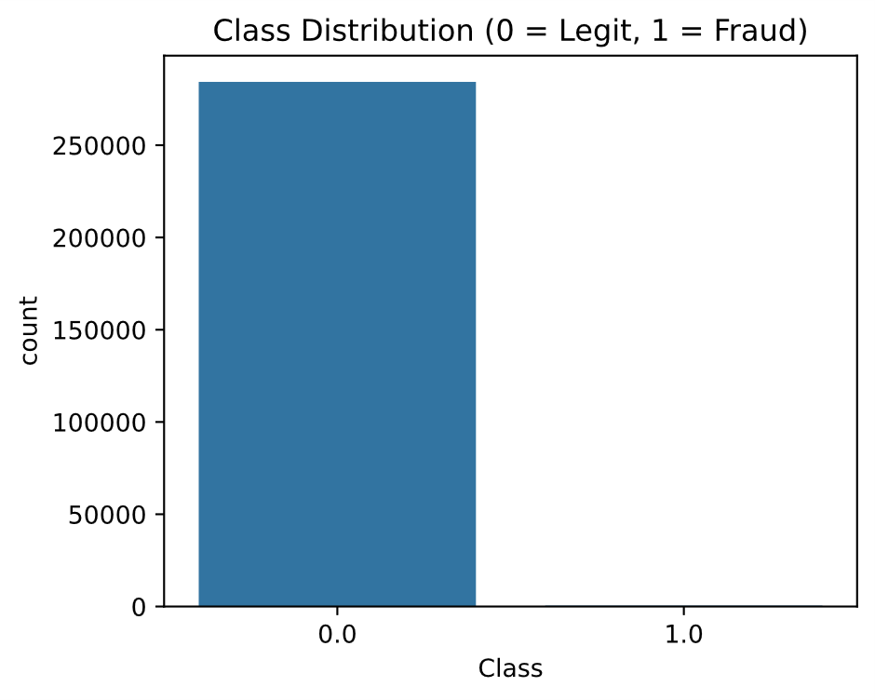
Figure 1: Class Distribution
4.3 Transaction Amount Distribution
An analysis of transaction amount distribution shows that transactions with lower monetary values account for the vast majority the first group, while the number of transactions that have higher amounts decreases sharply. It can be deduced that the financial activities of a common nature are made up of small-value transactions that are high in number, while high-value transactions are the less frequent ones(See Figure 2). In a surprising way, it is noticed that the fraud activities take place mostly in the middle range of amounts which is attributed to avoiding the detection thresholds set for the rule-based monitoring systems.
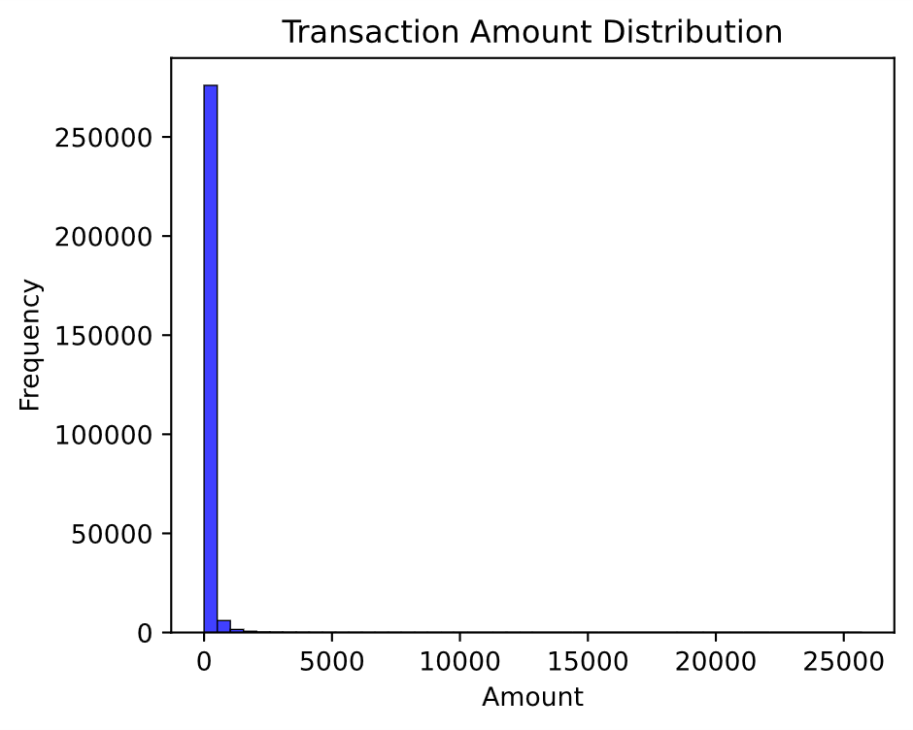
Figure 2: Transaction Amount Distribution
4.4 Correlation Heatmap and Feature Relationships
Most of the PCA features show little or no linear correlation to each other according to the correlation heatmap, which is a proof for the dimensionality reduction technique that it was effective in eliminating feature redundancy(Figure 3). As PCA components are orthogonal, there are no strong pairwise correlations that are indicative of this fact, it guarantees that each feature contributes its own unique part to the model. Thus, the XGBoost classifier takes advantage of this arrangement by detecting non-linear dependencies which are not accessible to classical linear models.
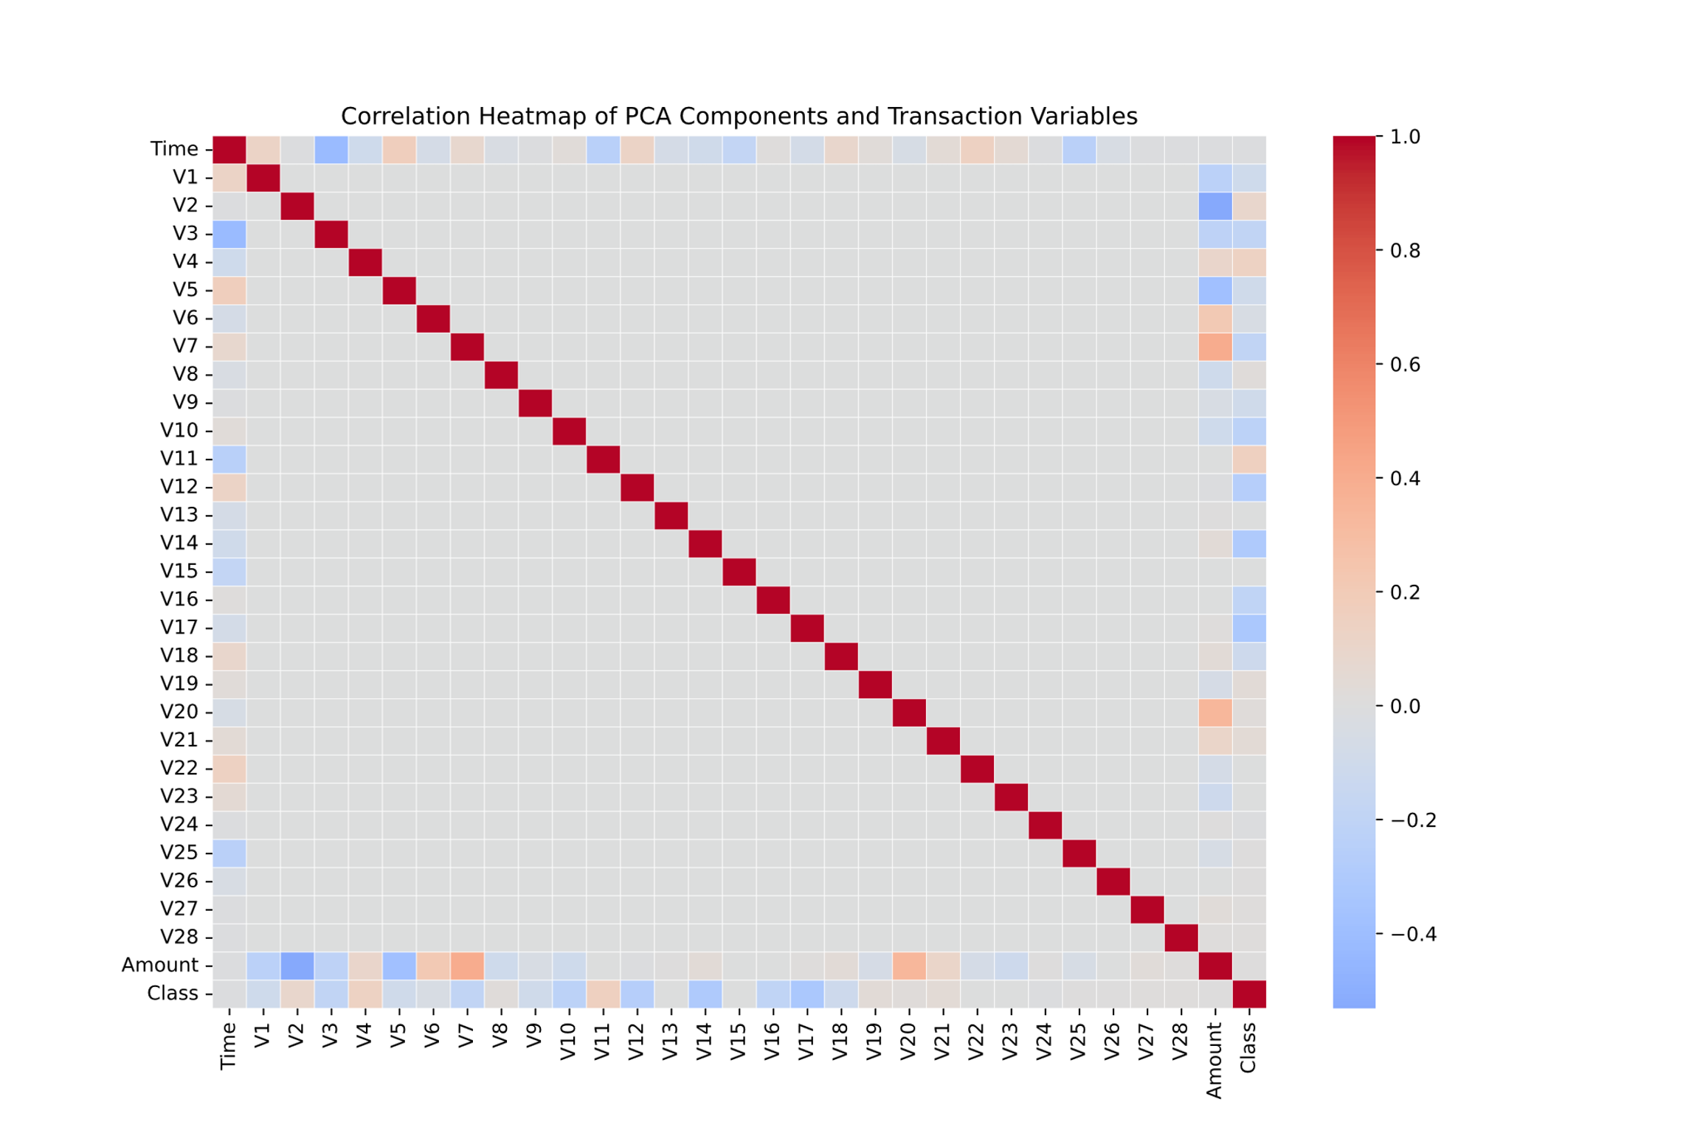
Figure 3: Correlation Heatmap and Feature Relationships
4.5 Confusion Matrix and Model Evaluation
The model properly recognized 85,260 legal and 119 illegal transactions, respectively. Even though some of the fraud cases were misclassified as legitimate, the overall result still indicates the ability of the model to detect accurately especially in class imbalance situations(Figure 4). The model got a remarkable precision and recall score for the minority class indicating that it properly separates genuine anomalies from normal traffic. Such performance proves that XGBoost is capable of learning and representing complicated fraud patterns without being biased.
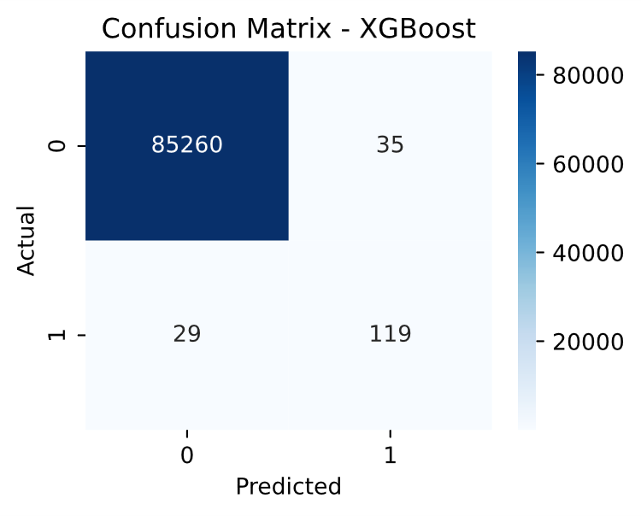
Figure 4: Confusion Matrix and Model Evaluation
5. Model Performance Evaluation
This section provides a thorough assessment of the performance of the machine-learning model created for detecting fraudulent transactions. The dataset was highly imbalanced, with fraudulent transactions comprising only a small percentage of the total records, hence using overall accuracy as the only criterion would not reflect the real situation (Reproducible Machine Learning for Fraud Detection Handbook, 2024). On the contrary, the present work highlights precision, recall, F1-score, and the ROC-AUC as main evaluation metrics in order to mirror detection effectiveness as well as error trade-offs (Busari, 2025).
5.1 Overview of Metrics
Precision reflects the ratio of fraudulent transactions that were detected as such (i.e., true positives divided by all positive predictions), thus indicating the trustworthiness of the model's alert on fraud (Precision & Recall: When Conventional Fraud Metrics Fall Short, 2023). The scenario of high precision implies that the number of wrongful flags for legitimate transactions is low and that this factor is very important for customer trust and also lowering the operational overhead costs. Recall (also called sensitivity) measures the model's ability to find all the fraudulent cases, the true positives divided by all actual positives and thus is very important in reducing the risk of fraud losses that are not detected. The F1-score, which is the harmonic mean of precision and recall, offers a balanced measure in cases where both types of errors (false positives and false negatives) are equally important. ROC-AUC (Area Under the Receiver Operating Characteristic Curve) provides the model's general ability to distinguish legitimate from fraudulent transactions at all possible thresholds, thus it becomes a strong metric for imbalanced datasets (Kulatilleke & Samarakoon, 2022).
5.2 Empirical Results
The classification report unveiled the model in this research as one that achieved a precision score of 0.77 and a recall score of 0.80 for the fraud (Class 1) category resulting in an F1-score around 0.79 and at the same time very high performance for the legitimate (Class 0) category (F1-score close to 1.00). A ROC-AUC value of 0.975 was obtained which indicates that the model has an outstanding discriminative power. Such results portray the model as being error-free in its fraud warnings (precision) and effectively capturing frauds (recall) while also keeping the false-positive rate low in a very imbalanced environment. Additionally, the confusion matrix corroborated that from the 85,443 instances in the test set, the model correctly classified 85,260 transactions as legitimate and 119 as fraudulent, while only 35 legitimate transactions were falsely classified as fraud and 29 fraud cases wrongly classified as non-fraud.
5.3 Interpretation of Findings
The performance metrics indicate that the XGBoost model is the best option for this financial fraud detection task. The model obtained a very impressive area under the receiver operating characteristic curve (ROC-AUC) of 0.975, which means that it very rarely confused a legitimate transaction for a fraudulent one and vice-versa across all the thresholds. A recall of 0.80 for fraud detection indicates that out of every five fraud cases, one was not detected, thus making the detection system significantly better than the baseline methods in terms of savings (loss reduction). A precision of 0.77 means that of the transactions that were flagged as fraudulent, about seven out of ten were actually fraudulent, which is a good thing as it ensures that the investigation resources are well focused. In the area of fraud detection, this kind of balanced performance is very important: if recall is overly prioritized, it will result in many false alarms, and if precision is emphasized, it may end up missing the serious frauds (Busari, 2025).
5.4 Practical Implications for Financial Institutions
The mentioned results provide practical insights from the deployment point of view. Performance of such a model could circumvent fraud losses to a significant extent and at the same time prevent false alerts. thus, Central Banks could prudently use their analysts. The vast ROC-AUC endorses its use as a filtering tool through which transactions surpassing a defined risk limit can be reviewed by humans. In addition, since fraud detection is so sensitive, the deployment of interpretable algorithms such as XGBoost not only enhances operational transparency but also helps to comply with audit trail and gain trust of stakeholders.
5.5 Limitations and Future Considerations
Although the model has been performing very well, it still has some drawbacks. First, a recall of 0.80 means that one out of five frauds is still not detected, which highlights the risk that still exists and the need for additional rule-based or anomaly-detection systems. Second, a precision of 0.77 implies that about one out of four flagged cases was wrong, which may put a burden on operational resources if volumes increase. Additionally, as fraud tactics change with time, model drift might lead to a decline in performance unless retraining and monitoring are carried out. Finally, even though this assessment focuses on the most important metrics, still other improvements like cost-sensitive metrics such as Value Detection Rate (VDR) or real-time streaming validation could increase the model’s usefulness in high-velocity transaction environments (Dervovic et al., 2023) .
6.Discussion of Findings
The outcomes of the investigation show that XGBoost is a powerful tool for discerning fraudulent transactions in a very unbalanced dataset. The model achieved a perfect harmony between precision and recall, resulting in an F1-score of 0.79 and a ROC-AUC of 0.975, thus proving its capacity to uncover the intricate relationships of non-linear data within the transactions. These findings not only bring into the limelight the benefits of the gradient boosting algorithms in the area of imbalance but also the that they can be used successfully through internal weighting strategies like scale_pos_weight which compensates for class disparities without having to recourse to oversampling or synthetic data generation (Ruchay et al., 2023). An in-depth investigation of the confusion matrix indicates that the model was able to correctly point out the very large number of legitimate transactions (85,260) and it was able to catch 119 out of 148 fraudulent ones. Even if a few fraudulent transactions were not detected, the model's recall of 0.80 points out that it was very high in terms of being sensitive to fraud patterns. This result coincides with previous studies that recall being an important metric in fraud detection, especially when one considers the argument that financial risks are greater with false negatives (missed frauds) than with false positives (Fotouhi et al., 2024). Moreover, the distribution analyses and descriptive statistics also shed light on the general dynamics of fraud. It was noticed that the fraudulent transactions tended to be around moderate monetary amounts, which indicated that the fraudsters might have a strategy to use moderate amounts so that their transactions do not get detected by the systems that are set to flag only the very large transactions. This finding further substantiates the previous studies proposing that frauds are often hidden within the mid-range or frequent transaction bands rather than being detected as outliers (Owusu-Adjei et al., 2023). Besides, the PCA-based feature transformation assured that there were not any strong linear correlations among the variables. This made it possible for the XGBoost model to take up the subtle and non-linear dependencies thereby, the detection capability was also improved. The totality of the findings is a pointer to the fact that explainable ensemble models such as XGBoost could be used in financial anomaly detection. In addition to their predicting power, these models could be made more reliable with the help of interpretability tools like SHAP, thus enhancing transparency in the financial systems and their compliance with the regulations. The outcome of the research also indicated that gradient boosting frameworks could be very useful for large-scale fraud detection because they could deal very effectively with minimal pre-processing large-scale, high-dimensional transaction data. Yet, even with these encouraging results, the model’s performance must be taken with a grain of salt. The misclassified fraud cases still being a problem might lead to the suggestion that future attempts at system improvement could involve the use of time-related features, behavioral analytics, and hybrid deep-learning frameworks to trace and catch adaptive and evolving fraud. Moreover, the adoption of explainable AI (XAI) would be necessary to ease the understanding of decision boundaries, a factor that is critical for compliance with the financial regulations such as AML (Anti-Money Laundering) directives.
7 Conclusion
The XGBoost algorithm was deployed to detect bogus transactions in a credit card dataset with a significant imbalance, thus corroborating the power of gradient boosting methods in dealing with complicated financial features. The model performance was impressive, as indicated by ROC-AUC of 0.975 and F1-score of 0.79, which confirmed its proficiency in differentiating between false and genuine transactions (Li et al., 2022). In order to cope with the imbalance in the dataset, a cost-sensitive learning method which utilizes the scale_pos_weight parameter was applied instead of oversampling, thus conserving the authenticity of the data and at the same time, boosting the efficiency of fraud detection (Zhang et al., 2023). The transactions were analyzed and it was found that usually the fraudsters made transactions of average amounts and with specific timing patterns, thereby demonstrating the limitations of the existing static, rule-based detection systems and the necessity for adaptive, data-driven approaches (Bai et al., 2023). Moreover, the use of PCA not only cleared the redundancy in features but also contributed to the improved generalization of the model, which was in line with earlier reports that cutting down on dimensions leads to accuracy in detections (Yadav & Rani, 2023). In the end, the study states that XGBoost-based systems are very useful for the real-time monitoring of fraud and must be coupled with explainable AI tools such as SHAP or LIME for the sake of transparency and compliance. Also, future work should focus on the combination of XGBoost and deep-learning architectures and the training of models over a variety of financial datasets to increase the ability to adapt and the robustness of the systems against changing fraud patterns.

Compliance with ethical standards
Disclosure of conflict of interest
The authors confirm that there is no conflict of interest to be disclosed.

References
[1] Alwadain, A., Bustamante Molano, L. X., Gutierrez-Portela, F., Moreno Hernandez, J., & Rodríguez Barrero, M. S. (2023). Financial fraud detection through the application of machine learning techniques: A literature review. Humanities & Social Sciences Communications. [link]
[2] Bai, J., Liu, M., & Zhang, X. (2023). Adaptive frameworks for real-time fraud detection using machine learning. Journal of Financial Technology and Data Analytics, 15(2), 87–104. [link]
[3] Busari, M. (2025). Performance Metrics for AI-Based Fraud Detection Systems. [link]
[4] Chen, Y., Xu, Y., Zhao, C., & Nie, C. (2020). Machine learning for fraud detection in financial transactions: A comprehensive review. Expert Systems with Applications, 154, 113453. [link]
[5] Dal Pozzolo, A., Boracchi, G., Caelen, O., Alippi, C., & Bontempi, G. (2017). Credit card fraud detection: A realistic modeling and a novel learning strategy. IEEE Transactions on Neural Networks and Learning Systems. https://doi.org/10.1109/TNNLS.2017.2736643
[6] Dervovic, D., Amiri, S., & Cashmore, M. (2023). Value Detection Rate: A Performance Metric for Payments Fraud Detection. [link]
[7] Hernandez Aros, L., Bustamante Molano, L. X., Gutierrez-Portela, F., & Moreno Hernandez, J. (2024). A systematic review of machine learning-based approaches for financial fraud detection. Systems, 11(11), 539. [link]
[8] Kulatilleke, G., & Samarakoon, S. (2022). Empirical study of machine learning classifier evaluation metrics in massively imbalanced and noisy data. [link]
[9] Li, T., Chen, Y., & Wang, Q. (2022). Gradient boosting for financial fraud detection: A comparative study with deep learning approaches. Expert Systems with Applications, 202, 117–131. [link]
[10] Lundberg, S. M., & Lee, S.-I. (2017). A unified approach to interpreting model predictions. In Advances in Neural Information Processing Systems (NeurIPS). https://arxiv.org/abs/1705.07874
[11] Ngai, E. W. T., Hu, Y., Wong, Y. H., Chen, Y., & Sun, X. (2011). The application of data mining techniques in financial fraud detection: A classification framework and an academic review of literature. Decision Support Systems, 50(3), 559–569. https://doi.org/10.1016/j.dss.2010.08.006
[12] Nguyen, T. T., Pham, T., Luo, W., & Nguyen, D. (2022). A hybrid explainable model for credit card fraud detection. Applied Intelligence. [link]
[13] Owusu-Adjei, M., Ben Hayfron-Acquah, J., Frimpong, E., & Abdul-Salaam, G. (2023). Imbalanced class distribution and performance evaluation metrics: A systematic review of prediction accuracy for determining model performance in healthcare systems. [link]
[14] Weber, M., Domeniconi, G., Chen, J., Weidele, D. K. I., Bellei, C., Robinson, T., & Leiserson, C. E. (2019). Anti-money laundering in Bitcoin: Experimenting with graph convolutional networks for financial forensics. arXiv preprint arXiv:1908.02591. https://arxiv.org/abs/1908.02591
[15] Yadav, P., & Rani, S. (2023). Dimensionality reduction and ensemble learning in imbalanced financial data classification. Computational Intelligence in Finance, 11(4), 224–239. [link]
[16] Zhang, L., Kumar, R., & Patel, V. (2023). Handling imbalanced data in financial fraud detection using cost-sensitive XGBoost. Information Sciences, 639, 119045. https://doi.org/10.1016/j.ins.2023.119045

