Original Research Article
Hydrogeomorphological mapping using geospatial techniques for identifying groundwater potential zones in Chittur Block, Kerala

ABSTRACT
This study delineated groundwater potential zones in the Chittur Block of Palakkad District, Kerala, using an integrated hydrogeomorphological and geospatial approach. The hard rock terrain of the region faces acute water scarcity due to limited surface water, increasing anthropogenic stress and over-exploitation of groundwater. Thematic layers such as geology, geomorphology, slope, drainage density, lineament density, and land use/land cover were derived from remote sensing data and are integrated within a GIS framework using the Weighted Index Overlay Analysis (WIOA) technique to identify groundwater potential zones. The analysis indicated that hydrogeomorphological and structural features significantly influence groundwater occurrence and movement. Valley floors and floodplains exhibited high recharge potential owing to their permeability and infiltration capacity, whereas pediment zones showed moderate potential and suitability for artificial recharge. Lineament-dense areas enhanced groundwater flow and storage connectivity. The resulting groundwater potential zonation map classified the study area into five categories, excellent, very good, good, moderate and poor, with most of the region falling under favourable to moderate potential zones. The study highlighted that integrating hydrogeomorphological parameters with GIS-based multi-criteria evaluation offers an effective tool for groundwater exploration and sustainable water resource management in hard rock terrains.
Keywords: Hydrogeomorphology, Pediment, Valley floor, Groundwater, GIS

- INTRODUCTION
Groundwater is one of the most valuable natural resources on Earth, playing a vital role in sustaining life, agriculture, industry, and ecosystems. It serves as a dependable freshwater source, particularly in regions where surface water resources are limited or seasonal. Because of its large storage volume, slow movement, and reliable availability, groundwater acts as a critical buffer against hydrological variability and climate change (Qiu et al., 2015).
In hard-rock terrains, common across peninsular India, groundwater occurrence and movement are highly heterogeneous, controlled by secondary porosity features such as fractures, joints, and weathered zones. Understanding the hydrogeomorphological nature of landforms and lineament distribution is thus crucial for assessing recharge and storage potential in such environments (Sethupathi et al., 2012; Sedhuraman et al., 2014). Hydrogeomorphology, an interdisciplinary field linking geomorphology and hydrology, provides a valuable framework for evaluating the spatial relationship between landforms, structure, and groundwater occurrence (Babar and Shah, 2012; Teixeira et al., 2013).
The influence of hydrogeomorphological features on groundwater dynamics is a well-established principle in hydrogeology (Singhal and Gupta, 2010; Igwe et al., 2020). Landforms shaped by erosional and depositional processes control the permeability and storage characteristics of subsurface materials, which in turn govern groundwater recharge and flow pathways. Integration of remote sensing (RS) and Geographic Information System (GIS) techniques with hydrogeomorphological analysis has become an effective approach for delineating groundwater potential zones, particularly in complex lithological and climatic settings (Magesh et al., 2012; Nag, 2018; Rajaveni et al., 2015).
In Kerala, groundwater resource management has gained increasing importance due to rising population pressure, industrial growth, and the impacts of changing rainfall patterns. According to the Central Groundwater Board (CGWB, 2022), several blocks in Palakkad District exhibit critical to over-exploited groundwater conditions, with Chittur Block identified as one of the most severely affected. High extraction rates for irrigation and domestic use, coupled with low natural recharge, have led to a significant groundwater decline, up to 16 m in some locations over the past two decades (CGWB, 2022; Praseeja and Younous, 2024).
Recent studies have highlighted alarming trends in Chittur Block, including groundwater salinization and deterioration of water quality due to elevated fluoride (up to 6.3 mg L⁻¹) and nitrate (up to 141 mg L⁻¹) concentrations, primarily attributed to over-abstraction and mineral weathering in gneissic formations (Mohamed et al., 2024). Projected hydrogeological models suggested that, without intervention, groundwater levels could decline by an additional 9 m by 2050 (Varghese et al., 2018). These findings underscore the urgent need to assess and map groundwater potential zones in Chittur block.
In this context, the present study focused on the Chittur Block of Palakkad District and employed an integrated hydrogeomorphological and geospatial framework to delineate groundwater potential zones. The objectives are to (i) analyse the influence of hydrogeomorphology on groundwater occurrence, and (ii) generate a GIS-based potential zonation map to support groundwater exploration, artificial recharge planning, and sustainable water management in this water-stressed hard-rock terrain.
- DETAILS OF THE STUDY AREA
The Chittur Block, situated in the Palakkad District of Kerala, lies between latitudes 10°37′–10°48′ N and longitudes 76°41′–76°54′ E, encompassing an area of approximately 271 km². The region forms part of the midland physiographic zone of Kerala and is characterized by undulating terrain with elevations ranging from 95 m to 250 m above mean sea level. The location map of the study area is shown in Fig. 1.
The climate of the area is humid tropical, with an average annual temperature ranging from 22 °C (minimum) to 36 °C (maximum). During the summer months, particularly in April and May, temperatures may rise to around 38 °C. The block lies in a rain-shadow zone on the leeward side of the Western Ghats and therefore receives comparatively lower rainfall than western Kerala. The mean annual precipitation is approximately 1,413 mm, largely contributed by the southwest monsoon, while the northeast monsoon provides supplementary rainfall.
Topographically, the Chittur Block exhibits gently sloping to moderately elevated landscapes (85 to 250 m) with interspersed pediments, residual hills, and alluvial plains. This physiographic diversity, coupled with its hard-rock geology and seasonal rainfall, exerts significant influence on the region’s groundwater recharge and availability patterns.
2.1 Hydrogeology of the study area
The Chittur block is predominantly situated within a hard rock terrain, which constitutes the major portion of the study area. The primary hard rock aquifer is composed of hornblende biotite gneiss, characterized by its low primary porosity. Groundwater occurrence in this aquifer is largely controlled by secondary porosity features such as fractures, joints, and weathered zones. These structural features significantly influence the storage and movement of groundwater within the hard rock formations, making them the principal source for domestic and irrigation purposes in the region.
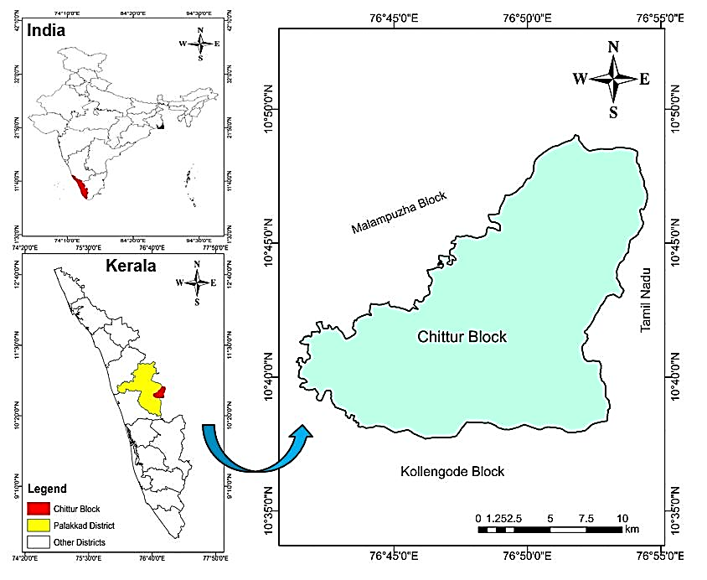
Fig. 1. Location map of the study area
- MATERIALS AND METHODS
3.1 Overview of the approach adopted
Hydrogeomorphology examines the interrelationship between geomorphic features and hydrological processes, emphasizing how landform characteristics influence groundwater occurrence and movement. Parameters such as relief, slope, degree of weathering, nature and thickness of alluvial deposits, and the composition of surface materials collectively determine the groundwater regime, particularly in hard rock and unconsolidated sedimentary terrains (Reddy et al., 2000).
Hydrogeomorphic units represent distinct zones characterized by uniform geological structure, landform type, and recharge potential (Manjare, 2014; Rajaveni et al., 2015; Igwe et al., 2020). Mapping and analysis of these units involve identifying and delineating landforms, drainage patterns, and structural features that exert a significant control over groundwater occurrence and flow (Deepika et al., 2013; Mondal et al., 2007).
Integrating geomorphological, geological, and hydrological factors is therefore essential to understand the spatial variability of groundwater systems. The delineation of groundwater potential zones requires a comprehensive, multi-criteria approach incorporating parameters such as geomorphology, geology, land use/land cover (LULC), lineament density, drainage density, and slope (Samake et al., 2011).
3.2 Software and data used
ArcGIS 10.3 was used for data analysis and thematic map preparation. The secondary data required were obtained from the Kerala State Remote Sensing and Environment Centre (KSREC), Thiruvananthapuram, and the Central Ground Water Board (CGWB). Table 1 summarizes the key datasets and their sources.
Table 1: Data, Source and its Applications
Data Type | Source / Institution | Details / Application
Geological map | KSREC, Thiruvananthapuram | Lithological and structural characteristics
Geomorphology map | KSREC, Thiruvananthapuram | Landform classification
Lineament map | KSREC, Thiruvananthapuram | Structural features and fracture systems
SRTM DEM (30 m resolution) | USGS Earth Explorer | Slope and drainage density derivation
Landsat 8 OLI imagery | USGS Earth Explorer | Land Use / Land Cover (LULC) classification
Groundwater data | CGWB & local records | Validation and hydrogeological context
3.3 Preparation of various thematic Layers
Multiple thematic layers were generated and standardized to represent the dominant factors influencing groundwater potential. These include geology, geomorphology, lineament, slope, drainage density, lineament density, and land use/land cover (LULC).
Geology and Geomorphology
The geological and geomorphological layers were derived from KSREC shape files. Landforms were categorized based on morphological and lithological characteristics following NRSC (2007) guidelines. Visual interpretation of satellite imagery, supported by field validation, was used to delineate geomorphic units such as pediments, valley floors, floodplains, and residual hills.
Slope and Drainage Density
The Slope Map was generated from the 30 m SRTM Digital Elevation Model (DEM) using ArcGIS Spatial Analyst tools. The Drainage Density Map was derived from stream networks extracted via hydrological processing of the DEM. These layers helped identify areas of high runoff versus high infiltration potential.
Lineament and Lineament Density
Lineaments were digitized and extracted from KSREC shape files to determine orientation and density. The lineament density layer was classified into five categories (poor, moderate, good, very good and excellent) to depict the degree of secondary porosity, which enhances groundwater movement.
Land Use / Land Cover (LULC)
The LULC map was produced through supervised classification of Landsat 8 imagery using the maximum likelihood algorithm in ArcGIS. Major classes identified include agricultural land, built-up areas, fallow land, forest cover, and water bodies.
Hydrogeomorphology map
The hydrogeomorphological setting of the Chittur Block plays a vital role in governing groundwater occurrence, storage, and movement. The hydrogeomorphology map of the study area was prepared in accordance with the Groundwater Prospect Mapping guidelines of the Rajiv Gandhi National Drinking Water Mission, NRSC, Hyderabad (2007). The various thematic maps used for the preparation of Hydrogeomorphology map were geology, geomorphology and lineament maps. Satellite imagery supported by field verification was also incorporated to identify the hydrogeomorphic unit.
3.4 Weighted Index Overlay Analysis (WIOA) method for identifying groundwater potential zones
All thematic layers were reclassified according to their relative contribution to groundwater occurrence and standardized to a uniform scale. The weighting of each parameter was determined based on expert judgment and established literature (Nag, 2018; Magesh et al., 2012; Rajaveni et al., 2015). As highlighted by Nag (2005), the WIOA approach does not adhere to a fixed weighting scheme but instead relies on informed expert evaluation and logical reasoning to ensure analytical robustness. Accordingly, in this study, the weights assigned to each thematic layer were derived from their relative hydrological significance, supported by insights from previous studies and regional hydrogeological assessments (Magesh et al., 2012). The assigned theme weights and their corresponding percentage influence are presented in Table 2. The Weighted Index Overlay Analysis (WIOA) was performed in ArcGIS to integrate these thematic layers using the following expression:
GWPI=∑(W_{i}×X_{i})
where GWPI represents the Groundwater Potential Index, W_{i} is the assigned weight of the ith thematic layer, and X_{i} denotes the normalized rank of each class within the layer.
Before integration, all thematic maps were spatially aligned and projected to a common coordinate system in ArcGIS. The WIOA technique, based on a Multi-Criteria Evaluation (MCE) framework, was then applied to delineate groundwater potential zones by combining key thematic layers such as hydrogeomorphology, slope, lineament density, drainage density, and land use/land cover.
Table 2: Weights and percentage influence considered for parameters of groundwater occurrence
Theme | Feature Class | Category | Weight | Percentage influence %
Geomorphology | Flood plain | Good | 3 | 25
Geomorphology | Pediplain | Good | 3 | 25
Geomorphology | Plateau | Moderate | 2 | 25
Geomorphology | Rock exposure | Poor | 1 | 25
Geomorphology | River body | Good | 3 | 25
Geology | Charnockite | Poor | 1 | 25
Geology | Khondalite | Moderate | 2 | 25
Geology | Migmatites | Moderate | 2 | 25
Geology | Pegmatite | Poor | 1 | 25
Geology | Streams | Excellent | 5 | 25
LULC | Waterbodies | Good | 4 | 15
LULC | Agricultural crops | Moderate | 2 | 15
LULC | Fallow lands | Moderate | 2 | 15
LULC | Builtups | Poor | 1 | 15
LULC | Forest lands | Poor | 1 | 15
Slope (%) | 0-4 | Excellent | 5 | 15
Slope (%) | 4-9 | Very good | 4 | 15
Slope (%) | 9-15 | Good | 3 | 15
Slope (%) | 15-21 | Moderate | 2 | 15
Slope (%) | >21 | Poor | 1 | 15
Drainage density  (km⁻¹) | 0-1.6 | Poor | 1 | 10
Drainage density  (km⁻¹) | 1.6-3.3 | Moderate | 2 | 10
Drainage density  (km⁻¹) | 3.3-4.95 | Good | 3 | 10
Drainage density  (km⁻¹) | 4.95-6.67 | Very good | 4 | 10
Drainage density  (km⁻¹) | 6.67-8.25 | Excellent | 5 | 10
Lineament density (km⁻¹) | 0-1.43 | Poor | 1 | 10
Lineament density (km⁻¹) | 1.43-2.87 | Moderate | 2 | 10
Lineament density (km⁻¹) | 2.87-4.31 | Good | 3 | 10
Lineament density (km⁻¹) | 4.31-5.74 | Very good | 4 | 10
Lineament density (km⁻¹) | 5.74-7.18 | Excellent | 5 | 10
3.5 Groundwater Potential Zonation
The composite map obtained by the Weighted Index Overlay Analysis (WIOA) technique was used to classify the study area into five categories: poor, moderate, good, very good, and excellent based on groundwater potential. Field data and CGWB well records were used to validate the spatial accuracy of the delineated zones in the Chittur Block.

- RESULTS AND DISCUSSION
Groundwater occurrence and movement are governed by the interactive influence of geology, geomorphology, and structural features such as lineaments. Hydrogeomorphology, which integrates hydrological and geomorphological principles, provides a comprehensive framework for assessing groundwater potential and promoting its sustainable management.
Geological formations define the nature and extent of aquifers, while geomorphological features indicate areas conducive to recharge and groundwater storage. Structural elements, particularly lineaments, function as conduits facilitating subsurface water movement. The integration of these factors enables a deeper understanding of the spatial variability and dynamics of groundwater systems.
Therefore, hydrogeomorphological analysis, combining geological, geomorphic, and structural characteristics, forms a scientific basis for identifying groundwater potential zones, delineating recharge areas, managing watersheds, and ensuring sustainable utilization of groundwater resources. The results derived from the various thematic maps corresponding to these parameters are discussed in the following sections.
4.1 Geology map
The geological formations identified within the study area include the migmatite complex, charnockite, khondalite, pegmatite/aplite/quartz veins, and rivers/streams. Among these, the migmatite complex constitutes the predominant rock type, occupying a major portion of the area. These ancient, highly metamorphosed rocks form the fundamental lithological framework. Charnockite appears in scattered zones and is recognized as a hard, dark-coloured metamorphic rock. Khondalite occurs in limited patches, mainly in the southeastern sector, and represents a high-grade metamorphic unit. Intrusive bodies, such as pegmatite, aplite, and quartz veins, were found as small, isolated outcrops, indicating that subsequent geological events had occurred. The landscape was further influenced by an interconnected system of rivers and streams, which delineate the principal drainage network and contribute significantly to geomorphic development and groundwater recharge. The geological distribution of these units classified for the Chittur block is depicted in Fig. 2.
4.2 Geomorphology map
The geomorphological framework of the study area comprises a variety of landforms that play a crucial role in controlling surface runoff and groundwater behaviour. The plateau areas form elevated, flat to gently undulating terrains that primarily act as runoff zones with limited infiltration capacity. The pediplains represent mature, gently sloping erosional surfaces that offer moderate potential for groundwater recharge due to their relatively permeable nature. Floodplains, occurring as flat, low-lying tracts along river courses, serve as excellent recharge zones because of their alluvial deposits and close hydraulic interaction with surface water bodies. Rock exposures, where bedrock is exposed at the surface, generally exhibit poor groundwater potential owing to minimal weathering and low infiltration rates. The river systems and associated water bodies constitute major drainage features that shape the regional landscape and aid in groundwater replenishment through percolation along riverbeds and adjoining valley fills. The classified geomorphological features of the study area are illustrated in Fig.3.
4.3 Lineament map
The spatial pattern of lineaments in the study area revealed structurally controlled zones that significantly influence groundwater occurrence and movement. Areas where lineaments intersect often act as favourable sites for groundwater accumulation, providing enhanced permeability and facilitating the downward movement of surface water into deeper aquifers. Regions exhibiting a high density of lineaments are generally more conducive to groundwater recharge, whereas areas with fewer fractures tend to have limited groundwater potential. The alignment of lineaments parallel to or intersecting drainage channels indicates a strong structural influence on both surface and subsurface hydrological processes, promoting recharge along river valleys and floodplains. The spatial distribution and density of these structural features are depicted in Fig.4.
4.4 Lineament density map
In the Chittur Block, lineament density varies from less than 1.437 km/km² to 7.185 km/km². Regions with higher density are associated with greater infiltration potential and improved groundwater storage. The generated lineament density map is shown in Fig. 5. Areas with higher lineament density typically correspond to enhanced secondary porosity and permeability which mostly seen in southern and eastern regions in the study area, making them more favorable for groundwater occurrence. A similar study was conducted by Haridas et al., 1998 and found that the areas with higher lineament density is more suitable for the groundwater occurrence.
4.5 Slope map
The region has been categorized into five slope classes as: flat to very gentle slope (0–4%), gentle slope (4–9%), moderate slope (9–15%), moderately steep slope (15–21%), Steep slope (>21%). The generated slope map was shown in Fig. 6. The western part of the block, characterized by lower elevations and gentler slopes, is generally more favorable for infiltration and groundwater recharge. Conversely, the eastern highland areas, with steeper slopes, promote surface runoff and exhibit limited recharge potential.
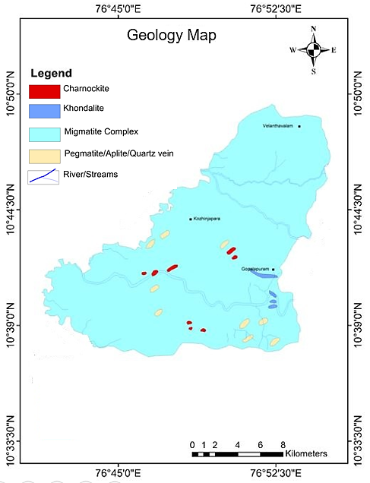
Fig. 2. Geology map of Chittur block
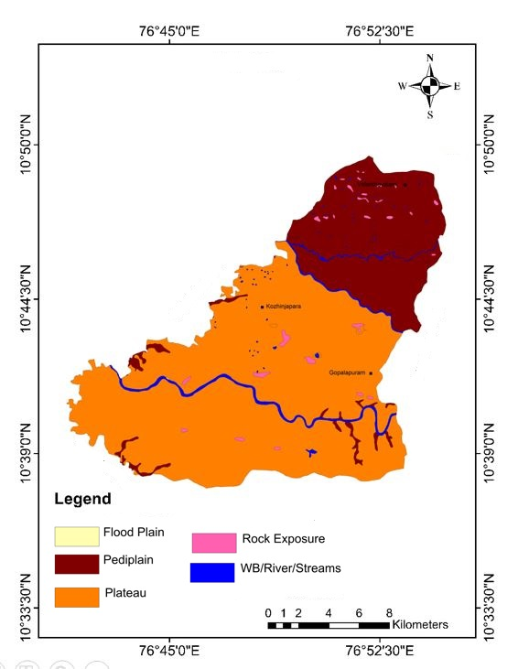
Fig. 3. Geomorphology map of Chittur block
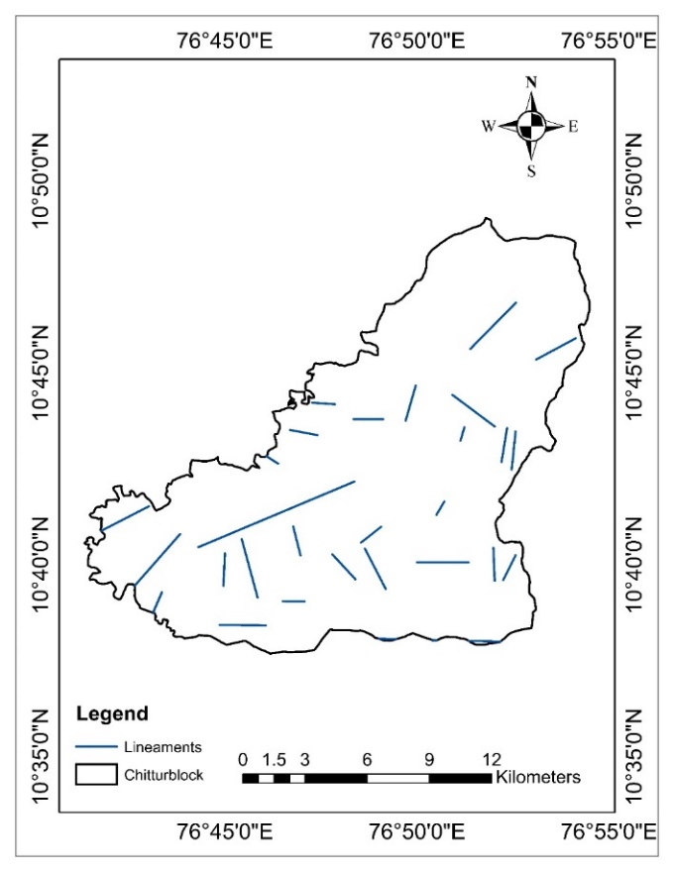
Fig. 4. Lineament map of Chittur block
4.6 Drainage density map
The drainage density map (Fig. 7) highlighted considerable spatial variability across the Chittur Block, ranging from low to high drainage density zones. The drainage density categories identified are as follows: 1. Low drainage density (0.1–1.6 km/km²) indicates permeable subsurface materials, gentle slopes, dense vegetation, or low rainfall, resulting in reduced surface runoff and enhanced infiltration. 2. Medium drainage density (1.6–4.95 km/km²) represents moderate runoff and stream frequency, typically associated with mixed landforms or variable soil and rock permeability. 3. High drainage density (4.95–8.25 km/km²) reflects less permeable materials, steep slopes, or sparse vegetation, leading to increased runoff and a denser stream network.
The drainage density categorization provides a clear visualisation of how efficiently surface water is drained across the Chittur block region. Areas with low drainage density seen in majority of the regions in the study area are indicative of higher infiltration rates and, consequently, higher groundwater potential, leading to greater well productivity and vice versa (Aravinda & Balakrishna, 2013). The higher drainage density is seen around river regions and some parts of western region in the study area. Hence, these patterns are helpful for water resource management, environmental planning and disaster mitigation in the region.

4.7 LULC map
The LULC map of the Chittur Block (Fig. 9) revealed the following distribution: 1. Agricultural land- 35.24% (95.51 km²), 2. Built-up areas- 30.54% (82.76 km²), 3. Fallow land- 14.62% (39.62 km²), 4. Forest cover: 13.89% (37.64 km²), 5. Water bodies- 5.71% (15.47 km²). This distribution indicated that the region is predominantly agricultural with significant urbanisation. The presence of fallow and forested areas contributes to natural recharge, while built-up zones may reduce infiltration and increase surface runoff. The categories that seen in the LULC map was verified by ground truth and the conditions were matched.
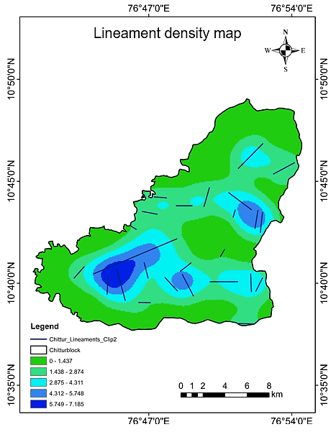
Fig. 5 Lineament density map of the study area
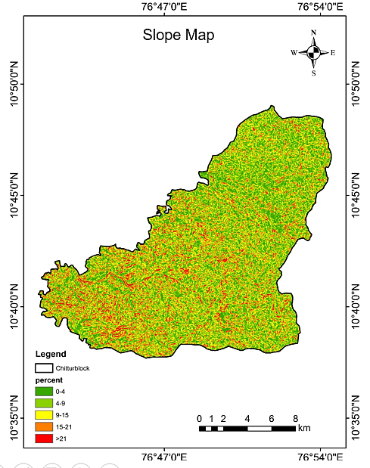
Fig. 6 Slope map of the study area
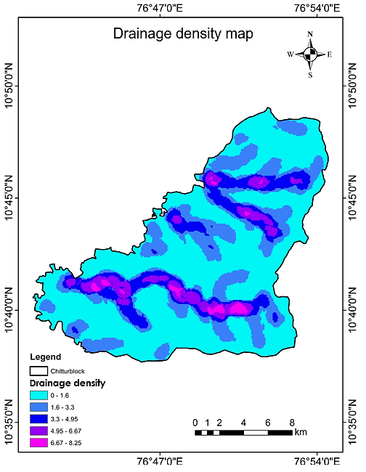
Fig. 7 Drainage density map of the study area
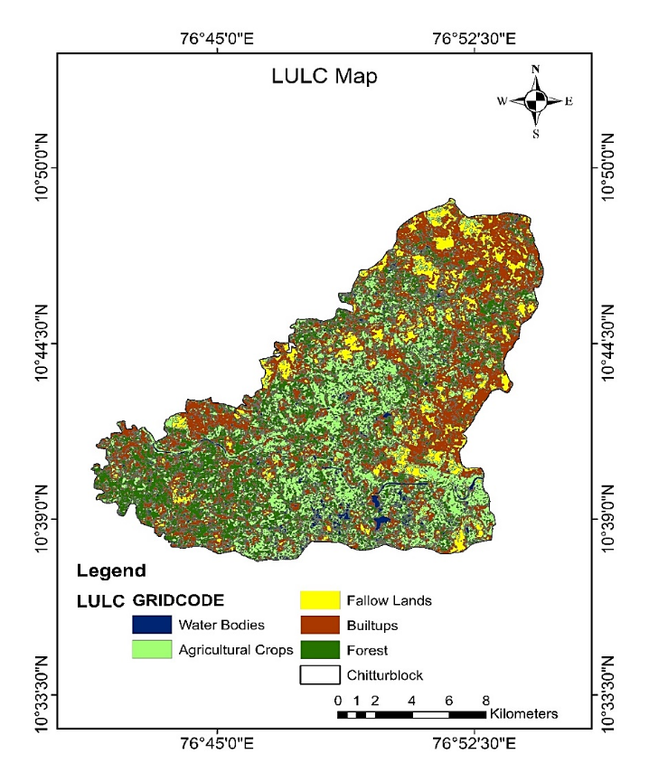
Fig. 8 LULC map of the study area
4.8 Hydrogeomorphology map
The hydrogeomorphological map of the study area was generated following the Groundwater Prospect Mapping Guidelines of the Rajiv Gandhi National Drinking Water Mission, NRSC, Hyderabad (2007). The hydrogeomorphological framework of the Chittur Block plays a crucial role in influencing groundwater occurrence, storage, and movement.
Interpretation of satellite imagery, corroborated through field verification, facilitated the identification of major geomorphic units within the Chittur Block, namely Pediment, Valley Floor, Floodplain, River Body, Waterbody Mask, and Lineaments. Each of these units exhibited distinct hydrological characteristics that govern their groundwater potential and recharge behaviour.
The classified hydrogeomorphological map of the study area is presented in Fig. 10. This classification provides a scientific foundation for delineating groundwater potential zones and supports the formulation of strategies for groundwater development and artificial recharge planning. The spatial extent of each hydrogeomorphic unit and its corresponding groundwater prospects are summarised in Table 3.
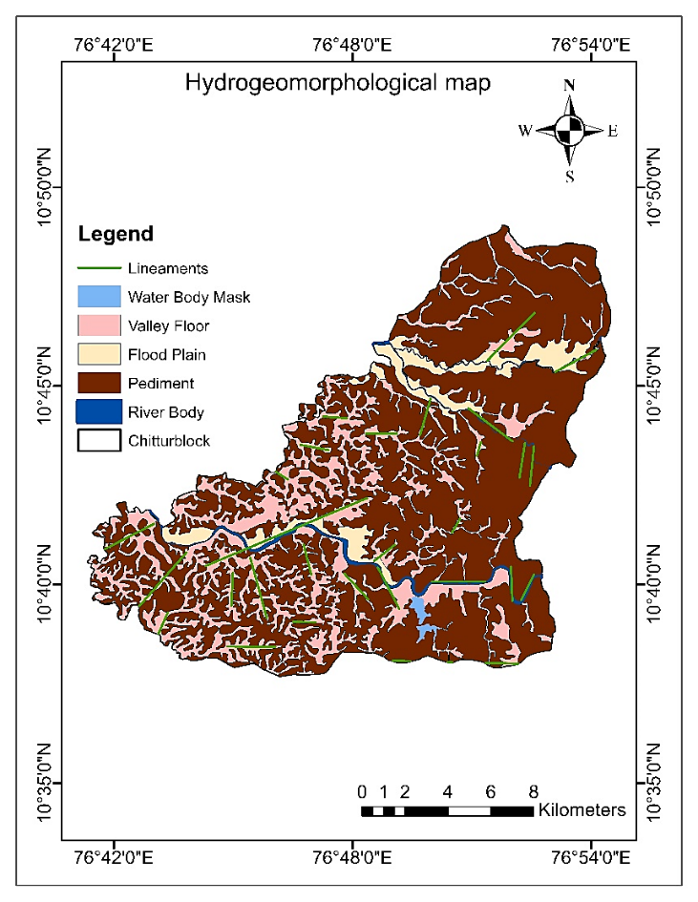
Fig. 9 Hydrogeomorphological map of Chittur block .
Table 3 Aerial coverage of hydrogeomorphic units and their groundwater prospects in Chittur
Hydrogeomorphic unit | Map symbol | Description | Groundwater prospect | Area (sq. km.) | % Area
Pediment | PZ | Moderately sloping zone of colluvium & alluvial sediments at the foot of hills | High | 172.47 | 63.64
Valley floor | VF | Accumulation of sediments in valleys, good for groundwater recharge. | Moderate to Good | 65.8 | 24.28
Flood plain | FP | Low-lying area adjacent to rivers, prone to seasonal flooding | Good | 17.58 | 6.48
River body | RT | Elevated flat surfaces formed due to river incision | Very good | 12.25 | 4.52
Water body mask | WB | Forms around surface water bodies | Good | 3.75 | 1.38

4.8.1 Details of Hydrogeomorphic Units of Chittur Block
The hydrogeomorphic units exhibited distinct geomorphic and hydrological characteristics that influence groundwater occurrence and movement.
Pediment: Occupying 63.64% (172.47 km²) of the study area, pediments represent gently sloping surfaces at the foothills. These zones consist of weathered materials overlying hard rock, allowing moderate infiltration and percolation. Although the storage capacity is limited due to a relatively shallow weathered zone, pediments act as important recharge areas, suitable for the construction of percolation tanks, recharge trenches, and similar structures. They generally exhibit good to very good groundwater prospects and were found in almost every region of Chittur block, covering major parts of all Panchayaths.
Valley floor: Covering 24.28% (65.8 km²), valley floors function as natural discharge and accumulation zones where runoff from higher terrains converges. The presence of thick alluvial and colluvial deposits enhances porosity and permeability, facilitating high groundwater recharge and storage. Wells located in these zones typically yield high discharge, making them favourable for both domestic and agricultural use and is found in south and western regions of the study area, which covers Chittur municipality, Nallepilly and Perumatty panchayaths and lately seen in some parts of Kozhinjampara and Eruthompathy Panchayaths.
Floodplain: Comprising 6.48% (17.58 km²) of the total area, floodplains are made up of unconsolidated sand, silt, clay, pebbles, and cobbles. Their high permeability supports efficient infiltration, making them highly productive aquifers. The sediment characteristics also influence groundwater quality, reflecting active recharge and strong interaction between surface and subsurface water and was found around the river regions and can be seen in north and southern regions, which cover Kozhinjampara and Eruthompathy Panchayaths in north and Chittur Municipality, Nallepilly and Perumatty Panchayaths in the south.
River body: Extending over 4.52% (12.25 km²), rivers serve as dynamic recharge sources that facilitate a two-way exchange between surface water and groundwater depending on hydraulic gradients. During high-flow periods, rivers recharge aquifers, whereas in dry seasons, they receive baseflow from groundwater, maintaining streamflow continuity and found in some parts of northern and southern regions covering a few parts of Kozhinjampara and Eruthompathy panchayaths in the north and Chittur municipality, Nallepilly and Perumatty panchayaths in the south.
Waterbody mask: Covering 1.38% (3.75 km²), this category includes ponds, tanks, and reservoirs that provide localized recharge. Their moderate to high permeability enhances percolation, contributing to groundwater replenishment in surrounding areas and is found in the southeastern region of the study area, which is primarily seen in Perumatty panchayath.
Lineaments: Spanning a total length of 508.03 km with an average segment length of 16.39 km, lineaments correspond to faults, fractures, and joints that enhance groundwater movement and connectivity between aquifer systems. The intersections of major lineaments often mark zones of higher groundwater potential due to enhanced secondary porosity and structural permeability.
Overall, valley floors, floodplains, and lineament-dense zones emerged as the most favourable areas for groundwater occurrence, owing to their high infiltration rates, aquifer thickness, and strong hydraulic connectivity. Pediments and waterbody zones, while comparatively less productive, offer considerable scope for artificial recharge interventions. The validation by ground truth confirmed that areas with high potential corresponded to valley floors, floodplains, and lineament-dense regions, while low potential zones coincided with pediment and residual hill areas. These findings align with the observations of Sethupathi et al. (2012) and Ndatuwong and Yadav (2014), who reported similar geomorphic controls on groundwater occurrence, movement, and recharge potential.
4.9 Mapping of Groundwater Potential Zone (GWPZ)
The graphical distribution of the GWPZs across the study area is presented in Fig. 10 and the spatial map of groundwater potential zones is shown in Fig. 11. The spatial analysis revealed a heterogeneous distribution of groundwater potential throughout the block, reflecting variations in topography, lithology, and structural features. The Chittur block was categorized into five distinct groundwater potential zones: excellent, very good, good, moderate and poor.
The poor and moderate zones were prominently seen in the eastern region of the study area, which covers Eruthompathy, Kozhinjampara and Perumatty panchayaths, whereas very good and excellent potential zones were seen in eastern and south eastern regions which cover Chittur municipality, Nallepilly, Pattenchery and few parts of Vadakarapathy Panchayaths.
This classification highlighted that the good and moderate zones together account for nearly 78% of the total area, reflecting significant potential for sustainable groundwater utilization in the area. The groundwater level data from 1994 to 2022 also showed that the shallow water levels (upto 10 mbgl) were seen in excellent, very good and good potential zone regions and deeper water levels (upto 20 mbgl) were seen in poor and moderate groundwater potential regions, which confirmed the validation for the groundwater potential zones in the area.
The excellent zones, though limited in area, are of particular interest for long-term water resource development, while poor zones require special management interventions such as artificial recharge and soil–water conservation measures. This integrated approach ensures that the final groundwater potential map accurately represents the hydrogeological reality of the region and provides a scientific basis for future groundwater management and artificial recharge planning.

Fig. 10 Distribution of groundwater potential zones in Chittur block
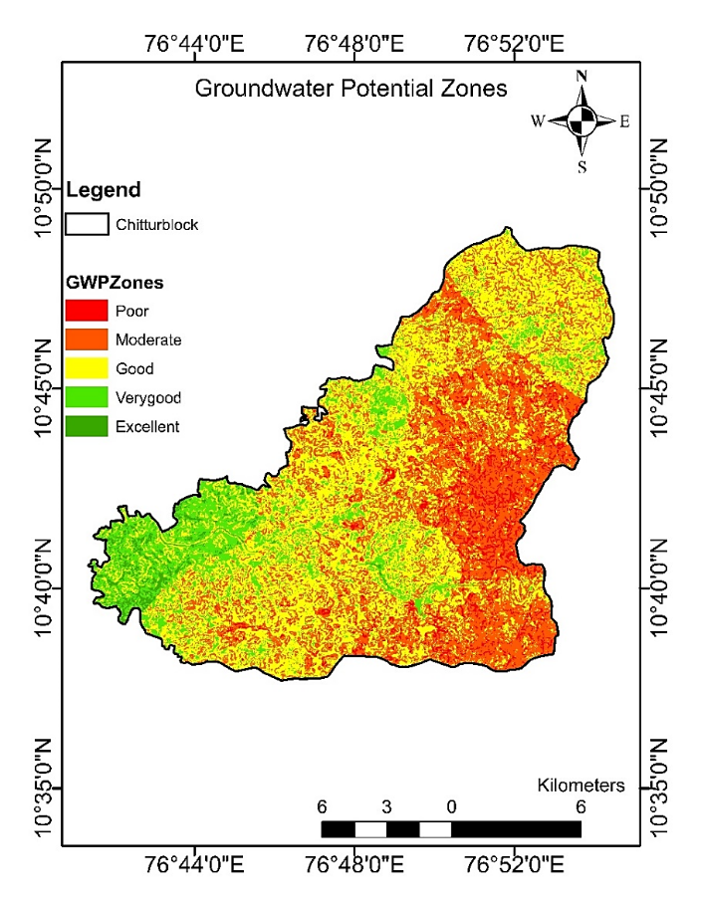
Fig. 11 Groundwater potential zone map of Chittur block
- CONCLUSION
In the Chittur Block, groundwater occurrence is predominantly governed by the interplay of hard rock geology, structural features, and geomorphic settings. The analysis underscored that geology, geomorphology, and lineament patterns collectively determine the spatial distribution, storage, and movement of groundwater within the region.
Hydrogeomorphological investigations revealed that landform characteristics and structural controls exert a significant influence on groundwater potential. Among the identified units, the valley floor and floodplain zones exhibited the highest groundwater prospects due to their greater permeability, storage capacity, and recharge potential. Pediment areas, although less productive, are suitable for implementing artificial recharge measures, while river bodies and associated surface water features act as active recharge sources, contributing to the dynamic replenishment of the aquifer system. However, these zones remained sensitive to over-extraction and require regulated management.
The Weighted Index Overlay Analysis (WIOA)-based groundwater potential zonation map categorised the study area into excellent, good, moderate, and poor potential zones. A major portion of the block falls under good (116.26 km²) and moderate (95.82 km²) categories. The excellent zones are concentrated in Vadakarapathy, Nallepilly, and Chittur Municipality Panchayaths, while poor potential areas are primarily observed in Eruthampathy, Kozhinjampara, and Perumatty Panchayaths. Correspondingly, groundwater levels are relatively shallow in the good and moderate zones (below 10 m bgl), and deeper in regions classified as poor or moderately (around 20 m bgl) productive.
Overall, the hydrogeomorphological and groundwater potential maps developed in this study provided valuable insights for groundwater exploration, recharge enhancement, and sustainable water resource management in the Chittur Block. These findings could serve as a scientific basis for future planning, ensuring long-term groundwater sustainability in the region.
- REFERENCES
Babar and Shah, I. I. 2012. Influence of geological and geomorphological characteristics on groundwater occurrence in Deccan basalt hard rock area of Tawarja river Sub-Basin Latur, Maharashtra. Journal of Environmental Sciences. 4(4): 440-447.
Chaudhary, B. S., Manojkumar, A. K., Roy and Ruhal, D. S. 1996. Application of Remote Sensing and Geographic Information Systems in groundwater investigations in Sohna Block, Gurgaon District, Haryana, India. International Archives of Photogrammetry and Remote Sensing. XXXI (B6): 18-23.
CGWB. 2016. Groundwater scenario in India, Central Ground Water Board, Ministry of Water Resources Government of India. 1-38 pp.
Central Ground Water Board (C.G.W.B.). (2022). District Groundwater Brochure: Palakkad District, Kerala. Ministry of Jal Shakti, Government of India. Retrieved from https://cgwb.gov.in/sites/default/files/2022-11/palakkad_district.pdf
Haridas, V. R., Aravindan, S., Girish, G. 1998. Remote Sensing and its applications for groundwater favorable area identification. Quarterly Journal of GARC. 6: 18-22.
Igwe, O., Stanley, I. I. and Obialo, S. O. 2020. Determining the occurrence of potential groundwater zones using integrated hydro-geomorphic parameters, GIS and remote sensing in Enugu State, Southeastern, Nigeria. Sustainable Water Resources Management. 6: 1-14.
Manjare, B. S. 2014. Identification of groundwater prospecting zones using Remote Sensing and GIS techniques in upper Vena river watersheds Nagpur district, Maharashtra, India. In 15th ESRI India User Conference. 1-14 pp.
Magesh, N. S., Chandrasekar, N. and Soundranayagam, J. P. 2012. Delineation of groundwater potential zones in Theni district, Tamil Nadu, using remote sensing, GIS, and MIF techniques. Environ. Earth Sci. 66 (8): 2313–2327.
Mohamed, E. T., Prasad, R., Varghese, J., & Suresh, V. (2024). Salinization and deterioration of groundwater quality by nitrate and fluoride contamination in Chittur Block, Palakkad District, Kerala. Environmental Monitoring and Assessment, 196(4), 122–137. https://doi.org/10.1007/s10661-024-12345-z
Nag, S. K. 2018. Application of remote sensing, GIS and multi-criteria analysis for delineation of groundwater potential zones. J. of the Geol. Soc. of India. 91(4): 456–466.
Ndatuwong, L. G. and Yadav, G. S. 2014. Morphometric analysis to infer the hydrogeological behavior in part of Sonebhadra District, Uttar Pradesh, India, using Remote Sensing and GIS Technique. International Journal of Remote Sensing and GIS. 3(1): 1-7.
NNRMS. 2016. Bulletin of the National Natural Resources Management System. Dept. of Space, Government of India, Bengaluru.
NRSC. 2007. Manual for Ground Water Prospects Mapping using Remote Sensing techniques and Geographic Information System. 15-24 pp.
Praseeja, A. V., and Younous, S. (2024). Monitoring of groundwater level fluctuation in Chittur, Palakkad. International Journal of Energy and Water Research. 9, 1–18. https://doi.org/10.1007/s42108-024-00325-9
Qiu, S., Liang, X., Xiao, C., Huang, H., Fang, Z. and Fengchao, L. 2015. Numerical simulation of groundwater flow in a River Valley Basin in Jilin Urban Area, China. Water. 7(10): 5768-5787.
Radhakrishnan, D. and Ramamoorthy. P. 2014. Delineation of groundwater recharge potential zones in Mailam Block, Villupuram district, using GIS. International Journal of Water Research. 2(2): 71-75.
Rajaveni, S. P., Brindha, K. and Elango, L. 2015. Geological and geomorphological controls on groundwater occurrence in a hard rock region. Applied Water Science. 7: 1377-1389.
Ramu., Mahalingam, B. and Vinay, M. 2014. Identification of groundwater potential zones using GIS and Remote Sensing Techniques: A case study of Mysore Taluk–Karnataka. International Journal of Geomatics and Geosciences. 5(3): 393-403.
Sedhuraman, M., Revathy, S. S., & Suresh, B. S. (2014). Integration of geology and geomorphology for groundwater assessment using remote sensing and GIS techniques. International Journal of Innovative Research in Science, Engineering and Technology. 3(3): 10203–10211
Sethupathi, A. S, Lakshmi, N. C., Vasanthamohan, V. 2012. Evaluation of hydrogeomorphological landforms and lineaments using GIS and Remote Sensing techniques in Bargur – Mathur subwatersheds, Ponnaiyar River basin, India. International Journal of Geomatics and Geosciences. 3(1): 21-32.
Singhal, B. B. S., & Gupta, R. P. (2010). Applied hydrogeology of fractured rocks (2nd ed.). Springer. https://doi.org/10.1007/978-90-481-8799-7
Sitender and Rajeshwari. 2011. Delineation of groundwater potential zones in Mewat District, Haryana, India. International Journal of Geomatics and Geosciences. 2(1): 270-281.
Teixeira, J., Helder, I. C., Jose, M. C., Augusto, P. A. and Fernando, R. 2013. Hydrogeomorphological mapping as a tool in groundwater exploration. Journal of Maps. 9(2): 263-273.
Varghese, A. A., Raikar, R. V. and Purandara, B. K. 2018. Simulation of groundwater levels in Malaprabha Command Area using Visual MODFLOW FLEX. Int. Res. J. of Eng. and Technol. 2 (8): 434-440.

Vincent, W., Herve, P., Pascal, A., Lise, V., Regis, G. and Philippe, G. 2016. Effects of geomorphology and groundwater level on the spatio-temporal variability of riverine cold water patches assessed using thermal infrared (TIR) remote sensing. Remote Sensing of Environment. 175: 337-348.

