Original Research Article

Prevalence of Brood Diseases in Indian Honey Bee (Apis cerana indica) Colonies: A Kerala Study

.
ABSTRACT

Aim: The study aimed to assess brood disease incidence in Apis cerana indica colonies across Kerala, analyze seasonal variation, and evaluate the effect of weather and hive conditions on disease prevalence for the management of brood diseases in Indian bee colonies.
Study design: Purposive survey, Correlation (regression) analysis, Temporal/seasonal assessment.
Place and Duration of Study: "The survey was conducted in apiaries across Kerala, India, with fieldwork carried out at sites managed by local beekeepers under the academic guidance of the Department of Agricultural Entomology, Kerala Agricultural University, College of Agriculture Vellayani. The study was carried out over a period from February 2024 to March 2025.
Methodology: The study involved a purposive one-year survey (Feb 2024-Mar 2025) across Kerala based on the disease incidence information from beekeepers. Geographical data and weather parameters such as temperature (̊C) and relative humidity (%), brood disease incidence, symptoms, & prophylactic management practices followed by the beekeepers were recorded. Observations on the number of infected colonies, its colony strength and infected brood cells were recorded and was correlated with weather parameters of apiary.
Results: Of the 1143 colonies surveyed in Kerala, brood diseases were found in 329 colonies (28.78%) with the highest incidence in Kondazhy (90%) of Thrissur and lowest in Muthalamada (4.0%) of Palakkad. Brood disease incidence peaked during the dearth season, followed by brood-rearing and honey flow season. Regression analysis showed a weak negative correlation with temperature (-0.507) and a weak positive correlation with relative humidity (0.191) in the apiaries. Hive temperature showed a strong negative correlation (-12.482), while relative humidity had positive correlation (0.612) with percentage brood disease incidence (%BDI). The symptoms recorded were unsealed brood pattern, young larvae (4–5 days) lying flat in melted condition with degraded tissue, and pre-pupal stages ceasing development with their heads upright in position
Conclusion: The study reveals significant brood disease incidence in Apis cerana indica colonies, influenced by environmental factors and colony strength. Hygienic behavior and diverse management practices helps to avoid spread and support recovery from the diseases. These findings highlight the need for integrated, climate-adapted disease management to sustain colony health and optimize honey production in Kerala. Further research is needed to validate and refine these approaches for sustainable apiculture.

Keywords: Purposive survey; brood disease incidence; Apis cerana indica; seasonal variation; weather correlation

1. INTRODUCTION

Honey bees (Apis spp.) are vital pollinators in natural and agricultural ecosystems, significantly supporting biodiversity and food security (Johannesmeier and Mostert, 2001). They can be managed in hives and deployed in required numbers (Goderham, 1950). In India, Apis mellifera and Apis cerana indica are the primary domesticated species, with the latter being preferred for commercial beekeeping in Kerala, a state rich in floral resources like rubber and coconut that offer ample foraging opportunities. The state’s favorable climate further enhances beekeeping and contributes nearly 70% of India’s honey production being a hub for high-quality organic honey (Jacob et al., 1992). Pollination by A. cerana indica improves cucumber yield by 25% and enhances crop quality (Premila et al., 2014).
Bee health is crucial due to the social behavior of worker bees involved in colony maintenance, brood care, and queen selection, all vital for colony productivity. However, colony vigor is compromised by pests and diseases at various life stages, causing up to 30% annual losses in India with severe economic impact to apiculture (Chen et al., 2006). Diseases affect adult and brood stages, with brood being particularly vulnerable to bacterial and viral infections. Major bacterial diseases include American foulbrood (AFB) caused by Paenibacillus larvae and European foulbrood (EFB) caused by Melissococcus plutonius; viral diseases include Sacbrood virus (SBV) and Thai sacbrood virus (TSBV) (Houiston and Sons, 1882; Arbia and Babbay, 2011). These diseases cause significant challenges globally and in India, with 48-50% of annual colony losses attributed to such infections (Hasan, 2021). AFB was first reported in Uttar Pradesh (1961), with EFB recorded in Maharashtra’s Karad in 1970, causing 25-30% losses in Maharashtra and Punjab (Singh, 1961; Diwan et al., 1971; Gatoria et al., 2003). SBV was documented in Himachal Pradesh in 1998, causing 2.52–2.92% brood mortality in Apis mellifera (Chandel et al., 1999), and is closely related to TSBV, first reported in Meghalaya in 1978. TSBV later spread north and south, causing pupal death in A. cerana colonies (Kshirsagar et al., 1982; Aruna et al., 2016). In 1991–1992, Kerala suffered a severe outbreak of TSBV disease, destroying of nearly 90% of honey bee colonies (Thomas et al., 2002﻿) while Amritha et al., (2014) reported about 45% incidence in Indian bee colonies with brood disease symptoms.
Seasonal variation in brood disease incidence is documented; SBV and TSBV peak during spring and brood-rearing seasons, with incidences up to 47% in some regions (Joshi and Verma, 1985; Naveen & Yadav, 2021). EFB and AFB peak in warmer months correlating positively with brood area and colony strength (Rathod et al., 2025). Correlation studies show brood disease incidence is positively associated with humidity and rainfall but negatively with higher temperatures. Colony hygienic behavior significantly affects disease resistance, with more hygienic colonies exhibiting lower brood disease rates (Joshi and Verma, 1985; Haran et al., 2024).
Despite the economic importance of Apis cerana indica in agriculture & honey production, there is a limited region-specific data on the incidence and seasonal dynamics of brood diseases in Indian bee colonies across Kerala. This knowledge gap restricts the development of effective disease monitoring and management strategies required for healthy and productive bee colonies in the region. Therefore, the current investigation was undertaken to conduct a purposive survey of brood disease incidence across multiple districts of Kerala, aiming to document spatial and temporal variations in brood disease incidence and to analyze correlations with environmental and hive parameters. The findings will provide valuable insights to support targeted disease control measures, promoting sustainable beekeeping practices that enhance pollination services, biodiversity conservation, and simultaneously represent the state’s role in quality and organic honey production.

2. material and methods

2.1. Purposive survey on the brood disease incidence in Kerala
Survey on the disease incidence of Indian bee colonies was conducted in different locations from Kerala during the period of one year, i.e. February, 2024 to March 2025. Proper survey schedule was prepared and data on apiary location such as GPS, Altitude, Temperature and Relative humidity were recorded. Around 2-3 apiaries from each location and ~90-100 infected colonies per each district surveyed based on the beekeeper’s information, were selected for recording the brood disease incidence. Information on different brood diseases, their symptoms and management strategies followed by the beekeepers were collected. Colony parameters such as the total number of colonies, number of diseased colonies and colony strength were recorded. Brood parameters and the hive parameters such as temperature and relative humidity were also recorded during the three seasons of beekeeping in Kerala.

2.1.1. Brood disease symptoms and management methods
The symptoms were recorded based on the change in the colour, position of the brood in the cells, odour emitted by the brood and their capping pattern. Along with the brood conditions, the activity of workers in the colony was also monitored to identify any change in their behaviour. Information on management methods followed by the beekeepers against the diseases in Indian bee colonies were recorded.

2.1.2. Colony parameters and percentage brood disease incidence
Colony parameters such as the number of diseased & healthy colonies from each apiary were recorded and the percentage of brood disease incidence was calculated by using the formula
Percentage of infection= $\frac{Number of diseased colonies}{Total number of colonies} ×100$

2.1.3. Colony strength
In the infected colonies, bee colony strength was also documented based on the number of bees present in a colony. It was assessed using visual scoring method (Delaplane et al., 2013) i.e. by observing the number of bees covering in each colony. Score was given to a colony as numbers. The colony was scored ‘6’ as the strength, if all the 6 combs are fully covered by the bees.

2.1.3. Brood parameters and Infected brood area
Brood conditions well as the number of infected larvae/pupal cells were recorded from the infected colonies. Then the infected brood area was calculated by using the formula.
Infected brood area = No. of infected larva or pupa (cells) × Area of a single cell (A)
where, Area of a single cell of a comb is measured by the equation
Area of a hexagon = $\frac{3√3}{2}×a$²
‘a’ is the side of a hexagon which is 0.30. The area of a single cell was calculated and found to be 0.47 cm² (Shah & Shah, 1973). Therefore, the area was multiplied with no. of infected larva or pupa to get the infected brood area.

2.1.4. Hive temperature and Relative humidity of the infected colonies
Temperature and Relative humidity of the diseased colonies were recorded by placing the two sensor wires of Digital Data logger inside the hive for 5 minutes. Correlation was done to know the effect of hive parameters on brood disease incidence.

3. results and discussion

3.1. Survey on brood disease incidence
Out of 1143 colonies surveyed for brood disease incidence from 14 different locations of nine districts of Kerala, 329 infected colonies were found. Apiaries surveyed for brood disease incidence from different regions of Kerala are geographically represented (Fig.1).

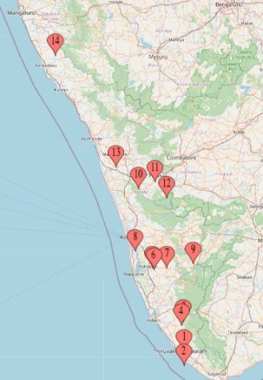

Fig. 1. Locations surveyed for brood disease incidence from different districts of Kerala during 2024-25
Data on the GPS, altitude, temperature and relative humidity (%RH) of apiaries purposively selected for recording brood disease incidence in Kerala during 2024-25 is presented in Table.1.

Table 1. Details of the apiaries surveyed for per cent brood disease incidence

District | Season | Location of apiary | GPS  Coordinates  (Latitude & Longitude) | Altitude (m) | Temperature (̊C) | RH  (%) | Apiaries visited | Total  colonies | Diseased colonies
Trivandrum | Honeyflow season | Kollamkavu | 8.62°N, 77.00°E | 65 | 31.80 | 51 | 3.00 | 105.00 | 17.00
Trivandrum | Dearth season | Kalliyoor | 8.43°N, 76.99°E | 10 | 30.38 | 78 | 1.00 | 45.00 | 12.00
Kollam | Dearth season | Edamon | 9.00°N, 76.99°E | 92 | 25.70 | 90 | 3.00 | 45.00 | 19.00
Kollam | Dearth season | Ayilara | 8.95°N, 76.97°E | 96 | 25.30 | 92 | 2.00 | 50.00 | 19.00
Kottayam | Honeyflow season | Puvanthurathu | 9.68°N, 76.59°E | 22 | 36.70 | 32 | 2.00 | 70.00 | 14.00
Kottayam | Dearth season | Kattachira | 9.68°N, 76.59°E | 600 | 35.40 | 35 | 1.00 | 100.00 | 50.00
Kottayam | Brood  rearing season | Panackapalam | 9.70°N, 76.76°E | 34 | 29.80 | 74 | 2.00 | 100.00 | 35.00
Ernakulam | Brood  rearing season | Arakkunnam | 9.90°N, 76.43°E | 34 | 36.80 | 60 | 3.00 | 90.00 | 55.00
Idukki | Brood  rearing season | Kanjar | 9.81°N, 76.82°E | 57 | 27.80 | 83 | 1.00 | 92.00 | 5.00
Thrissur | Honey flow season | Kondazhy | 10.71°N, 76.38°E | 96 | 29.90 | 70 | 3.00 | 30.00 | 27.00
Thrissur | Honey flow season | Akathethara | 10.83°N, 76.62°E | 89 | 30.00 | 71 | 3.00 | 102.00 | 17.00
Palakkad | Dearth season | Muthalamada | 10.58°N, 76.83°E | 217 | 35.50 | 41 | 2.00 | 99.00 | 4.00
Malappuram | Honey flow season | Chattipparamba | 11.00°N, 76.10°E | 60 | 33.90 | 54 | 5.00 | 125.00 | 42.00
Kasargod | Brood rearing season | Kolichal | 12.45°N, 75.30°E | 141 | 36.10 | 50 | 2.00 | 90.00 | 13.00
Total= 9 |  | 14 |  |  |  |  | 33 | 1143 | 329.00

3.2. Percentage brood disease incidence and colony strength
Colony parameters recorded on percentage brood disease incidence resulted in 28.78% incidence during the period, 2024-25 (Table.2.). The highest percentage brood disease incidence was recorded from Kondazhy (Thrissur) (90.00%) and lowest from Muthalamada (Palakkad) (4.04%). Colony strength of the infected colonies was comparatively less in the location which reported maximum incidence (Kondazhy) (1.30) and this was in similarity with the findings addressed by Haran et al., (2024) and Devi et al. (2024) in infected colonies of Apis cerana indica. Moreover, the findings in the studies regarding the colony strength by Budge et al. (2015) reported that the reduction in the strength as an indicator for pathogen exposure in the colonies.

Table.2. Percentage brood disease incidence, brood parameters and hive parameters of surveyed apiaries
District | Location | Colony strength* | Percentage brood disease incidence* | Mean number of brood cells with infected larva / pupa | Hive Temperature ( ̊C) | Hive Relative humidity (%)
Trivandrum | Kollamkavu | 2.25 | 16.19 | 53.67 | 34.50 | 54.10
Trivandrum | Kalliyoor | 3.50 | 26.67 | 40.00 | 34.50 | 53.00
Kollam | Edamon | 3.00 | 42.22 | 43.50 | 32.50 | 65.20
Kollam | Ayilara | 5.00 | 38.00 | 109.00 | 34.50 | 66.00
Kottayam | Puvanthurathu | 1.75 | 20.00 | 76.33 | 32.30 | 66.10
Kottayam | Kattachira | 4.80 | 50.00 | 60.34 | 35.10 | 62.80
Kottayam | Panackapalam | 2.80 | 35.00 | 96.00 | 33.50 | 82.30
Ernakulam | Arakkunnam | 4.00 | 61.10 | 115.33 | 32.30 | 81.90
Idukki | Kanjar | 4.30 | 5.43 | 44.83 | 35.00 | 70.00
Thrissur | Kondazhy | 1.30 | 90.00 | 38.67 | 31.00 | 69.00
Thrissur | Akathethara | 3.80 | 16.67 | 45.00 | 35.00 | 70.00
Palakkad | Muthalamada | 5.00 | 4.04 | 10.67 | 34.50 | 68.00
Malappuram | Chattipparamba | 2.75 | 33.60 | 99.50 | 34.50 | 58.00
Kasargod | Kolichal | 4.50 | 14.44 | 60.00 | 35.00 | 69.00
9 | 14 |  | 28.78±0.88
*Values are mean of four infected colonies
District wise brood disease incidence was computed and maximum incidence was reported from Ernakulam district (61.1%) while the minimum was from Palakkad district (4.04%) (Fig.2.). Variation in the percentage brood disease incidence was observed due to the spatial and temporal attributes of different agroclimatic regions (Rao, 2009) which was also evident in the present findings. The brood disease incidence of 28.78% recorded from the surveillance studies in the state, was higher than that of previous reports from Kashmir with 8–18% Suresh et al., (2018). Comparable or higher incidences have also been reported from China with 28.90% incidence in Apis cerana colonies (Gong et al., 2016) and American foulbrood affecting 37.30% of colonies in northwest Pakistan (Khan et al., 2018). The elevated incidence observed here may be due to local climatic conditions, nutritional stress during dearth periods, and colony management practices.
Season wise incidence resulted in the highest percentage brood disease incidence during honey flow season (Fig.3). This pattern aligns with the findings from the previous reports in Kerala wherein some of the regions surveyed for bacterial disease incidence were found to be more infected during dearth period (Joesph & Amritha, 2020). In Himachal Pradesh, the studies on influence between brood disease incidence and forage scarce period (dearth) also reported negative correlation (Sharma et al., 2025) suggesting that pollen substitutes and supplements during dearth periods improve colony strength, brood area, and disease resistance. This supports our present findings by highlighting the direct link between nutrition and disease dynamics in Indian bee colonies under Indian climatic conditions.

Fig.2. District wise brood disease incidence (%) from different locations of Kerala

Fig.3. Season wise brood disease incidence (%) from different locations of Kerala

In other countries, the research emphasizes that the nutrient deficiency during dearth period impacts increased susceptibility to brood pathogens (Mattila & Otis, 2006; Alaux et al., 2010). Conversely, abundant floral resources during the honey flow season enhance colony strength and hygienic efficiency, thereby lowering infection rates (Evans & Spivak, 2010). Similar seasonal trends have been reported in Indian apiaries, where the outbreak of foulbrood and sacbrood diseases peak during these periods (Bhatia et al., 2014; Suresh et al., 2018).

3.3. Symptomatology and Management strategies
The infected colonies exhibited an irregular brood pattern. Infected larvae, typically 4–5 days old, showed the color change from pearly white to creamish-white. At the early stages of infection, however, distinct color changes were not always noticeable. Most frequently, the affected larvae were observed lying flat along the cell base in a melted or semi-fluid condition with symptoms suggestive of bacterial infections (Fig.4.). When stretched out the infected brood, the ropy nature was not noticed. Similar symptoms such as irregular brood with flaccid or semi-liquid larvae were reported by Ansari et al. (2016) from India and Forsgren (2010) from Europe and the absence of ropey nature in the larval remains suggests the indication of EFB rather than American foulbrood (OIE, 2021). Similarly, the color change at the earlier stage of infections was not always pronounced as documented by Forsgren (2010) & Ellis (2016), indicating that subtle initial symptoms can complicate field diagnosis.
In addition, diseased colonies also displayed symptoms in the late larval to pupal stages, characterized by uncapped cells and a “pepperbox” brood pattern. The pupal stage within these cells showed their heads oriented upwards with retarded development which are indicative of possible viral infections such as sacbrood virus (Fig. 4). The typical sac-like symptoms were present in some of the colonies but was not seen in the asymptomatic colonies. Similarly, Wei et al. (2022) and Gong et al. (2016) also described that the symptoms in the colonies appear as “pepperbox” brood and head-up larvae in Apis sp. from Asia.
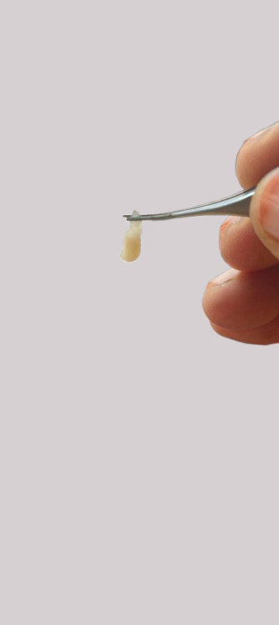
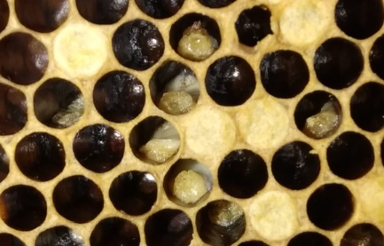
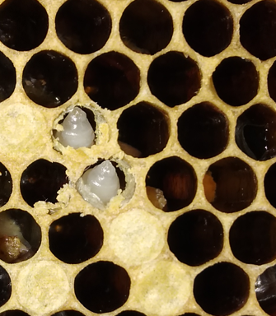
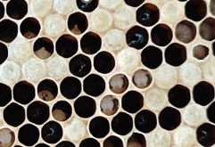
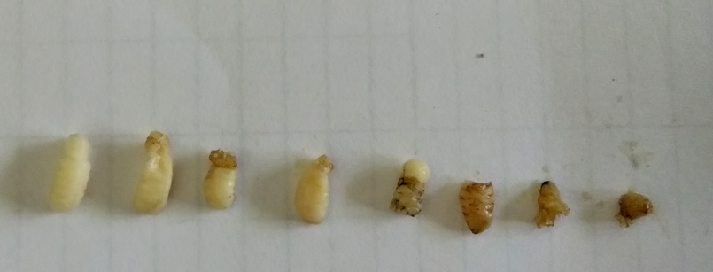
b.
e.
d.
c.
a.

Fig. 4. Symptoms of infected colonies recorded from different locations.
a) Larvae in melted condition, b&c) Pupal stages head in upright orientation, d) Sac-like appearance of the late-larval stage & e) Brood exhibiting colour change forming into scales

Information on management strategies adopted by the beekeepers revealed that different methods were followed by them in the apiaries. To reduce the spread of infection, colonies showing disease symptoms were discarded from the apiary. Bacterial infected colonies were treated by applying turmeric 2g or antibiotic, Terramycin 500mg along with the artificial feed (50% sugar solution) combat the infection. Sulphur based ayurvedic medicines were also used against these diseases. Old queen from the colonies showing viral infection was removed and new queen was provided. Combs having diseased brood were cut and discarded.

3.4. Infected brood area and hive parameters
Brood parameters viz., number of brood cells with infected larva or pupa, hive temperature & %relative humidity (Table.2.) revealed significant difference in the infected brood area. Maximum infected brood area was documented from Arakkonam (Ernakulam) (54.2cm²) while the lowest area was from Muthalamada (Palakkad) (5.01cm²) as represented in Fig. 5. This variation within the apiary of Arakkonam can be partially explained by differences in hive types. Taric et al. (2019) reports revealed that the hive type used for bee keeping differs due to the internal hive microclimate which influence the colony health and also the brood area. For instance, commercial or framed hives used in some apiaries provide different ventilation and temperature regulation compared to traditional hives, which can affect brood susceptibility to diseases. The present study also reported a reduction in the brood area of the infected colonies in colonies with less incidence; similar results were obtained in the studies of Rana et al. (2004) and Rao (2009). Moreover, disease incidence was not always correlated directly with the infected brood area of the colonies in a region from the present findings. The inverse relationship between hygienic behavior and the extent of infected brood area shows that colonies with stronger hygienic responses tend to have fewer infected brood cells. The positive influence of colony strength on hygienic activity further indicates that stronger colonies are more effective at detecting and removing diseased brood. This hygienic behavior helps in controlling brood disease severity by minimizing infected brood within the cells and limiting disease spread throughout the colony.

1-Kollamkavu, 2-Kalliyoor, 3- Edamon, 4- Ayilara, 5- Puvanthurathu, 6- Kattachira, 7- Panackapalam,
8- Arakkunnam, 9- Kanjar, 10- Kondazhy, 11- Akathethara, 12- Muthalamada, 13- Chattipparamba &
14- Kolichal
Fig.5. Infected brood area of the diseased colonies from different locations in Kerala (2024-25)
3.5. Correlation between temperature and %relative humidity and percentage brood disease incidence.

Location parameters and hive parameters on temperature and %RH showed significant correlation with percentage brood disease incidence (Table.3.). Regression analysis on the effect of weather parameters on %BDI of the apiary locations revealed a weak negative correlation with temperature (-0.507) and a weak positive correlation with percentage relative humidity (0.191). Hive parameter, temperature, showed a significantly strong negative correlation (-12.482) with percentage brood disease incidence while percentage relative humidity exhibited a positive correlation (0.612) as given in the fig.6.

Table. 3. Effect of weather parameters and hive parameters on per cent brood disease incidence (%BDI)
Parameters | Estimate | Standard Error | t value | P-value
Temperature (̊C) of the location | -0.507 | 1.695 | -0.299 | 0.770
%RH of the location | 0.191 | 0.339 | 0.564 | 0.583
Hive temperature (̊C) | -12.482 | 3.689 | -3.383 | 0.005
Hive %RH | 0.612 | 0.774 | 0.791 | 0.444
Regression analysis with dependent variable (%BDI) & parameters as independent variables
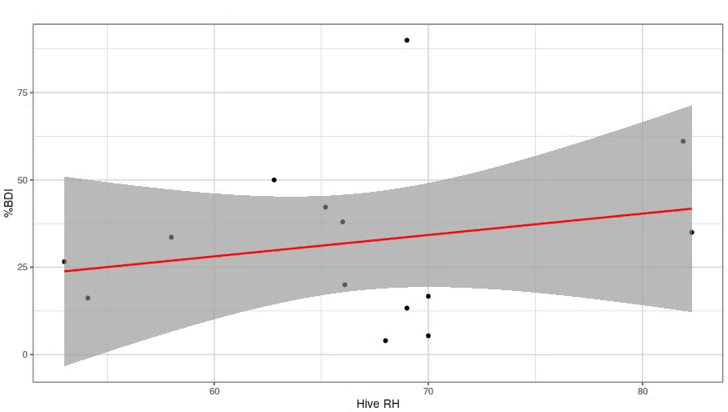
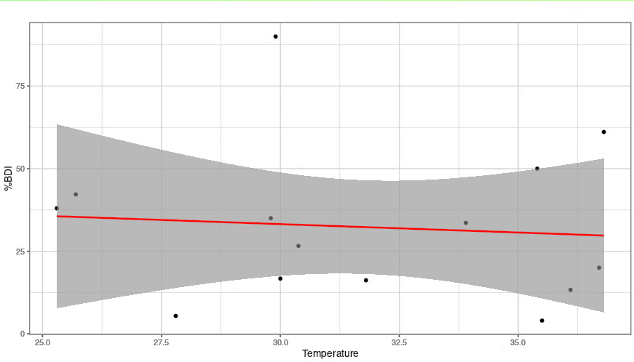
Regression co-efficient with P-value <0.05 are significant (alpha = 0.05)
(II)
(I)

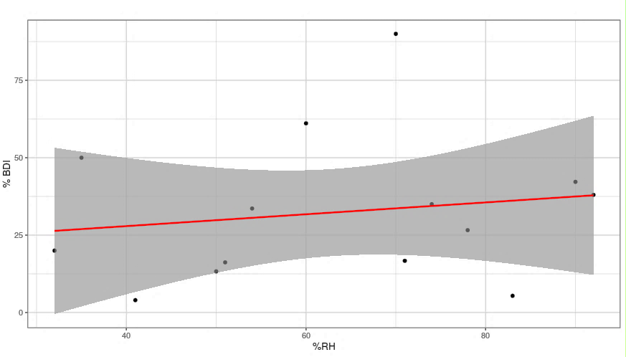
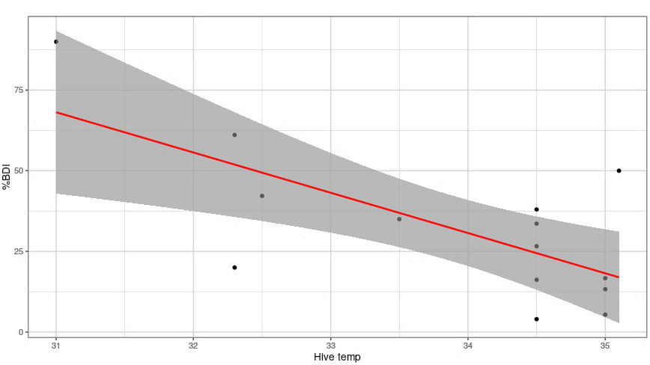
Fig. 6. Effect of weather parameters and hive parameters (Temperature ( ̊C), %RH) on percentage brood disease incidence.
(IV)
(III)
(I) Weak negative correlation between location temperature & % BDI, (II) Weak positive correlation between location %RH & % BDI, (III) Strong negative correlation between hive temperature & % BDI & (IV) Weak positive correlation between hive %RH & % BDI
4. Conclusion

In the present study, survey conducted across 14 locations in Kerala reveals a significant brood disease incidence in Apis cerana indica colonies, with an overall incidence of 28.78%. The spatial and seasonal variation in disease incidence underscores the influence of local environmental factors, particularly the positive correlation with relative humidity and inverse relationship with temperature, on brood disease dynamics. Low colony strength in regions of high disease incidence highlights the susceptibility of weak colonies to pathogen exposure, aligning with previous studies linking colony vigor to disease resistance. Hygienic behavior emerges as a critical factor in reducing the infected brood area and controlling the further spread of the disease in the colonies. The diverse management strategies adopted by beekeepers viz., the removal of infected colonies, queen replacement, comb sanitation and application of ayurvedic based medicinal treatments/ antibiotics in 50% artificial feed, positively influenced colony health by limiting disease spread and promoting recovery. These findings emphasize the necessity of integrated disease management suitable to changing climatic conditions and colony health contexts in order to sustain healthy colonies and optimize honey production. This study fills a vital gap in region-specific epidemiological data and offers a foundation for informed interventions promoting sustainable apiculture in Kerala, enhancing both pollination services and organic honey quality.

Consent to participate
Not applicable

Consent to publish
Not applicable

Ethics approval
Not applicable. No human or animal subjects, materials, or data were involved in this study.

References

Alaux, C., Ducloz, F., Crauser, D., & Le Conte, Y. (2010). Diet effects on honeybee immunocompetence. Biology Letters, 6(4), 562-565.
Amritha, V. S., Premila, K. S., Devanesan, S. & Abila, V. S. (2014). A new threat to Indian honey bee Apis cerana indica Fab., the indigenous pollinator of Kerala. In Proc. of International Symposium on Conservation and Management of Pollinators for sustainable agriculture and ecosystem services, 24-26 September, 2014, New Delhi. (p. 64).
Ansari, M. J., Al-Ghamdi, A., Usmani, S., Al-Waili, N., Nuru, A., Sharma, D., et al. (2016). In vitro evaluation of the effects of some plant essential oils on Paenibacillus larvae, the causative agent of American foulbrood. Biotechnology & Biotechnological Equipment, 30(1), 49-55.
Arbia, A., & Babbay, B. J. (2011). Management strategies of honey bee diseases. Journal of Entomology, 8(1), 1-15.
Aruna, R., Srinivasan, M. R., & Selvarajan, R. (2016). Comparison of genomic RNA sequences of different isolates of Thai Sac Brood Virus attacking Indian honeybee, Apis cerana indica Fab. in Tamil Nadu by reverse transcriptase-polymerase chain reaction method. Journal of Entomological Research, 40(2), 117-122.
Aupinel, P., Fortini, D., Dufour, H., Tasei, J. N., Michaud, B., & Loublier, Y. (2005). Improvement of artificial feeding in a standard in vitro method for rearing Apis mellifera larvae. Bulletin of Insectology, 58(2), 107-111.
Bakri, N. E., Bouchoucha, K., & Elhouda, N. (2024). Enhancing honeybee breeding for sustainable agriculture through temperature and relative humidity monitoring. World Journal of Advanced Research and Reviews, 21(2), 286-292.
Bhatia, A., Singh, S., & Kumar, P. (2014). Seasonal incidence of brood diseases in Apis cerana colonies under stationary apiary conditions. Journal of Apicultural Research, 53(4), 500-507.
Bhatia, A., Singh, S., & Kumar, P. (2014). Seasonal incidence of brood diseases in Apis cerana colonies under stationary apiary conditions. Journal of Apicultural Research, 53(4), 500-507.
Budge GE, Pietravalle S, Brown M, Laurenson L, Jones B, Tomkies V, et al. (2015). Pathogens as Predictors of Honey Bee Colony Strength in England and Wales. PLoS ONE, 10(7), e133228.
Chandel, Y. S., Kumar, A., & Ball, B. V. (1999). Sacbrood disease in Italian honey bee, Apis mellifera L., in Himachal Pradesh, India. Pest Management and Economic Zoology, 7, 181–182.
Chen, G., Wu, Y., Deng, J., Wen, Z., Wang, S., Chen, Y., et al. (2021). Seasonal variation of viral infections between the eastern honey bee (Apis cerana) and the western honey bee (Apis mellifera). Microbiology open, 10(1), e1162.
Chen, Y. P., Pettis, J. S., Collins, A., & Feldlaufer, M. F. (2006). Prevalence and transmission of honeybee viruses. Applied and Environmental Microbiology, 72(1), 606-611.
Delaplane, K. S., Van der Steen, J., & Guzman-Novoa, E. (2013). Standard methods for estimating strength parameters of Apis mellifera colonies. Journal of Apicultural Research, 52(1), 1-12.
Devi, D. (2024). Studies on molecular characterization of bacterial pathogen (s) and evaluation of non-chemical control methods in hive bees (Doctoral dissertation, Ph. D. Thesis. Department of Entomology. College of Horticulture, Dr. YS Parmar University of Horticulture and Forestry, Nauni, Solan, Himachal Pradesh, India. 351pp).
Diwan, V. V., Kshirsagar, K. K., Rao, A. R., Raghunath, D., Bhambure, C. S., & Godbole, S. H. (1971). Occurrence of a new bacterial disease of Indian honey-bees Apis indica F. Current Science, 40(8), 196-197.
Ellis, J. D. (2016). Diagnosing honeybee diseases: a practical guide. Journal of Apicultural Research, 55(1), 1-9.
Evans, J. D., & Spivak, M. (2010). Socialized medicine: Individual and communal disease barriers in honey bees. Journal of Invertebrate Pathology, 103, S62-S72.
Forsgren, E. (2010). European foulbrood in honey bees. Journal of Invertebrate Pathology, 103, S5–S9.
Gatoria, G. S., Singh, J., Chhuneja, P. K., Aulakh, R. K., Jindal, B. R., & Gupta, A. K. (2003). A micro level analysis on the constraints of beekeepers in Punjab: Some perspectives. Indian Bee Journal, 65, 95–99.
Goderham, C.B. (1950). Overwintered colonies versus package bees for orchard pollinations. Progressive Republic Domain Apiarist Canada, 50(7-8).
Gong, H., Wei, J., & Chen, Y. (2016). Seasonal variation of viral infections between the eastern honey bee Apis cerana and the western honey bee Apis mellifera. Journal of Economic Entomology, 109(5), 1953–1961.
Haran, S., Kumar, P., & Sharma, R. (2024). Unveiling the molecular basis of hygienic behavior in Apis cerana indica: Implications for colony strength and disease resistance. Journal of Apicultural Research and Bee Science. Advance online publication.
Hasan, W. (2021). An Applied Perspective.
Houiston and Sons, (1882). Dzierzon’s Rational Bee-keeping. London. 350p.
Jacob, A., Asari, P. R., & Mohandas, N. (1992). A new disease of the Indian honey bee, Apis cerana indica F., in Kerala. Agricultural Research Journal of Kerala (India), 30(1).
Johannesmeier, M.F. and Mostert, A.N. (2001). Crop pollination. In Beekeeping in South Africa (pp. 235-250). Pretoria Agricultural Research Council of South Africa.
Joseph, J. P., & Amritha, V.S., (2020). Survey and etiology of bacterial brood disease infecting Indian honey bees (Apis cerana indica F.) in Southern Kerala. Journal of Apicultural Research, 59(4), 519-527.
Joshi, B., Lekhak, S., & Sharma, A. (2009). Antibacterial property of different medicinal plants: Ocimum sanctum, Cinnamomum zeylanicum, Xanthoxylum armatum and Origanum majorana. Kathmandu University Journal of Science Engineering and Technology, 5(1).
Joshi, R. P., & Verma, L. R. (1985). Hygienic behaviour of honey bees and its relationship with disease resistance. In Proceedings of the National Seminar on Apiculture, India (pp. 45-50).
Kaftanoglu, O., Linksvayer, T., & Akyol, E. (2011). Seasonal variability in water balance and humidity regulation in honey bee (Apis mellifera) nests. Journal of Experimental Biology, 214(11), 1926-1934.
Khan, H. A., Shafique, M., Chaudhry, M. T., & Shakoori, A. R. (2018). Prevalence of American foulbrood disease of honeybee in northwest Pakistan. Veterinary World, 11(8), 1137-1141.
Kshirsagar, K. K. (1982). Current incidence of honeybee diseases and parasites in India. Bee World, 63(4), 162-164.
Mattila, H. R., & Otis, G. W. (2006). Influence of pollen diet in spring on development of honey bee (Apis mellifera) colonies. Apidologie, 37(4), 397-409.
Naveen, K., & Yadav, A. S. (2021). Seasonal Incidence of European Foul Brood and Sac Brood in Indian Bees. International Journal of Current Microbiology and Applied Sciences, 10(1), 3149-3157.
Premila, K. S., Devanesan, S., & Shailaja, K. K. (2014). Bee pollination and yield enhancement in culinary melon Cucumis melo var. conomon in Kerala. In Proceedings of international symposium on conservation and management of pollinators for sustainable agriculture and ecosystem services (p. 5), New Delhi.
Rana, H. S., & Rana, R. S. (2004). Seasonal incidence and impact of sacbrood virus on honey bee brood in Himachal Pradesh, India. Journal of Entomology, 1(2), 134-139.
Rao K.M. 2009. Molecular characterization of Melissococcus plutonius of hive honey bees and its control with antibiotics. (Doctoral dissertation, Ph. D. Thesis. Department of Entomology, Dr. Yashwant Singh Parmar University of Horticulture and Forestry, Nauni, Solan H.P. 97p).
Rathod, R. V., Shivankar, R. S., & Gandhi, B. N. (2025). Incidence and treatment of European foulbrood and sacbrood diseases. Journal of Entomology and Zoology Studies, 13(1), 14-21.
Shah, M. M., & Shah, G. B. (1973). Studies on the seasonal incidence of some important honey bee diseases and their management. Indian Journal of Entomology, 35(3), 215-220.
Sharma, A., Sharma, V., Chauhan, J., Chandel, R. S., Dev, I., & Devi, M., et al. (2025). Impact of proteinaceous diets on foraging behavior, brood production and honey yield in Apis cerana indica F. colonies of Himachal Pradesh, India. Plant Archives, 25(Supplement 2), 2067–2077. e-ISSN: 2581-6063 (Online), ISSN: 0972-5210.
Silva, A. S., Maia, L. G., & de Freitas, L. S. (2009). Influence of environmental humidity and temperature on brood development of Africanized honey bees (Apis mellifera). Journal of Apicultural Research, 48(4), 276-280.
Singh, S. (1961). Appearance of American foul brood in Indian Honey bee (Apis indica F.). Indian Bee Journal, 23, 46-50.
Suresh, R., Kumar, R., & Singh, V. (2018). Epidemiology and management of brood diseases in Indian honey bee colonies. Journal of Entomology and Zoology Studies, 6(3), 854-859.
Taric, E., Glavinic, U., Stevanovic, J., Vejnovic, B., Aleksic, N., Dimitrijevic, V., & Stanimirovic, Z. (2019). Occurrence of honey bee (Apis mellifera L.) pathogens in commercial and traditional hives. Journal of Apicultural Research, 58(3), 433–443.
Thomas, D., Pal, N., & Rao, K.S. (2002). Bee management and productivity of Indian honey bees. Apiacta, 3, 1-5.
Wei, J., Gong, H., & Chen, Y. (2022). Sacbrood Virus: A Growing Threat to Honeybees and Wild Pollinators. Pathogens, 11(9), 1025.
World Organization for Animal Health (OIE). (2021). American foulbrood of honey bees (infection of honey bees with Paenibacillus larvae). Terrestrial Animal Health Code.

