QUALITATIVE DATA ANALYTICAL TOOLS COMPARISON THROUGH OPEN-ENDED RESPONSES ON EXPERIENCE OF VIRTUAL REALITY IN VETERINARY TEACHING

Abstract
Veterinary Science educational institutes across the globe have witnessed a technological revolution in the last half-decade, giving a retouch to the traditional teaching methods to facilitate holistic learning and minimize animal usage in practical demonstrations. Computer-aided learning resources, Virtual worlds, Mixed reality, augmented reality, Immersive Virtual Reality, and Artificial intelligence-enabled reality are the technologies where veterinary science teaching is finding its scope to minimize animal usage. Virtual reality(VR) is one of the potential technologies that can be incredibly valuable in veterinary science teaching and learning environments. Several Western Veterinary Institutions have explored this and are implementing implemented in regular classroom teaching. The Govt of India, under the National Agricultural Higher Educational Project (NAHEP) component-II, also introduced VR in Veterinary and Agricultural Institutions.
The present experimental research investigated the application of VR in veterinary science teaching with a sample of 120 students from four different Veterinary institutions in India. The research involved collecting insights from the Students after undergoing exposure to specially developed priority-ranked Slaughterhouse procedure VR modules. Their responses were analyzed across various parameters to know the application of VR technology, including technical, personal, and practical constraints. A survey questionnaire was administered to collect detailed feedback, with an emphasis on open-ended responses to yield wide insights. Natural language processing (NLP) toolkit was employed to analyze the open-ended responses, comparative analysis was done using artificial intelligence (AI) large language models(LLM), qualitative data analytical software, Atlas.ti, and manual processing techniques. Further results were summarized through Exploratory Data Analysis (EDA) wherever applicable. The findings revealed the experience of the students using VR and its application in the classroom as a teaching aid, and also various constraints and practical limitations were analyzed.
Key Words: Virtual Reality, Veterinary Teaching, NAHEP, Large Language Models, Open-Ended Questions, Atlas.ti, NLP.

INTRODUCTION
The students of Veterinary Science in India now have the ubiquity of smartphones, interconnected devices, and uninterrupted affordable internet. They are connected in the cloud through social networks where they are sharing their experiences and redefining teen ideas of knowledge acquaintance. They are not just watching the content, they are creating, sharing, and experiencing the technology-mediated immersion. Veterinary Science being a vast trove of varied and Versatile embedded components makes classroom interactions challenging for teachers in comparison with the external world where a student is exposed to higher-end technologies. Keeping pace with the students is mandatory to be a competent teacher, so a combination of available innovations needs to be incorporated into Veterinary teaching. One potential technology to address a part of this challenge is Virtual Reality. It is defined as immersive, realistic, three-dimensional environments that involve visual feedback from body movement (Aarseth, 2001).
The widely used lecture format in teaching is usually linear in terms of presentation, supported by the almost exclusive use of PowerPoint. Many of the lectures were too full of information, It is noted that during a lecture, students will not listen to approximately 40% of the material delivered (Pollio HR, 1984). It is demand-driven to understand the subject-specific approach, learning goals, learner traits, and educational setting to determine the most effective combination of teaching methods and delivery approaches.
The 3R principles of animal experiments, namely reduction, replacement, and refinement, were given thought half a century ago by Russell WMS in 1959. Alternative approaches not involving animals that can still maintain scientific temper and vigor are imperative in the current Veterinary education context. Humane educational aids and teaching approaches can minimize the use of animals. ‘Saving the life and termination of life’ is a unique boon to Veterinarians, and it falls under the ethical radar during animal experimentation and demonstration. Many Universities under the Organization for Economic Cooperation and Development (OECD) are developing alternatives to invasive examinations wherever possible to ensure animal welfare and quality humane Veterinary student training. A similar intervention had been developed at Tamil Nadu Veterinary and Animal Sciences University (TANUVAS) under NAHEP, where a learning and assessment center is being developed. Robotics and haptic Simulators are put to use in Student teaching as animal alternates.
RESEARCH OBJECTIVE
To ensure informed decision-making utilizing the potential of multiple web-based tools, for comprehending and visualizing open-ended responses, in exploring the applicability of Virtual Reality as a teaching aid in Veterinary Science education.
H₀: VR technology cannot evoke a positive response as a Veterinary science teaching Aid
H₁: VR technology can evoke positive responses as a Veterinary science teaching Aid
RESEARCH METHODOLOGY
- Experimental Methodology:
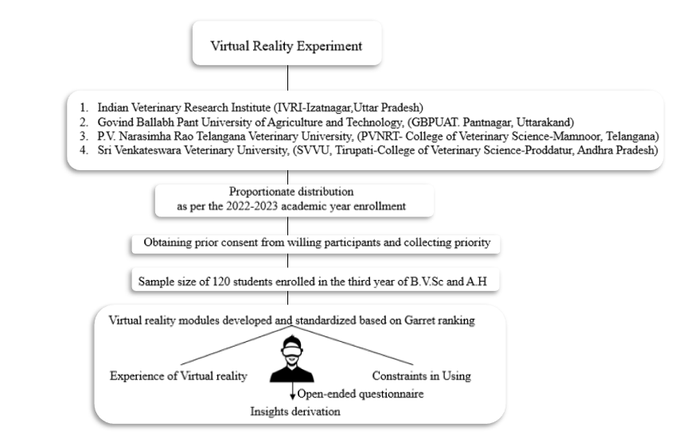
Fig 1: Describes the experimental research methodology

- Analytical Framework methodology:
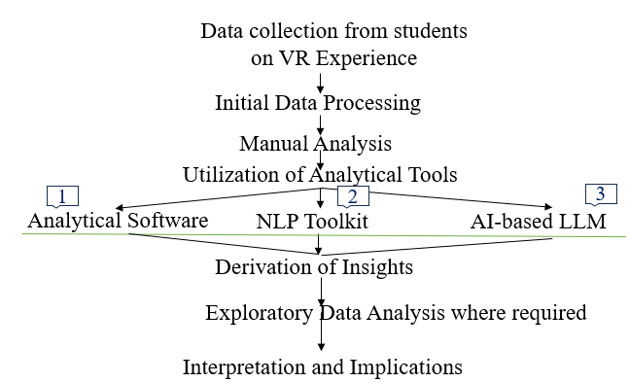
Fig 2: Qualitative data analytical framework
Open-ended questions play a crucial role in extracting deeper insights and are essential components of any Extension research. Manual analysis of open-ended responses remains a prevalent method to derive meaning from them, However, the emergence of new-generation tools and technologies provides opportunities for in-depth comprehension and visualization. In this study, three distinct analytical tools were employed, Atlas.ti, a qualitative data analysis software, NLP tool kit, a natural language processing tool; and artificial intelligence-based large language model analysis tools. These tools were utilized to examine the outputs and their implications by subjecting the responses obtained from the VR experience, EDA was further employed wherever necessary.
STUDIES ON VIRTUAL REALITY IN VETERINARY SCIENCES
Virtual Reality studies offer progressive adoption and application in various disciplines of the Veterinary Science curriculum, Studies like Veterinary Anatomy (CahyadiD,2022), novel surgical techniques and emergency case management (Baillie et al,2003), Live dog endoscopy skills (McCool KE, 2020), laparoscopic skills (Fransson and Ragle 2010), Virtual abattoir experience (Seguino, 2014), Medicine Training through VR (Franzluebbers, 2020), Virtual veterinary meat inspections (Almqvist et al, 2021), VR Robotics surgery (Angel-Urdinola, 2021), Pig liver VR animation (Jose, 2022), Canine Prostrate Simulator (Capilé KV, 2015) and many more study findings have supporting results regarding usage of VR in classroom teaching. From a thorough review of existing literature and meta-analysis conducted as part of this research, it was found that numerous perception-based studies are focusing on virtual reality in Veterinary Science, However, there is a notable lack of experimental research in this area.
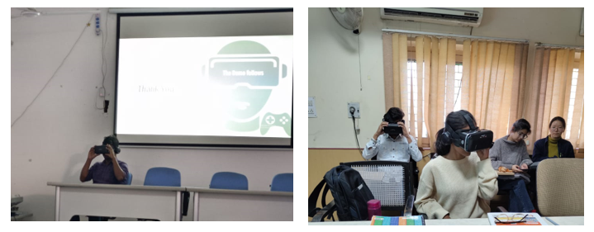
Pic : 1 & 2 - Students Participating in the VR experiment during the present research
RESULTS AND DISCUSSION
The three main new generation tools used for data comparison Atlas.ti, NLP Tool Kit, LLM, are discussed here
ANALYSING VIRTUAL REALITY THROUGH MULTIPLE TOOLS
Responses of 120 students on the following open-ended questions were recorded which resulted in 431 responses and a total of 4509 words which are considered to denote their reactions/sentiments towards the usage of VR. The experience of the students after watching VR modules was recorded as open-ended responses, Constraints were collected in three different categories to provide student participants with a wider scope of expression. The data was further grouped into two main categories Experience and Constraints for further processing.
  - Narrate your Experience of using VR as a classroom teaching Aid
  - Narrate the Practical constraint you experienced while using VR
  - Narrate the Technical constraint you felt while using VR
  - Mention any Personal constraint you experienced while using VR
I. NATURAL LANGUAGE PROCESSING TECHNIQUE
Natural Language Processing Technique (NLPT) and Python libraries were used because of the literature indications of their wider application. The approach involved gathering the responses from the survey as the primary data source. Data preprocessing was executed utilizing the NLTK library, encompassing tokenization, normalization, removal of stop words, and stemming/lemmatization to ensure data consistency and accuracy. The program received input comprising all open-ended responses.
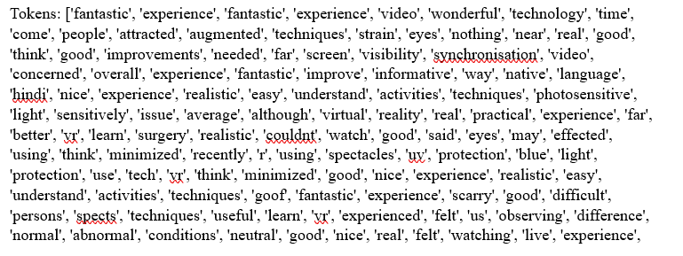 | 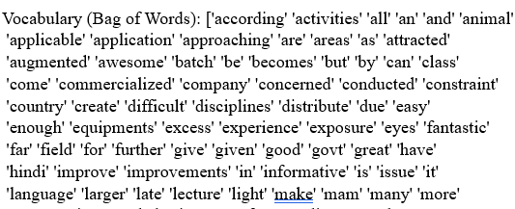
Fig 3: Sample tokens Fig 4: Bag of Words sample
Sample tokens and BOW did not provide any clear picture and Feature extraction was conducted using “sklearn.feature_extraction.text” and “CountVectorizer”, and “TfidfVectorizer” libraries. This process involved representing each document as a vector using Bag of Words (BoW), where each dimension corresponded to a word, and its value indicated the frequency of occurrence in the document as shown in Fig: 5 and 7, Additionally TF-IDF (Term Frequency-Inverse Document Frequency) was employed to assess the importance of each word relative to the entire document collection. Word embedding techniques such as BERT (Bidirectional encoder representations from transformers) were utilized to convert words into dense vectors, capturing semantic meaning. These methods facilitated a comprehensive analysis of the tokens generated as shown in Fig: 6, during the initial preprocessing step, ensuring cascading handling and interpretation of textual data.

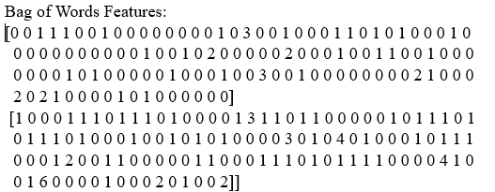 | 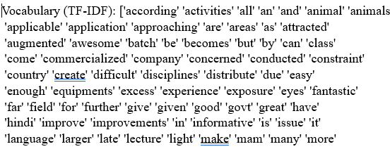 | 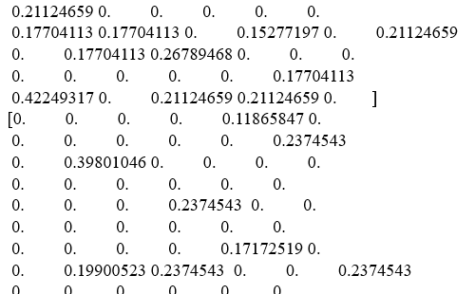
Fig 5: Words features Fig 6: TF-IDF Fig 7: Word frequency

Exploratory Data Analysis (EDA) was done to understand the distribution of words, common topics, and trends within responses generated. These involved techniques of word frequency analysis, topic modeling, and sentiment analysis. Pandas, matplotlib. pyplot, wordcloud from open-source libraries are used, The outputs from feature extraction were used as inputs.
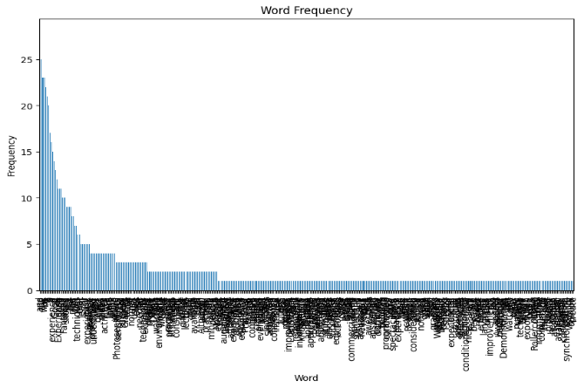 | 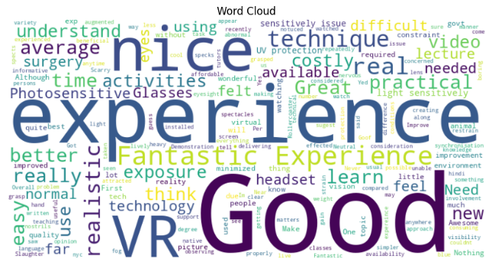
Fig 8: Word Frequency through NLP Fig 9: Word Cloud through NLP

Fig 10: Sentiment analysis through NLP

Fig 8 indicates the word frequencies as clustered features indicating common words and general modes of expression among students which were highly overlapping in nature, Fig: 9 word cloud highlights the overall experience of the VR as favorable technology, Fig 10 shows the overall sentiment analysis of the experience and a total of 237 expressions are captured as Positive and 83 expressions are considered negative, indicating a higher inclination towards usage of VR in classroom teaching. Most of the constraints expressed like heavy console, Inability in remote control operation, Issues adjusting Hair, etc can be addressed with the advancement and refinement of the technology except for the health issues associated. The results were in line with (Franzluebbers, 2020), (McCool KE, 2020), (Jose, 2022), (Xu,2022).

II. SOFTWARE TOOLS-ATLAS.ti
Out of many software available, Atlas.ti is selected due to its user-friendly interface, comprehensive features for qualitative analysis, and interpretation of complex qualitative data.
Survey responses import was directly uploaded as a CSV file, after text mining survey responses to pinpoint top experience and constraints, code-document analysis was conducted and a frequency distribution chart for the experience and a Sankey diagram revealing the interrelationship between denoted constraint and perceived constraints is visualized as in Fig 11 and 12,.. Through sentiment analysis, responses were discerned as positive, neutral, and negative sentiments, and their correlation with listed constraints was derived as shown in Fig: 13.

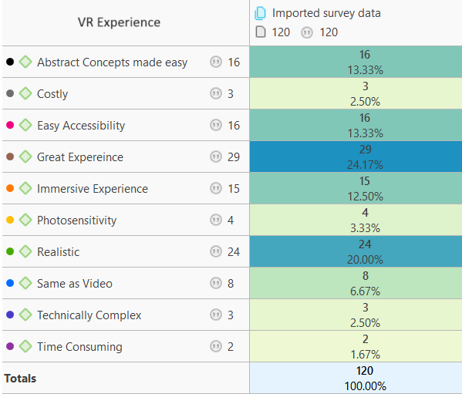
Fig 11: Frequency distribution chart
The frequency distribution chart suggests the overall experience was favorable and the majority of the participants expressed a positive attitude.

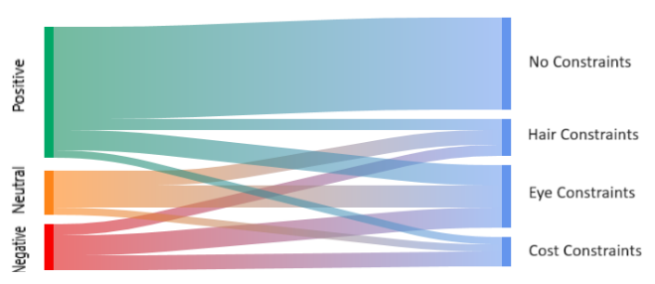
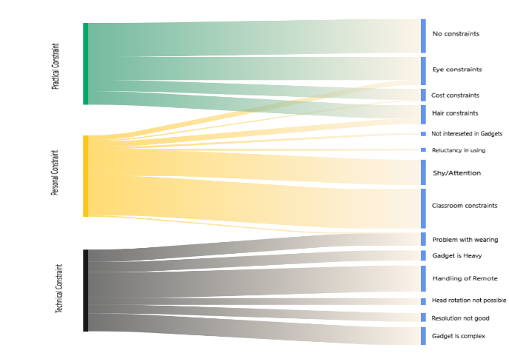
Fig 12: Sankey diagram showing Interrelationship Fig 13: Sentiment analysis
The results obtained from the tool suggest that there is an interrelationship between the denoted constraints and perceived constraints and sentiment analysis results were similar to that of results from NLP. Several constraints related to the gadget are expected to have less negative impact with the advancements as the technology is in its primitive form. Obtained results replicated study results from (Capilé KV, 2015), (Angel-Urdinola, 2021), (Fransson and Ragle 2010), (CahyadiD,2022)
III. LARGE LANGUAGE MODELS
Large Language Modelling, GPT-3.5 model, which is a version of the OpenAI's Language Model, specifically the GPT (Generative Pre-trained Transformer) architecture is being used.
For the Large Language Model (LLM), data was provided along with three specific questions to extract meaningful insights, leading to the analysis presented.

Table: 1 Large Language Model Data Analysis
S.N | QUESTION POSED TO LLM | DATA ANALYSIS RESULTS
Q.1 | What percentage of responses indicate a positive opinion on the usage of VR as a teaching aid? | - Total number of responses: 340  - Number of positive responses: 245  - The percentage of students who viewed VR positively was calculated.  - Approximately 72.05% of the students viewed virtual reality positively based on the provided responses.
Q.2 | Is there any relationship between the types of experiences students had during the experiment and the advantages they associate with its use for learning? | - Data analysis reveals a direct correlation between positive VR experiences, such as immersion and enjoyment, and increased learning engagement.  - Findings indicate that VR simulations mirroring real-world scenarios facilitate experiential learning, enhancing understanding and skill development.  - Analysis of student responses suggests that VR's informative and educational qualities contribute to improved learning outcomes by aiding comprehension and memory retention.  - Data insights demonstrate that VR's accessibility and flexibility for learning enhance convenience and adaptability to individual learning preferences.
Q.3 | How do constraints mentioned by students correlate with their perceptions of the limitations of virtual reality technology in the classroom? | - Vision issues: Students experiencing discomfort or blurred vision with VR headsets due to wearing glasses highlight personal barriers, impacting their perception of VR's clarity and usability.  - Physical discomfort: Students reporting neck pain or discomfort from wearing VR headsets discuss physical constraints, affecting their mobility and overall acceptance of VR technology in education.  - Technical proficiency: Students facing challenges in operating VR equipment express frustration with setup procedures and navigating VR environments, influencing their confidence in using VR for learning.  - Health concerns: Students experiencing motion sickness and discomfort influenced their perception of VR technology.  - Technical complexity and setup: Students encountering difficulties with VR equipment setup or usage due to complexity express reservations about integrating VR into learning, underscoring practical limitations.
The results were in alignment with the results obtained from previous tools and studies indicated.

Table 2: SUMMARY
S.No | Analytical tool Used | Result | Decision on Null Hypothesis
1 | NLP | A total of 237 expressions are captured as Positive and 83 expressions are considered negative, indicating a higher inclination towards usage of VR in classroom teaching. | Rejected
2 | Atlas.ti | 83% response frequencies are evaluated as a positive experience | Rejected
3 | LLM | Approximately 72.05% of the students viewed virtual reality positively based on the provided responses | Rejected

CONCLUSION
The overall percentage of students perceiving VR experience as positive is estimated same across tools with certain errors due to data processing loss, the constraints sorted by the three tools are nearly similar and provide a clear picture of the applicability of the technology and improvements that need to be done to make the technology user friendly. Based on the results it is evident that the VR technology is received as a positive experience by more than 70% of the participating Veterinary students across tools. When analyzing the tools used, Comparing three analytical tools reveals that they have huge similarities in interpreting the results, however, the input data processing techniques of each tool are different and in every tool, there is a loss of certain content during the filtration and number of responses were processed differently in quantity and quality at different stages. Atlas.ti needs manual intervention at different levels for identification of auto-suggested tags which are not in agreement with the researcher's discretion and are tedious with larger volumes of data, Natural language processing tool kits are easy to handle and provide deeper insights with in-depth data processing, AI-enabled Large language models are found to generate huge volumes of unfiltered uncontrolled language outputs which is often not related to the research data provided. AI models as of now are producing unclear data not pinpointed to the qualitative analytics. Manual intervention is required in all the tools and the fact that “These tools can never totally replace the rational decision making, researcher discretion and interpretation generated through experienced human intelligence and this remains strongly disproved as of now”. The H₁: “VR technology can evoke a positive response as Veterinary science teaching Aid” is accepted.
COMPETING INTERESTS DISCLAIMER:
Authors have declared that they have no known competing financial interests OR non-financial interests OR personal relationships that could have appeared to influence the work reported in this paper.
REFERENCES
Aarseth, E. (2001) ‘Virtual worlds, real knowledge: towards a hermeneutics of virtuality’,
European Review, Vol. 9, No. 2, pp.227–232.
Almqvist, Viktor & Berg, Charlotte & Hultgren, Jan. (2021). Reliability of remote post-mortem veterinary meat inspections in pigs using augmented-reality live-stream video software. Food Control. 125. 107940. 10.1016/j.foodcont.2021.107940.
Angel-Urdinola, Diego & Castillo-Castro, Catalina & Hoyos, Angela. (2021). Meta-Analysis Assessing the Effects of Virtual Reality Training on Student Learning and Skills Development. 10.1596/1813-9450-9587.
Baillie S, Mellor DJ, Brewster SA, Reid SW. Integrating a bovine rectal palpation simulator into an undergraduate veterinary curriculum. J Vet Med Educ 32:79–85, 2005.
Capilé KV, Campos GM, Stedile R, Oliveira ST. Canine Prostate Palpation Simulator as a Teaching Tool in Veterinary Education. J Vet Med Educ. 2015 Summer;42(2):146-50. doi: 10.3138/jvme.1214-120R1. Epub 2015 May 7. PMID: 25862400.
CahyadiD. D., AsfarianA., Nurhidayat, Nisa’C., Supratikno, NovelinaS., SetijantoH., & AgungpriyonoS. (2022). Virtual reality-based animal anatomy model: a new possible approach for veterinary education in Indonesia. ARSHI Veterinary Letters, 6(1), 11-12.
DeBose K. Virtual Anatomy: expanding veterinary student learning. J Med Libr Assoc. 2020 Oct 1;108(4):647-648. doi: 10.5195/jmla.2020.1057. PMID: 33013225; PMCID: PMC7524623.
Farrell R. Beyond the classroom: insights into the use of virtual simulation in veterinary education. Vet Rec. 2020 May 30;186(17):559-561. doi: 10.1136/vr.m2103. PMID: 32482819.
Franzluebbers, Anton & Platt, Simon & Johnsen, Kyle. (2020). Comparison of Command-Based vs. Reality-Based Interaction in a Veterinary Medicine Training Application. Frontiers in Virtual Reality. 1. 10.3389/frvir.. 2020.608853.
Hunt JA, Heydenburg M, Anderson SL, Thompson RR. Does virtual reality training improve veterinary students' first canine surgical performance? Vet Rec. 2020 May 30;186(17):562. doi: 10.1136/vr.105749. Epub 2020 Mar 18. PMID: 32188768.
Ioannou I, Kazmierczak E, Stern L. Comparison of oral surgery task performance in a virtual reality surgical simulator and an animal model using objective measures. Annu Int Conf IEEE Eng Med Biol Soc. 2015;2015:5114-7. doi: 10.1109/EMBC.2015.7319542. PMID: 26737442.
José, Zanchet & Montero, Edna. (2002). Pig liver sectorization and segmentation and virtual reality depiction. Acta Cirurgica Brasileira. 17. 10.1590/S0102-86502002000600005.
McCool KE, Bissett SA, Hill TL, Degernes LA, Hawkins EC. Evaluation of a Human Virtual-Reality Endoscopy Trainer for Teaching Early Endoscopy Skills to Veterinarians. J Vet Med Educ. 2020 Feb;47(1):106-116. doi: 10.3138/jvme.0418-037r. Epub 2019 Apr 22. PMID: 31009293.
Pollio HR. What students think about and do in college lecture classes. Knoxville, TN: Learning Research Center, University of Tennessee; 1984. (Teaching-learning issues; no. 53).
Russell WMS, Burch RL. The Principles of Humane Experimental Technique. Wheathampstead, UK: Universities Federation for Animal Welfare, 1959. Reprinted by UFAW, 1992
Seguino A, Seguino F, Eleuteri A, Rhind SM. Development and evaluation of a virtual slaughterhouse simulator for training and educating veterinary students. J Vet Med Educ. 2014 Autumn;41(3):233-42. doi: 10.3138/jvme.1113-150R. PMID: 25000879.
Xu, Xuanhui & Pan, Xingyu & Kilroy, David & Kumar, Arun & Mangina, Eleni & Campbell, Abraham. (2022). Using HMD-based Hand Tracking Virtual Reality in Canine Anatomy Summative Assessment: a User Study. 287-296. 10.1109/ISMAR55827.2022.00044.

