1
Review Article
2 Integrating IoT and Edge Computing for
3 Advanced Fault Diagnosis and Self-Healing in
4 132kV Transmission Networks: A Review

101
12 .
13 ABSTRACT
14
The need for resilience in 132kV transmission networks required a shift away from traditional SCADA and relay-based protection. This review paper critically analysed the architectural integration of an Internet of Things (IoT) sensor fabric, including Phasor Measurement Units (PMUs), distributed fault indicators, and unconventional sensors, with a hierarchical Edge Computing infrastructure to enable autonomous fault diagnosis and self-healing. The implementation of computational intelligence across device, substation, and fog layers was analysed, with an emphasis on localised processing that mitigates cloud latency. The study examined the use of optimised AI/ML models, including wavelet-based feature extraction, Support Vector Machines (SVM), and pruned 1D Convolutional Neural Networks (CNNs), to detect, classify, and locate faults in real-time at the edge of the network. It was also explained how the IEC 61850 GOOSE protocols for closed-loop actuation work for autonomous isolation and system reconfiguration. This synthesis demonstrated a possible method for self-healing in under a second; however, the review also highlighted significant issues that still require resolution in cybersecurity, the interoperability of different systems, and data integrity, all of which necessitate further research before they can be widely applied in industry.
15
- Keywords: SCADA, Phasor Measurement Unit (PMU), Edge Intelligence, Fault Detection
- Isolation and Restoration (FDIR), Wavelet Transform, Convolutional Neural
- Networks (CNN).
19
20

21 1. INTRODUCTION
22
- The electrical power transmission network must be reliable and robust for the economy to
- remain stable and secure. 132 kV transmission systems serve as a critical backbone
- between extra-high-voltage corridors and sub-transmission networks. A single 132 kV line or
- substation outage can cascade into widespread blackouts and significant socio-economic
- losses (Zhou et al., 2023). Historically, Supervisory Control and Data Acquisition (SCADA)
- systems and electromechanical or solid-state protective relays were the foundation for grid
- operation and fault management. Although effective for decades, these systems exhibit
- limitations, such as slow scanning rates (typically 2–10 seconds) and inadequate temporal
- granularity, making them unsuitable for real-time grid resilience and situational awareness
- (Ghosh & Dey, 2022). Traditional relay-based protection also lacks the adaptive and system-
- wide intelligence necessary for coordinated self-healing.

34
- The modern paradigm of power system control is shifting from reactive control to proactive
- resilience. The concept of a self-healing grid—a grid capable of autonomously detecting,
- analysing, isolating, and restoring service following a disturbance—has evolved into a crucial
- pillar of smart grid research and implementation (Liu et al., 2024). Achieving this vision,
- however, is hindered by two persistent technical constraints: the scarcity of high-fidelity,
- time-synchronised edge data and the latency inherent in centralised, cloud-based analytics.
41
- Recent advancements in the Internet of Things (IoT) and Edge Computing provide
- transformative solutions. IoT-enabled sensor fabrics, including Phasor Measurement Units
- (PMUs) and distributed fault indicators, generate fine-grained, time-aligned measurements
- that vastly outperform legacy SCADA telemetry (Kumar et al., 2023). Yet transferring these
- dense data streams to the cloud reintroduces delay and bandwidth inefficiencies. Edge
- computing mitigates this by embedding computational intelligence near substations and
- feeders, enabling millisecond-level analytics and actuation. This architectural shift enables
- the deployment of intelligent fault-diagnosis models at the network edge, thereby achieving
- near-real-time self-healing behaviour (Zhang et al., 2024).
51
- This review paper critically evaluated recent progress at the convergence of IoT and edge
- computing for 132 kV transmission systems. It explored how these technologies advance
- fault detection, classification, and localisation by decentralising intelligence from control
- centres to edge devices.
56

57 2. BACKGROUND AND THE EVOLUTION OF PROTECTION SCHEMES
58
- The pursuit of grid reliability has been a core focus since the inception of power systems. To
- appreciate the transformative role of IoT and edge computing, it is necessary to understand
- the limitations of legacy fault-management architectures and their gradual evolution toward
- intelligent, autonomous protection frameworks.
63

64 2.1 Conventional Protection Systems in 132kV Networks
65
- The first line of defence in transmission systems has traditionally been the protective relay
- infrastructure, dominated by impedance-based distance protection for 132 kV lines (Phadke
- & Thorp, 2017). These systems calculate apparent impedance from local voltage and current
- measurements to determine the proximity of faults. While highly effective for isolating faults
- on specific line segments, these systems possess inherent and significant constraints, such
- as (Sinha & Venkatesan, 2023):
- i. Localised Vision: Each relay has visibility only of the measurements at its own
- location. It cannot "see" the state of the entire network or dynamically adapt to
- changing system conditions, such as load flow variations or the injection of
- distributed generation.
- ii. Fixed Logic: Their operation is based on pre-set, fixed logic (for example, Zone 1,
- Zone 2, and Zone 3 timing). They are not designed to diagnose the type of fault or
- make complex restoration decisions.
- iii. Communication Dependence: Schemes like pilot-wire or transfer trip, which
- require communication between line ends for high-speed clearance of all faults, are
- expensive to install and maintain and can be a single point of failure.
82
- Conventional relays, whether electromechanical, solid-state, or early numerical, are
- inherently localised, unable to assess the system-wide state or dynamically adapt to
- changing grid topologies. Their fixed operating logic (like the predefined zone settings)
- restricts adaptive response under high-penetration distributed generation or fluctuating load

- conditions. Communication-assisted schemes, such as pilot-wire or permissive trip, although
- providing faster fault clearance, incur high deployment costs and are susceptible to single-
- point communication failures (Youssef et al., 2022).
90
- Supervisory Control and Data Acquisition (SCADA) systems, which operate at the
- supervisory layer, have historically augmented relays by enabling centralised monitoring and
- control (Northcote-Green & Wilson, 2006). However, traditional SCADA platforms suffer from
- latency, typically on the order of seconds, and are unsuitable for real-time decision-making in
- high-voltage environments (Ding et al., 2023). Consequently, they are used mainly for post-
- event analysis rather than active protection. Fig. 1 depicts a schematic diagram of zone-
- based power system protection.
98

99 2.2 The Shift Towards Automation and Self-Healing
100
- The limitations of centralised, human-in-the-loop systems motivated the development of
- automation frameworks such as Distribution Automation (DA) and Fault Location, Isolation,
- and Service Restoration (FLISR). These systems coordinate automated switches and
- reclosers to restore service after disturbances using data analytics and rule-based logic
- (Mohan et al., 2022; Short, 2013). While FLISR is well-established in medium-voltage
- distribution, its application at the transmission level remains constrained by latency and a
- reliance on centralised computation. At 132 kV, fault clearance must occur within cycles
- rather than seconds. Hence, centralised algorithms, even when combined with SCADA, are
- inadequate for stability-critical transmission operations. Recent studies emphasise
- decentralised automation using digital substations and intelligent electronic devices (IEDs)
- interconnected through high-speed protocols, such as IEC 61850 Sampled Values and
- GOOSE messaging (Huang et al., 2024). These frameworks form the foundation for near-
- real-time decision loops essential to self-healing. The architecture of the healing smart grid is
- illustrated in Fig. 2.
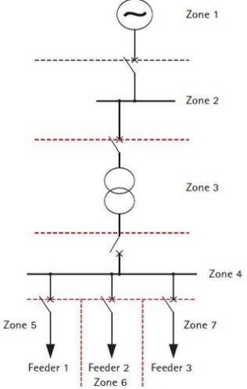
115

116
117

118 Fig. 1. Zone-based power system protection schematic (Jayaprakas et al., 2016)

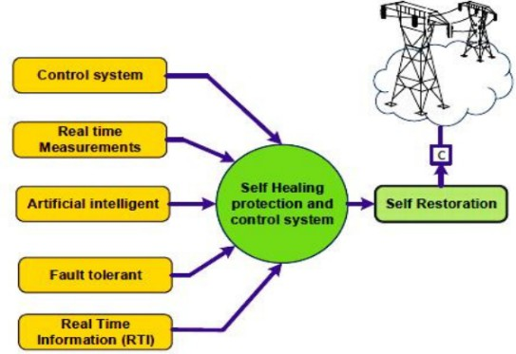
119
120

121 Fig. 2. Self-healing smart grid architecture (Kumar et al., 2021)
122

123 2.3 The Data Revolution: Phasor Measurement Units (PMUs)
124
- The advent of Wide-Area Measurement Systems (WAMS) based on Phasor Measurement
- Units (PMUs) represented a paradigm shift toward synchronised, high-resolution grid
- observability. PMUs provide time-aligned voltage and current phasors at rates of 30–240
- samples per second, synchronised to microsecond accuracy via GPS or IEEE 1588
- Precision Time Protocol (Nayak et al., 2023). A characteristic PMU schematic is presented in
- Fig. 3.
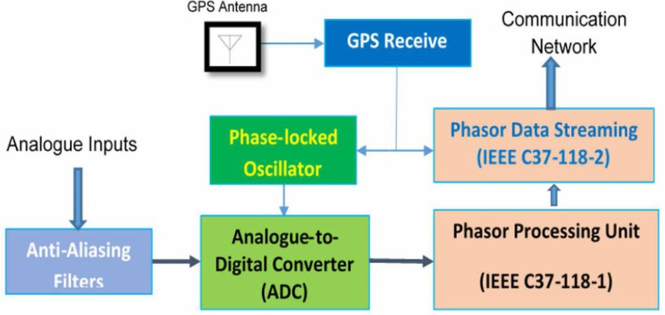
131

132

133 Fig. 3. Phasor measurement unit (Gharavi & Hu, 2017)
134
- Modern WAMS enables system-wide monitoring, oscillation detection, and fault localisation.
- For instance, real-time phase-angle measurements between dispersed PMUs can reveal
- stress and incipient instability before line tripping (Liu et al., 2023). Moreover, double-ended
- PMU-based fault location algorithms now achieve sub-kilometre accuracy without the need
- for source impedance estimation.
140

141 However, conventional WAMS architectures rely on centralised Phasor Data Concentrators
142 (PDCs) for data aggregation and analysis, creating latency and bandwidth bottlenecks that
143 hinder time-critical automation. Contemporary research, therefore, advocates decentralised
144 intelligence, deploying lightweight analytics at the edge to complement centralised situational
145 awareness (Qin et al., 2024). This decentralised processing is precisely where IoT-
146 integrated edge computing bridges the gap, moving the grid from automated to truly
147 autonomous operation.
148

149 3. THE IOT ECOSYSTEM FOR TRANSMISSION SYSTEM MONITORING
150
151 The transformation of the 132kV network into an intelligent, responsive entity is
152 fundamentally predicated on the collection and analysis of data. The IoT paradigm in power
153 systems (as depicted in Fig. 4) provides the sensory nervous system for this digital
154 transformation, enabling a density and diversity of measurement previously unattainable.
155 This section reviews the core sensing technologies, communication architectures, and data
156 challenges constituting the IoT ecosystem for high-voltage transmission monitoring.
157
158 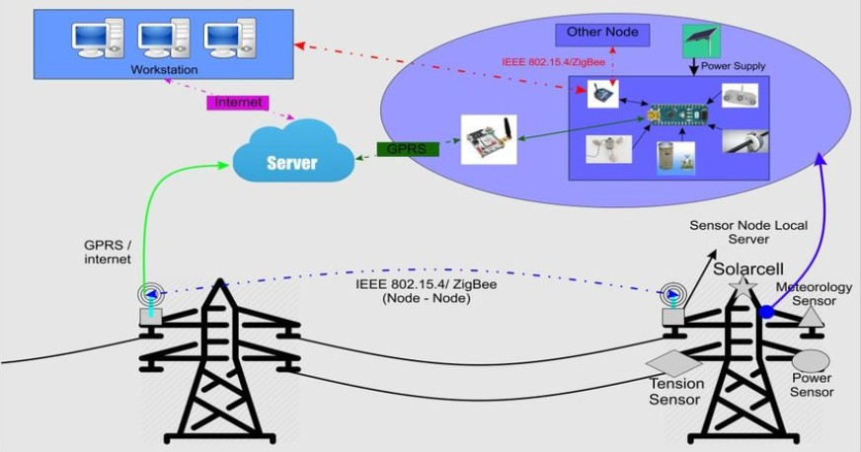
159

160 Fig. 4. IoT-based transmission system (Hidayatullah et al., 2018)
161

162 3.1 Advanced Sensing Technologies
163
- The cornerstone of any diagnostic system is its ability to perceive the state of the system
- accurately. While conventional current transformers (CTs) and voltage transformers (VTs)
- remain essential, the IoT ecosystem incorporates more advanced and distributed sensors:
- i. Phasor Measurement Units (PMUs) and Micro-PMUs (μPMUs): As introduced in
- Section 2, PMUs are the gold standard for time-synchronised, high-resolution
- phasor measurements of voltage and current. Their deployment at 132kV
- substations provides the critical data for wide-area observability and precise fault

- analysis (Bolognani & Zampieri, 2016). μPMUs, with even higher accuracy for
- distribution-level applications, are being used on the lower-voltage sides of
- 132/33kV substations, providing enhanced visibility for downstream network
- management.
- ii. Non-Conventional Sensors: The IoT paradigm extends beyond electrical
- parameters. A suite of other sensors is critical for comprehensive condition
- monitoring and incipient fault detection, which is a proactive form of diagnosis:
- • Partial Discharge (PD) Sensors: Acoustic, ultra-high frequency (UHF), and
- TEV (Transient Earth Voltage) sensors detect PD activity within
- transformers, switchgear, and cable terminations, a key indicator of
- insulation degradation (Stone et al., 2014).
- • Dissolved Gas Analysis (DGA) Monitors: Online DGA sensors provide
- continuous analysis of gases dissolved in transformer oil, enabling real-time
- assessment of thermal and electrical faults within the transformer, rather
- than relying on periodic manual sampling.
- • Line Monitoring Sensors: These include optical-based Dynamic Line
- Rating (DLR) sensors that measure conductor temperature and sag, as well
- as Lidar systems for monitoring vegetation encroachment, which helps
- prevent faults before they occur.
190

191 3.2 Communication Architectures and Protocols
192
- Fig. 5 depicts a secure communication protocol in a smart grid. The harsh electromagnetic
- environment of a 132kV substation imposes rigorous requirements on communication
- networks. A hybrid approach is often necessary:
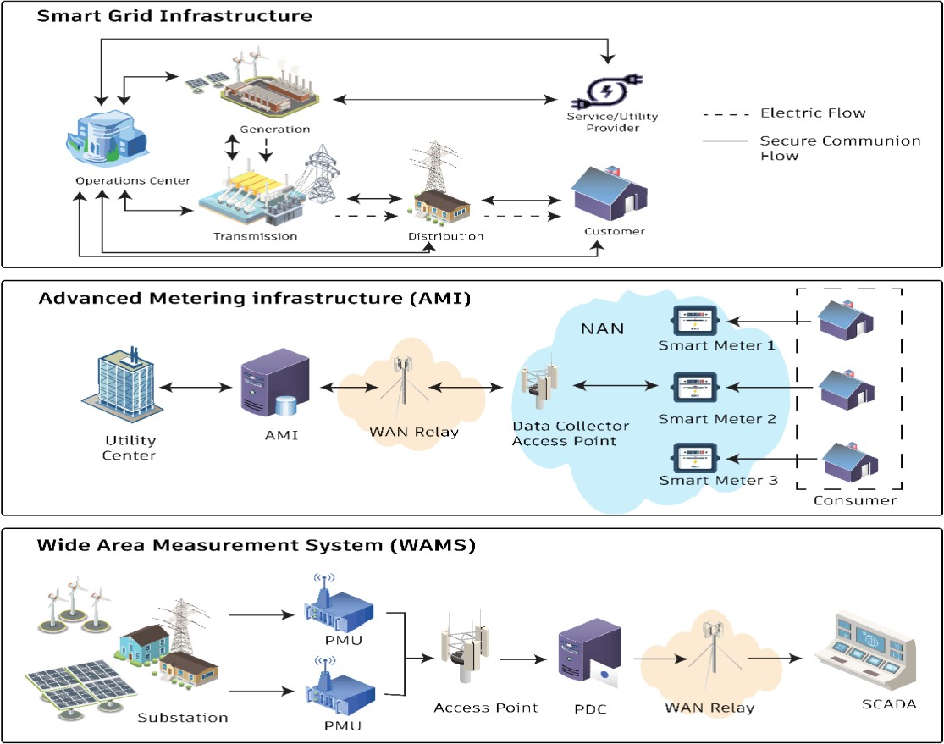
196

197
198

Fig. 5. Secure communication between nodes in smart grid (Hafeez et al., 2025)

- i. Local Area Networks (Within Substation): The IEC 61850 standard has become
- the seminal framework for substation automation. Its Sampled Values (SV) protocol
- is used for streaming high-speed digitised CT/VT data, and the Generic Object-
- Oriented Substation Event (GOOSE) protocol provides peer-to-peer messaging for
- critical protection and control signals with ultra-low latency (<4 ms) (Brand et al.,
- 2017). This forms the high-speed, reliable backbone for intra-substation data
- exchange.
- ii. Wide Area Networks (Back to Control Centre/Edge Cloud): Various protocols
- transport aggregated data from the substation gateway to wider networks. Fibre-
- optic cables, often embedded in the ground wire (OPGW), provide the highest
- bandwidth and immunity to EMI. Where fibre is unavailable, licensed spectrum
- wireless (such as microwave links) or cellular technologies, like 4G LTE and
- emerging 5G with its enhanced Mobile Broadband (eMBB) and Ultra-Reliable Low-
- Latency Communication (URLLC) capabilities, are viable options for less time-critical
- data (Gungor et al., 2013).
215

216 3.3 The Data Deluge Challenge
217
- The proliferation of IoT sensors creates a fundamental challenge: a massive, continuous
- stream of heterogeneous data. A single PMU can generate dozens of data points per cycle.
- When combined with data from other sensors, the volume from a single substation can
- quickly overwhelm traditional central processing systems, resulting in bottlenecks in
- communication links and control centre servers. This data deluge is the primary reason why
- a purely cloud-centric model is infeasible for real-time self-healing applications. It
- necessitates a paradigm of processing data closer to its source—filtering, compressing, and
- analysing it locally to extract actionable intelligence before transmitting only essential
- information upstream. This requirement directly motivates the Edge Computing layer, which
- is discussed in the next section.
228

4. EDGE COMPUTING AND AI: THE INTELLIGENT CORE FOR REAL-TIME
- AUTONOMY
231
- The deluge of data from the IoT sensor layer, if sent to a centralised cloud, would overwhelm
- communication networks and introduce crippling latency. Edge Computing directly
- addresses this by embedding computational resources physically close to the data sources
- (at substations or even directly on transmission line towers). This architectural shift is not
- merely a logistical change but the essential enabler for the millisecond-level decision-making
- required for true self-healing. This section reviews the architecture of edge intelligence and
- the AI algorithms that empower it. Fig. 6 shows a distinctive edge computing architecture.
239

240 4.1 The Edge Computing Architecture for Transmission Networks
241
- A hierarchical deployment model is most effective for managing the computational load and
- response times across a 132kV network:
- i. Device Edge (Line-mounted): The most granular level involves intelligent
- electronic devices (IEDs) or ruggedised computing modules installed directly on
- transmission infrastructure. Their role is to execute ultra-fast, pre-programmed
- functions (such as a travelling wave fault detection algorithm) and preprocess raw
- sensor data (compressing waveform data, for example) before sending it upstream.
- ii. Substation Edge (Local): The substation gateway is a powerful local aggregation
- and processing node. It receives data from all line-mounted devices, including
- CTs/VTs and other sensors, within the substation. Here, more complex analytics can
- be performed, such as correlating data from multiple points to precisely classify and

- locate a fault, or running a local state estimator. This layer is critical for making
- autonomous isolation decisions that require a substation-wide view.
- iii. Fog Node (Regional): A fog node serves multiple substations or regional control
- centres situated at a key substation or a regional control centre. It handles tasks that
- require a slightly broader perspective, such as coordinating the restoration path
- between two adjacent substations after an isolated fault, which may involve
- analysing the load flow on surrounding lines (Bonomi et al., 2012). This cloud-like
- layer has more computational power but remains geographically closer than a
- national control centre.
262
263 A variant algorithm incorporating an edge computing setup in power transmission, known as
264 the Short Supply Circuit Internet of Things (SSCIoT), is depicted in Fig. 7.
265
266 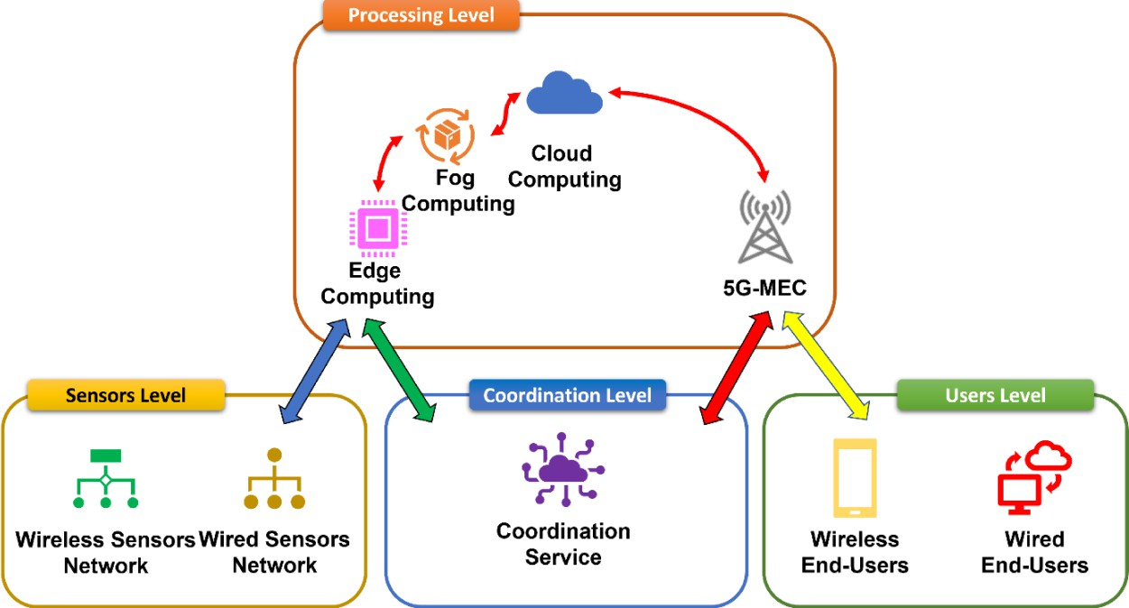
267

268 Fig. 7. Short Supply Circuit Internet of Things (Debauche et al., 2022)
269

270 4.2 AI and Machine Learning for Edge-Based Fault Diagnosis
271
- Lightweight and efficient AI/ML models trained for specific diagnostic tasks provide the real
- intelligence at the edge. The primary challenge is optimising the model to run on hardware
- with constrained processing, memory, and power.
- i. Feature Extraction: Raw waveform data is processed to extract discriminative
- features. The Wavelet Transform (WT) is particularly effective for this purpose, as it
- can localise transient features in both the time and frequency domains, making it
- ideal for detecting and characterising fault transients (Silva et al., 2016).
- ii. Lightweight Machine Learning Models: For tasks such as fault classification (e.g.,
- Phase-Ground, Phase-Phase) and location, traditional ML models often strike the
- best balance between accuracy and computational efficiency for edge deployment.
- Models like Support Vector Machines (SVM) and Random Forests, trained on
- historical fault data and extracted features (e.g., wavelet coefficients, harmonic
- components), can achieve high accuracy with minimal inference time.
- iii. Deep Learning on the Edge: While more computationally intensive, deep learning
- models like 1D Convolutional Neural Networks (1D-CNNs) can automatically learn
- features from raw current/voltage signals, eliminating the need for manual feature

- extraction. Advances in model compression techniques, such as pruning,
- quantisation, and knowledge distillation, are making it increasingly feasible to deploy
- compact versions of these powerful models on edge hardware (Wang et al., 2020).
291

292 4.3 From Diagnosis to Action: Closing the Loop for Self-Healing
293
- The output of these edge-resident AI models is not merely an alert; it is a validated, precise
- diagnosis that can directly trigger an action. The edge node can execute a predefined,
- validated action script upon confirming a fault. Crucially, this can be achieved by issuing
- commands through ultra-fast protocols, such as IEC 61850 GOOSE, to trip specific circuit
- breakers and isolate the faulted section (Feng et al., 2025).
299

300 5. SYNTHESIS, CHALLENGES, AND FUTURE DIRECTIONS
301
- Integrating IoT and Edge Computing represents a paradigm shift in managing 132kV
- transmission networks, moving from reactive, centralised protection to proactive,
- decentralised autonomy. This synthesis has demonstrated that the technological
- components for a self-healing grid (ubiquitous sensing, high-speed communication,
- distributed computation, and intelligent algorithms) are not merely conceptual but are
- actively being developed and deployed. The IoT layer provides the necessary high-
- resolution, time-synchronised data. In contrast, the Edge Computing layer furnishes the
- intelligence to process this data into actionable insights within the stringent timeframes
- required for stability. This final section consolidates the reviewed material, addresses the
- remaining significant challenges, and proposes critical avenues for future research.
312

313 5.1 Synthesis of a Cohesive Self-Healing Architecture
314
- The reviewed literature touches on a hierarchical architecture for fault management:
- i. Perception (IoT Layer): A network of PMUs, fault indicators, and condition
- monitoring sensors captures the real-time state of the network.
- ii. Processing (Edge Layer): Data is analysed locally at substation or device-level
- edge nodes using optimised AI/ML models for rapid fault diagnosis (detection,
- classification, and location).
- iii. Action (Actuation Layer): Based on the edge-processed diagnosis, autonomous
- commands are executed via protocols like IEC 61850 GOOSE to isolate the faulted
- segment.
- iv. Restoration (Coordination Layer): A slightly higher-level fog or edge node
- coordinates the reconfiguration of the network to restore power to unaffected
- sections via alternative pathways, all within a sub-minute timeframe.
- This closed-loop process effectively creates a "digital immune system" for the grid, where
- localised intelligence allows it to respond to and recover from disturbances automatically.
329

330 5.2 Persistent Challenges and Barriers to Adoption
331
- Despite the promising advancements, several formidable challenges impede widespread
- implementation:
- i. Cybersecurity: The expansion of the attack surface is the most critical risk. Every
- IoT sensor and edge node represents a potential entry point for malicious actors. A
- successful cyberattack could disable the self-healing system or, worse, force it to
- take destabilising actions. Developing robust, lightweight cryptographic solutions
- and intrusion detection systems that can run on resource-constrained edge devices
- is paramount (Wang, Lu, & Qu, 2018).

- ii. Interoperability and Standardisation: The ecosystem comprises devices and
- protocols from multiple vendors. A significant engineering challenge is ensuring
- seamless interoperability between legacy systems (like traditional relays), modern
- IEC 61850-based IEDs, and new IoT sensors. A lack of universal standards for edge
- computing platforms and API interfaces can lead to proprietary, siloed solutions.
- iii. Data Management and Quality: The effectiveness of edge AI depends entirely on
- the quality of the data it receives. Noisy, missing, or corrupted sensor data can lead
- to incorrect diagnoses and catastrophic false operations. Robust data validation,
- cleansing, and fusion techniques must be integral to the edge processing pipeline.
- iv. Validation and Testing: Deploying autonomous systems on critical infrastructure
- requires unparalleled reliability. Thoroughly testing and validating the performance of
- edge-based self-healing algorithms under a wide range of real-world fault and
- system conditions, possibly through large-scale digital twin simulations, is essential
- before live deployment.
354

355 5.3 Directions for Future Research
356
- To overcome these challenges and advance the field, future research should focus on:
- i. Explainable AI (XAI) for Grid Operations: Moving beyond "black box" AI models to
- develop techniques that provide grid operators with transparent reasoning for the
- decisions made by edge algorithms. This is crucial for building trust in autonomous
- systems and for post-event analysis.
- ii. Hybrid Cloud-Edge Architectures: Optimising the division of labour between edge
- nodes and the cloud. The edge would handle time-critical diagnostics and control,
- while the cloud performs long-term model retraining, fleet-wide performance
- analysis, and strategic planning using aggregated data.
- iii. Quantum-Resistant Cryptography: Preparing for future threats by developing and
- implementing cybersecurity protocols for IoT and edge devices that are secure
- against attacks from quantum computers.
- iv. Standardisation Efforts: Active participation in international standards bodies
- (such as IEEE, IEC) to develop open standards and frameworks for edge computing
- in power systems, ensuring interoperability and reducing vendor lock-in.
372
373 6. CONCLUSION
374
- The journey towards a fully self-healing 132kV transmission network is well underway. The
- convergence of IoT and Edge Computing has provided a viable architectural blueprint to
- address the latency and data volume limitations of traditional systems. This review has
- outlined how this synergy enables a new class of applications that can autonomously
- diagnose faults and restore service, vividly improving grid resilience and reliability. While
- significant technical and operational challenges remain, the trajectory is clear. The focus
- must now shift to hardening these systems against cyber threats, ensuring their
- interoperability and reliability, and fostering the collaborative research needed to turn the
- promise of the self-healing grid into a universal reality.
384
385
COMPETING INTERESTS DISCLAIMER:
Authors have declared that they have no known competing financial interests OR non-financial interests OR personal relationships that could have appeared to influence the work reported in this paper.

390 REFERENCES
391
392
- Amin, M., & Stringer, J. (2008). The electric power grid: Today and tomorrow. MRS
- Bulletin, 33(4), 399–407.
- Bie, Z., Zeng, P., & Fang, J. (2017). Power system reliability evaluation. Springer.
- Bolognani, S., & Zampieri, S. (2016). A distributed control strategy for reactive power
- compensation in smart microgrids. IEEE Transactions on Automatic Control, 58(11), 2818-
- 2833.
- Bonomi, F., Milito, R., Zhu, J., & Addepalli, S. (2012). Fog computing and its role in the
- internet of things. In Proceedings of the first edition of the MCC workshop on Mobile cloud
- computing (pp. 13-16).
- Borghetti, A., Nucci, C. A., Paolone, M., Ciappi, G., & Solari, A. (2017). Synchronized
- phasors monitoring during the islanding maneuver of an active distribution network. IEEE
- Transactions on Smart Grid, 2(1), 82-91.
- Brand, K. P., Ostertag, M., & Braun, M. (2017). IEC 61850: Principles and applications.
- Siemens AG.
- Debauche, O., Mahmoudi, S., & Guttadauria, A. (2022). A New Edge Computing
- Architecture for IoT and Multimedia Data Management. Information, 13(2), 89.
- https://doi.org/10.3390/info13020089
- Ding, R., Gao, F., & Li, J. (2023). Latency-aware SCADA and PMU integration for real-time
- situational awareness in power transmission networks. IEEE Transactions on Smart Grid,
- 14(2), 1467–1478.
- Feng, J., Yu, T., Zhang, K., & Cheng, L. (2025). Integration of Multi-Agent Systems and
- Artificial Intelligence in Self-Healing Subway Power Supply Systems: Advancements in Fault
- Diagnosis, Isolation, and Recovery. Processes, 13(4), 1144.
- https://doi.org/10.3390/pr13041144
- Gharavi, Hamid & Hu, Bin. (2017). Synchrophasor Sensor Networks for Grid Communication
- and Protection. Proceedings of the IEEE. PP. 1-21. 10.1109/JPROC.2017.2696881.
- Ghosh, A., & Dey, S. (2022). Review of SCADA system limitations and latency challenges
- for modern power networks. IEEE Access, 10, 42854–42868.
- Grzesik, P., & Mrozek, D. (2024). Combining Machine Learning and Edge Computing:
- Opportunities, Challenges, Platforms, Frameworks, and Use Cases. Electronics, 13(3), 640.
- https://doi.org/10.3390/electronics13030640
- Gungor, V. C., Sahin, D., Kocak, T., Ergut, S., Buccella, C., Cecati, C., & Hancke, G. P.
- (2013). A survey on smart grid potential applications and communication requirements. IEEE
- Transactions on Industrial Informatics, 9(1), 28-42.
- Hafeez, M. A., Shakib, K. H., & Munir, A. (2025). A Secure and Scalable Authentication and
- Communication Protocol for Smart Grids. Journal of Cybersecurity and Privacy, 5(2), 11.
- https://doi.org/10.3390/jcp5020011
- Hidayatullah, Nur & Kurniawan, A & Kalam, A. (2018). Power Transmission and Distribution
- Monitoring using Internet of Things (IoT) for Smart Grid. IOP Conference Series: Materials
- Science and Engineering. 384. 012039. 10.1088/1757-899X/384/1/012039.
- Huang, Y., Wang, H., & Lin, X. (2024). Digital substations and IEC 61850-based
- coordination for self-healing transmission protection. Electric Power Systems Research, 234,
- 110809.
- J, Jayaprakash & Angelin, Mercy & R, Jothi & J, Juanola. (2016). Planning and Coordination
- of Relay in Distribution System using ETAP. Pakistan Journal of Biotechnology. 13. 252-256.

- Kumar, Sarath & Srinivasan, Mohanambigai & Alexander, Dr.S.Albert & Ravi, Samikannu &
- Narasimha Rao, Dasari & Antony Raj, Raymon. (2021). A Technical Review on Self-Healing
- Control Strategy for Smart Grid Power Systems. IOP Conference Series: Materials Science
- and Engineering. 1055. 012153. 10.1088/1757-899X/1055/1/012153.
- Kumar, V., Reddy, P. S., & Basha, M. S. (2023). Edge-enabled IoT framework for adaptive
- fault detection in smart transmission networks. IEEE Internet of Things Journal, 10(8), 7143–
- 7156.
- Liu, J., Wu, Y., Zhao, H., & Li, Z. (2024). Self-healing grid architectures for high-voltage
- transmission networks using AI and edge computing. Electric Power Systems Research,
- 232, 110731.
- Liu, Z., Zhao, J., & Chen, Q. (2023). Phasor measurement-based fault location and
- resilience assessment in high-voltage transmission systems. IEEE Transactions on Power
- Delivery, 38(1), 315–326.
- Mohan, A., Rahman, M. S., & Patel, D. (2022). AI-driven FLISR for adaptive distribution
- automation in smart grids. IEEE Access, 10, 105832–105845.
- Nayak, P., Das, S., & Gupta, A. (2023). Advancements in wide-area measurement systems
- using next-generation PMUs and precision timing. IET Generation, Transmission &
- Distribution, 17(4), 849–861.
- Northcote-Green, J., & Wilson, R. (2006). Control and automation of electrical power
- distribution systems. CRC Press.
- Phadke, A. G., & Thorp, J. S. (2017). Synchronized phasor measurements and their
- applications (Vol. 1). Springer.
- Qin, L., Zhang, W., & Gao, T. (2024). Edge-enabled WAMS for low-latency event detection
- in transmission grids. IEEE Internet of Things Journal, 11(9), 15476–15488.
- Shi, W., Cao, J., Zhang, Q., Li, Y., & Xu, L. (2016). Edge computing: Vision and
- challenges. IEEE Internet of Things Journal, 3(5), 637-646.
- Short, T. A. (2013). Electric power distribution handbook. CRC press.
- Silva, K. M., Souza, B. A., & Brito, N. S. D. (2016). Fault detection and classification in
- transmission lines based on wavelet transform and ANN. IEEE Transactions on Power
- Delivery, 31(1), 62-70.
- Sinha, A., & Venkatesan, R. (2023). Modern relay coordination and distance protection
- challenges in hybrid AC-DC transmission systems. International Journal of Electrical Power
- & Energy Systems, 150, 109076.
- Stone, G. C., Boulter, E. A., Culbert, I., & Dhirani, H. (2014). Electrical insulation for rotating
- machines: design, evaluation, aging, testing, and repair (Vol. 90). John Wiley & Sons.
- Wang, K., Lu, T., & Qu, Z. (2018). Cybersecurity in smart grids: A review of threats,
- challenges, and solutions. IEEE Transactions on Industrial Informatics, 14(8), 3601-3611.
- Wang, X., Li, Y., & Wang, X. (2020). A compressed deep learning model for fault diagnosis
- of power systems. IEEE Transactions on Instrumentation and Measurement, 69(10), 7942-
- 7952.
- Youssef, A., Nassar, M., & Saleh, A. (2022). High-speed communication-assisted protection
- for 110–220 kV lines in IEC 61850 environments. Energies, 15(21), 7874.
- Zhang, X., Huang, C., & Chen, B. (2024). Low-latency edge intelligence for autonomous fault
- diagnosis in power transmission systems. IEEE Transactions on Smart Grid, 15(3), 2842–
- 2854.
- Zhou, Q., Wang, T., & Yan, J. (2023). Resilience evaluation of 110–220 kV transmission
- networks under cascading failure scenarios. International Journal of Electrical Power &
- Energy Systems, 151, 109067.
486
487

