Original Research Article

In silico analysis of andrographolide a bioactive compound of Andrographis paniculata against androgen receptor and Steroid 17-alpha-hydroxylase/17,20 lyase as a anti prostate cancer agent

Abstract
Prostate cancer incidence high in male human and male dogs. Increased male sex hormone play a vital role in pathogenesis. The treatment for prostate hyperplasia and prostate cancer is androgen receptor inhibitor and inhibit the synthesis of androgen synthesis by blocking the enzyme Steroid 17-alpha-hydroxylase/17,20 lyase. Medicinal plant is an integral part of human life to combat the sufferings and people depend either directly or indirectly on medicinal plants for the first line of treatment. Andrographis paniculata is an important medicinal plant and have broad range of pharmacological effects. The active principle Andrographolide is belong to the class diterpenoids. using discover studio and auto dock, the docking score for the 30 phyto chemicals of A. paniculatus is higher than the -5. The docking for andrographolide against the target androgen receptor and Steroid 17-alpha-hydroxylase/17,20 lyase are -6.7 and -8.6 respectively. Andrographolide was found to obey all the parameters of Lipinski’s Rule of 5 and has drug likeliness. Hence it is a promising lead molecule for further clinical studies against prostate cancer.
Keywords: Andrographolide, Androgen receptor, Steroid 17-alpha-hydroxylase/17,20 lyase, prostate cancer

1. INTRODUCTION
Prostate cancer (PC) is the second most commonly diagnosed cancer and the fifth leading cause of cancer death among men worldwide, with more than 1 460 000 estimated cases and 396 000 deaths in 2022 (Ferlay et al., 2020). It is predicted that by 2040, the PC burden will have increased to approximately 2.4 million cases and 712 000 deaths solely because of the aging and growing global population (Sung et al., 2021). The androgen hormones and their executor androgen receptors are known to regulate crucial roles in initiation and progression of prostate cancer. The dependence of prostate cancer on androgens was first demonstrated in 1941 by Huggins and colleagues, who showed that reducing serum androgen concentrations by orchiectomy or exogenous oestrogen administration induced tumour regression and palliation of symptoms, a discovery that led to a Nobel Prize for Huggins. Since then, gonadal androgen depletion has been the mainstay of treatment for advanced-stage prostate cancer. However, although many patients initially respond to androgen depletion therapy, they almost invariably relapse and develop resistance with transition of the disease to a castration-resistant state. Androgen-refractory tumors shows increased intratumor synthesis of androgen and contain mutations in the androgen-receptor gene. These mutations increase the number of ligands that can activate the receptor. Thus over the year, androgen receptor and enzymes for androgen synthesis has emerged as a potential and attractive target for Prostate cancer therapy (Messner et al., 2020). The drugs is used against prostate cancer is getting resistance so screening of herbs against prostate cancer is necessary. Structure-based virtual screening and post-screening analysis are emergent tasks in computer-based drug discovery. Combining these two methods to effectively reduce the false positives from a large compound database is considered as a key step to finding the lead compounds. Andrographis paniculata commonly known as the "King of Bitterness," belongs to the Acanthaceae family. studies have identified 187 chemical constituents in Andrographis paniculata, including andrographolide (Andro), deoxyandrographolide, neoandrographolide, andrographoside, and andrographosterin (Hu et al., 2024). Andrographis paniculata have been reported for a wide range of pharmacological activities, such as analgesic, anticancer, antidiabetic, antifertility, antiinflammatory, antimalarial, antimicrobial, antioxidant, antipyretic, antiretroviral, antivenom, cardioprotective, hepatoprotective and immunomodulatory, etc. (Singha et al., 2003; Dai et al., 2019; Kaushik et al., 2020). The present study focused on In-Silico analysis of andrographolide with androgen receptor and enzyme for androgen synthesis against prostate cancer.
2. MATERIALS AND METHODS
2.1 Protein Preparation
The 3 Dimensional structures of the target proteins Androgen Receptor (AR; PDB ID-4OH6) (fig 1) and Steroid 17-alpha-hydroxylase/17,20 lyase (CYP17A1; PDB ID- 5IRV) (fig 2) were downloaded from the online protein structure repository Protein Data Bank (PDB). The structures were determined by X-ray Diffraction method and had ligands coupled in the binding site. The protein was subsequently cleaned by removing the bound complex molecule, the non-essential water molecules and all the heteroatoms.

2.2 Preparation of ligand
The structures of the compound andrographolide (fig 3, 4) were downloaded from Pubchem in SDF format and converted to PDB format using the tool Online SMILES Translator and Structure File Generator an NCI/CADD Group (https://cactus.nci.nih.gov/translate) and further used for molecular docking analysis.

2.3 Molecular Docking
Subsequent to receptor and ligand preparation, molecular docking analysis was performed by AutoDock Version 4.2 (using the Lamarckian Genetic Algorithm and empirical free energy scoring function) to evaluate the hydrogen bond interaction and their binding affinities. AutoDock calculations are performed in several steps: 1) preparation of coordinate files using AutoDockTools. These coordinate files are created in an AutoDock-specific coordinate file format, termed PDBQT, which includes: add Polar hydrogen atoms, adds Kollman charges, Partial charges, Atom types for protein and detect root for ligands. 2) precalculation of atomic affinities using AutoGrid, 3) Docking of ligands using AutoDock, and 4) analysis of results using AutoDockTools. After the minimisation process, the grid box resolution was set at 60× 60 × 60 Å along the x, y and z axes respectively at grid resolution of 0.375 Å to define the binding site.

2.4 Drug likeliness and Bioavailability
It is important for any compound to obey the Lipinski’s rule of five (Yang and Chen., 2004) in order to be formulated as a drug . The Absorption Distribution, Metabolism, Elimination and Toxicity (ADMET) parameters are much significant for a drug to be available to the system. Drugs scans were carried out to determine whether the phytochemicals fulfil the drug-likeness conditions. Lipinski’s filters were applied for examining drug likeness attributes as including quantity of hydrogen acceptors (should not be more than 10), quantity of hydrogen donors (should not be more than 5), molecular weight (mass should be more than 500 daltons) and partition coefficient log P (should not be less than 5).

3. RESULT AND DISCUSSION
Docking score

In the present in silico study, the docking interactions of andrographolide with the target proteins, androgen receptor (AR; PDB ID: 4OH6) and CYP17A1 (Steroid 17α-hydroxylase/17,20-lyase; PDB ID: 5IRV), were analyzed. The docking score (ΔG) of the ligand–protein complex is a key indicator of binding affinity; values below –5 kcal/mol generally denote stable and potent interactions. The compound andrographolide exhibited binding energies of –6.7 kcal/mol and –8.6 kcal/mol with AR and CYP17A1, respectively (Fig. 5,6). These negative binding energies indicate strong interactions with both target proteins and reflect a high probability of receptor–ligand stability. When compared with standard inhibitors (Fig. 7, 8) andrographolide showed comparable binding affinities, suggesting its potential as a competitive ligand for both targets. Molecular interaction analysis revealed that andrographolide fits snugly within the ligand-binding domains of AR and CYP17A1, forming multiple hydrogen bonds and hydrophobic interactions with functionally important amino acid residues. The binding energy of –8.6 kcal/mol with CYP17A1suggests a particularly strong potential for interaction, which could inhibit androgen biosynthesis an essential process in prostate cancer progression. These findings are consistent with earlier reports indicating that andrographolide suppresses AR expression and proliferation in prostate cancer cells (Rajagopal et al., 2003). Recent literature continues to support the therapeutic promise of andrographolide as a natural inhibitor of signalling pathways implicated in tumorigenesis (Banerjee et al., 2016).
Drug likeliness and ADMET prediction

According to Lipinski’s Rule of Five, a compound is considered drug-like if its molecular weight is below 500 Da, the log P value is < 5, hydrogen bond donors ≤ 5, and hydrogen bond acceptors ≤ 10. From Table 3, andrographolide possesses a molecular weight of 350.458 Da, log P of 1.801, three hydrogen bond donors, and five hydrogen bond acceptors. Additionally, the compound has a Topological Polar Surface Area (TPSA) of 86.99 Å². These values indicate that andrographolide satisfies all the physicochemical requirements for oral bioavailability and membrane permeability. Compounds following these criteria generally exhibit favourable pharmacokinetic behaviour. As poor absorption and bioavailability often hinder the success of natural products, andrographolide compliance with Lipinski’s parameters supports its suitability as a drug-like molecule.

Comparative and Functional Implications
The docking analysis demonstrated that andrographolide binding affinities were comparable to those of clinically relevant AR and CYP17A1inhibitors (Tab 1&2). The ability of andrographolide to interact with both the androgen receptor and the enzyme responsible for androgen biosynthesis suggests a dual-target mechanism. This mechanism is therapeutically advantageous, as it could simultaneously suppress androgen production and receptor activation, thereby inhibiting prostate cancer progression through two converging pathways. Recent reports emphasize the potential of plant-derived terpenoids, including andrographolide, in modulating key cancer-related processes such as proliferation, apoptosis, and androgen signalling (Cheng et al., 2024; Dai et al., 2019). The results of the present study corroborate these findings, revealing energetically favourable interactions within both receptor and enzyme active sites. Pharmacokinetic predictions further reinforce its potential as a promising bioactive compound with oral bioavailability.

Limitations and Future Directions

While the docking scores suggest potent inhibitory potential, in silico results alone cannot confirm biological efficacy. The actual therapeutic performance of andrographolide depends on receptor occupancy in the cellular environment, compound stability, and its ability to penetrate tumour tissues. Resistance to AR-targeted therapies is often mediated by receptor splice variants lacking the ligand-binding domain and by androgen synthesis bypass mechanisms (Daniels et al.,, 2024). The dual-target inhibition of both AR and CYP17A1observed in this study may therefore help overcome such resistance mechanisms. For CYP17A1inhibition, abiraterone remains a clinically validated inhibitor; however, it is associated with adverse effects such as adrenal suppression and compensatory up-regulation of steroidogenic pathways (Attard et al. 2011). Andrographolide’s strong affinity for CYP17A1suggests that it may serve as a natural alternative with potentially lower toxicity, though this hypothesis requires validation through in vitro and in vivo studies.Further studies should focus on enzyme inhibition assays, receptor-binding experiments, cytotoxicity testing on prostate cancer cell lines, and animal models to establish andrographolide’s pharmacodynamic and pharmacokinetic profiles. Structure activity relationship (SAR) optimization could also improve its selectivity, stability, and potency.

Table 1: Docking score of androgen receptor (AR; PDB ID:4OH6) against andrographolide and bicalutamide

LIGAND | Binding affinity energy (kcal/mol) | Intermolecular H bonds Distance (Å)
Phytochemical-andrographolide | -6.7 | 2.74
Drug-Bicalutamide | -6.5 | 1.81,1.97,2.17,2.43,2.59

Table 2: Docking score of steroid17-alpha hydroxylase/17, 20 lyase (CYP17A1; PDB ID: 5IRV) against andrographolide and abiraterone acetate

LIGAND | Binding affinity energy (kcal/mol) | Intermolecular H bonds Distance (Å)
Phytochemical-andrographolide | -8.6 | 1.99,2.44,2.47,2.75
Drug-Abiraterone Acetate | -10.5 | 2.69,3.05

Table 3: The drug- like parameters of Andrographolide
S. No | Properties | Value
1 | Slog P | 1.699
2 | Slog D | 1.699
3 | Mlog P | 1.801
4 | Molecular weight | 350.458
5 | Hydrogen Bond Donor | 3.000
6 | Hydrogen Bond Donor (MNo) | 5.000
7 | Topological polar Surface Area (TPSA) | 86.990
8 | Rule of 5 | 0
9 | Violation of Rule of 5 | Nil

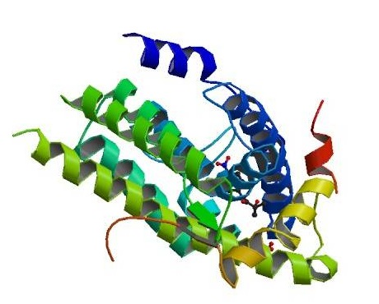  Figure 1:The crystal structure of the targets androgen receptor (AR; PDB ID: 4OH6) and | 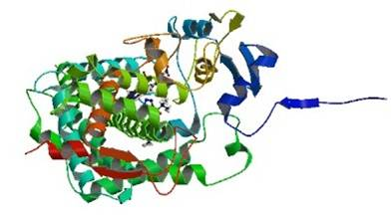  Figure 2:The Crystal structure of the targets CYP17A1 (Steroid 17α-hydroxylase/17,20-lyase; PDB ID: 5IRV)
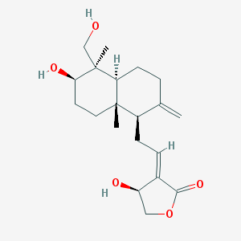  Figure 3:2D structure of andrographolide | Figure 4:3D structure of andrographolide

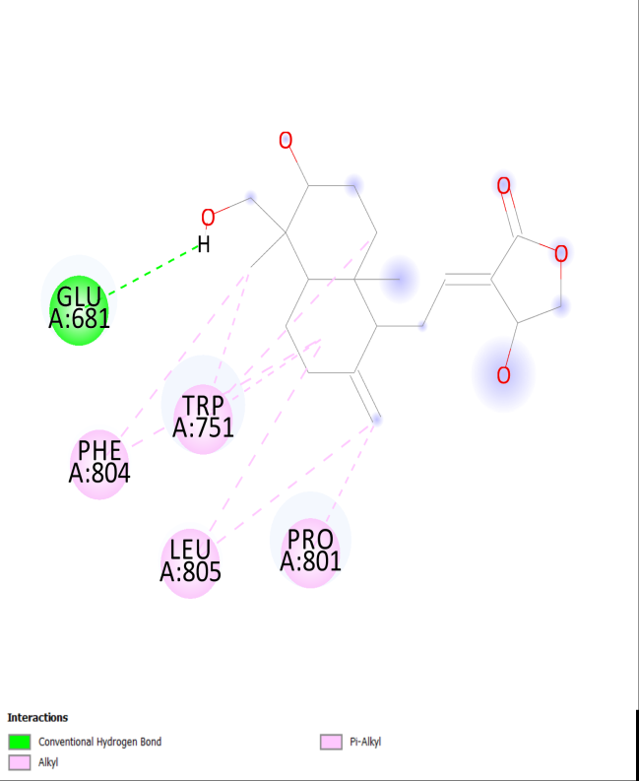 | 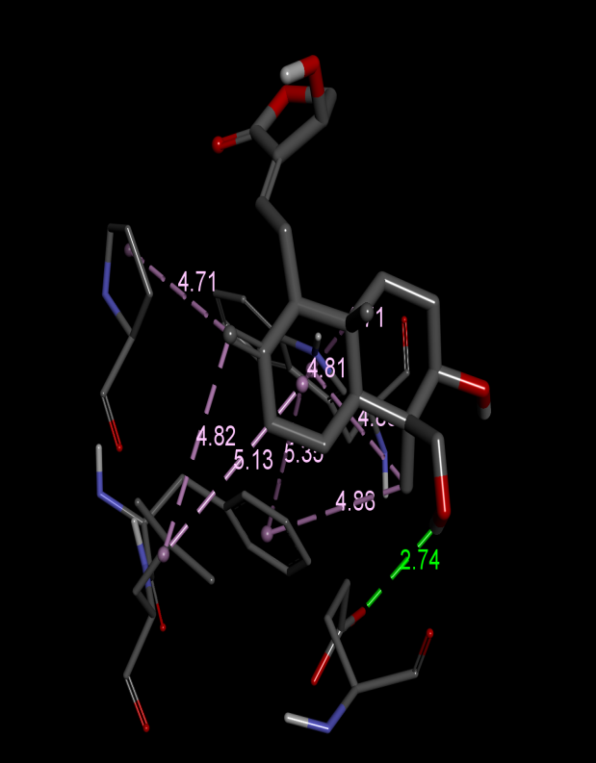
Figure 5:Interaction of andrographolide and androgen receptor

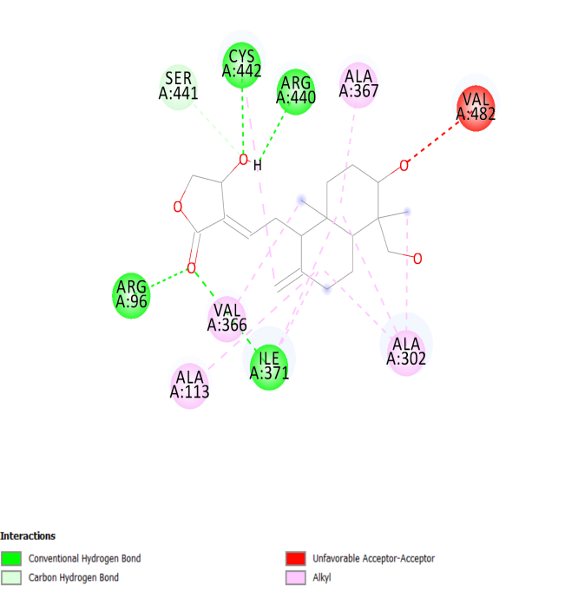 | 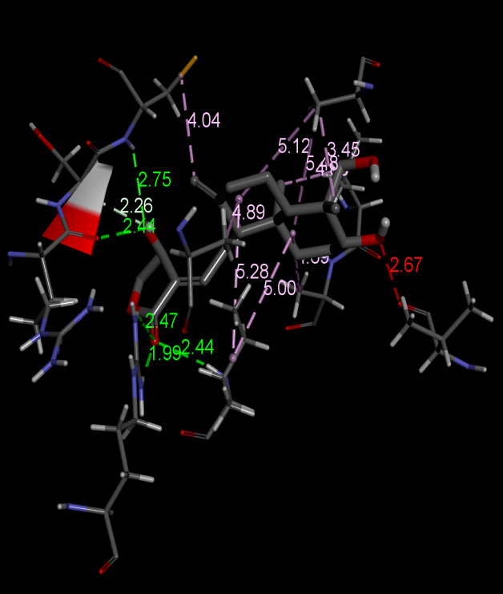
Figure 6:Interaction of andrographolide and steroid 17-alpha-hydroxylase/17,20 lyase

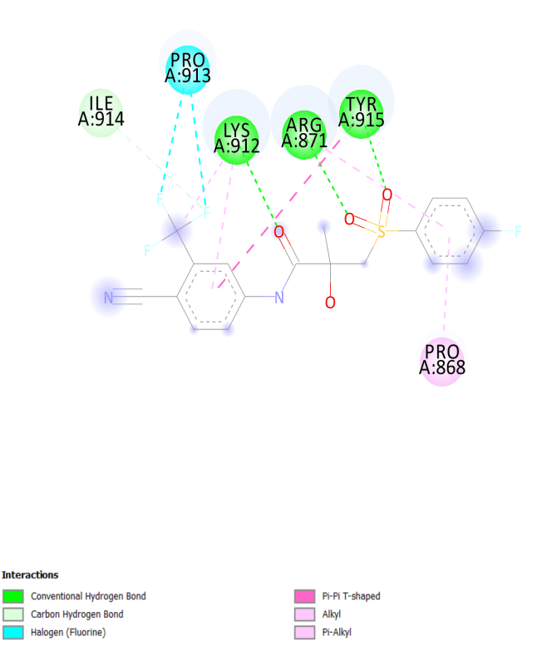 | 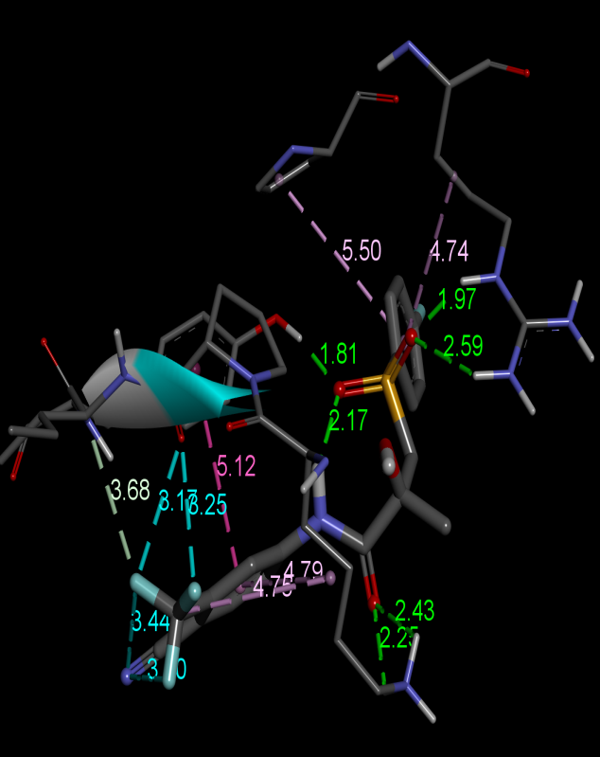
Figure 7:Interaction of Bicalutamide and androgen receptor

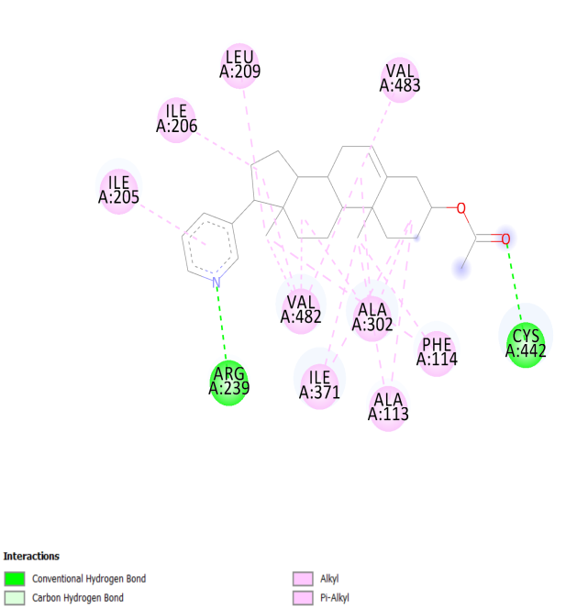 | 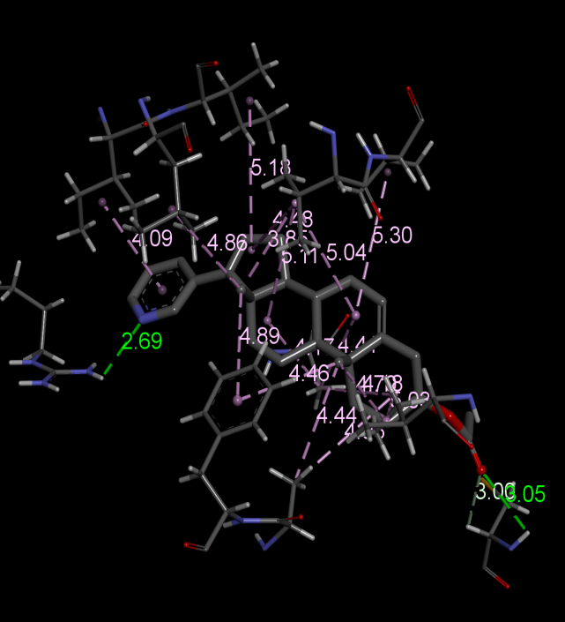
Figure 8:Interaction of abiraterone acetate and steroid 17-alpha-hydroxylase/17,20 lyase

CONCLUSION
The present in silico investigation demonstrates that andrographolide exhibits strong and energetically favourable interactions with both the androgen receptor and CYP17A1enzyme, with binding energies exceeding the threshold for potent inhibition. Its compliance with Lipinski’s Rule of Five and favourable physicochemical properties support its classification as a drug-like molecule. These findings indicate that andrographolide possesses significant potential as a natural dual-target inhibitor in androgen-dependent prostate cancer. Further in vitro and in vivo evaluations are warranted to confirm its efficacy, safety, and potential for development as a promising lead molecule for further preclinical studies aimed at developing novel anti-androgen therapies for prostate cancer.

REFERENCES
Attard., Gerhardt., Alison HM Reid., Richard J., Auchus, Beverly A. Hughes, Amy Mulick Cassidy, Emilda Thompson, Nikhil Babu Oommen et al.(2012). clinical and biochemical consequences of CYP17A1 inhibition with abiraterone given with and without exogenous glucocorticoids in castrate men with advanced prostate cancer. The Journal of Clinical Endocrinology & Metabolism 97(2): 507-516.
Banerjee, M., Chattopadhyay, S., Choudhuri, T., Bera, R., Kumar, S., Chakraborty, B., Mukherjee, S.K. (2016). Cytotoxicity and cell cycle arrest induced by andrographolide lead to programmed cell death of MDA-MB-231 breast cancer cell line. J. Biomed. Sci. 16;23:40
Cheng, C.R., Zheng, Z., Liang, R.M., Li, X.F., Jiang, Q.Q., Yue, L., Wang, Q., Ding, J., and Liu, Y. (2020). Preparation and cytotoxic Activity of 3,19-analogues of 12-thioether andrographolide. Chem Nat Compd. 56:264–269.
Dai, Y., Chen, S.R., Chai, L., Zhao, J., Wang, Y., & Wang, Y., (2019). Overview of pharmacological activities of Andrographis paniculata and its major compound andrographolide. Crit. Rev. Food Sci. Nutr. 59:17-29.
Daniels, V,A., Luo, J., Paller, C,J., Kanayama, M. (2024). Therapeutic Approaches to Targeting Androgen Receptor Splice Variants. Cells. 4;13(1):104. doi: 10.3390/cells13010104.
Ferlay, J., Ervik, M., Lam, F., Colombet, M., Mery, L., Piñeros, M., Znaor, A., Soerjomataram, I. & Bray, F. (2020). Global cancer observatory: cancer today. Lyon: International agency for research on cancer, 2018-2020.
Hu, J., Li, Y., Xie, X., Song, Y., Yan, W., Luo, Y., & Jiang, Y. (2024). The therapeutic potential of andrographolide in cancer treatment. Biomedicine & Pharmacotherapy 180: 1174382024.
Huggins, C., Stephens, R.E., & Hodges, C.V. (1941). Studies on prostate cancer II. The effects of castration on advanced carcinoma of the prostate. Arch. Surg. 43: 209-223.
Kaushik, S., Dar, L., Kaushik, S., & Yadav, J.P (2020). Identification and characterization of new potent inhibitors of dengue virus NS5 proteinase from Andrographis paniculata supercritical extracts on in animal cell culture and in silico approaches. J. Ethnopharmacol. https://doi.org/10.1016/j.jep.2020.113541.
Messner, Elisabeth A., Thomas M. Steele, Maria Malvina Tsamouri, Nazila Hejazi, Allen C. Gao, Maria Mudryj, & Paramita M. Ghosh (2020). The Androgen Receptor in Prostate Cancer: Effect of Structure, Ligands and Spliced Variants on Therapy. Biomedicines 8(10): 422.
Rajagopal, S., Kumar, R.A., Deevi, D.S., Satyanarayana, C., and Rajagopalan, R., (2003). Andrographolide, a potential cancer therapeutic agent isolated from Andrographis paniculata. Journal of Experimental therapeutics and Oncology, 3(3), pp.147-158.
Singha, P.K., Roy, S., & Dey, S. (2003). Antimicrobial activity of Andrographis paniculata. Fitoterapia 74: 692-694.
Sung, H., Ferlay, J., Siegel, R.L., Laversanne, M., Soerjomataram, I., Jemal, A. & Bray, F. (2021). Global cancer statistics 2020: GLOBOCAN estimates of incidence and mortality worldwide for 36 cancers in 185 countries. CA: a cancer journal for clinicians, 71(3):209-249.
Yang J.M and Chen C.C. (2004). GEMDOCK: A generic evolutionary method for molecular docking. Proteins: Structure, Function and Bioinformatics. ; 55:288-304.

