Original Research Article
TENSILE BEHAVIOUR OF A MAGUEY MANSO CUTICLE

Abstract
In this work, the tensile behaviour of an isolated maguey manso cuticle is studied from an engineering perspective. The maguey manso is a plant in the agavaceae family that grows in the semi-dry and cold Central Valley of Mexico, among the States of Mexico, Hidalgo, Puebla and Tlaxcala. The leaves of a maguey, known as pencas, are formed basically by sap, fibers along their full length, and the cuticle. It was found that the maguey cuticle behaves as a viscoelastic material. Once the tensile stress is reached, the cuticle breaks catastrophically in a brittle manner. This brittle fracture and an anisotropic behaviour are attributed to the complex, homogeneous microstructural arrangement of tetracytic stomata in the cuticle aligned in a preferential direction.

Keywords: Strength properties, salmiana cuticle, Maguey Manzo.

1 INTRODUCTION
The Maguey Manso is an Agavaceae plant family that grew up mainly in the semi-dry and cold central highlands of Mexico, mainly among the States of Mexico, Puebla, Hidalgo and Tlaxcala. About one hundred uses have been found for this plant [1, 2]; however, there are main four of them: in the elaboration of textile fibers, as ornamental plants, gastronomically as a stew cover (mixiotes), and in the production of alcoholic beverages known as pulque. The leaves of a maguey, named as pencas, are formed basically by sap, fibers along their full length that gives them stiffness, and the cuticle, which is the outer protective layer and interacts with the environment. The leaves are distributed in a spiral around a main pineapple and are commonly used as fodder, compost and exceptionally as fuel (Figure 1).
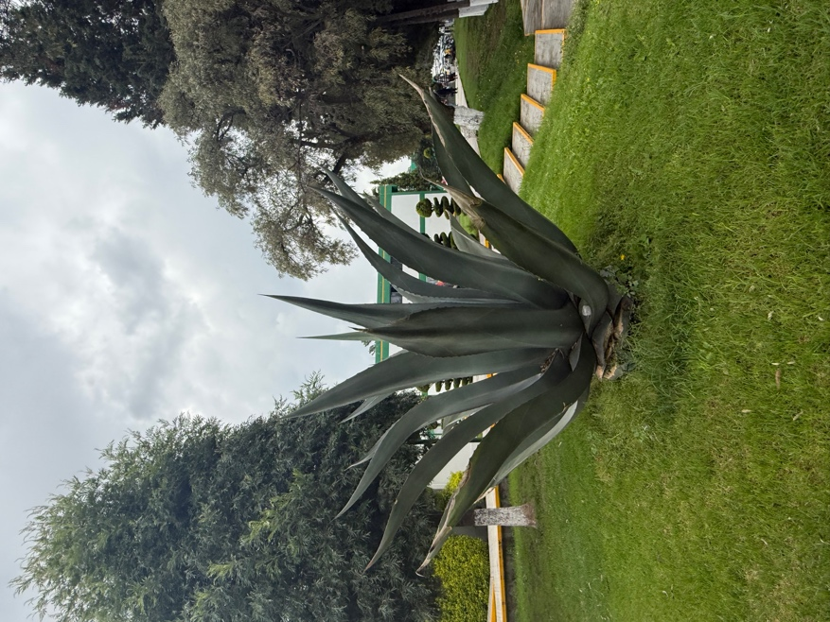
Figura 1. Typical maguey manso as an ornamental plant.
The cuticle is the outermost layer of plants, it provides an interface that ensures controlled interactions between plant surfaces and their environments [3]. The cuticle plays an important role by acting as a barrier that reduces water loss [4, 5], participates in plant-insect interactions [6], and provides mechanical support [7, 8]. The cuticle represents a natural composite that consist mainly of two hydrophobic polymers, the insoluble biopolyester cutin and soluble lipids (collective termed waxes), which are altered in both their composition and ultrastructure by genetic, physiological, and environmental factors, that is, they are strongly interconnected to the plant life and land [9, 10].
Mechanically, the cuticle protects the plants from the impact of external loads and, together with the epidermis, prevents tissue breakdown during plant growth, preventing the entry of insects and fungi [11]; therefore, in this context, mechanical strength is important for the normal growth and development of the plant organs. The characterization of mechanical properties in cuticles has been carried out mainly in those extracted from fruit such as apple, peach, tomato and cherry, among other fruits [11-15], but in plants like the maguey they have not been determined. The tests have been carried out using uniaxial tensile tests. From these studies, it has been observed that cuticles are viscoelastic polymers, where such a constitutive relationship results mainly from the cutin matrix. In some fruit cuticles the thickness, the chemical composition and their constituents affect the stiffness (k), the maximum force (F_{máx}) and maximum deformation (ε_{máx}) [7, 8, 15].
There are several reasons to study the mechanical behavior of the maguey cuticle: for potential industrial use, for the survival of the plant, for post-harvest handling of the plant and to provide the knowledge for the protection of this plant because of it is considered is endangered due to several natural and human factors [16]. Furthermore, the structural characteristics of the cuticle such as regulated porosity, water permeability and thermal resistance suggest that the cuticle of A. salmiana can be used in the industry as a natural membrane [17], in addition, the cuticle of A. Salmiana, functioning as a biological exchange membrane, can replace Nafion membranes in methanol and hydrogen fuel cells, since it is an ecological alternative [18]. However, during the present investigation, an exhaustive review was made about the characterization of mechanical properties in the cuticle of maguey salmiana, of which no document was found that directly addresses the topic that was carried out in this work.
This study is part of a research project on the mechanical behavior of natural and natural-based sheets. While the focus is on the physics of the cuticle, the results presented here pave the way for understanding the physiological processes that produce the mechanical strength and fracture behavior of the cuticle in this type of plant. Without detracting the importance of biochemical and biophysical processes during the life of the cuticle, in this work the mechanical strength behavior of the isolated maguey cuticle is studied from an engineering perspective. That is, solid mechanics tools are used to study the mechanical strength behavior.

2 materials and methods
Mechanical properties let us to know the work capacity of a body under the influence of a load. Tensile testing is the most important technique to characterize the strength and fracture parameters of materials. Unlike materials, where tensile behavior is studied for material selection, to ensure quality, for new material development, or to predict material behavior under loads other than uniaxial tension, in plants, mechanical behavior is studied primarily for their survival during the normal growth and development. The development of internal and external stresses is reached through their unique hierarchical architecture [19]. Stiffness is determined by a combination of morphological (geometrical) and compositional variables that vary across multiple length scales ranging from the whole plant to organ, tissue, cell and cell wall levels [20].

Sampling
The maguey manso is a plant that is usually found in open fields, so it is exposed to various agents, such as pests, insect bites, blows from objects, or aging, that cause damage in its components (being mainly in the cuticle) that can even lead to the loss of the plant (Figure 2a). Because of these inherent imperfections, the cuticle removal is usually performed very carefully by a mixiotero (a person dedicated to removing the cuticle for cooking purposes, Figure 2b).
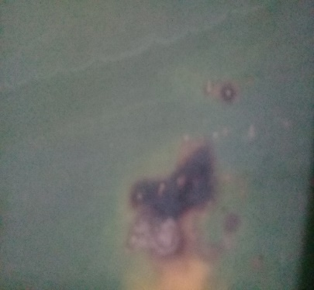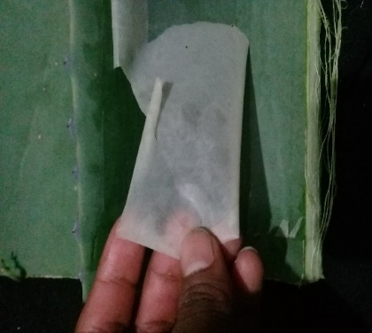
a) b)
Figure 2. Typical imperfections in the maguey cuticle: a) aging; b) insect bites.
In the present case, the specimens were extracted carefully by removing the cuticle from the adaxial surface of maguey manso leaves. The specimen dimensions were restricted to the size of the leaf: a width of w = 30 mm and a height of h = 60 mm (Figure 3) which were limited for the size of the leaf (Figure 3a). Due to the dimensions have a relationship h > w, it was considered h as the Longitudinal Direction (LD) in the leaf development and w in the Transversal Direction (TD), for the anisotropic study. This process was performed by tracing the geometry of the specimens in undamaged areas on the sheet (Figure 3b). Although the effect of the thickness of the cuticle has been observed in the mechanical properties of the cuticle [8], in the case of the present study it is assumed that the thickness is constant because, based on the specimens obtained, it is not shown a variation in thickness through the leaf (t = 0.113 ± 0.007 mm).

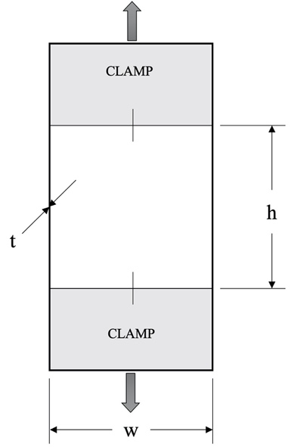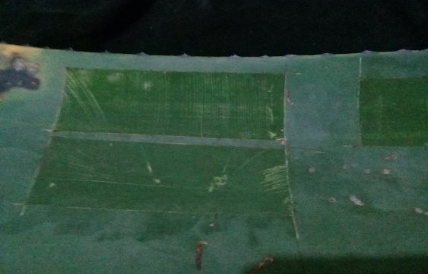
a) b)
Figure 3. Specimen for testing: a) Designation of the specimen, b) extraction from adaxial side of leaves.

Experimental procedure
Here, the standard procedure for tensile testing was used. The cuticle was subjected to incremental axial force in tension until the material reach the rupture, and through the relationships between the cross section, an initial calibrated length and the resulting force and displacement, the stress – strain curve was calculated. All mechanical parameters used to describe the mechanical properties of the cuticle are derived from these relationships. In the present work the tests were carried out in a Universal Testing Machine at a constant controlled displacement ratio of 1mm/min, at room temperature conditions of 24.4 ± 0.7 ° C and relative humidity (RH) of 45% ± 0.5, as shown in Figure 4.

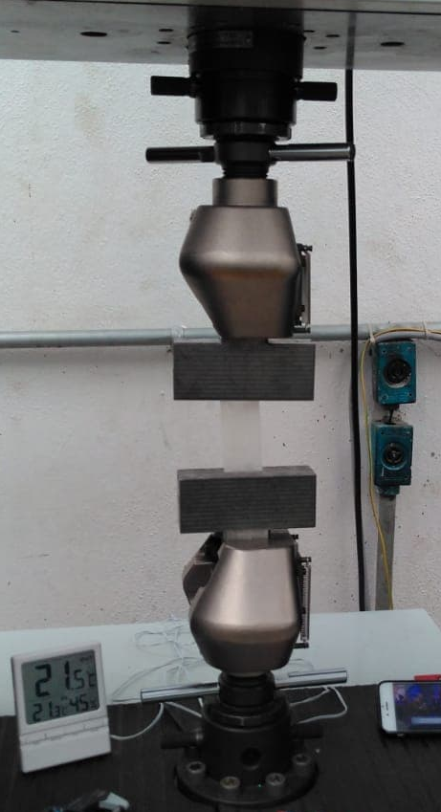
Figure 4. Experimental setup.
Figure 6 shows the resulting typical stress-strain diagram for the maguey cuticle. The strength properties in the material were obtained from this diagram.

3 RESULTS AND DISCUSSIONS

Microstructure
Scanning electron microscopy reveals a complex, homogeneous microstructural arrangement of tetracytic stomata in the cuticle (Figure 5a). The cuticle under study exhibited a suprastomatal cavity with measurements shown in Figure 5b. The stomata are aligned in a preferential direction (assuming the larger direction of the stomata as Length Direction, LD) consistent with the preferential direction of the leave fibers and, as shown below, could influence the anisotropic behavior of the cuticle.

(a)
(b)
Figure 5. Microstructure of the maguey manso cuticle: a) complex homogeneous structure of tetracytic stomata; b) suprastomatic cavity.

Strength Properties
As can be seen in the Figure 6, the maguey cuticle behaves as a viscoelastic material; that is to say, initially, the deformation is directly proportional to the stress and if the load is removed, the deformation returns to its initial value and is said is governed by the classical Hooke's Law. As the force continues, the material reaches non-recoverable deformation until it eventually ruptures catastrophically. In this material, the maximum stress is approximately equal to the rupture stress.
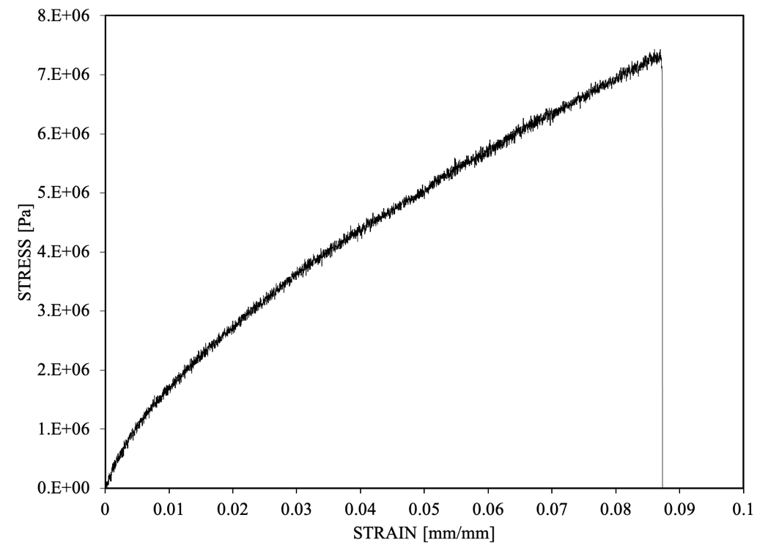
Figure 6. Typical Stress – Strain curve for the maguey cuticle.

Anisotropy effect
In order to study the effect of anisotropy on the mechanical properties of the maguey cuticle, the specimens were cut in two directions: longitudinal (in the preferential direction of the fibers in the leaf), and transverse (perpendicular to it), as shown in Figure 7a. Here, it was observed that it has an anisotropy effect, that is, the mechanical properties are different both in longitudinal and transverse directions (Figure 7b), this can be attributed to the stomata direction. The following Table 1 shows its mechanical properties of longitudinal and transverse cuts. In the strength properties is observed a high dispersion, this is due to the presence of the inherent defects around the leaf. The origin of those defects are due to the place of growth of the plant (uncontrolled environment).

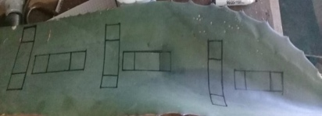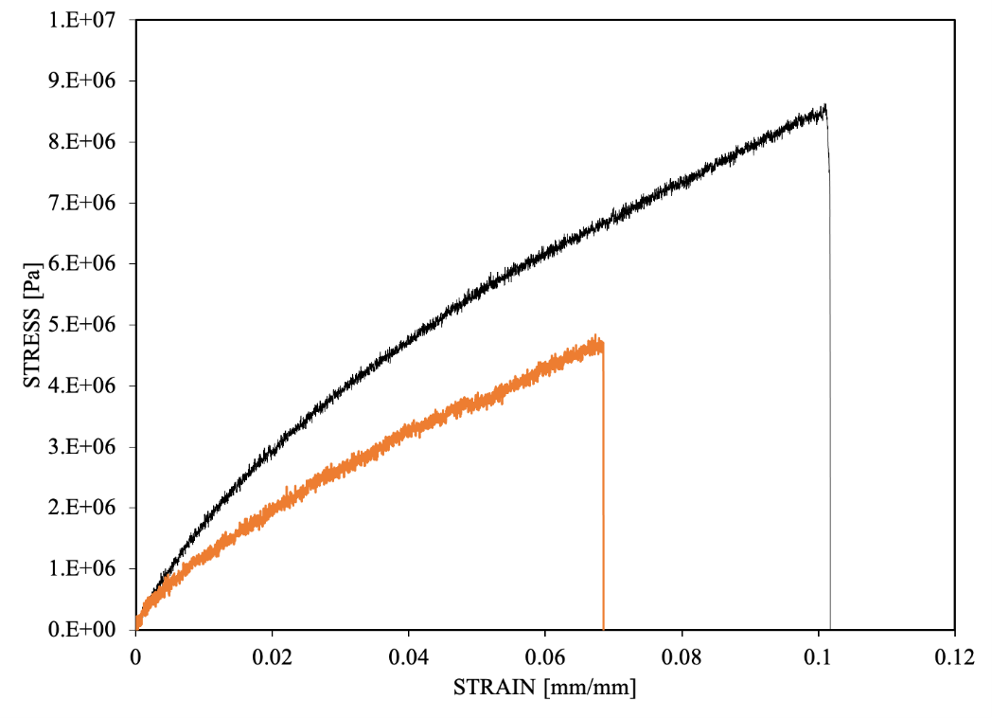
(a) (b)
Figure 7. Experimental anisotropy study: a) Specimen extraction from the leaf of maguey; b) Typical Stress-Strain curve for the two considered directions.
TABLE 1. Effect of anisotropy in the mechanical properties of the maguey cuticle.
PROPERTY | LONGITUDINAL | TRANSVERSAL
Elastic Limit [MPa] | 0.896 ± 0.134 | 0.626 ± 0.239
Tensile Strength [MPa] | 7.414 ± 1 | 3.376 ± 1
Rupture Stress [MPa] | 7.331 ± 1 | 3.362 ± 1
Elastic Modulus [MPa] | 210.645 ± 12 | 142.420 ± 27
Resilience [ KJ] | 2.712 ± 0.23 | 2.293 ± 1.4
Toughness [KJ] | 2183.514 ± 0.5 | 390.926 ± 219

Cuticle rupture.
Fracture in engineering materials is a failure phenomenon that depends on the operating conditions, the geometry and size of the specimen, and the microstructure of the material [21]; however, cuticle cracking is a common phenomenon in fleshy and fibrous plants and depends on the physiology and environment in which the plant is located [22]. Cracks allow the entry of insects and the generation of fungi, causing damage to the fruit and reducing its marketability and significant income losses in the market and in the processing industries. Furthermore, this phenomenon reduces the material's ability to withstand loads; that is, it reduces the resistance of the cuticle and therefore of the fruit.
In the case of the cuticle under study, two conditions are observed:
- When the cuticle is integrated into the stalk, the fracture is due to cracking caused by some of the aforementioned agents that occur during the growth, development and maturation of the maguey. In some fruits, during post-harvest, it is mainly due to environmental conditions (especially temperature and humidity) and handling [23]. It has been observed that cuticle cracking in fleshy fruits depends on the type of load applied and the method of incubation of the fruit [24].
- In extracted cuticle conditions. These are mainly due to the physiological changes that occur after it has been extracted, such as dehydration that reduces the stiffness of the cuticle, and its effect falls mainly on the use, in the case of the cuticle of maguey manso, it is used for the preparation of typical foods of the region called mixiotes and this must be moist to be able to manipulate, otherwise it becomes very fragile and breaks quickly.
In either case, the cracking is brittle.
The resulting stress-strain diagram (Figures 6 and 7) shows that once the tensile stress is reached, the cuticle breaks catastrophically; that is, it exhibits fracture behavior without permanent deformation at the tip of the developing crack, as seen in Figure 8.
Figure 8a shows that the crack runs approximately at 45º with respect to the preferential alignment of the stomata, which corresponds to the fracture of a brittle material, moreover, it can be observed that the crack runs through the stomatal cavity, this may be due to the reduction in thickness in these areas, causing a greater intensity of stress than through the epidermis areas. In Figure 8b it can be seen that the crack runs, inside the stomatal cavity, through the ostiole; this behavior is due to the fact that the pore behaves as a defect or discontinuity under conditions of force.
(a)
(b)
Figure 8. Process of rupture of the cuticle of the maguey Agave Salmiana: a) Proparagicon of the crack; b) Tip of the crack.

CONCLUSIONS
There are several important reasons for studying the mechanical behaviour of the maguey manso cuticle, for the normal growth and development of the plant and the potential ecological alternative as a natural membrane for industrial use of the isolated cuticle among others. In this work the tensile behaviour of an isolated cuticle of maguey manso was studied from an engineering perspective.
The tensile behavior of the cuticle of the maguye manso was studied through tests under axial tensile loading. Based on engineering stress-strain diagrams, it was determined that the cuticle behaves viscoelastically, a typical constitutive relationship of plant cuticles. Likewise, an anisotropy effect was determined in the mechanical strength properties; this relationship can be attributed to the preferentially directed arrangement of the stomatal microstructure of the cuticle. In this context, based on scanning electron microscopy, it was observed that crack propagation occurs at approximately 45° with respect to the preferential orientation of the stomata without plastic deformation in front of the crack tip, which corresponds to the direction of the fibers and the development of the leaves, this is a typical behaviour of a brittle fracture. Furthermore, the propagation path follows discontinuity zones such as pores or ostioles. Thus, the stomatal microstructural arrangement plays an important role in mechanical behaviour.
Although this work was limited to an engineering approach, it opens up a field of opportunity for studying the mechanical behavior of the cuticle in plants that grow outdoors, unlike fruits that grow in controlled environments.

REFERENCES

- Colunga-García, Marín, P., Zizumbo-Villarreal, D., Torres, I., Casas, A., Figueredo-Urbina, C. J., Rangel-Landa, S., Delgado-Lemus, A., & Carrillo-Galván, G. (2017). Los agaves y las prácticas mesoamericanas de aprovechamiento, manejo y domesticación. In Alejandro Casas, Juan Torres-Guevara y Fabiola Parra-Rondinel (Eds). Domesticación en el Continente Americano Volumen 2. Investigación para el manejo sustentable de recursos genéticos en el nuevo mundo. UNAM-UNALM. p. 273-309.
- Trejo, L., de Lourdes Luz Velázquez, M., Vallejo, M., & Montoya, A. (2022). Differentiating knowledge of Agave landraces, uses, and management in Nanacamilpa, Tlaxcala. Journal of Ethnobiology, 42(1), 31-50.
- González-Valenzuela, L., Renard, J., Depège-Fargeix, N., & Ingram, G. (2023). The plant cuticle. Current Biology, 33(6), R210-R214.
- Kerstiens, G. (1996). Diffusion of water vapour and gases across cuticles and through stomatal pores presumed closed. In Kerstiens, G. (Ed). Plant cuticles: an integrated functional approach. BIOS Scientific Publishers Ltd. pp. 121-134.
- Riederer, M., & Schreiber, L. (2001). Protecting against water loss: analysis of the barrier properties of plant cuticles. Journal of experimental botany, 52(363), 2023-2032.
- Müller, C. (2008). 13 Plant–Insect interactions on cuticular surfaces. Annu Plant Rev Biol Plant Cuticle, 23, 398.
- Khanal, B. P., & Knoche, M. (2014). Mechanical properties of apple skin are determined by epidermis and hypodermis. Journal of the American Society for Horticultural Science, 139(2), 139-147.
- Khanal, B. P., & Knoche, M. (2017). Mechanical properties of cuticles and their primary determinants. Journal of Experimental Botany, 68(19), 5351-5367.
- Martin, J. T., & Juniper, B. E. (1970). The cuticles of plants. St. Martin’s Press.
- Tafolla-Arellano, J. C., González-León, A., Tiznado-Hernández, M. E., Zacarías García, L., & Báez-Sañudo, R. (2013). Composición, fisiología y biosíntesis de la cutícula en plantas. Revista fitotecnia mexicana, 36(1), 3-12.
- Bargel, H., & Neinhuis, C. (2005). Tomato (Lycopersicon esculentum Mill.) fruit growth and ripening as related to the biomechanical properties of fruit skin and isolated cuticle. Journal of Experimental Botany, 56(413), 1049-1060.
- Wiedemann, P., & Neinhuis, C. (1998). Biomechanics of isolated plant cuticles. Botanica Acta, 111(1), 28-34.
- Matas, A. J., López‐Casado, G., Cuartero, J., & Heredia, A. (2005). Relative humidity and temperature modify the mechanical properties of isolated tomato fruit cuticles. American journal of botany, 92(3), 462-468.
- Tsubaki, S., Ozaki, Y., Yonemori, K., & Azuma, J. I. (2012). Mechanical properties of fruit-cuticular membranes isolated from 27 cultivars of Diospyros kaki Thunb. Food Chemistry, 132(4), 2135-2139.
- Tsubaki, S., Ozaki, Y., Yonemori, K., & Azuma, J. I. (2012). Mechanical properties of fruit-cuticular membranes isolated from 27 cultivars of Diospyros kaki Thunb. Food Chemistry, 132(4), 2135-2139.
- Secretaría de Medio Ambiente y Recursos Naturales. (2010). NORMA Oficial Mexicana NOM-059-SEMARNAT-2010, Protección ambiental-Especies nativas de México de flora y fauna silvestres-Categorías de riesgo y especificaciones para su inclusión, exclusión o cambio-Lista de especies en riesgo. Diario Oficial: Jueves 30 de Diciembre de 2010.
- Vargas-Rodríguez, L., García-Vieyra, M. I., León-Bata, B. I., & Lozano-Sotomayor, P. (2017). Physical properties and microscopic structure of the Agave salmiana cuticle (mixiote). Revista Chapingo Serie Zonas Áridas, 17(2), 1-9.
- Arredondo, C. H., Aguilar-Lira, G., Perez-Silva, I., Rodriguez, J. A., Islas, G., & Hernandez, P. (2019). Characterization and application of Agave salmiana cuticle as bio-membrane in low-temperature electrolyzer and fuel cells. Applied sciences, 9(20), 4461.
- Gibsen, L. J. (2012). The hierarchical structure and mechanics of plant materials. JR Soc. Interface, 9, 2749-2766.
- Brulé, V., Rafsanjani, A., Pasini, D., & Western, T. L. (2016). Hierarchies of plant stiffness. Plant Science, 250, 79-96.
- Anderson, T. L., & Anderson, T. L. (2005). Fracture mechanics: fundamentals and applications. CRC press.
- Hosoi, R., Ikeda, K., Nishizawa, T., & Nabeshima, T. (2025). Time–Course Analysis of the Onset and Progression of Cuticle Cracking in Fruits of Cherry Tomato Cultivar ‘Nene’. Horticulturae, 11(1), 89.
- López Casado, Gloria M. (2006). Biomecánica de la epidermis y la cutícula del fruto de tomate (solanum lycopersicum l.) Y su relación con el agrietado. Ph D Thesis. Universidad de Málaga. Málaga, España.
- Brüggenwirth, M., & Knoche, M. (2017). Cell wall swelling, fracture mode, and the mechanical properties of cherry fruit skins are closely related. Planta, 245(4), 765-777.

