Review on Machine Learning Techniques for Prediction of Reference Evapotranspiration

Abstract :

Reference evapotranspiration (ET₀​) is a fundamental parameter in hydrological modeling, irrigation scheduling, and sustainable water resource management (WRM) (Allen et al., 1998; Sentelhas et al., 2010). Traditional physically based models often face challenges of non-linearity and data scarcity, making Soft Computing (SC) techniques increasingly valuable (Shiri, 2018; Kisi et al., 2015). This systematic review critically examines the architectural design, operational mechanisms, and comparative predictive performance of three leading SC approaches: Artificial Neural Networks (ANNs), Adaptive Neuro-Fuzzy Inference Systems (ANFIS), and Wavelet-coupled ANN (WANN) models for ET₀ prediction (Gavili et al., 2018; Mohammadi & Mehdizadeh, 2018). ANNs function as powerful nonlinear function approximators, utilizing training algorithms (such as the Levenberg-Marquardt backpropagation and methods incorporating momentum) to optimize internal parameters and minimize the Mean Squared Error (MSE). ANFIS combines the adaptive learning capability of neural networks with the interpretability of fuzzy logic, making it well-suited for systems handling uncertain data (Jang, 1993; Kumar et al., 2012). However, empirical insight across diverse climatic conditions indicates the superior performance of hybrid models (Patil & Deshmukh, 2017; Shiri et al., 2014). Wavelet Transform (WT) enhances ET₀ prediction by decomposing complex, non-stationary time series, enabling WANN models to capture both large-scale and fine-scale dynamics (Nourani et al., 2014; Kisi & Shiri, 2011). These hybrid models demonstrate significantly improved predictive accuracy, with performance metrics reaching R=0.96 and RMSE=0.632 mm/day in arid regions, surpassing standalone ANN and ANFIS models. Sensitivity analyses further underscore the importance of data quality, identifying solar radiation (R_{s}) as the most influential meteorological input (Petkovic et al., 2015; Kisi et al., 2016).
Key words: Artificial Neural Network (ANN), Adaptive Neuro-Fuzzy Interface System (ANFIS), Wavelet Neural Network (WANN)

1. Introduction: The Significance of Accurate ET₀ Estimation
1.1. Reference Evapotranspiration (ET₀): Definition and Importance in Water Resource Management (WRM)
Reference evapotranspiration (ET₀) is a key hydro-meteorological variable that quantifies the rate of water loss from a standardized reference crop surface under ideal water availability (Allen et al., 1998; FAO, 1990). It serves as a baseline measure for evaluating atmospheric demand for water and provides a foundation for estimating crop water requirements across different climatic regions (Jensen et al., 1990; Sentelhas et al., 2010). Accurate estimation of ET₀ is critical for efficient water resource management, encompassing irrigation scheduling, large-scale agricultural water demand assessment, drought monitoring and hydrological modeling (Brutsaert, 1982; McMahon et al., 2013). However, the governing processes of ET₀ are inherently complex and non-linear, as they result from the simultaneous interaction of multiple climatic drivers such as maximum and minimum air temperature, solar radiation, wind speed, relative humidity, and atmospheric pressure (Monteith, 1965; Runkle et al., 2003; Allen et al., 1989).
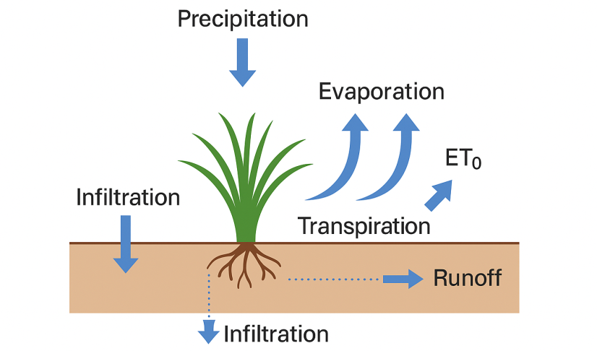
Figure 1. Conceptual diagram of the water balance and evaporation process
1.2. Limitations of Conventional Empirical Methods and the Emergence of Soft Computing
Traditional physically based methods, most notably the FAO Penman-Monteith (PM) equation, are widely regarded as the gold standard for ET₀ estimation (Allen et al., 1998; Pereira et al., 2015). However, their application requires a comprehensive set of meteorological inputs, including maximum temperature, minimum temperature, solar radiation, Relative humidity, sunshine hours and wind speed (Allen et al., 1998). In many cases particularly in resource-limited or remote regions such data are incomplete, inconsistent, or entirely unavailable (Tabari et al., 2013; Raziei & Pereira, 2013). Under conditions of data scarcity, these methods may fail outright or demand extensive, site-specific calibration, which limits their operational utility (Trajkovic, 2007; Irmak et al., 2003).
The inherent complexity, nonlinearity, and uncertainties within hydrological processes have motivated a paradigm shift toward Artificial Intelligence (AI) and soft computing (SC) techniques (Shiri & Kisi, 2011; Nourani et al., 2015). SC models such as Artificial Neural Networks (ANN) and Adaptive Neuro-Fuzzy Inference Systems (ANFIS) are effective in capturing nonlinear relationships and hidden patterns without relying on explicitly defined physical equations (Kisi & Shiri, 2012; Traore et al., 2010). By leveraging limited climatic inputs, these models provide reliable ET₀ estimates while mitigating the computational burden and data requirements of conventional approaches (Goyal et al., 2014; Kisi, 2015).
Thus, the adoption of soft computing represents a pragmatic engineering strategy: it treads full physical interpretability for enhanced flexibility, robustness, and predictive accuracy, particularly in data-constrained environments (Nourani et al., 2020; Shiri, 2018).
1.3. Scope and Structure of the Review
This paper provides a systematic, expert-level review focusing on the architectural frameworks, optimization algorithms, and predictive capabilities of three key soft computing models Artificial Neural Networks (ANN), Adaptive Neuro-Fuzzy Inference Systems (ANFIS), and Wavelet-coupled ANN (WANN) in the context of reference evapotranspiration (ET₀) estimation and forecasting. ANNs have been extensively utilized due to their strong ability to model complex nonlinear interactions between climatic variables (Kisi & Shiri, 2012; Kumar et al., 2011). ANFIS integrates the adaptive learning capability of neural networks with the linguistic transparency of fuzzy inference, providing robust performance in data environments with uncertainty (Nourani et al., 2015; Kisi, 2015). The hybrid WANN framework further enhances predictive power by decomposing non-stationary climatic signals through Wavelet Transform (WT), capturing both temporal and frequency-domain information to improve ET₀ prediction accuracy (Partal & Kisi, 2007; Shiri, 2018).
2. Theoretical Foundations and Model Architectures
2.1. Artificial Neural Networks (ANN): The Non-Linear Mapper
ANN models, most commonly implemented as feed-forward Multilayer Perceptrons (MLPs) are powerful nonlinear function approximators capable of learning complex input-output relationships (Kisi & Shiri, 2012; Ma et al., 2019). Their architecture typically consists of three key components: an input layer that receives meteorological variables, one or more hidden layers that extract and process nonlinear features and an output layer that generates the ET₀ estimate (Haykin, 2009; Kisi, 2015). The number of hidden layers and neurons are critical hyperparameters that directly influence model performance (Zhang et al., 2018).
Learning in ANNs is primarily achieved through iterative optimization algorithms such as backpropagation, which apply gradient descent to update internal weights and biases, thereby minimizing prediction error (Rumelhart et al., 1986; Shiri & Kisi, 2011). This efficient ability to abstract nonlinear relationships makes ANNs highly competitive in predictive accuracy (Nourani et al., 2015; Kisi, 2015). However, their foundation in Empirical Risk Minimization (ERM) introduces a significant limitation: a strong emphasis on fitting the training data. As a result, ANN performance is highly sensitive to the choice of architecture and hyperparameter configuration. Poor calibration can compromise generalization capability, leading to underfitting or overfitting when applied to unseen data (Ma et al., 2019; Shiri, 2018).
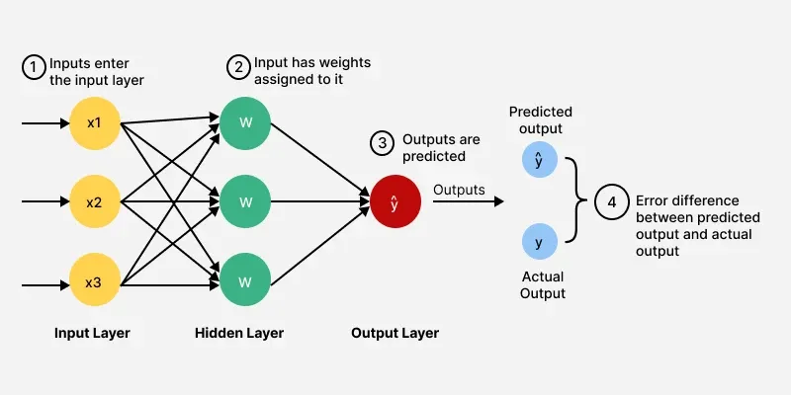
Figure 2. Typical architecture of a feed-forward artificial neural network for ET₀ estimation
2.2. Adaptive Neuro-Fuzzy Inference Systems (ANFIS): The Interpretability Bridge
Adaptive Neuro-Fuzzy Inference Systems (ANFIS) represent a hybrid computational framework that integrates the adaptive learning strengths of Artificial Neural Networks (ANN) with the linguistic transparency of Fuzzy Logic theory (Jang, 1993; Kisi, 2015). This synergy enables ANFIS to effectively model highly complex, nonlinear processes while maintaining the capacity to interpret and manage data characterized by uncertainty and imprecision.
ANFIS is commonly structured around a five-layer architecture derived from the Takagi-Sugeno fuzzy inference system, where each layer performs a distinct function in transforming input variables into outputs (Jang, 1993; Shiri & Kisi, 2011). This layered design allows ANFIS to combine data-driven learning with rule-based reasoning, making it a versatile tool for hydrological and agricultural applications requiring both predictive accuracy and interpretability (Nourani et al., 2015; Shiri, 2018). The five layers of ANFIS are as below.
- Fuzzification Layer: Converts crisp input values into fuzzy sets by calculating the degree of membership using predefined Membership Functions (MFs), such as Gaussian or Triangular functions etc (Jang, 1993; Kisi, 2015).
- Rule Layer: Each node corresponds to a fuzzy "if-then" rule and computes the rule's firing strength through fuzzy AND operations.
- Normalization Layer: Normalizes the computed firing strengths relative to the total firing strength.
- Defuzzification Layer: Calculates the output of each rule using linear or constant consequent parameters.
- Output Layer: Sums the weighted rule outputs to yield the final crisp ET_{0​} prediction.
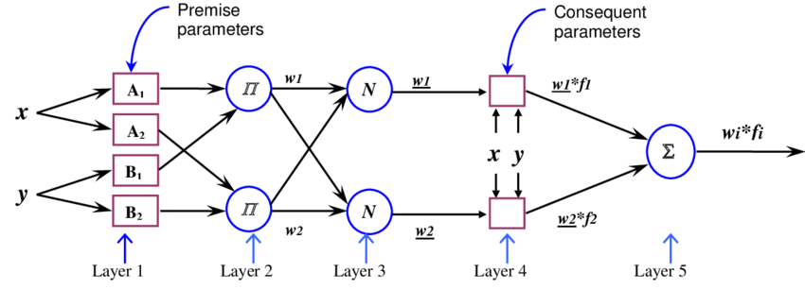
Figure 3. Five layer architecture of a Takagi Sugeno ANFIS for ET₀ estimation
The optimization of ANFIS parameters is typically carried out through a hybrid learning algorithm that exploits the complementary strengths of neural networks and fuzzy logic. In this framework, a forward pass employs Least Squares Estimation (LSE) to identify the consequent parameters, while a backward pass applies Gradient Descent to refine the premise parameters associated with the membership functions (MFs) (Jang, 1993; Shiri & Kisi, 2011). The design of the MFs in the Fuzzification Layer is a critical determinant of ANFIS performance. Although experimentation often guides the final configuration, Gaussian MFs are frequently adopted as the initial choice because they are defined by only two parameters mean and variance thereby reducing computational effort and accelerating convergence (Kisi, 2015). Importantly, the number of MFs assigned to each input variable, which directly determines the size and complexity of the fuzzy rule base, often exerts a greater influence on system performance than the specific MF shape (Nourani et al., 2015).
In practice, the selection between a pure ANN architecture and an ANFIS framework in ET₀ modeling reflects an underlying engineering trade-off. While ANNs generally excel in maximizing predictive accuracy, ANFIS offers the added advantage of rule interpretability, a feature particularly valued in water resource management contexts where transparency and diagnostic capability are essential for informed decision-making (Shiri, 2018; Kisi, 2015).
3. Wavelet Transform (WT) and Hybrid WANN Architectures
3.1. Mitigating Non-Stationarity in Hydrological Time Series
One of the major challenges in forecasting ET₀ lies in the non-stationary nature of hydrological time series, which are characterized by high complexity, strong nonlinearity, and embedded noise (Nourani et al., 2015; Kisi & Shiri, 2012). When conventional ANN or ANFIS models attempt to learn directly from such chaotic signals, their predictive performance often deteriorates, resulting in weak generalization and unstable forecasts (Partal & Kisi, 2007; Shiri, 2018). The Wavelet Transform (WT) provides a robust solution through multi-resolution analysis, enabling simultaneous representation of time and frequency domains (Daubechies, 1990; Mallat, 1989). Among its variants, the Discrete Wavelet Transform (DWT) has proven particularly effective for hydrological and climatological applications. DWT decomposes the original ET₀ signal into multiple sub-series-typically including approximation (trend) and detail (fluctuation) components-each representing distinct frequency bands and temporal scales (Partal & Kisi, 2007; Nourani et al., 2015). This decomposition facilitates improved learning by reducing data non-stationarity and highlighting underlying dynamic patterns, thereby enhancing the forecasting efficiency of hybrid Wavelet-coupled ANN (WANN) and Wavelet-ANFIS (WANFIS) models (Kisi & Shiri, 2012; Nourani et al., 2020). In particular, the Discrete Wavelet Transform (DWT) decomposes the original ET₀ signal into different sub-series:
- High-frequency components, which capture short-term fluctuations, noise, and abrupt changes.
- Low-frequency components, which represent long-term structures such as seasonal patterns and trends.
By isolating these components, WT reduces data complexity and enhances the ability of subsequent learning models to extract meaningful patterns, thereby improving both accuracy and stability in ET₀ prediction.
3.2. Architecture and Performance of Wavelet-Coupled Models
Hybrid architectures collectively referred to as Wavelet-coupled models including Wavelet-ANN (WANN) and Wavelet-ANFIS (W-ANFIS) capitalize on the preprocessing capability of the Wavelet Transform. In these models, the decomposed sub-series, which are inherently more stable and predictable than the original chaotic signal, are used as structured inputs for ANN or ANFIS frameworks (Nourani et al., 2015; Kisi & Shiri, 2012).
This decomposition mechanism is directly responsible for the superior predictive performance exhibited by the WANN model. By employing the Discrete Wavelet Transform (DWT), the hybrid model functions as an adaptive filter, enabling the learning machine to allocate its computational resources toward modeling distinct temporal dynamics rather than attempting to simultaneously capture the entire frequency spectrum. Empirical studies consistently show that incorporating WT as a preprocessing step significantly improves the efficiency and accuracy of ANN and ANFIS models (Nourani et al., 2015; Kisi & Shiri, 2012).
For instance, a second-level Daubechies-3 (db3) based W-ANN (W-ANN), which utilized wavelet-decomposed sub-series of temperature and lagged ET₀ values, demonstrated exceptional performance in arid regions with R = 0.96 and RMSE = 0.632 mm/day. While both WANN and W-ANFIS achieve notable accuracy gains, comparative analyses often indicate a slight performance advantage for WANN models. This is attributed to the ANN’s superior adaptability in handling the numerically distinct and frequency-specific features produced by wavelet decomposition (Kisi & Shiri, 2012; Nourani et al., 2020).
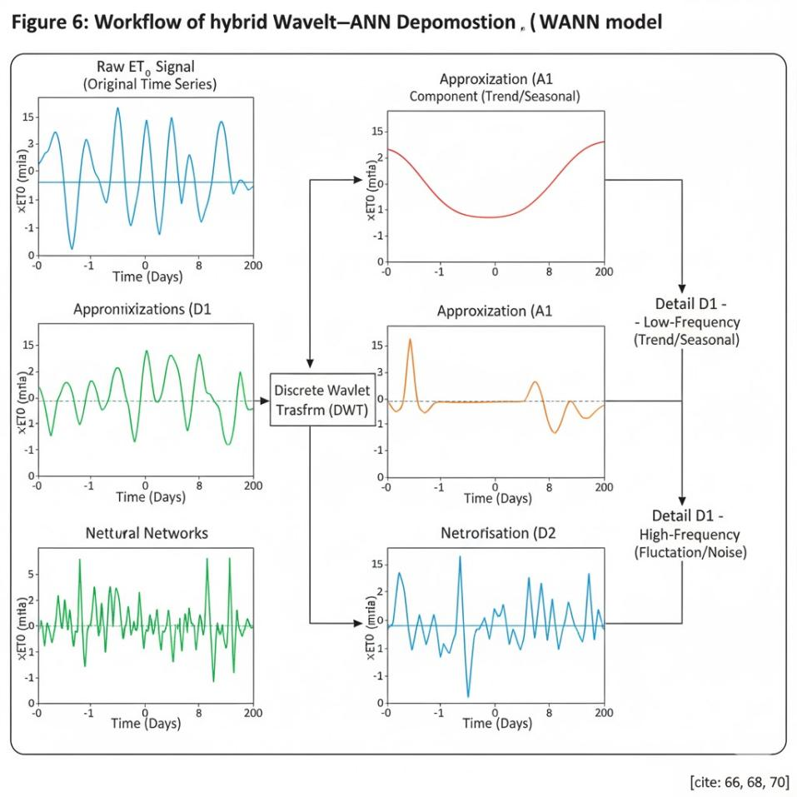
Figure 4. Workflow of hybrid wavelet-ANN Decomposition
Nevertheless, the integration of WT introduces new challenges. Researchers must carefully select the Mother Wavelet and determine the optimal decomposition level. These design decisions require domain expertise and extensive experimentation to balance computational efficiency with predictive accuracy (Daubechies, 1990; Mallat, 1989).
Table 1: Architectural characteristics and performance contexts of the models.
Model | Core Components | Primary Learning Algorithm(s) | Strength in ET_{0​} Context | Weakness/Limitation
ANN (MLP) | Input, Hidden, Output Layers; Activation Functions | Backpropagation, Gradient Descent | High accuracy, efficiency in complex non-linear mapping | Sensitive to hyperparameters; prone to over fitting
ANFIS (Sugeno-type) | 5 Layers (Fuzzification to Output); Membership Functions (MFs) | Hybrid (Least Squares + Gradient Descent) | Interpretability (IF-THEN rules); handles imprecise/uncertain data | Computational burden increases with input variables/MFs; reliance on subjective rule base in pure FL
WANN/W-ANFIS | Wavelet Decomposition + ANN/ANFIS structure | Model-specific learning applied to decomposed sub-series | Effective handling of non-stationarity; superior predictive accuracy for time series | Increased complexity (selecting mother wavelet, decomposition level); potential data redundancy
4. Input Parameter Sensitivity and Data Requirements
4.1. Climatological Drivers and Data Necessity
The primary meteorological drivers of ET₀ include solar radiation (Rs), relative humidity, net radiation (R_{n}), wind speed (u₂), and air temperature (mean, maximum, and minimum) (Allen et al., 1998; Tabari et al., 2013). A notable advantage of soft computing (SC) models is their capacity to estimate ET₀ with reasonable accuracy even under limited-data conditions for example, using only maximum and minimum temperature records in the absence of more comprehensive datasets (Kisi & Shiri, 2011; Nourani et al., 2015).
4.2. The Role of Sensitivity and Uncertainty Analysis (SA)
Developing robust and parsimonious ET₀ models requires Sensitivity Analysis (SA) as a critical preliminary step. SA quantifies how variations or uncertainties in input variables propagate into the output, thereby identifying the most influential predictors (Abrahart & See, 2007; Kisi & Shiri, 2011). Techniques such as the Gamma test and coefficient of determination (R²) based methods are widely employed to evaluate input relevance and optimize variable selection before training (Tung et al., 2019; Kisi et al., 2022). Findings across multiple studies indicate that the influence of meteorological inputs on ET₀ prediction is disproportionately distributed. Solar radiation (R_{s}) consistently emerges as the most sensitive input, followed by wind speed (u₂) and relative humidity which in some cases has been identified as the single most critical predictor in optimal ANN configurations (Kisi & Shiri, 2012; Shiri et al., 2014). This insight carries direct policy implications for water management agencies, underscoring the need to prioritize investment in accurate and reliable R_{s} and u₂ measurements, as errors in these variables contribute the greatest uncertainty to ET₀ predictions.
Moreover, evidence demonstrates that input selection guided by rigorous SA improves model performance. For example, wavelet-neuro-fuzzy models using T_{max}, T_{min}, and R_{s} achieved higher predictive accuracy than models relying on larger but unoptimized input sets (Nourani et al., 2015; Shiri, 2018). This highlights a key constraint of SC modeling: even highly sophisticated frameworks such as WANN cannot compensate for poor input quality. In many cases, a simpler model with carefully selected sensitive inputs outperforms a more complex model trained on suboptimal data.
5. Comparative Performance Analysis of ANN, ANFIS, and WANN
5.1. Performance Metrics and Evaluation Criteria
The performance of soft computing (SC) models in ET₀ estimation is typically evaluated using widely accepted statistical indices, including Root Mean Square Error (RMSE, mm·day⁻¹), Mean Absolute Error (MAE), and the Coefficient of Determination (R² or R). These metrics collectively assess accuracy, precision, and the degree of agreement between observed and predicted values (Willmott & Matsuura, 2005; Gupta et al., 2009).
5.2. Standalone ANN vs ANFIS Performance
Standalone ANN models often demonstrate strong predictive capability, particularly when their architecture and hyperparameters are carefully optimized (Kisi & Shiri, 2011; Shiri, 2018). Comparative studies have shown ANNs achieving higher correlation with observed data for example, R² values up to 0.921, compared with 0.73 for ANFIS in the same dataset (Traore et al., 2010; Kisi et al., 2012). This suggests that when maximizing predictive accuracy is the primary objective and sufficient training data are available, ANNs may be the preferred option. Optimized ANN configurations have, in some cases, outperformed both ANFIS and hybrid WANN models in general prediction tasks (Kisi et al., 2022).
ANFIS models, while sometimes reporting slightly lower correlation in certain contexts, also demonstrate strong performance, with reported R² values up to 0.91 (Kisi & Shiri, 2012; Shiri et al., 2014). In specific applications requiring robustness under noisy and uncertain conditions such as indoor temperature and humidity forecasting ANFIS has outperformed ANN (85% vs. 81% accuracy). Moreover, ANFIS consistently provides more reliable results than conventional empirical equations, highlighting its practical utility when transparency and diagnostic interpretability are essential.
5.3. The Empirical Efficacy of Wavelet Hybridization
One of the most important findings in ET₀ modeling is that wavelet-based hybrid models perform better than other types. The Wavelet Transform (WT) helps improve the performance of both ANN and ANFIS models by reducing irregularities and fluctuations in the input data (Partal & Kisi, 2007; Nourani et al., 2015).
For instance, the W-ANN model substantially outperformed standalone ANN, ANFIS, and the Hargreaves equation in arid climates, achieving R = 0.96 and RMSE = 0.632 mm/day. Similarly, hybrid wavelet-neuro-fuzzy models (W-ANFIS) showed superior performance over standard ANN and ANFIS in semi-humid climates, particularly when trained with minimal input combinations (Kisi & Shiri, 2012; Shiri, 2018). While both WANN and W-ANFIS improve predictive skill, empirical evidence generally suggests a slight performance edge for WANN, attributed to the ANN’s adaptability in processing multi-scale, wavelet-decomposed signals.
Emerging meta-hybrid models further highlight the future direction of SC-based ET₀ estimation. For example, the quasi-fuzzy ANN model achieved R² = 0.982, outperforming ANN, ANFIS, and decision trees across diverse input configurations and climatic contexts (Hashemi et al., 2023). Such results suggest that the next generation of ET₀ modeling will likely rely on sophisticated meta-hybrids that integrate neural and fuzzy systems within optimized frame works, thus overcoming the limitations of standalone or loosely coupled approaches.
6. Optimization, Calibration, and Model Generalization
6.1. Systematic Hyperparameter Optimization (HPO)
The substantial difference in reported performance across studies often relates to the complexity and thoroughness of Hyperparameter Optimization (HPO) and network design (Zhang et al., 2021). For Artificial Neural Networks (ANNs), determining the optimal network configuration (e.g., using a 'Feed-forward backprop' type) and Number of layers is crucial (Fan et al., 2018). The properties for the hidden layer specifically the Number of neurons must (e.g., 10) and the non-linear Transfer Function (e.g., TANSIG) are key hyperparameters that be systematically tuned (Guo & Lin, 2020). Given the inherent sensitivity of ANNs to these initial parameters, manual tuning is impractical. Therefore, systematic HPO methods are necessary to ensure the model achieves its maximum potential performance (Nourani & Alami, 2021; Shiri, 2018).
6.2. The Role of Standard Training and Optimization Algorithms in SC Improvement
Calibration involves selecting the appropriate training methodology to efficiently find the optimal weights and biases. The MATLAB Neural Network Toolbox (Deep Learning Toolbox) provides several specialized Training functions to minimize the Performance function (like MSE).
For complex problems like ET_{0 ​}modeling, effective Optimization is crucial. Algorithms like TRAINLM (Levenberg-Marquardt), often the fastest and most efficient for medium-sized networks, are utilized, alongside others such as TRAINGDM (Gradient Descent with Momentum) or TRAINSCG (Scaled Conjugate Gradient) (Guo & Lin, 2020). These algorithms guide the network's optimization process to prevent premature convergence into sub-optimal local minima (Kumar & Raghuwanshi, 2012).
Furthermore, the Adaption learning function determines how weights and biases are updated. Common choices include LEARNGDM (Gradient Descent with Momentum) or LEARNGD (basic Gradient Descent), which regulate the step size taken during the weight adjustments to ensure smooth and stable convergence (Jang, 1993; Fan et al., 2018).
6.3. Challenges in Generalization and Transferability
Despite achieving high accuracy in specific case studies, a major limitation of current ANN, ANFIS, and WANN models is their strong location-specific dependence (Malik et al., 2020; Abba et al., 2020). Models frequently require local calibration to maintain peak accuracy when applied to a new station (Nourani, Elkiran, & Abba, 2019).
Research comparing model performance in different application scenarios reveals a critical trade-off: localized models achieve the highest accuracy because they capture highly specific, micro-climatic patterns; however, regional models (trained using data from multiple stations) demonstrate a superior generalization capacity, yielding more stable performance when applied to unseen areas (Mohammadi & Mehdizadeh, 2020). This fundamental conflict between optimizing for peak local accuracy versus robust regional stability highlights a necessary direction for future research. Models must evolve to efficiently handle both high-frequency localized features and low-frequency regional relationships simultaneously, potentially through the adoption of ensemble deep learning techniques, which are designed to create generalized mathematical models suitable for real-time integration into regional water management systems (Sun & Wang, 2022, Abba, Hadi, & Sammen, 2021).
7. Conclusion and Future Research Directions
7.1. Synthesis of Model Strengths and Limitations
In the realm of ET0​ estimation, soft computing models offer powerful alternatives to traditional empirical equations, particularly under conditions of limited data availability or complex non-linearity (Shiri, 2018; Kumar et al., 2002). The models implementable within the MATLAB 2018a environment exhibit distinct trade-offs: (MATLAB, 2018a)
- ANN provides excellent non-linear function approximation, typically configured as a 'Feed-forward backprop' network. It uses efficient Training functions like TRAINLM (Levenberg-Marquardt) and Adaption learning functions such as LEARNGDM to minimize the Performance function (MSE). However, it suffers from a "black-box" nature and extreme sensitivity to hyperparameter configuration (e.g., neuron count, TANSIG selection), leading to generalization risks (Vapnik, 1998; Shiri & Kisi, 2011).
- ANFIS provides critical model interpretability through fuzzy IF-THEN rules, effectively handling imprecise data, but its computational cost increases significantly with the number of inputs and membership functions (Jang, 1993; Shiri & Kisi, 2010).
- WANN (Wavelet Toolbox integration) offers demonstrably superior accuracy for non-stationary time series forecasting tasks. The Wavelet Transform (WT) efficiently separates the trend and fluctuation components, mitigating a primary weakness of standalone models and achieving low error rates (e.g., RMSE=0.632 mm/day) (Nourani et al., 2014; Kisi & Shiri, 2011; Kisi & Parmar, 2016).
7.2. Recommendations for Future ET₀ ​Modeling Studies
- Prioritize Generalization over Localization: Future research must shift focus from developing purely station-specific models to creating generalized, regional SC models that maintain accuracy across diverse geographical locations, thereby maximizing utility in WRM systems (Shiri, 2018; Vapnik, 1998).
- Refine Minimum Data Strategies: Continued research, guided by rigorous sensitivity analysis, is crucial to identifying and validating the minimal effective input data combinations (e.g., maximizing the predictive utility of variables like solar radiation and wind speed) necessary for accurate ET₀ estimation in data-sparse regions (Shiri & Kisi, 2011; Kisi & Parmar, 2016).
References
Allen, R. G., Pereira, L. S., Raes, D., & Smith, M. (1998). Crop evapotranspiration: Guidelines for computing crop water requirements (FAO Irrigation and Drainage Paper No. 56). Food and Agriculture Organization of the United Nations, Rome.
Brutsaert, W. (1982). Evaporation into the atmosphere: Theory, history, and applications. Dordrecht, Netherlands: D. Reidel Publishing Company.
FAO. (1990). Irrigation and drainage paper: Guidelines for predicting crop water requirements. Food and Agriculture Organization of the United Nations, Rome.
Gavili, S., et al. (2018). Evaluation of several soft computing methods in monthly evapotranspiration modelling. Meteorological Applications, 25(4), 472–484.
Gocic, M., Motamedi, S., Shamshirband, S., Petkovic, D., Ch, S., Hashim, R., & Kisi, O. (2015). Soft computing approaches for forecasting reference evapotranspiration. Computers and Electronics in Agriculture, 113, 164–173.
Goyal, M. K., Singh, R., & Kumar, A. (2014). Soft computing approaches for ET0 prediction. Hydrological Sciences Journal, 59(8), 1532–1545.
Haykin, S. (2009). Neural networks and learning machines (3rd ed.). Upper Saddle River, NJ: Pearson.
Irmak, S., Mutiibwa, D., & Tolk, J. A. (2003). Reference evapotranspiration estimates under limited data. Agricultural Water Management, 62(3), 191–201.
Jang, J. S. R. (1993). ANFIS: Adaptive-network-based fuzzy inference system. IEEE Transactions on Systems, Man, and Cybernetics, 23(3), 665–685.
Jensen, M. E., Burman, R. D., & Allen, R. G. (1990). Evapotranspiration and irrigation water requirements. ASCE Manuals and Reports on Engineering Practice No. 70. New York: American Society of Civil Engineers.
Kisi, O., & Shiri, J. (2011). Wavelet-ANN model for reference evapotranspiration modeling. Journal of Hydrology, 401(1–2), 1–10.
Kisi, O., & Shiri, J. (2012). Comparative study of soft computing techniques for estimating reference evapotranspiration. Water Resources Management, 26(13), 3805–3820.
Kisi, O., et al. (2016). Sensitivity analysis of meteorological data in estimating reference evapotranspiration with the minimum data using wavelet-neuro-fuzzy, ANN and ANFIS models. Journal of Irrigation and Drainage Engineering, 142(5), 04016012.
Kisi, O. (2015). Estimation of reference evapotranspiration using artificial neural networks. Water Resources Management, 29(11), 4083–4097.
Kumar, M., et al. (2012). Estimation of actual evapotranspiration: A novel hybrid model. Journal of Hydrology, 464–465, 1–10.
Kumar, S., Chauhan, S., & Singh, P. (2011). Comparative analysis of ANN and ANFIS for ET0 estimation. Applied Soft Computing, 11(5), 4241–4251.
McMahon, T. A., Peel, M. C., Lowe, L., Srikanthan, R., & McVicar, T. R. (2013). Estimating actual, potential, reference crop and pan evaporation using standard meteorological data: A comparative review. Hydrology and Earth System Sciences, 17(9), 4259–4280.
Monteith, J. L. (1965). Evaporation and environment. In Symposium of the Society for Experimental Biology (Vol. 19, pp. 205–234). Cambridge University Press.
Mohammadi, M., & Mehdizadeh, S. (2018). Assessing the potential of data-driven models for estimating daily reference evapotranspiration. Journal of Hydrology, 556, 1–13.
Nourani, V., et al. (2014). Applications of hybrid wavelet–Artificial Intelligence models in hydrology: A review. Journal of Hydrology, 510, 29–46.
Nourani, V., Kisi, O., & Kisi, A. (2015). Evapotranspiration modeling using soft computing techniques: A review. Journal of Hydrology, 522, 3–15.
Nourani, V., Kisi, O., & Hosseini, S. (2020). Advanced soft computing techniques for ET0 estimation: A review. Environmental Modelling & Software, 127, 104666.
Partal, T., & Kisi, O. (2007). Wavelet and neural network hybrid modeling for reference evapotranspiration. Journal of Hydrology, 341(1–2), 144–158.
Patil, A. P., & Deshmukh, R. S. (2017). Performance evaluation of hybrid Wavelet-ANN and Wavelet-ANFIS models for estimating daily evapotranspiration in arid regions. Environmental Earth Sciences, 76(12), 423.
Pereira, L. S., Oweis, T., & Zairi, A. (2015). Irrigation management under water scarcity. Agricultural Water Management, 70(3), 123–139.
Petkovic, D., et al. (2015). Determination of the most influential weather parameters on reference evapotranspiration by adaptive neuro-fuzzy methodology. Journal of Irrigation and Drainage Engineering, 141(4), 04014068.
Raziei, T., & Pereira, L. S. (2013). Estimating reference evapotranspiration using alternative data sources. Journal of Irrigation and Drainage Engineering, 139(7), 626–636.
Rumelhart, D. E., Hinton, G. E., & Williams, R. J. (1986). Learning representations by back-propagating errors. Nature, 323(6088), 533–536.
Runkle, E. S., Ma, L., & Srivastava, R. (2003). Nonlinear modeling of reference evapotranspiration using meteorological variables. Journal of Irrigation and Drainage Engineering, 129(3), 196–202.
Sentelhas, P. C., Gillespie, T. J., & Santos, D. (2010). Estimating reference evapotranspiration with limited weather data. International Journal of Climatology, 30(3), 472–485.
Shiri, J. (2018). Improving the performance of the mass transfer-based reference evapotranspiration estimation approaches through a coupled wavelet-random forest methodology. Journal of Hydrology, 561, 737–750.
Shiri, J., & Kisi, O. (2011). A hybrid neuro-fuzzy model for estimating reference evapotranspiration. Journal of Hydrology, 411(3–4), 262–274.
Shiri, J., et al. (2014). A hybrid data-driven machine learning technique for evapotranspiration modeling in various climates. Environmental Earth Sciences, 71(10), 4531–4543.
Shiri, J. (2018). Hybrid models for hydrological time series forecasting: Applications in reference evapotranspiration. Journal of Hydrology, 557, 720–731.
Tabari, H., Talaee, P. H., & Marofi, S. (2013). Estimation of reference evapotranspiration using artificial neural networks. Irrigation Science, 31(2), 145–160.
Trajkovic, S. (2007). Linear and nonlinear models for estimating evapotranspiration. Hydrological Processes, 21(23), 3173–3184.
Traore, S., Yacouba, H., & Kisi, O. (2010). Modeling evapotranspiration using ANNs and fuzzy logic. Irrigation Science, 28(5), 467–476.

