Integrated Drought Monitoring Using Mandatory and Impact Indicators: A Block level study of Bolangir District, Odisha

Abstract
Drought is a complex phenomenon characterized by slow manifestation, so it is difﬁcult to predict its onset and termination. Careful monitoring of the symptoms of drought and early warning are the key for effective management of the calamity. As the complexity of drought cannot be captured with the aid of a single indicator, therefore many drought indices categorised as mandatory and impact indicator are used combinedly for monitoring purpose. The present study was carried out to monitor drought in Bolangir district of Odisha for the year 2018 taking each block as unit using mandatory indicators like Rainfall deviation (RFdev), dry spell and impact indicators like Vegetation Condition Index (VCI), Percent Available Soil Moisture (PASM) and Ground Water Drought Index (GWDI). Occurrence of drought in all the fourteen blocks during the period of study clearly indicated that the Bolangir district is a drought prone area district of Odisha. Based on the mandatory indictor matrix (RFdev/SPI and Dryspell) drought was seemed to be triggered in 11 out of 14 blocks of Bolangir. According to Drought Management Manual 2016, based on impact indicator matrix (crop sown area, NDVI, PASM, GWDI) severe drought like situation found in Bangomunda, Belpada, and Muribahal, whereas moderate drought situation is noticed in Agalpur, Titilagarh and Tuekela block of Bolangir district. In order to make a final determination on drought after impact indicator assessment, there should be a survey for ground level verification by the concerned government authorities.
Keywords: Drought, Rainfall, NDVI, Remote sensing
- Introduction
Drought is a disastrous natural phenomenon that differs from other natural hazards by its slow manifestation and its indefinite commencement and termination. It has significant impact on agricultural, socio-economic and environmental sphere but is difficult to accurately quantify since its definition is spatially variant and context dependent (Quiring, 2009a). In general, drought gives an impression of water scarcity resulted due to insufficient precipitation, high evapotranspiration, and over-exploitation of water resources or combination of these parameters. There are various methods and indices for drought analysis and they measure different drought-causative and drought-responsive parameters, and identify and classify drought accordingly.
Drought is also referred to as a climatic anomaly characterized by deficient supply of moisture resulting either from sub-normal rainfall, erratic rainfall distribution, higher water need or a combination of all the three factors. The main types of drought are: (a) Meteorological drought, (b) Hydrological drought and (c) Agricultural drought. Meteorological drought is the first observation of drought condition caused by deviation in rainfall amount from its normal. Meteorological droughts lead to soil moisture deficits (Wang et al. 2009), which in result affect plant growth, and hampers the overall quantity and quality of crops produced (Mishra and Cherkauer 2010). Due to prolonged meteorological drought, hydrological drought situation arises where there is unavailability of water in surface and sub- surface levels. Then comes the agricultural drought which is a situation when rainfall and soil moisture are inadequate during the crop season to support the timely cultural practices and healthy crop growth. Soil moisture depletion below the permanent wilting point results in crop mortality, putting the food security of the region at risk.
No single index can fully describe the multi-scale, multi-impact nature of drought in all its complexity. To accurately assess the occurrence extent and severity of drought it is necessary to get an exact picture of the spatial and temporal distribution of key variables like meteorological, hydrological and surface variables. So many different tools (e.g., drought indices) have been developed for monitoring drought conditions (Quiring, 2009b). Each drought index has different data requirements and utilizes unique methods to measure drought.
Bolangir is one of the drought prone district identified by the State Disaster Management Authority (OSDMA). Keeping these things in view the present study was planned to make an attempt foridentifying various drought indices in different blocks of Bolangir district to continuously monitor the drought condition and assess the severity in those areas during June to October of 2018.
- Study area
Bolangir district is situated in western region of state Odisha, India bounded by Subarnapur and Boudh district in the east, Nuapada in the west, Kalahandi in the south and Bargarh in the north. The district lies between 20°09’ and 21°05’ North latitudes and 82°41’ and 83°42’ East longitudes (Fig.1), falling in Survey of India toposheet nos. 64O, 64P & 64L. The district is located under Western Central Table Land Agro Climatic zone covering an area of 6,575 square kilometers characterized by hot and sub humid climate, comprised of 14 blocks viz. Agalpur, Balangir, Bangomunda, Belpada, Deogaon, Gudvella, Khaprakhol, Loisingha, Muribahal, Patnagarh, Puintala, Saintala, Titilagarh and Turekela under Sub divisions viz. Balangir, Patnagarh and Titilagarh. There are 15 percent of areas under black soil identified in the district. Less than ten percent of the aerial extent of Laterite and Lateritic (9.0 %) were noticed in the district. In general mixed red and yellow soil covered maximum of the area in the district.
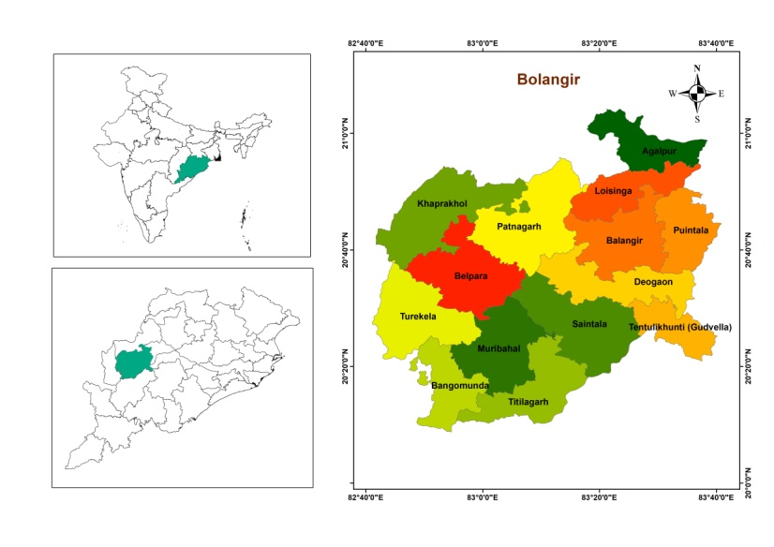
Fig. 1 Location map of study area

- Materials and methods
The drought management manual developed by Mahalanobis National Crop Forecasting Centre (MNCFC), New Delhi, India during 2016 clearly emphasised that no single indicator or index can precisely identify the onset and severity of the event and its potential impacts rather multiple indicator are more effective. In this manual different drought indices are suggested for analyzing the drought situation under two categories such as mandatory indicators under Rainfall related indices : Rainfall Deviation (RFdev), Standardized Precipitation Index (SPI), Dry Spell, and Impact indicators under (a) Agriculture based indices : Crop Sown Area, (b) Remote sensing based vegetation indices : Normalized Difference Vegetation Index (NDVI), Vegetation condition Index (VCI), (c) Soil moisture based indices : Percent Available Soil Moisture (PASM), (d) Hydrological indices : Reservoir Storage Index (RSI), Groundwater Drought Index (GWDI). According to the manual, the assessment of drought is done using following two steps. Step 1 is for estimating Trigger-1 using Mandatory Indicators and Step 2 if for estimating Trigger-2 using Impact Indicators. In order to make a final determination there should be a survey for ground level verification in the location of Trigger-2 set off by the concerned government department.
Step-1: Mandatory indicators viz. RF Deviation and Dry spell are considered for this study as per Matrix Table 1 to assess if the first drought trigger is set off. Deficits in quantum of rainfall received from the normal (Table 2) and its pattern of distribution signifying the number of dry spell experienced during the period considered as per Trigger -1 matrix (Table 1) to assess the triggering of occurrence of drought in a location.
Table 1: Matrix for rainfall deviation/SPI and dry spells (Trigger-1)
RF Dev/ SPI | Dry spell | Drought trigger
Deficit or scanty rf/SPI<-1 | Yes | Yes
Deficit or scanty rf/SPI<-1 | No | Yes if rf is scanty or SPI<-1.5, Else No
Normal rf/SPI>-1 | Yes | Yes
Normal rf/SPI>-1 | No | No

  - Rainfall based indices
3.1.1 Rainfall deviation
Rainfall deviation from normal long term mean, is the most commonly used indicator for drought monitoring. Percent deviation of rainfall (RFdev) is expressed as
RFdev = $\frac{RFi -RFn}{RFn}$ ×100
Where RFi is current rainfall (in mm) in time period ‘i’ and RFn is normal rainfall (in mm) average of at least 30 years
Table 2: IMD classification of rainfall deviation
Deviation from normal rainfall (%) | Category of rainfall
> + 19 | Excess
+19 to -19 | Normal
+19 to - 19 | Normal
-20 to -39 | Deficient
-40 to -59 | Severe Deficient
< - 60 | Scanty
Source: Manual for Drought Management, 2016
    - Dry Spell
A dry spell is a short period, usually 4 weeks (up to 3 weeks in case of light soils), of low rainfall or no rainfall. Thus, consecutive 3/4 weeks after the due date for the onset of monsoon with rainfall less than 50% of the normal in each of the weeks is defined as a dry spell. The weekly rainfall data of each block was analysed to calculate the number of dry spell occurred in the respective month.
Percentage of rainfall= $\frac{Observed rainfall}{Normal rainfall}$× 100
Step 2:- Impact indicators from Agriculture based indices, Remote sensing based vegetation indices Soil moisture based indices and Hydrological indices are considered to assess the severity of drought condition in the area.
3.2 Agriculture based indices
Crop sown area
Drought conditions could said to be exist if the total sown area under kharif crop is less than 85% of the total normal sown area by the end of July / August, depending upon the schedule for sowing in individual states due to failure of rains or very late arrival of monsoon. In such situations, even if rainfall revives in the subsequent months, there is a little possibility of full recovery and the agricultural production is likely to take a substantial hit. However, the conditions will indicate portents for drought of a ‘severe’ nature, if the area under crop falls to 75% of the normal by the end of July / August. The crop sown area coverage data for the month of July and August of 2018 and normal crop sown area of all the block was collected from Department of Agriculture, Agriculture Statistic of State, Odisha and its deviation of current season crop sown area from its normal sown area for the respective blocks were calculated.
3.3 Remote sensing based vegetation indices
Vegetation Condition Index (VCI)
NDVI was developed by Rouse et al. (1973) and is based on the fact that internal mesophyll structure of healthy green leaves reflects Near-infrared (NIR) radiation whereas the leaf chlorophyll and other pigments absorb a large proportion of the red visible (RED) radiation. The current period values of NDVI can be compared with long-term data (at last ten years) for computing Vegetation Condition Index (VCI) which compares the observed NDVI to the range of values observed for the same period in previous years. The VCI is expressed in percentage (%) and gives an idea where the current value is placed within the extreme value (minimum and maximum) in the historical dataset normalized to a scale of 0-100% (Table 3). Lower and higher values indicate bad and good vegetation state conditions, respectively. VCI is computed as:
VCI (NDVI) = $\frac{NDVIcurr - NDVImin}{NDVImax - NDVImin}$ × 100
Where the subscript ‘curr’ refers to current period value, ‘min’ and ‘max’ refer to minimum and maximum values of NDVI in historical dataset for the same period and same location.
Table 3: VCI representing different drought classes
VCI Values (%) | Vegetation Condition
60 - 100 | Normal
40 - 60 | Moderate
0 - 40 | Severe
Source: Manual for Drought Management, 2016
3.4. Soil moisture based drought indices
Percent Available Soil Moisture (PASM)
PASM (Table 4) is derived from observed moisture sensor data or sample soil-water balance model following the ‘bucket approach’ and using the following formula:
PASM=$\frac{SMw-PWP}{FC-PWP}$× 100
Where, SM_{w}=weekly calculated volumetric soil moisture (vol/vol) for the current week
FC= Field capacity of soil (vol/vol)
PWP= Permanent wilting point of soil (vol/vol)

Table 4: Drought classification based on PASM
PASM (%) | Agricultural drought classes
76 – 100 | No drought
51-75 | Moderate drought
0 – 50 | Severe drought
Source: Manual for Drought Management, 2016

3.5. Hydrological drought indices
Groundwater Drought Index (GWDI)
Ground water drought index derived from the ground water level which is measured quarterly (January, April, August and November) in a year by the Central Ground Water Board (CGWB). As we are monitoring the drought during kharif 2018 this GWDI of August month is taken as a representative one for this consideration of drought situation. Ground water drought is a distinctive class of drought resulting from the decrease in ground water recharge and the decrease in ground water storage and discharge (Bloomfield et al. 2015).
The computation procedure for Ground Water Drought Index (Table 5) is as follows:
GWDIij = $\frac{MGWDj-GWDij}{GWDimax}$
Where, GWDij= Ground water drought index for $i^{th}$ month and $j^{th}$year.
MGWDj= Mean depth to ground water table below surface (in meter)
GWDij= Depth to ground water table in $i^{th}$ month and $j^{th}$ year (in meter)
GWDimax= Maximum depth to ground water table in ith month in available data set for n number of years (in meter)
Table 5: Ground Water deficit class
Ground Water Drought Index (GWDI) | Ground Water deficit class
>-0.15 | Normal
-0.16 to -0.30 | Mild
-0.31 to -0.45 | Moderate
-0.46 to -0.60 | Severe
< -0.60 | Extreme
Source: Manual for Drought Management, 2016
3.6 Assessment of drought severity of drought
The severity of the drought will be contingent upon the values of at least three out of four impact indicators viz. Agriculture, Remote sensing, Soil moisture and Hydrology in the following manner:
- Severe drought: If at least two of the selected 3 impact indicators are in ‘severe’ category and one is ‘moderate’ category, then the area is considered to be in severe drought.
- Moderate drought: If at least two of the selected 3 impact indicators are on ‘moderate’ category then the area is considered to be in moderate drought.
- For all other cases the area is considered to be in normal condition.
- Results and Discussion
4.1 Rainfall deviation
The rainfall received during 2018 in all the blocks and the percent rainfall deviation from the normal annual rainfall of respective blocks of Bolangir district were estimated and categorised as normal to scanty based on IMD classification. Severe deficit was noticed in Agalpur and Belpada block with -43% and -41% deviation in annual rainfall from normal respectively (Table 6). Loisingha, Muribahal, Turekela were under deficit rainfall category exceeding deficiency more than -25% whereas, in rest of the blocks therainfall was normal.
Table 6: Annual rainfall deviation
Block | Normal | Current | RF Dev (%) | Category of rainfall
Agalpur | 1429.9 | 814 | -43.1 | Severe deficit
Balangir | 1462.3 | 1298.5 | -11.2 | Normal
Bangomunda | 1104.1 | 1030 | -6.7 | Normal
Belpada | 1044.5 | 616 | -41.02 | Severe deficit
Deogaon | 1280.9 | 1400.2 | 9.3 | Normal
Gudvella | 1672.8 | 1916.7 | 14.6 | Normal
Khaprakhol | 1068.5 | 1040 | -2.7 | Normal
Loisingha | 1089.1 | 737.5 | -32.3 | Deficit
Muribahal | 1154.6 | 835.4 | -27.6 | Deficit
Patnagarh | 1210.6 | 1254.4 | 3.6 | Normal
Puintala | 1394.6 | 1239 | -11.2 | Normal
Saintala | 1207.4 | 1297.5 | 7.5 | Normal
Titilagarh | 1375.2 | 1503.4 | 9.3 | Normal
Turekela | 1067 | 810.4 | -24.04 | Deficit
District | 1254.4 | 1128.1 | -10.1 | Normal

Similarly the monthly rainfall deviation was calculated for the months from June to October and high degree of temporal variability was observed in different blocks (Fig. 2). The overview of rainfall during the entire period (June- October, 2018) indicated that there exists a spatio- temporal variability of rainfall among the blocks of the Bolangir district. The overview of rainfall during the entire period (June- October, 2018) clearly depicted that the blocks like Gudvella, Belpada and Loisingha experienced deficit to scanty rainfall in all the months whereas the blocks like Muribahal, Puintala and Turekela though experienced normal rainfall in one or two months but that was less than the normal rainfall of the respective blocks. In rest of the blocks there was no problem with the receipt of rainfall indicating the rainfall was either normal or excess in most of the months.

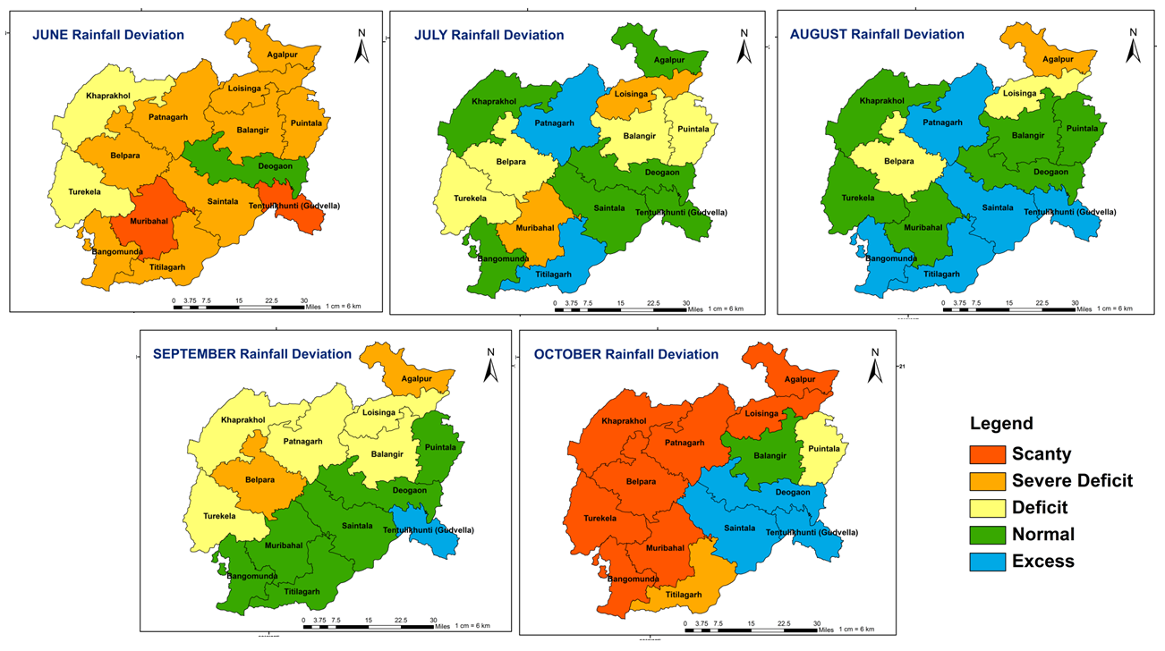
Fig 2: Monthly rainfall deviation of Bolangir district during June-October
4.2 Dry spell
Considering 3-4 consecutive week with rainfall less than 50% of the normal in each week as dry spell after due date of onset of monsoon, the number of dry spell were calculated for each block of Bolangir district.In case of three consecutive dry weeks, maximum numbers of dry spell (2) were observed in Agalpur and Gudvella block, whereas one dry spell was observed in Patnagarh, Puintala and Saintala blocks leaving other blocks of the district with no dry spell. Four or more than four weeks of consecutive dry weeks were observed in Loisingha (24-28 SMW), Belpada, Khaprakhol, and Muribahl, Turekela (39-43 SMW) and Bangomunda (40-43 SMW), have clearly indicated that crop had experienced initial drought condition in Loisingha and Terminal drought condition in rest of the above said blocks. Other than that Agalpur, Gudvella, Patnagarh, Puintala and Saintala blocks experienced 3 consecutive dry weeks. Similar results were also observed by Dabral et al. in 2014.
Table 7: Number of Dry Spell and consecutive dry weeks during June to October
Block | Consecutive 2 dry weeks |  | Consecutive 3 dry weeks |  | Consecutive 4 and >4 dry weeks
Block | No. of dry spell | Week | No. of dry spell | Week | No. of dry spell | Week
Agalpur | 2 | 39-40, 42-43 | 2 | 26-28, 31-33 | 0
Balangir | 3 | 30-31, 39-40, 42-43 | 0 |  | 0
Bangomunda | 3 | 23-24, 26-27, 30-31 | 0 |  | 1 | 40-43
Belpada | 3 | 24-25, 30-31, 36-37 | 0 |  | 1 | 39-43
Deogaon | 3 | 30-31, 39-40, 42-43 | 0 |  | 0
Gudvella | 2 | 39-40, 42-43 | 2 | 23-25, 30-32 | 0
Khaprakhol | 2 | 30-31, 36-37 | 0 |  | 1 | 39-43
Loisingha | 3 | 30-31, 39-40, 42-43 | 0 |  | 1 | 24-28
Muribahal | 2 | 26-27, 30-31 | 0 |  | 1 | 39-43
Patnagarh | 2 | 39-40, 42-43 | 1 | 24-26 | 0
Puintala | 2 | 39-40, 42-43 | 1 | 30-32 | 0
Saintala | 3 | 30-31, 39-40, 42-43 | 1 | 25-27 | 0
Titilagarh | 4 | 25-26, 30-31, 39-40, 42-43 | 0 |  | 0
Turekela | 1 | 30-31 | 0 |  | 1 | 39-43
4.3Crop sown area
The extent of sowing is an important indicator of the spread and severity of drought. Sowing operations are linked to rainfall and availability of water during initial growth stages. The percent deviation of current season crop sown area from its normal sown area for the respective blocks were calculated for the months of July and August. Crop sown area for all block was found below 85% of normal by the end of July which indicated the existence of drought during this month. Agalpur, Balangir, Bangomunda, Deogaon, Gudvella, Loisingha, Muribahal, Patnagarh, Puintala, Saintala, Titilagarh and Turekela had less than 75% of the normal crop sown area which indicated relatively higher intensity of drought by the end of July. But the deviation exceeded 85% by the end of August totally implied that there was no drought on the basis of crop coverage. Here a clear difference can be seen between sown area of July and August month and it is not giving any clear indication of drought during early crop growth stages. As the data on sown area under crops may not shed any light either on the health of crop and subsequent damage to the sown crop due to moisture stress we cannot rely on sown area for monitoring of drought.
4.4 Vegetation Condition Index (VCI)
Availability of long term NDVI data enables computation of Vegetation Condition Index (VCI), which is a more robust parameter than the instant NDVI. The VCI was found in normal range in all the blocks during June month except in Gudvella block which showed severe vegetation condition. Balangir, Bangomunda, Belpada, Deogaon, Gudvella, Khaprakhol, Muribahal, Puintala, Saintala, Titilagarh, Turekela block experienced severe vegetation condition during both the months July and August which clearly indicated presence of severe early season drought in above mentioned blocks. However, Agalpur block had moderate drought in August month. All the block had normal vegetation condition during September and October month except Turekela that had moderate value during September. One of the main advantage of VCI is that, because it is a satellite based drought product, it can provide near real time data over a region at a relatively high spatial resolution. In addition the VCI uses completely independent methodology for monitoring of drought while all of the other meteorological indices rely to some extent on station based meteorological data (Quiring and Ganesh 2010).
4.5 Percent Available Soil Moisture (PASM)
PASM was calculated using soil moisture and weekly rainfall data. Based on that value severe drought was experienced in most of the blocks till 2nd week of July except at Belpada and Muribahal up to 4th week of August. Bangomunda had severe drought up to 1st week of August whereas in Loisingha severe drought was found till 3rd week of august. Most of the blocks experienced moderate to severe drought condition during SMW 42- 43 of October month.The estimated PASM values indicated scarcity of available soil moisture to the plant in above mentioned block till 1st to 4th week of August, which may create agricultural drought condition in early growth stages of kharif crops. Soil moisture is a clear reflectance of the receipt of rainfall in a particular area (Mbah 2012). Thus the diversity in PASM of all the blocks of Bolangir was the clear indication of the non-uniform distribution of rainfall during June to October.
4.6 Ground Water Drought Index (GWDI)
The GWDI values clearly indicated that there is no situation of drought in almost 44 wells excepting one well in Agalpur block, two wells in Titilagarh block and one well in Turekela block. The GWDI values at well of Uchchabahal of Agalpurblock, Chormara of Titilagarh and Dhamana Donga of Turekela block exhibited moderate drought situation whereas the well at Titilagarh (new) of Titilagarh block exhibited severe drought condition. This clearly indicated that ground water is not stressed for different purposes.
4.7 Assessment of Trigger 1 and Trigger 2
Based on the mandatory indicator (RF_{dev} and DrySpell) matrix (Table 1) Bolangir, Deogaon, and Titilagarh did not show drought Trigger-1. Agalpur, Belpada, Loisingha, Muribahal and Turekela experienced both deficit rainfall deviation and dry spell, whereas rest of the triggered block like Bangomunda, Gudvella, Khaprakhol, Patnagarh, Puintala, and Saintala experienced only dry spell.
As per the Manual for drought Management, 2016, New Delhi, the severity of the drought will be contingent upon the values of at least 3 out of 4 impact indicators. But in the present study the crop sown area by the end of August always exceeded 85% indicating no drought situation in any of the blocks of Bolangir district during kharif 2018. So, crop sown area is excluded from consideration of drought and rest 3 impact indicators such as VCI, PASM and GWDI considered for the assessment of drought. NDVI based VCI estimation, Balangir, Bangomunda, Belpada, Deogaon, Gudvella, Khaprakhol, Muribahal, Puintala, Saintala, Titilagarh and Tureikela experienced moderate to severe vegetation condition during which indicated impact of early season drought. PASM was calculated using soil moisture and weekly rainfall data, based on that value severe drought was found in all blocks till 2nd week of July except Bangomunda & Loisingha up to mid August and Belpada & Muribahal up to 4th week of August. Based on GWDI value, there was no drought condition found in majority of blocks except moderate condition in Agalpur, Titilagarh and Tuekela. Considering the impact indicators, severe drought was observed in Bangomunda, Belpada and Muribahal whereas moderate drought was noticed in Agalpur, Titilagarh and Tuekela block.
Table 8. Observation of Drought Trigger-2 using impact indicators
Block | VCI | PASM | GWDI | Category of drought
Agalpur | Moderate | Normal | Moderate | Moderate
Balangir | Severe | Normal | Normal | No drought
Bangomunda | Severe | Severe | Normal | Severe
Belpada | Severe | Severe | Normal | Severe
Deogaon | Severe | Normal | Normal | No drought
Gudvella | Severe | Normal | Normal | No drought
Khaprakhol | Moderate | Normal | Normal | No drought
Loisingha | Normal | Severe | Normal | No drought
Muribahal | Severe | Severe | Normal | Severe
Patnagarh | Normal | Normal | Normal | No drought
Puintala | Severe | Normal | Normal | No drought
Saintala | Severe | Normal | Normal | No drought
Titilagarh | Severe | Normal | Moderate | Moderate
Turekela | Severe | Normal | Moderate | Moderate
Conclusion
In the process of monitoring of drought, the mandatory indicators i.e. rainfall deviation/ SPI and dry spell it was observed that the drought like situation triggered almost in 11 blocks excepting Balangir, Deogaon, Khaprakhol, and Titilagarh. The impact indicators considered as the consequential inferences of the mandatory indicators indicated severe drought like situation in Bangomunda, Belpada, and Muribahal, whereas moderate drought situation is noticed in Agalpur, Titilagarh and Tuekela block of Bolangir district. The Revenue & Disaster Management Department, Government of Odisha declared drought in 1423 villages, 3 ULBs and 254 gram panchayat under 11 blocks of Bolangir district based on drought indicators like dry spell, poor crop conditions along with village level crop field verification in their report for the year 2018 (Source: Special Relief Commissioner). The total number of block affected in the result of this analysis after considering Trigger-1 is 11 and after Trigger-2 is 6 which is less than the government report. This indicates that the drought indices may help in real time drought monitoring but for drought declaration of a location, crop field verification is very much essential after considering the drought mandatory and impact indicators.

COMPETING INTERESTS DISCLAIMER:
Authors have declared that they have no known competing financial interests OR non-financial interests OR personal relationships that could have appeared to influence the work reported in this paper.

References

Annual Report on Natural Calamities 2018-2019, Special Relief Commissioner, Revenue & Disaster Management Department, Government of Odisha,: https://srcodisha.nic.in/annual_report.php
Bloomfield JP. Marchant BP. Beicker SH. Morgan RB. Regional analysis of ground water droughts using hydrograph classification, Hydrology and Earth System Sciences, 19:4327-4344
Dabral P. Purkayastha K. and Aram M. 2014. Dry and wet spell probability by Markov chain model – a case study of North Lakhimpur (Assam), India, InternationalJournal of Agricultural and Biological Engineering,7(6):8-13.
Manual for Drought Management. 2016. Government of India, New Delhi, pp. 154.
Mbah CN. 2012. Determining the Field Capacity, Wilting point and Available Water Capacity of some Southeast Nigerian Soils using Soil Saturation from Capillary Rise, Nigerian Journal of Biotechnology, 24:41-47.
Mishra V. and Cherkauer KA. 2010. Retrospective droughts in the crop growing season: Implications to corn and soyabean yield in the Midwestern United states, Agricultural and Forest Meteorology, 150:1030-1045.
Quiring S.M. 2009a. Developing objective operational definitions for monitoring drought, Journal of Applied Meteorology and Climatology,48:1217-1229.
Quiring S.M. 2009b. Monitoring drought: an evaluation of meteorological drought indices, Geography compass, 3:64-88.
Quiring SM. Ganesh S. 2010. Evaluating the utility of the Vegetation Condition Index (VCI) for monitoring meteorological drought in Texas, Agricultural and Forest Meteorology, 150:330-339.
Rouse JW. Haas HR. Schell AJ. and Deering WD. 1973. Monitoring vegetation systems in the Great Plains with ERTS. 3rd ERTS Symposium, NASA SP-351(1): 309-317.
Wang A. Bhon TJ. Mahanama SP. Koster RD. and Lettenmaier DP. 2009. Multimodel ensemble reconstruction of drought over continental United States. Journal of Climate, 24:3257-3271.

