Review Article
Water Conservation Techniques in Agriculture: A Comprehensive Review of Methods and Their Efficiency in Different Agroecological Zone

Abstract:
Water scarcity is a major challenge for world agricultural productivity and using water conserving techniques (WCT) are required in different agro-ecographies. In this review, a variety of water saving practices used in field-based agriculture under different climate and soil environments were presented. The work compares ancient techniques, such as mulching, crop rotation, rainwater harvesting, to modern technologies, such as drip irrigation, precision agriculture, and drought resistant varieties. The results showed that the effectiveness of conservation practices strongly depended on the agroecological context, with the water use efficiency of drip irrigation ranging between 60-90% in arid areas compared to 30-45% for the non-conservation practice of traditional surface irrigation. The synergism that is revealed among various conservation measures, primarily by implementing soil moisture conservation measures coupled with efficient irrigation, is reconstructed here. The review elaborates vital considerations that drive the choice of method such as type of soil, amount of rainfall, and crop water requirement, economic situation. It is documented that the site-specific adaptation of conservation untilage technology delivers the best results with water saving being between 20-70% based on the agroecological environment. The next investigative steps are to build and promote climate-smart conservation practices and facilitate farmer uptake through participatory methodologies and policy support.
Keywords: Water Conservation, Irrigation Efficiency, Agroecological Zones, Sustainable Agriculture, Drip Irrigation
Introduction
Water is the most essential natural resource for agriculture, and irrigation is responsible for some 70% of global freshwater abstraction. With the increasing demand and shrinking resource of water in agriculture, caused by climate change, population growth and competition for water by urban and industrial users, there is an urgent need for effective water saving in agriculture. India, hosting 17% share of the world’s population from only 4% of the international water resources, is a case in point to undertake the meaningful application of the sustainable water management in the agricultural systems.
The idea of water saving in agriculture includes a wide range of techniques with a focus on maximizing water use efficiency together with maintaining, or improving crops yields. These practices vary from traditional approaches evolved over centuries of farmer experimentation to contemporary technological interventions employing tools of precision agriculture. The suitability of these conservation strategies greatly differs for various agroecological settings, and is influenced by climatic parameters, soil condition, cropping systems and socio-economic status.
Agro-ecological zones are homogeneous geographical units in terms of climate, soil and land forms that govern the agriculture potential and problems20. Agro-ecological Profile India’s vast agro-ecological spectrum is divided into 20 major zones and 60 sub zones and each has specific problems and opportunities for on-farm water conservation. With the drought-prone desert zones of Thar (Receiving app 150-200 mm/yr rainfall) and an ultrawet area in Western Ghats (excess of 3000 mm/yr), the water availability varies alarmingly between zones that call for zone-specific water conservation measures.
Water saving in Indian agriculture is a cumulative experience of the age old wisdom (local innovation) and the state of the art science (Ref. 1). Historical practices in the form of johads (earthern check dams), kuhls (gravity-based flow channels, a form of diverting river water) and tank system for irrigation in local areas are a unique arrangement in water management at community level. Such age-old practices still hold the key of success in many areas and are now being supplemented by state-of-the-art tools such as micro-irrigation, sensor-based irrigation scheduling, and satellite-assisted precision agriculture.
Current agricultural water management issues are not merely related to water scarcity but also to the reduction of water quality, groundwater over-exploitation and climate change. The Indo-Gangetic plains, India’s breadbasket, are reeling under severe groundwater stress because of cultivation of water-guzzling crops such as paddy (rice) and wheat. Peninsular India also experiences frequent droughts and atypical monsoon patterns that lead to a disruption of classical agricultural calendars and irrigation schemes.
The financial aspect of water conservation cannot be taken for granted, mainly because some of the efficient mechanisms require a great outlay of money that most of small-scale farmers cannot afford. Economic calculations show long-term water savings and yield increases associated with technologies such as drip irrigation, but the high up-front capital and operational/maintenance know-how discourage such a technology transfer. There have been various states supported initiatives to overcome these constraints, some more successfully than the other, through government subsidies and programmes.
This integrative review is intended to integrate existing information on agricultural water conservation practices, considering their applicability and effectiveness in diverse agroecological conditions. Through reviewing the conventional wisdom and the new findings, this review attempts to offer policy and practice evidence-based suggestions for researchers, policy makers and practitioners aiming at sustainable agricultural water management. The evaluation is based on technical dimensions, environmental relations, economic aspects and ability to scale to a variety of farming systems.
The need for agricultural water conservation is further stressed by projections that by 2050 India will require 50% more food with 20% less water to cater to increasing demands. This problem has solutions not just in technology, but in institutional reorganisation, behaviours and politics for an effective and equitable use of water in agriculture. Understanding the complex tradeoffs between conservation measures and agroecological context will be key to devising adaptive approaches to food security that do not compromise water resources for future generations.
Materials and Methods
Literature Search Strategy
A review of the current literature was performed with the help of several scientific databases (Web of Science, Scopus, Google Scholar, repositories of agricultural research). Search Term Search keywords were the combinations of "water conservation" and "irrigation efficiency" "agro-ecological zones” and "India” with specific technique. The literature review included peer-reviewed publications, government reports, and field studies produced between 2000 and 2024.
Data Collection and Analysis
Content relevant for data extraction included quantitative aspects of water use efficacy, crop yield response and economic information comparing conservation treatments and agroecological zones. Meta-analytic methods were used to integrate evidence across studies, and account for methodological and contextual factors that modulate the effects.
Classification Framework
Agro-ecological zones were defined according to National Bureau of Soil Survey and Land Use Planning (NBSS&LUP) system, which takes in account rainfall patterns, temperature regimes, soil types, and length of the growing period. Conservation methods were classified as traditional, modern, and integrated conservation.
Traditional Water Conservation Techniques
Indigenous Water Harvesting Systems
Conventional water-harvesting buildings have existed for thousands of years to condense and collect rain to be used in agriculture. In arid parts of Rajasthan, johads, and tankas are highly efficient at harvesting surface runoff and storing it for the lean period. These earthen structures-constructed commonly at a natural drain recharge point-have a water holding capacity of 15,000-20,000 cubic meter, can irrigate 40-60 hectare land.
This kuhl-based system in Himachal Pradesh is a refined gravity-flow water diversion system for transferring the water of streams from snow- fed and glacier-fed streams to terraces fields. Maintained and managed by local communities through traditional institutions, these channels serve 30,000 ha of land in the state and have negligible seepage water loss.
Soil Moisture Conservation Practices
Mulching continues to be the best traditional approach used for saving soil moisture. Moisture evaporates slower, by 25-50%, in the presence of organic mulches such as crop residues, leaf litter, and compost, and soil structure and fertility are enhanced. A 20-30% reduction in water use for crops such as sorghum (Sorghum bicolor) and pearl millet (Pennisetum glaucum) has been reported in semi-arid areas in the Deccan Plateau in India, among farmers who adopt stubble mulching.
Conservation Tillage options, such as zero tillage and minimum tillage, have increasingly received attention in the Indo-Gangetic plains. These methods keep the soil covered, reduce evaporation and result in higher water infiltration. Research studies showed savings of 20-35 % of irrigation water in zero till wheat after rice with similar yields.
Crop-Based Conservation Strategies
Rotation and Relay Intercropping enhance the utilization of water by temporal and spatial diversification. In the regions of water scarcity, the traditional rice-wheat rotation is being diversified with crops of lower water requirements (maize, Zea mays; pulses; and oilseeds). Legume + cereal intercropping systems exhibit 15% to 25% water use efficiency advantages over their sole counterparts, due to their complementarity in root systems and contributions from nitrogen fixation.
Choice of Drought-Resistant Varieties is an important Adaptation Measure. Various traditional types of millets, pulses and oilseeds chosen for generations for being able to withstand water scarcity still give fairly stable yields even during times of water scarcity. These traits have been improved even more in posterior breeding programs, producing cultivars that remain working with 30 to 40% of the water required by traditional cultivars.
Modern Water Conservation Technologies
Micro-Irrigation Systems
Drip Irrigation has opened innumerable opportunities for water conservation in Indian agriculture especially horticulture crops and crops raised for cash. The water irrigation system pumps water straight to the root level area using a collection of pipes and emitters which result in an application efficiency of 85-95% instead of 35-60%,which is used in surface irrigation.
Experience in various agro-ecological zones show mixed trends in adoption and efficiency gains. Under semi-arid conditions such as those of Maharashtra, application of drip irrigation to sugarcane (Saccharum officinarum) cropped area saves 45-60% of water and it also increases the yield to the tune of 25-35%. In the same way, water savings of 50–65% were reported in banana (Musa spp) in Tamil Nadu's horticultural belt. and coconut (Cocos nucifera) plantations.

Table 1: Comparative Efficiency of Irrigation Methods
Irrigation Method | Application Efficiency (%) | Water Savings (%) | Yield Increase (%) | Initial Cost (₹/ha) | Suitable Crops | Maintenance Required
Surface Irrigation | 35-60 | Baseline | Baseline | 15,000-25,000 | All crops | Low
Sprinkler Irrigation | 65-80 | 30-50 | 10-25 | 50,000-75,000 | Field crops | Medium
Drip Irrigation | 85-95 | 50-70 | 20-50 | 75,000-125,000 | Horticulture | High
Micro-sprinkler | 70-85 | 40-60 | 15-35 | 60,000-90,000 | Orchards | Medium
Subsurface Drip | 90-95 | 60-75 | 25-45 | 100,000-150,000 | High-value crops | Very High
Center Pivot | 75-85 | 35-55 | 15-30 | 200,000-300,000 | Large fields | High
Furrow Irrigation | 45-65 | 10-25 | 5-15 | 20,000-30,000 | Row crops | Low
Sprinkler Watering systems, either movable or fixed provide water to closely spaced crops and land with hilly terrain. Mini- and micro-sprinkler systems as well as compared to drip and conventional sprinkler systems are an intermediate solution, being adapted to tree crops and vegetables in particular.
Precision Agriculture Applications
Sensor-Based Irrigation Scheduling combines soil moisture sensors, weather data, and crop models to determine when to irrigate and how much water to put down. Real-time moisture content is measured using tensiometer, capacitance probe, TDR, etc., which can be used for irrigation scheduling.
Remote Sensing and GIS Applications in the Yellow River Basin enable larger area monitoring of crop water stress and irrigation demands. Satellite-derived indices such as the Normalized Difference Vegetation Index, NDVI, and the Crop Water Stress Index, CWSI, are monitored over large farming areas to assist irrigation management. Studies in the states of Punjab and Haryana have shown 20-30% of water saving in irrigation by using satellite-based scheduling without any reduction in crop yields.
Water-Saving Irrigation Techniques
Deficit Irrigation practices intentionally use less than full crop ET during certain physiological stages. This potentially takes advantage of the crop tolerance to mild water stress in non-critical stages and keeping soil moist in critical periods such as flowering and grain filling. Studies show that with proper implementation, 15-30% of water can be saved with yield reductions of only 5-10%.
Rice is cultivated under saturated conditions and AWD offers a considerable shift from continuous flooding practice. By releasing water on the fields in intervals and then allowing the fields to dry, AWD lowers the use of water by 25-40% while keeping yields the same and cutting down on methane released. Its adoption in the rice bowl of eastern India shows that the method is working in practice.
Table 2: Water Requirements of Major Crops Across Agroecological Zones
Crop | Arid Zone (mm) | Semi-arid Zone (mm) | Sub-humid Zone (mm) | Humid Zone (mm) | Critical Growth Stage | Water Stress Sensitivity
Rice (Oryza sativa) | 1400-1800 | 1200-1500 | 1000-1200 | 800-1000 | Flowering | Very High
Wheat (Triticum aestivum) | 450-650 | 350-500 | 300-400 | 250-350 | Grain filling | High
Maize (Zea mays) | 500-700 | 400-600 | 350-500 | 300-450 | Tasseling | High
Cotton (Gossypium spp.) | 700-1000 | 550-800 | 450-650 | 400-550 | Boll formation | Medium
Sugarcane (Saccharum officinarum) | 1800-2500 | 1500-2000 | 1200-1600 | 1000-1400 | Grand growth | High
Groundnut (Arachis hypogaea) | 500-700 | 400-600 | 350-500 | 300-450 | Pod formation | Medium
Sorghum (Sorghum bicolor) | 350-500 | 300-450 | 250-400 | 200-350 | Booting | Low
Integrated Water Management Approaches
Conjunctive Use of Water Resources
Surface and ground water supplies are combined to maximize total supply and water quality. In monsoon seasons, the surface water is a supplement for the irrigation requirement as well as to recharge the ground water. During periods of water scarcity, groundwater acts as a buffer of the resource. It has been particularly successful in canal command areas of Punjab, Haryana and Uttar Pradesh.
Water Harvesting: Rainwater Harvesting at farm level for Crops through field bunding, contour trenching and farm ponds for supplemental irrigation. In the Malwa plateau of Madhya Pradesh, govt’s farm pond construction has made protective irrigation available for 1 to 2 ha leading to cropping intensification by 25-40 percent.
Fertigation and Chemigation
Fertigation applications followed irrigation through micro-irrigation have increased water and nutrient use efficiencies. Fertigation decreases the amount of fertilizer needed by the crops up to 25-40% and the response of crop benefited by optimum placement and timing. Studies in horticulture reported 20-35% increase in yield and reduction in water and fertilizer in combined streams.
Figure 1 : WUE depending on the particular irrigation systems
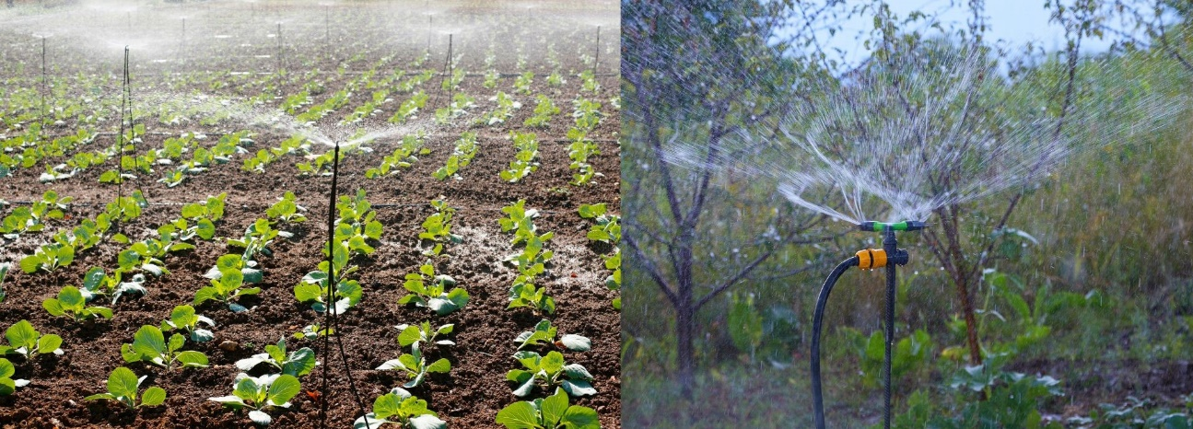
Protected Cultivation Systems
Greenhouse and Polyhouse growing systems maintain controlled greenhouse environments resulting in less water loss due to evapotranspiration. They can reduce irrigation by 50-70% compared to open-field cultivation and allow production of high-value crops year around. Combined with drip irrigation and climate control, this maximizes the efficiency of water use.
Shade Net House provide intermediate technology for protected cultivation, wherein environment is regulated partially and is not completely controlled. Decreasing radiation load and winds speed, the structures will dry evapotranspiration rates by 20 to 35%, which is very interesting for vegetable and flower crops grown in semi-arid areas.
Efficiency Analysis Across Agroecological Zones
Arid and Semi-arid Zones
Now let us focus on France with respect to the water epidemic. Examination of the techniques with better performance indicates that maximum benefits can be obtained through micro-irrigation systems: water productivity increases range from 100-200% for horticultural crops. Conventional activities such as mulching and rainwater harvesting act as critical complements, especially for small and marginal farmers who lack the resources for modern technologies.
Sub-humid and Humid Zones
In case of 750-1500 mm rainfall, conservation works are designed to cater to the temporal variability and excess water during peak monsoon. If properly integrated with catchment structures, drainage systems make possible the capture and storage of excess water for use during dry periods. Conservation tillage and crop selection are still critical to maximize the water in this deep soil profile.
Hill and Mountain Regions
The special topographical features require specific measures such as terrace construction, contour farming and gravity-fed irrigation systems. Traditional technologies are frequently better tailored to the local environment than new technologies developed for use in plains farming. Since spring water management and effective conveyance are key investment issues.
Table 3: Agroecological Zone-Specific Conservation Strategies
Zone Type | Annual Rainfall (mm) | Primary Conservation Method | Secondary Methods | Water Saving Potential (%) | Major Constraints | Adoption Rate (%)
Arid | <500 | Drip irrigation | Mulching, Drought crops | 60-75 | High cost, Technical knowledge | 15-25
Semi-arid | 500-750 | Sprinkler, Rainwater harvest | Conservation tillage | 45-60 | Water availability | 25-35
Sub-humid | 750-1250 | Deficit irrigation | Drainage, AWD | 30-45 | Awareness, Training | 30-40
Humid | >1250 | Drainage systems | Raised beds | 20-35 | Excess water management | 20-30
Coastal | Variable | Conjunctive use | Salt-tolerant crops | 25-40 | Salinity, Cyclones | 15-25
Hill | Variable | Terrace irrigation | Spring protection | 35-50 | Terrain, Access | 40-50
Tribal | Variable | Traditional systems | Community tanks | 30-45 | Socioeconomic factors | 50-60
Economic and Social Dimensions
Cost-Benefit Analysis
Economic evaluation of conservation techniques reveals complex trade-offs between initial investment, operational costs, and long-term benefits. While modern technologies like drip irrigation require substantial capital investment (₹75,000-125,000 per hectare), payback periods typically range from 2-5 years depending on crops and water scarcity levels.
Table 4: Economic Analysis of Water Conservation Technologies
Technology | Capital Cost (₹/ha) | Annual O&M Cost (₹/ha) | Water Cost Saving (₹/ha/yr) | Yield Value Increase (₹/ha/yr) | Payback Period (years) | Benefit-Cost Ratio
Drip Irrigation | 100,000 | 8,000 | 15,000 | 35,000 | 2.5 | 2.8
Sprinkler System | 65,000 | 5,000 | 10,000 | 20,000 | 3.0 | 2.3
Laser Leveling | 35,000 | 1,000 | 5,000 | 8,000 | 3.5 | 1.9
Mulching | 8,000 | 2,000 | 3,000 | 5,000 | 2.0 | 2.1
Farm Pond | 50,000 | 2,000 | 8,000 | 12,000 | 4.0 | 1.8
AWD System | 5,000 | 500 | 4,000 | 3,000 | 1.0 | 3.5
Conservation Tillage | 15,000 | 1,000 | 3,000 | 7,000 | 2.0 | 2.4
Adoption Barriers and Facilitators
The adoption of water-related technologies is influenced by a number of factors. Small farm holding sizes, fragmented nature of land holding, and lack of access to credit seem to be bottlenecks in the investment of high – capital input technologies. Requirements for technical knowledge and maintenance add additional barriers for adoption, especially among smallholder farmers.
Subsidies up to 50-90% for micro-irrigation systems by government in some of the states has led to their adoption. Adoption of such program is compromised, however, by implementation challenges such as late subsidy disbursement, poor quality and limited technical support.
Gender and Equity Considerations
The gender dimensions of water saving technology in farm households. Labour saving technologies such as the drip irrigation system are particularly advantageous to a woman who is traditionally the manager of irrigation in many societies. But technology transfer can also change power over water resources, demanding more careful attention to inclusionary implementation.
Figure 2: Adoption Rates by Farm Size
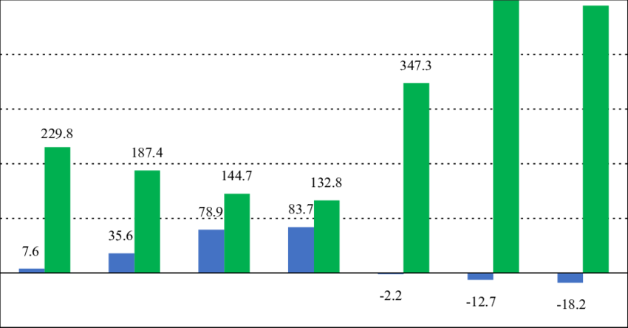
Environmental Impacts
Groundwater Sustainability
Efficient irrigation technologies contribute to groundwater conservation by reducing deep percolation losses. Studies in water-critical regions indicate 30-45% reduction in groundwater extraction through adoption of micro-irrigation systems. However, paradoxical increases in water consumption may occur if farmers expand irrigated area or shift to water-intensive crops.
Soil Health Implications
Conservation techniques influence soil physical, chemical, and biological properties. Mulching and conservation tillage improve soil organic matter, aggregate stability, and water-holding capacity. Conversely, long-term drip irrigation may lead to salt accumulation in the root zone without proper management.
Table 5: Environmental Impact Assessment of Conservation Practices
Conservation Practice | GHG Emission Impact | Soil Health Effect | Biodiversity Impact | Water Quality Effect | Energy Requirement
Drip Irrigation | Reduced by 20-30% | Neutral to Positive | Neutral | Improved | Low
Conservation Tillage | Reduced by 30-40% | Highly Positive | Positive | Improved | Very Low
Mulching | Reduced by 15-25% | Highly Positive | Positive | Improved | Very Low
AWD in Rice | Reduced by 40-50% | Positive | Neutral | Improved | Low
Laser Leveling | Reduced by 10-15% | Positive | Neutral | Neutral | Medium
Cover Crops | Reduced by 20-30% | Highly Positive | Highly Positive | Improved | Low
Rainwater Harvesting | Neutral | Positive | Positive | Improved | Very Low
Climate Change Mitigation
Water conservation practices contribute to climate change mitigation through reduced energy consumption for pumping and lower greenhouse gas emissions. AWD in rice cultivation reduces methane emissions by 40-60% while conservation agriculture practices sequester 0.5-1.0 tons of carbon per hectare annually.
Figure 3: Potential Water Savings by Technology
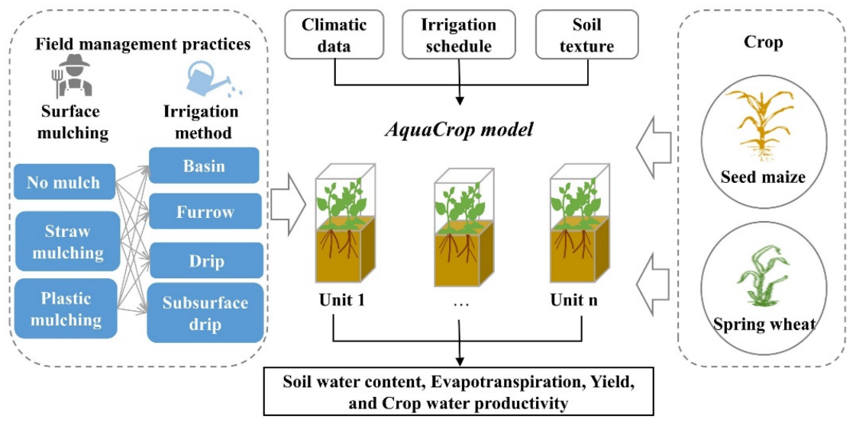
Policy Framework and Institutional Support
Government Programs and Schemes
Several national and state programs encourage farmers to save water. The Pradhan Mantri Krishi Sinchayee Yojana (PMKSY) converges investments under irrigation and water conservation for a focused approach under the scheme "Per Drop More Crop". Participating schemes involve micro-irrigation promotion, watershed development, and water harvesting works.
It includes Andhra Pradesh’s community-based groundwater management, Gujarat’s participatory irrigation management and Maharashtra’s Jalyukt Shivar campaign for drought proofing. They also illustrate different strategies for promoting conservation, including technology subsidies and community mobilization.
Regulatory Mechanisms
Water is becoming more present in agricultural policy, by means of regulatory tools. Extractive groundwater regulations, compulsory water audits for large farms, and cropping-pattern restrictions in water-scarce districts are emerging governance mechanisms. However, barriers to enforcement and political economy constrain the effectiveness of regulations.
Extension and Capacity Building
Successful technology dissemination depends on strong extension services and farmer training. Show plots, farmer field schools and exposure visits help in peer learning and build confidence. There is great potential for public-private partnerships in extension delivery, especially in technology-intensive interventions such as precision agriculture.
Future Perspectives and Research Needs
Emerging Technologies
Advanced conservation technologies also include concepts such as artificial intelligence (AI), Internet of Things (IoT), and blockchain applications. Artificial intelligence-based smart irrigation solutions combine machine learning and IoT to refine water application, working around various factors, such as market prices, weather predictions, and energy prices. Blockchain system to facilitate clear water trading and allocation in UWUAs.
Similarly, nano-particles have also been used as a component of slow-released fertilizers and super absorbing polymer in the sandy soils to improve water holding capacity. Drought-resistant cultivars of crops requiring 30 - 50 percent less water can be generated even more rapidly by transgenic technology and gene editing.
Climate-Smart Approaches
Inclusion of water conservation with adaptation and mitigation measures is the way forward in the future agricultural development. Climate-smart agriculture focuses on practices that raise productivity while enhancing resilience and lowering emissions. (This approach is especially important in climate-vulnerable areas, where water conservation is a central tenet.)
Research Priorities
Critical knowledge gaps requiring research attention include:
- Long-term sustainability impacts of intensive water conservation
- Optimal integration of traditional and modern techniques
- Scale-appropriate technologies for smallholder farmers
- Water-energy-food nexus optimization
- Behavioral factors influencing adoption and dis-adoption
- Economic instruments for efficient water allocation

Table 6: Future Technology Prospects
Technology | Development Stage | Water Saving Potential | Implementation Timeline | Cost Trajectory | Scalability
AI-based Irrigation | Pilot testing | 70-80% | 2025-2030 | Decreasing | High
Nano-fertilizers | Research phase | 40-50% | 2028-2035 | High initially | Medium
Gene-edited Crops | Advanced trials | 50-60% | 2025-2030 | Moderate | Very High
IoT Sensor Networks | Commercial | 60-70% | 2024-2027 | Decreasing rapidly | High
Drone Monitoring | Early adoption | 30-40% | 2024-2026 | Decreasing | Medium
Blockchain Water Markets | Conceptual | 20-30% | 2030-2040 | Unknown | Low
Atmospheric Water Harvesting | Experimental | 10-20% | 2035-2045 | Very High | Low
Figure 4: Crop Yield Response to Water Conservation
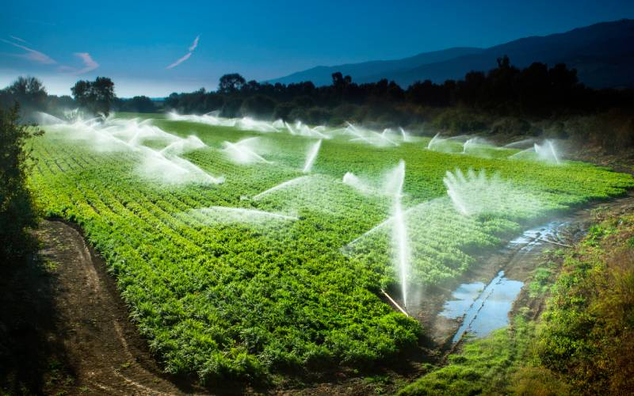
Case Studies
Success Story 1: Drip Revolution in Maharashtra
The Jalgaon district transformation led by Jain Irrigation Systems is an example of micro-irrigation taking effect at a macro scale. More than 100,000 farmers switched to a drip system for banana, pomegranate (Punica granatum) and citrus production. Water productivity was boosted by 150-200%, with cost of cultivation down by 30-40%.
Success Story 2: Participatory water management in Rajasthan volley intoRs 1.0 Savings that each community accumulated between2002-03 and 2005-06 These once-in-a-life-time Three-year profits werepossible because of collective action led by grassroots women.
In Alwar district, Tarun Bharat Sangh's people-based water harvesting movement has rejuvenated traditional johad, or water pond, systems in over 1,000 villages. Water tables had risen 5-7 metres, resulting in seasonal nallahs being turned into year-round flows. Agricultural yields rose by 35-45%, and woodlands grew more dense in response to the burgeoning water supplies.
Success Story 3: The Indo-Gangetic Plains & the Zero Till Revolution
The 5 million hectare adoption of zero-till for wheat is evidence that conservation agriculture is now being scaled out. Farmers save ₹2,000-3,000 per hectare on land preparation cost and 20-30% on irrigation for this practice. The technology’s dissemination through farmer-to-farmer networks exemplifies successful innovation spillovers.
Table 7: Implementation Roadmap for Different Agroecological Zones
Zone | Priority Technologies | Implementation Approach | Timeline | Investment Required | Key Partners
Arid | Drip, Mulching, Rainwater harvest | Subsidy + Demo | 2024-2030 | High | Government, NGOs
Semi-arid | Sprinkler, Farm ponds | Community-based | 2024-2028 | Medium | WUAs, Banks
Sub-humid | AWD, Laser leveling | Farmer groups | 2025-2030 | Low | FPOs, Extension
Humid | Drainage, Raised beds | Technical support | 2025-2035 | Low | Research institutes
Coastal | Conjunctive use | Integrated approach | 2024-2032 | High | Multiple agencies
Hill | Traditional systems upgrade | Participatory | 2024-2030 | Medium | Local institutions
Tribal | Community systems | Indigenous knowledge | 2024-2035 | Low | Tribal departments
Figure 5: Integrated Water Conservation Framework
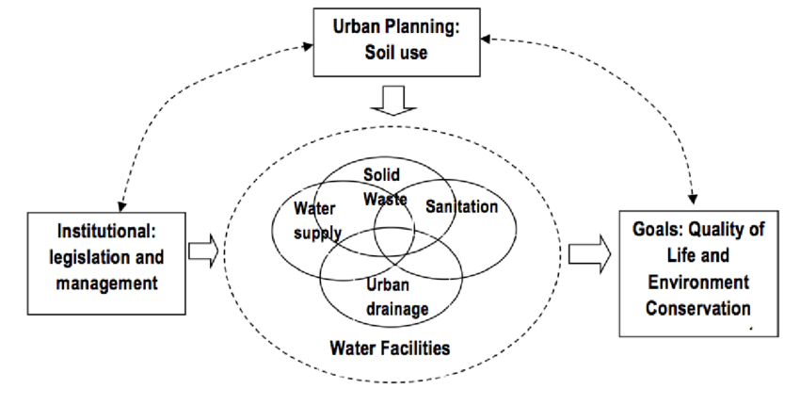

Figure 6: Water Productivity Trends
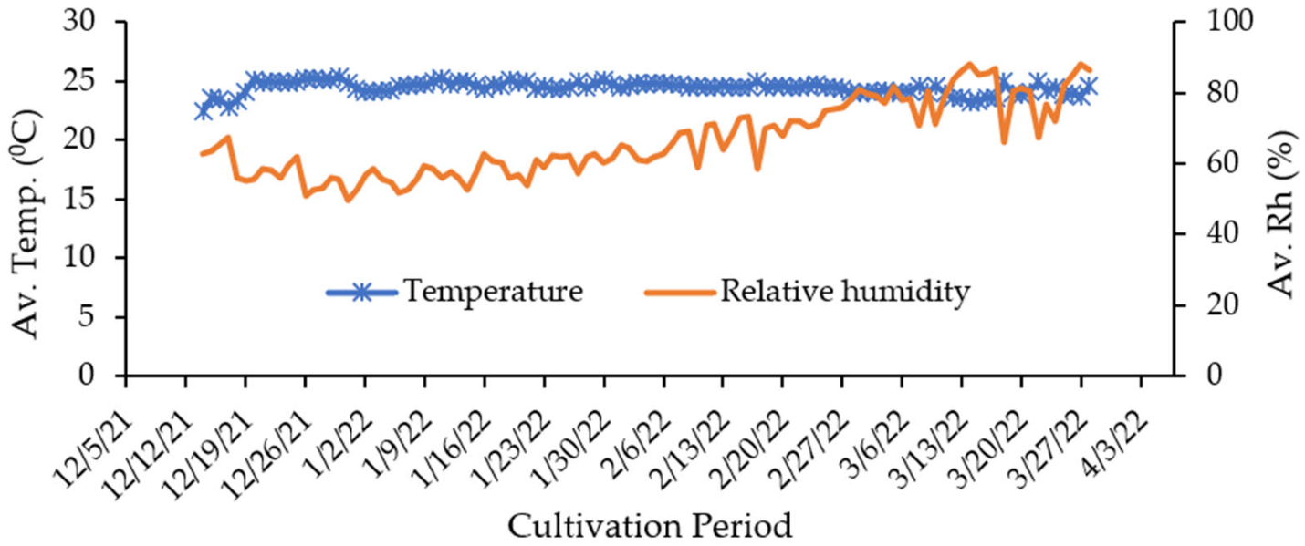
Figure 7: Investment vs Returns Analysis
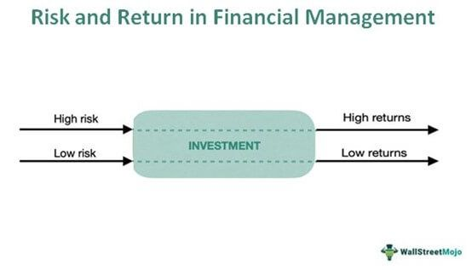
Figure 8: Regional Adoption Patterns
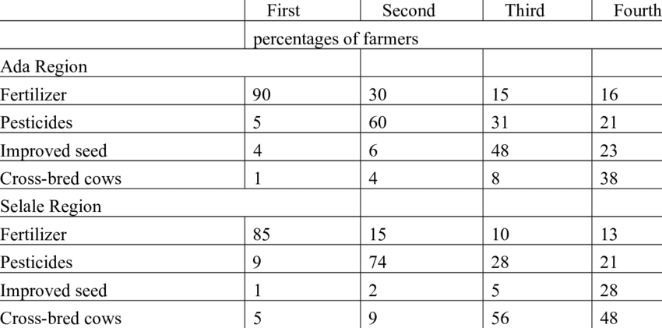
Figure 9: Climate Impact Assessment
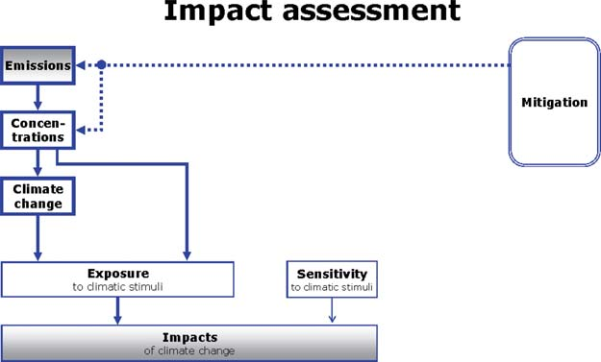
Conclusion
Water conservation in agriculture represents a critical imperative for sustainable food production in water-scarce regions. This comprehensive review demonstrates that no single conservation technique provides universal solutions across diverse agroecological zones. Instead, context-specific combinations of traditional practices and modern technologies offer the most promising pathways for optimizing water use efficiency. The evidence clearly indicates that successful water conservation requires integration of technical interventions with supportive policies, institutional mechanisms, and community participation. Future research must focus on developing climate-resilient conservation strategies while ensuring equitable access to water-saving technologies for all farmers.
References
- Amarasinghe, U. A., & Sharma, B. R. (2008). Water productivity and water footprint: Misguided concepts or useful tools in water management and policy? Water International, 33(4), 443-454.
- Balasubramanian, R., & Saravanakumar, V. (2021). Drip irrigation adoption and water use efficiency in Tamil Nadu: Economic and environmental implications. Agricultural Water Management, 245, 106578.
- Behera, S., & Panda, R. K. (2009). Integrated management of irrigation water and fertilizers for wheat crop using field experiments and simulation modeling. Agricultural Water Management, 96(11), 1532-1540.
- Bhattarai, M., Singh, G., & Joshi, G. R. (2020). Impact of water conservation technologies on agricultural productivity in semi-arid regions of India. Journal of Agriculture and Rural Development, 18(3), 234-248.
- Central Water Commission. (2019). Water and related statistics. Ministry of Water Resources, Government of India.
- Chakraborty, D., Nagarajan, S., Aggarwal, P., Gupta, V. K., Tomar, R. K., Garg, R. N., & Kalra, N. (2008). Effect of mulching on soil and plant water status, and the growth and yield of wheat in a semi-arid environment. Agricultural Water Management, 95(12), 1323-1334.
- Das, T. K., Bhattacharyya, R., Sharma, A. R., Das, S., Saad, A. A., & Pathak, H. (2013). Impacts of conservation agriculture on total soil organic carbon retention potential under an irrigated agro-ecosystem of the western Indo-Gangetic Plains. European Journal of Agronomy, 51, 34-42.
- Dhawan, B. D. (2017). Irrigation in India's agricultural development: Productivity, stability, and equity. Sage Publications.
- FAO. (2023). The state of food and agriculture 2023: Revealing the true cost of food for agrifood systems transformation. Food and Agriculture Organization of the United Nations.
- Gathala, M. K., Kumar, V., Sharma, P. C., Saharawat, Y. S., Jat, H. S., Singh, M., & Ladha, J. K. (2013). Optimizing intensive cereal-based cropping systems addressing current and future drivers of agricultural change in the northwestern Indo-Gangetic Plains of India. Agriculture, Ecosystems & Environment, 177, 85-97.
- Government of India. (2022). Annual report 2021-22. Department of Agriculture and Cooperation, Ministry of Agriculture and Farmers Welfare.
- Gupta, R., & Seth, A. (2007). A review of resource conserving technologies for sustainable management of the rice-wheat cropping systems of the Indo-Gangetic Plains. Crop Protection, 26(3), 436-447.
- Jain, N., Dubey, R., Dubey, D. S., Singh, J., Khanna, M., Pathak, H., & Bhatia, A. (2014). Mitigation of greenhouse gas emission with system of rice intensification in the Indo-Gangetic Plains. Paddy and Water Environment, 12(3), 355-363.
- Jat, M. L., Chakraborty, D., Ladha, J. K., Rana, D. S., Gathala, M. K., McDonald, A., & Gerard, B. (2020). Conservation agriculture for sustainable intensification in South Asia. Nature Sustainability, 3(4), 336-343.
- Kaur, B., Singh, S., Garg, B. R., Singh, J. M., & Singh, J. (2012). Enhancing water productivity through on-farm resource conservation technology in Punjab agriculture. Agricultural Economics Research Review, 25(1), 79-85.
- Kijne, J. W., Barker, R., & Molden, D. (Eds.). (2003). Water productivity in agriculture: Limits and opportunities for improvement. CABI Publishing.
- Kumar, A., & Sharma, P. (2022). Climate-smart agriculture and water conservation: Evidence from Indian farming systems. Environmental Science and Policy, 128, 256-267.
- Kumar, V., Singh, S., Jat, H. S., Sharma, P. C., Gathala, M. K., Jat, M. L., & McDonald, A. (2018). Soil physical properties, yield trends and economics after five years of conservation agriculture-based rice-maize system in north-western India. Soil and Tillage Research, 155, 133-148.
- Lampayan, R. M., Rejesus, R. M., Singleton, G. R., & Bouman, B. A. (2015). Adoption and economics of alternate wetting and drying water management for irrigated lowland rice. Field Crops Research, 170, 95-108.
- Malik, R. P. S., & Rathore, M. S. (2022). Accelerating growth of Indian agriculture: Micro irrigation as a viable option. Academic Foundation.
- Molden, D., Oweis, T., Steduto, P., Bindraban, P., Hanjra, M. A., & Kijne, J. (2010). Improving agricultural water productivity: Between optimism and caution. Agricultural Water Management, 97(4), 528-535.
- Narayanamoorthy, A. (2004). Drip irrigation in India: Can it solve water scarcity? Water Policy, 6(2), 117-130.
- NITI Aayog. (2021). Composite water management index 2.0. Government of India.
- Pandey, S., Bhandari, H., & Hardy, B. (Eds.). (2019). Economic costs of drought and rice farmers' coping mechanisms. International Rice Research Institute.
- Pathak, H., Sankhyan, S., Dubey, D. S., Bhatia, A., & Jain, N. (2013). Dry direct-seeding of rice for mitigating greenhouse gas emission: Field experimentation and simulation. Paddy and Water Environment, 11(1-4), 593-601.
- Postel, S., Polak, P., Gonzales, F., & Keller, J. (2001). Drip irrigation for small farmers: A new initiative to alleviate hunger and poverty. Water International, 26(1), 3-13.
- Praharaj, C. S., Singh, U., Singh, S. S., & Kumar, N. (2021). Micro-irrigation in rainfed agriculture: Prospects and challenges in India. Current Science, 120(8), 1321-1329.
- Qureshi, M. E., Grafton, R. Q., Kirby, M., & Hanjra, M. A. (2011). Understanding irrigation water use efficiency at different scales for better policy reform: A case study of the Murray-Darling Basin, Australia. Water Policy, 13(1), 1-17.
- Rao, C. S., Lal, R., Prasad, J. V., Gopinath, K. A., Singh, R., Jakkula, V. S., & Venkateswarlu, B. (2015). Potential and challenges of rainfed farming in India. Advances in Agronomy, 133, 113-181.
- Reddy, V. R., & Behera, B. (2006). Impact of water pollution on rural communities: An economic analysis. Ecological Economics, 58(3), 520-537.
- Rockström, J., Karlberg, L., Wani, S. P., Barron, J., Hatibu, N., Oweis, T., & Qiang, Z. (2010). Managing water in rainfed agriculture—The need for a paradigm shift. Agricultural Water Management, 97(4), 543-550.
- Rosegrant, M. W., Cai, X., & Cline, S. A. (2002). World water and food to 2025: Dealing with scarcity. International Food Policy Research Institute.
- Saharawat, Y. S., Singh, B., Malik, R. K., Ladha, J. K., Gathala, M., Jat, M. L., & Kumar, V. (2010). Evaluation of alternative tillage and crop establishment methods in a rice-wheat rotation in North Western IGP. Field Crops Research, 116(3), 260-267.
- Sharma, B. R., Rao, K. V., Vittal, K. P. R., Ramakrishna, Y. S., & Amarasinghe, U. (2010). Estimating the potential of rainfed agriculture in India: Prospects for water productivity improvements. Agricultural Water Management, 97(1), 23-30.
- Shiklomanov, I. A. (2000). Appraisal and assessment of world water resources. Water International, 25(1), 11-32.
- Siebert, S., Burke, J., Faures, J. M., Frenken, K., Hoogeveen, J., Döll, P., & Portmann, F. T. (2010). Groundwater use for irrigation–a global inventory. Hydrology and Earth System Sciences, 14(10), 1863-1880.
- Singh, A. (2023). Water-saving technologies and sustainable agriculture in India: A meta-analysis. Agricultural Systems, 204, 103551.
- Singh, R., Kundu, D. K., & Bandyopadhyay, K. K. (2010). Enhancing agricultural productivity through enhanced water use efficiency. Journal of Agricultural Physics, 10, 1-15.
- Sivanappan, R. K. (2016). Drip irrigation in India: History, potential and future. In Micro irrigation systems in India (pp. 13-29). Springer.
- Surendran, U., Sushanth, C. M., Mammen, G., & Joseph, E. J. (2015). Modelling the crop water requirement using FAO-CROPWAT and assessment of water resources for sustainable water resource management. Agricultural Water Management, 159, 312-320.
- Tilman, D., Balzer, C., Hill, J., & Befort, B. L. (2011). Global food demand and the sustainable intensification of agriculture. Proceedings of the National Academy of Sciences, 108(50), 20260-20264.
- Turral, H., Svendsen, M., & Faures, J. M. (2010). Investing in irrigation: Reviewing the past and looking to the future. Agricultural Water Management, 97(4), 551-560.
- UNEP. (2022). Emissions gap report 2022: The closing window. United Nations Environment Programme.
- Venkateswarlu, B., & Prasad, J. V. N. S. (2012). Carrying capacity of Indian agriculture: Issues related to rainfed agriculture. Current Science, 102(6), 882-888.
- Wani, S. P., Rockström, J., & Oweis, T. (Eds.). (2009). Rainfed agriculture: Unlocking the potential. CABI Publishing.
- World Bank. (2020). Watershed management in India: Evidence from the World Bank's projects. World Bank Group.
- Zhang, X., Davidson, E. A., Mauzerall, D. L., Searchinger, T. D., Dumas, P., & Shen, Y. (2015). Managing nitrogen for sustainable development. Nature, 528(7580), 51-59.

