Understanding Farmers’ Decisions on Neem-Based Bio pesticide Adoption

Abstract
This study investigates the behavioural determinants influencing farmers’ adoption of neem-based bio pesticides in Tamil Nadu, India, using an integrated framework combining Protection Motivation Theory (PMT) and the Unified Theory of Acceptance and Use of Technology (UTAUT). Data were collected from 450 farmers across nine districts using a structured survey and analyzed through Partial Least Squares Structural Equation Modeling (PLS-SEM). Results indicate that coping appraisal strongly enhances adoption intention (β = 0.817, p < 0.001; f² = 0.482), followed by threat appraisal (β = 0.354, p < 0.001; f² = 0.168) and performance expectancy (β = 0.213, p < 0.05; f² = 0.046), while efficacy expectation negatively influences intention (β = –0.548, p < 0.001; f² = 0.120). Facilitating conditions positively support adoption (β = 0.102, p < 0.05; f² = 0.032), whereas social influence is non-significant (β = 0.035, p > 0.05; f² = 0.006). Adoption intention significantly mediates the relationship between motivational and contextual factors and actual adoption behaviour (β = 0.319, p < 0.001; f² = 0.165). The integrated model explains (77.50%) of variance in adoption intention and (62.00%) in actual behaviour (R²). Findings underscore the centrality of perceived efficacy, technology performance and enabling resources in promoting eco-friendly pest management and provide insights for scaling neem-based bio pesticides in smallholder farming systems.
Keywords: Neem-based bio pesticides, Adoption intention, PMT, UTAUT, Sustainable pest management, PLS-SEM
1. INTRODUCTION
Smallholder farming systems in India face major challenges from pest outbreaks, soil degradation and climate variability, which reduce crop productivity and resilience. Heavy reliance on synthetic pesticides, though effective in the short term, has led to pesticide resistance, soil and water contamination and health hazards (Pretty & Bharucha, 2015; Sharma & Gaur, 2021). These issues are acute in intensively cultivated regions such as Tamil Nadu, where farmers must sustain yields while safeguarding the environment.
Neem-based bio pesticides, derived from Azadirachta indica, offer an eco-friendly alternative with insecticidal, fungicidal and nematicidal properties, while being biodegradable and safe for non-target organisms (Isman & Machial, 2006; Kumar et al., 2021). Despite their proven efficacy and alignment with Integrated Pest Management (IPM), adoption remains limited, mainly due to economic, institutional and behavioural constraints (Mancini et al., 2009; Dhawan & Peshin, 2009; Amare & Darr, 2023).
To address this gap, the present study integrates Protection Motivation Theory (PMT) and the Unified Theory of Acceptance and Use of Technology (UTAUT) to analyze the factors shaping farmers’ adoption decisions. The study uses survey data from 450 smallholder farmers in Tamil Nadu to develop and test a conceptual model of neem bio pesticide adoption. Findings provide insights into psychological, social and institutional drivers of adoption and offer recommendations for policies and extension strategies to promote sustainable pest management.
2. THEORETICAL FRAMEWORK
The adoption of neem-based bio pesticides is not only a technical choice but also a behavioural process shaped by cognitive, psychological and social factors. To capture these dynamics, this study integrates Protection Motivation Theory (PMT) (Rogers, 1975) and the Unified Theory of Acceptance and Use of Technology (UTAUT) (Venkatesh et al., 2003). PMT explains adoption as a protective response driven by threat appraisal (perceptions of pest risk, yield loss and chemical pesticide hazards) and coping appraisal (beliefs in neem efficacy, self-efficacy and manageable costs). UTAUT complements this by focusing on performance expectancy (yield and cost benefits), effort expectancy (ease of use), social influence (peer and institutional support) and facilitating conditions (access, training and availability). Integrating PMT and UTAUT provides a comprehensive model, recognizing that farmers’ decisions involve both risk-response motivations and technology acceptance drivers. The conceptual framework (Figure 1) posits that motivational and contextual determinants influence adoption intention, which in turn predicts actual adoption behaviour.
Hypotheses
- H1: Threat appraisal → adoption intention
- H2: Coping appraisal → adoption intention
- H3: Performance expectancy → adoption intention
- H4: Effort expectancy → adoption intention
- H5: Social influence → adoption intention
- H6: Facilitating conditions → adoption intention and actual use
- H7: Adoption intention → actual adoption behaviour
To test these hypotheses, Structural Equation Modeling (SEM) was employed to simultaneously assess measurement and structural relationships among constructs. This framework offers a robust basis for understanding and scaling neem-based bio pesticide adoption in sustainable agriculture.

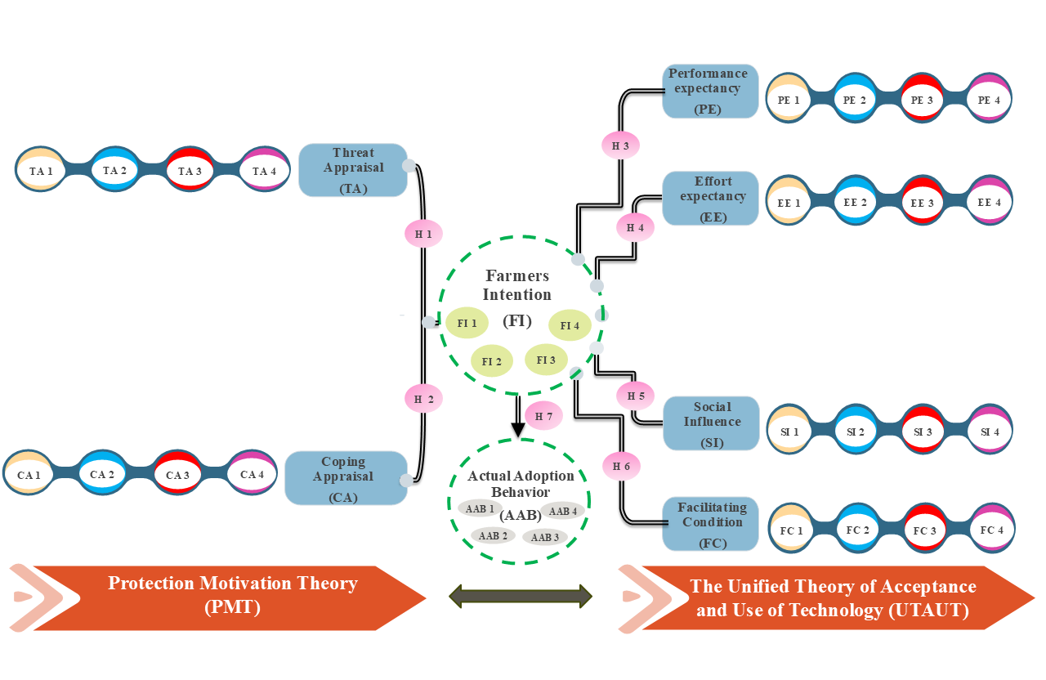Figure 1. Integrated conceptual framework for farmers’ adoption of neem-based bio pesticides
3. RESEARCH METHODOLOGY
The study was conducted in Tamil Nadu, India, where diverse agro-ecological zones and intensive cultivation make pest management a critical issue. A multistage sampling technique was employed. In the first stage, nine districts with relatively higher pesticide consumption and intensive cropping were purposively selected such as Madurai, Dindigul, Theni, Virudhunagar, Tirunelveli, Thoothukudi, Sivagangai, Tenkasi and Ramanathapuram. In the second stage, one block from each district was selected based on cropping intensity, pest vulnerability and the presence of active farmer communities. At the final stage, two representative villages from each block were chosen, resulting in 18 villages. Within each village, farm households were selected using simple random sampling, yielding a total sample of 450 farmers. A structured questionnaire, based on Protection Motivation Theory (PMT) and the Unified Theory of Acceptance and Use of Technology (UTAUT), measured variables such as threat appraisal, coping appraisal, performance expectancy, effort expectancy, social influence, facilitating conditions and behavioural intention on a five-point Likert scale. The instrument was pre-tested with 30 farmers for clarity and contextual relevance and data were collected through face-to-face interviews. Analysis was conducted using Partial Least Squares Structural Equation Modeling (PLS-SEM) in SmartPLS 4.0, with measurement reliability and validity assessed through Cronbach’s alpha, composite reliability, average variance extracted (AVE) and discriminant validity (Fornell-Larcker and HTMT). Structural relationships were tested using bootstrapping with 5,000 resamples and the sample size was considered adequate under the “10-times rule” for SEM.
4. RESULTS
4.1. Measurement model evaluation
The measurement model demonstrated satisfactory reliability and validity. Cronbach’s alpha and composite reliability (ρc) values exceeded 0.70 and AVE values were above 0.50, confirming internal consistency and convergent validity, while all item loadings surpassed 0.70 (Table 1, Table 2). Discriminant validity was established as the square root of AVE values exceeded inter-construct correlations and all HTMT ratios were below 0.90 (Table 3, Table 4). CFA results also indicated a good model fit (Table 5) (χ²/df = 2.45, CFI = 0.927, TLI = 0.965, GFI = 0.912, NFI = 0.939, RMSEA = 0.055, RMR = 0.060), thereby confirming that the constructs were reliable, valid and suitable for subsequent structural analysis.
Table 1. Reliability and convergent validity statistics for the measurement model constructs
 | Cronbach's alpha | Composite reliability (rho_a) | Composite reliability (rho_c) | Average variance extracted (AVE)
AAB | 0.857 | 0.870 | 0.903 | 0.700
CA | 0.915 | 0.916 | 0.940 | 0.797
EE | 0.956 | 0.959 | 0.968 | 0.883
FC | 0.900 | 0.927 | 0.930 | 0.769
FI | 0.920 | 0.920 | 0.943 | 0.806
PE | 0.926 | -0.123 | 0.852 | 0.600
SI | 0.868 | 0.908 | 0.908 | 0.713
TA | 0.851 | 0.855 | 0.900 | 0.694
Table 2. Indicator loadings and item reliability for the measurement model constructs
 | AAB | CA | EE | FC | FI | PE | SI | TA
AAB1 | 0.822
AAB2 | 0.811
AAB3 | 0.874
AAB4 | 0.837
CA1 |  | 0.889
CA2 |  | 0.882
CA3 |  | 0.893
CA4 |  | 0.907
EE1 |  |  | 0.945
EE2 |  |  | 0.952
EE3 |  |  | 0.934
EE4 |  |  | 0.928
FC1 |  |  |  | 0.902
FC2 |  |  |  | 0.908
FC3 |  |  |  | 0.822
FC4 |  |  |  | 0.873
FI1 |  |  |  |  | 0.894
FI2 |  |  |  |  | 0.893
FI3 |  |  |  |  | 0.907
FI4 |  |  |  |  | 0.897
PE1 |  |  |  |  |  | 0.812
PE2 |  |  |  |  |  | 0.868
PE3 |  |  |  |  |  | 0.965
PE4 |  |  |  |  |  | 0.885
SI1 |  |  |  |  |  |  | 0.861
SI2 |  |  |  |  |  |  | 0.844
SI3 |  |  |  |  |  |  | 0.902
SI4 |  |  |  |  |  |  | 0.766
TA1 |  |  |  |  |  |  |  | 0.875
TA2 |  |  |  |  |  |  |  | 0.873
TA3 |  |  |  |  |  |  |  | 0.742
TA4 |  |  |  |  |  |  |  | 0.835

Table 3. Fornell-Larcker criterion results confirming discriminant validity of the constructs in the neem-based bio pesticide adoption model
 | AAB | CA | EE | FC | FI | PE | SI | TA
AAB
CA | 0.435
EE | 0.069 | 0.227
FC | 0.117 | 0.302 | 0.267
FI | 0.355 | 0.595 | 0.418 | 0.166
PE | 0.177 | 0.195 | 0.431 | 0.219 | 0.063
SI | 0.119 | 0.333 | 0.239 | 0.243 | 0.121 | 0.078
TA | 0.151 | 0.301 | 0.265 | 0.339 | 0.371 | 0.352 | 0.222
Table 4. HTMT ratio of correlations demonstrating discriminant validity among latent constructs in the integrated Protection Motivation-UTAUT framework
 | AAB | CA | EE | FC | FI | PE | SI | TA
AAB | 0.836
CA | 0.387 | 0.893
EE | -0.034 | 0.211 | 0.940
FC | -0.107 | -0.267 | -0.251 | 0.877
FI | 0.319 | 0.546 | -0.394 | 0.155 | 0.898
PE | -0.125 | -0.209 | 0.408 | 0.168 | -0.107 | 0.775
SI | -0.031 | 0.298 | 0.215 | -0.169 | 0.083 | 0.008 | 0.845
TA | -0.126 | -0.265 | -0.245 | 0.295 | 0.330 | 0.160 | -0.178 | 0.833
Table 5. Goodness-of-fit indices of the CFA model
Fit Index Category | Fit Statistic | Obtained Value | Threshold | Reference | Assessment
Absolute Fit Measure | TLI | 0.951 | ≥ 0.90 | Bentler (1990) | Accepted
Absolute Fit Measure | RMSEA | 0.061 | ≤ 0.08 | Hu and Bentler (1999) | Accepted
Incremental Fit Indices | NFI | 0.921 | ≥ 0.90 | Hair et al. (2010) | Accepted
Incremental Fit Indices | GFI | 0.905 | ≥ 0.90 | Hair et al. (2010) | Accepted
Incremental Fit Indices | CFI | 0.936 | ≥ 0.90 | Bentler (1990) | Accepted
Incremental Fit Indices | RMR | 0.057 | ≤ 0.08 | Hu and Bentler (1999) | Accepted
Chi-Square Fit | χ² / df | 2.62 | ≤ 3.00 | Wheaton et al. (1977) | Accepted

4.2. Structural model evaluation
The structural model showed strong explanatory power, with R² values of 0.775 for adoption intention (FI) and 0.620 for actual adoption behaviour (AAB), indicating that the integrated PMT–UTAUT framework effectively captured farmers’ decision-making. Effect size (f²) analysis revealed that coping appraisal (CA) had a substantial impact on intention (f² = 0.482), threat appraisal (TA) and intention on behaviour (FI → AAB) had medium effects (f² = 0.168 and 0.165), performance expectancy (PE) and facilitating conditions (FC) had small effects (f² = 0.046 and 0.032), efficacy expectation (EE) had a medium negative effect (f² = 0.120) and social influence (SI) was trivial (f² = 0.006). Path coefficient analysis confirmed these patterns: CA strongly predicted intention (β = 0.817, p < 0.001), followed by TA (β = 0.354, p < 0.001), PE (β = 0.213, p < 0.05) and FC (β = 0.102, p < 0.05), while EE negatively influenced intention (β = –0.548, p < 0.001) and SI was non-significant (β = 0.035, p > 0.05). FI significantly predicted AAB (β = 0.319, p < 0.001), highlighting its mediating role. Detailed path coefficients, effect sizes and explanatory power for all constructs are presented in Table 6, demonstrating that cognitive appraisals and perceived benefits are key drivers of neem-based bio pesticide adoption, whereas social pressures have minimal influence in this context. Structural relationships were assessed via SmartPLS 4 (Figure 3).
Table 6. Path coefficients, effect sizes (f²) and explanatory power (R²) of the structural model for neem-based bio pesticide adoption
Predictor → Endogenous Construct | β (Path Coefficient) | t-value | p-value | f² (Effect Size) | Results
Coping Appraisal (CA) → FI | 0.817 | 15.526 | 0.000 | 0.482 | Substantial
Threat Appraisal (TA) → FI | 0.354 | 6.084 | 0.000 | 0.168 | Medium
Performance Expectancy (PE) → FI | 0.213 | 2.354 | 0.029 | 0.046 | Small
Facilitating Conditions (FC) → FI | 0.102 | 2.179 | 0.000 | 0.032 | Small
Efficacy Expectancy (EE) → FI | –0.548 | 5.931 | 0.019 | 0.120 | Medium
Social Influence (SI) → FI | 0.035 | 0.872 | 0.383 | 0.006 | Trivial
Adoption Intention (FI) → AAB | 0.319 | 4.240 | 0.000 | 0.165 | Medium
Model explanatory power (R²):
- Adoption Intention (FI) = 0.775
- Actual Adoption Behaviour (AAB) = 0.620
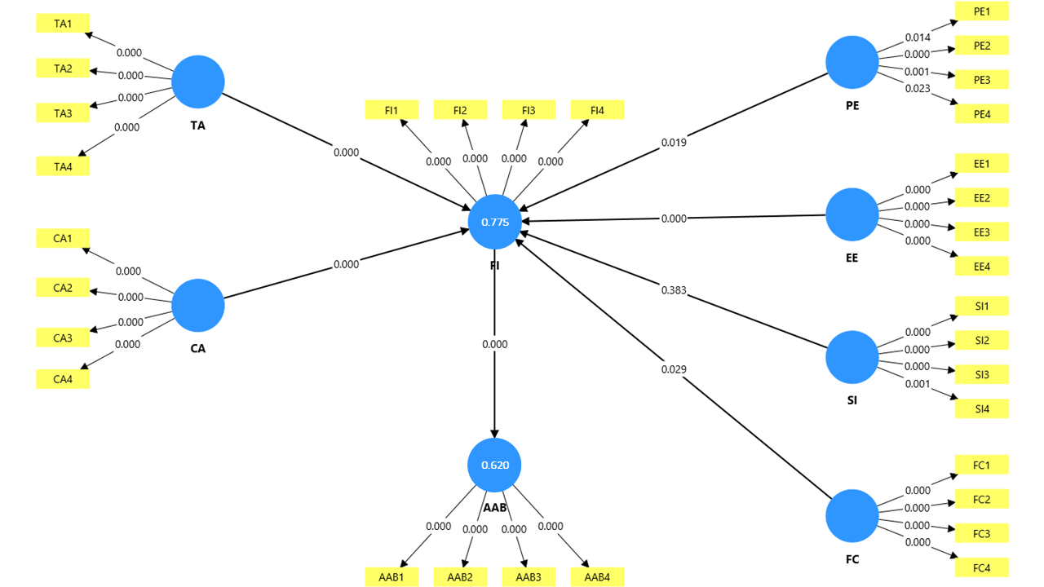
Figure 2. Structural model results of neem-based bio pesticide adoption showing standardized path coefficients and significance levels (Smart -PLS 4 output).
5. DISCUSSION
This study examined farmers’ adoption of neem-based bio pesticides using an integrated PMT-UTAUT framework, highlighting the interplay of motivational, cognitive and contextual drivers. Coping appraisal emerged as the strongest predictor of adoption intention, reflecting the importance of perceived efficacy, affordability and manageability. Threat appraisal also positively influenced intention by raising awareness of pesticide-related risks, whereas efficacy expectation negatively affected intention, indicating persistent skepticism about product performance. Social influence was non-significant and adoption intention strongly mediated actual use, confirming its central role in translating perceptions into behaviour.
From a technology acceptance perspective, performance expectancy and facilitating conditions positively shaped adoption intention. Farmers perceived neem as improving pest control efficiency, reducing costs and aligning with existing spraying routines, while access to inputs, extension support and institutional resources further enabled uptake. The negligible effect of social influence suggests that adoption decisions are primarily individualistic, relying more on personal evaluation of efficacy and utility than peer or community pressure. These findings underscore the importance of evidence-driven extension, participatory field trials and input quality assurance to strengthen farmers’ confidence and encourage adoption.
Neem-based bio pesticides occupy a critical position within the pest management spectrum as a transitional technology bridging conventional pesticide reliance and integrated ecological approaches. They offer observable, rapid benefits and fit seamlessly into existing farm practices, making them attractive for risk-averse smallholders. While they provide fewer ecosystem co-benefits than systemic IPM strategies, their accessibility and farmer acceptability make them an ideal entry point for sustainable pest management. Scaling adoption requires enabling policies, reliable distribution networks, financial support and integration into broader sustainability programs, ensuring neem-based products serve as both farmer-friendly innovations and catalysts for agro-ecological transitions.
6. LIMITATIONS AND FUTURE RESEARCH
This study’s cross-sectional design limits causal inference between behavioural constructs and actual adoption, as intention-behaviour gaps may vary across cropping seasons. The sample, confined to nine districts in Tamil Nadu, may not represent the diversity of Indian farming systems and reliance on self-reported data introduces potential biases, including social desirability and recall errors. Actual adoption was inferred from intention rather than direct field monitoring. Future research should adopt longitudinal, experimental and multi-site designs to track adoption over time, assess crop- and region-specific contextual moderators and strengthen causal insights. Integrating mixed-method approaches, participatory assessments and digital data sources can capture socio-cultural, institutional and practical barriers more accurately, while field trials and policy experiments would provide actionable evidence to scale neem-based bio pesticides as a sustainable, climate-smart pest management strategy.
7. CONCLUSION
This study investigated farmers’ adoption of neem-based bio pesticides using an integrated PMT-UTAUT framework. Findings indicate that coping appraisal, threat appraisal and performance expectancy are key drivers of adoption intention, with facilitating conditions providing additional support, while efficacy doubts negatively influence intention and social influence is negligible. Adoption intention strongly mediates actual behaviour, linking motivational and contextual factors to practice. The study validates the integration of behavioural and technology adoption models for sustainable agriculture and emphasizes the practical importance of institutional support, input access and incentives. Neem-based bio pesticides emerge as a viable eco-friendly innovation, offering a pathway to reduce chemical dependency and enhance resilience in farming systems.
Disclaimer (Artificial Intelligence)
The author(s) hereby declare that no generative AI technologies, including Large Language Models (e.g., ChatGPT, Copilot) or text-to-image generators, were used in the writing, editing, or preparation of this manuscript.

References
Amare, D., & Darr, D. (2023). Farmers’ intentions toward sustained agroforestry adoption: An application of the theory of planned behavior. Journal of Sustainable Forestry, 42(9), 869-886. https://doi.org/10.1080/10549811.2022.2123358
Bentler, P. M. (1990). Comparative fit indexes in structural models. Psychological bulletin, 107(2), 238.
Dhawan, A. K., & Peshin, R. (2009). Integrated pest management: concept, opportunities and challenges. Integrated Pest Management: Innovation-Development Process: Volume 1, 51-81. https://doi.org/10.1007/978-1-4020-8992-3_2
Hair JR, J. F., Black, W. C., Babin, B. J., & Anderson, R. E. (2010). Multivariate Data Analysis (7th Ed.). Upper Saddle River, NJ: Pearson Prentice Hall.
Hu, L. T., & Bentler, P. M. (1998). Fit indices in covariance structure modeling: Sensitivity to underparameterized model misspecification. Psychological methods, 3(4), 424.
Isman, M. B., & Machial, C. M. (2006). Pesticides based on plant essential oils: from traditional practice to commercialization. Advances in phytomedicine, 3, 29-44. https://doi.org/10.1016/S1572-557X(06)03002-9
Kumar, J., Ramlal, A., Mallick, D., & Mishra, V. (2021). An overview of some biopesticides and their importance in plant protection for commercial acceptance. Plants, 10(6), 1185. https://doi.org/10.3390/plants10061185
Mancini, F., Jiggins, J. L., & O'Malley, M. (2009). Reducing the incidence of acute pesticide poisoning by educating farmers on integrated pest management in South India. International journal of occupational and environmental health, 15(2), 143-151. https://doi.org/10.1179/oeh.2009.15.2.143
Pretty, J., & Pervez Bharucha, Z. (2015). Integrated pest management for sustainable intensification of agriculture in Asia and Africa. Insects, 6(1), 152-182. https://doi.org/10.3390/insects6010152
Rogers, R. W. (1975). A protection motivation theory of fear appeals and attitude change1. The journal of psychology, 91(1), 93-114. https://doi.org/10.1080/00223980.1975.9915803
Sharma, P., & Gaur, N. (2021). Microbial biopesticides use in insect-pest management: an overview. Microbial biotechnology in crop protection, 123-145. https://doi.org/10.1007/978-981-16-0049-4_5
Venkatesh, V., Morris, M. G., Davis, G. B., & Davis, F. D. (2003). User acceptance of information technology: Toward a unified view. MIS quarterly, 425-478. https://doi.org/10.2307/30036540
Wheaton, B., Muthen, B., Alwin, D. F., & summers, G. F. (1977). Assessing reliability and stability in panel models. Sociological methodology, 8, 84-136. https://doi.org/10.2307/270754

