Structure Optimization of Seeding Device of Small Wheat Planter Based
on Orthogonal Test

.
ABSTRACT

In order to further improve the backward status of agricultural infrastructure construction in hilly and mountainous areas, this paper adopted the method of orthogonal experimental design on the basis of existing small wheat planter seeding devices at home and abroad, and selected three factors that had the greatest influence on seeding efficiency and seed damage rate, namely, planting height, rotation speed of seeding wheel and number of single seeding, and obtained the optimized structural parameters. Then the structural design is carried out according to the structural parameters. The above research results show that the orthogonal experimental design combined with numerical calculation and regression analysis can effectively optimize and adjust the structural parameters of the seed arrangement, improve the seeding efficiency and reduce the seed damage rate at the same time, among which the seeding efficiency is increased by 0.23 times /min, and the seed damage rate is reduced by 0.0024%.

Keywords: Seeding device; Orthogonal test; Seeding efficiency; Seed damage rate

1. INTRODUCTION

China's grain-producing areas are mainly hilly and mountainous areas, and its output plays an important role in the country's total grain production. Due to the imbalance of economic development, the degree of agricultural mechanization in this region is relatively low [1]. As the main wheat sowing device in this region, the optimization of the seeding device of small wheat seeder can further improve the sowing efficiency and reduce the seed damage rate [5-7].
As an efficient multi-factor test method, orthogonal test can obtain a large amount of information in a limited number of tests, and reveal the influence degree and interaction of various factors on the results [2,8-10]. In the optimization design of seeding device of small wheat drill, various factors affecting seeding effect, such as seeding height, rotation speed of seeding wheel, size of seeding hole, etc. were systematically analyzed and evaluated by orthogonal test [3], so as to find out the optimal parameter combination.

2.Numerical simulation

As a key component of small wheat planter, the working performance of the seeding device directly affects the working effect of the whole machine.
In this paper, the existing wheat planter is used as a model to analyze its seeding device, and its structure is shown in the following Fig.1.[4].
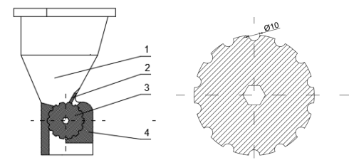
Fig.1. Structure of seeding device
1. Seed box 2. Seed cleaning brush 3. Seed row 4. Seed protection plate

2.1 Seed Wheel Diameter

The diameter of the seeding wheel determines the overall structure of the seeding device, the seeding speed and the size of the seeding device. Therefore, the equation of seeding wheel diameter and seeding speed is established as follows:
（2-1）
（2-2）
In the formula:
$v_{t}$--Tangential speed of seeding wheel, m/s;
$d_{p}$--Seed wheel diameter, mm;
$ω_{p}$--Seed wheel angular velocity, rad/s;
$n_{p}$--Seeding wheel speed, r/min.
After sorting out the formulas (2-1) and (2-2), we can get:
（2-3）
2.2 Hole Shape and Size

The size of the hole determines how much to plant each time. The shape of wheat seeds is approximately oval, with an average size of 5.2×2.5×1.5mm. Combined with the shape of wheat seeds, the shaped hole is set as a hemispherical shape, each hole contains 4 to 6 grains, and the size of the shaped hole should meet the following requirements:
（2-4）
In the formula:
$l_{max}$--Maximum wheat seed size, mm;
n--Number of seeds per row, grains;
$d_{k}$--Mold hole diameter, mm.

2.3 Number of Holes

The speed of the seeding wheel determines the number of holes, which meets the relationship:
（2-5）
In the formula:
v--Planter advance speed, m/s;
$t_{y}$--Planting spacing, mm.
- ORTHOGONAL DESIGN SCHEME

The three factors of seeding height h(A), rotation speed of seeding wheel n_{p}(B), and number of single seeding n(C) have great effects on seeding efficiency and seed damage rate of wheat. In order to improve seeding performance of small wheat seeder, the above three factors were selected for structural optimization design. Meanwhile, orthogonal test table L₉(3⁴) was selected for design experiment in order to facilitate modeling and optimization. The empty columns are error columns. According to the investigation, the best distance between wheat seed planting height and seed bed is 30~50mm, not more than 60mm; The rotation speed of the seeding wheel is 26~27r/min. Each hole holds 4 to 6 wheat seeds.
Table 1. Factor level table
Level | Planting height h(A)/mm | The speed of the Seeding Wheel Is n_{p}(B)r/min | Number of Species in a Row n (C) /mm
1 | 30 | 26 | 4
2 | 40 | 26.5 | 5
3 | 50 | 27 | 6

Table 2.Orthogonal test scheme
Test Number | Planting Height h(A)/mm | The Speed of the Seeding Wheel Is n_{p}(B)r/min | Number of Species in a Row n (C) /mm | Black  Column
1 | 1 | 1 | 1 | 1
2 | 1 | 2 | 2 | 2
3 | 1 | 3 | 3 | 1
4 | 2 | 1 | 2 | 3
5 | 2 | 2 | 3 | 1
6 | 2 | 3 | 1 | 2
7 | 3 | 1 | 3 | 2
8 | 3 | 2 | 1 | 3
9 | 3 | 3 | 2 | 1

4. Analysis of orthogonal test results

With seeding efficiency and seed damage rate as the result indicators, nine simulated calculations were carried out on the influencing factors, and the calculation results were shown in Table 3.
Table 3 Orthogonal test results
Test Number | Seeding Efficiency y₁ Times /min | Seed Damage Rate y₂/%
1 | 61 | 0.081
2 | 65 | 0.079
3 | 67 | 0.091
4 | 65 | 0.076
5 | 64 | 0.077
6 | 67 | 0.083
7 | 62 | 0.079
8 | 60 | 0.085
9 | 67 | 0.093
4.1 Range Analysis

The range analysis was carried out to determine the influence of each factor on the result of orthogonal experiment. The analysis is as follows.
The range analysis results of seeding efficiency and seed damage rate are shown in Table 4 and 5 Based on Table 4 and Table 5, it can be seen that the degree of influence on seeding efficiency from large to small is the speed of seeding wheel > the number of seeding > the height of seeding; the degree of influence on seed damage rate from large to small is the speed of seeding wheel > the height of seeding > the number of seeding. Under different factors, the trend diagram of seeding efficiency and seed damage rate of wheat seed is shown in Fig 2 and 3 It can be seen from the figure that seeding efficiency always increases with the increase of seeding wheel rotation speed. With the increase of planting height and the increase of the number of planting in a single time, the trend is to increase first and then decrease. The seed damage rate showed an increasing trend with the increase of the rotation speed of the seeding wheel, decreased first and then increased with the increase of the seeding height, and decreased with the increase of the amount of single seeding, but the change was not obvious.
Table 4Analysis results of seeding efficiency range
Project | A | B | C
K₁ | 193 | 188 | 188
K₂ | 196 | 189 | 197
K₃ | 189 | 201 | 193
k₁ | 64.33333333 | 62.66666667 | 62.66666667
k₂ | 65.33333333 | 63 | 65.66666667
k₃ | 63 | 67 | 64.33333333
R | 2.333333333 | 4.333333333 | 3
rank | B>A>C

Table 5 Results of seed damage rate range analysis
rank | A | B | C
K₁ | 0.251 | 0.236 | 0.249
K₂ | 0.236 | 0.241 | 0.248
K₃ | 0.257 | 0.267 | 0.247
k₁ | 0.03666667 | 0.078666667 | 0.083
k₂ | 0.078666667 | 0.080333333 | 0.082666667
k₃ | 0.085666667 | 0.089 | 0.082333333
R | 0.007 | 0.010333333 | 0.000666667
rank | B>A>C

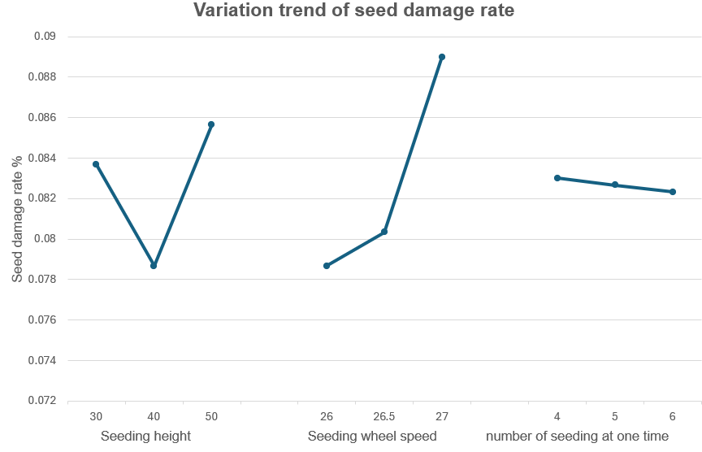
Fig 2 Variation trend of seeding efficiency

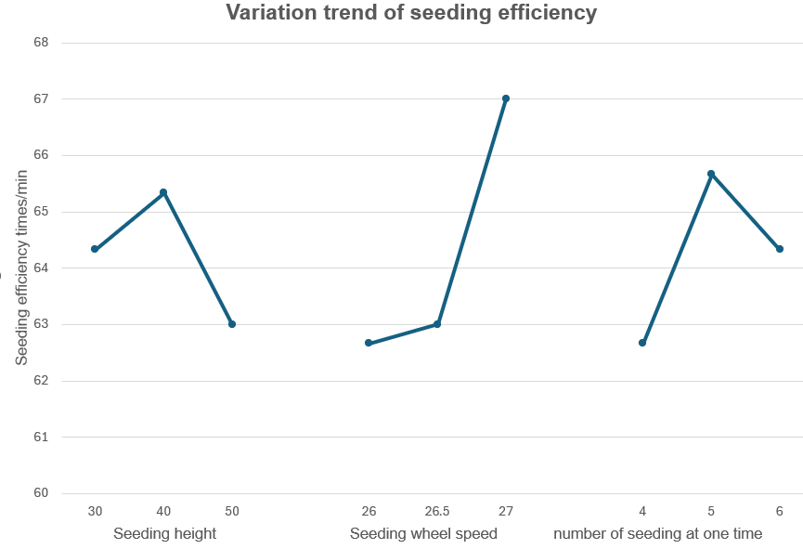
Fig 3 Trend chart of seed damage rate
4.2 Analysis of Variance

The intuitive method cannot estimate the size of the error and the importance of the influence of the test results, especially for the test with the level number greater than or equal to 3, so the analysis of variance is used to make up for this defect, and the test level confidence is selected as α=0.05.
The range analysis results of seeding efficiency and seed damage rate are shown in Table 6 and 7. The variance analysis results show that the degree of influence on seeding efficiency from large to small is the speed of seeding wheel > the number of seeding > the height of seeding; the degree of influence on seed damage rate from large to small is the speed of seeding wheel > the height of seeding > the number of seeding. The analysis results are consistent with those of range analysis.

Table 6 Results of variance analysis of seeding efficiency
Difference Source | SS | df | MS | F | P-value | Significance
B | 34.88888889 | 2 | 17.44444444 | 39.25 | 0.02484472 | Significant
A | 13.55555556 | 2 | 6.777777778 | 15.25 | 0.061538462 | Non-significant
C | 8.222222222 | 2 | 4.111111111 | 9.25 | 0.097560976 | Non-significant
e | 0.888888889 | 2 | 0.444444444
e^{Δ} | 57.55555556 | 8

Table 7 Results of variance analysis of seed damage rate
Difference Source | SS | df | MS | F | P-value | Significance
B | 0.000184667 | 2 | 9.23333E-05 | 14.57895 | 0.014552784 | Significant
A | 7.8E-05 | 2 | 3.9E-05 | 6.157895 | 0.060104058 | Non-significant
C | 6.66667E-07 | 2 | 3.33333E-07
e | 2.46667E-05 | 2 | 1.23333E-05
e^{Δ} | 2.53333E-05 | 4 | 6.33333E-06
Sum | 0.000288 | 8

4.3 Optimal Scheme Screening

After the influence of various factors on the result is obtained, the optimal plan needs to be determined by comprehensive analysis. The results of seeding efficiency analysis showed that A₂B₃C₃ was the best option, but the results of seed damage rate analysis showed that A₁B₁C₃ was the best option. It can be seen from the analysis results that the rotation speed of the seeding wheel has the greatest influence on the seeding efficiency and seed damage rate. With the increase of the rotation speed of the seeding wheel, the seeding efficiency also gradually increases, but at the same time, the seed damage rate also increases rapidly, so the rotation speed of the seeding wheel is not the bigger the better. The optimal scheme was A₂B₂C₃. The scheme was the planting height of 40mm, the rotation speed of the planting wheel 26.5r/min, and the single planting quantity of 6 grains.
Substituting n=6 into the formula (2-4) yields:
Take $d_{k}$=11mm. Substituting into the formula (2-3) yields:
In the formula, the limit linear speed of the seed plate is $v_{t}$=0.15m/s, and $d_{p}$=108.11mm is substituted into the formula (2-5) to obtain:
In the formula, the forward speed of the planter is 0.54~0.72m/s, the planting hole distance t_{y}=100mm, the calculated N_{k}>12.0002, the number of pattern holes is usually even, so the design of the number of pattern holes is N_{k}=14.
4.4 Comparative Analysis of Optimized Structure and Initial Structure

The structural parameters before and after the seeding device are as follows:
Table 8 Comparison of structural parameters
p  Planting Mechanism | Planting Height h(A)/mm | The Speed of the Seeding Wheel Is n_{p}(B)r/min | Number of Species in a Row n (C) /mm | Seeding Efficiency y₁ Times /min | Seed Damage Rate y₂/%
initial | 38 | 13.7 | 5 | 64.44 | 0.0828
optimize | 40 | 13.5 | 6 | 64.67 | 0.0804
The comparison results showed that the optimized seed arrangement device not only improved the seeding efficiency, but also reduced the seed damage rate, among which the seeding efficiency was increased by 0.23 times /min, and the seed damage rate was reduced by 0.0024%, which met the expected requirements.
The structure diagram before and after optimization is as follows:
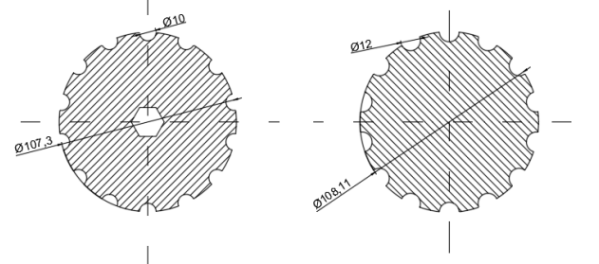
Before optimization After optimization
Figure 4 Structure comparison before and after optimization
4. CONCLUSION

(1) Through the orthogonal analysis of the main structural parameters of the seeding device, it was concluded that the main factor that significantly affected the seeding efficiency and seed damage rate was the rotation speed of the seeding wheel.
(2) The structural parameters obtained from range analysis and variance analysis were analyzed, and the analysis results were compared with the results under the initial conditions. It was found that the seeding efficiency was increased by 0.23 times /min and the seed damage rate was reduced by 0.0024% after optimizing the seeding wheel structure, meeting the expected requirements.

References

- Sun Jijun. Discussion on the current situation and solution strategy of agricultural mechanization development in agricultural engineering [J]. Agricultural Development and Equipment,2023(07):22-24.
- Li Yunyan, Hu Chuanrong. Experimental Design and Data Processing (3rd Edition) [M]. Beijing: Chemical Industry Press,2017.
- Ru Mengfei, Zhang Jing, Li Zhiwei, et al. Optimization of seed discharge performance of a new type of buckwheat seed feeder [J]. Journal of Agricultural Engineering, 2019,10(11):79-83.
- Liao Qingxi, PEI Limin, Zhang Qingsong, et al. Design and experiment of Rolling film cutting and punching device of rape film laying and punching drill [J]. Transactions of the Chinese Society for Agricultural Machinery,2023,54(09):85-98.
- Jin ZH, Chao ZH, Jinguo ZH, Dongliang HA, Yongkang NI, Nan SU. Parameter optimization and experiment of differential filling groove single grain seed metering device for wheat. Nongye Jixie Xuebao/Transactions of the Chinese Society of Agricultural Machinery. 2020;51(12).
- Wang C, Li H, He J, Wang Q, Lu C, Yang H. Optimization design of a pneumatic wheat-shooting device based on numerical simulation and field test in rice–wheat rotation areas. Agriculture. 2022 Jan 2;12(1):56.
- Zhao J, Zhang C, Wei Y, Guo M, Chen C, Zhang C, Zhang Y. Design and testing of planting unit for rice dry-direct-seeding planter in cold region. International Journal of Agricultural and Biological Engineering. 2023 Oct 17;16(4):76-84.
- Luo W, Chen X, Qin M, Guo K, Ling J, Gu F, Hu Z. Design and Experiment of Uniform Seed Device for Wide-Width Seeder of Wheat after Rice Stubble. Agriculture. 2023 Nov 20;13(11):2173.
- Cheng X, Li H, He J, Wang Q, Lu C, Wang Y, Wang C, Wang C, Lou S. Optimization of operating parameters of seeding device in plot drill with seeding control system. International Journal of Agricultural and Biological Engineering. 2021 Jun 11;14(3):83-91.
- Wei L, Wang Q, Niu K, Bai S, Wei L, Qiu C, Han N. Design and Test of Seed–Fertilizer Replenishment Device for Wheat Seeder. Agriculture. 2024 Feb 26;14(3):374.

