Review Article

Hexane (HEX) and Ethyl Acetate (EtoAc): Risk assessment, environmental, and health hazard: a short review

ABSTRACT

Backgroung: Manufactured chemicals are the second important classes as the natural chemicals mentioned above and the American Chemistry Council (ACC) projects global chemical production to rise by 3.4 % in 2024 and 3.5 % in 2025, after increasing just 0.3 % in 2023. Exist a variety of process in the industries that use a wide range of different chemicals accordingly their classes considering structure, polarity solubility for specific targeting. The common organic solvents are generally classified as an aliphatic hydrocarbon, aromatic hydrocarbon, cyclic hydrocarbon, halogenated hydrocarbon, amines, ketones, esters, ether, aldehyde, alcohols among others. Objective: This short-critical review will discuss throughout the literature background risk assessment, environmental and health hazard of two organic solvents as known Hexane (HEX) and Ethyl Acetate (EtoAc). Methods: The most significative databases regarding risk assessment, environmental, and health hazard was consulted and evaluated as American Chemistry Council (ACC); National Center for Biotechnology Information advances science and health by providing access to biomedical and genomic information in the NIH (National Library of Medicine); U.S. Environmental Protection Agency (EPA); U.S. Food and Drug Administration (FDA); European Chemicals Agency (ECHA-OECD); World Health Organization (WHO) and Department of Climate Change, Energy, the Environment and Water (AU). Conclusions and Future Outlook: In recent decades, various efforts have been made to replace toxic VOCs in chemical processes, according to the principles of Green Chemistry and Green Extraction One of the. However even for EtoAc still exist and susbtantial lack of background do be evaluated and properly described. Additionally the lack of accurated data, the number of unclear regulations and non-standarized protocols to proof risk assessment, environmental and health hazard of VOCs as HEX and EtoAc and many other chemicals are still a great challenge to be harmonized.

Keywords: Hexane, HEX, Ethyl Acetate, EtoAc, Toxicity.

1. INTRODUCTION

Prior to the safety status is essential the knowledge acquired from the chemical substances regarding their composition, origen, states and physical changes when in contact with any living organism in each of existent trophical levels that could generate any type of risk or hazard. Substances called chemicals, are eveywhere in our environmental. All matter on our planet consist of chemicals. We are made up of a few thousand different types of chemicals, some of wich are considered toxic. The vast majority of the chemicals are natural; infact, the most potent chemicals on the planet are those occuring naturally in plants and animals¹.

Manufactured chemicals are the second important classes as the natural chemicals mentioned above and the American Chemistry Council (ACC) projects global chemical production to rise by 3.4 % in 2024 and 3.5 % in 2025, after increasing just 0.3 % in 2023. However, even with chemical production improving and margins reverting to average levels, the industry still faces challenges and uncertainty. In the next year, chemical companies will navigate many of the same challenges as other industries: evolving macroeconomic conditions, shifts in policy and regulations across regions, changing customer preferences, and advances in technology².

Exist a variety of process in the industries that use a wide range of different chemicals accordingly their classes considering structure, polarity solubility for specific targeting. The common organic solvents are generally classified as an aliphatic hydrocarbon, aromatic hydrocarbon, cyclic hydrocarbon, halogenated hydrocarbon, amines, ketones, esters, ether, aldehyde, alcohols among others⁶. Each of these compounds present an response when exposed to the wilde life their living and non-living organisms.
The hydrophobic nature of the organic solvents and the polar water has a great role in organic synthesis; from the quenching practice to the extraction of organic compounds and excretion of undesired side products to the water layer⁶. The separation action plays a crucial role in chemical, pharmaceutical industries, drug development, biosensors, nanomaterials development, new ingredients and new molecules traping, identification, quantification and application.

This short review will discuss throughout the literature background risk assessment, environmental and health hazard of two organic solvents as known Hexane (HEX) and Ethyl Acetate (EtoAc).

2. substance category

Table 1 shows the substance harmonical characterization accordinly the name and possible synonyms, their classe, formula, origen and key physico-chemical parameters for solvent miscibility considering water^{1,6,11-14}.

Table 1. Hexane (HEX) and Ethyl Acetate (EtoAc) substance harmonical physico-chemical classification

Name |  | Synonyms | Abreviation (Smiles) | Classe | Formula | Origen | Structure | Solubility Parameter (MPa^{1/2}) | MW (g/mol) | Solubility in water (g/100g) | Reference
Hexane | n-Hexane; Esani;  Gettysolve-B; among other names |  | HEX (CCCCCC ) | Hydrocarbon | C₆H₁₄ | Petroleum based | 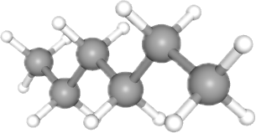 | δ 14.9 | 86.18 | 0.0014 | [1,6,12, 13]
Ethyl acetate | Ethyl ethanoate;  Acetic acid ethyl ester; Acetoxyethane; among other names |  | EtoAc (CCOC(=O)C) | Ether | C₄H₈O₂ | Bio and Petroleum based | 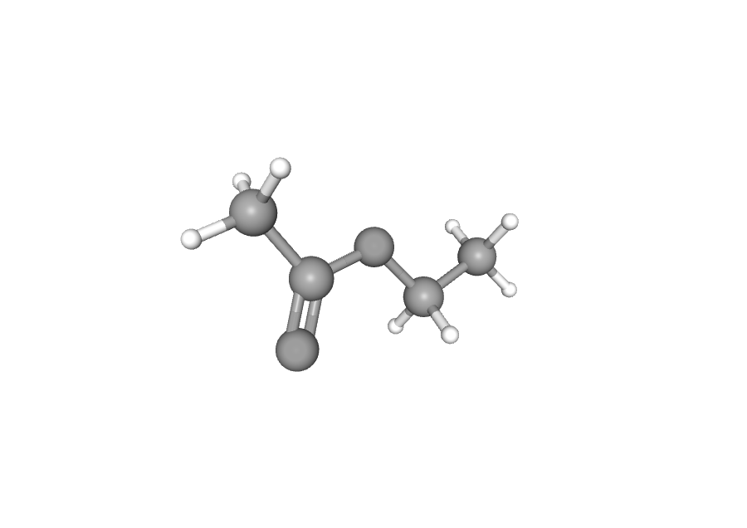 | δ 18.6 | 88.11 | 8.7 | [6,11, 13, 14]

3. production route

Figure 1 shows hexane is generally produced from naphtha, one of the lightest fractions obtained directly from petroleum refining. This fraction accounts for about 20% of the weight of crude oil and consists of a mixture of C5 to C10 hydrocarbons with a boiling point in the range of 30–200°C. Figure 2 shows The primary production method for ethyl acetate occurs through Fischer esterification (FE) of ethanol (EtOH) with acetic acid (AA). The AA is produced from EtOH through a two-step process: either chemical or biological or via a one-step method derived from 1 G and 2 G sugars. In the chemical process, the initial step involves the alcoholic fermentation of sugars (anaerobicfermentation), followed by catalytic chemical upgrading to AA. In the biological route, the first stage is similar to the chemical route, followed by the oxidation of EtOH into AA using acetic acid bacteria (AAB)^{5,14}.

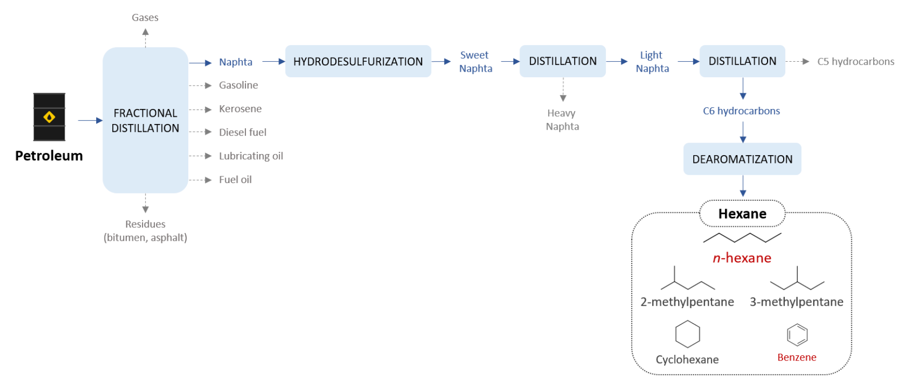
Figure 1. HEX production and composition⁵.

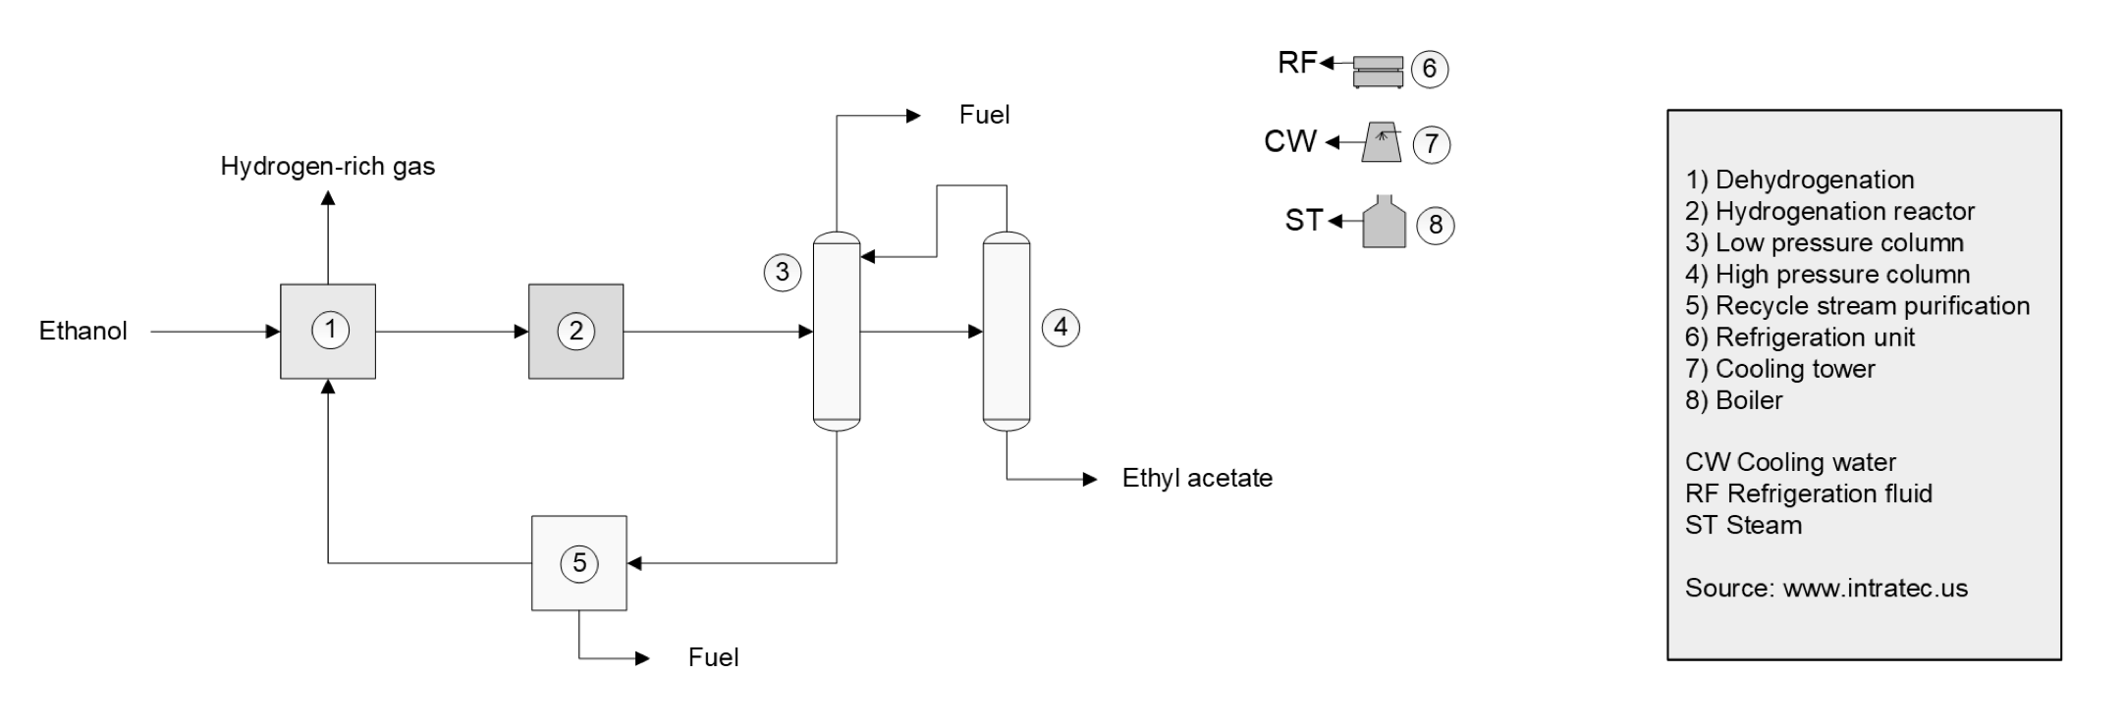
Figure 2. EtoAc production and composition²⁰.
The common organic solvents are generally classified as an aliphatic hydrocarbon, aromatic hydrocarbon, cyclic hydrocarbon, halogenated hydrocarbon, amines, ketones, esters, ether, aldehyde, alcohols, among others as HEX and EtoAc in Figure 1 and 2. It’s hard to talk about organic synthesis without organic solvents. In common, the organic solvents are chemicals that are used to dissolve other chemicals but in detail, we need to understand the reactivity of respective solvents on specific reactions conditions. So, the selection of appropriate solvents for a reaction is to be noted always. The choice of solvents is usually done by previous experience with particular solvents or the following similar pattern literature review and practice it in a laboratory setting. However, the scenario does not remain same nowadays because of some strict rules and regulation we need to consider like solvent power, volatility that leads to toxicity to the researcher and to our society and overall environment. This leads to search new and new best option and because of which, nowadays the solvent-free organic synthesis is rapidly growing⁶.
4. Intended Use and Application
Table 2 shows the substance category for HEX and EtoAc reported accordingly the National Center for Biotechnology Information advances science and health by providing access to biomedical and genomic information in the NIH (National Library of Medicine)^{11,12}. Our summary considering all uses of these both substances was divided in 19 categories considering all listed intent of applications existing and mentioned in the NIH. It is important to mention the summarization was adopted as strategies to reduce the redundance of intent uses cited and grouping both HEX and EtoAc in similar classes of use that better fit for each molecule in their respectively physical state.

Table 2. Hexane (HEX) and Ethyl Acetate (EtoAc) applications divided accordingly broad category of use reported

Category uses reported | HEX | EtoAc | Reference
Additive | x | x | [11,12]
Arts/Crafts/Office supplies | x | x | [11,12]
Cleaner/Cleaning products | x | x | [11,12]
Construction/Bulding materials | x | x | [11,12]
Fragrance | x | x | [11,12]
General purpose | x | x | [11,12]
Landscape/yard | x | x | [11,12]
Manufactured formulations | x | x | [11,12]
Pure chemical | x | x | [11,12]
Personal care | x | x | [11,12]
Solvent or vehicle | x | x | [11,12]
Viscosity controlling | x |  | [11,12]
Flavor enhancer |  | x | [11,12]
Foam |  | x | [11,12]
Maintenance | x | x | [11,12]
Health care | x | x | [11,12]
Pet care |  | x | [11,12]
Specialty occupational products |  | x | [11,12]
Unknow | x |  | [11,12]

5. Intended Use and Application
Chemicals introduced to the environment as a result of anthropogenic activity include an wide number of toxic substances. Toxic substances generally exert their effects on organisms through direct toxicity and the extent of the effect is dependent on the chemical form of the substance, the concentration, and the period of exposure^{1,17}.

In order to assess the occurrence and the extent of exposure of a chemical in the environment and possibly its effect on the environment and living organisms, it is necessary to evaluate the chemical's fate and its behavior in specific environmental compartments. While the amount and frequency of a chemical's release into the environment, as well as the environmental compartment air, water, or soil into which it is released are important factors, the environmental fate is determined by what happens after the chemical has been released. Fate and behavior of a chemical is governed by its physicochemical properties (such as vapor pressure, water solubility, water octanol partition coefficient (K_{ow}), soil organic carbon–water partitioning coefficient (K_{oc}), etc.). However, the concentration and time of exposure to the chemical and its biological and chemical transformations are affected by several important processes in the receiving environment¹⁷.

Considering the possible pathways to degrade this both VOCs, three major environmental as air, water, and soil and plants are considered in Figure 3. Throughout the air pathway, HEX, volatilizes easily and undergoes atmospheric photodegradation when exposed to sunlight and when in water it enters aquatic systems, it can be broken down through biodegradation. Otherwise, EtoAc, tends to bioconcentrate in organisms and can also volatilize from soil into the air when acting as soil and plants xenobiotic substance. In general HEX and EtoAc could biodegrade due to microorganisms in the soil and water break it down into less harmful substances however more accessibles also. These pathways are crucial for understanding how volatile organic compounds (VOCs) like these affect ecosystems and human health¹⁶.

Linking environmental fate and the chemicals classification, Table 3 shows Hexane (HEX) and Ethyl Acetate (EtoAc) chemical classification and labeling accordingly Globally Harmonized System Of Classification And Labelling Of Chemicals (GHS). The use of chemicals to enhance and improve life is a widespread practice worldwide. But alongside the benefits of these products, there is also the potential for adverse effects to people or the
Environment as discussed above. Because of that, several countries or organizations have developed laws or regulations over the years that require information to be prepared and transmitted to those using chemicals, through labels and codes. The provision of information gives those using chemicals the identities and hazards of these chemicals and allows the appropriate protective measures to be implemented in the local use settings¹⁹.

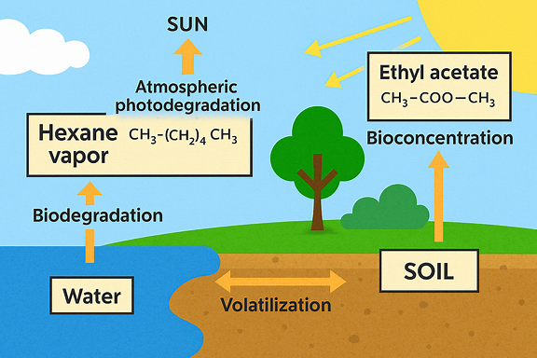

Figure 3. HEX and EtoAc pathways for understanding how volatile organic compounds (VOCs) like these affect ecosystems and human health¹⁵.

HEX is a crude oil derived chemical as exemplified in Figure 1 route. It is anonpolar molecule and is a highly volatile and ammable toxic chemical. The liquid form of pure n Hexane is colorless and smells like gasoline. It is a signicant component of natural gas. It dissolves very weakly in water and evaporates extremely easily into the atmosphere³. Into the air exane volatilizes rapidly when released into water, according to Henry’s law constant; the amount of volatilization is contingent upon several conditions, including temperature, turbulence, and the depth of the receiving water. The main sources of n Hexane emissions are motor fuels, heating systems, and the extraction of edible oil. The primary way that people are exposed to n-Hexane is through their inhaling, although it can also occur through skin contact with things that contain the compound. The vast majority of an individual’s exposure to n-Hexane occurs at work. According to the reporting data, n-Hexane is a prevalent air contaminant³. In soil, n-Hexane has a comparatively low absorptivity. The most likely sources of its release into soil or sediments are sledge spills and land lls, along with other industrial and municipal sewage treatment-related pollutants. The substance evaporates or seeps into the groundwater if it is spilled on the ground. Volatilization is expected to be the predominant environmental process involving n-Hexane, despite its biodegradability in soil and water as exemplified in Figure 3. The origin of n-Hexane spilled into the water from industrial emissions, nonpoint-source runoff from highways, and municipal waste treatment, among other sources. The nonpolar solvent n-Hexane is used for the extraction of oils from vegetables, oil from sh, and meal from sh. It is possible to consume vegetable and sh oils that contain n-Hexane residues from solvent extraction, usually at concentrations of around 1 ppm. The daily consumption of n-Hexane from meals often contained in re ned vegetable oils is 0.8 ppm, according to a 2009 research by Environment Canada³.

Table 3. Hexane (HEX) and Ethyl Acetate (EtoAc) classification considering possible environmental fate contamination and the chemical classes

Name | Number | Classification | Pictograms | Agency source | Reference
HEX | 110-54-3 (CAS Number) / 601-037-00-0 (EU Harmonised CLP Classification no.) | Flammable liquid 2 |        | ECHA C&L inventory | 18
HEX |  | Skin corrosion/irritation 2 |  | ECHA C&L inventory | 18
HEX |  | Aspiration toxicity 1 |  | ECHA C&L inventory | 18
HEX |  | Reproductive toxicity 2 |  | ECHA C&L inventory | 18
HEX |  | Specific target organ toxicity, single exposure 3 |  | ECHA C&L inventory | 18
HEX |  | Specific target organ toxicity, repeated exposure 2 |  | ECHA C&L inventory | 18
HEX |  | Hazardous to aquatic environment, long-term hazard 2 |  | ECHA C&L inventory | 18
HEX | 110-54-3 (CAS Number) | Flammable liquid 2 |  | NITE Japan-GHS | 18
HEX | 110-54-3 (CAS Number) | Skin corrosion/irritation 2 |  | NITE Japan-GHS | 18
HEX | 110-54-3 (CAS Number) | Eye irritation 2 |  | NITE Japan-GHS | 18
HEX | 110-54-3 (CAS Number) | Aspiration toxicity 1 |  | NITE Japan-GHS | 18
HEX | 110-54-3 (CAS Number) | Reproductive toxicity 2 |  | NITE Japan-GHS | 18
HEX | 110-54-3 (CAS Number) | Specific target organ toxicity, single exposure 3 |  | NITE Japan-GHS | 18
HEX | 110-54-3 (CAS Number) | Specific target organ toxicity, repeated exposure 1 |  | NITE Japan-GHS | 18
HEX | 110-54-3 (CAS Number) | Hazardous to aquatic environment, acute hazard 2 |  | NITE Japan-GHS | 18
EtoAc | 141-78-6 (CAS Number) 607-022-00-5 (EU Harmonised CLP Classification no.) | Flammable liquid 2 |  | ECHA C&L inventory | 18
EtoAc |  | Eye irritation 2 |  | ECHA C&L inventory | 18
EtoAc |  | Specific target organ toxicity, single exposure 3 |  | ECHA C&L inventory | 18
EtoAc | 141-78-6 (CAS Number) | Flammable liquid 2 |  | NITE Japan-GHS | 18
EtoAc | 141-78-6 (CAS Number) | Acute toxicity, inhalation 4 |  | NITE Japan-GHS | 18
EtoAc | 141-78-6 (CAS Number) | Eye irritation 2B |  | NITE Japan-GHS | 18
EtoAc | 141-78-6 (CAS Number) | Specific target organ toxicity, single exposure 3 |  | NITE Japan-GHS | 18

EtoAc is a colourless liquid with a pleasant fruity odor as a organic solvent, and as mentioned above is s a flammable liquid, and an explosion hazard. It is slightly soluble in water, but soluble in most organic solvents. EtoAc could enter the body if we breathe in contaminated air or eat or drink contaminated materials and can pass through the skin. Workers in the industries that use or produce ethyl acetate are at risk of exposure in the other hand consumers can be exposed to ethyl acetate by exposure to air from production and processing facilities using ethyl acetate. Consumers may also be exposed to ethyl acetate when using consumer products containing ethyl acetate (thinners for paint lacquers and enamels, nail preparations, among others) especially if there is not good ventilation, and by drinking wine. Industrial emissions of ethyl acetate can produce elevated, concentrations in the atmosphere around the source. Ethyl acetate that makes its way into the ground, and does not evaporate, will eventually end up in the ground water as Illustrated by Figure 3, finally Ethyl acetate evaporates to a gas if released as a liquid. Ethyl acetate is a volatile organic chemical (VOC) and will contribute to the formation of smog²¹.

6. Mode of Action and Toxicity
Both solvents are considered toxic accordinly the toxicity levels for human and environmentals as we can observe in Table 4 for specific doses of each solvent. Accordindly all data presented from the databases and literature background searched in this review it is important to clarify when we compare both solvents HEX and EtoAc considering since their origin, production, applications and risk assessment, environmental, and health hazard HEX are more prejudicial to human and their environmental fate is critical than EtoAc. Besides that EtoAc could present an sustainable ptoduction process or at least part of this process is considerade more renewable when compared with HEX. Nevetherless HEX also was classified as carcinogenic to humans accordingly the National Center for Biotechnology Information advances science and health by providing access to biomedical and genomic information in the NIH (National Library of Medicine)^{11,12}.

Finally considering all the aspects of both VOCs substances as demonstrated in Figure 3 and Table 1 and 2, they have an significative interaction with all medias due to their physico-chemical properties and when in contact with humans, HEX could mainly affect the nervous system. It causes degeneration of the peripheral nervous system (and eventually the central nervous system), starting with damage to the nerve axons. Exposure to hexane may also damage the lungs and reproductive system¹². In other hand EtoAc at short-term exposure to high levels results first in irritation of the eyes, nose and throat, followed by headache, nausea, vomiting, sleepiness, and unconsciousness¹¹.

Table 4. Hexane (HEX) and Ethyl Acetate (EtoAc) toxicity human and ecological values considering their human short-term effects and their carcinogenic potential effect

Name | LD50 - Human Toxicity Values | EC50 - Ecological values | Heath effects | Carcinogen classification | Reference
HEX | LC50 (rat) = 77,000 ppm/1 hr | Species: Chlamydomonas angulosa (Green Algae) age 3-4 days, exponential growth phase 5x10+4 cells/mL | Hexane mainly affects the nervous system. It causes degeneration of the peripheral nervous system (and eventually the central nervous system), starting with damage to the nerve axons. Exposure to hexane may also damage the lungs and reproductive system. | Hexane is found in gasoline, which is possibly carcinogenic to humans (Group 2B) | 12
HEX | LD50: 28 710 mg/kg (Oral, Rat) | Chlorella vulgaris (Green Algae) age 3-4 days, exponential growth phase 20x10+4 cells/mL |  |  | 12
HEX | LC50: 48 000 ppm over 4 hours (Inhalation, Mouse) | - |  |  | 12
EtoAc | LC50 (mice) = 45,000 mg/m3/2H | Chlorococcales (Green Algae Order); Conditions: freshwater, static; Concentration: 4300000 ug/L for 24 hr | Short-term exposure to high levels of ethyl acetate results first in irritation of the eyes, nose and throat, followed by headache, nausea, vomiting, sleepiness, and unconsciousness. | Its carcinogenic properties are not known | 11
EtoAc | - | Scenedesmus subspicatus (Green Algae) exponential growth phase; Conditions: freshwater, static, 24 °C, pH 8.0-9.3; Concentration: 3300000 ug/L for 48 hr |  | Its carcinogenic properties are not known | 11

7. Regulatory Status
Table 5 demonstrate the number of occurrence of both VOCs solvents, HEX and EtoAc reviwed in this short-literature background focused on the search of Food Ingredient and Packaging Inventories. This databases are public and could be consulted at U.S. Food and Drug Administration. Both solvents are not banned or prohibited and an comprehensive list of application considered 19 summarized categories uses commercially HEX and EtoAc.

Considering the FDA databases, it is a great example of many approved application for both VOCs and even HEX appear with an GRAS (Generally Recognized as Safe), means the substance is a food ingredient that is considered safe for consumption, either because it has a long history of common use or because it has been affirmed as safe through scientific procedures. This designation exempts the substance from the need for pre-market approval by the U.S. Food and Drug Administration (FDA)²².

Table 5. Hexane (HEX) and Ethyl Acetate (EtoAc) search food Ingredient and packaging inventories occurrence²²

FDA Dataset base listed | HEX | EtoAc
Cumulative Estimated Daily Intake (CEDI) | 83 Hits | 0 Hits
Final Rules: Food Additives and Color Additives | 7 Hits | 2 Hits
Food Additive and Color Additive Petitions Under Review or Held in Abeyance | 0 Hits | 0 Hits
Food Contact Substance (FCS) Notifications that are No Longer Effective | 6 Hits | 0 Hits
GRAS Notices | 0 Hits | 0 Hits
Human Food Made with Cultured Animal Cells Inventory | 0 Hits | 0 Hits
Inventory of Effective Food Contact Substance (FCS) Notifications | 134 Hits | 1 Hits
Inventory of Environmental Impact Decisions for Food Contact Substance Notifications | 140 Hits | 1 Hits
Inventory of Food Contact Substances Listed in 21 CFR | 118 Hits | 6 Hits
New Plant Variety Consultations | 0 Hits | 0 Hits
New Protein Consultations | 0 Hits | 0 Hits
Post-market Determinations that the Use of a Substance is not GRAS | 1 Hits | 0 Hits
Premarket Meetings Regarding Food from Genome Edited Plants | 0 Hits | 0 Hits
Regulatory Status of Color Additives | 0 Hits | 0 Hits
SCOGS (Select Committee on GRAS Substances) | 1 Hits | 0 Hits
Submissions on Post-Consumer Recycled (PCR) Plastics for Food-Contact Articles | 0 Hits | 0 Hits
Substances Added to Food (formerly EAFUS) | 73 Hits | 20 Hits
Threshold of Regulation (TOR) Exemptions | 3 Hits | 0 Hits

8. Conclusions and Future Outlook

In recent decades, various efforts have been made to replace toxic VOCs in chemical processes, according to the principles of Green Chemistry and Green Extraction. To this end, various approaches have been explored involving both the use of non-toxic solvent systems and green extraction intensification technologies⁵. One of the great possibilities to replace HEX is EtoAc in big part of their application portfolium. However even for EtoAc still exist and susbtantial lack of background do be evaluated and properly described. Additionally the lack of accurated data, the number of unclear regulations and non-standarized protocols to proof risk assessment, environmental and health hazard of VOCs as HEX and EtoAc and many other chemicals are still a great challenge to be harmonized.

COMPETING INTERESTS DISCLAIMER:
Authors have declared that they have no known competing financial interests OR non-financial interests OR personal relationships that could have appeared to influence the work reported in this paper.

9. References

1. Stelljes ME. Toxicology for Non-Toxicologists. 2nd ed. Government Institutes; 2007

2. American Chemistry Council. Solid Economy Provides Boost to Chemical Production: ACC Mid-Year Situation & Outlook 2024. American Chemistry Council website. Published June 20, 2024. Accessed October 8, 2025. https://www.americanchemistry.com/chemistry-in-america/news-trends/blog-post/2024/solid-economy-provides-boost-to-chemical-production

3.Kumar P, Pandey SK. Chapter 31 - Exploring Hexane’s impact: Toxicological insights, challenges, and forward-looking perspectives. In: Chawla M, Singh J, Kaushik RD, eds. Hazardous Chemicals. Academic Press; 2025:453-465. doi: https://doi.org/10.1016/B978-0-323-95235-4.00037-2

4. Hartwig A, MAK Commission. Ethyl acetate: MAK Value Documentation, addendum – Translation of the German version from 2017. MAK Collect Occup Health Saf. 2025;4(4):2027-2044. Doi:10.34865/mb14178e6319_w

5. Cravotto C, Fabiano-Tixier A-S, Claux O, Abert-Vian M, Tabasso S, Cravotto G, Chemat F. Towards Substitution of Hexane as Extraction Solvent of Food Products and Ingredients with No Regrets. Foods. 2022; 11(21):3412. https://doi.org/10.3390/foods11213412

6. Dirgha Raj Joshi & Nisha Adhikari. (2019). An Overview on Common Organic Solvents and Their Toxicity. Journal of Pharmaceutical Research International, 2019; 28(3), 1–18. https://doi.org/10.9734/jpri/2019/v28i330203

7. Agency for Toxic Substances and Disease Registry. Toxicological Profile for n-Hexane. Atlanta, GA: U.S. Dept. of Health and Human Services, Public Health Service, 2024. https://www.atsdr.cdc.gov/toxprofiles/tp113.pdf [accessed 7 October 2025]

8. U.S. Environmental Protection Agency. Toxicological Review of n-Hexane (CAS No. 110-54-3) in Support of Summary Information on the Integrated Risk Information System (IRIS). EPA/635/R-03/012. November 2005. https://iris.epa.gov/ChemicalLanding/&substance_nmbr=486 [accessed 7 October 2025]

9. U.S. Environmental Protection Agency. IRIS Toxicological Review and Summary for n-Hexane [Internet]. Washington, DC: U.S. Environmental Protection Agency; Last Revised December 23, 2005 [cited 2025 Oct 7]. https://iris.epa.gov/static/pdfs/0486_summary.pdf [accessed 7 October 2025]

10. U.S. Environmental Protection Agency. IRIS Toxicological Review and Summary for Ethyl acetate [Internet]. Washington, DC: U.S. Environmental Protection Agency; Last Revised March 1, 1987 [cited 2025 Oct 7]. https://iris.epa.gov/static/pdfs/0157_summary.pdf [accessed 7 October 2025]

11. National Center for Biotechnology Information. PubChem Compound Summary for CID 8857, Ethyl Acetate. https://pubchem.ncbi.nlm.nih.gov/compound/Ethyl-Acetate. [accessed 7 October 2025]

12. National Center for Biotechnology Information. PubChem Compound Summary for CID 8058, Hexane. https://pubchem.ncbi.nlm.nih.gov/compound/Hexane. [accessed 7 October 2025]

13. Polymer Handbook”, Eds. Brandrup, J.; Immergut, E.H.; Grulke, E.A., 4th Edition, John Wiley, New York, 1999, VII /675-711

14. Phasha M, Petersen A, Görgens J. Process flowsheet development for bio-ethyl acetate production from sugar mill feedstocks: A techno-economic approach. Chem Eng Res Des. 2025;217:10.1016/j.cherd.2025.03.026

15. Copilot. Environmental fate of hexane and ethyl acetate [illustration]. Microsoft Copilot; October 2025. Accessed October 9, 2025

16. Copilot. Explanation of environmental fate and transport of hexane and ethyl acetate. Microsoft Copilot; October 2025. Accessed October 9, 2025

17. Wexler P, ed. Encyclopedia of Toxicology. 4th ed. Academic Press; 2024

18. OECD, European Chemicals Agency. eChemPortal: The Global Portal to Information on Chemical Substances. https://echemportal.org/echemportal/. [accessed 10 October, 2025]

19. World Health Organization. Globally harmonized system of classification and labelling of chemicals (GHS). 4th rev. United Nations; 2011. https://www.who.int/publications/i/item/9789211169542. [accessed 10 October, 2025]

20. Intratec. 2024. Ethyl Acetate Production from Ethanol, Report ICC-PREV-
012-B-PREM-USA. In: Intratec Commodity Production Costs. Volume 12 (Ethyl Acetate). Issue B. Premium Edition. Rev 0. https://cdn.intratec.us/_nt/docs/icc/previews/INTRATEC-ICC-PREV-012-B-PREM-USA.pdf. [accessed 10 October, 2025]

21. Department of Climate Change, Energy, the Environment and Water. Ethyl acetate. National Pollutant Inventory. Updated June 30, 2022. https://www.dcceew.gov.au/environment/protection/npi/substances/fact-sheets/ethyl-acetate#tabs-1 [accessed 10 October , 2025]

22. Food and Drug Administration. Food ingredients and packaging. In: FDA Food Contact Substance Inventory [database online]. Updated October 10, 2025. https://www.hfpappexternal.fda.gov/scripts/fdcc/index.cfm?cat=FoodIngredientsPackaging&type=basic&search=. [accessed 10 October, 2025]

