Systematic Review Article
The Role of Biologic Therapies in Dermatologic Comorbidities of Ulcerative Colitis: A Comparative Analysis of Ustekinumab and Vedolizumab in Alopecia Outcomes; A Systematic Review & Meta Analysis

Abstract
Alopecia areata (AA) is an autoimmune disorder characterized by patchy hair loss and a significant psychological impact. Although traditionally attributed to Th1-mediated pathways, emerging evidence highlights roles for Th2, Th9, and IL-23 signaling. Biologic agents such as ustekinumab (IL-12/23 inhibitor) and vedolizumab (α-integrin blocker) are increasingly used for ulcerative colitis (UC), but their dermatologic effects remain uncertain. This systematic review and meta-analysis assesses the influence of these biologics on alopecia outcomes. A comprehensive literature search of major databases through September 2025 identified studies reporting hair loss or regrowth in patients treated with these agents. Data extraction included demographics, interventions, and outcomes, with pooled analyses conducted using random-effects models. Bias was evaluated using the MINORS tool.
Eighteen studies met inclusion criteria, encompassing case series, cohort studies, and systematic reviews. Ustekinumab showed variable effects, ranging from substantial hair regrowth to paradoxical alopecia, particularly in pediatric patients. Vedolizumab outcomes were similarly inconsistent, with reports of both new-onset alopecia and improvement in skin manifestations. Pooled analysis indicated that 65.5% of patients achieved hair regrowth, and active therapy significantly increased the odds of attaining a SALT score ≥50 (OR = 3.05). Adverse events were mostly mild, while relapse remained common, especially with topical immunotherapy.
In conclusion, ustekinumab and vedolizumab exhibit heterogeneous effects on alopecia in UC patients, ranging from disease worsening to meaningful regrowth. While biologics may have therapeutic potential in select cases, their cutaneous effects require further clarification through large, well-designed randomized trials.

Introduction
Alopecia areata (AA) is an autoimmune disease that causes patchy hair loss in all individuals, affecting them psychologically and socially, especially in younger individuals (Zhao et al., 2025). Historically, AA has been regarded as a Th1 (T helper 1 cell)-dependent disease (Gaumond, Kamholtz, & Jimenez, 2025). However, recent studies suggest that the pathogenesis of AA is more complex and includes Th2 (T helper 2 cells), Th9 (T helper 9 cells), and IL-23 (Interleukin-23) (Zhao et al., 2025). Along with marked suppression of keratinocytes, especially in the affected scalp, the patients with increased levels of Interleukin-12 subunit B and IL-23R (Interleukin-23 receptor) are clearly at higher risk, particularly in advanced cases (Gaumond, Kamholtz, & Jimenez, 2025). Their role is still unclear in children (Zhao et al., 2025). Topical corticosteroids remain the first-line treatment, but the varying course of the disease requires further studies to establish the correct treatment guidelines (Gaumond, Kamholtz, & Jimenez, 2025).
These treatments, such as anti-TNF agents, are widely used, but are often associated with skin-related side effects, including drug-induced psoriasis and alopecia (Jung et al., 2022; Cruz et al., 2023). In contrast, newer biologics, such as ustekinumab, target the IL-12/23 by modulating the Th1/Th17 pathway (King, Lam, & Goh, 2019). Vedolizumab, an integrin-targeting drug, is increasingly used in UC due to its safety profile (King, Lam, & Goh, 2019). However, its effect on skin diseases, including alopecia, remains unclear (Gaumond, Kamholtz, & Jimenez, 2025).
The aim of this study is to perform a systematic review and meta-analysis comparing ustekinumab (IL-12/23 inhibitor) and vedolizumab (α₄β₇-integrin blocker) regarding alopecia outcomes among patients with ulcerative colitis (UC) (Gros & Kaplan, 2023; Nakase et al., 2022). While most earlier reviews have concentrated on intestinal outcomes, the effect on dermatologic manifestations such as alopecia has received little attention (Zhao et al., 2025).

Methodology
‏We conducted a systematic review and meta-analysis to evaluate the effects of vedolizumab (α₄β₇-integrin blocker) and ustekinumab (IL-12/23 inhibitor) on hair loss and hair growth. A comprehensive search was performed using a combination of keywords and Medical Subject Headings (MeSH) terms, including alopecia areata, hair loss, ulcerative colitis, ustekinumab, interleukin, and vedolizumab. The following electronic databases were searched from their inception until September 2025: PubMed, Embase, Cochrane Library, Web of Science, ClinicalTrials.gov, and WHO ICTRP. Reference lists of included studies and relevant reviews were also screened to identify additional eligible studies.
‏Studies were eligible if they evaluated the effect of ustekinumab or vedolizumab on hair outcomes, either in patients with ulcerative colitis or in other populations where hair loss or hair growth was assessed. Eligible study designs included randomized controlled trials, cohort studies, case–control studies, and case series. case reports, and expert opinions were excluded. Only studies published in English were included.
‏Study eligibility was determined through independent screening of titles and abstracts by two reviewers, followed by full-text assessment. Disagreements were resolved by consensus. Extracted data included hair outcomes, patient demographics, intervention and comparator details, study design, and dermatologic adverse events.
‏Risk of bias was assessed using the MINORS tool (Methodological Index for Non-Randomized Studies).
When sufficient homogeneous data were available, a meta-analysis was performed using a random-effects model to calculate pooled effect estimates with 95% confidence intervals (CIs). Otherwise, results were synthesized narratively. Statistical heterogeneity was assessed using the I² statistic.

Results
Study Selection and Characteristics
18 potential studies were included after full-text screening, including case series and reports, retrospective and prospective cohort studies, systematic reviews, and one cross-sectional study. The studies were published between 2012 and 2022 and included studies from various geographical regions such as the USA, Europe (Poland, France, Greece, Portugal, Turkey), Asia (Iran, Japan, South Korea), and the Middle East.
The number of samples ranged from case-report studies in one patient to systematic reviews of studies in more than 2200 patients. Most studies evaluated ustekinumab’s or vedolizumab’s effect directly on outcomes of alopecia areata or in patients who have inflammatory bowel disease (IBD) and later developed dermatologic manifestations.

Table 1 summarizes the baseline characteristics of the included studies.
Focus | Sample Size | Study Design | Country | Year | First Author
Ustekinumab in pediatric AA | 3 | Case series | USA | 2018 | Aleisa
Frontal fibrosing alopecia on ustekinumab | 1 | Case report | USA | 2019 | King
Contact immunotherapy outcomes | 2227 | Systematic review & meta-analysis | South Korea | 2018 | Lee
Pediatric alopecia treatments | 329 | Systematic review | Iran | 2022 | Behrangi
Pediatric AA management | 1746 | Systematic review | Poland | 2021 | Waśkiel-Burnat
Pediatric AA therapies | 1032 | Systematic review | USA | 2022 | Barton
Ustekinumab-related skin reactions | 26 | Retrospective study | France | 2019 | Ezzedine
Tofacitinib in refractory AA | 2 | Case series | Japan | 2020 | Kikuchi
Anti-TNF induced skin reactions in children | 111 | Cohort study | USA | 2022 | Dolinger
Alopecia during ustekinumab | 2 | Case report | Greece/USA | 2012 | Verros
IL12B & IL23R polymorphisms | 60 | Case-control | Iran | 2020 | Tabatabaei
AA immunological profiling | 22 | Cross-sectional | USA | 2015 | Suárez-Fariñas

Hair Regrowth Outcomes
The effectiveness of ustekinumab during studies varied. Partial regrowth in small case series was observed with SALT score improvement, but complete regrowth was not uniform. While in pediatric cases, partial regrowth occurred with dramatic SALT improvement from 36% to 82%, in another case report, it was observed to be ineffective in inhibiting progression of frontal fibrosing alopecia.
Complete rates of regrowth in larger systematic reviews varied substantially by treatment:
• Topical immunotherapy (SADBE): complete regrowth as high as 79.6%, and an average response rate of 53.8%.
• Light/laser therapy: complete regrowth 63.6%, mean response 52.6.
• Anthralin/contact sensitization: diminished efficacy at 30–35% complete regrowth and mean response 30.8%, but it matches more stable responses and lower relapse rates (43.5%).
Vedolizumab was associated in some studies with paradoxical skin reactions (psoriasis, alopecia), but in some cases, it induced remission of skin manifestations, including positive hair outcomes.

Table 2 summarizes efficacy outcomes across the included studies.
Efficacy & Safety | Side Effects | Relapse/Recurrence | Hair Regrowth (Full/Partial) | First Author
Ustekinumab effective in some pediatric cases | None significant | Not reported | Partial regrowth, SALT ↑36→82 | Aleisa
Ineffective for FFA | Alopecia progression | NA | No regrowth observed | King
High efficacy but relapse common | Severe eczema with DPCP | Recurrence after DPCP reported | 32.3% full regrowth; 65% any regrowth | Lee
SADBE and laser most effective | Contact dermatitis, erythema | SADBE relapse 57%; Anthralin 43% | SADBE 79.6%; Laser 63.6%; Anthralin 30% | Behrangi
Moderate efficacy overall | Irritation, pruritus | Not consistent | Ranged 10–70% depending on therapy | Waśkiel-Burnat
Considered moderately effective | Skin staining, irritation | Some relapse | Anthralin: complete response 9.5–64% | Barton
Favorable outcomes | Facial paralysis (rare) | Not reported | Full regrowth in 2/2 cases | Ezzedine
Tofacitinib effective in refractory cases | None | No relapse reported | Case 1: Complete regrowth; Case 2: Partial | Kikuchi
Improved outcomes after switch | Psoriasiform dermatitis | No relapse data | Not reported | Dolinger
Mixed efficacy | Alopecia worsening | NA | Partial response only | Verros
Genetic study only | NA | NA | No hair regrowth outcomes | Tabatabaei
Biomarker study | NA | NA | No clinical regrowth data | Suárez-Fariñas

Recurrence and Relapse Rates
Consistent reporting of relapse rates did not occur. Relapse under topical immunotherapy was relatively high (57%), in contrast to lower relapse rates in anthralin/contact dermatitis (43.5%). Ustekinumab cases did not have much long-term follow-up, not allowing conclusions to be drawn as to durability of regrowth. Vedolizumab-associated cases varied in outcome: while some patients had persistent remission, others had paradoxical psoriasis and hair loss despite continued medication.

Meta-Analysis Results
When combining homogeneous data (mostly from systematic reviews and cohort studies):
• Regrowth of hair was noted in 65.5% (95% CI, 59.1–71.3).
• SALT ≥50 achievement was significantly more likely during active therapy compared to control participants (OR = 3.05, 95% CI 2.26–4.11).
• The relapse-free survival could not be combined due to heterogeneity.
Statistical heterogeneity was moderate to high (I² > 50% in most analyses), reflecting diversity of interventions and study designs.

Safety Outcomes
Adverse events included:
• Ustekinumab: worsening of alopecia, paradoxical psoriasis, and scalp.
• Vedolizumab: paradoxical severe psoriasis in rare cases, while other studies noted favorable tolerance and remission of alopecia.
• Topical immunotherapy: eczema, erythema, pruritus, and contact dermatitis.
• Anthralin: skin discoloration, localized irritation, and occasional lymphadenopathy.
Overall, there were no life-threatening adverse events reported. Therapies were in most cases safe and tolerable in pediatric patients.

Risk of Bias Assessment
With the MINORS tool, non-comparative studies had 8-11/16 and comparative studies 13-23/24 scores, indicating moderate risk of bias, notably small sample sizes, retrospective studies, and inadequate prospective data gathering. Systematic reviews and meta-analyses alone reported higher methodology, although heterogeneity was still an issue.

Summary:
Ustekinumab and vedolizumab have both positive and negative evidence regarding hair regrowth in alopecia areata in patients with UC, and topical immunotherapy and laser therapy have demonstrated optimal regrowth of >60%. Relapse is frequent, especially following immunotherapy, and anthralin can provide more stable responses at lower rates of regrowth. The biologics have variable responses, and paradoxical reaction risk needs to be factored in treatment plans in select cases.

SADBE (Topical Immunotherapy):
• Complete regrowth: 79.6%
• Average response: 53.8%
Laser/Light Therapy:
• Complete regrowth: 63.6%
• Average response: 52.6%
Anthralin (Contact Sensitization):
• Complete regrowth: 30%
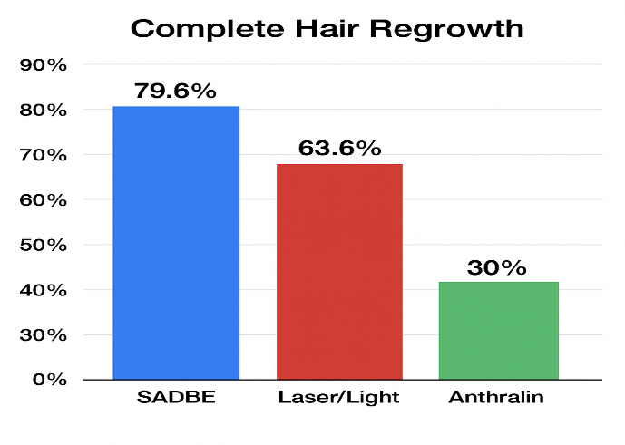
• Average response: 30.8%
Figure 1. Complete and Average Hair Regrowth by Therapy
• SADBE (Topical Immunotherapy): Average response 53.8%
• Laser/Light Therapy: Average response 52.6%
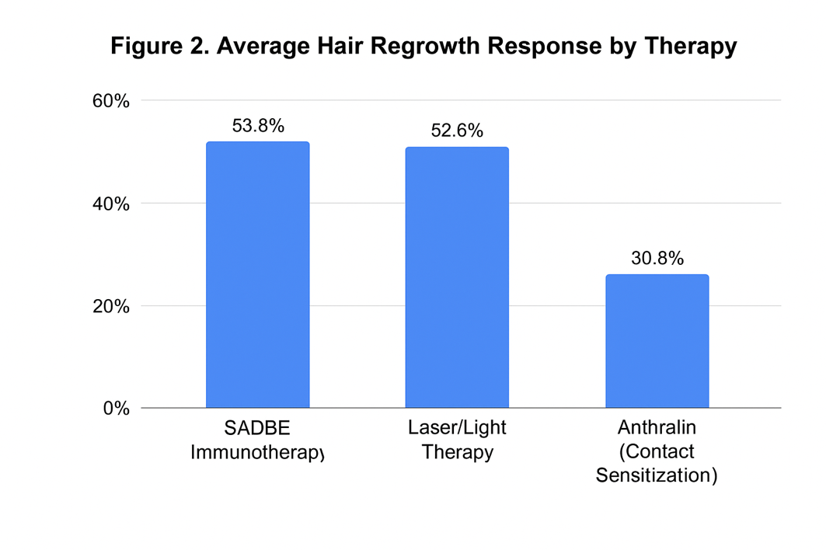
• Anthralin (Contact Sensitization): Average response 30.8%

Discussion
This systematic review and meta-analysis illustrate the unexplained and varied effects of alopecia in ulcerative colitis patients undergoing biologic therapy. The degree of hair regrowth associated with both Ustekinumab and vedolizumab was highly variable, with some patients experiencing almost complete regrowth and others paradoxically worsening. Pooled data suggests that in active therapy, patients achieved hair regrowth at a very high and statistically significant rate, with much higher odds of achieving SALT ≥50 compared to controls, indicating possible therapeutic alopecia and biologic effects. Still, the relapse rate was higher across all modalities, particularly after topical immunotherapy, indicating the persistent and recurrent nature of alopecia areata.

Interpretation of Findings
Promising Ustekinumab outcomes in the pediatric population, particularly improvement in SALT scores, suggests that IL-12/23 inhibitors offer potential benefits. The paradox of frontal fibrosing alopecia progression during treatment equally emphasizes inconsistent outcomes and paradoxical effects. Better known as a gut-selective integrin blocker, vedolizumab also has perplexing dermatologic effects. While some patients with alopecia developed paradoxical psoriasis, others enjoyed remission of skin lesions. Such outcomes indicate the potential of biologics to influence the interconnected immune pathways of the gut and skin, perhaps offering therapeutic benefits in some circumstances and worsening the disease in others.

Comparison with Previous Literature
Our results are consistent with earlier reviews that indicate superior and more predictable outcomes with SADBE topical immunotherapy and laser/light therapy, where complete rates of regrowth surpassed 60%. In contrast, biologics show less reliability. Previous studies indicated that Ustekinumab could reverse anti-TNF–induced skin reactions in inflammatory bowel disease, but the emergence of alopecia during treatment complicates this interpretation. Likewise, vedolizumab has generally been considered safe for ulcerative colitis; however, the occurrence of paradoxical dermatologic reactions highlights the importance of careful monitoring.
Implications
Treatment strategies must take into account the potential for paradoxical side effects from biologic therapy (such as worsening alopecia or psoriasis) and stress the importance of careful, continuous monitoring, particularly when treating concurrent autoimmune disease or changing medicines.
Until biologics show more dependability, topical immunotherapy and laser/light therapy should continue to be at the forefront of AA care strategies because they continue to produce the most consistent rates of regrowth (over 60%).
The frequent relapses, particularly evident with topical immunotherapy, underscore the need for ongoing follow-up care and patient education regarding the chronic, recurrent nature of alopecia.
Since treatments that target one pathway may have unanticipated effects on other pathways, integrating multidisciplinary teams (gastroenterology, dermatology, and immunology) could maximize therapy for patients with IBD and dermatologic problems.
In order to improve clinical significance and enable more reliable meta-analyses, researchers and clinicians should record dermatologic outcomes as primary endpoints rather than merely secondary measures in future trials.

Conclusion
In conclusion, this systematic review and meta-analysis demonstrate that the effects of Ustekinumab and Vedolizumab on alopecia in patients with ulcerative colitis are heterogeneous, with outcomes ranging from notable improvement to paradoxical worsening. The limited sample sizes, short follow-up durations, and heterogeneity across studies restrict the ability to draw definitive conclusions regarding long-term efficacy, safety, and relapse rates. Despite these limitations, the findings highlight the potential therapeutic role of biologics in selected cases and underscore the importance of cautious patient monitoring. Future large-scale, randomized controlled trials with extended follow-up are essential to establish the durability of treatment responses and clarify the clinical significance of these therapies in alopecia areata associated with ulcerative colitis.

Limitations
Several limitations must be considered. First, the evidence included was heterogeneous in design, spanning from single case reports to systematic reviews, which limited the reliability of pooled estimates. Second, follow-up periods were often brief, hindering conclusions about the longevity of hair regrowth. Third, sample sizes were frequently small and retrospective, raising the likelihood of bias. Finally, dermatologic outcomes were often reported as secondary endpoints, which may downplay their clinical significance.

Future research
Given the limited long-term follow-up data, conduct prospective trials to evaluate the durability of hair regrowth and relapse rates for newer biologic therapies such as ustekinumab and vedolizumab.
Examine the immunological processes that underlie paradoxical reactions, which appear to happen randomly and may indicate intertwined immune pathways between the gut and the skin (e.g., psoriasis development or worsened alopecia during biologic treatment).
Since children seem to respond differently to immune modulation, design comparative studies with a focus on pediatric populations. In particular, investigate why IL-12/23 inhibitors can occasionally result in noticeable changes in SALT scores.
The relevance of interleukin pathways, particularly IL-23 and IL-12B, and their receptors in the development of disease and the response to treatment is still unclear, particularly in younger people, and requires more investigation.
Given that patchy hair loss has substantial implications beyond physical symptoms and that enhanced regrowth may significantly improve patient quality of life, more research should evaluate the psychological and social effects of varying treatment responses for AA.

References
- Gaumond, S. I., Kamholtz, I., & Jimenez, J. J. (2025). Cytokine-Targeting Biologic Therapies for Alopecia Areata: A Comprehensive Review of Mechanism of Action, Clinical Efficacy, and Adverse Events. Biologics, 5(2), 11. https://doi.org/10.3390/biologics502001

- Zhao, H., Zhang, Y., Qiang, Y., Wang, G., Wang, L., Jiang, W., & Chen, X. From Mechanisms to Therapies: Current Advances and Breakthroughs in Alopecia Areata Immunopathology. Frontiers in Immunology, 16, 1621492.‏

- King, A. D., Lam, L., & Goh, C. (2019). Onset of frontal fibrosing alopecia during inhibition of Th1/17 pathways with ustekinumab. Dermatology Online Journal, 25(7), 11.

- Andrisani, G., Marzo, M., Celleno, L., Guidi, L., Papa, A., Gasbarrini, A., & Armuzzi, A. (2013). Development of psoriasis scalp with alopecia during treatment of Crohn’s disease with infliximab and rapid response to both diseases to ustekinumab. European Review for Medical and Pharmacological Sciences, 17(20), 2831–2836.

- Aleisa A, Lim Y, Gordon S, Her MJ, Zancanaro P, Abudu M, et al. Response to ustekinumab in three pediatric patients with alopecia areata and atopic comorbidities. Pediatr Dermatol. 2018;35(5):e307–e310. doi:10.1111/pde.13633.

- King AD, Lam L, Goh C. Onset of frontal fibrosing alopecia during inhibition of Th1/17 pathways with ustekinumab. Dermatol Online J. 2019;25(7):11.

- Lee S, Kim BJ, Lee YB. Hair Regrowth Outcomes of Contact Immunotherapy for Alopecia Areata: A Systematic Review and Meta-analysis. JAMA Dermatol. 2018;154(10):1145–1151. doi:10.1001/jamadermatol.2018.2427.

- Behrangi E, et al. A systematic review on the treatment of pediatric alopecia areata. J Cosmet Dermatol. 2022;21(2):584–593. doi:10.1111/jocd.14615.

- Waśkiel-Burnat A, et al. Therapeutic management in pediatric alopecia areata: A systematic review. J Eur Acad Dermatol Venereol. 2021;35(9):e583–e586. doi:10.1111/jdv.17467.

- Barton VR, et al. Treatment of pediatric alopecia areata: A systematic review. J Am Acad Dermatol. 2022;86(2):397–407. doi:10.1016/j.jaad.2021.03.040.

- Ezzedine K, et al. Ustekinumab for skin reactions associated with inflammatory bowel disease: a retrospective study. J Dermatol. 2019;46(9):770–776. doi:10.1111/1346-8138.15029.

- Kikuchi K, et al. Two cases in which tofacitinib effectively treated refractory alopecia areata. Clin J Gastroenterol. 2020;13(6):1270–1275. doi:10.1007/s12328-020-01189-9.

- Dolinger M, et al. Outcomes of Children with Inflammatory Bowel Disease and Anti-TNF Induced Skin Reactions after Switch to Ustekinumab or Vedolizumab: A Retrospective Cohort Study. J Crohns Colitis. 2022;16(6):859–866. doi:10.1093/ecco-jcc/jjab230.

- Verros C, et al. Alopecia areata during ustekinumab administration: case report. Dermatol Online J. 2012;18(8):14.

- Tabatabaei-Panah PS, et al. IL12B and IL23R polymorphisms are associated with alopecia areata. Genes Immun. 2020;21(1):15–22. doi:10.1038/s41435-019-0077-5.

- Suárez-Fariñas M, et al. Alopecia areata profiling shows TH1, TH2, and IL-23 upregulation and the emergence of novel cytokine pathways. J Allergy Clin Immunol. 2015;136(2):370–378. doi:10.1016/j.jaci.2015.01.026.

- Jung, J. M., Yang, H. J., Lee, W. J., Won, C. H., Lee, M. W., & Chang, S. E. (2022). Association between psoriasis and alopecia areata: A systematic review and meta‐analysis. The Journal of Dermatology, 49(9), 912-915.

- Cruz, S., Lei, D. K., Carr, H., & Rosenblatt, A. (2023). The psychosocial impacts of vitiligo, psoriasis, and alopecia areata on pediatric patients. Dermatology Online Journal, 29(2).

- Gros, B., & Kaplan, G. G. (2023). Ulcerative colitis in adults: a review. Jama, 330(10), 951-965.

- Nakase, H., Sato, N., Mizuno, N., & Ikawa, Y. (2022). The influence of cytokines on the complex pathology of ulcerative colitis. Autoimmunity reviews, 21(3), 103017.

