MOLECULAR DOCKING ANALYSIS OF PHYTOCHEMICALS CONTAINED IN MENTHA SPICATA USED IN THE MANAGEMENT OF PCOS

.
ABSTRACT

Aims: Polycystic Ovary Syndrome (PCOS) is an endocrine disorder that primarily affects women of reproductive age, associated with hormonal imbalances and metabolic irregularities, often leading to various health complications. PCOS is associated with elevated levels of androgens, which are male hormones that women also produce, and this hormonal imbalance can result in various symptoms such as irregular menstruation, excessive hair growth, acne, and even infertility. Some herbal plants have shown promise in managing PCOS symptoms due to their anti-androgenic and anti-inflammatory properties. Spearmint (Mentha spicata) has long been recognized for its potential therapeutic properties in managing PCOS. Therefore, this study aimed at investigating the phytochemicals in Mentha spicata that specifically targets specific key protein molecules associated with PCOS using Molecular docking analysis.
Methodology: The target proteins used in this study were: androgen receptor, FSH receptor, LHCG receptor, Insulin receptor and Anti-mullerian hormone
Results: The results revealed potential binding affinities and interaction patterns, highlighting spearmint's role in the management of PCOS. The analysis identified oleanolic acid as the phytochemical with the best binding affinity across all five proteins used in the study amongst others. This suggests that oleanolic acid may be a good candidate of spearmint in targeting the key proteins associated with PCOS, potentially helping to reduce the effects of the condition. These findings are consistent with previous research showing that spearmint may have anti-androgenic effects.
Conclusion: While the results of this molecular docking analysis seem promising, it is important to note that these findings are computational. Further in vitro and in vivo experiments are needed to validate these computational findings.

Keywords: Mentha spicata, Molecular Docking, Polycystic Ovary Syndrome, Target Proteins.

1. INTRODUCTION

Polycystic ovary syndrome (PCOS) is an endocrine gynecological disorder that affects many women of childbearing age (Sadeghi et al., 2022). It is a condition in which the ovaries produce an abnormal amount of androgens, which are male sex hormones that are usually present in small amounts in women (Allah and Jwaid, 2023). Polycystic ovary syndrome (PCOS) is characterized by hormonal imbalances, particularly insulin resistance and elevated androgen levels in women. The condition leads to a range of systems, and it can have significant impact on women’s health, reproductive system and overall well-being. PCOS can cause menstrual irregularities, such as irregular or absent periods, which can lead to difficulties in conception (Singh et al., 2023).
In recent times, healthcare professionals have increasingly turned to herbal medicines as a significant approach to treating PCOS. Herbal medicines consist of extracts from entire plants or specific parts of a plant that demonstrate notable therapeutic effects while causing fewer side effects compared to conventional therapies (Abasian et al., 2018). Different herbs act against PCOS through various mechanisms, such as reducing prolactin levels, exhibiting anti-androgenic activity, promoting follicle stimulating hormone (FSH), reducing luteinizing hormone (LH), inducing ovulation, and restoring glucose sensitivity, estrus cyclicity, and enzyme activity (Lakshmi et al., 2023).
Previous studies have suggested that spearmint may have positive effects on hormonal regulation, insulin sensitivity, and PCOS symptoms (Akdoğan et al., 2007; Grant, 2010; Ataabadi et al., 2017). Some studies have indicated that consuming spearmint tea or extract may lead to improvements in menstrual regularity, hormonal balance, and reductions in androgen levels (Akdoğan et al., 2007; Grant, 2010). Despite these promising findings, the exact mechanisms underlying the potential benefits of spearmint in PCOS management remains poorly understood. The existing literature on the potential effects of spearmint on PCOS is somewhat fragmented and there is no comprehensive research investigating the individual phytochemicals present in spearmint and their specific roles in hormonal regulation and symptom relief for PCOS. Hence, there is a pressing need for more comprehensive research to identify and characterize the specific phytochemicals in spearmint responsible for its therapeutic effects on PCOS.

2. experimental details

2.1. The biological target proteins structures used for this study
Insulin receptor (1QQG), anti-müllerian hormone (7LOJ), luteinizing hormone / choriogonadotropin receptor (7FIJ), androgen receptor (8E1A) and follicle stimulating hormone receptor (812H).

2.2. Data Collection
A comprehensive literature review was conducted to identify the reported phytochemicals in spearmint using the google scholar database. The phytochemicals components of M. spicata were retrieved on 25th July, 2023 from a journal titled “The traditional uses, Phytochemistry and pharmacology of Spearmint (Mentha spicata L.): A review” by Mahendran et al., 2021.
2.3. Database Search
The chemical database, PubChem was explored to access information on the phytochemicals of spearmint gotten from the journal. The molecular weight, structure, formula and biological activity with its corresponding reference were obtained and put in an Excel spreadsheet.
2.4. Phytochemicals Structure Retrieval
The 3D molecular structures of the phytochemicals were retrieved from the chemical databases (PubChem).
2.5. Biological Target Proteins Structures Retrieval
The 3D structure for relevant biological targets proteins involved in PCOS were retrieved from the protein database (www.rcsb.org).
2.6. Screening of Phytochemicals
The 3D structures of the phytochemicals were opened using BIOVIA and saved in a SMILE format. The SMILE format of the phytochemical which is gotten from BIOVIA was inputted in the pkCSM site (https://biosig.lab.uq.edu.au/pkcsm/) and checked for its ADMET properties. The phytochemicals were screened based on Lipinski’s rule of five parameters: molecular weight; log P, number of hydrogen bond donors and number of hydrogen bond acceptors which was gotten obtained from pkCSM site. Phytochemicals with more three and more violations were screened out. This was to assess their drug-likeness.
2.7. Purification of Biological Target Proteins
The structures retrieved were opened in BIOVIA and the heteroatoms were deleted. This ensures that the pure protein form was obtained.
2.8. Molecular Docking
Molecular docking was carried out using AutoDock and AutoDock Vina to predict the interactions between the identified phytochemicals and relevant biological targets implicated in PCOS pathogenesis. A grid box was configured to encompass the entire area, guaranteeing full coverage of the active site, with grid parameters recorded.
The docking results showing the binding affinity for each target protein were recorded in an Excel data sheet with each row representing a phytochemical, and docking score. Phytochemicals were ranked based on their docking scores, with those achieving the lowest (most negative) scores being prioritized as potential drug candidates.
2.9. Visual Analysis of Docking Complexes
The docking complexes were visualized using BIOVIA to gain insights into the binding mode and interactions (hydrogen bonding/ hydrophobic contacts) between the phytochemicals and the target proteins. The interaction of the protein and ligand was seen using BIOVIA and the possible binding amino acid residue sites were seen too.

3. results and discussion

Data Collection
A total of thirty-five (35) phytochemical constituents were identified from various parts of M. spicata, which fell into the categories of phenolic acids, flavonoids and lignans. Furthermore, three (3) common chemical constituents belonging to terpenoids were identified in spearmint essential oil from different geographic regions. Hence, a total of thirty-seven (37) phytochemicals were analyzed further in this study. Spicatolignan A was excluded from the analysis due to a lack of molecular information.
The phytochemical library showcasing the bioactive compounds identified in the medicinal plant M. spicata is shown in Table 1. These compounds exhibit diverse biological activities, some of which can potentially alleviate the symptoms associated with Polycystic Ovary Syndrome (PCOS). Notable among these activities are antioxidant properties, anti-inflammatory effects, anti-tumor potential and anti-diabetic properties, among others. The Lipinski properties of each compound in the phytochemical library are presented in Table 2. This screening of phytochemicals considered the severity of three and more rule violations, leading to the exclusion of Linarin, Didymin, Hesperidin, Rutin, Diosmin, and Naringin from further analysis.

Table 1: Phytochemicals library showing the bioactive compounds identified in M. spicata
S/N | Name of Compound | Molecular Weight (g/mol) | Molecular Structure | Molecular Formula | Biological Activity |  | Reference
PHENOLIC ACIDS
1 | Rosmarinic acid | 360.3 | 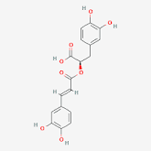 | C₁₈H₁₆O₈ | Antiviral, antibacterial, anticancer, antioxidant, anti-aging, antidiabetic, cardioprotective, hepatoprotective, nephroprotective, antidepressant, antiallergic, and anti-inflammatory activities. |  | National Center for Biotechnology Information (2023). PubChem Compound Summary for CID 5281792, Rosmarinic acid. Retrieved July 16, 2023 from https://pubchem.ncbi.nlm.nih.gov/compound/Rosmarinic-acid.
2 | Caffeic acid | 180.16 | 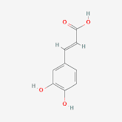 | C₉H₈O₄ | Antioxidants |  | National Center for Biotechnology Information (2023). PubChem Compound Summary for CID 689043, Caffeic Acid. Retrieved July 16, 2023 from https://pubchem.ncbi.nlm.nih.gov/compound/Caffeic-Acid.
3 | p-Coumaric acid | 164.16 | 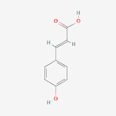 | C₉H₈O₃ | Anti-Infective, Male Contraceptive, Free Radical Scavengers, Antioxidants |  | National Center for Biotechnology Information (2023). PubChem Compound Summary for CID 637542, p-Coumaric acid. Retrieved July 16, 2023 from https://pubchem.ncbi.nlm.nih.gov/compound/p-Coumaric-acid.
4 | Syringic acid | 198.17 | 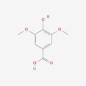 | C₉H₁₀O₅ | Anti-oxidant, antimicrobial, anti-inflammatory, antiendotoxic, neuro and hepatoprotective activities. |  | National Center for Biotechnology Information (2023). PubChem Compound Summary for CID 10742, Syringic acid. Retrieved July 16, 2023 from https://pubchem.ncbi.nlm.nih.gov/compound/Syringic-acid.
5 | Cinnamic acid | 148.16 | 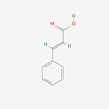 | C₉H₈O₂ | Anti-diabetic, Hepatoprotective, Anticancer,Antimicrobial, Anti-inflammatory and Antioxidant activity |  | National Center for Biotechnology Information (2023). PubChem Compound Summary for CID 444539, Cinnamic acid. Retrieved July 16, 2023 from https://pubchem.ncbi.nlm.nih.gov/compound/Cinnamic-acid.
6 | Ferulic acid | 194.18 | 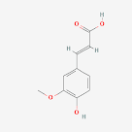 | C₁₀H₁₀O₄ | Anticoagulants, anti-Inflammatory agent, antihypertensive agent. |  | National Center for Biotechnology Information (2023). PubChem Compound Summary for CID 445858, Ferulic acid. Retrieved July 16, 2023 from https://pubchem.ncbi.nlm.nih.gov/compound/Ferulic-acid.
7 | Gallic acid | 170.12 | 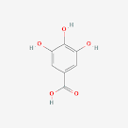 | C₇H₆O₅ | Antioxidants, anti-bacteria |  | National Center for Biotechnology Information (2023). PubChem Compound Summary for CID 370, Gallic Acid. Retrieved July 16, 2023 from https://pubchem.ncbi.nlm.nih.gov/compound/Gallic-Acid.
8 | Oleanolic acid | 456.7 | 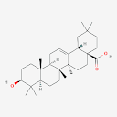 | C₃₀H₄₈O₃ | Anti-oxidant, anti-tumor, anti-inflammatory, anti-diabetic, anti-microbial and hepatoprotective effect |  | National Center for Biotechnology Information (2023). PubChem Compound Summary for CID 10494, Oleanolic Acid. Retrieved July 16, 2023 from https://pubchem.ncbi.nlm.nih.gov/compound/Oleanolic-Acid.
9 | Sinapic acid | 224.21 | 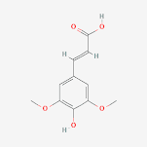 | C₁₁H₁₂O₅ | Antioxidant, antimicrobial, anti-inflammatory, anticancer, and anti-anxiety activity |  | National Center for Biotechnology Information (2023). PubChem Compound Summary for CID 637775, Sinapinic acid. Retrieved July 17, 2023 from https://pubchem.ncbi.nlm.nih.gov/compound/Sinapinic-acid.
10 | Phloretic acid | 166.17 | 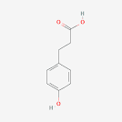 | C₉H₁₀O₃ | Antioxidant |  | National Center for Biotechnology Information (2023). PubChem Compound Summary for CID 10394, 3-(4-Hydroxyphenyl)propionic acid. Retrieved July 17, 2023 from https://pubchem.ncbi.nlm.nih.gov/compound/3-_4-Hydroxyphenyl_propionic-acid.
11 | Vanillic acid | 168.15 | 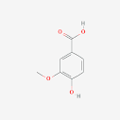 | C₈H₈O₄ | Anticancer, antiobesity, antidiabetic, antibacterial, anti-inflammatory, and antioxidant effects | National Center for Biotechnology Information (2023). PubChem Compound Summary for CID 8468, Vanillic Acid. Retrieved July 17, 2023 from https://pubchem.ncbi.nlm.nih.gov/compound/Vanillic-Acid.
12 | Chlorogenic acid | 354.31 | 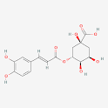 | C₁₆H₁₈O₉ | Anti-oxidant, anti-bacterial and anti-tumor, anti-inflammatory activity. |  | National Center for Biotechnology Information (2023). PubChem Compound Summary for CID 1794427, Chlorogenic Acid. Retrieved July 17, 2023 from https://pubchem.ncbi.nlm.nih.gov/compound/Chlorogenic-Acid.
13 | Hydroxybenzoic acid | 138.12 | 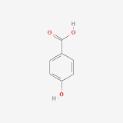 | C₇H₆O₃ | Anti-oxidant and emulsifier |  | National Center for Biotechnology Information (2023). PubChem Compound Summary for CID 135, 4-Hydroxybenzoic acid. Retrieved July 17, 2023 from https://pubchem.ncbi.nlm.nih.gov/compound/4-Hydroxybenzoic-acid.

S/N | Name of Compound | Molecular Weight (g/mol) | Molecular Structure | Molecular Formula | Biological Activity | Reference
FLAVONOIDS
14 | Hesperidin | 610.6 | 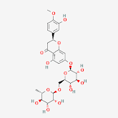 | C₂₈H₃₄O₁₅ | Antioxidant, antibacterial, antimicrobial, anti-inflammatory and anticarcinogenic properties | National Center for Biotechnology Information (2023). PubChem Compound Summary for CID 10621, Hesperidin. Retrieved July 17, 2023 from https://pubchem.ncbi.nlm.nih.gov/compound/Hesperidin.
15 | Didymin | 594.6 | 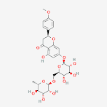 | C₂₈H₃₄O₁₄ | Anti-inflammatory, antioxidant, and anticancer properties. | National Center for Biotechnology Information (2023). PubChem Compound Summary for CID 16760075, Didymin. Retrieved July 17, 2023 from https://pubchem.ncbi.nlm.nih.gov/compound/Didymin.
16 | Linarin | 592.5 | 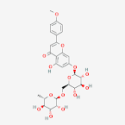 | C₂₈H₃₂O₁₄ | Anti-inflammatory, antitumor, antioxidant, antibacterial, sedation, analgesia, and antihypertension effect. | National Center for Biotechnology Information (2023). PubChem Compound Summary for CID 5317025, Linarin. Retrieved July 17, 2023 from https://pubchem.ncbi.nlm.nih.gov/compound/Linarin.
17 | Apigenin | 270.24 | 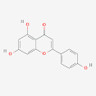 | C₁₅H₁₀O₅ | Antioxidants | National Center for Biotechnology Information (2023). PubChem Compound Summary for CID 5280443, Apigenin. Retrieved July 17, 2023 from https://pubchem.ncbi.nlm.nih.gov/compound/Apigenin.
18 | Luteolin-7-O-glucoside | 448.4 | 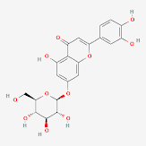 | C₂₁H₂₀O₁₁ | Anti-inflammatory and antioxidative activity. | National Center for Biotechnology Information (2023). PubChem Compound Summary for CID 5280637, Luteolin 7-O-glucoside. Retrieved July 17, 2023 from https://pubchem.ncbi.nlm.nih.gov/compound/Luteolin-7-O-glucoside.
19 | Diosmin | 608.5 | 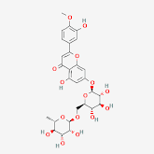 | C₂₈H₃₂O₁₅ | Antioxidants | National Center for Biotechnology Information (2023). PubChem Compound Summary for CID 5281613, Diosmin. Retrieved July 17, 2023 from https://pubchem.ncbi.nlm.nih.gov/compound/Diosmin.
20 | Luteolin | 286.24 | 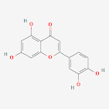 | C₁₅H₁₀O₆ | Anti-oxidant, anti-inflammatory, anti-microbial, anti-cancer, anti-diabetic, neuroprotective, anti-allergic and cardioprotective activity. | National Center for Biotechnology Information (2023). PubChem Compound Summary for CID 5280445, Luteolin. Retrieved July 17, 2023 from https://pubchem.ncbi.nlm.nih.gov/compound/Luteolin.
21 | Cirsilineol | 344.3 | 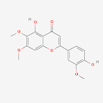 | C₁₈H₁₆O₇ | Antiproliferative, gastroprotective, anti-Helicobacter pylori, anti-diabetic and anti-oxidant activity. | National Center for Biotechnology Information (2023). PubChem Compound Summary for CID 162464, Fastigenin. Retrieved July 17, 2023 from https://pubchem.ncbi.nlm.nih.gov/compound/Fastigenin.
22 | Desmethylnobiletin | 388.4 | 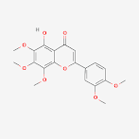 | C₂₀H₂₀O₈ | Antioxidant | National Center for Biotechnology Information (2023). PubChem Compound Summary for CID 358832, 5-o-Desmethylnobiletin. Retrieved July 17, 2023 from https://pubchem.ncbi.nlm.nih.gov/compound/5-o-Desmethylnobiletin.
23 | Thymusin | 330.29 | 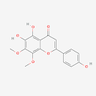 | C₁₇H₁₄O₇ | Antimicrobial activity | National Center for Biotechnology Information (2023). PubChem Compound Summary for CID 628895, Thymusin. Retrieved July 17, 2023 from https://pubchem.ncbi.nlm.nih.gov/compound/Thymusin.
24 | Sideritoflavone | 360.3 | 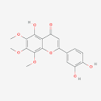 | C₁₈H₁₆O₈ | Anti-inflammatory, antioxidant, and anti-cancer properties | National Center for Biotechnology Information (2023). PubChem Compound Summary for CID 155493, Sideritoflavone. Retrieved July 17, 2023 from https://pubchem.ncbi.nlm.nih.gov/compound/Sideritoflavone.
25 | Thymonin | 360.3 | 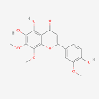 | C₁₈H₁₆O₈ | Anti-microbial activity | National Center for Biotechnology Information (2023). PubChem Compound Summary for CID 442662, Thymonin. Retrieved July 17, 2023 from https://pubchem.ncbi.nlm.nih.gov/compound/Thymonin.
26 | Naringenin | 272.25 | 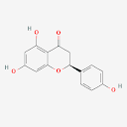 | C₁₅H₁₂O₅ | Anti-ulcer agents, estrogen antagonists | National Center for Biotechnology Information (2023). PubChem Compound Summary for CID 439246, Naringenin. Retrieved July 17, 2023 from https://pubchem.ncbi.nlm.nih.gov/compound/Naringenin.
27 | Naringin | 580.5 | 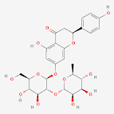 | C₂₇H₃₂O₁₄ | Antioxidant, antitumor, antiviral, antibacterial, anti-inflammatory, antiadipogenic and cardioprotective activities. | National Center for Biotechnology Information (2023). PubChem Compound Summary for CID 442428, Naringin. Retrieved July 17, 2023 from https://pubchem.ncbi.nlm.nih.gov/compound/Naringoside.
28 | Quercetin | 302.23 | 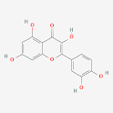 | C₁₅H₁₀O₇ | Antioxidant | National Center for Biotechnology Information (2023). PubChem Compound Summary for CID 5280343, Quercetin. Retrieved July 18, 2023 from https://pubchem.ncbi.nlm.nih.gov/compound/Quercetin.
29 | Kaempferol | 286.24 | 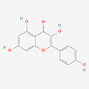 | C₁₅H₁₀O₆ | Selective estrogen receptor modulator, antioxidant | National Center for Biotechnology Information (2023). PubChem Compound Summary for CID 5280863, Kaempferol. Retrieved July 18, 2023 from https://pubchem.ncbi.nlm.nih.gov/compound/Kaempferol.
30 | Myricetin | 318.23 | 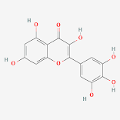 | C₁₅H₁₀O₈ | Cyclooxygenase 1 inhibitor, an antineoplastic agent, an antioxidant, a hypoglycemic agent and a geoprotector. | National Center for Biotechnology Information (2023). PubChem Compound Summary for CID 5281672, Myricetin. Retrieved July 18, 2023 from https://pubchem.ncbi.nlm.nih.gov/compound/Myricetin.
31 | Rutin | 610.5 | 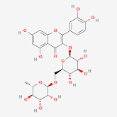 | C₂₇H₃₀O₁₆ | Antioxidant | National Center for Biotechnology Information (2023). PubChem Compound Summary for CID 5280805, Rutin. Retrieved July 18, 2023 from https://pubchem.ncbi.nlm.nih.gov/compound/Rutin.
32 | Catechin | 290.27 | 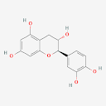 | C₁₅H₁₄O₆ | Antioxidant | National Center for Biotechnology Information (2023). PubChem Compound Summary for CID 9064, Cianidanol. Retrieved July 18, 2023 from https://pubchem.ncbi.nlm.nih.gov/compound/Cianidanol.
33 | Epicatechin | 290.27 | 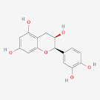 | C₁₅H₁₄O₆ | Antioxidant | National Center for Biotechnology Information (2023). PubChem Compound Summary for CID 72276, Epicatechin. Retrieved July 18, 2023 from https://pubchem.ncbi.nlm.nih.gov/compound/Epicatechin.

S/N | Name of Compound | Molecular Weight (g/mol) | Molecular Structure | Molecular Formula | Biological Activity | Reference
LIGNANS
34 | Spicatolignan B | 372.4 | 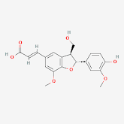 | C₂₀H₂₀O₇ | Antioxidant and anti-inflammatory activity. | National Center for Biotechnology Information (2023). PubChem Compound Summary for CID 38356815, (2R,3S)-glycosmisic acid. Retrieved July 20, 2023 from https://pubchem.ncbi.nlm.nih.gov/compound/2R_3S_-glycosmisic-acid.
TERPENOIDS
35 | Carvone | 150.22 | 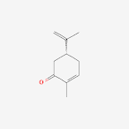 | C₁₀H₁₄O | Antimicrobial, anticancer, anti-inflammatory, antidiabetic and neurological activity. | National Center for Biotechnology Information (2023). PubChem Compound Summary for CID 7439, Carvone, (+/-)-. Retrieved July 26, 2023 from https://pubchem.ncbi.nlm.nih.gov/compound/Carvone.
36 | Limonene | 136.23 | 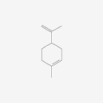 | C₁₀H₁₆ | Antitumor, antiviral, anti-inflammatory, and antibacterial activity. | National Center for Biotechnology Information (2023). PubChem Compound Summary for CID 1254, Menthol. Retrieved July 26, 2023 from https://pubchem.ncbi.nlm.nih.gov/compound/Menthol.
37 | Menthol | 156.26 | 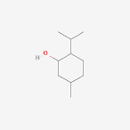 | C₁₀H₂₀O | Anticancer and anti-inflammatory activities. | National Center for Biotechnology Information (2023). PubChem Compound Summary for CID 1254, Menthol. Retrieved July 26, 2023 from https://pubchem.ncbi.nlm.nih.gov/compound/Menthol.

Table 2 : Lipinski’s properties of the phytochemicals identified in M.spicata
S/N | Ligand | Molecular Weight (g/mol ) | logP | No. Acc | No. Donors | No. of Violations (Lipinski's Rule)
1 | Linarin | 592.55 | -0.7953 | 14 | 7 | 3
2 | Didymin | 594.566 | -0.8622 | 14 | 7 | 3
3 | Hesperidin | 610.565 | -1.1566 | 15 | 8 | 3
4 | Rutin | 610.521 | -1.6871 | 16 | 10 | 3
5 | Epicatechin | 290.271 | 1.5461 | 6 | 5 | 0
6 | Oleanolic acid | 456.711 | 7.2336 | 2 | 2 | 1
7 | Diosmin | 608.549 | -1.0897 | 15 | 8 | 3
8 | Cirsilineol | 344.319 | 2.897 | 7 | 2 | 0
9 | Rosmarinic acid | 360.318 | 1.7613 | 7 | 5 | 0
10 | Naringin | 580.539 | -1.1652 | 14 | 8 | 3
11 | Kaempferol | 286.239 | 2.2824 | 6 | 4 | 0
12 | Chlorogenic acid | 354.311 | -0.6459 | 8 | 6 | 1
13 | Quercetin | 302.238 | 1.988 | 7 | 5 | 0
14 | Myricetin | 318.237 | 1.6936 | 8 | 6 | 1
15 | Luteolin-7-O-glucoside | 448.38 | -0.2445 | 11 | 7 | 2
16 | Thymusin | 330.292 | 2.594 | 7 | 3 | 0
17 | Apigenin | 270.24 | 2.5768 | 5 | 3 | 0
18 | Luteolin | 286.239 | 2.2824 | 6 | 4 | 0
19 | Naringenin | 272.256 | 2.5099 | 5 | 3 | 0
20 | Spicatolignan B | 372.373 | 2.7168 | 6 | 3 | 0
21 | Catechin | 290.271 | 1.5461 | 6 | 5 | 0
22 | Thymonin | 360.318 | 2.6026 | 8 | 3 | 0
23 | Cinnamic acid | 148.161 | 1.7844 | 1 | 1 | 0
24 | Limonene | 136.238 | 3.3089 | 0 | 0 | 0
25 | Sideritoflavone | 360.318 | 2.6026 | 8 | 3 | 0
26 | Caffeic acid | 180.159 | 1.1956 | 3 | 3 | 0
27 | Desmethylnobiletin | 388.372 | 3.2086 | 8 | 1 | 0
28 | Gallic acid | 170.12 | 0.5016 | 4 | 4 | 0
29 | Carvone | 150.221 | 2.4879 | 1 | 0 | 0
30 | p-Coumaric acid | 164.16 | 1.49 | 2 | 2 | 0
31 | Ferulic acid | 194.186 | 1.4986 | 3 | 2 | 0
32 | Sinapic acid | 224.212 | 1.5072 | 4 | 2 | 0
33 | Phloretic acid | 166.176 | 1.4094 | 2 | 2 | 0
34 | Hydroxybenzoic acid | 138.122 | 1.0904 | 2 | 2 | 0
35 | Syringic acid | 198.174 | 1.1076 | 4 | 2 | 0
36 | Vanillic acid | 168.148 | 1.099 | 3 | 2 | 0
37 | Menthol | 156.269 | 2.4395 | 1 | 1 | 0

Molecular Docking
The parameters for the grid boxes employed for each protein are detailed and presented in Table 3.
Table 3: Grid box parameters
S/N | TARGET | Center_x | Center_y | Center_z | Size_x | Size_y | Size_z
1 | Androgen Receptor | 19.236 | 6.4 | 12.588 | 108 | 96 | 110
2 | Anti-müllerian Hormone | 6.713 | -15.502 | 13.714 | 102 | 82 | 78
3 | Luteinizing Hormone/ Choriogonadotropin Receptor (LHCGR) | 100.682 | 101.221 | 89.361 | 62 | 84 | 126
4 | Insulin Receptor | 150.027 | 144.969 | 144.878 | 126 | 126 | 126
5 | Follicle Stimulating Hormone Receptor | 109.643 | 107.311 | 95.801 | 90 | 100 | 126

The binding analysis between the target proteins and phytochemicals revealed that the binding pattern varied with the nature of the phytochemicals. Lower docking scores indicate a higher binding affinity. These scores are typically presented in negative valued, with more negative values signifying stronger binding. The results gotten from the docking is recorded in Table 4.
For andogen receptor, docking scores ranged from -8.3kcal/mol to -5kcal/mol. Epicatechin exhibited the highest binding affinity, while menthol had the lowest. Docking scores ranged from -7.9 (oleanolic acid) to -4.5 (sinapic acid) for anti-mullerian hormone (AMH) For luteinizing hormone/choriogonadotropin receptor (LHCGR), the docking scores ranged from -9.6 (oleanolic acid) to -5 (syringic acid). Follicle-stimulating hormone receptor had docking scores that ranged from -10 (oleanolic acid) to -4.9 (menthol). Insulin receptor’s docking scores ranged from -9.5 (oleanolic acid) to -4.2 (hydroxybenzoic acid). This summarizes the results of the molecular docking analysis of biotic compounds from spearmint with various target proteins related to Polycystic Ovary Syndrome (PCOS).

Table 4: Molecular docking score for bioactive compounds with target proteins
 | Binding Affinity (kcal/mol)
S/N | Name of Compound | Androgen Receptor | Anti-müllerian Hormone | Luteinizing Hormone/ Choriogonadotropin Receptor (LHCGR) |  | Insulin Receptor |  |  | Follicle Stimulating Hormone Receptor
1 | Epicatechin | -8.3 | -6.7 | -7.3 |  | -7 |  |  | -7.4
2 | Oleanolic acid | -8.2 | -7.9 | -9.6 |  | -9.5 |  |  | -10
3 | Cirsilineol | -8.2 | -6.5 | -7 |  | -7.6 |  |  | -7.4
4 | Rosmarinic acid | -7.7 | -6.5 | -7.4 |  | -7.6 |  |  | -7.6
5 | Kaempferol | -7.6 | -6.8 | -7.4 |  | -8.1 |  |  | -7.3
6 | Chlorogenic acid | -7.6 | -6.4 | -7.9 |  | -7.5 |  |  | -7.7
7 | Quercetin | -7.5 | -6.9 | -7.4 |  | -7.7 |  |  | -7.3
8 | Myricetin | -7.5 | -6.5 | -7.4 |  | -7.4 |  |  | -7.2
9 | Luteolin-7-O-glucoside | -7.4 | -7 | -8.3 |  | -8.6 |  |  | -8.2
10 | Thymusin | -7.3 | -6.4 | -7.3 |  | -7.3 |  |  | -7.1
11 | Apigenin | -7.2 | -7.2 | -7.5 |  | -8 |  |  | -7.5
12 | Luteolin | -7.2 | -7.1 | -7.5 |  | -7.4 |  |  | -7.4
13 | Naringenin | -7.1 | -6.9 | -7.3 |  | -7.3 |  |  | -7.3
14 | Spicatolignan B | -7 | -7 | -7 |  | -7.4 |  |  | -8
15 | Catechin | -6.9 | -6.6 | -7.2 |  | -7.2 |  |  | -7.4
16 | Thymonin | -6.9 | -6.1 |  | -7.2 |  | -7.4 | -7.3
17 | Cinnamic acid | -6.7 | -4.8 |  | -5.7 |  | -5.8 | -5.3
18 | Limonene | -6.6 | -4.7 |  | -5.6 |  | -6.1 | -5.5
19 | Sideritoflavone | -6.5 | -6.4 |  | -7.3 |  | -8 | -7.1
20 | Caffeic acid | -6.5 | -5.3 |  | -5.8 |  | -5.8 | -5.5
21 | Desmethylnobiletin | -6.3 | -7.1 |  | -6.6 |  | -6.3 | -7
22 | Gallic acid | -6.2 | -5.7 |  | -5.4 |  | -6.1 | -5
23 | Carvone | -5.8 | -4.9 |  | -5.8 |  | -5.9 | -5.5
24 | p-Coumaric acid | -5.7 | -5 |  | -5.7 |  | -6.3 | -5.8
25 | Ferulic acid | -5.6 | -5.5 |  | -6 |  | -6.1 | -5.7
26 | Sinapic acid | -5.6 | -4.5 |  | -5.8 |  | -5.8 | -5.4
27 | Phloretic acid | -5.5 | -4.8 |  | -5.6 |  | -6.1 | -5.4
28 | Hydroxybenzoic acid | -5.4 | -5 |  | -5.3 |  | -5.2 | -5.1
29 | Syringic acid | -5.3 | -5.1 |  | -5 |  | -5.5 | -5.1
30 | Vanillic acid | -5.1 | -5.2 |  | -5.5 |  | -5.3 | -5
31 | Menthol | -5 | -5.1 |  | -5.7 |  | -5.5 | -4.9

The 2D interactions of the first three phytochemicals with the best binding affinity for each target protein is shown from Figure 1 –15
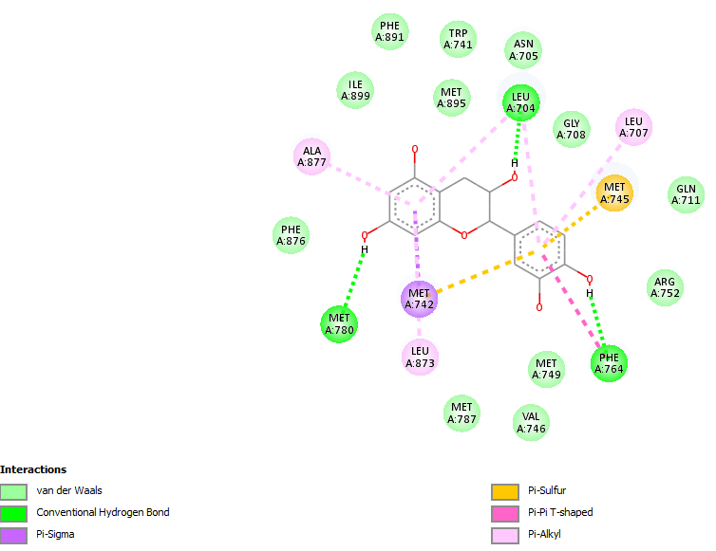
Figure 1: 2D relationship between epicatechin and androgen receptor
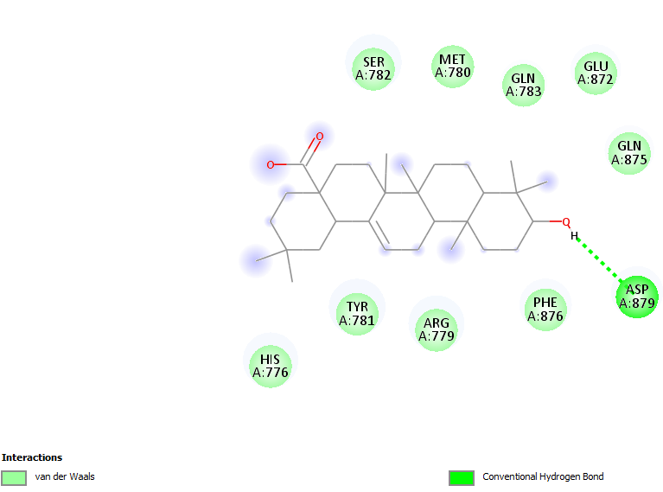
Figure 2 : 2D relationship between oleanolic acid and androgen receptor
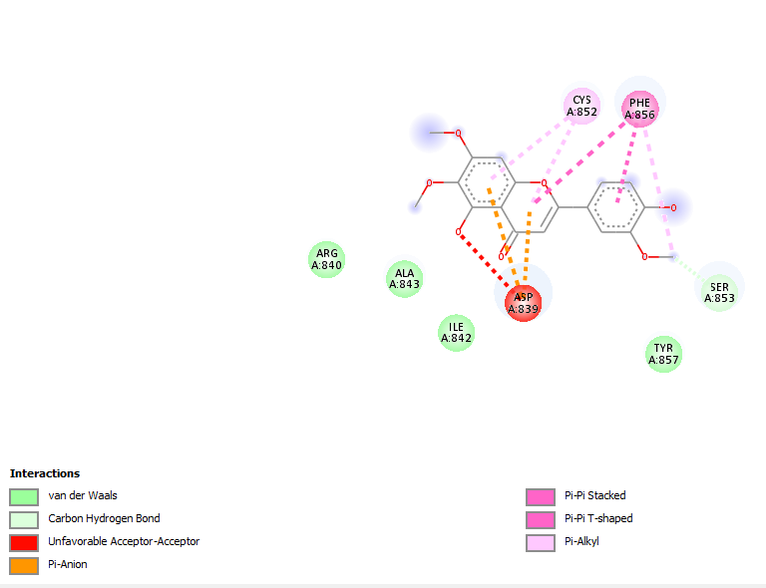
Figure 3: 2D relationship between cirsilineol and androgen receptor

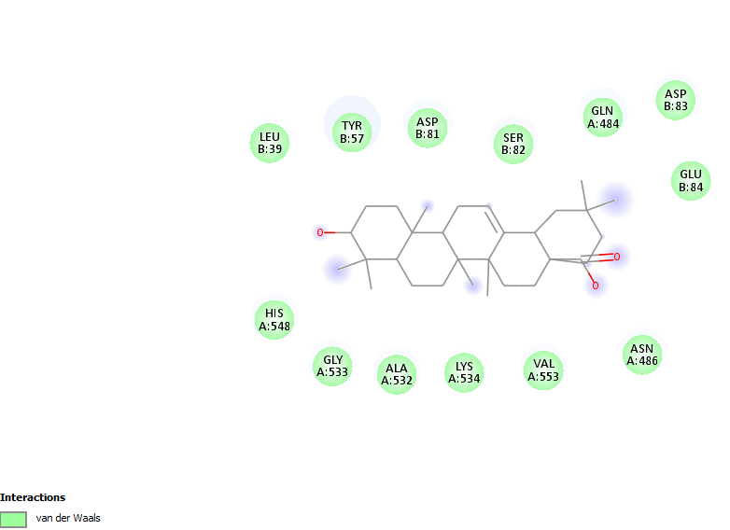

Figure 4 : 2D relationship between oleanolic acid and anti-mullerian hormone
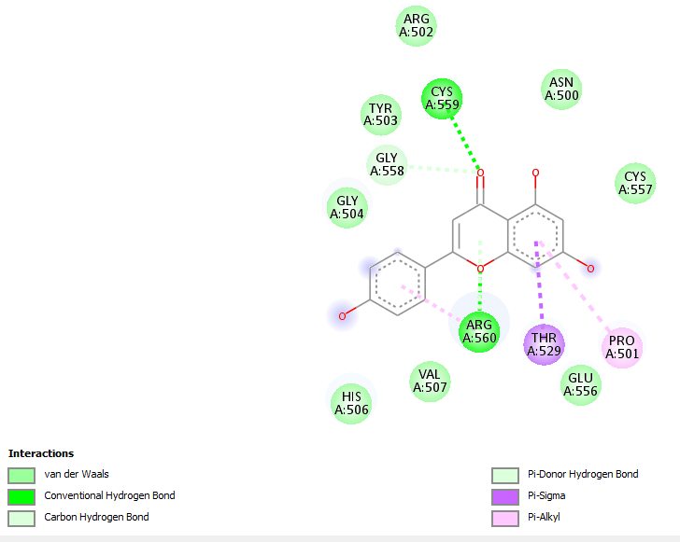
Figure 5: 2D relationship between apigenin and anti-mullerian hormone

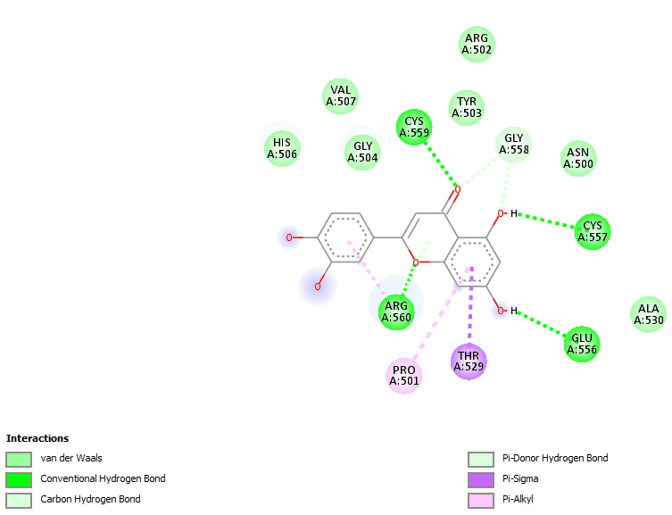
Figure 6: 2D relationship between luteolin and anti-mullerian hormone
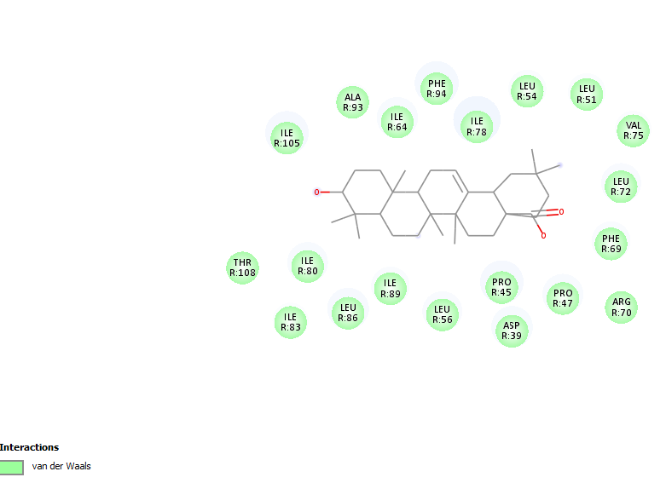
Figure 7: 2D relationship between oleanolic acid and LHCGR
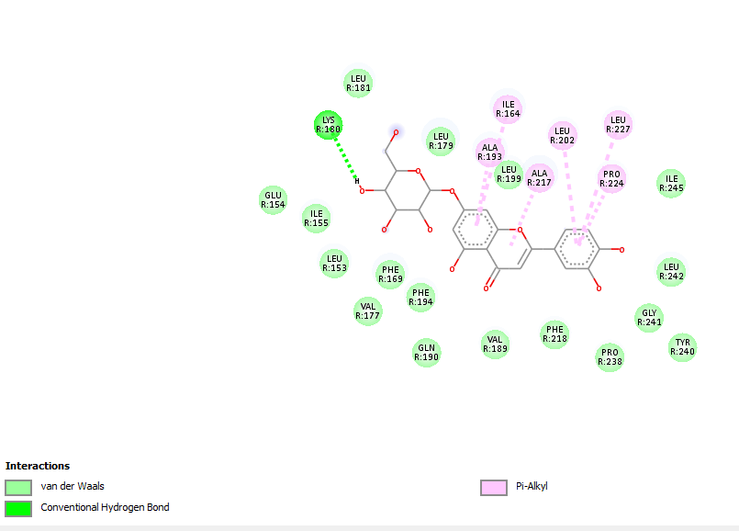
Figure 8: 2D relationship between luteolin-7-O-glucoside and LHCGR
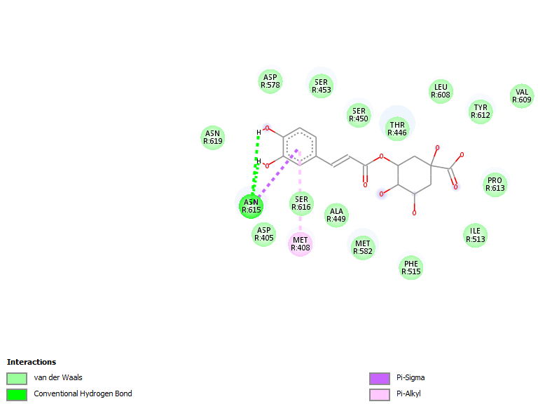
Figure 9: 2D relationship between chlorogenic acid and LHCGR

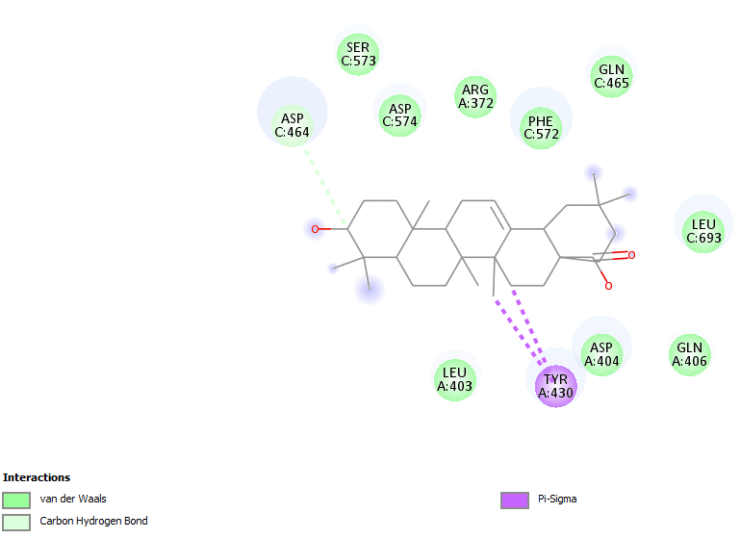
Figure 10: 2D relationship between oleanolic acid and insulin receptor

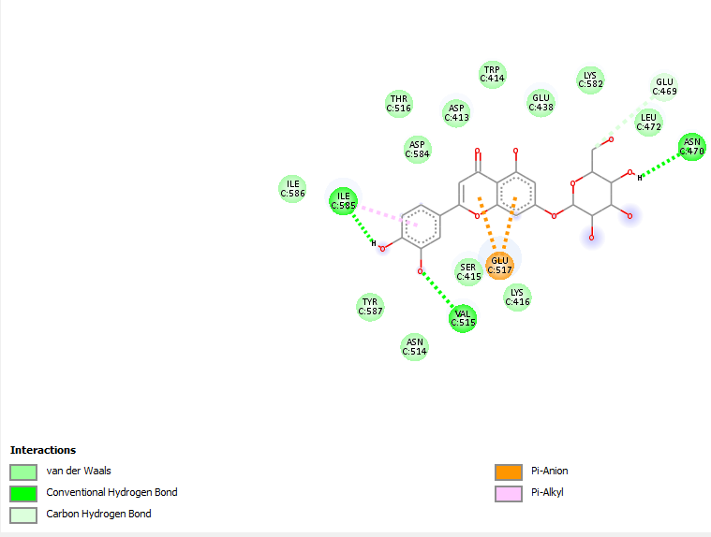
Figure 11: 2D relationship between luteolin-7-O-glucoside and insulin receptor

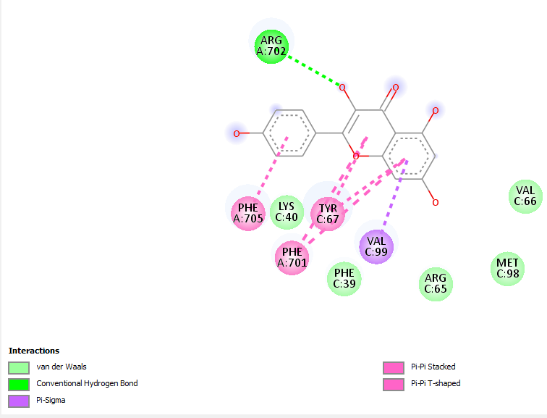
Figure 12: 2D relationship between kaempferol and insulin receptor

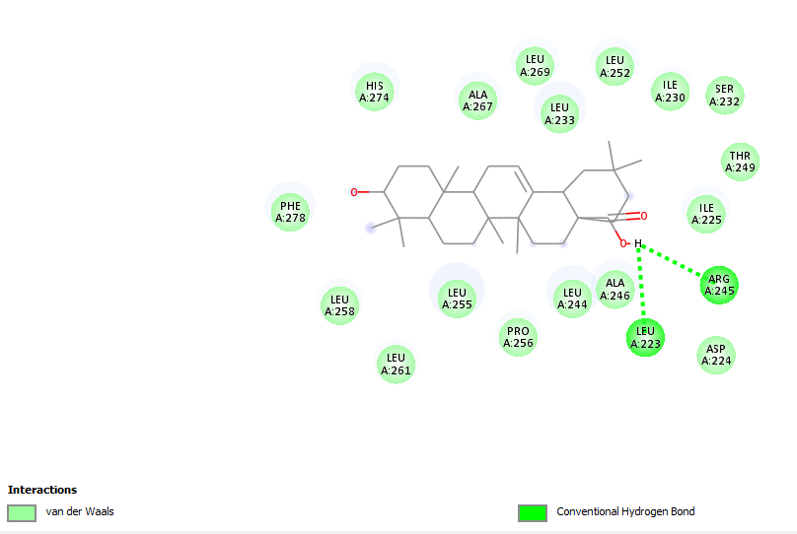
Figure 13: 2D relationship between oleanolic acid and FSHR
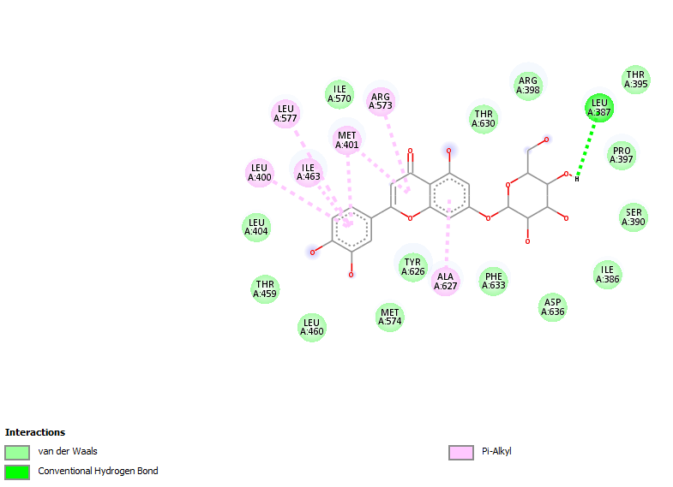
Figure 14: 2D relationship between luteolin-7-O-glucoside and FSHR

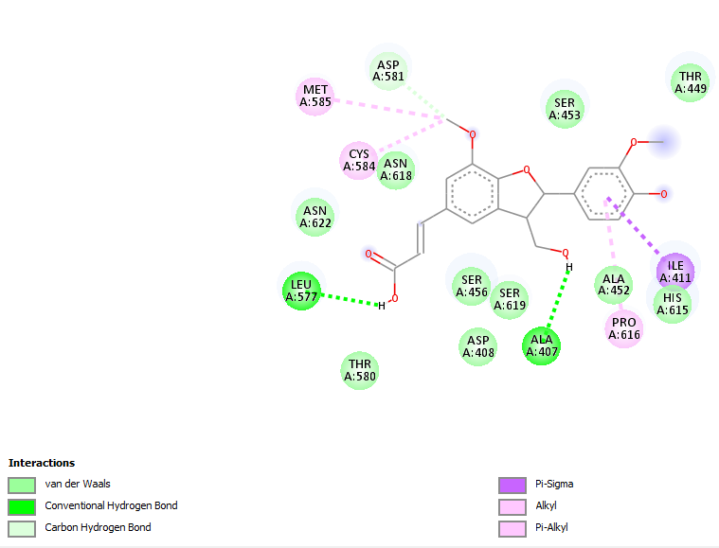
Figure 15: 2D relationship between spicatolignan B and FSHR

Discussion

Computational advancements have exerted a profound impact on the drug development process. One of the key tools in this realm is virtual screening, which is employed extensively to streamline the drug development process, saving both time and costs. Molecular docking, a technique used to identify new ligands for protein structures, is instrumental in the field of structure-based drug design. The intricate connection between compounds and receptors is pivotal in shaping drug formulations.
Spearmint (Mentha spicata) has gained attention as a potential herbal remedy for Polycystic Ovary Syndrome (PCOS), a hormonal disorder that affects women of reproductive age.
Most of the phytochemicals contained in the M.spicata possess antioxidant activity. Antioxidants play a potential role in managing Polycystic Ovary Syndrome (PCOS) by reducing oxidative stress, improving insulin sensitivity, regulating hormones, and supporting reproductive health (Cheng and He, 2022). Additionally, phytochemicals contained in M.spicata possess antitumor activity (which may help in reducing the risk of endometrial cancer), anti-inflammatory activity (which may mitigate inflammation and metabolic issues), antidiabetic activity (to manage insulin resistance which is associated with PCOS) and estrogen antagonists which address hormonal imbalances.
The phytochemicals from spearmint exhibited varying degrees of binding affinity with the PCOS-related target proteins. These suggests that some of the compounds have a strong potential for interacting with these proteins and may be of interest for further research or potential therapeutic applications in the context of PCOS. They also conform to the Lipinski’s rule of five which is based on four parameters which determines the likely oral bioavailability of the phytochemical.
Epicatechin stands out as the leading candidate for the androgen receptor followed by Oleanolic acid. Epicatechin has potent antioxidant activity. It forms multiple types of bonds with the protein, including three hydrogen bonds, Van der Waals forces, pi-sigma bonds, pi-sulfur bonds, pi-pi T-shaped bonds, and pi-alkyl bonds. These diverse interactions highlight the importance of Epicatechin in its ability to affect the androgen receptor's function.
Oleanolic Acid is the leading candidate for the remaining target proteins (AMH, LHCGR, FSHR, and the insulin receptor). It is known for its multifaceted benefits, including antioxidant, anti-tumor, anti-inflammatory, and anti-diabetic properties. When binding to AMH and LHCGR, Oleanolic Acid forms Van der Waals interactions. For FSHR, it engages in both Van der Waals forces and a conventional hydrogen bond. In its interaction with the insulin receptor, Oleanolic Acid establishes Van der Waals interactions, a carbon-hydrogen bond, and a pi-sigma bond. These findings suggest that oleanolic acid may be a promising lead compound for potential therapeutic applications related to PCOS.

4. Conclusion
Overall, the selected biotic compounds from spearmint demonstrated the potential to act as anti-androgenic agents, in that they counteract the effects of male sex hormones which could be significant in the management of PCOS. This research supports the hypothesis that spearmint could be used as a tool for managing PCOS, and it provides valuable insights into the mechanisms of action of spearmint against PCOS target proteins.

References

- Sadeghi, H. M., Adeli, I., Calina, D., Docea, A. O., Mousavi, T., Daniali, M., Nikfar, S., Tsatsakis, A. & Abdollahi, M. (2022). Polycystic Ovary Syndrome: A Comprehensive Review of Pathogenesis, Management, and Drug Repurposing. International journal of molecular sciences, 23(2), 583 PMCID: PMC8775814 DOI: 10.3390/ijms23020583

- Allah, P. J. S. & Jwaid, A. H. (2023). The effect of Daflon on Polycystic Ovary Syndrome Induced by Letrozole in the Rat model. Research Journal of Pharmacy and Technology, 16(6), 2765-0. DOI: 10.52711/0974-360X.2023.00454

- Singh, S., Pal, N., Shubham, S., Sarma, D. K., Verma, V., Marotta, F. & Kumar, M. (2023). Polycystic Ovary Syndrome: Etiology, Current Management, and Future Therapeutics. Journal of clinical medicine, 12(4), 1454. PMCID: PMC9964744 DOI: 10.3390/jcm12041454

- Abasian, Z., Rostamzadeh, A., Mohammadi, M., Hosseini, M. & Rafieian-Kopaei, M. (2018). A review on the role of medicinal plants in polycystic ovarian syndrome: Pathophysiology, neuroendocrine signaling, therapeutic status and future prospects. Middle East Fertility Society Journal, 23, 255-262. DOI: 10.1016/j.mefs.2018.04.005

- Lakshmi, J. N., Babu, A. N., Kiran, S. S. M., Nori, L. P., Hassan, N., Ashames, A., et al. (2023). Herbs as a Source for the Treatment of Polycystic Ovarian Syndrome: A Systematic Review. Biotech (Basel (Switzerland)), 12(1), 4. PMCID: PMC9844343 DOI: 10.3390/biotech12010004

- Akdoğan, M., Tamer, M. N., Cüre, E., Cüre, M. C., Köroğlu, B. K. & Delibaş, N. (2007). Effect of spearmint (Mentha spicata Labiatae) teas on androgen levels in women with hirsutism. Phytotherapy Research, 21(5), 444–447. PMID: 17310494 DOI: 10.1002/ptr.2074

- Grant, P. (2010). Spearmint herbal tea has significant anti-androgen effects in polycystic ovarian syndrome. A randomized controlled trial. Phytotherapy Research, 24(2), 186–188. PMID: 19585478 DOI: 10.1002/ptr.2900

- Ataabadi, M. S, Alaee, S., Bagheri, M. J. & Bahmanpoor, S. (2017). Role of essential oil of Mentha spicata (spearmint) in addressing reverse hormonal and folliculogenesis disturbances in a polycystic ovarian syndrome in a rat model. Advanced Pharmaceutical Bulletin, 7(4), 651–654. PMCID: PMC5788221 DOI: 10.15171/apb.2017.078

- Mahendran, G., Verma, S. K. & Rahman, L. U. (2021). The traditional uses, phytochemistry and pharmacology of spearmint (Mentha spicata L.): A review. Journal of Ethnopharmacology, 278, 114266. PMID: 34087400 DOI: 10.1016/j.jep.2021.114266

- Cheng, X & He, B. (2022). Clinical and Biochemical Potential of Antioxidants in Treating Polycystic Ovary Syndrome. International Journal of Women’s Health,14, 467-479. PMCID: PMC8982783 DOI: 10.2147/IJWH.S345853

