Formulation And Predicted Property Behaviour Of Palm Kernel Shell Ash, Stone Dust, And Coconut Fiber Hybrid Reinforced Epoxy Composites

Abstract
The development of sustainable composite materials using agro-mineral and natural reinforcements has gained significant attention as an alternative to conventional or synthetic fillers. In this short communication, epoxy-based hybrid composites were formulated using palm kernel shell ash (PKSA), stone dust, and coconut fiber as reinforcing materials. Two sets of formulations were developed a binary hybrid system (PKSA-stone dust) and a ternary hybrid system (PKSA-stone dust-coconut fiber), with reinforcement weight fractions varied from 2 wt.% to 10 wt. % while the polymer matrix content decreased correspondingly from 98 wt.% to 90 wt.%. This short research communication aimed to predict the influence of reinforcement type and loading on the mechanical, wear, and thermal properties of the composites based on established strengthening and toughening mechanics. Results from theoretical and mechanistic analyses indicate that low to moderate reinforcement level (4 – 6 wt.%) are expected to enhance tensile, flexural, and impact strength due to good filler dispersion and improved interfacial adhesion. PKSA and stone dust contribute to stiffness, hardness, and wear resistance, while coconut fiber improves ductility and energy absorption through fiber pull-out and crack bridging effects. Higher reinforcement levels (8 wt. % and above) may lead to agglomeration, void formulation, and reduced tensile strength. Overall, the tenary hybrid system demonstrates a synergistic balance of strength and toughness compared to the binary composite potentially suitable for structural and automotive applications.
Keywords: Hybrid composites, Palm kernel shell ash, Stone dust, Coconut fiber, Epoxy resin, Sustainable materials, Mechanical properties, Reinforcement mechanism, Waste to wealth.

Introduction
The increasing demand for sustainable and low-cost engineering materials has driven extensive research into hybrid composites that use locally available agro-waste and mineral by-products as reinforcing phases. Natural fibers and ashes derived from agro wastes provide environmental benefits, reduced density, and attractive mechanical properties when combined with polymer matrices. Several researchers have revealed that there is a growing interest in plant-fiber reinforced polymers and the effectiveness of fiber treatments to improve interfacial bonding and impact performance.
Palm kernel shell ash (PKSA), a by-product of the carbonization of palm kernel shell, is an abundant agro-waste in many tropical regions and has been explored as a particulate filler and reinforcement in metal and polymer matrices, demonstrating potential for enhancing stiffness, hardness, and thermal stability when suitably processed (Achukwu et al., 2015; Oladele & Okoro, 206; Iyasele, 2018; ). The solid waste from palm oil mill industry in Nigeria has been increasing annually. According to Ohimain and Izah who reported that over 4.6 million metric tons of fresh fruit bunch is produced annually, which means that PKS is always available. The use of coconut fiber in fiber-reinforced composites (FRCs) has garnered significant attention due to their lightweight nature coupled with exceptional strength and durability, making them ideal for a wide range of applications across industries such as wind energy, sports, automotive, and aerospace (Tarikul et al., 2024; Shukla, & Behera 2022; Jayan et al., 2021). Natural fibres have gained interest because of their high specific strength and modulus, light weight, low cost, and biodegradability (Vasiliev & Morozov 2013; Aleksendrić & Carlone 2015; Lamidi et al., 2025). Similarly, stone dust which is a by-product of stone processing (quarry sites) has been successfully employed as a hard particulate filler in polymer composites to improve wear resistance and surface hardness in prior studies including (Hariharan et al., 2023; Lamidi et al., 2025;). These waste-derived fillers are attractive for a waste-to-wealth approach and for reducing material costs while achieving desirable tribological and mechanical performance (Kazeem et al., 2023; Bello et al., 2020; Risti, 2023). Hybridization combining mineral particulates with natural fibers aims to generate synergistic behavior (Elfaleh et al., 2023; Rasego, 2024; Rakesh & Singh, 2014). The mineral phase contributes stiffness and abrasion resistance while the fibrous phase improves toughness and energy absorption through mechanisms such as fiber pull-out and bridging. Recent literature reviews on hybrid polymer composites emphasize that well-designed hybrid systems can outperform single-reinforcement composites when dispersion and interfacial adhesion are properly controlled (Fong et al., 2025; Akinwande & Oladele, 2021; Li et al., 2025).
Despite a growing number of studies on individual uses of PKSA, stone dust, and coconut fiber in composites, there is comparatively limited documentation on their combined (ternary) hybridization in an epoxy matrix with systematic, low-weight-fraction formulations (2–10 wt%). This paper presents formulation tables for a binary PKSA - stone dust hybrid and a ternary PKSA - stone dust - coconut fiber hybrid in epoxy, and provides a mechanistic prediction of how these formulations are expected to influence tensile, flexural, impact, hardness, wear, and density-related behavior a necessary design step that guides experimental validation and application selection (e.g., lightweight panels, wear components, or eco-friendly automotive parts).
The objective of this short communication is to (1) present a transparent and reproducible set of formulation matrices for PKSA - stone dust and PKSA - stone dust - coconut fiber hybrid epoxy composites (2–10 wt% reinforcement), (2) interpret expected property trends and mechanisms based on established reinforcement physics, and (3) highlight the most promising application areas and next experimental steps for validation.

2.0 Methodology and material selection
The materials used in this research were chosen based on their availability, processability, excellent mechanical properties, and environmental sustainability (Kazeem et al., 2023; Bello et al., 2020; Lamidi et al., 2025). The following materials were used:
- Coconut Fiber (CF): Selected as a reinforcement due to its high tensile strength, thermal resistance, and biodegradability (Osarenmwinda and Efedi, 2021; Agunsoye et al., 2020). The fiber is an agricultural waste byproduct commonly available in tropical regions.
- Palm Kernel Shell (PKS): Palm Kernel Shell Ash (PKSA) was derived from the combustion of palm kernel shells, PKSA is rich in Silica (SiO₂) which gives it the tendency of high wear resistance and abrasive properties. It is also known for its excellent thermal stability (Amaren et al., 2019; Lawal et al., 2020).
- Stone Dust (SD): Granite stone dust a mineral waste product from stone-cutting industries. Granite dust was included as a filler material for its hardness and wear resistance (Hiteshi and Ruchika, 2022).
- Epoxy Resin: Chosen as the matrix material for its superior bonding strength, chemical resistance, and ease of processing (Oladele et al, 2025)

2.1 Experimental Procedure
Preparation Process of Coconut Fiber
Matured coconut fiber husk was sourced from school of Agricultural and Agricultural technology farmland, Akure, Ondo State. Fibers were extracted from the coconut husk manually; the fibers were cleaned to remove impurities such as dirt and other organic matter. The cleaning process involved washing the fibers with clean water then sun dried for 5 hours as shown in Figure 1. The dried coconut fibers were chemically retted by soaking in 1M of sodium hydroxide solution (NaOH) for 24 hours to enhance fiber-matrix adhesion by removing lignin and hemicellulose. After soaking, the fibers were rinsed thoroughly and dried in a convection oven at 105°C for 5 hours to remove all moisture content which is critical for bonding with the resin. The dried coconut fibers were cut into smaller pieces using a mechanical shredder to obtain a uniform length of 10 mm. The shredded fibers were then sieved through a 2 mm mesh to remove oversized particles, ensuring consistency in the reinforcement phase.
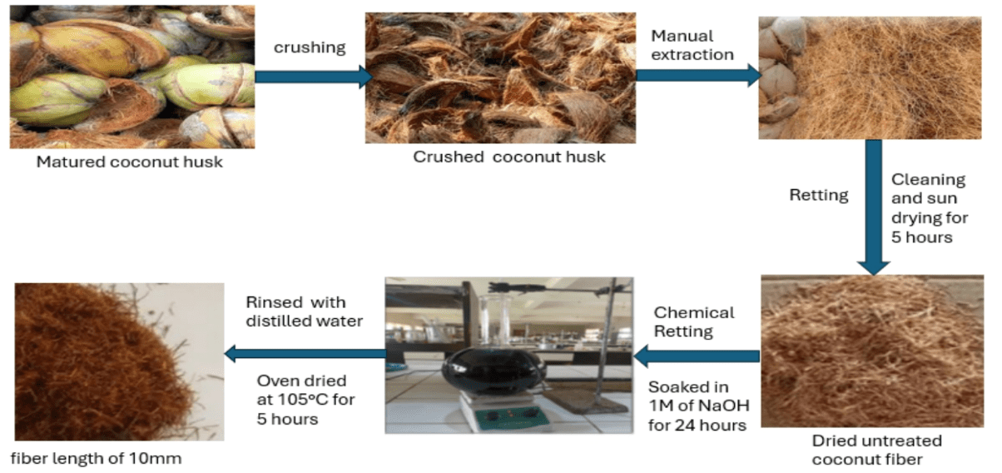
Figure.1: Preparation process of coconut fiber
2.2 Preparation Process of Palm Kernel Shell Ash
Palm kernel shells were sourced from school of Agricultural and Agricultural technology farmland, Akure, Ondo State. The Palm Kernel Shells were washed and oven dried for 5 hours at 105ºC to remove moisture content and oily residual organic matters. Carbonization of the palm kernel shells was done by burning in a muffle furnace at 700°C for 5 hours to obtain carbonized ash. The Muffle furnace ensures uniform heating and protect the PKS from direct heating as shown in Figure 2. The ashes were crushed, grinded using ball milling machine and sieved through a 106 µm mesh to ensure uniform particle size distribution.
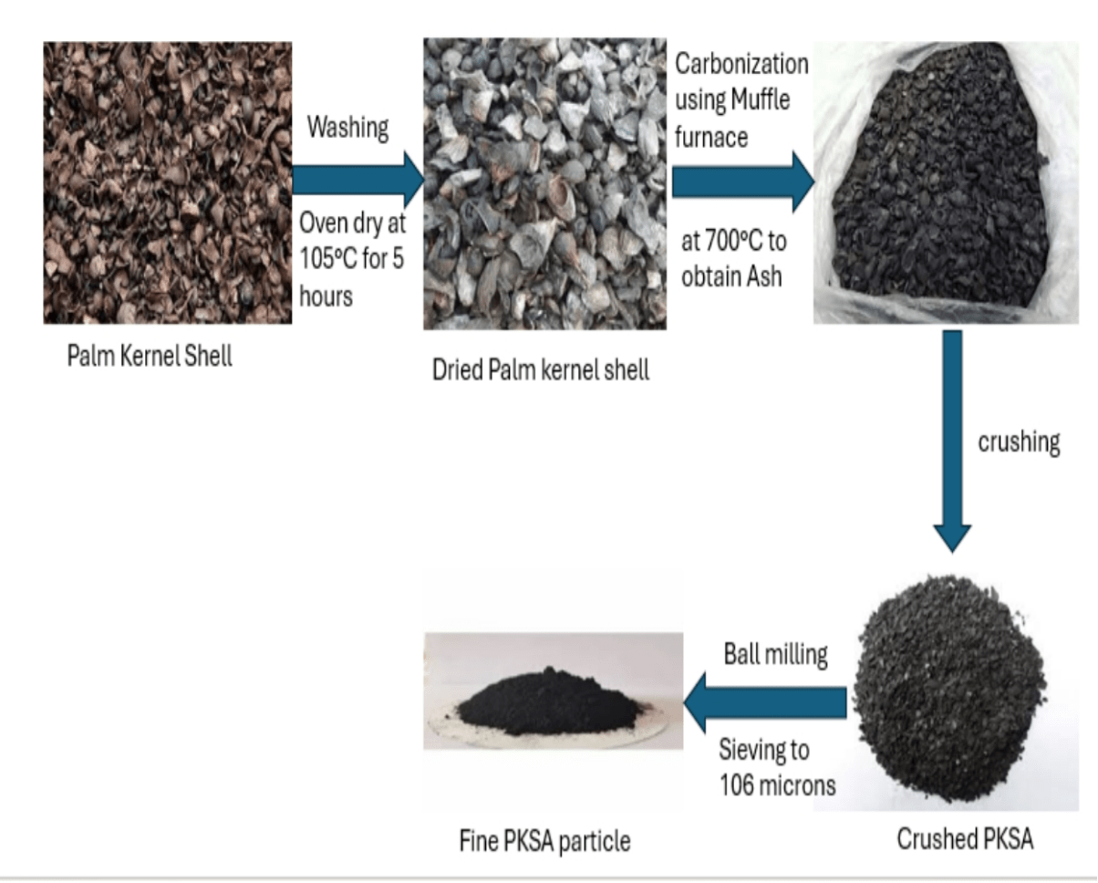
Figure 2: Preparation process of Palm kernel shell ash
2.3 Preparation Process of Granite Stone Dust
Granite stone dust obtained from quarry mining site, Shasha, Benin road, Akure, Ondo sate, as a byproduct of stone cutting was sun dried for 2 days to remove all moist content present in it. The dried Stone dust was Sieved through a 106 µm mesh to remove oversized particles and ensure homogeneity as shown in figure 3.
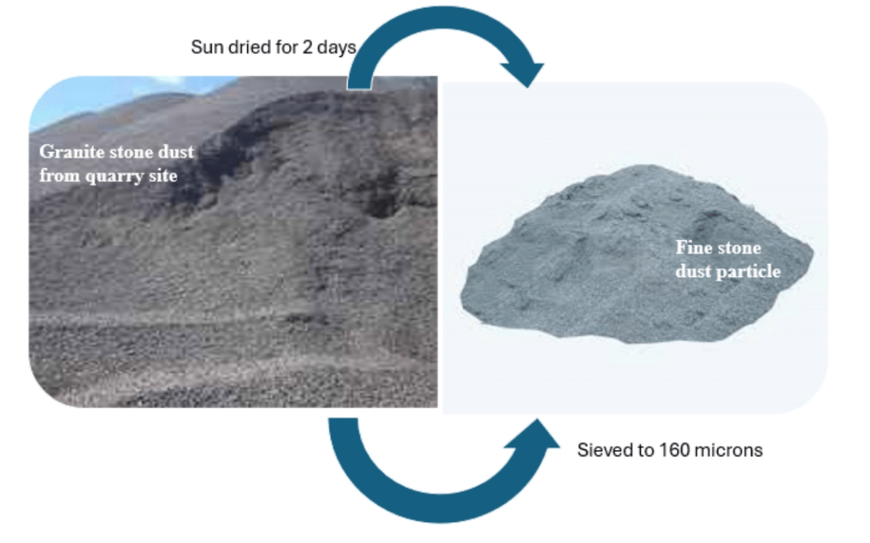
Figure 3: Preparation process of Stone Dust

3.6 Composite Fabrication
Hand- layup technique was used to produce composites since it provides low-cost tooling, simple processing and high production rate. Tensile, impact, flexural and wear molds were prepared by applying releasing agent to enable easy removal of the specimens after fabrication Epoxy and hardener were first mixed in ratio 2:1. The weight fractions of the resin, palm kernel shell ash, stone dust and coconut fiber were determined using the formulation table. Pre-determined weight fractions of palm kernel shell ash alongside stone dust as shown in Table 1 and 2 were then mixed with the resin by manual stirring to avoid agglomeration and poured into the molds. Spreading was done to remove air bubbles and excess resin. The experiment was carried out for all weight fractions, and curing of the developed hybrid composites was done at room temperature for 6 hours. After curing, the samples were removed from the molds and subjected to mechanical tests according to the ASTM standards mentioned, present the fabricated samples. Hybrid of palm kernel shell ash-coconut fiber and stone dust-coconut fiber run along with the same formulation table across all weight fractions as shown in Table 3 while the blend of the three (coconut fiber, palm kernel shell ash and stone dust) follow through the formulation table as seen in Table 1 and 2.

Results

In this research, we developed two formulation tables representing the formulation matrices for hybrid reinforced epoxy co.mposites developed with palm kernel shell ash (PKSA) and stone dust i.e Table 1, and in the second case, palm kernel shell ash, stone dust, and coconut fiber as shown in Table 2. The detailed breakdown of the tables are clearly presented for a clearer understanding of the compositional logic, purpose, and scientific insights behind them. These formulation tables represent systematic experimental designs in composite material research which enables controlled study of reinforcement effects on material properties, compare between inorganic-only and inorganic–organic hybrid composites, and Identify optimal reinforcement ratio balancing strength, stiffness, and toughness.
Table 1: Formulation table for Palm kernel shell ash-Stone dust Hybrid Reinforced Epoxy Composite
Sample | Polymer Matrix (wt.%) | Palm Kernel Shell Ash (wt.%) | Stone Dust (wt.%)
2 | 98 | 1 | 1
4 | 96 | 2 | 2
6 | 94 | 3 | 3
8 | 92 | 4 | 4
10 | 90 | 5 | 5
Control | 100 | 0 | 0

Insights from Table 1: Epoxy resin (polymer matrix) serves as the continuous phase responsible for binding and transferring load to the reinforcement (Palm kernel shell ash and stone dust). Its percentage decreases progressively from 98 wt% to 90 wt% as the reinforcement content increases. Palm kernel shell ash, a hard inorganic filler with good thermal and mechanical stability, and the stone dust contributes to density, improve stiffness, and increases wear resistance. Both are introduced equally in increasing weight fractions, from 1 wt% each (total 2 wt%) up to 5 wt% each (total 10 wt%). The gradual increase in reinforcement allows the researcher to evaluate how different filler loading affect the composite’s mechanical, thermal, and wear properties. Also, the control sample (100% epoxy) serves as a baseline to compare how reinforcement alters the material’s performance.

Table 2: Fomulation table for Palm kernel shell ash-Stone dust-Coconut fiber Reinforced Epoxy Composite
Sample | Polymer Matrix (wt.%) | Palm Kernel Shell Ash (wt.%) | Stone dust (wt.%) | Coconut Fiber (wt. %)
2 | 98 | 0.67 | 0.67 | 0.67
4 | 96 | 1.33 | 1.33 | 1.33
6 | 94 | 1.67 | 1.67 | 1.67
8 | 92 | 2.33 | 2.33 | 2.33
10 | 90 | 2.67 | 2.67 | 2.67
Control | 100 | 0 | 0 | 0

Insights from Table 2: The epoxy matrix decreases from 90 wt% to 90 wt% as the reinforcement content increases similar to table 1. The three-reinforcement used are Palm kernel shell, stone dust, and coconut fiber. The coconut fiber introduces ductility, flexibility, and impact resistance due to its fibrous lignocellulosic nature. This hybridization can achieve synergistic effects with the PKSA and stone dust enhance mechanical and wear properties, while coconut fiber improves toughness and energy absorption. The increasing weight fractions allows evaluation of optimum reinforcement content where properties are maximized without deteriorating interfacial bonding. It is worthy to note that control (100 % epoxy) serves again as a reference, helping to determine the effect of reinforcement addition on composite behavior.
Table 3: Comparative Insights Between the two Formulation Tables
Aspects | Table 1(PKSA-Stone dust) | Table 2(PKSA-Stone dust-Coconut fiber)
Reinforcement | 2 inorganic fillers | 2 inorganic + 1 natural fiber
Purpose | To enhance strength, hardness, and wear resistance | To combine strength with ductility and impact strength
Expected density | Higher (due to minerals) | Slightly lower (fiber is lighter)
Flexibility | Brittle at higher loadings | More flexible due to fiber presence
Applications | Brake pads, structural components | Automotive interior/exterior parts, eco-composites, panels
4.0 Discussions on the Fomulation Table for Hybrid Reinforced Epoxy Composites
The formulation tables presented in Tables 1 (Palm Kernel Shell Ash–Stone Dust hybrid) and 2 (Palm Kernel Shell Ash–Stone Dust–Coconut Fiber hybrid) describe the systematic variation of reinforcement weight fractions incorporated into an epoxy polymer matrix to develop hybrid composite materials. The purpose of these formulations is to determine how the addition of different reinforcements and their combinations influence the mechanical, thermal, and wear properties of the resulting composites. Each formulation series includes a control sample containing 100% epoxy resin without reinforcement, serving as the reference baseline for comparison.
4.1 Palm Kernel Ash-Stone Dust Hybrid Reinforced Epoxy Composite
According to table 1 which is the formulation of the palm kernel shell ash–stone dust hybrid composite involved varying the total reinforcement content from 2 to 10 wt%, with both reinforcements contributing equally at each level. The polymer matrix percentage decreased correspondingly from 98 wt% to 90 wt% as the reinforcement content increased. This composition strategy was designed to evaluate the reinforcing efficiency of two inorganic agro-mineral fillers within the epoxy system. The inclusion of palm kernel shell ash (PKSA), which contains silica, alumina, and potassium oxide, enhances thermal stability and stiffness due to its ceramic-like properties. On the other hand, stone dust, a fine-grained mineral by-product, improves surface hardness, compressive strength, and wear resistance. At lower filler loadings (2–4 wt%), the reinforcements are expected to be well dispersed within the matrix, promoting good interfacial bonding and efficient stress transfer between the matrix and fillers. This can lead to improved mechanical strength, hardness, and dimensional stability. However, as the reinforcement content increases beyond 8 wt%, there is a likelihood of particle agglomeration, poor wetting, and micro-void formation within the epoxy matrix, which may reduce impact strength and ductility. The progressive reduction of the polymer matrix ensures that the effect of reinforcement addition on material performance can be systematically evaluated. This approach also enables the determination of the optimum filler concentration at which maximum property enhancement occurs before the onset of property deterioration due to excessive filler content.
4.2 Palm Kernel Shell Ash–Stone Dust–Coconut Fiber Hybrid Reinforced Epoxy Composite
Table 2 shows the second formulation incorporated three reinforcements palm kernel shell ash, stone dust, and coconut fiber in equal weight proportions across five composite samples. The total reinforcement content was varied from 2 wt% to 10 wt%, while the polymer matrix decreased from 98 wt% to 90 wt%. This hybridization approach was developed to achieve a synergistic balance between the mechanical stiffness of inorganic fillers and the toughness of natural fibers. The palm kernel shell ash and stone dust contribute to hardness, wear resistance, and dimensional stability, while coconut fiber introduces ductility, improved impact resistance, and better energy absorption characteristics due to its fibrous and lignocellulosic structure. At low reinforcement levels (2–4 wt%), uniform distribution of the three reinforcements within the epoxy matrix enhances the interfacial adhesion and stress transfer capability, thereby improving tensile and flexural strengths. At moderate filler levels (6–8 wt%), a balance between stiffness and toughness is achieved, making the composite suitable for applications requiring both load-bearing capacity and shock resistance (e.g., automotive interior panels, covers, and low-friction structural parts).
At higher filler loading (10 wt%), however, the increase in particulate and fibrous content may cause interfacial incompatibility, uneven dispersion, or clustering, leading to microstructural defects and potential reduction in mechanical integrity.
4.3 Table 4: Comparative Discussion of Both Formulation Systems
The two formulations strategies represent distinct reinforcement systems within the same epoxy polymer framework. While the PKSA-stone dust emphasizes hardness, strength and wear resistance, the second formulation (PKSA-stone dust-coconut fiber) is engineered for improved strength, flexibility and environmental sustainability.
Table 4 -- comparative discussion of both formulation systems.
Parameter | PKSA-Stone dust- Hybrid | PKSA-Stone dust-Coco fiber Hybrid
Reinforcement type | Two inorganic fillers | Two inorganic + one natural
Matrix reduction | From 98 wt% - 90 wt% | From 98 wt% - 90 wt%
Reinforcement Progression | Equal PKSA and Stone dust | Equal PKSA, Stone dust, and Coconut fiber
Objective | Improve strength, hardness, wear resistance. | Achieve balanced strength, ductility and toughness
Expected behaviour | High density, brittle behaviour at high filler load. | Lower density, improved toughness and flexibility
Application Potential | Brake pads, wear resistant coatings, mechanical housings | Lightweight components, eco-friendly composites, energy-absorbing parts.

4.4 Expected Property Trends and Strengthening Mechanism
The type, amount and interaction of the reinforcements with the epoxy matrix generally influence the expected trends in the mechanical, thermal, and wear properties of the developed hybrid composites. The reinforcement loading ranges between 2 wt% and 10 wt% with the polymer matrix serving as the continuous phase that transforms stress to the embedded particulate and fibrous phases. The interaction between the matrix and the reinforcements significantly influences the overall performance of the composites.
4.4.1 Tensile Strength
It is observed that at low filler loadings (2 wt% to 4 wt%), the tensile strength of both composites (PKSA–Stone Dust and PKSA–Stone Dust–Coconut Fiber) is expected to increase compared to the control sample. This improvement can be attributed to good dispersion of the reinforcements within the matrix, enhanced interfacial adhesion between the epoxy resin and the filler particles/fibers, and Effective load transfer from the polymer to the stiffer reinforcement phases. For the PKSA-Stone dust-Coconut fiber hybrid, the natural fiber contributes to better interfacial bonding due to its rough surface morphology and cellulose epoxy interaction, resulting in higher tensile strength than the purely inorganic hybrid at comparable weight fractions. However, at higher filler loadings (8–10 wt%), tensile strength may decrease due to, agglomeration of fillers, formation of voids and stress concentration sites, and reduced polymer chain mobility leading to brittleness. An expected trend of peak tensile strength at ~6 wt% reinforcement, followed by a gradual decline beyond that level.
4.4.2 Flexural Strength and Modulus
It is expected that flexural strength and modulus follow a similar pattern to the tensile strength. Therefore, at lower and moderate filler loading (2 - 6 wt%), improved stiffness and flexural strength are expected due to the rigid nature of PKSA and stone dust particles, which restrict the deformation of the polymer matrix under bending loads. The incorporation of coconut fiber enhances the ability of the composite to resist crack propagation, increasing the flexural modulus at intermediate loadings. At higher loadings, the flexural strength may drop due to filler clustering, poor stress distribution, and microcrack formation at particle–matrix interfaces. It is expected that the PKSA-Stone Dust hybrid composite exhibits higher stiffness but more brittle at high load. Similarly, PKSA-Stone Dust-Coconut Fiber hybrid is expected to possess a slightly lower stiffness but improved flexibility and toughness.
4.4.3 Impact Strength
The impact strength represents the material’s ability to absorb and dissipate energy under sudden load. The control epoxy (100% matrix) has low impact strength due to its brittle nature. The inclusion of reinforcements up to 6 wt% enhances impact strength, particularly in the PKSA-Stone Dust-Coconut Fiber composite, because the natural fiber component (coconut fiber) absorbs and redistributes impact energy effectively. In contrast, the purely inorganic PKSA–Stone Dust hybrid may exhibit reduced impact energy absorption due to the rigidity of both fillers. Beyond 8 wt%, increased filler concentration can lead to microvoids and interfacial defects that initiate crack propagation, thus lowering impact resistance.
It is expected that the PKSA-Stone Dust composite exhibits moderate improvement, peak at 4–6 wt%. Alternatively, the PKSA-Stone Dust-Coconut Fiber composite would exhibits higher improvement, peak at 6–8 wt%.
4.4.4 Hardness
Hardness measures the material’s resistance to indentation and surface deformation or abrasion. The PKSA-Stone Dust Composite is expected to exhibit a significant increase in hardness as the filler content increases because both PKSA and stone dust are hard, mineral-based materials with high microstructural rigidity. Therefore, at low to moderate filler content (2-6 wt%), the improvement in hardness is due to uniform dispersion and the restriction of polymer segment mobility. Then at high loadings (8-10 wt%), hardness continues to rise slightly or stabilizes due to particle clustering, but excessive loading could create brittle zones, compromising toughness. In contrast, for the PKSA-Stone Dust-Coconut Fiber hybrid, the natural fiber has a lower hardness compared to mineral fillers, so overall hardness may increase at a slower rate but with improved toughness. The expected trend is that the PKSA-Stone Dust composite at 8-10 wt% shows highest hardness values. The PKSA-Stone Dust-Coconut Fiber composite is expected to exhibits moderate hardness, and more balanced ductility.
4.4.5 Wear Resistance
The wear resistance of both composites is expected to improve significantly compared to the neat epoxy resin. The incorporation of PKSA (rich in silica and alumina) and stone dust (rich in silicates and quartz) introduces hard particles that enhance surface resistance to abrasion. At low loadings (2–4 wt%), the reinforcement particles are well integrated within the matrix, providing an even distribution of resistance to wear. At higher loadings (8–10 wt%), reinforcement clustering and poor matrix wetting may lead to localized wear due to the detachment of weakly bonded particles. Furthermore, the PKSA-Stone dust composite is expected to show better wear resistance than the fiber-containing hybrid due to its higher inorganic filler content, while the Coconut fiber may show slightly reduced wear resistance but better resistance to surface cracking under frictional stress.
4.4.6 Density and Weight Variation
The density of the PKSA-Stone Dust composite is expected to be higher due to the mineral nature of both fillers. Conversely, the inclusion of coconut fiber in the hybrid system will reduce the overall density, creating a lightweight composite that is advantageous for applications where reduced mass is critical (e.g., automotive interiors, aerospace panels).
4.4.7 Strengthening and Toughening Mechanisms in the Hybrid Composites
The observed and predicted improvements in the mechanical and wear properties of the hybrid epoxy composites can be explained through several fundamental reinforcement mechanisms. Firstly, the load transfer mechanism plays a dominant role in both the binary (PKSA-stone dust) and ternary (PKSA-stone dust-coconut fiber) systems. In this mechanism, the epoxy matrix functions as a continuous phase that transfers externally applied stresses to the stiffer and stronger reinforcement phases. The inclusion of palm kernel shell ash, stone dust, and coconut fiber facilitates efficient stress transmission across the matrix–reinforcement interface, thereby enhancing tensile and flexural strengths. This mechanism is particularly effective at moderate filler loadings, where the interfacial bonding between the epoxy and the reinforcement phases is strong and uniform.
Secondly, the particle reinforcement mechanism contributes significantly to the improved surface hardness and wear resistance observed in the composites. The hard mineral fillers-palm kernel shell ash and stone dust act as rigid microstructural barriers within the polymer matrix. These particles impede the mobility of polymer chains and restrict plastic deformation under load. Consequently, the composites exhibit higher hardness, greater stiffness, and improved resistance to abrasion and surface wear.
In the ternary hybrid composite, the fiber pull-out and crack-bridging mechanism is an additional and crucial factor influencing toughness. The embedded coconut fibers act as micro-scale bridges across propagating cracks, absorbing fracture energy through gradual fiber stretching and controlled pull-out. This mechanism delays catastrophic failure and enhances impact resistance and energy absorption capacity. It provides the ternary hybrid composite with superior ductility and toughness compared to the binary composite containing only mineral fillers. The constraint effect also contributes to the observed mechanical behavior. As the filler loading increases, the presence of rigid particles constrains the mobility of the polymer molecular chains. This restriction results in enhanced stiffness and modulus at low-to-moderate filler concentrations. However, at higher reinforcement levels, excessive constraint may lead to localized stress concentrations and reduced ductility, rendering the composite more brittle.
Finally, the hybrid synergy mechanism emerges from the combined presence of inorganic (PKSA and stone dust) and organic (coconut fiber) reinforcements. The inorganic fillers contribute to improved stiffness, hardness, and wear resistance, while the organic fibers enhance toughness and energy absorption. This synergistic interaction between dissimilar reinforcements results in a balanced mechanical performance combining the strength and rigidity of the mineral fillers with the flexibility and toughness imparted by the natural fibers. Together, these mechanisms explain the complex yet complementary roles of each reinforcement phase in optimizing the overall performance of the hybrid epoxy composites. The result is a sustainable material system that exhibits a favorable balance between strength, stiffness, wear resistance, and impact toughness, making it suitable for both structural and functional engineering applications.
Table 5: Summary of Expected Property Trend
Property | PKSA-Stone Dust Hybrid | PKSA-Stone Dust-Coconut Fiber Hybrid
Tensile Strength | ↑ up to 6 wt%, ↓ beyond 8 wt% | ↑↑ up to 6–8 wt%, mild ↓ beyond 10 wt%
Flexural Strength | ↑ up to 6 wt%, brittle after 8 wt% | ↑ up to 8 wt%, retains ductility
Impact Strength | Slight ↑ up to 4–6 wt% | Significant ↑ up to 8 wt%
Hardness | Continuous ↑ up to 10 wt% | Significant ↑ up to 8 wt%
Wear Resistance | High Improvement | Moderate improvement, better surface integrity
Density | High | Lower
Ductility | Low | Higher

5.0 Conclusion
This work proposes a practical formulation strategy for two sustainable hybrid epoxy composite systems: a PKSA-stone dust binary hybrid and a PKSA-stone dust-coconut fiber ternary hybrid, with reinforcement levels varied from 2 wt% to 10 wt%. Mechanistic analysis predicts that low-to-moderate reinforcement loadings (approx. 4-6 wt%) are likely to maximize tensile and flexural performance due to effective filler dispersion and interfacial load transfer, while the ternary hybrid is expected to show superior impact resistance and toughness because of fiber-mediated energy dissipation mechanisms (fiber pull-out and bridging). High reinforcement levels (>8 wt%) are anticipated to risk agglomeration, void formation, and subsequent reductions in tensile ductility unless dispersion and surface treatments are optimized. From an application perspective, the binary PKSA-stone dust system is especially promising for wear- and hardness-critical components (e.g., brake-pad backing layers, wear-resistant housings), whereas the ternary PKSA-stone dust-coconut fiber system is better suited to lightweight structural elements and impact-resistant parts (e.g., interior automotive panels, protective casings). The proposed formulations thus offer an adaptable, waste-to-wealth pathway for locally sourced reinforcements that align with circular-economy goals.

References
1. Hariharan Arumugam, Mohamed Iqbal M, Cheol-Hee Ahn, Sarawut Rimdusit, Alagar Muthukaruppan, (2023). Development of high-performance granite fine fly dust particle reinforced epoxy composites: structure, thermal, mechanical, surface and high voltage breakdown strength properties,Journal of Materials Research and Technology, Volume 24,2023, Pages 2795-2811.
2. Sheriff Babatunde Lamidi, Kasali A. Adedeji, Nurudeen A. Raji, Oladele O. Isiaka, Mathew A. Ajayi, Adesina Oluwole, Olalere K. Rafiu, Dele D. Elizabeth, and Mubaraq A. Olojo. 2025. “Experimental Investigation of Physical, Mechanical and Wear Index in Polymer Matrix Composites for Potential Structural Applications”. Journal of Materials Science Research and Reviews 8 (4):805–820. https://doi.org/10.9734/jmsrr/2025/v8i4442.
3. Fong A, Wong DH, Lau S, et al. (2025). A review on the hybrid polymer composites comprising natural fibre and nanomaterial reinforcement. Journal of Composite Materials. 59(22):2615-2646. doi:10.1177/00219983251334861
4. Elfaleh I, Abbassi F, Habibi M, et al. (2023) A comprehensive review of natural fibers and their composites: an eco-friendly alternative to conventional materials. Results Eng 19: 101271.
5. Tarikul Islam, Mehedi Hasan Chaion, M. Abdul Jalil, Abu Sayed Rafi, Faujia Mushtari, Avik Kumar Dhar, Shahin Hossain (2024). Advancements and challenges in natural fiber-reinforced hybrid composites: A comprehensive review. SPE Polymers, Volume 5(4), Pages 481-506. https://doi.org/10.1002/pls2.10145
6. Shukla S, Behera BK. (2022). Auxetic fibrous structures and their composites: a review. Compos Struct. 290:115530. doi:10.1016/j.compstruct.2022.115530
7. Jayan JS, Appukuttan S, Wilson R, Joseph K, George G, Oksman K. 1 – An introduction to fiber reinforced composite materials. In: K Joseph, K Oksman, G 8. George, R Wilson, S Appukuttan, eds. Fiber Reinforced Composites. Woodhead Publishing; 2021: 1-24. doi:10.1016/B978-0-12-821090-1.00025-9
9. Vasiliev VV, Morozov EV. (2013) Introduction. Advanced Mechanics of Composite Materials. Elsevier 1-27. doi:10.1016/B978-0-08-098231-1.00001-7
10. Aleksendrić D, Carlone P. (2015). Introduction to composite materials. Soft Computing in the Design and Manufacturing of Composite Materials. Elsevier;1-5. doi:10.1533/9781782421801.1
11. Sheriff Babatunde Lamidi, Oluwole A. Adesina, Kasali Aderinmoye Adedeji, Nurudeen Adekunle Raji (2025). Modeling and Development of Local Raw Materials for Automotive Brake Pad. International Journal of Latest Technology in Engineering, Management, and Applied Science. DOI: 10.51583/IJLTEMAS Volume XIV, Issue III.
12. Akinwande, O. O., & Oladele, I. O. (2021). Mechanical and wear properties of granite dust filled recycled polyethylene composites. Journal of Materials Research and Technology, 15, 521-530.
13. Li, Q., Zhang, H., & Wang, J. (2025). Alkali treatment of granite stone dust for improved mechanical interlocking in polymer composites. Materials Today Communications, 34, 105231.
15. Achukwu, E.O, A. M. Barnabas1, A. Mamman1, M. I. Uzochukwu (2015). Fabrication Of Palm Kernel Shell Epoxy Composites And Study Of Their Mechanical Properties. Nigerian Journal of Material Science and Engineering. Volume 6, issue1.
16. Iyasele, Edgar Omondiale (2018). Comparative Analysis On The Mechanical properties Of A Metal-Matrix Composite (Mmc) Reinforced With Palm Kernel/Periwinkle Shell ash. Global Scientific Journal. Volume 6, issue 8.
17. Isiaka Oluwole Oladele and Avwerosuoghene Moses Okoro (2016). The effect of palm kernel shell ash on the mechanical properties of as-cast aluminium alloy matrix composites. Leonardo Journal of Science. Issue 28. p 15-30.
18. Bello S.K, Bajela G.G, Lamidi S.B, Oshinlaja S., (2020). Design and Fabrication of Pneumatic Can Crushing Machine. International Journal of Advances in Scientific Research and Engineering. Volume 6, Issue 10. https://doi.org/10.31695/IJASRE.2020.33914
19. Ayomide Z. Kazeem, Sheriff B. Lamidi, Yakub O. Bankole, Murisiku Onigemo, Lateefah A. Apete, Abiodun Y. Akinsanya (2023). Smart Materials: Awareness and Impact in the Construction Industry in Lagos State. International Research Journal of Advanced Engineering and Science. Volume 8, Issue 3. Pp 58-62.
20. Lawal S.S , Ademoh N.A , Bala K.C , A.S.Abdulrahman (2020). A Review of the Compositions, Processing, Materials and Properties of Brake Pad Production. Journal of Physics: Conference Series.
21. Hitesh Bhakuni, Muley A.V and Ruchika (2022). Fabrication, testing & analysis of particulate ceramic matrix composite for automotive brake pad application. Materials Today: Proceedings of the International Conference on Advancement in Manufacturing engineering, https://doi.org/10.1016/j.matpr.2023.01.413
22. Rakesh Singh, V. C. (2014). Polyester/Kota Stone Dust Composite: A Comprehensive Investigation of Mechanical and Sliding Wear Properties. Mechanics of Advanced Composite Structures, 11(2), 375 - 384. doi:https://doi.org/10.22075/MACS.2024.31203.1537
23. Resego Phiri, S. M. (2024). Agro-waste for renewable and sustainable green production: A review. Journal of Cleaner Production, 434, 0959-6526. doi:https://doi.org/10.1016/j.jclepro.2023.139989
24. Risti Ragadhita, D. F. (2023). Techno‐Economic Evaluation of The Production of Resin-Based Brake Pads using Agricultural Wastes: Comparison of Eggshells/Banana Peels Brake Pads and Commercial Asbestos Brake Pads. ASEAN Journal of Science and Engineering, 3(3), 243-250. doi:http://ejournal.upi.edu/index.php/AJSE

