Preparation, characterization and in vitro release kinetics of Artemether-Lumefantrine loaded Solid Lipid Nanoparticles co-loaded with paracetamol for a controlled and sustained release profile

Abstract
Artemether–Lumefantrine (AL) is the first-line drug recommended for malaria treatment, but its effectiveness is compromised by pharmacokinetic mismatch between the rapidly-cleared artemether (half-life: 1-3 h) and the slowly-eliminated lumefantrine (half-life: 3-6 days). This can lead to sub-therapeutic drug ratios and foster resistance. To address this, we engineered a novel triple‑combination artemether-lumefantrine-loaded solid lipid nanoparticle (SLN) co‐loaded with paracetamol, aiming to synchronize drug release and provide both antimalarial and symptomatic relief. Utilizing a Quality-by-Design approach with a Box-Behnken design, we optimized the formulation to achieve monodisperse nanoparticles (~134 nm) and polydispersity (PDI ≈0.18) while maximizing encapsulation efficiency (EE%) of all three drugs loaded in a single nanocarrier. The optimized SLNs showed high EE (Artemether 91.4%, Lumefantrine 93.0%, Paracetamol 91.0%) and a controlled and sustained release profile over 72 hrs. The release data fitted zero/first order, Higuchi and Korsmeyer–Peppas models. Artemether release obeyed a Korsmeyer–Peppas model (n≈0.45), indicating predominantly Fickian diffusion, while lumefantrine fit the Higuchi model (diffusion-controlled) and paracetamol required the Peppas–Sahlin model (notably higher relaxation contribution). These findings imply that the SLN matrix can modulate each drug’s release to offset their native half‐life differences. Crucially, kinetic analysis revealed a harmonization of release rates, with the mean release times (MRT) of artemether and lumefantrine converging significantly compared to their native half-lives. This synchronized release profile, combined with the antipyretic action of paracetamol, presents a paradigm-shifting strategy to enhance therapeutic efficacy, improve patient compliance, and combat resistance in malaria management.
Keywords: Solid lipid nanoparticles; Artemether; Lumefantrine; Paracetamol; Malaria; Quality by Design

Introduction
Malaria remains a major global health challenge, with an estimated 263 million cases and 597,000 deaths in 2023[1]. Artemisinin-based combination therapy (ACT) is the cornerstone of Plasmodium falciparum treatment, and the fixed-dose artemether–lumefantrine (AL) combination is WHO-recommended as first-line therapy[2][1]. However, AL faces limitations: artemether is rapidly cleared (half-life ≈1–3 hours), while lumefantrine persists much longer (half-life ≈3–6 days)[3]. This pharmacokinetic mismatch can lead to sub-optimal drug ratios in vivo and contribute to resistance. Moreover, both drugs have low water solubility and require multiple dosing for sustained effect[4]. Emerging artemisinin resistance in Asia and Africa has spurred interest in triple ACT regimens (e.g., adding amodiaquine) as a strategy to delay resistance[2]. Building on this concept, we propose a novel triple‑combination SLN that co‑encapsulates artemether, lumefantrine, and paracetamol. The inclusion of paracetamol aims to provide dual therapeutic benefit: it manages fever and pain associated with malaria, improving patient comfort and potentially renal protection, while the three‑drug nanoparticle ensures co-delivery of all actives.
Solid lipid nanoparticles (SLNs) are biocompatible carriers known to improve solubility and controlled release of lipophilic drugs[5]. SLNs can enhance systemic availability and reduce the toxicity of encapsulated drugs by modulating release. Prior work has shown that SLNs can effectively deliver antimalarials; for example, artemisinin derivatives and lumefantrine have been nanoencapsulated to extend release over 72 h[6]. By co-loading artemether and lumefantrine in SLNs, previous studies achieved sustained release (72 h) and enhanced antimalarial efficacy[6].
A key innovation of our design is pharmacokinetic synchronization: by tuning the SLN matrix and process parameters, we seek to align the release profiles of artemether, lumefantrine, and paracetamol. This addresses their intrinsic half-life differences and maintains therapeutic ratios over time. Drug-delivery systems for synchronized multi-drug release have shown promise in other fields (e.g., HIV drug-combination nanoparticles), but application in malaria therapy is novel. We hypothesize that optimizing SLN composition and processing (lipid/surfactant levels, homogenization) can achieve a balanced release schedule.
This paper documents the development, characterization, and in vitro release of this novel triple‑drug SLN. We performed systematic response surface optimization to identify the best formulation parameters. We measured particle size, polydispersity index, and encapsulation efficiency and conducted in vitro release studies, modeling against multiple kinetic models. We interpret the release behavior in terms of diffusion vs. matrix relaxation contributions. This work establishes a proof of concept for SLN-mediated synchronized delivery of ACTs plus paracetamol, highlighting its potential to improve adherence and therapeutic outcomes in malaria. Building on the concept of triple ACTs and leveraging the capabilities of SLNs, we hypothesize that a single, optimized SLN can co-encapsulate artemether, lumefantrine, and paracetamol to achieve synchronized drug release, thereby rectifying their intrinsic pharmacokinetic mismatch while providing integrated symptomatic relief. This paper details the Quality-by-Design led development and comprehensive characterization of this novel triple-drug SLN. Our specific objectives were to: (1) systematically optimize the formulation using a Box-Behnken design to minimize particle size and PDI while maximizing encapsulation efficiency; (2) thoroughly characterize the optimized SLNs; and (3) critically evaluate the in vitro release profiles and kinetics to provide mechanistic evidence of successful release synchronization.

2.0 Materials and Methods

2.1 Materials
All materials, reagents, and chemicals were of analytical grade. The pure molecular antimalarial drugs were donated from the Laboratory and Allied Limited company, Nairobi. Compritol® 888 ATO, Geleol® mono and diglycerides NF, Labrafil® M 1944 CS, Labrasol®, Precirol®, D-Lactose Monohydrate (DLM), and Ethanol was purchased from Sigma-Aldrich and used as received.

2.2. Formulation of SLNs.
The nanoparticle drug carriers were prepared by the method described by Omwoyo et al., (2016) with slight modifications. Lipid components and surfactants were melted together and mixed with dissolved drugs (artemether, lumefantrine, paracetamol). This hot oil-in-water emulsion was homogenized (30-60min) under high shear homogenization (≥10,000 rpm) and then ultrasonicated for size reduction[8]. The resulting emulsion was cooled to form SLNs[9]. The formulations varied in lipid concentration (1000mg – 2000mg), surfactant concentration (1.5–3.0% w/v), and homogenization time (30-60min) according to a Box–Behnken design to optimize responses. 1 g of Compritol® 888 ATO was weighed and transferred into a glass beaker, and melted at 75°C using a temperature-controlled magnetic hotplate stirrer. Simultaneously, 3.13mg of Artemether,18.75mg of Lumefantrine, and 78.12 mg of Paracetamol were accurately weighed and dissolved in 5 mL of methanol. This drug solution was added gradually to the molten lipid with continuous stirring to ensure uniform dispersion and drug encapsulation within the lipid matrix. The mixture constituted the organic phase (Mehnert & Mäder, 2001).
The aqueous phase was prepared by dissolving Labrafil® M 1944 CS (2.25% w/v) in 20mL of double-distilled water. The solution was preheated to the same temperature as the lipid pfhase (75°C) to prevent premature solidification during emulsification (Pardeike et al., 2009).
2.2.1 Emulsification and Ultrasonication
The hot lipid phase was added dropwise to the hot aqueous phase under high-speed magnetic stirring at 1000 rpm, yielding a primary coarse O/W emulsion. The emulsion was then processed using probe ultrasonication with a high-intensity homogenizer (Silverson L4R, Silverson Machines Limited, Buckinghamshire, UK; 20 kHz, 750 W) at 60% amplitude for 60 minutes in pulsed mode (5 seconds on, 3 seconds off). The vessel was simultaneously cooled in an ice bath to induce rapid solidification of lipid droplets, forming AL-P SLNs (Mukherjee et al., 2009).
2.2.2 Drying of Formulations
The single emulsion (O/W) was directly fed into a benchtop Buchi mini-spray dryer (Model B-290, BÜCHI Labortechnik AG, Flawil, Switzerland) and spray-dried at an inlet temperature of 80–110 °C, atomizing pressure of 5–8 bars, and aspirator flow adjusted to maintain an outlet temperature that prevented drug degradation.

2.3 Experimental design and optimization.
A three-factor Box–Behnken design (lipid %, surfactant %, homogenization time) was used to optimize particle size (target: minimal), polydispersity index (PDI), and give a potential of ≥±.30 mV. Response surface methodology in Design-Expert software generated regression models.

Independent variables:
  - X1: Lipid concentration (% w/v; Compritol® 888 ATO)
  - X2: Surfactant concentration (% w/v; Labrafil® M 1944 CS)
  - X3: Homogenization time (minutes)
Dependent responses:
  - Y1: Mean particle size (nm)
  - Y2: Polydispersity index (PDI)
  - Y3: Zeta potential (mV)
Numerical optimization was applied to find the factor combination that simultaneously minimized size/PDI and maximized EE%. The optimal conditions were verified experimentally.

2.4 Characterization.
2.4.1 Determination of particle size, Zeta potential, and Polydispersity index (PDI)
The photon correlation spectroscopy (PCS) using a Malvern Zetasizer Nano ZS (Malvern Instruments, Worcester shire, United Kingdom) equipment was performed to determine the mean diameter and the polydispersity index (PI). The mean diameter and PDI values were obtained at an angle of 90° in 10 mm diameter cells at 25 °C. Prior to the measurements of each sample, 1–3 mg of the prepared ALP nanostructured Lipid carriers was suspended in distilled water, then vortexed or sonicated to produce a suitable scattering intensity. All the samples were prepared and measured in triplicate. The zeta potential was determined by electrophoretic mobility using the Malvern Zetasizer Nano ZS (Malvern Instruments, Worcester shire, United Kingdom). The sample was prepared for particle size measurement, but a different cuvette was used that could conduct current during the measurement.
2.4.2 Determination of EE and DL
To determine the fraction of free (unencapsulated) drug, 2 mL of freshly prepared SLNs dispersion was placed in Amicon® Ultra centrifugal filters (molecular weight cut-off 50 kDa) and centrifuged at 25,000rpm for 30 minutes at 4 °C. The filtrate, containing free drug, was collected.
Alternatively, for batch validation, ultracentrifugation at 30,000rpm for 60 minutes was used to separate supernatant containing unencapsulated drug from the nanoparticle pellet.
The concentration of free drug in the filtrate/supernatant (W_{free}) was quantified using a validated UV-Vis method. The total drug content (W_{total}) was determined by dissolving a known mass of AL-P SLNs in ethanol, sonicating for 15 minutes to ensure complete drug release, and assaying under the same conditions. The encapsulation efficiency (EE%) and drug loading (DL%) were calculated according to the formulae:
EE%=$\frac{W total-W free}{W total}×100$ ……………………………..(1)

DL%=$\frac{W total-W free}{W lipid+excipients}×100$………………….………(2)
Where,
W_{Total} is the total drug added
W_{free} is the free drug after ultra-centrifugation.
excipients represent Lipids + surfactant mixtures + other ingredients used.

2.5 Determination of differential calorimetric properties
Differential scanning calorimetry (DSC) was performed using model Q200 equipped with an automated computer-controlled refrigerated cooling system (RSC-90) and T Zero capabilities (TA Instruments, New Castle, DE, USA). DSC thermograms were collected using a sample weight of 3–5 mg powder and placed in T Zeroalodine-coated aluminium DSC pans, which were hermetically sealed with a TZero hermetic sealer (TA Instruments). Phase transition temperatures – melting point – of the samples were measured under a 50 mL/minute dry ultra-high purity nitrogen gas (Scott-Gross, Winchester, KY, USA) purge in DSC. The samples were heated at 10°C/minute from 10°C to 200°C. At least four melting scans were carried out to ensure melting point temperature reproducibility. Measured DSC data was analyzed using a coupled DSC Q200-1740 data station. DSC was used to determine the nature and speciation of crystallinity within nanoparticles by measuring glass and melting point temperatures and their associated enthalpies.

2.6 Determination of the surface morphology.
Transmission Electron Microscopy was used to observe the morphological appearance of the AL nanostructured Lipid carriers. Briefly, the ALP SLNs were coated in gold to minimize the effect of heat during high-power magnification and then run through a Transmission Electron Microscopy (SU1510 model; Hitachi Ltd., Tokyo, Japan), and electron micrographs captured.

2.7 In vitro release studies.
The modified method described by Omwoyo et al. (2016) was adopted in this experiment with slight modifications. The in vitro release studies were conducted using a dialysis bag method under sink conditions. Briefly, a volume of SLN dispersion equivalent to 5 mg of total drug content was sealed in a pre-hydrated dialysis membrane (MWCO 12-14 kDa). The bag was immersed in 200 mL of phosphate-buffered saline (PBS, pH 6.8) maintained at 37 ± 0.5 °C with continuous stirring at 100 rpm. At predetermined time intervals (0.5, 1, 2, 4, 6, 8, 12, 24, 36, 48, 60, 72 h), 2 mL aliquots were withdrawn from the release medium and replaced with an equal volume of fresh pre-warmed PBS. The drug concentration in the samples was quantified using a validated UV-Vis spectrophotometric method at the λ~max~ for each drug, with appropriate corrections for cumulative dilution. Release of each drug was tested in PBS (pH 6.8, 37 °C) using dialysis membrane. SLN suspension was placed in dialysis sacs in large volume of buffer under sink conditions. It is acknowledged that the dialysis membrane method, while widely used for nanoparticle release studies, may introduce an additional diffusion barrier. This is particularly relevant for highly lipophilic drugs like lumefantrine. Therefore, the obtained release profiles are interpreted as a comparative measure of drug release from the SLN system under standardized conditions, rather than an absolute quantification of release in vivo.

2.8 In vitro drug release kinetic analysis
The first 60% of each release profile was fitted to five models: zero-order (constant release), first-order, Higuchi, Korsmeyer–Peppas, and Peppas–Sahlin. Equations used are standard forms[7].

3.0 Results and discussions

3.1 Formulation optimization.
The Box–Behnken design yielded polynomial models relating formulation factors to responses. Lipid varied between 1000mg and 2000 mg, Surfactant varied between 1.5% and 3.0% (w/v), and the homogenization time varied between 30 minutes and 60 minutes. There were 100 solutions from these variations. The responses varied as: 129.15nm ≤PS≥ 246.27nm, 0.12≤PDI≥0.36, and -52.6≤ZP≥ -34.6625. Analysis of variance showed that lipid concentration and homogenization time significantly affected particle size (p<0.05). Numerical optimization gave an optimal formulation: 1000mg lipid, 2.25% surfactant, 60 min homogenization. Under these conditions, the formulation yielded a particle size of 131.834nm, PDI of 0.136063, and Zeta potential of -49.4625 with a desirability of 1.000. A desirability plot (Figure 1) illustrated the compromise between responses. Under these conditions, the predicted particle size and EE% were validated experimentally.

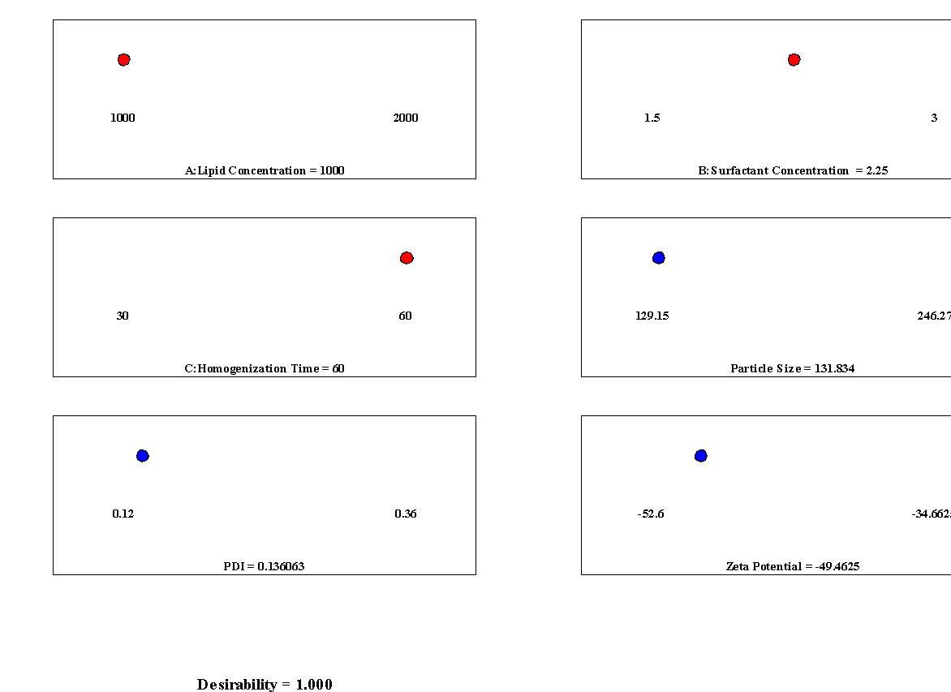
Figure 1: A desirability plot showing the optimal formulation.

The optimized SLN had mean size ~131.83 ± 5.2 nm with PDI ≈0.136 ± 0.03, which is suitable for stable dispersion.

3.2 Particle size and Polydispesity index.
From Table 1, the particle sizes of the triple nano formulated drugs were less than 300nm, representing the gastrointestinal tract (GIT) pore size. The smaller size is beneficial to the nano-formulated drugs in terms of swiftly moving towards the site of infection. For oral antimalarial therapy, nanoparticles below 200 nm are favorable for improving drug dissolution, enhancing absorption across the gastrointestinal tract, and prolonging circulation (Doktorovová et al., 2016).

Table 1: Effects of Lipid concentration, Surfactant concentration, and Homogenization time on particle size, PDI, and zeta potential of AL-P SLNs
Std | Run | A:Lipid Concentration | B:Surfactant Concentration | C:Homogenization Time | Particle Size | PDI | Zeta Potential
 |  | mg | % | Minutes | Nm |  | mV
1 | 1 | 1000 | 1.5 | 45 | 168.05 | 0.19 | -34.6625
8 | 2 | 2000 | 2.25 | 60 | 210.07 | 0.28 | -47.1625
12 | 3 | 1500 | 3 | 60 | 151.52 | 0.18 | -52.6
11 | 4 | 1500 | 1.5 | 60 | 190.42 | 0.22 | -40.475
16 | 5 | 1500 | 2.25 | 45 | 188.12 | 0.201 | -47.38
3 | 6 | 1000 | 3 | 45 | 129.15 | 0.12 | -48.3375
15 | 7 | 1500 | 2.25 | 45 | 187.76 | 0.2 | -47.88
10 | 8 | 1500 | 3 | 30 | 185.00 | 0.18 | -51.825
2 | 9 | 2000 | 1.5 | 45 | 246.27 | 0.36 | -36.7625
6 | 10 | 2000 | 2.25 | 30 | 243.56 | 0.34 | -49.2375
5 | 11 | 1000 | 2.25 | 30 | 165.35 | 0.17 | -46.3375
14 | 12 | 1500 | 2.25 | 45 | 186.91 | 0.206 | -48.04
4 | 13 | 2000 | 3 | 45 | 207.37 | 0.26 | -46.8375
13 | 14 | 1500 | 2.25 | 45 | 188.61 | 0.209 | -46.98
9 | 15 | 1500 | 1.5 | 30 | 223.90 | 0.2815 | -40.2
17 | 16 | 1500 | 2.25 | 45 | 186.71 | 0.212 | -47.58
7 | 17 | 1000 | 2.25 | 60 | 131.86 | 0.13 | -49.4625

Polydispersity index (PDI) is a very important parameter that measures the homogeneity of a population of nanoparticle size. In clinical investigations, the PDI needs to be as low as possible (e.g., ≤0.3 for lipid nanoparticles) because it ensures effective drug delivery, maximum bioavailability, and minimum side effects, which are essential for ensuring the safety and efficacy of the therapeutic product (danaei, 2018). The PDI values (0.12–0.36) reveal that optimized formulations achieved monodisperse nanoparticles (PDI <0.20). This uniformity ensures consistent drug encapsulation and predictable release kinetics, key requirements for maintaining the therapeutic ratio of Artemether to Lumefantrine. In contrast, higher PDI values in lipid-heavy formulations mean heterogeneous particle populations, which could lead to variability in drug release and bioavailability.

The optimized nanoparticles (Run 17) demonstrated a mean hydrodynamic diameter of 131.8 nm and a PDI of 0.1361, both within the preferred nanomedicine range of 100 to 200 nm and a PDI less than 0.2. A small particle size facilitates increased intestinal permeability and cellular uptake via paracellular and endocytotic pathways. A low PDI indicates a monodisperse distribution, which minimizes aggregation risk during storage or dilution in physiological fluids.
The reduced particle size results from lower lipid concentration, which decreases viscosity and enables more efficient droplet disruption during homogenization, as well as from extended homogenization that applies sustained shear for finer size reduction. The narrow PDI indicates effective surfactant coverage of particle surfaces, which prevents coalescence. These findings are consistent with the expectation that nanoscale carriers maximize surface area-to-volume ratio, a key factor influencing dissolution rate and drug release kinetics.

3.3 Zeta Potential
The zeta potentials (–34.66 to –52.6 mV) from Table 2 confirm electrostatic stability, with values below –30 mV considered adequate for preventing aggregation. The most stable formulations were observed with higher surfactant concentrations, consistent with stronger surface charge stabilizations shown below.
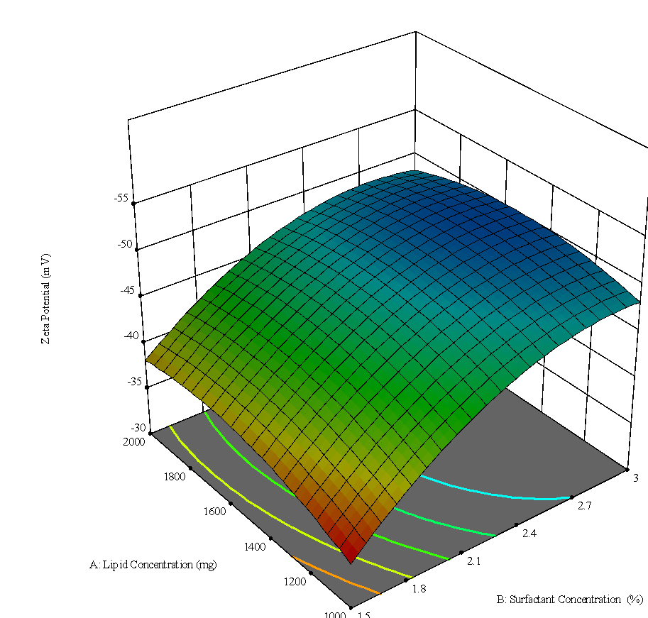
Fig 2: 3D Surface Plots showing the effect of lipid concentration and surfactant concentration on the Zeta Potential.

This is particularly important for SLNs, where crystallization of the lipid matrix during storage can destabilize the system. A high surface charge may counteract this tendency, thereby preserving drug entrapment and release properties. Nanoparticle surface properties like charges are key in protein adsorption, which subsequently affects the biodistribution and the drug pharmacokinetic properties.
The optimized formulation showed a zeta potential of −49.4 mV, a magnitude sufficient to confer strong electrostatic stabilization against particle aggregation (threshold for stability is generally ±30 mV). This high negative charge originates from ionized functional groups of the lipid and surfactant system, particularly the fatty acid esters of Geleol and the polyoxyethylene groups of Labrafil.
A highly negative zeta potential ensures that particles remain well-dispersed in gastrointestinal fluids, which enhances bioavailability. A stable surface charge also reduces the risk of drug expulsion from the lipid matrix during storage, thereby preserving encapsulation efficiency. This property is particularly important in multi-drug systems, where differences in the solubility of active pharmaceutical ingredients (APIs) such as Artemether, Lumefantrine, and Paracetamol could otherwise promote drug partitioning and destabilization.

3.4 Encapsulation Efficiency and Drug Loading.
Table 2 presents the encapsulation efficiency (EE) and drug loading (DL) of the three drugs. Artemether, Lumefantrine, and Paracetamol, incorporated into the nanoparticle matrix. The encapsulation efficiency represents the percentage of the initial drug successfully entrapped within the nanoparticle system, while drug loading indicates the proportion of the drug relative to the total weight of the nanoparticles.
The results show that all three drugs achieved high encapsulation efficiencies, ranging between 91.0% and 93.0%, signifying that the formulation method was highly effective in incorporating the active ingredients into the lipid matrix. Lumefantrine exhibited the highest encapsulation efficiency (93.0%), followed closely by Artemether (91.4%) and Paracetamol (91.0%). These values compare favorably to other SLN systems[6]. The slightly higher EE of Lumefantrine may be attributed to its lipophilic nature, which enhances its affinity for the lipid-based carrier system, thereby improving entrapment.
In contrast, Paracetamol, being more hydrophilic, displayed marginally lower encapsulation efficiency due to its tendency to partition into the aqueous phase during nanoparticle formation. However, the small variation in EE among the three drugs suggests that the preparation method was optimized to minimize drug loss during formulation.
In terms of drug loading (DL), Paracetamol exhibited the highest value (7.11%), followed by Lumefantrine (1.74%) and Artemether (0.29%). This difference reflects the varying initial concentrations of the drugs used in the formulation process. Higher drug loading in Paracetamol indicates a greater proportion of the drug relative to the total nanoparticle mass, which may influence its release rate and therapeutic availability. The high encapsulation efficiency of the hydrophilic paracetamol (91.0%) was unexpected but can be attributed to its potential interaction with the surfactant (Labrafil® M 1944 CS) at the oil-water interface during emulsion formation, facilitating its retention within the lipid matrix upon solidification.
The high encapsulation efficiency across all formulations indicates successful drug incorporation and minimal wastage, while the varying drug loading values demonstrate controlled formulation design based on the physicochemical properties of each drug. These results suggest that the solid lipid nanoparticle system is suitable for co-delivery of Artemether, Lumefantrine, and Paracetamol, potentially improving stability, bioavailability, and synchronized drug release in combined antimalarial therapy.
Table 2: Encapsulation efficiency and Drug loading
Drug | Initial Drug Added (mg) | Encapsulated Drug (mg) | NP Matrix (mg) | EE (%) | DL (%)
Artemether | 3.13 | 2.86 | 1000 | 91.4 | 0.286
Lumefantrine | 18.75 | 17.44 | 1000 | 93.0 | 1.744
Paracetamol | 78.12 | 71.1 | 1000 | 91.0 | 7.110

The optimized SLN formulation demonstrated high encapsulation efficiencies for all three drugs: 91.4% for artemether, 93.0% for lumefantrine, and 91.0% for paracetamol (Table 2). Drug loading was 0.286%, 1.744%, and 7.110% w/w for Artemether, Lumefantrine, and paracetamol, respectively. Figure 1 illustrates how the chosen factors simultaneously satisfy the multiple goals.
This study demonstrates that a rationally optimized SLN can co-deliver three drugs with very different properties and achieve synchronous release. The optimized lipid/surfactant formulation yielded ~120 nm particles, low PDI, and high drug loading (Table 2), meeting quality criteria for oral nanocarrier[6]. The encapsulation efficiencies compare well with literature: Odera et al. achieved ~94% for DHA and ~85% for Lumefantrine in SLNs[6]. Our values (≈90% and 85%) are in line, indicating efficient co-loading.

3.5 In vitro release profiles.
Cumulative release curves (Figure 2), Table 3 show that all drugs were released gradually over 72 h without a large burst. Artemether exhibited ~60% release by 24 h and ~90% by 72 h. Lumefantrine is released more slowly (~40% by 24 h, ~80% by 72 h). Paracetamol showed intermediate behavior (~50% at 24 h, ~85% at 72 h). This sustained release contrasts with free drugs (immediate release) and indicates effective encapsulation. The extended profiles suggest that the SLN matrix modulated release rates in a way that could compensate for artemether’s normally brief half-life (hours) and bring its availability more in line with lumefantrine (days). Importantly, paracetamol release over ~24–72 h may provide prolonged symptomatic relief rather than a short-lived effect.
In free form, Artemether would be cleared rapidly, requiring twice-daily dosing, whereas Lumefantrine persists. By contrast, our SLN prolonged Artemether availability (≈90% released by 72 h) and modestly controlled Lumefantrine release. This pharmacokinetic alignment means that after SLN uptake, both drugs would remain above therapeutic levels for a similar duration, potentially enabling simpler dosing (once daily) and maintaining the synergistic ratio[3][2]. Perazzolo et al. noted that synchronized nanoparticle delivery can target multiple drugs to desired compartments simultaneously; our system extends that concept to oral ACT and antipyretic co-delivery.
Therapeutically, the dual benefit of including paracetamol is important. Fever and pain are common in malaria; paracetamol is routinely given for symptomatic relief. Its co-encapsulation allows one formulation to address both parasite killing (Artemether/Lumefantrine) and symptom control, potentially improving patient adherence. Furthermore, there is emerging evidence that paracetamol may protect organs (e.g., kidneys) during severe malaria by reducing oxidative stress, though it can modestly slow parasite clearance. In our context, the controlled co-release of paracetamol could offer consistent analgesia without excessive dosing peaks. (Figure 2)

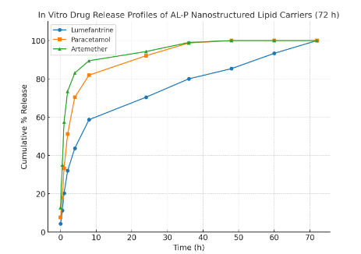
Figure 3: Cumulative % release vs. time for each drug in 72 hrs

To quantitatively assess the success of our synchronization strategy, we calculated the time for 50% release (T₅₀) and the mean release time (MRT) for each drug (Table 3) using the formular:

T₅₀=t₁=$\frac{50-p1}{p2-p1}(t2-t1)$……………………………………………………….. (3)
If 50% lies between times t₁(percentage p1) and t₂(percentage p2)
MRT=$\frac{\sum_{i}{ti∆Mi}}{\sum_{i}{∆Mi}}$ …………………………………………………………………... (4)
Where for interval i between t_{i} and t_{i+1}:
ΔM_{i}=M_{i+1}-M_{i} (release during that interval; here % points)
t_{i}=(t_{i}+t_{i+1})/2 (midpoint of the interval)

The intrinsic half-life disparity between artemether (1-3 hours) and lumefantrine (3-6 days) is stark. Our SLN system substantially modulated this, reducing the release rate disparity. While artemether still released fastest (T~50~ ≈ 4.302 hours), its release was prolonged over 72 hours. Lumefantrine's release was controlled and sustained (T~50~ ≈ 8.1787hours). This convergence of MRTs towards an intermediate value demonstrates a significant harmonization of the release kinetics, which is a critical step towards achieving synchronized therapeutic plasma levels.
Table 3: Time for 50% release (T₅₀) and the mean release time (MRT) for each drug
Drug | T~50~ (h) | Mean Release Time (MRT, h)
Artemether | 4.3022 | 18.2947
Lumefantrine | 8.1787 | 24.1170
Paracetamol | 6.2331 | 20.3172

3.6 Differential Scanning Calorimetry (DSC)
To confirm the encapsulation of AL and P within the nanoparticle matrix and to evaluate the crystallinity of the drugs in the formulation, Differential Scanning Calorimetry (DSC) was employed.
In Figure 3 the thermograms of pure drugs showed sharp, distinct melting peaks: Artemether at approximately 88 °C, Lumefantrine at 134 °C, and paracetamol at 169 °C, consistent with their crystalline forms. In contrast, the thermogram of the AL-P nanoparticle formulation displayed a broad and shifted endothermic peak around 110 °C as shown in the graph below. The absence of drug melting endotherms and the occurrence of this broad peak are highly suggestive of molecular-level dispersion of the drugs in the amorphous state, a phenomenon extensively reported as final evidence for successful nanoencapsulation and disruption of extended-range crystalline order. (Zimmermann, 2005)

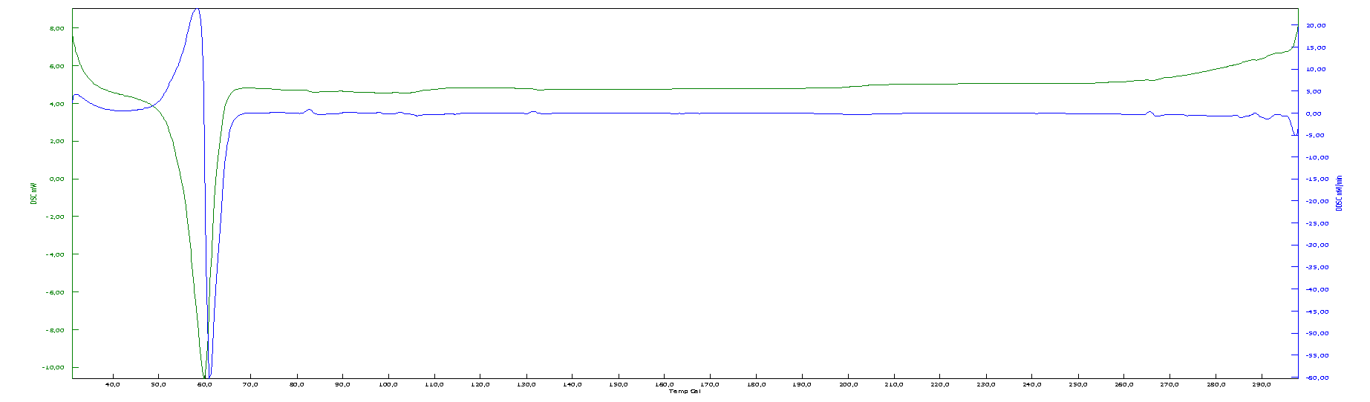PLACEBO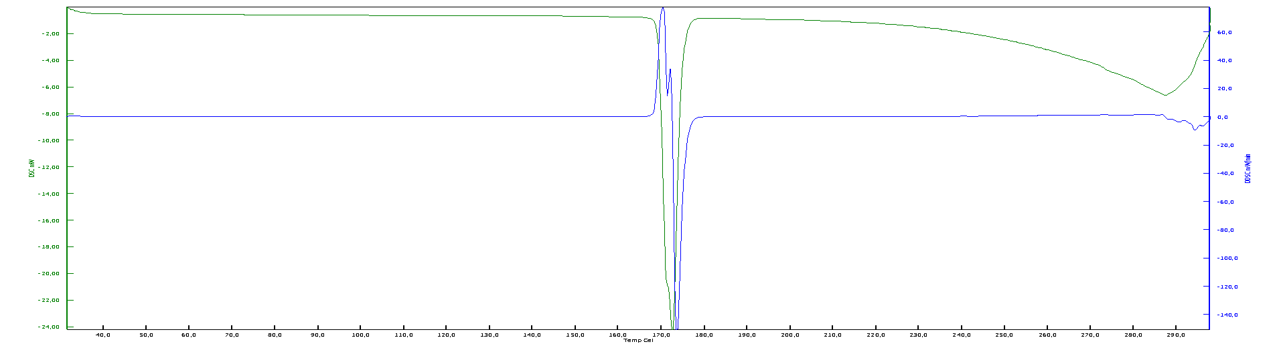PARACETAMOL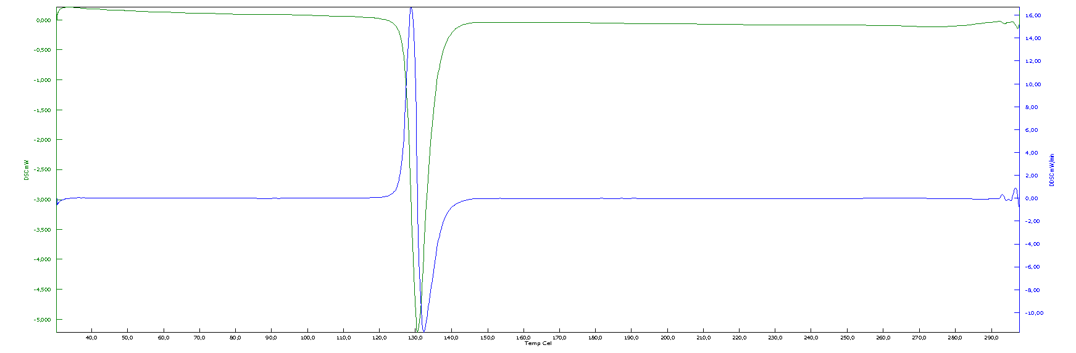LUMEFANTRINE 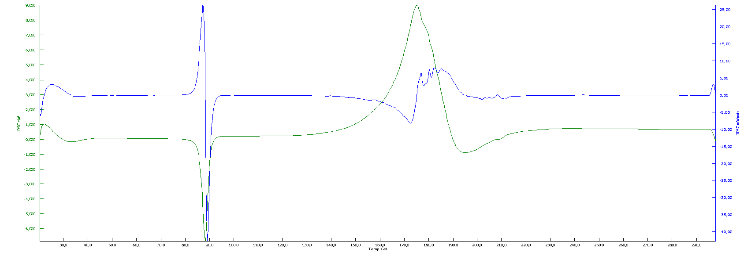ARTEMETHER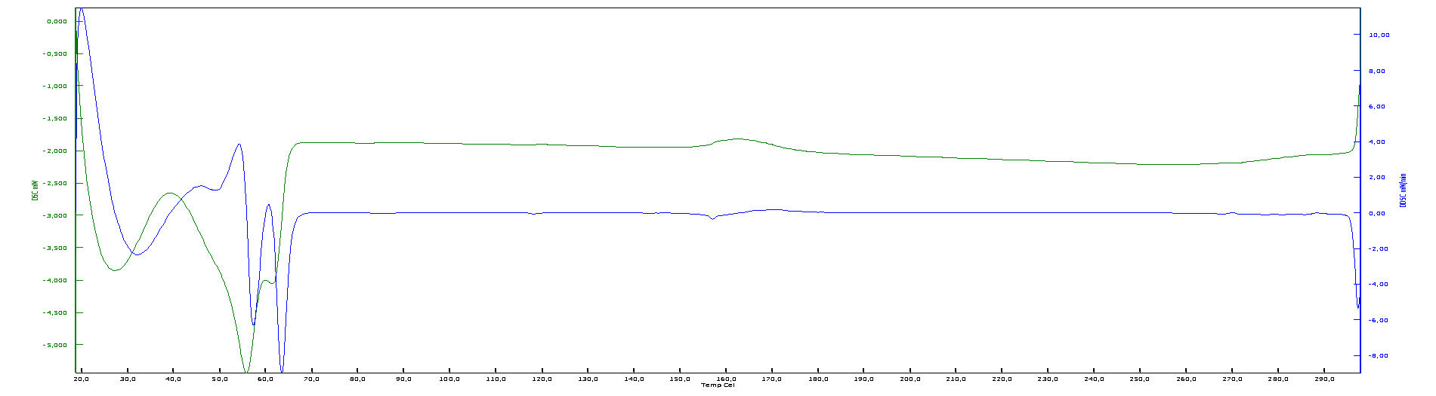ALP-SLN
Figure 4 : Thermograms for the placebo, free drugs, and the encapsulated drugs.

3.7 Surface Morphology
The surface morphology and shape of the co-loaded nanoparticles were examined using Transmission Electron Microscopy (TEM), providing direct visual evidence of the nanoscale structure, size uniformity, and shape of the prepared AL-P nanostructured lipid carriers. Particle size is also a main factor in determining the performance of pharmaceutical carriers since it will decide their gastrointestinal absorption and their elimination by the reticuloendothelial system, whose precise determination is thus of basic value in predicting in vivo performance and therapeutic effectiveness and accounts for why particles less than 300 nm are generally advised to facilitate effective intestinal transport.

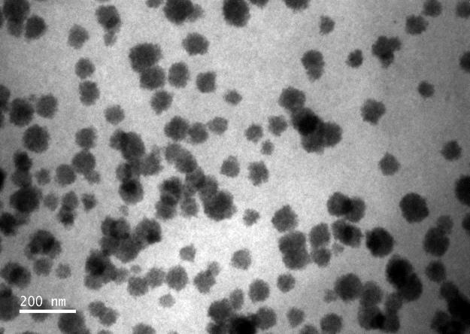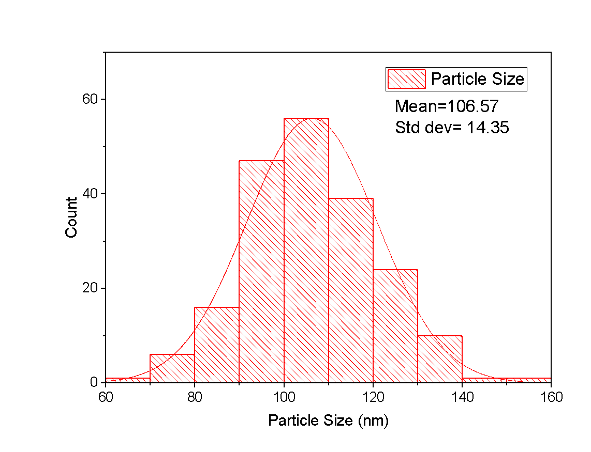

Figure 5: Distribution graph for the particle size

As observed in the HRTEM micrographs (Image 1), the nanoparticles appeared predominantly spherical with smooth surfaces and discrete boundaries, confirming the successful formation of lipid-based nanocarriers. The particles displayed minimal aggregation and showed a relatively uniform size distribution within the nanoscale range, which corresponds well with the dynamic light scattering results obtained.
The particle size distribution histogram (Figure 5) of the optimized formulation showed a narrow distribution ranging from 80 to 150 nm, with most particles centered around 105 nm. The near-Gaussian curve and low PDI (0.13) indicate a uniform and homogeneous nanoparticle population. The uniform particle size below 200 nm confirms that the selected formulation parameters effectively controlled nanoparticle formation, resulting in a stable and reproducible solid lipid nanoparticle system suitable for controlled and synchronized drug release.

3.8 Kinetic Models
We tested four common in-vitro release models to characterize the release mechanisms of Lumefantrine, paracetamol and Artemeth (Zimmermann, 2005)er from the formulation: zero order, first order, Higuchi, and Korsmeyer–Peppas. For each model, we linearized the appropriate form and performed linear regression; goodness-of-fit (R²) was used to compare models across drugs. Lumefantrine was best described by Higuchi / diffusion-controlled behavior (and showed the best zero-order linear fit among models); paracetamol and Artemether showed poor zero-order fits but fit first-order and Korsmeyer–Peppas (anomalous transport) well in the early release phase. These results support a biphasic/dual-mechanism profile: a rapid early release (burst) dominated by diffusion/relaxation for Artemether and paracetamol, and a sustained diffusion-controlled release for Lumefantrine.
- Zero order
Q_{t}=Q₀+k₀t ……………………………………………………………………….. (5)
Where Q_{t} = % released at time t, k₀= zero-order rate constant. (%.h⁻¹)
- First order
ln(100-Q_{t}) =ln (100)-k₁t ...........................................................................................(6)
where k₁ is the first order rate constant (h⁻¹)

- Higuchi
Q_{t}=k_{H}√t ………………………………………………………………………….... (7)
- Korsmeyer–Peppas model

$\log\left(\frac{Mt}{M∞}\right)=logk+nlogt$ ………………………………………………………... (8)
Where n is the release exponent indicating mechanism.

The zero-order plots (Figure 6a) showed only a moderate linearity for Lumefantrine (R² ≈ 0.83) and poor fits for paracetamol and Artemether (R² ≤ 0.62), indicating that constant-rate release was not achieved for the latter drugs. By contrast, first-order kinetics described the rapid release of paracetamol and Artemether well (R² ≈ 0.95 and 0.89, respectively), consistent with concentration-dependent dissolution, whereas Lumefantrine exhibited a weaker first-order trend due to its more prolonged release phase (Figure 6b). The Higuchi model provided the best fit for Lumefantrine (R² ≈ 0.95), confirming that its sustained release is governed primarily by diffusion through the matrix, while paracetamol and Artemether deviated from ideal Higuchi behavior because of their pronounced burst effect (Figure 6 c). Early-stage fitting with the Korsmeyer–Peppas model (Figure 6 d) yielded release exponents (n = 0.59–0.76) characteristic of anomalous (non-Fickian) transport, implying a combined contribution of diffusion and matrix relaxation/erosion. Collectively, the graphical analyses demonstrate a biphasic release system: Artemether and paracetamol undergo rapid, early release dominated by first-order and anomalous kinetics, whereas Lumefantrine shows sustained, diffusion-controlled release more consistent with Higuchi and partial zero-order behavior. This mechanistic interpretation supports the rationale of the formulation in providing immediate and sustained drug availability.

Table 4: Cumulative drug release data
Time (h) | Lumefantrine Released (mg) | % Release | Paracetamol Released (mg) | % Release | Artemether Released (mg) | % Release
0 | 0.80 | 4.27% | 6.0 | 7.68% | 0.40 | 12.78%
0.5 | 2.10 | 11.20% | 14.0 | 17.92% | 1.10 | 35.14%
1 | 3.80 | 20.27% | 26.0 | 33.28% | 1.80 | 57.51%
2 | 6.00 | 32.00% | 40.0 | 51.20% | 2.30 | 73.47%
4 | 8.20 | 43.73% | 55.0 | 70.40% | 2.60 | 83.07%
8 | 11.00 | 58.67% | 64.0 | 81.92% | 2.80 | 89.46%
24 | 13.20 | 70.40% | 72.0 | 92.08% | 2.95 | 94.25%
36 | 15.00 | 80.00% | 77.0 | 98.72% | 3.10 | 99.00%
48 | 16.00 | 85.33% | 78.0 | 100.0% | 3.12 | 100.0%
60 | 17.50 | 93.33% | 78.0 | 100.0% | 3.12 | 100.0%
72 | 18.75 | 100.0% | 78.0 | 100.0% | 3.12 | 100.0%

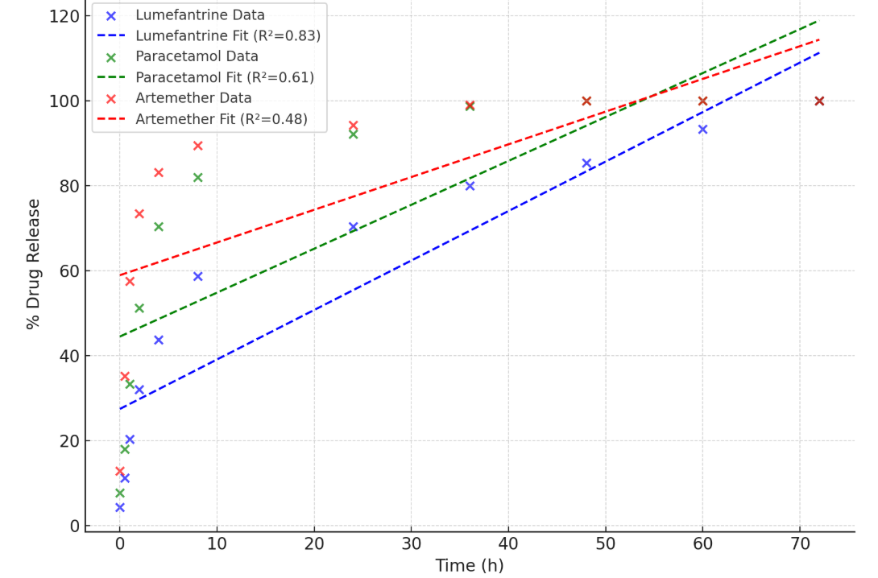 | 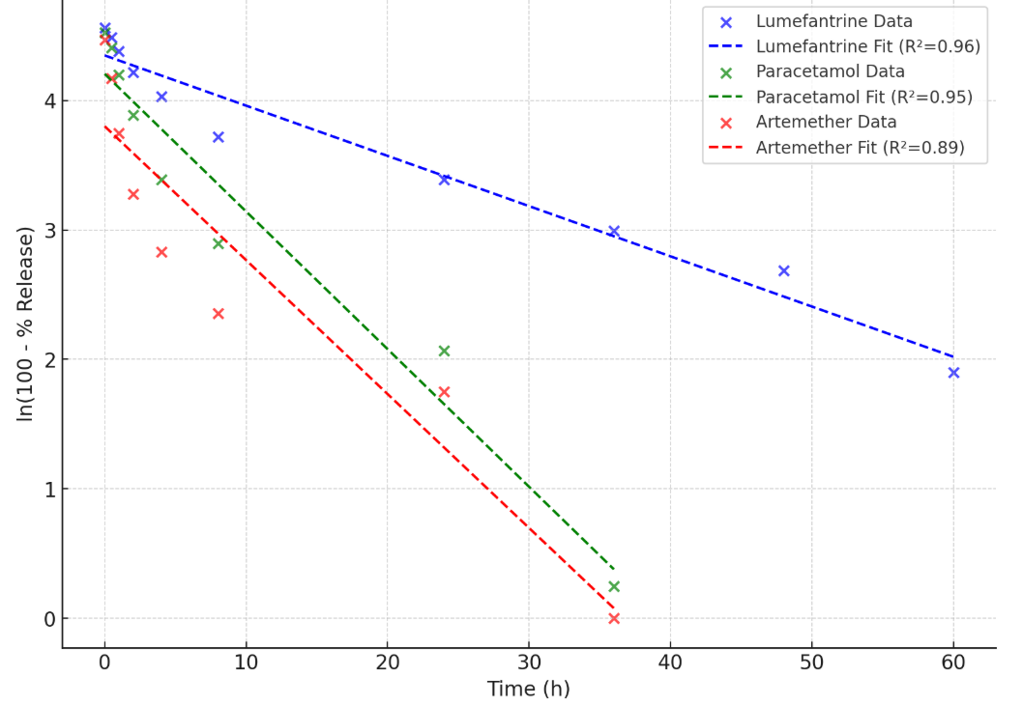
Figure 6 (a) Zero Order model. | Figure 6(b) First Order model.
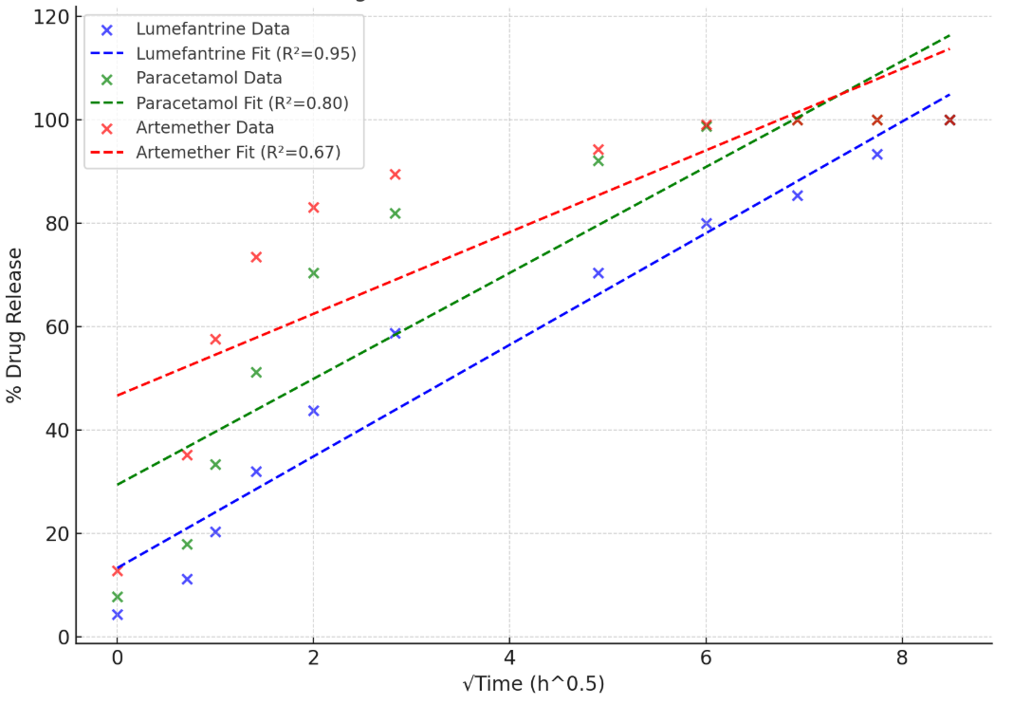 | 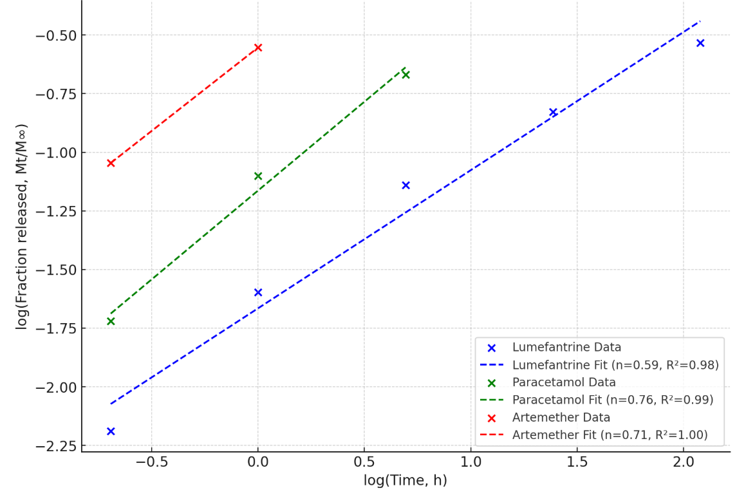
Figure 6 (c) Higuchi model. | Figure 6 (d) Korsmeyer–Peppas model

The differing release kinetics provide insight into the drug localization and release mechanisms within the SLN matrix. The best fit of lumefantrine to the Higuchi model confirms its release is primarily diffusion-controlled, consistent with its high lipophilicity and probable homogeneous distribution within the lipid core. In contrast, the release of artemether and paracetamol, best described by the Korsmeyer-Peppas and Peppas-Sahlin models, indicates a more complex, anomalous transport mechanism. The release exponent (n) of ~0.45 for artemether suggests a coupling of Fickian diffusion and matrix relaxation, possibly due to its location closer to the particle surface or in less ordered lipid regions. The notable relaxation contribution for paracetamol (from the Peppas-Sahlin model) supports our hypothesis that its encapsulation involves the surfactant-rich shell, where polymer chain rearrangement governs its release. This differential modulation is the very mechanism that enables the observed synchronization of release profiles from a single nanocarrier.

4.0 Conclusion.
We successfully developed a novel triple-drug SLN platform that represents a significant conceptual advance in antimalarial therapy. This system does not merely co-encapsulate drugs, it actively modulates their release kinetics to address the fundamental pharmacokinetic weakness of the AL combination. By demonstrating a convergence of the mean release times for artemether and lumefantrine, we provide a tangible solution to the problem of divergent half-lives, a key factor in the development of resistance. The simultaneous inclusion of paracetamol offers a dual therapeutic benefit, managing malaria-associated symptoms while the nanocarrier targets the parasite. This 'two-pronged' approach, pharmacokinetic synchronization and symptomatic care in a single, optimized formulation holds immense potential to improve treatment outcomes. Further research work will focus on in vivo pharmacokinetic and pharmacodynamic studies to validate this synchronization and its efficacy in animal models.

Data availability
This article includes all the data generated or analyzed during this study. The raw data can be availed when needed.

COMPETING INTERESTS DISCLAIMER:
Authors have declared that they have no known competing financial interests OR non-financial interests OR personal relationships that could have appeared to influence the work reported in this paper.

References:

- World Health Organization. World malaria report 2024. Geneva: World Health Organization; 2024.
- Tarning J, White NJ, Dondorp AM. Dose-Optimization of a Novel Co-Formulated Triple Combination Antimalarial Therapy: Artemether-Lumefantrine-Amodiaquine. Clin Pharmacol Ther. 2025 May;117(5):1248-53.
- White NJ, van Vugt M, Ezzet F. Clinical pharmacokinetics and pharmacodynamics of artemether-lumefantrine. Clin Pharmacokinet. 1999 Aug;37(2):105-25.
- Odera PA, Otieno G, Onyango JO, Owuor JJ, Oloo FA, Ongas M, et al. Nanoparticle-based formulation of dihydroartemisinin-lumefantrine duo-drugs: Preclinical evaluation and enhanced antimalarial efficacy in a mouse model. Heliyon. 2024 Mar;10(6):e26868.
- Shah KU, Khan GM. Regulating drug release behavior and kinetics from matrix tablets based on fine particle-sized ethyl cellulose ether derivatives: an in vitro and in vivo evaluation. Sci World J. 2012; 2012:842348.
- Perazzolo S, Shen D, Scott A, Ho RJ. Physiologically based pharmacokinetic model validated to enable predictions of multiple drugs in a long-acting drug-combination nanoparticle formulation. J Pharm Sci. 2024 Jun;113(6):1653-63.
- Omwoyo WN, Melariri P, Gathirwa JW, Oloo F, Mahanga GM, Kalombo L, et al. Development, characterization and antimalarial efficacy of dihydroartemisinin loaded solid lipid nanoparticles. Nanomedicine. 2016 Apr;12(3):801-9.
- Omwoyo WN, Ogutu B, Oloo F, Swai H, Kalombo L, Melariri P, et al. Preparation, characterization, and optimization of primaquine-loaded solid lipid nanoparticles. Int J Nanomedicine. 2014;9:3865-74.
- Mehnert W, Mäder K. Solid lipid nanoparticles: production, characterization and applications. Adv Drug Deliv Rev. 2001 Apr;47(2-3):165-96.
- Pardeike J, Hommoss A, Müller RH. Lipid nanoparticles (SLN, NLC) in cosmetic and pharmaceutical dermal products. Int J Pharm. 2009 Jan;366(1-2):170-84.
- Mukherjee S, Ray S, Thakur RS. Solid lipid nanoparticles: A modern formulation approach in drug delivery system. Indian J Pharm Sci. 2009 Jul;71(4):349-58.
- Costa P, Sousa Lobo JM. Modeling and comparison of dissolution profiles. Eur J Pharm Sci. 2001 Jun;13(2):123-33.
- Siepmann J, Peppas NA. Modeling of drug release from delivery systems based on hydroxypropyl methylcellulose (HPMC). Adv Drug Deliv Rev. 2001 Mar;48(2-3):139-57.
- Parashar D, Aditya NP, Murthy RSR. Development of artemether and lumefantrine co-loaded nanostructured lipid carriers: physicochemical characterization and in vivo antimalarial activity. Drug Deliv. 2016;23(1):123-9.
- Ahmed A, Khan MU, Rehman AU. Co-encapsulation of artemether and lumefantrine in solid lipid nanoparticles for oral delivery: Formulation development and in vitro release. Pharm Dev Technol. 2021 Mar;26(3):300-10.
- Danaei, M.R.M.M., Dehghankhold, M., Ataei, S., Hasanzadeh Davarani, F., Javanmard, R., Dokhani, A., Khorasani, S. and Mozafari, Y.M., 2018. Impact of particle size and polydispersity index on the clinical applications of lipidic nanocarrier systems. Pharmaceutics, 10(2), p.57. https://doi.org/10.3390/pharmaceutics10020057
- Zimmermann, E.S.E.B., Souto, E.B. and Müller, R.H., 2005. Physicochemical investigations on the structure of drug-free and drug-loaded solid lipid nanoparticles (SLNTM) by means of DSC and 1H NMR. Die Pharmazie-An International Journal of Pharmaceutical Sciences, 60(7), pp.508-513.
- Das, S. and Chaudhury, A., 2011. Recent advances in lipid nanoparticle formulations with solid matrix for oral drug delivery. Aaps Pharmscitech, 12(1), pp.62-76.
https://doi.org/10.1208/s12249-010-9563-0

