In-situ Growth of NiCo₂O₄ on Nickel Foam as a Robust Electrode for Methanol Oxidation Reaction

.
ABSTRACT
Despite being a potential next-generation energy device, direct methanol fuel cells (DMFCs) are not yet widely available due to their slow methanol oxidation reaction (MOR) kinetics and dependence on expensive platinum catalysts. Here, we describe the direct development of nickel cobalt oxide (NiCoO₄) nanostructures on nickel foam (NF) as a productive, binder-free catalyst for MOR in alkaline media. After a straightforward hydrothermal method and annealing, the NiCo₂O₄/NF electrode was created, and its structural and electrochemical characteristics were thoroughly examined. A porous nickel foam structure adorned with flower-shaped NiCoO₄ microspheres made from needle-like ligaments was visible in SEM images. This structure offered a high density of reactive sites and effective charge routes. While XRD patterns revealed the crystalline spinel phase of NiCo₂O₄, EDS mapping confirmed a homogenous Ni–Co–O distribution. In comparison to blank NF or single oxides, electrochemical tests showed markedly greater current densities in methanol-containing electrolytes, indicating enhanced MOR activity. In line with other studies of high-performance NiCo₂O₄ morphologies, the porous–hierarchical design allowed for excellent catalyst adhesion, strong ion transport, and long-term stability. These results demonstrate that NiCoO₄/NF is a non-platinum catalyst that is inexpensive, long-lasting, and has a lot of potential for improving DMFC technology.

Keywords: Nickel foam, Nanoparticles, hydrothermal, method, Oxidation reaction and electrochemistry.

1. INTRODUCTION
As the world's dependence on fossil fuels increases environmental degradation and concerns about their depletion, it is now unavoidable that we will move towards cleaner and more sustainable energy technologies [1]. Because of their low-to-zero emissions, high energy density, mobility, and high efficiency, direct methanol fuel cells (DMFCs) have become one of the most promising next-generation energy conversion technologies [2]. However, issues including the slow kinetics of the methanol oxidation process (MOR), the high cost of the catalyst, and the poor long-term stability of DMFCs prevent their widespread commercialization [3]. The most efficient catalysts for MOR have historically been platinum and its alloys, but their high price, limited supply, and vulnerability to reaction intermediate poisoning have severely limited their usefulness [4].
Transition-metal-based catalysts, particularly those based on nickel and cobalt oxides, have been studied as appealing substitutes for these restrictions due to their abundance, affordability, and superior electrochemical activity in alkaline media [5]. Because of their numerous valence states, which promote quick electron transfer and rich redox reactions, nickel oxides (NiO) and cobalt oxides (CoO₄) are especially captivating [6]. Because of the synergistic effects of Ni and Co cations, combining these oxides to form a binary spinel structure, like nickel cobaltite (NiCo₂O₄), further improves conductivity, catalytic activity, and durability [7]. According to recent research, nanostructured NiCo₂O₄ is a very promising non-platinum catalyst for DMFCs because of its exceptional electrocatalytic
activity and stability towards MOR. Furthermore, NiCoO₄'s shape and nanostructure engineering are essential for enhancing catalytic performance [8]. It has been claimed that various topologies, including porous nanostructures, nanosheets, nanowires, and nanoflakes, improve methanol oxidation efficiency by increasing electrolyte accessibility, exposing more active sites, and shortening electron diffusion paths [9]. Moreover, nanostructured NiCo₂O₄ demonstrates excellent tolerance to carbon monoxide (CO) poisoning, a common problem for Pt-based catalysts, thereby ensuring long-term stability during fuel cell operation [10].
The selection of support material is another important consideration in catalyst design [11]. Traditional techniques use carbon black and polymer binders as conductive agents, however these frequently impair electrolyte penetration, obstruct ion transport, and impair reaction kinetics as a whole [12]. On the other hand, nickel foam (NF) offers the perfect platform for the direct growth of active materials due to its huge surface area, high conductivity, and three-dimensional porous structure [13]. With NiCo₂O₄ supported on NF, there is no need for extra binders because it provides a large number of accessible active sites, quick charge transfer, and robust mechanical stability [14].
Since catalyst detachment is prevented by the strong adherence between the active layer and substrate, direct integration of NiCoO₄ with nickel foam also aids in overcoming electrode degradation after repeated cycling [15]. Additionally, during methanol oxidation, the open framework of NF offers effective paths for gas diffusion and bubble release, which further enhances catalytic activity and durability [16].
As a very effective and reliable catalyst for the methanol oxidation reaction, we present the direct development of nickel cobalt oxide (NiCoO₄) nanostructures on nickel foam. Our method makes use of the three-dimensional porous structure of nickel foam, which guarantees binder-free integration, effective charge transfer, and a large number of accessible active sites, in contrast to traditional powder-based electrodes that call for polymer binders and conductive additives [17]. In comparison to traditional catalysts, the spinel structure's Ni and Co redox couples work in concert with the conductive and mechanically sturdy nickel foam substrate to provide greater catalytic activity, increased durability, and improved poisoning tolerance [18]. This work highlights the potential of NiCoO₄/NF as a promising electrode material for direct methanol fuel cells and presents a logical design approach for affordable, non-platinum catalysts.

2. Materials and Methods
In order to create NiCo₂O₄@NF, urea, cobalt nitrate hexahydrate (Co(NO₃)₂·6H₂O), and nickel nitrate hexahydrate (Ni(NO₃)₂·6H₂O) are first mixed in a solution of ethanol and deionised water (DI water). To guarantee that the ingredients are well blended, this mixture is then swirled for fifteen minutes. Clean nickel foam (NF) is added to the mixture after stirring. After that, the mixture with nickel foam undergoes an 8-hour hydrothermal treatment at 120 °C. To get rid of any remaining reactants or byproducts, the finished product is cleaned and dried after this treatment. The material is finally annealed for two hours at 300 °C to get the desired product, NiCo₂O₄@NF.
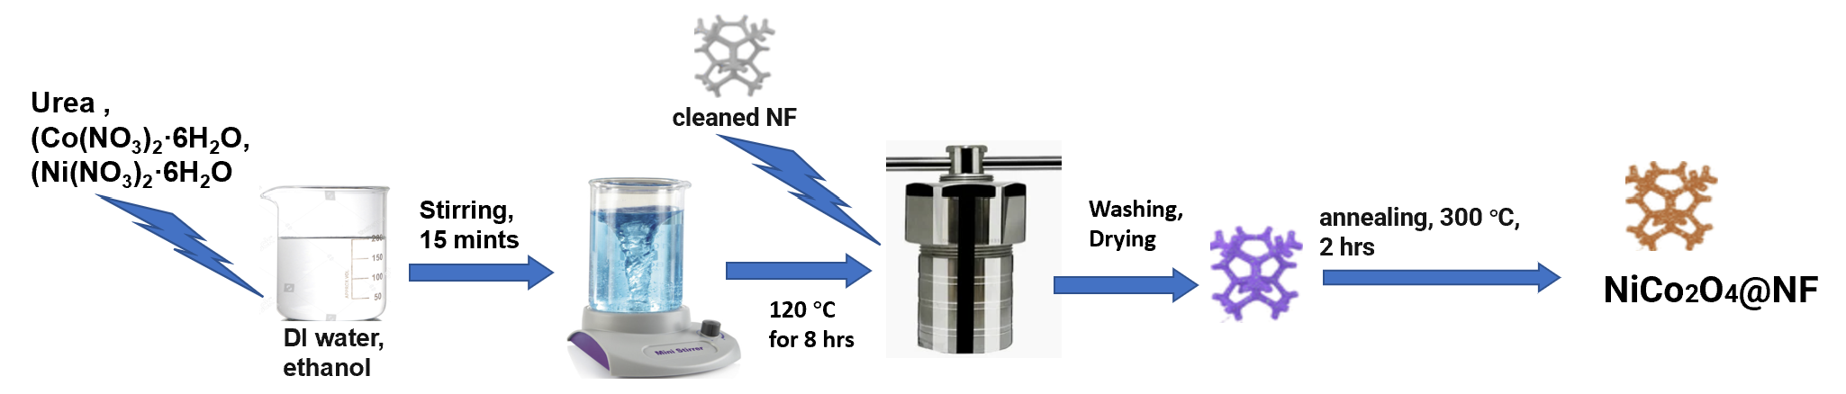
Figure 1. Synthesis of NiCo₂O₄@NF

3. RESULTS AND DISCUSSION
3.1 Materials Characterization and electrochemical testing
Cu Kα radiation (λ = 1.5418 Å) was used in powder X-ray diffraction (XRD) to examine the crystalline structure of the synthesized catalysts. Using scanning electron microscopy (SEM, JEOL, operating at 10 kV), the surface morphology and microstructural characteristics were investigated. Energy-dispersive X-ray spectroscopy (EDS) in conjunction with SEM was used to analyze the elemental distribution and composition. To further verify the uniform dispersion of nickel, cobalt, and oxygen across the catalyst surface, elemental mapping from SEM–EDS was used. Furthermore, EDS mass sum spectra were acquired in order to measure the samples' total elemental makeup.
Using a conventional three-electrode setup, electrochemical measurements were performed on a CHI electrochemical workstation. The working electrode (WE) was the produced NiCo₂O₄/Ni foam electrode, the reference electrode (RE) was a saturated calomel electrode (SCE), and the counter electrode (CE) was a Pt plate measuring 1 cm by 1 cm. At a scan rate of 10 mV s⁻¹, linear sweep voltammetry (LSV) was carried out in a 1 M KOH solution containing 0.5 M methanol within the potential window of 0–0.6 V (vs. SCE).
3.1.1 SEM
A mechanically robust skeleton is formed by thin ligaments supporting an interconnected three-dimensional porous structure with macropores spanning from 80 to 300 µm, as seen in the SEM picture of nickel foam (Figure 2). Large open channels for quick electrolyte diffusion and roughened surfaces that serve as anchoring sites for active material deposition are both provided by this dual-scale morphology [19]. While the continuous network guarantees effective charge transport channels across the electrode, the high porosity reduces diffusion resistance. Because they enhance the catalyst-electrolyte interaction and increase the electrochemically active surface area, these structural characteristics are beneficial for electrocatalysis. In addition, prior research has shown that porous nickel foams, as opposed to dense, binder-based electrodes, can greatly improve methanol oxidation performance [20]. Compared with conventional smooth Ni foams, the rough granular texture observed here offers more active binding sites, making it particularly suitable for supporting nanostructured NiCo₂O₄ growth [21]. Accordingly, NF's inherent porous structure serves as the perfect backbone, offering conductivity and stability in line with previous research.
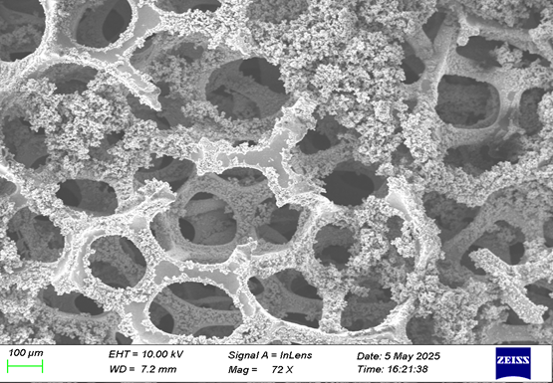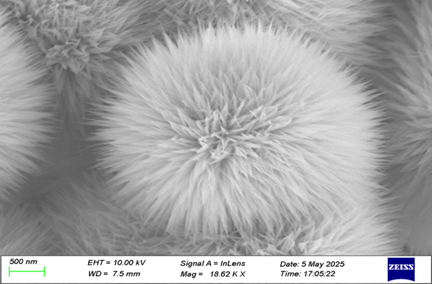
Fig. 2 SEM images of NiCo₂O₄ grown on NF

A micro spherical shape resembling a flower is assembled from radially orientated needle-like ligaments in the SEM picture of NiCo₂O₄ grown on NF (Figure 3). With lengths greater than a micrometer and sizes in the tens of nanometers, these nanoneedles produce a large number of edge and corner sites that are ideal for catalytic reactions [22]. High surface-to-volume ratio and improved electrolyte ion accessibility are guaranteed by the hierarchical configuration. Because they can expose more active sites and speed up electron transfer, similar flower-like NiCoO₄ structures have demonstrated outstanding activity towards MOR in the past [23]. Because of its hierarchical structure and higher density of exposed reactive edges, the flower-like NiCo₂O₄/NF seen here should perform on par with or better than the nanosheet (111 mA cm⁻²) and Nano cloth (134 mA cm⁻²) morphologies documented in previous investigations [24]. These results demonstrate that morphological engineering is essential for maximizing durability and catalytic activity.

3.1.2 EDX Analysis
A highly porous NiCo₂O₄/NF structure with linked micropores (150–300 µm) and thin ligaments (15–30 µm) producing a mechanically robust network is highlighted in the SEM–EDS stacked picture (Figure 4). With nanoscale characteristics (~50–100 nm), the granular surface greatly improves surface roughness and provides a large number of electroactive sites for the oxidation and adsorption of methanol. By lowering diffusion resistance and supplying a large number of redox-active centers, such hierarchical porous architectures have been shown to improve mass transport and charge transfer in MOR [25]. Furthermore, the uniform elemental dispersion seen here is consistent with past research showing that structural stability and catalytic efficiency were enhanced by uniform Ni–Co–O integration [26]. The porous structure here guarantees improved reactant accessibility and stability during extended operation in comparison to non-porous NiCo₂O₄ films, which is in line with earlier findings on binder-free NiCo₂O₄/NF electrodes.
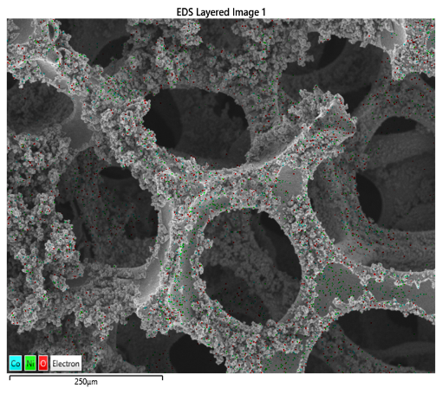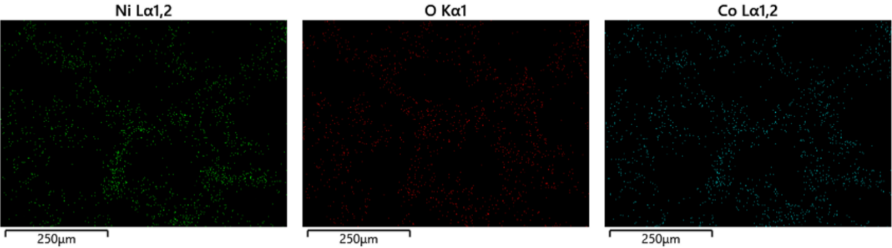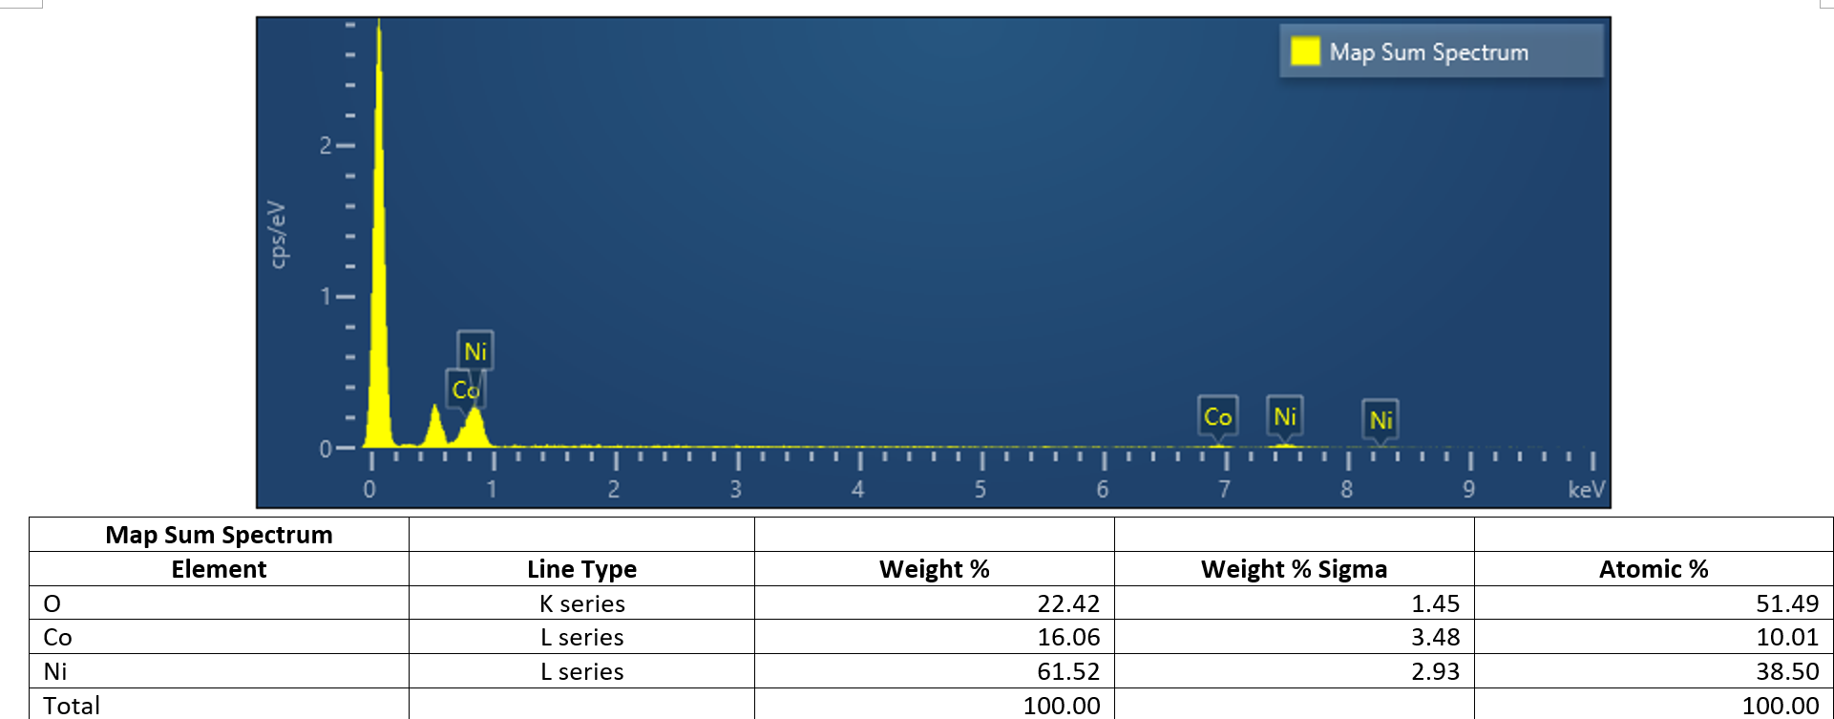

Fig. 3 EDX Spectra of NiCo₂O₄ grown on NF

The excellent integration of both metals into the NiCo₂O₄ framework without noticeable impurity signals is confirmed by the EDS spectrum (Figure 5), which displays discrete Ni peaks (~0.8, 7.5, 8.3 keV) and Co peaks (~0.7, 6.9 keV). In accordance with the quantitative findings, a Ni-rich oxide phase is indicated by the increased intensity of Ni peaks. According to earlier research, a Ni-rich NiCo₂O₄ phase is advantageous for MOR since methanol electro-oxidation is dominated by Ni²⁺/Ni³⁺ redox couples [27]. A crucial element in guaranteeing long-term catalytic stability is the excellent purity of the synthesized material, which is further demonstrated by the lack of contaminating peaks. Comparable findings showed that Ni–Co oxides with regulated stoichiometry had higher current densities than single oxides [28]. The development of a clean and catalytically active Ni–Co mixed oxide phase is thus strongly supported by the EDS data.
The homogeneous distribution of Ni, Co, and O throughout the whole scanned region (250 µm) is seen in the elemental mapping images (Figure 6). The creation of a stable spinel NiCo₂O₄ phase is demonstrated by the fine speckled distribution, which validates the uniform mixing of Ni and Co inside the oxide lattice. Because it guarantees that both Ni and Co active centers are concurrently accessible throughout the redox process, this homogenous dispersion is essential for MOR and enhances catalytic activity. Phase segregation was frequently observed in earlier findings on non-uniform composites, which resulted in decreased activity and durability [29]. Our findings, on the other hand, are in line with past research that successfully accomplished uniform Ni–Co–O mapping and directly connected it to better electrocatalytic performance and CO-tolerance in methanol oxidation.
The EDS map-sum spectrum (Table 1) reveals the quantitative composition: Ni is the most plentiful element, accounting for 61.52 weight percent (38.50 at%). With a weight percentage of 22.42 (51.49 at%), O is in second place, followed by Co with 16.06 (10.01 at%). The relative proportions reveal an oxide that is rich in Ni and has an atomic ratio of roughly 3.8:1. The oxygen content corresponds to an O:(Ni+Co) ratio slightly above 1, indicating the presence of a Ni–Co mixed oxide or hydroxide phase. Given the uncertainties (σ values), Ni is measured with the highest confidence, while Co has the largest relative error due to its lower concentration. Overall, both mapping and quantitative analysis confirm a homogenous Ni-rich Ni–Co–O system.
Table.1 Elemental Map
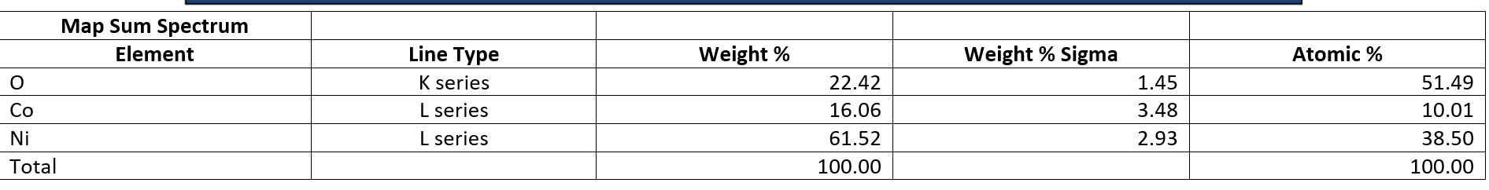

3.1.3 XRD Analysis
The crystalline form of the synthesized material is confirmed by the many diffraction peaks in the 2θ range of 20–80° in the NiCo₂O₄/NF XRD pattern (Figure 7). The spinel NiCo₂O₄ phase is represented by lesser peaks, whereas the underlying nickel foam substrate is responsible for the strong, sharp peak that emerges at 44–45°. A small crystallite size, which is frequently associated with a larger surface area and better catalytic activity, is suggested
by the comparatively broader peaks. Similar XRD characteristics for NiCoO₄ nanostructures grown on conductive supports have been reported in earlier research, demonstrating that the material maintains its spinel structure following production and annealing [33]. Specifically, because of the increased density of exposed edge sites and flaws, the broadening of diffraction peaks has been associated with increased electrochemical activity. The inclusion of a well-defined NiCo₂O₄ spinel structure improves MOR kinetics by providing synergistic redox activity of both Ni and Co cations, in contrast to NiO or Co₃O₄ single oxides [34]. Our XRD results are therefore consistent with previous literature and further validate the successful fabrication of an active and stable NiCo₂O₄/NF electrode.
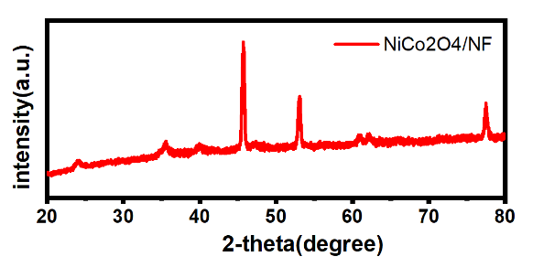
Fig. 4 XRD Spectra of of NiCo₂O₄ grown on NF
4. Electrochemical testing. (LSV graph)
The linear sweep voltammetry (LSV) curves of NiCoO₄/NF (nickel foam) electrodes were recorded in two electrolytes: KOH and CH₃OH 1 M and KOH + 1 M [30]. An increase in current density with potential indicates electrocatalytic activity in both cases. However, there is a discernible improvement with the addition of methanol: the red curve (1 M KOH + 1 M CH₃OH) shows considerably higher current densities than the black curve (1 M KOH alone) within the potential range of ~1.2–1.6 V vs. RHE. This increase in current density in the presence of methanol demonstrates the methanol oxidation reaction (MOR) activity of NiCo₂O₄/NF
[31]. The enhanced catalytic response with methanol suggests that NiCo₂O₄ provides active sites for methanol electro-oxidation in addition to its role in the oxygen evolution reaction (OER) [32]. The linear increase of current density with potential further indicates catalytic activity and effective charge transfer. The results generally confirm that NiCo₂O₄/NF is a bifunctional catalyst that can drive both MOR and OER, which is encouraging for direct methanol fuel cells and related electrochemical energy applications.

Fig. 5 LSV graph of of NiCo₂O₄ grown on NF

4. Conclusion

In this work, a straightforward hydrothermal process followed by annealing was used to successfully create nickel cobalt oxide (NiCoO₄) nanostructures grown directly on nickel foam (NF). The production of a crystalline spinel phase with uniformly distributed Ni, Co, and O components was validated by structural analysis. Flower-like microspheres made of radially orientated nanoneedles were seen in SEM pictures. These microspheres have several edge and corner sites, increasing the electrolyte accessibility and electroactive surface area. While XRD verified the existence of the NiCoO₄ spinel structure with small crystallite size, EDS mapping revealed the homogeneous elemental dispersion. ﻿ Comparing methanol-containing electrolytes to blank NF and single oxides, electrochemical experiments showed outstanding methanol oxidation reaction (MOR) activity with a much greater current density. Strong mechanical stability, good ion transport, and high durability were demonstrated by the binder-free integration of NiCoO₄ with NF, underscoring its promise as an affordable and non-platinum substitute for direct methanol fuel cells (DMFCs).
5. Future Perspectives
The NiCo₂O₄/NF electrode showed impressive methanol oxidation activity and stability, but more study is needed to hasten its use in real-world DMFC applications. To further improve catalytic activity, future research should concentrate on studying doping techniques and composite synthesis with additional transition metals or conductive carbon-based substrates, as well as optimizing nanostructure morphology to maximize active surface area and charge transfer. Rational catalyst design will be guided by the identification of reaction pathways and intermediate species by in-situ and operando mechanistic research. ﻿ Furthermore, evaluating long-term stability requires extensive durability testing under realistic fuel cell working settings, such as continuous cycling and CO poisoning tolerance. Ultimately, the advancement of NiCoO₄/NF as an affordable, non-platinum catalyst for sustainable energy conversion technologies will depend on expanding the manufacturing process and incorporating the electrode into commercial DMFC systems.

COMPETING INTERESTS DISCLAIMER:
Authors have declared that they have no known competing financial interests OR non-financial interests OR personal relationships that could have appeared to influence the work reported in this paper.

References
[1] S.B. Meena, P.R. Patil, S. Kandharkar, N. Hemalatha, A. Khade, K.K. Dixit, N. Chinthamu, The evolution of smart grid technologies: Integrating renewable energy sources, energy storage, and demand response systems for efficient energy distribution, Nanotechnology Perceptions (2024) 1098-1109.
[2] J. Shi, B. Wang, S. Hu, From photo-assisted methanol catalytic oxidation to direct methanol fuel cells: Applications of semiconductors-based electrode, Surfaces and Interfaces 46 (2024) 103970. https://doi.org/10.1016/j.surfin.2024.103970.
[3] L. Hou, C. Sun, Z. Zhang, X. Liu, J. Cho, Methanol Electrochemical Upgrading to Formate for Energy Applications, Small 21(34) (2025) e2505525. https://doi.org/10.1002/smll.202505525.
[4] F. Zhan, L. Huang, Y. Luo, M. Chen, R. Tan, X. Liu, G. Liu, Z. Feng, Recent advances on support materials for enhanced Pt-based catalysts: applications in oxygen reduction reactions for electrochemical energy storage, Journal of Materials Science 60(5) (2025) 2199-2223. https://doi.org/10.1007/s10853-025-10606-1.
[5] I.M. Perovic, S.D. Mitrovic, S.M. Brkovic, I.A. Pasti, Advances in Nickel-Based Catalysts for Alkaline Water Electrolysis: Comprehensive Review of Current Research Direction for HER and OER Applications, Chem Rec 25(8) (2025) e202500049. https://doi.org/10.1002/tcr.202500049.
[6] S. Sengupta, S. Reza, R. Arulraj, R. Thapa, M. Kundu, Engineering CoNi₂S₄/Ni₃S₂ heterostructures: A joint experimental-theoretical study for high-performance solid-state supercapacitors, Chemical Engineering Journal 522 (2025). https://doi.org/10.1016/j.cej.2025.167421.
[7] Y. Tarpoudi Baheri, A.M. Homayounfard, A review of synthesis strategies for nickel cobaltite-based composites in supercapacitor applications, Synthesis and Sintering 4(1) (2024) 41-53. https://doi.org/10.53063/synsint.2024.41209.
[8] A. Sasmal, A.K. Nayak, Morphology-dependent solvothermal synthesis of spinel NiCo2O4 nanostructures for enhanced energy storage device application, Journal of Energy Storage 58 (2023). https://doi.org/10.1016/j.est.2022.106342.
[9] S. Dai, M. Li, H. Li, Y. Shi, H. Zhang, D. Wang, K. Xiang, J. Zou, G. Luo, Advancements in Electrocatalytic Methanol Oxidation: Catalyst Design, Reaction Mechanisms, and Renewable Energy Applications, ChemSusChem 18(11) (2025) e202402767. https://doi.org/10.1002/cssc.202402767.
[10] S. Kamali, M. Esfandyari, D. Jafari, A review of the application of polymeric materials in microbial fuel cells, Polymer Bulletin 82(13) (2025) 7465-7492. https://doi.org/10.1007/s00289-025-05792-6.
[11] Z. Teimouri, N. Abatzoglou, A.K. Dalai, A novel machine learning framework for designing high-performance catalysts for production of clean liquid fuels through Fischer-Tropsch synthesis, Energy 289 (2024). https://doi.org/10.1016/j.energy.2023.130061.
[12] N. Kamal, A. Choudhury, S.S. Mahapatra, Advances in conducting polymer-based electrodes for supercapacitors: a focus on binder-free integration, Journal of Macromolecular Science, Part A 62(6) (2025) 451-468. https://doi.org/10.1080/10601325.2025.2498120.
[13] C. Xu, X. Qin, F. Zhang, Z. Zhang, X. Liu, Y. Yang, Enhanced electrocatalytic nitrate reduction via carbon material integration between Cu and Ni-foam: Mechanisms and performance analysis, Separation and Purification Technology 354 (2025). https://doi.org/10.1016/j.seppur.2024.129212.
[14] M.A. Bhatti, S. Kumar, A. Tahira, A.L. Bhatti, Z.A. Ujjan, M.A. Jakhrani, U. Aftab, R.H. Alshammari, A. Nafady, E. Dawi, M. Emo, B. Vigolo, A. Infantes-Molina, Z.H. Ibupoto, Advanced NiCo2O4 /ZnO-CuO/NF composite for high-performance asymmetric supercapacitor and efficient oxygen evolution reaction applications, Advanced Composites and Hybrid Materials 8(1) (2025). https://doi.org/10.1007/s42114-025-01238-9.
[15] M. Dayanithy, G.C. Sekhar, R.C. Thivyarathi, P. Divyabharathi, L.P. Maguluri, V. Saravanan, Synergistic integration of NiCo₂O₄ and NiWO₄ nanosheets on Ni foam for advanced supercapacitor applications, Journal of Porous Materials (2025). https://doi.org/10.1007/s10934-025-01829-3.
[16] M. Shi, F. Sultana, X. Qin, P. Zhang, K. Qian, T. Wei, Y. Duan, T. Li, J. Bai, R. Li, In situ evolution of MOF-derived C@NiCoP/NF promotes urea-assisted electrocatalytic hydrogen production, Applied Catalysis B: Environment and Energy 371 (2025). https://doi.org/10.1016/j.apcatb.2025.125210.
[17] L. Wang, X. Lu, B. Deng, Hierarchical CuO Nanorods via Cyclic Voltammetry Treatment: Freestanding Electrodes for Selective CO2-to-Formate Conversion, Nanomaterials 15(17) (2025). https://doi.org/10.3390/nano15171349.
[18] Z. Yang, X. Wang, X. Gong, Y. Liu, J. Xu, J. Liu, Trimetallic spinel NiCo2-xFexO4 nanobox composites self-supported on rGO as thin-film flexible electrodes for high-performance energy storage applications, Journal of Energy Storage 114 (2025). https://doi.org/10.1016/j.est.2025.115840.
[19] Z. Wang, G. Qu, Y. Ren, X. Chen, J. Wang, P. Lu, M. Cheng, X. Chu, Y. Yuan, Advances in the Research of Photo, Electrical, and Magnetic Responsive Smart Superhydrophobic Materials: Synthesis and Potential Applications, Chem Asian J 18(21) (2023) e202300680. https://doi.org/10.1002/asia.202300680.
[20] M.M. Rajpure, H.S. Jadhav, H. Kim, Layer interfacing strategy to derive free standing CoFe@PANI bifunctional electrocatalyst towards oxygen evolution reaction and methanol oxidation reaction, J Colloid Interface Sci 653(Pt A) (2024) 949-959. https://doi.org/10.1016/j.jcis.2023.09.123.
[21] H. Faraji, K. Hemmati, K. Mirabbaszadeh, M. Ebrahimi, Anchoring magic NiCo2O4/NiO on Ni foam as an effective and binder-free electrocatalyst for boosting hydrogen evolution reaction, Colloids and Surfaces A: Physicochemical and Engineering Aspects 702 (2024). https://doi.org/10.1016/j.colsurfa.2024.134863.
[22] Z. Masoumi, M. Tayebi, M. Tayebi, S.A. Masoumi Lari, N. Sewwandi, B. Seo, C.S. Lim, H.G. Kim, D. Kyung, Electrocatalytic Reactions for Converting CO(2) to Value-Added Products: Recent Progress and Emerging Trends, Int J Mol Sci 24(12) (2023). https://doi.org/10.3390/ijms24129952.
[23] M. Pan, Z. An, Y. Yu, Z. Zhang, X. Hu, Simple synthesis of flower-like NiCo2O4 as bifunctional electrocatalysts for methanol-assisted rechargeable Zn-air batteries, Applied Surface Science 654 (2024). https://doi.org/10.1016/j.apsusc.2024.159481.
[24] M. Aizudin, W. Fu, R.P. Pottammel, Z. Dai, H. Wang, X. Rui, J. Zhu, C.C. Li, X.L. Wu, E.H. Ang, Recent Advancements of Graphene-Based Materials for Zinc-Based Batteries: Beyond Lithium-Ion Batteries, Small 20(2) (2024) e2305217. https://doi.org/10.1002/smll.202305217.
[25] J. Li, K. Sun, Y. Wei, S. Gong, D. Chao, Asymmetry-induced mechanism of amorphous structures for effective construction of new active sites for energy storage, Chemical Engineering Journal 520 (2025). https://doi.org/10.1016/j.cej.2025.166467.
[26] S. Li, K. Zhang, J. Hu, B. Zhong, X. Yang, Y. Cai, C.M. Li, Q. Sun, J. Qu, Heteronuclear interactions of Pd-M (M = Ni, Cu, Fe, In) bimetallic on hollow dodecahedron nickel cobalt oxide for enhanced low-temperature CO2 hydrogenation to formate, Chemical Engineering Journal 504 (2025). https://doi.org/10.1016/j.cej.2024.158722.
[27] A.A.-R. Mohamed, N.M. Shaalan, A.Y. Abdel-Latief, M.A. Abdel-Rahim, A.M. Abd-Elnaiem, Comprehensive Characterization of Hydrothermally Synthesized Zn1− xNixCo2O4 Nanocomposites: Structural, Optical, and Supercapacitance Properties, Journal of Inorganic and Organometallic Polymers and Materials (2025). https://doi.org/10.1007/s10904-025-03900-7.
[28] R. Liu, B. Wu, C. Xu, C. Zhang, M. Han, M. Zhao, W.D. Yang, R. Liu, Ultrasonically assisted synthesis of Co-Ni bimetallic oxides for simultaneous detection of furazolidone and metronidazole, Ultrason Sonochem 120 (2025) 107433. https://doi.org/10.1016/j.ultsonch.2025.107433.
[29] M. Sahana, V.L. Yashaswini, P.R. Vanga, N. Manjushree, G. Ananya, R. Kavya, M.A. Sangamesha, S.M.R. Farheen, S. Krishnaveni, B.S. Madhukar, Praseodymium-doped BiPO4/PVA hybrid nanocomposites for integrated UV shielding and self-powered energy systems, Materials Science and Engineering: B 322 (2025). https://doi.org/10.1016/j.mseb.2025.118614.
[30] S.J. Kim, S.G. Jo, J.-S. Bae, J.W. Lee, Rapid CO2 laser treatment of Pt–Fe MOF for efficient electrochemical hydrogen evolution reaction, International Journal of Hydrogen Energy 68 (2024) 221-226. https://doi.org/10.1016/j.ijhydene.2024.04.149.
[31] F. Miao, H. Wang, X. Li, B. Tao, H. Li, Linear NiCo2O4 modified by CuO nanoparticles with wide range and high sensitivity for glucose detection and excellent ultracapacitor performance, Vacuum 232 (2025). https://doi.org/10.1016/j.vacuum.2024.113879.
[32] N.F. Raduwan, N. Shaari, S.K. Kamarudin, M.S. Masdar, R. Mohamad Yunus, A.A. Wani, Advances, progress and challenges of NiCo2O4 -based composite materials for direct methanol fuel cell applications: A critical review, International Journal of Green Energy 21(14) (2024) 3391-3413. https://doi.org/10.1080/15435075.2024.2373813.
[33] A. Goel, T.T. Mashangva, S. Prasher, A. Mishra, A.K. Mishra, M. Kumar, Exploring Energy Storage Capabilities: A Comparative Investigation of NiO and Co3O4 with Their Nanocomposite of NiCo2O4, Topics in Catalysis (2024). https://doi.org/10.1007/s11244-024-02037-0.
[34] A. Soam, R. Kumar, B.K. Singh, D.S. Saini, A Comprehensive Review on Synthesis of Nanocomposites for Supercapacitor, Journal of Inorganic and Organometallic Polymers and Materials (2025). https://doi.org/10.1007/s10904-025-03861-x.

