Original Research Article

Meteorological Analysis of Extreme Fires in Albania during the Period 2019–2025

.
ABSTRACT

This study investigates the relationship between weather conditions and extreme fires in Albania during the period 2019-2025, with the aim of assessing the impact of atmospheric conditions on the occurrence, intensity and spatial distribution of forest fires. The analysis was carried out by integrating satellite data and data from various sources such as Copernicus (Sentinel-2B). EFFIS (European Forest Fire Information System) is the main geospatial database of areas burned by fires. The meteorological data belong to the National Meteorological Monitoring System. The methodology includes the processing of satellite images to identify burned areas, the statistical analysis of the main meteorological indicators (temperature and precipitation) and the application of the FWI (Fire Weather Index) to assess the potential of fire risk at a national scale. The reference period is the warm half of the year from April to September where weather conditions with high temperatures favor the spread of fires.
Through spatial and temporal analysis, the most affected areas, periods of highest fire activity and relationships between meteorological parameters and fire outbreaks have been identified. The results show a progressive increase in both the frequency and intensity of fires, with the highest values ​​recorded during 2024–2025, when the burned areas exceeded 47,000–59,000 ha, while the Vlora region in the south of the country affected more than 40–47% of the national total. Fire activity consistently peaks in August (52%) and July (35%), coinciding with the period of climatic drought, heat waves and extreme temperatures. The interannual comparison confirms that the dynamics of fires are significantly influenced by thermal anomalies, lack of summer rainfall and prolonged periods of drought.
The study highlights the essential role of meteorological conditions and climate trends in the development and expansion of forest fires in Albania, as well as the importance of early warning systems and preventive policies based on scientific evidence. The findings contribute to strengthening national strategies for fire risk management, territorial planning and the protection of ecosystems and local communities in the context of ongoing climate change impacts.

Keywords: Wildfires; Weather conditions; Fire Weather Index (FWI); Mediterranean Climate; Albania.

1. INTRODUCTIOn

In recent decades, the phenomenon of forest fires has become increasingly serious in the Mediterranean region, becoming one of the most serious challenges for the environment, the rural economy and the security of communities. The Mediterranean region is characterized by a climate with dry and hot summers and mild winters, a condition that is accelerated and intensified by climate change. This makes it particularly vulnerable to the ignition of fires and their rapid spread in conditions of dry vegetation and strong winds. According to the Intergovernmental Panel on Climate Change(1), the Mediterranean region constitutes a “climate hotspot”, where average warming is progressing at a rate of about 0.3°C per decade, accompanied by a decrease in annual precipitation of 10–20%, increasing the risk of droughts and prolonged periods of extreme heat. Such changes are also clearly reflected in Albania, where the combination of seasonal droughts, lack of summer rainfall and high temperatures has created extremely favorable conditions for the ignition and spread of fires (WMO, 2023; EEA, 2022).
In this context, Albania, with its typical Mediterranean climate and rich biodiversity, is increasingly exposed to the impacts of climate change that directly affect ecological balances and the sustainability of natural resources. In addition to natural factors, anthropogenic factors also have important impacts, such as controlled burning, agricultural use of forests, or the lack of integrated management of forest territories (San-Miguel-Ayanz et al., 2023).
In this context, the meteorological and climatological assessment of extreme fires is a necessity to better understand the mechanisms that drive them and to build appropriate forecasting and early warning models. The current study focuses on analyzing extreme fires in Albania for the period 2019–2025, using a combination of data from Copernicus Sentinel-2B, EFFIS (European Forest Fire Information System) and the national meteorological network, to identify links between meteorological conditions and fire spread.
Albania is geographically located in the western part of the Balkan Peninsula. To its west are the Adriatic and Ionian Seas, while the country shares borders with countries such as Greece, North Macedonia, Kosovo and Montenegro. The territory is formed by hills and mountains with an altitude of about 700 meters above sea level.(2). The climate of Albania is Mediterranean. It is characterized by hot and dry summers and mild winters with rainfall reaching up to 3000 mm in the north-west of the territory. (3). This territory is divided into 4 main climatic regions, where the physical and geographical features are based on this regionalization. (4, 5). From various studies on air temperature in the plain area, in the western part of the country, from the first climate norm 1961-1990 to the second norm 1991-2020, temperatures have increased by about 1˚C. (6, 7). These factors, which combine with climatic conditions, especially during the April-September period, which is the reference of this study, where temperatures are high and forest areas have the greatest potential for fires, increase the risk of their spread in forests, where in addition to the climate factor, the anthropogenic element significantly influences as a cause in many cases and a spreader of these fires.

The main objectives of the work are:
- To analyze the fire situation in Albania from Effis data, from which are with shapefile format and attribute data.
- To analyze the annual trend of burned areas in hectares at the national level.
- To identify the regions in which the fire situation is most problematic.
- To analyze the monthly progress of burned areas in the April-September period, which is also the highest risk from temperatures, considering the number of fires in the analysis and not leaving aside the maximum duration in each year.
- To select an example of a fire hearth, among the most extreme in Albania, to analyze the meteorological conditions in that period.
This analysis aims to contribute to improving fire risk management policies, territorial planning and sustainable strategies for the protection of forests and local communities under climate change.
2. material and methods

The study is based on an integrated approach, combining satellite data, statistical information and meteorological data to achieve a comprehensive analysis of the situation. The main data sources are: (a) EFFIS for burned area data and FWI index(8), (b) Copernicus Open Access Hub for Sentinel-2B images (10 m resolution, cloud cover ≤10%), and (9) the National Monitoring Meteorological System(10) for daily temperature and precipitation data.
The data were processed through GIS software (ArcGIS and QGIS), using spatial analysis for the distribution of fires at the regional and municipal levels. A classification was performed according to the burned area in three categories: <100 ha, 100–1000 ha and >1000 ha. Extreme events with an area >1000 ha were analyzed in detail to understand the relationship between meteorological conditions and fire spread. For each extreme case, the average daily temperature, precipitation and the FWI index value for the period ±7 days surrounding the event were analyzed.
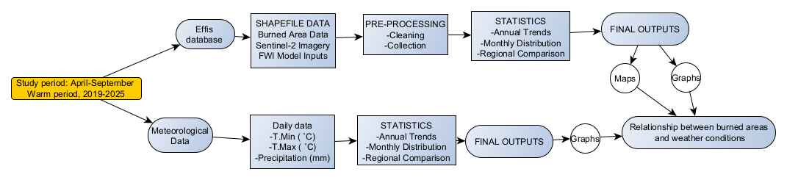
The methodological flowchart illustrates the structured workflow adopted to analyze the spatiotemporal dynamics of wildfires in Albania during the warm period (April–September) for the years 2019–2025. The workflow integrates multi-source datasets, including burned-area products from the EFFIS database(8, 11), meteorological observations from the national monitoring network, and satellite-derived information such as Sentinel-2 imagery from the Copernicus (12). The integration of these datasets enables a comprehensive assessment of wildfire occurrence, distribution, and meteorological drivers.

Fig. 1. Workflow of the data processing
The first stage involves the acquisition and organisation of two primary data streams:
(1) burned-area shapefiles and FWI model input data derived from EFFIS, and
(2) daily meteorological variables (Tmin, Tmax, and precipitation) obtained from ground-based stations.
These datasets undergo a pre-processing phase, including data cleaning, quality control, harmonization of coordinate systems, and the preparation of a geospatial database suitable for temporal and regional aggregation(13).
Following data preparation, parallel analytical pathways are implemented. Burned-area datasets are processed to extract annual totals, monthly distributions, and regional comparisons by administrative units. Meteorological datasets undergo statistical evaluation to compute seasonal trends, thermal anomalies, and precipitation deficits, which are known to strongly influence fire occurrence and behaviour across Mediterranean-type climates(14, 15).
The final stage involves synthesising these outputs into maps, graphs, and statistical summaries, enabling a detailed examination of the relationship between burned areas and the prevailing weather conditions. This integration aligns with international fire-danger modelling approaches, particularly those recommended in the Canadian Fire Weather Index (FWI) system (16, 17), widely applied for operational fire-risk assessment across Europe.
Statistical analysis was used to compare annual trends in the number of fires and burned areas, while for the meteorological component, a correlation analysis between weather parameters and fire intensity was used. The results are presented in tabular and graphical form to facilitate the interpretation and communication of the findings.

3. results and discussion

The results of this scientific paper are published through graphs, maps and images of scientific language. The analysis of fires begins with figure no. 1 which shows the annual data on the number of fires in the April-September season for the period 2019-2025.
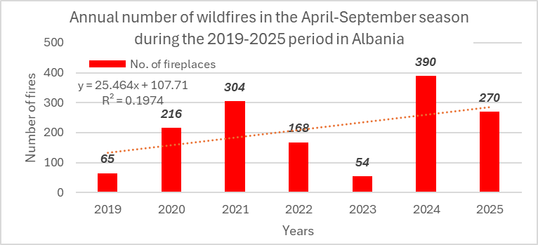
The data presented in the figure illustrate the annual dynamics of the number of fires during the warm season (April–September) for the period 2019–2025 in Albania. The time series is characterized by high interannual variability, which suggests a complex interaction between the anthropogenic factor and environmental conditions. The period begins with a low level of activity in 2019, where 65 fire cases are recorded. Then, a marked increase is observed in 2020 (216 cases), which culminates in 2021 with 304 fires, representing one of the most active years of the period. This increase is followed by a gradual decrease in 2022 (168) and 2023, the latter with only 54 cases, which constitutes the lowest value recorded after 2019.
Fig. 2. Annual Wildfire Incidence during the April–September Fire Season in Albania (2019–2025)
However, in 2024, a remarkable increase appears again, with the number of fires reaching 390, the maximum value of the entire series. The year 2025 marks a relative reduction to 270 cases, but remains significantly higher than the first years of the observation period. The presence of an increasing trend is evident, the low value of the coefficient of fit (R² = 0.1974) indicates that the linear model explains only about 20% of the total variation, highlighting that the annual evolution of fires is mainly influenced by other factors not explained by the time trend alone.
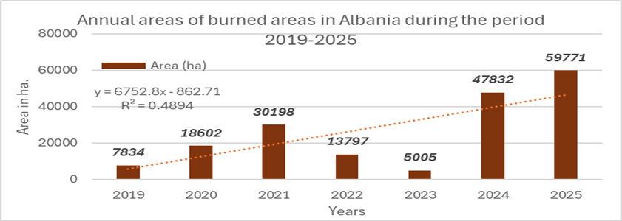
The results presented in Figure No. 3 on the annual burned areas for the period 2019–2025 show a marked variability, which in many cases follows the same dynamics as the annual number of fires. In the years 2019–2021, a clear increase in the affected areas is observed, from 7,834 ha in 2019, to 18,602 ha in 2020, and up to 30,198 ha in 2021. This increase is consistent with the progressive increase in the number of fires in these years, suggesting that the intensity and extent of fire episodes have been proportional to their frequency. However, in 2022 the burned area drops to 13,797 ha, and reaches its lowest level in 2023 with only 5,005 ha, a dynamic that reflects the significant decrease in the number of fires observed in the same period.
Fig.3. Distribution of Annual burned in ha areas by region in Albania (EFFIS, 2019–2025).
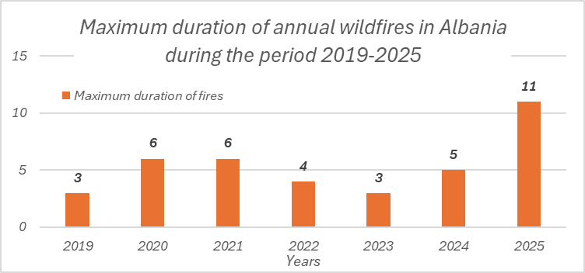
On the other hand, the years 2024 and 2025 present a strong contrast, both in the number of fires and in the burned areas. The year 2024, which marked the highest number of fires in the previous graph (390 cases), also coincides with an explosion of burned areas up to 47,832 ha. This trend continues in 2025, where although the number of fires is lower (270 cases), the burned area reaches its peak of the entire period at 59,771 ha, suggesting that meteorological conditions, vegetation characteristics or the typology of fires have enabled faster and wider spread of flames.
Fig.4. Distribution of Annual burned in ha areas by region in Albania (EFFIS, 2019–2025).
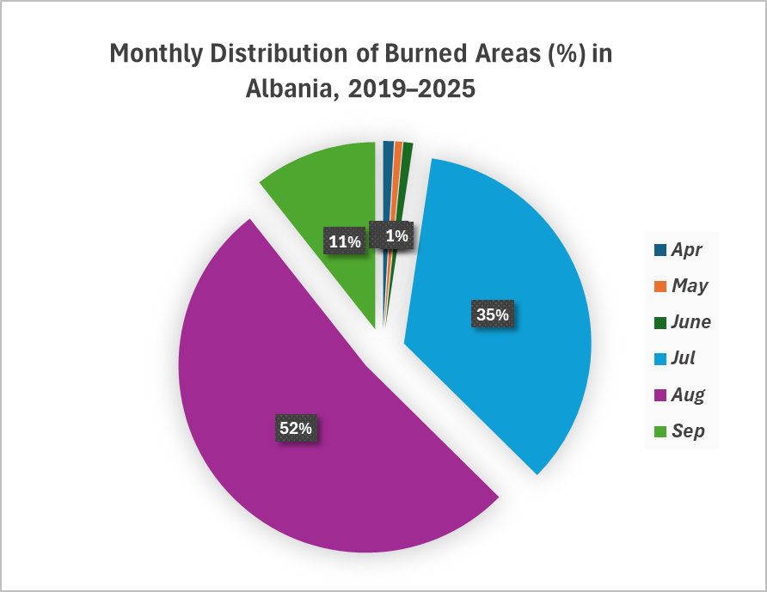
The data on the maximum duration of fires in Albania for the period 2019–2025, presented in Figure No. 4, show an unstable dynamic, but with a recent upward trend. In the first years of the period, the maximum duration of a fire remains limited, ranging from 3 days in 2019 and 2023, to 6 days in 2020 and 2021. The decrease in 2022 to 4 days and the moderate increase to 5 days in 2024 partially match the fluctuations in the number of fires and burned areas evidenced in the previous graphs. However, the year 2025 presents a noticeable deviation with a maximum duration of 11 days, suggesting not only an intensification of favorable conditions for the spread of flames, but also increased challenges in fire management and control. This result, in combination with the increase in burned areas in 2025, highlights that not only the frequency and territorial extent of fires are increasing, but also their resistance and stability over time. However, the results of Table No. 1 present the absolute maximum duration of the hearth with the longest duration per day for each year, it does not represent any trend in terms of duration or damage to vegetation, it is simply a statistical indicator that, in conjunction with other elements of the behavior of the fire phenomenon, reflects their characteristics.
Fig.5. Monthly distribution burned areas (%) in Albania (EFFIS, 2019–2025).
Figure No. 5 presents in the form of a pie chart the average monthly distribution for the 2019-2025 time period of fires in Albania. These results are expressed in %, they represent the months in which the spread of fires has been most frequent. During the 6-year time period 2019-2025, the month of August has known the widest spread of fires nationwide with 52%. Also, to a large extent, 35% of fires have also occurred in the month of July, followed by the month of June with 11%. The other months, April, May and September, occupy a very low percentage of around 1% respectively. This situation is related to several factors. First of all, the weather conditions which directly affect the spread of flames, becoming a positive factor. Based on the climatic conditions of Albania, where the summer season is characterized by high temperatures and rare rainfall.(4), it favors an increase in the probability of fires and their spread in forest areas. A 2022 report by the Food and Agriculture Organization of the United Nations emphasizes that only 10% of fires in the world occur due to natural causes, while the rest are all caused by human causes(18). For the region of Europe and Southern Europe, other authors raise this figure to 99% of the fires that spread are due to human causes(19). However, weather conditions in a given territory significantly affect the spread of fires, especially in forest areas. Figure No. 6 shows the multi-year average values ​​of daily temperatures in ˚C for the period 1991-2020, according to Era 5 Copernicus(20). During the months of July and August, daily temperatures reach maximum values ​​of up to about 30˚C. This graph shows temperature data for the capital, Tirana, which is located in the center of Albania. Referring to local sources for the climate of Albania for this period of time such as the Monthly Climate Bulletin, maximum daily temperatures reach over 36˚C, especially during periods of heat waves(21).
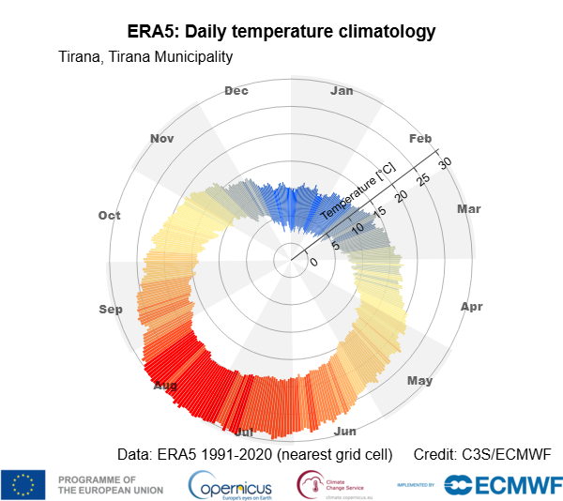

Fig.6. Daily Temperature Climatology (ERA5, 1991–2020) for Tirana Municipality
Part of this scientific analysis is the geographical distribution by fire districts in the time period 2019-2025. The data presented in the graph of figure No.7 show heterogeneity in the multi-year distribution of burned areas in Albania during the period 2019–2025.
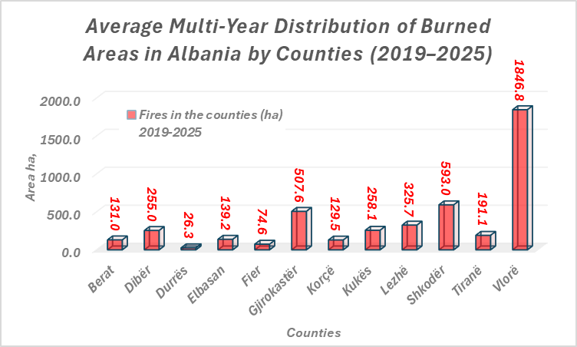

Fig.7. Average Multi-Year Burned Area by Counties in Albania (2019–2025)
The Vlora region stands out as the most affected area, with an average of 18,468 ha burned, far exceeding all other regions. The group of regions with high exposure also includes Shkodra (593 ha), Korça (507.6 ha) and Lezha (325 ha), areas that include forest and hilly ecosystems with increased vulnerability to fires. Regions such as Dibra, Fier, Kukës and Gjirokastra present moderate levels of burned areas, while the lowest values ​​are recorded in more urbanized areas or with reduced forest coverage, such as Durrës, Elbasan and Tirana. This distribution highlights clear regional differences in fire risk, related both to the climatic and ecological characteristics of the regions, as well as to the intensity of human activity and land management.
Presented in Figure No. 8, the data on burned areas for 2025 show their geographical distribution, clearly highlighting the areas most affected by fires at the national level. The map identifies several large fires with significant territorial impact. Among them, the fire in the Lura area in the Dibër district, which took place on 7–10 July, with a burned area of ​​3603 ha, stands out, representing one of the largest episodes of the year. In the central region, the fire in Skënderbegës, Gramsh (12–15 August) affected a total of 3138 ha, testifying to the high vulnerability of hilly-forest areas to the spread of flames.
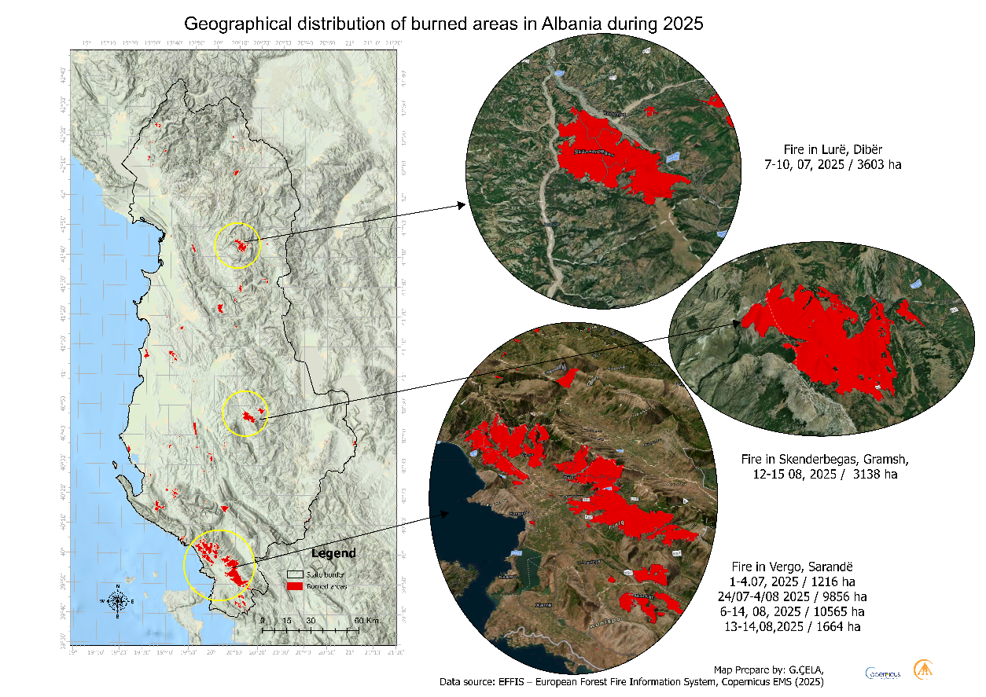
In the south of the country, the largest outbreak is the one recorded in Vergo, Saranda, which includes several episodes that occurred in the intervals of 1–4, 24–30 July, 6–14 and 13–14 August 2025, with burned areas ranging from 1216 ha to 10,656 ha in the largest episode.
Fig.8.Geographical distribution of burned areas in Albania during 2025.
These numerous and large-scale fires, concentrated mainly in the south and northeast, show a significant intensification of fires in areas with high density of natural vegetation, national parks and forested lowlands. The geographical distribution described by the map highlights the importance of continuous monitoring and improvement of fire risk management measures, especially in regions where their intensity and frequency are increasing.
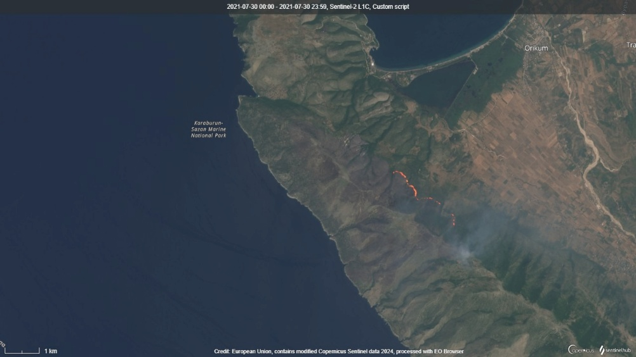
The main part of this scientific study is the analysis of meteorological conditions during the periods in which forest fires occurred. This analysis is achieved in this paper by identifying one of the most problematic fire outbreaks in terms of environmental consequences. For this reason, the time period of July 30 was chosen, from which a fire outbreak began in the Vlora region near the Orikum area, combined with several other fire outbreaks that lasted 12 days. During this period, 5421 hectares were burned and the environmental damage was considerable since part of the location was in the Karaburun Sazan National Park and also in a part of the Llogara National Park classified as protected areas(22). Figure No. 9 shows a satellite image dated July 30, 2021 from where these fire outbreaks began to spread and then led to the situation that followed. The fire appears in an area with pronounced slopes and dry Mediterranean vegetation, consisting mainly of dense shrubs and forest formations with low resistance to extreme heat conditions. Furthermore, the position of the fire outbreak in a difficult terrain for intervention suggests rapid spread of flames, which is typical for fires in hilly and mountainous terrains of Albania.
Fig.9 Satellite view of fires in Orikum, Vlora, July 30, 2021.
The weather conditions during this period are graphically presented in Figure No. 10, from the data of the National Meteorological Monitoring System, for the Orikum meteorological station, very close to the fire centers. The extreme daily temperatures, precipitation and values ​​of the Fire Weather Index indicator are presented, which correspond to the daily EFFIS forecasts for this period of time. Maximum temperatures are recorded high throughout the period, fluctuating between 28.0–40.0°C, while minimum temperatures remain relatively high (14–23°C), which indicates a continuous thermal load that favors the rapid drying of vegetation. The temperature peak on July 31 (around 40°C) marks an increase in temperatures, which precedes the increase in the FWI index. The only rainfall of the period of about 3 to 4 mm, recorded on August 4 and 10, has only a temporary reducing effect on the risk, but is not sufficient to restore ground moisture to stabilizing levels, as temperatures remain high immediately afterwards.
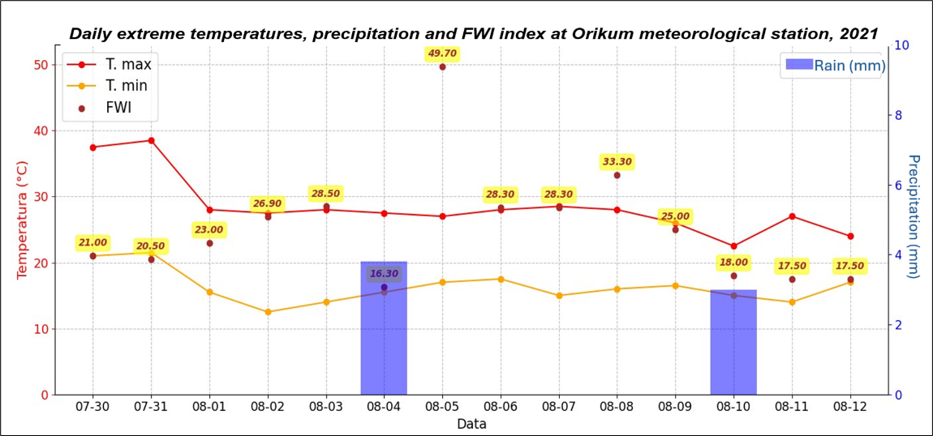
Fig.10.Daily Extreme Temperatures, Precipitation, and FËI Index at Orikum Meteorological Station (2021).
As presented above, the meteorological conditions of this fire outbreak do not represent the conditions of a heat wave or the characteristics of an extreme weather situation with very high temperatures. This example has been selected as a classic case where the damages caused by them have serious ecological and environmental consequences but are inversely related to the weather conditions, since in the middle of this 12-day period with fires there has been little rainfall. This situation highlights the importance of the anthropogenic factor which is the cause in the vast majority of cases, as cited above, in 99% of them for the Mediterranean region. The causes of this negative phenomenon may be different, but they do not justify the damage to nature and the time it takes for forest massifs and vegetation to recover.

4. Conclusion

The multi-year analysis of fire indicators in Albania for the period 2019–2025 shows a steady increase in firefighting activity both in terms of frequency and affected areas. The number of fires varies significantly over the years, going from 65 cases in 2019 to the maximum value of 390 cases in 2024, while the trend line shows a growth rate of about 25 fires per year. The burned areas also reflect the same intensifying dynamic, increasing from 7,834 ha in 2019 to 59,771 ha in 2025, with an additional annual trend of about 6,752 ha. This development shows that fires are not only becoming more frequent, but also larger and more difficult to control.
The spatial importance of fires is also reflected in the territorial distribution by regions, where some of them appear significantly more exposed than others. The region of Vlora ranks first by a large margin, with a multi-year average of 18,468 ha burned, followed by Shkodra, Lezha and Korça with significant areas affected. Other regions, such as Tirana, Durrës and Elbasan, present significantly lower values, a pattern that reflects the relationship between forest cover, territory morphology and the intensity of human activities. This geographical variation underlines that fire risk management should be differentiated by area. In seasonal terms, about 87% of burned areas occur in July and August, periods when human activity in nature is highest and nature is at its maximum drying stage. This temporal distribution shows that the seasonality of fires is not a random phenomenon, but is closely related to human-environment interaction, emphasizing anthropogenic activities as the main causative factor. In addition, the analysis of the maximum duration of fires shows that recent years have been characterized by more stable outbreaks, where in 2025 a outbreak lasted up to 11 days, a significant increase compared to previous years where outbreaks lasted 3–6 days.
The meteorological analysis carried out by selecting some of the outbreaks with the most negative impact in the country, not only because of their large surface area but also because they occurred in a protected natural area and with numerous movements of mountain tourism to balneal tourism in the field, presented several elements of interest. The weather conditions at the beginning of that time period were favorable for the spread of flames, but temperatures decreased in the following days. This confirms once again that the anthropogenic element is the main cause of forest fires. The resulting environmental damage is extensive, also endangering human lives, infrastructure or settlements. This study also serves as a form of civic and institutional awareness on the importance of preserving nature and increasing caution against fires, especially in the warm period of the year, where the above statistics provide a clear summary of the risk and damage to which nature and human activity are exposed.

References

1. IPCC. Climate Change 2022:
Impacts, Adaptation and Vulnerability2022.
2. Qiriazi P. Gjeografia fizike e Shqip·eris·e. Tiran·e: Af·erdita; 2011 2001.
3. Zorba P. Klimatologjia. Tirana, Albania: AlbPAPER; 2009 2009.
4. IHM. Klima e Shqipërisë. Tirana, Albania: IHM, Instituti Hidrometeorologjik; 1975.
5. IHM. Atlas Klimatik i RPS të Shqipërise: Hidrometeorological Institute of Albania; 1988.
6. Çela G, editor Long-term trends in average air temperature in the Central Lowland Mediterranean Climate Zone of Albania. 4th International Conference on Contemporary Academic Research ICCAR 2025 2025 February 22-23, 2025; Konya, Turkey: © 2025 Published by All Sciences Academy; 2025.
7. Çela G, Papathimiu S, Laçi S. Temporal Dynamics Of The Vegetation Period In The Myzeqe Plain (Albania) Based On Temperature Thresholds (1961–2020). International Journal of Agriculture and Environmental Research. 2025;11(3):866-78.
8. EFFIS. European Forest Fire Information System. In: EFFIS, editor. 2025.
9. Sentinel-2B imagery via Copernicus Browser [Internet]. Copernicus Data Space Ecosystem, European Space Agency (ESA), European Commission. 2024. Available from: https://browser.dataspace.copernicus.eu/.
10. IGEO. Sistemi Kombetar i Monitorimit meteorologjik. In: IGEO, editor. 2024.
11. San-Miguel-Ayanz J, Schulte E, Schmuck G, Camia A, Strobl P, Libertà G, et al. Comprehensive Monitoring of Wildfires in Europe: The European Forest Fire Information System (EFFIS). 2012.
12. Drusch M, Del Bello U, Carlier S, Colin O, Fernandez V, Gascon F, et al. Sentinel-2: ESA's Optical High-Resolution Mission for GMES Operational Services. Remote Sensing of Environment. 2012;120:25-36.
13. Chuvieco E, Mouillot F, van der Werf GR, San Miguel J, Tanase M, Koutsias N, et al. Historical background and current developments for mapping burned area from satellite Earth observation. Remote Sensing of Environment. 2019;225:45-64.
14. Pausas JG, Keeley JE. Wildfires and global change. Frontiers in Ecology and the Environment. 2021;19(7):387-95.
15. Turco M, von Hardenberg J, AghaKouchak A, Llasat MC, Provenzale A, Trigo RM. On the key role of droughts in the dynamics of summer fires in Mediterranean Europe. Scientific Reports. 2017;7(1):81.
16. Wagner Cv. Development and structure of the Canadian Forest Fire Weather Index System. Forestry Technical Report - Canadian Forestry Service. 1987(No. 35):viii + 37 pp.
17. WMO. THe 2022 GCOS ECVs Requirements2022.
18. FAO. Forests Fires and the Global Fire Platform. 2022.
19. Dijkstra J, Durrant T, San-Miguel-Ayanz J, Veraverbeke S. Anthropogenic and Lightning Fire Incidence and Burned Area in Europe. Land. 2022;11(5):651.
20. (C3S) CCCS. ERA5: Fifth generation of ECMWF atmospheric reanalyses of the global climate: European Centre for Medium-Range Weather Forecasts (ECMWF); 2023 [Available from: https://cds.climate.copernicus.eu/cdsapp#!/dataset/reanalysis-era5-single-levels.
21. Zorba P. Monthly Climate Bulletin. Monthly Climate Bulletin. 2024;8:38.
22. AKZM. Protectet Areas 2025 [Available from: https://akzm.gov.al/parku-kombetar-divjake-karavasta/

