Original Research Article
Removal of oil spills on water using biochar of the fruit of Cerbera manghas (Wel Kaduru)

ABSTRACT
Marine ecosystems and inland surface water are important in maintaining the natural environmental balance, yet pollution has become a serious concern recently. Among many pollutants, oil spills require prompt attention due to their severe threat. Natural sorbents have emerged as a sustainable solution for oil spill removal, mainly due to their low-cost, availability, biodegradation, and buoyancy. Through this research, the capability of Cerbera manghas (Wel Kaduru in Sinhala) fruit, a natural sorbent and waste material, was investigated for oil spill removal. The efficiency of biochar produced by this natural sorbent was optimized for dosage, size, pore morphology, contact time, oil type, oil volume and salinity. Maximum adsorption capacities for crude, engine and motor oils are in the range of 4.9 +/- 0.00 and 11.1 +/- 0.03 g oil/g biochar, highlighting the fact that the maximum capacity depends on the oil type. With the variation of the biochar dosage, the maximum adsorption capacity ranges from 7.4 +/- 0.01 to 10.5 +/- 0.02 g oil/g, indicating that the extent of oil adsorption increases with the biochar dosage. Variation of the time of interaction of oil types with the biochar led to maximum adsorption capacities within 30‒45 min. Moreover, the extent of removal of oil was strongly affected by the size of the sorbent, suggesting that small sizes are more effective in oil cleanup. The oil-adsorbed biochar is subsequently used for energy production, and its residual could be used for dye removal. This adsorption process neither fits the Langmuir nor the Freundlich isotherm model, indicating multilayer adsorption and hydrophobic behavior. Biochar characterization was done using FTIR and SEM, to analyze surface functional groups and pore morphology, while XRF detected surface metals. Overall, this biochar offers an and effective approach to cleanup oil spills in water sources in a practical and sustainable manner.
Keywords: Adsorption, Biochar, Capacity, Sorbent, Sustainability
1. INTRODUCTION
The natural environment, which refers to the surroundings in which living organisms, including humans, exist and interact, encompasses the entire system of physical, biological and chemical factors that influence life on Earth. The natural environment provides resources such as clean air, water, food and habitat for diverse species to sustain life on Earth. Human activities, however, impact the natural environment negatively through pollution, deforestation, climate change, and other activities[1]. Among all the natural resources, water is considered to be the most important, yet the availability of natural water sources has become scares due to the increase of pollution[2].
Environmental pollution, at present, has become a serious concern with significant implications for ecosystems, human health, and the overall quality of life. Among all forms of pollution, water pollution has received the greatest attention, since natural water sources are gradually becoming polluted and being inappropriate for consumption and other uses due to the discharge of various pollutants. Discharge of different oil types has become a major issue with respect to water pollution[3]. Oil spills in water are seriously considered in the marine environment and other aquatic systems due to considerable activities in offshore and onshore oil exploration, production, and transportation over the recent years[4].
Many chemical, physical and biological methods are used to remove oil spills. Among these, the utilization of adsorbents, a physical removal method which follows the techniques of adsorption, provides an efficient means to remove oil[5]. In the context of pollution removal, the phenomenon of adsorption takes place at the interface between a solid adsorbent and the polluted water. Adsorption can be either physisorption or chemisorption with respect to the interactions taking place between the surface and the adsorbent material. In physisorption, week physical forces such as Van der Waals forces, hydrogen bonds, dipole−induced dipole interactions control the adsorption process which is reversible and non-dissociative leading to a multilayer uptake[6]. Since this is a non-activated process, kinetics of physisorption is fast and the adsorption enthalpy is related to factors such as molar mass and polarity. In chemisorption, chemical bond formation takes place, and hence, it is highly specific[7]. It is limited to monolayer adsorption, and the nature of adsorption is often dissociative. Chemisorption may be irreversible, and kinetics of adsorption could be complex depending on the specific adsorption type[5],[8].
The degree of liquid packing that can occur in pores is determined using the adsorption capacity. The adsorption process would be more effective if the absorbate molecules and the adsorbent surface have comparable pore sizes. Adsorption capacity, which increases with the concentration of adsorbate and the surface area of adsorbent, can be calculated using the following equation[9],[10].
$$Adsorption capacity= \frac{Mass of adsorbed oil (g)}{Mass of biochar (g)}$$
where, $Mass of adsorbed oil= Mass of biochar after adsorption-Initial mass of biochar$
The use of natural adsorbents has become an emerging topic due to many beneficial factors such as low-cost, availability, buoyancy, and environmentally friendly nature[11]. The fruit of Cerbera manghas (‘Wel Kaduru’ in Sinhala), which is commonly found in coastal areas and near inland water sources in Sri Lanka, is used in this study as it exhibits the above advantages. Typically, these fruits contain a relatively small seed. The natural buoyancy of the fruit, attributed to its thick fibrous-corky mesocarp and lignified endocarp, may aid in the potential for hydrochorous seed dispersal in natural environments[12],[13]. Biochar prepared from this fruit is used in this research, as it can be efficiently used for the removal process and efficient post removal processes can also be applied for the oil-adsorbed biochar.
The use of sorbent materials to clean up oil spills from water sources has been studied widely as it is found to be an efficient remediation technology[14]. Though such studies are widely carried out worldwide, it is not an area of research that has been investigated much in Sri Lanka. This research project has thus been conducted to determine how effectively biochar made from the fruit of Cerbera manghas can be used to clean up oil spills on water sources. Efficiency of adsorption can be further studied by applying modifications to the biochar via activation processes. The goal of this study is to use environmentally friendly, locally available biochar material for practical applications of cleanup processes.

2. materials and methods
NaCl was purchased from Loba Chemie (Mumbai, India) and used as received.
Laboratory instruments used to conduct this research project were analytical balance (Kern, ALJ 250-4AM, Germany) and electrical balance (KERN EW 2200-2NM) for mass measurements, oven (Ecogain Series-7047DT-091) for drying, fourier transform infrared (FTIR) spectra were recorded on JASCO FTIR - 6700 spectrophotometer and scanning electron microscopic (SEM) images were recorded at 500X, 1000X and 5000X magnifications on Carl Zeiss Evo Is 15 model. X-ray fluorescence (XRF) spectra were recorded using Fischerscope Model-DF500FG-456.
2.1 Preparation of raw sorbent material
Fruits of Cerbera manghas were collected from lagoons and coastal areas in Negombo, Sri Lanka. The fruits collected were soaked in water for 24 h and the remaining water was discarded. This procedure was repeated for another 24 h and the fruits were air dried for 7 days till all the moisture was removed[15],[16]. The mesocarp of the fruit was separated, and the rest of the fruit was cut into cubes of similar dimensions of approximately 2.5 cm. Cut pieces were then used to prepare biochar.
2.2 Preparation of biochar
Uniformly cut pieces of Cerbera manghas were pyrolyzed (350−400 ℃, 20 min) in a household kiln under limited oxygen conditions[17],[18].
2.3 Adsorption studies
Adsorption studies were performed using three main oil types, crude oil, engine oil and motor oil. Using these oil types, different parameters were varied, and the adsorption capacities were calculated.
Variation of biochar dosage was studied using different amounts (0.50, 1.00, 2.00, 3.00, 4.00, 5.00 g) of biochar[19]. An aliquot of 500.0 mL of water was added to 30.0 mL of each oil type, and the system was thoroughly agitated. Thereafter, weighed samples of biochar were added separately into each beaker. The system was kept for 30 min to reach adsorption equilibrium. Thereafter, biochar was removed from the oil/water suspension, and air dried for 30 min until excess oil was dripped off. Biochar samples were then oven-dried for 1.0 h at 105 °C to remove the remaining moisture and was allowed to cool to room temperature through natural convection[18]. The mass of biochar was recorded, and its adsorption capacity was determined. The control was also run simultaneously. The mass of biochar which gave the maximum adsorption capacity was selected as the optimum mass for further studies. The same procedure was repeated for all oil types.
To study the variation of contact time, the selected oil type (30.0 mL) was added to 500.0 mL of water sample, followed by thorough agitation. Thereafter, the optimum mass of biochar was added to each sample and kept for 15, 30, 45, 60 and 75 min separately[20]. After adsorption, a similar procedure as stated above was repeated to find the optimum time of adsorption.
To examine the variation of oil volume, different volumes (10.0, 20.0, 30.0, 40.0, 50.0, 60.0, 70.0 and 80.0 mL) of the selected oil type were added to 500.0 mL of water separately and mixed well[18]. Then, the optimum mass of biochar was added to each sample and kept for the optimum adsorption (contact) time. After adsorption, a similar procedure was repeated to find the optimum oil volume of adsorption.
The variation of salinity was studied using three NaCl solutions of different concentrations (0.49, 0.59 and 0.69 mol L⁻¹) and DI water. The selected oil type (30.0 mL) was added to each NaCl (500.0 mL) solution separately, and mixed well[21]. The optimum mass of biochar was added to each sample and kept in each oil type for the optimum contact time for adsorption. Thereafter, a similar procedure was repeated to determine the behavior of the biochar at different salinities.
Engine oil was used to study the effect of the size of biochar. The mass of biochar of the entire fruit was measured, and a similar mass of half of the fruit, quarter of the fruit and smaller pieces were taken. Excess engine oil was added to 500.0 mL of water sample, and mixed. Then, known masses of biochar were added to water samples separately, and each system was kept for 30 min for adsorption. After adsorption, the same procedure was repeated to find which size of biochar is most suitable for the oil removal[9].
Motor oil was used to study the effect of weathering. For this, an aliquot of 30.0 mL of motor oil was added to 500.0 mL of water and mixed well. The resulting suspension was kept for 1 day, 3 days, 5 days, 7 days, and 9 days, separately[22]. Then a sample of 0.50 g of biochar was added to each sample and kept for 30 min for adsorption, and thereafter, the maximum adsorption capacity of each system was determined[23].
2.4 Applications of oil adsorbed biochar
A 1.00 g sample of each oil−adsorbed biochar was burnt, and the energy released during the burning process was used to heat water in a thermostat setup. The initial temperature and the temperature of water at 1 min intervals up to 20 min were recorded. This procedure was followed to check whether oil adsorbed biochar can be used for energy production.

3. results and discussion
3.1 Variation of biochar dosage
According to the results obtained from this analysis, the maximum adsorption capacity is given by the biochar dosage of 0.50 g for all the three oil types, having values of 7.48 +/- 0.01 g oil/g biochar for crude oil, 8.06 +/- 0.02 g oil/g biochar for engine oil and 10.56 +/- 0.02 g oil/g biochar for motor oil (Fig. 1.). The sorbent dosage affects the interactions between the oil and the sorbent[24]. Though the extent of oil adsorbed increases with the biochar dosage, the maximum adsorption capacity decreases. This occurrence is linked to a rise in the number of pores for adsorption at higher sorbent dosages. Nevertheless, the sorption capacity diminishes as the sorbent dosage increases, primarily due to the increase of unsaturated oil binding sites. Furthermore, the saturation effect contributes to a decline in the efficiency of oil removal once the maximum sorption capacity is attained[25],[26]. Though the sorbent dosage has increased, there may not be an adequate amount of oil molecules for all the exchange sites on the sorbent. This may lead to a decrease in adsorption[21].
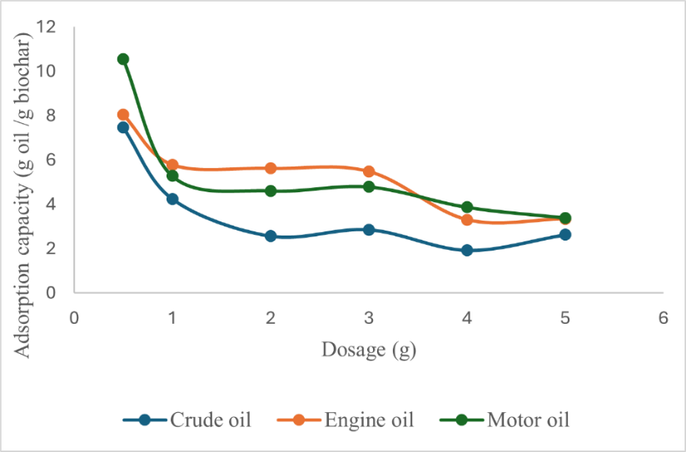

Fig. 1. Effect of variation of biochar dosage on adsorption capacity of different oil types

3.2 Variation of oil volume
This study reveals that motor oil shows the highest adsorption capacity at an initial volume of
60.0 mL, and moreover, the adsorption capacity is comparatively higher than that of other oil types (Fig. 2.). Adsorption capacity of engine oil shows a maximum value when 20.0 mL of oil is added initially. The maximum volume of crude oil giving the highest adsorption capacity is 40.0 mL. The aspect of investigation on oil concentration lies in its ability to significantly influence the adsorption kinetics, and more precisely, directs the equilibrium behavior of the sorption process on the prepared sorbents. Elevated concentrations enhance the gradient between the bulk solution and the center of the sorbent particle, leading to improved distribution of oil residue throughout the film surrounding the particle and within the internal network of the prepared sorbents[27],[28].
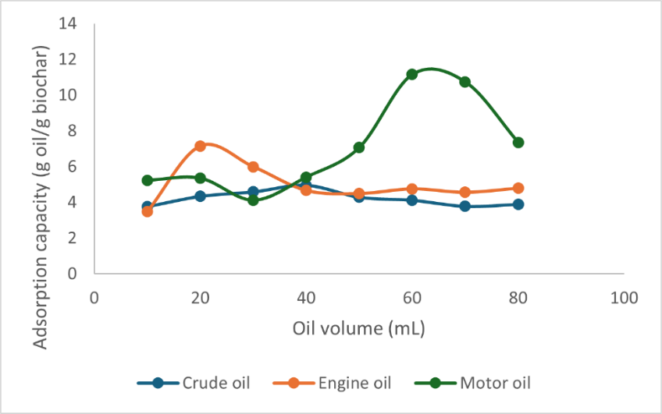

Fig. 2. Effect of variation of oil volume on adsorption capacity of oil types

3.3 Variation of contact time
When considering the maximum adsorption capacity values determined, the highest capacity of crude oil is observed at a contact time of 30 min (Fig. 3.). The contact time required for the maximum capacity is observed to be 45 min for both engine oil and motor oil. According to the results, the maximum adsorption capacity increases with contact time, and after a certain point, it starts to decrease giving an optimum contact time for the maximum adsorption. As the concentration gradient between solution and oil spill is initially high, the sorption rate increases and after the maximum is reached, the sorption rate gradually decreases due to a decrease in concentration difference. The majority of adsorption sites within the adsorbent structure are occupied by oil. As the contact time increases, adsorption as well as desorption would take place as the adsorption sites get more occupied. When desorption increases over adsorption, adsorption capacity decreases leading to the results stated above. The high adsorption capacity can be due to the existence of empty active sites on the surface and due to the reducing strong attractive forces between the oil molecules and the adsorbent as the contact time increases[11]. The adsorption capacity after reaching the maximum value is not significantly changed thereafter, probably due to the establishment of equilibrium between adsorption and desorption processes that occur after saturation[11], [29]. Fig. 4. illustrates how oil is adsorbed to biochar with time over a 40 min period.
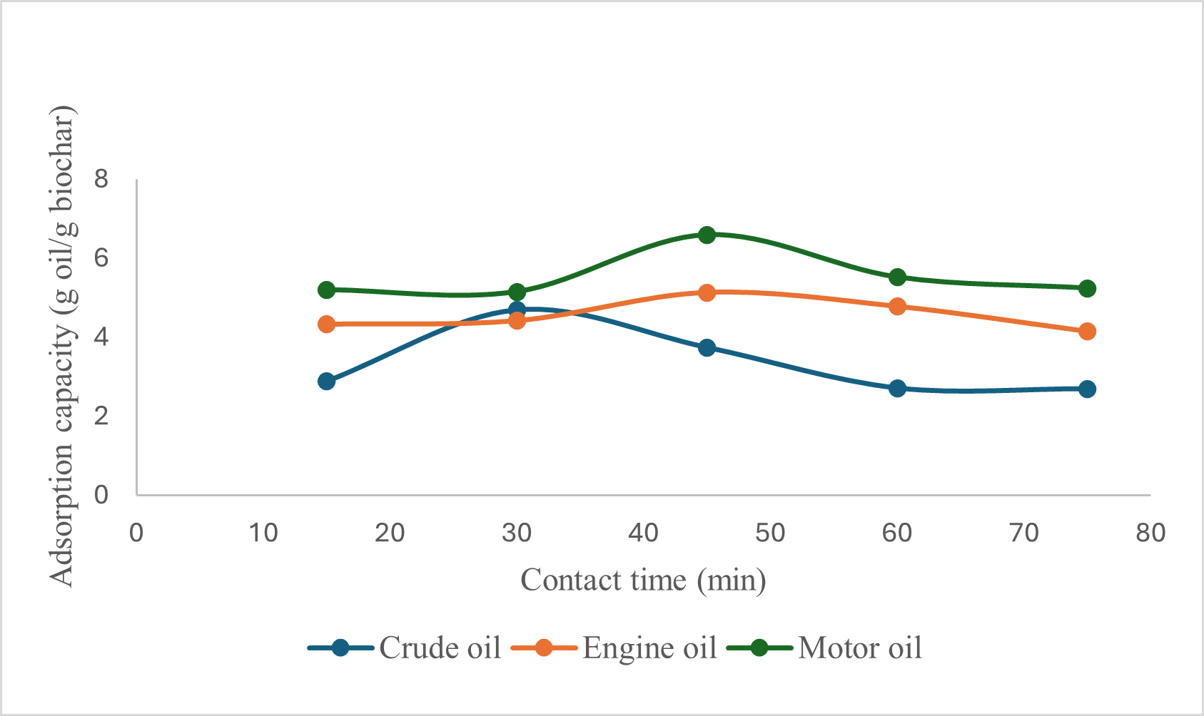

Fig. 3. Variation of contact time on adsorption capacity of oil types
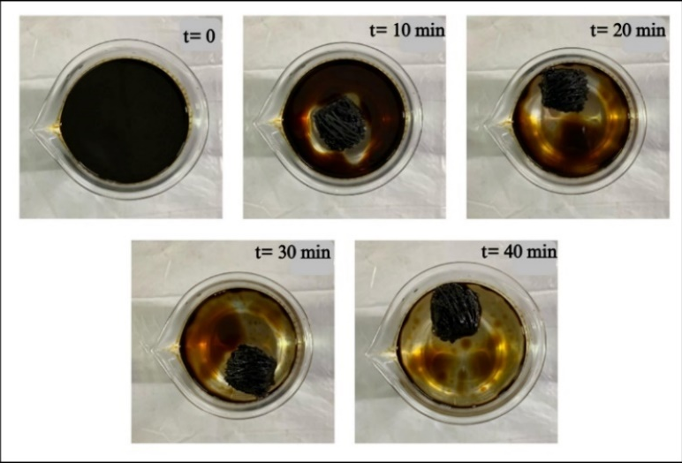

Fig. 4. Removal of oil from the water surface with time

3.4 Variation of size
According to the results obtained, the highest average adsorption capacity of 9.61 g oil/g biochar is shown by pieces of approximately 0.5 g, and the lowest capacity of 3.57 g oil/g biochar is shown by the entire fruit of biochar (Fig. 5.). The biochar of half of the fruit and quarter of the fruit showed adsorption capacity values between 7.01 g oil/g biochar and 7.62 g oil/g biochar, respectively; however, these two types do not exhibit a significant difference in capacities. Oil absorptivity depends on the active surface area of a sorbent material as the adsorption capacity increases with the surface area[25]. When considering the size of a sorbent material, the available surface area for oil binding becomes high when the size is smaller, showing higher adsorption capacities. Though larger pieces can capture more oil because of increased collisions with the oil-sorbent, their higher shear forces decrease the likelihood of retaining the oil. When considering the morphology of Cerbera manghas, the exocarp shows low adsorption and the middle sponge like mesocarp shows higher adsorption. The mesocarp is not exposed for adsorption because of the outer exocarp[25]. The increase in oil sorption capacity achieved by reducing the average size can be attributed to the expansion of the interfacial area[9].
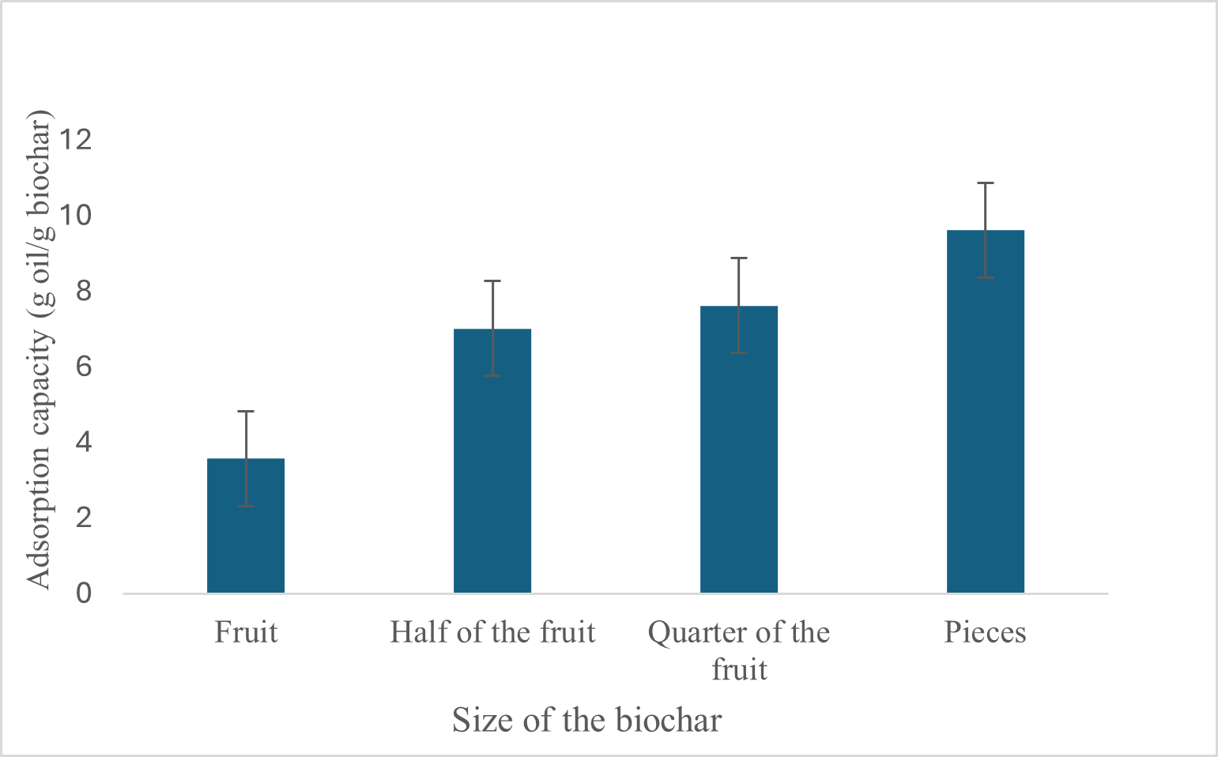

Fig. 5. Effect of variation of adsorbent size on adsorption capacity of oil types
3.5 Variation of salinity
It is clear from the results obtained that saltwater solutions experience greater adsorption capacity. As Fig. 6. illustrates, motor oil exhibits the highest adsorption capacity for all the three NaCl solutions, followed by engine oil and then crude oil. Here, De Ionized (DI) water was used as a control. The variation of adsorption capacity with salinity can be explained using the presence of functional groups on the surface of the sorbent material. Biochar has a large surface area, and it contains functional groups that can interact with the ions in the saline solution. Polar functional groups interact via electrostatic interactions while nonpolar functional groups interact via hydrophobic interactions. Accessibility and availability of certain functional groups are affected by changing the pH and ionic strength of the solution[30],[31]. However, depending on the nature of the adsorbate and the salt concentration, the adsorption capacity differs[30].
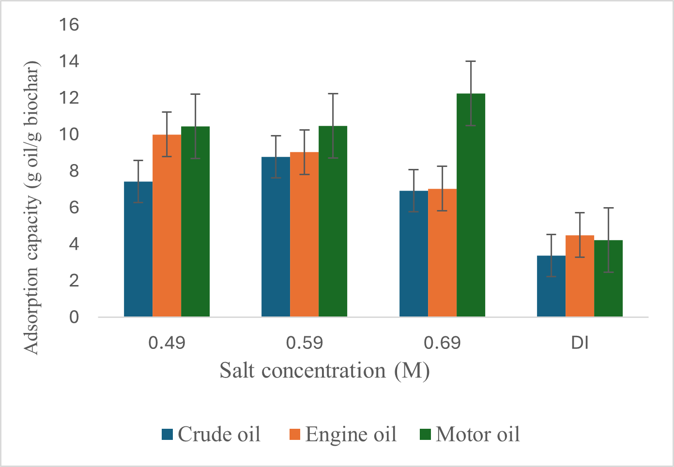

Fig. 6. Effect of variation of salinity on adsorption capacity of oil types

3.6 Investigation of the effect of weathering of oil on adsorption
As observed in Fig. 7., adsorption capacity decreases with increase in standing time of the adsorbate oil. This clearly indicates that, when oil is kept unused for a longer time in a water body, its properties diminish and the ability of adsorption by a sorbent material becomes less. The highest capacity of 6.71 g oil/g biochar is observed after 1 day of an oil spill and according to the experimental procedure, while the lowest capacity of 5.30 g oil/g biochar is observed after 9 days of an oil spill (Fig. 7.). These capacity values would probably further decrease with the increase in standing time. Initially, an oil layer was observed on the top of the water surface, and thereafter, a sticky nature was observed with time where the floating oil started to gradually sink. Sinking particles were observed as globules after one week. Such observations may be attributed to compositional changes of oil associated with weathering. Fresh oil is less viscous, more volatile and floats on water. It contains more water-soluble components and is easily dispersed from the source. With time, weathering takes place, and weathered oil initially loses volatile components, and the oil becomes more viscous and more likely to coagulate giving a sticky nature. Over time, the ongoing process of weathering alters the composition of oil until it breaks down in the environment, eventually leaving behind minimal remnants such as tar balls[32],[33].
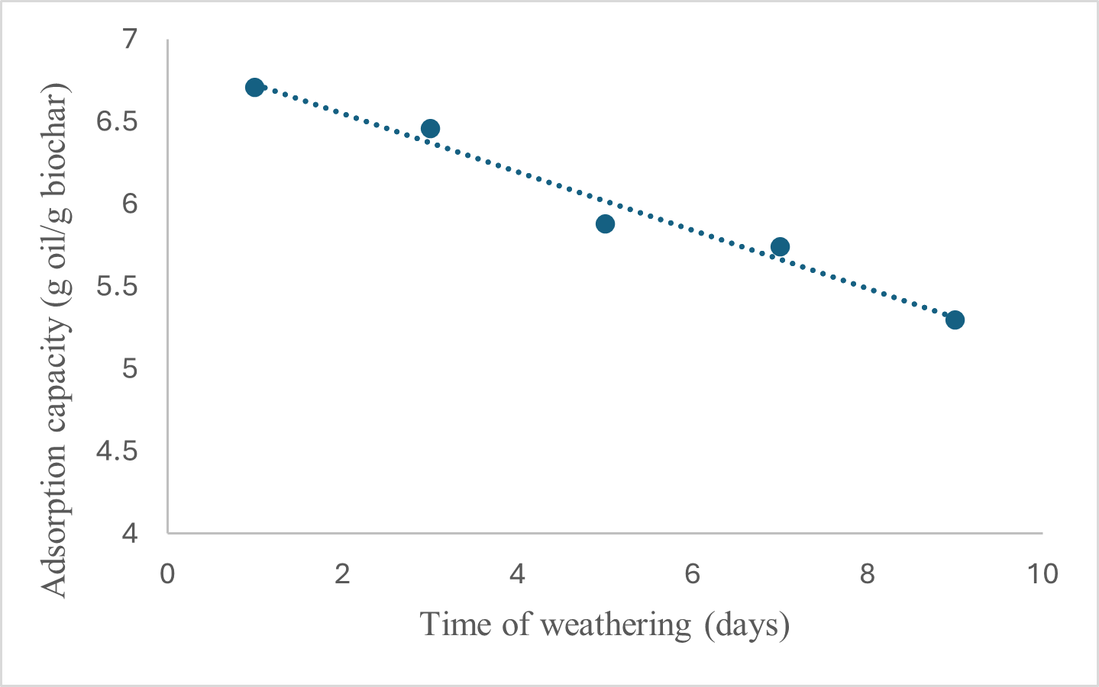

Fig. 7. Impact of weathering time on adsorption capacity of crude oil

3.7 Energy production from oil adsorbed biochar
After the oil removal process, as an effective method to discard the oil adsorbed biochar, the possibility of energy production was examined. The heat energy produced is indicated by the temperature rise. As in Fig. 8., oil adsorbed biochar and biochar without oil being adsorbed are compared, where in all cases a maximum temperature is reached followed by gradual decrease. Only a maximum temperature of 35 °C is obtained when raw biochar (i.e., without oil adsorption) is burnt, and higher maximum temperatures are obtained when oil adsorbed biochar is burnt. Among the three oil types, the highest temperature achieved is 54 °C for crude oil, and 50 °C for both engine and motor oil. This highlights the fact that oil adsorbed biochar can be effectively used to produce heat energy, and efficiency should be monitored for large scale applications. Though this process is advantageous since used biochar is applied in an effective manner, a major drawback is the production of CO₂ in the burning process.
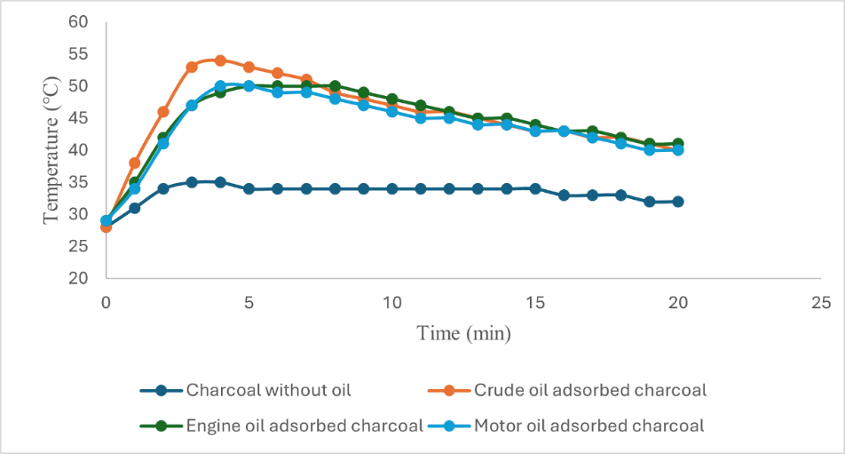

Fig. 8. Variation of temperature with time

3.8 Isotherm studies
According to the results obtained, the adsorption process conforms to neither the Langmuir nor the Freundlich isotherm models (Fig. 9. [a], [b]) Therefore, it can be argued that the interaction of oil with biochar is not a chemisorption process, and hence, monolayer adsorption is not possible. Therefore, adsorption of oil by biochar of Cerbera manghas may take place via physisorption, indicating multilayer adsorption, where the entire process can be explained by adhesive and cohesive forces. Adhesive forces take place between oil molecules while cohesive forces take place between oil molecules and the surface of the sorbent material. Initially, pores of the sorbent may get occupied by oil molecules by cohesive forces. Thereafter, the other adsorbing oil molecules may bind to the initially adsorbed oil molecules via adhesive forces forming another layer on top of the initial oil layer[34]. This process would continue until the maximum capacity is reached. During the dripping period, excess of oil is removed from the sorbent which can be clearly observed. Smooth oil layers may not form on top of another due to the heterogenous nature of the sorbent material. Since the fruit of Cerbera manghas is a natural sorbent, the same conditions would not be possible in every fruit, and accordingly, the porosity and the efficiency of adsorption could differ. The oil adsorption process that occurs through adhesive−cohesive forces highlight the hydrophobic nature of the adsorbent. This hydrophobicity will allow the sorbent to be more likely to oil molecules over water molecules, specifying the fact that it would be more efficient to remove oil spills from water bodies. The use of biochar prepared from the fruit of Cerbera manghas highlights the importance of extending these findings toward large scale applications. The biochar of the fruit of Cerbera manghas is extremely light, and hence, the ease of handling it is another advantage[14]. This light nature can be understood using Fig. 10.
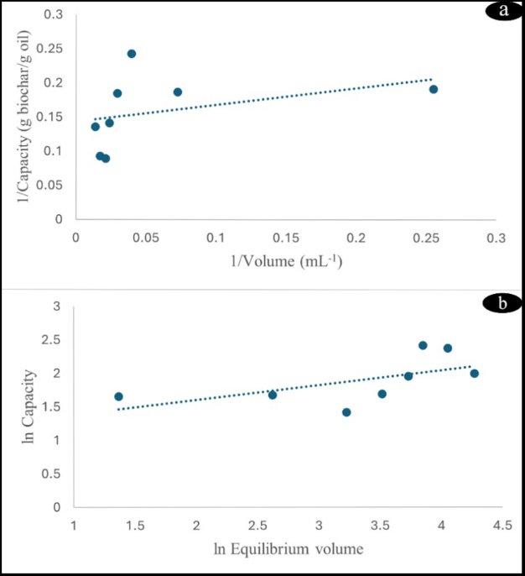

Fig. 9. Linearized Langmuir [a] and Freundlich [b] adsorption isotherm models for motor oil on biochar
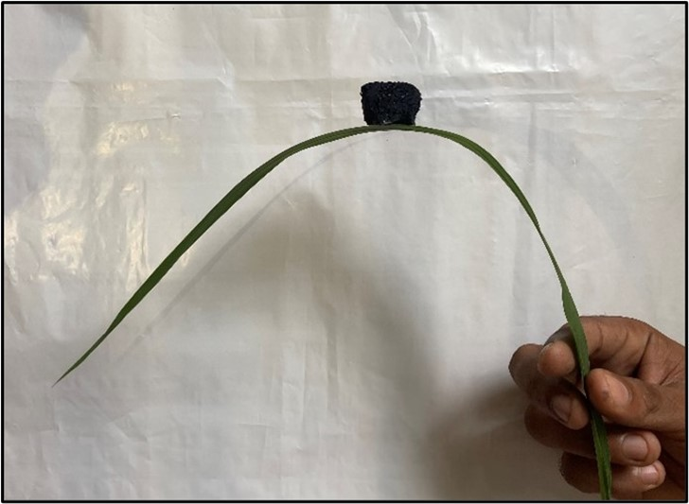

Fig. 10. Ultralight nature of Cerbera manghas biochar

3.9 Characterization of biochar
XRF spectral data are useful to identify the metal constituents in each sample. It is clear that biochar used in this study contains Ca, Fe and K metals (Fig. 11. [a]). Higher Ca content and the presence of K and Fe could be attributed to the fact that Cerbera manghas grows near coastal areas. Adsorption of oil has led to the disappearance of K or decrease in levels below its detection limit (Fig. 11. [b]). Moreover, the Fe content has increased, while the Ca content has decreased during oil adsorption. Most K exists on biochar surfaces in water soluble forms, such as K₂O or KOH, and hence, upon the addition of oil to water, some K⁺ ions would have transferred from the biochar phase to water phase. The disappearance of K signals may also result from surface masking caused by the adsorbed oil layer. The reason for the increase in the Fe amount would probably be due to the presence of Fe in the oil sample, which would result in the concomitant decrease in the relative extent of Ca.[35]
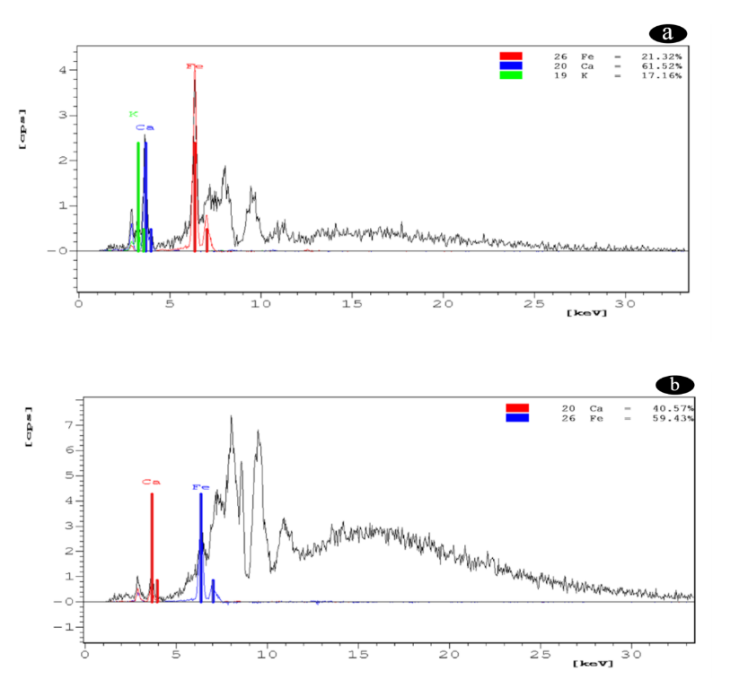

Fig. 11. XRF spectra of biochar without oil [a] and biochar with engine oil [b]

SEM was used to analyze the surface morphologies of the prepared biochar of Cerbera manghas before oil adsorption (Fig. 12. [a], [b] and [c]) and biochar with crude oil (Fig. 12. [d], [e] and [f]). SEM scans of biochar before oil adsorption revealed an irregular structure and a porous surface[36]. This could be due to the amorphous nature of the organic raw materials used during pyrolysis. Pyrolysis carbonizes the carbonaceous raw materials used, which creates many adsorbent surfaces capable of adsorbing molecules. The pyrolysis temperature of 350−400 ℃ used for a period of 20 min would be sufficient for the above-mentioned process[36]. After oil is adsorbed to biochar, pores get filled with oil and it gets compact as shown on Fig. 12. [d], [e] and [f].

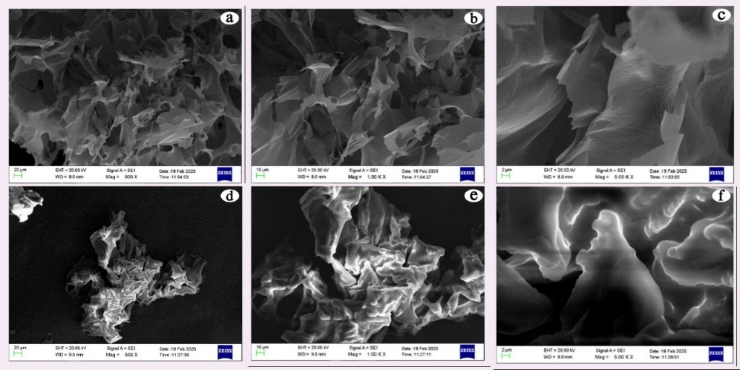

Fig. 12. SEM images of biochar before adsorption [a][b][c] and biochar with crude oil [d][e][f]

The FTIR spectrum of the raw sorbent material consists of a band at 3336 cm⁻¹ which is attributed to the O–H stretching vibration of hydroxyl groups (Fig.13. [a] – black spectrum). The bands at 1590 cm⁻¹ and 1642 cm⁻¹ indicate strong stretching vibration of non-conjugated dienes (-C=C-) or aromatic hydrocarbons having benzene like rings, while the band at 1027 cm⁻¹ is assigned to carbonyl components such as esters, ethers, alcohols and acids[37]. The FTIR spectrum of biochar before oil adsorption (Fig. 13. [a] – red spectrum) highlights major differences, where the peaks of O-H and carbonyl components have disappeared and sharp bands at 2850 cm⁻¹ and 2923 cm⁻¹ have appeared, and they can be attributed to C-H stretching vibration on aliphatic compounds CH_{n}[37],[38]. Furthermore, bands in the range of 1375 cm⁻¹ and 1450 cm⁻¹ indicate bending vibration of C-H bond. These results highlight the fact that after charring, surface water molecules have been replaced by H atoms. Comparison of the two FTIR spectra of biochar before and after crude oil adsorption indicates that there is no significant difference between the two spectra (Fig. 13. [b]). This proves that there is no chemical bond formation or chemical bond cleavage during the oil adsorption process, further providing evidence for physical adsorption.
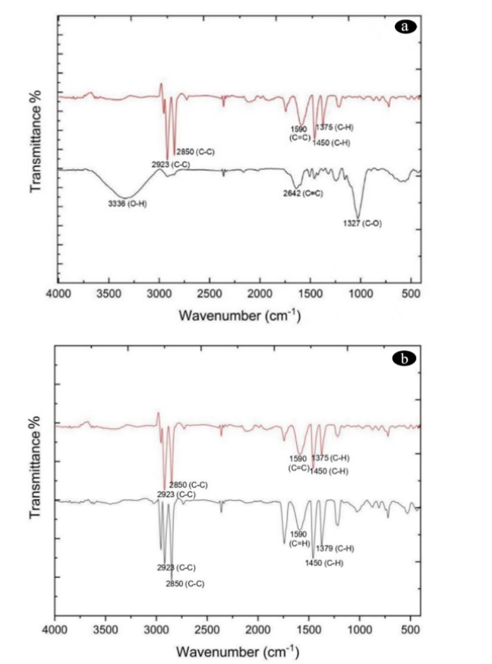

Fig. 13. FTIR spectrum of raw material ([a]-black), biochar without oil ([a], [b]-red) and biochar after adsorption of crude oil ([b]-black)

4. Conclusion
This study highlights the use of biochar of the fruit of Cerbera manghas as a natural sorbent material to clean up oil spills from water bodies. The efficiency of biochar produced by this natural sorbent is studied by varying experimental parameters, such as biochar dosage, size of biochar, contact time, oil type, oil volume, salinity, and the effect of weathering. The results suggest that the adsorption process does not conform to Langmuir or Freundlich isotherm models, indicating a multilayer adsorption process and highlighting the hydrophobic nature of the adsorbent. This can be extended by studying other types of oil as well. Efficiency of adsorption can be further studied by applying modifications to biochar prepared via different activation processes. The use of this natural sorbent presents a beneficial and effective approach for cleaning up oil spills in water sources in a practical and applicable manner. XRF data which were used to identify surface metals revealed that mainly Ca, K and Fe are present. According to SEM images it is confirmed that the biochar has high porosity and an irregular structure, and pores get filled with oil and get compacted after oil is adsorbed. FTIR data indicates that there is no significant difference between surface functional groups before and after oil adsorption, which highlights the fact that there is no chemical bond formation or chemical bond cleavage during adsorption.

References
[1] E. Sociology et al., Environment and Society.
[2] J. W. Farrington, “Oil pollution in the marine environment II: Fates and effects of oil spills,” Environment, vol. 56, no. 4, pp. 16–31, 2014, doi: 10.1080/00139157.2014.922382.
[3] D. Dave and A. E. Ghaly, “Remediation technologies for marine oil spills: A critical review and comparative analysis,” Am. J. Environ. Sci., vol. 7, no. 5, pp. 424–440, 2011, doi: 10.3844/ajessp.2011.424.440.
[4] B. Zhang, E. J. Matchinski, B. Chen, X. Ye, L. Jing, and K. Lee, Marine oil spills-oil pollution, sources and effects, Second Edi. Elsevier Ltd., 2018. doi: 10.1016/B978-0-12-805052-1.00024-3.
[5] I. Ali, M. Asim, and T. A. Khan, “Low cost adsorbents for the removal of organic pollutants from wastewater,” J. Environ. Manage., vol. 113, pp. 170–183, 2012, doi: 10.1016/j.jenvman.2012.08.028.
[6] P. L. Yap, M. J. Nine, K. Hassan, T. T. Tung, D. N. H. Tran, and D. Losic, “Graphene-Based Sorbents for Multipollutants Removal in Water: A Review of Recent Progress,” Adv. Funct. Mater., vol. 31, no. 9, pp. 1–25, 2021, doi: 10.1002/adfm.202007356.
[7] A. Upamali, P. B. T. Pradeep, K. S. Triantafyllidis, and M. Vithanage, “Propensity and appraisal of biochar performance in removal of oil spills : A comprehensive review,” Environ. Pollut., vol. 288, no. June, p. 117676, 2021, doi: 10.1016/j.envpol.2021.117676.
[8] O. D. Agboola and N. U. Benson, “Physisorption and Chemisorption Mechanisms Influencing Micro (Nano) Plastics-Organic Chemical Contaminants Interactions: A Review,” Front. Environ. Sci., vol. 9, no. May, pp. 1–27, 2021, doi: 10.3389/fenvs.2021.678574.
[9] R. Behnood, B. Anvaripour, N. Jaafarzade, and H. Fard, “Application of Natural Sorbents in Crude Oil Adsorption,” vol. 2, no. 4, pp. 1–11, 2013.
[10] T. Dong, G. Xu, and F. Wang, “Oil spill cleanup by structured natural sorbents made from cattail fibers,” Ind. Crops Prod., vol. 76, pp. 25–33, 2015, doi: 10.1016/j.indcrop.2015.06.034.
[11] U. A. Abel, G. R. Habor, and O. I. Oseribho, “Adsorption Studies of Oil Spill Clean-up Using Coconut Coir Activated Carbon Adsorption Studies of Oil Spill Clean-up Using Coconut Coir Activated Carbon ( CCAC ),” no. April, 2020, doi: 10.11648/j.ajche.20200802.11.
[12] D. Quigley and D. Fenwick, “Cerbera sp. (Apocynaceae) drift mesocarps: first record from British waters and a summary of previous records from north-western Europe,” Cah. Biol. Mar., vol. 60, no. October, pp. 419–423, 2019, doi: 10.21411/CBM.A.A9AA3201.
[13] M. Eddleston and S. Haggalla, “Fatal injury in Eastern Sri Lanka, with special reference to cardenolide self-poisoning with Cerbera manghas fruits,” Clin. Toxicol., vol. 46, no. 8, pp. 745–748, 2008, doi: 10.1080/15563650701668617.
[14] Z. Zhang et al., “Enhanced properties of magnetic ultralight pear sponge assisted by Fenton-like reaction for oil-water separation,” J. Taiwan Inst. Chem. Eng., vol. 126, pp. 332–340, 2021, doi: 10.1016/j.jtice.2021.07.009.
[15] M. Yang, J. Wang, Y. Chen, and J. Gao, “Biochar produced from cotton husks and its application for the adsorption of oil products Biochar produced from cotton husks and its application for the adsorption of oil products,” 2020, doi: 10.1088/1755-1315/545/1/012022.
[16] J. Saj, K. George, R. Dewan, M. Mittal, and A. Irshad, “Oil Spill Removal Using Natural Sorbents,” vol. VII, no. 13, pp. 13–18, 2020.
[17] D. S. M. De Silva, “Surface modification of Trema orientalis wood biochar using natural coconut vinegar and its potential to remove aqueous calcium ions : column and batch studies,” vol. 28, no. 1, pp. 0–3, 2023.
[18] O. Abdelwahab, “Assessment of raw luffa as a natural hollow oleophilic fibrous sorbent for oil spill cleanup,” Alexandria Eng. J., vol. 53, no. 1, pp. 213–218, 2014, doi: 10.1016/j.aej.2013.11.001.
[19] A. O. Ifelebuegu, T. Vu, A. Nguyen, and P. Ukotije-ikwut, “Journal of Environmental Chemical Engineering Liquid-phase sorption characteristics of human hair as a natural oil spill sorbent,” Biochem. Pharmacol., 2015, doi: 10.1016/j.jece.2015.02.015.
[20] A. T. Hoang and X. D. Pham, “An investigation of remediation and recovery of oil spill and toxic heavy metal from maritime pollution by a new absorbent material,” vol. 4177, 2018, doi: 10.1080/20464177.2018.1544401.
[21] T. M. Tamer, A. M. Omer, R. E. Khalifa, A. A. Ali, Y. A. Ammar, and M. S. M. Eldin, “Aminated chitosan-g-poly ( butyl acrylate ) copolymer for heavy oil spills removal : kinetic , isotherm , and thermodynamic investigations,” vol. 226, pp. 319–327, 2021, doi: 10.5004/dwt.2021.27275.
[22] S. E. Agarry, K. M. Oghenejoboh, E. O. Oghenejoboh, C. N. Owabor, and O. O. Ogunleye, “Adsorptive Remediation of Crude Oil Contaminated Marine Water Using Chemically and Thermally Modified Coconut ( Cocos nucifera ) Husks,” vol. 8, no. 2, pp. 694–707, 2020.
[23] G. A. El-din, A. A. Amer, G. Malsh, and M. Hussein, “Study on the use of banana peels for oil spill removal,” Alexandria Eng. J., 2017, doi: 10.1016/j.aej.2017.05.020.
[24] M. Husseien and A. A. Amer, “Availability of barley straw application on oil spill clean up,” vol. 6, no. 1, pp. 123–130, 2009.
[25] R. Wahi, L. C. Abdullah, T. Choong, S. Yaw, Z. Ngaini, and M. N. Mobarekeh, “Oil Removal from Aqueous State by Natural Fibrous Sorbent : An Overview Department of Chemistry , Universiti Malaysia Sarawak , 94300 Kota Samarahan , Sarawak ,” Sep. Purif. Technol., 2013, doi: 10.1016/j.seppur.2013.04.015.
[26] A. L. Ã. Ahmad, S. Sumathi, and B. H. Hameed, “Adsorption of residue oil from palm oil mill effluent using powder and flake chitosan : Equilibrium and kinetic studies,” vol. 39, pp. 2483–2494, 2005, doi: 10.1016/j.watres.2005.03.035.
[27] R. Ghonim, C. Of, T. Applications, and Y. A. Ammar, “Efficient eco-friendly crude oil adsorptive chitosan derivatives : kinetics , equilibrium and thermodynamic studies Efficient eco-friendly crude oil adsorptive chitosan derivatives : kinetics , equilibrium and thermodynamic studies,” no. January, 2019, doi: 10.5004/dwt.2019.24166.
[28] Y. G. Anusha, A. A. Machado, and L. Mulky, “A Comparative Study of Treatment Methods of Raw Sugarcane Bagasse for Adsorption of Oil and Diesel,” Water. Air. Soil Pollut., vol. 234, no. 4, 2023, doi: 10.1007/s11270-023-06210-1.
[29] P. R. Ukotije-ikwut, A. K. Idogun, C. T. Iriakuma, and A. Aseminaso, “A Novel Method for Adsorption using Human Hair as a Natural Oil Spill Sorbent,” vol. 7, no. 8, pp. 1754–1764, 2016.
[30] H. A. Arafat, M. Franz, and N. G. Pinto, “Effect of Salt on the Mechanism of Adsorption of Aromatics on Activated Carbon †,” no. 11, pp. 5997–6003, 1999.
[31] J. Jun et al., “Removal of diesel oil from water using biochar derived from waste banana peels as adsorbent,” Carbon Res., 2024, doi: 10.1007/s44246-024-00100-9.
[32] P. Zito, E. B. Overton, G. M. Olson, P. L. Adhikari, and T. O. Society, “THE OFFICIAL MAGAZINE OF THE OCEANOGRAPHY SOCIETY CITATION Tarr, M.A., P. Zito, E.B. Overton, G.M. Olson, P.L. Adhikari, and C.M. Reddy. 2016. Weathering of oil spilled in the marine environment.,” vol. 29, no. 3, pp. 126–135, 2016.
[33] I. A. Mendelssohn et al., “Oil impacts on coastal wetlands: Implications for the Mississippi River delta ecosystem after the deepwater horizon oil spill,” Bioscience, vol. 62, no. 6, pp. 562–574, 2012, doi: 10.1525/bio.2012.62.6.7.
[34] J. J. D. T. Urgel, J. M. A. Briones, E. B. Diaz, K. M. N. Dimaculangan, K. L. Rangel, and E. C. R. Lopez, “Batch adsorption of diesel oil in water using saba banana peel biochar immobilized in teabags,” J. Eng. Appl. Sci., vol. 71, no. 1, pp. 1–19, 2024, doi: 10.1186/s44147-024-00398-7.
[35] G. Gascó, S. P. Barragán-Mantilla, J. Paz-Ferreiro, and A. Méndez, “The effect of thiourea activation on physicochemical and catalytic properties of biochars and hydrochars from sugarcane bagasse: Application to metal recovery from wastes,” Waste Manag., vol. 200, no. April, 2025, doi: 10.1016/j.wasman.2025.114773.
[36] J. J. D. T. Urgel, J. M. A. Briones, E. B. Diaz, K. M. N. Dimaculangan, K. L. Rangel, and E. C. R. Lopez, “Removal of diesel oil from water using biochar derived from waste banana peels as adsorbent,” Carbon Res., vol. 3, no. 1, 2024, doi: 10.1007/s44246-024-00100-9.
[37] M. Bardalai and D. K. Mahanta, “Characterisation of Biochar Produced by Pyrolysis from Areca Catechu Dust,” Mater. Today Proc., vol. 5, no. 1, pp. 2089–2097, 2018, doi: 10.1016/j.matpr.2017.09.205.
[38] S. Yoshimoto, N. Luthfi, K. Nakano, T. Fukushima, and K. Takisawa, “Effects of potassium on hydrothermal carbonization of sorghum bagasse,” Bioresour. Bioprocess., vol. 10, no. 1, pp. 4–11, 2023, doi: 10.1186/s40643-023-00645-4.

