Integrating GIS and Remote Sensing to Assess Natural Heritage Management Challenges under Climate Change: The Case of Prespa National Park, Albania

.
ABSTRACT

Prespa National Park is located in southeastern Albania and is also part of the Transboundary Biosphere Reserve that extends into Greece and North Macedonia. It offers a unique landscape where elements of natural and cultural heritage are combined with high potential for the development of tourism and other sustainable activities. Several methods were used in this study, including analyses based on geospatial data and processed in QGIS, to assess the possibilities of sustainable management of Prespa National Park, under the conditions of climate change and pressure from tourism development.
The analyses carried out using GIS/RS highlight some of the changes in land use, plant cover, reduction of tree areas, areas with higher ecological sensitivity, which need special strategies and care, etc.
The results also highlight the urgency of taking action to address climate change, as well as the high potential of Prespa National Park for ecotourism initiatives and other forms of community-based economic activities that enhance the conservation of both natural and cultural values.
The study demonstrates that GIS/RS methods can provide transferable and evidence-based tools for planning and managing protected areas, especially national parks. Furthermore, given the obvious impacts of climate change on aquatic ecosystems and local heritage, a new approach to tourism planning that integrates climate adaptation with sustainable development is required.

Keywords: Prespa National Park, Ecotourism, Natural and cultural heritage, GIS/RS, Climate change, protected area management

1. INTRODUCTION

Prespa National Park was declared a protected area in 1999 and represents an important ecosystem in Albania. The park has a wide area and includes Greater and Lesser Prespa as well as important wetland, forest, pasture habitats, etc., which further add to its environmental and scientific values. Prespa National Park has high biodiversity, precisely from this combination of different habitats. One of the important species found in this National Park is the Dalmatian pelican (Pelecanus ciprus), which is a species that requires special attention for protection (Wagner et al., 2010; Albrecht et al., 2011). These habitats not only provide a refuge for numerous plant and animal species, but also contribute to ecosystem services such as: maintaining water quality, flood protection, supporting local agriculture, tourism, etc. (Latinopoulos, 2020).
Prespa National Park is also important for its rich cultural and historical heritage represented by traditional settlements, cult sites, gastronomy, etc. The interweaving of natural and cultural heritage elements further adds to its values, illustrating the interaction and strong connection between man and nature (Carnevale et al 2021), but at the same time increases the responsibility of managers for the preservation and promotion of sustainable activities in and around it. This cultural heritage makes Prespa a destination of national and international importance, as it contributes to the development of cultural tourism and eco-tourism, offering opportunities for the preservation of local traditions and the economic development of the region (Latinopoulos, 2020) (Map 1. Geographical position of Prespa NP in Albania).
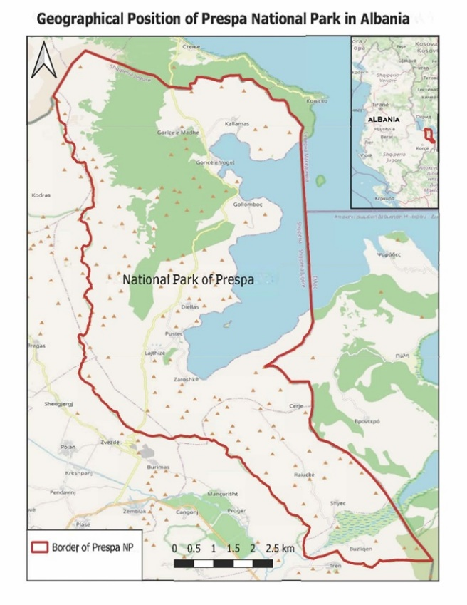
Fig. 1. Geographical map of Prespa National Park

Another important aspect for Prespa is the dimension of transboundary cooperation and management, together with North Macedonia and Greece. This status creates the possibility of a natural laboratory for environmental and climate cooperation between these three countries, where the management of natural resources and biodiversity requires close political and scientific coordination (Voudouris et al., 2021). In order to address the impacts of climate change in this region, it is necessary to develop sustainable strategies for the planning and management of water and biological resources (Trajkovski & Apostolova, 2024).
Climate changes that have occurred in recent decades in the Balkan region include an increase in average temperatures and a decrease in precipitation, which have significantly affected the aquatic and terrestrial ecosystems of the area (Soria & Apostolova, 2022). These changes have led to a decrease in water levels in the Prespa lakes and have increased the risk of invasions by alien species, making these systems sensitive and endangered (Wagner et al., 2010). The situation observed since 2010 requires a detailed assessment and the use of GIS and Remote Sensing, to analyze and identify the areas that are most affected by these transformations (Soria & Apostolova, 2022; Albrecht et al., 2011).
This study analyzes the trends of some of the climate indicators such as: minimum, maximum and average temperatures; annual precipitation amounts; anomalies of each indicator, etc. to identify the impact of climate change on the natural heritage of Prespa, including the use of geoinformation techniques to identify landscape transformations and the most ecologically fragile areas (Katsiapi et al., 2019). These analyses help establish the scientific basis for sustainable management in a context closely related to the effects of climate change and threats to biodiversity in the region, providing a valuable model for similar applications in other areas (Trajkovski & Apostolova, 2024).

2. material and methods

The methodology is built on four main components: climate data analysis, the use of satellite imagery and Geographic Information System (GIS), the processing of biophysical indicators, and the development of a multi-criteria analysis (MCE) for ecological sensitivity.
The climate data are from the Copernicus system, where the reanalyzed database provides detailed climate information on minimum and maximum temperatures, as well as precipitation at annual and monthly levels. These data provide accuracy and help in analyzing the impacts of climate change on biodiversity and aquatic and terrestrial ecosystems of the park.
Satellite data also provided by Copernicus and Earth explorer, etc., were used for the analysis of land cover and spatial transformations of the landscape. The data were integrated into QGIS to create thematic layers on land cover typology, forests and other natural habitats. GIS was also used to combine data from different sources, enabling the visualization of environmental changes related to climatic and anthropogenic pressures.
The study also processed data on biophysical indicators such as terrain slope, tree cover density, changes in forest cover, etc., which reflect ecological characteristics and help determine areas with higher ecological sensitivity. Slope was classified into four categories, while forest density and land cover (orldCover) were reclassified according to ecological importance (forests and wetlands with higher values, built-up or agricultural lands with lower values).
An important element of this study is the implementation of multicriteria analysis to combine biophysical indicators and map the ecological sensitivity of Prespa National Park. Each indicator was normalized to a scale of 0–1 and then given a specific weight according to its ecological importance (e.g. land cover 0.4, forest density 0.3, slope 0.3). The analysis was carried out in QGIS through the Raster Calculator functions, generating a final ecological sensitivity map. The result was classified into four categories: very low, low, medium and very high.
The methodology used combines climate data, GIS/RS technologies and multicriteria analysis, providing an integrated approach to assessing the ecological sensitivity of Prespa National Park. This approach provides a strong scientific basis for designing sustainable management strategies, balancing biodiversity conservation with the needs of local communities, and can serve as a model for other protected areas.

3. results and discussion

The results of this study begin with a graph showing the evolution of minimum, average and maximum annual air temperatures in the Liqenas area, Prespa National Park, during the period 1990–2023, based on ERA5 (Copernicus) reanalysis data. A clear climate warming trend is observed, expressed in all indicators. Maximum temperatures range from 13–16 °C and show a steady increase, indicating increasingly hot summers and long periods of high temperatures. Average temperatures have gradually increased from around 9 °C at the beginning of the time series to over 11 °C in recent years, which demonstrates an overall warming of the local climate. Minimum temperatures have also increased significantly, from around 5 °C in the early 1990s to over 6 °C after 2015, reflecting warmer nights and a reduction in cold extremes.
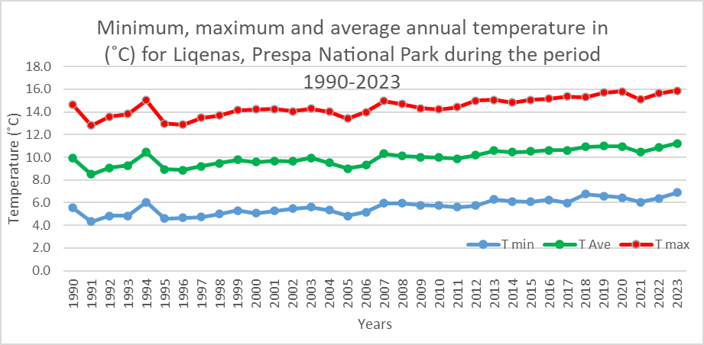
This homogeneous upward trend in all temperature categories confirms the impact of climate change on Prespa ecosystems. In addition to the climatological implications, these developments have direct consequences on agro-ecological systems, biodiversity and the sustainability of natural resources in this protected area.
Fig. 2. Minimum, maximum and average annual temperature values for Liqenas, Prespa National Park during the period 1990-2023, according to Era 5, Copernicus

The data show a high interannual variability of precipitation, without a clear long-term increasing or decreasing trend. The values range from a minimum of around 610 mm (2010) to a maximum of over 1130 mm (2011), testifying to significant climatic variability in this region. The overall average of the period is around 850–900 mm, with years where precipitation falls significantly below this threshold, especially after 2010, which indicates more frequent periods of relative drought.
Although the period 1990–2005 shows a more stable distribution around the average of the reference period, the years after 2006 are characterized by stronger fluctuations between wet and dry extremes. This pattern reflects the impact of climate change, where precipitation appears more uneven and often concentrated in intense episodes, while dry periods can last longer.
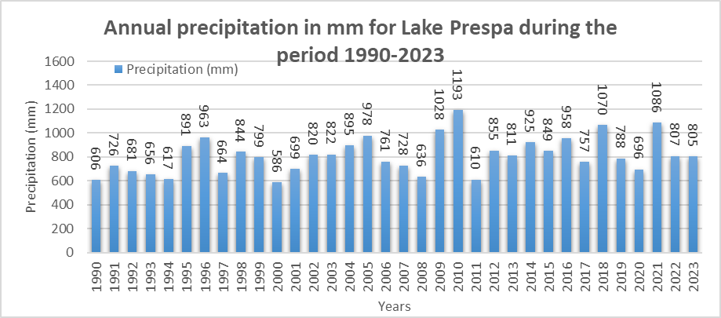

Fig 3. Annual precipitation amounts for Liqenas, Prespa National Park during the period 1990-2023, according to Era 5, Copernicus.

During the period 1990–2005, there is a change in 1990-2005, with the years after 2006 being characterized by stronger extreme and dry fluctuations. This pattern reflects the impact of climate change, with rainfall becoming more uneven and often concentrated in intense episodes, sometimes making their periods longer.
The results over a 33-year period confirm the progressive warming of the area, especially in maximum temperatures, while precipitation remains without a consistent trend. This combination makes Prespa a sensitive ecosystem, where climate pressure is expected to have consequences on biodiversity, traditional agriculture and ecosystem services. For this reason, it is recommended that the park management integrate climate indicators on an ongoing basis, building adaptation scenarios for the long-term conservation of the natural heritage.

Description | 2018 (ha) | 2018 (%) | 2021 (ha) | 2021 (%) | Changes (ha)
Low density | 16,178 | 57.6 % | 16,507 | 59.8 % | +329
Average density | 5,899 | 21.0 % | 5,792 | 21.0 % | –107
Hight density | 5,514 | 19.6 % | 5,292 | 19.2 % | –222
Total | 27,591 | 100 % | 27,591 | 100 % | 0
Table 1. Change of the area covered with trees in the Prespa NP (2018-2021)

The below maps (Fig.4 and Fig.5) present the changes in tree cover and the distribution of forest areas in Prespa National Park. Fig.2 maps the change in tree cover of the Park for the period 2018–2021, using the latest high-resolution map data from Copernicus (Copernicus 2021), where a decrease in tree cover is observed in some hilly and northern areas, and an increase in some smaller areas in other parts of the park, especially in the southeast and northeast.

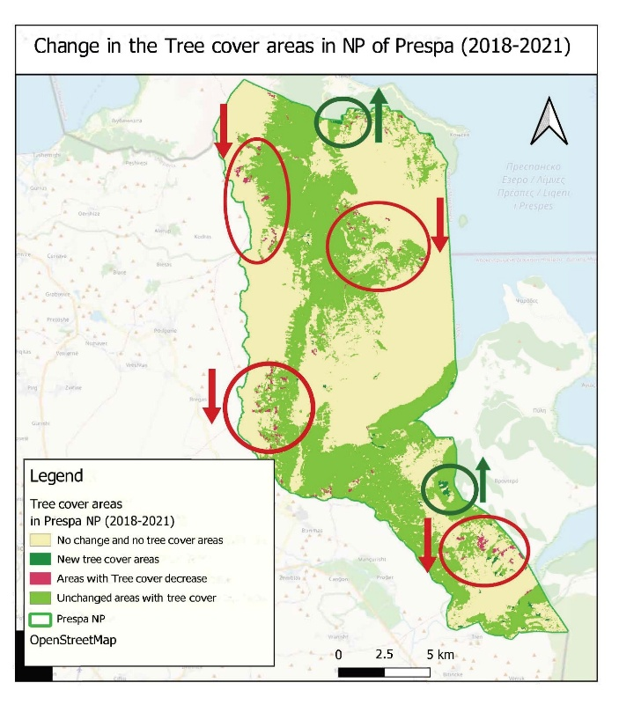
Fig 4. Map of the Change of Tree Cover in Prespa NP
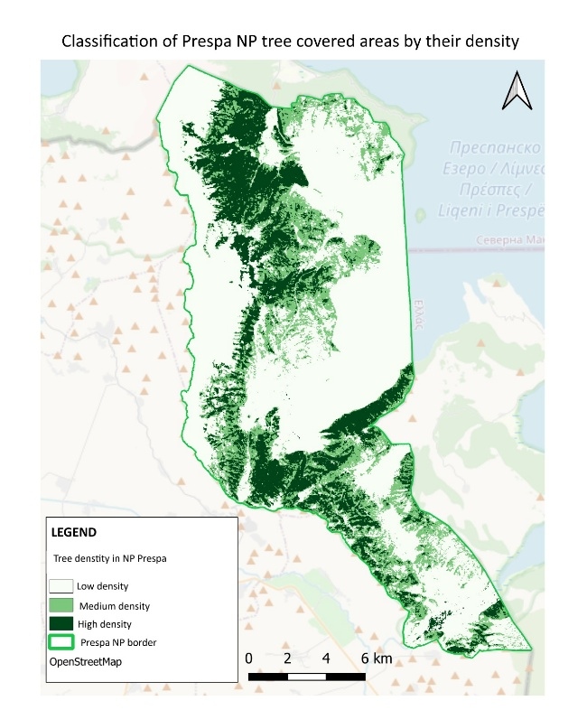

Fig 5. Map of tree distribution by density in the Prespa NP

This dynamism reflects the influence of climatic, natural and anthropogenic factors on the evolution of the landscape. Meanwhile, the other map (Fig.4) classifies the areas covered by trees according to their density for 2021, showing that areas with high density are mainly concentrated in the mountainous and steep parts of the park, while areas with low density are more spread out in the plains and transition zones. The combination of these two analyses highlights the trends of forest cover transformation and identifies areas where careful monitoring and intervention are required to maintain ecological sustainability.
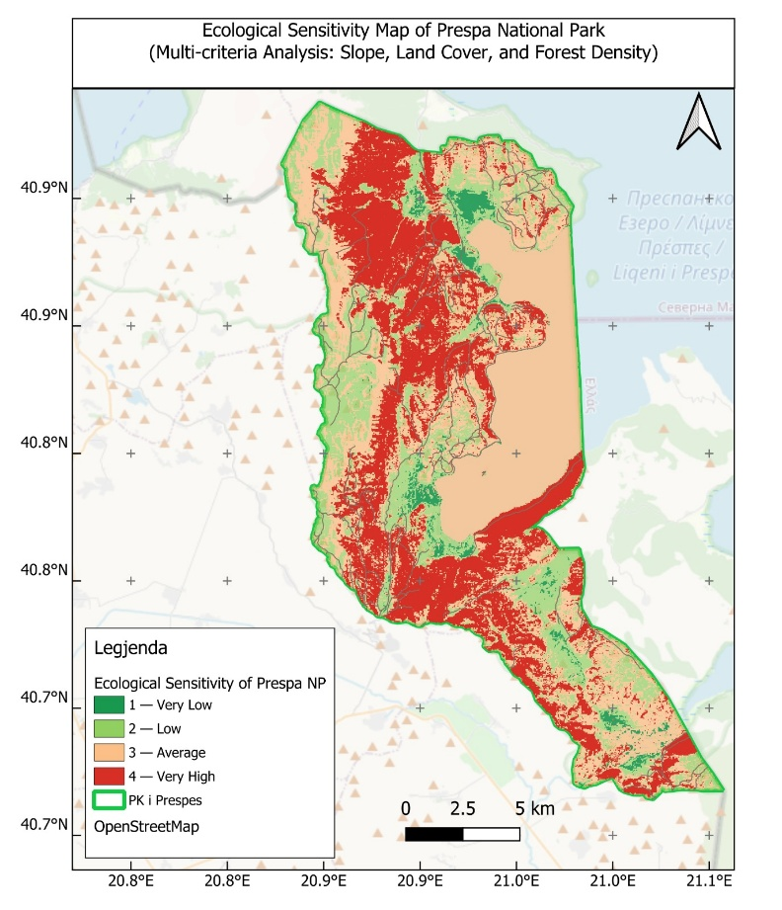
The ecological sensitivity map classifies the Prespa NP into four zones of different sensitivity, calculated through a multi-criteria analysis combining slope, land cover and tree density. The results show that the very high sensitivity zones (in red) are mainly concentrated on steep slopes, dense forest areas and near wetland habitats, highlighting their role as fragile ecosystems and important for biodiversity.
Fig 6. Ecological sensitivity map of the Prespa NP

Areas of medium sensitivity (orange) lie in transition zones between forests and pastures, while low or very low sensitivity (green) predominate in flat areas or areas used for agriculture. This distribution reflects the influence of natural and anthropogenic factors on the landscape structure and provides a scientific basis for defining areas where economic activities, especially tourism and agriculture, should be developed with increased caution.

4. Conclusion

The climate analysis for the period 1990–2023 shows a clear warming of the Prespa region, with a more pronounced increase in maximum temperatures and a reduction in frost days after 2010. Precipitation variability remains high, with years above and below average, which increases the probability of drought episodes especially when combined with increasing temperatures. The assessment of land cover and forest density shows a relative stability of tree-covered areas, but with spatial redistribution: a decrease in some hilly subzones and a local increase in the southeastern and northeastern parts. The results of the multicriteria analysis (MCE) – based on slope, land cover (WorldCover 2021) and forest density – identified bands of very high sensitivity along wetland contacts, on steep slopes with dense forests and in landscape transition zones where anthropogenic pressure interacts with climatic factors. These findings confirm that Prespa is a fragile ecosystem to warming, periodic droughts and habitat fragmentation, with direct implications for biodiversity, ecosystem services and traditional livelihood practices.
For the improvement of the situation and successful management of the Prespa NP under climate change conditions, it is important to take several measures for climate and ecological monitoring such as:
- Installation and maintenance of a network of local (automatic) stations for temperature, precipitation and evaporation; to update a composite indicator (Climate–Eco Index) that signals periodically (weekly/monthly) the risk of drought for wetlands and forest habitats;
- Creation of an ecological base with designated areas for monitoring forests, wetlands, pastures and other ecosystems classified in the category of high ecological sensitivity;
- To build local capacities for monitoring through the use of satellite images in each season, producing local thematic maps for NDVI/NDMI, thermal anomalies, trends in vegetation cover and land use, etc.
- Possibility of publishing data for use by researchers and scientific research projects.
In order to promote the development of tourism and other sustainable activities, it is necessary to take several measures using the ecological sensitivity map as a basis, determining the type of infrastructure and activities allowed/prohibited depending on the level of ecological sensitivity. For example, in areas identified as ecologically sensitive, there should be a limitation of economic activities, sustainable tourism, clear definition of paths and spaces that can be used, etc. In areas with “low or medium” sensitivity, more economic activities and tourism should be allowed, but always according to the principles of sustainability.
The management of the Prespa Park is important to be carried out through the promotion and increase of cross-border cooperation for the conservation of natural heritage. For this, it is good to carry out joint monitoring with Greece and North Macedonia regarding climate, hydrological, biodiversity data, etc. Adding joint programs to promote cross-border ecotourism. Cross-border cooperation increases the efficiency of management, ensures policy coherence and increases access to international financing for climate adaptation and ecosystem restoration.
The study shows that the combination of climate data with GIS/RS and multi-criteria analysis (MCE) provides applicable and transferable tools for decision-making. The ecological sensitivity map and the climate indicators that can be improved should be turned into operational tools for the park: for spatial planning, activity licensing, education and public communication. This evidence-based approach is essential for the long-term preservation of Prespa's natural and cultural heritage in the face of climate change.]

References

1. Albrecht, C., Hauffe, T., Schreiber, K., & Wilke, T. (2011). Mollusc biodiversity in a european ancient lake system: lakes prespa and mikri prespa in the balkans. Hydrobiologia, 682(1), 47-59. https://doi.org/10.1007/s10750-011-0830-1
2. Carnevale, D., Dimitrova, P., & Dražeta, B. (2021). Zrnosko. cultural landscapes and social economy of a village in mala prespa. Anthropology of East Europe Review, 37(1). https://doi.org/10.14434/aeer.v37i1.31777
3. Katsiapi, M., Genitsaris, S., Stefanidou, N., Tsavdaridou, A., Giannopoulou, I., Stamou, G., & Moustaka‐Gouni, M. (2019). Ecological connectivity in two ancient lakes: impact upon planktonic cyanobacteria and water quality. Water, 12(1), 18. https://doi.org/10.3390/w12010018
4. Latinopoulos, D. (2020). The role of ecotourism in the prespa national park in greece. evidence from a travel cost method and hoteliers’ perceptions. Journal of Environmental Management and Tourism, 10(8), 1731. https://doi.org/10.14505//jemt.v10.8(40).03
5. https://wwf.panda.org/es/?164611/GREECE-ALBANIA-MACEDONIA---Creation-of-Prespa-National-Park-the-1st-transboundary-protected-area-in-the-Balkans
6. Soria, J. and Apostolova, N. (2022). Decrease in the water level of lake prespa (north macedonia) studied by remote sensing methodology: relation with hydrology and agriculture. Hydrology, 9(6), 99. https://doi.org/10.3390/hydrology9060099
7. Trajkovski, D. and Apostolova, N. (2024). The catastrophic water loss of ancient lake prespa: a chronicle of a death foretold. Hydrology, 11(12), 199. https://doi.org/10.3390/hydrology11120199
8. Voudouris, K., Kiri, E., Reci, H., & Kolokytha, E. (2021). Application of dpsir method for integrated management of the transboundary aquifer in prespa-ohrid basin. https://doi.org/10.5194/egusphere-egu21-419
9. Wagner, B., Vogel, H., Zanchetta, G., & Sulpizio, R. (2010). Environmental change within the balkan region during the past ca. 50 ka recorded in the sediments from lakes prespa and ohrid. Biogeosciences, 7(10), 3187-3198. https://doi.org/10.5194/bg-7-3187-2010
10. UNEP-WCMC and IUCN (2025), Protected Planet: The World Database on Protected Areas (WDPA) and World Database on Other Effective Area-based Conservation Measures (WD-OECM) [Online], September 2025, Cambridge, UK: UNEP-WCMC and IUCN. Available at: www.protectedplanet.net.
11. Gardin, J. (2007). The Tri-National Prespa Park in Albania, Greece and Macedonia (FYROM): Using environment to define the new boundaries of the European Union. Borders of the European Union: Strategies of Crossing and Resistance. CEFRES.
12. Management Plan of Prespa National Park in Albania. (2020–2025). Ministria e Turizmit dhe Mjedisit, Republikën e Shqipërisë.
13. UNEP. (2012). Biodiversity in the Mediterranean Basin: Trends and threats. United Nations Environment Programme, Regional Office for Europe.
14. UNDP. (2019). Climate change adaptation in South-Eastern Europe: Lessons from transboundary ecosystems. United Nations Development Programme.
15. Beqiraj, S., & Ruci, P. (2019). The impact of climate change on water resources in Albania. Journal of Environmental Protection and Ecology, 20(2), 487–495.
16. Xylogiannis, E., Dichio, B., & Nuzzo, V. (2017). Climate change impact on biodiversity of Mediterranean ecosystems. Italian Journal of Agrometeorology, 22(1), 45–58.
17. Copernicus dataset: DOI (raster 10 m): https://doi.org/10.2909/e677441e-fb94-431c-b4f9-304f10e4dfd8
18. World Cover, 2021; ESA WorldCover project / Contains modified Copernicus Sentinel data (2021) processed by ESA WorldCover consortium; Zanaga, D., Van De Kerchove, R., De Keersmaecker, W., Souverijns, N., Brockmann, C., Quast, R., Wevers, J., Grosu, A., Paccini, A., Vergnaud, S., Cartus, O., Santoro, M., Fritz, S., Georgieva, I., Lesiv, M., Carter, S., Herold, M., Li, Linlin, Tsendbazar, N.E., Ramoino, F., Arino, O., 2021. ESA WorldCover 10 m 2020 v100. https://doi.org/10.5281/zenodo.5571936

