Real-time Instance Segmentation Algorithm for Steel Structure Weld Seams Based on SOLOv2
.
ABSTRACT

Steel structure buildings, as an important component of modern infrastructure, have safety and reliability directly related to public safety. Weld seams, as the critical connection points of steel structures, are prone to defects such as cracks, pores, and slag inclusions during long-term service. The accumulation of these defects may lead to structural failure. Traditional manual inspection methods are not only inefficient but also pose significant safety hazards in complex environments such as high altitudes and large structures. Therefore, developing intelligent weld seam inspection robot systems has important engineering application value. Magnetic crawler wall-climbing robots can stably attach to and flexibly move on vertical steel structure surfaces, providing an ideal platform for automated inspection. This study focuses on the application of instance segmentation technology in weld seam recognition, aiming to build an efficient and reliable visual navigation system for wall-climbing robots. The research objective is to establish a weld seam recognition system based on SOLOv2 to provide reliable visual navigation support for magnetic crawler wall-climbing robots. The main contributions of this research are: first application of SOLOv2 instance segmentation algorithm to industrial weld seam detection, proving its advantages in handling elongated targets; establishment of a weld seam dataset containing 3,070 images, providing a data foundation for related research. Experimental results powerfully confirm that SOLOv2 has significant comprehensive advantages in industrial weld seam recognition tasks, achieving 96.4% AP with 30.4 FPS inference speed.

Keywords: Weld seam detection; Instance segmentation; SOLOv2; Deep learning; Wall-climbing robot; Real-time processing

1. INTRODUCTION

1.1 Research Background and Significance
Steel structure buildings, as an important component of modern infrastructure, have safety and reliability directly related to public security. Weld seams, as the critical connection points of steel structures, are prone to defects such as cracks, pores, and slag inclusions during long-term service, and the accumulation of these defects may lead to structural failure. Traditional manual inspection methods are not only inefficient but also pose significant safety hazards in complex environments such as high altitudes and large structures. Therefore, developing intelligent weld seam inspection robot systems has important engineering application value.
Magnetic crawler wall-climbing robots can stably attach to and flexibly move on vertical steel structure surfaces, providing an ideal platform for automated inspection. However, industrial field environments are extremely complex, including variable strong and weak lighting conditions, common surface contamination such as oil and rust on metal surfaces, and background texture interference [1]. These factors pose severe challenges to traditional machine vision methods and accurate recognition. To solve these problems, the vision system not only needs to recognize the position of weld seams but also needs to achieve pixel-level precise instance segmentation to distinguish different weld seam targets and output high-quality mask images, providing a reliable visual foundation for subsequent path extraction and trajectory tracking.
In recent years, deep learning technology has made breakthrough progress in the field of computer vision [2]. Convolutional neural network-based object detection and instance segmentation algorithms provide new solutions for weld seam recognition. Compared with traditional edge detection and template matching methods, deep learning models have stronger feature expression capabilities and environmental adaptability. This research focuses on the application of instance segmentation technology in weld seam recognition, aiming to build an efficient and reliable visual navigation system for wall-climbing robots.
1.2 Research Objectives and Contributions
The research objective of this paper is to establish a weld seam recognition system based on SOLOv2 to provide reliable visual navigation support for magnetic crawler wall-climbing robots. Specific research content includes:
(1) Build a dedicated dataset for weld seam detection tasks, covering various weld seam forms, lighting conditions, and background interference, and expand sample diversity through systematic data augmentation strategies;
(2) Adopt the SOLOv2 instance segmentation framework to achieve precise recognition of weld seams, utilizing its single-stage, anchor-free design advantages to avoid the complexity of traditional two-stage methods;
(3) Verify the effectiveness and superiority of the proposed method in weld seam recognition tasks through comparative experiments with mainstream algorithms.
The main contributions of this research are: first application of SOLOv2 instance segmentation algorithm to industrial weld seam detection, proving its advantages in handling elongated targets; establishment of a weld seam dataset containing 3,070 images, providing a data foundation for related research.

2. RELATED WORK
2.1 Traditional Weld Seam Detection Methods
2.1.1 Edge Detection-based Methods
Early weld seam detection research mainly relied on image processing technology. Edge detection operators such as Sobel and Canny identify weld seam boundaries by calculating grayscale gradients. Zhang et al. proposed a straight-line detection method based on Hough transform [3], identifying linear features of weld seams through parameter space voting. The advantage of these methods is simple computation and easy implementation, but their performance highly depends on threshold settings and edge continuity. In complex industrial scenarios, textures, reflections, and contamination on metal surfaces produce numerous noise edges, leading to unstable detection results. Additionally, edge detection can only provide contour information and cannot achieve pixel-level region segmentation, making it difficult to meet precise navigation requirements.
2.1.2 Template Matching Methods
Template matching methods search for similar regions in images by predefining the grayscale pattern or geometric shape of weld seams. Typical techniques include Normalized Cross-Correlation (NCC) and shape context descriptors. Li et al. designed weld seam feature representation based on Gabor filter banks [4], capturing texture characteristics of weld seams through multi-scale multi-directional filtering responses. However, template methods assume that weld seams have relatively fixed appearance patterns, which often does not hold in practical applications. Weld seam morphologies produced by different welding processes (such as arc welding and laser welding) differ significantly, and the visual appearance of the same weld seam at different lighting angles also varies greatly. The insufficient generalization capability of templates limits the application scope of these methods.
2.2 Deep Learning-based Detection Methods
2.2.1 Two-stage Detection Methods
Mask R-CNN [5], as a classic architecture in the instance segmentation field, adopts a "detect first, then segment" two-stage strategy. It first generates candidate object boxes through a Region Proposal Network (RPN), then performs classification, bounding box regression, and mask prediction for each proposed region. This method achieved excellent performance on the COCO dataset and has been widely applied to various object detection tasks. The Mask R-CNN network architecture is shown in Figure 1.
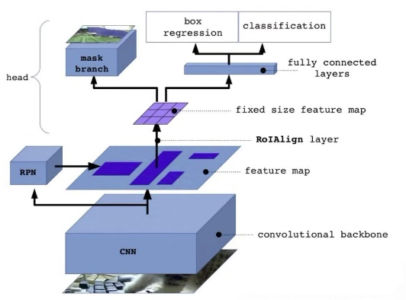
Fig. 1. Architecture of Mask R-CNN network showing the two-stage detection and segmentation pipeline
Although Mask R-CNN performs well in accuracy, its two-stage design brings high computational complexity. The RPN stage needs to generate a large number of candidate boxes, and subsequent feature extraction and ROI Align operations further increase the computational burden. In robot navigation scenarios with high real-time requirements, the inference speed of Mask R-CNN is difficult to meet the demand. Additionally, anchor box settings have a significant impact on detection performance and require fine-tuning for specific tasks, which increases the difficulty of system deployment.
2.2.2 Single-stage Detection Methods
To improve the efficiency of instance segmentation, researchers have proposed a series of single-stage methods. YOLACT (You Only Look At CoefficienTs) [6] achieves fast segmentation through prototype networks and coefficient prediction, improving speed to 30+ FPS while maintaining high accuracy. Its core idea is to decompose mask prediction into two subtasks: global prototype generation and instance coefficient prediction, generating final masks through linear combination. This design significantly reduces computational load, but the global nature of prototypes limits the ability to characterize local details. The YOLACT architecture is illustrated in Figure 2.
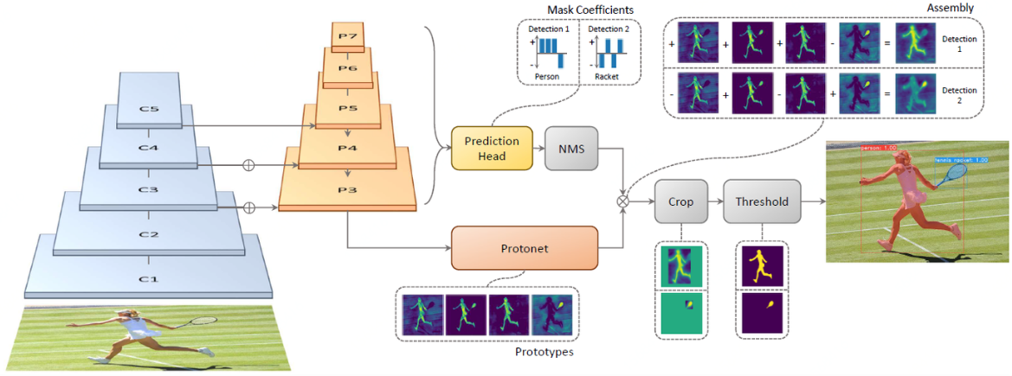
Fig. 2. Architecture of YOLACT demonstrating the prototype network and coefficient prediction mechanism
CondInst (Conditional Convolutions for Instance Segmentation) [7] proposed a conditional convolution mechanism, dynamically generating dedicated convolutional kernel parameters for each instance. Unlike YOLACT's global prototypes, CondInst's instance-specific convolutions can better adapt to shape changes of targets. However, this method still relies on bounding box proposals and requires an additional detection head to locate targets, which to some extent increases network complexity. The CondInst architecture is shown in Figure 3.
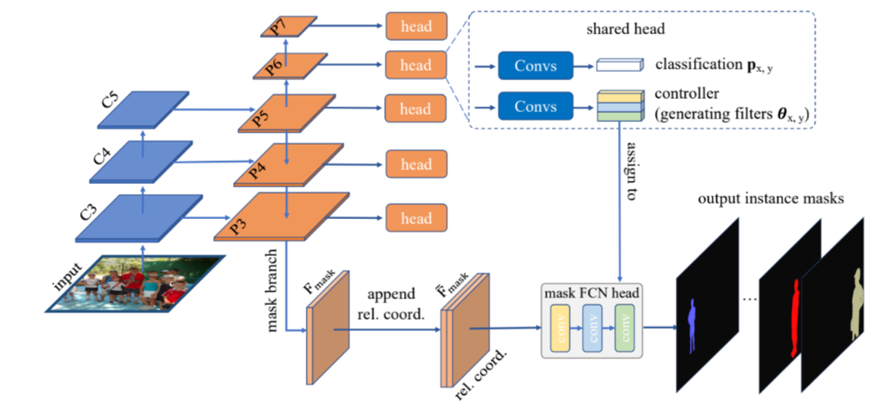
Fig. 3. Architecture of CondInst with conditional convolution mechanism for instance-specific mask generation
2.3 Advantages Analysis of SOLOv2
SOLOv2 (Segmenting Objects by Locations v2) [8] proposed a completely new instance segmentation paradigm, thoroughly freeing from dependence on anchors and proposals. Its core innovation lies in reformulating the instance segmentation task as a location-dependent dense prediction problem: the image is divided into an S×S regular grid, with each grid cell responsible for predicting instances whose centers fall within it. This spatial location-based instance encoding strategy naturally solves the instance distinction problem—centers of different instances must be located in different grids, requiring no additional grouping mechanism.
Compared with two-stage methods, SOLOv2 has the following significant advantages:
Architecture simplicity: SOLOv2 adopts a single-stage end-to-end design, without the need for complex components such as RPN and ROI Pooling. The category branch and mask branch work in parallel, obtaining multi-scale representation through a unified Feature Pyramid Network (FPN). This concise architecture is not only easy to understand and implement but also convenient for subsequent optimization and deployment.
Inference efficiency: Thanks to the anchor-free design, SOLOv2 avoids the process of generating and screening a large number of candidate boxes. The dynamic convolutional kernel mechanism allows multiple instances to be processed in parallel, and Matrix NMS achieves efficient overlap suppression through matrix operations. With ResNet-50 backbone network configuration, SOLOv2 can reach approximately 25 FPS on the COCO dataset, significantly faster than Mask R-CNN.
Shape adaptability: SOLOv2's dynamic instance segmentation mechanism has strong adaptability to target morphology. Each instance uses dedicated convolutional kernel parameters, which can flexibly capture different shape features. This is particularly important for elongated targets with extreme aspect ratios like weld seams—traditional bounding boxes are difficult to tightly fit weld seam regions, while SOLOv2's pixel-level prediction can accurately outline weld seam contours.
Multi-scale processing capability: By fusing features at different levels through FPN, SOLOv2 can simultaneously handle small-scale and large-scale targets. For weld seam detection tasks, weld seam sizes acquired by robots at different working distances vary greatly, and SOLOv2's multi-scale mechanism can ensure detection stability under various fields of view.
Compared with YOLACT, SOLOv2 does not rely on global prototypes but generates dedicated representations for each instance, avoiding limitations of prototype quantity and global modeling. Compared with CondInst, SOLOv2 requires no bounding box proposals, reducing one prediction branch and further simplifying network structure. These design features make SOLOv2 demonstrate unique advantages in specific industrial scenarios like weld seam recognition.
3. SOLOV2-BASED WELD SEAM RECOGNITION SYSTEM
3.1 Overall System Architecture Design
The SOLOv2 model is a major breakthrough in the instance segmentation field in recent years. Its design ingeniously integrates high-level semantic features with low-level spatial details and achieves efficient pixel-level prediction through dynamic mechanisms. The overall architecture of SOLOv2 is a standard deep learning paradigm, as shown in Figure 4.
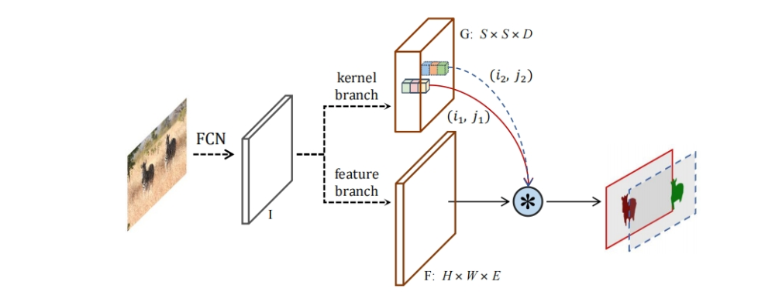
Fig. 4. Overall architecture of SOLOv2 illustrating the feature pyramid network, category prediction branch, and mask generation branch
3.2 Weld Seam Dataset Construction
3.2.1 Data Collection Strategy
A high-quality dataset is the foundation for training deep learning models. This research conducted systematic data collection in real industrial environments to ensure sample representativeness and diversity. Using industrial cameras, a total of 360 original high-quality images were obtained. These images were manually screened to remove invalid samples with severe blur or missing information. The original data was divided into training set (252 images), validation set (72 images), and test set (36 images) in a 7:2:1 ratio, ensuring that each subset has similar distribution characteristics. Figure 5 shows examples of data collection in the industrial environment.
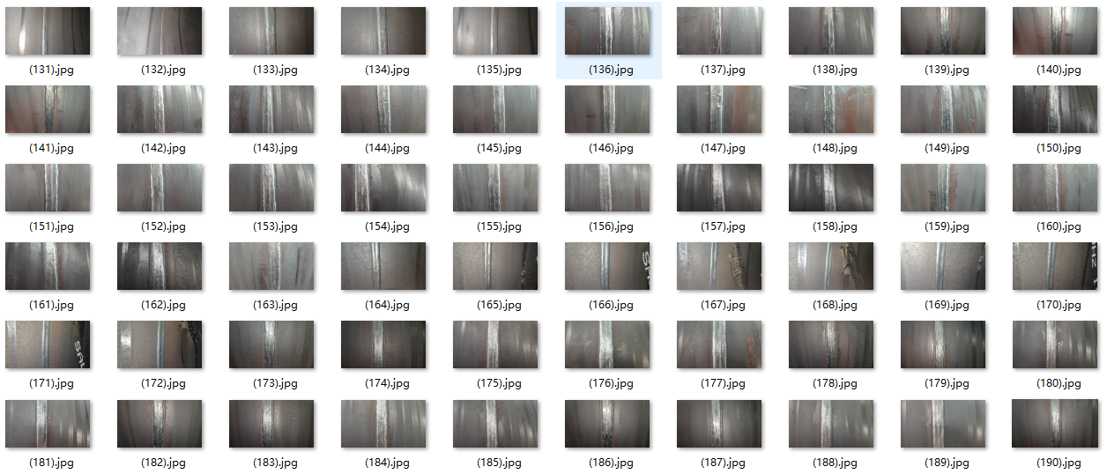
Fig. 5. Data collection in industrial environment showing various weld seam types under different lighting conditions and surface contamination scenarios
3.2.2 Data Annotation and Format Conversion
Precise annotation is key to instance segmentation tasks. This paper uses the Labelme tool for pixel-level annotation, which supports polygon drawing and can accurately depict irregular boundaries of weld seams. The JSON files output by Labelme need to be converted to COCO standard format [9] to adapt to the SOLOv2 framework. The converted COCO JSON file contains three top-level fields: images, annotations, and categories. Images record the file path, width, height, and unique identifier of each image; annotations store annotation information for all weld seam instances; categories define category metadata (in this task, only includes a single category with id=1, name="weld"). Figure 6 displays the visualization of weld seam dataset annotation results.
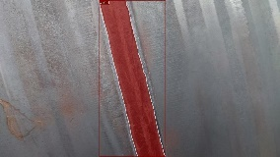 | 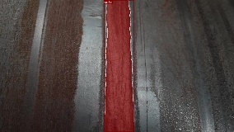 | 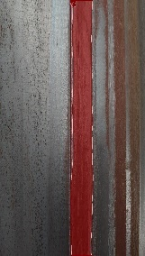 | 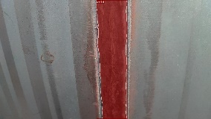
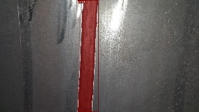 | 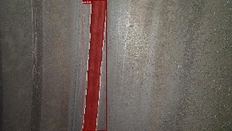 | 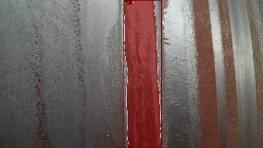 | 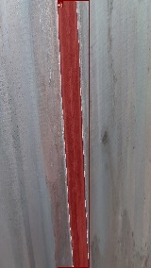
Fig. 6. Visualization of weld seam dataset annotation showing pixel-level polygon annotations using Labelme tool
3.2.3 Data Augmentation Techniques
To improve the model's generalization capability and robustness, this research designed a comprehensive data augmentation strategy [10], expanding the original 360 images to 3,070 images. Data augmentation includes geometric transformation enhancement, illumination transformation enhancement, Gaussian noise, and motion blur. As shown in Figure 7, the augmented dataset maintains the original 7:2:1 division ratio, with the training set expanded to 2,149 images, validation set 614 images, and test set 307 images. The rich sample diversity lays the foundation for the model to learn robust weld seam feature representations.
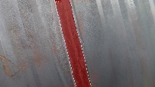 | 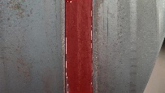 |  | 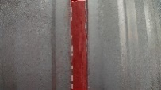 | 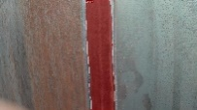
A1 | B1 | C1 | D1 | E1
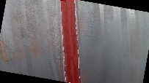 |  | 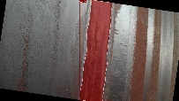 | 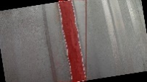 | 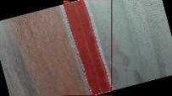
A2 | B2 | C2 | D2 | E2
 | 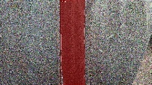 | 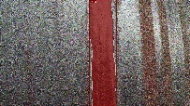 | 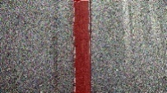 | 
A3 | B3 | C3 | D3 | E3
 | 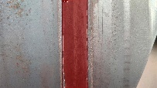 |  | 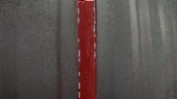 | 
A4 | B4 | C4 | D4 | E4
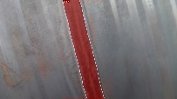 | 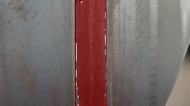 | 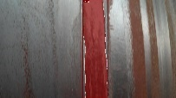 | 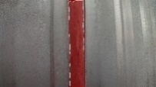 | 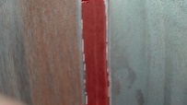
A5 | B5 | C5 | D5 | E5
Fig. 7. Examples of data augmentation results including geometric transformations (rotation, scaling, flipping), illumination adjustments (brightness, contrast), Gaussian noise addition, and motion blur effects applied to original weld seam images
4. EXPERIMENTAL RESULTS AND DISCUSSION
4.1 Experimental Setup
4.1.1 Hardware and Software Environment
All experiments were conducted on a unified computing platform with the following specific configuration:
Hardware Environment: CPU: Intel Core i9-13900HX (24 cores, maximum turbo frequency 5.4GHz); GPU: NVIDIA GeForce RTX 4060 Laptop (8GB GDDR6 memory); RAM: 16GB DDR5 4800MHz; Storage: 2TB NVMe SSD.
Software Environment: Operating System: Windows 11 Professional; Development Environment: PyCharm 2024.1.4; Python Version: 3.9.18; Deep Learning Framework: PyTorch 2.3.0; CUDA Version: 12.1; cuDNN Version: 8.8.0.
4.1.2 Evaluation Metrics
Referring to the standard evaluation system of the COCO dataset, this paper adopts the following metrics to comprehensively measure model performance:
Segmentation Accuracy Metrics: AP (Average Precision): Average precision at IoU thresholds from 0.5 to 0.95 with a step of 0.05, comprehensively reflecting model performance under different strictness levels; AP@0.5: Accuracy at IoU threshold of 0.5, measuring the model's basic detection capability; AP@0.75: Accuracy at IoU threshold of 0.75, measuring high-quality segmentation performance.
Precision and Recall are defined as follows: TP (True Positive) is the number of correctly detected weld seam instances, FP (False Positive) is the number of false detections, and FN (False Negative) is the number of missed detections. AP is calculated through the area under the precision-recall curve.
Efficiency Metrics: FPS (Frames Per Second): Number of frames processed per second, directly reflecting real-time performance; Inference Time: Average processing time per image (milliseconds), including preprocessing, network forward propagation, and post-processing; Parameters (Params): Total number of model parameters (millions, M), reflecting model complexity; FLOPs: Number of floating-point operations (billions, G), measuring computational complexity.
These metrics comprehensively evaluate the model's overall performance from both accuracy and efficiency dimensions, providing reference for practical deployment.
4.2 Comparative Experiments with Mainstream Algorithms
To objectively evaluate the performance of SOLOv2 in weld seam recognition tasks, four representative instance segmentation algorithms were selected as comparison baselines:
Mask R-CNN: Uses ResNet-50-FPN as backbone network, representing classic two-stage methods. The RPN stage generates 2,000 candidate boxes, and ROI Heads perform classification and mask prediction for each proposal.
YOLACT: Single-stage real-time segmentation method using ResNet-50 backbone network and ProtoNet architecture. The number of prototypes is set to 32, with coefficient dimension of 32.
CondInst: Single-stage method based on conditional convolutions, backbone network is also ResNet-50-FPN. Dynamic convolutional kernel dimension is 169, consistent with SOLOv2.
SOLOv2-R50: Original SOLOv2 configuration using ResNet-50 backbone network, as a control for ablation experiments.
SOLOv2-R18 (This work): The configuration adopted in this paper, using ResNet-18 backbone network to improve efficiency.
All models were trained on the same weld seam dataset, using consistent data augmentation strategies and training hyperparameters to ensure fair comparison. Table 1 shows the quantitative results of each model on the test set.
Table 1. Performance comparison of different instance segmentation models on weld seam dataset
Model | Backbone | AP (%) | AP@0.5 (%) | AP@0.75 (%) | FPS | Params (M) | FLOPs (G)
Mask-RCNN | R50-FPN | 97.8 | 99.8 | 97.2 | 8.2 | 44.2 | 275.6
YOLACT | R50 | 88.9 | 92.1 | 80.6 | 34.5 | 36.8 | 119.3
CondInst | R50-FPN | 90.6 | 94.2 | 86.2 | 18.9 | 37.5 | 158.4
SOLOv2-R50 | R50-FPN | 97.6 | 98.8 | 97.4 | 24.6 | 46.3 | 186.2
SOLOv2-R18 | R18-FPN | 96.4 | 97.8 | 95.1 | 30.4 | 22.1 | 91.8
4.3 Discussion of SOLOv2 Advantages in Weld Seam Recognition
Experimental results powerfully confirm that SOLOv2 has significant comprehensive advantages in industrial weld seam recognition tasks.
4.3.1 Balance of Accuracy and Real-time Performance
SOLOv2-R18 demonstrates significantly higher accuracy than other single-stage algorithms. Its comprehensive AP value reaches 96.4%, with only a minor gap from the highest accuracy Mask R-CNN (97.8%). This indicates that SOLOv2-R18, through its dynamic convolutional kernel mechanism, can effectively capture the elongated geometric morphology and complex edge details of weld seams, achieving high-quality pixel-level segmentation.
Meanwhile, in terms of real-time performance, SOLOv2-R18 achieves an inference speed of 30.4 FPS, significantly higher than the two-stage Mask R-CNN (8.2 FPS), even approaching the speed-renowned YOLACT (34.5 FPS). This high frame rate real-time processing capability comes from its proposal-free end-to-end pipeline and parallelized Matrix NMS mechanism. In robot navigation scenarios, continuous and fast visual feedback is a prerequisite for achieving precise path adjustment and safe obstacle avoidance, and the performance of SOLOv2-R18 perfectly meets this application requirement.
In addition, compared with CondInst, which uses a similar conditional convolution mechanism, SOLOv2-R18 has higher AP and also has obvious advantages in FPS, verifying the superiority of its location-based instance partitioning and dynamic kernel generation mechanism in handling industry-specific targets.
4.3.2 High-quality Segmentation and Path Planning Reliability
For weld seam recognition applications, the quality of segmentation masks directly determines the accuracy of subsequent robot path extraction. AP@0.75 is a key indicator for measuring high-quality segmentation. SOLOv2-R18's AP@0.75 reaches 95.1%, again approaching the peak of Mask R-CNN (97.2%). The excellent performance of this indicator has important practical significance. High-precision masks ensure that the robot can accurately extract the centerline of weld seams, enabling precise trajectory planning and stable tracking during movement. This pixel-level accuracy is crucial for maintaining the inspection quality and operational safety of the wall-climbing robot.
5. CONCLUSION AND OUTLOOK
5.1 Summary
This research successfully applied the original SOLOv2-R18 single-stage instance segmentation framework to complex industrial weld seam recognition tasks and conducted comprehensive performance evaluation for the real-time navigation needs of magnetic crawler wall-climbing robots.
Research results show that SOLOv2-R18, with its proposal-free architecture, efficient FPN multi-scale feature fusion, and innovative dynamic convolution and parallelized Matrix NMS mechanism, achieved excellent performance balance in industrial scenarios. The performance of SOLOv2-R18 on the weld seam dataset not only approaches traditional high-accuracy two-stage algorithms in accuracy but also reaches 30.4 FPS in inference speed, fully meeting the core requirements of robot systems for real-time, high-precision visual guidance, providing a reliable visual foundation for robot autonomous path planning.
In summary, the original SOLOv2 algorithm is an excellent solution highly suitable for industrial automated detection, especially for weld seam recognition tasks with strict requirements for real-time performance and pixel-level accuracy.
5.2 Future Research Directions
Future work can further explore the application potential of SOLOv2 in complex industrial environments based on its stable segmentation output.
For example, research can be conducted on how to combine the high-quality 2D mask information generated by SOLOv2 with the robot's 3D environment perception to achieve real-time 3D reconstruction and pose estimation of weld seam regions, thereby providing spatial positioning basis for more refined maintenance and repair operations. In addition, the feature extraction capability of SOLOv2 can be explored to expand the system's recognition range, not only performing weld seam instance segmentation but also simultaneously classifying and locating common defect types (such as pores and cracks) inside or at the edges of weld seams. These directions will help further improve the intelligence level and functional diversity of automated detection systems.

COMPETING INTERESTS DISCLAIMER:
Authors have declared that they have no known competing financial interests OR non-financial interests OR personal relationships that could have appeared to influence the work reported in this paper.
REFERENCES
[1] G. D. Guo, L. Zhang, & N. Zhang, "A survey on deep learning based face recognition," Computer Vision and Image Understanding, vol. 189, pp. 102805, Dec. 2019.
[2] Y. LeCun, Y. Bengio, & G. Hinton, "Deep learning," Nature, vol. 521, no. 7553, pp. 436-444, May 2015.
[3] J. Zhang, X. Jin, J. Sun, J. Wang, & K. Li, "Dual model learning combined with multiple feature selection for accurate weld defect detection," IEEE Access, vol. 7, pp. 85232-85239, 2019.
[4] S. Li, Z. Liu, & Y. Hu, "Weld defect detection based on deep learning method," in Proc. IEEE Int. Conf. Automation Science and Engineering (CASE), Vancouver, BC, Canada, Aug. 2019, pp. 1574-1579.
[5] K. He, G. Gkioxari, P. Dollár, & R. Girshick, "Mask R-CNN," in Proc. IEEE Int. Conf. Computer Vision (ICCV), Venice, Italy, Oct. 2017, pp. 2961-2969.
[6] D. Bolya, C. Zhou, F. Xiao, & Y. J. Lee, "YOLACT: Real-time instance segmentation," in Proc. IEEE/CVF Int. Conf. Computer Vision (ICCV), Seoul, South Korea, Oct. 2019, pp. 9157-9166.
[7] Z. Tian, C. Shen, H. Chen, & T. He, "Conditional convolutions for instance segmentation," in Proc. European Conf. Computer Vision (ECCV), Glasgow, UK, Aug. 2020, pp. 282-298.
[8] X. Wang, R. Zhang, T. Kong, L. Li, & C. Shen, "SOLOv2: Dynamic and fast instance segmentation," in Proc. Advances in Neural Information Processing Systems (NeurIPS), vol. 33, Dec. 2020, pp. 17721-17732.
[9] T.-Y. Lin, M. Maire, S. Belongie, J. Hays, P. Perona, D. Ramanan, P. Dollár, & C. L. Zitnick, "Microsoft COCO: Common objects in context," in Proc. European Conf. Computer Vision (ECCV), Zurich, Switzerland, Sep. 2014, pp. 740-755.
[10] C. Shorten & T. M. Khoshgoftaar, "A survey on image data augmentation for deep learning," Journal of Big Data, vol. 6, no. 1, pp. 1-48, Jul. 2019.

