Development of an Enhanced Internet of Things-Based Wearable Human Tracking Security System with Integrated Distress Alert Mechanism

Abstract
The increasing rate of human abduction, accidents, and insecurity has necessitated the development of advanced, reliable, and real-time tracking systems for personal safety. This study presents the Development of an Enhanced Internet of Things (IoT)-Based Wearable Human Tracking Security System with Integrated Distress Alert Mechanism. The system is designed to monitor and track individuals in real time using Global Positioning System (GPS) technology, with communication facilitated through Global System for Mobile communication (GSM) and Wi-Fi modules. The ESP32 microcontroller serves as the central processing unit, coordinating data acquisition and transmission to a cloud-based platform accessible via a mobile application. A dedicated distress button enables the user to send an emergency alert containing real-time location coordinates to predefined contacts through Short Message Service (SMS) and email notifications. The system also integrates a camera module for capturing images during emergency activation to enhance situational awareness. Experimental evaluation demonstrated high accuracy in location tracking, fast alert response time, and low power consumption, making the device suitable for vulnerable groups such as children, the elderly, and field workers. The proposed IoT-based wearable device offers an efficient, low-cost, and scalable solution for human safety monitoring and emergency response applications.
Keywords: Internet of Things (IoT), Human Tracking, Security System, ESP32 Microcontroller, GPS-GSM Module, Distress Alert, Wearable Device.
- Introduction
The increasing rate of security challenges in Nigeria, including kidnapping, armed robbery, terrorism, and human trafficking, has emerged as a major national concern threatening personal safety, social stability, and economic development. Over the past decade, the country has witnessed a sharp rise in abduction incidents, particularly in northern and central regions, with devastating effects on families and communities (Abdullahi, 2022). Traditional security measures such as neighborhood watch schemes, manual patrols, and community policing have proven inadequate in addressing modern security threats, primarily due to their reactive nature and lack of real-time communication and monitoring. This has created a significant gap in the ability to ensure individual safety in both urban and rural settings.

The advent of emerging technologies, especially the Internet of Things (IoT), offers promising opportunities to bridge this gap through intelligent, interconnected systems capable of real-time data transmission and automated response. IoT enables devices to communicate seamlessly through networks, integrating sensors, microcontrollers, and cloud-based systems to enhance situational awareness (Wei, 2014). Within the realm of personal safety and human security, IoT-based wearable devices have been recognized for their ability to monitor physiological and locational data while ensuring timely distress alerts during emergencies (Yacchirema et al., 2018). These devices combine GPS, GSM, Wi-Fi, and Bluetooth communication technologies to provide continuous tracking and reliable connectivity even in areas with limited infrastructure.

However, several challenges continue to limit the adoption and performance of existing IoT-based tracking systems. These include inaccurate location detection, high latency in alert transmission, limited network coverage, energy inefficiency, and insufficient data privacy measures (Suma and Rekha, 2021). Many existing solutions also lack localization for the socio-economic conditions of developing nations like Nigeria, where affordability, ease of use, and network resilience are crucial for widespread deployment. As a result, there remains a pressing need for cost-effective, low-power, and high-accuracy IoT-based wearable security systems tailored to local contexts.

1.1 IoT and Wearable Technologies for Human Security

IoT-based wearable systems have gained significant traction in applications such as health monitoring, elderly care, child safety, and workforce tracking. The integration of multiple sensors in wearable devices allows real-time detection of parameters such as location, motion, and heart rate, which are transmitted wirelessly to a cloud or mobile interface for analysis (Chatzimichail et al., 2019). In the context of security, the capability of these systems to send emergency alerts embedded with precise location data has been a major innovation in modern safety systems (Chadil et al., 2022). The distress alert mechanism, often implemented as a physical or touch-based emergency button, serves as a lifeline during dangerous situations by transmitting real-time coordinates to pre-registered contacts or emergency units. However, studies have shown that existing systems frequently suffer from delayed message delivery and inconsistent network performance, especially in regions with poor mobile coverage (Harikiran et al., 2016; Sanwo-Olu, 2022). Moreover, power efficiency remains a crucial factor many wearable devices drain rapidly during continuous GPS tracking, compromising their reliability in emergencies (Arora and Jain, 2019).

Wei (2014) emphasized that real-time responsiveness and interoperability between IoT devices are fundamental to ensuring reliability and scalability.

1.2 Contextual Challenges and Research Gaps

Nigeria’s complex security landscape necessitates the adoption of technologies that combine precision, reliability, and affordability. While high-end IoT safety devices are available globally, most are cost-prohibitive for the average Nigerian user and dependent on stable network infrastructure. Furthermore, socio-economic factors, including low digital literacy and poor network coverage in rural areas, exacerbate usability challenges (Akinola and Yusuf, 2020). Consequently, locally developed and contextually adaptive solutions are essential to ensure accessibility and sustainability.

Akinola and Yusuf (2020) further noted that the majority of existing personal safety systems in Nigeria rely heavily on manual intervention, thereby reducing the efficiency of emergency response. Additionally, GPS accuracy in urban environments is often compromised due to signal obstruction, a phenomenon known as “urban canyoning,” where tall buildings reflect or block satellite signals. Sun et al. (2020) proposed a machine learning–based approach that reduced GPS pseudorange errors by 70%, demonstrating that algorithmic optimization could significantly enhance positional accuracy. This insight informs the development of improved tracking mechanisms in the present study.

Another limitation in existing systems is the lack of real-time feedback mechanisms to confirm successful distress signal delivery. The absence of acknowledgment from the recipient side reduces user confidence and hampers system effectiveness during emergencies. The integration of messaging platforms such as Telegram, which offers real-time confirmation and encrypted communication, can effectively close this feedback loop, ensuring that alerts are received, acknowledged, and acted upon promptly.

1.3 Rationale and Objectives of the Study: To address the highlighted limitations, this study focuses on developing an Enhanced Internet of Things-Based Wearable Human Tracking Security System with Integrated Distress Alert Mechanism. The proposed system incorporates a combination of GPS, GSM, Wi-Fi, and Bluetooth technologies managed by the ESP32 microcontroller, which enables fast data transmission and low power consumption. The design also integrates a camera module to capture environmental images during distress events, improving situational awareness for emergency responders.

The primary aim of this research is to develop an automatic IoT-based wearable panic alert system by designing it in KiCAD software, implementing and simulating the system through printed circuit board (PCB) integration of key components, including the ESP32 microcontroller, GPS, GSM, and heart rate sensors, and evaluating its performance in terms of accuracy, latency, real-time responsiveness, and usability using the Extended Unified Theory of Acceptance and Use of Technology (UTAUT) framework. By fulfilling these objectives, the study seeks to deliver a reliable, efficient, and cost-effective device capable of ensuring rapid and accurate communication between distressed users and their designated contacts, while remaining power-efficient and suitable for deployment in the Nigerian context.

1.4 Significance and Contribution: The significance of this study lies in its potential to enhance emergency response efficiency and reduce fatalities resulting from delayed distress communication. The system’s IoT-driven architecture ensures instantaneous location tracking and automated message dispatch during emergencies. Its successful deployment could influence national policy on personal security, encouraging the integration of smart technologies into community policing frameworks.

From a technological standpoint, the system contributes to the growing field of context-aware IoT applications and wearable computing by addressing limitations in connectivity, usability, and power management under developing-country conditions. Moreover, the project demonstrates how open-source hardware platforms such as ESP32 and communication protocols like MQTT and Telegram API can be leveraged to create low-cost, scalable, and user-friendly safety systems.

1.5 Structure of the Remaining Work: Following this introduction, Section 2 presents an in-depth review of technologies currently employed in human security systems, including drones, surveillance cameras, and IoT-based sensors. Section 2 details the materials and methods used in the design and development of the proposed system, while Section 3 discusses results and evaluation outcomes, section 4 is on conclude and section 5 is for recommendation of the study.
2.0 Methodology
This study employs a design-based research methodology to develop an IoT-enabled wearable panic alert system, integrating sensors for heart rate monitoring, GPS tracking, and real-time distress notifications. System performance is evaluated through accuracy, latency, responsiveness, and usability metrics using the Extended UTAUT framework.

2.1 Research Design and Approach: This study employs a design-based research methodology to develop a reliable, real-time wearable human tracking security system leveraging IoT technology. The system integrates multiple sensors for physiological monitoring, geolocation tracking, and emergency alert dissemination to enhance user safety and facilitate rapid response in critical situations. Its design prioritizes low latency, high accuracy, energy efficiency, and ease of use, making it suitable for deployment in real-world scenarios within the Nigerian context. The developed prototype comprises five key functional units: the Power Supply Unit, Heart Rate Sensor Unit, GPS Module, Display Unit, and Control Unit (ESP32).
2.2 System Architecture and Functional Units: The wearable security system is built around a modular hardware architecture, with each functional unit contributing to real-time tracking, physiological monitoring, and distress alert generation. The system integrates sensing, processing, communication, power management, and user interaction within a compact wearable platform.
2.2.1 Power Supply Unit: The power supply delivers regulated power to the system using two 18650 lithium-ion batteries connected in parallel to increase capacity while maintaining nominal voltage. Nickel jumper plates, spot-welded for low-resistance connections, and 1.5 mm jumper cables interface the batteries with the power management module. A USB Type-C port allows efficient charging. Two independent +5 V output channels supply up to 2.4 A each, filtered with 1000 μF, 25 V capacitors to stabilize voltage and minimize ripple, ensuring reliable power delivery (Figure 1).

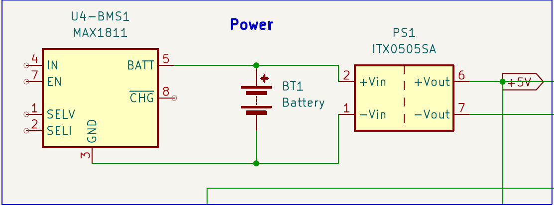

Figure 1: The Power Supply Unit Circuit
2.2.2 Heart Rate Sensor Unit: The MAX30102 sensor module integrates LEDs, photodetectors, and low-noise electronics for pulse oximetry and heart-rate monitoring. Powered via 1.8 V and 3.3 V rails, it communicates with the ESP32 over I2C and supports software-controlled shutdown with zero standby current. This module enables continuous heart-rate monitoring in wearable applications.
2.2.3 Display Unit: A 0.96-inch OLED display interfaces with the ESP32 via the I2C bus and Adafruit SSD1306 library. It presents real-time heart rate, bpm, time, and GPS coordinates. In the event of abnormal readings, the display shows the user’s heart rate, location, and “sending…” to indicate that a Telegram alert has been transmitted.
2.2.4 Control Unit: The ESP32 microcontroller serves as the system’s brain, coordinating all operations. It interfaces with the MAX30102 sensor, OLED, and DS1307 RTC via I2C, and communicates with the NEO-7M GPS module through UART. The ESP32-WROOM-32 module offers dual CPU cores (80–240 MHz), low-power coprocessor functionality, integrated Wi-Fi and Bluetooth/BLE, and a rich set of peripherals, making it highly suitable for wearable IoT applications. Its low sleep current (<5 µA) and high data rate (up to 150 Mbps) ensure energy-efficient operation and wide connectivity. Figures 2 and 3 present the prototype and system flowchart.
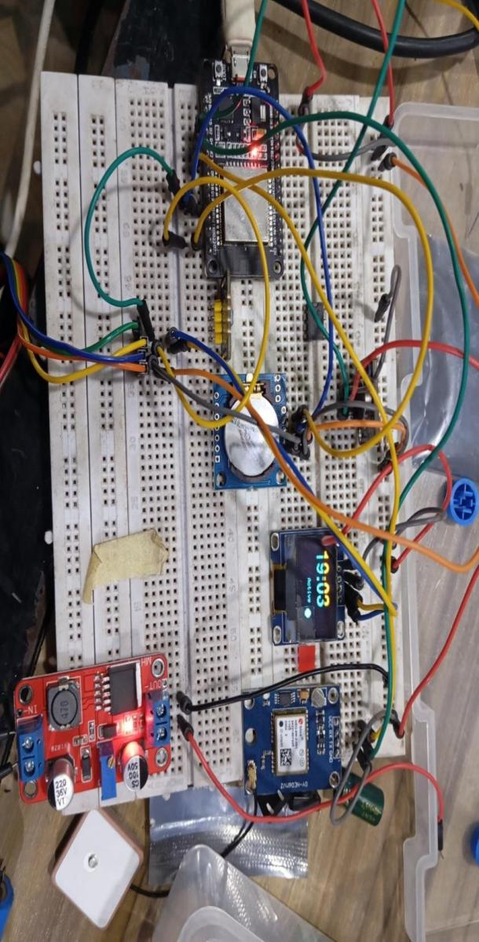
Figure 2: Prototype of the developed human tracking security system with alert mechanism
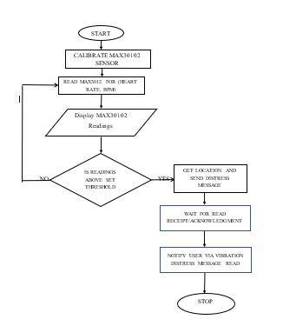
Figure 3: Systems Flowchart Diagram
2.3 Component Interfacing: Seamless interfacing of hardware components with the ESP32 ensures reliable operation, low latency, and energy efficiency.
- Power Supply: Managed via MAX1811 BMS and TX0505SA DC-DC converters to deliver 5 V and 3.3 V outputs to all modules with ground lines forming a common reference.
- ESP32 Microcontroller: Serves as the central processor, coordinating data acquisition, processing, and control of peripherals. Heart rate sensor, OLED, and RTC communicate via I2C (GPIO22/21), while the GPS module uses UART. Digital I/O drives the vibration motor through a BC547 transistor.
- Heart Rate Sensor: MAX30102 communicates via I2C and triggers interrupts when thresholds are exceeded.
- OLED Display: Displays system readings in human-readable format over I2C.
- RTC Module: DS1307 provides accurate timestamps for logging events.
- GPS Module: NEO-M8N provides real-time coordinates via UART.
- Vibration Motor: Driven by BC547 transistor with a flyback diode for tactile alerts.
- Bus Configuration: Shared I2C bus reduces GPIO usage; dedicated UART ensures reliable GPS communication.
2.4 Circuit Design and Implementation: The circuit (Figure 4) integrates the ESP32 microcontroller, MAXREFDES117 heart rate sensor, DS1307 RTC, SSD1306 OLED, NEO-7M GPS, vibration motor, and supporting power electronics. The ESP32 manages all peripherals via GPIO, I2C, UART, and PWM interfaces. The system is powered by a Li-ion battery regulated through an AMS1117 module, with proper filtering and voltage regulation to ensure stable operation across all components.
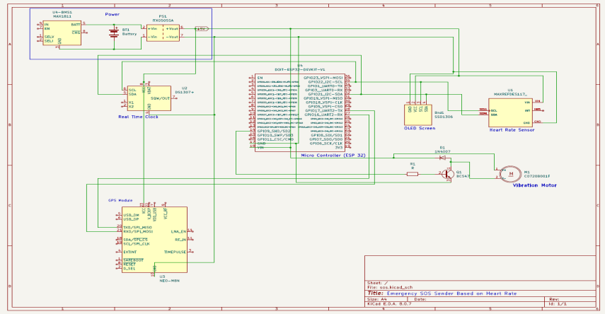
Figure 4: The Circuit Design of the Developed System.
2.5 Performance Evaluation: The system was evaluated on three primary metrics:
2.5.1 Accuracy and Precision: Accuracy measures the closeness of system outputs to true values, while precision assesses repeatability over multiple trials. Both are critical for reliable emergency detection.
2.5.2 Latency and Real-Time Performance: Latency quantifies the delay between an event and system response. Real-time performance ensures timely alerting, crucial for emergency applications.
2.5.3 Usability and User Experience: Usability evaluates how easily users interact with the system, while UX assesses overall satisfaction and perceived effectiveness. Designing for ease of use enhances adoption and operational effectiveness.
3.0 Results and Discussion
3.1 Results Overview: The enhanced IoT-based wearable human tracking security system was successfully developed and implemented following the design framework presented in Chapter Three. The prototype integrates a MAX30102 sensor for continuous heart rate monitoring, and when readings exceed 100 bpm, it automatically retrieves GPS coordinates from the Neo-7M module and sends a distress alert via Telegram to a registered emergency contact. The ESP32 microcontroller coordinates all system operations, with an OLED display providing real-time feedback and a vibration motor delivering tactile confirmation upon successful alert transmission. The system’s performance was evaluated across three key metrics: accuracy and precision, latency and real-time responsiveness, and usability and user experience (UX).
3.2 System Output Results: Figures 5 to 7 illustrate the actual system outputs during testing. Figure 5 shows a Telegram notification confirming successful startup and operational readiness. Figure 6. displays a real-time Telegram alert containing the user’s heart rate (69 BPM), GPS coordinates (8.168136, 4.271147), and timestamp (18:05:50). Figure 7 presents the user’s precise location on the LAUTECH campus map, retrieved through the developed system.


Figure 5: Telegram Notification with Timestamp Figure 6 Real-Time Telegram Alert Showing User’s Heart
Rate Tracked Location
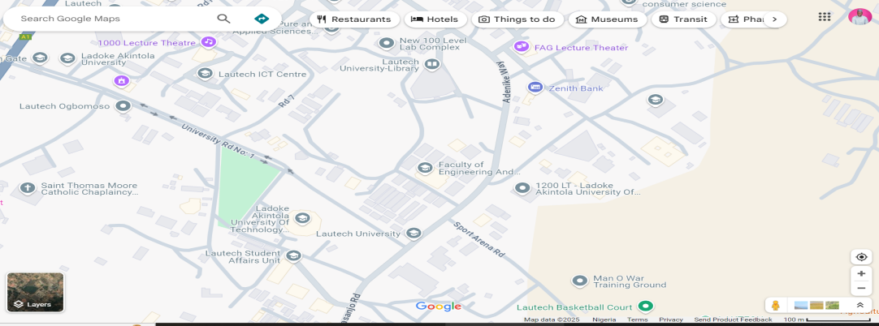
Figure 7: Real-Time User Location and Alert Interface on LAUTECH Map
3.3 Performance Evaluation Methodology: The system’s performance was assessed using standard engineering metrics:
- Accuracy and Precision: Accuracy measures the closeness of detected events to actual conditions, while precision evaluates the consistency of detection outcomes.
- Latency and Real-Time Performance: Latency quantifies the time delay between a triggering event (e.g., heart rate threshold breach) and system response, while real-time performance assesses responsiveness within defined limits.
- Usability and User Experience (UX): Assessed through a structured survey based on the Extended UTAUT2 model, measuring constructs such as performance expectancy, effort expectancy, social influence, facilitating conditions, perceived security and privacy, and trust in technology.
3.4 Evaluation of Results
3.4.1 Accuracy and Precision: The system was tested on 100 event instances. Confusion matrix results (Table 1) show 43 true positives, 48 true negatives, 3 false positives, and 6 false negatives, yielding an overall accuracy of 91% and precision of 93%. These results indicate that the system reliably differentiates distress events from normal conditions, with minimal false alarms.
Table 1: Confusion Matrix for Distress Detection Performance
Event Type | Actual Condition | System Detected | Count
True Positives (TP)  True Negatives (TN)  False Positives (FP)  False Negatives (FN) | Distress present  No distress  No distress  Distress present | Detected distress  No distress detected  Detected distress  No distress detected | 43  48  3  6

3.4.2 Latency and Real-Time Performance: Latency was measured across 10 independent trials, ranging from 2.0 s to 2.8 s, with an average of 2.4 s, well below the 5-second threshold. This confirms that the system consistently meets real-time performance requirements, ensuring timely alert transmission during emergencies (Tables 2 and 3).
Table 2: Evaluation Metrics of the System Performance
Trial | Trigger Time(s) | Alert Time (s) | Latency (s)
1  2  3  4  5  6  7  8  9  10 | 00  00  00  00  00  00  00  00  00  00 | 2.3  2.7  2.2  2.6  2.5  2.1  2.4  2.8  2.0  2.5 | 2.3  2.7  2.2  2.6  2.5  2.1  2.4  2.8  2.0  2.5
Table .3: Tabular Summary of Evaluation Metrics
Metric | Value
Accuracy (%)  Precision (%)  Average Latency  Real-Time Performance | 91.0  93.0  2.4  Achieved (≤ 5s)

3.4.3 Usability and User Experience: A total of 134 participants completed the UTAUT2-based survey. Respondents were primarily male, young-to-middle-aged, highly educated, and technologically literate. Cronbach’s Alpha of 0.967 across 23 items confirmed excellent internal consistency. Participants reported that the device is intuitive, easy to learn, and effective in enhancing safety and emergency response. Social influence, facilitating conditions, and trust in technology emerged as strong determinants of behavioral intention to adopt the device.
4.5 Correlation Analysis: Pearson correlation analysis (Table 4) revealed significant relationships between UTAUT constructs and behavioral intention:
- Performance Expectancy (r = .543, p < .001)
- Effort Expectancy (r = .549, p < .001)
- Social Influence (r = .631, p < .001)
- Facilitating Conditions (r = .664, p < .001)
- Perceived Security & Privacy (r = .639, p < .001)
- Trust in Technology (r = .494, p < .001)
Behavioral Intention showed a very strong correlation with actual adoption (r = .930, p < .001), validating the extended UTAUT framework. Facilitating conditions, social influence, and perceived security and privacy were the strongest predictors, highlighting the importance of supportive infrastructure, social endorsement, and data protection in promoting adoption.

Table 4: Pearson Correlation of UTAUT Constructs and IoT Wearable Adoption

UTAUT Construct |  | Behavioural Intention
Performance Expectancy | Pearson Correlation | .543**
Performance Expectancy | Sig. (2-tailed) | .000
Performance Expectancy | N | 134
Effort Expectancy | Pearson Correlation | .549**
Effort Expectancy | Sig. (2-tailed) | .000
Effort Expectancy | N | 134
Social Influence | Pearson Correlation | .631**
Social Influence | Sig. (2-tailed) | .000
Social Influence | N | 134
Facilitating Conditions | Pearson Correlation | .664**
Facilitating Conditions | Sig. (2-tailed) | .000
Facilitating Conditions | N | 134
Perceived Security & Privacy | Pearson Correlation | .639**
Perceived Security & Privacy | Sig. (2-tailed) | .000
Perceived Security & Privacy | N | 134
Trust in Technology | Pearson Correlation | .494**
Trust in Technology | Sig. (2-tailed) | .000
Trust in Technology | N | 134
Behavioural Intention | Pearson Correlation | 1
Behavioural Intention | Sig. (2-tailed)
Behavioural Intention | N | 134
Adoption of IoT Wearable Human Tracking Device | Pearson Correlation | .930**
Adoption of IoT Wearable Human Tracking Device | Sig. (2-tailed) | .000
Adoption of IoT Wearable Human Tracking Device | N | 134

3.6 Discussion of Results: The evaluation confirms that the developed IoT-based wearable security system meets its design and functional objectives. KiCAD-based circuit design and PCB implementation provided a reliable platform for integrating panic alert and real-time tracking capabilities. The system demonstrated high accuracy (91%) and precision (93%) in distress detection, with minimal false alarms, consistent with prior research emphasizing real-time accuracy in emergency applications. Average latency of 2.41 s confirms responsive, real-time performance, while user evaluations indicate strong usability, trust, and perceived security. Social influence further reinforces adoption intentions, emphasizing the combined importance of technical performance and user-centered design.
Collectively, these results suggest that successful IoT-based wearable safety devices must integrate technical excellence accuracy, low latency, and robustness with usability, security, and social acceptance to achieve widespread adoption. Figure 8 illustrates the UTAUT model for adoption of the IoT wearable human tracking system, confirming that behavioral intention mediates the relationship between system features and actual adoption.
Perceived Security and Privacy

Performance Expectancy
Effort Expectancy
Behavioural Intention

Facilitating Conditions
Trust in Technology
Social Influence
Adoption of the IoT wearable human tracking device
R1 = .543
R7 = .930
R6 = .494
R2 = .549
R3 = .631
R4 = .664
R5 = .639
Figure 8: Unified Theory of Acceptance and Use of Technology (UTAUT) Model for IoT Wearable Adoption.
4.0 Conclusion
This project successfully developed and tested a prototype IoT-based Human Tracking Security System that integrates physiological monitoring with real-time alert functionality. The system effectively detects abnormal heart rate activity specifically when readings exceed 100 beats per minute and automatically transmits a distress message containing the user’s real-time location to a designated emergency contact. This functionality enhances emergency response efficiency and significantly improves personal safety, particularly in health-critical or high-risk scenarios. Evaluation findings reveal that behavioral intention plays a pivotal role in the adoption of the wearable security system, with performance expectancy, effort expectancy, social influence, facilitating conditions, perceived security, privacy, and trust in technology all exerting significant influence. Facilitating conditions and social influence emerged as the strongest determinants of adoption. The strong correlation between behavioral intention and actual adoption (r = .930, p < .001) validates the robustness of the extended UTAUT framework in explaining user adoption behavior. Overall, the results emphasize the technical need for reliable, user-friendly, and secure device design, as well as the professional importance of aligning technological innovation with user trust, expectations, and social acceptance to ensure sustainable and impactful deployment of IoT-based safety solutions.
5.0 Recommendation
Although the prototype Human Tracking Security System demonstrated strong performance across key evaluation metrics, several enhancements are recommended for future development. Integrating cloud-based services will enable remote monitoring and data storage, while implementing sensor fusion techniques can further improve data accuracy and system reliability. The adoption of adaptive thresholding through machine learning is also advised to provide personalized and context-aware alert responses. Moreover, optimizing power consumption with low-energy components and conducting extensive usability testing across diverse user groups will enhance the system’s reliability, accessibility, and long-term operational efficiency in real-world conditions.

COMPETING INTERESTS DISCLAIMER:
Authors have declared that they have no known competing financial interests OR non-financial interests OR personal relationships that could have appeared to influence the work reported in this paper.

REFRENCES
[1] Abdullahi, M. (2022, October 3). Surveillance technologies could reduce security risks in Northwest Nigeria. HumAngle. https://humanglemedia.com/surveillance-technologies-could-reduce-security-risks-in-northwest-nigeria/
[2] Wei, J. (2014). How wearables intersect with the cloud and the Internet of Things: Considerations for the developers of wearables. IEEE Consumer Electronics Magazine, 3(3), 53–56.
[3] Yacchirema, D., de Puga, J. S., Palau, C., and Esteve, M. (2018). Fall detection system for elderly people using IoT. Procedia Computer Science, 130, 603–610. https://doi.org/10.1016/j.procs.2018.04.110
[4] Suma, T., and Rekha, G. (2021). IoT-based women safety devices with screaming detection. International Journal of Engineering Applied Sciences and Technology, 6(7), 257–262. https://doi.org/10.33564/ijeast.2021.v06i07.041
[5] Chatzimichail, A., Chatzigeorgiou, C., Tsanousa, A., Ntioudis, D., and Meditskos, G. (2019). IoT infrastructure for security in public places. Information, 10(1), 1 20. https://doi.org/10.3390/info10010012
[6] Chadil, N., Russameesawang, A., and Keeratiwintakorn, P. (2022). Real-time tracking management system using GPS and GPRS. In Proceedings of the 5th International Conference on Electrical Engineering/Electronics, Computer, Telecommunications and Information Technology (ECTI CON) (pp. 393 396). IEEE. https://doi.org/10.1109/ecticon.2008.4600454
[7] Harikiran, G. C., Menasinka, K., and Shirol, S. (2016). Smart security solution for women based on IoT. In 2016 International Conference on Electrical, Electronics, and Optimization Techniques (ICEEOT) (pp. 3551 3554). IEEE. https://doi.org/10.1109/ICEEOT.2016.7755380
[8] Sanwo-Olu, B. (2022, December 24). Over 600 surveillance cameras in Lagos. ThisDayLive. https://www.thisdaylive.com/index.php/2022/12/24/sanwo-olu-over-600-surveillance-cameras-in-lagos
[9] Arora, S., and Jain, R. (2019). Low-cost women safety device. In International Conference on Recent Advances in Engineering, Technology and Science (pp. 142–147). IEEE.
[10] Gao, Y., Li, H., and Luo, Y. (2015). Wearable technology acceptance in healthcare. Industrial Management & Data Systems, 115(9), 1704–1723. https://doi.org/10.1108/IMDS-03-2015-0087
[11] Akinola, A., & Yusuf, O. (2020). Community Policing and Security Challenges in Nigeria: A Technological Perspective. Journal of African Security Studies, 12(3), 45–59.

