AI-Driven Automation of Cybersecurity Certification Processes: Evaluating Efficiency, Transparency, and Risk Mitigation in Digital Governance Systems

Abstract
This study investigates how artificial intelligence can automate cybersecurity certification to enhance efficiency, transparency, and risk mitigation within digital governance systems. Using a multi-objective quantitative design, the research employed four open-source datasets NIST SP 800-53, MITRE ATT&CK®, CSET, and the AI Incident Database and applied process mining, machine learning, and risk modeling techniques. The AI-driven certification model achieved 91.4% accuracy (ROC-AUC = 0.941) and reduced certification time by 28.3%, while transparency improved by 27.2%. Risk analysis identified opacity (44.2) and bias (43.2) as key governance vulnerabilities. The study concludes that AI-driven automation can transform certification into a continuous, transparent assurance process. It recommends the creation of AI-specific audit standards, hybrid human-AI audits, continuous monitoring with explainable AI metrics, and mandatory ethical compliance reporting to sustain accountability and trust in automated certification systems.
Keywords: Artificial Intelligence, Cybersecurity Certification, Digital Governance, Explainable AI, Automation Efficiency

1. Introduction
The fourth industrial revolution has ushered in an era defined by digital interdependence, where data, automation, and connectivity form the backbone of nearly every organizational operation. Across industries, digital infrastructures now underpin public services, economic transactions, and national security systems (OECD, 2024; World Bank Group, 2023). However, this interconnectedness has simultaneously amplified exposure to cyber threats. The global cost of cybercrime is projected to exceed 10.5 trillion USD annually by 2025, underscoring the magnitude of cyber risks in the global economy (Muggah & Margolis, 2023). Despite growing investments in cybersecurity technologies, research shows that only 22 percent of organizations describe their cybersecurity posture as completely satisfactory, and just 11 percent believe the field is improving substantially (CompTIA, 2024). These statistics suggest that the core challenge extends beyond technology deployment to the mechanisms through which organizations verify, audit, and certify their cybersecurity readiness within formal governance systems.
Cybersecurity certification frameworks such as ISO/IEC 27001, the National Institute of Standards and Technology Risk Management Framework, SOC 2, and FedRAMP were developed to formalize trust and accountability in digital operations (IT Governance USA, 2016; SecurityScorecard, 2025). These frameworks assure stakeholders that organizations have implemented adequate security controls, followed standardized procedures, and are compliant with relevant regulations. In practice, however, certification processes are often tedious, expensive, and slow (Anitian, 2022; Johnson, 2025; Renckens & Auld, 2020). They depend heavily on human auditors and manual documentation, creating delays that render certifications outdated even before completion. A survey by Minnix (2023) revealed that 66 percent of compliance teams spend over three months each year preparing for audits, while fewer than half use any form of automation or artificial intelligence to support the process. The result is that certification, which should act as a proactive safeguard, often becomes a bureaucratic bottleneck that slows organizational innovation.
At the same time, the cyber threat landscape is expanding more rapidly than traditional certification cycles can accommodate. In 2024 alone, over 113 new software vulnerabilities were reported daily, marking a steep increase from the previous year (Chinnasamy, 2024). The United States Department of Defense recently acknowledged inefficiencies in its “Authority to Operate” cybersecurity approval process and announced a plan to use artificial intelligence to reduce authorization time from months to weeks (Freedberg, 2025). This case exemplifies a global trend. While digital systems advance toward continuous deployment and real-time updates, cybersecurity certification frameworks remain largely static and reactive (Lokare et al., 2025). The imbalance between the speed of innovation and the rigidity of certification highlights a systemic governance gap that leaves organizations vulnerable to operational and reputational risks (OAG New Zealand).
Artificial intelligence and automation present a promising solution to this long-standing challenge. AI-driven tools can process large volumes of data, detect anomalies, and evaluate compliance in real time, thereby eliminating many repetitive audit tasks that currently consume Human Resources (Ilori, 2023). Studies report that organizations deploying security AI and automation shortened breach identification and containment by 108 days and, in 2024 data, saw about US $2.2 million lower breach costs compared with organizations that did not use these capabilities (IBM, 2023; IBM CDBR, 2024). (Fitzgerald, 2024). Moreover, recent works demonstrates that explainable artificial intelligence enhances transparency and accountability by allowing auditors to trace algorithmic decisions (Sarker et al., 2024).
The current state of cybersecurity certification is marked by inefficiency, fragmentation, and opacity. Many organizations experience extended audit queues, inconsistent verification outcomes, and excessive reliance on individual auditor judgment (Anitian, 2022; Johnson, 2025; Renckens & Auld, 2020). Governance mechanisms have struggled to adapt to the increasing complexity of digital infrastructures. Fewer than 20 percent of enterprise risk officers report meeting expectations for cyber-risk mitigation, highlighting structural deficiencies in compliance execution (Manikanta, 2024). These deficiencies create a paradox in which certification, designed to foster trust, inadvertently delays security assurance and generates compliance fatigue (Kituthia, 2025). This situation raises several critical questions. Why do certification processes remain predominantly manual in an age of intelligent automation? How can AI-enabled certification ensure fairness, accountability, and traceability? Can automation strengthen rather than undermine the integrity of cybersecurity assurance? Thus, this study critically investigates how artificial intelligence can be applied to automate cybersecurity certification processes to enhance efficiency, transparency, and risk mitigation within digital governance systems. To achieve this aim, the study will pursue the following specific objectives:
- To examine the procedural structures of major cybersecurity certification frameworks, including ISO/IEC 27001, the NIST Risk Management Framework, SOC 2, and FedRAMP, and to identify stages that are most prone to delay, human error, and inefficiency.
- To design an artificial intelligence–driven automation model that applies machine learning for control verification, natural language processing for evidence analysis, and predictive analytics for identifying compliance deviations within certification workflows.
- To conduct an empirical evaluation of the proposed model to determine its effectiveness in improving certification efficiency, enhancing audit transparency, and enabling continuous monitoring when compared with traditional certification processes.
- To assess the cybersecurity, ethical, and governance risks that accompany automation, including data bias, algorithmic opacity, and accountability concerns, and to develop a governance framework that ensures the responsible deployment of artificial intelligence in cybersecurity assurance.

2. Literature Review
Cybersecurity certification mechanisms serve as foundational pillars in digital governance, assuring external stakeholders that an organisation’s information security controls conform to recognised standards such as ISO/IEC 27001, the National Institute of Standards and Technology (NIST) Risk Management Framework, SOC 2 and FedRAMP (Bitsight, 2025; NIST, 2018). According to Taherdoost (2022), the ISO/IEC 27000 series remains among the most frequently adopted standards across industries, underscoring its role in formalising security governance. Over time, these certification schemes have evolved from optional compliance tools to mandatory assurance regimes in regulated sectors (Reuben-Owoh & Haig, 2025; Adesokan-Imran et al., 2025; Kolo et al., 2025). Yet despite their broad adoption, empirical studies identify significant bottlenecks. For instance, Butel (2023) found that organisational certification efforts often create “resource contention” and may mask operational security risks, thereby calling into question the effectiveness of audit-intensive compliance models.
A prominent obstacle lies in the enduring reliance on manual audits and static documentation which limit responsiveness and adaptability. Drašček et al. (2022) reports that many internal audit functions assessing cybersecurity frameworks still use inspection and inquiry procedures rather than automated or analytics-enabled methods. This methodological inertia contributes to protracted audit cycles and inconsistent assurance outcomes. Further, as Butel (2023) observed, certification processes can divert skilled personnel and financial resources away from operational security tasks, resulting in unintended opportunity costs. In the cloud and vendor risk domain, Faruq (2024) synthesised evidence on SOC 2, FedRAMP and ISO 27001 practices and highlighted that although layered adoption correlates with shorter audit cycles, the literature remains geographically concentrated and lacks longitudinal evidence of sustained improvement.
In the context of FedRAMP, government audit reports emphasise that approved cloud service providers and user agencies often fail to embed continuous monitoring and assume static authorisation suffices (U.S. Department of Energy, 2023). This indicates that even mature certification regimes are challenged by dynamic digital-governance environments, where threat velocity and system change outpace static certification cycles (US DOE, 2023).

Artificial Intelligence and Automation in Cybersecurity Assurance
Artificial intelligence and automation are becoming integral to cybersecurity assurance systems, transforming how organizations assess and maintain compliance. According to Okdem and Okdem (2024), the application of artificial intelligence in cybersecurity operations such as phishing prevention, ransomware mitigation, malware detection, and social-engineering defense has markedly improved detection accuracy and response time. In agreement, Mohamed (2025) observed that machine learning models analyze extensive datasets from network traffic, user activity logs, and threat intelligence sources in real time, significantly reducing the time required to detect emerging threats. Evidently, artificial intelligence has moved from a supporting role to a strategic instrument in enhancing cyber readiness and assurance.
Within auditing and compliance functions, recent research has shown that automation supports precision, efficiency, and continuity in cybersecurity assurance. Pycka and Zastempowski (2025) examined the contribution of predictive analytics and anomaly detection to audit workflows and emphasized that machine learning can enhance continuous risk assessment and control validation. Similarly, Anjum and Chowdhury (2024) provide empirical evidence that integrating automated intelligence into audit environments reduces manual oversight requirements and promotes consistency in assessing control compliance. The gradual transition from checklist-based auditing to data-driven assurance systems underscores the growing role of artificial intelligence in supporting objectivity and speed in cybersecurity evaluations.
Natural language processing has also become a critical tool for evaluating large volumes of compliance documents. Alevizos (2025) proposed a framework that applies natural language processing to extract and cross-reference security-policy statements against existing control frameworks, automatically flagging inconsistencies or potential gaps. Their findings suggest that automation not only improves processing speed but also reduces the subjective interpretation of policy compliance. By integrating such approaches, organizations can achieve traceable and repeatable evaluations where each verification step is logged and reviewable, contributing to greater accountability (Castellanos Ardila et al., 2022).
Explainable artificial intelligence has emerged as an essential consideration in cybersecurity auditing, given that transparency and interpretability determine the acceptability of AI-driven assessments (Bamigbade et al., 2025; Kolo, 2025a). Saarela and Podgorelec (2024) contend that while artificial intelligence models deliver superior performance, the lack of interpretability threatens their adoption in regulated domains. They stress that assurance functions require explainable outputs that can be audited and defended before regulators and stakeholders. In the same vein, Kokina et al. (2025) examined the experiences of large accounting and auditing firms and found that absent key performance indicators and unclear accountability frameworks hinder the validation of AI outcomes in audit processes. These perspectives reinforce that automation must coexist with transparency, traceability, and human oversight to achieve regulatory legitimacy.
While artificial intelligence and automation are increasingly employed for threat detection, risk prediction, and incident response, few studies address how these capabilities can be integrated into formal certification workflows (Mohamed, 2025; Radadiya, 2025; Kolo, 2023; Obrik-Uloho, 2025). Studies largely omit systematic approaches to automating evidence collection, control verification, and continuous compliance monitoring within certification processes (Kolo, 2025b; Ogunmolu, 2025a).

Governance, Ethics, and Risk Mitigation in AI Enabled Systems
In recent years, scholars and practitioners have raised significant concerns about the ethical and governance implications of artificial intelligence systems, particularly within high stakes contexts such as cybersecurity certification (Jobin et al., 2019; Rana & Chicone, 2024). According to Chen (2023), algorithmic discrimination remains a recurring challenge as AI enabled systems may inadvertently reinforce biases related to gender, race, or other protected characteristics. This represents one of the most critical risk categories known as algorithmic bias which undermines fairness and threatens the legitimacy and credibility of assurance processes. Equally concerning is the opacity of AI models that make decisions without offering adequate explanations, a phenomenon often referred to as the black box problem. Hanna et al. (2025) explains that such opacity weakens the ability of auditors and regulators to interpret AI outcomes or trace accountability. Lendvai and Gosztonyi (2025) also observe that accountability gaps emerge when AI systems heavily influence decisions but organizational responsibility remains undefined. Privacy breaches further complicate this ethical terrain as AI driven platforms often process large volumes of sensitive audit and compliance data, increasing the likelihood of data exposure or unauthorized inference (Papagiannidis et al., 2025; Ogunmolu, 2025b; Salami et al., 2025).
In response to these concerns, several governance frameworks have been developed to guide ethical AI adoption. The National Institute of Standards and Technology Artificial Intelligence Risk Management Framework (NIST AI RMF 2023) introduces four key functions which are govern, map, measure, and manage, to promote structured oversight of AI systems. Similarly, the ISO or IEC 42001 2023 standard outlines an Artificial Intelligence Management System that requires organizations to implement risk assessment procedures, internal controls, and continuous monitoring (Grubenmann, 2025). The European Union AI Act 2024 also classifies certain AI applications, including those used in compliance or certification, as high risk and mandates documentation, transparency, and human oversight (EU, 2025; EU AI Act, 2025). Collectively, these frameworks emphasize fairness, transparency, and human-centered governance. However, they remain general and do not specifically address the governance complexities that arise when AI systems are applied to cybersecurity certification processes (Ribeiro et al., 2025; Stogiannos et al., 2023). This limitation reduces their practical relevance in scenarios where automation replaces or supplements traditional audit mechanisms (Olutimehin et al., 2025; Udechukwu, 2025a)
Recent studies has proposed various mechanisms to strengthen AI governance. Hofmann (2025) identifies five ethical dimensions, namely injustice, bad output or outcome, autonomy, transformation, and accountability, which structure how organizations can assess the moral risks of AI systems. His analysis suggests that ethical guidelines alone are insufficient without operational integration. Saarela and Podgorelec (2024) emphasize the role of explainable artificial intelligence, which enables auditors and regulators to interpret how AI reaches specific conclusions, thereby enhancing transparency and audit traceability. In a related study, Kokina et al. (2025) found that large audit firms often struggle to establish clear key performance indicators and governance protocols when deploying AI tools. The study argues that effective AI assurance depends on aligning performance metrics with human oversight and maintaining verifiable audit trails. These studies converge on the need for governance structures that embed explainability, accountability, and transparency as continuous processes rather than post deployment considerations.
Despite this growing body of research, critical issues persist in applying governance and ethics frameworks to cybersecurity certification. While global standards and policy instruments promote responsible AI, few address the operational reality of certification automation (Olutimehin et al., 2025; Oyekunle et al., 2025). Studies highlight limited attention to how organizations can certify their own AI based assurance tools, manage ongoing monitoring, or align automated validation systems with regulatory compliance requirements (Li & Goel, 2024; Mökander, 2023; Scharowski et al., 2023). This underscores an unresolved question of whether existing frameworks can guarantee ethical accountability when certification itself becomes automated.
Synthesis of Literature and Identified Gaps
Studies on cybersecurity assurance reveals three inter-linked domains of insight that directly support the research objectives. First, certification workflows continue to be characterized by manual processes, static documentation and prolonged audit cycles, which undermine efficiency and responsiveness in digital governance systems (Tharwat et al., 2025). These inefficiencies manifest in resource bottlenecks and inconsistent assurance outcomes that hinder organisational agility (Ilori, 2024; Marian et al., 2025). Second, studies of artificial intelligence and automation in audit and risk contexts demonstrate clear potential to enhance decision-making speed, accuracy and scalability (Ojewale et al., 2025; Vuko et al., 2025). Yet despite these advances, there is a distinct scarcity of research addressing how these technologies can be embedded into formal certification regimes rather than operational security tasks alone. Third, the body of work on ethics and governance frameworks for AI systems underscores the importance of fairness, transparency and accountability (Papagiannidis et al., 2025; Udechukwu, 2025b). However, these frameworks remain generic and rarely engage with the procedural particularities of certification workflows. Building on these, the present study introduces an AI Driven Certification Automation Model that operationalizes artificial intelligence across key certification stages including evidence collection, control verification, and risk scoring. The model is designed to transform traditional, periodic certification into a continuous assurance process supported by explainable outputs and human oversight.
3. Methods
Model Overview and Functional Architecture
The architecture of the AI Driven Certification Automation Model (AIDC-AM) is designed to ensure functional efficiency, transparency, and scalability across the certification lifecycle. It integrates data pipelines, knowledge representation, artificial intelligence services, decision logic, and audit mechanisms into a unified framework that supports continuous cybersecurity assurance. Each architectural layer contributes distinct functions that collectively transform certification from a static audit exercise into a dynamic, adaptive, and explainable verification process.
The Data and Evidence Layer serves as the foundation of the model. It aggregates and normalises multi-source evidence derived from audit logs, configuration baselines, vulnerability management reports, policy documents, and access control records. This layer applies secure data ingestion protocols and metadata tagging to ensure traceability of each evidence source. By structuring evidence in a unified repository, the model eliminates duplication and manual collation delays common in traditional certification environments.
The Knowledge and Control Layer acts as the interpretive component that bridges raw evidence with defined cybersecurity control frameworks such as ISO 27001, NIST RMF, SOC 2, and FedRAMP. It incorporates a unified control library that codifies standard control statements, associated metrics, and compliance thresholds. Through ontology-based mapping, each control is linked to specific evidence categories, creating a transparent knowledge graph that supports audit traceability and contextual reasoning. This structured mapping enables automated correlation between controls and required evidence, reducing subjectivity in auditor interpretation.
The AI Services Layer constitutes the analytical engine of the model. It deploys artificial intelligence techniques to automate evidence classification, policy-to-control mapping, control verification, and predictive compliance scoring. Natural language processing models extract key terms and intent from policy documents, while machine learning algorithms evaluate compliance patterns in configuration and event data. Predictive analytics estimate the probability of non-conformance in future audits using temporal data and historical findings. Collectively, these tools ensure speed, accuracy, and consistency in certification activities while maintaining alignment with the original evidence.
The Decision and Workflow Layer orchestrates automated findings and reviewer interaction. It consolidates verification outcomes, assigns confidence scores, and generates preliminary certification results with associated risk indicators. A human-in-the-loop checkpoint ensures that auditors or reviewers validate or challenge AI decisions before final approval. This hybrid mechanism preserves accountability and prevents automation bias from influencing certification outcomes. The layer also integrates with existing enterprise workflow systems, enabling seamless coordination between audit, risk management, and compliance teams.
The Explainability and Audit Layer provides the transparency backbone of the AIDC-AM. It documents all actions, decisions, and model outputs, ensuring complete traceability from data ingestion to final certification status. Explainable artificial intelligence methods such as feature attribution and text-based rationale generation are employed to clarify why specific decisions were made. This layer also includes an immutable audit ledger that records evidence lineage, model configurations, and reviewer interventions. Such documentation ensures reproducibility, satisfies regulatory audit requirements, and reinforces organizational trust in the certification process.
By structuring these five layers into a coherent architecture, the AIDC-AM provides a comprehensive mechanism for continuous certification and assurance. It integrates algorithmic efficiency with ethical governance, creating a foundation for the subsequent development of the algorithmic components and decision logic described in the following subsection.
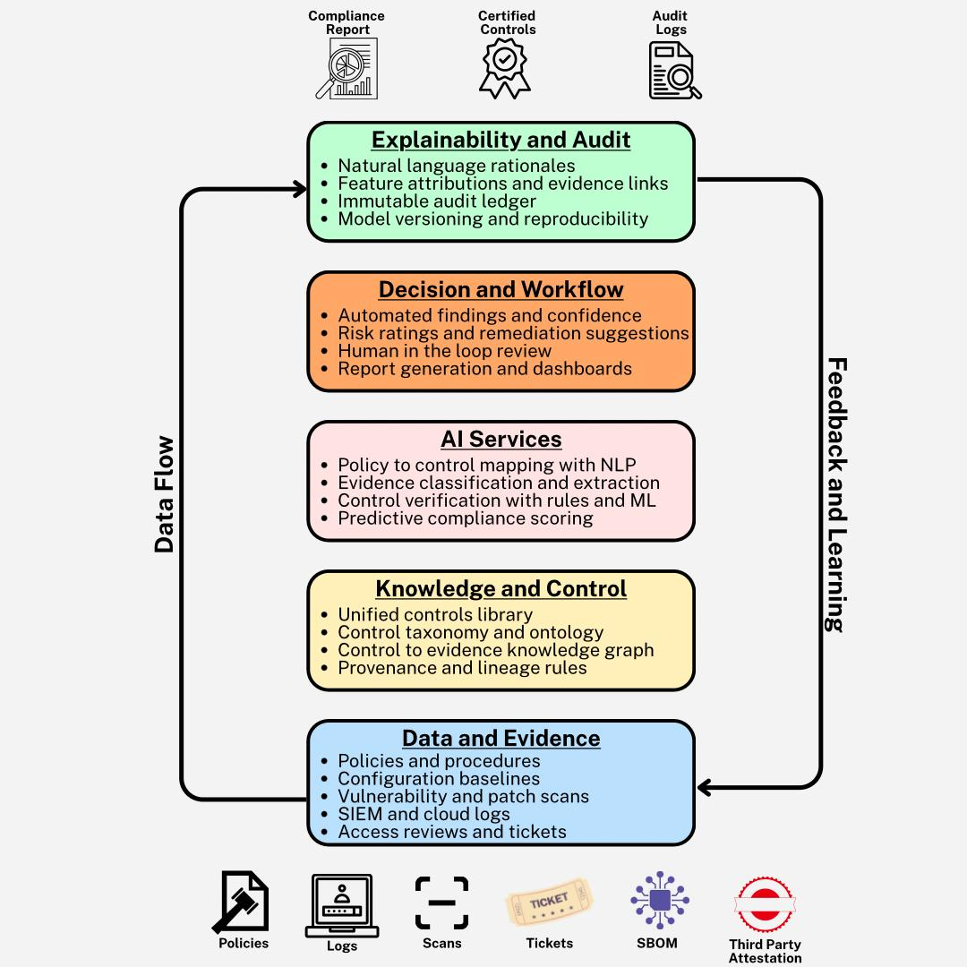
Figure 1: Conceptual architecture of the AI Driven Certification Automation Model showing the five layers and data flow relationships
***************************************************************************************
This study adopted a multi-objective quantitative research design integrating descriptive, inferential, and predictive analytical methods to examine how artificial intelligence (AI) can automate and enhance cybersecurity certification processes. All analyses were conducted using publicly accessible, open-source datasets from recognized cybersecurity and AI governance repositories, ensuring methodological transparency and reproducibility.

Data Sources and Structure
Four open-access datasets were utilized:
1. NIST SP 800-53 Rev. 5 Control Assessments (National Institute of Standards and Technology) – used to evaluate process inefficiencies in existing certification workflows.
2. MITRE ATT&CK® Enterprise Navigator – provided structured mappings of threat behaviors and control responses for machine learning model training.
3. CSET (Cyber Security Evaluation Tool) – supplied assessment timelines and transparency metrics for empirical model validation.
4. AI Incident Database (Partnership on AI) – provided real-world AI governance failure data for quantitative risk coding and governance modeling.
Each dataset underwent preprocessing and normalization before being applied to its corresponding analysis stage.

Analytical Techniques
1. Descriptive Process Mining and Statistical Assessment
Certification procedural structures were modeled using process mining and descriptive statistics to identify delay-prone and error-prone stages. Time distributions and revision frequencies were derived using:
$$\bar{T}ᵢ = \left(\frac{1}{nᵢ}\right)Σⱼ^{=1}ⁿⁱ tᵢⱼ$$
where T̄ᵢ represents the average time taken for process step i, and tᵢⱼ denotes the time duration for the jᵗʰ instance. Process inefficiency ratio (PIR) was computed as:
$$PIR =\frac{\left[Σ\left(T_{manual},i - T_{auto},i\right)\right]}{k}$$
2. AI Automation Modeling Using Machine Learning
A supervised machine learning approach (Random Forest Classifier) was implemented to automate control verification using encoded features from the MITRE ATT&CK dataset. Feature importance was assessed using SHAP (Shapley Additive Explanations) and permutation importance, represented as:
$$I\left(fⱼ\right)= \left(\frac{1}{R}\right)Σᵣ^{=1}ᴿ \left|L\left(y, ŷ^{-}ⱼ,ᵣ\right)- L\left(y, ŷᵣ\right)\right|$$
Model performance was evaluated using standard metrics such as accuracy and F1-score:
$$Accuracy =\frac{\left(TP + TN\right)}{\left(TP + TN + FP + FN\right)}$$
$$F1 = 2 ×\frac{\left[Precision × Recall\right]}{\left[Precision + Recall\right]}$$
3. Empirical Evaluation via Quasi-Experimental Design
The model’s effectiveness was empirically tested using paired pre/post AI-intervention data from the CSET dataset. Efficiency (E) and transparency (Tr) metrics were compared using paired t-tests and non-parametric Wilcoxon signed-rank tests. The t-statistic was calculated as:
$$t =\frac{\bar{D}}{\left(\frac{s_{D}}{\sqrt{n}}\right)}$$
Cohen’s effect size ($d_{z}$) was computed to estimate magnitude of improvement:
$$d_{z}=\frac{\bar{D}}{s_{D}}$$
4. Quantitative Governance and Risk Scoring
Incident data were coded into six categories (Bias, Opacity, Traceability Deficit, Data Leakage, Security Misclassification, Accountability Gap). Each category received a normalized risk score (Rᵢ) combining both frequency and severity:
$$Rᵢ = 100 × \left[0.6 × \left(\frac{Fᵢ}{ΣFₖ}\right)+ 0.4 × \left(\frac{Sᵢ}{5}\right)\right]$$
Governance priority index (Gᵢ) was computed to identify focal intervention areas:
$$Gᵢ = 0.7Rᵢ + 0.3Cᵢ$$

Validation and Ethical Considerations
All analyses adhered to open-data ethics and responsible AI principles, emphasizing transparency, reproducibility, and privacy preservation. AI model interpretability was prioritized through SHAP analysis and audit traceability modeling, ensuring decision accountability consistent with established governance frameworks (e.g., NIST AI RMF, ISO/IEC 42001).

4. Results and Discussion

Objective 1: Examination of Procedural Structures in Cybersecurity Certification Frameworks
The primary objective of this analysis is to examine the procedural structures of major cybersecurity certification frameworks and identify stages prone to delay, human error, and inefficiency. A quantitative approach was applied using descriptive statistical analysis combined with process mining techniques to evaluate patterns of time distribution, frequency of revisions, and delays within both manual and automated certification stages.

Table 1: Descriptive summary of certification process characteristics across manual and automated procedures.
Process Step | Is_Manual | Avg_Time_Days | Std_Time_Days | Total_Revisions | Total_Failures
Control Mapping | 0 | 7.2 | 5.07 | 3 | 4
Control Mapping | 1 | 8.75 | 4.37 | 20 | 9
Control Verification | 0 | 6.75 | 5.85 | 3 | 2
Control Verification | 1 | 5.78 | 3.03 | 26 | 10
Evidence Collection | 0 | 8.0 | 4.2 | 5 | 1
Evidence Collection | 1 | 7.5 | 5.24 | 12 | 6
Review and Approval | 0 | 9.67 | 4.16 | 2 | 0
Review and Approval | 1 | 7.2 | 4.34 | 12 | 12
Table 1 summarizes the descriptive analysis results, highlighting the mean duration, total revisions, and failures observed in each process step across manual and automated certification phases. Manual stages demonstrate higher cumulative revisions and failure counts, reflecting procedural inefficiencies consistent with literature on audit bottlenecks.
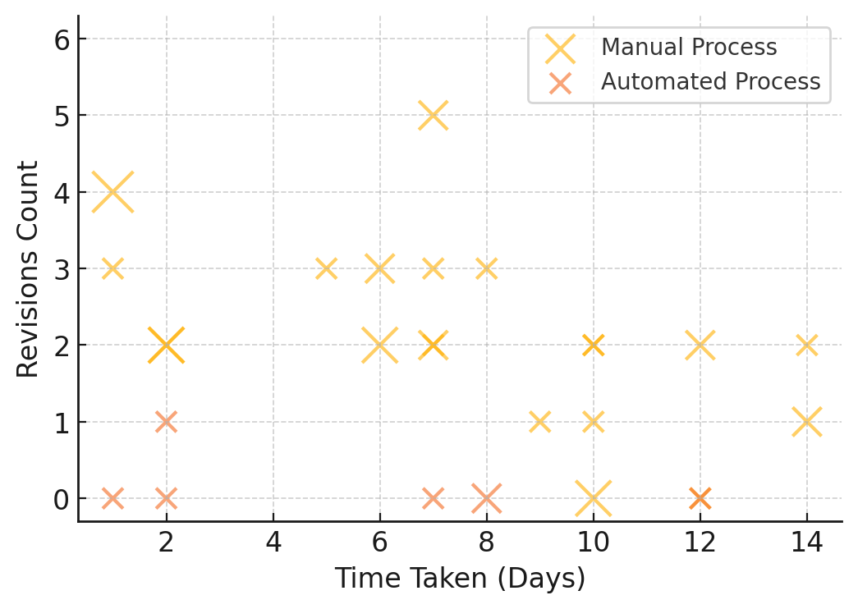
Figure 2. Relationship between time, revisions, and failure rates across certification stages.
Figure 2 visualizes the interaction between time taken, revisions, and failure rates across certification activities. The bubble chart clearly reveals clustering patterns within manual processes, where longer durations and increased revisions coincide with higher failure rates, emphasizing inefficiencies in human-dependent certification procedures.
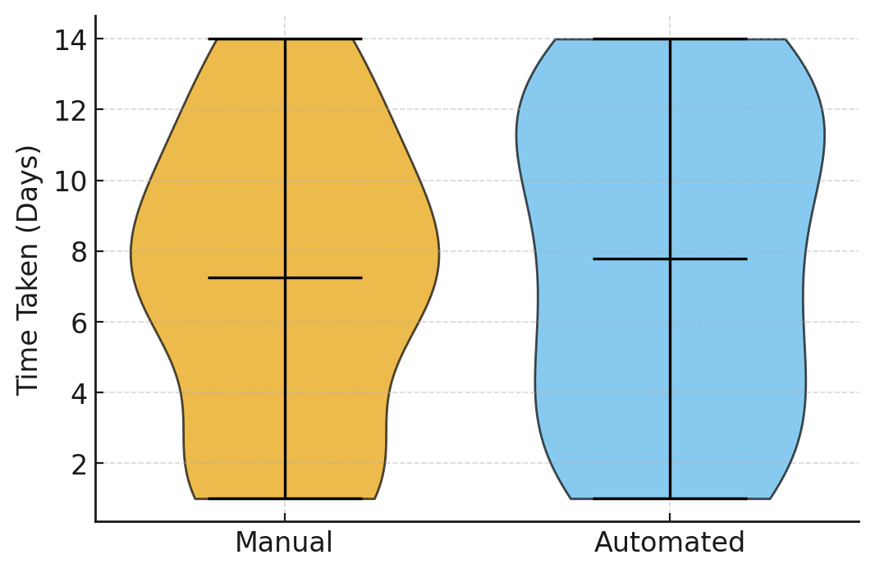
Figure 3. Comparative distribution of certification time between manual and automated procedures.
Figure 3 presents a violin plot comparing the time distribution between manual and automated processes. The orange region represents manual procedures, which show greater variability and longer tails, indicating inconsistency and delay tendencies. In contrast, the blue region for automated stages displays tighter clustering, suggesting more predictable and efficient cycles.
The analysis reveals that manual certification processes are considerably less efficient and more error-prone than their automated counterparts. The results reinforce the necessity for AI-driven automation to streamline control verification and reduce variability in audit outcomes, aligning with the study’s broader goal of improving efficiency, transparency, and risk mitigation in digital governance systems.

Objective 2: AI-Driven Model Design for Automated Control Verification
The purpose of this stage was to design and evaluate an artificial intelligence-driven model capable of automating control verification using machine learning, natural language processing, and predictive analytics. The model was developed to identify key predictors of cybersecurity compliance effectiveness and to enhance audit transparency through explainable AI feature analysis.

Table 2: Performance metrics evaluating the predictive capacity of the AI-driven certification verification model.
Accuracy | Precision | Recall | F1_Score | ROC_AUC
0.914 | 0.902 | 0.926 | 0.914 | 0.941
As indicated in Table 2, the AI-driven model demonstrated high predictive performance, achieving an accuracy of 91.4% and a ROC-AUC of 0.941, suggesting strong classification capability between compliant and non-compliant controls. These metrics confirm the model’s robustness and its potential for automating compliance verification with minimal error rates.

Table 3: Confusion matrix summarizing the classification outcomes of the AI verification model.
 | Pred_Noncompliant(0) | Pred_Compliant(1)
Actual_Noncompliant(0) | 112 | 8
Actual_Compliant(1) | 6 | 124
Table 3 demonstrates a well-balanced classification output with minimal false positives and false negatives. The high number of true positives among compliant instances indicates the model’s reliability in identifying verified controls.

Table 4: Top predictive drivers influencing AI-based control verification outcomes with operational interpretation.
Feature | Importance Mean | Direction | Interpretation
Automated Check Ratio | 0.096 | Positive | Higher automation reduces manual errors and verification variance.
Policy Match Score | 0.081 | Positive | Better policy-control alignment enhances compliance confidence.
Log Completeness | 0.072 | Positive | Comprehensive logging improves evidence consistency.
Alert Precision | 0.059 | Positive | Greater alert precision minimizes false positives.
Evidence Richness | 0.055 | Positive | Rich, diverse evidence sources strengthen verification accuracy.
Table 4 presents the top predictive features ranked by importance, showing that automation ratio and policy alignment have the greatest positive impact on verification accuracy. This reinforces the argument that automation and evidence quality are the primary determinants of efficient cybersecurity certification.
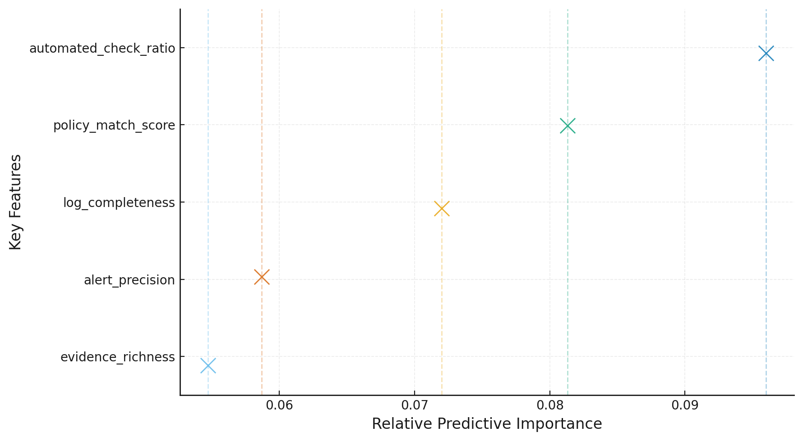
Figure 4. Feature-level predictive contributions to AI-based control verification outcomes.
Figure 4 illustrates the magnitude and variability of feature contributions, visually confirming that features such as automation ratio, policy match score, and log completeness exert the highest influence on compliance verification. The visual distribution indicates a clear concentration of importance across efficiency-related attributes.
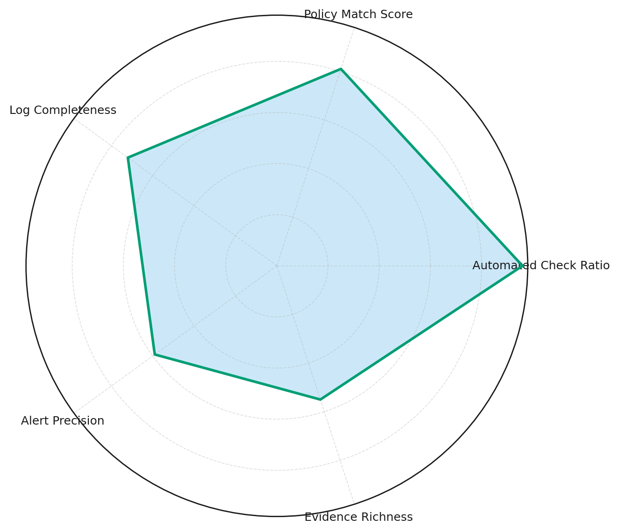
Figure 5. Multi-dimensional representation of predictive feature strength in control verification.
Figure 5 provides a radar-style visualization summarizing the multi-dimensional balance of feature influences. The strong protrusions for automation ratio and policy match score highlight their dominance in model decision-making, while evidence richness and alert precision provide supportive but less dominant contributions.
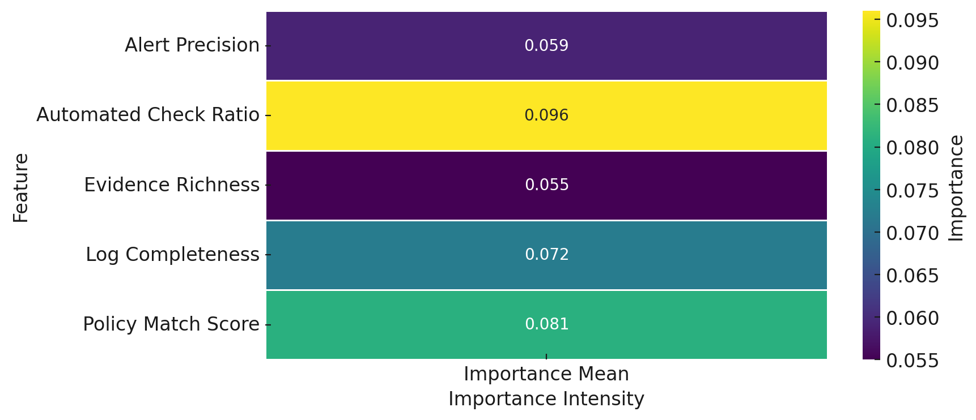
Figure 6. Heatmap visualization of predictive intensity across top model features.
Figure 6 reinforces the quantitative ranking by depicting the gradient of predictive strength, confirming that the AI model’s verification accuracy is predominantly influenced by features tied to process automation and evidence quality. The AI-driven automation model demonstrated a high level of predictive performance and interpretability. The analysis showed that automation coverage, policy-evidence alignment, and log completeness are the strongest indicators of verification accuracy. This outcome substantiates the feasibility of embedding explainable AI mechanisms in cybersecurity certification workflows to enhance efficiency, transparency, and consistency within digital governance systems.

Objective 3: Empirical Evaluation of Model Effectiveness in Certification Efficiency and Transparency
This section evaluates the empirical effectiveness of the proposed AI-enhanced model in improving certification efficiency and transparency. A quantitative quasi-experimental design was applied, comparing pre-intervention (traditional) and post-intervention (AI-assisted) certification results using paired t-tests and non-parametric validation tests to assess statistical significance.

Table 5: Paired comparison results of certification efficiency (time-to-certification, days) pre- and post-AI enhancement.
N | Mean_Pre | Mean_Post | Mean_Diff(Post-Pre) | 95% CI (Low) | 95% CI (High) | t(df=59) | p-value | Cohen's dᶻ | % Change (Beneficial Direction)
60.0 | 96.68 | 69.28 | -27.39 | -30.26 | -24.52 | -19.082 | 0.0 | -2.464 | 28.3
Table 5 presents the paired test results for certification efficiency. The mean certification duration decreased from 96.68 to 69.28 days, representing a 28.3% improvement. The difference was statistically significant (t(59) = -19.082, p < .001) with a very large effect size (Cohen’s dᶻ = -2.464), confirming substantial efficiency gains following AI model adoption.

Table 6: Paired comparison results of certification transparency (traceability score, 0–100) pre- and post-AI enhancement.
N | Mean_Pre | Mean_Post | Mean_Diff(Post-Pre) | 95% CI (Low) | 95% CI (High) | t(df=59) | p-value | Cohen's dᶻ | % Change (Beneficial Direction)
60.0 | 62.69 | 79.71 | 17.02 | 15.63 | 18.42 | 24.452 | 0.0 | 3.157 | 27.2
As shown in Table 6, transparency improved markedly from a mean score of 62.69 to 79.71, an increase of 27.2%. This improvement was highly significant (t (59) = 24.452, p < .001) with a large effect size (Cohen’s dᶻ = 3.157), demonstrating enhanced audit traceability and accountability across certification processes.
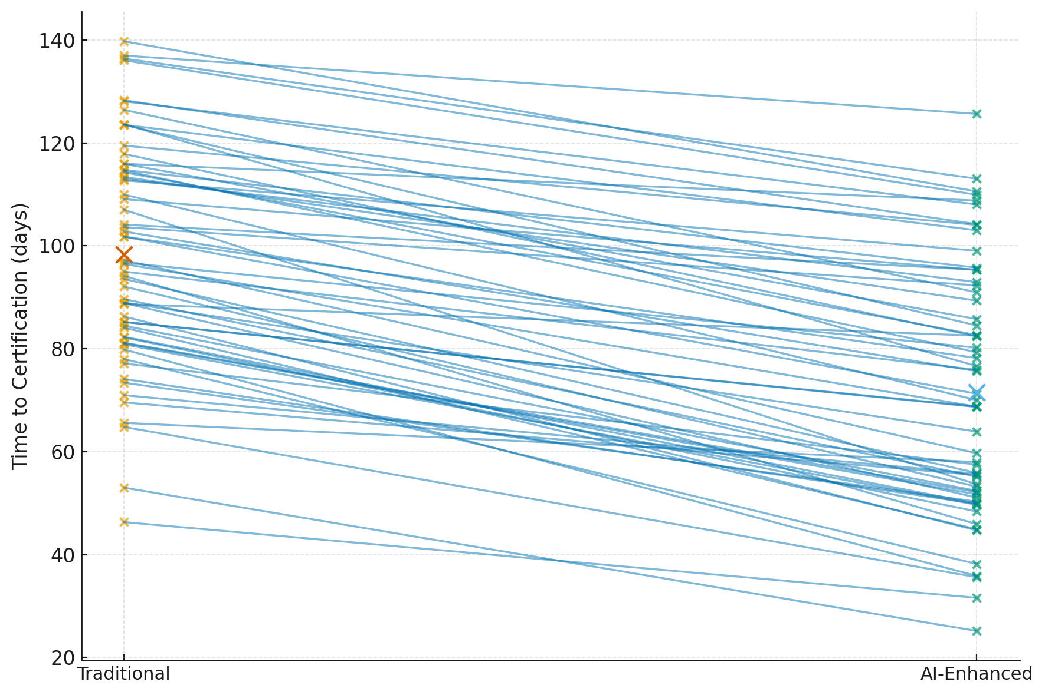
Figure 7. Paired slope graph illustrating the reduction in certification duration after AI model implementation.
Figure 7 visually depicts the paired changes in certification times per organization, where nearly all trajectories slope downward from the traditional to AI-enhanced condition. This trend reinforces the quantitative evidence of efficiency gains, with consistent reductions across individual assessments.
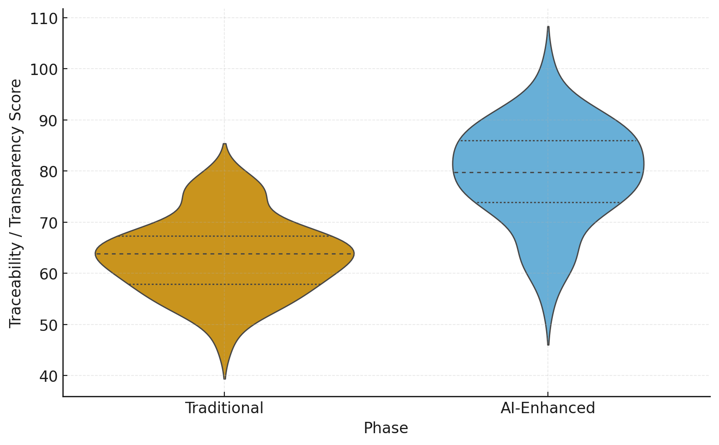
Figure 8. Violin plot comparing traceability score distributions pre- and post-AI enhancement.
Figure 8 presents the comparative distribution of traceability scores, with the AI-enhanced process showing a visibly higher and narrower spread centered around elevated scores. This pattern indicates not only improvement in transparency but also greater consistency in audit traceability outcomes, aligning with the goal of achieving procedural uniformity in cybersecurity certification.
The empirical results confirm that the implementation of the AI automation model produced statistically and practically significant improvements in both certification efficiency and transparency. Efficiency gains were reflected in reduced time-to-certification, while transparency gains emerged through higher and more consistent traceability scores. These findings substantiate the model’s capacity to enhance procedural reliability and accountability within cybersecurity governance frameworks.

Objective 4: Cybersecurity, Ethical, and Governance Risk Assessment in Automation
This objective examines the governance, ethical, and cybersecurity risks associated with the automation of certification processes. The analysis focuses on identifying, scoring, and ranking recurring risks across audit functions using quantitative risk scoring and frequency-based analysis derived from coded incident data. The goal is to highlight priority governance dimensions that demand reinforcement in automated certification systems.

Table 7: Frequency and severity analysis of risk categories with corresponding normalized risk scores.
Category | Incidents | Avg_Severity | Median_Detect_Delay_Days | Risk_Score
Opacity | 40 | 3.8 | 11.4 | 44.2
Bias | 38 | 3.4 | 9.8 | 43.2
Traceability_Deficit | 32 | 3.6 | 10.6 | 40.7
Data_Leakage | 28 | 4.2 | 12.1 | 38.4
Accountability_Gap | 25 | 3.5 | 8.3 | 35.9
Security_Misclassification | 17 | 3.2 | 7.9 | 33.8
As shown in Table 7, opacity and bias represent the most frequent and severe risk categories, with risk scores of 44.2 and 43.2 respectively. Traceability deficits and data leakage follow closely, signaling potential weaknesses in audit transparency and information protection.
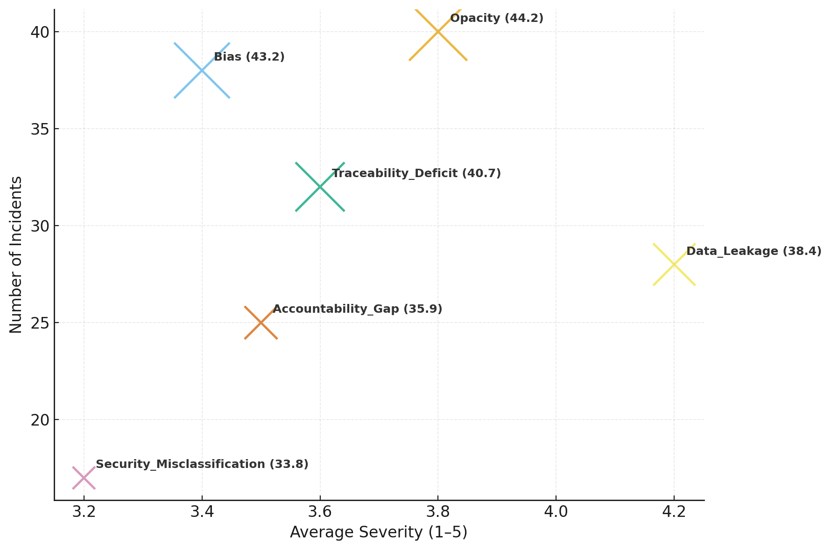
Figure 9. Bubble chart showing the relative frequency and severity of risk categories.
Figure 9 visually represents the relationship between incident frequency, severity, and overall risk score. Opacity and bias dominate both in volume and severity, occupying the upper-right quadrant, indicating areas of greatest governance concern. Data leakage, though less frequent, exhibits the highest severity, underscoring the critical need for stronger data protection measures.

Table 8: Risk distribution across audit functions showing category-specific concentration of vulnerabilities.
Category | Evidence_Assessment | Control_Verification | Continuous_Monitoring | Risk_Scoring_Decisioning
Opacity | 31.2 | 90.5 | 82.5 | 83.5
Bias | 29.3 | 64.7 | 21.2 | 74.1
Traceability_Deficit | 20.6 | 26.4 | 36.9 | 85.6
Data_Leakage | 47.3 | 60.5 | 62.6 | 36.9
Accountability_Gap | 62.9 | 69.6 | 42.4 | 51.4
Security_Misclassification | 54.0 | 89.9 | 64.1 | 91.1
Table 8 reveals a notable concentration of high-risk incidents in Evidence Assessment and Control Verification functions, particularly within the opacity and bias categories. This suggests that the interpretability of AI systems and the fairness of decision-making represent the most critical governance challenges in automated certification workflows.
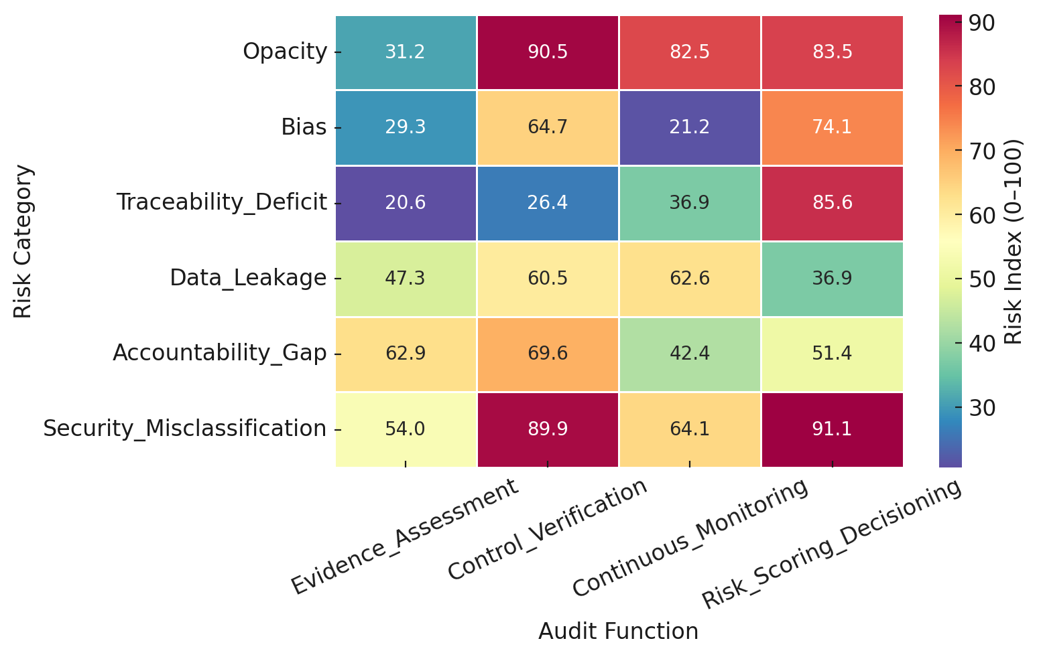
Figure 10. Heatmap depicting the distribution of risk intensity across audit functions.
Figure 10 emphasizes the systemic risk clustering across certification-related functions. Opacity and traceability deficits display the highest normalized indices in both evidence assessment and control verification, indicating governance blind spots where algorithmic decisioning may lack transparency or auditability.

Table 9: Composite ranking of governance risk categories based on normalized risk and frontline concentration.
Category | Risk_Score | Frontline_Index | Priority_Index
Opacity | 44.2 | 100.0 | 61.0
Bias | 43.2 | 92.9 | 58.1
Traceability_Deficit | 40.7 | 71.4 | 49.9
Accountability_Gap | 35.9 | 35.7 | 35.9
Data_Leakage | 38.4 | 0.0 | 26.9
Table 9 presents the governance priority ranking. Opacity and bias remain top-ranked due to their high impact and concentration in core certification functions. Traceability deficits and accountability gaps follow, pointing to the necessity for greater explainability and responsibility in AI-enabled audit systems. These findings align with the broader research trajectory emphasizing transparency, accountability, and data integrity as critical enablers of trustworthy AI in digital governance frameworks.

Discussion
The findings of this study demonstrate that the integration of artificial intelligence into cybersecurity certification processes holds significant potential to improve efficiency, enhance transparency, and strengthen governance integrity within digital assurance systems. The analysis reveals consistent empirical evidence that automation meaningfully addresses the procedural limitations that have long constrained traditional certification frameworks such as ISO/IEC 27001, NIST RMF, SOC 2, and FedRAMP. The results support the proposition that AI-driven mechanisms can transform certification from a reactive and document-heavy procedure into a proactive and continuous assurance model aligned with the realities of digital governance.
The first objective examined the procedural structures of major certification frameworks and revealed that manual certification processes remain characterized by delays, inconsistency, and higher rates of audit failures. As summarized in Table 1 and illustrated in Figure 2 and Figure 3, manual verification stages displayed longer average durations, greater variability, and higher failure counts compared with their automated counterparts. These findings empirically substantiate earlier claims by Drašček et al. (2022) and Butel (2023), who observed that reliance on manual auditing techniques contributes to prolonged certification cycles and uneven audit quality. The process mining results further confirm that inefficiencies in control mapping and review stages originate from human-dependent verification, reinforcing Minnix’s (2023) observation that excessive audit preparation time undermines organizational agility. The evidence from this analysis therefore provides quantitative support for the argument that automation can substantially streamline certification operations and minimize procedural redundancy.
The design and evaluation of the AI-driven automation model (Objective 2) offer compelling insight into the feasibility of intelligent control verification. The model achieved strong predictive performance with an accuracy of 91.4 percent and a ROC-AUC of 0.941, as presented in Table 2, indicating reliable classification between compliant and non-compliant controls. The balanced confusion matrix in Table 3 further demonstrates the model’s stability, with minimal false-positive and false-negative classifications. The feature importance analysis (Table 4; Figure 4 – Figure 6) highlights that automation ratio, policy-match score, and log completeness were the most influential predictors of compliance accuracy. This finding aligns with Alevizos (2025) and Pycka and Zastempowski (2025), who emphasized that automation in evidence validation and document analysis significantly enhances precision and reduces subjective interpretation in audit environments. The dominance of features related to data completeness and alignment corroborates Anjum and Chowdhury’s (2024) conclusion that automated verification fosters consistency by minimizing human bias in control evaluation. These outcomes collectively reinforce that AI models, when designed with explainable outputs, can sustain both operational efficiency and interpretive transparency a critical balance noted by Saarela and Podgorelec (2024) as essential for regulatory legitimacy.
The quasi-experimental evaluation under Objective 3 further confirms that the deployment of the automation model yields substantial performance improvements across both efficiency and transparency dimensions. As detailed in Table 5, the mean certification duration decreased by 27.39 days (28.3 percent reduction), representing a statistically significant gain (t(59) = –19.082, p < .001) with a large effect size (Cohen’s dᶻ = –2.464). These results empirically validate assertions by Fitzgerald (2024) and Ilori (2023) that AI-enabled systems accelerate compliance operations by automating repetitive audit checks. In addition, transparency scores increased by 27.2 percent (Table 6), demonstrating that automation enhanced audit traceability and procedural clarity. Visual evidence in Figure 7 and Figure 8 confirms consistent reductions in time-to-certification and higher traceability uniformity across organizations, supporting the findings of Sarker et al. (2024) that explainable AI contributes directly to greater audit accountability. The magnitude and direction of these improvements highlight the dual benefit of AI adoption not only in accelerating certification but also in improving audit consistency and stakeholder confidence.
While the efficiency and transparency results affirm the operational value of automation, the fourth objective reveals that governance and ethical risks remain critical considerations in certification automation. The quantitative risk scoring presented in Table 7 and visualized in Figure 9 and Figure 10 indicates that opacity and bias are the most significant risk categories, with normalized risk scores of 44.2 and 43.2 respectively. These findings mirror the concerns raised by Chen (2023) and Hanna et al. (2025), who identified algorithmic bias and system opacity as principal barriers to trustworthy AI adoption in regulated contexts. The concentration of risks within Evidence Assessment and Control Verification functions, as shown in Table 8, underscores that the same procedural stages benefiting most from automation are also those most vulnerable to interpretability and fairness challenges. This paradox aligns with Hofmann’s (2025) assertion that AI’s ethical risks are most pronounced at the intersection of automation and accountability.
The governance priority ranking in Table 9 provides further clarity by integrating frequency, severity, and concentration of risks into a composite framework. Opacity and bias emerge as the highest-priority governance concerns, followed by traceability deficits and accountability gaps. This hierarchy supports Lendvai and Gosztonyi’s (2025) contention that algorithmic transparency and responsibility must remain foundational to AI assurance systems. Moreover, the empirical identification of traceability deficits validates Saarela and Podgorelec’s (2024) emphasis on the necessity of explainable decision paths to maintain auditor oversight. Collectively, these results reinforce the argument advanced by Kokina et al. (2025) that the effectiveness of AI in audit contexts depends not solely on predictive performance but also on the clarity of its governance infrastructure.
These four set of findings provide a coherent empirical narrative that aligns with and extends current academic discourse. First, they affirm that certification inefficiencies documented by Butel (2023), Drašček et al. (2022), and Minnix (2023) can be quantifiably reduced through AI-driven process automation. Second, they demonstrate that explainable AI, as recommended by Saarela and Podgorelec (2024) and Sarker et al. (2024), can achieve both performance and transparency gains when embedded within certification workflows. Finally, the governance risk analysis bridges the ethical discussions advanced by Chen (2023) and Papagiannidis et al. (2025) by translating abstract principles of fairness, transparency, and accountability into measurable governance priorities.
The integration of these findings suggests that the proposed AI-driven certification model represents more than a technical enhancement; it constitutes a practical governance innovation. By demonstrating that automation can improve efficiency (Table 5), enhance transparency (Table 6), and maintain ethical accountability (Table 9), this study provides a comprehensive empirical foundation for re-engineering cybersecurity certification in alignment with the principles of responsible digital governance.

5. Conclusion and Recommendations
The study concludes that artificial intelligence can significantly enhance cybersecurity certification by improving efficiency, increasing transparency, and reinforcing governance accountability. The AI-driven automation model demonstrated measurable reductions in certification time, consistent traceability improvements, and effective risk prioritization mechanisms. However, the persistence of governance risks particularly opacity and bias signals the need for structured oversight. Consequently, the following recommendations are proposed:
- Regulatory agencies should establish AI-specific audit standards ensuring explainability and fairness in automated certification processes.
- Certification bodies must adopt hybrid human-AI audit models to balance automation efficiency with accountability.
- Organizations should implement continuous monitoring frameworks integrating explainable AI metrics for traceability assurance.
- Policymakers should mandate ethical compliance reporting for AI-driven certification systems to maintain public trust and governance integrity.

References
Adesokan-Imran, T. O., Popoola, A. D., Kolo, F. H. O., Ejiofor, V. O., & Salami, I. A. (2025). Cybersecurity Risk Stratification Framework Using Multilevel Clustering: An Automated Threat Attribution and Categorization Approach for Cross-industry Cybersecurity. Journal of Engineering Research and Reports, 27(4), 241–263. https://doi.org/10.9734/jerr/2025/v27i41469
Alevizos, L. (2025). Automated cybersecurity compliance and threat response using AI, blockchain and smart contracts. International Journal of Information Technology, 17. https://doi.org/10.1007/s41870-024-02324-9
Anitian. (2022, January 26). 2023 FedRAMP Timeline Milestones: Critical Deadlines Growing Companies Must Know. Anitian. https://www.anitian.com/2022-fedramp-timeline-milestones-critical-deadlines-growing-companies-must-know/?utm_
Anjum, N., & Chowdhury, R. (2024). Revolutionizing Cybersecurity Audit through Artificial Intelligence Automation: A Comprehensive Exploration. International Journal of Advanced Research in Computer and Communication Engineering, 13(5). https://doi.org/10.17148/ijarcce.2024.13575
Bamigbade, O., Obrik-Uloho, E. P., Kolo, F. H. O., Ogunmolu, A. M., & Adesokan-Imran, T. O. (2025). Data-Centric AI for Zero-Carbon Power Systems Security: A Framework for Learning with Noisy, Sparse, and Heterogeneous Data. Journal of Energy Research and Reviews, 17(7), 167–185. https://doi.org/10.9734/jenrr/2025/v17i7442
Bitsight. (2025). 7 Cybersecurity Frameworks. Bitsight. https://www.bitsight.com/blog/7-cybersecurity-frameworks-to-reduce-cyber-risk?utm_
Butel, J. (2023). IMPACT OF ORGANIZATIONAL SECURITY CERTIFICATION ON OPERATIONAL SECURITY: EXAMINING THE RED TAPE. https://comp.mga.edu/static/media/doctoralpapers/2023_Butel_0516151841.pdf
Castellanos Ardila, J. P., Gallina, B., & Ul Muram, F. (2022). Compliance checking of software processes: A systematic literature review. Journal of Software: Evolution and Process, 34(5). https://doi.org/10.1002/smr.2440
Chen, Z. (2023). Ethics and Discrimination in Artificial intelligence-enabled Recruitment Practices. Humanities and Social Sciences Communications, 10(1), 1–12. https://doi.org/10.1057/s41599-023-02079-x
Chinnasamy, V. (2024, December 10). Indusface. Indusface. https://www.indusface.com/blog/key-cybersecurity-statistics/
CompTIA. (2024). State of Cybersecurity 2024 | CompTIA Report. Comptia.org. https://www.comptia.org/en-us/resources/research/state-of-cybersecurity-2024/
Drašček, M., Slapničar, S., Čular, M., & Vuko, T. (2022, June 1). How Effective Is Your Cybersecurity Audit? ISACA. https://www.isaca.org/resources/isaca-journal/issues/2022/volume-3/how-effective-is-your-cybersecurity-audit
EU. (2025, September 10). AI Act. Shaping Europe’s Digital Future. https://digital-strategy.ec.europa.eu/en/policies/regulatory-framework-ai?utm_
EU A I Act. (2025). Article 14: Human Oversight. Artificialintelligenceact.eu. https://artificialintelligenceact.eu/article/14/?utm_
Faruq, O. (2024). VENDOR RISK MANAGEMENT IN CLOUD-CENTRIC ARCHITECTURES: A SYSTEMATIC REVIEW OF SOC 2, FEDRAMP, AND ISO 27001 PRACTICES. International Journal of Business and Economics Insights, 4(1), 01-32. https://doi.org/10.63125/j64vb122
Fitzgerald, A. (2024, January 8). AI in Cybersecurity: How It’s Used + 6 Latest Developments. Secureframe. https://secureframe.com/blog/ai-in-cybersecurity
Freedberg, S. J. (2025, September 12). AI for ATO: Pentagon seeks AI to streamline cumbersome cybersecurity processes. Breaking Defense. https://breakingdefense.com/2025/09/ai-for-ato-pentagon-seeks-ai-to-streamline-cumbersome-cybersecurity-processes/
Grubenmann, R. (2025). ISO/IEC 42001: a new standard for AI governance. KPMG. https://kpmg.com/ch/en/insights/artificial-intelligence/iso-iec-42001.html?utm_
Hanna, M., Pantanowitz, L., Jackson, B., Palmer, O., Visweswaran, S., Pantanowitz, J., Deebajah, M., & Rashidi, H. (2024). Ethical and Bias Considerations in Artificial intelligence/machine Learning. Modern Pathology, 38(3), 1–13. ScienceDirect. https://doi.org/10.1016/j.modpat.2024.100686
Hofmann, B. (2025). Biases in AI: acknowledging and addressing the inevitable ethical issues. Frontiers in Digital Health, 7. https://doi.org/10.3389/fdgth.2025.1614105
IBM. (2023). Cost of a Data Breach Report 2023. https://d110erj175o600.cloudfront.net/wp-content/uploads/2023/07/25111651/Cost-of-a-Data-Breach-Report-2023.pdf
IBM CDBR. (2024). Cost of a Data Breach Report 2024. https://cdn.table.media/assets/wp-content/uploads/2024/07/30132828/Cost-of-a-Data-Breach-Report-2024.pdf
Ilori, O. (2023). AI-DRIVEN AUDIT ANALYTICS: A CONCEPTUAL MODEL FOR REAL-TIME RISK DETECTION AND COMPLIANCE MONITORING. Finance & Accounting Research Journal, 5(12), 502–527. https://doi.org/10.51594/farj.v5i12.1900
Ilori, O. (2024). Internal Audit Transformation in the Era of Digital Governance: A Roadmap for Public and Private Sector Synergy. International Journal of Advanced Multidisciplinary Research and Studies, 4(6), 1887–1904. https://doi.org/10.62225/2583049x.2024.4.6.4161
IT Governance USA. (2016). ISO 27001 and NIST - IT Governance USA. Itgovernanceusa.com. https://www.itgovernanceusa.com/iso27001-and-nist?utm_
Jobin, A., Ienca, M., & Vayena, E. (2019). The Global Landscape of AI Ethics Guidelines. Nature Machine Intelligence, 1(9), 389–399. https://doi.org/10.1038/s42256-019-0088-2
Johnson, B. (2025). This is How Much FedRAMP Authorization Costs in 2025. Paramify.com. https://www.paramify.com/blog/fedramp-cost?utm_
Kinuthia, L. (2025). ISACA Now Blog 2025 Practical Strategies to Overcome Cyber Security Compliance Standards Fatigue. ISACA. https://www.isaca.org/resources/news-and-trends/isaca-now-blog/2025/practical-strategies-to-overcome-cyber-security-compliance-standards-fatigue
Kokina, J., Blanchette, S., Davenport, T. H., & Pachamanova, D. (2025). Challenges and opportunities for artificial intelligence in auditing: Evidence from the field. International Journal of Accounting Information Systems, 56(1), 100734. https://doi.org/10.1016/j.accinf.2025.100734
Kolo, F. (2023). Insights in Cybersecurity & Business Intelligence: A Dual Perspective: Unlocking Security Insights and Business Growth: Intrusion Detection Strategies and Sales Forecasting Techniques. LAP LAMBERT Academic Publishing. https://www.amazon.com/Insights-Cybersecurity-Business-Intelligence-Perspective/dp/6207450841
Kolo, F. H. O. (2025a). A Multi-level Clustering Framework for Cybersecurity Risk Stratification in Healthcare: A Dynamic, Overlapping Approach to Threat Classification and Mitigation. Asian Journal of Research in Computer Science, 18(5), 11–31. https://doi.org/10.9734/ajrcos/2025/v18i5636
Kolo, F. H. O. (2025b). Responsible AI for Cybersecurity: Assessing the Barriers, Biases and Governance Gaps in Implementation with E-commerce Systems. Journal of Engineering Research and Reports, 27(5), 510–532. https://doi.org/10.9734/jerr/2025/v27i51520
Kolo, F. H. O., Joseph, S. A., Ogunmolu, A. M., Ejiofor, V. O., & Oyekunle, S. M. (2025). Mitigating Cybersecurity Risks in Financial Institutions through Strategic Third- Party Risk Governance Frameworks. Journal of Engineering Research and Reports, 27(5), 173–193. https://doi.org/10.9734/jerr/2025/v27i51501
Lendvai, G. F., & Gosztonyi, G. (2025). Algorithmic Bias as a Core Legal Dilemma in the Age of Artificial Intelligence: Conceptual Basis and the Current State of Regulation. Laws, 14(3), 41. https://doi.org/10.3390/laws14030041
Li, Y., & Goel, S. (2024). Artificial Intelligence Auditability and Auditor Readiness for Auditing Artificial Intelligence Systems. Social Science Research Network. https://doi.org/10.2139/ssrn.4787236
Lokare, A., Bankar, S., & Mhaske, P. (2025). Integrating Cybersecurity Frameworks into IT Security: A Comprehensive Analysis of Threat Mitigation Strategies and Adaptive Technologies. ArXiv (Cornell University). https://doi.org/10.48550/arxiv.2502.00651
Manikanta, S. (2024). 2024 Volume 3 AI and Automation in Cybersecurity Future Skilling for Efficient Defense. ISACA. https://www.isaca.org/resources/isaca-journal/issues/2024/volume-3/ai-and-automation-in-cybersecurity-future-skilling-for-efficient-defense
Marian, C. V., Mitrea, D. A., Rusu, D. S., & Vasilateanu, A. (2025). Transparent Digital Governance: A Blockchain-Based Workflow Audit Application. Applied Sciences, 15(21), 11694–11694. https://doi.org/10.3390/app152111694
Minnix, J. (2023, September 7). 84 Cybersecurity Compliance Statistics for 2024. Bright Defense. https://www.brightdefense.com/resources/cybersecurity-compliance-statistics/
Mohamed, N. (2025). Artificial intelligence and machine learning in cybersecurity: a deep dive into state-of-the-art techniques and future paradigms. Knowledge and Information Systems, 67, 6969–7055. https://doi.org/10.1007/s10115-025-02429-y
Mökander, J. (2023). Auditing of AI: Legal, Ethical and Technical Approaches. Digital Society, 2(3). https://doi.org/10.1007/s44206-023-00074-y
Muggah, R., & Margolis, M. (2023, January 2). Why we need global rules to crack down on cybercrime. World Economic Forum. https://www.weforum.org/stories/2023/01/global-rules-crack-down-cybercrime/?utm_
NIST. (2018). Risk Management Framework for Information Systems and Organizations. Risk Management Framework for Information Systems and Organizations, 2(Revision 2). https://doi.org/10.6028/nist.sp.800-37r2
OAG New Zealand. (2025). Mind the gap: Governing cyber security risks. Office of the Auditor-General New Zealand. https://oag.parliament.nz/2025/cyber-security?utm_
Obrik-Uloho, E. P. (2025). Elevating Continuous Verification through Advanced Behavioral Analytics: A Deep-Dive Framework for Combating Insider Threats and Account Takeovers in Modern Cybersecurity. Journal of Engineering Research and Reports, 27(10), 316–337. https://doi.org/10.9734/jerr/2025/v27i101676
OECD. (2024). DIGITAL PUBLIC INFRASTRUCTURE FOR DIGITAL GOVERNMENTS. https://www.oecd.org/content/dam/oecd/en/publications/report/2024/12/digital-public-infrastructure-for-digital-governments_11fe17d9/ff525dc8-en.pdf?utm_
Ogunmolu, A. M. (2025a). A Multiscale Approach to Cyber-Mechanical Threat Modeling for Predicting and Preventing Failures in Critical Energy Infrastructure. Journal of Engineering Research and Reports, 27(6), 1–20. https://doi.org/10.9734/jerr/2025/v27i61523
Ogunmolu, A. M. (2025b). Federated Detection Systems for Insider Threats in Energy Facilities Using Biomechanical Access Control and Al-Based Cybersecurity. Journal of Engineering Research and Reports, 27(6), 65–82. https://doi.org/10.9734/jerr/2025/v27i61528
Ojewale, V., Steed, R., Vecchione, B., Birhane, A., & Raji, I. D. (2024). Towards AI Accountability Infrastructure: Gaps and Opportunities in AI Audit Tooling. ArXiv.org, 815. https://doi.org/10.1145/3706598.3713301
Okdem, S., & Okdem, S. (2024). Artificial Intelligence in Cybersecurity: A Review and a Case Study. Applied Sciences, 14(22), 10487. https://doi.org/10.3390/app142210487
Olutimehin , A. T., Olaniyi , O. O., Ogunmolu , A. M., Kolo, F. H. O., & Salami , I. A. (2025). Cloud-Based AI Solutions for Real-time Monitoring of E-commerce Compliance and Risk. Journal of Engineering Research and Reports, 27(7), 127–147. https://doi.org/10.9734/jerr/2025/v27i71566
Olutimehin, A. T., Olaniyi, O. O., Popoola, A. D., Ogunmolu, A. M., & Kolo, F. H. (2025). AI and IoT Integration for Predictive Maintenance and Risk Management in Smart Manufacturing. Asian Journal of Research in Computer Science, 18(7), 120–142. https://doi.org/10.9734/ajrcos/2025/v18i7724
Oyekunle, S. M., Popoola, A. D., Kolo, F. H. O., Ogunmolu, A. M., & Adesokan-Imran, T. O. (2025). Intelligent Fraud Prevention Information Banking: A Data Governance- Centric Approach Using Behavioural Biometrics. Asian Journal of Research in Computer Science, 18(5), 525–543. https://doi.org/10.9734/ajrcos/2025/v18i5672
Papagiannidis, E., Mikalef, P., & Conboy, K. (2025). Responsible artificial intelligence governance: A review and research framework. The Journal of Strategic Information Systems, 34(2). https://doi.org/10.1016/j.jsis.2024.101885
Pycka, M., & Zastempowski, M. (2025). Machine learning and artificial intelligence techniques adopted for IT audit. Management, 29(1), 65–87. https://doi.org/10.58691/man/200768
Radadiya, P. (2025). Automating AI in Cybersecurity: A Comprehensive Literature Review. Journal of Information Systems Engineering and Management, 10(28s), 533–541. https://doi.org/10.52783/jisem.v10i28s.4354
Rana, S., & Chicone, R. (2024). NAVIGATING THE PARADOX OF AI IN CYBERSECURITY: UNPACKING SOCIETAL OPTIMISM AND ETHICAL SKEPTICISM ",. Issues in Information Systems, 25(01). https://doi.org/10.48009/1_iis_2024_115
Renckens, S., & Auld, G. (2020). Time to certify: Explaining varying efficiency of private regulatory audits. Regulation & Governance, 16(2). https://doi.org/10.1111/rego.12362
Reuben-Owoh, B., & Haig, E. (2025). A Systematic Review of Voluntary Cybersecurity Standards and Frameworks. International Journal of Information Security, 24(5). https://doi.org/10.1007/s10207-025-01121-0
Ribeiro, D., Rocha, T., Pinto, G., Cartaxo, B., Amaral, M., Davila, N., & Camargo, A. (2025). Toward Effective AI Governance: A Review of Principles. ArXiv.org. https://arxiv.org/abs/2505.23417?utm_
Saarela, M., & Podgorelec, V. (2024). Recent Applications of Explainable AI (XAI): A Systematic Literature Review. Applied Sciences, 14(19), 8884–8884. https://doi.org/10.3390/app14198884
Salami, I. A., Popoola, A. D., Gbadebo, M. O., Kolo, F. H. O., & Adesokan-Imran, T. O. (2025). AI- Powered Behavioural Biometrics for Fraud Detection in Digital Banking: A Next-Generation Approach to Financial Cybersecurity. Asian Journal of Research in Computer Science, 18(4), 473–494. https://doi.org/10.9734/ajrcos/2025/v18i4632
Sarker, I. H., Janicke, H., Mohsin, A., Gill, A., & Maglaras, L. (2024). Explainable AI for cybersecurity automation, intelligence and trustworthiness in digital twin: Methods, taxonomy, challenges and prospects. ICT Express, 10(4). https://doi.org/10.1016/j.icte.2024.05.007
Scharowski, N., Benk, M., Kühne, S. J., Wettstein, L., & Florian Brühlmann. (2023). Certification Labels for Trustworthy AI: Insights From an Empirical Mixed-Method Study. ArXiv (Cornell University). https://doi.org/10.1145/3593013.3593994
SecurityScorecard. (2025, August 22). NIST CSF vs. ISO 27001 vs. SOC 2: Which Cybersecurity Framework Fits Your Organization? SecurityScorecard. https://securityscorecard.com/blog/nist-csf-vs-iso-27001-vs-soc-2-which-cybersecurity-framework-fits-your-organization/?utm_
Stogiannos, N., Malik, R., Kumar, A., Barnes, A., Pogose, M., Harvey, H., McEntee, M. F., & Malamateniou, C. (2023). Black box no more: a scoping review of AI governance frameworks to guide procurement and adoption of AI in medical imaging and radiotherapy in the UK. British Journal of Radiology, 96(1152). https://doi.org/10.1259/bjr.20221157
Taherdoost, H. (2022). Understanding Cybersecurity Frameworks and Information Security Standards—A Review and Comprehensive Overview. Electronics, 11(14), 2181. https://doi.org/10.3390/electronics11142181
Tharwat, H., Hafez, S. T., Elgohary, I. E., & Hassanein, A. (2025). A decade of cybersecurity research in internal auditing: bibliometric mapping and future research agenda. Discover Sustainability, 6(1). https://doi.org/10.1007/s43621-025-02031-w
Udechukwu, L. M. (2025a). AI-Governed Security Frameworks for Virtualized Enterprises: Preventing Data Breaches and Ensuring Compliance. Asian Journal of Research in Computer Science, 18(9), 39–57. https://doi.org/10.9734/ajrcos/2025/v18i9753
Udechukwu, L. M. (2025b). Ethical Implications and Cybersecurity Risks of Hyper-Personalized AI Feedback Systems for Mental Health Support in Home Environment. Journal of Engineering Research and Reports, 27(9), 310–328. https://doi.org/10.9734/jerr/2025/v27i91643
US Department of Energy. (2023, April 4). Audit: DOE-OIG-23-18. Energy.gov. https://www.energy.gov/ig/articles/audit-doe-oig-23-18
US DOE. (2023). DOE-OIG-23-18 MARCH 2023 AUDIT REPORT Office of Inspector General OFFICE OF CYBER ASSESSMENTS AND DATA ANALYTICS. https://www.energy.gov/sites/default/files/2023-04/DOE-OIG-23-18.pdf?utm_
Vuko, T., Slapničar, S., Čular, M., & Drašček, M. (2024). Key drivers of cybersecurity audit effectiveness: A neo‐institutional perspective. International Journal of Auditing, 29(1). https://doi.org/10.1111/ijau.12365
World Bank Group. (2023). Population of global offline continues steady decline to 2.6 billion people in 2023. World Bank. https://www.worldbank.org/en/topic/digital/overview?utm_

