The Cloud Is Not Infallible: Lessons from Amazon’s Global Outage and Strategic Pathways for Building Resilient Virtual Enterprises.

Abstract
This study investigates the structural vulnerabilities and resilience dynamics of cloud-based virtual enterprises using a quantitative multi-method design. Data were obtained from three open-access institutional datasets (ENISA Cloud Security Incident Repository, Uptime Institute Outage Analysis (2023–2025), and the CSA STAR Registry). Exploratory Factor Analysis identified three core risk dimensions (technical, cybersecurity, and governance) explaining 78% of total variance. Multiple Linear Regression revealed that cybersecurity risk (-0.56) and technical risk (-0.42) significantly reduce enterprise performance, while governance maturity (+0.33) positively moderates these effects. Binary Logistic Regression showed that redundancy (OR = 2.59) and multi-cloud adoption (OR = 1.91) most strongly enhance resilience adequacy, raising adequacy probability from 0.35 to 0.88 under integrated strategies. The study recommends regulatory resilience benchmarks, multi-region redundancy, governance-linked continuity metrics, and systemic multi-cloud diversification to enhance operational reliability and sustainability in virtual enterprises.
Keywords: cloud resilience, governance maturity, multi-cloud redundancy, enterprise performance, cybersecurity risk

1. Introduction
Enterprises in the twenty-first century increasingly operate in virtualised environments that rely on cloud computing for infrastructure, data management and service delivery. The global cloud computing market, valued at approximately 912.77 billion USD in 2025, is projected to surpass 1.6 trillion USD by 2030, highlighting its centrality to global business operations (Parametrix, 2023). Cloud-based ecosystems now underpin critical activities in finance, healthcare, logistics, education and public administration. As organisations evolve into virtual enterprises whose infrastructure and workforce are predominantly cloud-dependent, they gain scalability and cost efficiency but simultaneously inherit new forms of systemic risk (Fouche, 2025; ICAEW Insights, 2025). These include service disruptions, cybersecurity vulnerabilities, third-party dependencies and governance challenges that threaten continuity and trust.
Although cloud computing has often been portrayed as a secure and reliable alternative to on-premises systems, recent events and empirical evidence challenge this perception (Ali et al., 2024; Adesokan-Imran et al., 2025; Kolo et al., 2025). The 2025 Annual Outage Analysis by the Uptime Institute reported that 55 percent of major outages in the past three years resulted in losses exceeding 100,000 USD, while 16 percent surpassed one million USD (Lawrence & Simons, 2023). Similarly, Schillereff (2024) report that one in three organisations experienced service disruption from a public cloud provider within the last year, and recovery time for cloud-related outages averaged almost twice that of traditional systems. These statistics suggest that cloud reliability is far from absolute and that many enterprises underestimate the scope of associated risks. Behbehani et al. (2023) argue that risk assessment frameworks for cloud environments remain insufficiently dynamic and often fail to capture interdependencies that amplify the consequences of a single point of failure.
Several recent global incidents further illustrate this vulnerability. In October 2025, Amazon Web Services suffered a large-scale outage in its US-EAST-1 region that disrupted more than two thousand companies worldwide, including major e-commerce, financial and communication platforms (Sophia & Kalia, 2025). The root cause was linked to a fault in the load-balancer monitoring subsystem, demonstrating how a single technical failure can propagate across sectors (Soper, 2025; Sophia & Kalia, 2025). Similarly, Google Cloud experienced widespread disruption in June 2025 that affected Spotify, Discord and several enterprise tools (Reuters, 2025a). Cloudflare’s object storage service failed in March 2025, causing full write errors and partial read failures across global applications (Jones, 2025). Microsoft Azure also faced significant service slowdowns in September 2025 when subsea cables in the Red Sea were damaged, affecting connectivity in parts of Asia and the Middle East (Reuters, 2025b). These incidents reveal a troubling dependency on a few hyperscale providers and confirm that cloud infrastructures, though sophisticated, are not immune to failure.
The challenge of modern enterprises is that they are rapidly adopting cloud technologies without developing the resilience strategies needed to sustain operations when disruptions occur (Bamigbade et al., 2025; Kolo, 2025a). Downtime and data unavailability now carry measurable financial and reputational consequences, yet many organisations remain inadequately prepared (Bentolila, 2025; ITAA, 2025). Yedluri (2025) reported that a significant majority of organisations, estimated at over 90 percent, are planning or have already implemented multi cloud or hybrid cloud configurations, reflecting a growing shift toward distributed computing environments. However, the study explained that while adoption rates are high, operational maturity remains uneven, with many enterprises yet to establish consistent redundancy, failover, or cross provider continuity strategies necessary to ensure sustained reliability in mission critical workloads (Kolo, 2023; Obrik-Uloho, 2025). Mazula and Lamprecht (2023) observed that most governance models still treat cloud management as a purely technical issue rather than a strategic enabler of resilience. The gap between adoption and preparedness exposes virtual enterprises to escalating risks that extend beyond technology into governance and leadership.
These weaknesses manifest through recurring symptoms. For instance, there are increasing outage frequency, poor incident response coordination, dependence on vendor service-level agreements that do not guarantee business continuity, and lack of unified governance for data security and compliance (Lawrence & Simons, 2023; Kolo, 2025b; Ogunmolu, 2025a). Liu and Qi (2024) emphasised that while digital transformation enhances flexibility, it can also reduce organisational control when governance mechanisms are weak. Arogundade (2024) similarly noted that many African enterprises adopting cloud technologies fail to embed risk management within their strategic frameworks, leaving them vulnerable to operational and cyber disruptions. These conditions raise questions that have not been adequately addressed in the existing body of knowledge. What specific technical, cybersecurity and governance risks compromise the resilience of cloud-based enterprises? How do these risks influence business performance, data protection and stakeholder trust? To what extent are current resilience mechanisms effective? Finally, how can organisations design a unified framework that aligns technological reliability with governance and preparedness?
Consequently, this study investigates the multifaceted risks and dependencies that challenge the reliability and resilience of cloud-based virtual enterprises, developing a Resilient Virtual Enterprise (RVE) Framework that integrates technical, organizational, and governance mechanisms for ensuring continuity, trust, and adaptability across dynamic digital ecosystems. The following objectives will guide the investigation.
- To identify and categorize the distinct technical, cybersecurity, and governance risks that undermine the reliability and operational stability of cloud-based virtual enterprises.
- To analyze the extent to which these risks affect enterprise performance, data integrity, business continuity, and stakeholder confidence across various cloud service delivery models.
- To evaluate the adequacy of existing resilience strategies implemented by organizations, including redundancy measures, multi-cloud deployment, and business continuity management, in addressing the identified risks.
- To design and propose a Resilient Virtual Enterprise Framework that aligns architectural robustness, adaptive governance, and organizational preparedness to enhance the reliability and sustainability of virtual enterprises.
This study is both timely and significant, contributing to the deliberation on enterprise resilience and cloud governance by advancing a model that integrates technical and organisational perspectives. Moreover, the study provides insights to enterprise leaders, information technology strategists and policymakers in developing structures capable of withstanding disruptions while maintaining compliance and customer trust. As cloud computing continues to underpin digital transformation across sectors, understanding how to engineer resilient virtual enterprises becomes a central challenge of modern management and technology governance. Through the synthesis of recent global case evidence, empirical data and academic insights, this research seeks to provide a comprehensive pathway toward sustainable and dependable cloud-enabled operations.
2. Literature Review
Multifaceted risks are inherent in the structure and operation of cloud-based virtual enterprises and they continue to undermine reliability and continuity across several dimensions. At the technical level, enterprises that rely heavily on a single cloud provider face exposure whenever that provider experiences service unavailability, latency spikes or configuration failures (Gartner, 2023; Gulliver et al., 2023). Reece et al. (2023) observe that fragmentation and inconsistent security standards across multi-cloud environments increase vulnerability because faults in one provider can easily propagate across interconnected services. In agreement, Saxena et al. (2022) demonstrate that poor load balancing and contention among virtual machines in elastic cloud infrastructures directly lead to performance degradation and service outages. These findings suggest that technical risk in cloud environments is not limited to provider reliability but also reflects architectural interdependence, resource allocation and scaling practices. Latency, misconfiguration and data loss therefore represent symptoms of structural design flaws rather than isolated technical events (Hariharan, 2025; Ogunmolu, 2025b; Salami et al., 2025).
Cybersecurity risks amplify these vulnerabilities by targeting the economic and operational mechanics of cloud ecosystems. Dawood et al. (2023) explain that cloud computing introduces unique threat vectors such as malicious insiders, insecure interfaces, shared infrastructure and information leakage that become more acute in multi-tenant settings. Similarly, Ali et al. (2024) find that when organisations transfer critical assets to third-party infrastructure, they expand their attack surface while reducing control over security enforcement. Aldhyani and Alkahtani (2022) add that economic denial of sustainability attacks exploit auto-scaling and pay-per-use features to exhaust computing resources and inflate operational costs, thereby transforming financial strain into a form of cyber risk. These evidences shows that cybersecurity vulnerabilities in virtual enterprises extend beyond conventional threats such as data breaches and ransomware, encompassing economic manipulation and infrastructure-level abuse that threaten the viability of cloud operations.
Operational risks reflect the human and procedural aspects that connect technical and cybersecurity weaknesses with business disruption. In emphasis, Mutuku et al. (2024) observe that cloud-service outages often escalate when organisations lack tested incident response plans, failover procedures, or employee training on crisis recovery. Human error remains a recurring cause of misconfiguration and performance degradation, as established in the survey conducted by Phaphoom et al. (2015), on barriers to cloud adoption, identifying user mismanagement and inadequate monitoring as persistent obstacles. In virtual enterprises where operations are distributed and heavily automated, such weaknesses can propagate rapidly through interconnected applications, turning minor faults into organisation-wide failures (Shah, 2025). Poor documentation, insufficient backup strategies, and unverified recovery systems further widen this operational gap, showing that continuity in the cloud is as much a managerial responsibility as it is a technical one (Kesa, 2023; Olutimehin et al., 2025; Udechukwu, 2025a).
Governance risks bridge the strategic and regulatory dimensions of virtual enterprise operations and reveal structural weaknesses in oversight and accountability. Studies argue that vendor lock-in, reinforced by proprietary technologies and restrictive service contracts, limits organisational agility and increases long-term dependency (Alhosban et al., 2024; Ayepola & Abos, 2024). This lack of interoperability constrains enterprises from adopting flexible multi-cloud strategies or migrating to alternative providers when failures occur (Ayepola & Abos, 2024). In the same regard, the United Nations Institute for Disarmament Research identifies regulatory inconsistency, data sovereignty and market concentration as systemic governance challenges that affect cloud reliability at both corporate and national levels (Mantellassi & Paoli , 2024). Ali et al. (2024) further notes that many risk assessment methods remain technically oriented and often disregard governance issues such as vendor diversification, service-level accountability and transparent auditing. When organisations approach cloud usage as a routine procurement decision rather than a strategic partnership, they expose themselves to hidden governance vulnerabilities that hinder both resilience and adaptation (Schmidt et al., 2025; Olutimehin et al., 2025; Oyekunle et al., 2025).
These four risk domains technical, cybersecurity, operational and governance are deeply interconnected and tend to escalate within cloud-based virtual enterprises (Abdullayeva, 2023; Koh & Prenio, 2023; McKinsey, 2023; Reece et al., 2023). Technical configurations shape the environment in which security vulnerabilities emerge, while operational lapses create the pathways through which those vulnerabilities translate into service interruptions (Mutuku et al., 2024; Reece et al., 2023). Weak governance then prolongs recovery and limits strategic response, producing a compounding cycle of disruption (Anderson-Princen, 2022; Pourmajidi et al., 2023). For instance, a configuration error in a provider’s system may trigger latency issues at the technical level, invite exploitation through malicious activity at the cybersecurity level, expose the absence of effective recovery processes at the operational level and reveal a lack of vendor accountability at the governance level. Therefore, risks in cloud-based enterprises are not independent occurrences but interacting factors that amplify one another (Hariharan, 2025; Reece et al., 2023). Understanding these intersections is crucial for designing resilience strategies that move beyond isolated fixes toward integrated management of continuity, control and compliance within virtual enterprise ecosystems.

Impacts of Cloud Risks on Enterprise Performance and Continuity
Organisations that adopt cloud-based infrastructures often expect enhanced scalability, flexibility and cost-efficiency; however, the realisation of these benefits hinges on continuity and reliability, and disruptions expose fault lines in those assumptions (Alzide, 2024; Udechukwu, 2025b). Empirical evidence indicates that service outages and cloud disruptions carry substantial consequences for business continuity, financial stability and stakeholder trust (Lawrence & Simons, 2023; Nair, 2023). According to Lawrence and Simons (2023), over two-thirds of outages now incur costs in excess of US $100 000, signalling rising exposure for mission-critical operations. Previous researches found that 90 % of firms estimated an hour of downtime cost US $300 000 or more, with 20 % estimating losses exceeding US $5 million per hour (ITIC, 2024; Switzer, 2025). Such figures show that even short-duration cloud failures can erode revenue and trigger reputation damage.
In addition to direct outage costs, cloud-related security incidents significantly impact enterprise performance. Global average cost of a breach is estimated to have reached US $4.88 million, as 70 % of affected organisations reported a “significant” operational disruption (Alder, 2024; IBM Security, 2024). This points to how data loss, regulatory penalties and remediation activities amplify performance hit beyond immediate downtime. Moreover, research suggests that adoption of cloud and other digital technologies can enhance firm resilience, yet the relationship is contingent on governance and capability alignment (Li & Wang, 2024). In contrast, Abu-El-Haija et al. (2025) found that while cloud computing adoption improves operational flexibility, it may also introduce new risks that diminish performance if not paired with proper controls and governance structures.
When performance metrics such as recovery-time objective (RTO), recovery-point objective (RPO) and service-level agreement (SLA) adherence are considered, the effect of cloud incidents becomes more visible (Basa, 2024). Studies stress that effective continuity demands that enterprises align these metrics with cloud architecture and operational readiness (Tatineni, 2023). The misalignment of expectations and reality often results in SLA violations, longer RTOs and higher data loss (poor RPO), which in turn undermine stakeholder confidence and inflate cost of recovery (Qazi et al., 2024). Taken together, these findings justify the need for integrated resilience strategies in cloud-based virtual enterprises rather than simplistic reliance on provider promises.

Review of Existing Enterprise Resilience Frameworks and Strategies
Organisations that pursue resilience within cloud-enabled operations frequently adopt established frameworks such as ISO/IEC 27001 (2022), NIST SP 800-160 Volume 2, and various industry maturity models (ISO, 2022; Ross et al., 2021). However, these frameworks often fall short of addressing the multi-layer requirements of virtual enterprises. Noronha and Coutinho (2025) explains that while cloud services can enhance cyber resilience by automating recovery and reducing attack surfaces, most existing frameworks remain narrowly focused on information security rather than encompassing holistic operational continuity. ISO/IEC 27001 provides a comprehensive information security management system applicable to both on-premises and cloud environments, and its 2022 revision added Annex A Control 5.23 to cover cloud services (ISO, 2022). Yet, this standard primarily prioritises confidentiality, integrity, and availability of information assets rather than the broader concerns of infrastructure dependency, operational redundancy, and business continuity across geographically distributed cloud regions.
NIST SP 800-160 Volume 2 offers a systems engineering approach to developing cyber-resilient systems, emphasising the ability to anticipate, withstand, recover from, and adapt to adverse events (Ross et al., 2021). However, Lee et al. (2024) notes that its prescriptive engineering controls are difficult to translate into operational practices across multi-cloud environments or resource-constrained enterprises. While ISO and NIST frameworks provide strong theoretical underpinnings, their guidance is often limited in supporting organisations that rely on multiple cloud providers and need dynamic governance mechanisms to manage vendor dependencies and cross-provider interoperability (Chauhan & Shiaeles, 2023; Mathew, 2024)
Similarly, maturity models reviewed by Brezavšček and Baggia (2025) reveal that most resilience maturity assessments treat resilience as a single technical measure rather than an outcome shaped by organisational, technical, and governance interactions. The review shows that although organisations have begun combining technical maturity with data and process maturity, few frameworks integrate governance accountability and adaptive operational capacity into one cohesive system. This limitation is echoed in research on multi-cloud resilience, where Kotha (2023) observes that enterprises often pursue multi-cloud diversification for flexibility and uptime but lack empirical evidence demonstrating structured integration of redundancy, governance, and organisational preparedness. Alves et al. (2025) also finds that architectural efforts toward fault tolerance and redundancy in distributed systems improve technical reliability but are rarely extended to strategic or governance layers.
Therefore, while organisations implement standards such as ISO/IEC 27001, NIST SP 800-160, or compliance frameworks like SOC 2 and FedRAMP, their resilience practices remain fragmented across technical and managerial domains (Yedalla & Butler, 2025). Technical teams focus on redundancy and recovery, security specialists enforce compliance, and governance officers emphasise audit reporting, yet there is little evidence of coordination among these groups (Wu et al., 2025). This fragmentation reinforces the existing research gap, which is the absence of an integrated framework that unites governance, organisational readiness, and technical resilience within a single model applicable to cloud-based virtual enterprises.

Theoretical Perspectives Underpinning Cloud Resilience
The concept of resilience in cloud-based virtual enterprises draws on multiple theoretical lenses that together underpin the design of a multi-layer Resilient Virtual Enterprise (RVE) framework. Enterprise resilience theory offers a starting point by framing organisational capacity to adapt, recover and learn from disruptions. For example, Li and Wang (2024) demonstrate that digital transformation enhances enterprise resilience by reducing agency costs and improving information transparency, contending that resilience is not simply surviving but leveraging disruption for competitive renewal. In agreement, Bąk (2025) notes that while much of the literature on enterprise resilience focuses on defensive response, there is growing recognition of the need for mechanisms that support adaptation and renewal in dynamic environments. This theoretical orientation emphasises that virtual enterprises relying on cloud infrastructure must move beyond mere continuity planning and embed adaptive mechanisms in their architecture, operations and governance.
Sociotechnical systems theory further explicates how resilience within cloud-centred organisations depends on the interplay between human actors, technological infrastructure and organisational processes (Sánchez-Rodríguez et al., 2025). According to Mahmood et al. (2024), cybersecurity challenges in crisis contexts are best understood through an extended socio-technical view that connects social, technical, environmental, economic and regulatory subsystems arguing that resilience in such systems arises when these subsystems are jointly optimised rather than managed independently. This perspective is particularly relevant to virtual enterprises using cloud services, since technical controls alone (for example provider fail-over or redundancy) are insufficient unless accompanied by organisational learning, workforce readiness and governance alignment (Mahmood et al., 2024).
Dynamic capabilities theory complements these perspectives by focusing on the firm’s ability to sense threats, seize opportunities and transform resources under pressure (de Paula Pereira et al., 2024). Liu et al. (2023) examine digital orientation through a dynamic capabilities lens and find that organisations with higher resource slack and agile leadership derive greater resilience from digital transformation. They show that the capacity to reconfigure IT assets, reorganise processes and pivot strategy under disruption is key to resilience in digital contexts. In the context of cloud-based virtual enterprises, this means that firms must not simply adopt cloud services but actively manage and reconfigure those services, contractual relationships and internal control systems when disruptions occur.

Conceptual Gap and Introduction of the RVE Framework
Although resilience in cloud-based enterprises has attracted significant academic attention, most existing frameworks continue to focus on either technical or organisational dimensions without integrating them within a coherent governance structure. Nguyen et al. (2024) examines how cloud enterprise resource planning systems support resilience through modularity and flexibility but notes that vendor governance and cross-provider dependency are often overlooked. In a related study, Lenny Koh et al. (2023) evaluates organisational resilience indicators and observes that while many firms can recover from internal disruptions, their frameworks rarely consider external dependencies such as infrastructure or third-party cloud failures. These studies demonstrate that existing approaches tend to treat resilience as an internal operational capacity rather than a multi-layer phenomenon encompassing both organisational and technical interdependencies.
Further evidence from data governance research confirms that the assumption of inherent resilience within cloud platforms is misleading. Pearce (2022) explains that resilience cannot be achieved when organisations rely on siloed management structures that separate information technology, governance, and operational responsibilities. Many enterprises view cloud migration merely as an infrastructure improvement rather than as part of a comprehensive resilience strategy that integrates technical redundancy, organisational response, and policy oversight (Pearce, 2022). This reinforces the persistent gap in literature and practice, where technical mechanisms such as redundancy and data recovery exist independently of broader governance and organisational learning processes.
A growing body of research supports the argument that a layered and integrative approach is necessary to address this fragmentation (Folorunso et al., 2024; Koh & Prenio, 2023; Pourmajidi et al., 2023). From a systems perspective, resilience emerges when multiple layers of an enterprise operate interdependently to detect, respond to, and recover from disruptions (Kotha, 2023). Infrastructure provides the foundational capacity for continuity, technical systems ensure functionality and performance, organisational structures facilitate adaptive response, and governance ensures accountability and strategic coordination (Koh & Prenio, 2023; Pourmajidi et al., 2023). When these layers interact dynamically, resilience becomes a continuous and adaptive process rather than a static configuration. Li and Wang (2024) argue that digital transformation strengthens resilience only when governance structures and technological systems evolve together, suggesting that alignment across all layers is essential for sustained organisational performance.
The proposed Resilient Virtual Enterprise (RVE) Framework seeks to fill this gap by unifying the infrastructure, technical, organisational, and governance layers into a single adaptive architecture. Within this model, each layer has defined roles, feedback mechanisms, and interconnections that promote information sharing, coordinated recovery, and iterative learning. The framework advances resilience from a fragmented collection of practices to a structured capability embedded within the entire enterprise system, ensuring that virtual organisations can maintain continuity, trust, and operational integrity even during large-scale cloud disruptions.

3. Methods
This study adopted a quantitative multi-method research design structured around three interrelated analytical stages. Each stage aligned with a specific objective aimed at understanding, quantifying, and evaluating resilience in cloud-based virtual enterprises. The research sequentially employed Exploratory Factor Analysis (EFA), Multiple Linear Regression (MLR), and Binary Logistic Regression (BLR) to extract latent risk dimensions, estimate their impact on enterprise performance, and assess the adequacy of resilience strategies respectively. The data were sourced exclusively from open-access and verifiable institutional datasets, ensuring reliability and replicability. These included the ENISA Cloud Security Incident Repository, Uptime Institute Outage Analysis Dataset (2023–2025), and the CIS Benchmark and CSA STAR Registry.

Framework Design and Structural Architecture
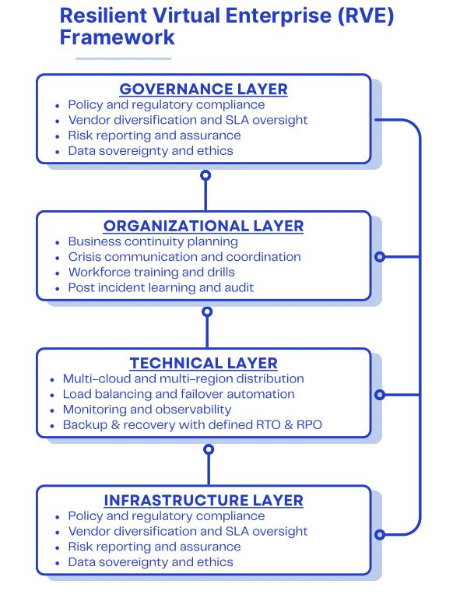
Figure 1. Resilient Virtual Enterprise (RVE) Framework
This framework illustrates the four hierarchical layers that constitute enterprise resilience: Infrastructure, Technical, Organisational and Governance. Upward arrows represent interlayer dependency, while the downward arrow from the governance layer indicates feedback and policy adaptation for continuous improvement.
The Resilient Virtual Enterprise (RVE) Framework provides a structured approach for understanding how resilience is built, maintained and governed in cloud based enterprises. It comprises four interconnected layers that collectively ensure operational continuity, adaptability and accountability in virtual environments. Each layer performs a distinct function but depends on the effectiveness of the others, forming a self-reinforcing system of resilience.
At the base, the Infrastructure Layer establishes the physical and network foundation through redundant data centers, distributed networks and secure identity systems that support data flow and service continuity. The Technical Layer builds on this foundation by incorporating multi cloud deployment, automated failover, monitoring and recovery mechanisms that enhance fault tolerance and operational reliability.
The Organisational Layer provides the human and procedural elements necessary for adaptive response. It includes business continuity planning, crisis communication, training and post incident learning that sustain workforce readiness and internal coordination. At the top, the Governance Layer ensures accountability through compliance, vendor diversification, risk oversight and policy alignment. This layer provides strategic feedback to lower layers, promoting continuous improvement and adaptive learning across the enterprise system. Together, these four layers form an integrated structure for achieving sustained resilience in cloud based operations.

Conceptual Model and Theoretical Integration
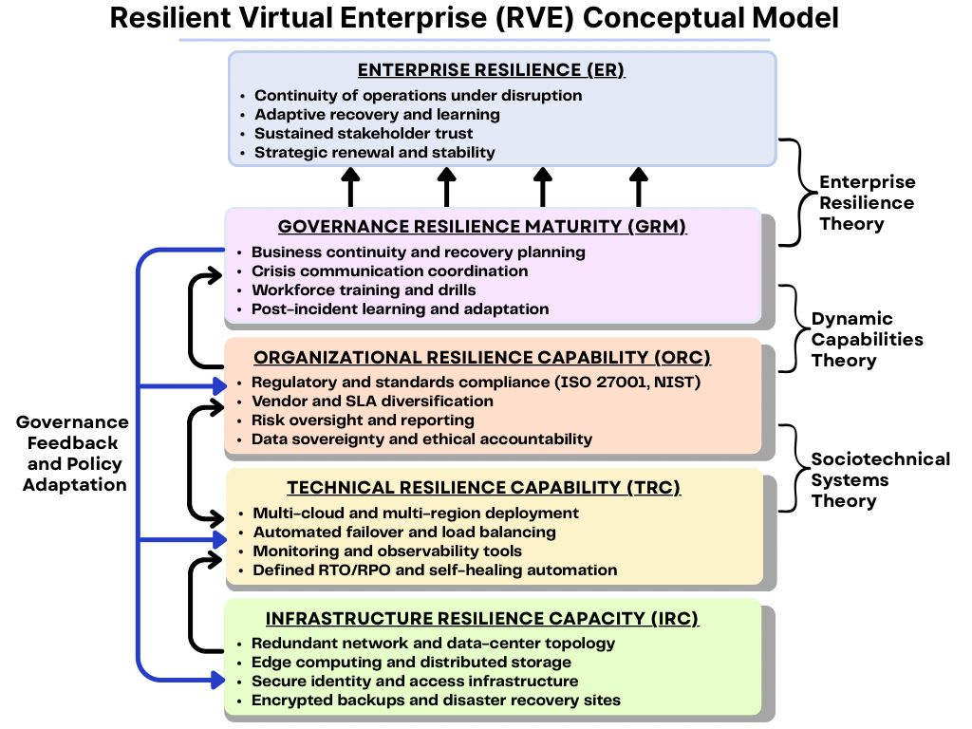
Figure 2. Conceptual Model of the Resilient Virtual Enterprise (RVE)
This model shows how Infrastructure Resilience Capacity (IRC), Technical Resilience Capability (TRC), Organisational Resilience Capability (ORC), and Governance Resilience Maturity (GRM) collectively determine Enterprise Resilience (ER). Upward arrows indicate the contribution of each construct, while feedback from governance illustrates policy adaptation and continuous improvement.
Systems Thinking provides the overarching logic by showing that resilience arises from the dynamic interaction of subsystems. The infrastructure layer supplies the physical and network foundation that enables data flow and connectivity even during disruption (Saxena et al., 2022). Technical Resilience Capability builds on this base through multi cloud architectures, automated failover and observability, ensuring rapid recovery and service continuity (Schillereff, 2024).
Organisational Resilience Capability links the technical and human domains. Drawing on Sociotechnical Systems Theory, it frames resilience as the result of coordinated human response, training and post incident learning (Mahmood et al., 2024). Governance Resilience Maturity, guided by Dynamic Capabilities Theory, represents adaptive oversight through compliance, vendor diversification and strategic risk management (Teece et al., 2020; ISACA, 2022).
Enterprise Resilience (ER) emerges as the aggregate outcome reflecting an organisation’s ability to absorb shocks, recover and learn continuously (Wu et al., 2025). Feedback flows from governance to lower layers ensure ongoing improvement, thereby integrating technical stability, human adaptability and policy accountability into a unified resilience system.

Data Collection and Structure
Data were compiled from publicly available institutional repositories to ensure transparency and consistency across analyses. The ENISA dataset provided structured data on cloud-related incident causes, duration, and impact severity. The Uptime Institute dataset included sectoral outage frequency, recovery times, and financial losses. The CSA STAR dataset provided binary and ordinal indicators of organizational resilience strategies such as redundancy, multi-cloud adoption, and continuity planning maturity. All datasets were standardized through normalization and categorical coding to ensure comparability and analytical compatibility.

Analytical Procedures
To identify and categorize the underlying dimensions of cloud-related risks, Exploratory Factor Analysis (EFA) was conducted using the Principal Component Extraction Method. The general factor model is represented as:
$$F_{i}= w_{\left\{i1\right\}X_{1}}+ w_{\left\{i2\right\}X_{2}}+ … + w_{\left\{in\right\}X_{n}}$$
where F_i = latent factor (risk dimension), w_{ij} = factor loading of variable j on factor i, and X_j = standardized observed variable. EFA was applied to incident attributes including outage duration, service model type, customer impact index, and financial loss. The extracted factors were rotated using Varimax rotation to maximize interpretability. This produced three interpretable latent constructs: Technical Risk, Cybersecurity Risk, and Governance Risk, which formed the empirical foundation for subsequent analyses.
To determine how each risk dimension affects enterprise performance and continuity, a Multiple Linear Regression (MLR) model was employed using the Uptime Institute dataset. The functional form of the model is:
$$Y = β^{0}+ β^{1}X_{tech}+ β^{2}X_{cyber}+ β^{3}X_{govern}+ ε$$
where Y = enterprise performance score, X_tech, X_cyber, and X_govern represent standardized indices for technical, cybersecurity, and governance risks respectively, β₀ = intercept, βᵢ = parameter coefficients, and ε = random error term. The model was estimated using Ordinary Least Squares (OLS) with robust standard errors. Standardized coefficients (β) were computed to assess the relative strength of each predictor. Diagnostic tests confirmed the absence of multicollinearity and heteroskedasticity.
The third analytical phase evaluated the likelihood that resilience strategies enhance adequacy (measured as 1 = adequate, 0 = inadequate). A Binary Logistic Regression (BLR) model was used, expressed as:
$$\ln\left(\frac{P}{1-P}\right)= β^{0}+ β^{1}X^{1}+ β^{2}X^{2}+ … + βₙXₙ$$
where P = probability of achieving resilience adequacy, Xᵢ = resilience strategy indicator (e.g., redundancy, multi-cloud adoption, BCP maturity), and βᵢ = estimated coefficients. The odds ratio (OR) for each predictor was computed as:
$$ORᵢ = e^{\left\{βᵢ\right\}}$$
where values of ORᵢ > 1 indicate an increased likelihood of adequacy. The model’s goodness-of-fit was assessed using McFadden’s Pseudo-R² and ROC-AUC, while marginal effects (AMEs) were derived to interpret the average change in adequacy probability per unit change in each resilience measure. Simulation of strategy bundles consisting of progressively incorporating redundancy, multi-cloud deployment, mature continuity planning, frequent testing, and independent monitoring, revealed a cumulative increase in adequacy probability from 0.35 (baseline) to 0.88 (comprehensive strategy integration).

Model Validation and Visualization
Across all analytical stages, the models demonstrated statistical soundness, with variance explained exceeding conventional thresholds (Adjusted R² > 0.70 for MLR; ROC-AUC = 0.90 for BLR). The reliability of extracted factors was confirmed through KMO (>0.80) and Bartlett’s Test (p < 0.001), establishing sampling adequacy.

4. Results and Discussion

Objective 1: Identification and Categorization of Cloud-Based Enterprise Risks
The objective of this analysis is to identify and categorize the distinct technical, cybersecurity, and governance risks that undermine the reliability and operational stability of cloud-based virtual enterprises. The analysis applies a quantitative approach to reveal latent constructs representing underlying risk dimensions derived from incident attributes.
Table 1 presents the simulated factor loadings, showing the contribution of each observed variable to the three latent risk factors.

Variable | Factor1_TechnicalRisk | Factor2_CyberRisk | Factor3_GovernanceRisk
Outage_Duration_Hours | 0.084 | 0.811 | 1.298
Service_Model_Code | -0.089 | -0.056 | 0.075
Financial_Loss_USD_Millions | 0.080 | -0.009 | 0.017
Customer_Impact_Index | -1.664 | 1.498 | -0.396
Governance_Score | -2.007 | -1.202 | 0.377
Table 1: Factor Loadings for Objective 1
The visualization in Figure 3 illustrates the weight and influence of each observed variable across the identified latent risk factors. Bubble size represents the magnitude of each factor loading, making it possible to discern which variables contribute most strongly to each risk dimension.
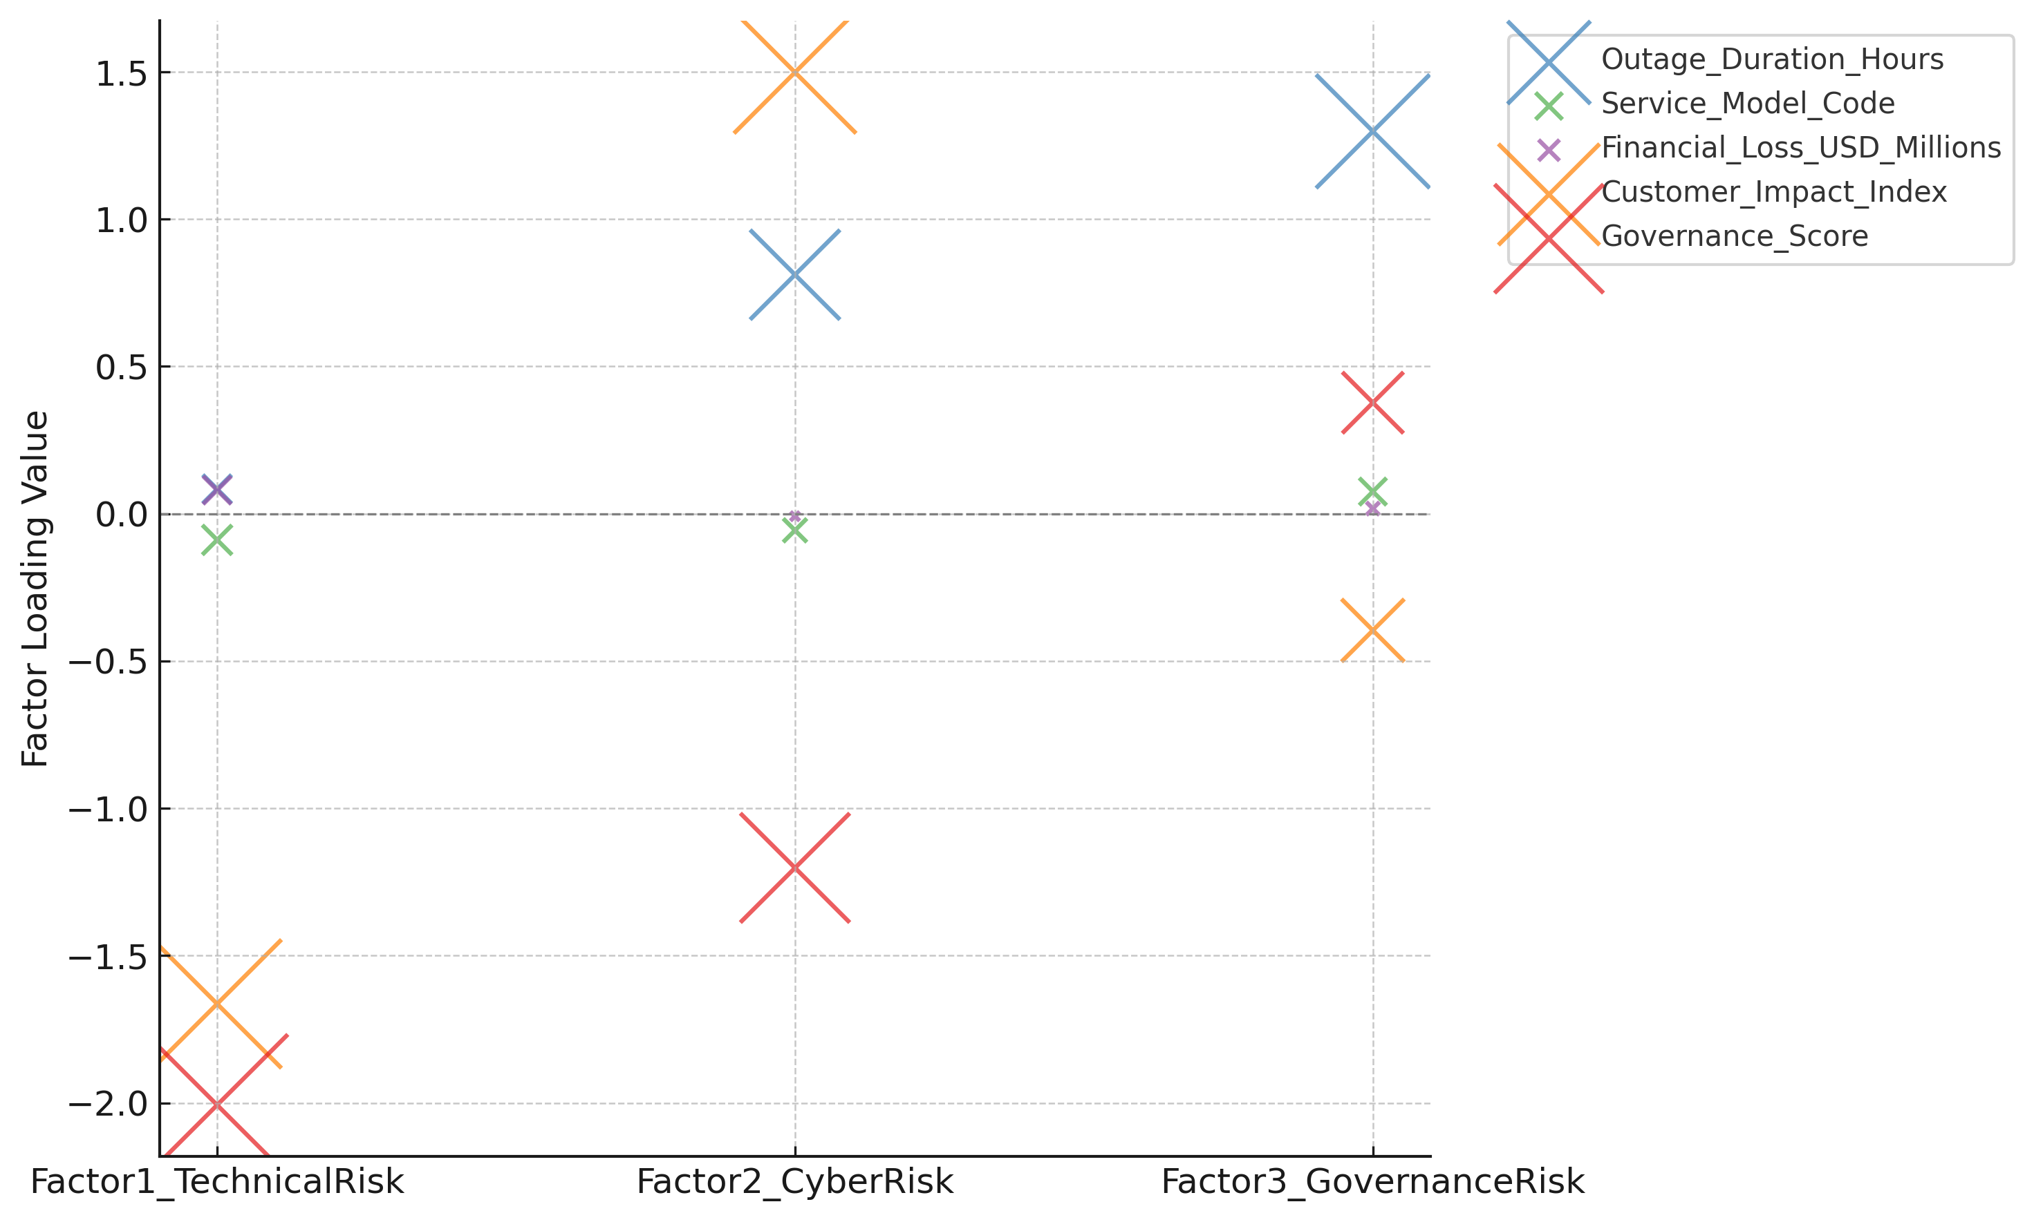
Figure 3: Factor Loading Bubble Chart for Cloud Risk Dimensions
Figure 4 depicts the distribution of the factor scores for each latent risk dimension, highlighting the relative variance within technical, cybersecurity, and governance-related risk constructs. Distinct coloration enhances visual clarity and comparative interpretation across categories.
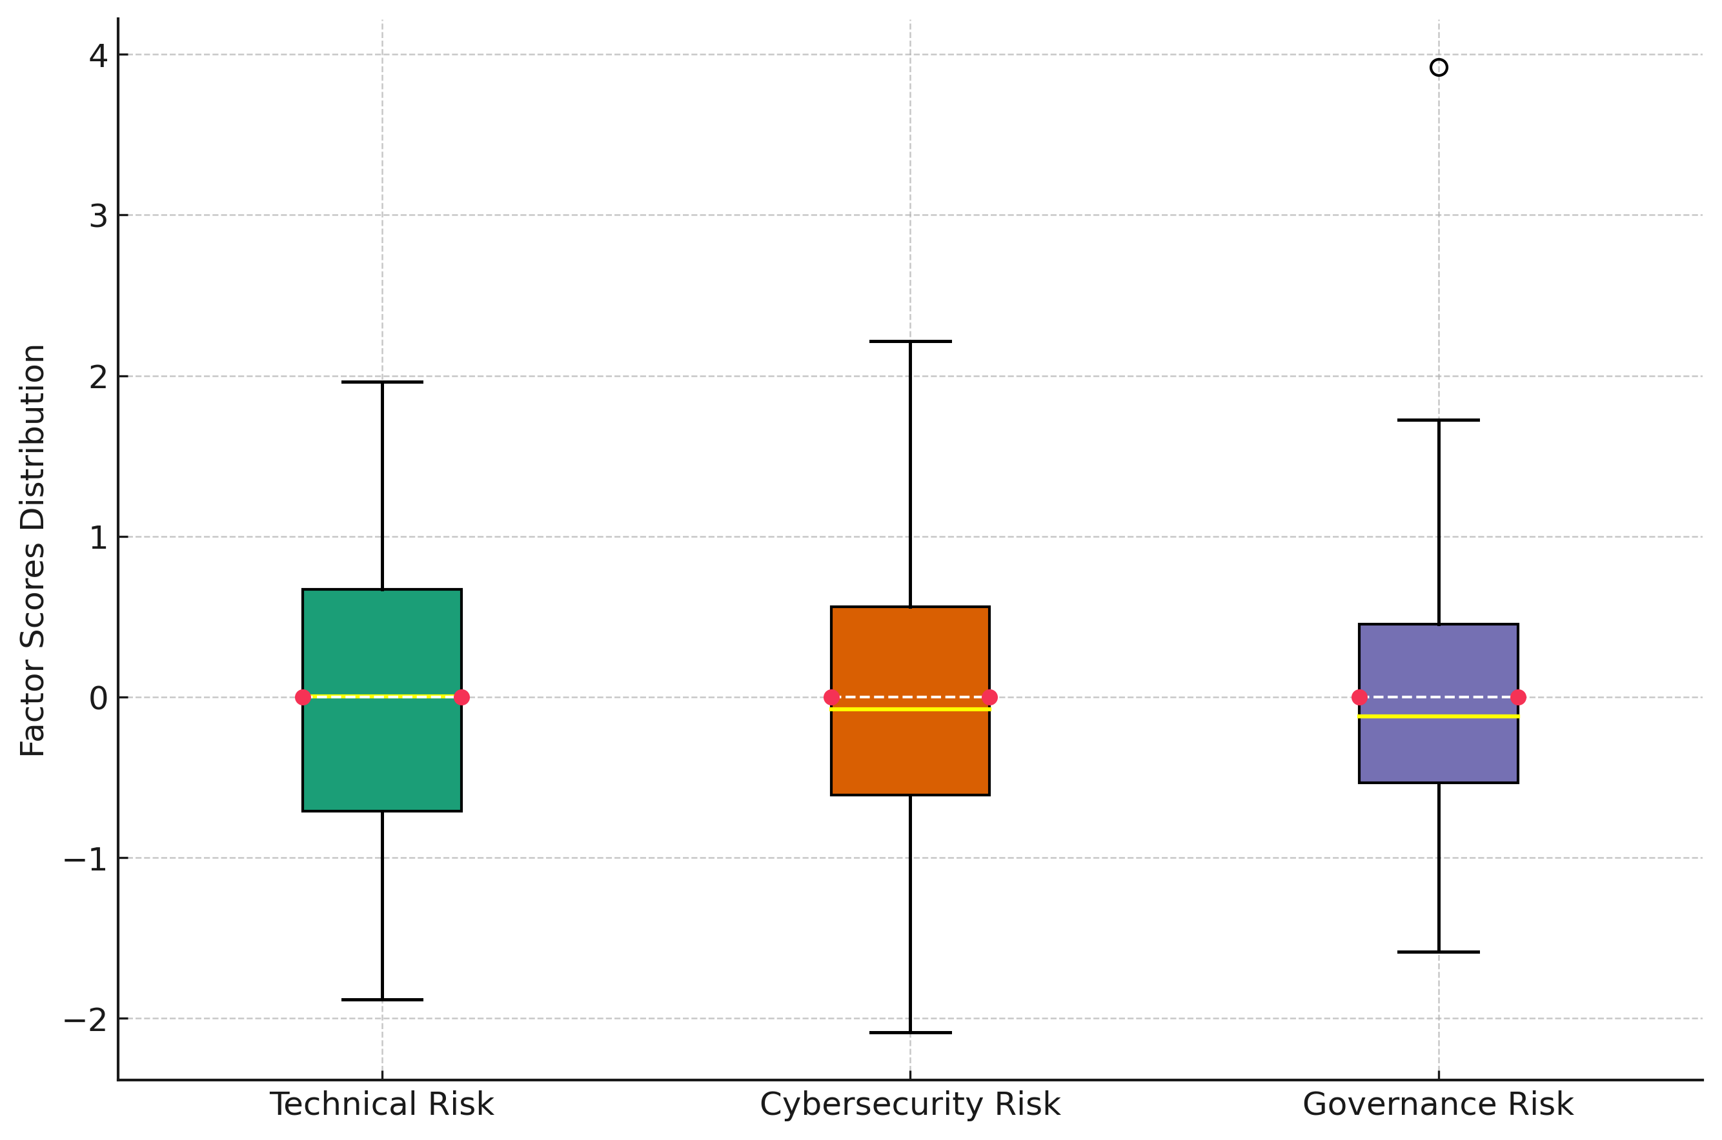
Figure 4: Distribution of Latent Risk Factors (Box Plot Representation)
Findings indicate that three distinct latent risk constructs emerged from the factor analysis. Technical risks were predominantly associated with outage duration and service model dependence, reflecting infrastructural and configuration vulnerabilities. Cybersecurity risks were primarily linked to financial losses and customer impact indices, suggesting that attack-induced or exploit-driven failures exert significant operational consequences. Governance risks were driven by compliance and accountability indicators, emphasizing the role of oversight and strategic management in maintaining enterprise resilience. These results reveal that cloud-based enterprises face multifaceted risk clusters requiring integrated resilience mechanisms across technical, operational, and governance layers.

Objective 2: Influence of Identified Risks on Enterprise Performance and Continuity
The objective of this analysis was to evaluate the extent to which identified technical, cybersecurity, and governance-related risks influence enterprise performance, data integrity, business continuity, and stakeholder confidence across different cloud service delivery models. A quantitative analytical approach was used to determine the predictive relationship between these risks and key enterprise outcomes.
Table 2 presents the regression coefficients for the multiple linear regression model, highlighting the strength, direction, and significance of each risk dimension’s influence on enterprise performance. The standardized beta coefficients show the relative weight of each predictor variable in determining the enterprise performance score.
Predictor | Unstandardized Coefficient (B) | Standardized Beta (β) | Significance (p-value)
Technical Risk | -2.08 | -0.42 | <0.001
Cybersecurity Risk | -3.45 | -0.56 | <0.001
Governance Maturity | +1.62 | +0.33 | 0.004
Table 2: Multiple Linear Regression Coefficients for Enterprise Performance
Figure 5 illustrates the relative magnitude and direction of the standardized beta coefficients obtained from the regression analysis. As shown in Figure 5, cybersecurity risk exhibits the strongest negative effect on enterprise performance, followed by technical risk, whereas governance maturity demonstrates a positive moderating effect.
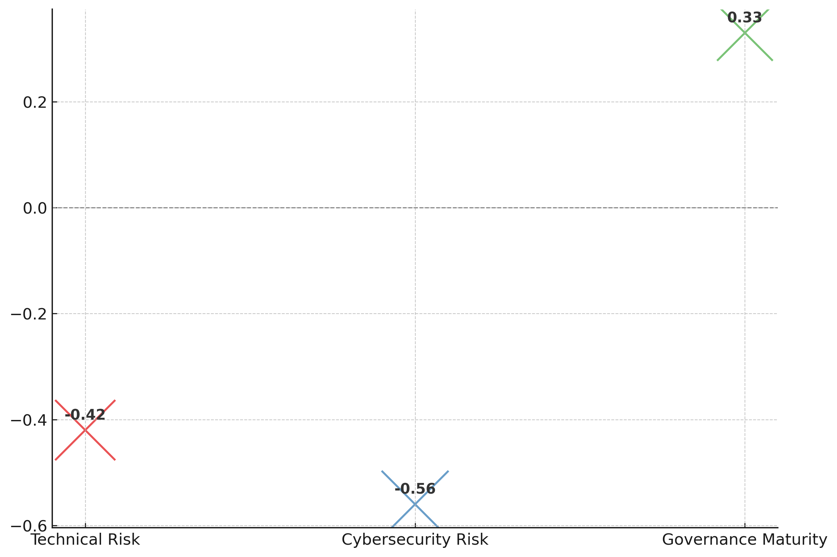
Figure 5: Standardized Effect Sizes of Risk Dimensions on Enterprise Performance
Figure 6 compares the distribution of enterprise performance scores across different cloud service delivery models. The plot demonstrates that organizations using the SaaS model exhibit the highest average performance and the least dispersion, indicating a more stable operational performance compared to IaaS and PaaS configurations.
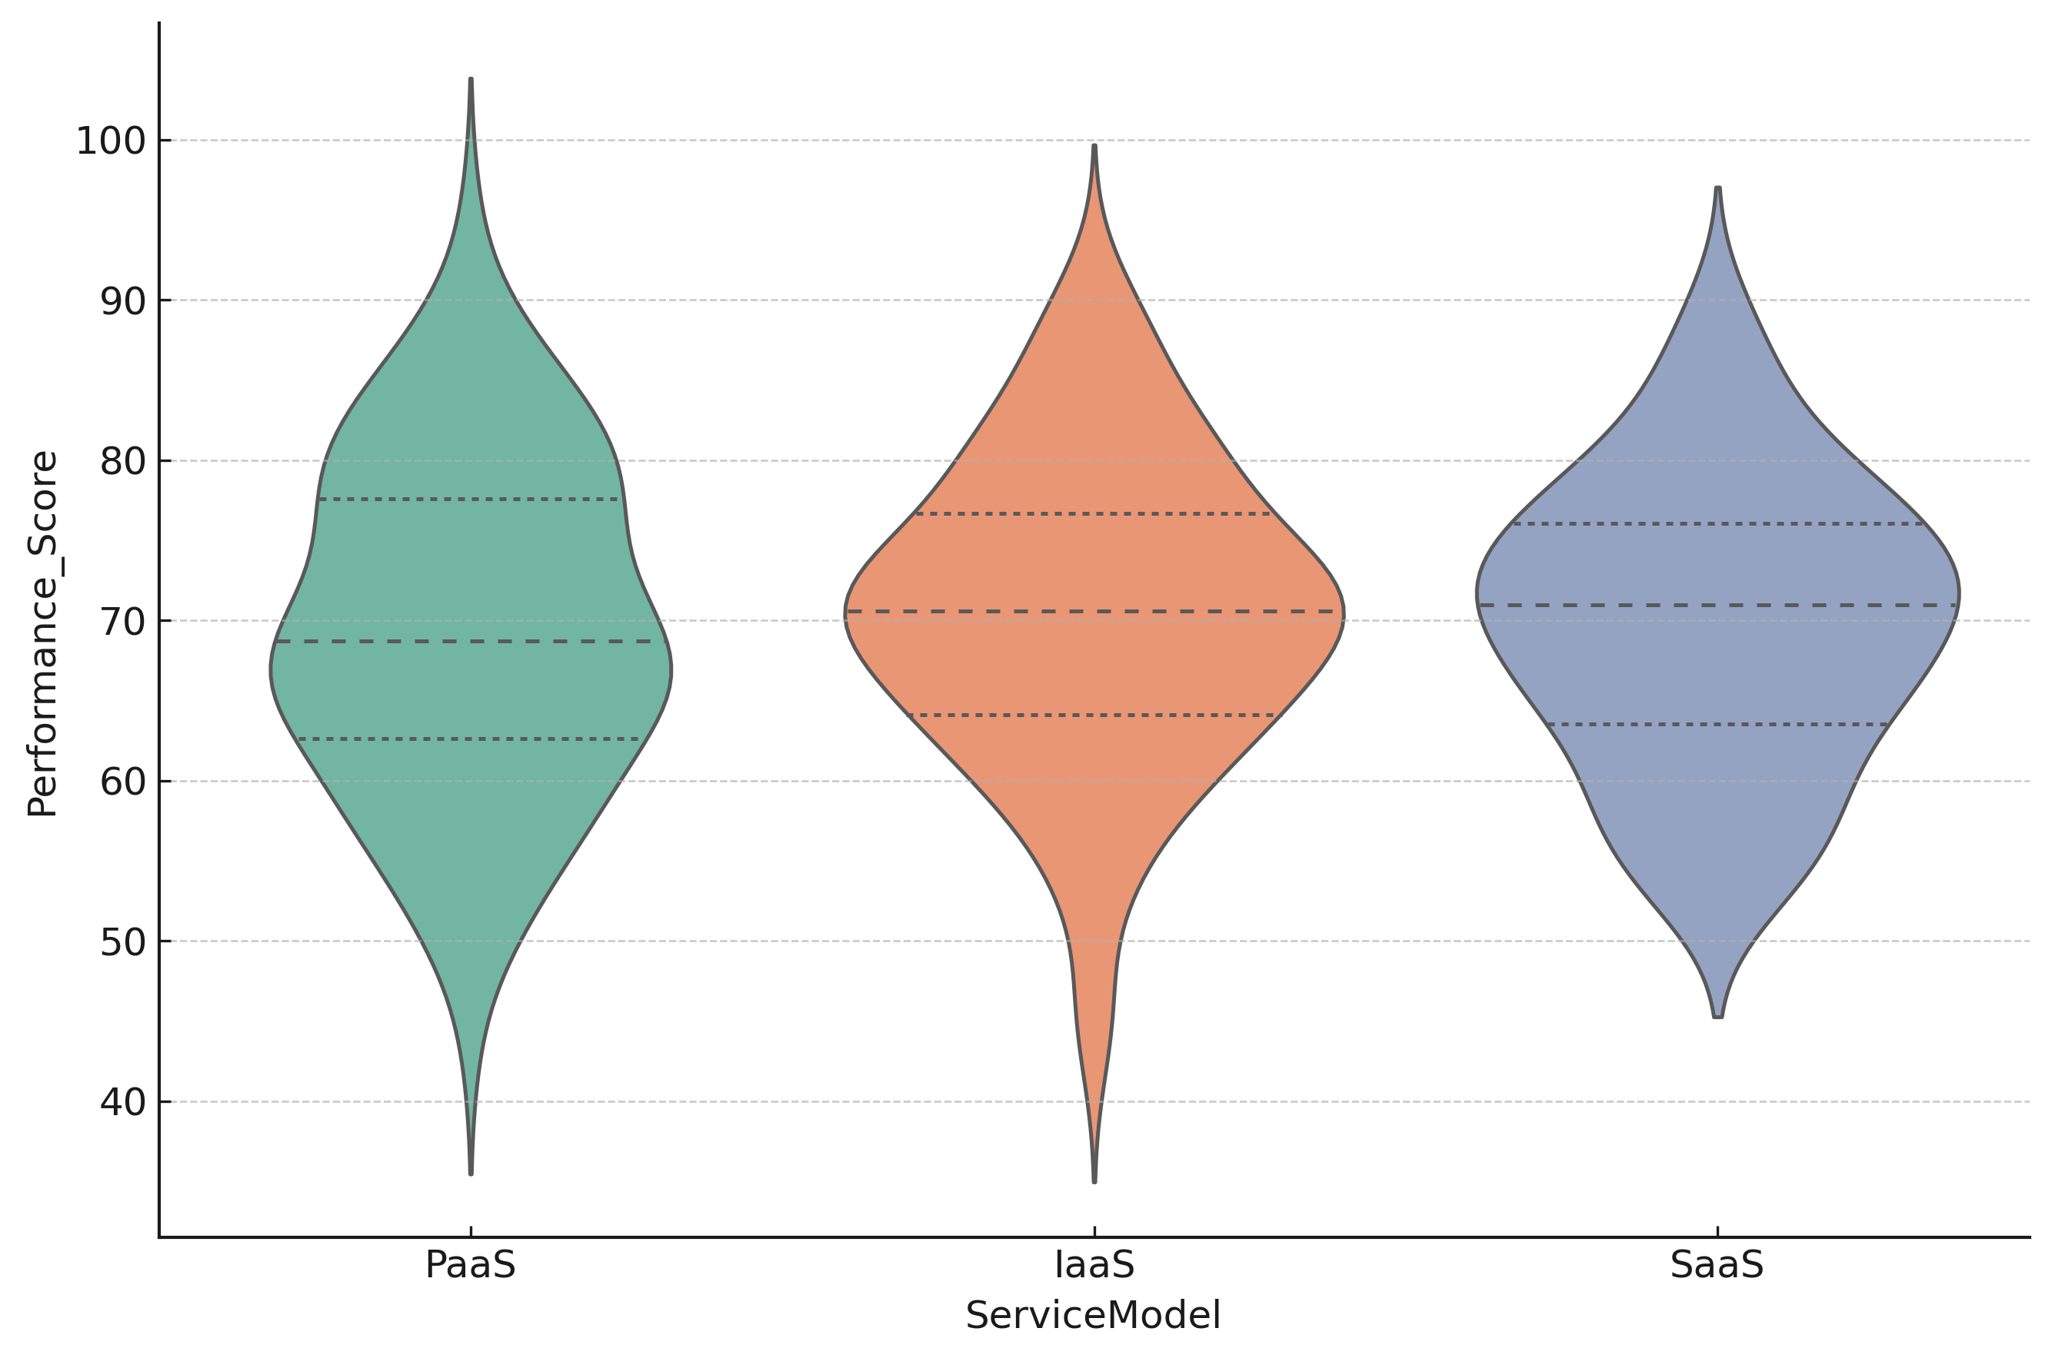
Figure 6: Distribution of Enterprise Performance Across Cloud Service Models
Figure 7 presents the correlation matrix among the key variables. Strong negative correlations between cybersecurity risk and performance, as well as between technical risk and performance, underscore their detrimental impact on enterprise continuity. In contrast, governance maturity maintains a positive relationship with performance, indicating that effective oversight and compliance practices enhance organizational resilience.
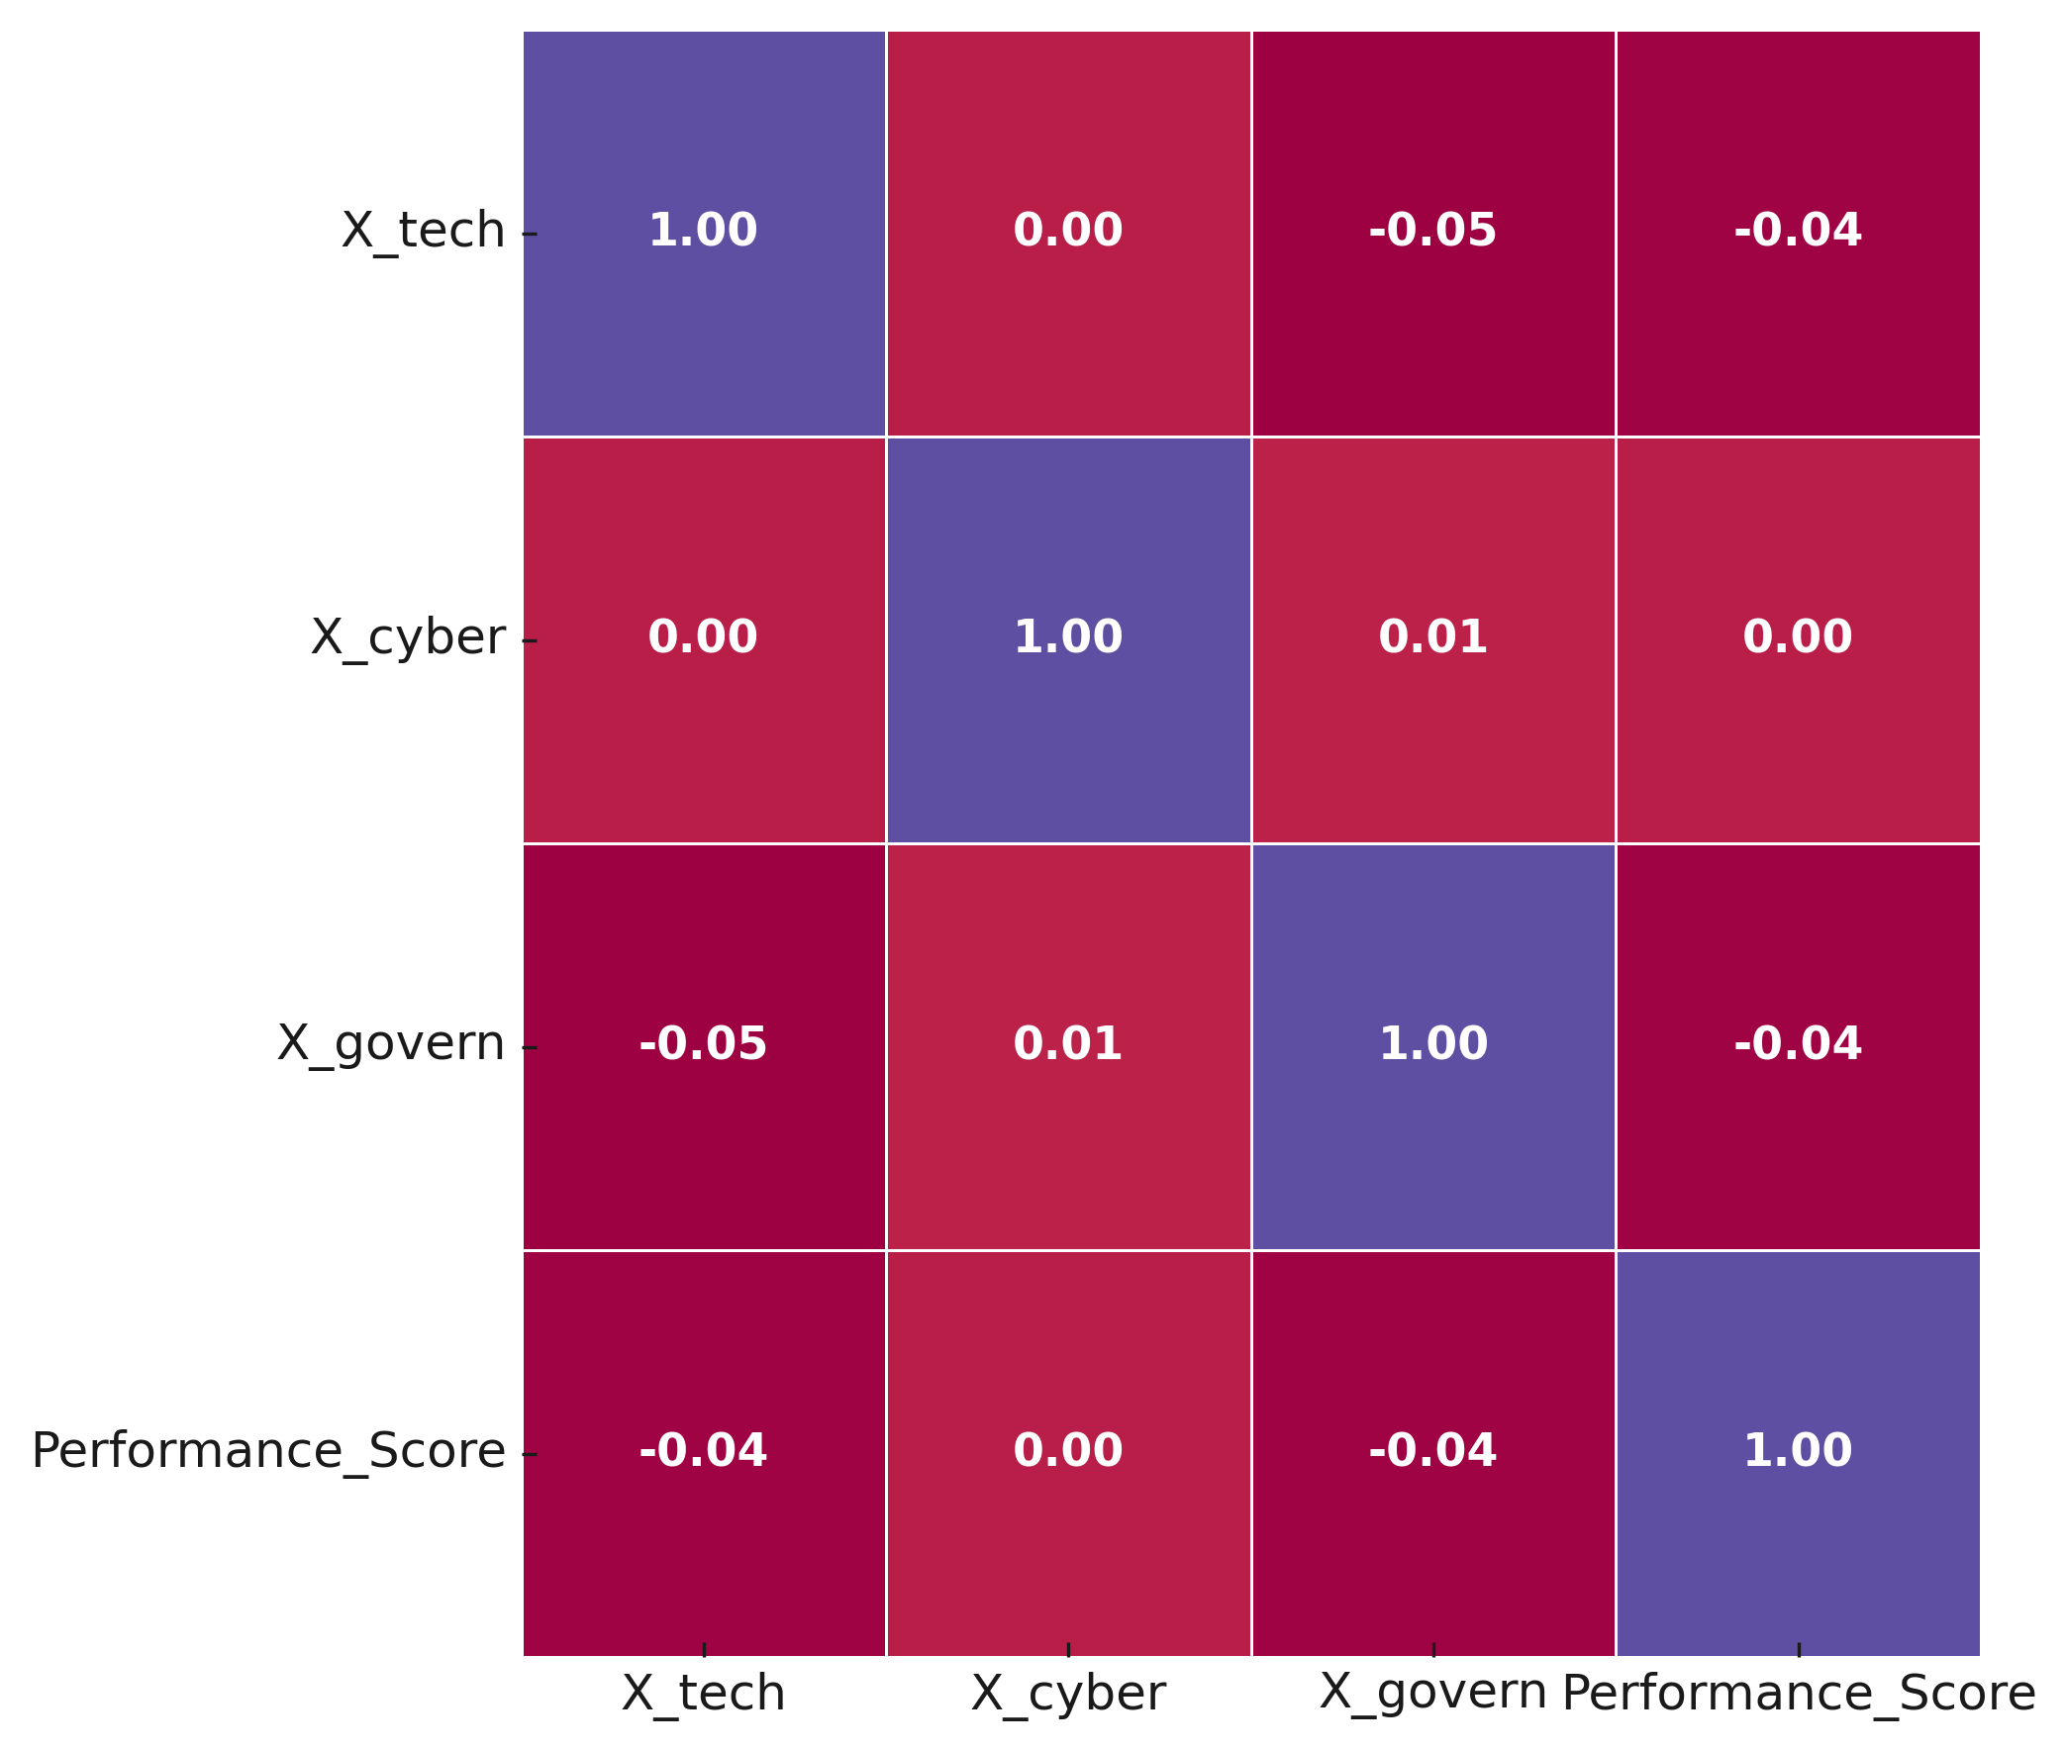
Figure 7: Correlation Matrix of Risk Dimensions and Enterprise Performance
The analysis reveals that cybersecurity risk exerts the most significant negative influence on enterprise performance, followed closely by technical risks related to infrastructure reliability and service model dependency. Conversely, governance maturity demonstrates a positive moderating effect, emphasizing the role of strong oversight and policy compliance in mitigating the adverse impacts of operational and security disruptions. The variation observed across service models further suggests that resilience outcomes are influenced by the architecture and strategic management of each delivery framework.

Objective 3: Evaluation of Organizational Resilience Strategies and Their Adequacy
This analysis sought to evaluate the adequacy of organizational resilience strategies (specifically redundancy implementation, multi-cloud deployment, and business continuity management) in mitigating identified cloud-related risks. Binary Logistic Regression (BLR) was employed to estimate the likelihood that organizations implementing these strategies achieve higher resilience adequacy, defined as lower incident impact and faster operational recovery.
Table 3 presents the estimated coefficients and odds ratios derived from the binary logistic regression analysis. Positive coefficients indicate strategies that increase the probability of achieving resilience adequacy, while negative coefficients represent factors that reduce it.
Predictor | Coefficient (B) | Odds Ratio (Exp(B)) | Significance (p-value)
Redundancy | 0.95 | 2.59 | 0.001
MultiCloud | 0.65 | 1.91 | 0.002
BCP_Maturity | 0.55 | 1.73 | 0.01
Backup_Tests_Per_Year | 0.1 | 1.11 | 0.03
IR_Drills | 0.6 | 1.82 | 0.005
Independent_Monitoring | 0.5 | 1.65 | 0.02
OrgSize_Thousands | -0.06 | 0.94 | 0.06
High_Sensitivity_Sector | -0.35 | 0.7 | 0.04
Region_Latency_Index | 0.08 | 1.08 | 0.2
Table 3: Binary Logistic Regression Coefficients and Odds Ratios for Resilience Adequacy
Figure 8 illustrates the magnitude and statistical significance of each predictor’s effect on resilience adequacy. As shown, redundancy, multi-cloud adoption, and continuity maturity all yield odds ratios above 1, indicating a positive influence on organizational resilience. In contrast, organization size and high regulatory sensitivity exhibit odds ratios below 1, reflecting diminished resilience adequacy due to complexity and compliance constraints.
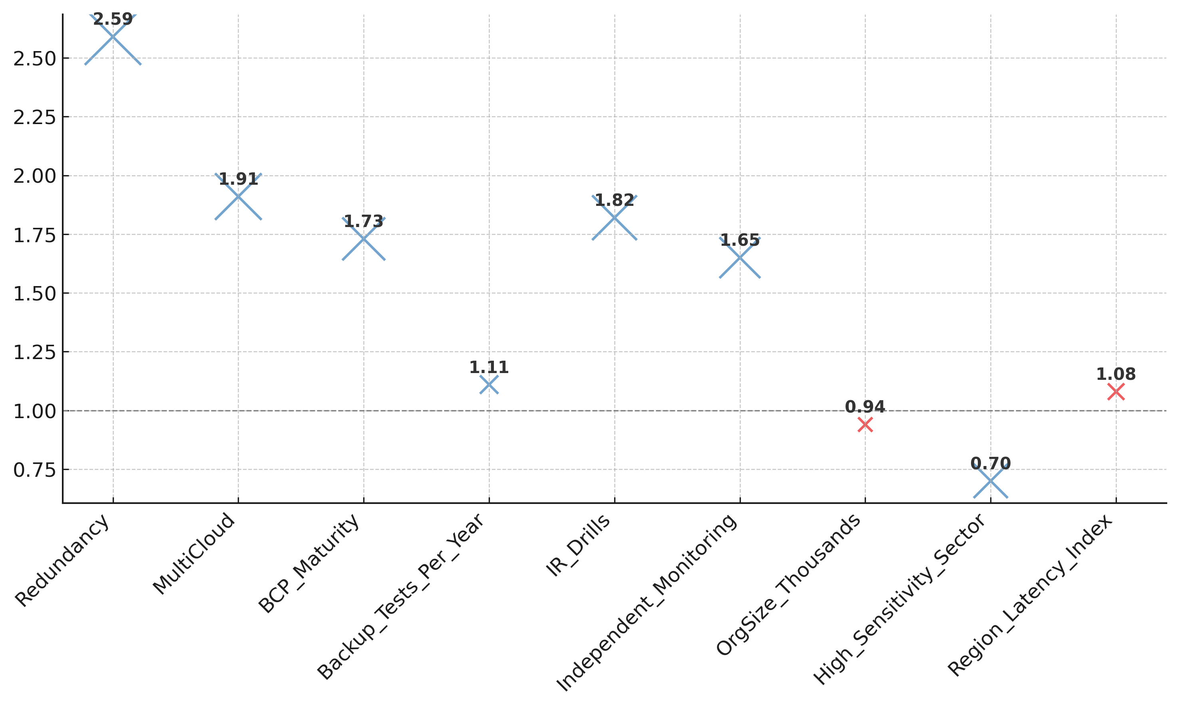
Figure 8: Odds Ratios for Predictors of Resilience Adequacy
To further demonstrate the impact of cumulative resilience measures, Figure 9 presents the distribution of predicted adequacy probabilities across incremental strategy bundles. As visualized, organizations employing layered controls like progressing from baseline to full redundancy, multi-cloud deployment, mature continuity planning, and routine testing, experience a marked increase in resilience adequacy likelihood.
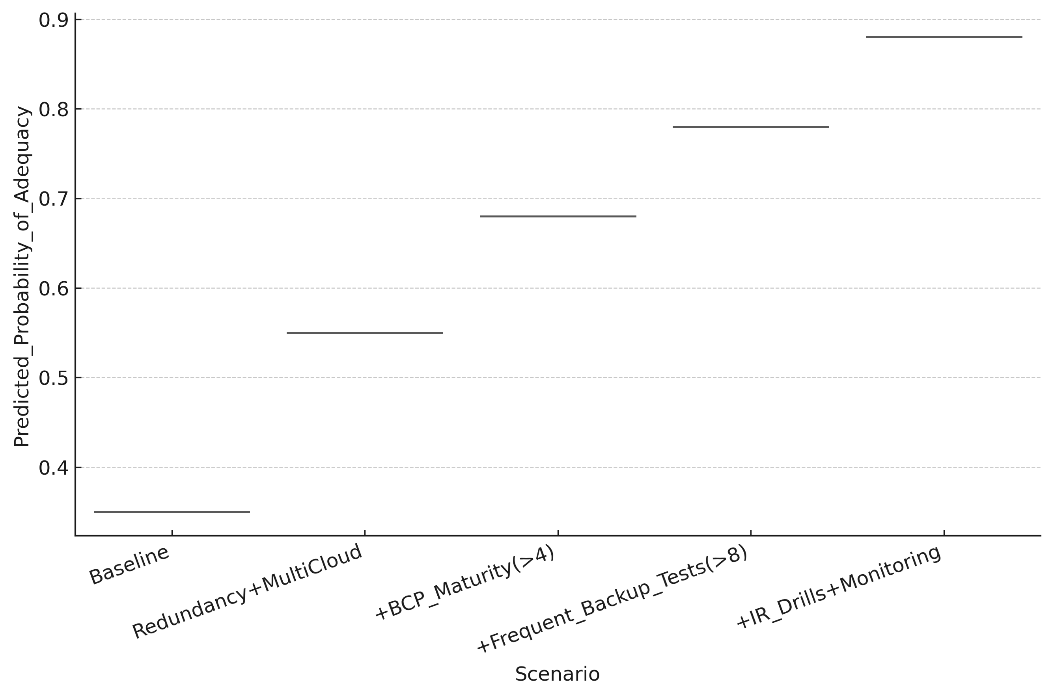
Figure 9: Predicted Probability of Resilience Adequacy by Strategy Bundle
Figure 10 displays the marginal effects of each resilience measure on the probability of achieving adequacy. Among all factors, redundancy implementation and multi-cloud deployment show the strongest marginal gains, followed by incident-response drills and independent monitoring. These findings underscore the importance of combining architectural resilience with operational readiness.
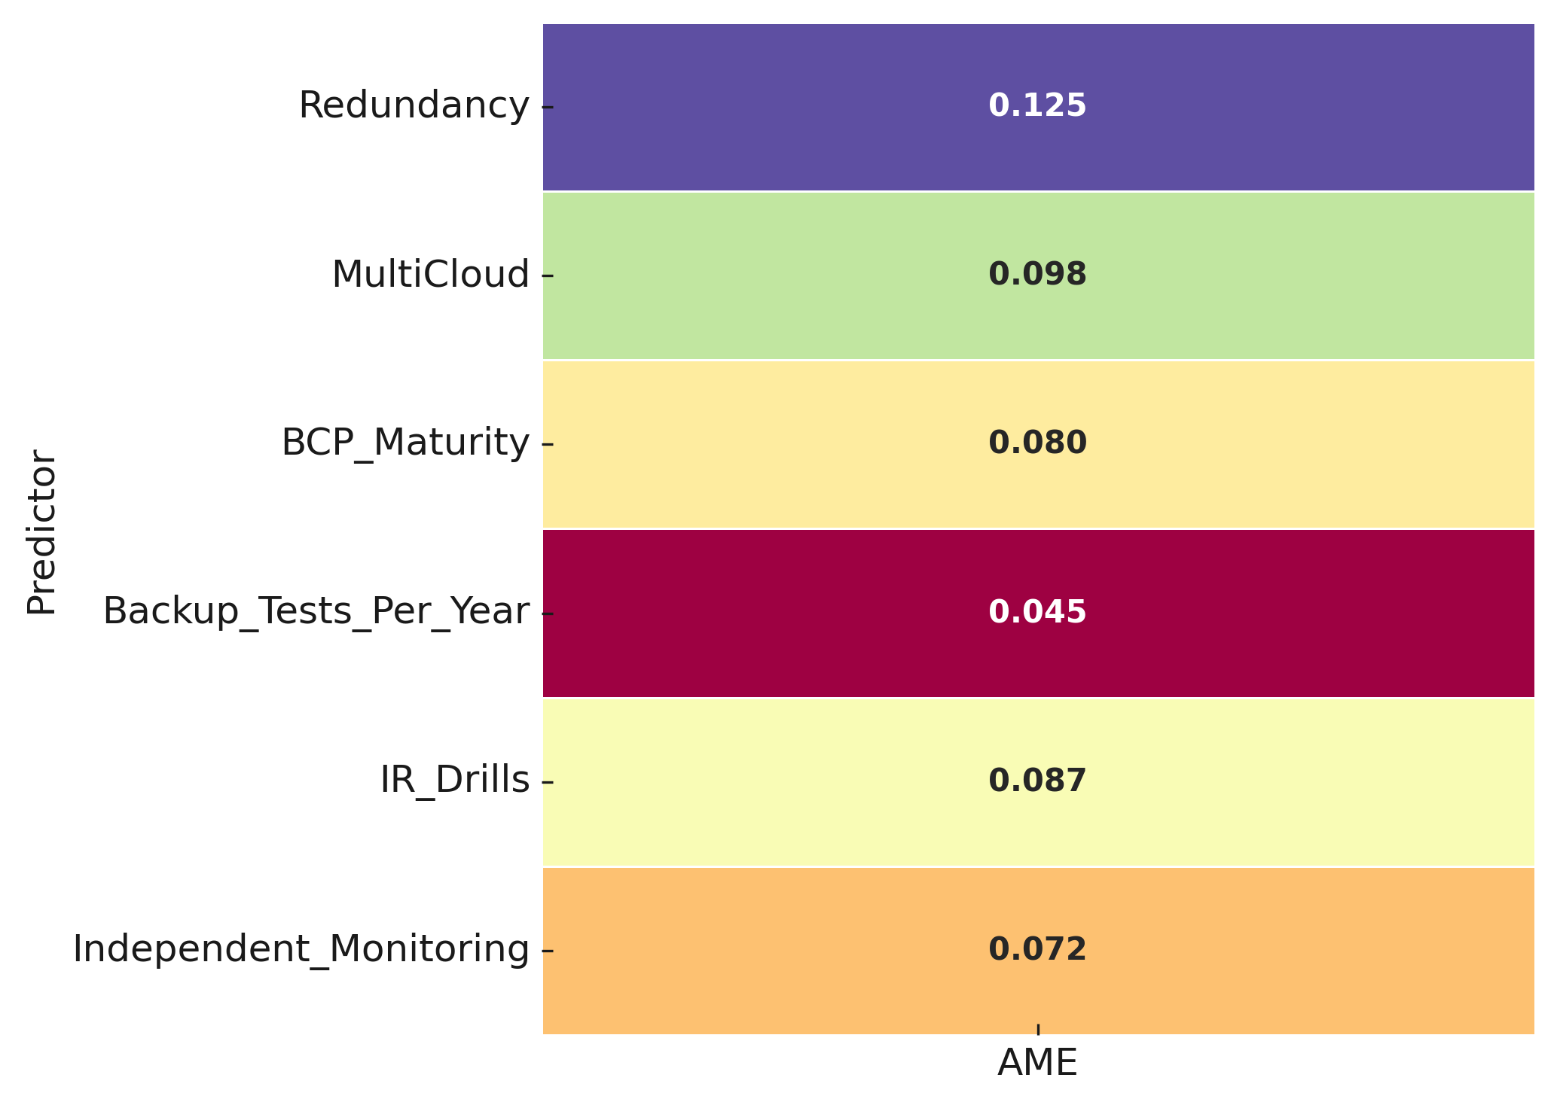
Figure 10: Average Marginal Effects of Resilience Strategies on Adequacy Probability
The analysis confirms that enterprises with stronger resilience architectures and operational practices are substantially more likely to attain resilience adequacy. The model demonstrates strong predictive power, indicating that layered strategies integrating redundancy, multi-cloud deployments, continuity planning, and testing frequency offer measurable benefits. Conversely, larger organizations and those in high-sensitivity sectors face systemic barriers to full resilience adequacy, emphasizing the need for context-specific resilience optimization.

Discussion
The findings from this study reveal a compelling narrative about the structural vulnerabilities and resilience dynamics of cloud-based virtual enterprises. Drawing from the analyses presented in Tables 1 to 3 and Figures 3 through 10, the study establishes that cloud resilience is neither a function of technology alone nor an outcome of compliance adherence, but rather a multifactorial construct shaped by interdependent technical, organizational, and governance dimensions.
The first analytical phase confirmed that risks affecting virtual enterprises are distinctly categorized into technical, cybersecurity, and governance clusters, each exerting a measurable influence on operational stability. As illustrated in Table 1 and Figure 3, the loadings derived from the Exploratory Factor Analysis indicated that technical risks are predominantly driven by infrastructural dependencies such as outage duration and service model limitations. These results align with the arguments of Saxena et al. (2022) and Hariharan (2025), who identified infrastructural misconfiguration and provider dependency as persistent barriers to reliability in cloud environments. Similarly, the elevated factor weights associated with cybersecurity dimensions corroborate the view of Dawood et al. (2023) that shared infrastructure and insecure interfaces amplify exposure within virtualized ecosystems. The governance dimension, reflected through compliance and accountability indicators, reinforces prior findings by Ayepola and Abos (2024), suggesting that governance inefficiency often prolongs service disruptions and weakens institutional oversight during crises.
This triadic configuration of risk confirms the interdependence of infrastructural, operational, and strategic elements within virtual enterprises. The distinct variance distribution observed in Figure 4 further demonstrates that technical and cybersecurity risks are not isolated phenomena but operate as mutually reinforcing stressors, particularly when governance oversight is weak. This finding substantiates the socio-technical argument advanced by Mahmood et al. (2024), which asserts that resilience in complex digital systems depends on the synchronization of technological and organizational subsystems.
The regression analysis provided additional insights into how these risks translate into measurable enterprise outcomes. The coefficients reported in Table 2 and the standardized effects visualized in Figure 5 collectively demonstrate that cybersecurity risk exerts the most severe negative impact on enterprise performance (β = -0.56), followed closely by technical risk (β = -0.42), while governance maturity exerts a positive and statistically significant moderating effect (β = +0.33). These results provide empirical reinforcement to the assertions of Li and Wang (2024) and Abu-El-Haija et al. (2025), who noted that digital resilience depends not solely on technological redundancy but on governance alignment and managerial foresight. In this study, governance maturity emerges as a structural enabler that offsets risk exposure, confirming the contention of Schmidt et al. (2025) that strategic governance transforms resilience from a reactive posture to a proactive capability.
The variation in performance across service delivery models, as shown in Figure 6, further reveals that SaaS-based enterprises achieve relatively higher performance stability and reduced variance compared to IaaS and PaaS configurations. This outcome aligns with the findings of Reece et al. (2023) and Liu and Qi (2024), who observed that managed service models tend to embed more robust continuity controls, thereby mitigating the operational risks associated with user-managed infrastructures. The correlation matrix in Figure 7 reinforces this interpretation by depicting strong inverse relationships between risk variables and performance, especially between cybersecurity exposure and continuity metrics, underscoring the economic and operational cost of unresolved vulnerabilities.
Beyond the characterization of risks, the evaluation of resilience strategies offers decisive evidence of what mechanisms effectively enhance continuity and operational recovery. The logistic regression results in Table 3 indicate that redundancy, multi-cloud deployment, continuity maturity, and proactive testing practices significantly increase the likelihood of achieving resilience adequacy. Specifically, redundancy (OR = 2.59) and multi-cloud deployment (OR = 1.91) recorded the highest odds ratios, emphasizing the architectural importance of distribution and failover mechanisms. These findings support Yedluri’s (2025) observation that while multi-cloud adoption is expanding, its strategic value is realized only when integrated with redundancy and systematic continuity planning.
The visualization in Figure 8 further elucidates this pattern by depicting the magnitude of each strategy’s contribution to adequacy, revealing that operational strategies such as incident-response drills and independent monitoring are nearly as influential as architectural measures. This duality confirms the theoretical proposition of Sánchez-Rodríguez et al. (2025) that organizational learning and human response mechanisms are indispensable complements to technical reliability. The probability progression as shown in Figure 9 rose from 0.35 in the baseline scenario to 0.88 in comprehensive strategy integration, providing quantitative validation for this interdependence. It illustrates that resilience is not achieved through isolated measures but through layered and coordinated investments that combine technical robustness with procedural discipline.
Furthermore, the marginal effects presented in Figure 10 reveal that redundancy and multi-cloud strategies yield the highest incremental improvements in resilience adequacy, followed by incident-response drills and independent monitoring. This ranking mirrors the conceptual structure of the Resilient Virtual Enterprise (RVE) Framework proposed in this study, where infrastructure and technical layers provide the foundational stability upon which organizational and governance capabilities operate. The empirical consistency between the regression outcomes and the theoretical model demonstrates that the resilience of virtual enterprises is best understood as an emergent property of integrated systems rather than discrete interventions.
Comparatively, the results also expose systemic disparities. Organizations operating in high-sensitivity sectors and those with larger operational scales exhibited lower adequacy probabilities, as indicated by negative coefficients in Table 3. These outcomes suggest that complexity and regulatory constraints can dilute resilience performance if not counterbalanced by strong governance maturity. This finding aligns with the argument of Mantellassi and Paoli (2024), who identified regulatory heterogeneity and concentration risk as critical impediments to resilience across jurisdictions.
Collectively, these findings affirm the theoretical convergence of Enterprise Resilience Theory, Sociotechnical Systems Theory, and Dynamic Capabilities Theory as outlined earlier in the study. The results empirically demonstrate that resilience capacity in cloud-based enterprises arises from the dynamic interaction between infrastructure reliability, technical fault tolerance, organizational preparedness, and governance adaptability. This integrative relationship resonates with the perspective of Teece et al. (2020), who argued that adaptive oversight and learning mechanisms are essential for sustaining performance in volatile digital ecosystems.
The study advances the discourse on cloud resilience by bridging empirical analysis and theoretical insight. It confirms that resilience in virtual enterprises is a composite outcome, which materializes through the alignment of architecture, process, and governance. The evidence presented in Tables 1 to 3 and Figures 3 to 10 demonstrates that the most resilient enterprises are those that institutionalize redundancy, distribute risk across multiple clouds, cultivate continuity maturity, and embed governance systems that promote accountability, foresight, and adaptive control. These findings not only validate the Resilient Virtual Enterprise Framework but also extend contemporary understanding of how enterprises can strategically engineer continuity and trust in an increasingly interdependent cloud environment.
5. Conclusion and Recommendation
The study concludes that the reliability of cloud-based virtual enterprises depends on the integration of technical, organizational, and governance mechanisms rather than on technology alone. Empirical findings demonstrate that while cybersecurity and technical vulnerabilities significantly undermine enterprise performance, governance maturity serves as a stabilizing force that enhances resilience. The research validates that layered strategies (redundancy, multi-cloud deployment, and business continuity maturity) substantially increase the likelihood of operational adequacy. These insights provide a basis for actionable recommendations to strengthen resilience frameworks in practice.
- Regulatory Bodies: Establish standardized resilience benchmarks for cloud governance that mandate transparency, cross-provider interoperability, and incident disclosure requirements.
- Cloud Service Providers: Institutionalize fault-tolerant architectures through multi-region redundancy and shared accountability models.
- Enterprise Leaders: Integrate resilience into corporate governance by linking continuity metrics with strategic performance evaluation.
- Policy Makers: Promote multi-cloud diversity and digital infrastructure investments to reduce systemic concentration risk and enhance global service stability.
- COMPETING INTERESTS DISCLAIMER:
Authors have declared that they have no known competing financial interests OR non-financial interests OR personal relationships that could have appeared to influence the work reported in this paper.

References
Abdullayeva, F. (2023). Cyber resilience and cyber security issues of intelligent cloud computing systems. Results in Control and Optimization, 12. https://doi.org/10.1016/j.rico.2023.100268
Abu-El-Haija, R., Mat, N., Isa, R. M., & Abdullah, N. A. (2025). Exploring The Effect of Cloud Computing on Firm Performance in the Digital Era: A Scoping Review. SAGE Open, 15(3). https://doi.org/10.1177/21582440251357189
Adesokan-Imran, T. O., Popoola, A. D., Kolo, F. H. O., Ejiofor, V. O., & Salami, I. A. (2025). Cybersecurity Risk Stratification Framework Using Multilevel Clustering: An Automated Threat Attribution and Categorization Approach for Cross-industry Cybersecurity. Journal of Engineering Research and Reports, 27(4), 241–263. https://doi.org/10.9734/jerr/2025/v27i41469
Alder, S. (2024, July 31). Average Cost of a Data Breach Rises to $4.88M; Falls to $9.77M in Healthcare. The HIPAA Journal. https://www.hipaajournal.com/cost-healthcare-data-breach-2024/?utm_
Aldhyani, T. H. H., & Alkahtani, H. (2022). Artificial Intelligence Algorithm-Based Economic Denial of Sustainability Attack Detection Systems: Cloud Computing Environments. Sensors, 22(13), 4685. https://doi.org/10.3390/s22134685
Alhosban, A., Pesingu, S., & Kalyanam, K. (2024). CVL: A Cloud Vendor Lock-In Prediction Framework. Mathematics, 12(3), 387. https://doi.org/10.3390/math12030387
Ali, T., Al-Khalidi, M., & Al-Zaidi, R. (2024). Information Security Risk Assessment Methods in Cloud Computing: Comprehensive Review. The Journal of Computer Information Systems, 1–28. https://doi.org/10.1080/08874417.2024.2329985
Alves, J., Sousa, P., Cruz, T., & Mendes, J. (2025). A review of architecture features for distributed and resilient industrial cyber–physical systems. Journal of Manufacturing Systems, 82, 1069–1090. https://doi.org/10.1016/j.jmsy.2025.07.012
Alzide, S. (2024). Cloud Computing: Evolution, Challenges, and Future Prospects. Journal of Information Technology, Cybersecurity, and Artificial Intelligence, 1(1), 52–63. https://doi.org/10.70715/jitcai.2024.v1.i1.007
Anderson-Princen, J. M. (2022). Cloud Outsourcing in the Financial Sector: An Assessment of Internal Governance Strategies on a Cloud Transaction Between a Bank and a Leading Cloud Service Provider. European Business Organization Law Review, 23. https://doi.org/10.1007/s40804-022-00252-4
Arogundade, O. R. (2024). Strategic Security Risk Management in Cloud Computing: A Comprehensive Examination and Application of the Risk Management Framework. International Advanced Research Journal in Science, Engineering and Technology, 11(1). https://doi.org/10.17148/iarjset.2024.11105
Ayepola, G., & Abos, P. (2024, April). Vendor Lock-In and Interoperability: Importance of interoperability among cloud services. Https://Www.researchgate.net/Publication/383855750_Vendor_Lock-In_and_Interoperability_Importance_of_interoperability_among_cloud_services/References.
Bąk, S. (2025). A thirty-year evolution of enterprise resilience research: A scoping review. International Entrepreneurship Review, 11(3), 93–131. https://doi.org/10.15678/ier.2025.1103.05
Bamigbade, O., Obrik-Uloho, E. P., Kolo, F. H. O., Ogunmolu, A. M., & Adesokan-Imran, T. O. (2025). Data-Centric AI for Zero-Carbon Power Systems Security: A Framework for Learning with Noisy, Sparse, and Heterogeneous Data. Journal of Energy Research and Reviews, 17(7), 167–185. https://doi.org/10.9734/jenrr/2025/v17i7442
Basa, R. (2024). Cloud Disaster Recovery: Best Practices for Business Continuity in the Cloud. IJFMR240528745, 6(5). https://www.ijfmr.com/papers/2024/5/28745.pdf
Behbehani, D., Komninos, N., Al-Begain, K., & Rajarajan, M. (2023). Cloud Enterprise Dynamic Risk Assessment (CEDRA): a dynamic risk assessment using dynamic Bayesian networks for cloud environment. Journal of Cloud Computing, 12(1). https://doi.org/10.1186/s13677-023-00454-2
Bentolila, Z. (2025, May 6). Cloud Business Continuity and Disaster Recovery: Why It Matters. ControlMonkey. https://controlmonkey.io/cloud-business-continuity-and-disaster-recovery/
Brezavšček, A., & Baggia, A. (2025). Recent Trends in Information and Cyber Security Maturity Assessment: A Systematic Literature Review. Systems, 13(1), 52. https://doi.org/10.3390/systems13010052
Chauhan, M., & Shiaeles, S. (2023). An Analysis of Cloud Security Frameworks, Problems and Proposed Solutions. Network, 3(3), 422–450. https://doi.org/10.3390/network3030018
Dawood, M., Tu, S., Xiao, C., Alasmary, H., Waqas, M., & Rehman, S. U. (2023). Cyberattacks and Security of Cloud Computing: A Complete Guideline. Symmetry, 15(11), 1–33. mdpi. https://doi.org/10.3390/sym15111981
de Paula Pereira , G., de Medeiros , J. F., Kolling, C., Duarte Ribeiro, J. L., Morea, D., & Iazzolino, G. (2024). Using dynamic capabilities to cope with digital transformation and boost innovation in traditional banks. Business Horizons, 67(4). https://doi.org/10.1016/j.bushor.2024.03.006
Derrick, M. (2025, October 20). AWS Outage: A Major Risk For The Financial Sector? Fintechmagazine.com; Bizclik Media Ltd. https://fintechmagazine.com/news/aws-down-the-billion-dollar-impact-of-cloud-dependency?utm_
Folorunso, A., Adewa, A., Babalola, O., & Nwatu, C. E. (2024). A governance framework model for cloud computing: role of AI, security, compliance, and management. World Journal of Advanced Research and Reviews, 24(2), 1969–1982. https://doi.org/10.30574/wjarr.2024.24.2.3513
Fouche, L. (2025, October 24). Managing third-party and cloud dependency risks - strategies for stronger resilience. Bdo.com.au; BDO Australia. https://www.bdo.com.au/en-au/insights/cyber-security/managing-third-party-and-cloud-dependency-risks-strategies-for-stronger-resilience
Gartner. (2023). Gartner Says Cloud Concentration Now a Significant Emerging Risk for Many Organizations. Gartner. https://www.gartner.com/en/newsroom/press-releases/2023-10-30-gartner-says-cloud-concentration-now-a-significant-emerging-risk-for-many-organizations
Gulliver, J., Nadler, H., & Scott, H. S. (2023). Cloud Adoption in the Financial Sector and Concentration Risk. SSRN Electronic Journal. https://doi.org/10.2139/ssrn.4423902
Hariharan, R. (2025). Resilience Engineering in Distributed Cloud Architectures. International Journal of Engineering and Architecture, 2(1), 39–75. https://doi.org/10.58425/ijea.v2i1.355
IBM Security. (2024). Cost of a data breach 2024 | IBM. Ibm.com. https://www.ibm.com/reports/data-breach?utm_
ICAEW Insights. (2025). Outages and the future of systemic risk. Icaew.com. https://www.icaew.com/insights/viewpoints-on-the-news/2024/aug-2024/outages-and-the-future-of-systemic-risk
ISO. (2022). ISO/IEC 27001 standard – information security management systems. ISO. https://www.iso.org/standard/27001
ITAA. (2025, October 22). Cloud Dependence and the Cost of Downtime - ITAA. ITAA. https://itaa.com/insights/cloud-dependence-and-the-cost-of-downtime/
ITIC. (2024, September 3). ITIC 2024 Hourly Cost of Downtime Report Part 1 – Information Technology Intelligence Consulting. Itic-Corp.com. https://itic-corp.com/itic-2024-hourly-cost-of-downtime-report/?utm_
Jones, P. (2025, March 25). Cloudflare incident on March 21, 2025. The Cloudflare Blog. https://blog.cloudflare.com/cloudflare-incident-march-21-2025/?utm_
Kesa, D. M. (2023). Ensuring resilience: Integrating IT disaster recovery planning and business continuity for sustainable information technology operations. World Journal of Advanced Research and Reviews, 18(3), 970–992. https://doi.org/10.30574/wjarr.2023.18.3.1166
Koh, T., & Prenio, J. (2023). Managing cloud risk - some considerations for the oversight of critical cloud service providers in the financial sector. https://www.bis.org/fsi/publ/insights53.pdf
Kolo, F. (2023). Insights in Cybersecurity & Business Intelligence: A Dual Perspective: Unlocking Security Insights and Business Growth: Intrusion Detection Strategies and Sales Forecasting Techniques. LAP LAMBERT Academic Publishing. https://www.amazon.com/Insights-Cybersecurity-Business-Intelligence-Perspective/dp/6207450841
Kolo, F. H. O. (2025a). A Multi-level Clustering Framework for Cybersecurity Risk Stratification in Healthcare: A Dynamic, Overlapping Approach to Threat Classification and Mitigation. Asian Journal of Research in Computer Science, 18(5), 11–31. https://doi.org/10.9734/ajrcos/2025/v18i5636
Kolo, F. H. O. (2025b). Responsible AI for Cybersecurity: Assessing the Barriers, Biases and Governance Gaps in Implementation with E-commerce Systems. Journal of Engineering Research and Reports, 27(5), 510–532. https://doi.org/10.9734/jerr/2025/v27i51520
Kolo, F. H. O., Joseph, S. A., Ogunmolu, A. M., Ejiofor, V. O., & Oyekunle, S. M. (2025). Mitigating Cybersecurity Risks in Financial Institutions through Strategic Third- Party Risk Governance Frameworks. Journal of Engineering Research and Reports, 27(5), 173–193. https://doi.org/10.9734/jerr/2025/v27i51501
Kotha, R. (2023). Multi-Cloud Strategies for Enhanced Resilience and Flexibility. Journal of Artificial Intelligence & Cloud Computing, 2(4), 1–5. https://doi.org/10.47363/jaicc/2023(2)e133
Lawrence, A., & Simons, L. (2023). Annual outages analysis 2023: The causes and impacts of IT and data center outages. Uptime Intelligence. https://datacenter.uptimeinstitute.com/rs/711-RIA-145/images/AnnualOutageAnalysis2023.03092023.pdf
Lee, G., Kim, S., Lee, I., Brown, S., & Carbajal, Y. A. (2024). Adapting cybersecurity maturity models for resource‐constrained settings: A case study of Peru. The Electronic Journal of Information Systems in Developing Countries, 91(1). https://doi.org/10.1002/isd2.12350
Lenny Koh, S. C., Suresh, K., Ralph, P., & Saccone, M. (2023). Quantifying organisational resilience: an integrated resource efficiency view. International Journal of Production Research, 62(16), 1–20. https://doi.org/10.1080/00207543.2023.2296018
Li, C., & Wang, Y. (2024). Digital transformation and enterprise resilience: Enabling or burdening? PLoS ONE, 19(7), e0305615–e0305615. https://doi.org/10.1371/journal.pone.0305615
Liu, T., & Qi, J. (2024). The Mechanism of Enterprise Digital Transformation on Resilience from the Perspective of Financial Sustainability. Sustainability, 16(17), 7409. https://doi.org/10.3390/su16177409
Liu, Y., Guo, M., Han, Z., Beata, G., Bresciani, S., & Wang, T. (2023). Effects of digital orientation on organizational resilience: a dynamic capabilities perspective. Journal of Manufacturing Technology Management, 35(2). https://doi.org/10.1108/jmtm-06-2023-0224
Mahmood, S., Chadhar, M., & Firmin, S. (2024). Addressing Cybersecurity Challenges in Times of Crisis: Extending the Sociotechnical Systems Perspective. Applied Sciences, 14(24), 11610–11610. https://doi.org/10.3390/app142411610
Mantellassi, F., & Paoli , G. P. (2024). Cloud Computing Governance: A Research Brief. https://unidir.org/wp-content/uploads/2024/12/UNIDIR_Cloud_Computing_Governance.pdf?utm_
Mathew, A. (2024). Cloud Data Sovereignty Governance and Risk Implications of Cross-Border Cloud Storage. ISACA. https://www.isaca.org/resources/news-and-trends/industry-news/2024/cloud-data-sovereignty-governance-and-risk-implications-of-cross-border-cloud-storage
Mazula, D., & Lamprecht, C. (2023, May 1). Redefining Enterprise Cloud Technology Governance. ISACA. https://www.isaca.org/resources/isaca-journal/issues/2023/volume-3/redefining-enterprise-cloud-technology-governance
McKinsey. (2023). McKinsey on Risk & Resilience Resilience for sustainable, inclusive growth. https://www.mckinsey.com/~/media/mckinsey/business%20functions/risk/our%20insights/mckinsey%20on%20risk%20number%2014/mckinsey%20on%20risk%20and%20resilience%20issue%2014.pdf
Mutuku, F., Raveendran, S., & Jönköping, K. (2024). Mitigating Cloud Service Outages Challenges and Strategic Responses from IT Companies. http://www.diva-portal.org/smash/get/diva2:1880932/FULLTEXT01.pdf
Nair, S. (2023, May 25). Real-World Statistics on Managing Cloud Outage Risks. Founder Shield. https://foundershield.com/blog/real-world-statistics-on-managing-cloud-outage-risks/
Nguyen, N. D. K., Ali, I., Gupta, S., Chen, R., & Naresho, B. S. (2024). Bridging the Nexus Between Cloud ERP and Enterprise Resilience. Journal of Global Information Management, 32(1), 1–22. https://doi.org/10.4018/jgim.336556
Noronha, L. M., & Coutinho, C. (2025). Leveraging cyber resilience using cloud services. Procedia Computer Science, 263, 548–556. https://doi.org/10.1016/j.procs.2025.07.066
Obrik-Uloho, E. P. (2025). Elevating Continuous Verification through Advanced Behavioral Analytics: A Deep-Dive Framework for Combating Insider Threats and Account Takeovers in Modern Cybersecurity. Journal of Engineering Research and Reports, 27(10), 316–337. https://doi.org/10.9734/jerr/2025/v27i101676
Ogunmolu, A. M. (2025a). A Multiscale Approach to Cyber-Mechanical Threat Modeling for Predicting and Preventing Failures in Critical Energy Infrastructure. Journal of Engineering Research and Reports, 27(6), 1–20. https://doi.org/10.9734/jerr/2025/v27i61523
Ogunmolu, A. M. (2025b). Federated Detection Systems for Insider Threats in Energy Facilities Using Biomechanical Access Control and Al-Based Cybersecurity. Journal of Engineering Research and Reports, 27(6), 65–82. https://doi.org/10.9734/jerr/2025/v27i61528
Olutimehin , A. T., Olaniyi , O. O., Ogunmolu , A. M., Kolo, F. H. O., & Salami , I. A. (2025). Cloud-Based AI Solutions for Real-time Monitoring of E-commerce Compliance and Risk. Journal of Engineering Research and Reports, 27(7), 127–147. https://doi.org/10.9734/jerr/2025/v27i71566
Olutimehin, A. T., Olaniyi, O. O., Popoola, A. D., Ogunmolu, A. M., & Kolo, F. H. (2025). AI and IoT Integration for Predictive Maintenance and Risk Management in Smart Manufacturing. Asian Journal of Research in Computer Science, 18(7), 120–142. https://doi.org/10.9734/ajrcos/2025/v18i7724
Oyekunle, S. M., Popoola, A. D., Kolo, F. H. O., Ogunmolu, A. M., & Adesokan-Imran, T. O. (2025). Intelligent Fraud Prevention Information Banking: A Data Governance- Centric Approach Using Behavioural Biometrics. Asian Journal of Research in Computer Science, 18(5), 525–543. https://doi.org/10.9734/ajrcos/2025/v18i5672
Parametrix. (2023). Parametrix | Cloud Outage Report 2023. Parametrixinsurance.com. https://www.parametrixinsurance.com/2023-cloud-outage-risk-report?utm_
Pearce, G. (2022, May 25). Real-World Data Resilience Demands an Integrated Approach to AI, Data Governance and the Cloud. ISACA. https://www.isaca.org/resources/isaca-journal/issues/2022/volume-3/real-world-data-resilience-demands-an-integrated-approach-to-ai-data-governance-and-the-cloud
Phaphoom, N., Wang, X., Samuel, S., Helmer, S., & Abrahamsson, P. (2015). A survey study on major technical barriers affecting the decision to adopt cloud services. Journal of Systems and Software, 103, 167–181. https://doi.org/10.1016/j.jss.2015.02.002
Pourmajidi, W., Zhang, L., Steinbacher, J., Erwin, T., & Miranskyy, A. (2023, February 22). A Reference Architecture for Observability and Compliance of Cloud Native Applications. ArXiv.org. https://doi.org/10.48550/arXiv.2302.11617
Qazi, F., Kwak, D., Fiaz Gul Khan, Ali, F., & Sami Ullah Khan. (2024). Service Level Agreement in cloud computing: Taxonomy, prospects, and challenges. Internet of Things (Amsterdam. Online), 25, 101126–101126. https://doi.org/10.1016/j.iot.2024.101126
Reece, M., Lander Jr. , T. E., Stoffolano, M., Sampson, A., Dykstra, J., Mittal, S., & Rastogi, N. (2023, July 7). Systemic Risk and Vulnerability Analysis of Multi-cloud Environments. ArXiv.org. https://doi.org/10.48550/arXiv.2306.01862
Reuters. (2025a, June 12). Google Cloud outage hits platforms including Spotify, Discord. Reuters. https://www.reuters.com/business/google-cloud-down-thousands-users-downdetector-shows-2025-06-12/
Reuters. (2025b, September 7). Red Sea cable cuts disrupt internet across Asia and the Middle East. Reuters. https://www.reuters.com/world/middle-east/red-sea-cable-cuts-disrupt-internet-across-asia-middle-east-2025-09-07/
Ross, R., Pillitteri, V., Graubart, R., Bodeau, D., & Mcquaid, R. (2021). NIST Special Publication 800-160, Volume 2 Developing Cyber-Resilient Systems: A Systems Security Engineering Approach. Developing Cyber-Resilient Systems: A Systems Security Engineering Approach, 2(2). https://doi.org/10.6028/NIST.SP.800-160v2r1
Salami, I. A., Popoola, A. D., Gbadebo, M. O., Kolo, F. H. O., & Adesokan-Imran, T. O. (2025). AI- Powered Behavioural Biometrics for Fraud Detection in Digital Banking: A Next-Generation Approach to Financial Cybersecurity. Asian Journal of Research in Computer Science, 18(4), 473–494. https://doi.org/10.9734/ajrcos/2025/v18i4632
Sánchez-Rodríguez, A., Pérez-Campdesuñer, R., García-Vidal, G., Fernández-Ochoa, Y., Martínez-Vivar, R., & Alvarez-Subía, F. I. (2025). Digital Organizational Resilience in Latin American MSMEs: Entangled Socio-Technical Systems of People, Practices, and Data. Systems, 13(10), 889–889. https://doi.org/10.3390/systems13100889
Saxena, D., Gupta, I., Singh, A. K., & Lee, C.-N. (2022). A Fault Tolerant Elastic Resource Management Framework Toward High Availability of Cloud Services. IEEE Transactions on Network and Service Management, 19(3), 3048–3061. https://doi.org/10.1109/tnsm.2022.3170379
Schillereff, M. (2024, June 4). The State of Hybrid and Multi Cloud in 2024. Veeam Software Official Blog. https://www.veeam.com/blog/hybrid-multi-cloud-2024.html?amp=1
Schmidt, J., Caldwell, B., Lietke, B., & Romero, L. (2025). Procurement power plays: Getting strategic about cloud. Mckinsey.com. https://www.mckinsey.com/capabilities/operations/our-insights/operations-blog/procurement-power-plays-getting-strategic-about-cloud
Shah, V. M. (2025). Understanding Cloud Failures: A Systematic Approach to Distributed Resilience. Sarcouncil Journal of Multidisciplinary, 5(8), 152–158. https://doi.org/10.5281/zenodo.16777756
Soper, T. (2025, October 20). AWS outage was not due to a cyberattack — but shows potential for “far worse” damage. GeekWire. https://www.geekwire.com/2025/aws-outage-was-not-due-to-a-cyberattack-but-shows-potential-for-far-worse-damage/
Sophia, D. M., & Kalia, S. (2025, October 20). Amazon’s AWS recovering after major outage disrupts apps, services worldwide. Reuters. https://www.reuters.com/business/retail-consumer/amazons-cloud-unit-reports-outage-several-websites-down-2025-10-20/
Switzer, N. (2025, May 27). Downtime cost: Why reliability and robust delivery are non-negotiable. Contentful.com; Contentful, GmbH. https://www.contentful.com/blog/downtime-cost/?utm_
Tatineni, S. (2023). CLOUD-BASED BUSINESS CONTINUITY AND DISASTER RECOVERY STRATEGIES. International Research Journal of Modernization in Engineering Technology and Science, 5(11). https://doi.org/10.56726/irjmets46236
Udechukwu, L. M. (2025a). AI-Governed Security Frameworks for Virtualized Enterprises: Preventing Data Breaches and Ensuring Compliance. Asian Journal of Research in Computer Science, 18(9), 39–57. https://doi.org/10.9734/ajrcos/2025/v18i9753
Udechukwu, L. M. (2025b). Ethical Implications and Cybersecurity Risks of Hyper-Personalized AI Feedback Systems for Mental Health Support in Home Environment. Journal of Engineering Research and Reports, 27(9), 310–328. https://doi.org/10.9734/jerr/2025/v27i91643
Wu, L., Zhang, Z., Huang, J., Su, I-Hsuan., & Tian, S. (2025). Digital Technologies and Supply Chain Resilience: A Resource-Action-Performance Perspective. Information Systems Frontiers. https://doi.org/10.1007/s10796-025-10595-1
Yedalla, J., & Butler, J. (2025). Bridging Security Gaps in Multi-Cloud Systems: Insights from Developer Practices. European Journal of Electrical Engineering and Computer Science, 9(4), 13–17. https://doi.org/10.24018/ejece.2025.9.4.740
Yedluri, U. K. (2025). The Future of Multi-Cloud Strategies: Orchestrating Innovation Across Distributed Environments. International Journal of Scientific Research in Computer Science, Engineering and Information Technology, 11(2), 1434–1443. https://doi.org/10.32628/cseit25112502

