Analysis of Reactive Power Compensation by SVC in the Electrical Network of N’Djamena

ABSTRACT

This study evaluates the impact of integrating a Static Var Compensator (SVC) on the voltage stability and energy losses of the electrical network in N’Djamena, Chad. Using NEPLAN software, simulations were conducted under two load regimes: nominal (100%) and maximum (120%), both with and without an SVC. The results demonstrate a significant improvement in the voltage profile, particularly at critical nodes (NT30, N1T100, N2T100, N15LA), where the voltage increased by up to +20.19 percentage points under maximum load. Furthermore, a reduction in active losses (up to 1.586 MW) and reactive losses (up to 3.677 MVar) was observed, confirming the effectiveness of the SVC in optimising network performance. The study concludes that the SVC constitutes a mature technological solution suited to the constraints of African networks, simultaneously enhancing operational stability and reducing energy losses, with prospects for optimisation and integration with renewable energies.

Keywords: Electrical Network, Energy Losses, N’Djamena, Reactive Compensation, SVC, Voltage Stability.
1. INTRODUCTION

The electrical network of N’Djamena, like many urban networks in developing countries, faces growing challenges related to voltage stability and energy losses [1–4]. Historically managed by electromechanical devices with limited regulation capabilities, this network now shows its limitations in the face of the demographic and economic growth of the Chadian capital [5–7]. Pronounced voltage drops, particularly in peripheral areas, and the increase in active and reactive losses compromise the quality of electricity supply and the economic viability of the system [3, 8].
In this context, FACTS (Flexible AC Transmission Systems) technologies emerge as a promising solution for modernising existing infrastructure without heavy investments in generation or transmission [6]. Among these technologies, the Static Var Compensator (SVC) stands out due to its technical maturity and performance-cost ratio suited to the constraints of African networks [6]. Capable of providing dynamic and bidirectional reactive compensation, the SVC helps maintain voltage stability [3, 6] while reducing energy losses [5].
This article presents an in-depth study of the impact of SVC integration on the N’Djamena electrical network [9]. Through simulations performed with NEPLAN software, we evaluate the improvement in the voltage profile and the reduction of losses for different load scenarios [10]. Our methodological approach combines an analysis of critical nodes with SVC modelling based on industry standards [11, 12], thus providing a solid foundation for the modernisation planning of the Chadian network.
The originality of this work lies in its application to the specific context of Chad, characterised by particular infrastructure constraints and an urgent need for optimisation of existing networks. The results obtained provide concrete technical arguments to guide investment decisions in the modernisation of the national electrical system.
2. Theoretical framework

2.1 The issue of reactive power compensation

Modern electrical networks, particularly in developing countries, face significant challenges related to reactive power management [13]. Poor management thereof leads to significant technical consequences:
- significant voltage drops in weakly meshed areas;
- increase in active losses due to the Joule effect;
- reduction in the power transmission capacity of transmission lines;
- risks of voltage instability potentially leading to complete system collapse.
Figure 1 presents a simplified model of a two-node network for analysing the fundamental phenomena governing voltage stability.
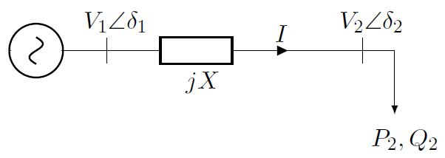
Fig. 1. Simplified model of a two-node electrical network.

The fundamental equations governing this system are as follows.
The apparent power injected at node 2 is expressed as:
$\overline{S_{2}}=V_{2}\overline{I^{*}}=P_{2}+jQ_{2}$ (1)
The current in the line is given by:
$I =\frac{V_{1}- V_{2}}{jX}$ (2)
By developing these expressions, we obtain the active and reactive powers:
$P_{2}=\frac{V_{1}V_{2}}{X}sinδ_{2}$ (3)
$Q_{2}=\frac{V_{1}V_{2}}{X}cosδ_{2}-\frac{V_{2}^{2}}{X}$ (4)
By eliminating the $δ_{2}$ using the trigonometric identity $\cos_{2}{δ_{2}^{2}+\sin_{2}{δ_{2}^{2}=1}}$, we obtain the characteristic equation:
$P_{2}^{2}+ {\left[Q_{2}+\frac{V_{2}^{2}}{X}\right]}^{2}=\frac{V_{1}^{2}V_{2}^{2}}{X^{2}}$ (5)
This leads to a quadratic equation in $V_{2}^{2}$:
$V_{2}^{4}+ \left(2Q_{2}X - V_{1}^{2}\right)V_{2}^{2}+ \left(P_{2}^{2}+ Q_{2}^{2}\right)X^{2}= 0$ (6)
By setting $Q_{2}=P_{2}\tan{ϕ}$, this equation becomes:
$V₂ = √\left[\frac{V_{1}^{2}- 2P^{2}X tanϕ}{2}±\frac{\sqrt{V_{1}^{4}- 4P_{2}^{2}X^{2}- 4P_{2}XV_{1}^{2}tanϕ}}{2}\right]$ (7)
Figure 2 presents the P-V curves derived from equation (7), illustrating the critical link between the voltage at node 2 and the active power for different power factors.
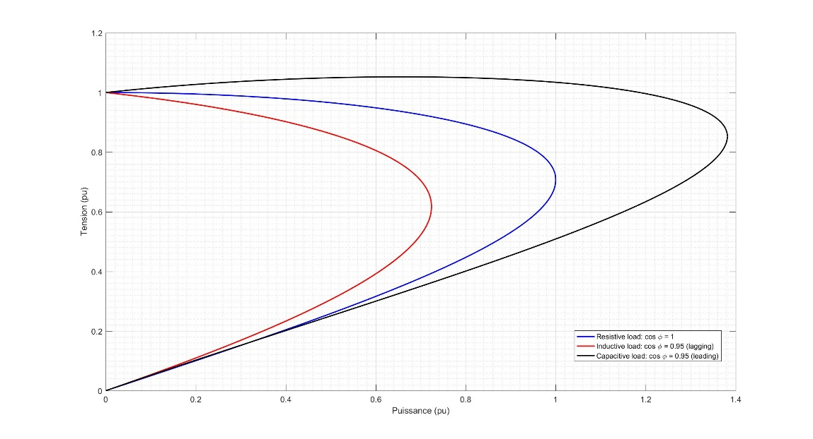

Fig. 2. Voltage evolution as a function of power.

Analysis of the P-V curves (Figure 2) reveals the existence of a collapse point beyond which the system becomes unstable [14]. Appropriate reactive power compensation moves this critical point further away and increases the stability margin.
2.2 Compensation techniques

2.2.1 Traditional compensation

Capacitor banks represent the traditional solution for reactive power compensation. Their operating principle is based on the injection of capacitive reactive power proportional to the square of the voltage [15]:
$Q_{C}= V^{2}·ωC =\frac{V^{2}}{X_{C}}, \text{avec} X_{C}=\frac{1}{ωC}$ (8)
Where C est la capacité de la batterie et $ω=2πf$ la pulsation.
Capacitor banks represent the traditional solution for reactive power compensation. Their widespread adoption is explained by several technical and economic advantages [16]:
- Cost-effective and proven solution: their acquisition and installation costs remain lower than those of advanced compensators, with a technology that has been mastered for several decades.
- Low maintenance costs: The absence of moving parts and the simplicity of their design reduce maintenance operations to periodic visual inspections.
- Simple installation: Their implementation does not require complex control systems, which facilitates their deployment in existing networks.
However, this technology has significant limitations that reduce its effectiveness in modern networks [16]:
- Quadratic dependence on voltage ($Q_{C}∝ V^{2}$): the injected reactive power decreases significantly during voltage drops, precisely when the need for compensation is most critical.
- Stepped, non-continuous compensation: the switching of capacitor stages creates abrupt transitions that can cause disturbances in the network.
- Inability to respond to rapid load variations: the high response time (on the order of seconds) makes them unsuitable for rapid fluctuations of industrial loads.
- Risk of overvoltage under light load conditions: excessive compensation can lead to dangerous overvoltages for equipment.
- Non-adaptive compensation: the lack of automatic regulation requires manual adjustments to adapt to changes in network configuration.

2.2.2 Advanced solutions

To overcome the limitations of traditional compensators, FACTS (Flexible AC Transmission Systems) technologies offer dynamic and controllable compensation [12, 16]. Among these, the Static Var Compensator (SVC) stands out due to its technological maturity and favorable performance/cost ratio [16].
2.2.2.1 SVC architecture
The SVC consists of a judicious combination of power electronics components enabling dynamic and precise compensation [16]:
- TSC (Thyristor Switched Capacitors): Capacitor banks switched by thyristors allowing rapid injection of capacitive reactive power. Each stage can be connected or disconnected within a few milliseconds [16].
- TCR (Thyristor Controlled Reactors): Thyristor-controlled reactors allowing the absorption of inductive reactive power. Phase angle control enables continuous variation of the absorbed power [16].
- Harmonic filters: Passive LC systems eliminating harmonics generated by thyristor switching, ensuring the quality of the voltage waveform [16].
- Control system: A real-time electronic regulation unit that measures the grid voltage and continuously adjusts the SVC’s susceptance to maintain the voltage at its setpoint [16].
This modular architecture allows the SVC to operate as a source/sink of reactive power with a continuous control range, offering good operational flexibility [16].

2.2.2.2 Advanced SVC modeling

Beyond the basic proportional model$Q_{SVC} = k (V_{ref}- V)$, modern SVCs implement sophisticated control strategies enabling robust and high-performance regulation of electrical networks [12, 16].
Complete dynamic model :
$Q_{SVC} = B_{SVC}V^{2}$ (9)
where $B_{SVC}$ represents the variable susceptance dynamically controlled by the electronic control system. This quadratic relationship reflects the dependence of the injected reactive power on the square of the voltage at the coupling point [16].
Advanced control scheme :
$B_{SVC}= K_{p\left(V_{ref}- V\right)}+ K_{i}∫\left(V_{ref}- V\right)dt$ (10)
This PI (Proportional-Integral) control structure eliminates steady-state error while ensuring an optimised dynamic response for network transients. The proportional term ensures a rapid reaction to voltage deviations, while the integral action cancels the residual error [16].
Implemented control strategies:
- PI/PID controllers with anti-windup: limiting the integrator wind-up effect during actuator saturation.
- Phase lead compensators: phase margin correction to improve closed-loop stability.
- Adaptive control: automatic adjustment of gains Kp and Ki based on network operating conditions.
- Current and voltage limiters: protection of semiconductor components against overstress [16].
Differential advantages of SVCs compared to traditional compensators [16]:
- Continuous and adaptive compensation: real-time regulation without jerks, with automatic adjustment to load variations.
- Rapid response: response time less than 20-50 ms, allowing it to follow the fastest fluctuations.
- Bidirectionality of reactive power: ability to supply (capacitive mode) or absorb (inductive mode) according to network needs.
- Improvement of transient stability: active voltage support during faults and abrupt load changes.
- Damping of oscillations: reduction of electromechanical power oscillations thanks to the stabilizing action.
- Independence from voltage: ability to inject reactive power even during severe voltage drops.
These advanced characteristics give SVCs a manifest technical superiority for applications requiring high-performance dynamic compensation [16].

3. Literature review

Reactive power compensation is a cornerstone of the stability and efficiency of electrical networks. This literature review traces the evolution of compensation solutions, from theoretical foundations to modern applications, highlighting the emergence of FACTS technologies and the particular relevance of SVC for networks with constraints similar to those in N’Djamena.
3.1 Theoretical foundations and emergence of FACTS technologies

The theoretical foundations of reactive compensation were established by reference works. Kundur (1994), in his seminal work Power System Stability and Control, identified reactive compensation as a key factor in preventing voltage collapse, particularly in weakly meshed and heavily loaded networks [9]. Concurrently, Hingorani and Gyugyi (2000) laid the groundwork for FACTS systems in Understanding FACTS, demonstrating their ability to radically improve network stability and controllability by increasing, for example, transmissible power by up to 30% on critical lines [17]. This work paved the way for dynamic compensators like the SVC.
3.2 Technical superiority of SVC

Faced with the limitations of traditional compensators (capacitor banks), notably their quadratic dependence on voltage and their slow, stepped response, the SVC stands out as an optimal solution. Dixon et al. (2005) conducted a comprehensive review of the technologies, concluding that the SVC offers the best performance-cost compromise for voltage regulation in medium-sized networks [16]. Its ability to provide bidirectional (injecting or absorbing reactive power), continuous, and fast (response time < 50 ms) compensation gives it a decisive advantage for maintaining a stable voltage profile and reducing energy losses, as quantified by El-Hawary (2008) and others [18].
3.3 Applications and challenges in african networks

The specific context of African electrical networks, marked by rapid demand growth, ageing infrastructure, and low inertia, requires robust and adapted solutions. Recent studies have validated the effectiveness of SVC in this framework. For instance, work on the West African power pool showed a 7 to 10% improvement in the voltage profile thanks to static compensators. Research specific to Central and Southern African networks emphasises that SVC is a key technology for enhancing stability and facilitating the integration of renewable energies, despite challenges related to maintenance and instrumentation.
3.4 Future prospects: integration of renewable energies and artificial intelligence

The current evolution of networks, with the massive penetration of intermittent renewable energies (solar, wind), reinforces the need for dynamic compensation. Research is now exploring hybrid architectures combining SVC and energy storage systems to simultaneously manage production variations and reactive power needs. An emerging trend involves applying Machine Learning for SVC control, aiming to develop self-adaptive systems capable of anticipating load and generation fluctuations.
3.5 Positioning of the present study

Within this scientific landscape, the present study positions itself by providing concrete, contextualized experimental validation of the impact of SVC on the real network of N’Djamena. It addresses a gap by providing a rigorous quantitative analysis of gains in voltage stability and loss reduction, thus offering a solid technical rationale to guide investment decisions in the modernisation of Chadian electrical networks and, by extension, those sharing similar operational constraints.
4. Methodology

4.1 Description of the studied network

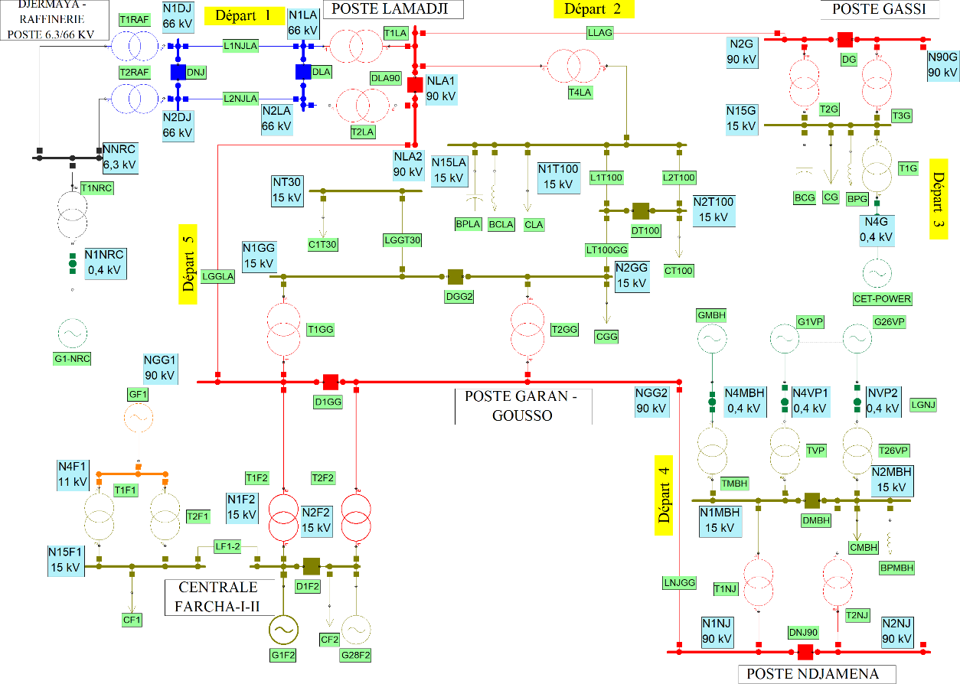
The modelled N’Djamena network comprises 31 nodes, 31 lines, 8 generating units, and 8 loads, with passive compensators at Lamadji, Gassi, Garangosso, and Djambalbar. This topology faithfully represents the real network of the Chadian capital, as shown in Figure 3.

Fig. 3. Single-line diagram of the N’Djamena network.

4.2 Simulation tools and parameters

Simulations were performed using NEPLAN software, utilising the Newton-Raphson algorithm for power flow calculation. The calculations are based on the fundamental equations governing active and reactive power flows between nodes i and j:
$\left\{\begin{aligned}P_{ij}= V_{i}{ V}_{j}{ Y}_{ij} cos(θ_{i} - θ_{j} -ϕ_{ij}) \\ Q_{ij}= V_{i}V_{j}Y_{ij} sin(θ_{i} - θ_{j} -ϕ_{ij})\end{aligned}\right.$ (11)
These equations determine the complete state of the network (voltages, powers, losses) in the different scenarios considered.
The total active energy losses in the network were calculated by aggregating the losses on each line. The formula used is as follows:
$P_{perte} = \sum_{(i,j)}{R_{ij} }· \left(\frac{{\left|S_{ij}\right|}^{2}}{{\left|V_{i}\right|}^{2}}\right)$ (12)
where $R_{ij}$ is the resistance of the line between i and j, $S_{ij}$ is the apparent power flowing in this line, and $V_{i}$ is the voltage at node i. This method allows a precise evaluation of the impact of SVCs on the network’s energy efficiency.
4.3 Study scenarios

Two scenarios are analysed:
- Nominal load (100%) with and without SVC;
- Maximum load (120%) with and without SVC.
The placement of the SVCs was determined by an analysis of critical voltage deviations identified at nodes NT30, N1T100, N2T100, and N15LA, which exhibited the most severe voltage drops (>10%). The SVC power was sized to cover the global reactive deficit observed during preliminary simulations. This strategic choice aims to maximise the impact of the compensators on the overall voltage stability.
5. Results and discussion

5.1 Presentation of simulation results

Simulations were conducted on the N’Djamena network to evaluate the impact of the Static Var Compensator (SVC) on voltage stability. Two load scenarios were considered: nominal load (100%) and maximum load (120%). The results obtained are presented in Tables 1 and 2, which compare the voltages at critical nodes as well as the active and reactive energy losses, with and without SVC compensation.
Table 1. Impact of SVCs on voltage profile and losses at nominal load (100%)

Parameter / Node | Without SVC | With SVC | Absolute improvement
Voltage profile (% of nominal)
N15LA | 89.78 % | 92.83 % | +3.05 points
N1T100 | 85.05 % | 92.53 % | +7.48 points
N2T100 | 85.03 % | 92.52 % | +7.49 points
NT30 | 79.01 % | 92.51 % | +13.50 points
Energy losses
Active losses (MW) | 9.104 | 8.296 | -0.808 MW
Reactive losses (MVar) | 7.912 | 6.059 | -1.853 MVar

Table 2. Impact of SVCs on voltage profile and losses at maximum load (120%)

Parameter / Node | Without SVC | With SVC | Absolute improvement
Voltage profile (% of nominal)
N15LA | 86.68 % | 91.49 % | +4.81 points
N1T100 | 80.57 % | 92.39 % | +11.82 points
N2T100 | 80.55 % | 92.38 % | +11.83 points
NT30 | 72.18 % | 92.37 % | +20.19 points
Energy losses
Active losses (MW) | 13.224 | 11.638 | -1.586 MW
Reactive losses (MVar) | 18.808 | 15.131 | -3.677 MVar

These initial quantitative results form the basis of the comparative analysis presented in the following section, aiming to interpret the physical and dynamic influence of the SVC on the voltage behaviour of the network.
5.2 Comparative analysis of network performance

The analysis highlights the determining role of the Static Var Compensator (SVC) in improving voltage stability. Without compensation, the voltage drops rapidly when the load increases, particularly on the lines farthest from the source, reflecting a reduced stability margin characteristic of a network weakly supported by reactive power.
The introduction of the SVC alters this dynamic: the device acts as a local source of reactive power, injecting or absorbing reactive current according to the instantaneous needs of the network. This automatic action makes it possible to maintain voltages within acceptable limits and to flatten the voltage profile while pushing the critical instability point towards higher load levels. Thus, the voltage profile becomes more homogeneous and the stability margin increases significantly.
Indeed, the simulation results indicate a systematic improvement in the voltage profile across all critical nodes when the SVC is activated. The beneficial effect is particularly marked at nodes NT30 and N1T100, where the voltage increases by +13.5 and +7.5 points respectively at nominal load, and up to +20 points at maximum load. Concurrently, a notable reduction in active and reactive losses is observed, reflecting an overall more efficient network operation.
This reduction in losses stems directly from the decrease in reactive power flows circulating in the lines. By maintaining voltages close to their nominal value, the SVC optimises power flow distribution, reduces energy dissipation, and improves network efficiency. These observations confirm the theoretical predictions of reactive compensation and illustrate the effectiveness of the SVC as a tool for stabilizing voltage in heavily stressed distribution networks.
6. conclusion

This study has evaluated the effectiveness of the Static Var Compensator (SVC) in improving voltage stability and reducing electrical losses in the N’Djamena network. The simulation results confirm that the integration of this device contributes significantly to the improvement of the voltage profile and the optimisation of the overall system operation.

6.1 Summary of improvements

Comparative analyses have shown that the introduction of the SVC makes it possible to maintain all critical nodes within an admissible voltage range, between 92 and 98% of the nominal voltage, compared to 72 to 90% in the absence of compensation. This effective voltage regulation is accompanied by a notable reduction in active losses (up to 12%) and reactive losses (up to 23.4%), reflecting better utilisation of transmitted power and a limitation of unnecessary reactive flows. Furthermore, the network retains good robustness even under maximum load conditions (+20%), while eliminating the risk of voltage collapse at the most sensitive nodes. These performances confirm the essential role of the SVC in strengthening the operational security of the network.
6.2 Main contributions

Beyond the results obtained, this study brings several notable contributions. Firstly, it provides experimental validation of the effectiveness of SVC compensators in the particular context of African networks, often characterised by ageing infrastructure and high load variability. Secondly, it proposes a rigorous methodology for identifying critical nodes, allowing for the targeting of network points where the installation of compensation devices yields the greatest benefit. Finally, it offers a precise quantification of the technical gains obtained in terms of voltage stability and energy efficiency, thus providing a solid scientific basis for the planning and modernisation of local electrical networks.
6.3 Perspectives

The prospects of this work pave the way for several avenues of further research:
- A first direction involves optimising the placement and sizing of SVCs to maximise their impact while minimising investment costs.
- The joint integration of the SVC with renewable energy sources also constitutes a major challenge, particularly in a context of energy transition where production variability increases the need for reactive compensation.
- Furthermore, an in-depth cost-benefit analysis would economically justify the implementation of these solutions on larger portions of the network.
- Finally, the coordination of the SVC with other FACTS (Flexible AC Transmission Systems) devices could offer a more global approach to managing voltage stability and power flows.
In summary, the results obtained demonstrate that the SVC constitutes a mature, high-performance, and adaptable technological solution for improving the voltage stability of developing electrical networks. Its large-scale adoption could contribute to strengthening the reliability and sustainability of electrical systems, particularly in contexts similar to that of the N’Djamena network.
References

- Kanchev, H. (2014). Energy flow management in a hybrid renewable energy system: Optimization of operational planning and adjustment of an urban microgrid [Doctoral dissertation, Ecole Centrale de Lille and Sofia Technical University].

- Omar, C. I. (2023). Modeling, optimization, and energy management of a hybrid renewable energy power plant [Doctoral dissertation, Normandie Université].
- Turitsyn, K., Sulc, P., Backhaus, S., & Chertkov, M. (2011). Options for control of reactive power by distributed photovoltaic generators. Proceedings of the IEEE, 99(6), 1063–1073. https://doi.org/10.1109/JPROC.2011.2116750
- Ganongo, A. O., Gogom, M., Nianga-Apila, Obita, L. L. A., & Ganga, G. (2024). Optimization of lightning current discharge to the ground in electrical networks: Introduction of the proportionality coefficient (k). Electric Power Systems Research, 231, 110348. https://doi.org/10.1016/j.epsr.2024.110348
- Gogom, M., Oko Ganongo, A., Apila, N., & Lilonga-Boyenga, D. (2020). Optimization of power transit through a double-term line term by the UPFC. Science Journal of Energy Engineering, 8(4), 44–53. https://doi.org/10.11648/j.sjee.20200804.11
- Omboua Eyandzi, A., Gomba, R., Nianga-Apila, Nsongo, T., & Kani Mboyo, U. V. (2025). Analysis of dynamic interactions between reactive compensation and voltage stability in THT networks with svc. American Journal of Electrical Power and Energy Systems, 14(3), 45–63. https://doi.org/10.11648/j.epes.20251403.11
- Li, C., Disfani, V., Haghi, H.V., & Kleissl, J. (2019). Optimal voltage regulation of unbalanced distribution networks with coordination of OLTC and PV generation. arXiv. https://arxiv.org/abs/1901.09509
- Prasetya, C. A., & Sudiarto, B. (2023). The Impact of a 1.1 MWp PV Rooftop Integration in Medium Voltage Distribution Networks. International Journal of Electrical, Computer, and Biomedical Engineering, 1(1), 11–23. https://ijecbe.ui.ac.id/go/article/view/7
- Acha, E., Fuerte-Esquivel, C. R., Ambriz-Pérez, H., & Angeles-Camacho, C. (2004). FACTS: Modeling and Simulation in Power Networks. Wiley.
- Kundur, P. (1994). Power System Stability and Control. McGraw-Hill.
- IEEE Power Engineering Society. (2011). IEEE Guide for the Functional Specification of Transmission Static Var Compensators.
- Shea, J.J., Hingorani, N.G., Gyugyi, L., et al. (2002). Understanding facts-concepts and technology of flexible ac transmission systems. IEEE Electrical Insulation Magazine, 18(1), 46. https://doi.org/10.1109/MEI.2002.981326

- Andersson, G. (2012). Power System Analysis (2nd ed.). CRC Press.
- Van Cutsem, T., & Vournas, C. (2015). Voltage Stability of Electric Power Systems. Springer.
- Grainger, J. J., & Stevenson, W. D. (1994). Power System Analysis (1st ed.). McGraw-Hill.

- Dixon, J., Morán, L., Rodríguez, J., & Domke, R. (2005). Reactive power compensation technologies: State-of-the-art review. Proceedings of the IEEE, 93(12), 2144–2164. https://doi.org/10.1109/JPROC.2005.859937

- Hingorani, N. G., & Gyugyi, L. (2000). Understanding FACTS: Concepts and Technology of Flexible AC Transmission Systems. IEEE Press.

- El-Hawary, M. E. (2008). Electrical Power Systems. CRC Press.

APPENDIX

These tables (tables 3, 4, 5 and 6) presents the detailed results of the simulations performed under the different load Scenarios, with and without the integration of the static var compensator (SVC). The tables below provide the complete values of voltages, active and reactive powers at the different nodes of the N’Djamena Electrical network. These data allow visualisation of the precise impact of the SVC on the voltage profile and on power Flows, and constitute the numerical support for the analyses presented in the main body of the article.

Table 3. Voltages and powers at different nodes without SVC (nominal load 100%)

BUS | U (kV) | U (%) | P_{R}(MW) | Q_{R}(MV AR) | P_{G}(MW) | Q_{G}(MV AR)
N15F1 | 15 | 100 | 0.3 | 0.13 | 0 | 0
N15G | 14.716 | 98.11 | 18 | 4.5 | 0 | 0
N15LA | 13.467 | 89.78 | 18 | 4.5 | 0 | 0
N1AGG | 0.414 | 103.45 | 0 | 3 | 28 | 0
N1DJ | 65.553 | 99.32 | 0 | 0 | 0 | 0
N1F2 | 15.024 | 100.16 | 0 | 0 | 76.004 | 35.278
N1GG | 13.891 | 92.61 | 0 | 0 | 0 | 0
N1LA | 64.898 | 98.33 | 0 | 0 | 0 | 0
N1MBH | 14.086 | 93.91 | 0 | 0 | 0 | 0
N1NJ | 87.996 | 97.77 | 0 | 0 | 0 | 0
N1T100 | 12.757 | 85.05 | 0 | 0 | 0 | 0
N2DJ | 65.553 | 99.32 | 0 | 0 | 0 | 0
N2F2 | 15.01 | 100.07 | 0.8 | 0.33 | 0 | 0
N2G | 88.188 | 97.99 | 0 | 0 | 0 | 0
N2GG | 13.889 | 92.59 | 26 | 6.5 | 0 | 0
N2LA | 64.898 | 98.33 | 0 | 0 | 0 | 0
N2MBH | 14.078 | 93.85 | 40 | 10 | 0 | 0
N2NJ | 87.995 | 97.77 | 0 | 0 | 0 | 0
N2T100 | 12.755 | 85.03 | 10 | 2.5 | 0 | 0
N4F1 | 10.992 | 99.93 | 0 | 3 | 7 | 0
N4G | 0.4 | 100 | 0 | 0 | 5.3 | 9.594
N4MBH | 0.38 | 95.12 | 0 | 0 | 5.3 | 0
N4VP1 | 0.379 | 94.72 | 0 | 0 | 5.3 | 0
N9OG | 88.188 | 97.99 | 0 | 0 | 0 | 0
NAGG | 6.33 | 100.48 | 0 | 0 | 0 | 0
NGG1 | 88.305 | 98.12 | 0 | 0 | 0 | 0
NGG2 | 88.305 | 98.12 | 0 | 0 | 0 | 0
NLA1 | 87.645 | 97.38 | 0 | 0 | 0 | 0
NLA2 | 87.646 | 97.38 | 0 | 0 | 0 | 0
NT30 | 11.852 | 79.01 | 10 | 2.5 | 0 | 0
NVP2 | 0.379 | 94.66 | 0 | 0 | 5.3 | 0

BUS | U (kV) | U (%) | P_{R} (MW) | Q_{R} | (MVAR) | P_{G} (MW) | Q_{G} (MVAR)
N15F1 | 15 | 100 | 0.3 |  | 0.13 | 0 | 0
N15G | 14.783 | 98.55 | 18 |  | 4.5 | 0 | 0
N15LA | 13.924 | 92.83 | 18 |  | 4.5 | 0 | 0
N1AGG | 0.418 | 104.41 | 0 |  | 3 | 28 | 0
N1DJ | 66.199 | 100.3 | 0 |  | 0 | 0 | 0
N1F2 | 15.024 | 100.16 | 0 |  | 0 | 75.196 | 20.816
N1GG | 14.271 | 95.14 | 0 |  | 0 | 0 | 0
N1LA | 65.546 | 99.31 | 0 |  | 0 | 0 | 0
N1MBH | 14.2 | 94.67 | 0 |  | 0 | 0 | 0
N1NJ | 88.652 | 98.5 | 0 |  | 0 | 0 | 0
N1T100 | 13.88 | 92.53 | 0 |  | 0 | 0 | 0
N2DJ | 66.199 | 100.3 | 0 |  | 0 | 0 | 0
N2F2 | 15.01 | 100.07 | 0.8 |  | 0.33 | 0 | 0
N2G | 88.835 | 98.71 | 0 |  | 0 | 0 | 0
N2GG | 14.268 | 95.12 | 26 |  | 6.5 | 0 | 0
N2LA | 65.546 | 99.31 | 0 |  | 0 | 0 | 0
N2MBH | 14.192 | 94.61 | 40 |  | 10 | 0 | 0
N2NJ | 88.651 | 98.5 | 0 |  | 0 | 0 | 0
N2T100 | 13.878 | 92.52 | 10 |  | 2.5 | 0 | 0
N4F1 | 10.992 | 99.93 | 0 |  | 3 | 7 | 0
N4G | 0.4 | 100 | 0 |  | 0 | 5.3 | 7.043
N4MBH | 0.384 | 95.88 | 0 |  | 0 | 5.3 | 0
N4VP1 | 0.382 | 95.47 | 0 |  | 0 | 5.3 | 0
N9OG | 88.834 | 98.7 | 0 |  | 0 | 0 | 0
NAGG | 6.392 | 101.46 | 0 |  | 0 | 0 | 0
NGG1 | 88.956 | 98.84 | 0 |  | 0 | 0 | 0
NGG2 | 88.956 | 98.84 | 0 |  | 0 | 0 | 0
NLA1 | 88.519 | 98.35 | 0 |  | 0 | 0 | 0
NLA2 | 88.521 | 98.36 | 0 |  | 0 | 0 | 0
NT30 | 13.877 | 92.51 | 10 |  | 2.5 | 0 | 0
NVP2 | 0.382 | 95.42 | 0 |  | 0 | 5.3 | 0

Table 4. Voltages and powers at different nodes with SVC (nominal load 100%)

Table 5. Voltages and powers at different nodes without SVC (maximum load 120%)

BUS | U (kV) | U (%) | P_{R} (MW) | Q_{R} (MVAR) | P_{G} (MW) | Q_{G} (MVAR)
N15F1 | 15 | 100 | 0.36 | 0.156 | 0 | 0
N15G | 14.823 | 98.82 | 21.6 | 5.4 | 0 | 0
N15LA | 13.723 | 91.49 | 21.6 | 5.4 | 0 | 0
N1AGG | 0.418 | 104.41 | 0 | 3 | 28 | 0
N1DJ | 65.657 | 99.48 | 0 | 0 | 0 | 0
N1F2 | 15.025 | 100.17 | 0 | 0 | 103.158 | 28.893
N1GG | 14.108 | 94.05 | 0 | 0 | 0 | 0
N1LA | 65.004 | 98.49 | 0 | 0 | 0 | 0
N1MBH | 14.200 | 94.67 | 0 | 0 | 0 | 0
N1NJ | 88.252 | 98.06 | 0 | 0 | 0 | 0
N1T100 | 13.858 | 92.39 | 0 | 0 | 0 | 0
N2DJ | 65.657 | 99.48 | 0 | 0 | 0 | 0
N2F2 | 15.006 | 100.04 | 0.96 | 0.396 | 0 | 0
N2G | 88.435 | 98.26 | 0 | 0 | 0 | 0
N2GG | 14.105 | 94.03 | 31.2 | 7.8 | 0 | 0
N2LA | 65.004 | 98.49 | 0 | 0 | 0 | 0
N2MBH | 14.192 | 94.61 | 48 | 12 | 0 | 0
N2NJ | 88.251 | 98.06 | 0 | 0 | 0 | 0
N2T100 | 13.857 | 92.38 | 12 | 3 | 0 | 0
N4F1 | 10.992 | 99.93 | 0 | 3 | 7 | 0
N4G | 0.4 | 100 | 0 | 0 | 5.3 | 9.651
N4MBH | 0.384 | 95.88 | 0 | 0 | 5.3 | 0
N4VP1 | 0.382 | 95.47 | 0 | 0 | 5.3 | 0
N9OG | 88.434 | 98.26 | 0 | 0 | 0 | 0
NAGG | 6.392 | 101.46 | 0 | 0 | 0 | 0
NGG1 | 88.556 | 98.40 | 0 | 0 | 0 | 0
NGG2 | 88.556 | 98.40 | 0 | 0 | 0 | 0
NLA1 | 88.119 | 97.91 | 0 | 0 | 0 | 0
NLA2 | 88.121 | 97.91 | 0 | 0 | 0 | 0
NT30 | 13.856 | 92.37 | 12 | 3 | 0 | 0
NVP2 | 0.382 | 95.42 | 0 | 0 | 5.3 | 0

Table 6. Voltages and powers at different nodes with SVC (maximum load 120%)

BUS | U (kV) | U(%) | P_{R} (MW) | Q_{R} (MVAR) | P_{G} (MW) | Q_{G} (MVAR)
N15F1 | 15 | 100 | 0.36 | 0.156 | 0 | 0
N15G | 14.72 | 98.13 | 21.6 | 5.4 | 0 | 0
N15LA | 13.724 | 91.49 | 21.6 | 5.4 | 0 | 0
N1AGG | 0.416 | 103.95 | 0 | 3 | 28 | 0
N1DJ | 65.887 | 99.83 | 0 | 0 | 0 | 0
N1F2 | 15.025 | 100.17 | 0 | 0 | 103.158 | 26.516
N1GG | 14.113 | 94.09 | 0 | 0 | 0 | 0
N1LA | 65.233 | 98.84 | 0 | 0 | 0 | 0
N1MBH | 13.942 | 92.95 | 0 | 0 | 0 | 0
N1NJ | 88.144 | 97.94 | 0 | 0 | 0 | 0
N1T100 | 13.859 | 92.39 | 0 | 0 | 0 | 0
N2DJ | 65.887 | 99.83 | 0 | 0 | 0 | 0
N2F2 | 15.006 | 100.04 | 0.96 | 0.396 | 0 | 0
N2G | 88.421 | 98.25 | 0 | 0 | 0 | 0
N2GG | 14.109 | 94.06 | 31.2 | 7.8 | 0 | 0
N2LA | 65.233 | 98.84 | 0 | 0 | 0 | 0
N2MBH | 13.932 | 92.88 | 48 | 12 | 0 | 0
N2NJ | 88.143 | 97.94 | 0 | 0 | 0 | 0
N2T100 | 13.857 | 92.38 | 12 | 3 | 0 | 0
N4F1 | 10.992 | 99.93 | 0 | 3 | 7 | 0
N4G | 0.4 | 100 | 0 | 0 | 5.3 | 9.455
N4MBH | 0.377 | 94.18 | 0 | 0 | 5.3 | 0
N4VP1 | 0.375 | 93.77 | 0 | 0 | 5.3 | 0
N9OG | 88.421 | 98.25 | 0 | 0 | 0 | 0
NAGG | 6.362 | 100.99 | 0 | 0 | 0 | 0
NGG1 | 88.599 | 98.44 | 0 | 0 | 0 | 0
NGG2 | 88.598 | 98.44 | 0 | 0 | 0 | 0
NLA1 | 88.096 | 97.88 | 0 | 0 | 0 | 0
NLA2 | 88.098 | 97.89 | 0 | 0 | 0 | 0
NT30 | 13.855 | 92.37 | 12 | 3 | 0 | 0
NVP2 | 0.375 | 93.7 | 0 | 0 | 5.3 | 0

