Original Research Article

Assessing the Profitability of a Remanufactured Electric Vehicle Battery Pack

ABSTRACT
Background: The rapid global adoption of electric vehicles (EVs) is generating a growing stream of lithium-ion battery packs reaching their end-of-first-life (EOFL), typically with 70-80% of their original capacity remaining. While recycling recovers valuable materials, remanufacturing, the process of disassembling, testing, repairing, and reconfiguring these packs for secondary applications, presents a promising circular economy strategy. This approach can create significant economic value and mitigate environmental impacts. However, the commercial viability of this practice remains uncertain due to a complex interplay of technical, logistical, and market factors. This study conducts a detailed techno-economic assessment to develop a robust profitability model for EV battery pack remanufacturing.
Objectives: This study aims to construct a comprehensive financial model to determine if the revenues from selling remanufactured EV battery packs outweigh the total costs incurred in the remanufacturing process, thereby achieving a measurable and attractive profit.
Methods: The methodology involves creating a comprehensive cost-revenue model. Key cost drivers are quantified, including core acquisition (cost of the EOFL pack), reverse logistics (transportation and collection), diagnostic testing, disassembly labour, replacement of defective cells or modules, and reassembly. Revenue streams are analyzed across multiple second-life applications, each with distinct market values and technical requirements. These include stationary energy storage systems (ESS) for residential, commercial, and grid support, as well as reuse in lower-demand mobility applications, such as forklifts or urban delivery vehicles. Scenario analysis is used to identify the most critical variables that influence profitability.
Results: The results indicate that under optimised conditions, such as economies of scale, design-for-remanufacturing principles, and access to high-value second-life markets like grid-scale ESS, remanufacturing can achieve a positive net present value (NPV) and attractive internal rates of return (IRR). However, the current nascent state of the market, characterised by high core costs and volatile resale prices, presents significant financial risk. This study concludes that while a profitable remanufacturing operation is feasible, its realisation is contingent upon strategic partnerships between OEMs, remanufacturers, and second-life off-takers, supportive policy frameworks, and continued innovation in automated disassembly and diagnostic technologies. The findings provide a critical decision-support framework for investors, policymakers, and entrepreneurs seeking to capitalise on the emerging circular economy for EV batteries.
Keywords: Electric Vehicle (EV), Battery Remanufacturing, Second-Life Batteries, Circular Economy, Profitability Model, Lithium-Ion Battery, End-of-Life (EOL) Management, Stationary Energy Storage.

Table 1: Table of acronyms.
Acronym Description
AR Augmented Reality
Bad cells < 2.5 volts per cell
BMS Battery Management System
BYD Buy Your Dreams
DC Direct Current
EOL End-of-Life
ESS Energy Storage Systems
EV Electric Vehicle
EPA Environmental Protection Agency
Good cells > 2.5 – 3.2 volts per cell
GHG Greenhouse gas
IRR Internal rate of return
IoT Internet of Things
ISO International Standard Organization
LCA Life Cycle Assessment
LIB Lithium-Ion Battery
mΩ million ohms
OCV Open Circuit Voltage
OEM: Original Equipment Manufacturer
RUL: Remaining Useful Life
SOC State of Charge
SOH State of Health

INTRODUCTION

As a result of the pressing need to reduce reliance on fossil fuels and combat climate change, the global transportation sector is undergoing a significant transition. [1]The fast electrification of road transportation is at the vanguard of this shift, with millions of electric vehicles (EVs) being deployed annually worldwide. Lithium-ion battery technology, which offers the high energy density and power needed for contemporary mobility, is largely responsible for this spike in EV adoption[2]. This achievement, however, raises a serious and expanding end-of-life issue. In their primary application, EV battery packs, the most valuable part of the vehicle, have a limited service life. They are generally considered to have reached their "end-of-first-life" (EOFL) when their capacity drops to 70–80% of the original, at which point they are no longer able to meet consumer expectations for performance and range[3]. An important moment for resource and waste management sustainability is presented by the upcoming wave of EOFL batteries. Recycling has historically been the primary end-of-life process for complex items, with an emphasis on recovering raw elements such as nickel, cobalt, and lithium[4]. Even while recycling is crucial to completing the material cycle, it is a "low-value" recovery option for EOFL EV batteries, which nevertheless have a significant amount of economic value and functional capability. Remanufacturing is an alternative and increasingly promising paradigm; hence,[5] remanufacturing is an industrial process that carefully disassembles, cleans, inspects, replaces parts, and reassembles a used product to restore it to a like-new or better-than-new functional state and performance guarantee. In the context of EV batteries, this process breathes a second life into these packs, diverting them from the waste stream and creating a core pillar of the circular economy.
These remanufactured battery packs have a wide range of potential uses and are reasonably priced. [6]They can be used for stationary energy storage systems (ESS), which offer vital services like peak shaving for businesses, integration of intermittent renewable energy sources like wind and solar, backup power for homes, and grid stability. Industrial machinery, material handling devices like forklifts, and low-speed electric cars are among the further uses. Significant economic and environmental benefits result from this second-life use, which further prolongs the battery's usable life, delays recycling expenses, and lowers the need for raw materials for new battery manufacture[7]. Despite this compelling potential, the commercial viability and profitability of remanufacturing EV battery packs remain highly uncertain and are not yet well-understood. [8]The remanufacturing process faces a complex web of technical, logistical, and economic hurdles. First of all, has to do with High and Variable Costs: The process is inherently cost-intensive, involving expensive reverse logistics, sophisticated diagnostic testing, labour-intensive disassembly (often complicated by a lack of standardization across OEMs), and the potential need for costly cell or module replacements[9]. Secondly, Uncertain Revenue Streams: The market for second-life batteries is still nascent, with volatile and often unpredictable pricing. The value of a remanufactured pack is highly dependent on its proven remaining capacity, lifetime expectancy, and the specific demands of the second-life application[10]. Lastly, Technical and Informational Barriers: Assessing the State of Health (SOH) and remaining useful life (RUL) of a used battery is complex. A lack of transparent historical data and standardized pack designs increases processing time, cost, and risk[11]. Therefore, a systematic and detailed assessment of profitability is not merely an academic exercise but a critical necessity to de-risk investment, guide business model development, and inform policy[12]. This study seeks to address this crucial gap by conducting a comprehensive techno-economic analysis (TEA) where the model will meticulously quantify all major cost drivers and potential revenue streams, and through scenario analysis, identify the most critical factors that determine financial success or failure. The findings of this study are intended to provide a decisive framework for remanufacturers, investors, and policymakers, enabling them to navigate the complexities of this emerging industry and unlock the significant economic and environmental value embedded in end-of-first-life EV batteries.
The paper is organised as follows: Section 2 covers the methodology used to undertake the study. Section 3 presents the real-world performance testing results and discussions on all the profitability made on the remanufactured battery. Profitability assessment of EV batteries at large is given in Section 4, and finally, a conclusion on the study is given in Section 5

2. METHODOLOGY
[13]The viability of the entire remanufacturing operation depends upon the efficient and safe acquisition of End-of-First-Life (EOFL) battery packs and their accurate initial assessment.

2.1 Battery Collection and Screening
This phase is designed to ensure a consistent supply of suitable cores while minimizing the risk of acquiring packs that are economically unviable to remanufacture. [14]The researcher sourced degraded EV battery packs from fleet operators, vehicles dismantlers and authorised dealerships at the end of their first life, ensuring a representative range of understandings and degradation levels and were all transported to the laboratory, where documentation of each battery pack was checked to retrieve their history, such as age, mileage, charge cycles, failure records, and warranty claims. Upon arrival, a visual inspection was conducted to identify obvious signs of physical damage, swelling, corrosion, leakage, integrity of connectors, fire exposure, and unsafe batteries were immediately excluded to ensures that only packs with a confirmed economic and technical potential for remanufacturing proceed to the subsequent stages of disassembly and repair, thereby optimizing resource allocation and maximizing the profitability of the overall operation.

  - Battery Testing and Categorisation
The objective of this phase is to move from a general assessment to a precise, data-driven evaluation of each battery module's health and characteristics, where the data is essential for determining the technical feasibility, cost, and optimal second-life application for the remanufactured pack. The state of health (SoH), state of charge (SoC), and Internal resistance of the batteries were all tested by the researcher with instruments such as multimeters, battery testers and cyclers, including diagnostics tools, respectively, to know the remaining capacity, check whether the battery modules can hold and retain charge, while checking for higher degradation and heat risk for the batteries. [15]Batteries were then grouped into directly reusable, where modules and cells are still within an acceptable performance range, which is >80% SoH threshold, and may only need testing and balancing. Manufacturable, where modules and cells with little degraded performance but still safe and strictly viable for recovery, and Recyclable, where batteries are too damaged and chemically exhausted, suitable only for material recovery. Only batteries that are safe, carefully viable, and have a capacity above a threshold (usually ≥70% SoH) were remanufactured, while the others were diverted to second-life applications and recycling.

  - Remanufacturing and Cost Analysis
The objective of this phase is to execute the physical remanufacturing of battery packs based on the categorisation data and, concurrently, to build a comprehensive cost-revenue model to determine the economic viability of the entire operation. After careful observation and testing, the researcher used an ISO approach to disassemble and assemble the battery pack, and Items that needed replacement were bought and replaced[16]. A detailed financial blueprint for evaluating the viability of EV battery remanufacturing is provided in Table 2. This helps to determine realistic pricing strategies, identify cost-saving opportunities, and accurately project profitability.
Table 2. Cost of items for battery remanufacturing.
Material Cost | Amount Ghc
Cost of cells replaced | 2580.5
Cathode | 650
Anode | 650
Separators | 1300
Mechanical Items (casing, brackets, bolts, nuts, screws, damping pads) | 3000.4
Electrical Items (copper, wires, nickel plates, aluminium) | 2499.9
Electronics Items (temp. Sensors, voltage sensors, microcontrollers) | 5500.3
Thermal Items (cooling plates, insulation plates, etc) | 1496.3
Total | 17677.4
Labour Cost | Amount Ghc
Disassembly | 1800.5
Inspection | 300.3
Reassembly | 1999.4
Testing | 495.3
Total | 4595.5
Energy Consumed | Amount Ghc
Total energy consumed per 1battery remanufactured | 250
Equipment’s | Amount Ghc
1.Load testers, 2.Cell balancers, 3.Diagnostic software/hardware, 4.Welding/soldering equipment | (1) 78,000. (2) 26,000 (3) 65,000  (4) 39,000  10% Depreciation
Table 2 is divided into four (4) sections, which include the following items,
1. Material Cost: These are the expenses related to the raw materials required to build the battery pack, and they include the cost of cells, Cathode, Anode, Separators, Mechanical Items, Electrical Items, Electronic Items, and Thermal Items
2. Labour Cost: These are wages paid for manual or technical work during the remanufacturing process, and they include Disassembly, Inspection, Reassembly, and
Testing.
3. Energy Consumed: This represents the electricity used during the entire remanufacturing process, including disassembly, diagnostics, charging, and testing
4. Equipment Cost: These are capital expenditures on specialised tools required for the remanufacturing process and depreciated at 10% annually. They include: Load Testers
Cell Balancers, Diagnostic Software/Hardware, Welding/Soldering Equipment, 10% Depreciation on Equipment.

2.4 Other Information
Table 3 shows additional Information that was documented but was not captured in Table 2, which assisted the researcher in the assessment of the remanufactured battery profitability.
Table 3. Other items for additional information.
Items | Value
Cost of a New Battery | 93,210 – 139,815GHC
Cost of a Remanufactured Battery | 46,605 – 97,890GHC
Battery Type | Lithium Iron Phosphate (LiFePO4)
Total Pack Capacity | 71.7 kWh
Voltage | 320V
Number of Cells in Series (to reach pack voltage) | 100

A thorough understanding of the technical and financial factors influencing the profitability of EV battery remanufacturing is facilitated by this comprehensive methodology.

3. Results and Discussions
The profitability of remanufactured electric vehicle (EV) battery packs was evaluated after a thorough examination of labour costs, material costs, energy usage, and equipment depreciation. To assess the profit potential, the unit cost of remanufacturing a degraded battery was calculated and compared to the planned market selling price.

3.1 Battery Collection and Screening
A total of 10 degraded EV battery packs were collected from various sources and processed, which include 2 batteries from end-of-life vehicles, 3 batteries from warranty returns, and 5 batteries from fleet operations. The collected batteries, based on the documents review, had a majority of their service life between 5 – 8 years, and had between 3000 – 5000 charging and discharge cycles, and most of these batteries were used in urban areas. Upon systematic evaluation based on visual integrity, 30% of the collected batteries showed no physical damage, such as intact casing and corrosion-free terminals. It was observed that 50% of the battery had minor defects such as surface corrosion, loose terminals, and casing dents, but still remained structurally safe. 20% of the batteries showed severe defects by exhibiting swellings, leakages of electrolyte, and the danger of fire outbreak. These batteries were immediately excluded from further processing and were recommended for recycling

3.2 Battery Testing and Categorisation
Approximately 80% of the batteries' internal resistance remained within suitable limits when measured, averaging 3.2–4.8 mΩ per cell, indicating stable conductivity. The packs also maintained thermal stability under charge and discharge cycles, with no hot spots or thermal spikes detected via infrared imaging. These outcomes demonstrate the technical value of the remanufacturing process, which produces safe, high-performing battery packs with little performance loss. Batteries were then categorised into three groups (A, B, C), where 30% of the batteries that fall under categorise A showed minimal degradation and require minor reconditioning; hence, it was recommended for second-life application. About 50% of the batteries that fall under categorise B were degraded but exhibited both mechanical and chemical structural intact, hence these batteries were recommended for remanufacturing. About 20% of the batteries, which fall under categorise C, showed severe defects by exhibiting swellings, leakages of electrolyte, and danger of fire outbreak, hence these batteries were directed to recycling.

3.3 Remanufacturing and Cost Analysis
Using the International Standard Organisation (ISO 14040) procedure, a battery pack was remanufactured. Thirty-four (34) bad cells (< 2.5v) were replaced with good cells (> 2.8v) out of 100 cells in a pack. Units with outdated software were replaced with programmable BMS modules to ensure compatibility and reliable performance in the remanufactured packs. The battery pack was reassembled and tested for performance metrics, including energy capacity, power output, charge and discharge cycles, and thermal stability and between 70-80% SOH was recorded, making the pack an excellent candidate after remanufacturing the total cost analysis of remanufacturing a single 71.7 kWh EV battery pack and to determine its economic feasibility with market prices is as follows:

3.3.1 Material Cost
The total cost of materials required to remanufacture one battery pack was GHC 17,677.40, as shown in Table 4
Table 4. Total cost of material
Material Cost | Amount (Ghc)
Cost of cells | 2580.5
Cathode | 650
Anode | 650
Separators | 1300
Mechanical Items (casing, brackets, etc.) | 3000.4
Electrical Items (copper, wires, etc) | 2499.9
Electronic items (sensors, micro controls) | 5500.3
Thermal Items (cooling plates, etc) | 1496.3
Total (MC) | 17677.4

These materials accounted for 77.8% of the total remanufacturing cost, making them the most significant cost driver.

3.3.2 Labour Cost
Labour-related activities totalled GHC 4,595.50, broken down as shown in Table 5
Table 5. Total cost of labour
Labour Cost | Amount (Ghc)
Disassembly | 1800.5
Inspection | 300.3
Reassembly | 1999.4
Testing | 459.3
Total (LC) | 4595.5

The Labour costs represented 20.2% of the total cost, which reflects the skill and time intensity of manual remanufacturing processes.

3.3.3 Energy Consumption
The electricity cost incurred per remanufactured battery pack was GHC 250.00, accounting for 1.1% of the total cost, as shown in Table 6.

Table 6. Total energy consumed
ENERGY CONSUMED (EC) | GHC
Total energy consumed per 1battery remanufactured | 250

This includes the energy required for diagnostics, balancing, charging, discharging, and performance testing.

3.3.4 Equipment Depreciation
Equipment used included load testers, diagnostic tools, welding/soldering equipment, and software platforms, valued at GHC 208,000 as shown in Table 7.
Table 7. Cost of equipment and depreciation
EQUIPMENTS | GHC
Load testers, | 78,000.00
Cell balancers, | 26,000
Diagnostic software/hardware, | 65,000
Welding/soldering equipment | 39,000
TOTAL COST | 208,000.00
Applying a 10% annual depreciation rate and assuming a production volume of 100 battery packs per year, the depreciation cost per unit was calculated as:
Depreciation per Battery: 10% x 208,000 = 20,800.
From the above calculation, it means that the equipment used for the remanufacturing of the batteries will depreciate by 20,800 every year

4. Profit Assessment
By comparing the unit production cost with the market-based selling price, the study aimed to determine the financial return on remanufacturing electric vehicle (EV) battery packs. To determine the commercial feasibility of the remanufactured battery pack, this assessment considered all operating costs, anticipated revenue per unit, and profitability measures.

4.1 Definition of terms

i. Selling Price (SP). The selling price per unit is the amount of money you expect to charge for one remanufactured EV battery pack when it is sold to a customer[17]. Therefore: SP = TC + P

ii. Fixed Cost (FC): Fixed cost refers to business expenses that do not change with the number of units produced, and these are costs that you must pay regardless of the number of batteries remanufactured[18]. Fixed costs remain constant over time and are usually associated with infrastructure, equipment, and administration.

iii. Variable Cost (VC): Variable cost refers to the expenses that change in direct proportion to the number of units produced. In other words, the more EV battery packs you remanufacture, the higher your total variable cost because these costs are tied to each unit you produce[19]. Therefore: VC = Variable cost per unit x Number of units produced.

iv. Total Cost (TC): Total cost is the sum of all expenses incurred to produce one remanufactured EV battery pack, and it includes both Fixed and Variable costs[20]. Therefore: TC = FC + VC
v. Break-Even Point (BEP): The break-even point is the level at which total revenues equal total costs, meaning there is no profit and no loss[21]. Therefore: BEP = FC/SP-VC.
Vi. Profit margin is the ratio of profit to revenue, showing how efficiently a company converts sales into earnings[22]. Therefore: Profit margin = SP-CP/SP x 100

4.2 Assessment
4.2.1 Assessment of the average selling price
Table 8 presents a financial assessment of a remanufactured battery selling at an average price of 72,247.5 based on different production quantities. The average selling price (SP) of a remanufactured battery is between 46,605 for the minimum price and 97,890 for the maximum selling price, where all figures quoted are in Ghana cedis (GHC), hence the average unit selling price for one remanufactured battery is:
$\frac{min+max}{2}$ $\frac{46,605+97,890}{2}$ = 72,247.5

Table 8: Data on average selling price
Quantity | VC | FC | TC | SP | PROFIT/LOSS
10 | 222,729.00 | 1,500,000.00 | 1,722,729.00 | 722,475.00 | - 1,000,254.00
20 | 445,458.00 | 1,500,000.00 | 1,945,458.00 | 1,444,950.00 | -500,508.00
30 | 668,187.00 | 1,500,000.00 | 2,168,187.00 | 2,167,425.00 | -762.00
40 | 890,916.00 | 1,500,000.00 | 2,390,916.00 | 2,889,900.00 | 498,984.00
50 | 1,113,645.00 | 1,500,000.00 | 2,613,645.00 | 3,612,375.00 | 998,730.00
60 | 1,336,374.00 | 1,500,000.00 | 2,836,374.00 | 4,334,850.00 | 1,498,476.00
70 | 1,559,103.00 | 1,500,000.00 | 3,059,103.00 | 5,057,325.00 | 1,998,222.00
80 | 1,781,832.00 | 1,500,000.00 | 3,281,832.00 | 5,779,800.00 | 2,497,968.00
90 | 2,004,561.00 | 1,500,000.00 | 3,504,561.00 | 6,502,275.00 | 2,997,714.00
100 | 2,227,290.00 | 1,500,000.00 | 3,727,290.00 | 7,224,750.00 | 3,497,460.00

From Table 8, the quantity represents the number of remanufactured battery units produced or sold, which starts from 10 – 100 units.
Variable Cost (VC) = Material Cost (MC) + Labour Cost (LC). 17,677.4 + 4,595.5 = 22,272.90.
Fixed Cost (FC) associated with equipment, infrastructure, etc. The FC is always constant, which is 1,500.000 from Table 8.
Total Cost (TC): The sum of variable cost and fixed cost, which is = VC + FC. (222,729 + 1,500,000 = 1,722,729).
The Selling Price (SP): Quantity produced (10units) from table 2 x average selling price per unit, which is (10 x 72,247.5 = 722,475.00).
The average selling price of a remanufactured battery, which determines whether a profit or loss is made, depends on the quantity of batteries remanufactured or sold in a month; hence, from Table 8, the net result of subtracting total cost from total revenue, which is SP – TC (722,475.00 - 1,722,729 = Profit/Loss - 1,000,254). Since the value was negative (-), it was a loss.
Figure 1 shows the graphical summary from Table 8, that at low production quantities of remanufactured batteries, that is, between 10 to 30 units of battery production, there was an operational loss. (At 10 units sold, the loss is –1,000,254.00).
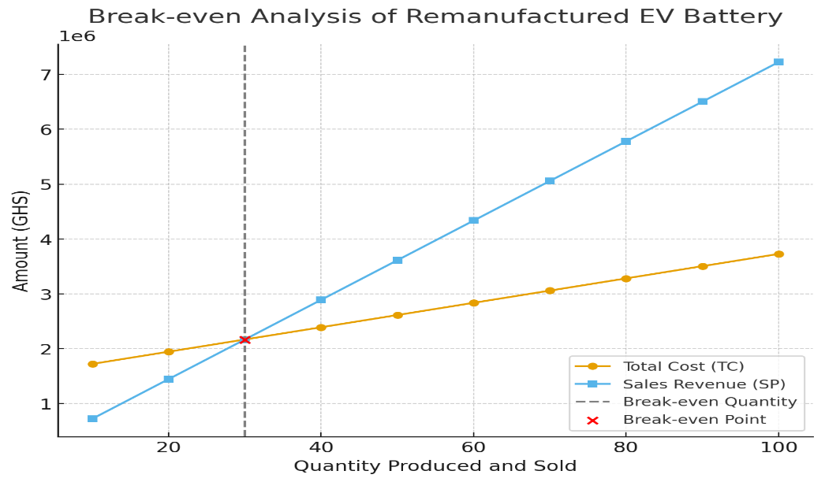
Figure 1. Average selling price of batteries

In the production or sales of a battery, between 30.5 and 31 units show the break-even point, as shown in figure 1, where there is neither profit nor loss in the sales of the remanufactured batteries. From the sale of 40 units onward, the manufacturer begins to generate a profit, which increases with quantity to 100 units, where the profit reaches Gh¢ 3,497,460.00. The graph in Figure 1 shows that at the average selling price, the remanufacturing operation must produce and sell at least 30 battery units and over to cover all fixed and variable costs. Selling more than 30 units leads to profitability, while selling fewer than 30 units results in losses.
4.2.2 Assessment of the minimum selling price
Table 9 presents a financial assessment of a remanufactured battery selling at a minimum price of 46,605 based on different production quantities.

Table 9. Data on the minimum selling price
Quantity | VC | FC | TC | SP | PROFIT/LOSS
10 | 222,729.00 | 1,500,000.00 | 1,722,729. | 466,050.00 | -1,256,679.00
20 | 445,458.00 | 1,500,000.00 | 1,945,458.00 | 932,100.00 | -1,013,358.00
30 | 668,187.00 | 1,500,000.00 | 2,168,187.00 | 1,398,150.00 | -770,037.00
40 | 890,916.00 | 1,500,000.00 | 2,390,916.00 | 1,864,200.00 | -526,716.00
50 | 1,113,645.00 | 1,500,000.00 | 2,613,645.00 | 2,330,250.00 | -283,395.00
60 | 1,336,374.00 | 1,500,000.00 | 2,836,374.00 | 2,796,300.00 | -40,074.00
70 | 1,559,103.00 | 1,500,000.00 | 3,059,103.00 | 3,262,350.00 | 203,247.00
80 | 1,781,832.00 | 1,500,000.00 | 3,281,832.00 | 3,728,400.00 | 446,568.00
90 | 2,004,561.00 | 1,500,000.00 | 3,504,561.00 | 4,194,450.00 | 689,889.00
100 | 2,227,290.00 | 1,500,000.00 | 3,727,290.00 | 4,660,500.00 | 933,210.00

From table 9, at the given minimum selling price, remanufactured EV batteries only become profitable from 70 units and above, based on quantity production or sales. At low production volumes between 10 – 60 units, losses are incurred because fixed costs are spread over too few units. At 70 units sold, table 9 shows the first positive value (203,247.00 profit), which indicates the break-even point (Figure 2), where profit grows significantly from 70 units and above, showing economies of scale. The break-even quantity is between 60 – 70 units; therefore, producing and selling more than 70 units ensures profitability, with profits increasing steadily as quantity increases.
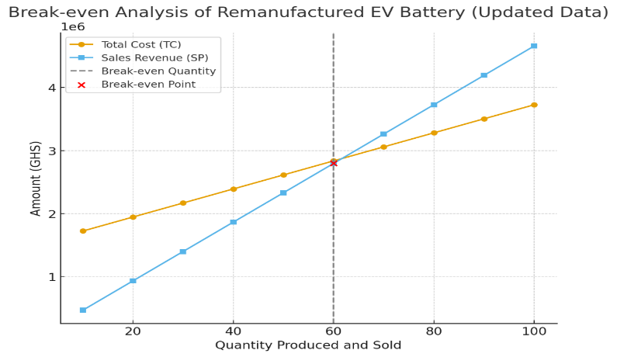
Figure 2. Minimum selling price of batteries

Figure 2 clearly shows that at the minimum selling price, the remanufacturing operation becomes financially viable after producing and selling around 60 units of EV batteries. Producing or selling fewer than 60 units results in losses, while producing or selling more than 60 units leads to increasing profitability.

4.2.2 Assessment of the maximum selling price
Table 10 presents a financial assessment of a remanufactured battery selling at a maximum price of 97,890.00 based on different production or sale quantities.
Table 10. Data on the maximum selling price
Quantity | VC | FC | TC | SP | PROFIT/LOSS
10 | 222,729.00 | 1,500,000.00 | 1,722,729. | 97,890.00 | -743, 829.00
20 | 445,458.00 | 1,500,000.00 | 1,945,458.00 | 1,957,800.00 | 12,342.00
30 | 668,187.00 | 1,500,000.00 | 2,168,187.00 | 2,936,700.00 | 768,153.00
40 | 890,916.00 | 1,500,000.00 | 2,390,916.00 | 3,915,600.00 | 1,524,684.00
50 | 1,113,645.00 | 1,500,000.00 | 2,613,645.00 | 4,894,500.00 | 2,280,855.00
60 | 1,336,374.00 | 1,500,000.00 | 2,836,374.00 | 5,873,400.00 | 3,037,026.00
70 | 1,559,103.00 | 1,500,000.00 | 3,059,103.00 | 6,852,300.00 | 3,793,197.00
80 | 1,781,832.00 | 1,500,000.00 | 3,281,832.00 | 7,831,200.00 | 4,549,368.00
90 | 2,004,561.00 | 1,500,000.00 | 3,504,561.00 | 8,810,100.00 | 5,305,539.00
100 | 2,227,290.00 | 1,500,000.00 | 3,727,290.00 | 9,789,000.00 | 6,061,710.00
From table 10, at the given maximum production or selling price, remanufactured EV batteries only become a loss at 10 units (- 743,829.00) because sales cannot yet cover costs. At 20 units, the operation has already broken even (Figure 3), recording a small profit of 12,342.00; hence, beyond 20units, profit grows rapidly with an increase in quantity production of EV remanufactured batteries: 30 units amount to 768,513.00 profit, 50 units amount to 2,280,855.00 profit, and 100 units amount to 6,061,710.00 profit. The break-even point is reached very early, at around 20 units, compared to 70 units in the minimum price case, and the profit margins are significantly higher due to the higher per-unit selling price. The business becomes highly profitable beyond 20 units, showing strong economies of scale. By 100 units, the project achieves over 6 million in profit, compared to under 1 million at the minimum price scenario.
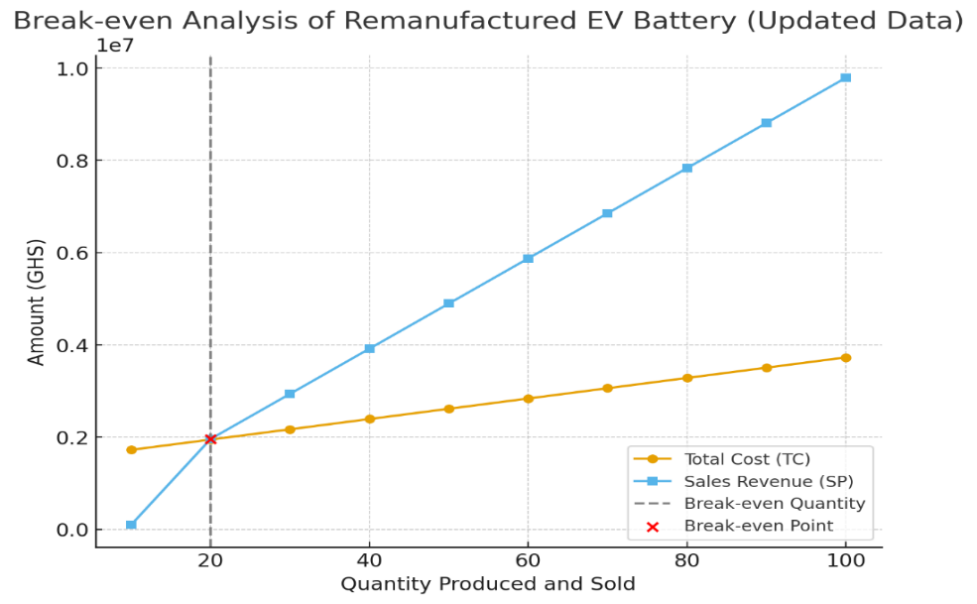
Figure 3. Maximum selling price of batteries
Figure 3 shows that the remanufacturing operation becomes profitable after producing and selling around 20 EV battery units. Producing or selling fewer than 20 units leads to losses, while producing or selling more than 20 units results in growing profitability.

4.3 Profit Margin
Profit margin is a financial ratio that shows how much profit a company makes from its revenue. In simple terms, it tells what percentage of sales is left as profit after all costs are deducted.
Mathematically,
Profit margin = $\frac{Selling Price-Cost Price }{Selling Price}$ x 100
From Figure 4, the maximum selling price, at 10 to 30 units, margins are negative (losses), reaching as low as -138% at 10 units, while from 30 units, the profit margin is almost 0% (break-even point). At 40 units onward, margins turn positive and grow steadily, and by 100 units, the margin rises to about 48%, showing strong profitability at larger volumes.
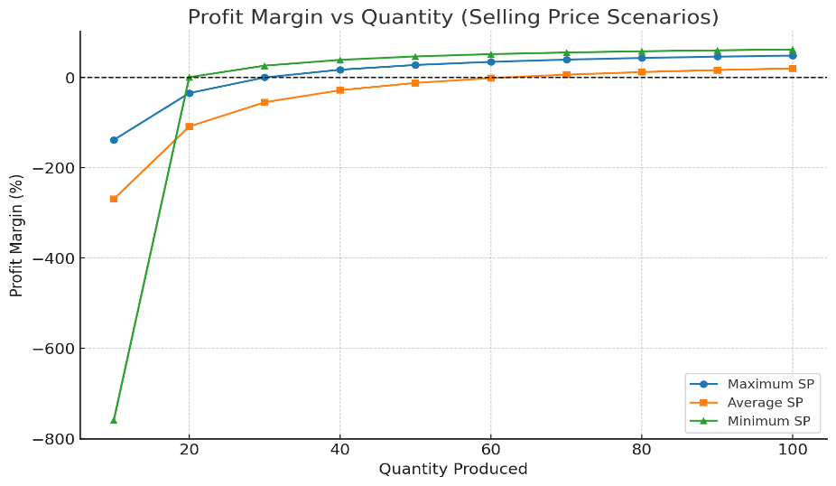
Figure 4. Profit margin of batteries
At average selling price, margins are negative from 10 to 60 units, meaning the company is losing money at lower quantities but at 70 units, profit margin turns positive at about 6% where margins then grow steadily, reaching about 20% at 100 unit and at this point, the break-even is delayed until about 70 units sales, then profitability is possible, but margins remain much smaller compared to the maximum selling price case. At the minimum selling price of 10 units, there is a large loss (-760%), but surprisingly, at 20 units, the profit margin already turns positive (0.6%), and margins keep rising rapidly from 26% at 30 units up to 62% at 100 units. Therefore, the break-even point is reached very early at 20 units, and this scenario gives the highest profit margins at scale, even though the selling price per unit is lower.

5. Conclusion.
From the initial break-even analysis for remanufactured electric vehicle (EV) batteries, the graphs offer a clear visual grasp of the link between production quantity, total cost, and sales income. Figure 1 makes it clear that, while at different rates, both total cost and total revenue climb as production does. The presence of large fixed costs (such as facility rent, equipment, and administrative expenses) causes the Total Cost (TC) line to start high, whereas the Selling Price (SP) line starts lower and rises more sharply with each extra unit sold. The break-even point, which is reached at about 30 units of production, is shown by the junction of the Total Cost and Sales Revenue lines. At this point, there is a very small loss of only GHS 762 because the whole cost of manufacturing (GHS 2,168,187) almost equals the total income (GHS 2,167,425). This is the turning moment where the company stops losing money and starts turning a profit. After this, the sales revenue exceeds the entire cost, meaning that every additional unit sold directly boosts net profit. Production or sales below this threshold, on the other hand, is a loss because revenue is still not enough to pay for both fixed and variable costs. In order to recoup all costs and start turning a profit, the remanufacturing operation needs to produce or sell at least 30 battery units, as Figure 1 illustrates. Because it illustrates the amount of production necessary to maintain the company's profit, this information is essential for financial forecasting and production planning. Additionally, the analysis highlights how pricing and cost management methods affect profitability, implying that price, cost, or efficiency improvements could reduce the break-even point and increase total profitability. Achieving or exceeding this production or sales level ensures financial sustainability and positions the operation for consistent profit growth as sales expand.

For the second analysis of break-even, the financial performance of the system for producing remanufactured EV batteries under revised cost and revenue conditions is depicted in Figure 2. It provides a comprehensive understanding of how variations in production volume impact total cost (TC) and selling price (SP), enabling the determination of the break-even point, the point at which a corporation neither incurs a loss nor turns a profit. The plotted data shows that the addition of variable costs (materials, energy, and labor) to the fixed base cost of GHS 1,500,000 causes the Total Cost (yellow line) to rise gradually with production. Conversely, the sales revenue (yellow line), which shows increasing revenue from more units sold, grows more rapidly as production volume rises. At approximately 60 units of manufacturing, the two lines converge, and the total cost and total sales revenue, at GHS 2,836,374 and GHS 2,796,300, respectively, are nearly identical. This is the break-even threshold, where the company makes a nearly zero profit (a marginal loss of GHS 40,074) after covering all of its fixed and variable costs. The total cost line stays above the sales revenue line below this break-even point (less than 60 units), indicating operational losses as a result of the company's inability to recoup its costs completely. The sales revenue line rises above the total cost line after 60 units, indicating the point at which profitability begins. The company's financial situation improves as each additional unit sold adds to net profit. As production surpasses the break-even point, the graph clearly shows the shift from loss to profit. Practically speaking, this research shows that for the remanufacturing facility to be financially viable, it must manufacture and sell a minimum of 60 remanufactured EV batteries. Producing less than this causes losses, whereas producing more than 60 units results in a steady profit increase. The break-even point's location also emphasizes how crucial it is to optimize pricing and cost structures; for example, cutting variable costs or increasing manufacturing efficiency may reduce the break-even point and boost profitability even at lower production volumes. Reaching this level ensures full cost recovery and signals the start of profitability. Therefore, maintaining production and sales beyond this level is essential for long-term financial sustainability and business growth in the remanufacturing process.

For the third analysis of break-even, the relationship between production quantity, total cost (TC), and sales revenue (SP) for remanufactured electric vehicle (EV) batteries under updated financial data is shown in detail in Figure 3. It makes the break-even point the moment at which a corporation stops losing money and starts making money clearly visible. Understanding price strategy, cost behavior, and the production volume necessary for financial viability all depend on this study. Plotting the data shows that the fixed cost of GHS 1,500,000, which represents inescapable expenses including equipment, facility maintenance, and administrative costs, starts the Total Cost (blue line) at a high level. Additional variable costs (materials, energy usage, and direct labor) lead the total cost to rise continuously as output increases. On the other hand, the sales revenue (orange line), which represents higher income from more units sold, begins lower and increases more steeply with rising output. The break-even point, where Total Cost (GHS 1,945,458) and Sales Revenue (GHS 1,957,800) are almost equal and produce a meager profit of GHS 12,342, is indicated by the intersection of these two lines at about 20 units. The total cost line stays above the sales income line when production levels fall below 20 units, meaning that the company is losing money because sales aren't enough to pay the high fixed costs. However, the revenue line overtakes the total cost line when manufacturing reaches 20 units, indicating that the business starts to turn a profit. Beyond this point, every extra unit produced and sold directly boosts net profit and strengthens the company's financial situation. Figure 3 highlights that the minimum production level necessary for cost recovery in the operation of remanufactured EV batteries is represented by the break-even threshold of 20 units. Reaching this point guarantees that the company will be able to pay for both variable and fixed costs. While generating fewer units results in financial losses, operating above this barrier leads to profitability. This result emphasizes how crucial cost control, smart pricing, and manufacturing efficiency are to preserving financial stability. Producing and selling more than 20 units enables the business to generate sustainable profits, reinforcing the importance of achieving and maintaining production levels above the break-even point to ensure long-term financial success in the remanufacturing industry.

If production and sales volumes surpass the determined break-even limits, the refurbished EV battery operation shows promise for profitability in all three scenarios. The remanufacturing business's financial viability is confirmed by the constant intersection of total cost and sales revenue across all graphs. In both situations, once production exceeds the break-even point, profitability can be achieved. This indicates that remanufactured EV batteries can make enough money to pay for all of the fixed expenses (like rent, payroll, and equipment) and variable expenses (like materials, energy, testing, and logistics) and still turn a profit. However, the variation in break-even points emphasizes the importance of operational efficiency and cost control by Lowering variable costs (through improved production methods or supply chain optimization) reduces the break-even point. Increasing the selling price (while maintaining competitive value) enhances profit margins, and managing fixed costs efficiently ensures sustainability even during lower production cycles. The study concluded that, based on all three break-even analyses, the remanufactured EV battery is profitable once production surpasses the identified break-even quantity in each scenario. Despite differences in cost structures, the trend across all graphs shows that the remanufactured battery operation moves from loss to profit as output increases.[23] Profitability improves with better efficiency and optimized pricing strategies. And the business becomes more sustainable when production is maintained above 30–60 units, depending on the scenario. Therefore, the remanufactured EV battery project is financially viable and profitable, especially under the conditions reflected in the third analysis, where cost reduction and revenue enhancement have significantly improved the break-even position. Continuous monitoring of production costs, pricing policies, and sales performance will be key to sustaining and expanding profitability in the long term.

REFERENCES
1. Shelar, R., Accelerating the Shift to Electric: Challenges, Opportunities and Strategies. 2024, KTH Royal Institute of Technology Stockholm, Sweden.
2. Xu, J., et al., High‐energy lithium‐ion batteries: recent progress and a promising future in applications. Energy & Environmental Materials, 2023. 6(5): p. e12450.
3. Gerolda, E., et al., Energy, Environment, and Resources| Circular Economy. Encyclopedia of Electrochemical Power Sources, 2024: p. 57.
4. Hagelüken, C. and D. Goldmann, Recycling and circular economy—towards a closed loop for metals in emerging clean technologies. Mineral Economics, 2022. 35(3): p. 539-562.
5. Nwankpa, C., et al., Achieving remanufacturing inspection using deep learning. Journal of Remanufacturing, 2021. 11(2): p. 89-105.
6. Sahoo, S. and P. Timmann, Energy storage technologies for modern power systems: A detailed analysis of functionalities, potentials, and impacts. IEEe Access, 2023. 11: p. 49689-49729.
7. Iqbal, H., et al., A survey of second-life batteries based on techno-economic perspective and applications-based analysis. Carbon Neutrality, 2023. 2(1): p. 8.
8. Psarommatis, F., G. May, and V. Azamfirei, Product reuse and repurpose in circular manufacturing: a critical review of key challenges, shortcomings and future directions. Journal of Remanufacturing, 2025: p. 1-38.
9. Tuinman, R., From cell to cycle: local pretreatment in battery recycling. 2025.
10. Russell, J.D. and N.Z. Nasr, Value-retained vs. impacts avoided: the differentiated contributions of remanufacturing, refurbishment, repair, and reuse within a circular economy. Journal of Remanufacturing, 2023. 13(1): p. 25-51.
11. McKnight, T., T. Ward, and K. Jenab, Data-driven quality improvement for sustainability in automotive packaging. Applied Sciences, 2024. 14(13): p. 5723.
12. Andaloro, A., et al., De-risking the energy efficient renovation of commercial office buildings through technical-financial risk assessment. Sustainability, 2022. 14(2): p. 1011.
13. Mohanty, N., N.K. Goyal, and V.A. Naikan, A comparative analysis of operational planning for battery swapping and fast charging in electric vehicles. Life Cycle Reliability and Safety Engineering, 2025. 14(1): p. 1-17.
14. Pesaran, A., L. Roman, and J. Kincaide, Electric Vehicle Lithium-Ion Battery Life Cycle Management. 2023, National Renewable Energy Laboratory (NREL), Golden, CO (United States).
15. Teng, J.-H., et al., Accurate and efficient SOH estimation for retired batteries. Energies, 2023. 16(3): p. 1240.
16. Quijano-Ortiz, F. and C. Seepersad. Design Recommendations for Reducing the Environmental Impact of Battery Packs. in International Design Engineering Technical Conferences and Computers and Information in Engineering Conference. 2022. American Society of Mechanical Engineers.
17. Kotak, Y., et al., End of electric vehicle batteries: Reuse vs. recycle. Energies, 2021. 14(8): p. 2217.
18. Oi, W., The fixed employment costs of specialized labor, in The measurement of labor cost. 1983, University of Chicago Press. p. 63-122.
19. Ganc, M. and M. Soliwoda, Usefullnes of variable costs accounting in dairy cooperatives in Poland. Management and Production Engineering Review, 2011. 2(2): p. 16-21.
20. Rallo, H., et al., Economic analysis of the disassembling activities to the reuse of electric vehicles Li-ion batteries. Resources, conservation and recycling, 2020. 159: p. 104785.
21. Oppusunggu, L.S., Importance of Break-EVEN analysis for the micro, small and medium enterprises. International Journal of Research-GRANTHAALAYAH, 2020. 8(6): p. 212-218.
22. Mao, R. Verify the Relationship Between a Company’s Earning per Share, Return on Equity, Return on Asset, Sales Growth, Price to Earning Ratio, Current Ratio, Gross Profit Margin, Quick Ratio, Asset Turnover and Its Stock Price. in SHS Web of Conferences. 2023. EDP Sciences.
23. Oteri, O.J., et al., Cost optimization in logistics product management: strategies for operational efficiency and profitability. International Journal of Business and Management. Forthcoming, 2023.

