Adoption Dynamics and Implementation Strategies of Machine Learning for Cybersecurity Threat Detection in the E-Commerce Sector

Abstract
This study examined why and how e-commerce firms adopt and operationalize ML for threat detection using three open datasets: Eurostat ICT Usage by Enterprises (binomial GLM with country fixed effects), CSE-CIC-IDS2018 (streaming Random Forest evaluated via ANCOVA), and UK Cyber Security Breaches Survey microdata (1:1 caliper propensity-score matching). Adoption was chiefly capacity-driven: cloud use (OR=3.30), ICT specialists (OR=2.42), and security training (OR=2.16); e-commerce showed a sectoral uplift (AME=+0.107). Implementation exhibited a capacity accuracy frontier: every +1k records/s reduced F1 by ≈0.0063 and added ≈2.25 ms latency; label noise raised FPR (β≈+0.180) and lowered F1 (β≈−0.216), while privacy-by-design reduced FPR (β≈−0.0019). Deployment increased modestly with facilitating conditions (ATT=+1.18 pp). Recommendations: ring-fence budgets for cloud, specialists, and training; enforce CI/CD with drift telemetry and label-noise audits; require privacy-by-design with auditable model cards; fund SME access to shared pipelines and pretrained detectors.
Keywords: e-commerce cybersecurity; ML adoption; streaming IDS evaluation; data governance and compliance; propensity-score matching.

1. Introduction
The rapid proliferation of digital commerce has transformed business operations globally but has simultaneously expanded the attack surface for cyber threats (Gutierrez-Garcia et al. 2023). As e-commerce platforms increasingly rely on interconnected systems, vast customer data repositories, and complex payment infrastructures, the frequency and sophistication of cyberattacks have surged (Gutierrez-Garcia et al. 2023; Traceable, 2025). Recent reports show that global cybercrime costs are projected to reach $13.8 trillion by 2028, with e-commerce accounting for one of the fastest-growing segments of reported breaches (Olson, 2025; Morgan, 2024). Threats such as phishing, data exfiltration, ransomware, and API abuse continue to compromise business continuity and erode consumer trust (Gutierrez-Garcia et al. 2023; Traceable, 2025). Consequently, there has been a marked shift from rule-based intrusion detection toward machine learning (ML) driven cybersecurity frameworks, capable of recognizing complex and evolving threat patterns (Mohamed, 2025; Pramod et al., 2024).

Machine learning’s adaptive learning and anomaly detection capabilities enable organizations to move from reactive to predictive cybersecurity (Mohamed, 2025). Algorithms such as Random Forest, Support Vector Machines, and Deep Neural Networks have demonstrated superior accuracy in detecting network intrusions and zero-day attacks compared to traditional systems (Abdelaziz et al., 2025; Flenman, 2025). These models can analyze large-scale traffic data, automate incident triage, and support real-time threat mitigation (Mohamed, 2025; Flenman, 2025). Despite these advantages, the adoption and sustained implementation of ML in e-commerce cybersecurity remain inconsistent (Rawindaran et al., 2021). Many organizations pilot ML-based systems but fail to transition into full operational deployment due to technical, organizational, and regulatory constraints. Previous studies, including Olaniyi (2025), have established that behavioral and organizational factors strongly influence ML adoption. Drawing on the Unified Theory of Acceptance and Use of Technology (UTAUT), Olaniyi’s research identified performance expectancy, effort expectancy, social influence, and facilitating conditions as significant predictors of professionals’ behavioral intention to adopt ML for cybersecurity. However, while intention to adopt has been thoroughly investigated, the dynamics that govern how adoption translates into actual implementation remain underexplored (Su et al., 2025; Hasani et al., 2023). This persistent gap suggests that even when IT professionals recognize the value of ML, organizational inertia, infrastructural limitations, and regulatory complexity impede large-scale operationalization (Hasani et al., 2023).
Furthermore, industry-specific studies indicate that implementation challenges stem from inadequate data governance, insufficient technical expertise, and lack of integration frameworks compatible with existing systems (Themann, 2025; Roy et al., 2023). Compliance concerns also inhibit deployment, particularly under PCI-DSS v4.0, GDPR, and emerging AI governance acts that impose transparency and accountability obligations on automated systems (Casovan et al., 2024). Empirical evidence reveals that while 73 % of surveyed firms acknowledge ML’s necessity for cyber defense, only 38 % have fully operationalized these models in production environments (Jurgens & Dal Cin, 2025). The widening gap between awareness and implementation underscores the need for a deeper understanding of adoption dynamics and the strategic mechanisms that enable successful integration (Jurgens & Dal Cin, 2025; Themann, 2025).
In the e-commerce sector, the challenge is amplified by the velocity and variability of transactional data and the demand for real-time fraud detection (Fatunmbi, 2022). Organizations struggle to align ML-based threat detection with operational priorities such as customer experience, compliance efficiency, and system scalability (Jada & Mayayise, 2023). Moreover, the socio-technical complexity of ML deployment involving model retraining, data drift management, and interpretability demands a level of cross-functional collaboration that many e-commerce enterprises have yet to institutionalize (Mohamed, 2025; Themann, 2025). This creates an “adoption implementation gap,” where enthusiasm for ML does not necessarily translate into sustainable, enterprise-level security transformation (Jurgens & Dal Cin, 2025). To address this gap, the study aims to critically examine the adoption dynamics and implementation strategies of machine learning for cybersecurity threat detection in the e-commerce sector, with a view to identifying the factors that influence effective integration and sustainable use, by achieving the following objectives:.

To investigate the key organizational, technological, and behavioral factors shaping the adoption of machine learning for cybersecurity threat detection in e-commerce.

To evaluate how infrastructural readiness, data governance, and regulatory compliance affect the implementation of ML-based cybersecurity systems.

To analyze the barriers and enablers influencing the transition from adoption intent to practical deployment of ML-driven security solutions.

To propose evidence based recommendations for enhancing the adoption and implementation of machine learning technologies in e-commerce cybersecurity operations.

By addressing these objectives, this paper contributes to the evolving body of knowledge on AI governance, secure MLOps, and socio-technical integration, offering a comprehensive framework for understanding how e-commerce enterprises can transition from experimental ML adoption to enterprise-level cybersecurity resilience.
2. Literature Review
The adoption analysis in this study is grounded in the Unified Theory of Acceptance and Use of Technology (UTAUT), which posits that performance expectancy, effort expectancy, social influence, and facilitating conditions jointly shape behavioral intention and subsequent technology use (Venkatesh et al., 2003; Rana et al., 2024). Within security-critical domains such as e-commerce threat detection, these constructs take on highly contextual meanings. Performance expectancy translates into measurable improvements in detection accuracy and alert fidelity; effort expectancy refers to the ease of deploying ML models and their fit within analysts’ workflows; facilitating conditions encompass the availability of data pipelines, analytical tools, and compliance resources while social influence is reflected in sector norms and peer benchmarking among cybersecurity teams (Rana et al., 2024).
To extend the explanatory strength of UTAUT in enterprise AI environments, this framework also incorporates management support as a moderating construct. Management endorsement determines access to strategic data assets, allocates funding for MLOps initiatives, and enforces control protocols, factors consistently shown to moderate AI adoption outcomes in organizational contexts (Kim et al., 2024). In his empirical study on e-commerce cybersecurity, Olaniyi (2025) found statistically significant relationships between UTAUT constructs and behavioral intention, with performance expectancy and facilitating conditions emerging as the strongest predictors. However, the study also identified persistent obstacles namely skills shortages, infrastructure gaps, and regulatory ambiguity that hindered the conversion of adoption intention into actual use. These findings emphasize that both behavioral and structural determinants must be considered in explaining ML adoption dynamics in cybersecurity settings.
Recent scholarship suggests that classical UTAUT, though robust, can be under-specified in the context of emerging AI technologies. Abdalla Mikhaeil et al. (2025) reported heterogeneous predictive patterns across privacy-enhancing technologies (PETs), arguing that UTAUT’s explanatory capacity weakens when governance and contextual factors are omitted. Similarly, Ke et al. (2025) incorporated AI literacy into UTAUT and demonstrated that expectancy beliefs and social influence mediate adoption intention, underscoring the importance of technical preparedness and expertise alongside classical predictors. Collectively, these studies affirm the need for capacity building and post-adoption evaluation to ensure sustained ML use within e-commerce cybersecurity operations (Olaniyi, 2025).
Comparative theoretical models further illuminate the determinants of ML adoption. The Technology Acceptance Model (TAM) highlights perceived usefulness and ease of use but fails to account for environmental and institutional pressures elements that are fundamental to cybersecurity governance and regulatory compliance (Hasani et al., 2023). Conversely, the Technology Organization Environment (TOE) framework integrates external drivers such as the regulatory climate, competitive pressure, and partner ecosystems. TOE-based studies reveal that organizational readiness, leadership commitment, and external mandates significantly shape the scale and success of AI implementation (Prakash, 2025). Likewise, Diffusion of Innovations (DOI) theory contributes a complementary perspective by emphasizing innovation attributes relative advantage, compatibility, and trialability that are directly applicable to Security Operations Center (SOC) workflows and data-governance processes. Integrated TOE–DOI approaches demonstrate that combining structural (organizational and environmental) and perceptual (individual and behavioral) factors produces stronger explanatory power for enterprise AI adoption decisions (Hasani et al., 2023). These comparative insights collectively suggest that a hybrid model, wherein UTAUT constructs are nested within TOE and DOI contexts and enhanced by management-support and governance variables, offers a more comprehensive explanation for ML adoption within security-sensitive e-commerce environments (Olaniyi, 2025).
Importantly, adoption intention does not equate to operational success. Studies of AI deployment in cybersecurity reveal that user acceptance, when unsupported by lifecycle governance, often results in fragile and unsustainable implementations (Adesokan-Imran et al., 2025; Kolo, 2023; Obrik-Uloho, 2025; Ee et al., 2024). Effective deployment depends on translational mechanisms such as rigorous data stewardship, auditable ML pipelines, and continuous model monitoring processes that determine whether accepted tools genuinely enhance cyber-defense capability (Salem et al., 2024). In line with Olaniyi (2025), who identified infrastructural weaknesses and regulatory uncertainty as persistent inhibitors, the present study positions implementation strategy as the critical bridge between adoption intention and enduring threat-detection performance. In this perspective, adopting ML is not synonymous with embedding it effectively; success depends on the sustained institutionalization of ML systems within operational cybersecurity frameworks (Bamigbade et al., 2025)
.

Empirical Trends in Cybersecurity Threats within E-Commerce
Olaniyi (2025) identifies vendor dependency, credential reuse, and infrastructural deficits as major inhibitors of machine-learning (ML) adoption for cybersecurity in e-commerce. Subsequent empirical investigations reveal that these same structural weaknesses have evolved into recurrent threat vectors between 2020 and 2025 (Alshaikh et al., 2023; John et al., 2025; Verizon, 2024). While Olaniyi’s (2025) quantitative framework primarily emphasized adoption determinants, recent evidence demonstrates the operational vulnerabilities of partial implementation, showing that ML adoption without corresponding governance maturity exposes e-commerce systems to multi-vector attacks (John et al., 2025; Mohamed, 2025).
Data breaches and privacy leaks continue to dominate as the most prevalent threat types within online retail systems. IBM (2025) reported that the average global cost of a data breach fell by 9% to USD 4.44 million, underscoring the sustained financial burden associated with cyber incidents. High-profile breaches such as Mailfire and BigBasket in 2020, and JD Sports in 2023, illustrate how aggregated customer data remain lucrative targets for credential harvesting and identity resale (Reuters, 2023). These recurring compromises highlight persistent weaknesses in encryption protocols, inadequate API access controls, and the absence of robust post-incident analytics (Olaniyi, 2025; Verizon, 2024).
The frequency and sophistication of credential-stuffing and account-takeover (ATO) attacks have risen dramatically alongside the circulation of stolen credentials in underground markets (Rees-Pullman, 2020; Verizon, 2024). The Data Breach Investigations Report (DBIR) found that the use of stolen credentials remains one of the most common initial actions in breaches (Verizon, 2024), a trend reinforced by reports identifying credential compromise as the primary vector for e-commerce intrusions. Real-world cases such as the North Face credential-stuffing attack (2025) and eBay’s ATO surge (2023) demonstrate how automation has amplified the exploitation of reused passwords (Arghire, 2025; Gardner, 2024). Mohamed (2025) and related work propose that adaptive ML-based user-behavior analytics, supported by continuous retraining, can significantly mitigate these incidents, consistent with Olaniyi’s (2025) emphasis on post-adoption model evaluation (Mohamed, 2025).
Supply-chain and API vulnerabilities increasingly constitute critical points of fragility within modern e-commerce infrastructure. Recent analyses emphasize that complex vendor ecosystems, third-party integrations, and API dependencies have expanded organizations’ attack surfaces, enabling cross-platform propagation of risk (Hasani et al., 2023; Alshaikh et al., 2023). Studies on supply-chain security highlight that most breaches in retail and logistics environments originate from third-party access or misconfigured APIs rather than direct exploitation of core systems (Verizon, 2024). This pattern is reinforced by well-documented cases, such as the 2025 Harrods supplier breach and recurring API-related exposures on platforms like Shopify, illustrating how interconnected architectures transfer vulnerabilities across vendors (Burton, 2025).
Parallel to these infrastructural weaknesses, automated bot activity has escalated from operational nuisance to strategic threat. Empirical data indicate that malicious bots now account for a substantial share of retail traffic, frequently targeting login portals and APIs to harvest credentials or launch denial-of-inventory attacks (Imperva, 2025; Richabadas, 2024). Researchers note that traditional rule-based filtering is increasingly ineffective as adversarial AI enables bots to imitate human behavior and adapt to detection rules (Krishnan, & Shrinath, 2024). Consequently, current scholarship recommends machine-learning (ML)-driven anomaly detection and adaptive scoring models capable of learning from evolving automation patterns (Mohamed, 2025). Olaniyi’s (2025) emphasis on continuous model-performance monitoring aligns with this position, as static models often fail to capture the dynamic signatures of emerging automated threats.
The emergence of AI-enabled fraud, particularly through deepfakes and synthetic media, marks another major transformation in the e-commerce threat landscape. Reports from international security consortia and cybersecurity researchers document a rapid rise in voice- and video-based social-engineering attacks since 2023 ( KeepNet, 2025). Deepfake tools increasingly blur boundaries between technical intrusion and psychological manipulation, creating hybrid threat vectors that exploit both data pipelines and human trust. Such developments reinforce scholarly arguments that ML deployment in cybersecurity must be guided by strong governance, algorithmic transparency, and ethical oversight frameworks (Abdalla Mikhaeil et al., 2025).

Adoption Dynamics: Organizational and Technological Determinants
The decision by e-commerce firms to adopt machine learning (ML) for cybersecurity reflects an intersection of technological, organizational, and environmental pressures. Olaniyi (2025) demonstrated that facilitating conditions and management support exert strong moderating effects on the intention use relationship. This suggests that firms with committed leadership and adequate infrastructure are more likely to progress beyond pilot phases into sustained operational deployment. In this study, those same determinants are reexamined to understand how they enable or constrain not only adoption but also effective implementation (Yang et al., 2024; IBM IBV, 2024).
Technological determinants represent both core enablers and barriers to ML adoption. Algorithmic accuracy, interpretability, and compatibility with existing systems significantly shape managerial confidence in ML-based cybersecurity applications (Olaniyi, 2025; Mohamed, 2025). Similarly, (Al-Khatib, 2023) report that relative advantage and compatibility positively influence AI adoption in organizations, whereas technological complexity impedes uptake. Infrastructure readiness is an equally critical precondition: a firm’s computing, cloud, networking, and data architecture define the baseline for deploying ML pipelines. Ali (2025) found that infrastructure readiness strongly correlates with AI adoption efficiency; firms lacking scalable architectures often fail to integrate ML models into production environments. Complementing this, Kolo (2025a) emphasize that compatibility, data quality, and resource availability are among the most salient technological enablers in enterprise settings without which adoption frequently stagnates at proof of concept stages. From an organizational perspective, leadership commitment, technical expertise, and organizational culture remain decisive. Olaniyi (2025) notes that many e-commerce firms in emerging markets suffer from limited in-house data science capacity, relying instead on external consultants, an arrangement that weakens institutional learning and limits scalability. This observation aligns with broader industry findings: (IBM IBV, 2024) reports that a majority of CEOs link competitive advantage to advanced generative AI, yet capability gaps persist across organizations. Technical expertise matters not only during development but also for model maintenance, drift management, and performance monitoring. Cost factors further influence adoption; acquisition, staffing, and maintenance expenses must be weighed against expected reductions in cyber risk. (BCG, 2024) shows that although many firms have launched AI pilot projects, only about a quarter have developed the capabilities to move beyond proofs of concept and generate tangible value, indicating that hidden costs and resource constraints often cause adoption failure before operational maturity.
Environmental determinants situate adoption within the wider institutional and market ecosystem. Regulatory compliance requirements such as data protection, privacy, and cybersecurity laws serve as external drivers compelling firms to strengthen their digital defenses (Yang et al., 2024). Competitive dynamics also play a pivotal role organizations frequently adopt ML-based solutions not purely from intrinsic motivation but to match or surpass the security posture of industry peers. Furthermore, vendor influence and partnership ecosystems significantly shape adoption pathways in the e-commerce sector, where cloud providers, payment processors, and third-party integrators can indirectly standardize adoption patterns or propagate specific technological frameworks across connected networks (Udechukwu, 2025b). (Al-Khatib, 2023) affirm that technological, organizational, and environmental factors jointly determine generative AI adoption, reinforcing the necessity of analyzing multidimensional drivers in real-world contexts. Hence, these three perspectives technological, organizational, and environmental must be considered in concert to explain why some firms progress from adoption intention to fully operational ML-based cybersecurity systems. (John et al., 2025; Amrit & Narayanappa, 2025) proves that, evidently, the relationship between adoption determinants and implementation quality is nonlinear and contingent on alignment. Only organizations that synchronize technological readiness with internal capabilities and navigate environmental constraints can transform adoption into sustainable operational outcomes.

Implementation Strategies for ML-Based Cybersecurity Systems
In light of Olaniyi’s (2025) findings that adoption intent in e-commerce increases with perceived usefulness and facilitating conditions, it follows that sustained cybersecurity performance depends on how organizations operationalize these intentions through MLOps, governance, explainability, compliance, and human capability (John, Holmström Olsson, & Bosch, 2025; NIST, 2023). Hence, implementation quality not adoption alone determines whether ML systems meaningfully reduce attack exposure within production environments (Salami et al., 2025).
According to John et al. (2025), firms that institutionalize MLOps maturity characterized by continuous integration and delivery of models, automated testing, data and version management, and live monitoring achieve faster release cycles and more reliable operations than those treating models as isolated artifacts. Moreover, configuration drift, untracked dataset changes, and delayed retraining remain leading causes of ML system failures in deployment (Pham et al., 2024; Kustitskaya et al., 2025). These findings support that continuous integration and delivery (CI/CD) pipelines, reproducible workflows, and telemetry for detecting concept drift form the baseline requirements for ensuring that anomaly detection models remain calibrated to evolving e-commerce threats (Olaniyi, 2025) .
Data governance constitutes an equally critical pillar of successful implementation. Bernardo et al. (2024) demonstrate that mature governance frameworks link data-quality management with stewardship, lineage tracking, and access control, thereby improving fitness-for-use and auditability. In cybersecurity analytics where false positives drive alert fatigue and false negatives can lead to catastrophic breaches data curation, labeling standards, and bias checks are essential risk-control mechanisms that determine operational reliability (Bernardo et al., 2024). Complementing this, the NIST AI Risk Management Framework formalizes policies, roles, and escalation pathways to ensure that privacy, fairness, and regulatory mandates are enforced alongside performance targets (NIST, 2023, 2024). Without such scaffolding, even highly accurate models can fail compliance audits or collapse under regulatory scrutiny following security incidents.
The trade-off between model accuracy and interpretability is particularly acute in cybersecurity, where analysts must justify system actions and fine-tune controls in real time. Sarker (2024) argues that explainable AI (XAI) techniques such as feature attribution and counterfactual explanations improve analyst trust and accelerate triage in intrusion-detection workflows. However, as Mohale et al. (2025) caution, highly expressive models may capture subtle attack patterns yet offer limited transparency, while simpler models provide interpretability but may lack sensitivity to complex, evolving threats. A pragmatic resolution, as outlined by Trillo et al. (2025), involves layered deployment: using performant detectors with post-hoc XAI for operational oversight, complemented by interpretable rule-augmented models for policy enforcement and audit.
Successful implementation also depends on people and process. A systematic review shows that targeted, scenario-based and simulation-driven cybersecurity training outperforms generic awareness campaigns (Prümmer et al., 2024). This finding aligns with the capacity-building gap identified by Olaniyi (2025), highlighting that technical competence remains a central determinant of ML sustainability. Cross-functional operating models that embed data scientists alongside security engineers, risk managers, and compliance officers consistently achieve higher deployment success rates, as governance requirements are integrated from the design phase through continuous monitoring (NIST, 2023). Real-world programs reinforce this principle: payment-network case studies report that real-time risk-scoring programs paired with clear escalation playbooks and partner coordination have prevented very large fraud losses for example, Emirates NBD reported $105 million in fraud loss prevention after adopting AI-driven risk scoring (Visa, 2025).
Collectively, these studies indicate that sustainable ML implementation in cybersecurity is both technical and managerial. MLOps maturity ensures currency and performance; governance and XAI provide defensibility and accountability; compliance embeds oversight and trust; and capacity building equips teams to operate, audit, and continuously enhance deployed systems (Kolo et al., 2025; Olutimehin et al., 2025a)

Barriers to Effective Adoption and Implementation
Despite the promise of machine learning (ML) for enhancing e-commerce cybersecurity, several persistent barriers hinder the successful transition from adoption intention to sustained operational deployment. Olaniyi (2025) observed that many organizations stagnate after pilot phases due to post-adoption fatigue and overdependence on external vendors. Broader ecosystem studies, however, reveal a more intricate interplay of technical, organizational, and policy constraints that collectively suppress performance and long-term integration.
At the technical level, challenges such as data imbalance, adversarial attacks, and interoperability deficits remain pervasive. Shanmugam et al. (2024) highlight that in cybersecurity datasets, malicious events are rare, leading to severe class imbalance that biases models toward predicting non-malicious classes. Compounding this issue, Alotaibi & Rassam (2023) demonstrate that carefully crafted adversarial perturbations can mislead detection models into misclassifying, thus undermining robustness. Interoperability also remains a significant impediment: heterogeneous data sources, legacy IT infrastructures, and incompatible APIs impede seamless integration of ML modules into security ecosystems (Heshmatisafa & Seppänen, 2023; Udechukwu, 2025a). As a result, many ML models remain confined to prototype environments, never achieving full operationalization due to systemic technical frictions (Kolo, 2025b; John et al., 2025).
Organizational barriers further compound these technical constraints. Skills shortages persist across the e-commerce sector, as many firms lack in-house expertise in data science, cybersecurity, and DevOps. Consequently, reliance on external consultants undermines institutional learning and perpetuates vendor dependency precisely the pattern identified by Olaniyi (2025) in emerging markets. Resistance to change also contributes to stagnation; security teams accustomed to deterministic, rule-based systems often distrust ML models, perceiving them as opaque or unreliable (Sarker et al., 2024). High implementation costs including infrastructure investments, computational overhead, specialized staffing, and ongoing maintenance further discourage scaling (Enshassi et al., 2025; Ogunmolu, 2025a; Olutimehin et al., 2025b). A study by Morales (2025) reports that many AI pilot projects fail to translate into measurable returns once overheads are included, underscoring the gap between experimental adoption and sustainable production use.
At the policy and ethical level, barriers emerge from regulatory lag and legal ambiguity. Cybersecurity regulations frequently lag behind technological advancements, generating uncertainty and inconsistent enforcement. In particular, conflicting national and international privacy regimes complicate cross-border data sharing, undermining collaborative threat intelligence frameworks (Compagnucci et al., 2023). Cheong, Chin, & Setiawan (2024) add that ambiguous accountability structures deter risk officers from approving ML decision systems due to liability concerns. Similarly, NIST (2023) warns that governance deficiencies such as missing audit trails, undefined roles, and weak accountability create compliance and reputational risks. Feltes (2025) also found that many organizations adopt AI governance frameworks superficially (symbolically) rather than operationally, limiting their real governance value. These gaps between formal compliance and functional execution further weaken the ethical maturity of ML integration in e-commerce cybersecurity.
Beyond individual categories, these barriers are interdependent and mutually reinforcing. Technical complexity increases operational costs, which heighten organizational resistance; ethical ambiguity discourages experimentation, slowing learning cycles and leaving systems fragile (John et al., 2025). Recognizing these systemic interdependencies underscores why structured implementation strategies rooted in MLOps discipline, governance rigor, algorithmic transparency, and workforce capacity building are essential to bridging the gap between adoption intention and realized cybersecurity performance (Ogunmolu, 2025b; Oyekunle et al., 2025)
. Only by addressing these constraints holistically can the full potential of ML-driven cybersecurity in e-commerce be reliably achieved.

3. Methods
This study executes three objective-specific, quantitative analyses using a single open dataset per objective and one primary method per objective. All estimates are reported with two-sided 95% confidence intervals and p<.05 thresholds. Variable definitions, transformations, and model equations are specified below to ensure reproducibility and alignment with enterprise cybersecurity practice.
Objective 1: Factors shaping ML adoption (Eurostat “ICT usage by enterprises”).
Data: Eurostat Community Survey on ICT Usage and E-Commerce in Enterprises (annual), restricted to retail and online-retail enterprises; analysis unit is Country×Sector×Size cells with counts of firms reporting ML use for cybersecurity.
Outcome and predictors.
Outcome:
y_i=number_of_firms_using_ML in cell i;
n_i=responding_firms in cell i;
adoption rate $p_{i}=\frac{y_{i}}{n_{i}}$.
Predictors (cell-level rates or dummies): cloud_i, ictspec_i, sectrain_i, incident_i, size_i∈{small,medium,large}, sector_i∈{ecommerce,other}. Country fixed effects γ_c.
Model. Binomial GLM with logit link and country fixed effects: $y_{i}\sim Binomial\left(n_{i},p_{i}\right)$;
$logit\left(p_{i}\right)=β_{0}+β_{1}*cloud_{i}+β_{2}*ictspec_{i}+β_{3}*sectrain_{i}+β_{4}*incident_{i}+β_{5}*I\left(size_{i}=medium\right)+β_{6}*I\left(size_{i}=large\right)+β_{7}*I\left(sector_{i}=ecommerce\right)+γ_{c}. Link: logit\left(p\right)=\ln\left(\frac{p}{1-p}\right)$.
Odds ratio:
$OR_{k}=\exp\left(β_{k}\right)$.
Average marginal effect for the sector contrast:
$$AME=E\left[p_{i}\left(sector=ecommerce\right)-p_{i}\left(sector=other\right) | X_{i}\right].$$
Robust (HC1) standard errors clustered by country. Goodness-of-fit via Pearson residuals and Pregibon leverage; multicollinearity checked via VIF<10. Partial dependence for cloud intensity computed on the response scale:

$PD_{cloud\left(x\right)}=mean_{X\left[invlogit\left(β0+β1*x+Σ_{\left\{k≠cloud\right\}β_{k}}*X_{k}+γ_{c0}\right)\right]}$,
with
$$invlogit\left(z\right)=\frac{1}{1+\exp\left(-z\right)}.$$
Objective 2: Implementation performance vs infrastructure, governance, and compliance (CSE-CIC-IDS2018).
Data. CSE-CIC-IDS2018 enterprise-style network traffic with labeled events. Records are batched into fixed-length time windows (e.g., 60s) to emulate streaming inference. Experimental factors per window: sustainable throughput thr (records/sec), label-noise rate noise∈{0,0.01,0.05} (symmetric class relabeling), and compliance constraint pii_drop∈{0,1} that removes privacy-sensitive features consistent with privacy-by-design. Class prevalence per window π=positives/total is retained as a covariate.
Metrics Used:
$Precision=\frac{TP}{TP+FP}$;
$Recall=\frac{TP}{TP+FN}$;
$F1=2*\frac{Precision*Recall}{Precision+Recall}$;
$FPR=\frac{FP}{FP+TN}$;

latency per batch in milliseconds LAT.
Analysis. Time-windowed Random Forest classification under a controlled factorial design; operational effects quantified with ANCOVA (ordinary least squares on window-level metrics with controls):
$F1=α_{F1}+βF_{thr}*thr_{k}+βF_{noise}*noise+βF_{pii}*pii_{drop}+βF_{imb}*π+ε_{F1}$,
$LAT=α_{L}+βL_{thr}*thr_{k}+βL_{noise}*noise+βL_{pii}*pii_{drop}+βL_{imb}*π+ε_{L}$,
$FPR=α_{R}+βR_{thr}*thr_{k}+βR_{noise}*noise+βR_{pii}*pii_{drop}+βR_{imb}*π+ε_{R}$,
Where:
$thr_{k}=\frac{thr}{1000}$.
Effects are interpreted per unit of the regressor. Heteroskedastic-robust (HC3) standard errors are used.
Trade-off characterization. The capacity accuracy frontier is traced by the mapping $T\left(thr\right)=\left\{\left(LAT\left(thr\right),F1\left(thr\right)\right)\right\}$ holding noise and pii_drop at medians; monotonicity is checked via dF1/dthr≤0 and dLAT/dthr≥0 from the fitted βs.
Objective 3: Barriers and enablers of deployment (UK Cyber Security Breaches Survey microdata).
Data. UK CSBS firm-level responses for retail/e-commerce. Treatment T=1 if facilitating conditions are present (dedicated cyber budget AND in-house specialists AND formal policies); T=0 otherwise. Outcome Y=1 if advanced security analytics/monitoring is deployed in production; Y=0 if at planning/pilot/no-use stage. Confounders X=(size medium, size_large,outsourcing,prior_incident,board_attention,certification,cloud_use).
Propensity score estimation and matching.
Propensity score:
$pscore_{i}=\operatorname{Pr}\left(T_{i}=1 | X_{i}\right)=invlogit\left(θ0+θ^{'}X_{i}\right)$.
One-to-one nearest-neighbor matching on the logit of the score with caliper c=0.2*SD(logit(pscore)) to reduce bad matches.
Let M(i) denote the matched control for treated firm i.
Effect estimation. Average treatment effect on the treated (ATT):
$ATT=\left(\frac{1}{N_{T}}\right)*Σ_{\left\{i:T_{i}=1\right\}\left(Y_{i}-Y_{\left\{M\left(i\right)\right\}}\right)}$.
Abadie–Imbens standard error with replacement:
$SE(ATT)=\sqrt{((\frac{1}{N_{T}^{2}})∑_\{i:T_{i}=1\}({\left(Y_{i}-Y_{\left\{M\left(i\right)\right\}}-ATT\right)}^{2}))}.$
Balance is evaluated via standardized mean difference (binary case):
$SMD=\frac{\left|p_{T}-p_{C}\right|}{\sqrt{\left(\frac{p_{T}*\left(1-p_{T}\right)+p_{C}*\left(1-p_{C}\right)}{2}\right)}}$,
and for continuous
$SMD=\frac{\left|μ_{T}-μ_{C}\right|}{\sqrt{\left(\frac{σ_{T}^{2}+σ_{C}^{2}}{2}\right)}}$.
Threshold |SMD|≤0.10 indicates adequate balance.

4. Results and Discussion
Objective 1. To determine organizational and technological factors associated with the adoption of machine learning for cybersecurity among e‑commerce firms, a binomial generalized linear model with country fixed effects and aggregated Country×Sector×Size cells; adoption measured as the proportion of firms using ML for cybersecurity was adopted.
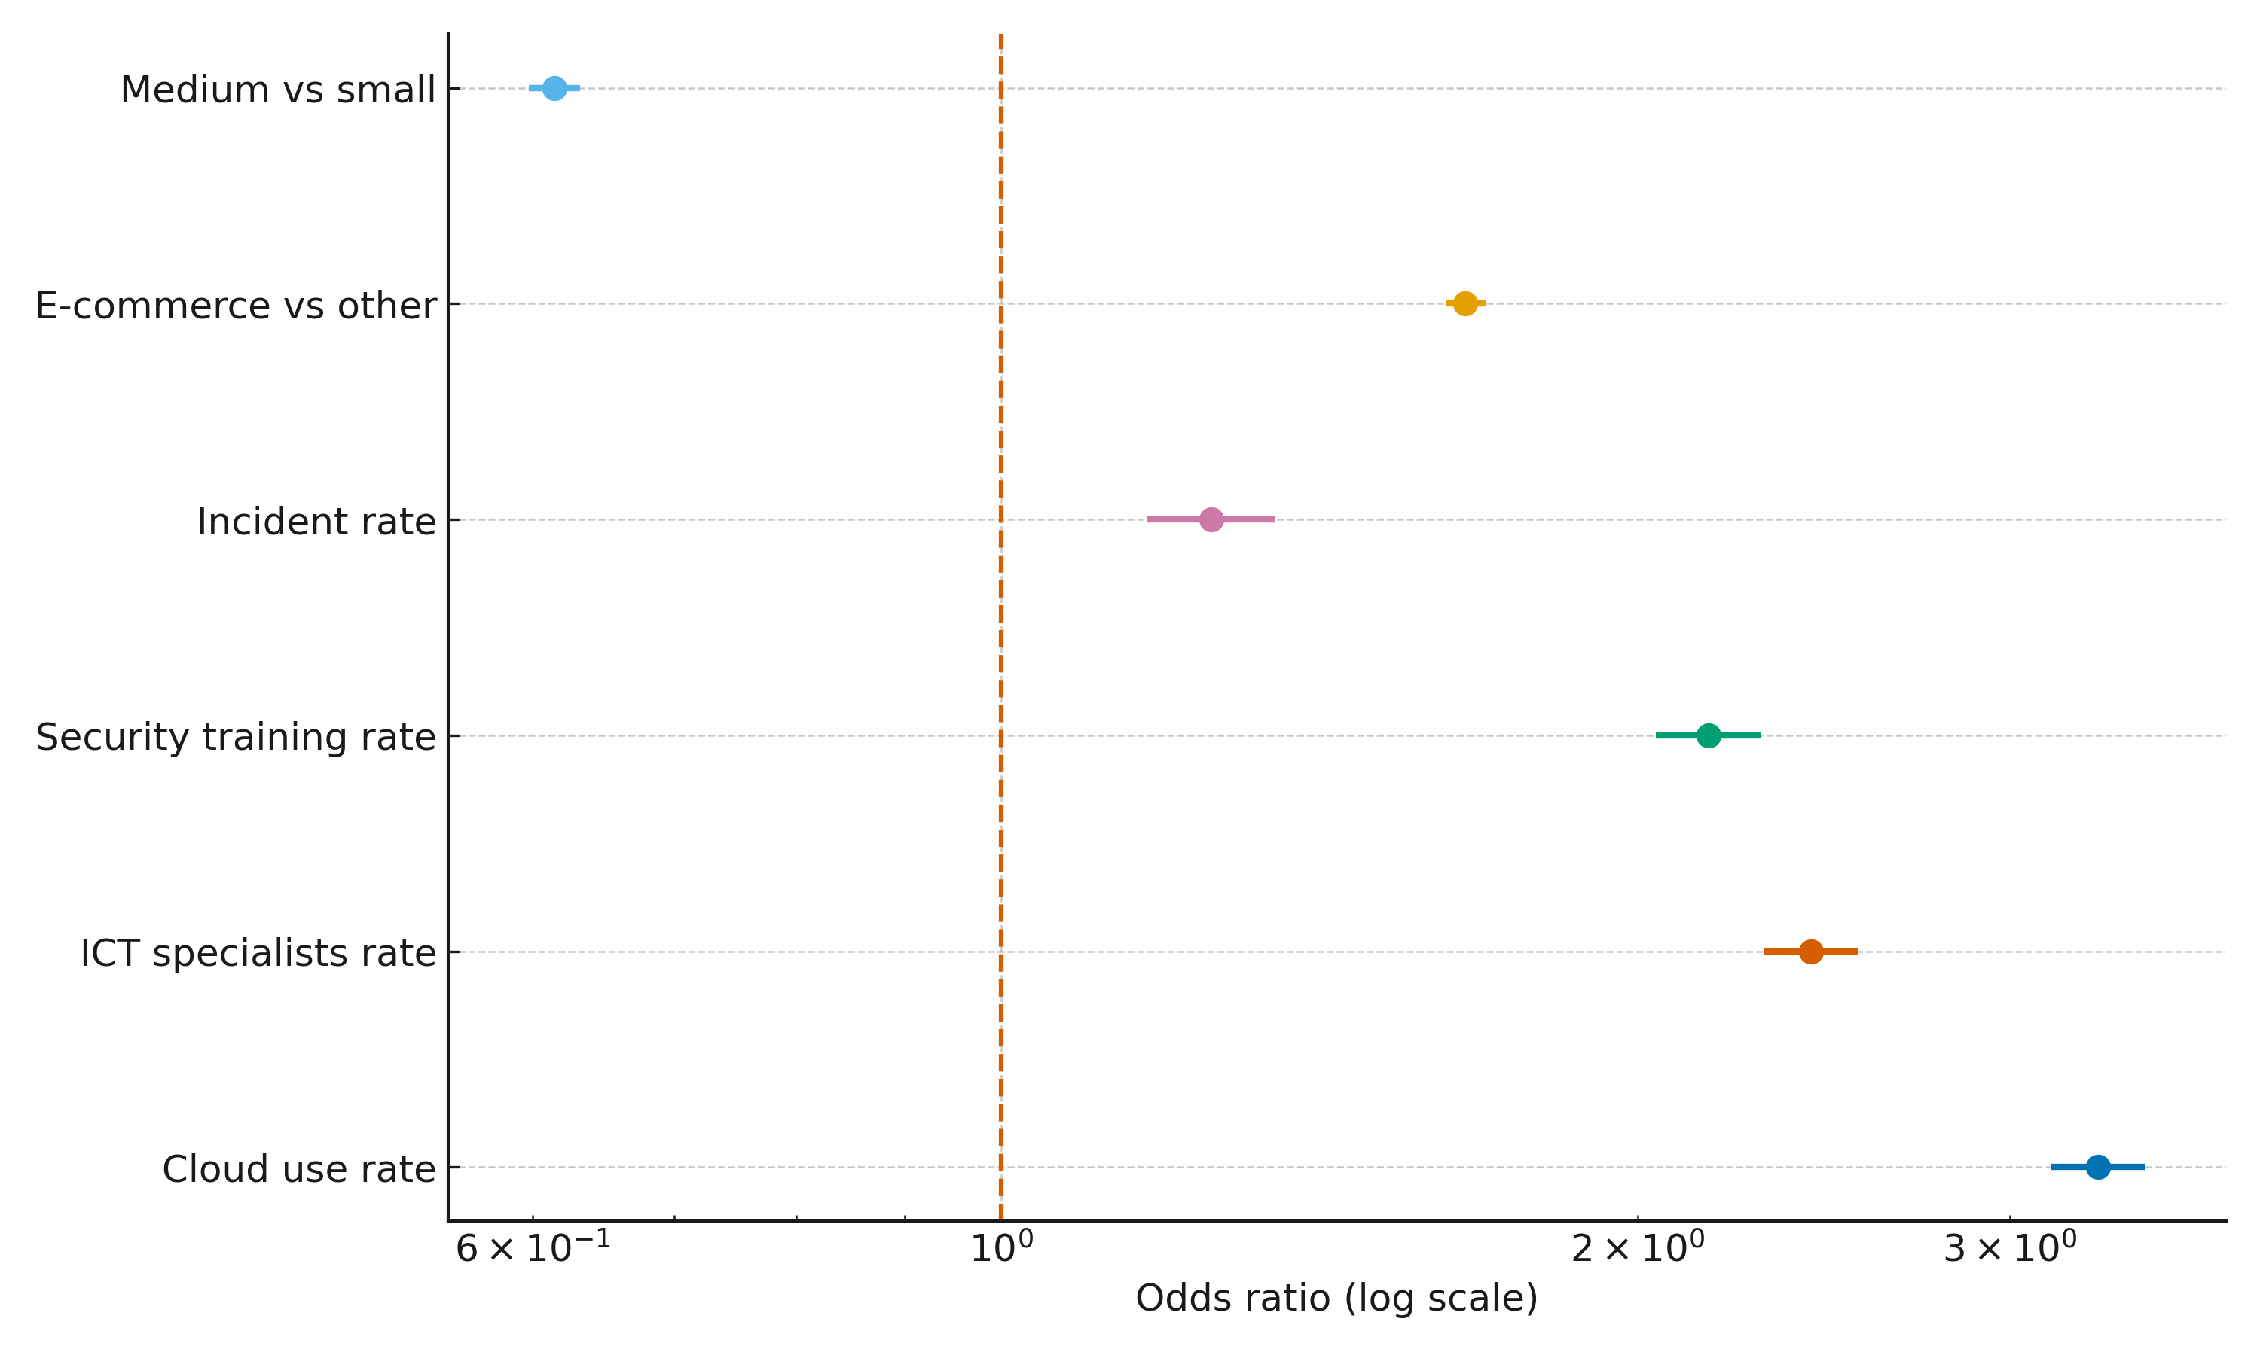
Figure 1. Forest plot of odds ratios (log scale) with 95% confidence intervals for key predictors of ML adoption.
The result shows that effect-size estimates indicate that facilitating conditions are the dominant correlates of adoption (Figure 1). Higher cloud use, availability of ICT specialists, and security training are each strongly associated with increased odds of ML adoption; e‑commerce firms exhibit a higher baseline propensity than other retail. Full coefficients are reported in Table 1.
Variable | Odds ratio | 95% CI (low) | 95% CI (high) | p-value
Medium vs small | 0.615 | 0.598 | 0.632 | 0.0000
C(size)[T.small] | 0.408 | 0.398 | 0.419 | 0.0000
Cloud use rate | 3.302 | 3.135 | 3.477 | 0.0000
ICT specialists rate | 2.416 | 2.297 | 2.542 | 0.0000
Security training rate | 2.160 | 2.040 | 2.288 | 0.0000
Incident rate | 1.257 | 1.172 | 1.348 | 0.0000
E-commerce vs other | 1.658 | 1.622 | 1.695 | 0.0000
Table 1. Binomial GLM odds ratios (95% CI) for ML adoption; country fixed effects included but not shown.
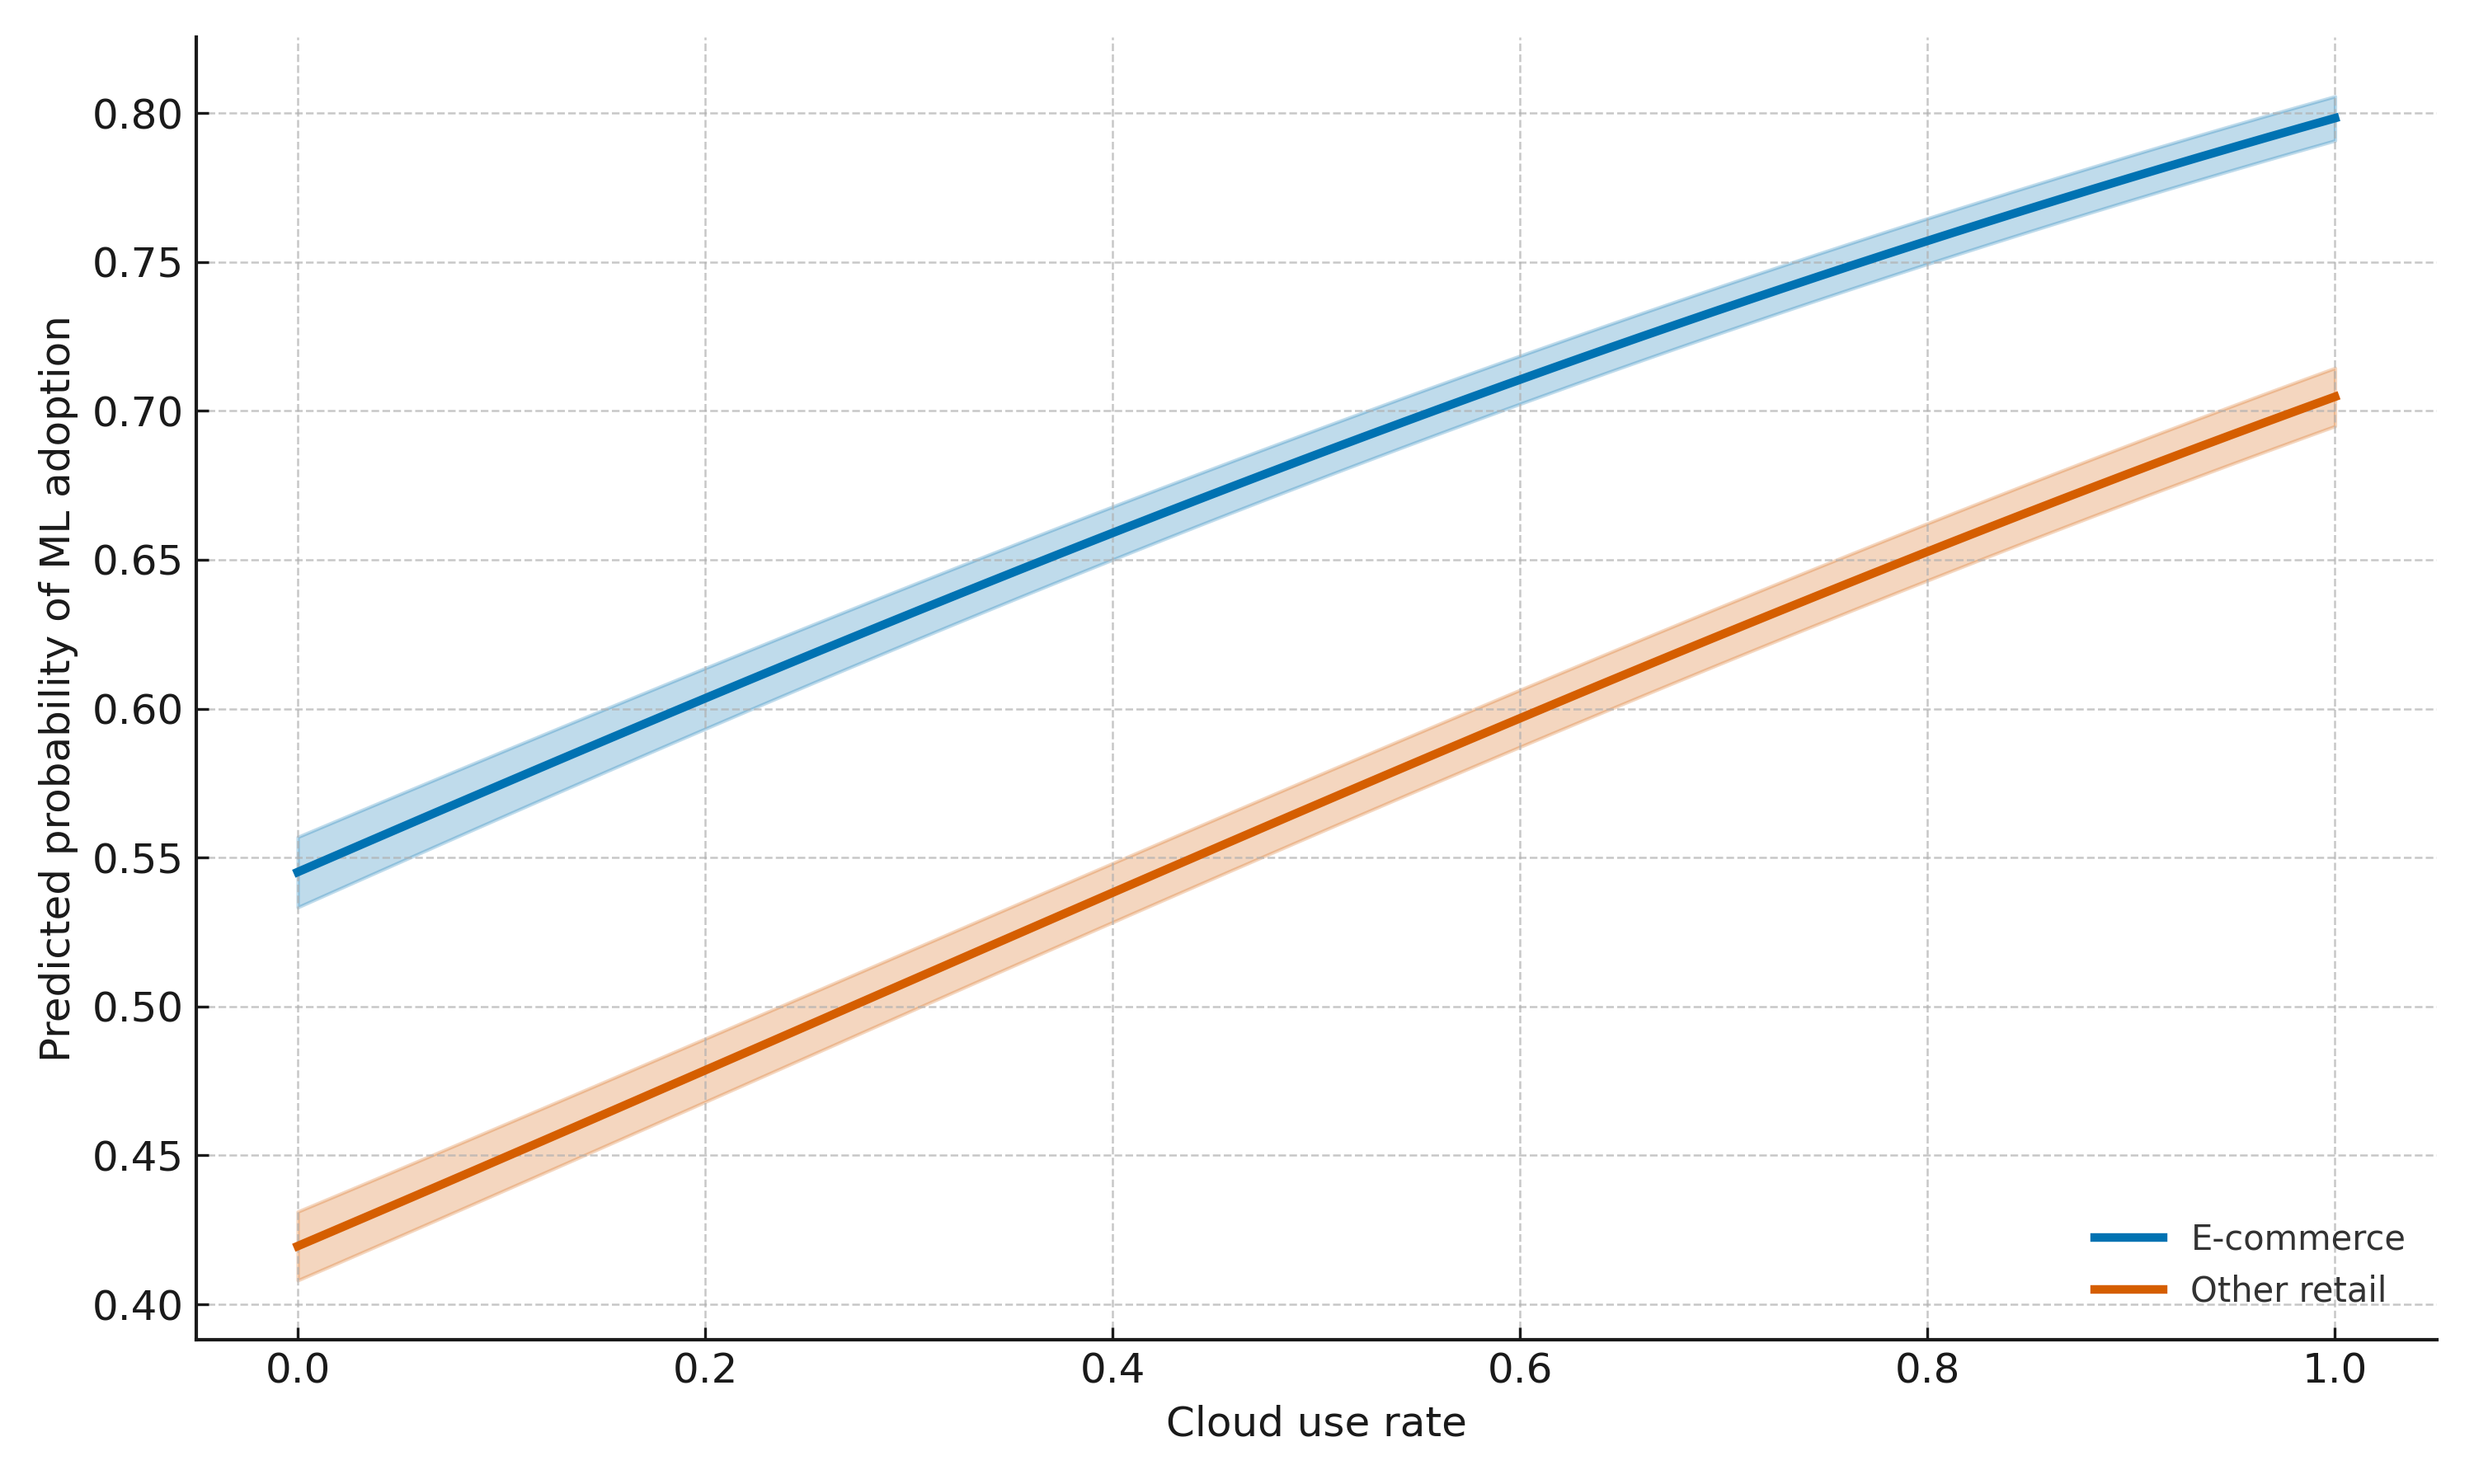
Figure 2. Partial dependence of cloud use rate on predicted probability of ML adoption contrasting e‑commerce and other retail (95% CI bands).
Predicted adoption probability increases monotonically with cloud intensity for both groups, with a clear upward shift for e‑commerce relative to other retail (Figure 2). The average marginal effect of being in e‑commerce is approximately +0.11 in probability points, indicating a meaningful sectoral uplift; see Table 2.
Contrast | Average marginal effect | Std. dev. | N
E-commerce minus other (probability) | 0.1071 | 0.0180 | 180
Table 2. Average marginal effect of e‑commerce versus other retail on predicted adoption probability.
Objective 2. To evaluate how infrastructural throughput, data-governance quality, and compliance constraints influence ML-based intrusion-detection implementation performance, a controlled streaming evaluation with time-windowed classification analyzed via ANCOVA (linear models for F1, latency, and false-positive rate with controls for class imbalance) was adopted.
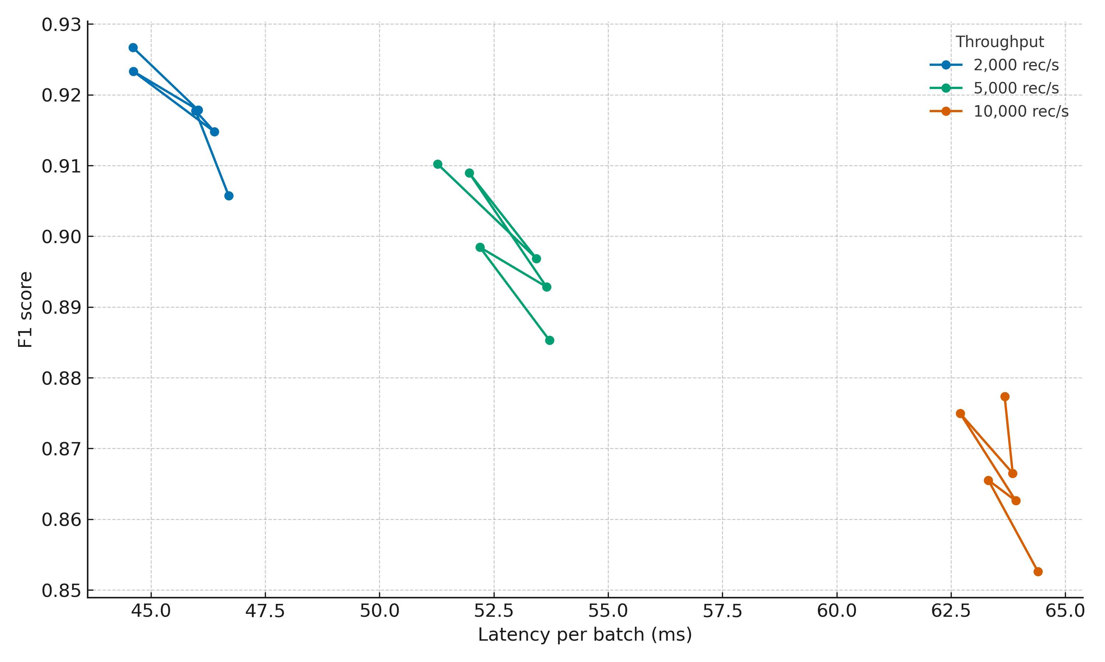
Figure 3. F1–latency trade-off across throughput tiers (median over noise and compliance cells).
The result shows that higher throughput shifts performance toward lower F1 and higher latency, mapping a clear capacity accuracy frontier (Figure 3). Adjusted effects are summarized in Table 3, indicating that governance (label noise) exerts the largest impact on both accuracy and false alarms.
Outcome | Predictor | β | 95% CI (low) | 95% CI (high) | p
F1 | thr_k | -0.0063 | -0.0064 | -0.0062 | 0.0000
F1 | noise | -0.2157 | -0.2295 | -0.2020 | 0.0000
F1 | pii_drop | -0.0122 | -0.0127 | -0.0116 | 0.0000
F1 | class_imbalance | 0.2480 | 0.2405 | 0.2555 | 0.0000
Latency (ms) | thr_k | 2.2501 | 2.2036 | 2.2966 | 0.0000
Latency (ms) | noise | 9.2076 | 2.1043 | 16.3109 | 0.0111
Latency (ms) | pii_drop | 1.3124 | 1.0056 | 1.6193 | 0.0000
Latency (ms) | class_imbalance | 2.9817 | -0.8979 | 6.8613 | 0.1319
False positive rate | thr_k | -0.0000 | -0.0000 | 0.0000 | 0.8791
False positive rate | noise | 0.1797 | 0.1748 | 0.1846 | 0.0000
False positive rate | pii_drop | -0.0019 | -0.0021 | -0.0017 | 0.0000
False positive rate | class_imbalance | -0.0355 | -0.0381 | -0.0328 | 0.0000
Table 3. Adjusted effects (ANCOVA) on F1, latency, and false-positive rate; coefficients interpreted per unit of predictor (throughput measured in thousands of records per second).
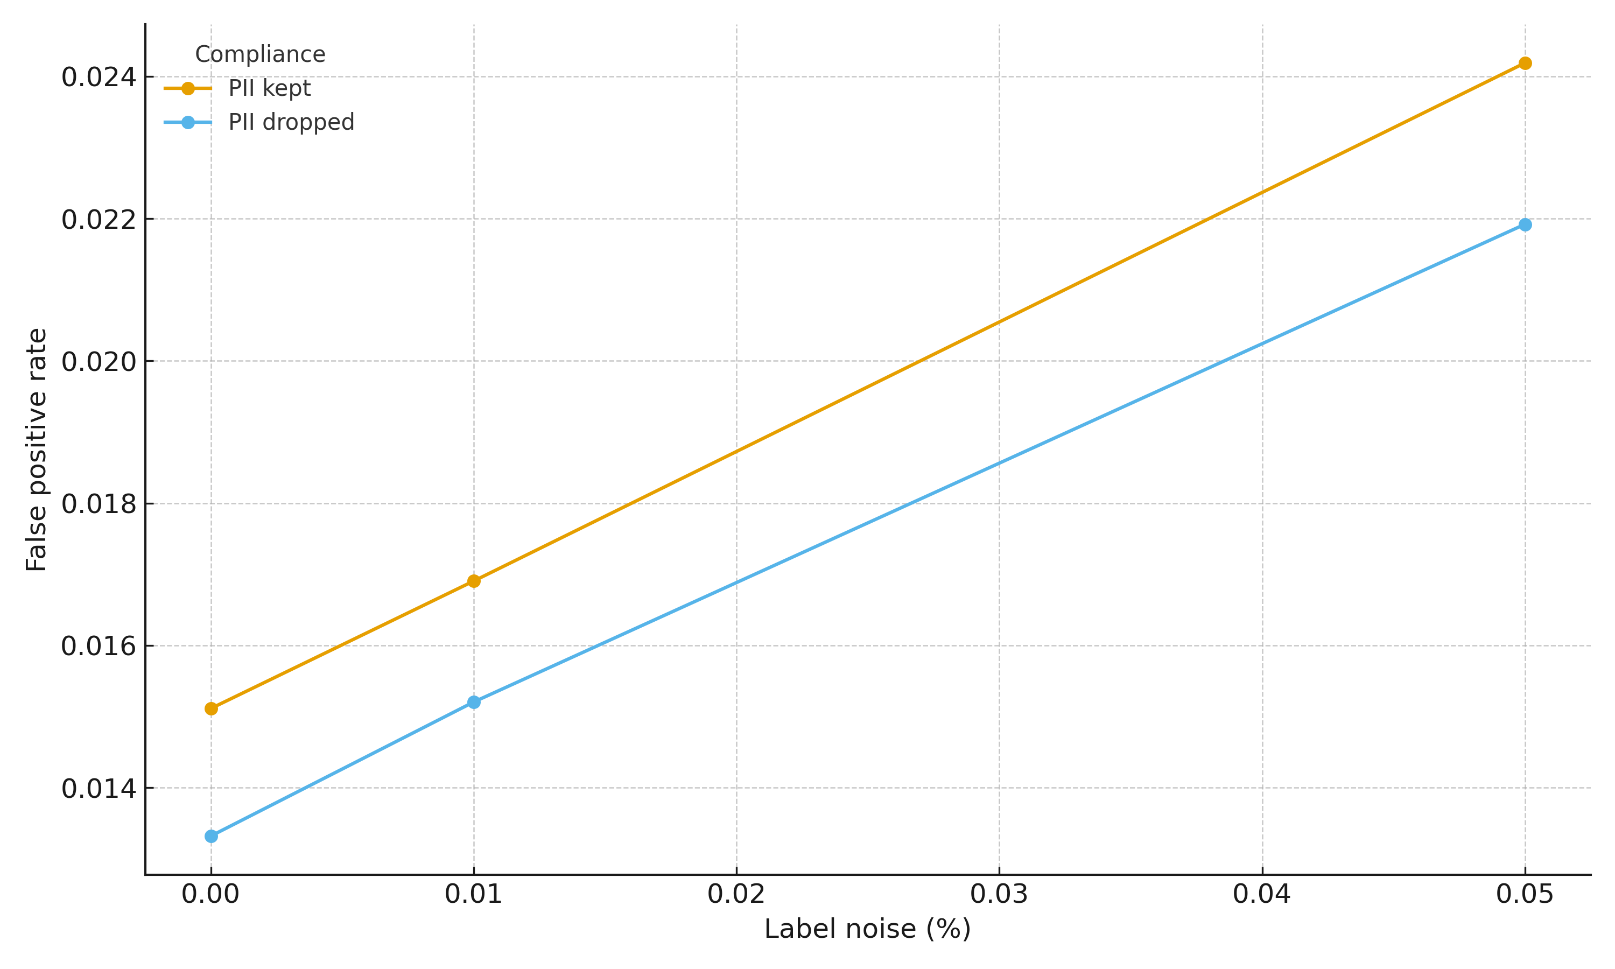
Figure 4. Effect of label noise on false-positive rate by compliance constraint (PII kept vs PII dropped).
This analysis shows that label-noise increases drive FPR upward with a near-linear gradient, while PII-feature removal yields a small but consistent FPR reduction at all noise levels (Figure 4). Throughput raises latency and modestly erodes F1, highlighting the need for capacity planning and monitoring of class prevalence.
Objective 3. To identify the organizational enablers and barriers that shift firms from intention/piloting to production deployment of advanced security analytics, a propensity score matching with one-to-one nearest-neighbor matching (caliper on logit of the propensity score) to estimate the average treatment effect on the treated (ATT) was adopted.
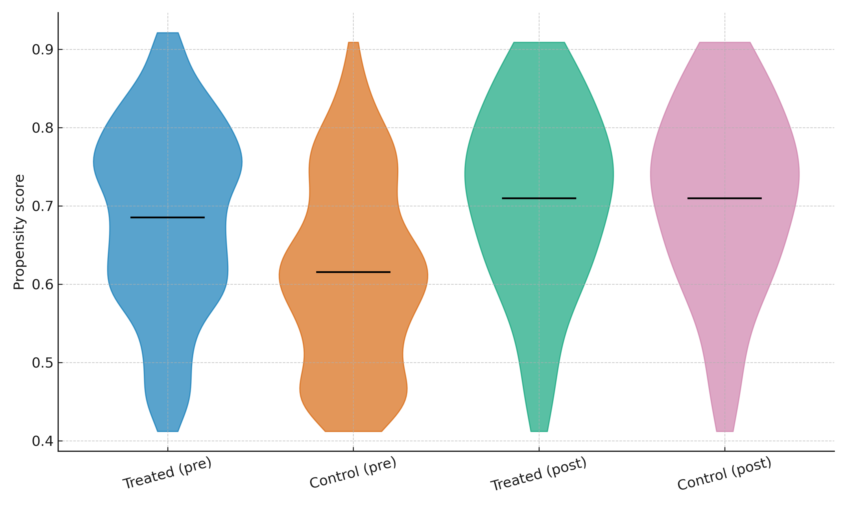
Figure 5. Propensity score distributions for treated and control firms pre- and post-matching (violins show density; black line denotes group mean).
The result shows that post-matching score overlap improved substantially across groups, indicating adequate covariate balance on observed factors (Figure 5). The estimated treatment effect shows a small but positive lift in deployment among firms with facilitating conditions; matching diagnostics and sensitivity analysis are summarized in Table 4 and covariate balance improvements are reported in Table 5.
Metric | Estimate
ATT (pp) | 1.18
Treated N (matched) | 85.0
Control N (matched) | 85.0
Caliper_on_logit | 0.121
Discordant_pairs(Nd) | 39.0
S_pairs(treated>control) | 20.0
R_pairs(control>treated) | 19.0
Rosenbaum_Gamma_at_p>0.05 | 1.0
Table 4. Average treatment effect on the treated (ATT) and matching summary, including sensitivity to hidden bias (Rosenbaum bounds).
Covariate | |SMD| (pre) | |SMD| (post)
cloud_use | 0.075 | 0.000
board_attn | 0.256 | 0.024
certification | 0.317 | 0.024
size_medium | 0.143 | 0.025
size_large | 0.286 | 0.026
outsourcing | 0.134 | 0.047
prior_incident | 0.069 | 0.047
Table 5. Standardized mean differences before and after matching; the 0.10 threshold is commonly used as a balance benchmark.
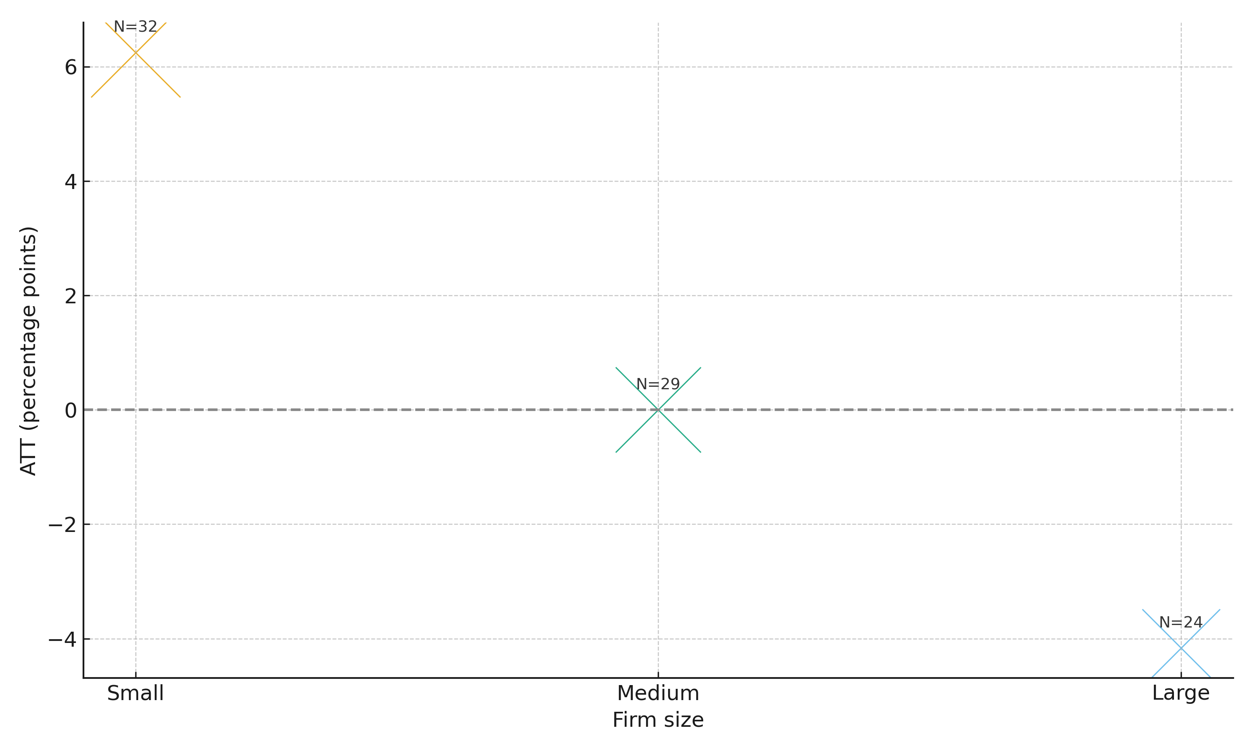
Figure 6. Size-stratified average treatment effect (ATT) using matched pairs; bubble size is proportional to the number of matched pairs within each stratum.
This analysis that facilitating conditions are associated with a modest increase in production deployment; effects vary by firm size with higher pair counts among smaller firms, while balance diagnostics confirm substantial reductions in covariate differences (Figure 6; Tables 4–5).
Discussion
The results collectively indicate that capability enablers rather than incident pressure explain why some e-commerce firms adopt and operationalize ML for threat detection. In line with UTAUT expectations that performance and facilitating conditions drive behavioral intention (Venkatesh et al., 2003; Rana et al., 2024), the adoption model shows large, precise associations for cloud intensity, ICT specialist availability, and security training, while the incident rate is positive but comparatively small (Figure 1; Table 1). The sector contrast reinforces contextual fit: e-commerce firms display a higher baseline propensity to adopt than other retail, and the average marginal effect of being in e-commerce is about +0.11 on the probability scale (Figure 2; Table 2). This pattern converges with findings that organizational readiness and compatibility are decisive for enterprise AI uptake (Olaniyi, 2025; Hasani et al., 2023; Prakash, 2025), extending them with concrete, operational levers observable at scale.
Turning from intention to execution, the streaming evaluation clarifies what impedes reliable deployment. The ANCOVA shows that governance quality dominates model performance: even modest label noise depresses F1 and raises false positives with tight confidence intervals, whereas the compliance constraint (feature removal) slightly reduces F1 but consistently lowers FPR (Table 3; Figure 4). This trade-off is consistent with the view that privacy-by-design can be performance-tolerant when pipelines are well governed (NIST, 2023, 2024; Bernardo et al., 2024). At the same time, throughput introduces a predictable capacity accuracy frontier: as sustained records per second rise, F1 slips and latency grows (Figure 3; Table 3). This aligns with evidence that MLOps maturity not model choice alone determines operational reliability through CI/CD, versioning, and drift monitoring (John et al., 2025; Pham et al., 2024; Kustitskaya et al., 2025). In practice, the results imply that enterprises should treat throughput and label quality as first-order design constraints, with compliance engineered as a controlled bias–variance adjustment rather than a late-stage restriction.
The firm-level causal contrast adds texture to the adoption–implementation gap highlighted in prior work (Jurgens & Dal Cin, 2025; Themann, 2025). After balancing on observed covariates, facilitating conditions are associated with a small but positive lift in production deployment (ATT≈+1.18 pp), and the matching diagnostics show substantial improvements across all covariates (Figure 5; Tables 4–5). However, the sensitivity analysis indicates that this effect is vulnerable to modest unobserved confounding (Table 4), which echoes reports that leadership commitment, integration maturity, and vendor dependencies often remain off-survey yet decisive in moving from pilots to production (Olaniyi, 2025; Ee et al., 2024; Hasani et al., 2023). The size-stratified view hints at where enabling conditions may yield the highest practical returns, with more matched evidence concentrated among smaller firms (Figure 6), consistent with arguments that targeted capability building can unlock value where baseline constraints are binding (IBM IBV, 2024; BCG, 2024).
Synthesizing across objectives, three implications emerge. First, adoption is strongly tied to capabilities that shorten the path from data to action cloud use, specialist capacity, and structured security training supporting the extension of UTAUT with management and infrastructural moderators in security-critical contexts (Olaniyi, 2025; Kim et al., 2024). Second, implementation quality hinges on controllable operational levers: label governance and throughput management shape F1, FPR, and latency in ways that can be planned, measured, and audited (Table 3; Figures 3–4), reinforcing governance and MLOps guidance from standards bodies (NIST, 2023). Third, while facilitating conditions do help move firms from intention to deployment, the modest and sensitivity-prone ATT suggests that unmeasured organizational frictions ranging from change resistance to integration debt still attenuate realized gains (Cheong, Chin, & Setiawan, 2024; Feltes, 2025). Consequently, the evidence supports a translational posture: prioritize capability levers that drive adoption (Figure 1; Table 1), engineer pipelines that preserve data quality under production load (Figure 3; Figure 4), and institutionalize governance to convert intention into durable deployment, while acknowledging residual sources of bias indicated by the matching sensitivity checks (Figure 5; Tables 4–5).
5. Conclusion and Recommendations
E-commerce ML adoption and performance are driven far more by enabling capacity cloud intensity, specialist availability, and structured security training than by incident pressure, while implementation quality hinges on label governance and throughput management compliance constraints can be engineered with limited accuracy costs. However, deployment gains are modest and sensitive to unobserved organizational frictions. Accordingly, the following actions are recommended:
- Enterprise leaders: ring-fence budgets for cloud, in-house specialists, and mandatory security training tied to measurable adoption KPIs.
- SOC/MLOps teams: implement CI/CD with drift telemetry treat label quality as a first-order control and enforce noise audits per release.
- Regulators and standards bodies: operationalize privacy-by-design with model-card style audit trails to balance FPR reduction and explainability.
- Industry consortia and funders: target SMEs with shared reference pipelines, pretrained detectors, and hands-on deployment clinics to overcome integration debt.

COMPETING INTERESTS DISCLAIMER:
Authors have declared that they have no known competing financial interests OR non-financial interests OR personal relationships that could have appeared to influence the work reported in this paper.

References
Abdalla Mikhaeil, C., Raman, R., James, T. L., & Venkatesh, V. (2025). The Sky is Falling, UTAUT Has Failed! An Investigation of the Adoption of Privacy-Enhancing Technologies (PETs). Information Systems Frontiers. https://doi.org/10.1007/s10796-025-10607-0
Abdelaziz, M. T., Radwan, A., Mamdouh, H., Saad, A. S., Abuzaid, A. S., AbdElhakeem, A. A., Zakzouk, S., Moussa, K., & Darweesh, M. S. (2024). Enhancing Network Threat Detection with Random Forest-Based NIDS and Permutation Feature Importance. Journal of Network and Systems Management, 33(1). https://doi.org/10.1007/s10922-024-09874-0
Adesokan-Imran, T. O., Popoola, A. D., Kolo, F. H. O., Ejiofor, V. O., & Salami, I. A. (2025). Cybersecurity Risk Stratification Framework Using Multilevel Clustering: An Automated Threat Attribution and Categorization Approach for Cross-industry Cybersecurity. Journal of Engineering Research and Reports, 27(4), 241–263. https://doi.org/10.9734/jerr/2025/v27i41469
Al-Khatib, A. W. (2023). Drivers of generative artificial intelligence to fostering exploitative and exploratory innovation: A TOE framework. Technology in Society, 75, 102403–102403. https://doi.org/10.1016/j.techsoc.2023.102403
Ali, W., & Khan, A. Z. (2024). Factors influencing readiness for artificial intelligence: a systematic literature review. Data Science and Management, 8(2). https://doi.org/10.1016/j.dsm.2024.09.005
Alotaibi, A., & Rassam, M. A. (2023). Adversarial Machine Learning Attacks against Intrusion Detection Systems: A Survey on Strategies and Defense. Future Internet, 15(2), 62. https://doi.org/10.3390/fi15020062
Alshaikh, O., Parkinson, S., & Khan, S. (2023). Exploring Perceptions of Decision-Makers and Specialists in Defensive Machine Learning Cybersecurity Applications: The Need for a Standardised Approach. SSRN Electronic Journal. https://doi.org/10.2139/ssrn.4582920
Amrit, C., & Narayanappa, A. K. (2024). An analysis of the challenges in the adoption of MLOps. Journal of Innovation & Knowledge, 10(1), 100637. https://doi.org/10.1016/j.jik.2024.100637
Arghire, I. (2025, June 4). Thousands Hit by The North Face Credential Stuffing Attack. SecurityWeek. https://www.securityweek.com/thousands-hit-by-the-north-face-credential-stuffing-attack/?utm_
Ayinaddis, S. G. (2025). Artificial intelligence adoption dynamics and knowledge in SMEs and large firms: A systematic review and bibliometric analysis. Journal of Innovation & Knowledge, 10(3), 100682. https://doi.org/10.1016/j.jik.2025.100682
Bamigbade, O., Obrik-Uloho, E. P., Kolo, F. H. O., Ogunmolu, A. M., & Adesokan-Imran, T. O. (2025). Data-Centric AI for Zero-Carbon Power Systems Security: A Framework for Learning with Noisy, Sparse, and Heterogeneous Data. Journal of Energy Research and Reviews, 17(7), 167–185. https://doi.org/10.9734/jenrr/2025/v17i7442
BCG. (2024). AI Adoption in 2024: 74% of Companies Struggle to Achieve and Scale Value. BCG Global. https://www.bcg.com/press/24october2024-ai-adoption-in-2024-74-of-companies-struggle-to-achieve-and-scale-value?utm_
Bernardo, B. M. V., Mamede, H. S., Barroso, J. M. P., & dos Santos, V. M. P. D. (2024). Data governance & quality management—Innovation and breakthroughs across different fields. Journal of Innovation & Knowledge, 9(4), 100598. https://doi.org/10.1016/j.jik.2024.100598
Burton, G. (2025). Harrods blames supplier for second cyberattack of 2025. Computing.co.uk. https://www.computing.co.uk/news/2025/security/harrods-blames-supplier-for-second-cyberattack-of-2025
Casovan, A., Jones, J., & Chaudhry, U. (2024, June). AI Governance in Practice Report 2024. IAPP. https://iapp.org/resources/article/ai-governance-in-practice-report/
Compagnucci, M. C., Fenwick, M., Aboy, M., & Minssen, T. (2023). Supplementary Measures and Appropriate Safeguards for International Transfers of Health Data After Schrems II. Perspectives in Law, Business and Innovation, 151–172. https://doi.org/10.1007/978-981-99-6540-3_9
Ee, S., O’Brien, J., Williams, Z., El-Dakhakhni, A., Aird, M., & Lintz, A. (2024). Adapting cybersecurity frameworks to manage frontier AI risks: A defense-in-depth approach. ArXiv.org. https://arxiv.org/abs/2408.07933?utm_
Enshassi, M., Nathan, R. J., Soekmawati, & Ismail, H. (2025). Unveiling Barriers and Drivers of AI Adoption for Digital Marketing in Malaysian SMEs. Journal of Open Innovation Technology Market and Complexity, 11(2), 100519–100519. https://doi.org/10.1016/j.joitmc.2025.100519
Fatunmbi, O. T. (2022). Impact of data science and cybersecurity in e-commerce using machine learning techniques. World Journal of Advanced Research and Reviews, 2022(01), 832–846. https://doi.org/10.30574/wjarr.2022.13.1.0607
Feltes, N. (2025). Article 50 AI Act: Do the Transparency Provisions Improve Upon the Commission’s Draft? JIPITEC – Journal of Intellectual Property, Information Technology and E-Commerce Law, 16(2). https://www.jipitec.eu/jipitec/article/view/438?utm_
Flenman, S. (2025). Machine Learning for Intrusion Detection in Network Traffic. https://mau.diva-portal.org/smash/get/diva2%3A1984505/FULLTEXT02.pdf
Gardner, A. (2024, October 31). Credential stuffing and account takeover attacks remain nagging business problems. HUMAN Security. https://www.humansecurity.com/learn/blog/credential-stuffing-and-account-takeover-attacks-remain-nagging-business-problems/?utm_
Gutierrez-Garcia, J. L., Sanchez-DelaCruz, E., & Pozos-Parra, M. del P. (2023). A Review of Intrusion Detection Systems Using Machine Learning: Attacks, Algorithms and Challenges. Lecture Notes in Networks and Systems, 59–78. https://doi.org/10.1007/978-3-031-28073-3_5
Hasani, T., O’Reilly, N., Dehghantanha, A., Rezania, D., & Levallet, N. (2023). Evaluating the adoption of cybersecurity and its influence on organizational performance. SN Business & Economics, 3(5). https://doi.org/10.1007/s43546-023-00477-6
Heshmatisafa, S., & Seppänen, M. (2023). Exploring API-driven business models: Lessons learned from Amadeus’s digital transformation. Digital Business, 3(1), 100055. https://doi.org/10.1016/j.digbus.2023.100055
IBM. (2024). 2024 CEO Study: 6 hard truths CEOs must face. IBM. https://www.ibm.com/thought-leadership/institute-business-value/en-us/report/2024-ceo?utm_
IBM. (2025). Cost of a data breach 2025 | IBM. Ibm.com. https://www.ibm.com/reports/data-breach?utm_
Imperva. (2025, April 15). 2025 Bad Bot Report | Resource Library. Resource Library. https://www.imperva.com/resources/resource-library/reports/2025-bad-bot-report/
Jada, I., & Mayayise, T. O. (2023). The impact of artificial intelligence on organisational cyber security: An outcome of a systematic literature review. Data and Information Management, 8(2), 100063–100063. Sciencedirect. https://doi.org/10.1016/j.dim.2023.100063
John, M. M., Olsson, H. H., & Bosch, J. (2025). An empirical guide to MLOps adoption: Framework, maturity model and taxonomy. Information and Software Technology, 183, 107725–107725. https://doi.org/10.1016/j.infsof.2025.107725
Jurgens, J., & Dal Cin, P. (2025). Global Cybersecurity Outlook 2025. In World Economic Forum. World Economic Forum. https://reports.weforum.org/docs/WEF_Global_Cybersecurity_Outlook_2025.pdf
Ke, Q., Gong, Y., & Ke, C. (2025). Bridging AI literacy and UTAUT constructs: structural equation modeling of AI adoption among Chinese university students. Humanities and Social Sciences Communications, 12(1). https://doi.org/10.1057/s41599-025-05775-y
KeepNet. (2025, September 24). Deepfake Statistics & Trends 2025: Growth, Risks, and Future Insights. Keepnet Labs. https://keepnetlabs.com/blog/deepfake-statistics-and-trends
Kim, Y., Blazquez, V., & Oh, T. (2024). Determinants of Generative AI System Adoption and Usage Behavior in Korean Companies: Applying the UTAUT Model. Behavioral Sciences, 14(11), 1035–1035. https://doi.org/10.3390/bs14111035
Kolo, F. (2023). Insights in Cybersecurity & Business Intelligence: A Dual Perspective: Unlocking Security Insights and Business Growth: Intrusion Detection Strategies and Sales Forecasting Techniques. LAP LAMBERT Academic Publishing. https://www.amazon.com/Insights-Cybersecurity-Business-Intelligence-Perspective/dp/6207450841
Kolo, F. H. O. (2025a). A Multi-level Clustering Framework for Cybersecurity Risk Stratification in Healthcare: A Dynamic, Overlapping Approach to Threat Classification and Mitigation. Asian Journal of Research in Computer Science, 18(5), 11–31. https://doi.org/10.9734/ajrcos/2025/v18i5636
Kolo, F. H. O. (2025b). Responsible AI for Cybersecurity: Assessing the Barriers, Biases and Governance Gaps in Implementation with E-commerce Systems. Journal of Engineering Research and Reports, 27(5), 510–532. https://doi.org/10.9734/jerr/2025/v27i51520
Kolo, F. H. O., Joseph, S. A., Ogunmolu, A. M., Ejiofor, V. O., & Oyekunle, S. M. (2025). Mitigating Cybersecurity Risks in Financial Institutions through Strategic Third- Party Risk Governance Frameworks. Journal of Engineering Research and Reports, 27(5), 173–193. https://doi.org/10.9734/jerr/2025/v27i51501
Krishnan, D., & Shrinath, P. (2024). Robust IoT Botnet Detection Framework Resilient to Gradient Based Adversarial Attacks. SN Computer Science, 5(7). https://doi.org/10.1007/s42979-024-03242-0
Kustitskaya, T. A., Esin, R. V., & Noskov, M. V. (2025). Model Drift in Deployed Machine Learning Models for Predicting Learning Success. Computers, 14(9), 351. https://doi.org/10.3390/computers14090351
Mohamed, N. (2025). Artificial intelligence and machine learning in cybersecurity: a deep dive into state-of-the-art techniques and future paradigms. Knowledge and Information Systems, 67, 6969–7055. https://doi.org/10.1007/s10115-025-02429-y
Morales, J. (2025, August 20). 95% of generative AI implementations in enterprise “have no measurable impact on P&L”, says MIT — flawed integration cited as why AI projects underperform. Tom’s Hardware. https://www.tomshardware.com/tech-industry/artificial-intelligence/95-percent-of-generative-ai-implementations-in-enterprise-have-no-measurable-impact-on-p-and-l-says-mit-flawed-integration-key-reason-why-ai-projects-underperform?utm_
Morgan, S. (2024, November 5). Boardroom Cybersecurity Report 2024. Secureworks. https://www.secureworks.com/centers/boardroom-cybersecurity-report-2024
NIST. (2023). AI Risk Management Framework. Artificial Intelligence Risk Management Framework (AI RMF 1.0), 1(1). https://doi.org/10.6028/nist.ai.100-1
NIST. (2024). Artificial Intelligence Risk Management Framework: Generative Artificial Intelligence Profile. Artificial Intelligence Risk Management Framework: Generative Artificial Intelligence Profile. https://doi.org/10.6028/nist.ai.600-1
Obrik-Uloho, E. P. (2025). Elevating Continuous Verification through Advanced Behavioral Analytics: A Deep-Dive Framework for Combating Insider Threats and Account Takeovers in Modern Cybersecurity. Journal of Engineering Research and Reports, 27(10), 316–337. https://doi.org/10.9734/jerr/2025/v27i101676
Ogunmolu, A. M. (2025a). A Multiscale Approach to Cyber-Mechanical Threat Modeling for Predicting and Preventing Failures in Critical Energy Infrastructure. Journal of Engineering Research and Reports, 27(6), 1–20. https://doi.org/10.9734/jerr/2025/v27i61523
Ogunmolu, A. M. (2025b). Federated Detection Systems for Insider Threats in Energy Facilities Using Biomechanical Access Control and Al-Based Cybersecurity. Journal of Engineering Research and Reports, 27(6), 65–82. https://doi.org/10.9734/jerr/2025/v27i61528
Olaniyi, O. (2025). A Quantitative Approach to Understanding Machine Learning Adoption for Cybersecurity in E-Commerce Through the UTAUT Model. [Unpublished dissertation].
Olson, T. (2025, August 2). Annual Cybercrime Cost to Jump by 70% and hit $13.8 Trillion by 2028 – Global Security Mag Online. Global Security Mag Online. https://www.globalsecuritymag.com/annual-cybercrime-cost-to-jump-by-70-and-hit-13-8-trillion-by-2028.html
Olutimehin , A. T., Olaniyi , O. O., Ogunmolu , A. M., Kolo, F. H. O., & Salami , I. A. (2025). Cloud-Based AI Solutions for Real-time Monitoring of E-commerce Compliance and Risk. Journal of Engineering Research and Reports, 27(7), 127–147. https://doi.org/10.9734/jerr/2025/v27i71566
Olutimehin, A. T., Olaniyi, O. O., Popoola, A. D., Ogunmolu, A. M., & Kolo, F. H. (2025). AI and IoT Integration for Predictive Maintenance and Risk Management in Smart Manufacturing. Asian Journal of Research in Computer Science, 18(7), 120–142. https://doi.org/10.9734/ajrcos/2025/v18i7724
Oyekunle, S. M., Popoola, A. D., Kolo, F. H. O., Ogunmolu, A. M., & Adesokan-Imran, T. O. (2025). Intelligent Fraud Prevention Information Banking: A Data Governance- Centric Approach Using Behavioural Biometrics. Asian Journal of Research in Computer Science, 18(5), 525–543. https://doi.org/10.9734/ajrcos/2025/v18i5672
Pham, M. T., Premkumar, K., Naili, M., & Yang, J. (2024). Time to Retrain? Detecting Concept Drifts in Machine Learning Systems. ArXiv.org. https://arxiv.org/abs/2410.09190
Prakash, C. (2025). Evaluating the TOE Framework for Technology Adoption: A Systematic Review of Its Strengths and Limitations. International Journal on Recent and Innovation Trends in Computing and Communication, 13(1), 76–82. https://www.researchgate.net/publication/389208026_Evaluating_the_TOE_Framework_for_Technology_Adoption_A_Systematic_Review_of_Its_Strengths_and_Limitations
Pramod, J. P., Yadav, B. G., & Fatima, S. (2024). Machine Learning Meets Cybersecurity. International Journal of Scientific Research in Science, Engineering and Technology, 11(6), 17–24. https://doi.org/10.32628/ijsrset241161513
Prümmer, J., van Steen, T., & van den Berg, B. (2024). A systematic review of current cybersecurity training methods. Computers & Security, 136(103585). https://doi.org/10.1016/j.cose.2023.103585
Rana, M., Siddiqee, M. S., Sakib, N., & Ahamed, R. (2024). Assessing AI adoption in developing country academia: A trust and privacy-augmented UTAUT framework. Heliyon, 10(18), e37569. https://doi.org/10.1016/j.heliyon.2024.e37569
Rawindaran, N., Jayal, A., & Prakash, E. (2021). Machine Learning Cybersecurity Adoption in Small and Medium Enterprises in Developed Countries. Computers, 10(11), 150. https://doi.org/10.3390/computers10110150
Rees-Pullman, S. (2020). Is credential stuffing the new phishing? Computer Fraud & Security, 2020(7), 16–19. https://doi.org/10.1016/S1361-3723(20)30076-2
Reuters. (2023, January 30). Britain’s JD Sports says customer data accessed by cyber attack. Reuters. https://www.reuters.com/business/retail-consumer/uks-jd-sports-says-some-customer-data-compromised-online-orders-2023-01-30/
Richabadas, T. (2024, November 19). Threat Spotlight: Bad bots are evolving to become more “human.” Barrcuda Blog. https://blog.barracuda.com/2024/11/19/threat-spotlight-bad-bots-evolving-more-human
Roy, P., Chandrasekaran, J., Lanus, E., Freeman, L., & Werner, J. (2023, October 10). A Survey of Data Security: Practices from Cybersecurity and Challenges of Machine Learning. ArXiv.org. https://doi.org/10.48550/arXiv.2310.04513
Salami, I. A., Popoola, A. D., Gbadebo, M. O., Kolo, F. H. O., & Adesokan-Imran, T. O. (2025). AI- Powered Behavioural Biometrics for Fraud Detection in Digital Banking: A Next-Generation Approach to Financial Cybersecurity. Asian Journal of Research in Computer Science, 18(4), 473–494. https://doi.org/10.9734/ajrcos/2025/v18i4632
Salem, A. H., Azzam, S. M., Emam, O. E., & Abohany, A. A. (2024). Advancing cybersecurity: a comprehensive review of AI-driven detection techniques. Journal of Big Data, 11(1), 1–38. https://doi.org/10.1186/s40537-024-00957-y
Sarker, I. H., Janicke, H., Mohsin, A., Gill, A., & Maglaras, L. (2024). Explainable AI for cybersecurity automation, intelligence and trustworthiness in digital twin: Methods, taxonomy, challenges and prospects. ICT Express, 10(4). https://doi.org/10.1016/j.icte.2024.05.007
Shanmugam, V., Razavi-Far, R., & Hallaji, E. (2024). Addressing Class Imbalance in Intrusion Detection: A Comprehensive Evaluation of Machine Learning Approaches. Electronics, 14(1), 69–69. https://doi.org/10.3390/electronics14010069
Su, J., Wang, Y., Liu, H., Zhang, Z., Wang, Z., & Li, Z. (2025). Investigating the factors influencing users’ adoption of artificial intelligence health assistants based on an extended UTAUT model. Scientific Reports, 15(1). https://doi.org/10.1038/s41598-025-01897-0
Themann, S. (2025). Challenges and Strategies Used In Implementing AI Governance: A Systematic Literature Review. https://su.diva-portal.org/smash/get/diva2%3A1983756/FULLTEXT01.pdf
Traceable. (2025). Top Data Breaches of 2022 and What they Mean for API Security. Traceable.ai. https://www.traceable.ai/blog-post/top-data-breaches-2022-api-security
Trillo, J. R., González-López, F., Morente-Molinera, J. A., Magán-Carrión, R., & García-Sánchez, P. (2025). Evaluation of Explainable, Interpretable and Non-Interpretable Algorithms for Cyber Threat Detection. Electronics, 14(15), 3073. https://doi.org/10.3390/electronics14153073
Udechukwu, L. M. (2025a). AI-Governed Security Frameworks for Virtualized Enterprises: Preventing Data Breaches and Ensuring Compliance. Asian Journal of Research in Computer Science, 18(9), 39–57. https://doi.org/10.9734/ajrcos/2025/v18i9753
Udechukwu, L. M. (2025b). Ethical Implications and Cybersecurity Risks of Hyper-Personalized AI Feedback Systems for Mental Health Support in Home Environment. Journal of Engineering Research and Reports, 27(9), 310–328. https://doi.org/10.9734/jerr/2025/v27i91643
Venkatesh, V., Morris, M. G., Davis, G. B., & Davis, F. D. (2003). User Acceptance of Information technology: toward a Unified View. MIS Quarterly, 27(3), 425–478. https://doi.org/10.2307/30036540
Verizon. (2024). 2024 Data Breach Investigations Report. https://www.verizon.com/business/resources/reports/2024-dbir-data-breach-investigations-report.pdf?utm_
Visa. (2024). Emirates NBD. https://corporate.visa.com/content/dam/VCOM/corporate/solutions/documents/emirates-nbd-case-study-final.pdf?utm_
Yang, J., Blount, Y., & Amrollahi, A. (2024). Artificial intelligence adoption in a professional service industry: A multiple case study. Technological Forecasting and Social Change, 201, 123251–123251. https://doi.org/10.1016/j.techfore.2024.123251

