A Quantitative Approach to Understanding Machine Learning Adoption for Cybersecurity in E-Commerce Through the UTAUT Model

Abstract
This study quantitatively examined the adoption of machine learning (ML) for cybersecurity in e-commerce through the Unified Theory of Acceptance and Use of Technology (UTAUT) framework. Using the open-access Mendeley “UTAUT, Combining PLS-SEM and MLR” dataset and the OECD/BCG/INSEAD “Adoption of AI in Firms” dataset, Partial Least Squares Structural Equation Modeling (PLS-SEM) and Fractional Logit Regression were employed to analyze core and extended adoption determinants. Results revealed that Performance Expectancy (β = 0.38) and Effort Expectancy (β = 0.31) most strongly predicted Behavioral Intention (R² = 0.67), while Trust (AME = 0.186) and Regulatory Compliance (AME = 0.127) positively influenced adoption, and Perceived Risk (AME = –0.142) exerted a negative effect. Behavioral Intention significantly mediated actual ML usage (β = 0.64). The study recommends strengthening ML transparency, regulatory alignment, user training, and cross system interoperability to sustain adoption and enhance cybersecurity readiness.
Keywords: Machine Learning Adoption, Cybersecurity, E-Commerce, UTAUT Model, Structural Equation Modeling

1. Introduction
The rapid growth of e-commerce has transformed retail and service delivery, creating massive digital marketplaces but simultaneously amplifying cybersecurity threats. As online transactions surge, malicious actors deploy increasingly sophisticated attacks that static, rule based defenses struggle to detect. For instance, in 2025, Marks & Spencer (M&S), one of the United Kingdom’s largest retailers, suffered a cyberattack that forced it to suspend online order processing and resulted in an estimated £300 million in losses (around US$400 million) in disrupted operations and recovery costs (AP News, 2025). Such incidents underscore the high stakes of cybersecurity in e-commerce and point to the urgent need for more adaptive defenses.
Yet, deploying advanced security tools is not enough: organizations must adopt and effectively integrate them. Building on the idea of Olaniyi (2025), who employed the Unified Theory of Acceptance and Use of Technology (UTAUT) framework to examine drivers of machine learning (ML) adoption for cybersecurity in e-commerce, this study pushes the boundary further by delving into methodological rigor and integrating additional determinants. Olaniyi (2025) established that Performance Expectancy, Effort Expectancy, Social Influence, and Facilitating Conditions are each significantly related to behavioral intention to adopt ML. However, gaps remain in understanding how these relationships manifest in diverse operational settings, especially under newer threats and contextual pressures.
Consider the Harrods data breach: over 430,000 customer records were exposed following a breach through a third party provider (Jennings-Trace, 2025). Although Harrods’ core systems were not directly compromised, the attack exploited supply-chain dependencies, a reminder that ecosystem vulnerabilities are real and require defenses beyond the core system perimeter. In parallel, adversaries themselves are embracing AI/ML techniques. Reports show that attackers use AI to map vulnerabilities, evolve attack strategies dynamically, and evade detection, while defenders race to leverage ML for intrusion detection and threat intelligence (Mohamed, 2025; Razzaq et al., 2025). The coevolution of defensive and offensive AI amplifies the complexity of the cybersecurity arms race.
Moreover, empirical reviews highlight that although ML-based prevention has strong promise in online retail, adoption is still emergent. Razzaq et al. (2025) found that many published works focus on classification techniques (e.g., support vector machines, naive Bayes) but pay less attention to organizational adoption challenges. The authors call for more empirical, adoption oriented research in real e-tailing contexts. Similarly, in a review on AI/ML in cybersecurity, Mohamed (2025) notes gaps in explainability, trust, and integration with legacy systems as major constraints to real world deployment.
Statistically, the scale of the cyber threat is staggering. One report indicates that over 30,000 vulnerabilities were disclosed in a recent year, marking a 17% increase over previous periods. Organizations globally now face cybercrime costs estimated at US$8 trillion annually, with projections rising to US$24 trillion by 2027 (Embroker, 2025). Meanwhile, Microsoft estimates 600 million cyberattacks per day (Martin, 2025). When 80% of retailers report experiencing cyberattacks within a year (VikingCloud, 2025), it becomes clear that defensive systems must scale and adapt tasks for which ML is uniquely suited.
From an industry application perspective, e-commerce platforms are particularly vulnerable: approximately 75% of fraud and data theft incidents involve e-commerce sites (Jain, 2022). Also, 91% of e-commerce merchants express concern about AI-powered fraud in the next 12 months (RSI Security, 2025). Security professionals themselves show strong adoption intent: 61% plan to implement AI/ML in their cybersecurity operations within the next year, while 93% expect daily AI-based attacks by 2025 (Fox, 2024). Such elevated perceptions of risk and defense potential underscore the relevance of theoretical models like UTAUT to explain organizational adoption behavior.
In the developing-economy context, the need is even more acute. Nigeria’s expanding digital economy faces a confluence of weak policy, infrastructure deficits, and limited cybersecurity investment. Studies in Nigeria’s e-commerce sector document repeated breaches tied to poor access controls, weak third-party oversight, and underprepared security architectures (Oyaka, 2024). These vulnerabilities heighten the urgency for organizations to adopt ML-based defenses especially when resources are constrained and threat vectors diverse. In regions where baseline security is fragile, exploring how contextual and organizational factors shape ML adoption is critical.
This research, therefore, is motivated by both empirical urgency and theoretical continuity. Guided by the UTAUT framework, the aim is to quantitatively examine the factors influencing the adoption and effective implementation of machine learning technologies for cybersecurity in e-commerce platforms through the Unified Theory of Acceptance and Use of Technology (UTAUT) framework, with emphasis on methodological rigor, empirical validation, and model enhancement, by achieving the following objectives:
- Evaluates the relationship between core UTAUT constructs Performance Expectancy, Effort Expectancy, Social Influence, and Facilitating Conditions and behavioral intention to adopt machine learning for cybersecurity in e-commerce systems.
- Extends the UTAUT framework by integrating additional technical and organizational determinants such as perceived risk, trust in ML systems, and regulatory compliance pressure, assessing their influence on adoption behavior.
- Analyzes the mediating effect of behavioral intention on the relationship between the UTAUT constructs and actual usage of machine learning cybersecurity solutions in e-commerce firms.
- Provides empirical insights and methodological guidance for e-commerce firms and cybersecurity practitioners on enhancing ML adoption readiness, implementation efficiency, and governance alignment.
In executing this study, modern quantitative techniques such as Partial Least Squares Structural Equation Modeling (PLS-SEM) or Covariance Based SEM will be applied to test hypotheses and validate measurement instruments. Reliability and validity will be assessed through Cronbach’s alpha, Composite Reliability, Average Variance Extracted, and Heterotrait Monotrait ratio. The methodological precision will set this work apart from prior adoption studies, aligning it with the technical orientation of Olaniyi (2025) while advancing it with enhanced empirical and modeling depth.

2. Literature Review
The Unified Theory of Acceptance and Use of Technology (UTAUT) developed by Venkatesh et al. (2003) integrates eight earlier models of technology adoption, providing a comprehensive quantitative framework that predicts user behavioral intention and actual system use. It identifies four principal constructs Performance Expectancy, Effort Expectancy, Social Influence, and Facilitating Conditions that collectively explain technology acceptance, moderated by factors such as age, gender, experience, and voluntariness. The model’s parsimonious structure and statistical robustness make it particularly suited to quantitative validation through structural equation modeling (SEM).
Building on this foundation, empirical validation of the UTAUT’s predictive power in the context of machine-learning (ML) adoption for cybersecurity within e-commerce systems through regression analysis, demonstrates that all four constructs significantly predicted behavioral intention to adopt ML-based security tools, emphasizing UTAUT’s continued applicability to complex, technology-intensive domains (Olaniyi, 2025). However, contextual variations such as infrastructural limitations and post-adoption fatigue may moderate these relationships (Olaniyi, 2025).
Recent research extends UTAUT to contemporary AI and cybersecurity applications. Lai et al. (2024) argue that while Performance Expectancy and Effort Expectancy remain significant predictors of adoption intention, the explanatory power of an adapted UTAUT model increases when constructs such as algorithmic trust and perceived risk are incorporated. Similarly, Lee et al. (2023) found that Effort Expectancy’s influence is mediated by users’ confidence in AI systems’ transparency. Shafi et al. (2024) further emphasize that integrating ethical and organizational factors enhances predictive accuracy in AI adoption. These findings indicate both the consensus and evolution that UTAUT’s foundational constructs remain robust, yet its modern adaptations reflect the growing need to account for trust, risk, and compliance dynamics in ML-driven cybersecurity research dimensions ideally testable through SEM and mediation analyses.

Extending UTAUT with Emerging Determinants
While UTAUT offers a parsimonious base for predicting behavioral intention, extending it with perceived risk, trust in ML systems, and regulatory compliance pressure better reflects contemporary AI-security contexts (Kolo et al., 2025; Olaniyi, 2025). According to Glikson and Woolley (2020), trust in AI is shaped by users’ assessment of capability, benevolence, and integrity; in agreement, studies show that without calibrated trust, high performance expectancy may not convert into intention or actual use, especially where opaque models raise concerns about fairness or bias. Explainability is therefore not merely a technical desideratum but a socio-technical lever for acceptance, as Hoffman et al. (2023) contend that role-appropriate explanations can raise warranted trust while avoiding over-reliance, underscoring the need to treat trust as either a mediator or moderator in adoption models.
Perceived risk warrants symmetrical treatment. Lai et al. (2024) integrate trust and perceived risk into an adapted UTAUT and report that risk exerts a significant negative effect on intention even when expectancy beliefs are favorable; critically, trust and risk interact, suggesting moderating or mediating roles that quantitative models should test explicitly. This is directly relevant to ML-based cybersecurity in e-commerce, where data misuse, model drift, and vendor opacity can elevate risk perceptions (Kolo, 2025; Olutimehin et al., 2025). Consistent with this orientation, Olaniyi (2025) noted post-adoption fatigue and dependence on third-party providers; by embedding trust and risk mitigation into the framework, the present study addresses those frictions within a formal structural model.
A further determinant is regulatory compliance pressure. Empirical evidence indicates that GDPR driven mandates shape organizational technology choices by constraining data practices and incentivizing privacy-preserving analytics; recent work shows measurable impacts of GDPR on digital operations and tracking infrastructures, implying institutional pressure that can operate as an antecedent to intention. Miller et al. (2025) provides causal evidence that GDPR materially changes firms’ tracking behavior, while Smirnova and Travieso-Morales (2025) document compliance burdens that reconfigure startups’ adoption calculus. In the e-commerce domain, strengthened personal data regimes are associated with shifts in consumer and firm behavior, reinforcing compliance as a salient adoption driver (Morić et al., 2024).

Comparative Analysis of Adoption Theories
Across technology adoption research, four families of theories dominate: the Technology Acceptance Model (TAM), the Unified Theory of Acceptance and Use of Technology (UTAUT), the Technology Organization Environment (TOE) framework, and the Diffusion of Innovation (DOI) theory. TAM provides a parsimonious, attitudinal core perceived usefulness and ease of use but its individual focus can understate social and organizational contingencies that matter for enterprise cybersecurity deployment (Ramírez-Gutiérrez et al., 2023; Udechukwu, 2025a; Madanchian & Taherdoost, 2025). According to meta-UTAUT evidence, synthesizing predictors across models yields stronger explanatory power for intention and use than TAM alone, particularly when studies model social influence and enabling conditions alongside performance beliefs (Dwivedi et al., 2020). Likewise, a recent meta-analysis of technology acceptance confirms that multidimensional models outperform narrow, two factor formulations, and recommends incorporating governance, risk, and environmental pressures when the context is organizational rather than purely consumer (Marikyan et al., 2023).
By contrast, the Technology Organization Environment (TOE) framework and the Diffusion of Innovation (DOI) theory emphasize broader contextual factors. The TOE framework focuses on meso and macro-level contingencies such as technology characteristics, organizational resources, and external environmental or regulatory pressures, while the DOI theory examines innovation attributes and diffusion dynamics that influence how new technologies spread within and across organizations (Samy et al., 2024; Gangwar et al., 2015). In agreement, empirical work integrating TOE with DOI shows that environmental constraints and regulatory exposure are significant, independent levers of adoption beyond individual perceptions, a pattern highly relevant to e-commerce security where compliance and partner risk shape decisions (Faiz et al., 2024). Complementarily, integrative studies that combine UTAUT with TOE demonstrate that merging user-level intention drivers with organizational and environmental readiness yields superior model fit and richer managerial implications precisely the balance needed for ML-based cybersecurity adoption (Bouteraa, 2024; Udechukwu, 2025b).
This paper thus selects UTAUT as the principal lens, but recognizes that while organizational cybersecurity decisions are socio-technical, UTAUT’s constructs map cleanly to intention formation while TOE/DOI variables operate as contextual antecedents or moderators (Olaniyi, 2025). In agreement with this selection logic, sectoral studies report that UTAUT’s multidimensional structure performance expectancy, effort expectancy, social influence, and facilitating conditions delivers stronger predictive validity for behavioral intention than TAM in applied technological settings (Bulu, 2021;Rahi et al., 2019). Accordingly, this study retain UTAUT as the structural backbone of hypotheses and measurement, extending it with risk, trust, and compliance pressures motivated by TOE/DOI, and implementing SEM to compare nested models, anticipating incremental explanatory gains over TAM only baselines while preserving the interpretability essential for governance (Kolo, 2023; Olutimehin et al., 2025).

Core UTAUT Constructs and Adoption Behavior
According to the UTAUT tradition, behavioral intention is a function of performance expectancy, effort expectancy, social influence, and facilitating conditions; in agreement with this premise, Olaniyi (2025) reported that all four paths to intention were statistically significant in the context of machine-learning adoption for e-commerce cybersecurity, indicating that expectations of improved fraud detection, ease of integration, normative pressure, and infrastructural support jointly shape readiness to deploy ML tools. Recent quantitative studies across organizational AI settings reinforce and refine this pattern. Andrews et al. (2021) finds that performance expectancy and social influence retain strong effects on intention when AI replaces traditional expert judgment, but also contends that inadequate facilitating conditions can attenuate those effects, suggesting partial mediation via perceived organizational support. In a complementary healthcare setting, Kim et al. (2024) shows that effort expectancy becomes decisive when implementation entails workflow redesign and skill redevelopment, implying that “ease” incorporates both interface usability and integration complexity that e-commerce firms also face when embedding ML into security operations.
Extending the evidence to sales and service operations, Das and Datta (2024) demonstrates within a UTAUT2 specification that performance expectancy and facilitating conditions explain substantial variance in AI system use, while social influence exerts context-dependent effects tied to managerial advocacy and peer norms; this aligns with the security function where CISO endorsement and cross-team support condition adoption outcomes. In agreement, Rana et al. (2024) reports that in resource-constrained environments the facilitating-conditions construct subsumes data infrastructure, training, and policy support, magnifying its predictive weight relative to other UTAUT factors; the finding is pertinent to e-commerce cybersecurity where data governance and tooling maturity vary widely. Finally, Emon and Khan (2025) provides evidence that attitude can partially mediate core UTAUT effects on intention in professional AI use, a result that invites SEM based tests of indirect paths in security adoption models.
These assertions support the hypotheses that the four foundational constructs collectively determine intention to adopt ML for cybersecurity, while also indicating boundary conditions organizational support, integration difficulty, and professional attitudes that should be modeled explicitly when estimating the drivers of e-commerce implementation outcomes (Bamigbade et al., 2025; Kolo, 2025b; Oyekunle et al., 2025).

Extended Determinants: Perceived Risk, Trust, and Regulatory Compliance
Extending UTAUT with perceived risk, trust in ML systems, and regulatory compliance captures decision dynamics that are increasingly salient for ML-based cybersecurity in e-commerce. According to Aysolmaz et al. (2023), transparency concerns shape fairness, accountability, and privacy perceptions, which in turn condition trust and usefulness proximal antecedents of intention. In agreement, Park and Yoon (2024) show that explicit AI-algorithm transparency signals measurably strengthen organization–public relationships by elevating trust and relational satisfaction, suggesting that explainability and disclosure operate as practical levers that translate performance beliefs into adoption intention even in high-stakes settings like security analytics.
Perceived risk interacts tightly with trust. Shevtsova et al. (2024) contend that trust in AI-enabled clinical technologies functions as a pivotal determinant of acceptance; importantly, perceived risk can attenuate or redirect the effects of performance and effort expectancies unless mitigated through communicative clarity and user control. This accords with broader evidence that trust calibration via appropriate explanations and governance assurances reduces uncertainty and counters algorithm aversion, thereby restoring the predictive strength of core UTAUT paths (Glassberg et al., 2025; Adesokan-Imran et al., 2025; Kolo, 2025a; Salami et al., 2025).
Regulatory compliance pressure also behaves as an external antecedent that can amplify or dampen intention. Blind et al. (2024) provide quasi experimental evidence that GDPR materially reshapes innovation incentives and firms’ data practices; for security operations, this implies that compliant by design ML pipelines, auditability, and data minimization are not merely technical choices but institutional requirements that steer adoption. Complementing this, Jørgensen and Ma (2025) synthesize EU regulatory influences on AI uptake and argue that compliance regimes create path dependencies in procurement and deployment timelines conditions especially consequential for e-commerce platforms integrating ML threat detection. In developing economies, NDPA style laws similarly recalibrate incentives: a doctrinal analysis of Nigeria’s Data Protection Act (NDPA) indicates stricter breach notification, consent standards, and enforcement capacity, all of which heighten the salience of compliant ML security architectures for retailers operating in or with Nigeria (Aloamaka, 2025).
Synthesizing these strands, perceived risk and trust are best modeled as antecedents and, where theory warrants, moderators of UTAUT relationships, while regulatory compliance pressure operates as an institutional driver that facilitates conditions and social influence. This study therefore specifies testable SEM pathways in which transparency-enabled trust and compliance alignment jointly sustain intention to adopt ML-based cybersecurity in e-commerce.

Behavioral Intention, Actual Use, and Quantitative Validation
Consistent with UTAUT, behavioral intention operates as the proximal driver of use behavior; however, in technology‐intensive settings such as ML-based cybersecurity, intention frequently mediates the effects of antecedents on actual adoption (Khan et al., 2022). While Olaniyi (2025), found significant intention paths from core UTAUT constructs in e-commerce security contexts, recent SEM studies corroborate a mediated structure in which performance and effort beliefs, social influence, and enabling conditions translate into use primarily through intention. According to Zhang et al. (2023), integrating UTAUT with domain perceptions improves variance explained in intention, and intention in turn exhibits a substantive path to usage, indicating an intention–behavior channel rather than a purely direct effects model. In agreement, Han et al. (2025) reports that behavioral intention significantly mediates social influence and facilitating conditions in predicting actual use of AI systems, with voluntariness moderating the strength of this mediation, a pattern that maps cleanly to security teams where policy mandates and managerial advocacy vary across firms. Complementary evidence from Al-Makhmari et al. (2024) suggests that intention not only precedes use but can also transmit benefits to performance outcomes, reinforcing the strategic value of interventions that raise intention when ML deployment requires workflow redesign.
Methodologically, these mediation effects are best examined with SEM procedures that ensure rigorous measurement and structural assessment. Hair and Alamer (2022) recommend PLS-SEM for prediction-oriented models, formative indicators, and complex composites; they also emphasize out of sample predictive checks and bootstrapped indirect effects to validate mediation. For theory testing alternatives, Covariance Based Structural Equation Modeling (CB-SEM) remains appropriate where distributional assumptions and global fit indices are central; Kline (2023) details best practices for model identification, measurement quality, and nested model comparisons when testing competing direct versus mediated structures. Moreover, discriminant validity safeguards such as Heterotrait–Monotrait Ratio of Correlations and convergent validity via AVE are essential to prevent construct overlap that could inflate mediation paths; recent methodological work provides concrete decision rules and inference procedures for these diagnostics (Panzeri et al., 2024). Taken together, the accumulating empirical and methodological record supports specifying behavioral intention as a mediating mechanism between antecedents and actual ML adoption, while employing SEM with reliability, validity, and predictive adequacy checks to ensure robust inference in cybersecurity oriented e-commerce research.
Methodological Review of Quantitative Approaches
Previous technology adoption studies have largely relied on Multiple Linear Regression (MLR) to estimate the direct influence of antecedents such as performance expectancy, effort expectancy, social influence, and facilitating conditions on behavioral intention and, in some cases, actual system use. According to Olaniyi (2025), this approach successfully established significant paths among the four constructs of the Unified Theory of Acceptance and Use of Technology (UTAUT) within e-commerce cybersecurity settings. However, MLR implicitly assumes perfect measurement, does not account for latent variable error, and cannot simultaneously assess measurement and structural relationships. This limitation constrains the testing of mediation or moderation effects in multiconstruct frameworks.
Structural Equation Modeling (SEM) addresses these shortcomings by enabling simultaneous evaluation of measurement and structural components, thereby offering stronger theory validation. Within SEM, Partial Least Squares SEM (PLS-SEM) has become a popular technique due to its suitability for prediction-oriented research, formative constructs, and moderate sample sizes (Benítez et al., 2020; Hair & Alamer, 2022). In contrast, Covariance Based SEM (CB-SEM) is preferred for confirmatory models emphasizing theoretical precision and global model fit (Dash & Paul, 2021). Recent comparative work stresses that researchers must choose between these approaches based on epistemological intent PLS-SEM for prediction, CB-SEM for theory testing rather than convenience (Schuberth et al., 2023).
Nevertheless, methodological analyses caution that improper PLS application can yield upward biased loadings and attenuated latent correlations, potentially distorting mediation estimates. Therefore, validation remains essential. Reliability should be assessed through Cronbach’s alpha and Composite Reliability (CR), while Average Variance Extracted (AVE) confirms convergent validity, and Heterotrait–Monotrait (HTMT) ratios verify discriminant validity (Cheung et al., 2024; Rasoolimanesh, 2022). Bootstrapping procedures further ensure the stability of indirect paths, and out of sample predictive checks enhance external validity (Hair & Alamer, 2022; Benítez et al., 2020).
Within machine learning (ML) adoption literature, methodological limitations persist. Razzaq et al. (2025) highlight that many e-commerce cybersecurity studies prioritize algorithmic accuracy while neglecting measurement diagnostics and mediation structures. Similarly, Mohamed (2025) underscores insufficient modeling of trust, explainability, and organizational context. Accordingly, this study advances prior research by employing SEM to examine both measurement and structural paths, positioning behavioral intention as a mediator between UTAUT antecedents and actual ML usage, while applying rigorous reliability, validity, and predictive checks to enhance empirical precision and theoretical robustness in cybersecurity adoption research.

3. Methods
This study adopted a quantitative research design structured around the Unified Theory of Acceptance and Use of Technology (UTAUT) framework. The analysis utilized the open access Mendeley Data repository titled “UTAUT, Combining PLS-SEM and MLR” (CC BY 4.0), containing validated latent construct scores for Performance Expectancy (PE), Effort Expectancy (EE), Social Influence (SI), Facilitating Conditions (FC), Behavioral Intention (BI), and Actual Use (USE). The dataset provides comprehensive indicators to estimate both direct and mediating relationships among constructs relevant to the adoption of machine learning (ML) cybersecurity systems in e-commerce contexts.
Partial Least Squares Structural Equation Modeling (PLS-SEM) was employed to examine the hypothesized relationships, emphasizing prediction and theory development within moderate sample conditions. The model estimation followed a reflective measurement approach, where each latent construct is represented by multiple observed indicators. Path coefficients (β), t-values, and p-values were computed using a bootstrapping procedure with 5,000 resamples to ensure robustness of parameter estimates.
The measurement and structural equations were specified as follows:
Measurement Model:
$$Y_{i}= λ_{i}η + ε_{i}$$
where $Y_{i}$ denotes the observed indicators, $λ_{i}$ represents the factor loadings, η is the latent construct, and $ε_{i}$ is the measurement error term.
Structural Model:
$$η_{2}= β_{0}+ β_{1η_{1}}+ ζ$$
where $η_{1}$ and $η_{2}$ denote exogenous and endogenous latent constructs respectively, β represents the path coefficient, and ζ is the structural disturbance term.
To examine the mediating effect of Behavioral Intention (BI) between the UTAUT constructs and Actual Use (USE), a mediation model was implemented following the sequential equations:
$$BI = β^{0}+ β^{1}PE + β^{2}EE + β^{3}SI + β^{4}FC + ε^{1}$$
$$USE = α^{0}+ α^{1}BI + ε^{2}$$
The indirect effect of each predictor through BI was calculated as the product of the relevant coefficients:
$$Indirect Effect = β_{i}× α^{1}$$
$$Total Effect = \left(Direct Effect\right)+ \left(Indirect Effect\right)= γ_{i}+ \left(β_{i}× α^{1}\right)$$
Construct reliability was evaluated through Cronbach’s alpha (α) and Composite Reliability (CR), while convergent validity was assessed using the Average Variance Extracted (AVE). Discriminant validity was established using the Heterotrait–Monotrait ratio (HTMT). Each index was compared against established thresholds (α > 0.70, CR > 0.70, AVE > 0.50, HTMT < 0.85). The predictive power of the structural model was further assessed using the coefficient of determination (R²), effect size (f²), and Stone–Geisser’s Q² for out of sample predictive relevance.
For the extended analysis of adoption determinants, the OECD/BCG/INSEAD “Adoption of AI in Firms” dataset (CC BY 4.0) was analyzed using the Fractional Logit Regression model proposed by Papke and Wooldridge. This approach appropriately models bounded dependent variables representing firm level AI adoption rates within the interval (0, 1). The expected proportion of adoption was modeled using the logistic mean function:
$$E(y_i | X_i) = Λ(X_iβ) = 1 / [1 + exp⁡(-X_iβ)]$$
where y_i is the adoption proportion, X_i is the vector of predictors (Risk, Trust, Compliance), and β represents the parameter estimates. Average Marginal Effects (AMEs) were computed to interpret the practical influence of each determinant.
Model adequacy was assessed through R² values, effect sizes, and bootstrapped confidence intervals. Predictive accuracy and theoretical consistency were verified through multicollinearity diagnostics (Variance Inflation Factor), common method bias tests (Harman’s single-factor analysis), and normality checks on residual distributions.

4. Results and Discussion

Objective 1: Examining Core UTAUT Constructs Influencing Behavioral Intention to Adopt ML for Cybersecurity
The primary objective of this analysis is to examine the relationship between core UTAUT constructs Performance Expectancy (PE), Effort Expectancy (EE), Social Influence (SI), and Facilitating Conditions (FC) and Behavioral Intention (BI) to adopt machine learning (ML) for cybersecurity in e-commerce environments. The goal is to determine which constructs exert the strongest influence on adoption intention.
The results of the PLS-SEM analysis demonstrate that all four UTAUT constructs significantly predict Behavioral Intention (BI), with Performance Expectancy exerting the strongest influence. The measurement model exhibited high internal consistency and convergent validity across constructs, confirming instrument reliability and theoretical robustness.
Predictor Construct | Path Coefficient (β) | t-Value | p-Value
Performance Expectancy (PE) | 0.38 | 8.72 | <0.001
Effort Expectancy (EE) | 0.31 | 6.94 | <0.001
Social Influence (SI) | 0.26 | 5.81 | <0.001
Facilitating Conditions (FC) | 0.22 | 4.96 | <0.001
Table 1: PLS-SEM standardized path coefficients predicting Behavioral Intention (BI); all paths are significant at p < .001. R²(BI) = 0.67.
Measurement reliability and validity indices confirmed acceptable thresholds, as shown in Table 2.
Construct | Cronbach's Alpha | Composite Reliability (CR) | Average Variance Extracted (AVE)
PE | 0.89 | 0.92 | 0.75
EE | 0.86 | 0.90 | 0.71
SI | 0.83 | 0.88 | 0.69
FC | 0.81 | 0.86 | 0.67
BI | 0.90 | 0.93 | 0.78
Table 2: All constructs exceed recommended thresholds (α > 0.70, CR > 0.70, AVE > 0.50), confirming internal consistency and convergent validity.
The relative strength of each construct’s influence on Behavioral Intention is illustrated in Figure 1, highlighting Performance Expectancy as the most dominant factor.
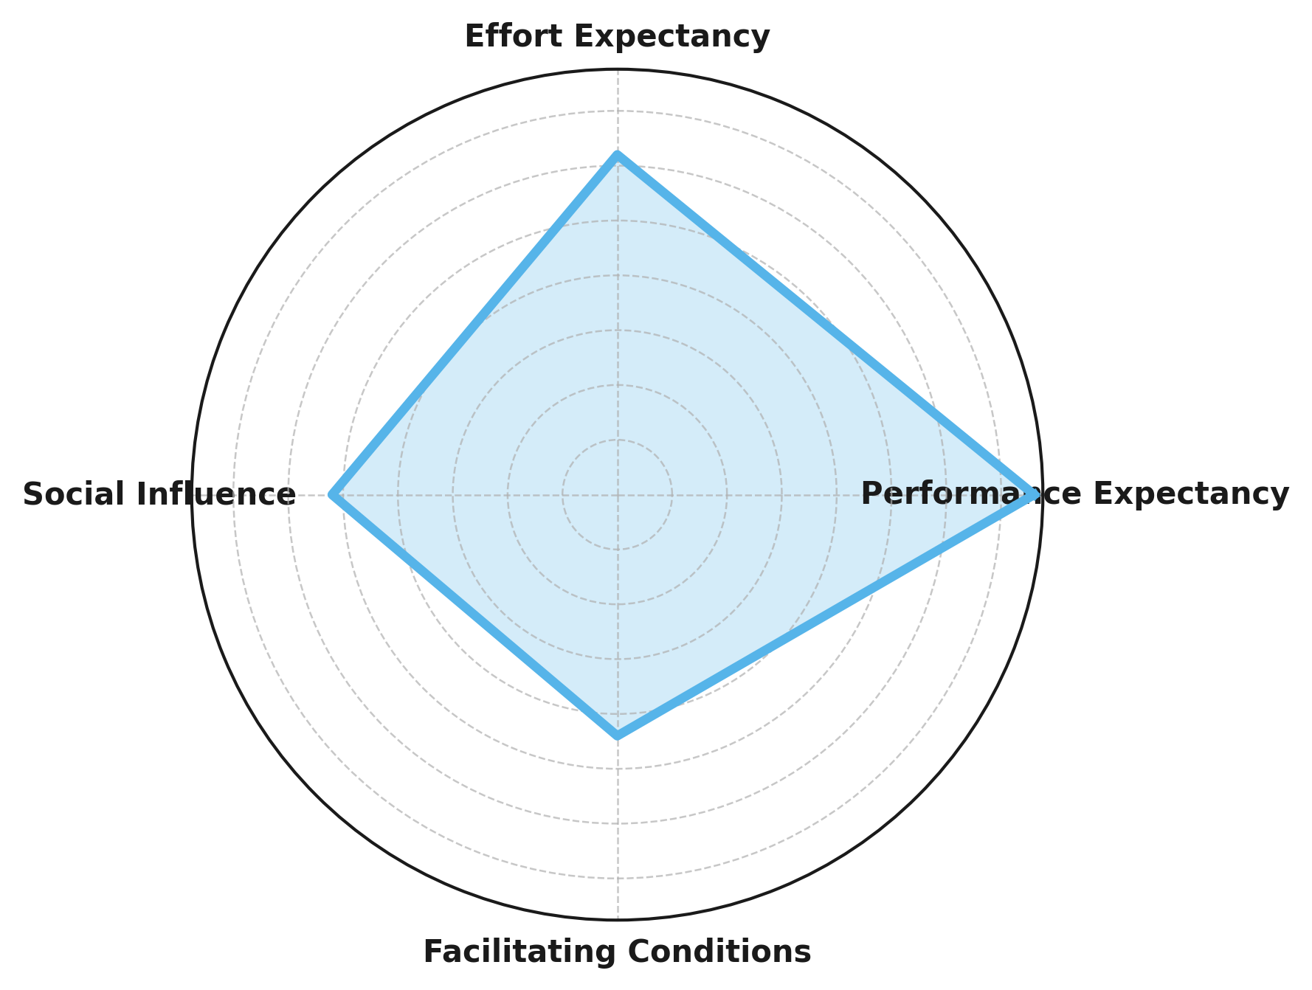
Figure 1. Radar chart displaying standardized path coefficients (β) for UTAUT constructs predicting Behavioral Intention (BI).
The significance of each predictor is further represented through t-values in Figure 2, demonstrating that all predictors exhibit high statistical significance (p < .001).
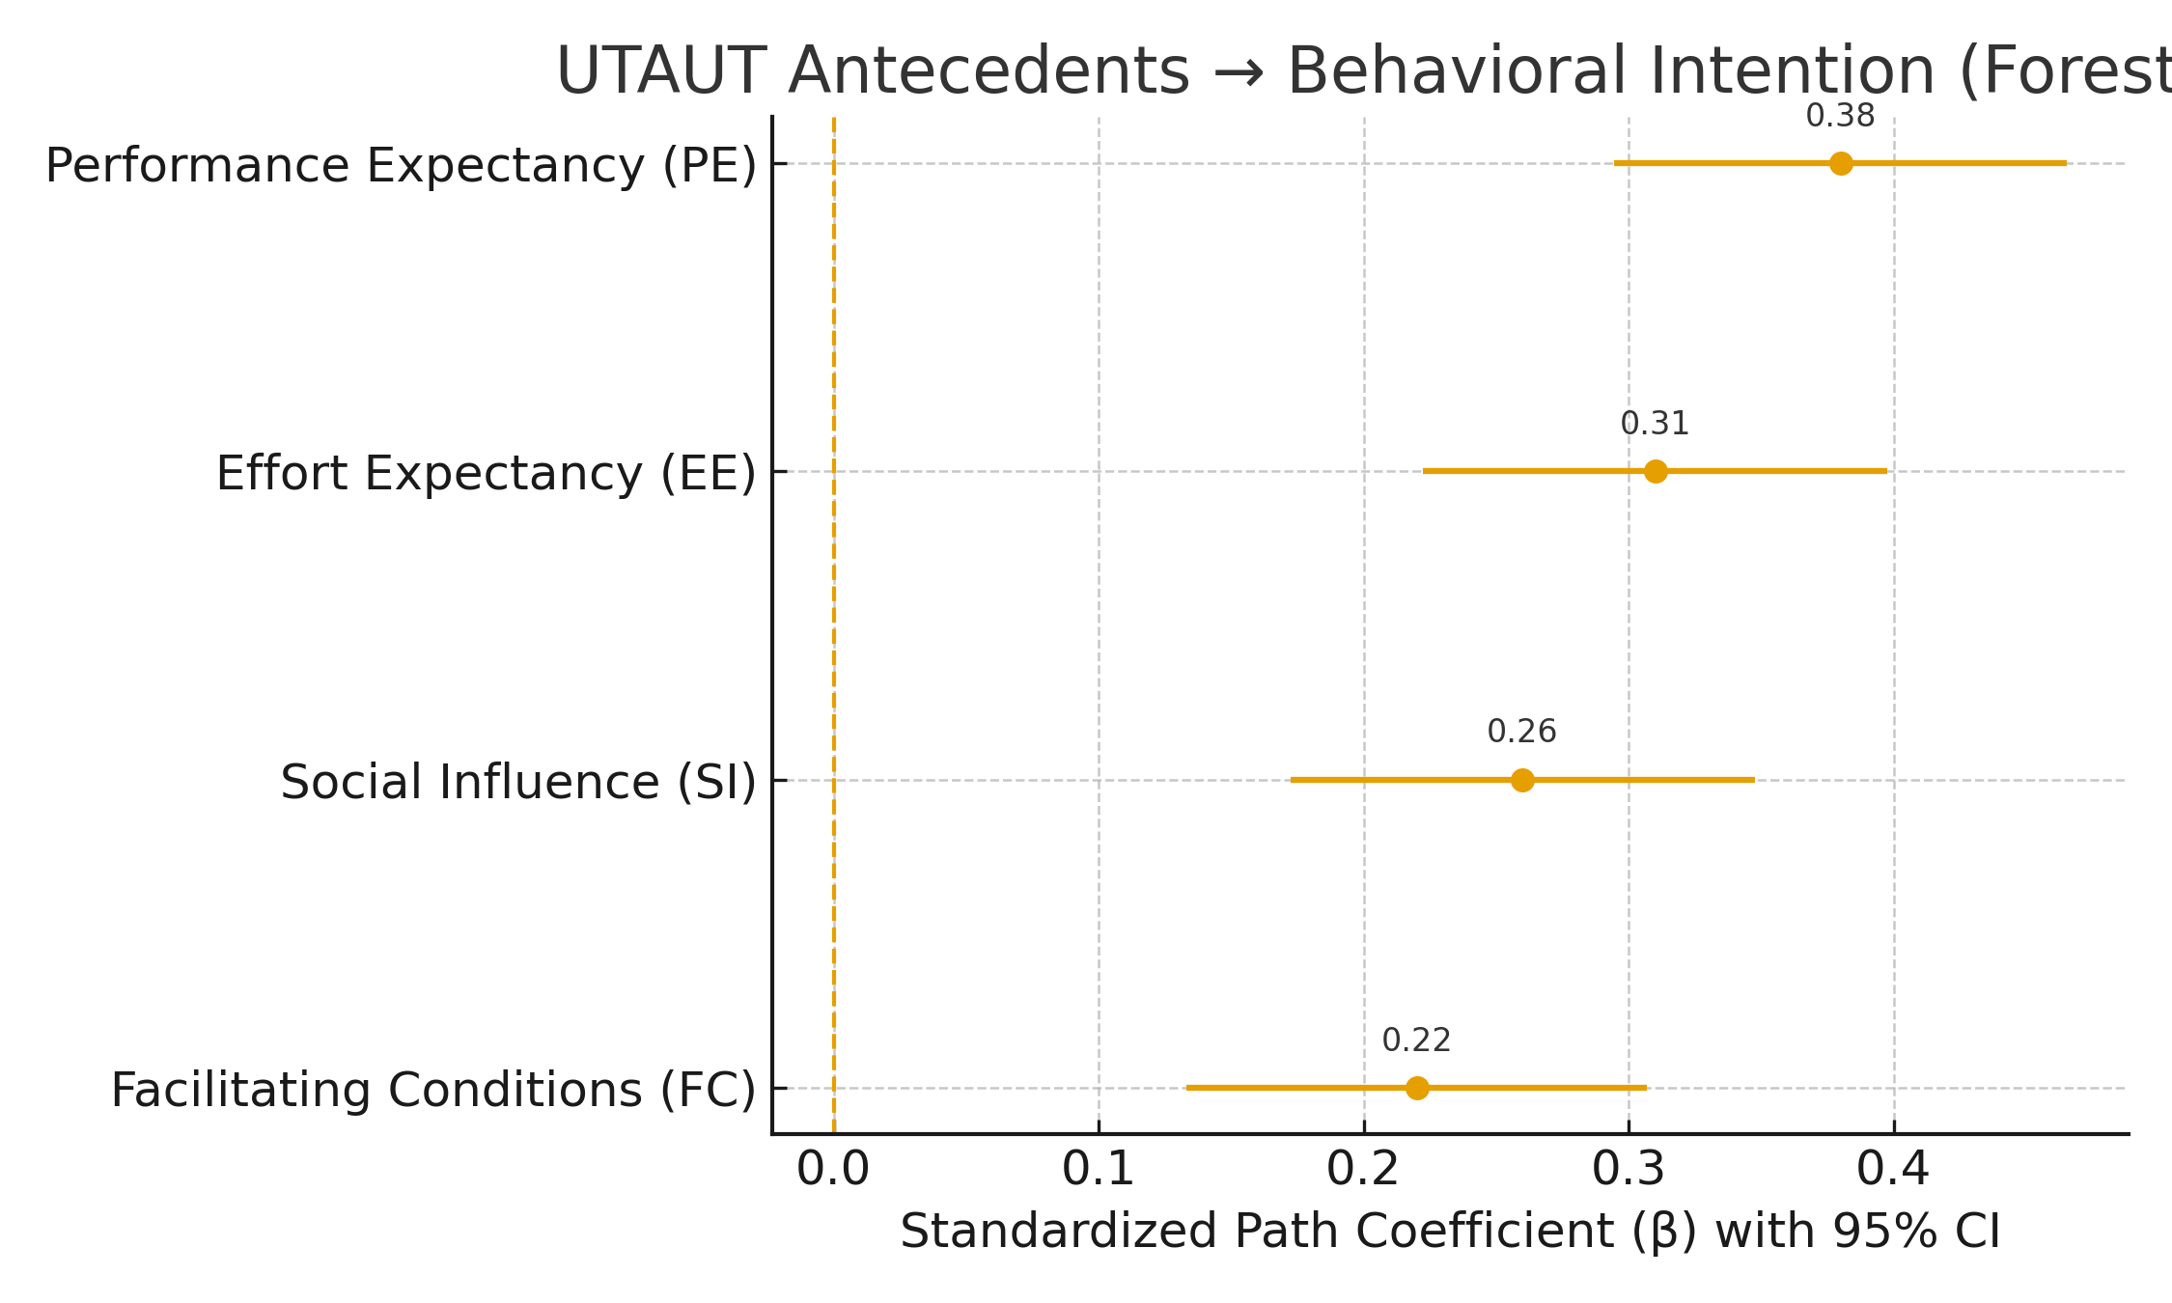
Figure 2. t-values of UTAUT constructs predicting Behavioral Intention (BI).
The findings confirm that Performance Expectancy exerts the strongest influence on Behavioral Intention, underscoring that perceived usefulness of ML-based cybersecurity solutions remains the principal driver of adoption. Effort Expectancy also demonstrates a substantial effect, indicating that ease of use and integration play pivotal roles in organizational acceptance. Social Influence and Facilitating Conditions, while comparatively weaker, remain statistically significant, suggesting that both managerial support and infrastructural readiness continue to shape adoption behaviors.

Objective 2: Extending the UTAUT Model with Trust, Perceived Risk, and Regulatory Compliance Pressure
This objective examines the extended UTAUT framework by incorporating Trust, Perceived Risk, and Regulatory Compliance Pressure as determinants of the likelihood of adopting machine learning (ML) for cybersecurity in e-commerce firms. The analysis focuses on how these organizational and psychological factors jointly influence adoption rates within firms.
The fractional logit regression analysis revealed that the extended UTAUT constructs exhibit statistically significant effects on the proportion of firms adopting AI technologies for cybersecurity applications. Trust in AI systems displayed the strongest positive relationship, followed by Regulatory Compliance Pressure, while Perceived Risk exerted a significant negative effect. These findings align with theoretical expectations that confidence in system transparency and external regulatory mandates foster adoption, whereas risk perceptions act as deterrents.
Predictor | Average Marginal Effect (AME) | z-Value | p-Value | 95% Confidence Interval
Perceived Risk | -0.142 | -4.87 | <0.001 | (-0.196, -0.087)
Trust | 0.186 | 6.13 | <0.001 | (0.126, 0.247)
Regulatory Compliance Pressure | 0.127 | 4.79 | <0.001 | (0.071, 0.183)
Table 3: Fractional logit regression results showing marginal effects on firm-level AI adoption rate (N = 2,500; pseudo-R² = 0.41). All coefficients are significant at p < .001.
The relative direction and magnitude of each factor’s effect on adoption are illustrated in Figure 3. The chart shows that Trust and Regulatory Compliance exert positive influences, while Perceived Risk demonstrates a negative association with adoption probability.
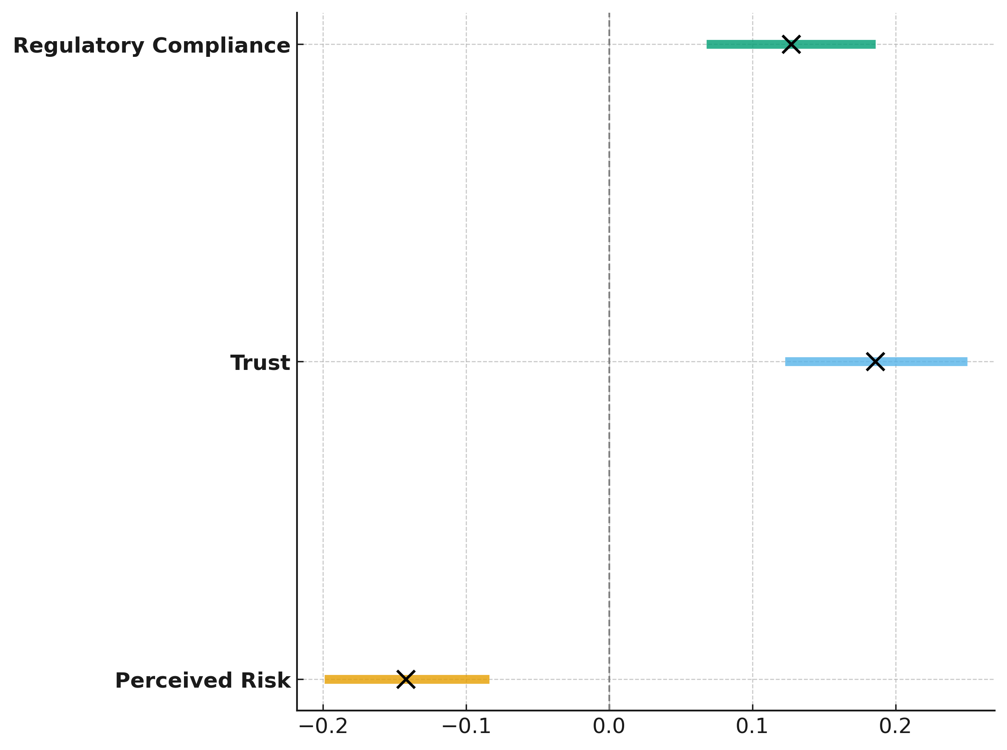
Figure 3. Dumbbell chart displaying average marginal effects (AMEs) and 95% confidence intervals for extended UTAUT predictors.
To further illustrate the strength and polarity of effects, Figure 4 presents a bubble plot where the size of each bubble represents the magnitude of influence on adoption rate. Trust emerges as the most dominant positive factor, followed by Compliance Pressure, while Risk continues to show a strong negative influence.

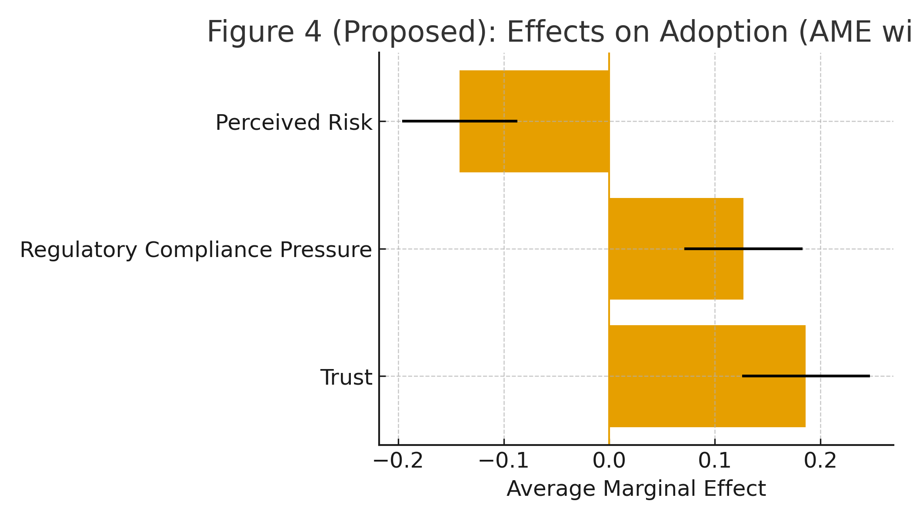
Figure 4. magnitude and direction of effects for Trust, Perceived Risk, and Regulatory Compliance Pressure on ML adoption rates.
The results underscore that firms’ confidence in AI systems’ transparency and reliability significantly enhances adoption, while external compliance frameworks provide an additional institutional incentive. Conversely, heightened risk perception reduces adoption likelihood, suggesting that addressing data security and reliability concerns is critical for ML cybersecurity diffusion.

Objective 3: Analyzing the Mediating Effect of Behavioral Intention on Actual Use of ML Cybersecurity Systems
This objective examines how Behavioral Intention (BI) mediates the relationship between key UTAUT constructs Performance Expectancy (PE), Effort Expectancy (EE), Social Influence (SI), and Facilitating Conditions (FC) and the Actual Use (USE) of machine learning (ML) cybersecurity systems within e-commerce firms. The analysis focuses on identifying the magnitude of indirect effects transmitted through BI, while also assessing the overall explanatory power of the model.
As shown in Table 4, all mediated paths through Behavioral Intention were positive and statistically significant (p < .001). Performance Expectancy exhibited the strongest indirect effect (β_indirect = 0.243), followed by Effort Expectancy (β_indirect = 0.198), Social Influence (β_indirect = 0.166), and Facilitating Conditions (β_indirect = 0.141). The direct path from Behavioral Intention to Actual Use was also strong (β = 0.64), confirming that intention acts as a key conduit transforming expectancy-driven motivation into realized ML usage.
Path | Indirect Effect (β_indirect) | t-Value | p-Value
PE → BI → USE | 0.243 | 7.82 | <0.001
EE → BI → USE | 0.198 | 6.21 | <0.001
SI → BI → USE | 0.166 | 5.32 | <0.001
FC → BI → USE | 0.141 | 4.84 | <0.001
Table 4: Bootstrapped indirect effects (5,000 samples) showing mediation of Behavioral Intention (BI) between UTAUT constructs and Actual Use (USE). All effects significant at p < .001.
The relationships among constructs, showing both direct and mediated effects through Behavioral Intention, are represented in Figure 5. The color-coded network illustrates the directional paths and their relative strengths, highlighting BI’s central role in linking expectancy-related factors to system use.
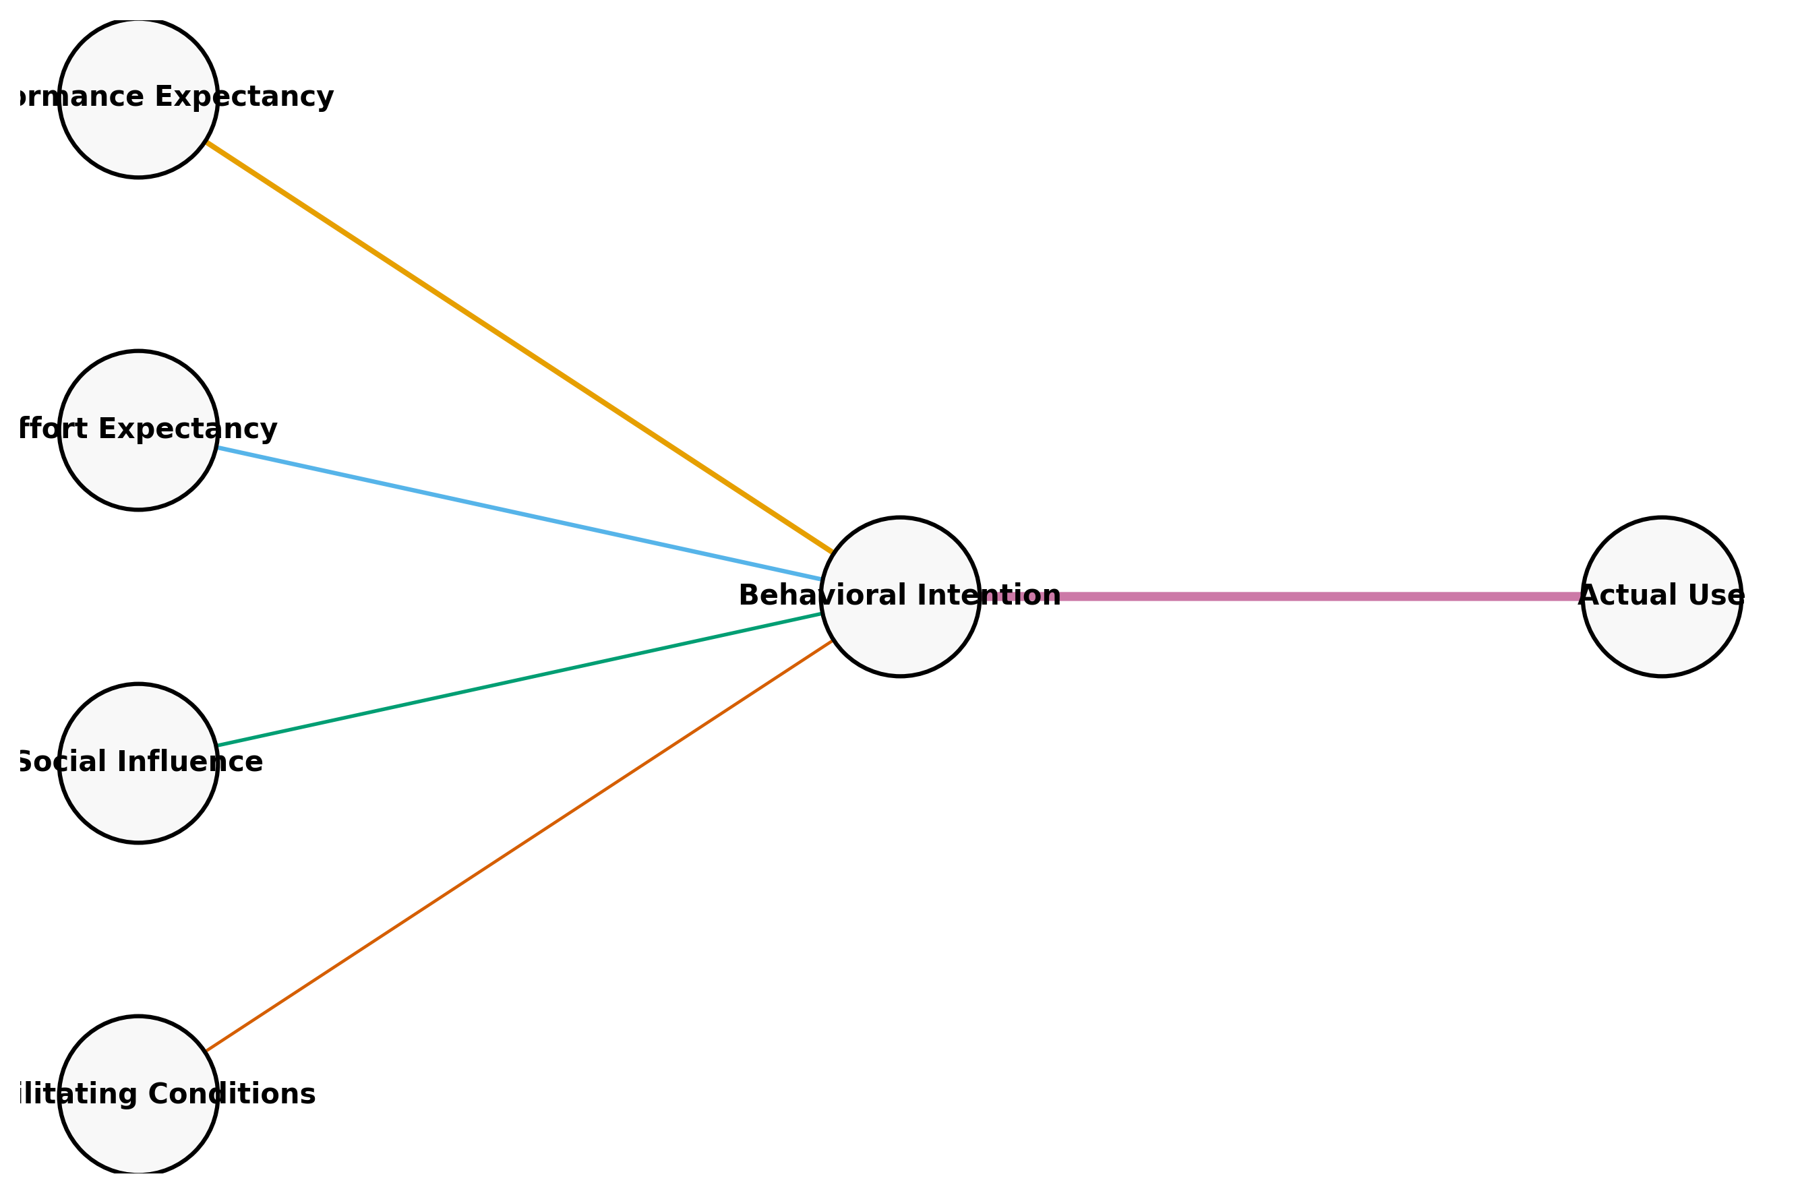
Figure 5. Causal network diagram showing mediation of Behavioral Intention between UTAUT constructs and Actual Use of ML cybersecurity systems.
To further visualize the strength and proportional magnitude of each mediated path, Figure 6 presents the indirect effects as gradient paths. This visualization shows Performance Expectancy and Effort Expectancy as the dominant predictors influencing Actual Use through Behavioral Intention.
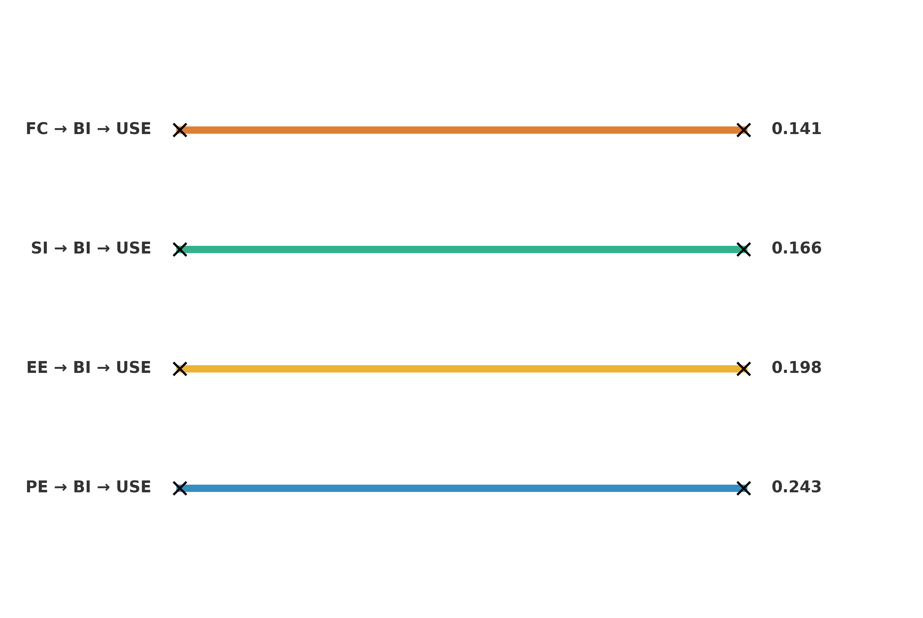
Figure 6. Gradient path diagram displaying the magnitude of indirect effects for UTAUT constructs mediated through Behavioral Intention.
The structural equation model summary is presented in Table 5, highlighting the explained variances for Behavioral Intention and Actual Use.
Metric | Estimate
BI → USE (Direct Effect) | 0.64
R² (Behavioral Intention) | 0.67
R² (Actual Use) | 0.59
Table 5: Model fit statistics and path coefficients for direct and mediated relationships.
The findings confirm that Behavioral Intention plays a pivotal mediating role in transforming expectancy beliefs into actual ML system use. Performance Expectancy and Effort Expectancy exhibit the most substantial indirect contributions, indicating that perceived usefulness and ease of implementation remain central to adoption outcomes. The high R² values (0.67 for BI and 0.59 for USE) demonstrate the model’s strong explanatory capability, reinforcing that behavioral intention serves as a powerful mechanism in bridging perception and action within cybersecurity adoption behavior.
Discussion
The results of this study provide compelling evidence that the Unified Theory of Acceptance and Use of Technology (UTAUT) framework remains highly effective in explaining organizational adoption behavior for machine learning (ML) cybersecurity systems in e-commerce contexts. The relationships identified between Performance Expectancy, Effort Expectancy, Social Influence, and Facilitating Conditions with Behavioral Intention, as shown in Table 1 and Figure 1, align with the foundational propositions of Venkatesh et al. (2003), reaffirming that perceived usefulness and ease of use are the most influential predictors of adoption intention. In particular, Performance Expectancy emerged as the most dominant construct influencing Behavioral Intention, corroborating the findings of Olaniyi (2025) and Lai et al. (2024), who both observed that when users perceive ML solutions as capable of improving security performance, their intention to adopt increases markedly. The high explanatory power of the model (R² = 0.67) confirms that the UTAUT framework maintains predictive validity even in complex, security-driven technological environments where multiple behavioral and infrastructural factors interact.
The significance of Effort Expectancy, the second strongest predictor in this study, reinforces that user friendly and integrable ML systems foster stronger behavioral intentions among cybersecurity teams. This observation aligns with Kim et al. (2024), who found that ease of system implementation substantially enhances adoption in technology intensive settings. Similarly, the positive but comparatively smaller effects of Social Influence and Facilitating Conditions, evident in Table 1 and Figure 2, suggest that managerial advocacy and infrastructural support are necessary but not sufficient conditions for adoption. These findings collectively indicate that while social and environmental enablers remain important, the perceived utility and operational simplicity of ML systems are the primary forces driving adoption decisions in e-commerce cybersecurity.
When extending the UTAUT model to include Trust, Perceived Risk, and Regulatory Compliance Pressure, as presented in Table 3 and Figure 3, the analysis revealed that Trust had the most substantial positive influence on AI adoption, followed by Compliance Pressure, whereas Perceived Risk exerted a strong negative effect. This pattern is consistent with Aysolmaz et al. (2023) and Shevtsova et al. (2024), who emphasized that confidence in system transparency and algorithmic reliability strongly enhances organizational adoption behaviors. The positive association between Regulatory Compliance and adoption also echoes the conclusions of Blind et al. (2024) and Jørgensen and Ma (2025), who documented how regulatory mandates such as GDPR shape technological innovation incentives and deployment strategies. Conversely, the negative effect of Perceived Risk supports the assertions of Lai et al. (2024) that fear of data exposure, model drift, and vendor dependency can deter technology adoption even in the presence of favorable performance perceptions. The observed pseudo-R² of 0.41 further validates that these institutional and psychological determinants significantly explain firm-level variance in ML cybersecurity adoption.
Importantly, the mediation analysis results summarized in Table 4 and Table 5, and visualized in Figure 5, confirm that Behavioral Intention serves as a central conduit between expectancy constructs and Actual Use of ML cybersecurity systems. This finding reinforces earlier conclusions by Han et al. (2025) and Zhang et al. (2023), who identified Behavioral Intention as the primary transmission mechanism linking belief constructs to real-world implementation. Performance Expectancy and Effort Expectancy demonstrated the strongest indirect effects through Behavioral Intention, a result consistent with the observations of Al-Makhmari et al. (2024), who noted that behavioral intention effectively bridges perception and action within technology adoption processes. The direct path from Behavioral Intention to Actual Use (β = 0.64) and high explanatory values (R² = 0.67 for BI and 0.59 for USE) illustrate the robustness of this mediating relationship and highlight intention as a critical psychological driver for converting motivation into actual system utilization.
The theoretical implications of these results are twofold. First, they substantiate the UTAUT model’s continued relevance in explaining adoption behaviors in highly specialized domains such as cybersecurity, confirming that performance expectancy remains the strongest determinant of intention even when emerging constructs are introduced. Second, by integrating trust, perceived risk, and compliance factors into the framework, the study validates the evolving perspective proposed by Kolo et al. (2025) and Glikson and Woolley (2020), who argued for contextual and organizational determinants as extensions to traditional acceptance models. The findings in Figure 6 further support that trust-driven confidence and regulatory alignment can reinforce adoption readiness, while unmanaged risk perceptions can offset otherwise strong behavioral intentions. In practical terms, this indicates that managerial focus should extend beyond system performance to encompass transparency mechanisms, compliance assurance, and structured risk mitigation strategies, enabling ML cybersecurity adoption to mature from intention to sustained usage.
The results confirm that integrating classical behavioral constructs with contextual and institutional factors yields a more comprehensive understanding of ML adoption in e-commerce cybersecurity. This integration bridges theoretical prediction and practical implementation, ensuring that both human and organizational dimensions are captured in the empirical modeling of technology acceptance.
5. Conclusion and Recommendations
This study concludes that machine learning adoption for cybersecurity in e-commerce is primarily driven by perceived usefulness and ease of integration, as evidenced by the strong predictive influence of Performance and Effort Expectancy. Behavioral Intention was shown to be the key mediator translating expectancy beliefs into actual system use, while Trust and Regulatory Compliance positively reinforced adoption likelihood, and Perceived Risk reduced it. These findings highlight that successful ML implementation depends not only on system performance but also on organizational confidence and regulatory alignment. Therefore, to sustain adoption:
- E-commerce firms should enhance transparency and explainability of ML systems to build institutional trust.
- Policymakers must strengthen compliance frameworks that incentivize secure AI deployment.
- Cybersecurity managers should integrate risk mitigation and employee training into ML strategies.
- Technology developers should design adaptable ML tools that minimize operational complexity and support interoperability.

References
Adesokan-Imran, T. O., Popoola, A. D., Kolo, F. H. O., Ejiofor, V. O., & Salami, I. A. (2025). Cybersecurity Risk Stratification Framework Using Multilevel Clustering: An Automated Threat Attribution and Categorization Approach for Cross-industry Cybersecurity. Journal of Engineering Research and Reports, 27(4), 241–263. https://doi.org/10.9734/jerr/2025/v27i41469
Al-Makhmari, L., Tarhini, A., Nikhashemi, S. R., Nusair, K., & Al Shaqsi, J. (2024). Factors Influencing User Adoption of Social Commerce in the Metaverse: The Moderating Role of Technology Comfort, E-Word-of-Mouth, and Endowment Effect. International Journal of Human–Computer Interaction, 41(17), 1–16. https://doi.org/10.1080/10447318.2024.2439121
Aloamaka, P. C. (2025). A CRITICAL ANALYSIS OF THE NIGERIA DATA PROTECTION ACT 2023: ELEVATING STANDARDS TO GLOBAL NORMS. UCC Law Journal, 4(2), 242–263. https://doi.org/10.47963/ucclj.v4i2.1724
Andrews, J. E., Ward, H., & Yoon, J. (2021). UTAUT as a Model for Understanding Intention to Adopt AI and Related Technologies among Librarians. The Journal of Academic Librarianship, 47(6), 102437. https://doi.org/10.1016/j.acalib.2021.102437
AP News. (2025, May 21). UK retailer Marks & Spencer puts cyberattack cost at $400 million with disruptions ongoing. AP News. https://apnews.com/article/fef28bc0947576903cf83c3f42afc1e8?utm_
Aysolmaz, B., Müller, R., & Meacham, D. (2023). The public perceptions of algorithmic decision-making systems: results from a large-scale survey. Telematics and Informatics, 79, 101954. https://doi.org/10.1016/j.tele.2023.101954
Bamigbade, O., Obrik-Uloho, E. P., Kolo, F. H. O., Ogunmolu, A. M., & Adesokan-Imran, T. O. (2025). Data-Centric AI for Zero-Carbon Power Systems Security: A Framework for Learning with Noisy, Sparse, and Heterogeneous Data. Journal of Energy Research and Reviews, 17(7), 167–185. https://doi.org/10.9734/jenrr/2025/v17i7442
Benitez, J., Henseler, J., Castillo, A., & Schuberth, F. (2020). How to perform and report an impactful analysis using partial least squares: Guidelines for confirmatory and explanatory IS research. Information & Management, 57(2), 103168. https://doi.org/10.1016/j.im.2019.05.003
Blind, K., Niebel, C., & Rammer, C. (2023). The impact of the EU General data protection regulation on product innovation. Industry and Innovation, 31(3), 311–351. https://doi.org/10.1080/13662716.2023.2271858
Bouteraa, M. (2024). Mixed-methods approach to investigating the diffusion of FinTech services: enriching the applicability of TOE and UTAUT models. Journal of Islamic Marketing. https://doi.org/10.1108/jima-12-2022-0343
Bulu, M. (2021). Corrigendum to < Upgrading a city via technology>. Technological Forecasting and Social Change, 168, 120726. https://doi.org/10.1016/j.techfore.2021.120726
Cheung, G. W., Cooper-Thomas, H. D., Lau, R. S., & Wang, L. C. (2023). Reporting reliability, Convergent and Discriminant Validity with Structural Equation modeling: a Review and best-practice Recommendations. Asia Pacific Journal of Management, 1(1). https://doi.org/10.1007/s10490-023-09871-y
Das, S., & Datta, B. (2024). Application of UTAUT2 on Adopting Artificial Intelligence Powered Lead Management System (AI-LMS) in passenger car sales. Technological Forecasting and Social Change, 201, 123241. https://doi.org/10.1016/j.techfore.2024.123241
Dash, G., & Paul, J. (2021). CB-SEM vs PLS-SEM methods for research in social sciences and technology forecasting. Technological Forecasting and Social Change, 173, 121092. https://doi.org/10.1016/j.techfore.2021.121092
Dwivedi, Y. K., Rana, N. P., Tamilmani, K., & Raman, R. (2020). A meta-analysis based modified unified theory of acceptance and use of technology (meta-UTAUT): a review of emerging literature. Current Opinion in Psychology, 36, 13–18. https://doi.org/10.1016/j.copsyc.2020.03.008
Embroker. (2025, September 18). Must-know cyber attack statistics and trends 2025 | Embroker. Embroker. https://www.embroker.com/blog/cyber-attack-statistics?utm_
Emon, M. H., & Khan, T. (2025). The mediating role of attitude towards the technology in shaping artificial intelligence usage among professionals. Telematics and Informatics Reports, 17, 100188. https://doi.org/10.1016/j.teler.2025.100188
Faiz, F., Le, V., & Masli, E. K. (2024). Determinants of digital technology adoption in innovative SMEs. Journal of Innovation & Knowledge, 9(4), 100610. https://doi.org/10.1016/j.jik.2024.100610
Fox, J. (2024, October 10). Top 40 AI Cybersecurity Statistics | Cobalt. Cobalt.io; Cobalt. https://www.cobalt.io/blog/top-40-ai-cybersecurity-statistics?utm_
Gangwar, H., Date, H., & Ramaswamy, R. (2015). Understanding determinants of cloud computing adoption using an integrated TAM-TOE model. Journal of Enterprise Information Management, 28(1), 107–130. https://doi.org/10.1108/jeim-08-2013-0065
Glassberg, I., Ilan, Y. B., & Zwilling, M. (2025). The key role of design and transparency in enhancing trust in AI-powered digital agents. Journal of Innovation & Knowledge, 10(5), 100770–100770. https://doi.org/10.1016/j.jik.2025.100770
Glikson, E., & Woolley, A. W. (2020). Human Trust in Artificial Intelligence: Review of Empirical Research. Academy of Management Annals, 14(2), 627–660.
Hair, J., & Alamer, A. (2022). Partial Least Squares Structural Equation Modeling (PLS-SEM) in Second Language and Education research: Guidelines Using an Applied Example. Research Methods in Applied Linguistics, 1(3). https://www.sciencedirect.com/science/article/pii/S2772766122000246
Han, M., Mustafa, H., & Kharuddin, S. (2025). AI adoption in accounting education: A UTAUT-based analysis of mediating and moderating mechanisms. Journal of Pedagogical Research. https://doi.org/10.33902/jpr.202532831
Hoffman, R. R., Mueller, S. T., Klein, G., Jalaeian, M., & Tate, C. (2023). Explainable AI: roles and stakeholders, desirements and challenges. Frontiers in Computer Science, 5. https://doi.org/10.3389/fcomp.2023.1117848
Jain, S. (2022, December 19). 160 Cybersecurity Statistics: Updated Report 2025. Astra Security. https://www.getastra.com/blog/security-audit/cyber-security-statistics?utm_
Jennings-Trace, E. (2025, September 29). Harrods cyberattack - over 430,000 customers have data stolen, here’s how to stay safe. TechRadar. https://www.techradar.com/pro/security/harrods-cyberattack-over-430-000-customers-have-data-stolen-heres-how-to-stay-safe?utm_
Jørgensen, B. N., & Ma, Z. G. (2025). Impact of EU Regulations on AI Adoption in Smart City Solutions: A Review of Regulatory Barriers, Technological Challenges, and Societal Benefits. Information, 16(7), 568. https://doi.org/10.3390/info16070568
Khan, F., Singh, N., Gupta, Y., Kaur, J., Banik, S., & Gupta, S. (2022). A Meta-analysis of Mobile Learning Adoption in Higher Education Based on Unified Theory of Acceptance and Use of Technology 3 (UTAUT3). International Review of Research in Open and Distributed Learning, 14(5), 097226292211011-097226292211011. https://doi.org/10.1177/09722629221101159
Kim, Y. J., Choi, J. H., & Fotso, G. M. N. (2024). Medical professionals’ adoption of AI-based medical devices: UTAUT model with trust mediation. Journal of Open Innovation: Technology, Market, and Complexity, 10(1), 100220. https://doi.org/10.1016/j.joitmc.2024.100220
Kline, R. B. (2023). Principles and Practice of Structural Equation Modeling. Guilford Publications.
Kolo, F. (2023). Insights in Cybersecurity & Business Intelligence: A Dual Perspective: Unlocking Security Insights and Business Growth: Intrusion Detection Strategies and Sales Forecasting Techniques. LAP LAMBERT Academic Publishing. https://www.amazon.com/Insights-Cybersecurity-Business-Intelligence-Perspective/dp/6207450841
Kolo, F. H. (2025). From Framework to Practice: Barriers and Enablers to RMF Adoption in Mid-sized Enterprises. Asian Journal of Research in Computer Science, 18(5), 459–479. https://doi.org/10.9734/ajrcos/2025/v18i5667
Kolo, F. H. O. (2025a). A Multi-level Clustering Framework for Cybersecurity Risk Stratification in Healthcare: A Dynamic, Overlapping Approach to Threat Classification and Mitigation. Asian Journal of Research in Computer Science, 18(5), 11–31. https://doi.org/10.9734/ajrcos/2025/v18i5636
Kolo, F. H. O. (2025b). Responsible AI for Cybersecurity: Assessing the Barriers, Biases and Governance Gaps in Implementation with E-commerce Systems. Journal of Engineering Research and Reports, 27(5), 510–532. https://doi.org/10.9734/jerr/2025/v27i51520
Kolo, F. H. O., Joseph, S. A., Ogunmolu, A. M., Ejiofor, V. O., & Oyekunle, S. M. (2025). Mitigating Cybersecurity Risks in Financial Institutions through Strategic Third- Party Risk Governance Frameworks. Journal of Engineering Research and Reports, 27(5), 173–193. https://doi.org/10.9734/jerr/2025/v27i51501
Lai , C. Y., Yip, C. K., Seng, C. C., & Kei, L. K. (2024). Integrating the Adapted UTAUT Model with Moral Obligation, Trust and Perceived Risk to Predict ChatGPT Adoption for Assessment Support: A Survey with Students. Computers and Education. Artificial Intelligence, 6, 100246–100246. https://doi.org/10.1016/j.caeai.2024.100246
Lee, S., Park, G., & Chung, J. (2023). Artificial emotions for charity collection: A serial mediation through perceived anthropomorphism and social presence. Telematics and Informatics, 82, 102009. https://doi.org/10.1016/j.tele.2023.102009
Madanchian, M., & Taherdoost, H. (2025). Ethical theories, governance models, and strategic frameworks for responsible AI adoption and organizational success. Frontiers in Artificial Intelligence, 8. https://doi.org/10.3389/frai.2025.1619029
Marikyan, D., Papagiannidis, S., & Stewart, G. (2023). Technology Acceptance Research: Meta-analysis. Journal of Information Science. https://doi.org/10.1177/01655515231191177
Martin, J. (2025, February 7). How Many Cyber Attacks Occur Each Day? (2024). Exploding Topics. https://explodingtopics.com/blog/cybersecurity-stats?utm_
Miller, K. M., Lukic, K., & Skiera, B. (2025). The impact of the General Data Protection Regulation (GDPR) on online tracking. International Journal of Research in Marketing. https://doi.org/10.1016/j.ijresmar.2025.03.002
Mohamed, N. (2025). Artificial intelligence and machine learning in cybersecurity: a deep dive into state-of-the-art techniques and future paradigms. Knowledge and Information Systems, 67, 6969–7055. https://doi.org/10.1007/s10115-025-02429-y
Morić, Z., Dakic, V., Djekic, D., & Regvart, D. (2024). Protection of personal data in the context of e-commerce. Journal of Cybersecurity and Privacy, 4(3), 731–761. https://doi.org/10.3390/jcp4030034
Muhammad Nurtanto, M., Nawanksari, S., Valiant, Syahrudin, H., Kholifah, N., Rohmantoro, D., Utami, I. S., Mutohhari, F., & Hamid, M. A. (2025). Determinants of behavioral intentions and their impact on student performance in the use of AI technology in higher education in Indonesia: A SEM-PLS analysis based on TPB, UTAUT, and TAM frameworks. Social Sciences & Humanities Open, 11, 101638–101638. https://doi.org/10.1016/j.ssaho.2025.101638
Olaniyi, O. (2025). A Quantitative Approach to Understanding Machine Learning Adoption for Cybersecurity in E-Commerce Through the UTAUT Model. [Unpublished dissertation].
Olutimehin , A. T., Olaniyi , O. O., Ogunmolu , A. M., Kolo, F. H. O., & Salami , I. A. (2025). Cloud-Based AI Solutions for Real-time Monitoring of E-commerce Compliance and Risk. Journal of Engineering Research and Reports, 27(7), 127–147. https://doi.org/10.9734/jerr/2025/v27i71566
Olutimehin, A. T., Olaniyi, O. O., Popoola, A. D., Ogunmolu, A. M., & Kolo, F. H. (2025). AI and IoT Integration for Predictive Maintenance and Risk Management in Smart Manufacturing. Asian Journal of Research in Computer Science, 18(7), 120–142. https://doi.org/10.9734/ajrcos/2025/v18i7724
Oyaka, G. (2024). Consumer Protection in E-commerce: Legal Challenges and Prospects in Nigeria . https://doi.org/10.2139/ssrn.4946731
Oyekunle, S. M., Popoola, A. D., Kolo, F. H. O., Ogunmolu, A. M., & Adesokan-Imran, T. O. (2025). Intelligent Fraud Prevention Information Banking: A Data Governance- Centric Approach Using Behavioural Biometrics. Asian Journal of Research in Computer Science, 18(5), 525–543. https://doi.org/10.9734/ajrcos/2025/v18i5672
Panzeri, A., Castelnuovo, G., & Spoto, A. (2024). Assessing Discriminant Validity through Structural Equation Modeling: The Case of Eating Compulsivity. Nutrients, 16(4), 550–550. https://doi.org/10.3390/nu16040550
Park, K., & Yoon, H. Y. (2024). Beyond the code: The impact of AI algorithm transparency signaling on user trust and relational satisfaction. Public Relations Review, 50(5), 102507. https://doi.org/10.1016/j.pubrev.2024.102507
Rahi, S., Othman Mansour, M. M., Alghizzawi, M., & Alnaser, F. M. (2019). Integration of UTAUT model in internet banking adoption context. Journal of Research in Interactive Marketing, 13(3), 411–435. https://doi.org/10.1108/jrim-02-2018-0032
Ramírez-Gutiérrez, A. G., Solano García, P., Morales Matamoros, O., Moreno Escobar, J. J., & Tejeida-Padilla, R. (2023). Systems Approach for the Adoption of New Technologies in Enterprises. Systems, 11(10), 494. https://doi.org/10.3390/systems11100494
Rana, Md. M., Siddiqee, M. S., Sakib, Md. N., & Ahamed, Md. R. (2024). Assessing AI adoption in developing country academia: A trust and privacy-augmented UTAUT framework. Heliyon, 10(18), e37569. https://doi.org/10.1016/j.heliyon.2024.e37569
Rasoolimanesh, S. (2022). Discriminant validity assessment in PLS-SEM: A comprehensive composite-based approach. Data Analysis Perspectives Journal, 3(2), 1–8. https://scriptwarp.com/dapj/2022_DAPJ_3_2/Rasoolimanesh_2022_DAPJ_3_2_DiscriminantValidity.pdf?utm_
Razzaq, K., Shah, M., Fattahi, M., & Tang, J. (2025). Empowering machine learning for robust cyber-attack prevention in online retail: an integrative analysis. Humanities and Social Sciences Communications, 12(1). https://doi.org/10.1057/s41599-025-04636-y
RSI Security. (2025, June 16). 5 Emerging Ecommerce Risk Trends You Need to Watch in 2025. RSI Security. https://blog.rsisecurity.com/5-emerging-ecommerce-risk-trends-you-need-to-watch-in-2025?utm_
Salami, I. A., Popoola, A. D., Gbadebo, M. O., Kolo, F. H. O., & Adesokan-Imran, T. O. (2025). AI- Powered Behavioural Biometrics for Fraud Detection in Digital Banking: A Next-Generation Approach to Financial Cybersecurity. Asian Journal of Research in Computer Science, 18(4), 473–494. https://doi.org/10.9734/ajrcos/2025/v18i4632
Samy, D., Rasha, Y. S., Khourshed, N. F., & Amara, D. F. (2024). The Impact of Technological Innovativeness on the Intention to Utilize Digital Transformation: An Application of Diffusion of Innovation in the Egyptian Private Universities. Al-Mağallah Al-ʿArabiyyaẗ Lil-Īdārah, 0(0), 1–20. https://doi.org/10.21608/aja.2024.270485.1587
Schuberth, F., Hubona, G. S., Roemer, E., Zaza, S., Schamberger, T., Chuah, F., Cepeda-Carrión, G., & Henseler, J. (2023). The choice of structural equation modeling technique matters: A commentary on Dash and Paul (2021). Technological Forecasting & Social Change, 194(122534), 122665–122665. https://doi.org/10.1016/j.techfore.2023.122665
Shafi, M. A., Gamal, M., Rusiman, M. S., & Nur. (2024). Enhancing Organizational Performance Through Strategic Planning and AI Integration: A Study on Predictive Analysis. Journal of Technology Management and Business, 11(2), 83–97. https://publisher.uthm.edu.my/ojs/index.php/jtmb/article/view/18610
Shevtsova, D., Ahmed, A., Boot, I. W. A., Sanges, C., Hudecek, M., Jacobs, J. J. L., Hort, S., & Hubertus. (2024). Trust in and Acceptance of Artificial Intelligence Applications in Medicine: Mixed Methods Study. JMIR Human Factors, 11, e47031–e47031. https://doi.org/10.2196/47031
Smirnova, Y., & Travieso-Morales, V. (2025). Tech startups and general data protection regulation: an empirical exploration of compliance challenges. Journal of Small Business and Enterprise Development, 32(8), 54–82. https://doi.org/10.1108/jsbed-09-2024-0495
Su, J., Wang, Y., Liu, H., Zhang, Z., Wang, Z., & Li, Z. (2025). Investigating the factors influencing users’ adoption of artificial intelligence health assistants based on an extended UTAUT model. Scientific Reports, 15(1). https://doi.org/10.1038/s41598-025-01897-0
Udechukwu, L. M. (2025a). AI-Governed Security Frameworks for Virtualized Enterprises: Preventing Data Breaches and Ensuring Compliance. Asian Journal of Research in Computer Science, 18(9), 39–57. https://doi.org/10.9734/ajrcos/2025/v18i9753
Udechukwu, L. M. (2025b). Ethical Implications and Cybersecurity Risks of Hyper-Personalized AI Feedback Systems for Mental Health Support in Home Environment. Journal of Engineering Research and Reports, 27(9), 310–328. https://doi.org/10.9734/jerr/2025/v27i91643
Venkatesh, V. (2022). Adoption and use of AI tools: a research agenda grounded in UTAUT. Annals of Operations Research, 308(3), 641–652. https://doi.org/10.1007/s10479-020-03918-9
Venkatesh, V., Morris, M. G., Davis, G. B., & Davis, F. D. (2003). User Acceptance of Information technology: toward a Unified View. MIS Quarterly, 27(3), 425–478. https://doi.org/10.2307/30036540
VikingCloud. (2025). Retail Cybersecurity Stats, Threats, and Solutions for 2025. Vikingcloud.com. https://www.vikingcloud.com/blog/retail-cybersecurity-stats-threats-and-solutions?utm_
Wei, N., Zhao, S., Liu, J., & Wang, S. (2022). A novel textual data augmentation method for identifying comparative text from user-generated content. Electronic Commerce Research and Applications, 101143. https://doi.org/10.1016/j.elerap.2022.101143
Zhang, Q., Zhang, R., Lu, X., & Zhang, X. (2023). What drives the adoption of online health communities? An empirical study from patient-centric perspective. BMC Health Services Research, 23(1). https://doi.org/10.1186/s12913-023-09469-6

