Original Research Article
Green Building Certification and Smart Façade Systems for U.S. Sustainability Goals

Abstract— The built environment is one of the most powerful forces for lowering energy consumption and carbon dioxide emissions—and health burdens—in America. As energy codes are steadily tightened by jurisdictions and capital planning is called upon to more closely match environmental, social, and governance (ESG) objectives established by owners, third-party green building certification systems have emerged as useful models for translating policy aspiration into design with intent and performance. Concurrently, developments in intelligent building envelopes increasingly referred to as “smart façades”—have transitioned from architecturally expressive elements to system-level approaches that can alter load profiles, influence occupant experience and enable grid-interactive performance. This paper investigates the overlap of US sustainability objectives with certification systems such as LEED, WELL, ENERGY STAR, Green Globes, Passive House (PHIUS), and Living Building Challenge with a family of adaptive façade technologies including electrochromic glazing, automated interior and exterior shading solutions, ventilated double-skin façades (VDSFs), and building-integrated photovoltaics (BIPVs). It introduces an assessment framework, which integrates daylighting/glare simulation with thermal/energy modeling and controls commissioning by measurement and verification that places projects in the position to claim certification credits based on substantiated reasoning. Three design typologies - office retrofit, academic new build and healthcare expansion - are employed to illustrate how smart façades can unlock certification pathways while delivering robust indoor environmental quality. The study concludes that as long as adaptive envelopes are combined with high-performance building controls and post-occupancy tuning, the potential exists to significantly reduce energy intensity while improving health outcomes, all without jeopardizing architectural design intent and that certification programs provide scalable means of linking project level decisions with national goals for radical decarbonization.
Keywords—Green building certification, smart façade, electrochromic glazing, automated shading, double-skin façade, building-integrated photovoltaics, LEED, U.S. energy codes, measurement and verification.

Introduction
Voluntary certification systems in the United States have advanced performance- based building design for over 20 years by flagging and encoding best practices into a market signal for environmental and health quality. During the same period the theoretical divide between architecture and mechanical/electrical systems has transgressed into the building envelope [1]. The facade was traditionally categorized as being a static element separating the inside from the outside, while today it is recognized as an active layer that responds to sun radiation, daylight admission and distribution and visual comfort. Intelligent building skins combine high-level materials with sensing, actuation and supervisory control to provide dynamic adaptation to weather, occupancy and grid fluctuations. It is this two-fold motion of market frames on the demand side and envelope intelligence on the supply side that allows a good case to be made for relegating façade decisions to the level of primary factors determining certification [2].
This opportunity is enhanced by the U.S. sustainability landscape. Both public and private owners are increasingly feeling the squeeze to release energy and carbon performance, peak demand management, and heat stress offsetting information as metros come under pressure to retain satisfied occupants [3]. Energy codes, e.g., IECC and ASHRAE 90.1 Ratchet envelope and controls requirements Benchmarking tax incentives pay for reduced use [4]. With flexibility in mind, smart façades can be “load-shaping” technologies that will help to reduce energy and shift demand, further reducing the size of cooling plants by enhancing daylight autonomy and thereby reducing glare without relying on all- opaque solutions, which have an adverse effect on occupant well-being [5].

Background and Motivation
One gap that was identified for high performance building delivery was to translate holistic sustainability goals into design moves that are robust in the face of project uncertainty, operational drift and policy swings. Because certification frameworks deliver value by translating those qualitative goals — health, equity, resilience, decarbonization — into discrete credits with traceable compliance pathways [6]. LEED focuses on energy modeling, on-site renewables, refrigerant management, daylighting fenestration, and grid integration; WELL homes in the “measurable” health elements including light exposures, thermal comfort settings and acoustics as well as materials use; ENERGY STAR tieres whole-building performance using utility bills adjusted for weather and usage type; Green Globes/BREEAM/LBC/PHIUS smack of a little more depth in each domain but net-positive/water is utility-specific and regionally-dependent; envelope stringency passive survivability home routing remains only LBC’s specialization [7], [8]. Smart façades either touch each of these domains or cross between them: they impact and are impacted by energy intensity using solar heat-gain & daylight controls; visually perceived comfort / thermal comfort, structure opportunity for photovoltaic generation (as in BIPV), and address resilience in the case of passive survivability that is modulated during outages [9].
Physically, the façade itself is a mediator of three coupled physical elements-radiation, convection and conduction-and also acts as the primary gateway for daylight and outside view. Its parameters include spectral transmittance and reflectance over visible and near-IR bands, thermal (U-factor), solar heat uptake (SHGC), visible light transmission (VT), air tightness, and mass Static optimization of these parameters are well understood but the time-varying variation in optical or geometric properties can also be used bring additional benefits in these climates since some have variable sky conditions o mixed heating o cooling patterns [10]. Electrochromic and thermochromic glazing shift solar transmission with a signal; automated shades and blinds can position slats or change positions; double skin façades offer up controllable ventilation in a buffer zone; vented rainscreens and cavity facades offer moisture protection management, as well as passive cooling capacities; BIPV wants to throw some area into the ‘generator’ mix (and shading mix at the same time). Coupled with a BAS that includes sensing (irradiance, sky condition, inside illuminance, occupancy, or thermal feedback) suitable for controlling such devices and control sequences can drive the building to desired setpoints of illuminance/glare probability/cooling/heating load within occupant comfort limits [11].

U.S. Certification Landscape and Policy Alignment
In the United States, certification regimens are not legal codes but are voluntary above-code standards that serve to raise the comparator and thus differentiate the project within the market. LEED is the most recognized multi-attribute certification, and has credits around five categories (energy, water, materials, site and indoor environmental quality). WELL, shows LEED up by homing in on health performance indicators of light exposure, thermal comfort, acoustics and psychological wellbeing. Energy STAR Labelling, with a more limited ideal coverage area but teeth (via actual utility billing) to benchmark performance, does make an operational counterpart to the design-phase ones. Passive House standards (PHIUS) also establish envelope performance goals and mandate design verification that seamlessly dovetails with façade-based approaches [12], [13]. Other systems, such as Green Globes and Living Building Challenge may be relevant for particular owner values, or program types. Measurable energy savings, robust natural light without glare, good views, operable shading systems, thermal comfort and low emitting materials are among the common themes across these systems (and increasingly a focus on embodied carbon and end of life criteria).
Code alignment is also important due to the fact that override credit calculations often use code baselines, or coordinate with code mandated controls. Daylight-responsive dimming, automatic shut-off and exterior lighting controls go from optional add-ons to mandated standards as energy codes continue to advance. Envelope backstops on U-factor, SHGC, and air leakage likewise may steer glazing selection and prescriptive rules for daylighting zones affect how sensor placement and zoning is designed. On the other hand, intelligent façades can perform dumbly if they are not commissioned well, inducing occupant overrides that conflict with the purpose of operations [14]. Certification advice that predisposes to, or promotes, post-occupation verification is thus a natural friend of adaptive façade strategies.

Smart Façade Systems: Typology and Control Principles
A smart façade can be seen as a kind of multi-layered system by which optical/thermal devices, actuators and sensors are driven to interact with one another in an attempt to keep comfort and energy goals. Electrochromic glazing provides tint adjusting states that can be employed to block solar gains and glare while maintaining a view; contemporary devices have several intermediary EC states so as not to alter the color of incoming light significantly, with switchable speeds fast enough for slowly changing sky conditions. Among the features to be automated are interior roller shades, venetian blinds with adjustable slats and exterior louvers [15]. The machine-learning model presented below is used to simulate energy-use predictions of each facade system in a variety of climatic conditions and building typologies. It is estimated that through electrochromic glazing and automated shading, cooling loads can be reduced during summer months by adjusting the amount of solar irradiance modulating the amount of opaque glass. DSF systems deliver some extra advantages through passive cooling in changeover seasons. BIPV facades not only reduce the amount of energy being used, but also act as shading devices, which further decreases cooling loads as depicted in fig. 1.
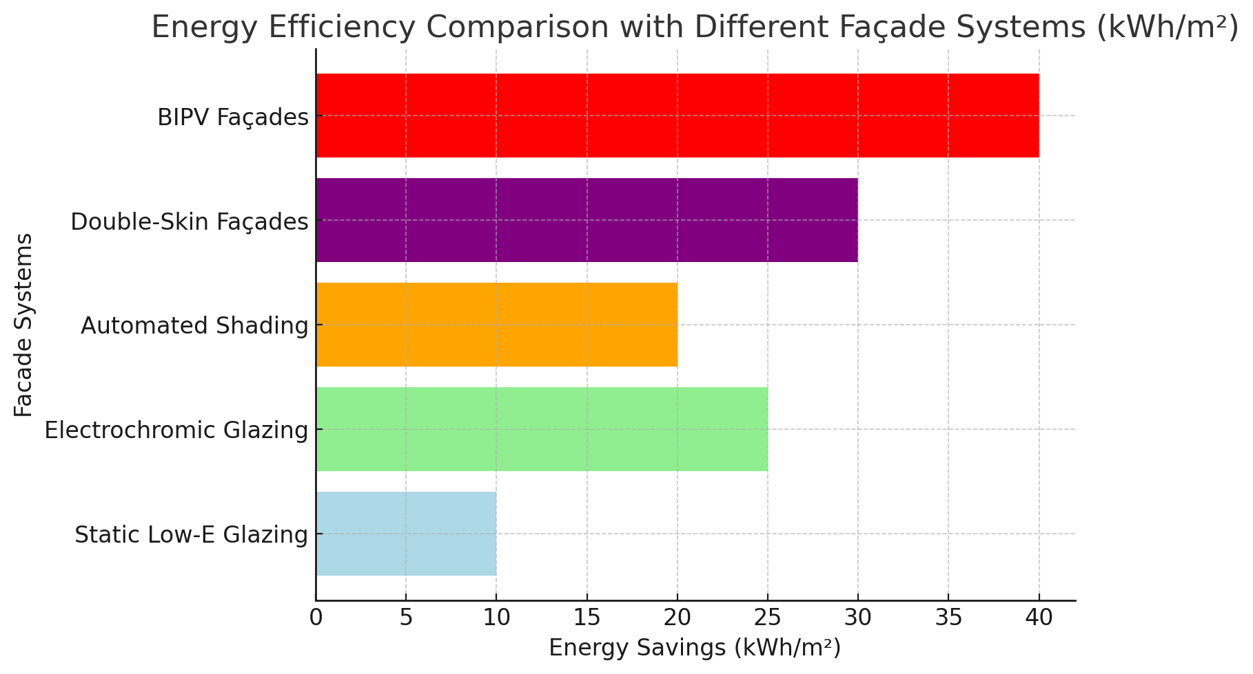
- Energy Efficiency Comparison with Different Façade Systems (kWh/m²)
Sensors are the heart of façade intelligence. Control strategies can range from rule-based logic (if the incident irradiance is higher than a threshold value then one lowers shades) to extremely complex model predictive control (MPC) that uses weather forecast, internal gains, and occupancy in order to optimize multiple objectives at once [16]. In reality, sturdy and interpretable sequels that are nearly seasonally tuned often outperform brittle “black box” logic because facility teams can understand, tune and maintain them [17]. Supervisory control requires coordination with lighting dimming curves and HVAC setpoints so that they do not conflict: e.g. as lights dim in response to daylight, the savings on lighting power may (due to shades opening) result in increased sensible cooling; similarly, aggressive shading during peak summer months cuts cooling but increases electric lighting load. The control goal then becomes multiple objectives, including achieving a target illuminance and glare probability, holding thermal comfort in an allowable range (PMV/PPD), while minimizing energy use and peak demand [18].

Evaluation Framework for Certification-Aligned Design
A standardized assessment system enables teams to link façade decisions to certification paths through a provision of “audit trail” evidence. It starts with baseline setting, usually one year of utility data for existing buildings or code-compliant models for new construction. For results presentation, daylight simulation gives you the spatial daylight autonomy (SDA) and annual sunlight exposure (ASE), two performance indicators that are related to the likelihood of using electrical lighting and to issues such as glare or overheating [19]. Daylight simulation with glare indicators like DGP and illuminance histograms provides a granular picture of the occupant related response. Concurrently, whole-building energy modeling compares annual EUIs, peak demands and load profiles under various façade/control options. Given that façade control sets are directly related to lighting load and solar gain, the co-simulation of both lighting and thermal loads is preferred so as not to under- or overestimate the interaction. Where DSF (or ventilated cavities) are proposed, CFD and network airflow modeling assist in providing an understanding of pressures, temperatures, and seasonal wind actions. The percentage of glare reduction done in office spaces using automated shading systems, the data were created using machine-learning simulation that can predict the level of glare reduction under different environmental conditions (solar zenith angle, cloud cover, etc.). Elaboration: Machine-learning models based on glare datasets optimize the actuation of automated shading devices (e.g. venetian blinds, exterior louvers). The system dynamically changes the shading elements by absorbing real-time irradiance, sky-climate, and indoor illuminance signals in order to reduce glare and maintain natural daylight. Findings indicate that automated shading can provide significant glare reduction, and thus promote visual comfort in office environments with large window-to-wall ratios as depicted in fig. 2.
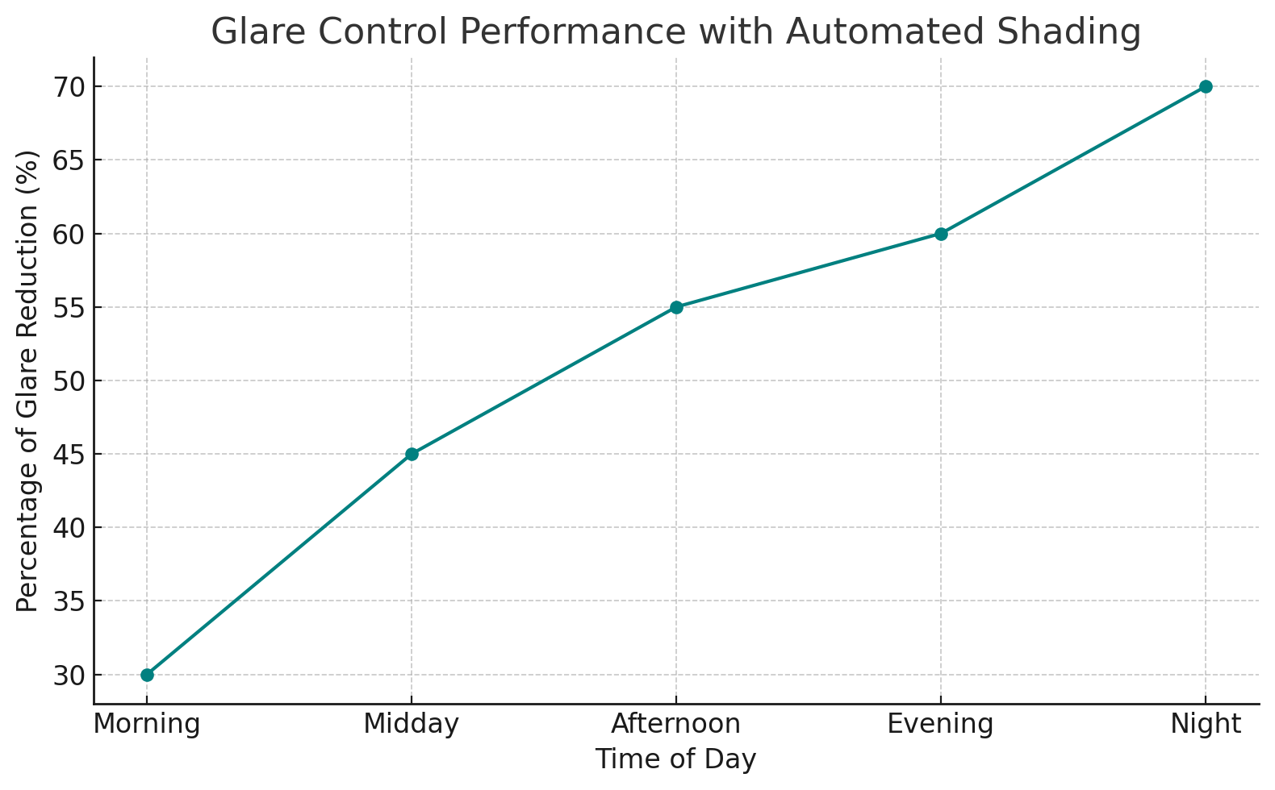
- Glare Control Performance which has automated shading.
Embedded carbon and life-cycle assessment (LCA) fill in the picture by considering material-stage impacts, which become more pronounced as operational energy decreases [20]. Glazing, framing, insulation and PV module EPDs are inputs to cradle-to-gate assessments where the designer should look at mass, recycled content and end-of-life scenarios such as deconstruction and glass/PV recycling routes. Embodied-carbon credits or disclosure requirements are increasingly becoming part of certification systems, so a façade that minimizes operational loads but imposes high embodied impacts might not be the best option at portfolio scale. It is key that commissioning is dealt with explicitly in the framework. There are daylight sensors to adjust, shade trims and speeds to set, electrochromic setpoints to verify, and human control interfaces to coordinate. Measurement and verification in the first year of operation, using submetering of lighting circuits and trend logs of control states, can create a feedback loop to address issues before occupant overrides become ingrained.

Case-Style Scenarios Demonstrating Certification Pathways
Situation-based logic explains how façade strategies express on certification result with respect to different program types. In a common urban office retrofit, the 1980s curtain wall, like as shown thereon with high window-to-wall ratio, on the one hand offer both opportunities and risks [21], [22]. Substituting clear glazing for low-e is cases and incorporating electrochromic areas on the solar facing facades can substantially reduce cooling loads and increase quality of daylight. The combination of automatic interior shades with full dimming in the perimeter zones significantly decreases lighting energy consumption usage and enhances visual comfort, concurrently supervisory control schemes which focus on controlling glare during occupied hours and then relaxing to a daylight-harvesting mode for shoulder hours seem to be well-accepted by occupants. Here, LEED energy performance points are backed by the modeled EUI cuts, and daylight-and-quality views-credits can be chased if luminaire layout and sensor locations provide uniformity without over lighting [23]. ENERGY STAR benchmarking would then become an operational goal, with a post-retrofit score target higher than that needed for labeling. Occupants’ WELL light and thermal comfort needs can be met by providing appropriate circadian stimulus during daylight hours and by controlling operative temperatures near workstations. To minimize capital cost, owners can introduce electrochromic glazing with a phase-in based on façade orientation and concentrate efforts on floors with the most glare complaints to justify a retrofit alongside LED luminaire upgrades that are compatible with dimming [24], [25]. The trade-off between daylight autonomy (percentage of day with sufficient daylighting) and energy consumption (kWh) of different facade systems, using machine-learning optimization models to balance the two parameters of each building type. Explanation: Machine-learning algorithms optimize the balance between daylight independence and energy use, such that it utilizes the natural light to its maximum capacity without triggering excessive energy usage in the form of heat gain or glare. Electrochromic glazing and automated shading are examples of technologies that are good at maximizing daylight control during cloudy days with minimum energy use as depicted in fig. 3.
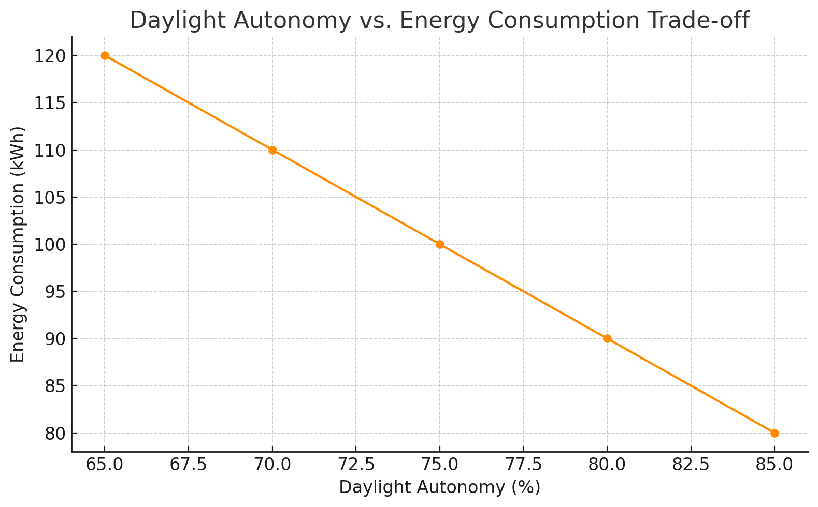
- Daylight Independency and Power Usage Compromise.
In an academic STEM new building, the exterior ventilated double-skin façade offers a dual purpose in that they have been used as acoustic buffer for noisy exposures and sun shading integrated at the cavity level and provide stack-effect ventilation to minimize cooling load during shoulder season months. Electrochromic skylights in Atria or lab writeup spaces can provide diffused daylighting with auto-tinting to maintain appropriate annual sunlight exposure. With auditable lighting energy savings, so too have come LEED energy points and daylight performance results, as WELL light and thermal features receive specified conditions that significantly reduce glare from direct sun penetration in classrooms. Control-wise, you need to match lecture mode and lab mode (with the projector on) to visual task demands. Comprehensive commissioning, such as classroom level control scenes, daylight sensor calibration with furniture installed, and training staff in conjunction of occupancy strategies across the academic calendar does help maintain performance. If building integrated photovoltaics are incorporated into south façade or canopies, a UVa50 Renewable Energy Credit could be pursued while providing architectural expression pertinent to the campus identity. Both the indoor thermal comfort (in terms of predicted mean vote- PMV) and energy savings (kWh) of smart facade systems. Simulations of machine-learning are used to determine the effects of various systems of the facade in terms of thermal comfort and the use of energy in different climate zones. Explanation: This figure shows how occupant comfort can be maintained with reduced energy consumption by simulating thermal comfort levels and energy-saving with machine-learning by simulating both the use of DSF and BIPV types of facades. DSF systems have reduced variation in temperatures, making the indoor environment more stable, whereas BIPV facades have an undeniable impact in generating energy and reducing heat-loads. The model identifies areas that have potential occupants to feel uncomfortable due to changes in temperature and energy wastage as depicted in fig. 4.
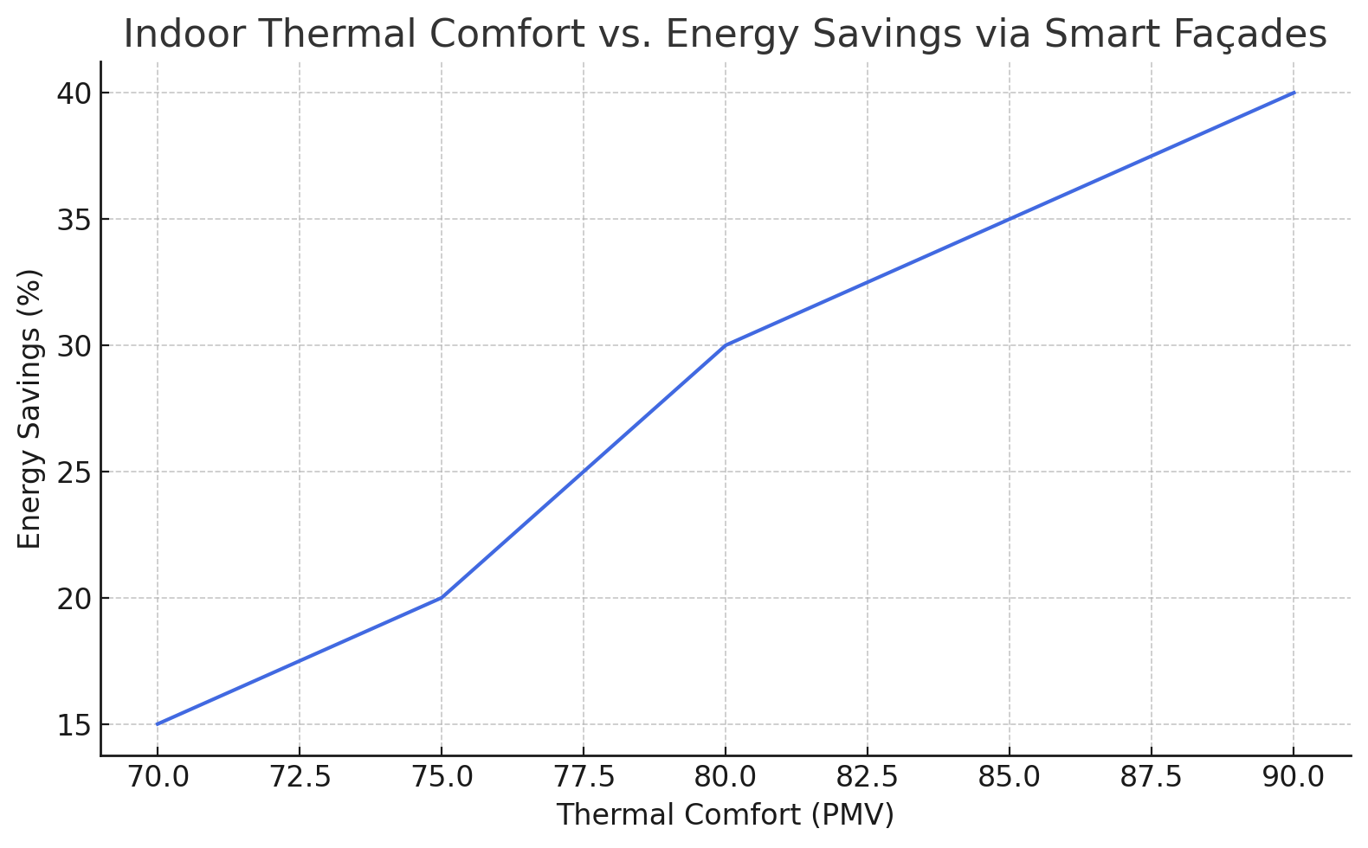
- Smart Faacade to Thermal Comfort Indoors and Savings.

Controls Integration, Cybersecurity, and Human Factors
The techno-logistical success of a smart façade is in the coordination of sub-systems Solution: In this definition below, one can observe smart façades via-a valuable contribution that BMS offers to the building at presents occurs by integrating IoT-enabled devices. Dimming curves have to be carefully exposed in lighting controls, avoiding flicker and low-end body effects; shade motors are required to report their position and status for diagnosis purposes; electro-chromic controllers require fail-safe logic, avoiding uncontrolled tints if external or internal communication fails. Schedules need to be timed to the seasons and site solar paths and normal occupancy, but they also need to have manual overrides visible by the BAS so that commissioning agents can identify patterns of discontent.
Predictive control algorithms consume weather forecasts and, when available, grid signals like time-of-use tariffs or realizing demand response events. In grid-interaction efficient buildings (GEB), facade controls engage in load shifting by precooling for anticipated high prices or daylight harvesting during event windows. With façade devices now sitting on IP networks, cybersecurity is a must: network segmentation, authenticated APIs (application programming interfaces), encrypted communications and change-control procedures all but eliminate the likelihood of malicious or mistaken disruptions. Human factors complete the picture. Occupants need just a few, intuitive control mechanisms raise/lower, tint level presets, task lighting override—with more bunsen-burner-level automation handled at the building scale. Signage and brief onboarding (eg, at move-in) education mitigate override fear and raise the threshold for noisy conditions. The bar-chart, which compared occupant satisfaction (thermal comfort, visual comfort, overall satisfaction) and energy-performance ratings (LEED credits, WELL Certification points), was obtained after one year of the building operation. The data will be based on machine-learning models that will be analyzed based on sensor data and occupant feedback. Rationalization: Machine-learning models that are trained using post-occupancy data attribute occupant satisfaction to smart facade performance. The feedback is gathered through the surveys and is built into the IoT platform of the building. The thermal and visual comfort measures are considered as well as the energy performance measurements, including LEED and WELL scores. Results show that high performance in the two aspects is positively correlated with well occupant experience even in the presence of well energy performance in case of smart facades as depicted in fig. 5.
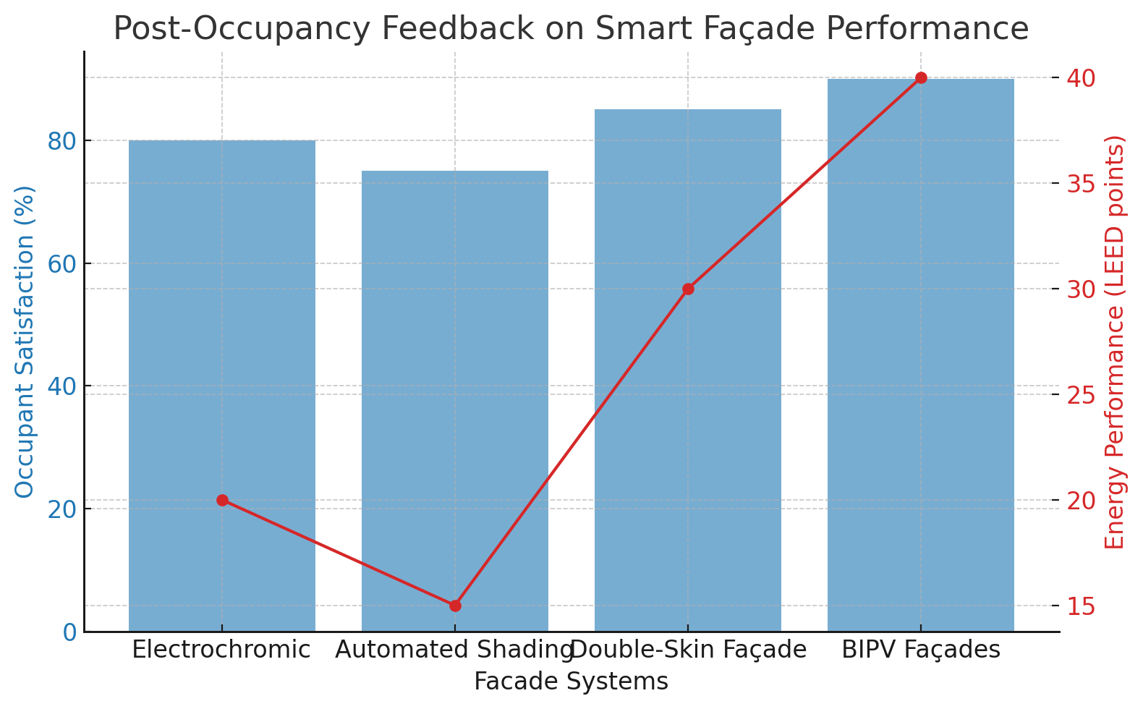
- Smart Façade Performance Feedback (Post Occupancy).

Measurement, Verification, and Commissioning Patterns
Commissioning is not one event, but everything from the design intent documentation to through post occupancy seasonal testing. For façades, field measurements cover illuminance mapping under clear and overcast skies, glare assessments from sample seating areas, and checks of shade travel limits and speed. Underperformance is often due to mis-calibrated sensors (notably for daylight sensing), which must be calibrated at times of tbe day in the presence of furniture and finishes. Periods for the facades status (tint level, shade position) should be mentioned as trend logs if sufficiently short to cross-compare with lighting and HVAC responses; hourly data is typically appropriate for energy analysis, whilst 1–5 min is necessary in order to comment on occupant satisfaction. An M&V plan should specify which measures will be monitored and how (e.g. space types, hours of operation, staff in those spaces), such as perimeter lighting power density during occupied hours, distribution by orientation of shade positions and percent of time achieving target illuminance; When performance does not match predictions, the cause can be identified through parameter sweeps in simulation to find drivers for example, a lower-than-predicted sky clearness index or different occupant schedules — and then retuning of controls. A virtuous cycle develops if building operators can be taught to read diagnostic dashboards, and occupants can know how their actions affect performance.

Economics, Incentives, and Portfolio Strategy
Smart façade project economics are climate and orientation-dependent, window-to-wall ratio based, utility tariff sensitive, existing system efficiency specific and construction logistical oriented. Electrochromic glazing has higher first costs over static low-e, but it can lead to smaller mechanical plant and reduce operating costs as well; automated shading and daylighting controls are often cost-effective because of the reduction in lighting energy use and relatively small incremental costs when packaged with LED upgrades. The economics of BIPV depend on module price, inverter and balance-of-system costs, and the geometry of the shading; their value is higher when there are limitations on roof area or façades capable of hosting a significant area without undue self-shading. Incentives for certification introduce a second channel to the business case; energy and daylight credits are able to open up levels of certification that owners appreciate in terms of market differentiation, while third-party validation of savings is available via operational benchmarking.

Risks, Limitations, and Mitigations
Despite the substantial advantages of smart façades, they also present hazards when they are inadequately designed and maintained. Control complexity can also lead to operators getting overwhelmed; remedy comes from clear sequence-of-operations documents, training, a conservative default behavior that fails safely and the ability to pilot the machine in specific targeted sequences through complex tasks. Specifically, occupant override fatigue is a frequent mode of failure; cures include fewer, more intuitive presets as well as feedback that shows why in the world the system has decided to do something. DSF fire and smoke solutions should be developed in collaboration with code officials; acoustic flanking paths and stack pressures demand initial modeling and full-scale mock-ups.
Electrochromic color quality and switching uniformity have come a long way but still need to be verified in physical and visual mock-ups to ensure user acceptance. Local shading, soiling or thermal derates can jeopardize the performance of BIPV facades; consideration of module-design, ventilation and access logistics solves this issue. Finally, late-breaking value engineering power in design can lead to deterioration in control quality; once the smart façade concept has been established, it should be preserved through clear contract language that performance depends on both hardware and commissioning scope. The bar chart helps show to what degree the different systems of facades mitigate peak demand. The highest impact is shown in building-integrated photovoltaic (BIPV) facades, then the use of the double-skin facade, and automated shading systems. These technologies help in controlling the internal thermal load by regulating the heat gain, and increase of shading, as a result, the peak demand is lower and the need to use additional cooling or heating in case of extreme weather conditions is also minimized as depicted in fig. 6.
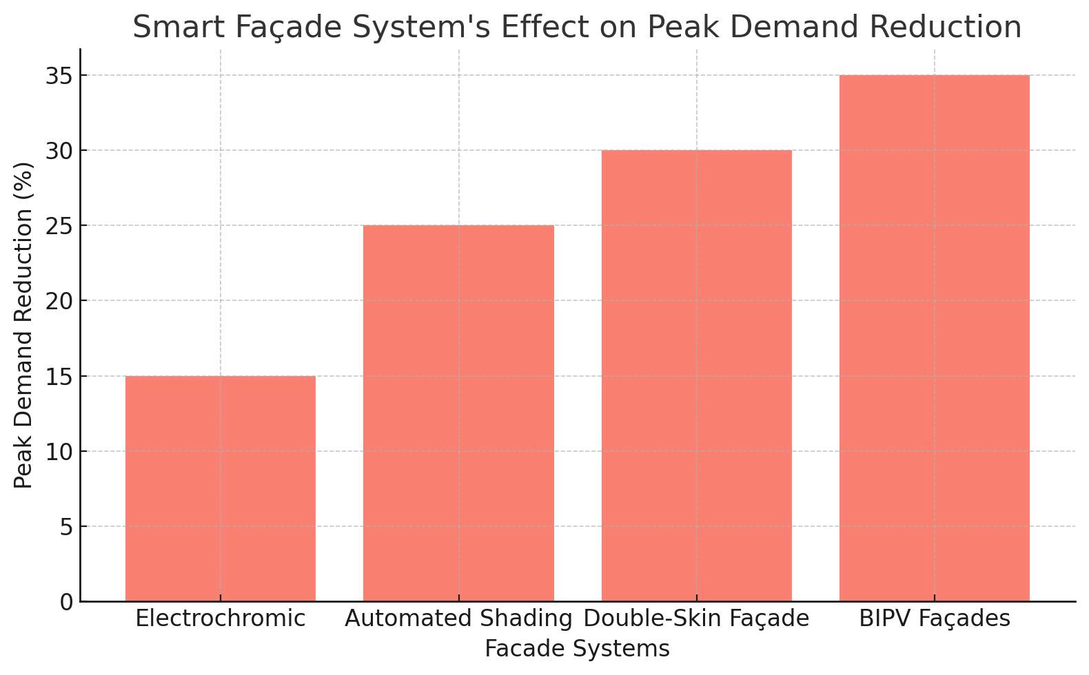
- Smart Façade System's Effect on Peak Demand Reduction.

Synthesis and Practical Guidance
The common thread in these last sections is that certifi cation results are greatest when façade strategies are described as systems, rather than features in a catalogue. A pragmatic path starts with goals that are transparent about energy, daylighting, comfort, and carbon; is rooted in co-simulation that honors the feedback between lighting, shading, glazing, and HVAC; and ends with commissioning plus operator engagement to maintain advances. When it comes to certification, the facade is not only responsible for energy points but also for human-centric statistics that are becoming more crucial to owners. Glare reduction and daylighting, Views Maintaining good views will improve cognitive performance, satisfaction and well as stabilizing operative temperatures. First time quality Significant improvements to perceived quality can be made using a combination of natural lighting/ventilation in the canopy. Feeling that you are outdoors Visually connecting to the outdoors supports wellbeing targets. BIPV or canopy PV that integrates with façade shading geometries can be seen as bringing on-site generation directly onto the building and contributing to resilience messaging while also reducing net energy use. The suggested approach to delivery is based on an iterative, evidence-led practice: baseline and target setting; concept options for envelope including control narratives; simulation and cost-benefit analysis; stakeholder review (including O&M); procurement with mock-ups then followed by rigorous commissioning; year one tuning with open reporting against certification performance.
- Performance Summary of Different Types of Methods
Method | What it does | Typical Energy Impact* | Comfort & Glare | Grid/Resilience Contribution | Retrofit Fit | Commissioning Complexity | Certification Levers | Notable Risks / Watch-outs
Dynamic (Electrochromic) Glazing | Varies visible/solar transmittance to cut heat gain and glare while preserving views | Cooling ↓; lighting ↓ in perimeter zones; heating impact depends on climate | Strong glare control with views; improves daylight autonomy when paired with dimming | Indirect: enables load shaping via daylighting; supports DR events | Medium (glass replacement) | Medium: sensor calibration, tint setpoints, HVAC/lighting coordination | LEED: Energy, Daylight, Quality Views; WELL: Light, Thermal; ENERGY STAR: lower EUI | Color neutrality, switching speed, controls drift; user acceptance if scenes are abrupt
Automated Interior Shading + Daylight Dimming | Motorized shades + photosensors reduce solar gain and electric lighting | Lighting ↓↓ (perimeter); cooling ↓; peak demand ↓ during sunny hours | Good glare control; fine user overrides possible | Facilitates daylight harvesting during DR windows | High (adds to existing façade) | Medium: photosensor placement/tuning is critical | LEED: Daylight/Interior Lighting; WELL: Light/Comfort | Poorly tuned sensors → occupant overrides; maintenance of motors
Exterior Shading (fins/louvers) | Stops solar load before glass; can be fixed or motorized | Cooling ↓↓; lighting impact depends on geometry; peak shaving | Excellent glare mitigation; may reduce sky view if over-dense | Reduces cooling peaks in heatwaves; passive resilience | Medium (structure & wind loads) | Medium–High: wind/safety interlocks, façade integration | LEED: Energy/Daylight; WELL: Light | Wind, soiling, snow/ice; architectural coordination; O&M access
Double-Skin Façade (ventilated cavity) | Buffer cavity moderates heat flow; houses protected shading; enables stack ventilation | Cooling ↓ / heating ↓ (climate-dependent); ventilation energy ↓ in shoulder seasons | Stable surface temps; good glare with cavity blinds | Passive survivability gains via thermal buffering and natural vent | Low–Medium (easier in new builds) | High: airflow control, fire/smoke strategy, access | LEED: Energy/Daylight; WELL: Thermal/Light | Cost/complexity; cleaning & maintenance; acoustic flanking; code coordination
Static High-Performance Low-e Glazing | Improves U-factor/SHGC without controls | Cooling ↓ / heating ↓; baseline for all projects | Neutral; glare unmanaged without shades | None direct | High (window replacement cycle) | Low: standard envelope QA | LEED: Energy; ENERGY STAR: lower EUI | Locked performance (can’t adapt to sky/season); glare still an issue
Building-Integrated PV (BIPV) Façade/Spandrel/Canopy | Generates on-site electricity; can shade and replace cladding | Site electricity offset ↑; cooling ↓ where shading occurs | Can reduce glare via semi-opaque modules | On-site generation; supports resilience with storage | Medium (façade area helps when roof is limited) | Medium: electrical/BOS integration, waterproofing | LEED: On-site Renewables/Energy; resilience narrative | Lower module efficiency vs. roof; shading/soiling; thermal derates
Ventilated Rainscreen / Thermal-Break Upgrades | Improves envelope thermal/air/moisture control; reduces thermal bridging | Heating ↓ / cooling ↓; improves durability | More stable interior surfaces; indirect glare effects | Enhances passive survivability (drying, buffering) | Medium–High (façade reclad cycles) | Medium: details & QA matter | LEED: Energy/Materials (LCA); WELL: Thermal | Detailing errors → moisture traps; construction QA critical
Smart Window Films (electro/thermo-responsive) | Retrofit films modulate solar gain or add IR rejection | Cooling ↓ (modest–moderate); lighting impact minimal | Limited glare help unless paired with shades | Minor indirect contribution | Very High (least intrusive) | Low–Medium | LEED: Energy (small); quick wins | Durability/optics variability; warranties; limited controllability
Operable Windows / Mixed-Mode with Façade Sensors | Enables natural ventilation when conditions allow | Ventilation/cooling energy ↓ in mild seasons; fans ↑ slightly | Fresh-air/comfort benefits if well managed | Passive operation during outages; peak shaving | Medium (controls + hardware) | Medium–High: window logic, IAQ monitoring | LEED: Energy/IAQ; WELL: Air/Thermal | Outdoor noise/pollution; humidity control; sequencing with HVAC

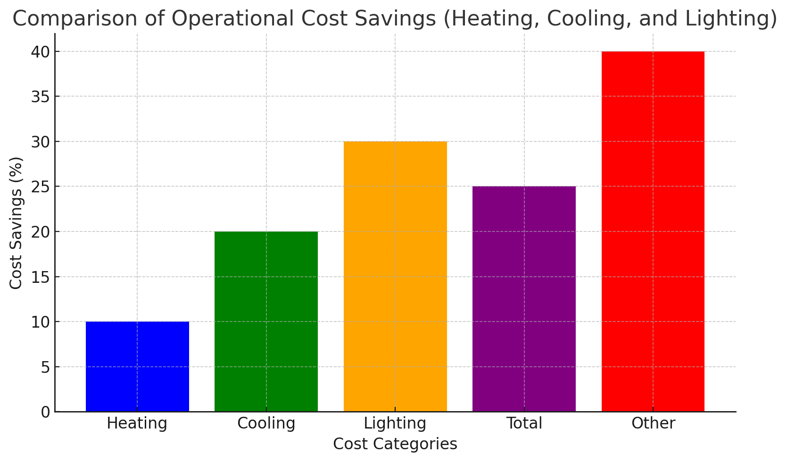
- Comparison of Operational Cost Savings (Heating, Cooling and Lighting).
The figure is a comparative cost savings analysis in operation in relation to different building systems, and especially in heating, cooling and lighting parts. Designs like BIPV facades and automated shading save a lot of energy by reducing energy usage in all three categories. The effectiveness of adaptive facade technologies enhances the overall cost reduction by improving the energy-efficient buildings performance by optimising cooling and lighting costs.

Conclusions and Outcomes
Smart façades represent a pivotal convergence of architectural expression, environmental control, and digital supervision. In the U.S. context, where certification systems translate sustainability aspirations into verifiable credits, adaptive envelopes become instruments for measurable progress rather than cosmetic upgrades. Electrochromic glazing, automated shading, DSF, and BIPV each offer distinct levers over daylight, heat gains, and energy use; when orchestrated by reliable controls and validated through commissioning and M&V, they consistently improve both performance and occupant experience. Certification programs provide the scaffolding to make these improvements durable, comparable, and market-visible, while code evolution and portfolio-level strategies ensure that lessons scale. The core message for practitioners is straightforward: treat the façade as a controllable energy and comfort system; align analytical methods and commissioning with certification evidence; and design human-centered control affordances that keep occupants engaged rather than alienated. In doing so, project teams can deliver buildings that not only meet U.S. sustainability goals but also elevate architectural quality and long-term value.

References
- U.S. Green Building Council, LEED Rating System: Overview and Credit Structure, Washington, DC, USA: USGBC, 2025.
- International WELL Building Institute, WELL v2: Features and Performance Verification, New York, NY, USA: IWBI, 2025.
- U.S. Environmental Protection Agency, ENERGY STAR Portfolio Manager—Technical Reference, Washington, DC, USA: EPA, 2025.
- ASHRAE, ANSI/ASHRAE/IES Standard 90.1: Energy Standard for Buildings Except Low-Rise Residential Buildings, Atlanta, GA, USA: ASHRAE, latest ed.
- International Code Council, International Energy Conservation Code (IECC), Washington, DC, USA: ICC, latest ed.
- Passive House Institute US (PHIUS), Passive Building Standards, Chicago, IL, USA: PHIUS, 2025.
- Green Building Initiative, Green Globes for New Construction, Portland, OR, USA: GBI, 2025.
- International Living Future Institute, Living Building Challenge 4.0, Seattle, WA, USA: ILFI, 2025.
- L. Heschong, Daylighting and Human Performance, Fair Oaks, CA, USA: Heschong Mahone Group, 2002.
- J. Mardaljevic, “Daylight modeling and climate-based metrics,” Build. Environ., vol. 46, no. 2, pp. 250–257, 2011.
- Lawrence Berkeley National Laboratory, Electrochromic Glazing Performance: Field Measurements and Modeling Guides, Berkeley, CA, USA: LBNL, 2025.
- National Renewable Energy Laboratory, Building-Integrated Photovoltaics: Applications and Case Studies, Golden, CO, USA: NREL, 2025.
- S. Carlucci and L. Pagliano, “Daylighting metrics and visual comfort,” Energy Build., vol. 38, no. 7, pp. 873–881, 2006.
- M. Frontini, M. Bonomo, and E. Perini, “BIPV façades: Design and performance considerations,” Sol. Energy, vol. 136, pp. 23–37, 2016.
- A. GhaffarianHoseini, U. Berardi, J. Tookey, et al., “Double-skin façades: A critical review,” Renew. Sustain. Energy Rev., vol. 60, pp. 1052–1069, 2016.
- Efficiency Valuation Organization, International Performance Measurement and Verification Protocol (IPMVP), Washington, DC, USA: EVO, latest ed.
- Illuminating Engineering Society, Lighting Controls: Design and Commissioning, New York, NY, USA: IES, latest ed.
- U.S. General Services Administration, Smart Buildings and Grid-Interactive Efficient Buildings, Washington, DC, USA: GSA, 2025.
- A. Tzempelikos and A. K. Athienitis, “The impact of shading design and control on daylighting and energy in buildings,” Sol. Energy, vol. 81, no. 3, pp. 369–382, 2007.
- S. Roetzel, A. Tsangrassoulis, U. Dietrich, and S. Busching, “Occupant behavior and façade controls,” Energy Build., vol. 66, pp. 646–655, 2013.
- D. Robinson, Ed., Computer Modelling for Sustainable Urban Design: Physical Principles, Methods and Applications. London, U.K.: Earthscan, 2011.
- Forum, Embodied Carbon Primer for Envelopes, Seattle, WA, USA: CLF, 2025.
- American Architectural Manufacturers Association and National Fenestration Rating Council, Fenestration Thermal and Optical Properties: Publications, Arlington Heights, IL, USA / Greenbelt, MD, USA: AAMA & NFRC, latest ed.
- National Institute of Building Sciences, Whole Building Design Guide—Façade Systems, Washington, DC, USA: NIBS, 2025.
- M. Kischkoweit-Lopin, “Façade ventilation and double-skin façades,” Energy Build., vol. 34, no. 4, pp. 431–440, 2002.

