Original Research Article
COMPARATIVE ANALYSIS OF SIGNAL LATENCY ON 4G NETWORK IN KARU SITE ABUJA, NIGERIA

ABSTRACT
Despite the advantages of 4G network the challenges of dynamic nature of wireless channels, interference from other users and devices, high latency, and ever-increasing demand for higher data rates and seamless connectivity are still common. This study carried out a comparative analysis of network latency on 4G network in Karu site Abuja, Nigeria. Using the speed test ooakla application the latency and jitter across the residential, commercial, and educational zones were recorded every 2 hours from 6am to 8pm at each zones within Karu site FCT Abuja. Result shows significant variability of network latency across zones. The mean latency for the residential zone was 41.4ms, while that of commercial zone was 40.8ms and that of educational zone was 55.9ms. This implies heightened network congestion due to high user density and under-optimized infrastructure at the educational and residential areas. Therefore, it is important for network engineers and service providers to focus on infrastructural efficiency and user dynamics to address congestion and temporal demand fluctuations for improving 4G network quality and user experience.

Keyword: Signal latency, jitter, uplink, downlink, speed test app, round-trip time,

1. Introduction
In the fast-evolving landscape of telecommunications, the advent of 4G networks represents a significant milestone, promising high levels of data speed, capacity, and reliability (Agarwal & Agarwal, 2014; Wang et al., 2020). However, as the demand for high-quality, uninterrupted connectivity continues to soar, so do the challenges associated with ensuring robust communication in 4G networks. One critical aspect in addressing these challenges lies in the development of advanced signal processing techniques tailored specifically for 4G networks (Yadav, 2017). This sets the stage for understanding the importance of advanced signal processing in achieving robust communication in 4G networks, delving into the key motivations, challenges, and research objectives (Adekunle et al., 2021). The journey of communication networks has been marked by a series of transformative leaps, from the early analog systems of 1G to the digital revolution of 2G and the broadband capabilities of 3G. With each generation, there have been remarkable advancements in data speed, capacity and functionality (Zhao et al., 2021).
The emergence of 4G technology represents the culmination of these advancements, offering unprecedented levels of performance and efficiency. 4G networks, based on technologies such as LTE (Long-Term Evolution) and WiMAX (Worldwide Interoperability for Microwave Access), promise data rates up to several hundred megabits per second, low latency and seamless mobility, making them the backbone of modern communication systems (Xin & Yan, 2023; Varum & Shikha, 2016; Pandiarai, 2013). Signal processing serves as the backbone of modern communication systems, encompassing a wide range of techniques aimed at enhancing the quality, efficiency and reliability of transmitted signals. In the context of 4G networks, signal processing plays a pivotal role in addressing the aforementioned challenges and optimizing network performance. By intelligently processing incoming signals, it becomes possible to mitigate the effects of channel impairments, reduce interference, improve spectral efficiency, and enhance overall system resilience (Li & Seshadri, 2011; Rappaport, 2011). Therefore, the development of advanced signal processing techniques tailored specifically for 4G networks is imperative to meet the evolving demands of modern communication applications.
Despite their many advantages, 4G networks face a myriad of challenges that threaten to compromise their performance and reliability. These challenges stem from various factors, including the dynamic nature of wireless channels, interference from other users and devices, high latency, the ever-increasing demand for higher data rates and seamless connectivity (Park & Kim, 2021; Park & Lee, 2020; Patel & Singh, 2019). Additionally, the proliferation of multimedia applications, IoT (Internet of Things) devices, and smart infrastructure further exacerbates the complexity of 4G networks, necessitating robust solutions to ensure uninterrupted communication under diverse conditions (Wang et al., 2021, 2022; Rasmussen & Kolding, 2014). The finding of this research is expected to have vast importance for 4G communication network. The research thereby enhances the efficacy of communication, thereby meeting modern communication network. The study will provide a guide for network engineers on areas that may requires upgrading network infrastructure and optimization for fair network distribution.
Materials and Methods
The materials used for this study includes 4G mother board 4000mAh phone used as instrument for data collection, Network latency testing tool (Speed test by Ookla) used to measure network latency at various times intervals, Power bank (20000mAh) used to ensure device stay charged throughout the study period, GPS logging device (Geo tracker) used to ensure accurate geographical mapping of the data, Data collection sheet used to record test results and device usage patterns, and HP Elite Book computer used to analyze the collected Data.
Study Area
Karu, located in the northeastern part of the Federal Capital Territory (FCT) Abuja, serves as an ideal study area for testing improvements in battery capacity and latency in the 4G network due to its unique blend of urban and suburban characteristics. As one of the rapidly developing areas within the FCT, Karu encompasses a diverse demographic profile that includes residential neighborhoods, commercial establishments, and educational institutions. This diversity provides a comprehensive setting for evaluating 4G network performance across different user scenarios. The area is characterized by a mix of high-density housing complexes and more spacious residential zones, ensuring varied data collection points. Additionally, Karu's proximity to Abuja's central business district makes it a critical node for network providers aiming to optimize service delivery. The presence of numerous small businesses, schools, and markets offers a wide range of environments to assess how 4G network improvements can affect battery life and latency in real-world applications. The infrastructure in Karu, including modern roads and connectivity facilities, further supports detailed and reliable data collection. This area's dynamic socio-economic environment and strategic importance within Abuja's metropolitan framework make it a representative and valuable location for this study. The map of FCT Abuja showing the location of Karu is shown in Figure 1.
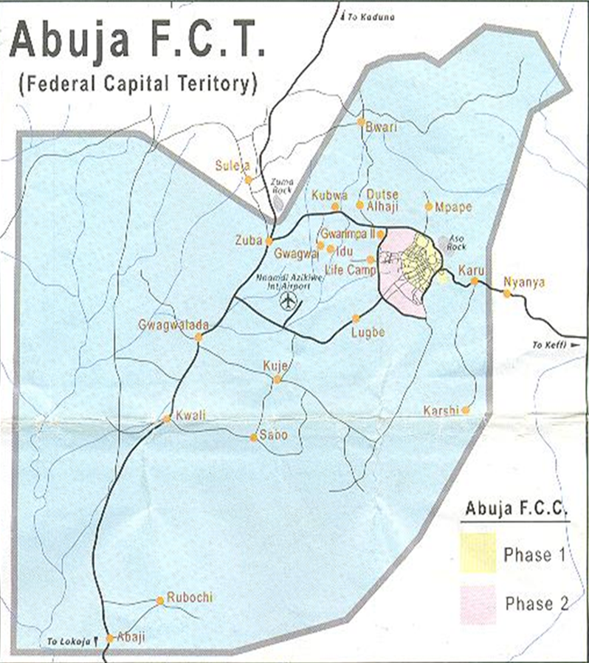
Figure 1: Map of Abuja (FCT) Showing Karu (Ibrahim et al., 2022)
Method of Data Collection
The application speed test ooakla was downloaded into a 4G enhanced phone or motherboard. The device was used to collect data on latency at three different locations in Karu site Abuja including educational, commercial and residential areas from 6am to 8pm at two hours’ time interval. The speed test apps on the mobile device measured the round-trip time (RTT) for data packets sent to and from a server. The Latency is the RTT, which indicates how long it takes for data to travel from the device to a server and back. The result was recorded on a data collection sheet and the mean for three different readings were used for analysis. Lower numbers indicate better latency. The practical formula used by speed test is given as:
RTT = Receive Time - Send Time (1)
A more theoretical calculation for one-way latency is given as:
$Latency=\frac{Distance}{Propagation Speed}$ (2)
Which for round-trip time (RTT), it is given as:
RTT = 2 x One-Way Latency (3)
The practical formula using the speed test app was used for this study because network latency is most accurately and practically measured using such tools as ping or speed test app. This is because real-world latency includes many factors beyond just distance and speed that can add up to the latency, such as, time spent by network devices (routers, switches) to process the data, time a packet spends waiting in queues at network devices due to congestion, time taken to push all the bits of the packet onto the link, and time taken to put the bits onto the wire, which depends on packet size and link speed (Cirelly, 2025). The acceptable values of latency and jitter for application specific are shown in Table 1.
Table 1: Application specific guidelines for latency and jitter
Application | Latency (ms) | Jitter (ms)
Ideal | 0 | < 10
VoIP | < 150 | < 30
Video Calls & Conferencing | < 150 | < 30 – 50
Online Gaming | < 100 | < 20
Streaming Media | < 150 | < 50 – 100
General Data Transfers | < 150 | < 100
(Uberuaga-Rodgers, 2024; Joy, 2025; Cirelly, 2025)
Result and Discussion
The result of the latency for the residential, commercial and educational zones within karu site are presented in Tables 2 to 4.
Table 2: Download, upload speed, ping and jitter for the residential Zone
Time (S) | 6am | 8am | 10am | 12am | 2pm | 4pm | 6pm | 8pm
Download (mbps) | 5.51 | 3.60 | 0.90 | 4.69 | 3.20 | 1.96 | 1.75 | 1.25
Upload (mbps) | 5.67 | 12.60 | 9.16 | 12.50 | 9.15 | 8.81 | 16.50 | 9.00
Ping (ms) | 57 | 38 | 33 | 40 | 35 | 38 | 44 | 46
Jitter (ms) | 17 | 10 | 31 | 10 | 15 | 32 | 22 | 17

Table 2 shows the result for the download, upload speed, ping and jitter for residential zone taking from 6am to 8pm every 2 hours interval. The latency was within the acceptable value throughout < 150ms. Users can enjoy almost all services within the residential areas including VoIP, video calls and conferencing, streaming media and general data transfer. However, services like VoIP, video calls and conferencing, and online gaming may suffer little fluctuation due to unstable network at 10am and at 4pm especially online gaming (jitter > 30). Overall, the network is very good at the residential area Figure 2 shows the variation in latency with time of the day for the residential zone.

Figure 2: Latency across Residential Zones
Table 3: Download, upload speed, ping and jitter for the commercial zone
Time (S) | 6am | 8am | 10am | 12am | 2pm | 4pm | 6pm | 8pm
Download (mbps) | 21.4 | 16.10 | 5.03 | 42.80 | 35.00 | 27.50 | 17.70 | 14.90
Upload (mbps) | 28.10 | 21.60 | 12.50 | 36.80 | 36.10 | 20.10 | 46.00 | 6.14
Ping (ms) | 27 | 59 | 40 | 42 | 39 | 37 | 42 | 40
Jitter (ms) | 5 | 75 | 12 | 9 | 2 | 6 | 19 | 12

Table 3 shows the result for the download, upload speed, ping/latency and jitter for the commercial zone taking from 6am to 8pm every 2 hours interval. The latency was within the acceptable value throughout the day < 150ms. Users can enjoy almost all services within the commercial areas including VoIP, video calls and conferencing, streaming media and general data transfer. However, services like VoIP, video calls and conferencing, and online gaming may suffer heavy fluctuation due to unstable network at 8am (jitter > 30). Overall, the network is very good at the commercial area. These shows a decline in latency and network performance. Figure 3 shows the variation in latency with time of the day for the commercial zone.

Figure 3: Latency across Commercial Zone
Table 4: Download, Upload Speed, Ping and Jitter for the Educational Zone
Time (S) | 6am | 8am | 10am | 12am | 2pm | 4pm | 6pm | 8pm
Download (mbps) | 16.80 | 0.71 | 13.40 | 0.46 | 0.97 | 13.40 | 17.00 | 21.10
Upload (mbps) | 29.20 | 9.05 | 6.62 | 0.94 | 3.72 | 11.30 | 26.60 | 19.30
Ping (ms) | 34 | 106 | 39 | 67 | 53 | 40 | 57 | 51
Jitter (ms) | 8 | 197 | 23 | 65 | 18 | 23 | 19 | 13

Table 4 shows the result for the download, upload speed, ping and jitter for the educational zone taking from 6am to 8pm every 2 hours interval. The latency was within the acceptable value throughout the day < 150ms except at 8am where it is very high > 150ms. Users can enjoy almost all services within the educational areas except at 8am where there will be heavy delay. Also, the network may be very unstable with heavy fluctuations experienced at 8am and at 12noon (jitter > 30). Overall, the network is fairly good at the educational area. Figure 4 shows the variation of latency with time of the day for educational zone.

Figure 4: Latency across Educational Zone

Figure 5: Correlation between latency for residential, commercial and education zones
Figure 5 reveals a clear temporal pattern in latency, with peak values observed during the morning and evening hours, aligning with high user activity periods. The sinusoidal trend demonstrates lower latency during off-peak hours, such as late at night and early afternoon. Comparing the trend for the three zones, educational zone shows higher latency values compared to residential and commercial areas. These findings emphasize the impact of user demand on network performance and the necessity for adaptive traffic management systems. Implementing dynamic resource allocation strategies during peak hours could mitigate latency spikes, ensuring a consistent user experience throughout the day. This insight is critical for developing time-sensitive optimization protocols for 4G networks.
Table 5: Summary of latency across zones
Zone | Metric | Mean | Median | Standard Deviation | Minimum
Residential | Latency (ms) | 41.4 | 36.5 | 6.4 | 33
Commercial | Latency (ms) | 40.8 | 38 | 6.4 | 27
Educational | Latency (ms) | 55.9 | 46.5 | 7.5 | 34

A detailed comparison of network latency across residential, commercial, and educational zones reveals notable variations in latency across different zones as shown in Table 5. Educational zones showed the worst efficient network performance, with the highest average latency (55.9 ms) and the greatest variability, as indicated by the larger standard deviation attributed to network congestion or longer routes and dynamic user activities. Residential zones exhibited the next higher average latency (41.4 ms) with significant variability, as shown by the standard deviation of 6.4 ms, reflecting challenges like higher user density and less optimized infrastructure and are more prone to network congestion. While, Commercial zones, having lower latency (mean 40.8 ms), indicating intensive app usage and network demand typical of business environments or better infrastructure design. These results emphasize the need for targeted network optimization and improvements especially in educational and residential areas to address congestion and to ensure equitable service quality across all zones while enhancing energy efficiency in commercial zones.
Discussion

The trends in latency across zones revealed key disparities in network performance, particularly in educational zones, which showed the highest average latency (55.9 ms) with significant variability. This finding aligns with the work of Sharma et al. (2020), who identified residential areas as hotspots for network congestion due to high user density and sporadic traffic patterns. The variability in latency observed in these zones can be attributed to the mix of devices and activities, from high-bandwidth streaming to intermittent browsing, as also reported by Park and Lee (2021). These factors highlight the need for infrastructural upgrades, including enhanced bandwidth allocation and load-balancing technologies, to mitigate congestion in residential areas.
In contrast, the high latency (55.9 ms) and minimal variability observed in educational zones are indicative of structured and controlled network environments, which corroborates findings by Patel and Kumar (2019). The lowest latency which is the best was found in the commercial zone and was found to be 40.8ms which is very good. Their research emphasized that well-managed networks in commercial settings benefit from a predictable user base and tailored resource allocation, resulting in consistent performance. Commercial zones' superior latency metrics revealed the importance of strategic network design and traffic management, which could serve as a model for addressing challenges in residential zones. When compared to commercial areas, where latency is typically lower than residential zones but higher than educational zones (Gupta et al., 2021), the findings further illustrate how infrastructural efficiency and user dynamics influence network performance across different zones. These insights underline the critical need for customized network solutions that cater to the unique demands of each zone.
Conclusion
The findings highlight the challenges and variations in network performance and energy consumption across different zones, emphasizing the need for targeted optimizations. The latency in the research was found to be fair in network delivery. The latency in residential zone is 41.4ms which is good, that of commercial zone is 40.8ms which is better while that of educational zone is 55.9ms which is fair. Physical distance to the cell tower and server is a primary factor that affect latency. Addressing network congestion and quality of the wireless link in education and residential zones, while enhancing energy efficiency in commercial areas, alongside adaptive resource management for temporal demand fluctuations, is crucial for improving 4G network quality and user experience.
References

Adekunle, O. A., Bello, M. T. & Yusuf, A. R. (2021). Network performance optimization in academic environments: A case study of Nigerian Universities. Journal of Educational Technology, 38(4), 211-224.
Agarwal, A. & Agarwal, K. (2014). The Next Generation Mobile Wireless Cellular Networks - 4G and Beyond. American Journal of Electrical and Electronic Engineering, 2(3), 92-97.

Cirelly, J. (2025). Jitter vs Latency – What’s The Difference and Why it Matters. Message posted to “Network Management Softwares”. Accessed on 18th Sept., 2025 from https://www.networkmanagementsoftware.com/jitter-vs-latency/.
Gupta, R., Sharma, P. & Singh, A. (2021). Latency dynamics in urban network environments: A cross-sector analysis. Journal of Network Science and Engineering, 18(4), 221-234.

Joy, M. (2025).What Is Internet Jitter? Understanding VoIP Jitter and Latency. Message posted to “Onsip”. Accessed on 18th Sept., 2025 from https://www.onsip.com/voip-resources/voip-fundamentals/what-is-internet-jitter-voip-latency-jitter.
Li, Y. & Seshadri, N. (2011). Orthogonal Frequency Division Multiplexing for Wireless Communications. Springer, 2(3), 4-6.

Patel, K. & Singh, R. (2019). Optimizing Connectivity in Educational Settings: Lessons from Controlled Environments. Computing in Academia, 29(1), 34-47.

Patel, R. & Kumar, S. (2019). Optimizing network performance in educational institutions: Lessons from structured environments. International Journal of Educational Technology, 29(3), 45-61.

Park, J. & Kim, S. (2021). The impact of user density on network latency: A residential study. Communications Research Letters, 45(6), 876-889.

Park, J. & Lee, K. (2020). Diurnal patterns in network performance: Implications for adaptive management. Communications Research Quarterly, 12(3), 221-235.

Park, J. & Lee, K. (2021). Residential network challenges: Evaluating user density and traffic variability. Communications Research Quarterly, 35(2), 113-127
Pandiaraj, T. (2013). Power Control Optimization and Improving Throughput for LTE Advanced Relay Networks. International Journal of Engineering and Innovative Technology (IJEIT), 3(2), 86.
Rappaport, T. S. (2011). Wireless Communications: Principles and Practice. Prentice hall communications Engineering and Emerging Technologies Series, 1(3), 3.
Rasmussen, L. K. & Kolding, T. E. (2014). MIMO in 4G Wireless Communication Systems. Springer, 1(2), 3-5.
Sharma, A., Gupta, R. & Verma, N. (2020). Urban network congestion: Understanding latency trends in residential areas. Urban Connectivity Journal, 12(3), 98-109.

Uberuaga-Rodgers, L. (2024). Jitter vs Latency: Definitions and Differences for Better Network Performance. Message posted to “Auvik”. Accessed on 18th Sept., 2025 from https://www.auvik.com/franklyit/blog/jitter-vs-latency.
Varum, D. & Shikha, S. (2016). A review paper on Advanced Network Parameter in LTE 4G. International Journal of Science, Engineering and Technology Research (IJSETR), 5(8), 5-7.

Wang, F., Xu, D. & Chen, L. (2021). Battery usage patterns in commercial network environments: Implications for optimization. Network Energy Journal, 45(5), 543-559.

Wang, F., Xu, D. & Chen, L. (2022). Energy consumption in commercial network environments: A study on application intensity. Network Engineering Journal, 50(5), 605-622.

Wang, T., Zhang, Y. & Liu, Q. (2020). Dynamic resource allocation strategies for congestion mitigation in 4G networks. IEEE Transactions on Mobile Computing, 15(6), 874-888.
Xin .F. & Yan .H. (2023). An overview of low latency for wireless communication: An Evolutionary Perspective. School of Electronic and Information Engineering, Beinjing Jiaotong University, Beinjing, china, 2(3), 3-4. .https://www.researchgate.net/publication/353117664,
Yadav, R. (2017). Challenges and Evolution of Next Generation Wireless Communication. Lecture notes in engineering and computer science: International Multi Conference of Engineers and Computer Scientists, Hong Kong, 1(1), 619-623.

Zhao, Y., Li, S. & Feng, Q. (2021). Adaptive scheduling for latency reduction in high-traffic networks. IEEE Transactions on Mobile Computing, 20(5), 895-904.

