Comparing the Performance of MobileNet and AlexNet Deep Learning-Based Models for Facial Recognition

.
ABSTRACT

Security systems are important and the need to upgrade from traditional approaches to more intelligent models for improved performances and crime mitigation is crucial. Deep learning approaches are a fast-growing research area exploring the performance of different architectures and datasets. The experiment in this work focuses on evaluating and comparing the performances of pre-trained MobileNet and AlexNet deep learning models for facial recognition of authorized and unauthorized users from a customized database. Multi-task Cascaded Convolutional Networks (MTCNN) was used for face and facial landmark detection of individuals in the image database comprising of real images of individuals from a corporate office (X-Hadlass) expanded with online images. Transfer learning was used to fine-tune the MobileNet and AlexNet models against the dataset for facial recognition. The models were tested for facial matching and their performances evaluated using key performance metrics. For confusion matrix results, AlexNet made more accurate predictions across multiple classes - 99% and 97% accuracy vs. MobileNet’s 98% and 79% for authorized individuals. It also showed a much stronger confidence in flagging unauthorized individuals (95% & 91% vs. MobileNet’s 58% & 74.6%). On the other hand, MobileNet showed strong performance in many other classes (e.g., AT_FRP_10 with 10 correct predictions). In other metrics, MobileNet had a higher accuracy (83%), precision (0.85), recall (0.83), and F1-score (0.83). Overall, though AlexNet performed better in specific cases with higher confidence and precision for known identities, MobileNet outperformed with higher accuracy, excelled in recognizing actual faces in the dataset exhibiting fewer false positives, and better balance across all evaluation metrics. MobileNet is more suitable for real-world facial recognition systems where accuracy and efficiency are a priority. AlexNet may be preferable in cases where slightly higher accuracy is required and computational resources are not a limitation.

Keywords: Deep learning, Facial recognition, MobileNet, AlexNet, and Customized database

1. INTRODUCTION

Facial recognition has become a critical technology in various domains, including security, access control, human-computer interaction, photography, films and in real time forensic investigations to identify unauthorised access to restricted places (Pappachan, et al., 2024) or crime scenes. Facial recognition access control systems have enhanced security measures by analysing facial features such as the size of the nose, lips, the distance between the eyes and facial angles in 2D, and modern 3D approaches to achieve curvatures around the nose (García-Gómez, et al., 2021). However, these systems face several problems and challenges such as unavailability of larger and more diverse real-life datasets leading to generalization issues from few-shot learning (Castillo Camacho & Wang, 2021). In addition, a major issue is vulnerability to unauthorized access by impostors which opens up the system to security breaches and is especially dangerous in forensic work thus posing a threat to secure environments and sensitive data.
The traditional access control systems such as passwords, PINs, badges, and magnetic cards, which require human intervention and have limitations including memory loss, theft, loss and falsification (G., et al., 2022) have been quickly replaced by access control systems developed with deep learning (DL) tools that learns patterns such as voice, fingerprints, retinal scans (Gudala, et al., 2022), adapts to changing conditions, and improves decision-making capabilities over time using smart devices and without human intervention.
Deep learning frameworks have significantly advanced the accuracy and efficiency of facial recognition systems. Deep learning is a specialized, more advanced and computationally intensive subset of machine learning that simulates human learning in an attempt to duplicate the operations of the human brain (Aboukadri, et al., 2024). By learning complex patterns from different unstructured datasets and examples to fulfil specialized functions, its convolutional neural networks (CNN) architecture facilitated by improvements in computer vision, uses facial data extracted from facial characteristics to improve the accuracy and reliability of the developed facial recognition system (Storey, 2019). This data is collected remotely from systems that can detect, track and recognize faces in real-time under different lighting conditions and facial angles (Cakir, et al., 2021) (Nagaraj, et al., 2021) for facial recognition.
This study compares the performance of two prominent deep learning architectures, MobileNet and AlexNet, in facial recognition tasks. The MobileNet neural network architecture can be integrated on mobile, embedded devices and systems where computational resources are limited for image classification and object detection. It uses a depthwise convolution and a pointwise convolution (1x1 convolution) approach to reduce the computational load compared to traditional convolutional networks (Mostafid, 2023). MobileNet is known for its lightweight design and suitability for resource-constrained devices.
The MobileNet architecture presented by (Howard, et al., 2017) was used in this work and is illustrated in Figure 1. MobileNet can be implemented for several recognition problems such as object detection, face attributes, fine-grain classification, and landmark recognition.
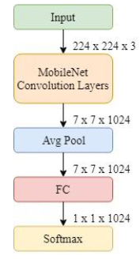
Figure 1 The original MobileNet architecture.

AlexNet is one of the earliest CNN architectures known for its breakthrough in large-scale image recognition. It has a simple framework and due to its relatively large size it is primarily used for classification tasks. With ReLU (Rectified Linear Unit) activation, AlexNet learns more complex patterns, speeds up the training process and features within a given data (Kumar, et al., 2023). AlexNet laid the foundation for convolutional neural network (CNN)-based image recognition.
By evaluating these frameworks on key performance metrics such as accuracy, computational efficiency, and scalability, this paper aims to provide insights into their suitability for facial recognition applications in different deployment environments.
The following are the highlights of the contributions of this study:
- Using a combination of a customized dataset of individuals and random online images to create diversity to investigate the eligibility of the deep learning models.
- Evaluating the MobileNet and AlexNet deep learning models on key performance metrics such as precision, accuracy, F1 score and recall to demonstrate their performance on the provided datasets.
- Comparing the performance of both deep learning models to provide insights into their computational efficiency, scalability and suitability for facial recognition applications.

Traditional security methods have given way to more sophisticated approaches, including biometric authentication, smart card access, and, most notably, deep learning-powered facial recognition (Galterio, et al., 2018) (Radzi, et al., 2020). The evolution of access control technologies over the years have undergone profound transformations driven by technological advancements. These security systems encompass a wide range of applications, from criminal investigations to cybersecurity and physical security measures (Chigozie-Okwum, et al., 2017) and access control systems are the first line of defence in protecting sensitive areas and valuable assets. This section will review aspects of facial recognition systems with respect to modern deep learning approaches.

1.1 Facial Recognition Technology
Facial recognition focuses on identifying and analysing individuals based on unique facial features such as the distance between eyes, nose shape, and other distinguishable characteristics, to establish a person's identity.
The evolution of face recognition technology from manually feeding in facial feature measurements into computers in the mid-1960s to using linear algebra to revolutionized image interpretation, enabling manipulation and simplification without human-defined markers in the late 1980s has laid the foundational phase and the groundwork for future advancements in facial recognition technology (Adjabi, et al., 2020) such as the ground-breaking facial recognition system utilizing statistical Principal Component Analysis (PCA) by MIT researchers (Cakir, et al., 2021). This later led to the introduction of the Face Recognition Technology (FERET) program, providing a substantial database of images for research and development. Subsequent models like Google FaceNet and OpenFace in 2015, also achieved significantly improved accuracy and performance (Adjabi, et al., 2020).
  - Principles and Components in Facial Recognition
Figure 2 shows a simplified block diagram of the key components of a facial recognition system. The first step is to obtain a database of facial images. The face detection algorithms then locate and extract the needed facial features from images or video frames. Deep learning techniques like Convolutional Neural Networks (CNNs) have proven highly effective in feature extraction and have been used to capture facial landmarks. These features are used to develop a facial recognition model that encodes these features into a compact representation, often known as a feature vector. This encoding facilitates comparison and matching against a database of known individuals. Finally, a decision-making mechanism, such as a similarity threshold or machine learning classifier, determines whether the input face corresponds to a registered individual (Fu, 2021) (Kortli, et al., 2020).
Figure 2: Face Recognition Generic Design Pipeline
Source: (Adjabi, et al., 2020)

1.3 Related works on Facial Recognition
In 2021, Camacho and Wang (Castillo Camacho & Wang, 2021) presented a review paper on detection methods in forensics with a focus on deep learning-based approaches. The overview highlighted the pre-processing steps and/or special network layer initializations which are unique to image forensics, especially in manipulation, falsification, camera identification, and CGI detection but less frequent in Deepfake detection, suggesting an area for future research. The review emphasizd the potential of combining different image and audio features for Deepfake detection. From their review of different image databases, they observed that image forgeries were becoming easy to create and an overview of anti-forensic methods showed that GAN strategies (Chen, et al., 2018) and (Chen, et al., 2019), were used to deceive forensic detectors. The authors therefore suggested future research on anti-forensic methods to explore alternative architectures and approaches to enhance forensic and anti-forensic capabilities.
The authors (Phiphiphatphaisit & Surinta, 2020) modified the pre-trained MobileNet architecture for food image classification. In the proposed version, the number of parameters in the model were reduced by removing three layers, including the average pooling, fully connected, and softmax layers from the original network, and replaced by the global average pooling (GAP) layers, the batch normalization (BN), and softmax layers. These modifications made the network train faster, reduced the size of the model, and the accuracy increased by approximately 5% and outperformed the original MobileNet architecture. When the data augmentation techniques are combined the proposed MobileNet architecture significantly outperformed other architectures.
Goel et al. (Goel, et al., 2021) evaluated the use of deep learning-based face recognition models to distinguish between sibling faces. The FaceNet, VGGFace, VGG16, and VGG19 deep learning models were used. The four datasets taken from the SiblingDB database focused on full-frontal faces and cropped face areas (eyes, nose, and forehead). Five standard similarity measures used to distinguish between sibling faces were the cosine similarity, Euclidean distance, structured similarity, Manhattan distance, and Minkowski distance with their respective thresholds. The results of the study showed that the the accuracy of a model varies depending on the facial area analyzed, and no single model consistently outperforms others across all facial features. VGGFace performs best when comparing full-frontal faces and eyes with an accuracy over 95%. However, FaceNet excelled with nose comparisons. Similarly, VGG16 and VGG19 perform well on forehead comparisons but not with eyes. Further studies suggest database expansions, combinations of best performing models into a single framework and the inclusion of other facial features such as chin and lips.

Due to the redundancy and quantization loss of the existing baseline MobileNet architectures, the authors (Kulkarni, et al., 2021) proposed the Quantization Friendly MobileNet (QF-MobileNet) architecture. The ImageNet dataset was used to verify and validate how well the proposed model was optimized for inference accuracy and resource utilization on image classification tasks when tested on on version MobileNetV2 and MobileNetV3. Results showed that the proposed model saves 33% of time complexity for QF-MobileNetV2 and QF-MobileNetV3 models against the baseline models. The proposed QF-MobileNet also showed optimized resource utilization with 32% fewer tunable parameters, 30% fewer MAC’s operations per image and reduced inference quantization loss by approximately 5% compared to the baseline models.
In tackling the significant computational resources required by deep learning approaches for face detection, (Chaves, et al., 2020) developed a prediction model and used it to analyze which features influenced the performance of the system the most and improved forensic face recognition tools. The possible trade-offs that can be made on the three popular deep-learning-based face detectors—MTCNN, PyramidBox, and DSFD— were evaluated using the WIDER Face and UFDD datasets across various CPUs and GPUs. The researchers developed a multiple linear regression model capable of predicting performance in terms of processing time and accuracy, with a Mean Absolute Error (MAE) of 0.113 to facilitate forensic investigators in choosing the best hardware and detection method for specific tasks. The results show that resizing images speeds up face detection but decreases accuracy, with the best trade-off achieved by resizing images to 50% for GPUs and 25% for CPUs. The DSFD detector performs best with this resizing, particularly on CPU i9-8950HK and GPU RTX 2060.
The rest of this paper is organised as follows: review of related literature in section 2; presented in section 3 is the methodology; section 4 shows the results and discussion of the results; section 5 presents the comparative analysis of the models used; section 6 is the summary of work and section 7 concludes the paper with recommendations. The references are listed in section 8.

2. material and methods

In this section, the materials used in the research, the flow diagram used to implement the methodology, the results obtained, the discussions derived, and the performance analysis with other works are presented.
2.1 Materials
The materials used to implement the objective of this research are:-
- High-resolution phone cameras
- Hp laptop with Intel(R) core(TM) i7-8550U processor @ 1.8GHz 1.99GHz; 16GHz ram
- Deep Learning Frameworks - TensorFlow, Keras, PyTorch
- Image Processing Libraries - OpenCV, PIL (Python Imaging Library), scikit-image
- Programming Language - Python (preferred for deep learning and image processing)
- Operating System - Windows 10
- Data and Datasets - Custom datasets of office staff, online sources, and others

2.2 Implementation
The method employed to implement the deep learning-based facial recognition autonomous access control system is outlined in the flow diagram shown in Figure 3. Each stage of the implementation is presented in subsequent sections.

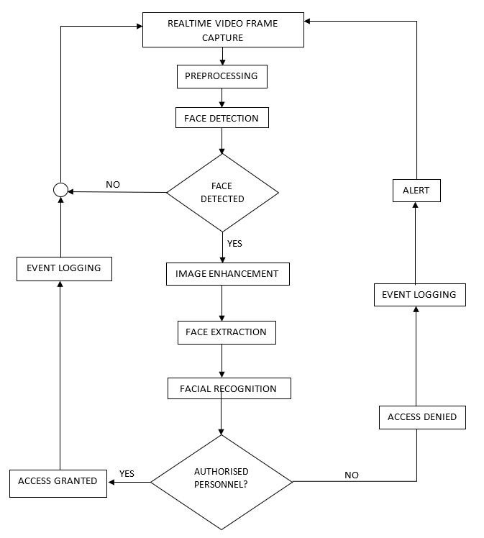
Fig. 3: Flowchart for real-time deep learning-based facial recognition access control system
2.2.1 Data Collection and Pre-processing
Images were gathered from sources such as online pictures, photographs and videos of the staff from X-hadlass service and divided into two main categories: authorized and unauthorized persons. For the authorized and unauthorized category, images for 20 individuals were used, with each individual having 50 images giving a total of 1,000 images. Additionally, 5 images representing potential intruders were collected in the dataset.
To generate new training image data in relation to the same image and improve generalization, data augmentation techniques such as rotation, horizontal, vertical, flip, width shift, height shift techniques are applied to the image recognition problems and the accuracy performance is improved (Yunus, et al., 2019). In this work, data augmentation was done by rotating (randomly by ±20 degrees) and flipping (horizontally and vertically) to simulate different viewing angles and to create mirror images that enhance the robustness of the dataset. Scaling was also done to adjust the images to different sizes by resizing and cropping the image by 224×224 section from the center of the original image. The data was normalized using the mean and standard deviation ([0.485, 0.456, 0.406], [0.229, 0.224, 0.225]) of the channels to normalize the image pixel values.
Some of the images used for image recognition are presented in Figures 4 and 5.

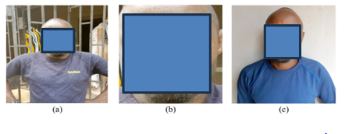
FIG 4. Personal AT FRP_04 (a) captured image (b) face extraction (c) database image

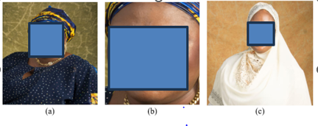
FIG 5. Personal AT FRP_04 (a) captured image (b) face extraction (c) database image

These images in part (a) of Figures 4 and 5 are the captured images of a person taken in a real-world environment and serve as the initial input to the face detection system similar to what is captured on a CCTV camera or other security camera. It is the raw input data that will be processed for the proceeding stages of authentication.
The second part (b) of Figures 4 and 5 show the face extraction performed by the system. At this stage, the facial region is isolated from the rest of the image. This involves detection, cropping, filtering and focusing on relevant facial features. This extracted face is then matched against database records.
The final part (c) of Figures 4 and 5 show the database image of the authorized person. This image is pre-stored in the database of the system and serves as the reference for identification. During the recognition process, the system compares the extracted face (from part b) with the database image (part c) to verify the individual’s identity. If a match is found, the system confirms the person as an authorized individual and allows access.
After pre-processing all the images to a standard dimension for consistency across the training dataset to enhance the performance and convergence rate of the machine learning model. The images were then annotated to indicate authorized and unauthorized persons and loaded in designated directories using
train_set = ImageFolder(root='output_train_faces', transform=transform)
valid_set = ImageFolder(root='output_valid_faces', transform=transform)
The “def count_samples_per_class(dataset)” function was used to count the number of images belonging to each class, while
print("train_data_size:", train_data_size)
print("valid_data_size:", valid_data_size)
was used to print the number of training and validation images. The DataLoader function was used to load batches of data efficiently and randomly change the images to generate a new image in each training epoch according to the range of the parameters which was set at 32 using the “batch_size=32”. The random ordering of images in each epoch was done using “shuffle=True”. Random cropping is applied (Takahashi, et al., 2019), the position of (x,y) points are random, and then the images are automatically cropped and resized to the target size using the 224x224 pixel dimension. Mapping Class Indices to Labels was implemented using
idx_to_class = {v: k for k, v in train_set.class_to_idx.items()}
print(idx_to_class);
2.2.2 Face Detection and Extraction
The step of face detection involves locating and identifying faces within images or video frames. The face detection system was implemented using multi-task cascaded convolutional networks (MTCNN) deep learning framework designed for face detection and facial landmark recognition (Zhang, et al., 2021). To check the presence of faces within the captured frames and to ensure that only images with faces are processed further, the cascaded structure of multi-task convolutional neural networks (CNNs) does the tasks of detecting faces in an image and identifying key facial landmarks like the eyes, nose, and mouth simultaneously. MTCNN consists of three stages of CNNs that progressively refine the results - P-Net that uses bounding boxes to generate candidate facial regions that might contain faces, along with rough estimates of facial landmarks like the nose, eyes and lips; the R-Net further refines the candidate facial regions from P-Net and improves the bounding box locations; thirdly, the O-Net, the final stage, further refines and produces the the final face detection and landmarks with high precision. This multi-task nature helps MTCNN achieve more robust and accurate detection, as facial landmark detection provides additional cues to the face detection process. MTCNN is effective across a wide range of face sizes, orientations, and lighting conditions, making it useful for real-world applications (Kumar, et al., 2023). The cascaded architecture allows it to reject non-face regions early in the pipeline, leading to efficient processing.
2.2.3 MobileNet
The MobileNet neural network architecture is integrable on mobile, embedded devices and systems where computational resources are limited for image classification and object detection. To reduce complexity, MobileNet breaks the standard convolution operation into two separate layers - depthwise convolution and pointwise convolution. MobileNet uses depthwise convolution and pointwise convolution (1x1 convolution). This reduces the computational load compared to traditional convolutional networks. The depthwise convolution applies a single filter to each input channel, while the pointwise convolution combines the outputs of the depthwise convolution through a 1x1 convolution (Mostafid, 2023). It also makes a trade-off of computational cost and memory usage over accuracy by using the width multiplier parameter to control the number of channels and the resolution multiplier parameter to control the input image resolution. It performs real-time spoof detection tasks with minimal computational and memory resources because of its lightweight and optimization for speed. The architecture of the MobileNet neural network is shown in Figure 6.
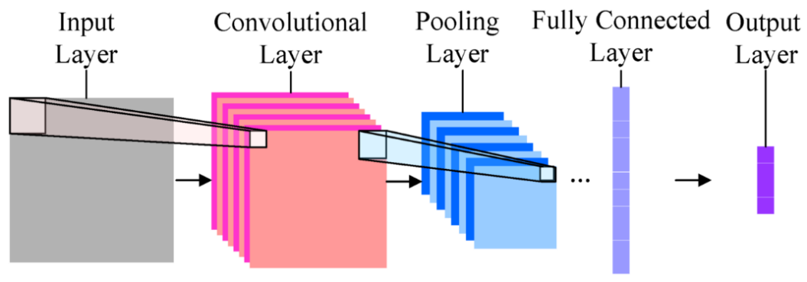
Figure 6: Facial Recognition MobileNet Architecture
Source: (Gupta, 2020)

In this work, the MobileNet-based facial recognition code uses transfer learning to classify faces into for facial recognition. It utilizes pre-trained MobileNet weights trained on the ImageNet dataset as the feature extractor and the base model layers were frozen to prevent Mobilenet from updating the layers during training and to avoid corrupting the pre-trained knowledge from ImageNet. The original classification layers were removed for custom layers to be added for classification. This approach of modifying classification layers proposed by (Song, et al., 2015) for over parameterized DNN algorithm models that exhibit significant redundancy involves removing model parameters and layers which do not contribute to the model performance and affect the accuracy to reduce computation cost. Other methods such as has been done through model compression (Choi, et al., 2020) (Schindler, et al., 2018), and quantization (Lin, et al., 2016) (Wang, et al., 2020) are notable approaches for optimization of DNN models.
The custom classification layer processes and learns new patterns from the extracted features and the Rectified Linear Unit (ReLU) activation function helps in preventing vanishing gradients and speeds up learning. In the final output layer, the face is classified into 20 categories with neurons equal to the number of people (20 classes). The softmax function ensures that the output is a probability distribution with a total probability of 1. The neuron with the highest probability represents the predicted class.
The model was compiled using the code
model = Model(inputs=base_model.input, outputs=predictions)
model.compile(optimizer=Adam(learning_rate=0.0001), loss='categorical_crossentropy', metrics=['accuracy']);

The model is defined with input from MobileNet and output from the new layers. The Adam optimizer was set with learning rate = 0.0001. “Categorical Crossentropy” Loss was used for the multi-class classification problem and the accuracy metric for tracking the performance.

Image augmentation for training and validation was done according to the pre-preprocessing presented in subsection 3.2.1 and the training data statistics used are class counts, dataset sizes, and class mappings. The training progress is documented as the loss and accuracy per epoch.
The validation accuracy is obtained after the training when the model accuracy on validation data is computed.
2.2.4 AlexNet
AlexNet architecture, shown in figure 7, is one of the earliest CNN architectures known for its breakthrough in large-scale image recognition. The AlexNet was chosen for its simplicity and due to its relatively large size is primarily used for classification tasks. With ReLU (Rectified Linear Unit) activation, AlexNet learns more complex patterns, speeds up the training process and features within a given data (Kumar, et al., 2023). It uses dropout layers to prevent overfitting by randomly setting a fraction of the input units to zero during training, and employs extensive data augmentation techniques like image translations, reflections, and patch extractions ensuring that the model generalizes better to new data. It also consists of multiple convolutional and pooling layers for proper feature extraction from images. The max-pooling feature allows for down-sampling, reducing spatial dimensions and enabling the extraction of the most important features.
This work trains an AlexNet-based facial recognition system using PyTorch, with data augmentation, transfer learning, and evaluation. The AlexNet model was initialized by loading it with pre-trained weights (ImageNet) using the function
alexnet = models.alexnet(pretrained=True);
All the layers were frozen to retain pre-trained features except for the final fully connected layer which was replaced to match the number of output classes (for instance, facial identities). The LogSoftmax layer was added for classification. The Adam Optimizer was used as an efficient weight update strategy.
optimizer = optim.Adam(alexnet.parameters();
At the training and validation stage, the training loop was done in multiple epochs (20 epochs) and the data forward-propagated through the model. The calculated loss was used to update weights by gradient descent and backpropagation while the training and validation losses and accuracy were calculated for feedback and analysis. This is useful for history tracking.

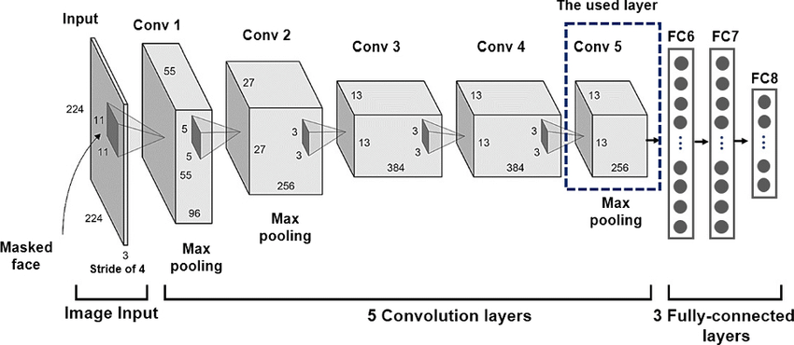
Figure 7: Facial Recognition AlexNet Architecture
Source: (Hariri, 2022)
2.5 Evaluation
Both MobileNet and AlexNet models were evaluated by introducing new images that were resized, normalized, and converted to a tensor. The models generate outputs for the input image, and the class with the highest probability is identified as the predicted class. The confidence is calculated using the softmax function.

3. results and discussion

After training the models on the collected dataset and fine-tuning their parameters to optimize performance, the accuracy, precision, recall, and F1-score metrics were used to assess the effectiveness of the models in facial recognition tasks. Together, these metrics provide a comprehensive evaluation of how well the models can distinguish between real and fake faces.
3.1 Test Results
Table 1 is structured into key performance metrics which present the results from the performance of the MobileNet and AlexNet facial recognition models evaluated on different test images. The ‘TEST IMAGE ID’ represents the identifier for the test face, ‘MODEL’ represents the model used for prediction - MobileNet or AlexNet, ‘FACIAL RECOGNITION’ represents the confidence score (probability) assigned to the predicted identity, ‘PREDICTED ID’ represents the identity predicted by the model, ‘PERSONNEL STATUS’ represents whether the individual is Authorized, Unauthorized, an Intruder, or an Imposter. The combination of these metrics was used to provide a holistic view of each models’ performance in real-world scenarios.
Table 1: Test Results for the Developed Deep Learning Models
TEST IMAGE ID | MODEL | FACIAL RECOGNITION | PREDICTED ID | PERSONNEL STATUS
AT_FRP_04 | MobileNet | 0.9828 | AT_FRP_04 | Authorized
AT_FRP_04 | AlexNet | 0.9998 | AT_FRP_04 | Authorized
AT_FRP_03 | MobileNet | 0.7990 | AT_FRP_03 | Authorized
AT_FRP_03 | AlexNet | 0.9752 | AT_FRP_03 | Authorized
AT_FRP_08 | MobileNet | 0.5845 | AT_FRP_08 | Unauthorized
AT_FRP_08 | AlexNet | 0.9537 | AT_FRP_08 | Unauthorized
AT_FRP_06 | MobileNet | 0.7460 | AT_FRP_06 | Unauthorized
AT_FRP_06 | AlexNet | 0.9145 | AT_FRP_06 | Unauthorized
- | MobileNet | 0.2393 | AT_FRP_19 | Intruder
- | AlexNet | 0.5439 | AT_FRP_19 | Intruder
- | MobileNet | 0.2654 | AT_FRP_14 | Intruder
- | AlexNet | 0.5537 | AT_FRP_01 | Intruder
AT_FRP_10 | MobileNet | - | - | Imposter
AT_FRP_10 | AlexNet | - | - | Imposter
AT_FRP_15 | MobileNet | - | - | Imposter
AT_FRP_15 | AlexNet | - | - | Imposter
Table 2 presents key performance metrics, precision, recall, F1-score, and accuracy for the MobileNet and AlexNet deep learning models, evaluated on facial recognition tasks.
Table 2: Performance Evaluation of Facial Recognition Deep Learning Models
MODEL | Precision | Recall | F1-Score | Accuracy
MobileNet | 0.85 | 0.83 | 0.83 | 0.83
AlexNet | 0.74 | 0.68 | 0.68 | 0.68
A confusion matrix was used to evaluate the performance of the deep learning models. It was used to show the actual and predicted classifications made by each model. Figure 8 and Figure 9 show the confusion matrix for Mobilenet and AlexNet face recognition models, respectively. It provides details of the models’ predictions by way of true positives, false positives, true negatives, and false negatives. The structure of the matrix is such that each row corresponds to the true class label (actual category of the data), each column represents the class predicted by the model, the numbers on the diagonal represent correctly classified samples (true positives) and numbers outside the diagonal (off-diagonal values) represent misclassifications, where the model predicted an incorrect class.
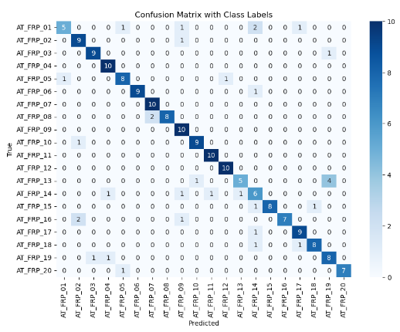
Figure 8: Confusion Matrix for MobileNet Model
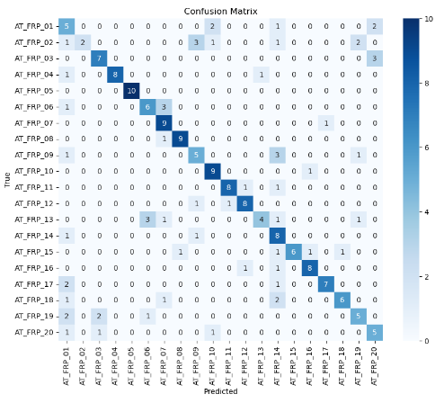
Figure 9: Confusion Matrix for AlexNet Model
3.2 Discussion
In Table 1, the two models evaluated were the MobileNet and AlexNet and they each demonstrated varying performances for each case.
Case 1: Both MobileNet and AlexNet correctly identified AT_FRP_04 and AT_FRP_03 as authorized personnel with high confidence scores. AlexNet consistently showed higher accuracy (99% and 97% respectively) than MobileNet (98% and 79% respectively).
Case 2: The images with the identifiers AT_FRP_08 and AT_FRP_06 were unauthorized individuals present in the system. Both models correctly identified the unauthorized personnel with different confidence scores. AlexNet performed better with significantly higher confidence scores 95% and 91% respectively than MobileNet. MobileNet had lower confidence scores of 58% for AT_FRP_08 and 74.6% for AT_FRP_06, meaning that it was less certain.
Case 3: The images AT_FRP_19 and AT_FRP_14 were not authorized personnel but were assigned a predicted identification. Both models predicted incorrect identities with low confidence scores less than 60%. AlexNet had higher confidence scores (54% & 55%) than MobileNet (23% & 26%), however both struggled with these cases. In this case, the intruders were incorrectly identified.
In the last case, for AT_FRP_10 and AT_FRP_15, no predictions were made ("-") because these individuals are not in the database. The models were unable to assign any identity, meaning they were not recognizable to the system and are completely unknown. Both models failed to classify them, indicating they were outside the dataset.
From Table 2, the models were also assessed based on their ability to recognize three categories of faces - authorized, unauthorized and intruders. MobileNet outperformed the other models with an accuracy of 83%, demonstrating its superior ability to correctly identify authorized individuals with less errors compared to the other two models.
The Precision score were MobileNet (0.85) and AlexNet (0.74). This shows that MobileNet made fewer false positives, indicating better precision in identifying faces correctly.
The Recall scores were MobileNet (0.83) and AlexNet (0.68). MobileNet clearly detected more actual faces from the dataset.
The F1-Score is a balance of precision and recall. With MobileNet (0.83) and AlexNet (0.68) MobileNet is better overall at facial recognition.
The Accuracy scores for MobileNet (0.83) and AlexNet (0.68) show that MobileNet has higher overall correctness, making it more reliable for real-world use.
Figure 8 and figure 9 show the confusion matrix results from the evaluation of MobileNet and AlexNet respectively.
For the MobileNet confusion matrix in figure 8, the diagonal entries show correct predictions such as Class AT_FRP_01 has 5 correct predictions, Class AT_FRP_10 has 10 correct predictions and Class AT_FRP_20 has 7 correct predictions.
Miscalculations can be seen from the off-diagonal non-zero values such as for AT_FRP_01 where the value “2” appears under AT_FRP_20 implying that two samples from class AT_FRP_01 were incorrectly classified as AT_FRP_20.
This MobileNet confusion matrix highlights that while the model has good performance for most classes like the AT_FRP_10, it struggles with some misclassifications. Also, larger off-diagonal values for some pairs indicate confusion between specific classes, potentially due to similarity in features. By calculation using True Positives (TP), False Positives (FP): and False Negatives (FN), the accuracy of 69%, and Class-wise Precision, Recall, and F1-Score for AT_FRP_01 are 100%, 71.4% and 83.3% respectively.
In a similar manner, for the AlexNet confusion matrix in figure 9 the diagonal entries show correct predictions such as class AT_FRP_01 has 5 correct predictions, class AT_FRP_04 has 10 correct predictions, class AT_FRP_10 has 10 correct predictions and class AT_FRP_20 has 7 correct predictions.
Miscalculations can be seen from the off-diagonal non-zero values such as for AT_FRP_01, 2 samples were misclassified as AT_FRP_20, for AT_FRP_09, 1 sample was misclassified as AT_FRP_13, as well as other misclassifications across other classes, as indicated by the non-zero off-diagonal entries.
3.3 Comparative analysis
Table 3 shows a comparative summary of the performances of the MobileNet and AlexNet deep learning models across different evaluation metrics.
Table 3. Comparison between MobileNet and AlexNet
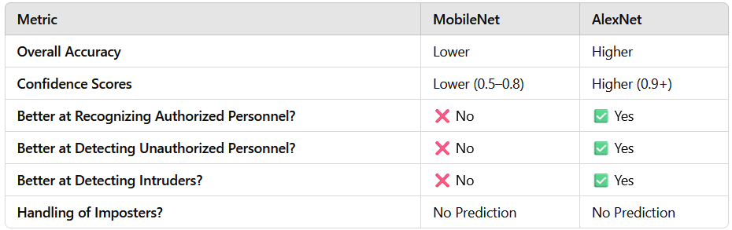
From the comparison made in Table 3 between MobileNet and AlexNet deep learning models, AlexNet is the more reliable model as it consistently yields higher confidence scores. MobileNet struggles with lower confidence, especially on unauthorized users and intruders. Both models failed to recognize imposters, indicating they need better handling for unseen faces.

4. Conclusion

The comparison of mobilenet and alexnet Deep Learning-Based Frameworks for Facial Recognition has been presented. The study evaluated and compared the performances of the MobileNet and AlexNet deep learning models for facial recognition tasks on customized dataset. Key metrics including confusion matrix, accuracy, precision, recall and F1-score metrics were used to evaluate the models. The experimental results obtained showed that AlexNet exhibited higher accuracy than the MobileNet model. In the confusion matrix, though AlexNet outperformed MobileNet in specific cases with higher confidence and precision for known identities, MobileNet still outperformed overall with higher accuracy, fewer false positives, and better balance across all evaluation metrics.

Overall, MobileNet is recommended for real-world facial recognition systems on resource-constrained devices where accuracy is a priority. AlexNet may be preferable in cases where slightly higher accuracy is required and computational resources are not a limitation.

Future work can explore other more varied datasets on the deep learning models. Also, a hybrid of the models can be developed and model compression techniques implemented and tested on customized datasets to evaluate the performance of both models alongside the hybrid.

COMPETING INTERESTS DISCLAIMER:
Authors have declared that they have no known competing financial interests OR non-financial interests OR personal relationships that could have appeared to influence the work reported in this paper.

References

Abdulrahman, S. & Alhayani, B., 2023. A comprehensive survey on the biometric systems based on physiological and behavioural characteristics.. Materials Today: Proceedings, Volume 80, pp. 2642-2646.
Aboukadri, S., Ouaddah, A. & Mezrioui, A., 2024. Machine learning in identity and access management systems: Survey and deep dive. Computers & Security, Volume 139, p. 103729.
Adjabi, I., Ouahabi, A., Benzaoui, A. & Taleb-Ahmed, A., 2020. Past, present, and future of face recognition: A review. 9(8), I 188.. Electronics, 9(8), p. 188.
Ahmed, S., Frikha, M., Hussein, T. & Rahebi, J., 2021. Optimum feature selection with particle swarm optimization to face recognition system using Gabor wavelet transform and deep learning.. BioMed Research International.
Binbeshr, F. et al., 2023. Secure pin-entry method using one-time pin (OTP). IEEE Access, Volume 11, pp. 18121-18133.
Cakir, D., Akay, S. & Arica, N., 2021. Deep learning approaches in face analysis.. In: Learning Control, Applications in Robotics and Complex Dynamical Systems. s.l.:Elsevier, pp. 103-145.
Cakir, D., Akay, S. & Arica, N., 2021. Deep learning approaches in face analysis.. In Learning Control, Elsevier., pp. 103-145.
Castillo Camacho, I. & Wang, K., 2021. A comprehensive review of deep-learning-based methods for image forensics.. Journal of imaging,, 7(4), p. 69.
Chaves, D. et al., 2020. Assessment and estimation of face detection performance based on deep learning for forensic applications.. Sensors, 20(16), p. 4491.
Chen, C., Zhao, X. & Stamm, M., 2018. MISLGAN: An anti-forensic camera model falsification framework using a generative. Athens, Greece, s.n.
Chen, C., Zhao, X. & Stamm, M., 2019. Generative adversarial attacks against deep-learning-based camera model identification.. IEEE Transactions on Information Forensics and Security, pp. 1-16.
Chigozie-Okwum, C. C., Michael, D. O. & Ugboaja, S. G., 2017. Computer forensics investigation; implications for improved cyber security in Nigeria.. AFRREV STECH: An Inter national Journal of Science and Technology, 5(1), pp. 59-73.
Choi, Y., El-Khamy, M. & Lee, J., 2020. Universal deep neural network compression.. IEEE Journal of Selected Topics in Signal Processing, , 14(4), pp. 715-726.
Deebak, B. & Fadi, A., 2021. Lightweight authentication for IoT/Cloud-based forensics in intelligent data computing.. Future generation computer systems, Volume 116, pp. 406-425..
Fu, X., 2021. Design of facial recognition system based on visual communication effect.. Computational Intelligence and Neuroscience.
G., A. L., Abana, A. B., Tonye, E. & Kabiena, Y., 2022. Facial recognition in the opening of door using deep learning and a cloud service. International journal of intelligent systems and Applications in Engineering, 10(3), pp. 40-45.
Galterio, M. G., Shavit, S. A. & Hayajneh, T., 2018. A review of facial biometrics security for smart devices.. Computers, 7(3), p. 37.
García-Gómez, M., Antonio-Cruz, M. & Castañeda-Miyamoto, A., 2021. A Review on Face Recognition-based Access Control Systems.. In 2021 IEEE International Autumn Meeting on Power, Electronics and Computing (ROPEC), Volume 5, pp. 1-11.
Goel, R., Mehmood, I. & Ugail, H., 2021. A study of deep learning-based face recognition models for sibling identification.. Sensors, 21(15), p. 5068..
Gudala, L., Reddy, A. K., Sadhu, A. K. R. & Venkataramanan, S., 2022. Leveraging Biometric Authentication and Blockchain Technology for Enhanced Security in Identity and Access Management Systems.. Journal of Artificial Intelligence Research, 2(2), pp. 21 - 50.
Gupta, S., 2020. Face Recognition with MobileNet Architecture using Transfer Learning. [Online]
Available at: https://www.linkedin.com/pulse/face-recognition-mobilenet-architecture-using-transfer-srishti-gupta
[Accessed 8 October 2024].
Hariri, W., 2022. Efficient masked face recognition method during the covid-19 pandemic. Signal, image and video processing, 16(3), pp. 605-612.
Howard, A. et al., 2017. MobileNets: Efficient Convolutional Neural Networks for Mobile Vision Applications. arXiv preprint arXiv:1704.04861, pp. 1-9.
Inc., T., 2019. Access Control Card Technology Guidance. , s.l.: National Safe Skies Alliance, lnc.
Iwok, U. U. et al., 2023. Evaluation of Machine Learning Algorithms using Combined Feature Extraction Techniques for Speaker Identification. Journal of Engineering Research and Reports, 25(6), pp. 197-216.
Kim, J., Poulose, A. & Han, D., 2021. The extensive usage of the facial image threshing machine for facial emotion recognition performance.. Sensors, 21(6), p. 2026.
Kortli, Y., Jridi, M., Al Falou, A. & Atri, M., 2020. Face recognition systems: A survey.. Sensors, 20(2), p. 342.
Kulkarni, U., Meena, S. M., Gurlahosur, S. V. & Bhogar, G., 2021. Quantization friendly mobilenet (qf-mobilenet) architecture for vision based applications on embedded platforms.. Neural Networks, Volume 136, pp. 28-39..
Kumar, K., Kasiviswanadham, Y., D.V.S.N.V., I. & Bhargavi, C., 2023. Criminal face identification system using deep learning algorithm multi-task cascade neural network (MTCNN).. Materials Today: Proceedings, Volume 80, pp. 2406-2410.
Lin, D., Talathi, S. & Annapureddy, S., 2016. Fixed point quantization of deep convolutional networks.. NY, USA, PMLR, pp. 2849-2858.
Liu, F., Liu, G., Zhao, Q. & Shen, L., 2020. Robust and high-security fingerprint recognition system using optical coherence tomography. Neurocomputing, Volume 402, pp. 14-28.
Mostafid, T., 2023. Overview of VGG16, ResNet50, Xception and MobileNet Neural Networks. [Online]
Available at: https://medium.com/@t.mostafid/overview-of-vgg16-xception-mobilenet-and-resnet50-neural-networks-c678e0c0ee85
[Accessed 8 October 2024].
Nagaraj, P., Banala, R. & Prasad, A., 2021. Real time face recognition using effective supervised machine learning algorithms.. Hyderabad, India, IOP Publishing, p. 012007.
Nerini, M., Favarelli, E. & Chiani, M., 2022. Augmented PIN authentication through behavioral biometrics.. Sensors, 22(13), p. 4857.
Pappachan, P., Adi, N. & Firmansyah, G., 2024. Deep Learning-Based Forensics. . In: Digital Forensics and Cyber Crime Investigation: Recent Advances and Future Directions. s.l.:CRC Press, p. 211.
Phiphiphatphaisit, S. & Surinta, O., 2020. Food image classification with improved MobileNet architecture and data augmentation. Cambridge, United Kingdom, Association for Computing Machinery, pp. 51-56.
Qiu, J. et al., 2020. A Survey on Access Control in the Age of Internet of Things. IEEE Internet of Things Journal, 7(6), pp. 4682-4696,.
Radzi, S. A. et al., 2020. loT-based facial recognition door access control home security system using1 Raspberry Pi. International Journal of Power Electronics and Drive Systems, Volume 1, p. 41.
Salim, F. et al., 2023. DenseNet-201 and Xception pre-trained deep learning models for fruit recognition.. Electronics, 12(14), p. 3132.
Schindler, G., Roth, W., Pernkopf, F. & Fröning, H., 2018. N-ary quantization for cnn model compression and inference acceleration..
Shen, T., Huang, Y. & Tong, Z., 2019. FaceBagNet: Bag-of-local-features model for multi-modal face anti-spoofing.. In Proceedings of the IEEE/CVF conference on computer vision and pattern recognition workshops, pp. 1611-1616.
Song, H., Mao, H. & Dally, W. J., 2015. Deep compression: Compressing deep neural networks with pruning, trained quantization and huffman coding. arXiv preprint arXiv:1510.00149.
Storey, G., 2019. Doctoral Thesis: Deep human face analysis and modelling.. Newcastle: University of Northumbria at Newcastle (United Kingdom).
Sujithra, J., Balaji, C. & Krishna, K., 2024. Aadhar Card Based Banking Security System To Protect Unauthorized Access.. Chennai, India , s.n., pp. 1-6.
Takahashi, R., Matsubara, T. & Uehara, K., 2019. Data Augmentation using Random Image Cropping and Patching for Deep CNNs. IEEE Transactions on Circuits and Systems for Video Technology, 30(9), pp. 2917-2931.
Wang, W. et al., 2020. A new image classification approach via improved MobileNet models with local receptive field expansion in shallow layers.. Computational Intelligence and Neuroscience, 2020(1), p. 8817849.
Yunus, R. et al., 2019. A Framework to Estimate the Nutritional Value of Food in Real Time Using Deep Learning Techniques.. IEEE Access, Volume 7, p. 2643–2652..
Zhang, L., Wang, H. & Chen, Z., 2021. A multi-task cascaded algorithm with optimized convolution neural network for face detection. Shenyang, China , s.n.

