Short Research Article

Scalable IoT-Based Smart Plant Monitoring and Control System for Sustainable Agriculture

.
ABSTRACT

Smart Plant Monitoring and Controlling Systems offer transformative potential for modern agriculture through IoT integration, real-time monitoring, and automation. This research presents a cost-effective system capable of tracking soil moisture, temperature, humidity, and pH levels, alongside visual plant health detection using an ESP32 Camera module. Automated control of water pumps and sprayers ensures efficient irrigation and nutrient delivery based on predefined thresholds, while a user-friendly Blynk IoT platform enables remote management and monitoring. Energy-efficient design and scalability make the system suitable for diverse agricultural applications, from small-scale farming to large operations. Detailed cost analysis confirms its affordability, enhancing accessibility for resource-constrained farmers. This system addresses critical challenges like water conservation and crop health management, promoting sustainable and precision agricultural practices, and offering a scalable solution for global agricultural advancements.

Keywords: Smart plant; Agriculture; Soil moisture; Sprayers; Microcontrollers, Esp 32 Camera, Blynk, Low-Cost.

1. INTRODUCTION
In an era characterized by rapid technological innovation, the integration of IoT-driven smart plant monitoring and controlling systems emerges as a transformative approach to reshaping agricultural practices and resource management [1]. These systems stand at the forefront of precision farming, bridging the gap between traditional methods and data-driven decision-making. With the mounting global challenges of climate change, resource scarcity, and the ever-growing demand for sustainable agriculture, the imperative for adopting intelligent, automated solutions has become more critical than ever [2]. Smart plant monitoring systems not only offer a pathway to optimize agricultural productivity but also serve as a beacon of sustainable resource utilization and environmental stewardship. The 21st century has witnessed an unprecedented fusion of agriculture with advanced technologies such as IoT, automation, and sensor networks. These innovations enable real-time monitoring of crucial environmental parameters, including soil moisture, temperature, humidity, pH levels, and light intensity, which are vital for plant health and growth [3]. Unlike traditional farming practices that often rely on manual and inconsistent measurements, these systems provide accurate, continuous, and automated data collection. The seamless integration of these technologies empowers farmers to remotely monitor their fields, automate processes like irrigation and nutrient delivery, and make informed decisions that enhance crop yields while conserving water and energy, IoT technology, in particular, has revolutionized modern agriculture by connecting sensors, actuators, and communication modules into intelligent networks [4]. These systems leverage platforms like Blynk and Thing Speak to deliver actionable insights through user-friendly dashboards accessible from anywhere via smartphones or computers. By enabling real-time remote monitoring and control, IoT solutions extend their reach beyond traditional farm boundaries, allowing for greater operational flexibility and scalability [5]. Such advancements have made smart plant systems increasingly relevant for diverse applications, ranging from urban gardening to large-scale agricultural enterprises, thus democratizing access to precision farming technologies. At the core of these systems lies the deployment of advanced sensors capable of capturing critical environmental data with precision. Soil moisture sensors play a pivotal role in optimizing irrigation by ensuring plants receive adequate hydration without water wastage. Similarly, temperature and humidity sensors maintain an ideal growing environment, while pH sensors provide insights into soil chemistry essential for nutrient absorption. Recent developments in sensor technology have not only enhanced their accuracy and reliability but also reduced costs, making them accessible to a broader demographic of farmers [6]. Complementing these sensors, camera modules such as ESP32 add a visual dimension to monitoring by providing real-time images and video feeds that detect diseases, pests, and anomalies, thus enabling early intervention. Automation serves as the operational backbone of these systems, converting real-time sensor data into actionable processes. For instance, automated irrigation systems activate water pumps based on soil moisture readings, ensuring optimal water use while eliminating manual oversight. Similarly, automated sprayers deliver precise amounts of nutrients or pesticides, reducing resource wastage and environmental impact. Microcontroller-based systems like Arduino and Node MCU orchestrate these components, seamlessly integrating sensor inputs and actuator outputs to execute processes with precision and consistency [7]. These advancements minimize labor-intensive tasks, enhance efficiency, and allow farmers to focus on other critical aspects of crop management. Despite the transformative potential of these systems, challenges persist in achieving widespread adoption. The high initial costs of smart systems, the technical expertise required for their deployment and maintenance, and limited infrastructure in rural areas pose significant barriers. Additionally, integrating cutting-edge technologies like machine learning and predictive analytics into these systems remains an underexplored frontier. Such capabilities could enable the analysis of historical data, trend prediction, and real-time optimization of farming practices, further enhancing their impact. Addressing these challenges requires an interdisciplinary approach that combines technological advancements, policy interventions, and educational initiatives to ensure accessibility and scalability [8].
In this research, explores the development and implementation of a cost-effective, IoT-driven smart plant monitoring and controlling system tailored to address these challenges. By leveraging readily available sensors, automation tools, and IoT platforms, this research aims to demonstrate the potential of such systems in improving agricultural efficiency, reducing resource wastage, and promoting sustainable practices. Ultimately, these systems serve as a vital step toward transforming agriculture into a more intelligent, resilient, and environmentally conscious industry.
2. LITERATURE REVIEW

The field of smart plant monitoring and controlling systems has undergone extensive research and development, laying the groundwork for advanced investigations. The convergence of IoT, sensor technology, and automation has revolutionized agricultural practices, transitioning from traditional methods to precision farming, which emphasizes sustainable resource utilization and data-driven decision-making [9]. These systems have proven instrumental in addressing critical challenges in agriculture, including inefficient resource use, high labor demands, and the adverse impacts of climate change. Researchers have examined diverse aspects of these systems, such as the deployment of sensors, integration of IoT platforms, automation, and remote monitoring, providing valuable insights into their design, implementation, and application. The incorporation of IoT technology has been a pivotal advancement in agriculture, enabling real-time data collection, remote monitoring, and control of farming operations [10]. IoT-based systems utilize sensors and actuators interconnected through the internet to monitor environmental parameters critical for plant health, such as soil moisture, temperature, humidity, and pH levels. Platforms like Blynk and Thing Speak have been extensively studied for their ability to provide user-friendly interfaces for remote monitoring and control. Researchers have highlighted the scalability and flexibility of IoT systems, which are applicable across various agricultural contexts, from small-scale home gardens to large commercial farms [11]. These platforms facilitate seamless data transmission and allow users to optimize irrigation, monitor crop health, and adjust environmental conditions, thereby improving operational efficiency and productivity. Sensor technology forms the backbone of smart plant monitoring systems by providing accurate and continuous measurements of critical environmental factors. Soil moisture sensors are extensively utilized for optimizing irrigation practices, ensuring efficient water use and preventing under- or over-watering [12]. Temperature and humidity sensors, such as the widely used DHT-11, play a crucial role in maintaining favorable environmental conditions for plant growth, while pH sensors provide insights into soil chemistry to support proper nutrient absorption. Studies emphasize the reliability, accuracy, and cost-effectiveness of these sensors, making them integral components of automated agricultural systems. Recent advancements have enhanced the precision and adaptability of sensors, enabling their deployment in diverse agricultural settings and improving the overall efficacy of smart systems. Automation has emerged as a transformative aspect of modern agriculture, reducing dependence on manual labor and ensuring consistent operational outcomes [13]. Automated irrigation systems, which activate water pumps based on real-time soil moisture readings, have been extensively researched for their ability to conserve water and promote healthy plant growth. Similarly, automated sprayers have been developed to precisely distribute water, nutrients, or pesticides, minimizing resource wastage and reducing environmental impact [14]. Arduino-based systems, in particular, have been highly effective in integrating sensors and actuators to automate critical farming processes. Research by demonstrated that such systems significantly improve resource utilization and enhance crop yields, underscoring their importance in modern agricultural practices [15]. The integration of visual monitoring into smart agricultural systems represents a significant innovation, allowing for comprehensive plant health assessments. Camera modules, such as the ESP32, have been incorporated to collect real-time visual data, which complement sensor readings and provides a holistic view of plant growth [16]. Studies have explored the use of visual monitoring for early detection of diseases, pests, and other anomalies, enabling timely interventions. For instance, developed a system combining visual monitoring with environmental sensors to enhance decision-making and crop management [17]. Additionally, the application of image processing techniques to analyze plant growth patterns has provided deeper insights, further improving the effectiveness of these systems’ platforms have been instrumental in scaling smart plant monitoring systems, offering real-time data visualization and remote-control capabilities [18]. Platforms like Blynk and Thing Speak enable users to monitor environmental parameters, control actuators, and receive alerts through smartphones or computers, significantly enhancing usability and accessibility. These platforms have demonstrated their scalability, adaptability, and applicability to various agricultural scenarios [19]. For example, implemented a Blynk-based system that effectively managed irrigation and nutrient delivery, showcasing its potential for widespread adoption in agriculture. Despite significant progress, several challenges hinder the widespread adoption of smart agricultural systems. High initial costs, limited access to reliable communication networks in rural areas, and the need for technical expertise remain significant barriers, particularly for small-scale and resource-constrained farmers [20]. Furthermore, the integration of advanced technologies such as machine learning and data analytics is still in its nascent stages. These technologies offer immense potential for enhancing decision-making by analyzing historical data, predicting trends, and generating actionable insights. Researchers emphasize the need for developing affordable, user-friendly systems to make smart agricultural technology more accessible and impactful. The literature highlights the transformative potential of smart plant monitoring and controlling systems in modern agriculture [21]. The integration of IoT, sensor technology, automation, and visual monitoring has significantly enhanced the efficiency, sustainability, and precision of farming practices [22]. These systems not only optimize resource utilization and reduce labor requirements but also promote sustainable agricultural practices, making them invaluable tools for addressing the challenges of traditional farming. However, further research and innovation are required to overcome existing barriers and fully realize the potential of these technologies. This study builds on the existing body of knowledge to design and evaluate a comprehensive smart plant monitoring and controlling system, contributing to the advancement of sustainable and precision agriculture.
3. Methodology
The smart plant monitoring and controlling system leverages IoT and automation technologies to efficiently monitor and manage plant growth conditions. This system employs various sensors, including soil moisture sensors, DHT-11 temperature and humidity sensors, pH sensors, and an ESP32 camera, to gather environmental data in real-time. These inputs are processed through an Arduino UNO microcontroller, which acts as the central hub for data processing and decision-making. The data collected from sensors is displayed on an LCD screen for local monitoring. When specific thresholds are met, such as low soil moisture or extreme temperature variations, the system triggers automated responses. For instance, the water pump is activated to irrigate plants when soil moisture levels fall below a pre-defined value. Similarly, a sprayer disperses water, nutrients, or pesticides when required. The integration with the Blynk IoT server enables remote access, allowing users to monitor environmental conditions and control system operations from their smartphones or other connected devices. This system also incorporates an ESP32 camera module for visual monitoring, providing a comprehensive view of plant health and enabling early detection of issues such as pest infestations or diseases. The combination of automated controls, real-time visualization, and IoT connectivity ensures efficient plant management, resource conservation, and reduced manual intervention. The operational flow and the integration of components within the system are illustrated in the block diagram, as seen in Fig. 1.
3.1 Block Diagram
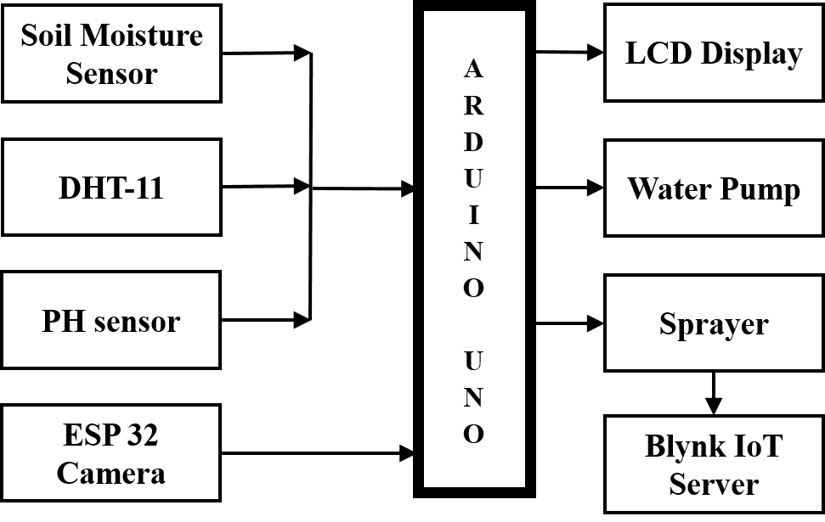

Fig. 1. Block diagram of the proposed work.
3.2 Algorithm of The System

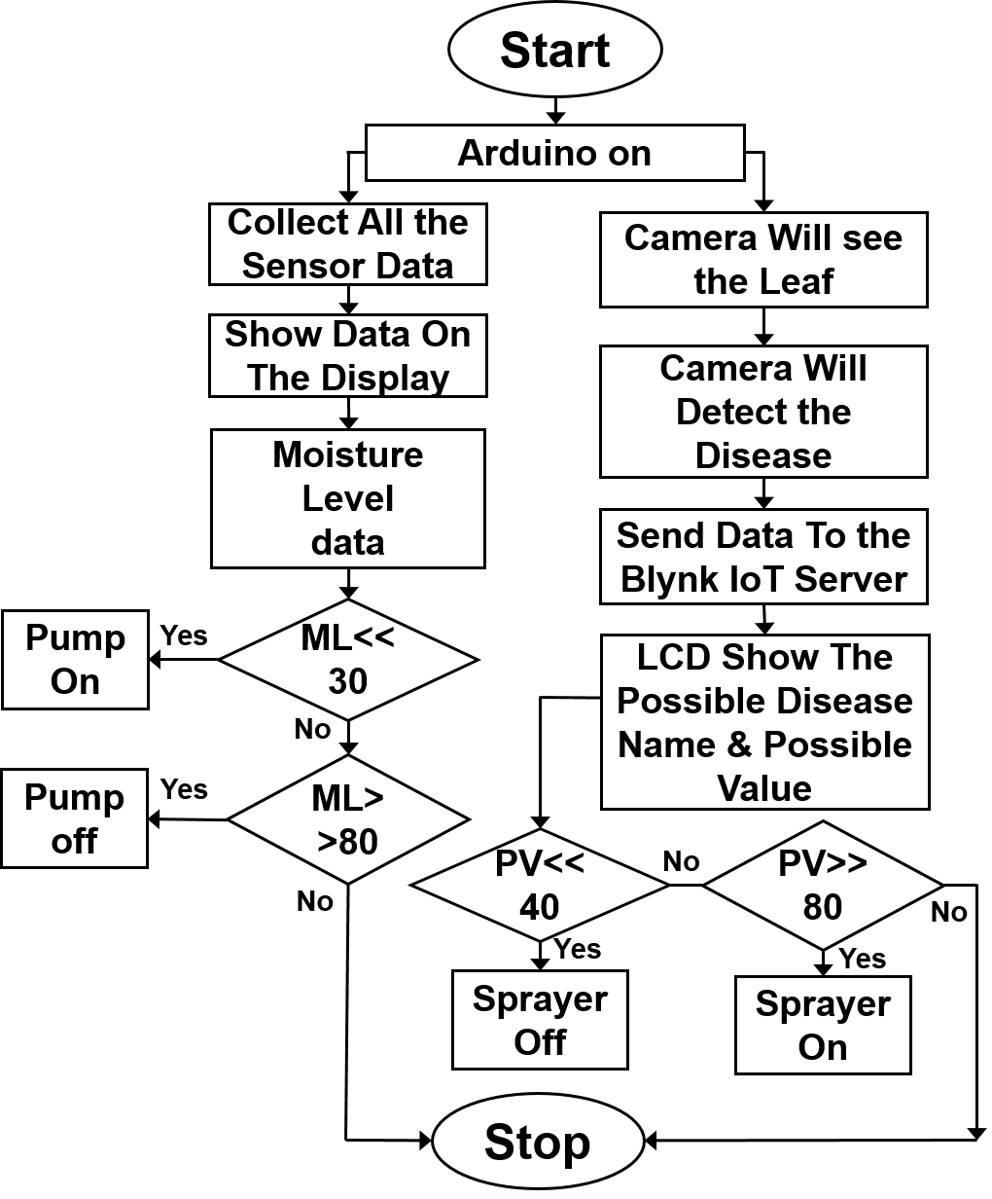
Fig. 2. Flowchart of the proposed work
The flowchart depicted in Fig. 2, outlines the operational process of the proposed Smart Plant Monitoring and Controlling System. The system begins with the initialization phase, where the Arduino UNO microcontroller sets up all connected components, including sensors (soil moisture, temperature and humidity via DHT-11, pH sensor, and ESP32 camera) and actuators (water pump and sprayer). During this phase, predefined threshold values for critical parameters such as soil moisture, temperature, and pH levels are loaded into the system for subsequent decision-making. Once initialized, the system transitions into continuous monitoring mode, where sensors gather real-time environmental data. The soil moisture sensor measures the water content in the soil, the DHT-11 sensor records ambient temperature and humidity, and the pH sensor evaluates soil acidity or alkalinity. Simultaneously, the ESP32 camera captures visual data to detect potential plant health issues such as pest infestations or diseases. The collected data is processed by the microcontroller, which compares the readings against the predefined threshold values. If any parameter exceeds or falls below the acceptable range, the system executes appropriate corrective actions. For instance, if soil moisture falls below the threshold, the water pump is activated to irrigate the plants. Similarly, if the pH level is outside the desired range, corrective measures such as nutrient adjustment or lime application are recommended or executed. The ESP32 camera complements this process by identifying visual anomalies, prompting notifications or alerts to the user for further intervention. Processed data is displayed on an LCD screen for on-site monitoring and is simultaneously transmitted to the Blynk IoT platform, enabling remote access through smartphones or other connected devices. Alerts are sent to notify users of critical conditions, facilitating timely responses and efficient resource management. The system operates in a continuous feedback loop, ensuring dynamic adjustment to changing environmental conditions. Once the corrective actions are completed and parameters return to their
.
optimal ranges, the system resumes real-time monitoring. This iterative process ensures that plant care is maintained efficiently, resources are conserved, and potential issues are addressed promptly. The operation concludes when monitoring is no longer required or when no further deviations are detected, demonstrating the system’s reliability and adaptability in diverse agricultural applications.

3.3 Working Principle
The Smart Plant Monitoring and Controlling System integrates multiple sensors, actuators, and IoT technology to automate the monitoring and management of plant health. The system comprises sensors that collect real-time environmental data essential for plant growth and health. These include a soil moisture sensor, which measures the water content in the soil to ensure adequate hydration levels, and a DHT-11 sensor, which records ambient temperature and humidity to maintain an optimal growing environment. The pH sensor evaluates the acidity or alkalinity of the soil, which is crucial for nutrient availability, while the ESP32 camera captures visual data for assessing plant health, including detecting pests, diseases, or growth abnormalities. The data collected by these sensors is transmitted to the Arduino UNO microcontroller, which acts as the system's central processing unit. The microcontroller processes the sensor data and compares it against predefined threshold values programmed during the initialization phase. For example, if the soil moisture level falls below the threshold, the Arduino triggers the water pump to irrigate the plants until the desired moisture level is restored. Similarly, if the pH sensor detects unfavorable soil conditions, corrective actions, such as nutrient adjustments, can be initiated manually or automatically. The ESP32 camera provides an added layer of monitoring by capturing real-time images of the plants. This visual data helps in identifying anomalies such as discoloration of leaves, pest infestations, or growth inconsistencies. The system can send alerts to the user via the Blynk IoT platform if visual or sensor-based anomalies are detected, enabling timely intervention. The system also integrates output components, including an LCD display and the Blynk IoT server. The LCD display provides on-site real-time feedback, displaying sensor readings such as soil moisture percentage, temperature, and pH levels. Simultaneously, the data is transmitted to the Blynk IoT server, enabling users to monitor and control the system remotely through a smartphone or web interface. This remote access capability ensures users can intervene, even from a distance, if critical conditions arise. Automation is a core feature of the system. For instance, if environmental parameters like temperature and humidity deviate from acceptable ranges, the system can activate the sprayer to adjust conditions. Similarly, visual anomalies identified by the ESP32 camera can trigger alerts, prompting manual or automated actions to mitigate potential risks. The Arduino UNO microcontroller is programmable and plays a pivotal role in processing sensor data and executing automated actions. It continuously analyzes environmental data to identify critical conditions, such as extreme soil dryness or adverse pH levels, and initiates the appropriate response. The microcontroller ensures the system operates in a feedback loop, maintaining optimal plant health and resource utilization by adjusting actions based on real-time data. This system operates continuously to ensure dynamic monitoring and proactive management of plant conditions. The seamless integration of sensors, actuators, and IoT connectivity makes it an efficient and scalable solution for precision agriculture. The ability to identify anomalies, automate corrective actions, and provide remote monitoring capabilities ensures its suitability for diverse agricultural applications, from home gardening to commercial farming. By automating resource-intensive tasks, this system not only reduces labor but also promotes sustainable farming practices and optimal plant health.

4. IMPLEMENTATION
In implementing the Smart Plant Monitoring and Controlling System, a comprehensive approach was undertaken that encompassed both simulation and hardware validation to ensure the system's efficacy and reliability. The simulation phase utilized tools like PROTEUS and Arduino IDE to emulate the integration of key components such as the soil moisture sensor, DHT-11 sensor, pH sensor, ESP32 camera, water pump, sprayer, and LCD display. This simulation framework provided a controlled environment to test the interconnected components and identify potential issues before transitioning to physical deployment. During the simulation, the system was configured to collect and process environmental data from the sensors, such as soil moisture levels, temperature, humidity, and pH values. These readings were visually represented on an LCD screen, replicating the real-time monitoring feature of the hardware implementation. The simulation also demonstrated the automation capabilities of the system, such as activating the water pump when the soil moisture fell below a predefined threshold or sending alerts when the pH sensor detected abnormal soil conditions. These tests ensured the accuracy and functionality of the algorithm used for decision-making and control actions. The integration of the ESP32 camera in the simulation allowed the system to incorporate visual monitoring, providing a simulated real-time feed to detect potential plant health issues, such as pest infestations or wilting. Additionally, the IoT functionality of the system was validated by connecting the simulated setup to the Blynk IoT platform, enabling remote monitoring and control through a smartphone or web interface. Alerts were successfully triggered within the simulation, confirming the capability of the system to notify users of critical conditions in a timely manner. Following the simulation phase, the physical implementation of the system was carried out using the Arduino UNO microcontroller as the central processing unit. All sensors and actuators were connected to the Arduino, and the system was programmed to operate in a real-world agricultural environment. The hardware setup included the deployment of sensors in a controlled field environment to monitor soil and atmospheric conditions. The data collected from the sensors was displayed on the LCD screen and simultaneously transmitted to the Blynk IoT platform, allowing for seamless local and remote monitoring. The automation features were validated in the hardware phase, demonstrating the system's ability to autonomously activate the water pump or sprayer based on real-time sensor data. For instance, when the soil moisture dropped below the threshold, the pump was triggered to irrigate the plants, and the system automatically stopped the pump once the desired moisture level was achieved. Similarly, the sprayer was tested to dispense nutrients or pesticides when required. The ESP32 camera captured images and videos of the plants, providing visual insights into plant health and detecting anomalies, which were cross verified with sensor data. This dual-phase approach, integrating simulation and hardware validation, was instrumental in ensuring the robustness and practicality of the system. The simulation phase allowed for iterative improvements in the algorithm and system design, while the hardware implementation demonstrated the real-world applicability and efficiency of the system. This methodical implementation strategy highlights the system's potential to revolutionize agricultural practices by providing an automated, IoT-driven solution for precision farming and sustainable resource management.
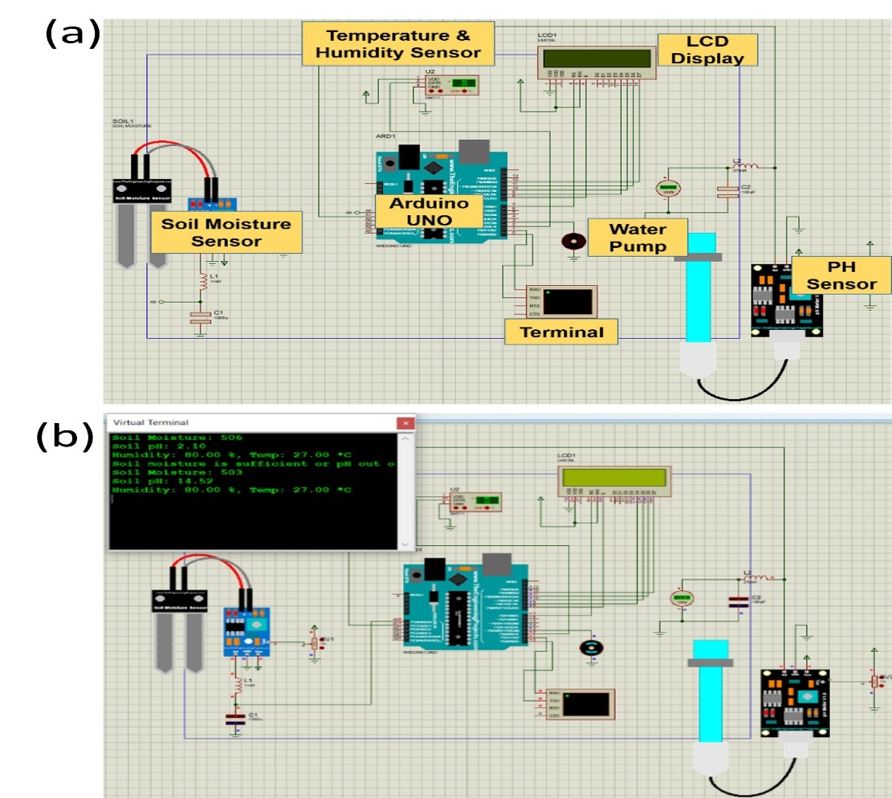
Fig. 3. (a) Simulation of the smart plant monitoring and controlling system showcasing the integration of soil moisture, temperature, humidity, and pH sensors, along with the LCD display and water pump, (b) Simulation results presenting real-time environmental data and system outputs on the virtual terminal.
The proposed Smart Plant Monitoring and Controlling System was designed and implemented using a combination of simulation and hardware validation approaches. The simulation phase, carried out using PROTEUS and Arduino IDE, modeled the key components, including the soil moisture sensor, DHT-11 temperature and humidity sensor, pH sensor, water pump, and LCD display, as depicted in Fig. 3(a), This simulation served as a foundational tool to evaluate the system’s functionality, reliability, and interaction among components, enabling the identification and resolution of potential challenges before transitioning to the physical implementation phase. In the simulation environment, the soil moisture sensor continuously monitored the water content in the soil, while the DHT-11 sensor recorded temperature and humidity data. The pH sensor provided real-time feedback on the soil's acidity or alkalinity levels. These data points were processed by the Arduino UNO microcontroller and displayed on an LCD screen for on-site monitoring. The system also demonstrated automation by activating the water pump when soil moisture fell below a predefined threshold, ensuring efficient irrigation. The virtual terminal, as shown in Fig. 3(b), further validated the real-time functionality of the system, presenting soil moisture, temperature, humidity, and pH readings in a clear and concise format. This step provided a comprehensive overview of environmental conditions and allowed for continuous data logging and anomaly detection. Once validated in the simulation phase, the system was implemented in hardware to test its real-world applicability. The hardware setup utilized the same components, integrated with the Arduino UNO microcontroller as the core processing unit. Sensors were deployed to monitor soil and environmental conditions, while the water pump was connected to automate irrigation. Data collected from the sensors was displayed in real-time on the LCD and simultaneously transmitted to the Blynk IoT platform. This IoT integration enabled remote monitoring and control of the system through a smartphone or web interface, extending its accessibility and usability for users. The ESP32 camera module was integrated to provide visual monitoring, allowing for the detection of plant health issues, such as pest infestations or discoloration of leaves. This visual data, combined with sensor readings, enabled timely intervention for maintaining optimal plant conditions. Additionally, the system's automation capabilities were further tested in the hardware phase, demonstrating its ability to autonomously respond to environmental changes and alert users to critical conditions via the IoT platform. Fig. 3(a) and 3(b) highlight the operational flow and interconnected components of the system. Fig. 3(a) illustrates the simulated design, detailing the integration of sensors, actuators, and the Arduino UNO, while Fig. 3(b) showcases the system's real-time data logging and operational feedback via the virtual terminal. The comprehensive approach of simulation followed by hardware validation ensured the system's robustness, scalability, and practical applicability. In Fig. 3(b), the final implementation model for the simulation circuit is shown. In this case, every sensor has been utilized, including the Arduino UNO, DHT-11 temperature sensor, OLED display, resistors, soil moisture sensor, water pump, and pH sensor. These components are integrated with a virtual terminal to display the sensor readings. The simulation demonstrates a range of sensor outputs, including an 80% humidity level and a 27°C air temperature. The water pump operates dynamically based on the moisture content of the soil. A threshold value of 400 was used in the simulation, such that the water pump is activated when the moisture reading falls below this value and deactivated once the desired level is restored. The pH sensor provides critical feedback to notify farmers about the soil's grade level, ensuring optimal conditions for plant growth. This iterative development process not only enhanced the system's credibility but also underscored its potential for real-world agricultural applications. The combination of automated monitoring, IoT connectivity, and resource efficiency makes this system a promising solution for precision farming, addressing critical challenges such as water conservation, soil management, and sustainable agricultural practices.
5. RESULTS AND DISCUSSION

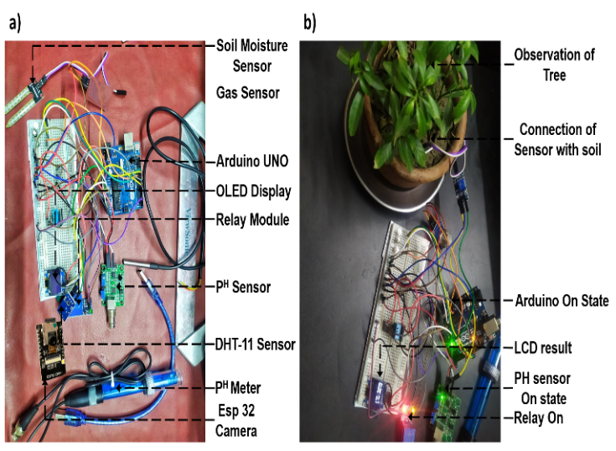
The performance of the Smart Plant Monitoring and Controlling System was rigorously evaluated through both simulation and hardware implementation phases. This comprehensive analysis validated the system’s functionality, reliability, and applicability in real-world agricultural scenarios. The results demonstrated the system's effectiveness in monitoring critical environmental parameters, automating irrigation, and providing actionable insights through IoT integration. The simulation phase served as a critical step to evaluating the system’s core functionality and component interactions.

Fig. 4. (a) Simulation of the smart plant monitoring and controlling system illustrating the integration of soil moisture, temperature, humidity, and pH sensors with automated irrigation and real-time OLED data display, (b) Virtual terminal showcasing live sensor readings and system responses, including automated water pump activation and dynamic feedback for efficient resource management.

In Fig. 4(a) and Fig. 4(b), the simulation successfully replicated real-world conditions, enabling detailed testing of soil moisture, temperature, humidity, and pH monitoring. The soil moisture sensor efficiently tracked water content in the soil, dynamically triggering the water pump when moisture levels fell below the predefined threshold of 400. This automation highlighted the system's capability to optimize water usage by irrigating only when necessary. The DHT-11 sensor accurately recorded environmental parameters such as 27°C air temperature and 80% humidity, which were displayed in real-time on the OLED and the virtual terminal. The pH sensor provided continuous feedback on soil acidity and alkalinity levels, allowing the simulation to showcase how the system ensures optimal soil health. The virtual terminal outputs further validated the system’s accuracy by presenting real-time data in a structured and user-friendly format, enabling anomaly detection and consistent data logging. The simulation results demonstrated not only the seamless integration of sensors with the Arduino UNO microcontroller but also the system's ability to automate essential tasks. The automated activation and deactivation of the water pump, based on soil moisture levels, ensured efficient irrigation. This phase provided valuable insights into the system’s design, allowing iterative refinements before transitioning to hardware implementation. Building on the simulation, the hardware implementation phase tested the system’s performance in a live environment. All components, including the Arduino UNO, DHT-11 sensor, soil moisture sensor, pH sensor, ESP32 camera module, water pump, and OLED display, were successfully integrated into the physical setup. The sensors accurately monitored environmental conditions, while the OLED display provided immediate on-site feedback with real-time data. The IoT integration through the Blynk platform extended the system’s accessibility and usability. Real-time sensor data, such as soil moisture, temperature, humidity, and pH levels, was transmitted to the IoT platform, allowing users to monitor environmental conditions and control the water pump remotely via a smartphone or web interface. This feature demonstrated the system’s scalability and applicability in remote farming scenarios. The ESP32 camera module enhanced monitoring capabilities by providing visual data, enabling users to assess plant health conditions such as pest infestations, discoloration, or growth abnormalities. The combination of visual monitoring and sensor data ensured comprehensive environmental oversight, allowing timely interventions to maintain optimal plant health. The system’s automation capabilities were thoroughly tested in both phases. The water pump dynamically responded to real-time soil moisture levels, activating automatically when readings dropped below the threshold of 400 and deactivating when sufficient moisture was restored. This precise control ensured water efficiency and eliminated the risk of over-irrigation. Similarly, the pH sensor continuously monitored soil conditions, generating notifications through the IoT platform whenever the soil's acidity or alkalinity deviated from optimal levels. The DHT-11 sensor consistently recorded temperature and humidity, providing vital insights into the plant's growing environment. These readings were cross validated between the OLED display, virtual terminal, and Blynk platform, ensuring 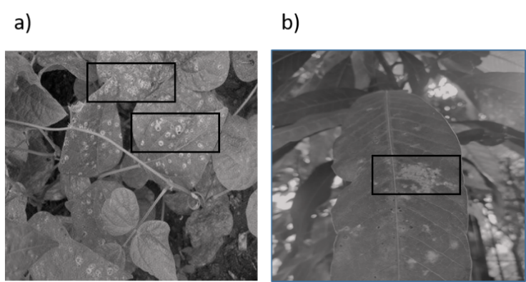the system’s accuracy and reliability.

Fig. 5. (a) Detection of disease on bean leaves, highlighting visible fungal infections and pest damage through irregular patterns and spots, (b) Identification of disease on mango leaves, showcasing discoloration and localized damage indicative of potential nutrient deficiencies or infections.

In Fig. 5(a) and Fig. 5(b), the visual monitoring capabilities of the proposed system were successfully demonstrated through the identification and analysis of plant health issues. The ESP32 camera module captured high-resolution images of leaves, enabling the detection of abnormalities such as discoloration, spots, and patterns associated with diseases or pest infestations. In Fig. 5(a), the highlighted areas on the leaves show irregular patterns, which are indicative of early-stage fungal infections or pest damage. This early detection allows farmers to take timely corrective actions, such as applying pesticides or adjusting irrigation and nutrient levels, preventing further spread and ensuring healthier crop outcomes. In Fig. 5(b), localized discoloration and spotting are visible on a leaf, as highlighted in the marked area. These symptoms could indicate nutrient deficiencies, environmental stress, or the onset of disease. The images provide precise visual evidence of affected areas, enabling farmers to diagnose and address specific issues with accuracy. The integration of visual monitoring with sensor data enhances the system’s ability to provide comprehensive plant health diagnostics. While environmental sensors measure factors such as soil moisture, pH, and temperature, the ESP32 camera complements these readings by identifying visual signs of plant distress that might otherwise go undetected. Building on these capabilities, Fig. 5 (a), demonstrates how the proposed system can advance to include disease identification using machine learning. The diseased leaf in Fig. 5(b), was photographed to illustrate how the system could analyze affected areas and identify potential diseases. The camera captures real-time images, which are processed through a machine learning algorithm trained on a database of pre-annotated images featuring various diseases, pest damage, and color patterns. Based on the analysis, the system associates the captured image with a potential disease and displays the diagnosis on the Blynk IoT server. This feature not only identifies the disease but also provides real-time feedback to the farmer, enabling informed decision-making and precise interventions. The system’s combined use of real-time sensor data, IoT connectivity, and machine learning-based image processing ensures a holistic approach to plant health management. The ESP32 camera module, alongside environmental sensors such as the soil moisture sensor and pH sensor, provides a dual-layered monitoring system. This combination allows for the detection of both environmental and biological stressors, ensuring proactive measures can be taken before the issues escalate. The capability demonstrated in Fig. 5(a) and Fig. 5(b), underscores the system’s practical applicability and scalability. By incorporating machine learning into its visual monitoring framework, the system bridges the gap between traditional agricultural practices and modern precision farming techniques. This comprehensive approach not only reduces crop losses but also optimizes resource usage, supporting sustainable and data-driven agricultural practices.
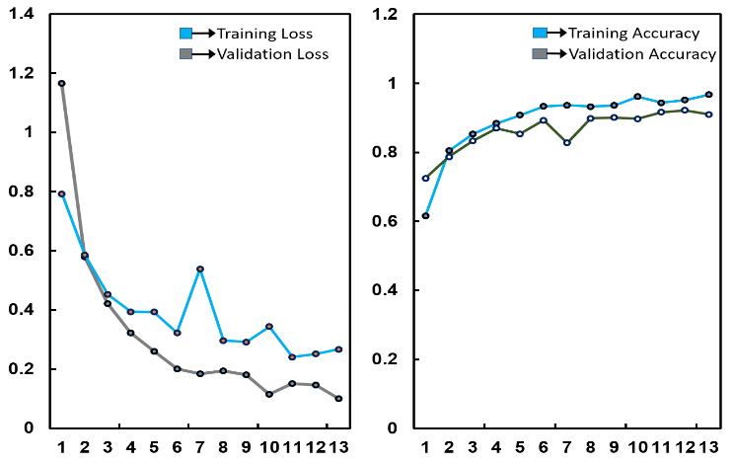
Fig. 6. (a) Training and validation loss curves for the leaf disease detection system, illustrating the model's learning efficiency and convergence over successive epochs, (b) Training and validation accuracy trends, demonstrating the system's reliability and effectiveness in accurately identifying plant diseases under varying conditions.

In Fig. 6(a) and Fig. 6(b), the training and validation performance of the leaf disease detection system highlights its effectiveness in identifying plant diseases using machine learning algorithms. The system was trained on a dataset comprising images of twenty distinct plant diseases, leveraging the integration of a cost-effective 2 MP camera. Despite the lower resolution of the camera, the system demonstrated promising performance, with observable trends in both training and validation loss, as well as accuracy. In Fig. 6(a), the training and validation loss curves show an initial steep decline, reflecting the model's ability to learn patterns and features from the dataset during early epochs. As training progressed, the loss values began to stabilize, indicating that the model reached a point of convergence. Some fluctuations in validation loss were observed, primarily due to the resolution constraints of the 2 MP camera, which introduced noise and variability in the captured images. However, the system's machine learning framework effectively mitigated these limitations, achieving a balance between training and validation loss. In Fig. 6(b), illustrates the trends in training and validation accuracy. The steady increase in accuracy during training indicates the model's growing ability to generalize disease patterns across various plant species. While minor fluctuations in validation accuracy were observed, these were attributed to challenges such as variations in lighting, angles, and image quality. Despite these hurdles, the model achieved high accuracy levels, validating its capability to reliably detect diseases in diverse scenarios. The system uses the camera to capture real-time leaf images and processes them through a machine learning algorithm trained on a pre-annotated dataset. Visible disease symptoms, such as discoloration, spots, and patterns, are analyzed, and the algorithm associates these features with specific plant diseases. The detected disease name is then displayed on the Blynk IoT server, providing farmers with immediate feedback. This functionality empowers users to implement targeted interventions, such as applying pesticides, adjusting irrigation, or modifying nutrient delivery. The results depicted in Fig. 6(a) and Fig. 6(b), underscore the system’s practicality in real-world agricultural applications. While the use of a cost-effective 2 MP camera introduces certain limitations, the machine learning-based approach compensates for these constraints, enabling accurate disease detection. This combination of cost efficiency and technological sophistication makes the system accessible for small-scale farmers while remaining scalable for larger agricultural operations. By integrating disease detection with IoT connectivity, the system offers a comprehensive solution for precision farming. It ensures proactive monitoring, early disease identification, and timely interventions, reducing crop losses and enhancing productivity. The trends in loss and accuracy, as demonstrated in Fig. 6(a) and Fig. 6(b), validate the robustness of the system's architecture, bridging the gap between affordable technology and modern precision agriculture practices. In Fig. 7, illustrates the integration of the ESP32 Camera module with the Smart Plant Monitoring and Controlling System, providing a seamless interface for real-time plant health monitoring and control. The system leverages the ESP32 Camera to capture high-resolution images of plant leaves, which are then processed using a machine learning algorithm to detect potential diseases. Detected diseases are displayed on the Blynk IoT server interface, along with their names and confidence levels, offering users actionable insights. As shown in the figure, potential diseases such as "Common Bacterial Blight" and "Sooty Mold," along with their respective detection probabilities, are listed on the dashboard. In addition to disease identification, the system automates the operation of key components such as the water pump and sprayer. These devices are programmed to function based on threshold values for environmental parameters like soil moisture and plant health conditions. For instance, the water pump activates automatically when soil moisture falls below the set threshold, ensuring consistent and efficient irrigation. Similarly, the sprayer dispenses nutrients or pesticides based on detected plant health anomalies, improving plant care and reducing manual intervention. The Blynk IoT server interface also allows users to manually control the water pump and sprayer through simple toggles. This manual override provides flexibility, enabling users to respond dynamically to specific conditions or preferences. The integration of automated functionality with manual controls ensures that the system can adapt to diverse agricultural needs, making it suitable for both precision farming and small-scale gardening. By consolidating disease detection, environmental monitoring, and device control into a single platform, the system significantly enhances usability and efficiency. The real-time display of disease information and device status empowers users to make informed decisions, ensuring timely interventions to prevent crop damage and optimize resource usage. This robust combination of automation, IoT connectivity, and machine learning-based disease detection underscores the system’s potential to revolutionize modern agricultural practices by providing a comprehensive and user-friendly plant monitoring and control solution

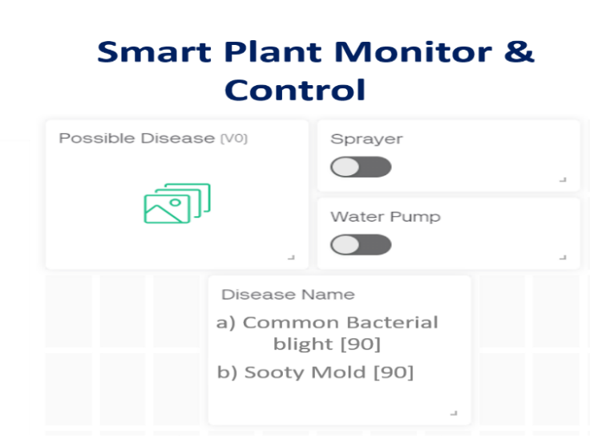
Fig. 7. Blynk IoT server interface showcasing disease detection, sprayer, and water pump controls integrate with the ESP32 Camera module for real-time monitoring and management.

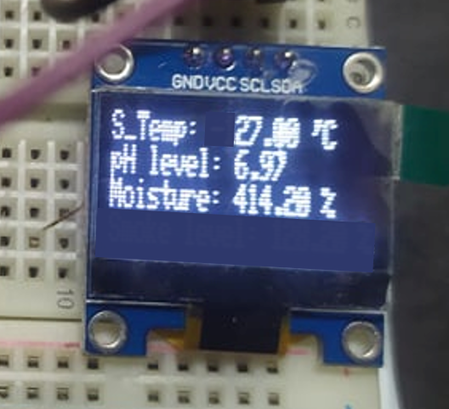
In Fig. 8, presents the real-time sensor values displayed on the OLED screen of the Smart Plant Monitoring and Controlling System, offering users critical insights into the environmental conditions required for plant health and growth. The display provides information on three key parameters: soil moisture, pH level, and soil temperature, ensuring immediate and actionable data for efficient decision-making. The soil moisture content is recorded as 414.20%, indicating that the soil is adequately wet, and irrigation is not currently required. This reading demonstrates the system’s ability to optimize water usage by monitoring soil conditions and preventing unnecessary activation of the water pump. The pH level, measured at 6.97, falls within the ideal range for most plants, ensuring proper nutrient availability and fostering healthy growth. The display confirms that this pH level is advantageous for agricultural productivity. Additionally, the soil temperature, measured at 27.00°C, reflects a moderate and suitable environment for plant growth, further validating the system’s accuracy and effectiveness. This figure represents a snapshot of the system’s functionality, as it is currently operating in prototype mode. While the data shown on the OLED focuses on essential metrics, the system can capture and processing additional parameters, such as humidity and visual data from the ESP32 Camera, which are transmitted to the Blynk IoT server for remote monitoring and advanced analysis. The clear and concise presentation of sensor data on the OLED screen enables users to quickly assess soil and environmental conditions, providing valuable support for decisions regarding irrigation, nutrient management, and environmental adjustments. The integration of real-time data monitoring with automated controls underscores the system’s potential to revolutionize modern agricultural practices by promoting precision farming and sustainable resource utilization.
Fig. 8. OLED display showing real-time sensor values, including soil temperature (27.00°C), pH level (6.97), and soil moisture content (414.20%), indicating optimal conditions for plant growth.

Name of Component | Quantity Used | Our System with Integrated Sensors (in BDT) | Equivalent Sensors (India) (in BDT)
Arduino Nano [23] | 1.0 | 540 | 1321 (Arduino  Nano Every)
Soil Moisture Sensor | 1.0 | 440 | 1500 (Soil & Leaf Moisture Sensor)
DHT 11 Humidity Sensor [23] | 1.0 | 190 | 1707 (Grove - Temperature & Humidity Sensor Pro)
P^{H} Sensor | 1.0 | 1800 | 4645 (Water Quality & Instrumentation)
ESP 32 Camera [24] | 1.0 | 390 | 850 (ESP32-CAM Wi-Fi)
LCD Display | 1.0 | 500 | 950 (SP14Q002 LCD Display)
Water Pump [25] | 1.0 | 3020 | 5060 (Crompton Water Pump)
Sprayer [26] | 1.0 | 2950 | 6550(Agricultural Sprayers)
Total (in BDT) |  | 9830 | 22583
Table 1. The final cost for the project and analysis

The primary goal of this project was to develop a comprehensive smart plant monitoring and control system while ensuring cost-effectiveness. The cost analysis for this system was meticulously conducted by focusing on the procurement of essential components required for its successful implementation. The estimation of project costs was based on an exhaustive research process, which included a detailed exploration of components sourced from various producers and sellers in both Bangladesh and India. This analysis involved a careful comparison between the costs of sensors and equipment used in the system and their equivalent counterparts available in the Indian market. The approach provided a detailed understanding of the financial aspects associated with the system's resource acquisition, ensuring transparency and cost optimization. By evaluating the pricing of components such as the Arduino Nano, DHT-11 humidity sensor, ESP32 Camera module, and others, the project aimed to balance affordability with performance. The final cost table reflects this comparative analysis, offering insights into how the system was developed within a reasonable budget while ensuring the integration of high-quality components to meet the project’s functional requirements. This dual-market analysis underscores the project's commitment to achieving efficiency and practicality in resource allocation for sustainable agricultural applications.

6. CONCLUSION

A cost-effective and scalable Smart Plant Monitoring and Controlling System has been developed to address key challenges in modern agriculture by integrating IoT technology, real-time monitoring, and automation. The proposed system enables precise tracking of essential parameters, including soil moisture, temperature, humidity, and pH levels, while incorporating visual plant health detection through an ESP32 Camera module. These features ensure early detection of plant health issues such as pest infestations and nutrient deficiencies, facilitating timely interventions. Rigorous testing and validation of the system through simulation and hardware implementation demonstrated consistent performance, reliability, and resource efficiency. The automated control of water pumps and sprayers, guided by threshold-based logic, optimized irrigation and nutrient delivery, minimizing resource wastage. The integration of the Blynk IoT platform provided a user-friendly interface for remote monitoring and control, ensuring accessibility for farmers in both developed and resource-constrained regions. In conclusion, this research achieves all its objectives, showcasing the system's financial feasibility and adaptability for diverse agricultural scenarios. The affordability, scalability, and user-centered design highlight its potential for promoting precision agriculture and sustainable farming practices. The proposed system not only advances agricultural efficiency but also holds the promise of long-term sustainability and practical application in addressing global agricultural challenges.

References

- Kumar, T., Khosla, C. and Rakhra, M., 2024. Automated Smart Agriculture Using Machine Learning. In Computer Science Engineering and Emerging Technologies (pp. 539-543). CRC Press.
- Akilan, T., & Baalamurugan, K. M. (2024). Automated weather forecasting and field monitoring using GRU-CNN model along with IoT to support precision agriculture. Expert systems with applications, 249, 123468.
- Lean, C.P., Krishnan, G., Li, C., Yuan, K.F., Kiat, N.P. and Khan, M.R.B., 2024. A raspberry pi-powered iot smart farming system for efficient water irrigation and crop monitoring. Malaysian Journal of Science and Advanced Technology, pp.149-158.
- Sharma, Prachi, Mehal Pandkar, and Shashank Nambiar. "Wireless Greenhouse Monitoring using ESP32 and Sensor Array for Sustainable Crop Production." In 2024 3rd International Conference on Artificial Intelligence For Internet of Things (AIIoT), pp. 1-6. IEEE, 2024.
- Jenitta, J., S. Akash, Ashutosh Mallick, and V. Bhumika. "Soil Moisture Monitoring and Seed Sowing Robot with ThingSpeak Integration." In 2024 International Conference on Intelligent and Innovative Technologies in Computing, Electrical and Electronics (IITCEE), pp. 1-4. IEEE, 2024.
- Senoo, Elisha Elikem Kofi, Lia Anggraini, Jacqueline Asor Kumi, Bunga Karolina Luna, Ebenezer Akansah, Hafeez Ayo Sulyman, Israel Mendonça, and Masayoshi Aritsugi. "IoT solutions with artificial intelligence technologies for precision agriculture: Definitions, applications, challenges, and opportunities." Electronics 13, no. 10 (2024): 1894.
- Soussi, Abdellatif, Enrico Zero, Roberto Sacile, Daniele Trinchero, and Marco Fossa. "Smart Sensors and Smart Data for Precision Agriculture: A Review." Sensors 24, no. 8 (2024): 2647.
- Kumar, Vijendra, Kul Vaibhav Sharma, Naresh Kedam, Anant Patel, Tanmay Ram Kate, and Upaka Rathnayake. "A Comprehensive Review on Smart and Sustainable Agriculture Using IoT Technologies." Smart Agricultural Technology (2024): 100487.
- ] Alex, Ambi Rachel, Mohamed Mahdi, and Walid El Fezzani. "Optimizing Water Usage in Agriculture: A Study on Automated Irrigation Systems Using Humidity Sensors and Arduino Uno." In Business Sustainability with Artificial Intelligence (AI): Challenges and Opportunities: Volume 2, pp. 119-128. Cham: Springer Nature Switzerland, 2024.
- Kadpan, Wpreen Rashed, Faiz F. Mustafa, and Hussein Tbena Kadhim. "A Review of Control Automatically Water Irrigation Canal Using Multi Controllers and Sensors." Journal Européen des Systèmes Automatisés 57, no. 3 (2024): 717.
- Yu, Shuwan, Xiaoang Liu, Qianqiu Tan, Zitong Wang, and Baohua Zhang. "Sensors, systems and algorithms of 3D reconstruction for smart agriculture and precision farming: A review." Computers and Electronics in Agriculture 224 (2024): 109229. doi.org/10.1016/j.compag.2024.109229
- Soussi, A., Zero, E., Sacile, R., Trinchero, D. and Fossa, M., 2024. Smart Sensors and Smart Data for Precision Agriculture: A Review. Sensors, 24(8), p.2647.
- Wang, Juexing, Yuda Feng, Gouree Kumbhar, Guangjing Wang, Qiben Yan, Qingxu Jin, Robert C. Ferrier, Jie Xiong, and Tianxing Li. "SoilCares: Towards Low-cost Soil Macronutrients and Moisture Monitoring Using RF-VNIR Sensing." In Proceedings of the 22nd Annual International Conference on Mobile Systems, Applications and Services, pp. 196-209. 2024.
- Grant, Spencer, Alex Harden, Kaleb Coggins, David Parker, Fatemehsadat Tabei, and Behnam Askarian. "A Comprehensive Comparison of IoT Soil Moisture Sensors for Agricultural Applications." In 2024 IEEE 17th Dallas Circuits and Systems Conference (DCAS), pp. 1-6. IEEE, 2024.
- Rieder, Lukas, Thorben Amann, and Jens Hartmann. "Soil electrical conductivity as a proxy for enhanced weathering in soils." Frontiers in Climate 5 (2024): 1283107.
- Bazargani, Khadijeh, and Taher Deemyad. "Automation’s impact on agriculture: opportunities, challenges, and economic effects." Robotics 13, no. 2 (2024): 33.
- Fadhilah, Habil Azmi, Lucky Purwantini, Nurlaila Maysaroh Chairunnisa, Purnama Putra, and Ummi Khoiriyah. "Smart Hydroponics Innovation: Blyink IoT Application for Sustainable Food Security." Entrepreneurship and Community Development 2, no. 2 (2024): 78-86.
- Dong, Huangtao, Jianxun Shen, Zhe Yu, Xiangyu Lu, Fei Liu, and Wenwen Kong. "Low-Cost Plant-Protection Unmanned Ground Vehicle System for Variable Weeding Using Machine Vision." Sensors 24, no. 4 (2024): 1287.
- Mushtaque, M. A. R. (2024). Integration of Wireless Sensor Networks, Internet of Things, Artificial Intelligence, and Deep Learning in Smart Agriculture: A Comprehensive Survey: Integration of Wireless Sensor Networks, Internet of Things. Journal of Innovative Intelligent Computing and Emerging Technologies (JIICET), 1(01), 8-19.
- Huo, Dongyang, Asad Waqar Malik, Sri Devi Ravana, Anis Ur Rahman, and Ismail Ahmedy. "Mapping smart farming: Addressing agricultural challenges in data-driven era." Renewable and Sustainable Energy Reviews 189 (2024): 113858.
- Miao, J., 2024. A Fog-Enabled Microservice-Based Multi-Sensor IoT System for Smart Agriculture (Doctoral dissertation, University of Colorado at Boulder).
- Liyakat, K.K.S., 2024. Blynk IoT-Powered Water Pump-Based Smart Farming. Recent Trends in Semiconductor and Sensor Technology, 1(1), pp.8-14.
- Riyad, Tarifuzzaman, Md Asif Iqbal, Habib Un Nabi Polash, SM Oaliullah Sohrab, and Shuvra Mondal. "Low-Cost Wearable Hand Glove For Physiological Signal Monitoring." In 2024 3rd International Conference on Advancement in Electrical and Electronic Engineering (ICAEEE), pp. 1-6. IEEE, 2024.
- Akintuyi, Olabimpe Banke. "Adaptive AI in precision agriculture: a review: investigating the use of self-learning algorithms in optimizing farm operations based on real-time data." Research Journal of Multidisciplinary Studies 7, no. 02 (2024): 016-030.
- Iqbal, Md Asif, Tarifuzzaman Riyad, Habib Un Nabi Polash, S. M. Sohrab, and Shuvra Mondal. "A Low-Cost Smart Wearable Glove for Non-Invasive Health Monitoring." Journal of Engineering Research and Reports 26, no. 5 (2024): 93-106.
- Rai, Hari Mohan, Kaustubh Kumar Shukla, Yashika Goya, Saule Amanzholova, and Askarbekova Nessibely. "IoT-based real-time monitoring and control system for tomato cultivation." Procedia Computer Science 241 (2024): 433-438.

