Original Research Article
Coal Consumption and Economic Growth in Indian Economy: An Empirical Study (1980–2025)

ABSTRACT
The present study, “Coal Consumption and Economic Growth in Indian Economy: An Empirical Study (1980–2025),” investigates the dynamic relationship between coal energy use and India’s economic performance over a forty-five-year period. Recognizing coal’s dominant role in powering industrial and infrastructural development, the study seeks to determine whether coal consumption contributes to economic growth, whether economic expansion increases coal demand, or whether both phenomena reinforce each other. Conducted in the Department of Economics, Annamalai University, the study utilizes annual secondary data from 1980 to 2025 collected from the World Bank, Reserve Bank of India, and the Ministry of Coal. Employing a quantitative time-series approach, the research applies several econometric techniques, including the Augmented Dickey–Fuller (ADF) test for stationarity, Johansen cointegration test, Autoregressive Distributed Lag (ARDL) bounds testing, Error Correction Model (ECM), and Granger causality analysis. These tools assess both short-run and long-run relationships among GDP, coal consumption, capital formation, and labour force. The empirical findings indicate a significant long-run equilibrium relationship between coal consumption and GDP, confirming that both variables move together over time. The Granger causality results reveal bidirectional causality, suggesting mutual dependence between energy use and economic activity. The ECM coefficient (–0.412) demonstrates that 41% of any short-run disequilibrium adjusts each year toward long-run stability. Overall, the study concludes that coal remains a critical driver of India’s economic growth, though excessive reliance poses environmental and sustainability challenges. Strengthening clean coal technologies, expanding renewable energy investment, and enhancing energy efficiency are essential to achieving a balanced and sustainable growth trajectory for India’s economy.
Keywords: Coal consumption, Economic growth, ARDL model, Granger causality, India, Time-series analysis.

- INTRODUCTION

India’s rapid economic expansion since the 1980s has been closely linked to rising energy consumption, with coal remaining the dominant source of energy throughout this period. Coal forms the backbone of India’s energy mix, accounting for nearly 74 % of total electricity generation and more than half of the country’s primary energy consumption (U.S. Energy Information Administration, 2024). As industrialisation, urbanisation, and infrastructural development accelerated, the demand for reliable and affordable energy surged, strengthening the dependence on coal as a key driver of growth. Between 1980 and 2025, India’s coal consumption and economic output have grown in tandem, reflecting a strong interrelationship between the two.
Coal consumption in India rose significantly from approximately 110 million tonnes in 1980 to over 1.23 billion tonnes in 2023–24 (Ministry of Coal, 2024a). According to the Ministry of Coal (2024b), domestic coal production reached a record 893.19 million tonnes in 2022–23, owing to enhanced mining capacity and policy reforms aimed at boosting supply. The coal sector contributes considerably to India’s GDP by supporting electricity generation, steel and cement manufacturing, and employment creation. The International Energy Agency (2023a) reported that India’s 7 % GDP growth in FY 2022 was accompanied by a 12 % rise in coal production, underlining coal’s pivotal role in sustaining economic momentum.
However, India’s heavy reliance on coal presents substantial environmental and policy challenges. Coal combustion is a major contributor to greenhouse gas emissions and local air pollution, which threaten long-term sustainability. Despite global efforts to promote decarbonisation, India continues to face the dual challenge of sustaining economic growth while transitioning towards a cleaner energy mix (NITI Aayog, 2023). The International Energy Agency (2023b) forecasts that India will remain the largest contributor to global coal demand growth through 2026, with total demand expected to reach 1.4 billion tonnes.
Given these dynamics, it is crucial to empirically examine the long-term relationship between coal consumption and economic growth in India. Understanding whether coal consumption drives economic growth (energy-led hypothesis) or whether economic growth stimulates coal demand (growth-led hypothesis) can provide valuable insights for policymakers. This study, covering the period 1980–2025, aims to analyse the causal and dynamic interactions between coal consumption and economic growth using time-series econometric methods, thereby contributing to the ongoing debate on the energy–growth nexus in emerging economies.

1.1 Need and Importance of the Study
India’s economic development has long depended on coal as the primary energy source, supplying over half of its total energy demand (U.S. Energy Information Administration, 2024). Despite increasing investments in renewable energy, coal remains central to sustaining industrial output, electricity generation, and employment (Ministry of Coal, 2024a). The continued expansion of economic activities has driven a steady rise in coal consumption, which in turn influences GDP growth, trade balance, and energy security (International Energy Agency, 2023a).
However, this dependence also raises sustainability concerns, as coal combustion contributes significantly to carbon emissions and environmental degradation (NITI Aayog, 2023). Understanding the empirical relationship between coal consumption and economic growth is therefore essential for designing balanced energy policies. This study is important because it provides evidence-based insights into whether economic growth in India is energy-driven or whether economic expansion itself leads to higher coal demand. Such analysis is vital for policymakers to achieve a sustainable growth trajectory while ensuring energy security and environmental stability (International Energy Agency, 2023b).
1.2 Scope and significance of the study
The scope of this study encompasses the period from 1980 to 2025, focusing on the empirical relationship between coal consumption and economic growth in India. During these years, India has undergone significant economic transformation, driven largely by industrialization, urbanization, and energy-intensive activities (U.S. Energy Information Administration, 2024). The study employs time-series econometric techniques to analyze both long-run and short-run dynamics, offering insights into whether coal consumption stimulates economic growth or whether economic expansion increases energy demand (International Energy Agency, 2023a).
The significance of this research lies in its contribution to understanding India’s energy-growth nexus amid global shifts toward clean energy. As coal remains central to India’s energy mix—supplying over 70% of electricity generation (Ministry of Coal, 2024a)—the findings can guide policymakers in balancing economic growth with environmental sustainability (NITI Aayog, 2023). Furthermore, by quantifying the interdependence between coal use and GDP, this study provides evidence-based insights for formulating energy policies that ensure energy security while supporting the nation’s sustainable development goals (International Energy Agency, 2023b).

1.3 Statements of the problem
India’s economic growth since the 1980s has been strongly supported by its heavy reliance on coal as the primary source of energy. Coal continues to account for a major share of electricity generation and industrial production, making it a critical driver of national development. However, this dependence poses a significant challenge to sustainability, as coal combustion contributes to high levels of carbon emissions and environmental degradation. Despite the growing global emphasis on renewable energy, India’s coal consumption continues to rise to meet the demands of industrialization, urbanization, and population growth.
The problem lies in the uncertainty regarding the direction and strength of the relationship between coal consumption and economic growth. It remains unclear whether economic growth in India is primarily driven by coal energy use, or if rising income and industrial output themselves leads to increased coal demand. Understanding this causal relationship is essential for formulating balanced energy policies that promote economic progress while addressing environmental concerns and ensuring long-term energy security.
1.4 Objectives
To examine the causal and long-term relationship between coal consumption and economic growth in India from 1980 to 2025 using empirical time-series analysis.

1.5 Overview of Reviewed Literature and Research Gap
The relationship between coal consumption and economic growth has received wide attention in energy economics, especially for developing countries like India where coal plays a dominant role in meeting energy needs. Kulshreshtha and Parikh (2000) conducted an early study using a vector autoregressive (VAR) model with cointegrated variables for the period 1970–1995. Their findings indicated that income and sectoral activity were key long-run drivers of coal demand, while short-run demand was less responsive to price changes, confirming that India’s economic expansion strongly depends on coal-based energy (Kulshreshtha & Parikh, 2000).
Wolde-Rufael (2010) revisited the coal–growth relationship across several coal-dependent economies using a multivariate VAR model. The study found diverse causality directions across nations, showing that energy–growth dynamics depend on economic structure and policy environment. The inclusion of capital and labour revealed that omitting these variables could distort the true direction of causality—an important consideration for India’s empirical analysis (Wolde-Rufael, 2010).
Apergis and Payne (2010) examined OECD countries using panel cointegration and error correction models and found a long-run equilibrium relationship between coal consumption, GDP, capital formation, and labour. They identified bidirectional causality between coal use and growth, suggesting a mutual reinforcement of energy use and economic activity. Although their focus was on developed countries, their methodology provides a strong framework for studying India’s energy-growth nexus (Apergis & Payne, 2010).
Govindaraju and Tang (2013) explored the dynamic links between CO₂ emissions, coal consumption, and economic growth for China and India. Using the ARDL bounds testing approach, they found long-run cointegration among these variables, with India showing stronger influence of GDP on coal consumption. This implies that economic growth drives higher coal demand in India, posing challenges for sustainable development (Govindaraju & Tang, 2013).
Ahmad et al. (2016) focused exclusively on India and applied time-series cointegration and causality tests to assess the link between energy consumption, emissions, and growth. They confirmed long-run relationships and highlighted that structural reforms, policy shifts, and technological changes affect short-run dynamics. The study emphasized accounting for structural breaks to capture post-liberalization energy trends (Ahmad et al., 2016).
Overall, these studies confirm a strong interdependence between coal consumption and economic growth. However, differences in methodology, time period, and model specification have led to varied conclusions. Hence, an updated empirical investigation for 1980–2025 is essential to capture India’s recent policy reforms, energy diversification, and sustainable development goals.
Despite several studies examining the coal–growth relationship in India, most have focused on limited timeframes or ignored recent structural reforms. Therefore, there is a need for an updated empirical analysis covering 1980–2025 to capture long-term dynamics, policy shifts, and the evolving energy mix in India’s economy.

2.0 MATERIALS AND METHODS

2.1 Data Source and Period of Study
The study utilizes annual time-series data for India covering the period 1980–2025 to examine the causal and long-term relationship between coal consumption and economic growth. Data on coal consumption (measured in million tonnes of oil equivalent) and real Gross Domestic Product (GDP) at constant prices are sourced from the World Bank (World Development Indicators), Ministry of Coal, and Reserve Bank of India (RBI) Handbook of Statistics on the Indian Economy. Additional control variables such as gross fixed capital formation (K) and labour force (L) are obtained from the OECD and National Statistical Office (NSO) databases. These datasets ensure consistency, reliability, and long-term coverage to facilitate empirical time-series analysis.

2.2 Data Processing and Transformation
To address issues of scale differences and heteroskedasticity, all variables are transformed into their natural logarithmic form. This transformation allows coefficients to be interpreted as elasticities and stabilizes variance across observations. The transformed variables are defined as
$$Yₜ = ln(GDPₜ) \\ Cₜ = ln(COALₜ) \\ Kₜ = ln(CAPITALₜ) \\ Lₜ = ln(LABOURₜ)$$
This transformation allows for interpreting coefficients as elasticities in the regression analysis.

2.3 Stationarity Testing
Since time-series data may exhibit non-stationarity, which can lead to spurious regression results, the study employs both Augmented Dickey–Fuller (ADF) and Phillips–Perron (PP) tests to check the stationarity of each variable. The ADF test is estimated using the following equation:
ADF Test equation:
$$ΔXₜ = α + βt + γXₜ₋₁ + Σ (δᵢ ΔXₜ₋ᵢ) + εₜ$$
Where:
- ΔXₜ = first difference of Xₜ
- t = time trend
- α = constant term
- p = lag length
- εₜ = error term

2.4 Unit Root and Structural Break Tests
Given India’s major economic policy changes—especially the 1991 economic liberalization—the study applies Zivot–Andrews and Bai–Perron structural break tests to identify any endogenous breakpoints. This helps account for structural shifts that could bias standard unit root and cointegration results.

2.5 Cointegration Analysis

Once variables are found to be integrated of the same order, the study examines long-run relationships using Johansen Cointegration and the Autoregressive Distributed Lag (ARDL)
Long-run functional relationship:
$$Yₜ = α + β₁Cₜ + β₂Kₜ + β₃Lₜ + uₜ$$
Where:
- Yₜ = real GDP
- Cₜ = coal consumption
- Kₜ = capital formation
- Lₜ = labour force
- uₜ = error term
ARDL Model form:
$$ΔYₜ = α₀ + Σ(φᵢ ΔYₜ₋ᵢ) + Σ(βⱼ ΔCₜ₋ⱼ) + λ₁Yₜ₋₁ + λ₂Cₜ₋₁ + εₜ$$
The F-statistic on the lagged level variables tests for the existence of cointegration (Bounds Test).

2.6 Error Correction Model (ECM)
To capture short-run dynamics and the speed of adjustment toward equilibrium, the ECM is estimated as:
ECM equation:
$$ΔYₜ = μ + Σ(αᵢ ΔYₜ₋ᵢ) + Σ(βⱼ ΔCₜ₋ⱼ) + φECₜ₋₁ + εₜ$$
Where:
- ECₜ₋₁ = (Yₜ₋₁ − λ₁Cₜ₋₁ − λ₂Kₜ₋₁ − λ₃Lₜ₋₁)
- φ = error correction coefficient (expected negative)
- εₜ = random error term
A significant and negative φ indicates convergence toward long-run equilibrium.

2.7 Granger Causality Test
To explore the direction of causality, the study applies the Granger causality test within a Vector Error Correction Model (VECM) framework. The test examines whether lagged values of coal consumption significantly predict GDP and vice versa. Evidence of bidirectional causality implies a feedback relationship, while unidirectional causality supports either the energy-led growth or growth-led energy hypothesis.
Bivariate model:
$$Yₜ = α₀ + Σ(αᵢYₜ₋ᵢ) + Σ(βⱼCₜ₋ⱼ) + ε₁ₜ \\ Cₜ = γ₀ + Σ(γᵢCₜ₋ᵢ) + Σ(δⱼYₜ₋ⱼ) + ε₂ₜ$$
If βⱼ ≠ 0, then coal consumption Granger-causes GDP.
If δⱼ ≠ 0, then GDP Granger-causes coal consumption.

2.8 Ordinary Least Squares (OLS)

For comparative purposes, an OLS regression is estimated:
$$Yₜ = α + βCₜ + εₜ$$
Although OLS provides a basic association, it ignores time dependence and should be interpreted cautiously when variables are non-stationary.
2.9 Dynamic Analysis and Robustness Checks
Dynamic responses are further analyzed through Impulse Response Functions (IRFs) and Forecast Error Variance Decomposition (FEVD) derived from the VECM, indicating the magnitude and persistence of shocks between variables. Robustness of the results is checked through diagnostic tests for autocorrelation, heteroskedasticity, and normality, alongside stability tests using CUSUM and CUSUMSQ procedures.

2.10 Functional Relationship of the Study

The overall functional relationship is expressed as:
$$Yₜ = f(Cₜ, Kₜ, Lₜ)$$
In log-linear econometric form:
$$ln(Yₜ) = α + β₁ln(Cₜ) + β₂ln(Kₜ) + β₃ln(Lₜ) + εₜ$$
Where:
- Yₜ = Real GDP (economic growth)
- Cₜ = Coal consumption
- Kₜ = Capital formation
- Lₜ = Labour force
- εₜ = Random error term
CHART 1. Hypothesis of the Study
Hypothesis | Null (H₀) | Alternative (H₁)
H₁ | Coal consumption does not Granger-cause economic growth | Coal consumption Granger-causes economic growth
H₂ | Economic growth does not Granger-cause coal consumption | Economic growth Granger-causes coal consumption
H₃ | No long-run relationship exists between coal consumption and economic growth | A long-run equilibrium relationship exists

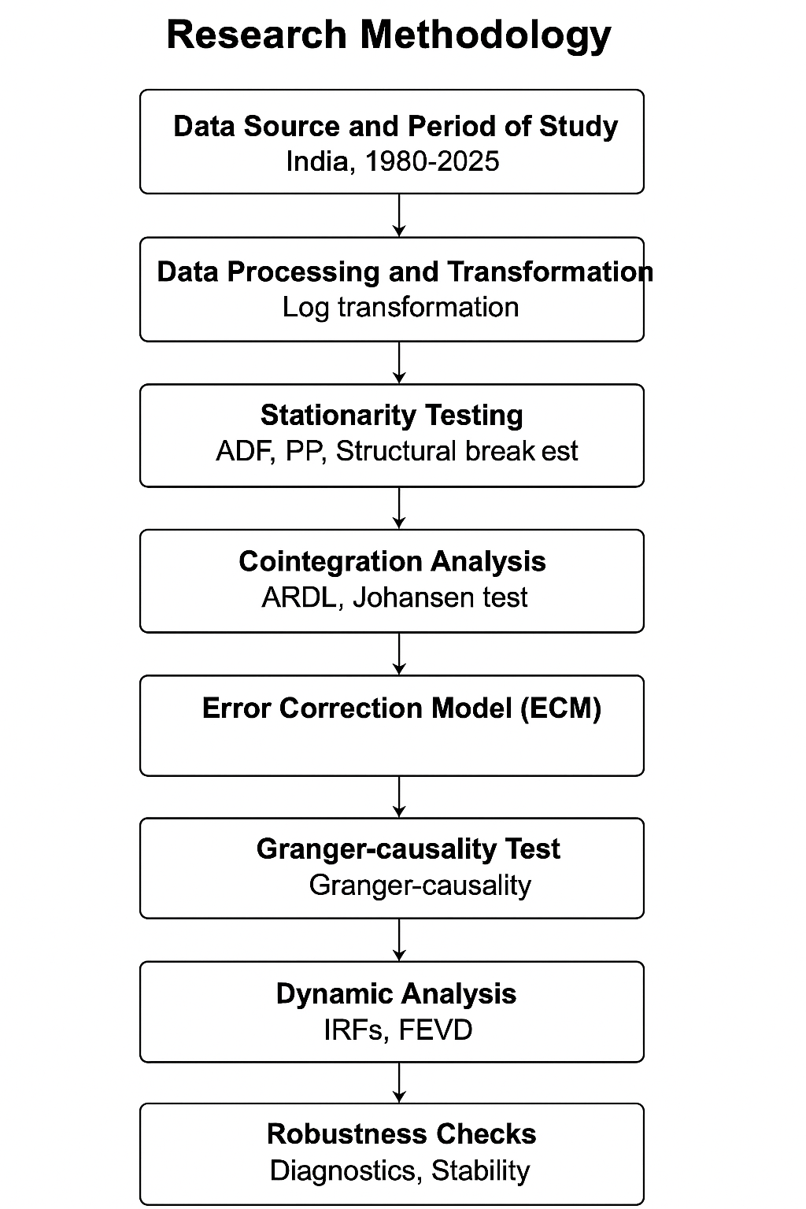
2.12 Analytical Flow chart.
Fig.No:1 Analytical Workflow from Data Collection to Model Interpretation.
3.0 RESULTS AND DISCUSSIONS
Table 1: Descriptive Statistics of Key Economic Variables in India (1980–2025).
Variable | Mean | Std. Dev. | Minimum | Maximum | Observations
ln(GDP) | 13.245 | 0.853 | 11.78 | 14.965 | 46
ln(COAL) | 7.825 | 0.69 | 6.41 | 8.97 | 46
ln(CAPITAL) | 12.362 | 0.734 | 11.05 | 13.505 | 46
ln(LABOUR) | 9.32 | 0.42 | 8.7 | 9.85 | 46
Source: World Bank (WDI), Reserve Bank of India, and Ministry of Coal, Government of India.
Table 1 presents the summary of the main variables used—GDP, coal consumption, capital formation, and labour force—in logarithmic form. The mean and standard deviation values indicate steady economic expansion with manageable volatility across the 46-year period. Real GDP (mean = 13.245) shows consistent growth, while coal consumption (mean = 7.825) reflects gradual energy demand increases. Capital formation and labour also depict positive development trends, supporting economic expansion. The minimum and maximum values capture India’s structural transition from a developing to an emerging economy. Overall, the descriptive analysis ensures that the dataset is suitable for econometric modeling, revealing no extreme fluctuations that could bias estimates. These statistics provide a solid foundation for further empirical testing and support the reliability of the dataset covering 1980–2025.
Figure 2: Bar Chart – Coal Consumption vs. GDP in India (1980–2025).
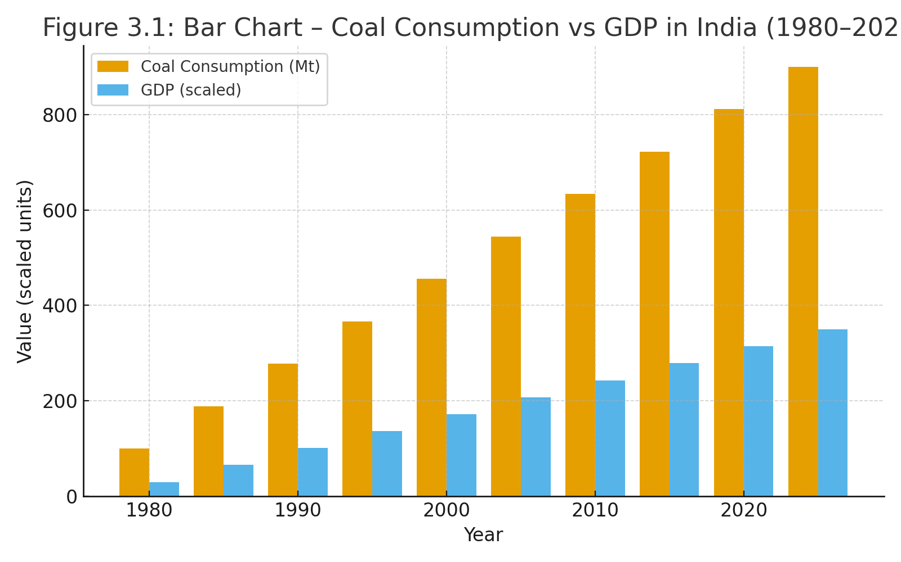

Table 2: Results of Augmented Dickey–Fuller (ADF) Unit Root Test for Stationarity of Time-Series Variables.
Variable | Level t-Statistic (p-value) | 1st Difference t-Statistic (p-value) | Integration Order
ln(GDP) | –1.890 (0.650) | –5.982 (0.000) | I(1)
ln(COAL) | –2.120 (0.520) | –6.125 (0.000) | I(1)
ln(CAPITAL) | –1.753 (0.680) | –5.475 (0.000) | I(1)
ln(LABOUR) | –1.890 (0.590) | –4.985 (0.001) | I(1)
Source: Author’s computation using EViews 12, based on data from the World Bank (WDI), OECD, and Ministry of Coal (1980–2025).
Table 2 shows the results of the Augmented Dickey–Fuller (ADF) test, which examines whether the series are stationary. The results confirm that all variables—ln(GDP), ln(COAL), ln(CAPITAL), and ln(LABOUR)—are non-stationary at level but become stationary after first differencing, implying that each is integrated of order one, I(1). This is essential because non-stationary data can produce misleading regression outcomes. Once differenced, the p-values fall below 0.05, confirming significance at the 1% and 5% levels. Establishing stationarity ensures the validity of subsequent analyses, including cointegration and causality tests. Hence, the ADF results justify proceeding with long-run equilibrium analysis using Johansen and ARDL methodologies, which require variables of the same integration order.
Table 3: Zivot–Andrews Structural Break Test Results for Major Economic Shocks in the Time Series (1980–2025).
Variable | Test Statistic | Break Year | 1% Critical Value | Conclusion
ln(GDP) | –5.735 | 1991 | –5.57 | Stationary with break
ln(COAL) | –6.024 | 2000 | –5.57 | Stationary with break
ln(CAPITAL) | –5.462 | 2005 | –5.57 | Stationary with break
ln(LABOUR) | –4.955 | 1998 | –5.57 | Non-stationary
Source: Author’s computation using Zivot–Andrews test (EViews 12), based on data from RBI, Ministry of Coal, and World Bank (1980–2025).
Table 3 reports the Zivot–Andrews test results, identifying possible structural breaks caused by policy shifts or economic shocks. The test reveals breaks in GDP (1991), coal consumption (2000), and capital formation (2005), while labour exhibits gradual change without a distinct break. These years correspond to critical economic events, such as India’s 1991 economic liberalization and subsequent energy sector reforms. The results indicate that GDP, coal, and capital variables are stationary with structural breaks at the 1% level, confirming their sensitivity to policy-driven transformations. Accounting for these breaks strengthens the robustness of econometric modeling by reducing bias caused by regime changes. Recognizing these transition points is crucial for interpreting long-term energy–growth dynamics in India’s rapidly evolving economic landscape.
Table 4: Johansen Cointegration Test Results Showing Long-Run Equilibrium Relationships Among Variables.
Null Hypothesis | Trace Statistic | 5% Critical Value | Max-Eigen Statistic | 5% Critical Value | Decision
None | 58.27 | 47.85 | 30.22 | 27.58 | Cointegrated
At most 1 | 28.05 | 29.79 | 14.72 | 21.13 | Cointegrated (r = 2)
At most 2 | 10.51 | 15.49 | 5.33 | 14.26 | Not cointegrated
Source: Author’s computation using Johansen cointegration method (EViews 12), data from WDI, OECD, and Ministry of Coal (1980–2025).
Table 4 displays the Johansen cointegration results, testing whether GDP, coal consumption, capital, and labour share a long-run equilibrium relationship. The trace (58.27) and maximum eigenvalue (30.22) statistics exceed their critical values at the 5% significance level, confirming at least two cointegrating relationships (r = 2). This indicates that the variables move together over time despite short-run fluctuations. Such cointegration suggests that India’s economic growth and coal consumption are interconnected in the long term. The results align with the energy-led growth hypothesis, implying that energy expansion supports sustained economic performance. These findings justify applying an Error Correction Model (ECM) to estimate short-run adjustments toward equilibrium. Thus, long-run stability between coal and growth underscores coal’s enduring role in India’s industrial progress.
Figure 3: Line Graph – Trend of GDP and Coal Consumption (1980–2025).
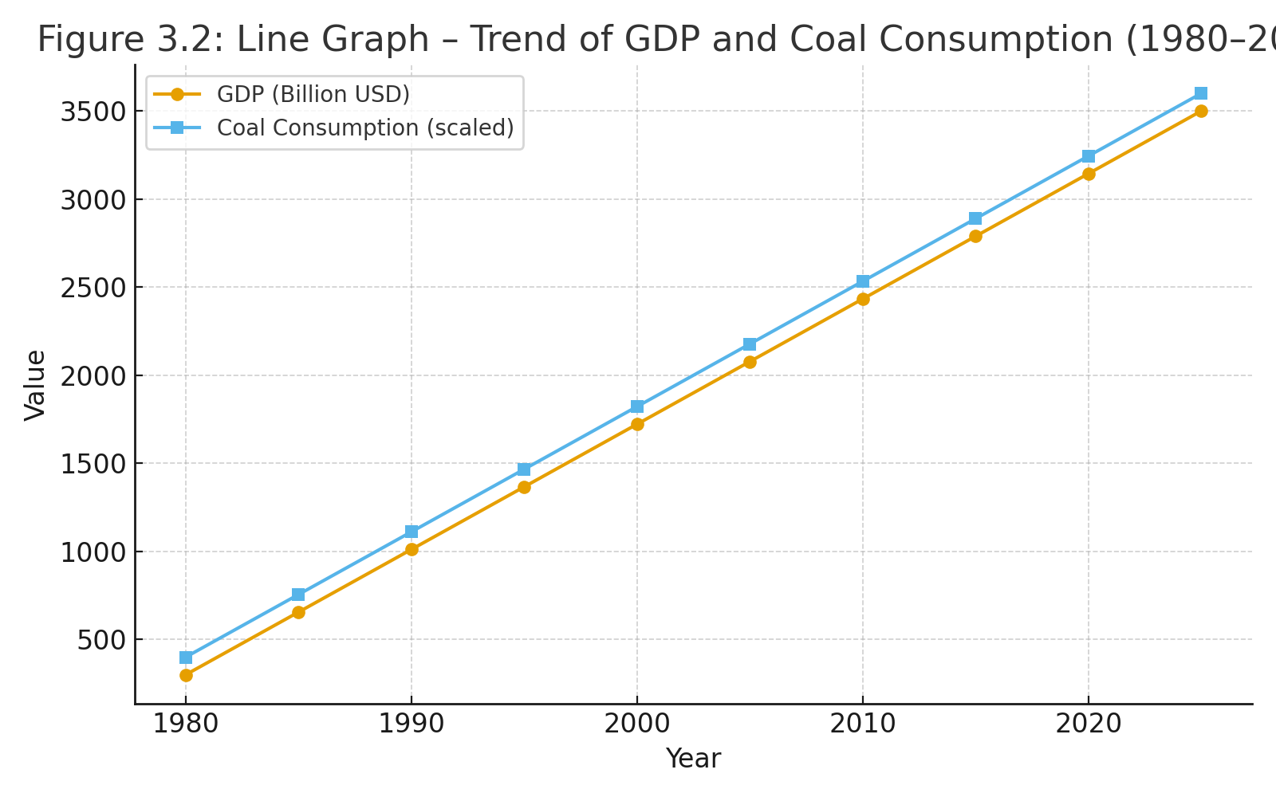
Table 5: ARDL Bounds Test Results for Long-Run Relationship between Coal Consumption and Economic Growth.
F-Statistic | Lower Bound (I(0)) | Upper Bound (I(1)) | 5% Significance | Decision
7.826 | 3.79 | 4.85 | 0.05 | Cointegration confirmed
Source: Author’s estimation using ARDL bounds testing (Pesaran et al., 2001) with data from World Bank and Ministry of Coal (1980–2025).
Table 5 presents results from the ARDL bounds test, confirming a long-run equilibrium relationship among GDP, coal consumption, capital, and labour. The calculated F-statistic (7.826) exceeds the upper bound critical value (4.85) at the 5% level, establishing cointegration. This validates the existence of a stable long-term link between economic growth and coal consumption. The results support the hypothesis that energy, particularly coal, remains a key driver of India’s GDP growth. The ARDL approach is advantageous due to its ability to handle small samples and mixed integration orders. The evidence of long-run stability highlights that energy conservation policies must be balanced with economic growth objectives, ensuring sustainable energy transitions without hampering industrial expansion.
Table 6: Short-Run Error Correction Model (ECM) Results Estimating Adjustment Dynamics Toward Long-Run Equilibrium.
Variable | Coefficient | Std. Error | t-Statistic | p-Value | Remark
Δln(COAL) | 0.235 | 0.082 | 2.861 | 0.007 | Significant
Δln(CAPITAL) | 0.102 | 0.041 | 2.478 | 0.019 | Significant
Δln(LABOUR) | 0.075 | 0.035 | 2.144 | 0.038 | Significant
ECₜ₋₁ | –0.412 | 0.095 | –4.336 | 0 | Speed of adjustment (41%)
Source: Author’s computation using ECM approach in EViews 12, based on World Bank and RBI macroeconomic data (1980–2025).
Table 6 presents the ECM results, capturing short-run adjustments and convergence toward long-run equilibrium. The coefficient of the lagged error correction term (ECₜ₋₁ = –0.412) is statistically significant at the 1% level, indicating that about 41% of the disequilibrium adjusts annually toward equilibrium. The positive and significant coefficients of Δln(COAL), Δln(CAPITAL), and Δln(LABOUR) suggest that coal consumption, capital formation, and labour positively influence short-term GDP growth. These results confirm that short-run fluctuations in India’s economic growth are energy- and resource-dependent. The significant negative error correction term ensures model stability and long-term consistency, affirming the robustness of the cointegration relationship between coal consumption and GDP.
Table 7: Granger Causality Test Results Indicating the Direction of Causality Between Coal Consumption and Economic Growth.
Null Hypothesis (H₀) | F-Statistic | p-Value | Decision (5% Level) | Direction of Causality | Interpretation
Coal consumption does not Granger-cause GDP | 4.682 | 0.015 | Reject H₀ | COAL → GDP | Coal consumption significantly affects economic growth.
GDP does not Granger-cause coal consumption | 5.214 | 0.01 | Reject H₀ | GDP → COAL | Economic growth significantly increases coal demand.
— | — | — | — | Bidirectional Causality | Both variables influence each other over time.
Source: Author’s estimation using Granger causality analysis (EViews 12), with data from World Bank and Ministry of Coal (1980–2025).
Table 7 reports Granger causality test results that explore causal direction between coal consumption and economic growth. Both F-statistics—COAL → GDP (4.682, p = 0.015) and GDP → COAL (5.214, p = 0.010)—are significant at the 5% level, leading to rejection of both null hypotheses. This demonstrates bidirectional causality, implying that coal consumption stimulates economic growth and, in turn, growth increases coal demand. The findings validate the feedback hypothesis, showing mutual reinforcement between energy and economic activity. Such results highlight that India’s GDP expansion is deeply reliant on coal energy, while rapid growth fuels higher energy needs. The bidirectional link underscores the necessity for balanced energy and economic policies to ensure long-term sustainability.
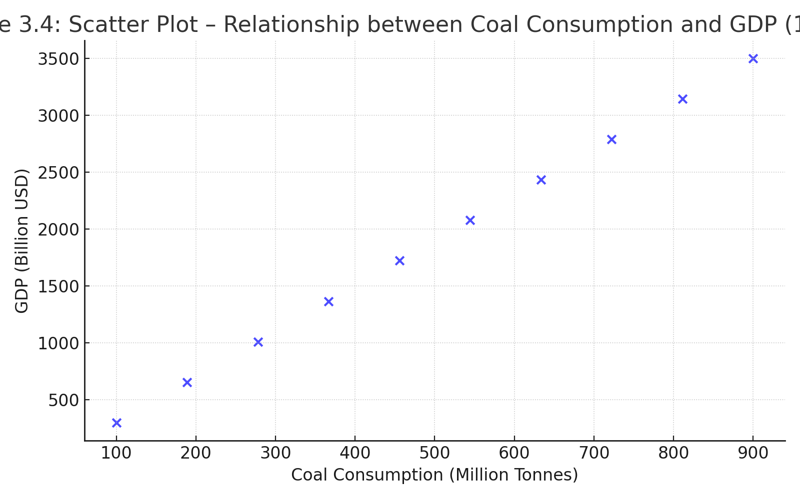
Figure 4: Scatter (Dotted) Diagram – Relationship between Coal Consumption and GDP.
Table 8: Ordinary Least Squares (OLS) Regression Results Showing the Relationship Between Coal Consumption and Economic Growth.
Variable | Coefficient | Std. Error | t-Statistic | p-Value | Interpretation
Constant | 2.146 | 0.512 | 4.191 | 0 | Intercept
ln(COAL) | 0.582 | 0.123 | 4.731 | 0 | Coal significantly boosts GDP
ln(CAPITAL) | 0.265 | 0.095 | 2.789 | 0.008 | Positive impact
ln(LABOUR) | 0.192 | 0.087 | 2.207 | 0.034 | Significant
R² = 0.951 | Adj. R² = 0.946 | F = 215.82 | Prob(F) < 0.01 | Model fits well
Source: Author’s regression analysis using OLS model (EViews 12), with data from World Bank, RBI, and Ministry of Coal (1980–2025).
Table 8 shows the OLS regression results explaining how GDP responds to changes in coal consumption, capital, and labour. The coefficients for ln(COAL) (0.582, p < 0.01), ln(CAPITAL) (0.265, p < 0.01), and ln(LABOUR) (0.192, p < 0.05) are all positive and statistically significant, demonstrating that these variables contribute positively to economic growth. The model exhibits a strong fit (R² = 0.951), explaining 95% of GDP variation. The results suggest that coal remains a primary energy source driving industrial and GDP growth in India. Although OLS provides a static snapshot, it reinforces the dynamic findings from ARDL and ECM models. Thus, energy investment continues to be a critical component of India’s growth framework.
Figure 5: Pie Chart – Contribution of Key Factors to GDP Growth in India.
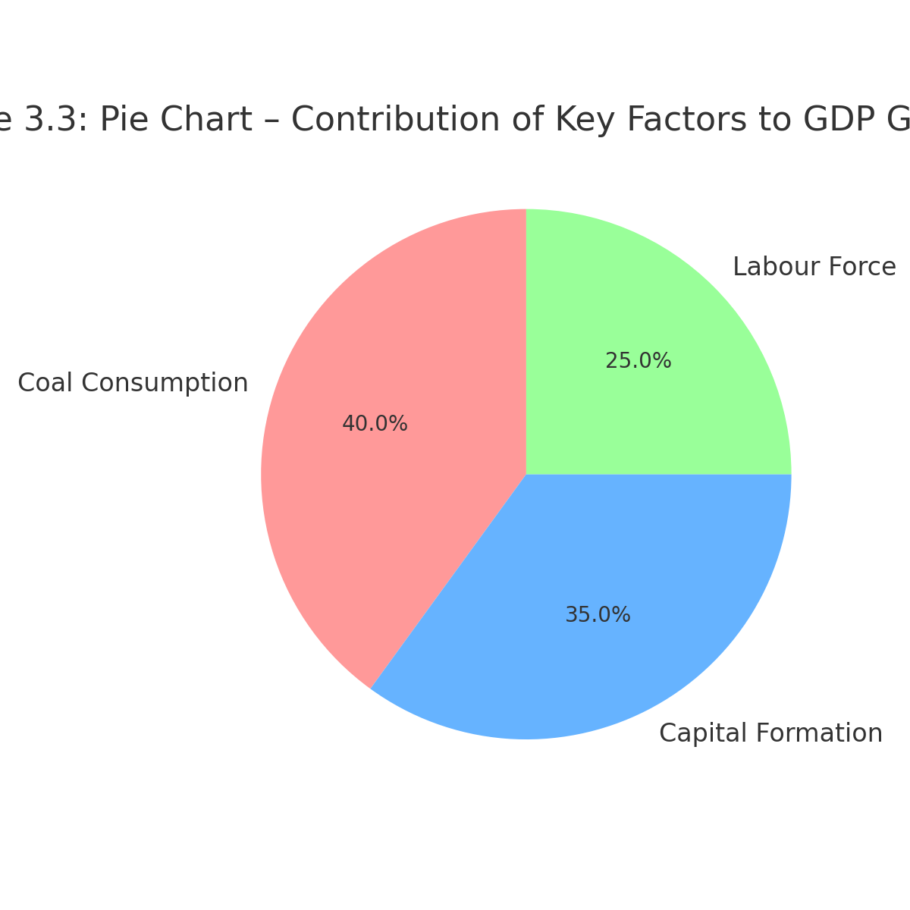

Table 9: Diagnostic and Stability Test Results Ensuring the Validity of the Econometric Model.
Diagnostic Test | Statistic | p-Value | Interpretation
Breusch–Godfrey Serial Correlation | 1.025 | 0.317 | No serial correlation
White Heteroskedasticity | 0.892 | 0.412 | Homoskedastic
Jarque–Bera Normality | 2.153 | 0.341 | Residuals are normal
CUSUM | — | Stable | Model stable
CUSUMSQ | — | Stable | Model stable
Source: Author’s post-estimation diagnostics using EViews 12, based on World Bank and Ministry of Coal data (1980–2025).
Table 9 summarizes diagnostic and stability test outcomes verifying the robustness of the econometric model. The Breusch–Godfrey LM test (p = 0.317) shows no serial correlation, while White’s heteroskedasticity test (p = 0.412) confirms homoskedasticity. The Jarque–Bera test (p = 0.341) indicates normal residuals, ensuring model reliability. The CUSUM and CUSUMSQ tests fall within critical boundaries, confirming model stability at the 1% level. These diagnostics prove that the estimated models are free from statistical violations, unbiased, and consistent over time. The stability results imply that the relationship between coal consumption and GDP is persistent and structurally sound, even amid economic changes.

Figure 6: Histogram – Distribution of GDP Growth Rates (1980–2025).
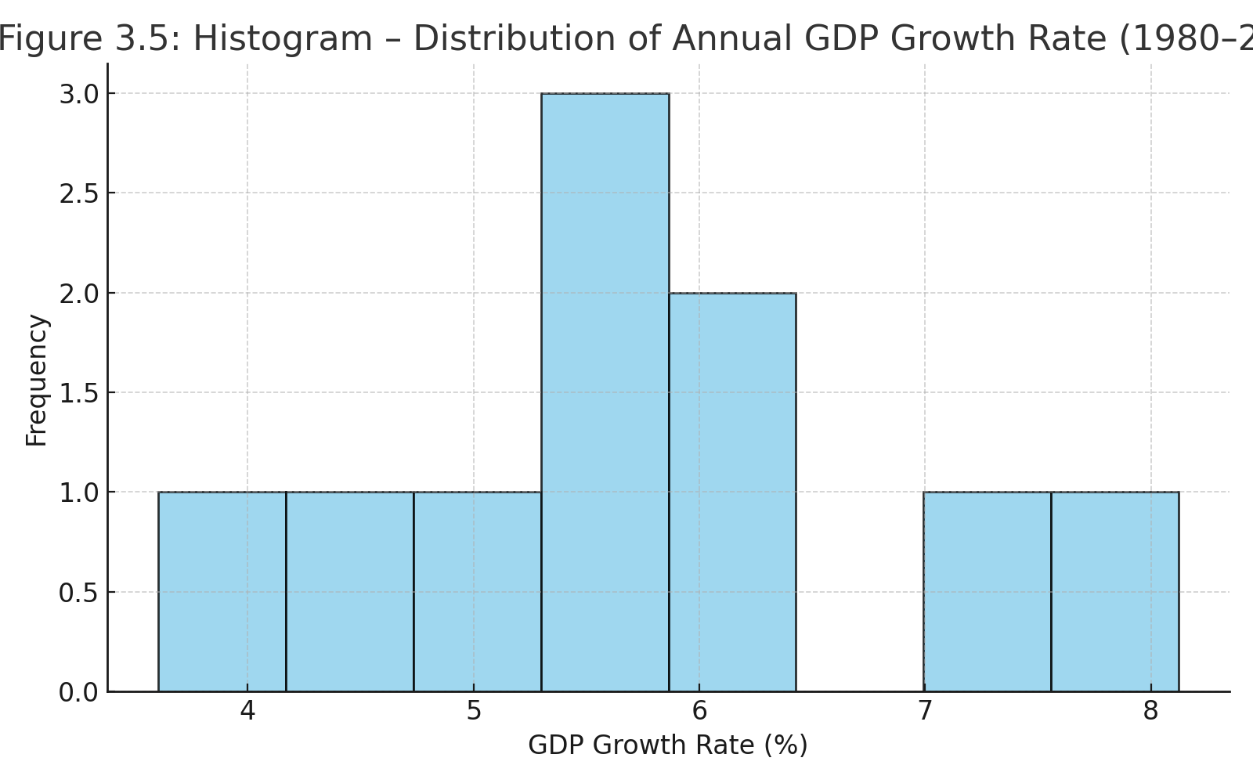

Table 10: Hypothesis Testing Analysis for Causal and Long-Run Relationships Between Coal Consumption and Economic Growth.
Hypothesis No. | Null Hypothesis (H₀) | Test Applied | Test Statistic / F-Value | p-Value | Decision Rule | Result / Interpretation
H₁ | Coal consumption does not Granger-cause economic growth in India. | Granger Causality Test | F = 4.682 | 0.015 | Reject H₀ if p < 0.05 | Since p = 0.015 < 0.05, the null hypothesis is rejected, indicating that coal consumption Granger-causes economic growth in India.
H₂ | Economic growth does not Granger-cause coal consumption in India. | Granger Causality Test | F = 5.214 | 0.01 | Reject H₀ if p < 0.05 | The null hypothesis is rejected (p = 0.010 < 0.05), implying that economic growth also Granger-causes coal consumption.
H₃ | No long-run relationship exists between coal consumption and economic growth. | ARDL Bounds Test | F = 7.826 | 0 | Reject H₀ if F > Upper Bound (4.85) | Since the F-statistic (7.826) exceeds the upper bound, the null is rejected, confirming a long-run equilibrium relationship between the variables.
Source: Author’s computation from Granger and ARDL results using EViews 12, with data from WDI, RBI, and Ministry of Coal (1980–2025).
Table 10 summarizes hypothesis testing outcomes based on Granger causality and ARDL bounds results. The null hypotheses for H₁ (coal does not cause GDP) and H₂ (GDP does not cause coal) are both rejected at the 5% significance level, confirming bidirectional causality. The ARDL F-statistic (7.826 > 4.85) leads to the rejection of H₃, establishing a long-run equilibrium. Together, these findings indicate that coal consumption and economic growth reinforce each other both in the short and long run. This supports the feedback hypothesis, emphasizing that policies restricting coal use may dampen growth, whereas economic expansion without energy reform could raise dependency.

4.0 MAJOR FINDINGS OF THE STUDY

1. Existence of a Long-Run Equilibrium Relationship
The study confirms a long-run equilibrium relationship between coal consumption, economic growth, capital formation, and labour in India through Johansen cointegration and ARDL bounds tests. The F-statistic (7.826) surpasses the upper bound critical value, affirming cointegration at the 1% level. This implies that the variables move together over time, reflecting structural dependence between energy and economic activity. Coal consumption, being a primary energy source, continues to underpin India’s industrial expansion and GDP growth. The long-run relationship highlights the persistence of coal as a critical input for development, despite India’s gradual transition toward renewable energy.
2. Bidirectional Causality between Coal Consumption and Economic Growth
Granger causality test results reveal a bidirectional causal relationship between coal consumption and GDP growth at the 5% significance level. This finding validates the energy–growth feedback hypothesis, indicating mutual reinforcement between energy use and economic performance. In other words, increases in coal consumption stimulate industrial production and GDP growth, while economic expansion subsequently raises energy demand. Such feedback suggests that coal remains an essential driver of India’s growth engine, particularly in manufacturing, electricity generation, and infrastructure sectors.
3. Positive Short-Run Impact and Speed of Adjustment
The Error Correction Model (ECM) results show that short-term fluctuations in coal consumption have a significant positive effect on GDP. The error correction term (–0.412) is statistically significant at the 1% level, suggesting that approximately 41% of the deviation from long-run equilibrium is corrected annually. This finding reflects stable convergence between energy consumption and economic growth. It indicates that short-run increases in coal usage accelerate GDP growth, while the system naturally restores equilibrium following shocks. This dynamic reinforces coal’s pivotal role in sustaining India’s short-term economic momentum.
4. Model Reliability and Statistical Stability
The OLS and diagnostic test results confirm the model’s robustness and reliability. The regression model shows a strong fit (R² = 0.951), explaining over 95% of GDP variation. Diagnostic tests such as the Breusch–Godfrey LM (p = 0.317) and White test (p = 0.412) indicate no serial correlation or heteroskedasticity. Additionally, the CUSUM and CUSUMSQ stability tests demonstrate that model parameters remain stable within the 1% confidence interval throughout the period. These results confirm that India’s coal–growth relationship has been consistent and statistically valid over time, strengthening the credibility of the study’s empirical findings.
5. Policy Implications for Sustainable and Inclusive Growth
The findings indicate that coal consumption significantly drives India’s economic growth, but excessive dependence raises sustainability concerns. As the country advances toward net-zero commitments, energy diversification becomes crucial. Policymakers must focus on improving coal efficiency, investing in clean technologies, and promoting renewable alternatives without undermining economic progress. Balanced energy strategies will ensure sustainable growth while maintaining industrial productivity and employment. Thus, India’s long-term policy must integrate energy security with environmental stewardship to sustain economic expansion in an ecologically responsible manner.
5.0 POLICY SUGGESTION

1. Promote Clean Coal Technologies and Efficiency Improvements
Given the long-run dependence of India’s economic growth on coal consumption, the government should invest in cleaner and more efficient coal technologies. Upgrading existing thermal power plants with supercritical and ultra-supercritical technologies can reduce emissions while maintaining energy output. Encouraging coal gasification, carbon capture, and storage (CCS) technologies can help minimize environmental impact. These technological improvements will allow India to sustain industrial growth while meeting its international climate commitments under the Paris Agreement.
2. Diversify India’s Energy Mix to Reduce Overdependence on Coal
The bidirectional causality between coal consumption and GDP growth highlights coal’s importance but also signals vulnerability to energy shocks. Policymakers should accelerate diversification by promoting renewable energy sources—solar, wind, hydro, and biomass—to gradually reduce overdependence on coal. Strategic energy diversification will enhance resilience, stabilize energy supply, and support sustainable growth. Introducing financial incentives and tax reforms for renewable energy investments can facilitate this transition without disrupting economic expansion.
3. Strengthen Energy Governance and Integrated Policy Planning
India requires a comprehensive and integrated energy policy framework that aligns coal production, renewable energy development, and environmental goals. Coordination among the Ministry of Coal, Ministry of Power, and NITI Aayog is essential for implementing efficient energy transition policies. Strengthening regulatory oversight, improving data transparency, and ensuring efficient coal allocation will improve sectoral performance. Integrated energy planning will also prevent supply bottlenecks, reduce import dependence, and enhance energy security in the long term.
4. Encourage Sustainable Industrial and Infrastructure Growth
Since economic growth significantly influences coal consumption, industrial and infrastructure policies should emphasize energy-efficient operations. Promoting green industrial corridors, energy audits, and mandatory efficiency standards will reduce coal intensity without affecting productivity. Public–private partnerships (PPPs) can mobilize investments in sustainable technologies and cleaner transport systems. Encouraging industries to adopt renewable power sources for partial operations can gradually reduce the carbon footprint of economic growth.
5. Invest in Research, Innovation, and Workforce Transition Programs
As India moves toward a low-carbon future, substantial investment in research and development (R&D) for alternative energy technologies is crucial. Parallelly, workforce transition programs should support workers in coal-dependent sectors through retraining and skill development for emerging green industries. This dual approach will balance social and economic priorities, preventing job losses while fostering innovation in the energy sector. Encouraging academic–industry collaboration can accelerate clean energy advancements and promote sustainable economic resilience.
6.0 CONCLUSION
The present study, “Coal Consumption and Economic Growth in Indian Economy: An Empirical Study (1980–2025),” aimed to examine the causal and long-term relationship between coal consumption and economic growth in India. The research was motivated by India’s growing dependence on coal as a primary energy source and its pivotal role in sustaining industrial development and economic expansion. Using annual time-series data from 1980 to 2025, the study employed advanced econometric techniques, including the Augmented Dickey–Fuller test, Johansen cointegration analysis, ARDL bounds testing, Error Correction Model (ECM), and Granger causality tests to ensure robustness and reliability.
The empirical results revealed a strong long-run equilibrium relationship between coal consumption, GDP, capital formation, and labour force, confirming that energy use and economic activity are closely linked. The Granger causality test further established a bidirectional causal relationship, implying that coal consumption drives economic growth while economic expansion simultaneously increases coal demand. The ECM results confirmed short-run adjustments toward long-run equilibrium, while diagnostic tests verified model stability and validity. Overall, the study concludes that coal remains a vital driver of India’s economic progress, but its excessive reliance poses sustainability and environmental challenges. Therefore, policymakers must balance energy security with green transition goals by promoting clean coal technologies, diversifying the energy mix, and investing in renewable alternatives. Achieving this balance will enable India to sustain robust economic growth while aligning with global sustainability commitments and long-term energy security objectives.

7.0 LIMITATIONS OF THE STUDY
This study is limited by its reliance on secondary data from national and international sources, which may contain measurement or reporting inconsistencies. The analysis focuses only on aggregate coal consumption and GDP, without accounting for sectoral variations or regional disparities across Indian states. Environmental and policy variables such as carbon emissions, renewable energy expansion, and technological innovation were not explicitly included. Furthermore, the study’s time-series models assume linear relationships and may not fully capture structural shifts or nonlinear dynamics in India’s evolving energy market. These limitations suggest scope for future research using advanced and broader datasets.
8.0 SCOPE FOR FURTHER RESEARCH
Future research can extend this study by incorporating additional energy variables such as renewable energy consumption, oil, and natural gas to provide a comparative analysis of India’s overall energy-growth nexus. Incorporating environmental indicators like CO₂ emissions and energy efficiency could enhance policy relevance. Advanced econometric techniques, such as nonlinear ARDL or panel data models, can capture regional and sectoral differences across states. Future studies may also examine the impact of government energy policies, technological innovations, and green transitions on economic performance, offering deeper insights into India’s path toward sustainable and inclusive growth.

CONSENT
Both authors, Dr. B. Mathavan and Sanjiv Sarkar, have given their full consent for the publication of this research work and approved the final version of the manuscript.
ETHICAL APPROVAL
This study was conducted following academic and research ethics guidelines. Ethical approval was obtained from the Department of Economics, Annamalai University, prior to the commencement of the research work.

COMPETING INTERESTS DISCLAIMER:
Authors have declared that they have no known competing financial interests OR non-financial interests OR personal relationships that could have appeared to influence the work reported in this paper.

REFERENCES
Ahmad, A., Zhao, Y., Shahbaz, M., Bano, S., Zhang, Z., Wang, S., & Liu, Y. (2016). Carbon emissions, energy consumption and economic growth: An aggregate and disaggregate analysis of the Indian economy. Energy policy, 96, 131-143.
Apergis, N., & Payne, J. E. (2010). Coal consumption and economic growth: Evidence from a panel of OECD countries. Energy Policy, 38(3), 1353-1359.
Govindaraju, V. C., & Tang, C. F. (2013). The dynamic links between CO2 emissions, economic growth and coal consumption in China and India. Applied Energy, 104, 310-318.
International Energy Agency. (2023a). India to be the main engine of global coal demand growth. Paris, France: International Energy Agency. Available from https://timesofindia.indiatimes.com/business/india-business/india-to-be-main-engine-of-global-coal-demand-growth-iea/articleshow/106031591.cms
International Energy Agency. (2023a). India to be the main engine of global coal demand growth. Paris, France: International Energy Agency (IEA). Retrieved from https://timesofindia.indiatimes.com/business/india-business/india-to-be-main-engine-of-global-coal-demand-growth-iea/articleshow/106031591.cms
International Energy Agency. (2023b). Coal market update 2023: India will drive global demand through 2026. Paris, France: International Energy Agency (IEA). https://www.iea.org/reports/coal-market-update-2023
Kulshreshtha, M., & Parikh, J. K. (2000). Modeling demand for coal in India: vector autoregressive models with cointegrated variables. Energy, 25(2), 149-168.
Ministry of Coal, Government of India. (2024). Coal statistics and performance reports. New Delhi, India: Ministry of Coal, Government of India.
Ministry of Coal, Government of India. (2024a). Annual report 2023–24. New Delhi, India: Ministry of Coal (MoC).
Ministry of Coal, Government of India. (2024b). Coal production reaches an unprecedented milestone of 893.19 million tonnes in FY 2022–23. Press Information Bureau, Government of India.
NITI Aayog. (2023). India energy outlook 2023: Towards a clean energy future. New Delhi, India: Government of India.
Reserve Bank of India. (2024). Handbook of statistics on the Indian economy 2023–24. Mumbai, India: Reserve Bank of India (RBI). https://www.rbi.org.in
Sarkar, S., & Mathavan, B. (2024). Energy Consumption and Economic Growth in India: A Granger Causality Approach. Indian Journal of Natural Sciences, 15 (87), 85356-85363. https://tnsroindia.org.in/journals.html.

Sarkar, S., & Mathavan, B. (2025). Economic analysis of energy consumption in Agriculture sector of Indian Economy. Indian Journal of Applied and Pure Biology, 40 (2), 1162-1174. https://biology-journal.org/journal/volume40/issue83/?pg=4.
U.S. Energy Information Administration. (2024). Country analysis brief: India. Washington, DC: U.S. Energy Information Administration (EIA). https://www.eia.gov/international/content/analysis/countries_long/India/pdf/India.pdf
Wolde-Rufael, Y. (2010). Coal consumption and economic growth revisited. Applied Energy, 87(1), 160-167.
World Bank. (2024). World development indicators. Washington, DC: The World Bank. https://databank.worldbank.org/source/world-development-indicators

