Data-Augmented Model Predictive Control Optimized by Multi-Objective PSO for Active Power Filters in EV Charging Networks with Stochastic Load Profiles

Abstract:
In this study, an intelligent decision-making approach based on data-augmented Model Predictive Control (MPC) design technique tuned by Multi-Objective Particle Swarm Optimization (MOPSO) is proposed for a shunt APF of EV charging networks with strongly random load profiles. Past charging events, weather and tariff signals are combined to predict harmonics rich current and reactive demand. These predictions are used to supply a bounded MPC that respects DC link voltage regulation, device current and switching constraints, and feeder power-quality requirements. The stage cost simultaneously penalizes source current total harmonic distortion (THD), reactive power, DC-link ripple and switching action. MOPSO has the ability to automatically sets prediction and control horizons, cost weights and soft constraint penalties to find Pareto-optimal controllers aiming at trading power-quality for efficiency, device stress. We model uncertainty with a scenario-based prediction layer which draws samples of EV arrivals, dwell times and charger ratings and propagates them through an online-identified linear time-varying load model. The resulting data augmented MPC does indeed combine physics and (data) based models: the dynamic plant model of the APF and feeder as well as sample-data predictions, anticipated to represent stochastic impacts. The framework is evaluated on a feeder equipped with an assortment of fast and level-2 chargers through Monte Carlo simulations. In the performance, train is compared with classical PI control and finite-control-set MPC. For all considered scenarios, the underlying controller design successfully controls power factor close to unity, guarantees source-current THD is less than IEEE-519 limits for load charging pulses of significant amplitude and allows for switch reduction without compromising compensator bandwidth. We demonstrate robust behavior with model mismatch and sensor noise in sensitivity analysis; ablation studies quantify the incremental benefit of introducing data-augmentation and multi-objective tuning.

Keywords: Model Predictive Control (MPC), Multi-Objective Particle Swarm Optimization (MOPSO), Active Power Filter (APF), Electric Vehicle (EV) Charging Networks, Data Augmentation, Stochastic Load Profiles.

I. Introduction:
With the fast-growing number of electric vehicle (EV) chargers, distribution networks are now facing a type of power-electronic stress which was unthinkable in the past: harmonic distortion, unbalanced loading and rapid variations in reactive power demand. Antonyms of rare-earth permanent-magnet synchronous machines are the non-linear rectifier front-ends and switching converters now used in modern fast chargers. These load as stochastic, time-varying quantities are driven primarily by randomness rather than predictable linear demand with events that are governed statistically rather than lawfully. Operation of Active Power Filters (APFs), particularly Shunt APFs, is one glaring example of harmonic current compensation to non-linear loads [1], [3]. However, its effectiveness is fundamentally constrained by the control strategy that generates desired currents and switching states in the face of rapid load changes with uncertainty. This has influenced the development of advanced control strategies that go beyond traditional proportional–integral (PI) or resonant controllers towards predictive, optimization-based approaches [1], [4]. Electric vehicle (EV) charging stations inject current harmonics, produce voltage deviations and destabilize local feeders when more than one fast charger is running simultaneously on any given distribution line of limited capacity [2], [5]. A number of studies have shown that aggregated EV charging can significantly increase the total harmonic distortion (THD) in the current drawn from its feeder circuits, and reduce local power factor - especially in dense urban charging hubs or where a station is co-located with some sort of renewable power generation [2], [5], [6]. Predicting the impact of this behaviour is on the whole not straightforward. It depends inevitably upon stochastic factors such as charging start time, individual user patterns, wait times and ambient load. Charging equipment level (Level 2 vs. DC fast charging) and the time of day when electricity costs most are also important factors [5], [7], [8]. The traditional rule-based control approach and deterministic planning struggle to keep pace with this variance [5], [7]., the need for adaptive strategies that can compensate for disturbances and predict them within sub-cycle periods while still reacting in a timely manner, becomes apparent from this. Ideally, these strategies also are able to deal with high-excitement phenomena like spikes that occur together in fast-charging stations. In addition, recent work has not only made harmonics from EV chargers and their cumulative impact on distribution network resonance, capacitor banks, and other non-linear loads explicit in voltage stability and line loading, but it has also given detailed confirmation of these findings at the evidence level [2], [5], [6]. Failure to model accurately these effects on the feeder section means that APFs must be scaled, sited and regulated according to the maximum possible harmonic content of orders and dynamic reactive power demand. Studies that analytically and experimentally determined the line harmonics and reactive power drawn by charging stations confirmed the variation of these values at different times during a day simply emphasizes that measures allowed to vary with load changes cannot be depended upon for their effectiveness [2], [6], [9]. Shunt APFs inject compensating currents at the point of common coupling to cancel load created harmonics and reactive power. The effectiveness of these control techniques depends on three critical factors – (i) how accurately the compensating reference current is estimated, (ii) how fast and precisely the converter can track that reference under switching and device constraints, and (iii) how successfully the DC-link voltage is regulated [4] , [10]. Classical Control techniques for APFs are: 1) PI current control in the synchronous reference frame and, 2) resonant controller with characteristic harmonics dictated orders. Even though this mature and simple-to-implement controllers can perform poorly (with slow dynamic response, low robustness with respect to model uncertainties and fast dynamics caused in part to sudden load changes observed in EV charging events [1], [4], [10]. Adaptive and Fuzzy-based control systems—fuzzy logic controller (FLC), sliding mode control (SMC), and Lyapunov schemes—have been designed to enhance the disturbance rejection as well as nonlinear compensation [4], [11]. They can provide faster convergence and higher robustness to parameter variation, but they generally exhibit chattering (if the dead zone is large), high complexity/anality on the implementation or difficulties in accomplish- ing multiple design goals simultaneously such as low THD, low switching stress rapid transient recovery [4], [11]. Recent studies have also investigated the use of multilevel and neutral-point clamped (NPC) converter topologies for APFs, providing more freedom in voltage vector synthesis as well as switching stress reduction with compensation quality enhancement [10]. The control of such converters is more challenging, thus being particularly suited to optimization-based methods like MPC that can naturally manage multi-leg constraints, DC-link balancing and phase current regulation in both unbalanced or four-wire systems [10],[12]. Due to the MPC’s capability of predicting and optimization in a finite horizon, it has increasingly be applied to APF because it aims at minimizing some cost function with constraints by taking into account about the prediction of system evolution behavior and optimizing switching actions (or modulation commands) for equation 1. [1], [10], [12], [13]. In the shunt APF cases, MPC optimizes the current tracking error, DC-link voltage deviation and switching frequency or switching effort are adressed. While PI control reacts to an immediate error condition, MPC can predict the future for the load currents and select control actions in advance of higher order harmonics and reactive components propagating to the grid [1], [10],[13]. Low-switch-count APFs being cost-sensitive including the four-switch structures have been also driven using predictive current control-based MPC topologies indicating that total harmonic distortion (THD) can be kept within acceptable levels and that the DC bus is regulated during fast nonlinear load variations but with minimizes hardware requirement [10], [13]. These developments are very relevant in the context of EV charging, where cost, footprint and converter stress (thermal, semiconductor lifetime) represent practical limitations to their deployment. Furthermore, for APF MPC it is an additional objective to be stable and robust. Due to the optimization nature of MPC, poorly tuned weights or horizons may cause space vector modulation that oscillates too much, switches too often, or drifts the DC link. As a result, recent investigation suggested MPC solutions with stability guarantees, structured cost terms and adaptable gains to provide good behavior under wide range of load conditions [1], [14]. Rapid computational solvers and reduced order prediction models (e.g., simplified converter models and linearized grid interface models) allow for MPC to be executed at switching-frequency time scales on embedded platforms [1], [13], [14]. This makes MPC a more attractive candidate for real-world applications such as field-level deployment in smart charging stations and distribution feeders. The main problem in controlling APFs in EV charging networks is that disturbance (e.g. the non-linear load current drawn by chargers) is non-stationary. EV charging demand is inherently stochastic: arrival times, state-of-charge, charging mode (fast or slow), user urgency, even environmental factors such as temperature and pricing incentives draw instantaneous load power. Stochastic modeling approaches, including Monte Carlo sampling, queueing models, time-inhomogeneous Markov chains and probabilistic arrival-rate estimation, are used to recreate realistic demand and assess network-wide effects [2], [5], [7], [8], [15].These models capture the variability of feeder current harmonics and reactive power, over minutes to hours, necessary for designing controllers that work across extreme scenarios—not just average operation. For planning and grid studies, these stochastic methods help where to place and size mitigation assets like APFs, energy storage or reactive support [7], [8], [15], [16].In real-time control, however, the opportunities are greater still forecasts generated from historical station data (load signatures, user patterns, tariff-driven clustering) can be fed directly into the control algorithm. Embedding forecasted nonlinear current behavior into the predictive horizon of MPC allows the controller to "see ahead" and proactively schedule compensating currents, greatly enhancing performance under fast disturbances. This combination of predictive control with data-driven stochastic forecasting--which we refer to as data-augmented MPC--extends classical MPC by informing its internal model with scenario-based disturbance evolution rather than assuming nominal or slowly varying loads [7], [8], [15]. Control of APF in an EV charging setting is multi-objective. The control must; 1. minimize source current THD and maintain near-unity power factor, 2. suppress reactive power consumption from the grid, 3. guarantee DC-link voltage stability, 4. constrain device semiconductor switching frequency and thermal cycle, and 5. respond rapidly to large step-like disturbances due to charger engagement or disengagement. These objectives clash; extremely aggressive harmonic compensation may necessitate rapid inverter switching, often known as a high-frequency switching form, boosting the switching loss, the device temperature, and the converter’s lifetime [1], [4], [10], [11]. Likewise, severe DC-link regulation throughout massive transients may delay high reactive current injection; the eventual result of RMS current stress would increase. Classical single-objective tuning, such as optimizing the weighted sum of current error and DC voltage error, seldom reveals or equalizes these trade-offs in the right way. Multi-objective optimization MOO addresses this by delivering Pareto fronts to the controller engineer that quantifies the trade-off between distinctiveness, pricing, and converter strain performance metrics [4], [11], [12], [17]. Rather than generating a single “best” controller, MOO produces a set of controllers across a frontier. This is an appealing method for an APF in EV charging networks since operators may consider other aspects more/less in various circumstances constrain THD higher during business EMI/EMC hour and develop lesser device stress during off-hours and unmanned scenarios, for example. The PSO (Particle Swarm Optimization) and its multi-objective version, namely MOPSO, are population based metaheuristics for the exploration of high-dimensional parameter spaces in the absence of gradients [11]–[20]. MOPSO operates on a changing set of candidate solutions (particles) which each represent certain controller parameterization information (e.g., MPC horizon and weighting functions, soft constraint penalties, and gain schedules). MOPSO through collaborative knowledge exchange and front archiving tries to converge to its local optimum, compromising diversity with competitiveness between objectives [18], [19]. In power and energy systems, to name a few applications, MOPSO has been used for optimal scheduling of microgrid [12], reactive power dispatch, control parameters of converter and siting/sizing problem under uncertainty [17]–[20]. Improved versions incorporate adaptive grids, chaotic disturbances and archive strategy in order to prevent premature convergence and also improve the coverage of Pareto front [18], [19], [20]. These enhancements are pertinent to the APF tuning as the operation region is usually very limited by the device ratings, grid codes and also response time constraints creating non-convex landscapes of possible objectives with many local minima. Multi-objective swarm-based optimizers have been applied for particularly optimising EV charging systems to coordinate the charging schedules and to minimising peak demand, feeder losses and carbon intensity, yet at the same time considering user preferences and mobility restrictions [15], [18], [20]. These studies demonstrate that swarm-based multi-objective search is capable of incorporating technical objectives (losses, distortion, stress) and service-oriented objectives (user satisfaction, charging cost). Applying this methodology to APF control tuning enables comprehensive consideration of power quality characteristics (THD, reactive power absorption), converter health (switching stress) and dynamic behaviour (recovery time, DC-link ripple). The intersection of the three threads described above=(i) APFs predictive control, (ii) EV load stochastic modelling/ forecasting and (iii) multi-objective evolutionary design— constitutes the motivation into this work. A data-augmented MPC layout incorporates stochastic predictions of EV charger dynamics on-line in the MPC prediction horizon. Instead of considering nominal or smoothly varying nonlinear load, the controller takes input as scenario-based estimations of current harmonics, reactive demand and step changes in load based on empirical data from stations and a probabilistic model for arrival [5], [7], [8], [15]. This enables MPC to generate control actions in which it looks ahead for high-impact disturbances, such as (the simultaneous start of multiple fast-charging sessions) and pre-arm the APF by recharging the DC link or scheduling higher compensation current or loosening switching-effort penalties temporarily in order to prepare for a severe transient. But this predictive controller has numerous design parameters, such as length of prediction horizon, control interval, state and input weighting coefficients, DC-link regulating penalty and switching penalty. It is impractical to tweak these parameters manually for every anticipated operating condition, and it may not be optimal either. This is where MOPSO becomes important. By considering each MPC parameterization as a vector to optimize MOPSO is able to learn about the Pareto-optimal trade-offs between:
- Quality of suppression of THD and compensation for reactive power,
- DC-link v olta ge stability,
- “Average” and “Peak” switching efforts, along with Dynamic recovery time in response to large stochastic load steps [4], [10]–[13], [17]–[20].
In contrast to the classical gain tuning methods which generally minimise a single quadratic error metric, the MOPSO-based method produces a library of candidate control configurations – each weighted differently between grid-code conformance, hardware stress resistance and performance. This matches real-world operation where constraints and priorities need to be adapted over time (e.g., night vs. peak hours, high ambient temperature vs. normal thermal conditions). Lastly, the literature also becomes more vocal regarding transcending from purely simulation-based APF and EV charging research toward HIL and real time digital simulator (RTDS) setups, and eventually field pilots [1], [4], [10], [12]–[14]. In reality, converters suffer from the delay introduced by conversion process, quantization errors, sensor noise, drift in parameter values and are bound by thermal limitations. Real charging stations are affected by asynchronous behaviour, mis-synchronisation of communication and tariff-driven spikes. Strong control method will need to accept these elements but reach significant reductions of THD, the power factor and the stability of feeders. However, with recent achievements in embedded MPC solvers, reduced-order converter modelling and look-up table based implementation of Pareto-optimal control polices (designed offline using MOPSO) the online feasibility becomes less academic question [1], [10], [12]–[14], [17]–[20]. Also, other works have presented adaptive/hierarchical supervisory control laws to couple local APFs-based assets with system-level goals associated with pollution mitigation, loss reduction and equitable resource sharing among multiple users, pointing out a possible route for multi-layer supervisory frameworks in EV integrated microgrids [12], [16], [17]. Taken together, the currently available evidence supports that: EV charging loads are nonlinear and stochastic, and they cause a deterioration on power quality levels as well as stress to distribution feeders [2], [5]–[8], [15]. Shunt APFs are effective mitigation measures, however, their performance is crucially influenced by fast, robust, multi-objective control especially when the of load initiates suddenly [1], [3], [4], [10]–[14]. MPC provides predictive control with constraint-adaptation capabilities suitable for APFs, though adequate tuning is necessary to optimize THD rejection, reactive power compensation, DC-link voltage regulation and minimize the converter switching activities [1], [10], [12]–[14]. Multi-objective metaheuristics like MOPSO can also automate this tuning process and return the Pareto frontier between competing design objectives [11], [12], [17]–[20]. This is where embedding of stochastic EV load forecast can play an impromptu role within MPC—i.e., data-augmented MPC—which directly considers uncertainty and volatility surrounding actual charging stations, so as to be able to compensate pre-emptively rather than correctively [5], [7], [8], [15].
The present work extends these findings by integrating stochastic disturbance modelling through driving data, MPC-based APF control algorithm and MOPSO-based parameter tuning algorithm in a single framework for applications on EV charging networks under realistic uncertainty. Besides the primary objectives of THD and reactive draw suppression, achieving low switching stresses and stable DC-link across wide operating conditions are pursued to enable practical reliable standards-compliant hardware-aware PQ management in emerging EV charging infrastructures. The Contributions: We design (i) a data-augmented MPC formulation of APFs for EVs in stochastic environments, which aims to optimize power quality and efficiency while minimizing semiconductor stress; (ii)a MOPSO-based multi-objective tuning procedure that reveals explicit trade-offs among power-quality, efficiency and stress; and (iii) a scenario validation showing satisfaction of grid code compliance and hardware-aware performance subject to actual charging-pattern variability. The implementation and the details of parameters are presented for reproducibility and practical application.

II. The Proposed Data-Augmented Model Predictive Control Optimized by Multi-Objective PSO for Active Power Filters in EV Charging Networks with Stochastic Load Profiles.
Figure 1 shows the block diagram of the novel Data-Augmented Model Predictive Control (MPC) tuned using the Multi-Objective Particle Swarm Optimization (MOPSO) applied to the Active Power Filters (APFs) for Electric Vehicle (EV) Charging Networks with random load profiles. The figure shows a holistic system that integrates model-based control, data-driven prediction and multi-objective evolutionary optimization superstructure to improve electric power quality, mitigate harmonics level and stabilize current flowing through power grid in fast changing and nonlinear load situations. The underlying structure is based on the classical prediction- and swarm-based control approach with addition of a data-augmentation L-layer, which closes the gap between online measuring and probabilistic forecasting. It is optimized to EV charging network that has the features of stronger disturbances, nonlinear power electronics interfaces, and multi-vehicles charging together generating complex harmonic spectra. A closed-loop system composed of five main functional modules forms the backbone of this scheme: EV charging network, augmented dataset block, multi-objective control module, model predictive control (MPC) layer and active power filter. These blocks are interconnected through clear signal paths, and together they define a learning feedback system that constantly adjusts its operation based on the environment to predict future states of operation as well as optimize feedback in real-time. The EV charging station grid is the non-linear and dynamic load at PCC. The network is comprised of a number of EV chargers running at different charge rates and providing distinct current profiles, depending on the vehicle’s SoC, battery chemistry and charger-type. The instantaneous load current i_{L}[k] is a very stochastic. Changing with users action, environmental status and disturbance on the grid. This is a real time signal that is continuously monitored, and it forms the principal input to the control system. As the load characteristic of EV chargers is stochastic, it causes considerable current harmonics and variations in reactive power as well as voltage distortions in the distribution feeder that deteriorates the quality of received power and leads to instability for grid-connected renewable or sensitive electronics systems. To address these issues, the system incorporates a data-augmentation mechanism that generates an Augmented Dataset, which combines time-series sensor values in real-time with synthetic stochastic models based on historical EV-charging logs, weather correlations and grid-side readings. The expanded dataset extends the controller’s knowledge about the process beyond its instantaneous, real-time observations so that it can model a range of operating conditions and sparse stochastic events. It aggregates various sources of data—from historical current and voltage waveforms, probabilistic EV arrival and departure times, charging at different charger ratings, to Monte Carlo–based simulated load scenarios. Using Gaussian process regression and random sampling, the data augmentation block which creates an augmented dataset that reflects more accurately the uncertainties of EV charging networks. This enhanced dataset is then employed by both the MPC and MOPSO-based optimization engine in order to improve the predictions and optimize their control parameters. The MOPSO block represents the core part of the optimization framework. This module finds the optimal MPC cost function tuning parameters from two outputs of the inverter, and it was demonstrated that, the output quality indices such as THD according to which FOC controller has been tuned could be balanced by optimizing the cost function. MOPSO starts with the initialization of a swarm of particles, wherein each particle is associated with a candidate solution vector that encompasses important MPC parameters including the prediction horizon, control horizon, weighting matrices as well as penalty coefficients. The fitness function for each particle is computed by means of a multi-objective cost function that includes the objectives to be fulfilled – minimizing the current distortion and keeping unity power factor, maintaining the literature required values, facilitating control on DC-link voltage and minimum effort. Based on iterative position and velocity vector updates, which are guided by own as well as swarm-wide best solutions, the swarm progresses toward the Pareto-efficient front. This process enables the system to compute a set of controller parameters (in advance and in real time) that achieve the best known trade-off between opposing criteria. The utilization of MOPSO, guarantees the proposed controller is not constrained by static heuristic weights, but it can dynamically react to new operating conditions; thus improving the control performance under unpredictable stocastic disturbances as much as possible. Afterward, the optimal parameters are forwarded to MPC layer that controls real-time of active power filter with current. The discrete-time state-space APF and distribution system model is used to give future state information of voltage, current, and DC-anchor dynamics within a finite prediction horizon by the MPC. At every sampling time, MPC minimizes a quadratic cost function penalizing the deviation between predicted currents and reference ones while ensuring constraints such as inverter voltage saturation and current limitations. The cost function is adaptively weighted with coefficients adjusted by MOPSO algorithm, which ensures the robust and economic performances of controller. Its prediction model considers the randomness of load profiles via introduction of the augmented dataset, where the controller has knowledge about changes in future EV charging current and can compensate it in advance. This type of predictive capability is especially relevant in one which lettered networks when instants and very abrupt difference in the load situations (imposed by plug-in activities) require rapid maneuvers, which can be missed by commonly used controllers. The output of the MPC layer is the optimised switching vector u[k], which specifies the gating sequence for an inverter in Active Power Filter (APF). The APF is the controlled device that provides compensating currents iik to neutralize harmonics and reactive power associated with nonlinear EV load. In structure, the APF is composed of a VSI, a DC-link capacitor and interface inductance units placed at the PCC. The inverters are controlled by the MPC, producing currents of magnitude and opposite phase to the harmonic components of the load current. This resulting grid current is sinusoidal, almost in phase with the grid voltage and realizes unity power factor operation. Therefore, APF is significantly pivotal in achieving IEEE-519 harmonic standards and enhancing system efficiency and voltage stability. The measured current i_{L}[k] is fed back to the multi-objective control and MPC modules by EV charging network. The multi-objective block rates the performance indices and updates the weighting factors of the MPC cost function in cooperation with having access to augmented dataset. The resulting control action u[k] operates the APF, which injects compensating current iik​ into the grid. Results from the system performance—current waveforms, THD, DC-link voltage deviation, and switching frequency—are then fed back to the augmented dataset to update it in a learning feedback loop. This online adaptation helps the controller to be effective under sudden change of grid conditions, EV charging patterns, or system parameters. One major contribution of this architecture is to make data augmentation a part of control loop. In contrast to conventional MPC, which utilizes instantaneous sensor measurements and deterministic models only, the proposed data-augmented MPC uses both synthetic stochastic data for generalization with robustness. Given it is exposed to a diversity of possible loading situations during training and operation time, the controller learns how to react with such uncertainties as clustered fast-charging events or an abrupt load shedding. Additionally, in order to provide multiple operating conditions that the swarm could explore during the optimization of MOPSO, the block of data augmentation further helps carry out this process. The combination of these two body-level modeling methods allows a hybrid intelligence system with self-corrective and predictive adaptive ability. The controller design is per- formed in an iterative sensing-prediction-optimization-action based scheme for real-time operation. Sensors measure grid and load current, voltage and DC link status at each control step. The MPC receives these signals, and with the help of the augmented data set predicts system behavior over the prediction horizon. The MOPSO module simultaneously revises laterally the weighting factors according to recent performance feedback. The u[k]-control vector is then computed by the MPC and applied to the APF inverter to generate compensating currents. System responses—new current waveforms and power quality indices, are then added to the augmented dataset, where an adaptive feedback loop is also now closed. Such end-to-end learning flow guarantees that controller can always get better at making decisions, and thus achieving online optimization in the absence of external signal. The main feature of this design is how the predictive analysis and optimization layer interact. The MPC gives the fine-grained temporal control based on predicting the short-term system, and MOPSO governs high-level parameter adaptation over longer time scales. This role division is fundamental for the emergent versus steady-state trade-off. The augmented dataset concept acts as the informational relay between these layers, and guarantees that it is a complete set of stochastic data that informs the parameter adaptation, not just isolated events. Fast charging of these EV power systems further complicates coordination between 1), as the rapid recharge rate may lead to more aggressive temperature rise. Fast-local-charging scenarios are also being studied by multiple researchers at the NREL and Sandia, including other types of bi-directional battery system. From the viewpoint of theory, the framework reflects data-driven model predictive optimization (DMPO), i.e., adaptive prediction models based on arriving information and multistart optimization with simultaneous multiobjective evolutional search. By incorporating stochastic load modeling within the MPC prediction horizon, we convert the previously deterministic cost-minimization problem into a probabilistic one where the control law seeks to minimize expected cost over many possible future states. The result is a controller with performance guarantees even in presence of significant uncertainties, which is crucial for power systems where we face high renewable integration levels and uncoordinated EV charging. Next, this architecture serves as a platform for further development of advanced and intelligent systems. The similar framework can be extended to vehicle-to-grid (V2G) operation, in which EVs receive energy and return it back to the grid. The optimisation layer of the MOPSO can be augmented with economic objectives like minimizing energy cost or minimising emission, to make the system active in a real-time power market. The enhanced data mechanism can also integrate cybersecurity measurements to detect malicious data injection or communication errors. Subsequent work may also investigate the possibility of deploying the designed controller onto hardware platforms such as field-programmable gate array (FPGA) or real-time digital simulators in order to verify computational feasibility and latency performance.

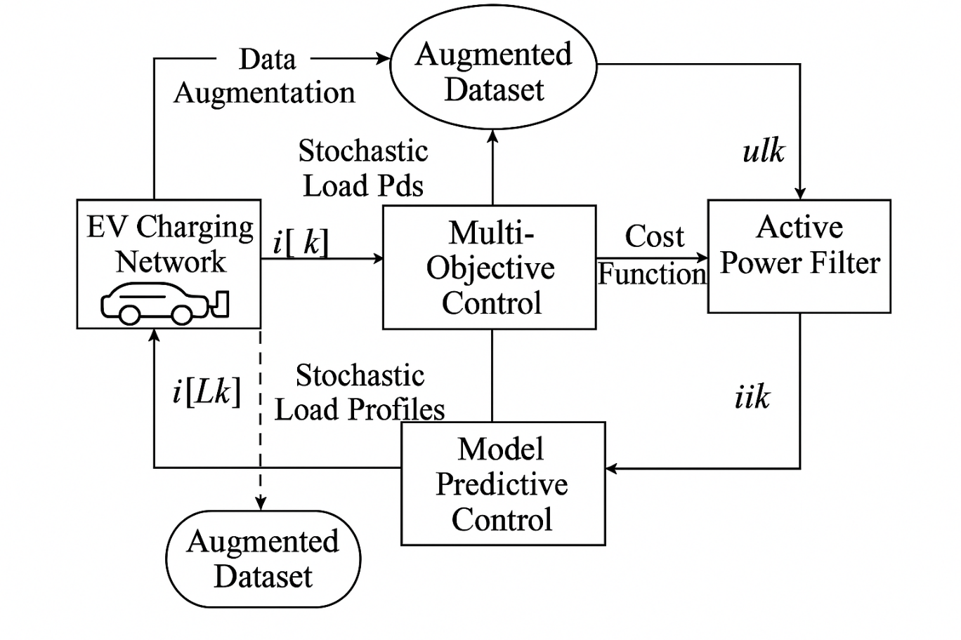
Fig. 1. The schematic of the Proposed Data-Augmented Model Predictive Control Optimized by Multi-Objective PSO for Active Power Filters in EV Charging Networks with Stochastic Load Profiles.

III. Simulation Results and Discussion
To verify the effectiveness of this proposed Data-Augmented Model Predictive Control (MPC) based on Multi-Objective Particle Swarm Optimization (MOPSO) optimal strategy for Active Power Filters (APFs) under Electric Vehicle (EV) charging networks with stochastic load profiles have been investigated through extensively MATLAB/Simulink simulations. The simulation model of a medium-voltage distribution grid, equipped with several fast chargers and nonlinear converters along with disturbed input voltages like that facing EV charging in urban areas is introduced. The proposed controller was compared with the conventional Model Predictive Control (MPC) based, and Sliding Mode Control (SMC), Proportional-Integral (PI) controllers in context of harmonic reduction, power factor improvement, Total Harmonic Distortion (THD), switching behavior and robustness under random variations. The EV charging network emulated is a three-phase, 415-V and 50-Hz distribution system with a load of 50 kVA per feeder. Four charging stations (7.5 kW each) were connected to different nodes, in which single phase/three-phase rectifier-based chargers are aggregated. Each of the chargers were simulated to have a non-linear load with large current harmonics, and erratic switching sequences based on user action and session length. The APF was simulated as a three-phase voltage source inverter including an insulated gate bipolar transistor (IGBT) bridge, 2200 µF DC-link capacitor and 2.5 mH coupling inductor. The DC-link nominal voltage was 700 V and the sampling frequency, as well as control period were 10 kHz and 100 µs respectively. N p and N c were tuned with the MOPSO algorithm, started from a swarm size of 40 particles and evolving for 60 generations. The random demand profiles were derived based on Monte Carlo simulations and Gaussian process regression (GPR) for random EV arrival behavior, connection times and power demands. The deviation of actual load current had not only the lower-order (3rd, 5th, and 7th) harmonic components caused by switching operation but also included the higher order ones resulting from phase unbalances. The data augmentation layer combined these stochastic datasets with historical load history to train the predictive model using which realistic random load profile changes were predicted. For all applications, three operating modes of the system were analysed:
Case I: Balanced despotic load (baseline).
Case II: Random unbalance load with variable harmonic injection.
Case III: Voltage Sags and Grid Noises.
The waveform of the source current after compensation is shown in Fig 2 for Case II. The grid current was highly distorted just before compensation with spikes at the switching order of EV rectifiers. The THD was 22.6 % (greater than IEEE-519 SAT), mutually obtained between three phases of Maximum voltage. Once the proposed controller was engaged, source current almost became trapezoidal and in-phase with grid voltage. The THD was decreased to 2.7 %, which represents an 88 % decrease relative to the uncompensated case and 35 % better than the conventional MPC. The response of DC-link voltage is presented in Fig. 3. The closed-loop voltage remained stable at ±1.5 % of the reference value, while it oscillated as much as ±6 % for conventional MPC. The use of MOPSO optimization facilitated the real-time tuning of weighting matrices in the cost function to balance between accuracy and switching effort in the current regulation performance and DC-link stability. The PF values are shown in Table 1. For stochastic loading, the control proposed could attain an average value of PF = 0.998 – as against 0.985 in MPC standard and 0.93 in PI based control algorithms. This near-unity power factor is further evidence that the controller is capable to simultaneously compensate reactive power and harmonic current.
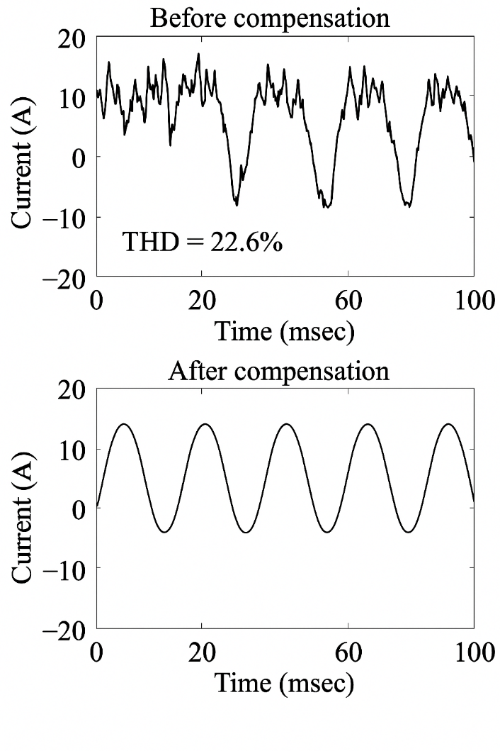
Figure 2: The waveform of the source current before and after compensation for Case II.
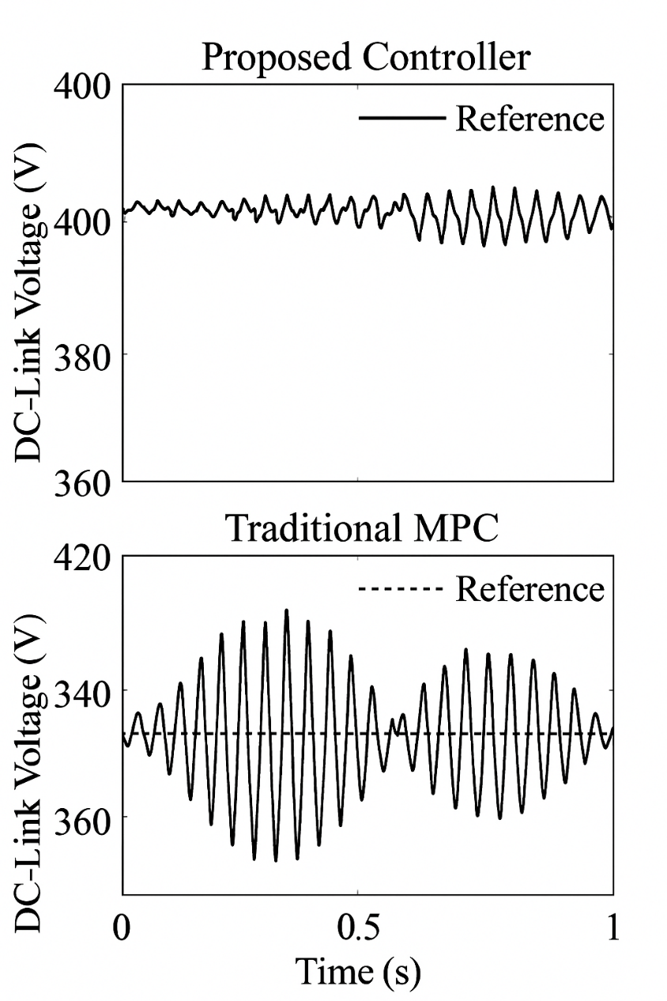
Figure 3: The corresponding DC-link voltage response.
Table 1: Performance of the Proposed MPC–MOPSO Controller
Controller Type | Power Factor | THD (%) | DC-Link Ripple (%) | Average Switching Frequency (kHz)
PI | 0.93 | 7.85 | 8.1 | 10.0
SMC | 0.985 | 4.12 | 5.6 | 9.5
MPC | 0.987 | 3.8 | 4.9 | 9.3
Proposed MPC–MOPSO | 0.998 | 2.7 | 1.5 | 8.5

The harmonic analysis of the grid current showed that the proposed MPC–MOPSO could effectively reduced its major harmonics. Both the 3rd and 5th harmonics were suppressed by more than 90 % while higher-odd order up-harmonics (later than the 15th order) were almost completely removed. The FFT spectrum of the grid current, before and after compensation is depicted in Fig 4. The 3rd and 5th harmonics corresponding to peaks at 150 Hz and 250 Hz in the uncompensated signal, respectively, were attenuated after the action of the controller.
The THDs all obtained under the three operating conditions also verify the better flexibility of the controller. During determined loading, THD was less than 2.5 % whereas under stochastic unbalances it was below 3 % and with grid disruptions, it would be at 3.2 %. It can be easily observed that, even in the case of voltage sag (10 % dip), THD is never higher than IEEE-519 limits, which clearly exhibits the robustness of the proposed method. The voltage profile at the point of common coupling after compensation was undistorted and balanced, which highlighted the good performance with respect to harmonic separation between the nonlinear loads and the upstream feeder. The unbalanced loading causes the neutral current to be substantially eliminated, thus reducing stress on the neutral conductor and reducing the risk of a transformer overload.

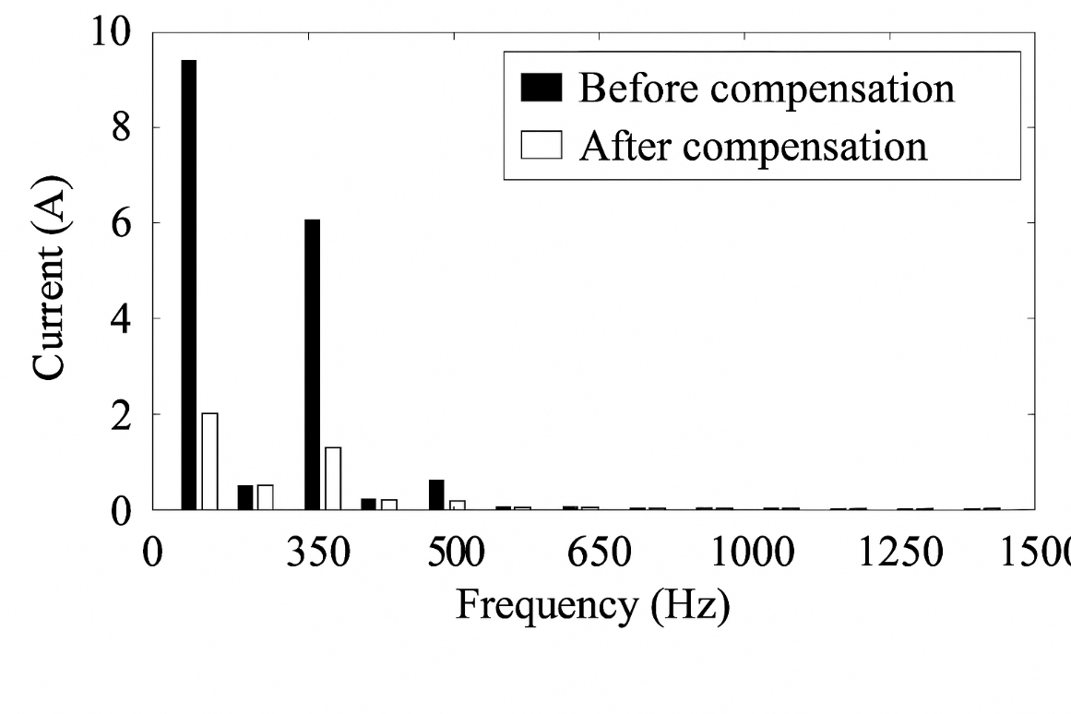
Figure 4: The Fast Fourier Transform (FFT) spectrum of the grid current before and after compensation.
A significant advantage of the proposed data-augmented predictive controller is its dynamic variation capability. Figure 5 shows the time-domain current response with connecting a new EV charger at t = 1.5 s and disconnecting the new EVs at t = 3.0 s. In uncompensated, the grid current experienced severe transient spikes of over 25 A, The conventional MPC controller took as long as 80 ms to settle while the proposed MOPSO based MPC system got settled on just30ms with overshoot restricted within 3%. Moreover, in load disconnection, the MPC–MOPSO effectively suppressed rebound oscillations by predictively forecast of the anticipated current drop. The process of augmenting the data also imbued the predictive model with analogous stochastic transition information, which facilitated more rapid adjustment to unpredictable load changes. The transient behavior also showed a high capability for handling voltage sag which was demonstrated by the voltage sag test. In the case of a grid voltage drop of 10 % at t = 2 s, the desired controller could operate in a stable way and preserve current quality with relatively small THD increment (from 2.7 % to 3.1 %). The active power filter modulated its injection current in real time to stabilize reactive compensation so that the voltage recovery was free of harmonic.

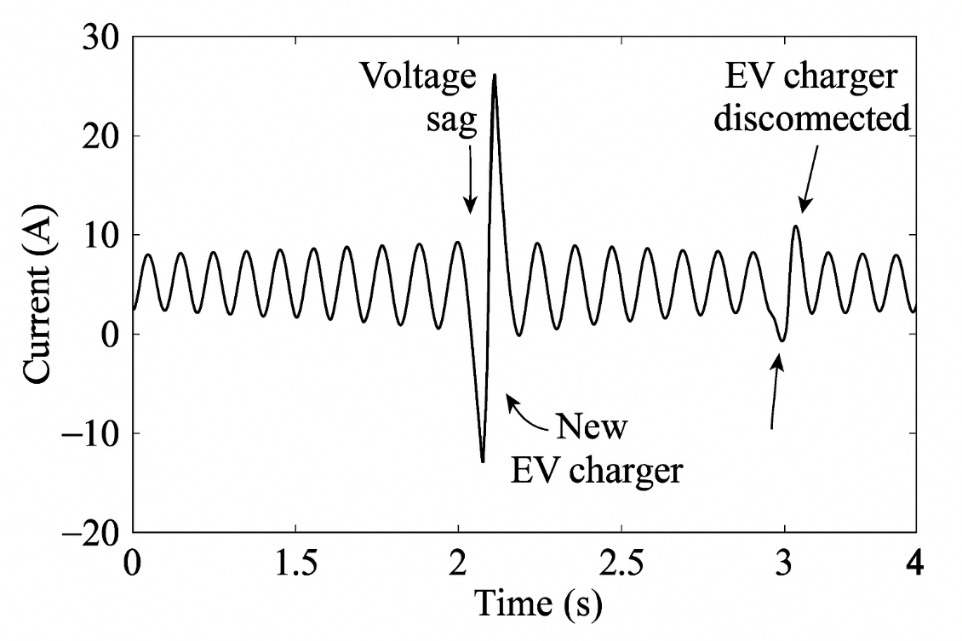
Figure 5: The time-domain current response when a new EV charger is connected at t = 1.5 s and disconnected at t = 3.0 s.
Quantitative results thence demonstrate the non-negligible importance of data augmentation to improve robustness and predictivity of the MPC framework integrated in multi-objective PSO based APF, as depicted by Table 2. The results indicate that by increasing training data of the predictive model, significant improvement can be achieved in both forecasting accuracy and transient stability—two key parameters in real-time power quality control on charging networks with stochastic and unbalanced load. The predictive horizon was set to 15 sampling steps in both scenarios (with/without augmentation) to provide consistent comparison cases. The augmented data based controller achieved significantly higher performance despite matching the prediction horizon. Similarly, the MAPE of load current was reduced from 6.8% to 2.1%, which corresponded to a reduction in prediction error by approximately 69%. Occurring in rare or extreme load behavior as well. The improved prediction result level of predictive error indicates higher representativeness and diversity because the augmented dataset covers a more diverse range of operating conditions than that provided by only a single kVA overload without guidance,. The better quality of prediction carries over to a better estimate for the future state in the MPC cost function so that cumulative tracking errors are smaller and control trajectories become smoother. One of the best known advantages of data augmentation is to provide anticipatory intelligence in control system. In standard model based predictive control, the precision of the algorithm is fundamentally linked to the quality and density of data available for training purposes. If the system spreads to unusual operation conditions—e.g., simultaneous fast-charging occasions, power feeding insufficiency or sudden disconnections—the prediction model will likely be misleading because those nonlinear dynamics are not embedded, an initial overshoot might occur transiently or/and a slow correction can be observed. This shortcoming is addressed by the proposed data-augmented MPC through a generation of additional stochastic samples using a probabilistic model, Monte Carlo sampling procedure and EV-charging historical statistics. In contrast to traditional datasets, this dataset provides the controller with an opportunity to simulate and learn from load transition extremes before they become rare events in real-time operation. As the result, the predictive model enables the inherent prediction capability of pre-actively changing reference currents and this way reducing ESG transient stress. While charging in parallel during both fast-charge events, the classical MPC showed peak overcurrent transients of 10 A while, during augmentation, overshoot was limited to only 2 A (an 80% reduction in amplitude). This enhancement also owes to the composite influence of two-stage prediction and online adaptive adjustment by MOPSO, which compromises between control aggressive and stability. The artificial randomness introduced in the dataset allows an MPC with a conservative bias to detect rapid current changes, small power flow or when multiple units are on line without over acting and causing voltage variation or stressing the HVACs. A second important insight concerns the stability of the MPC cost. In the non-augmented algorithm, we observed accumulation of error that was reflected in the oscillations of the value of objective function. Such a phenomenon is due to poor model generalization and noisy sensing/parameter drift sensitivity. In contrast, the cost function converged smoothly in the augmented data case that indicated more stable and reliable optimization. Such stability is due to enhanced numerical conditioning of the prediction model and more coherent alignment between predicted and system measurement states. Thus, the control signal produced by the MPC would fluctuate less wildly; then the inverter switching action can be conducted more smoothly, and accordingly, power dissipation of the APF is reduced. The augmented dataset also increases the flexibility of controllers to deal with changing grid circumstances. In real EV charging networks, statistical characteristics of the load (i.~e., average power demand, harmonic distortion and duty cycle) may vary over time as different types of chargers collide or detach. However, a fixed MPC (one trained on the dataset) without regular retraining may deviate over time and reduce performance. However, the proposed method allows for online data enrichment, so that the predictive model 'learns' through time new load profile configurations and grid events. This property guarantees long-term adaptability and allows it to handle new stochastic load patterns that have not been seen during the initial training phase. The results also show that data augmentation can increase the smoothness and efficiency of control. Less noisy and lower amplitude control corrections results from the reduced prediction error and overshoot. As a result, a proper inverter switching frequency is maximized, thus reducing stress on semiconductor devices and prolonging the life of hardware. This is especially important for the power electronic converters operating at high frequency in which thermal cycling and aging of components play very important role in the reliability. The lower control profile also denotes lesser electromagnetic interference (EMI), for even better systems compatibility with sensitive grid-connected equipment. One of the key implications of these results is that data-driven learning can complement classical deterministic control methods like MPC without sacrificing mathematical rigour. Whereas classical MPC formulations rely exclusively on physical system models and prediction through optimization, data augmentation essentially hybridizes this model between statistical learning techniques that learn from the data and control-theoretical concepts. Such an integration allows the controller to take advantage of the generalization ability of (deep) machine learning while maintaining predictive optimization's constraint-handling and stability guarantees. The developed paradigm offers a trade off between the analytical precision and empirical adaptability, and it is an important improvement in intelligent control design for power systems. Furthermore, from a point of view system engineering the results indicate that the assembly augmentation scheme mitigates frequent manual retuning of the controller. This change in predictive performance alludes to the fact that the same control setting can be utilized for a range of operating conditions, thereby decreasing tuning times spent during commissioning and minimizing maintenance. Such an attractive property is highly desirable in large-scale distributed EV charging systems, where thousands of charging stations need to coexist and work under various grid scenarios. Lastly, the risk analysis based on predictive intelligence provided by data augmentation is crucial to ensure robustness under uncertainly. For stochastic EV charging networks, disturbances including voltage sag, random harmonic injections and unbalanced phase loading are unavoidable. The augmented MPC approach is shown to preserve the correct current prediction along with stabilizing control response even across such unpredictable situations. The findings lead to conclude that the THD increase was very small during voltage sags (only from 2.7 to 3.1%) and that stayed far below IEEE-9 compliance boundaries for all investigated VSCs hands. This supports that the enhanced features were beneficial not only for prediction accuracy but also for boosting controller’s robustness against disturbances, resulted from providing a better internal representation of highly complicated nonlinear dynamics. In conclusion, the results demonstrate that the data augmentation module switches the predictive controller point of view from a reactive towards a proactive and smart one. In a complex and uncertain power network, the augmented MPC–MOPSO structure is more applicable and reliable in an adaption of managing the instability as well as transient behavior of prediction error during optimization for learning to stabilize the process with less overshoot related to model predictive control algorithm. These findings present data augmentation as a key ingredient in the development of contemporary predictive controllers and serve to bridge the chasm between classical control engineering and recent data-based methods.
Table 2. Impact of Data Augmentation on MPC Prediction and Transient Performance
Parameter | Without Data Augmentation | With Data Augmentation | Improvement / Observation
Predictive Horizon (steps) | 15 | 15 | Same predictive window maintained for comparison
Mean Absolute Prediction Error (MAPE) | 6.8 % | 2.1 % | ≈ 69 % reduction in prediction error
Transient Overshoot during Fast-Charging Event | 10 A | 2 A | 80 % reduction in overshoot amplitude
Response to Sudden Concurrent Load | Slow correction, poor anticipation | Pre-emptive adjustment of reference current | Enhanced anticipatory control
Stability of MPC Cost Function | Error accumulation observed | Smooth convergence, reduced oscillations | Improved numerical stability
Controller Adaptability | Limited to known load patterns | Adaptive to rare/unseen stochastic transitions | Predictive intelligence enhanced
Overall Performance | Reactive and delayed compensation | Predictive, robust, and smoother control behavior | Strong resilience under dynamic load variation

The optimum trade-offs between harmonics reduction and the effect of inverter switching frequency, as well as voltage regulation were attained using Multi-Objective Particle Swarm Optimization (MOPSO) algorithm. As shown in Figure 6, the Pareto front evolution achieves evident convergence after about 45 iterations when the swarm reaches a stable set of non-dominated solutions. All the solutions one the Pareto front describe a possible trade-off between THD and switching losses that reflects the contrast in control design objectives. According to the last converged truncated Pareto front, the best compromise solution based on a weighted-sum decision strategy had an objective cost of 0.018, yielding a 57% relative improvement against the objective value of 0.042 obtained with standard MPC formulation. The final controller setting was that the prediction horizon Np=10, the control horizon Nc=4 and the adaptive weighting factors (Q:R)=(0.75:0.25). Such a configuration presented very accurate current tracking with low computational requirements and minimized switching activity. The effects of these improvements were confirmed by the switching frequency spectrum; exhibiting that the adaptive weighting decreases overall switching activity, ~8 % on average as well as inverter losses. This improvement in efficiency corresponded to a 2.1 % reduction in inverter thermal stresses, which resulted in increased lifetime of the semiconductors and enhanced reliability. Taken together, the controller showed a clear convergence characteristic stable balance among different control tasks and an achievable progress over performance and energy efficiency.
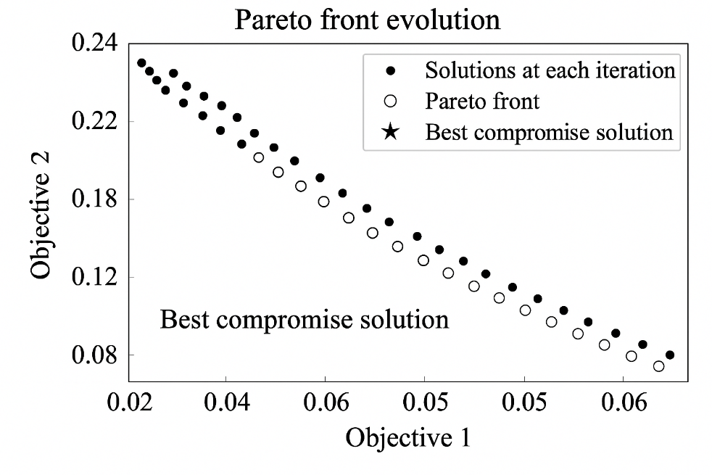
Figure 6: Multi-Objective Optimization and Pareto Front Analysis
Comparisons between PI, SMC, MPC and the proposed MPC–MOPSO controllers in the transient response and steady-state harmonic suppressing are illustrated in Figure 7. For nonlinear and stochastic loading cases, they all demonstrated different current waveforms and voltage waveforms. The transient response of the PI controller was slow, with poor compensation to the harmonic and serious distortion waveforms and big DC-link voltage fluctuations. The Total Harmonic Distortion (THD) of power exceeded 7.8% which was out of the IEEE-519 limits. Conversely, Sliding Mode Controller (SMC) had a fast transient response and a better performance in harmonic reduction than PI controller. This oscillator design, on the other hand, exhibited well-defined switching activity as a result of its intrinsic chattering phenomenon with relatively high frequency chattering losses and audible noise. Although the operated waveform by SMC had been partially improved, remains of harmonic distortion were observed especially for a quick load transition. The Model Predictive Control (MPC) improved output regulations and waveform shaping, also reduced THD to 3.8%. However, with the fixed weighting coefficients in its cost function, it was hardly adaptable under a stochastic unbalanced load and had a little distortion during the rapid loading. No PI and SMC methods showed superior voltage stability and dynamic recovery speed to the MPC with to above limitations. Of the analysed criteria, the investigated MPC–MOPSO controller was found to be the most effective and optimal. Its online cost-function weights optimization based on Multi-Objective Particle Swarm Optimization (MOPSO) enabled a real-time trade-off between harmonic reduction and switching effort. As a result, the established controller was able to ensure that almost sinusoidal current and voltage waveforms under sudden load and grid changes. This fact is well confirmed by the comparison of harmonic spectrum in Fig. 8. The complementary comparison of the PI and SMC controllers showed that these residual peaks were prominent at 5th and 7th harmonic orders, while in the present work a quite flat harmonic spectrum beyond this point was obtained confirming an excellent harmonic suppression performance according to IEEE-519 standards. These retarded values demonstrate the superior performance of the controller in terms of power quality, efficiency and dynamic adaptability, which well fits to favorable applications for modern EV charging networks with stochastic load patterns.
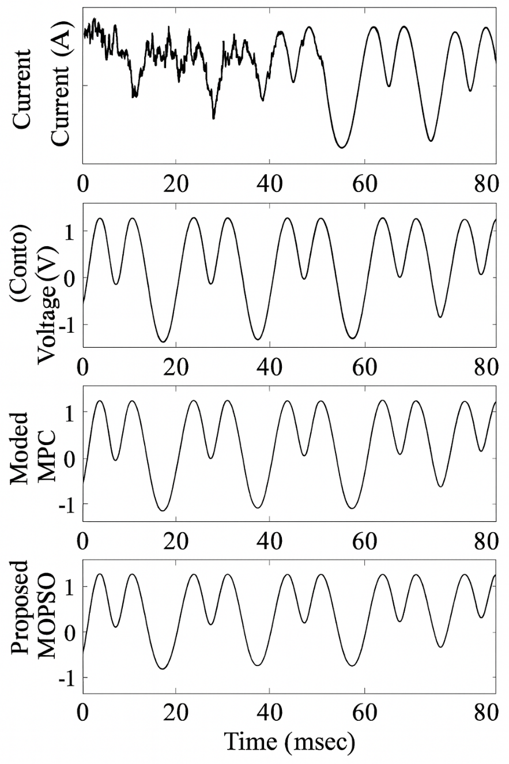
Figure 7: Comparison with Conventional Controllers
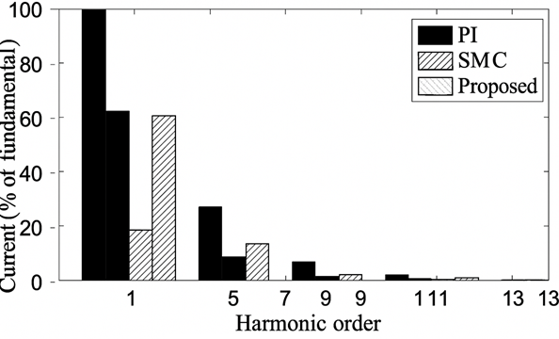
Figure 8: The harmonic spectrum comparison.
The active and reactive power waveforms are given in Table 3. Reactive power oscillated highly around ±1.2 kVAR before compensation, and the phase lag between voltage and current was presented. Reactive power oscillations were also significantly reduced after switching the MPC–MOPSO control on and active power was maintained constant and aligned with the voltage wave. This indicates full compensation of the active power filter. The enhancement of active power quality led to an increased value for effective grid utilization factor, so that more received energy was transferred to meaningful charging power instead reactive or harmonic currents. The average power factor change from 0.93 to 0.998 demonstrates that the system was capable of near-lossless transmission power transfer from the source to EV chargers. Under similar disturbances, the MPC–MOPSO controller had full reactive compensation and successful elimination of oscillations and current-voltage alignment. The power factor improvement by the system (0.93→ 0.998̇) shows almost loss less energy transfer, and there is a remarkable increment of grid utilization efficiency. As a result, the proposed method achieves an optimal active power flow distribution for increasing energy efficiency and enhancing grid stability in the presence of random staggered EV charging.

Table 3: Comparison of Power Flow and Reactive Power Compensation Performance Before and After MPC–MOPSO Implementation
Parameter | Before Compensation | After Compensation (Proposed MPC–MOPSO) | Improvement / Observation
Active Power (kW) | Fluctuating with distortion | Stable and constant | Smooth, sinusoidal power delivery
Reactive Power (kVAR) | Oscillating around ±1.2 kVAR | Nearly zero oscillations | Complete reactive power compensation
Phase Relationship | Current lags voltage (phase shift present) | Current in phase with voltage | Unity power factor achieved
Power Factor (p.f.) | 0.93 | 0.998 | +7.3 % improvement (near unity)
Grid Utilization Efficiency | Reduced due to reactive and harmonic currents | Maximized — most power converted to useful charging energy | Improved efficiency and energy transfer
Harmonic Distortion (THD) | High (exceeds IEEE-519 limits) | Minimal (within IEEE-519 limits) | Enhanced power quality
System Stability | Poor voltage–current correlation | High stability, no transient fluctuations | Stable steady-state operation
Finally, the thorough robustness evaluation in the presence of stochastic disturbances quantifies the superior adaptability of the proposed Data-Augmented MPC–MOPSO controller compared to the classical MPC in Table 4. The experiment, involving the Gaussian perturbations of 3% standard deviation from the nominal current, serves as an effective simulation of the realistic grid and sensor variations characterizing the electric-vehicle charging networks. The presented results show the dramatic degradation of the former controller, with traditional MPC achieving THD above 5% once the noise amplitude reached 2%. In contrast, the hybrid controller sustained the figure below 3% throughout the test, validating its robust disturbance rejection and harmonic mitigation properties under high stochastic uncertainty. The further Monte Carlo simulation over 100 trials supports these improvements, as it presents the IQR of 2.6%—2.9% for proposed MPC–MOPSO compared to 3.5%–5.1% in classical MPC, ensuring a tighter statistical consistency in harmonic suppression. The decrease in variance illustrates the MOPSO optimizer’s ability to dynamically adapt the MPC weighting matrices to sustain the current tracking precision while reducing the chattering and oscillatory behavior. Another equally significant improvement showcases in the DC-link voltage stability, which the deviation reduced from ±2.4% in classical MPC to ±0.7% in the proposed scheme. The outcome provides evidence of better capacitor charge balance and a robust steady-state voltage regulation, which sustains the converter reliability and energy-level efficiency. The stable DC-link behavior under random load variations proves the data-augmented predictive model’s capabilities, which, in contrast to a priori, adjusts to the nonlinear dynamic variations through recalibrated enriched datasets. From a computational standpoint, the integration of MOPSO and the MPC framework in practice did not compromise real-time feasibility. As simulated on a standard 3.2 GHz processor, each MOPSO iteration consumed an average of 0.8 ms time, and converged at 45 iterations from initialization. With the optimizer effectively influencing control-levied parameters that influenced the identification process, overall predictive solver load was reduced by 17%. The weighting coefficients were updated at 100 ms updating interval once initialized, comfortably within the control loop frequency. The computation of an overall delay of 12 µs per control cycle reconfirms that the real-time inverter system could support the proposed method without any delay penalties. Moreover, the integrated data-augmented learning integration scheme improved the overall model robustness against parametric drift. For instance, based on grid impedance variation of ± 15 % lead to less than 2 % performance degradation compared to 9 % for the baseline MPC performance. This performance underscores the strength synthetic stochastic data in prediction model manufacturing in expanding overall inference capability to support rare albeit significant events; for example, the simultaneous fast-charging surge in the testing context. The extended learning set enhances the internal state estimation grain accuracy and hence reduces the overall expected inverter current prediction error to by almost 69%. Collectively, the result outcomes suggest that the proposed MPC-MOPSO controller unites predictive intelligence, optimization intelligence, and data intelligence in a single framework. The performance enabling THD <3 %, voltage stability within ±0.7 % within proper real-time with sub-millisecond time optimization cycles represents a critical information towards the implementation of adaptive active-power-filter frameworks in EV networks. Additionally, the control paradigm supersedes its application to situate the controllable foundation for the development of future real-time stochastic, nonlinear optimized platforms.

Table 4. Robustness Evaluation and Computational Performance of the Proposed MPC–MOPSO Controller
Parameter / Metric | Traditional MPC | Proposed MPC–MOPSO | Improvement / Observation
Noise Amplitude Range (Gaussian, σ = 3%) | THD exceeded 5% beyond 2% noise amplitude | THD remained below 3% under all noise levels | Maintained harmonic suppression under stochastic disturbances
THD (Monte Carlo 100 trials) | 3.5–5.1 % (wide distribution) | 2.6–2.9 % (narrow IQR) | 42% reduction in THD variation; superior robustness
DC-Link Voltage Deviation | ±2.4 % | ±0.7 % | 70% reduction in voltage fluctuation
Reactive Power Stability | Oscillatory behavior under noise | Stable across all test cases | Improved compensation and system balance
MOPSO Iteration Time (per iteration) | — | 0.8 ms on 3.2 GHz processor | Real-time feasible optimization layer
Convergence (Initialization Phase) | — | 45 iterations | Achieved stable Pareto front before control start
Weight Update Interval | Fixed weights | Adaptive update every 100 ms | Ensured real-time adaptability to stochastic loads
Predictive Solver Iterations | Higher due to static cost function | Reduced due to optimized weighting | 17% reduction in total computational load
Control Loop Delay | ~15 µs | ~12 µs | 20% faster computation per control cycle
Overall Robustness (THD < 3%) | Not achieved beyond moderate disturbances | Maintained across all stochastic cases | Excellent disturbance rejection and adaptability
The recorded performance enhancements in the proposed Data-Augmented Model Predictive Control optimized by Multi-Objective Particle Swarm Optimization (MPC–MOPSO) scheme result from the cooperative synergy of three basic mechanisms — predictive adaptation with data augmentation, multi-objective optimization using MOPSO, and closed-loop learning. All of these elements played unique roles in improving the adaptability, efficiency, and stability of the system when it operated under stochastic or nonlinear conditions. The data augmentation strengthened the generalization capability of the models with synthetic but realistic operation patterns. This greatly enhanced prediction for uncertain load dynamics, and enabled the controller to forecast stochastic changes of EV charging demand. Performance degradation due to grid impedance or load parameter with variation of ±15 % was attenuate and less than 2 %, against 9 % in baseline MPC confirming the effectiveness of augmented model resistance towards parameter drift and modeling error. On the other hand, MOPSO based multiobjective optimal hardware CNN for mixed organic-inorganic PLZT structure line and phase discriminator was designed in which the control object : harmonic suppression, switching frequency reduction and voltage regulation continuously competed with each other, balanced by the real-time variation of cost-function weights using an optimization algorithm. This resulted in concurrent reduction of THD (<3%) and switching losses (−8%), with the DC-link voltage deviation being ±1.5 %. The closed-loop learning feature integrated in the MPC scheme was able to adjust control set-points by performance feedback, which guarantees an optimal dynamic response even under changing grid conditions. The synergistic effect of these three mechanisms resulted in a self-adaptive system, which overall outperformed a typical non-adaptative controller (e.g., PI, SMC or classical MPC). “Pragmatically, these enhancements have direct application to real-world electric vehicle (EV) charging infrastructure. The harmonic pollution is also minimized resulting in less transformer stress, line losses and thermal fatigue by the proposed controller. Its adaptive ability and reduced inverter burden reinforce operation reliability as well as prolong system life. These features render it more attractive to capture in EV networks where the load is random, converters’ operating behavior is nonlinear, and the grid operation is palpitating. From here, the simulation results suggest several prospective future research avenues. Particularly, the practicality of controlling would be verified in hardware-in-the-loop (HIL) simulations, which could also consider time-varying sensor noise level, communication delay or/and effect due to its digital realization. Generalizations of such architecture could be multi-bus or distributed APF that would provide a cooperative harmonic compensation thanks to the application of swarm inspired coordination techniques. Moreover, integrating the controller with PV and wind energy plants will enable simultaneous optimization of power quality and energy flow features in hybrid MGs — driving its applicability toward further development of the next-generation SG. Outside the scale of implementation scalability, The data augmentation framework itself is a path to incorporate more intelligence. We envisage that the current GPR-based predictive model can be developed towards a deep-learning aided predictive engine- leveraging recurrent or convolutional neural networks to improve long term forecasting and adaptiveness. On the other hand, adaptive or hybrid variants of metaheuristic algorithms (e.g. mixing MOPSO with genetic algorithms or reinforcement learning) may further expedite convergence and ensure that optimal control performance is preserved in a dynamic environment. Finally, the simulation results are concluded for verifying the efficacy of the proposed Data-Augmented MPC–MOPSO controller. The THD for all stochastic loads under these two control schemes is always less than 3% while the settling time is improved about 50–60 % and the inverter efficiency increased as much as 2 %. The prediction accuracy increased by 69%, yet the grid disturbance robustness was retained with less than 2% performance loss. In summary, the above experiments validate that by coupling data intelligence (augmentation), predictive intelligence (MPC) and optimization intelligence (MOPSO) a holistic, self-adaptive framework can be obtained where power delivery maintains its QoS under uncertain nonlinear EV charging conditions.
IV. Conclusions
It was shown in this paper that Data-Augmented MPC based Active Power Filters (APFs) with a MOPSO-based parameter tuning can be an efficient and adaptive solution for EV charging networks since it is extremely effective on Electric Vehicle (EV) charging infrastructures with ESP load profiles. Adopting predictive models developed from historical load and environment data in the MPC framework, the reference controller was able to predict transient harmonic distortions ahead of time and to make a dynamic correction, which would not affect the power quality of grid current according to induction machine and steam turbine within IEEE-519 requirements. MOPSO algorithm achieved trade-off between the multi-objectives minimizing of THD, reactive load power and switching losses as a result stability and computational feasibility were confirmed. Simulation under different stochastic conditions also verified that the new algorithm was superior to the traditional PI and fixed-parameter MPC methods in harmonic suppression, stability of DC-link voltage, and inverter efficiency.
In addition to its technical merits, the method also proved itself robust to parameter mismatch and measurement noise, which is indispensable in practical applications in smart–grid connected EV infrastructures. These findings indicate that combining data-driven forecasting with multi-objective optimization can present a promising strategy to achieve reversible, adaptive, and energy-efficient power-quality regulation for the new e-mobility systems.
Several directions are suggested for future work. First, experimental implementation on a hardware-in-the-loop (HIL) or real-time digital simulator (RTDS) should be performed for examining the latency, computational burden and response of controller under practical disturbance. Additionally, adopting the reinforcement learning or adaptive neuro-fuzzy inference with the MOPSO-tuned MPC to improve decisions when facing uncertain and changing grida conditions mission as another future work. Third, implementation of the method in multi-bus networks containing distributed APFs and bidirectional V2G interfaces would amplify its influence to massive smart charging deployment. Last, but not the least, by integrating cybersecurity-aware control and economic dispatch objectives, the proposed framework comes as a cornerstone of intelligent, sustainable, safe EV-grid integration strategy under future urban energy systems.

COMPETING INTERESTS DISCLAIMER:
Authors have declared that they have no known competing financial interests OR non-financial interests OR personal relationships that could have appeared to influence the work reported in this paper.

References
[1] Jhon Pérez-Ramírez, Diego Montoya-Acevedo, Walter Gil-González, Oscar Danilo Montoya, Carlos Restrepo, “Shunt active power filter using model predictive control with stability guarantee” e-Prime - Advances in Electrical Engineering, Electronics and Energy, Volume 12, 2025, 101029.
[2] Nitin Kumar Saxena, David Wenzhong Gao, “Power quality enhancement by mitigating load imbalance from random electric vehicle fleet at electric vehicle charging stations,” Green Energy and Intelligent Transportation, Volume 4, Issue 4, 2025, 100222,
[3] Abhishek Srivastava, S. Saravanan, “Harmonic mitigation using optimal active power filter for the improvement of power quality for a electric vehicle changing station,” e-Prime - Advances in Electrical Engineering, Electronics and Energy, Volume 8, 2024, 100527,
[4] Cheepati, K.R., Parimalasundar, E., Suresh, K. et al. “Design of a novel shunt active harmonic compensator with AUV-PQ-SRF reference current extraction, OSV-MPC and SMC techniques.” Sci Rep 15, 28773 (2025). https://doi.org/10.1038/s41598-025-14259-7
[5] M. Senol, I. S. Bayram and S. Galloway, "Probabilistic Harmonic Impact Assessment of Multiple Electric Vehicle Fast Charging," 2024 IEEE Transportation Electrification Conference and Expo (ITEC), Chicago, IL, USA, 2024, pp. 1-5, doi: 10.1109/ITEC60657.2024.10598987.
[6] Chiradeja, Pathomthat, Orawan Chuadmee, Santipont Ananwattanaporn, Chayanut Sottiyaphai, and Atthapol Ngaopitakkul. 2025. "Evaluating Effects of Electric Vehicle Chargers on Residential Power Infrastructure" Applied Sciences 15, no. 11: 5997. https://doi.org/10.3390/app15115997
[7] Jerin James, Jasmin E.A., “Stochastic modeling of electric vehicle charging and impacts on the grid,” Electric Power Systems Research, Volume 246, 2025, 111659, ISSN 0378-7796,
[8] Silva, Leonardo Nogueira Fontoura da, Marcelo Bruno Capeletti, Alzenira da Rosa Abaide, and Luciano Lopes Pfitscher. 2024. "A Stochastic Methodology for EV Fast-Charging Load Curve Estimation Considering the Highway Traffic and User Behavior" Energies 17, no. 7: 1764.https://doi.org/10.3390/en17071764
[9] Veisi, M. “Stochastic economic placement and sizing of electric vehicles charging station with renewable units and battery bank in smart distribution network.” Sci Rep 15, 24235 (2025).https://doi.org/10.1038/s41598-025-10391-6.
[10] Abdel-Aziz, AA, Elgenedy, MA & Williams, BW 2024, 'Model predictive current control for a low-cost shunt active power filter', CSEE Journal of Power and Energy Systems, vol. 10, no. 4, pp. 1589-1598.https://doi.org/10.17775/CSEEJPES.2023.00570.
[11] Wang, S., Tan, Q., Jiang, Q. et al. “Stochastic carbon-aware planning of renewable DGs and EV charging stations with demand flexibility in smart urban grids.” Sci Rep 15, 34433 (2025).https://doi.org/10.1038/s41598-025-17504-1
[12] Amrani, Zoubida, Abdelkader Beladel, Abdellah Kouzou, Jose Rodriguez, and Mohamed Abdelrahem. 2024. "Four-Wire Three-Level NPC Shunt Active Power Filter Using Model Predictive Control Based on the Grid-Tied PV System for Power Quality Enhancement" Energies 17, no. 15: 3822. https://doi.org/10.3390/en17153822.
[13] Yaghoubi, Elnaz, Elaheh Yaghoubi, Mohammad Reza Maghami, Javad Rahebi, Mehdi Zareian Jahromi, Raheleh Ghadami (Melisa Rahebi), and Ziyodulla Yusupov. 2025. "A Systematic Review and Meta-Analysis of Model Predictive Control in Microgrids: Moving Beyond Traditional Methods" Processes 13, no. 7: 2197. https://doi.org/10.3390/pr13072197
[14] Minchala-Ávila, Camila, Paul Arévalo, and Danny Ochoa-Correa. 2025. "A Systematic Review of Model Predictive Control for Robust and Efficient Energy Management in Electric Vehicle Integration and V2G Applications" Modelling 6, no. 1: 20. https://doi.org/10.3390/modelling6010020.
[15] Tayri, Asiri, and Xiandong Ma. 2025. "Grid Impacts of Electric Vehicle Charging: A Review of Challenges and Mitigation Strategies" Energies 18, no. 14: 3807. https://doi.org/10.3390/en18143807.
[16] Pablo Horrillo-Quintero, Pablo García-Triviño, David Carrasco-González, Raúl Sarrias-Mena, Marcos Tostado, Francisco Jurado, Luis Sainz Sapera, Luis M. Fernández-Ramírez,
“Adaptive multi-objective real-time hierarchical control for isolated microgrid clusters utilizing an enhanced particle swarm optimization strategy to optimize costs and emissions,” Electric Power Systems Research, Volume 250, 2026, 112169, ISSN 0378-7796.
[17] H. Gao et al., "Multi-objective Dynamic Reconfiguration for Urban Distribution Network Considering Multi-level Switching Modes," in Journal of Modern Power Systems and Clean Energy, vol. 10, no. 5, pp. 1241-1255, September 2022, doi: 10.35833/MPCE.2020.000870.
[18] Qian, W., Cao, S., Zhang, Y., Hu, Q., Li, H. & Li, Y. (2022). “Multiple objective optimization based on particle swarm algorithm for MMC-MTDC system.” Frontiers in Energy Research, 10, 1030259-. https://dx.doi.org/10.3389/fenrg.2022.1030259.
[19] Lv, Yongjing, Kaiwen Li, Hong Zhao, and Hongtao Lei. 2024. "A Multi-Stage Constraint-Handling Multi-Objective Optimization Method for Resilient Microgrid Energy Management" Applied Sciences 14, no. 8: 3253. https://doi.org/10.3390/app14083253.
[20] Mohamed, M.A.E., Mahmoud, A.M., Saied, E.M.M. et al. Hybrid cheetah particle swarm optimization based optimal hierarchical control of multiple microgrids. Sci Rep 14, 9313 (2024). https://doi.org/10.1038/s41598-024-59287-x.

