Original Research Article
Harnessing Bankable Wind-Wave Energy Potentials over Offshore Ondo State, Southwestern Nigeria

.
ABSTRACT

The study assessed the potential for renewable energy in some parts of Ondo State’s coastal locations. The research utilized hindcast data on daily averaged wave height, wave period, and 10m wind speed, averaged over one hour, from January 1, 2012, to December 31, 2024, generated using the Wavewatch III (WW3) model. The performance of the numerical model was validated against in-situ measurements from a buoy. A two-parameter Weibull distribution function, combined with the gamma function, was used to calculate wind power density. Regions with high wave power density, specifically those with seasonal averages above 6 kW/m and coefficient of variation (COV) below 2.0, were identified as rich-energy areas for wave power. The spatio-temporal variations of the wind-wave energy resources were also presented and discussed. Locations where clean renewable energy abounds within the study area were identified. Results showed that wave power is richest in waters between longitudes 3.25⁰E and 3.75⁰E of the study area. This region is most suitable for the exploitation of wave energy and the establishment and design of wave energy converter systems. The largest values of the wind power density (WPD) are found in the expansive waters between Seme Kpodji and Ghana. These locations have good potential for offshore wind energy extraction using offshore wind turbines. The renewable energy sites identified in this study stand to contribute to meeting the electricity demands of the citizens of Nigeria, particularly in the coastal areas of Ondo State, thereby reducing pressure on the nation’s national grid.

Keywords: Renewable energy; Wind power; Wave power; distribution; region; variation.

1. INTRODUCTION

The potential of the ocean for renewable energy generation is immense, and the development of the ocean energy industry is vital for a sustainable future. A vision into the future for the ocean energy industry, by harnessing the power of waves, tides, ocean thermal energy, and floating offshore wind, can induce the transformation of ocean energy systems and reduce wide reliance on fossil fuels (Tabibi, 2024). The ocean energy industry has a rich history that dates back to early experiments with wave and tidal power. Over the years, significant advancements have been made, driven by research, government policies, and global initiatives. These advancements have paved the way for innovative technologies capable of tapping into the vast energy potential of our oceans (Tabibi, 2024). One of the main advantages of ocean energy is its environmental benefits compared to conventional energy sources. Unlike fossil fuels, ocean energy is renewable, emits minimal greenhouse gases, and has a low carbon footprint. This makes it a crucial component in reducing global carbon emissions and mitigating climate change. Additionally, the ocean energy industry presents significant economic opportunities and job creation potential, contributing to sustainable development and economic growth (Tabibi, 2024).
Offshore Renewable Energy (ORE) as a clean energy source has emerged and options of integrating wave energy converters with offshore wind turbines are given more emphasis as they are economical (Perez-Collazo et al., 2015). Western Africa has an abundance of low intensity wave energy. The mild and predictable wave climate may constitute an advantage for the wave power industry since many developers have struggled to overcome the challenges of durable equipment in high-energy wave climates. Based on low-rated converters, wave power may become a suitable energy alternative throughout the region. National power sectors and the regional power pool (WEPP) contain enough hydropower, and high dispatchability to balance variations in grid-connected wave power, and as a result, conditions for wave power seem suitable in the region. Senegal and Cabo Verde have more winds and powerful waves compared to other parts of the region. The technical potential for wave power is rated high in both countries, and offshore wind power has particularly high potential in Cabo Verde. Both sources may become suitable components of the future Cabo Verde energy mix, counterbalancing the intermittency of other renewables in this island archipelago. Because of the wide continental shelf, which separates land from cold deep-sea water, Western Africa has low potential for land-based OTEC despite a sufficient heat gradient. Once the technology is more mature, it may provide vast resources for West African countries with advanced offshore capacity, for instance, utilizing their experiences from oil and gas drilling. The climate is more benevolent for high-seas deployments in Western Africa compared to Eastern and, particularly, Southern Africa. The relevance and suitability of floating OTEC may grow over time. Today, the challenges remain in transporting both desalinated water, as the byproduct, and the harvested energy products—namely liquid hydrogen—to land for use or for export (African Development Bank Group, 2021).
African coasts receive plenty of wave energy. The most powerful waves are in Southern and Eastern Africa, from Mozambique, Southern Madagascar, and Mauritius to Namibia. South Africa has the most energetic waves. The long Somali coastline also has high potential, together with Senegal, Cabo Verde, and Morocco on the Atlantic coast. Other parts of western and northern Africa have good potential with lower but reliable wave power. São Tomé and Príncipe and the Congo Republic in Central Africa, along with tropical eastern Africa, also receive reliable swell. The moderate low-risk wave climate is likely to be preferable to many developers (African Development Bank Group, 2021). In an attempt to explore the renewable energy potential along the Indian coast, Upadhyaya et al., 2024, developed a numerical wave model using MIKE 21 SW module to assess the wind and wave climate. The results showed that among the locations studied, those off Goa, Karnataka, Kerala, Tamil Nadu, and Andhra Pradesh had good potential to extract offshore wind energy using offshore wind turbines.

Rusu and Onea (2019) provided a comprehensive picture of the benefits of a wind and wave project near the largest and the most significant islands. The reported that the wind power has values in the range of 47.1 W/m2 (Borneo) – 1430 W/m2 (Greenland), while for the wave power has a minimum value of 2.28 kW/m near Sulawesi, compared to a maximum of 68.8 kW/m near Tasmania. Furthermore, they assessed the levelised cost of energy (LCOE), and it was estimated that for some sites, the wind systems already satisfy the EU target for the year 2025 of 0.11 USD/kWh, whereas wave systems still have a high electricity price and remain quite far from these targets.
As the world races to decarbonize power systems to mitigate climate change, the body of research analyzing paths to zero emissions electricity grids has substantially grown. Gonzalez et al., (2024) modeled, with high geographic resolution, both offshore wind and wave energy as independent technologies with the possibility of collocation in a power system capacity expansion model of the Western Interconnection with zero emissions by 2050. They identified cost targets for offshore wind and wave energy to become cost-effective, with a 17% reduction in total installed capacity by 2050 when offshore wind and wave energy are fully deployed, and showed how curtailment, generation, and transmission change as offshore wind and wave energy deployment increases. The objective reanalysis methodologies that produce the wind fields which force wave models have their own sources of uncertainty in addition to observational errors (Caires et al., 2004; Sterl, 2004; and Chang, 2007), not the least of which stems from changes in reanalysis data assimilation in 1979 resulting from the introduction of satellite observations. However, wave model hindcasts driven by reanalysis wind fields have produced reasonably good agreement with buoy measurements, Cox and Swail, 2001; Graham and Diaz, 2001; and Caires et al., 2004) and have been useful in studying broad-scale patterns over a range of time scales from synoptic to multidecadal, including trends.
The advantages of wave model hindcasts over buoy observations include their comprehensive spatial coverage and their consistent response to wind forcing over time, allowing for comparative trend analyses across basins. The maximum energy carrying wind speed (VmaxE) is the speed which generates maximum energy, while the wind energy density (WED) is a product of the wind power density (WPD) and the number of hours in a year. Both can be estimated from the Weibull parameters (Caires et al., 2004).
The wind speed carrying maximum energy (Vmax,E) is very significant for wind energy estimation (Akdag and Güler, 2010; Keyhani et al., 2010; and Hamad et al., 2006). This statistical characteristic is not directly connected to wind energy, but the efficiency of a wind turbine conversion system is closely related to this parameter, which should be as close as possible to the rated wind speed of the system. Bagiorgas et al., (2012) utilized 3-hourly measurements of wind speed and wind direction from 7 buoys stations in the Aegean Sea to assess the wind power potential using Weibull shape (k) and scale (c) parameters. They found that the maximum wind speed of 7.45 m/s at 10 m above water surface level was found at Mykonos and the minimum of 5.08 m/s and 5.31 m/s were observed at Athos and Petrokaravo, respectively. At the remaining locations, the wind speed was more than 5.88 m/s. The shape parameter values were around 1.5 ± 0.25 at all locations. The scale parameter value was more than 5.89 m/s for all the stations except at Athos, where it was 4.78 m/s. The maximum energy-carrying wind speed was highest at Mykonos (12.06 m/s) and the lowest at Petrokaravo (9.22 m/s). This implies that a wind speed of 10.37 m/s at Athos produced the maximum energy, and so on.
The richness of wave energy resources is an important factor in identifying ideal locations for wave power plants (Zheng et al., 2013; Jianli et al., 2008). Osinowo et al., (2017) indicated that wave energy is available when wave power is greater than or equal to 2 kW/m and is rich when wave power is greater than or equal to 20 kW/m. Osinowo et al., (2017) utilized a 37-year, 6-hour, and high-resolution reanalysis wind field dataset to evaluate the spatio-temporal variation in wind power potential by using Weibull shape and scale parameters over the mid-Atlantic. They reported that the minimum wind energy density of 107.5 kWh/m² was observed in September, and maximum value of 145.21 kWh/m² was observed in January, while the maximum energy-carrying wind speed lay between 6.59 m/s and 6.98 m/s in October and January, respectively. The annual mean wind power density, wind energy density, maximum energy-carrying wind speed, and wind speed stood at 170.23 W/m², 124.3 kWh/m², 6.81 m/s, and 5.85 m/s, respectively. According to the wind power classification proposed by Elliott and Schwartz (1993) of the Pacific Northwest Laboratory (Table 2), the annual mean power density for the mid-Atlantic is categorized as class 3, which indicates that the region can be fairly considered for wind power applications.
More recently, Enikanselu et al., (2025) used daily, one-hourly averaged wave height, wave period, and 10m wind speed, spanning from January 1, 1989, to December 31, 2023, derived from ERA5 reanalysis dataset to study the wind-wave energy distribution in parts of Ondo State’s coastal and offshore locations, Nigeria. They observed that the wave power in the 0–5 kW/m category prevailed in the study area and that the studied locations were generally deemed unsuitable for large-scale wind-wave energy generation. The energy potential could only be adequate for non-grid-connected electrical and mechanical applications. Also, a characterization of wave energy carried out by Osinowo et al., (2018) showed that wave power in the range of 0–10 kW/m prevailed in the mid-Atlantic. Wind-wave energy generation in offshore Ondo State, Southwestern Nigeria, relies solely on the availability of the wind-wave resource, which varies with location. Before a wind-wave farm can be built, a thorough assessment of the wind-wave energy potential over the said location must be conducted. This can then be followed by a detailed assessment in promising locations (Xydis et al., 2009). At present, little or no studies have been carried out on the wind-wave energy potential in the deeper offshore parts of the Ondo coastal locations, Southwestern Nigeria. Following the work of Enikanselu et al., (2025), this study therefore aims to probe deeper offshore to detect bankable regions of wind-wave energy deposits. These attributes of renewable resources are analyzed in the present study using 13 years (January 1, 2012 – December 31, 2024) of 6-hour reanalysis data derived from the European Center for Medium-Range Weather Forecasts (ECMWF) for the wind conditions and hindcast simulations of the sea states using the WAVEWATCH III (WW3) model. Furthermore, an investigation will be made to identify sites of relatively rich wave energy, ideal for the installation of wave power plants for electrical energy generation.
This work is organized as follows: Section 2 provides detailed information about the study region. Section 3 highlights the data sources and methodology used. The findings from this work are discussed in Section 4. Finally, the conclusions of this work are presented in Section 5.

2. DESCRIPTION OF THE STUDY AREA
2.1. Geography and Topography of the Study Area

Figure 1 illustrates the study area, which is located between latitudes 5.83°N and 6.3°N and longitudes 1°E and 5.08°E. Water depth increases westwards from parts of Ondo coastal locations (22 m) down to the coasts of Lome (180 m).

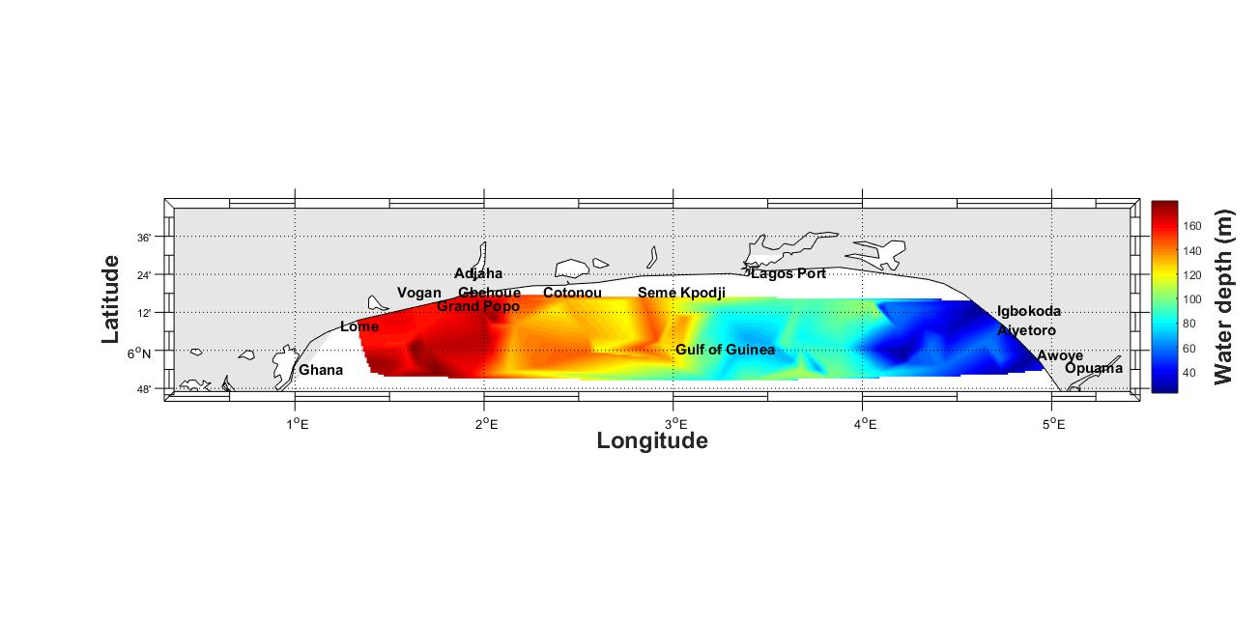

Figure 1. Geography and Topography of the Study Area

The tropical environment has two main seasons: the rainy season, which lasts about seven months (April to October), and the dry season, which lasts about four months, between November to March (Osinowo et al., 2024). The coastal regions of the area usually have rainforest-type vegetation, with a lot of trees and grasses growing along riverbanks; the environment is characterized by high-energy waves, which have led to constant sea incursions into inhabited areas (Olakunle et al., 2021). The study area's hydrological setting is dependent on the Niger River, which drains a large portion of West Africa with sediment-laden water that empties into the Atlantic Ocean through 14 major river inlets (Osinowo and Popoola, 2021). Because of its low-lying, flat topography, the region is extremely vulnerable to coastal erosion and flooding, especially during high tides (Olakunle et al., 2021).

2.2. Rainfall Pattern and Geology of the Study Area

The coastal region of Ondo state is renowned for its significant precipitation, which ranges from roughly 2,000 mm/year in the surrounds of Irele and Okitipupa to roughly 3,000 mm/year in the districts of Ilaje and Ese-Odo (Ishaku and Rafee, 2010). The main shallow hydro-geologic units in the region are the sands of the coastal plain. Aquifers are typically sea sands, continental sands, or gravels. The aquifer units are protected by the lateritic earth that covers the sands and the impervious clay/shale member of the Akinbo Formation underneath (Omosuyi et al., 2008). The Benin formation and recent alluvium comprise the surface geology of this coastal region. The water table occurs at a rather deep depth, beyond the reach of most typical hand-dug wells, due to the Benin Formation's heterogeneous and loose character (Asiwaju-Bello and Owoseni, 2023).

3. DATA SOURCE AND METHODOLOGY
3.1. Model Description/Data Source

This study employed WAVEWATCH III version 4.18, which incorporates updated source term parameters. The model’s capabilities, including wave breaking and dissipation processes, were enhanced. Water depth from the National Geophysical Data Center's ETOPO 1 were used to generate a water depth field with high resolution (0.0170 x 0.0170) using Gridgen 3.0. The energy spectra source terms in the wind-wave model were set to their default values. The model incorporated the spectrum up to a specified cut-off frequency, with a parametric tail applied beyond that point. It considered multiple directions (36) and wave numbers (24), spanning frequencies of 0.0412 – 0.4060 Hz and periods of 2.4 – 24.7 seconds. The output consisted of two-dimensional wave energy spectra at each grid point, generated at hourly intervals from January 1, 2012, to December 31, 2024. The ETA interim reanalysis wind field datasets served as the data source. This study focused on utilizing specific model outputs, including 10 m wind speed, significant wave height, mean wave period and mean wave direction, along with other ocean wave parameters. Reanalysis integrates model data with various observations to provide a reliable and consistent global estimate of atmospheric, wave, and oceanic variables. The WAM wave model’s spectrum was refined using ERA-Interim and altimeter wave height data. However, discrepancies were noted between the WW3 and WAM models, highlighting numerical and physical differences.

3.2.1 Data Validation

A comparison between simulated and measured values of mean wave period, significant wave height, and 10 m wind speed for March and April 2012 was conducted to assess the accuracy of the input data. The correlations are presented in Figure 2.
- (b)

Figure 2. (a) Time Series and (b) Scatter Plots of Model Against Buoy Data for the Significant Wave Heigh from 01-Mar-2012 to 30-Apr-2012t, Mean Wave Period and 10m Wind Speed. On the X-axis is the number of Data Points

The National Data Buoy Center (NDBC) provided buoy data (observational) for buoy 41040 in the North Equatorial One, 470 NM east of Martinique, with coordinates 14.559 N and 53.073 W (14° 33' 34" N and 53° 4' 23" W). As the closest buoy station to the study location, its data was used for validation. Efforts were made to obtain all 1,460 data values for the three variables, but gaps in the buoy records, particularly for wave parameters, hindered the process. To fill these gaps, the model calculated corresponding wave parameters and wind speed data over the buoy coordinates. The trends of the curves show good agreement between the simulations and observations. A standard statistical approach involving least correlation coefficient, mean bias error, and root mean square error was used to assess the accuracy of the model’s wind and wave parameters, as described in Wilks, (1995):
(1)
(2)
(3)
where N is the total number of observations, Xi and Yi stand for the buoy and model data, respectively, and X and Y are the mean values of the two sets of data.
Figure 2 revealed a strong correlation between modeled and observed wave parameters and wind speed, with a correlation coefficient (cc) of 0.8 at a 99% significance level. The mean bias error (MBE) ranged from 0.08 s to 0.27 m/s, indicating that the buoy data values were slightly higher than the model data. Root mean square error (RMSE) analysis showed that the model data errors were modest, ranging from 0.22m and 0.55s. Overall, the simulation results generally agree with the observations, suggesting that reanalysis-driven wind-wave model (WW3) data provided a more comprehensive and perhaps more accurate estimate of wind-wave characteristics in the study region.

3.3.2 Spatial Data Simulation

The WW3 model utilized long-term ECMWF ERA Interim wind field datasets to simulate spatial data. The model’s resolution was 0.125⁰ by 0.125⁰, with a spatial range of 2⁰ W to 8.5⁰ E and 2⁰ N to 9⁰ N. The 6-hour, zonal (u10), and meridional (v10) wind field data were used. The model computed wind speed data using the square root of the sum of the squares of the wind (uv) components. This produced a 10 m wind speed output at a spatial resolution of 0.1⁰. Additionally, the model provided mean wave period and significant wave height outputs. The computation box was set to include nearshore and offshore areas, spanning from 4⁰ N to 7⁰ N and 0⁰ to 6⁰ E. This setup allowed for accurate calculations of wind speed, wave parameters, and elimination of border influence. As shown in Figure 1, results over water were retrieved for the study area, which spans 1⁰ E, 5.83⁰ N, 5.08⁰ E, and 6.3⁰ N. The model generated output data at 1-hour intervals, with calculation time steps of 360, 180, and 60 seconds. The simulation covered the period from January 1, 2012, 00:00, to December 31, 2024, 18:00.

3.3.3 Analysis Methods
3.3.3.1 Computation of Wind Energy

The Weibull probability distribution function is widely recommended for evaluating wind data due to its strong agreement with experimental results (Ohunakin et al., 2011). This model employs a gamma function to calculate wind power density and illustrate wind speed frequency distribution, making it a valuable tool for wind data analysis (Gökçek et al., 2007). Various models, including Rayleigh, Weibull, long-normal, and normal distributions, have been historically used in wind data analysis (Fyrippis et al., 2010). The Weibull probability density function provides a reliable mathematical framework for understanding wind power density and wind speed distributions (Gökçek et al., 2007), as expressed as follows:
(4)
The corresponding cumulative density function is expressed in (Gökçek et al., 2007) as:
. (5)
The wind speed is denoted by “v”, with shape and scale parameters represented by “k” and “c”, respectively. The wind potential, measured in meters per second (m/s), is calculated using various methods, including the standard deviation (Justus et al., 1978), power density (Akdag and Dinler, 2009), maximum likelihood (Stevens and Smulders, 1979), and graphical approaches (Rinne, 2010). The dimensionless parameter “k” reflects the variability of average wind speed within a given sample. A higher value of “k” indicates more stable winds, while a higher value of “c” signifies a wider distribution of wind power (Khan et al., 2015). In this study, the standard deviation method as described in (Justus et al., 1978; Saleh et al., 2012), was employed to calculate the wind potential.
for 1 ≤ k ≤ 10 (6)
(7)
where σ is the standard deviation that describes the degree of wind speed variance, and v is the mean wind speed (m/s). The gamma function, Γ(x), is written as follows in (Manwell et al., 2002):

(8)
Wind power density is expressed in (Sathyajith, 2006) as:
(9)
where A (w/m²) is the swept area of the wind turbine rotor, P_{d} (w/m²) is the wind power density, P (v) is the wind power in watts, and ρ is the air density, which is taken to be 1.225 kg/m³.
The wind energy density is expressed in (Tchinda et al., 2000) as:
(10)
where T is the number of days in the month considered.
The maximum energy carrying wind speed is expressed in (Jamil et al., 1995) as:

(11)

Wind speed variability is explained by the coefficient of variation (cov), which is the ratio of mean wind speed to mean standard deviation. Ahmed (2012) presented COV in percentage, as stated below:
(12)

3.3.3.2 Computation of Wave Energy

The Wave Power Density (WPD) estimation method, as outlined by Cornett (2008), Iglesias and Carballo (2011), and Vosough (2011), was utilized to compute wave energy. It is estimated as follows:
(13)
where P_{w} represents wave power (unit: kW/m), H_{mo} is the significant wave height (unit: m), and T_{e} is the mean wave period (unit: s).
A relatively rich energy distribution was identified for Wave Power Density (WPD). According to Zheng et al., (2014), areas with a seasonal average WPD exceeding 6 kW/m and a coefficient of variation (COV) below 2.0 are considered rich energy regions (RER). This concept was applied in this study. Wave power variability can be evaluated using multiple metrics, with the COV being a particularly intuitive one. To assess wave power stability, the COV was calculated for each grid point, revealing that stability increases as the COV decreases.
The COV can be calculated using the following formula:
(14)
where s is the STD and is evaluated as:

$S=\sqrt{\frac{\sum_{i=1}^{n}{x_{i}^{2}}-{\left(\sum_{i=1}^{n}{x_{i}}\right)}^{2}/n}{n-1}}$ (15)

where $\overline{x}$ is the mean value
The monthly variability index (MVI) is expressed as:
(16)

where P_{M}1 and P_{M}12 are respectively the maximum and minimum monthly mean WVPD, and Pyear is the annual mean WVPD. Higher index values indicate larger wave energy variations, and decreased stability compared with lower index values.
The annual and monthly WVPD was computed using Equation 17. It is expressed as a percentage cumulative frequency, as stated below:
(17)

where N is the total of the WVPD values, and n is the frequency of WVPD that satisfies each of the stated intervals of WVPD, with respect to various wave powers.

This study investigated the bivariate distribution of wave occurrence and total wave power in the research area, analyzing wave height and period at 2.5m and 2.5s intervals. A statistical analysis of wind-wave data from 2012 to 2024 was conducted, examining wind speed frequency distribution for wind power assessment. Monthly measurements were taken of wind power density, wind energy density, maximum energy-carrying wind speed, mean wind speed, standard deviation, coefficient of variation, and Weibull parameters. The spatiotemporal characteristics of these metrics were also identified. Furthermore, monthly wind speed and WPD ratios were calculated, and the spatial patterns of wave power density, categories, wave power RER, and variability were determined. Temporal variations in wave power density and monthly variability index were also assessed.

4. RESULTS AND DISCUSSION

Figure 3 presents the ocean surface wave direction in the study region, showing that the dominant wave direction is northeasterly. This indicates that the predominant waves approaching the region originate from the northeast, suggesting a prevailing wind pattern or ocean current from this direction. The northeasterly wave direction may have significant implications for coastal erosion, sediment transport, and marine activities in the region.

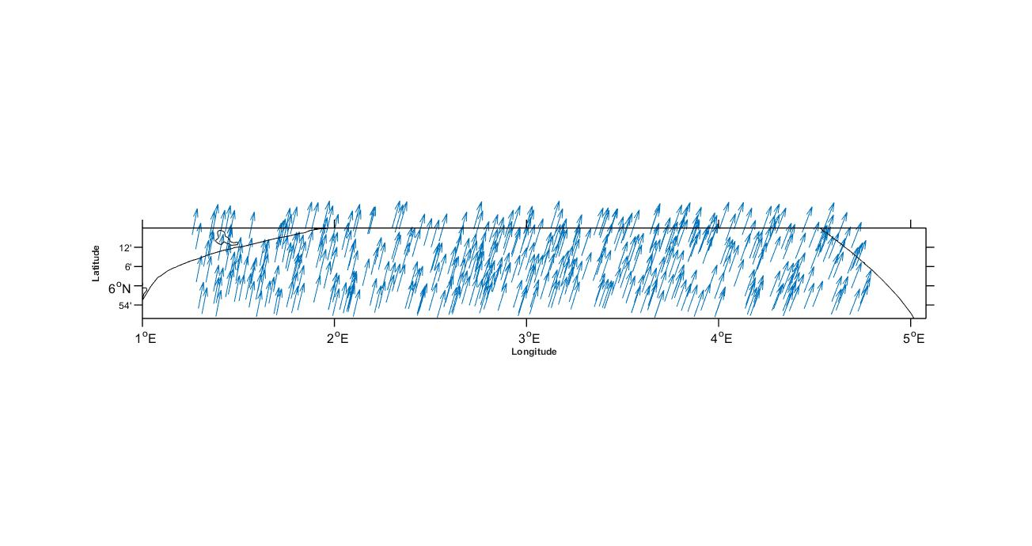

Figure 3. Annual distribution of mean wave direction in the study location.

4.1 Spatio-temporal characteristics of WVPD and wave power RER.

This section examined the distribution and temporal patterns of Wave Power Density (WVPD) in the study area, highlighting regional variations in wave energy richness. Figure 4a showed that the study area was generally dominated by yearly average wave power ranging from 5.2 to 6.4 kW/m. However, lower wave power values (<5.6 kW/m) were observed in certain eastern locations and near Ghana and Lome. In contrast, higher wave power values (>6.4 kW/m) were concentrated in waters between 3.25⁰ E and 3.75⁰ E longitudes. Figure 4b illustrated the long-term temporal trends of annual mean wave power, revealing a declining trend of -0.043 kW/m/yr. The annual mean wave power reached its minimum in 2021, with a value of 5.25 kW/m, while the highest values were recorded in 2016 and 2017. The declining trend was attributed to minimal influences of storminess, atmospheric circulation, and monsoonal variation. Moreover, the sharp fluctuations in wave power between 2017 and 2022 were linked to hurricane intensity and storminess in the basin, which were influenced by the weakening and strengthening of the West African Monsoon.
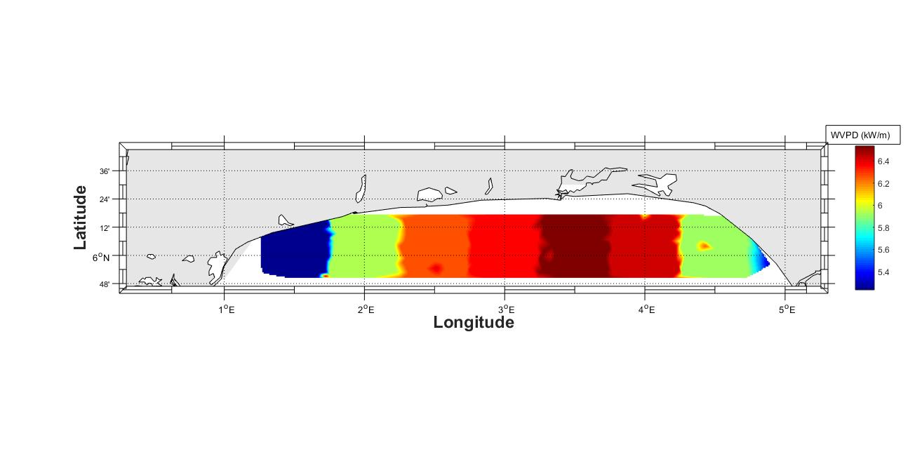
(a)

(b)
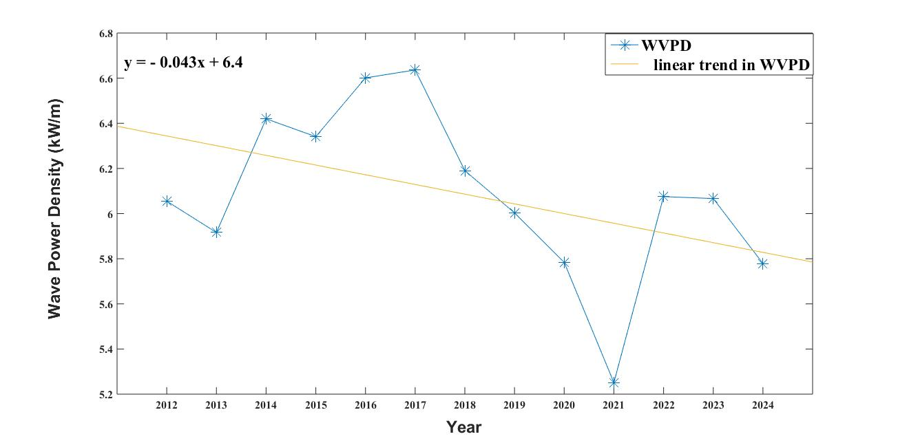

Figure 4. (a) The Spatial and (b) Temporal Variations of the Annual Mean WVPD in the Study Location. Units are in kW/m and kW/myr⁻¹ respectively.

4.1.1 Relative rich energy regions of wave power

Regional variations in wave power energy density were examined within the study area. Figure 5 revealed that the eastern and western parts of the region have relatively low wave power, with values less than 2 kW/m, making them less suitable for large-scale wave energy generation. The low wave power in these areas was attributed to weak wind speeds, which have a minimal impact on wave conditions. In contrast, the waters between longitudes 3.25⁰ E and 3.75⁰ E exhibited the highest wave power, exceeding 6kW/m, making this region the most promising for installing wave energy converters to generate electricity on a large scale. Furthermore, a smaller location near the Ondo State coastal waters, at 4.3⁰ E and 6.1⁰ N, was also identified as a site with relatively high wave power, with energy density values around 5kW/m.
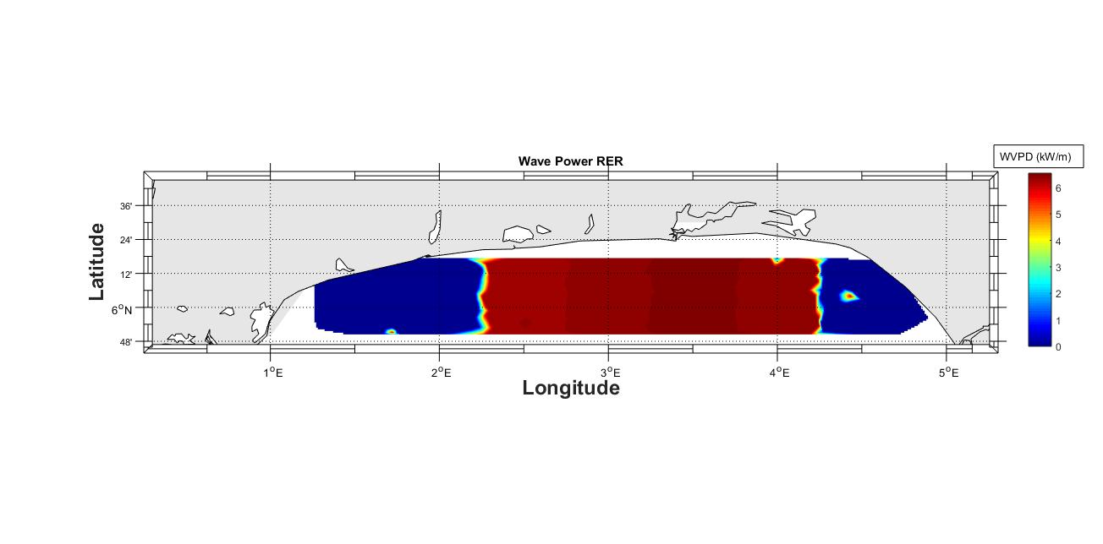

Figure 5. Wave Power in Relative Rich-Energy Regions.

4.2 Spatial Variation of Wave Power for Different Categories
The overall regional distribution of the percentage frequencies of wave power, representative of different categories, is shown in Figure 6.

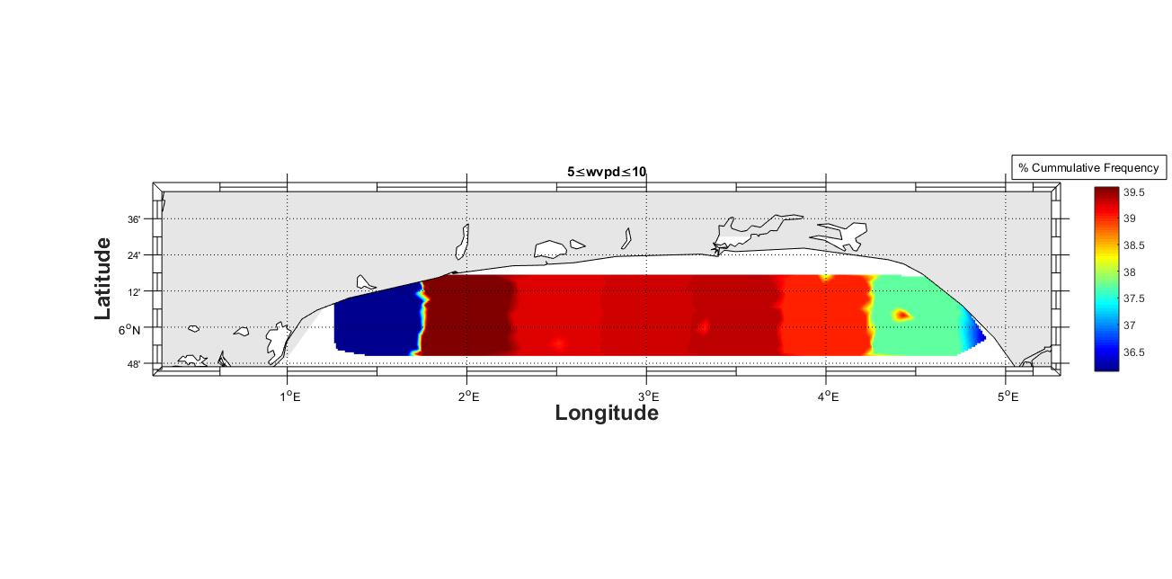
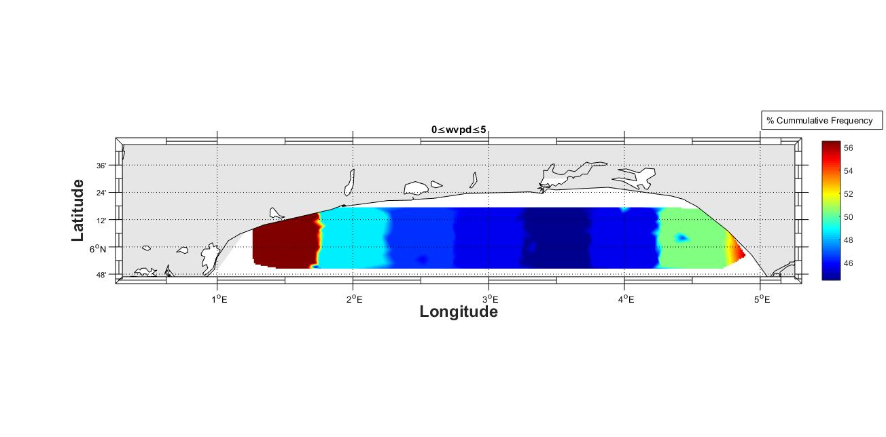
- (b)

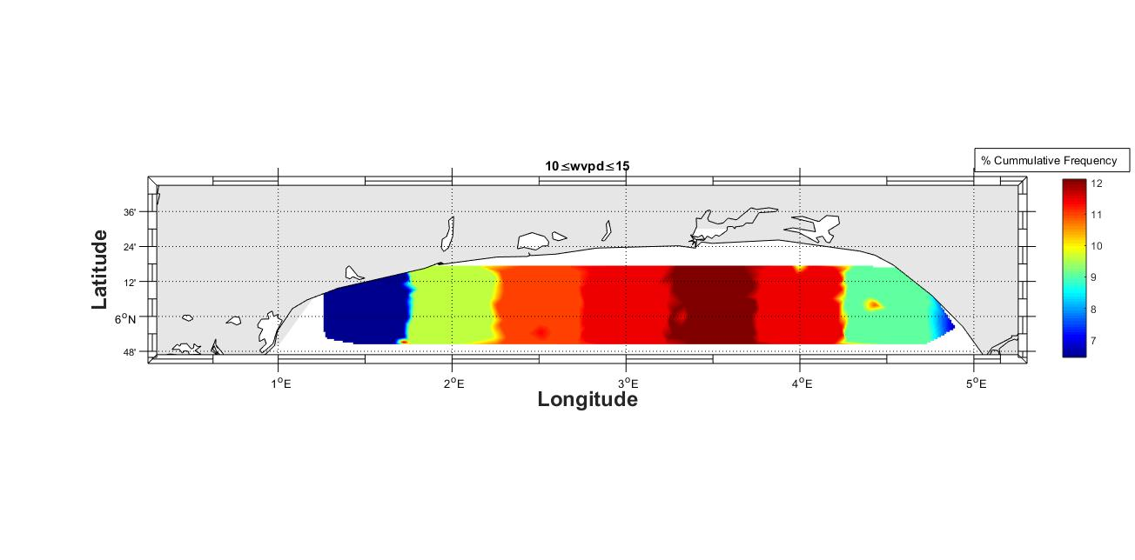
(c) (d)
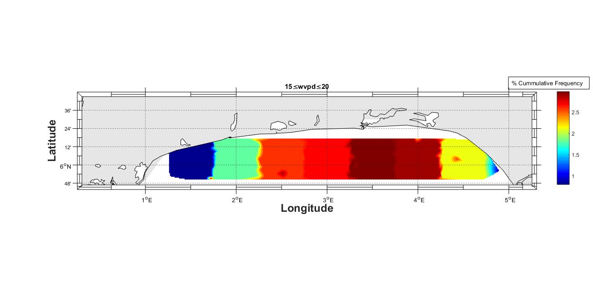

(e) (f)
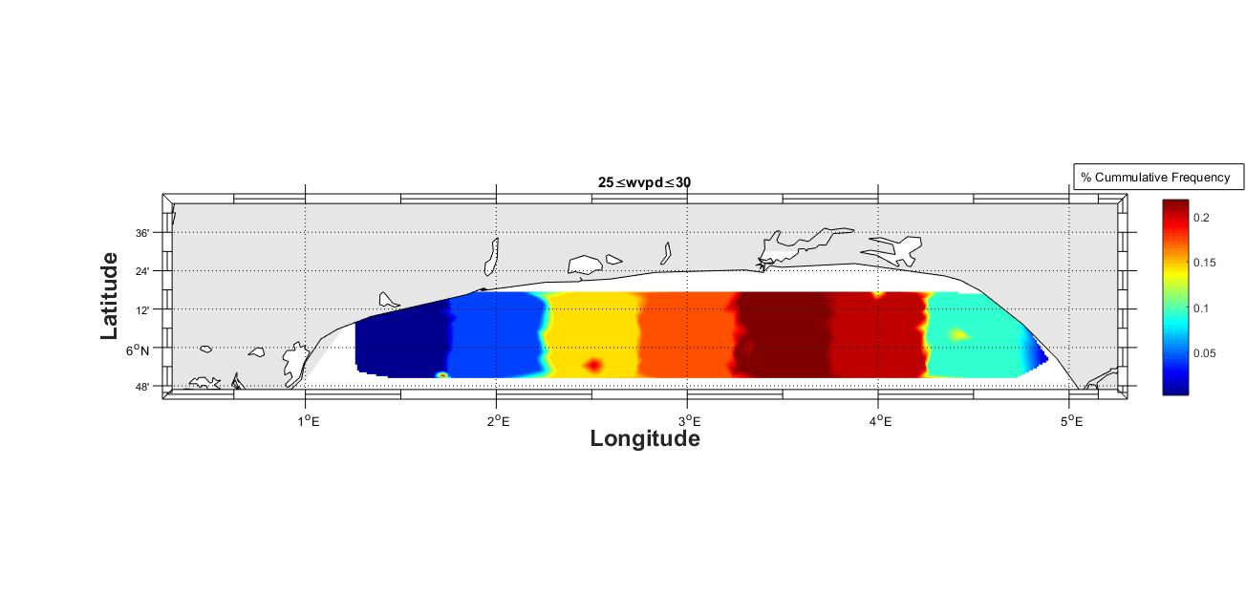
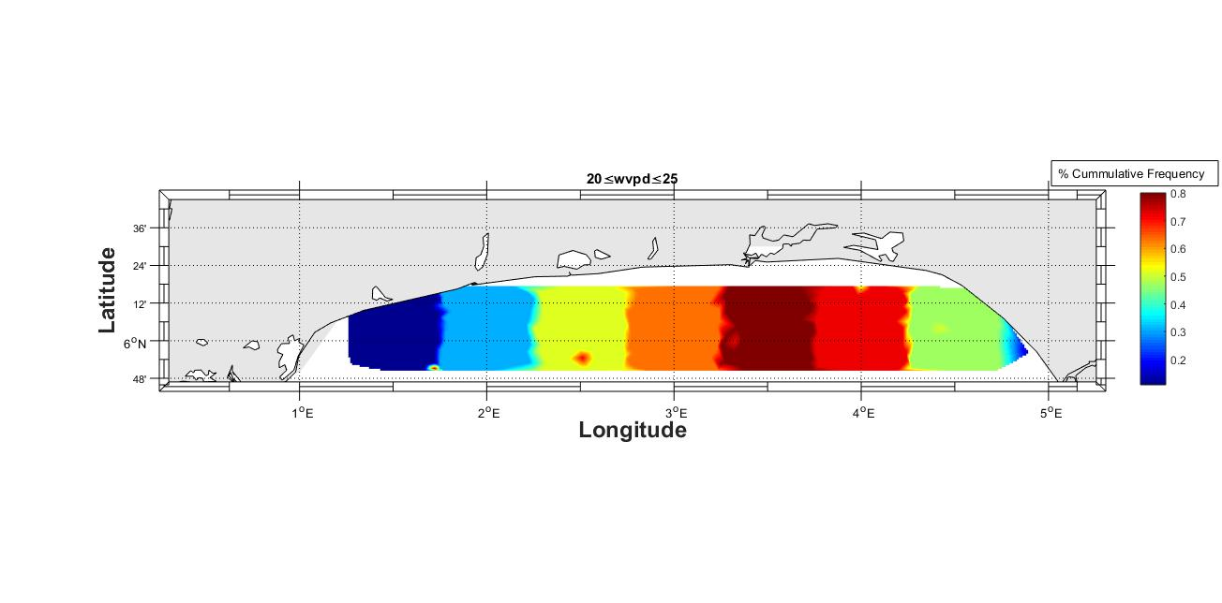

(g) (h)
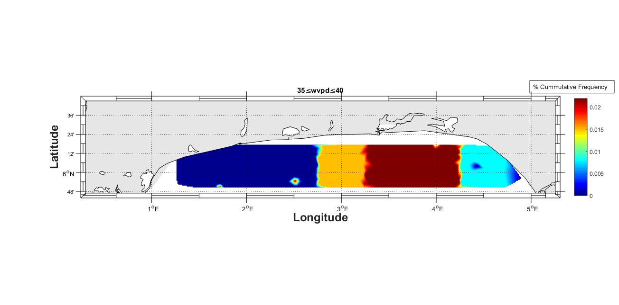
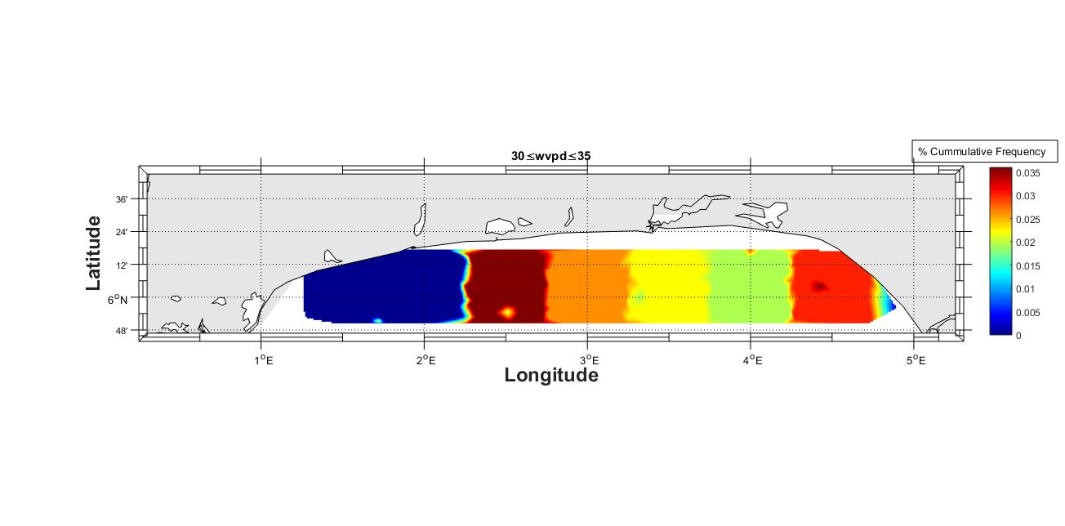

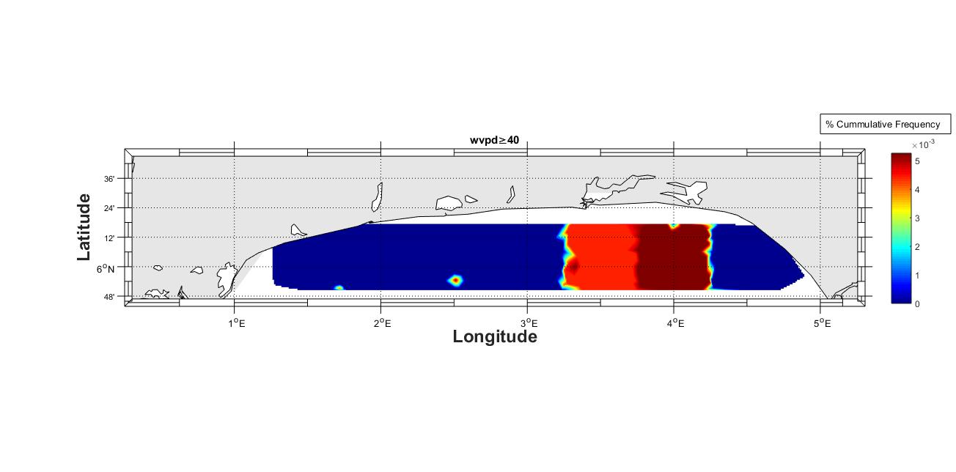
(i)

Figures 6 (a-i). Spatial distributions of the percentage cumulative frequencies of WVPD for different categories.

Figure 6a demonstrated that the percentage frequency of wave power in the category of 0≤wvpd≤5 was highest (around 56%) in locations close to Ghana and Lome, and lowest (<46%) in waters between longitudes 3.25⁰ E and 3.75⁰ E. High values, around 54%, were observed along the coast of Aiyetoro and Awoye. For the 5≤wvpd≤10 category shown in Figure 6b, the largest frequency (around 39.5%) occurred in waters south of Gbehoue. The percentage frequency increased westward to the longitude 3.25⁰ E and decreased in waters south of Seme Kpodji. It was lowest (<37%) in waters around Aiyetoro, Awoye, Ghana, Lome, and regions south of Vogan and Grand Popo. The percentage occurrence of the 10≤wvpd≤15 category in Figure 6c was largest (~12%) in waters between longitudes 3.25⁰ E and 3.75⁰ E and lowest (<8%) in waters around Aiyetoro, Awoye, and the extreme west of the study region. The wave power categories greater than 15kW/m showed very little or no occurrence (<3%) throughout the study area.

Table 1. Annual and Monthly Mean Wave Power Percentage Frequencies (f is computed using Equation 17)
Annual | 0≤wvpd≤5 | 5≤wvpd≤10 | 10≤wvpd≤15 | 15≤wvpd≤20 | 20≤wvpd≤25 | 25≤wvpd≤30 | 30≤wvpd≤35 | 35≤wvpd≤40 | wvpd≥40
 | 48.38 | 38.59 | 10.12 | 2.26 | 0.50 | 0.12 | 0.02 | 0.01 | 0.00
Jan | 84.39 | 14.68 | 0.93 | 0.00 | 0.00 | 0.00 | 0.00 | 0.00 | 0.00
Feb | 73.31 | 22.92 | 2.84 | 0.91 | 0.03 | 0.00 | 0.00 | 0.00 | 0.00
Mar | 44.34 | 33.26 | 3.48 | 0.58 | 0.02 | 0.00 | 0.00 | 0.00 | 0.00
Apr | 46.15 | 49.61 | 4.24 | 0.00 | 0.00 | 0.00 | 0.00 | 0.00 | 0.00
May | 36.15 | 53.38 | 9.18 | 1.13 | 0.17 | 0.00 | 0.00 | 0.00 | 0.00
Jun | 18.04 | 55.29 | 22.50 | 3.48 | 0.66 | 0.04 | 0.00 | 0.00 | 0.00
Jul | 13.09 | 45.83 | 28.80 | 9.11 | 2.47 | 0.69 | 0.00 | 0.00 | 0.00
Aug | 14.40 | 51.10 | 24.45 | 7.22 | 1.93 | 0.56 | 0.21 | 0.11 | 0.02
Sep | 23.26 | 58.30 | 14.13 | 3.45 | 0.65 | 0.19 | 0.00 | 0.00 | 0.00
Oct | 58.22 | 35.87 | 5.23 | 0.65 | 0.03 | 0.00 | 0.00 | 0.00 | 0.00
Nov | 70.67 | 25.34 | 3.64 | 0.35 | 0.00 | 0.00 | 0.00 | 0.00 | 0.00
Dec | 88.99 | 10.58 | 0.43 | 0.00 | 0.00 | 0.00 | 0.00 | 0.00 | 0.00

Table 1 presented the percentage cumulative frequency of the annual and monthly wave power density (WVPD) in the study area, as computed using Equation 17. It showed the annual and monthly percentage cumulative frequency distribution of wave power between 0 and 40 kW/m. It was noticed that the frequency of wave power values clustered around 0 to 10 kW/m across the area. The wave power between 0 and 5 kW/m showed higher occurrences from October through March, with respective frequencies of 58.22%, 70.67%, 88.99%, 84.39%, 73.31% and 44.34%. The months of April through September showed higher frequencies of 49.61%, 53.38%, 55.29%, 45.83%, 51.10% and 58.30% for the 5 to 10 kW/m wave power category. A critical examination of the 10 to 25 kW/m wave power category revealed that the sea was more energetic and turbulent between June and August, as indicated by the higher frequencies observed in these months. Phenomenal or no occurrences were observed for the remaining wave power categories.

4.3 Wave Power Stability and Bivariate Distribution of Wave Energy.
The pattern of wave power stability in the study area, as indicated by the monthly variability index (MVI), is shown in Figure 7.
(a)
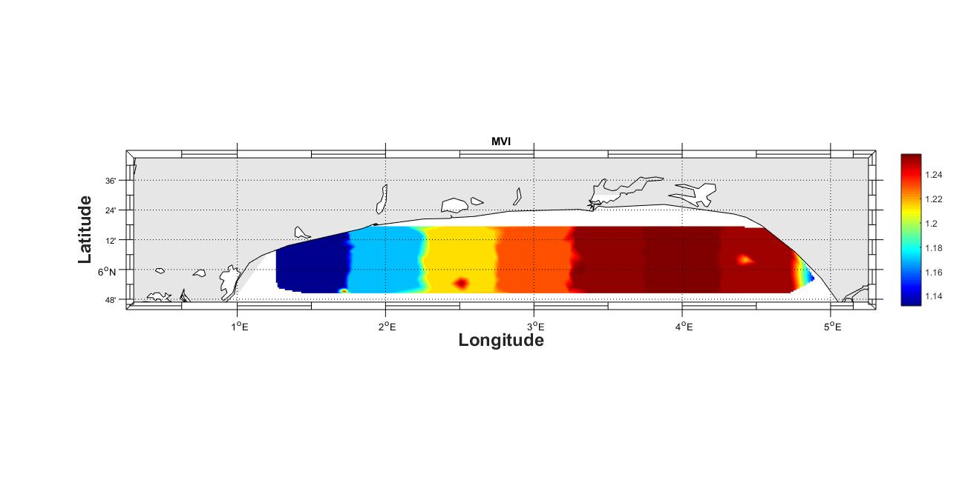

(b)

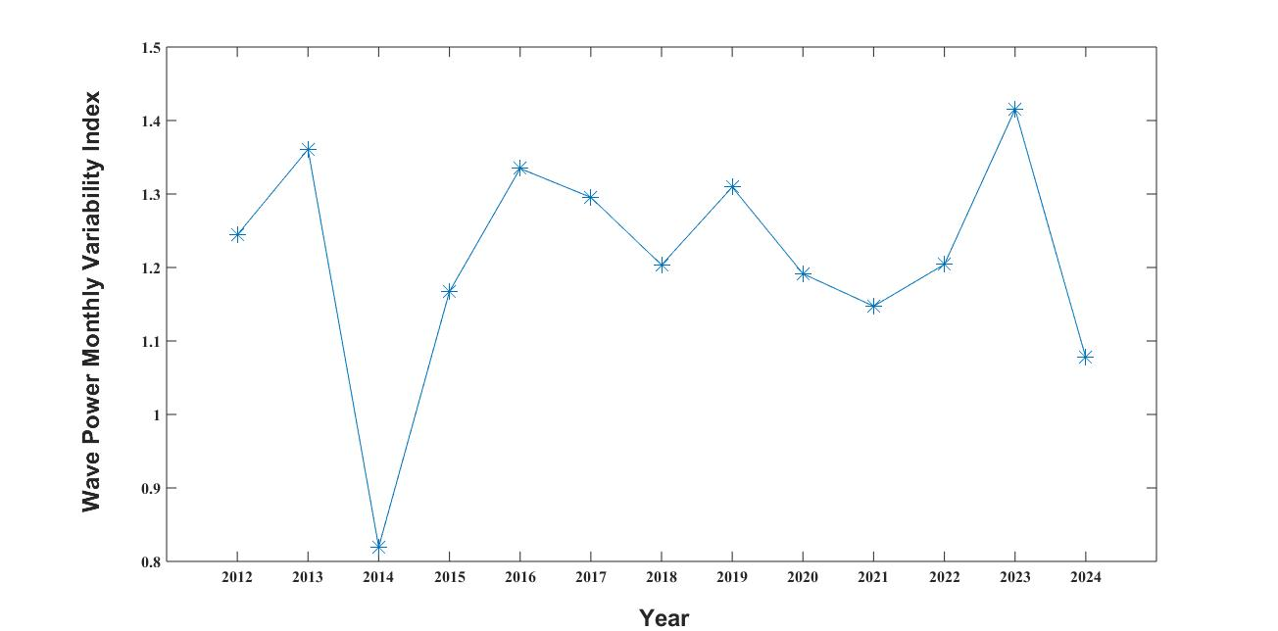

Figure 7. (a) Spatial and (b) Temporal Variation of Wave Power MVI in the Study Area.

As shown in Figure 7a, high MVI (>1.24) regions lie between longitudes 3.3⁰ E and 4.7⁰ E and in a small region around 5.85⁰ N, 2.5⁰ E of the study area. These are regions of the lowest stability of wave power. The wave power is most stable (MVI<1.17) around Aiyetoro, Awoye, Ghana, Lome and regions south of Vogan and Grand Popo. For the variability index presented in Figure 7b, wave power is most stable in the year 2014, with a value of 0.82, and least stable in the year 2023, with value of 1.42.
Table 2 showed a bivariate distribution of wave height (Hs) and wave period (Te) in the study location. It could be seen from the table that the most frequent sea states (bold and highlighted in green) concentrated between 3.5 s and 8.5 s for Te and values ≤ 5 m for Hs.

Table 2. Number of Occurrences of Different Sea States in the Study Area
Hs/Te | 1-3.5 | 3.5-6 | 6-8.5 | >=8.5
0-2.5 | 3373767 | 49855487 | 46484384 | 1019908
2.5-5 | 0 | 7491 | 13747 | 0

A scatter table is frequently used to display the frequency of occurrence of sea states defined by a characteristic wave height (Hs) and wave period (Te) (Iglesias and Carballo, 2011). The total annual wave power for different sea states is presented in Table 3. It could be seen that the main wave energy (bold and highlighted in green) is also concentrated between 3.5 s and 8.5 s (Te) and for values ≤ 5 m (Hs). When relating these results to the number of occurrences (Table 2), it was observed that the most frequent sea states coincided with the most energetic sea states.

Table 3. Total Wave Power (in GW/m) Corresponding to sea States for Different Ranges of Hs and Te in the Study Area
Hs/Te | 1-3.5 | 3.5-6 | 6-8.5 | >=8.5
0-2.5 | 9.87 | 207.75 | 382.04 | 12.90
2.5-5 | 0.00 | 0.14 | 0.50 | 0.00

4.4. Wind Characteristics.

The monthly variation of wind and their annual mean values are presented in Table 4.

Table 4. Monthly and Annual Mean Wind Characteristics.
 |  |  |  |  |  |  | WPD | u10
 |  | c | WPD | u10 | σ | cov | Ratio | ratio | VmaxE | WED
Month | K | (m/s) | (w/m²) | (m/s) | (m/s) | (%) | (w/m²) | (m/s) | (m/s) | (kWh/m²)
Jan | 3.50 | 4.73 | 65.30 | 4.26 | 1.41 | 33.33 | 0.77 | 0.92 | 5.44 | 48.58
Feb | 3.81 | 5.14 | 81.16 | 4.64 | 1.41 | 30.58 | 0.96 | 1.00 | 5.78 | 55.08
Mar | 4.18 | 5.35 | 90.87 | 4.86 | 1.38 | 28.50 | 1.07 | 1.05 | 5.92 | 67.61
Apr | 4.19 | 4.94 | 72.18 | 4.49 | 1.28 | 28.81 | 0.85 | 0.97 | 5.46 | 51.97
May | 3.55 | 4.41 | 52.81 | 3.97 | 1.27 | 32.50 | 0.62 | 0.86 | 5.02 | 39.29
Jun | 3.82 | 5.03 | 78.23 | 4.55 | 1.41 | 31.36 | 0.92 | 0.98 | 5.64 | 56.32
Jul | 6.49 | 6.61 | 165.44 | 6.16 | 1.19 | 19.64 | 1.95 | 1.33 | 6.92 | 123.09
Aug | 7.01 | 6.55 | 159.73 | 6.12 | 1.12 | 18.49 | 1.88 | 1.32 | 6.83 | 118.84
Sep | 5.19 | 5.81 | 114.83 | 5.35 | 1.30 | 24.66 | 1.35 | 1.15 | 6.23 | 82.68
Oct | 3.70 | 4.52 | 57.74 | 4.08 | 1.33 | 32.95 | 0.68 | 0.88 | 5.13 | 42.96
Nov | 3.18 | 3.80 | 35.21 | 3.41 | 1.23 | 36.23 | 0.41 | 0.74 | 4.46 | 25.35
Dec | 3.21 | 4.13 | 44.52 | 3.70 | 1.32 | 35.68 | 0.52 | 0.80 | 4.85 | 33.12
Annual | 4.32 | 5.09 | 84.83 | 4.63 | 1.30 | 29.40 |  |  | 5.64 | 62.07

Table 5. Wind power classification (Enikanselu et al., 2025).
Power Class | Power density (w/m²) at 10m | Resource Potential
1 | 0 < P ≤ 100 | Not Suitable
2 | 100 < P ≤ 150 | Marginal
3 | 150 < P ≤ 200 | Fair
4 | 200 < P ≤ 250 | Good
5 | 250 < P ≤ 300 | Excellent
6 | 300 < P ≤ 400 | Outstanding
7 | 400 < P ≤ 1000 | Superb

The “k” varied between 3.18 and 7.01 in November and August, respectively, revealing that the wind data was most stable in August and least stable in November. Consequently, August was the most appropriate month for the production of incessant and stable wind power. The “c” ranged between 3.80 m/s and 6.61 m/s in November and July, respectively, indicating that the wind power was most spread out in July and least spread out in November. The monthly mean u10 varied between 3.41 m/s in November and 6.16 m/s in July. The WPD ranged between 35.21 w/m² in November and 165.44 w/m² in August. The wind speed was largest (1.41 m/s) in January, February, and June and least (1.12 m/s) in August. The wind was most stable (COV 18.49%) in August and least stable (COV 36.23%) in November. The least WED of 25.35 kWh/m² was observed in November, and the highest value of 123.09 kWh/m² was observed in July, while VmaxE had a minimum value of 4.46 m/s in November and a maximum value of 6.92 m/s in July. The annual mean WPD and u10 stood at 84.83 W/m² and 4.63 m/s, respectively. According to the wind power classification proposed by Elliott and Schwartz, (1993) of Pacific Northwest Laboratory (Table 5), the annual mean WPD for the study area (84.83 W/m²) was categorized as Class 1, which indicated that the region was unsuitable and poor for large-scale wind power applications. The wind potential of the region could be adequate for non-grid-connected electrical and mechanical applications, such as wind generators, battery charging, and water pumping, as well as agricultural applications. Figure 8a presented the monthly variations of the WPD ratio and u10 ratio, while Figure 8b presented the percentage frequency distribution of u10 in the study area. For both wind variables, the ratio was highest in July, with respective values of 1.95 W/m² and 1.33 m/s, and least in November, with respective values of 0.41 W/m² and 0.74 m/s. The u10 within the range of 4 to 8 m/s had the highest frequency of 62.63%. This was followed by u10 in the range of 0 to 4 m/s, with a frequency of 35.51%. The u10 in the range of (8 – 12) m/s showed a low frequency of 1.86%, while higher u10 values had zero frequencies.

(a) (b)

Figure 8. (a) Monthly Variation in the Wind Ratios and (b) Percentage frequency distribution of wind speed in the study area.

4.4.1 Spatio-Temporal Variation of Wind Parameters.
The spatial distribution of wind parameters, including “k”, “c” (m/s), WPD (m/s), u10 (m/s), σ, cov (%), VmaxE (m/s) and WED (kWh/m²), were displayed in Figures 9(a-h). the “k” potential in Figure 9a, ranging between 2.53 in the coasts of Igbokoda, Aiyetoro, Awoye, and 3.85 in regions south of Lome, showed that wind stability increased westward. The “c” presented in Figure 9b was highest (5.53 m/s -5.87m/s) in a relatively large region between Seme Kpodji and Ghana, indicating that wind power was more spread out over a large portion of the western part of the study area. The WPD, u10, VmaxE and WED in Figures 9 (c, d, g, and h) followed the same distribution pattern as “c”. Higher values were distributed in large waters between Seme, Kpodji and Ghana, while the values were least along the coast of Igbokoda, Aiyetoro, Awoye, and Opuama. The WPD distribution in Figure 9c ranked immediate regions south of Cotonou and neighboring locations to Ghana as Class 2, indicating regions marginal for connected wind power applications. Most waters in the study area fell into Class 1 (WPD<100 w/m²), characterized by poor energy potentials suitable only for small wind turbines. The wind speed σ and wind speed percentage cov were shown in Figures 9e and 9f. A higher wind speed σ indicated higher variability and fluctuations in wind speed.
The wind in Figure 9e had the highest variability in the central part of the study region (1.65 ≤ σ ≤ 1.7) and was most consistent along the coast of Awoye (σ ≤ 1.25). In agreement with “k”, the wind speed percentage COV in Figure 9f, revealed that the wind stability increased westward (COV 42.4% - 28.9%).

Long-term trends in the yearly averaged values of the wind parameters, analyzed using linear regression with a reliability test of 95%, were displayed in Figures 10 (a-d). These trends were determined by calculating the regional mean wind energy from 00:00 UTC on January 1, 2012, to 18:00 UTC on December 31, 2024. The regression coefficients in Figure 10a were 0.01 and 0.0003, indicating that VmaxE and u10 increased by 0.01 m/syr⁻¹ and 0.0003 m/syr⁻¹, respectively. The u10 was lowest (4.44 m/s) and highest (4.78 m/s) in years 2016 and 2018, while VmaxE was lowest (5.42 m/s) and highest (5.83 m/s) in years 2012 and 2022. For the “k” and “c” parameters, the regression coefficients in Figure 10b were -0.016 and 0.005, showing that “k” decreased by 0.016 yr⁻¹ and “c” increased by 0.005 m/syr⁻¹. The “k” was lowest (3.61) and highest (4.35) in years 2017 and 2013, while “c” was lowest (4.72 m/s) and highest (5.19 m/s) in years 2012 and 2018. For the WPD and WED presented in Figure 10c, the regression coefficients were 0.29 and 2.6, indicating that WPD increased by 0.29 m/syr⁻¹ and WED increased by 2.6 kWh/m² yr⁻¹. The WPD was lowest (74.02 w/m²) and highest (92.57 w/m²) in years 2016 and 2022, while WED was lowest (650.16 kWh/m²) and highest (810.9 kWh/m²) in the same years. Lastly, the regression coefficients for wind speed σ and wind speed COV in Figure 10d were 0.01 and 0.21, implying that wind speed (σ) increased by 0.01 m/syr⁻¹ and wind speed (COV) increased by 0.21% yr⁻¹. The wind speed (σ) was lowest (1.41 m/s) and highest (1.66 m/s) in years 2013 and 2019, while the wind speed (COV) was lowest (30.23 %) and highest (36.22 %) in the same years.

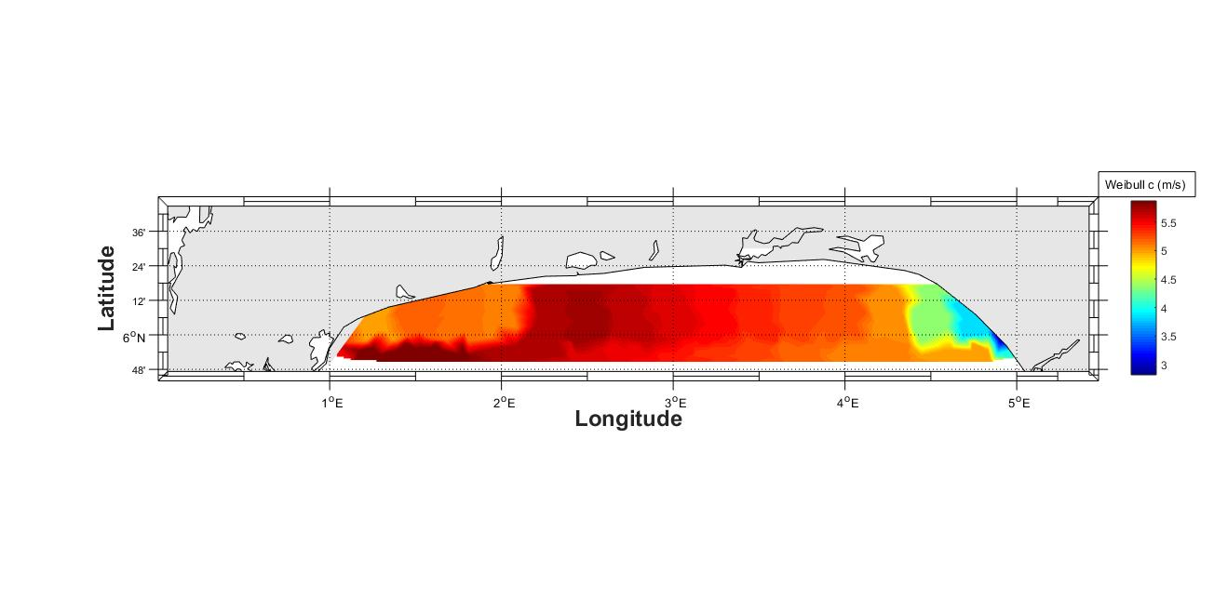
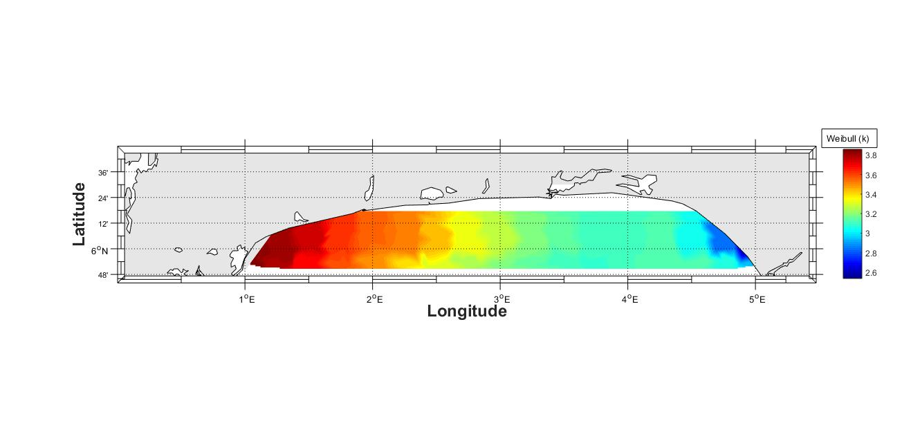
(a) (b)

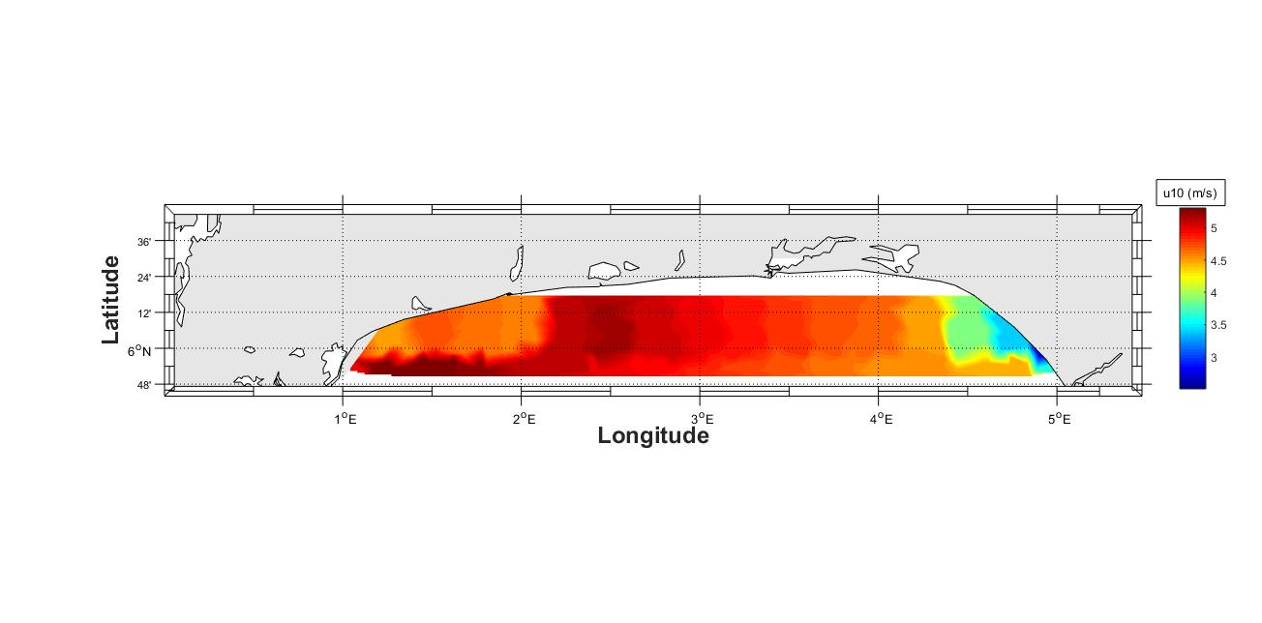
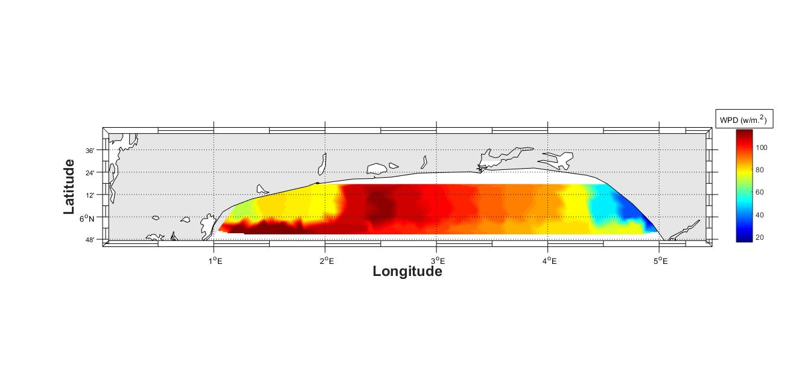
(c) (d)

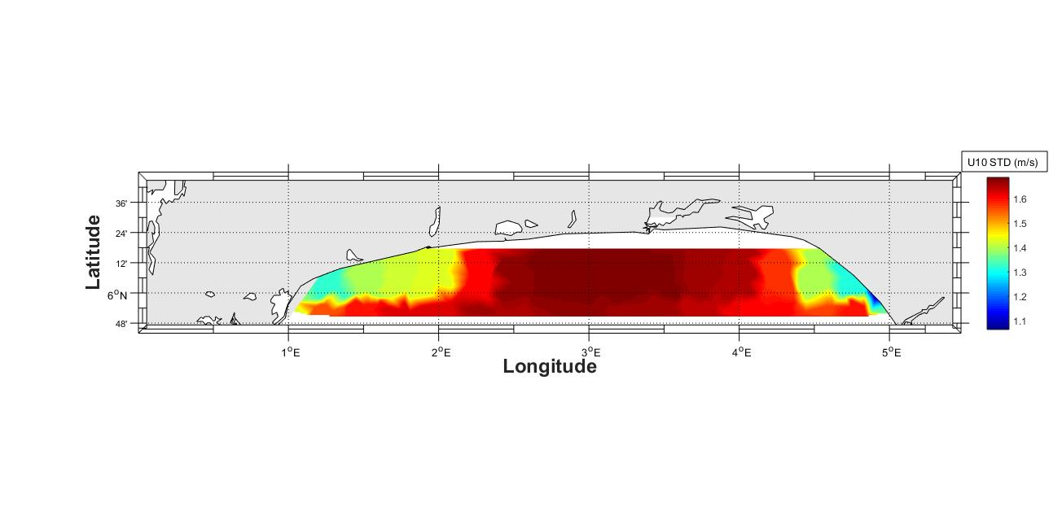
(e) (f)
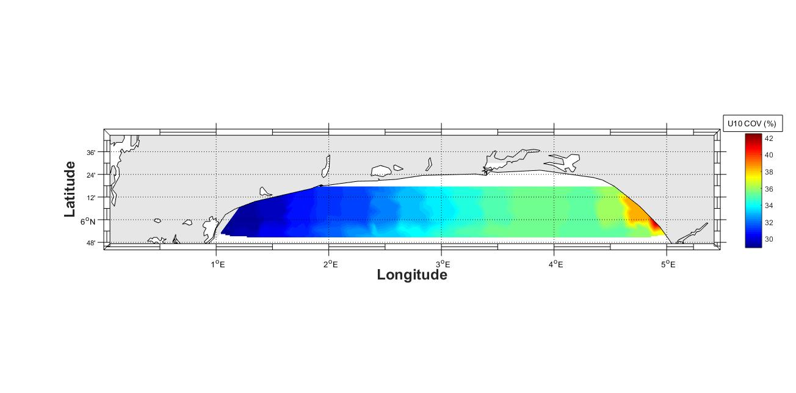

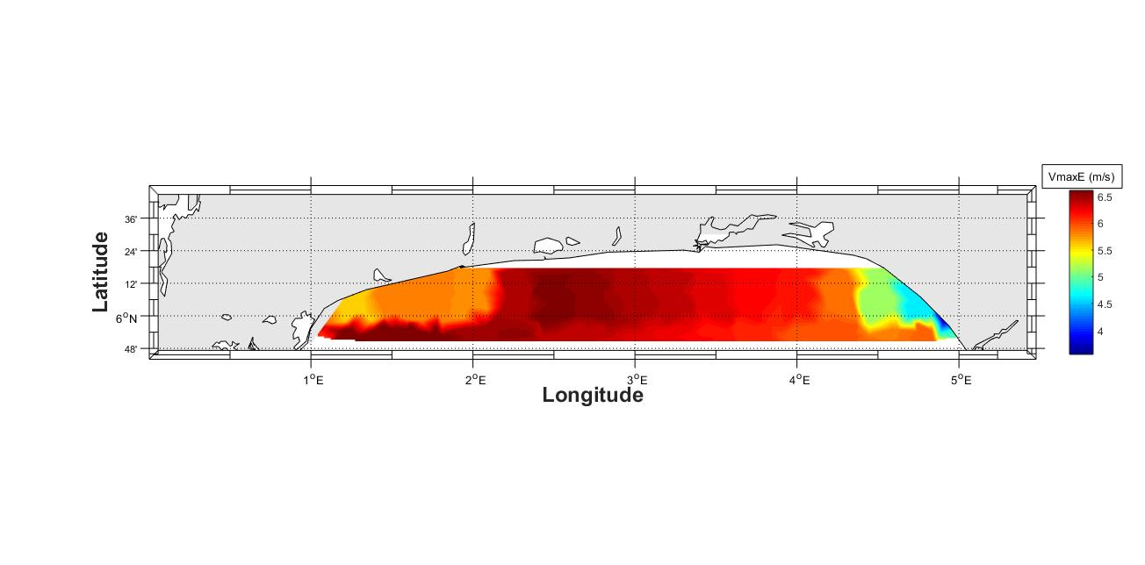
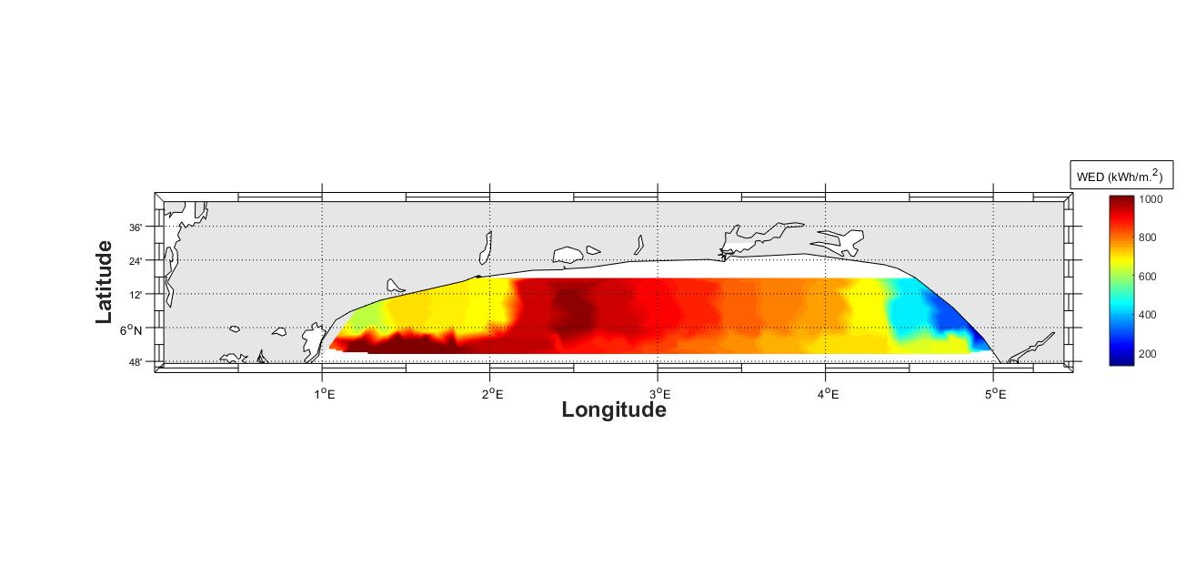
(g) (h)

Figure 9a-9h. Spatial Distribution of Wind Parameters in the Study Area.

(a) (b)

(c) (d)

Figures 10 (a-d). Long Term Trends in the Yearly Averaged Values of the Wind Parameters.
5. CONCLUSION

This study evaluated the spatio-temporal variation in wind power potential using Weibull parameters over the Offshore Ondo State, Southwestern Nigeria. Additionally, the richness of wave power in the study area was investigated by considering regions with seasonal average WVPD above 6kW/m and coefficient of variation (COV) below 2.0. The annual and monthly percentage frequency of different categories of wave power and their spatial distribution were analyzed. The major deductions from this study are as follows:
- The study area generally showed poor wind characteristics. This is seen in higher values of the monthly and yearly averaged wind speeds with wind power densities throughout the study period.
- The computed annual average wind power (84.83w/m²) characterizes the study area as being poor for wind power applications.
- The wind speed of 6.16 m/s was maximum in July, while a minimum value of 3.41 m/s occurred during November. The WPD fell within the range of 35.21 w/m² in November and 165.44 w/m² in July. The wind had the largest variation (36.23%) in November and the least (18.49%) in August, implying that the wind is most stable in November and least stable in August.
- The large region of higher wind power between 110 w/m² and 120 w/m² was centered in regions between Seme, Kpodji, and Ghana. These regions are marginal for connected wind power applications.
- For the periods that were studied, all the wind parameters, such as VmaxE, u10, c, WPD, WED, σ and COV, exhibited respective increasing trends of 0.0102 m/syr⁻¹, 0.0003 m/syr⁻¹, 0.0051 m/syr⁻¹, 0.29 w/m²yr⁻¹, 2.6 kWh/m²yr⁻¹, 0.01 m/syr⁻¹ and 0.21 %yr⁻¹, except k, which showed a declining trend of -0.0165.
- The wave power is richest (> 6kW/m) in waters between longitudes 3.25⁰ E - 3.75⁰ E. This region is most ideal and recommended for the installation of wave energy converters for massive electrical energy generation in the study area. Additionally, a small location, precisely at 4.3⁰ E and 6.1⁰ N, closer to the Ondo State coastal waters, is also identified as a location with relatively rich wave power energy, with a wave power of around 5kW/m.
- The wave power in the category of 0≤wvpd≤5 is most centered (56%) in areas close to Ghana and Lome, and least centered (<46%) in the middle of the study area. For the 5≤wvpd≤10 category, the largest frequency (around 39.5%) occurred in waters south of Gbehoue. It is least concentrated (<37%) in waters around Aiyetoro, Awoye, Ghana, Lome and regions south of Vogan and Grand Popo. The percentage occurrence of the 10≤wvpd≤15 category is largest (~12%) in the mid-waters of the study area, and least (<8%) in regions around Aiyetoro, Awoye and the extreme west of the study locations. The remaining wave power categories have very little or no occurrence (< 3%) throughout the study region.
- Lastly, for the annual and monthly percentage cumulative frequency distribution of wave power, higher frequency of wave power values cluster around 0 to 10 kW/m across the study area. The wave power between 0 and 5 kW/m showed higher occurrences from October through March. The months of April through September showed higher frequencies for the 5-10 kW/m wave power category. The sea is more energetic and turbulent between June and August.

ETHICAL APPROVAL AND CONSENT TO PARTICIPATE

The data provided in this article is exempt from the requirement for ethical approval or participant consent.

COMPETING INTERESTS DISCLAIMER:
Authors have declared that they have no known competing financial interests OR non-financial interests OR personal relationships that could have appeared to influence the work reported in this paper.

References
- Tabibi, A. (2024). 2025 and Beyond: A Vision for the Ocean Energy Industry. https://green.org. www,Green.org.
- Perez-Collazo, C., Greaves, D., and Iglesias, G. (2015). A review of combined wave and offshore wind energy. Renewable and Sustainable Energy Reviews, 42, 141–153. https://doi.org/10.1016/j.rser.2014.09.032
- African Development Bank Group, (2021). Assessing the Potential of Offshore Renewable Energy in Africa. 2021. African Natural Resources Center. https//www.afdb.org.
- Upadhyaya, S. K., Rao, S., and Rao, M. (2024). Assessment of wind and wave energy potential along the Indian coast, Cogent Engineering, 11:1, 2316950, DOI: 10.1080/23311916.2024.2316950 To link to this article: https://doi.org/10.1080/23311916.2024.231695.
- Rusu, E., and Onea, F. (2019). An assessment of the wind and wave power potential in the island environment,Energy,Volume 175,2019,Pages 830-846,ISSN 0360 5442,https://doi.org/10.1016/j.energy.2019.03.130.https://www.sciencedirect.com/science/article/pii/S0360544219305468
- Gonzalez, N., Serna-Torre, P., Sánchez-Pérez, P. A., Davidson, R., Murray, B., Staadecker, M., Szinai, J., Wei, R., Kammen, D. M., Sunter, D. A., and Hidalgo-Gonzalez, P. (2024). Offshore wind and wave energy can reduce total installed capacity required in zero emissions grids. Nature Communications| (2024) 15:6826 https://doi.org/10.1038/s41467-024-50040-6.
- Caires, S., Sterl, A., Bidlot, J. R., Graham, N., and Swail, V. (2004). Intercomparison of different wind-wave reanalyses, J. Clim., 17(10), 1893–1913.
- Sterl, A. (2004). On the (in)homogeneity of reanalysis products, J. Clim.,17, 3866–3873.
- Chang, E. K. M. (2007). Assessing the increasing trend in Northern Hemisphere winter storm track activity using surface ship observations and a statistical storm track model, J. Clim., 20, 5607–5628.
- Cox, A. T., and Swail, V. R. (2001). A global wave hindcast over the period 1958–1997: Validation and climate assessment, J. Geophys. Res.,106(C2), 2313–2329.
- Graham, N. E., and Diaz, H. F. (2001), Evidence for intensification of North Pacific winter cyclones since 1948, Bull. Am. Meteorol. Soc., 82(9),1869–1893.
- Akdag, S. A., Güler, Ö. (2010). Evaluation of wind energy investment interest and electricity generation cost analysis for Turkey. Appl Energy 2010;87(8):2574-80.
- Keyhani, A., Ghasemi-Varnamkhasti, M., Khanali, M., and Abbaszadeh, R. (2010). An assessment of wind energy potential as a power generation source in the capital of Iran, Tehran. Energy 2010;35(1):188–201.
- Hamad, N., Millot, C., and Taupier-Letage, I. (2006). Scientia Marina 70, 457.
- Bagiorgas, H. S., Mihalakakou, G., Rehman, S., and Al-Hadhrami, L. M. (2012). Wind power potential assessment for seven buoys data collection stations in Aegean Sea using Weibull distribution function. Journal of Renewable and Sustainable Energy 4, 013119 (2012). doi:10.1063/1.3688030
- Zheng, C. W., Pan, J., Li, J. X. (2013). Assessing the China sea wind energy and wave energy resources from 1988 to 2009. Ocean Eng 2013; 65: 39-48. http://dx.doi.org/10.1016/j.oceaneng.2013.03.006
- Jianli, R., Yuya, L., and Yingjie, Z. (2008). The implementation for the analysis system of ocean wave resources and the application of wave energy power generation. Journal of Zhejiang University of Technology (in Chinese) 2008; 36(2): 186-191.
- Osinowo, A. A., Okogbue, E. C., Eresanya, E. O., and Akande, S. O. (2017). Evaluation of wind potential and its trends in the mid-Atlantic. Modeling Earth Systems and Environment (2017) 3:1199–1213 https://doi.org/10.1007/s40808-017-0399-4
- Elliott, D., and Schwartz, M. (1993). Wind energy potential in the United States. Pacific Northwest Laboratory PNL-SA-23109, Richland, WA.
- Enikanselu, P. A., Balogun, A. A., Ewetumo, T., Osinowo, A. A., Ogundare, M. O., Ashiru, O. R., Abe, J. S., Ifanegan, A. S., and Okunlola, B. A. (2025). Exploration of Wind-Wave Energy Potentials for Renewable Energy Development in Parts of Ondo Coastal and Offshore Locations, Southwestern Nigeria. Indian Journal of Energy and Energy Resources (IJEER) ISSN: 2583-1186 (Online), Volume-4 Issue-2, February 2025.
- Osinowo, A. A., Balogun, I. A., and Eresanya, E. O. (2018). Assessment of wave energy resource in the mid-Atlantic based on 37- year numerical hindcast data. Modeling Earth Systems and Environment https://doi.org/10.1007/s40808-018-0484-3
- Xydis, G., Koroneos, C., and Loizidou, M. (2009). Energy analysis in a wind speed prognostic model as a wind farm sitting selection tool: a case study in Southern Greece. Appl Energy 2009;86(11):2411-20.
- Osinowo, A. A., and Popoola, S. O. (2024). Statistical evaluations of sea’s state along the Nigerian coast. Journal of Coastal Conservation, 2024. 28(1). DOI: https://doi.org/10.1007/s11852-023-01014-1
- Olakunle, G. W., Osinowo, A. A., and Okunlola, B. A. (2021). Potentials for Wave Power Generation in Ayetoro, Ondo State, Nigeria. International Journal of Engineering Research-Online. 2021, vol 9 (4), https://www.researchgate.net/publication/373797793. Potentials for wave power generation in Ayetoro, Ondo State, Nigeria.
- Osinowo, A. A., and Popoola, S. O. (2021). Long-term spatio-temporal trends in extreme wave events in the Niger delta coastlines. Continental Shelf Research,2021, 224, 104471. DOI: https://doi.org/10.1016/j.csr.2021.104471
- Olakunle, G. W., Salami, M., and Osinowo, A. A. (2021). Assessment of Sea Incursion and Flood Susceptibility Factors In Ayetoro Fishing Community of Ondo State, Nigeria. Journal of Advanced Studies in Agricultural, Biological and Environmental Sciences (JABE) 2021, Vol.8. (2) http://jabe.in/8.2.21/1-13%20OLAKUNLE,%20G.%20W.pdf
- Ishaku, H. T., and Rafee-Majid, M. (2010). X-Raying Rainfall Pattern and Variability in North-eastern Nigeria: Impacts on Access to Water Supply. J. Water Resource and Protection, 2:952-959. 2010. DOI: http://doi.org/10.4236/jwarp.2010.211113.
- Omosuyi, G. O., Ojo, J. S., and Olorunfemi, M. O. (2008). Geoelectric Sounding to Delineate Shallow Aquifers in the Coastal Plain Sands of Okitipupa Area, Southwestern Nigeria. Pacific Journal of Science and Technology. 9(2). 2008. 562-577. http://www.akamaiuniversity.us/PJST.htm
- Asiwaju-Bello, Y. A. and Owoseni, J. O. (2023). Hydrogeology of the coastal region of Ondo State, Nigeria. Engineering Research Journal, 3(5), 2023, 37-50.ISSN: 2782-8212. https://www.ijaar.org/erj.
- Wilks, D. S. (1995). Statistical Methods in the Atmospheric Sciences: An Introduction. Academic Press, San Diego, Calif, USA.
- Ohunakin, O., Adaramola, M., and Oyewola, O. (2011). Wind energy evaluation for electricity generation using WECS in seven selected locations in Nigeria. Appl Energy 88(9) 3197–206.
- Gökçek, M., Bayülken, A., Bekdemir, S. (2007). Investigation of wind characteristics and wind energy potential in Kirklareli, Turkey. Renewable Energy 32(10) 1739–52.
- Fyrippis, I., Axaopoulos, P. J., and Panayiotou, G. (2010). Wind energy potential assessment in Naxos Island, Greece. Appl Energy, 87(2) 577–86.
- Justus, C., Hargraves, W., Mikhail, A., and Graber, D. (1978). Methods for estimating wind speed frequency distributions. J Appl Meteorol 17(3) 350–3.
- Akdag, S. A., Dinler A. (2009). A new method to estimate Weibull parameters for wind energy applications. Energy Convers Manage 50(7) 1761–6.
- Stevens, M., Smulders, P. (1979). The estimation of the parameters of the Weibull wind speed distribution for wind energy utilization purposes. Wind Eng 3 132–45.
- Rinne, H. (2010). The Weibull distribution: a handbook. CRC Press
- Khan, J. K., Ahmed, F., Uddin, Z., Iqbal, S. T., Saif, U. J., Siddiqui, A. A., and Aijaz, A. (2015). Determination of Weibull Parameter by four Numerical Methods and Prediction of Wind Speed in Jiwani (Balochistan). J Basic Appl Sci 11, 62-68. http://dx.doi.org/10.6000/1927-5129.2015.11.08
- Saleh, H., Abou El-Azm Aly, A., and Abdel-Hady, S. (2012). Assessment of different methods used to estimate Weibull distribution parameters for wind speed in Zafarana wind farm, Suez Gulf, Egypt. Energy 44(1) 710–9.
- Manwell, J. F., McGowan, J. G., and Rogers, A. L. (2002). Wind energy explained: theory, design and application, Amherst (USA). John Wiley & Sons.
- Sathyajith, M. (2006). Wind energy: fundamentals, resource analysis and economics, Springer.
- Tchinda, R., Kendjio, J., Kaptouom, E., and Njomo, D. (2000). Estimation of mean wind energy available in far north Cameroon. Energy Convers Manage, 41 (17) 1917–29.
- Jamil, M., Parsa, S., and Majidi, M. (1995). Wind power statistics and evaluation of wind energy density. Renew Energ, 6 (5-6) 623-8.
- Ahmed, A. S. (2012). Investigation potential wind power generation in South Egypt. J Renew Sustain Energy, Rev16 1528–36.
- Cornett, A. M. (2008). A global wave energy resource assessment. In: Proceedings of the eighteenth international offshore and polar engineering conference (ISOPE), International Society of Offshore and Polar Engineers, Paper No. ISOPE-2008-579. Vancouver, July 6–11, 2008.
- Iglesias, G., and Carballo, R. (2011). Choosing the site for the first wave farm in a region: A case study in the Galician Southwest (Spain). Energy 36(9), 5525–5531, 2011.
- Vosough, A. (2011). Wave power. Int. J. Multidiscip. Sci. Eng. 2(7), 60–63, 2011.
- Zheng,C. W., Zhou, L., Jia, B. K., Pan, J. L., and Li, X. (2014). Wave characteristic analysis and wave energy resource evaluation in the China Sea. Journal of Renewable and Sustainable Energy 6, 043101; http://dx.doi.org/10.1063/1.4885842, 2014.

Abbreviations

cc: Correlation coefficient
WED: Wind Energy Density
WPD: Wind Power Density
COV: Coefficient of Variation
Vmax.E: Wind Speed carrying Maximum Energy
K: Weibull shape parameter
C: Scale parameter
WVPD: Wave Power Density

