Application of Lithium- Ion Batteries

ABSTRACT
The purpose of this project is the application of the discrete element method (DEM) for the realization of a particle model based on the electrode material of the lithium ion batteries in electric cars, trying to solve the main problems they present during charging and download since these directly affect the lifetime of the same
Key words. Electrode, batteries, electric vehicle

1. INTRODUCTION

One of the latest developments in the sector is lithium-ion batteries, designed to support electric vehicles. Regardless, the sector continues to advance, adapting to the needs of the automotive market and seeking to offer increasingly powerful batteries with greater range.
As battery and automotive researchers and manufacturers continue to work on innovations in battery development, there is a perception that the low cost and high density of lithium-ion batteries are beginning to change everything. This was evident during the Bay Area Battery Summit, held in Berkeley, California, this October. A conference that brings together technologists and entrepreneurs focused on short- and medium-term energy storage, particularly related to the automotive industry. Today, and without exaggeration, lithium-ion batteries have transformed the foundations of the world's infrastructure. From energy production to electricity distribution, the transportation of people and goods, and the operation of computing devices and even the internet. This scenario was analyzed during the aforementioned conference, where the latest innovations in the battery field—sodium, cobalt-free, and even solid-state batteries—were the main focus of the event. Furthermore, numerous researchers emphasized that lithium batteries are more successful, in terms of power and low cost, compared to other potential competitors today.
The reign of lithium is more than justified for several reasons. First, the development of lithium batteries continues to evolve, improving by 5 to 10% annually in terms of energy density. As if that weren't enough, lithium-ion batteries are increasingly more economically competitive compared to other options. These batteries are becoming increasingly cheaper to manufacture, and their applications are expanding, including stationary storage at any scale and their introduction into the aviation field. The potential in this area is very exciting, as it would allow for shorter flights (one or two hours) that are faster, quieter, and have a low environmental impact. Flights that would generate fewer CO2 emissions at a lower cost than the current one. As for long-haul flights, the conversion to electric mobility is anticipated in the long term.

2. methodology

Aitor Conde Velasco, an Industrial Technologies Engineer in 2018, presents his thesis for obtaining his degree entitled "Development and Validation of a Lithium-Ion Battery Model. Application to the Study of Aging Linked to the Type of Recharging." The thesis was carried out with the idea of ​​identifying those variables and recharging conditions that most influence the aging process of lithium-ion batteries intended to serve as power sources for electric vehicles. This was done in order to propose variation margins for key parameters and charging requirements that allow extending the useful life of these devices. A model was developed to simulate the use of batteries that allows systematic testing using a broad set of values ​​for each of the parameters identified as essential.

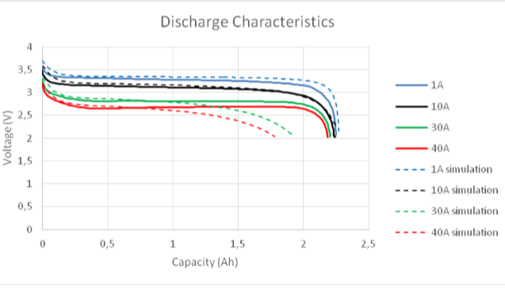
Figure 1 Discharge characteristics. LiFePo4 battery.

2.1 Importance of the discrete element method

Currently, the method is being disseminated by different centers and lines of research in different types of projects such as those already mentioned in the previous chapter, where work is recognized in different areas of study, including agriculture, structural mechanics, civil engineering, geomechanics, granular fluids, and the mining industry, among many others.

The method, although not well known, has great scope for the micromechanical study of different elements and materials. For example, we have the different types of fractures and crack propagation that can be represented and calculated correctly and illustratively with this method, something that would be difficult to visualize realistically with other types of computational solution strategies.
All this is thanks to the different parameters used for the real representation of a discrete medium where, depending on the area of ​​study, we can analyze a material or how it would behave under different types of external forces or reactions.

2.2 Breaking criterion

The contact model presents a microstructural failure criterion that characterizes the tensile or shear failure of the contacts between different elements. This aspect is delimited by a failure surface characterized by the maximum tensile strength (in terms of forces) and the maximum shear strength (in terms of forces).
Using the failure criterion, the contacts between particles can break (breaking of the cohesive contribution between particles) due to external loads of a certain magnitude. These contacts break when the interface forces in the normal or tangential directions are exceeded ($F_{n}>R_{T}$ o $\left|{|F}_{T}|\right|>R_{T}$). In the case of this contact constitutive model, the material's cohesion is considered to have been completely lost.

2.3 Cells used for analysis in software

Now that we have an idea of ​​how electric car batteries are constructed, we can begin a detailed analysis of each cell, which is mostly cylindrical or rectangular depending on the space they occupy. The images below show a specific type of 18650 cell, named for its 18 mm x 65 mm dimensions. This is a common nomenclature for battery manufacturing cells. We are also representing the differences between a physical model, drawing software, and software used to discretize said element.
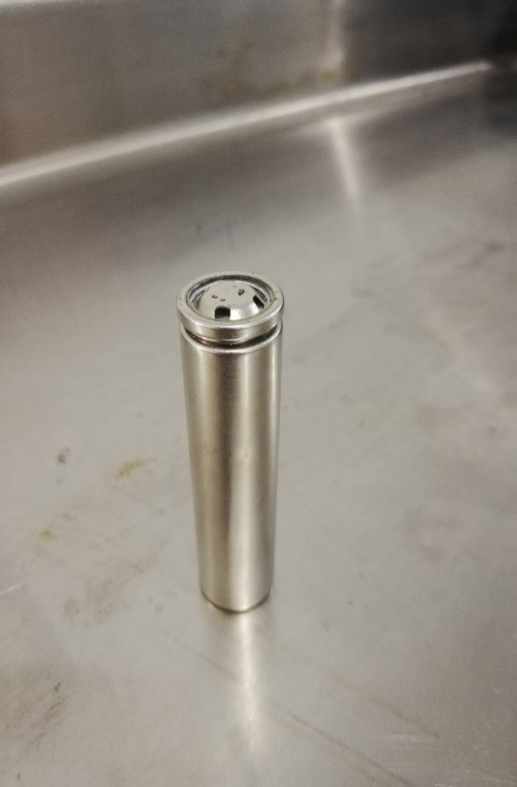
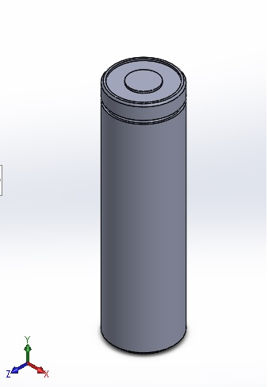
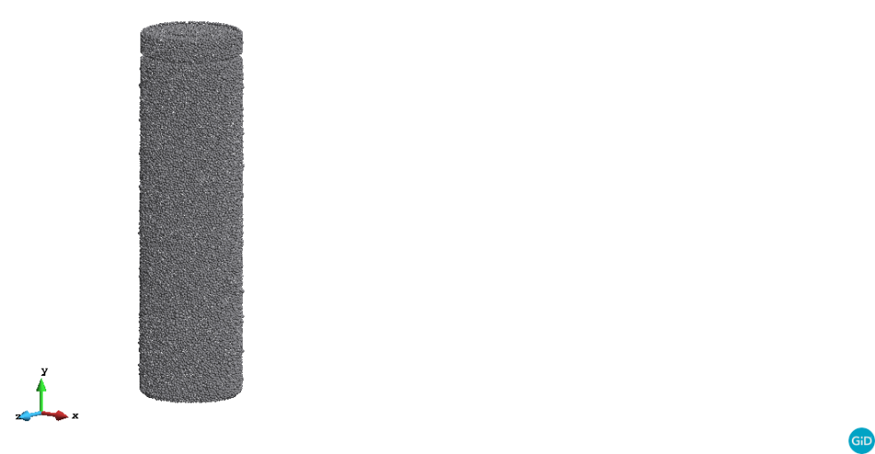
Figure 2 cell isometric view

The above is necessary to understand the nature of the project carried out, in order to clarify the pairs that make up the battery of an electric car from the general to the particular. The following images show how a lithium-ion cell is constituted, which will be taken as a basis for the implementation of the method.

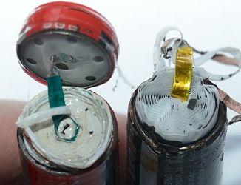
Figure 3 Cell open at the top

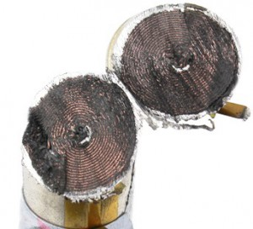

Figure 4 Cell with a cross section

Using the images above, we can render a drawing made in SolidWorks with the main parts to be analyzed: the anode, cathode, and electrolyte, which are enclosed in a perforated plastic film. The image below shows this rendering, and we can see the small layers that make up the lithium cell.

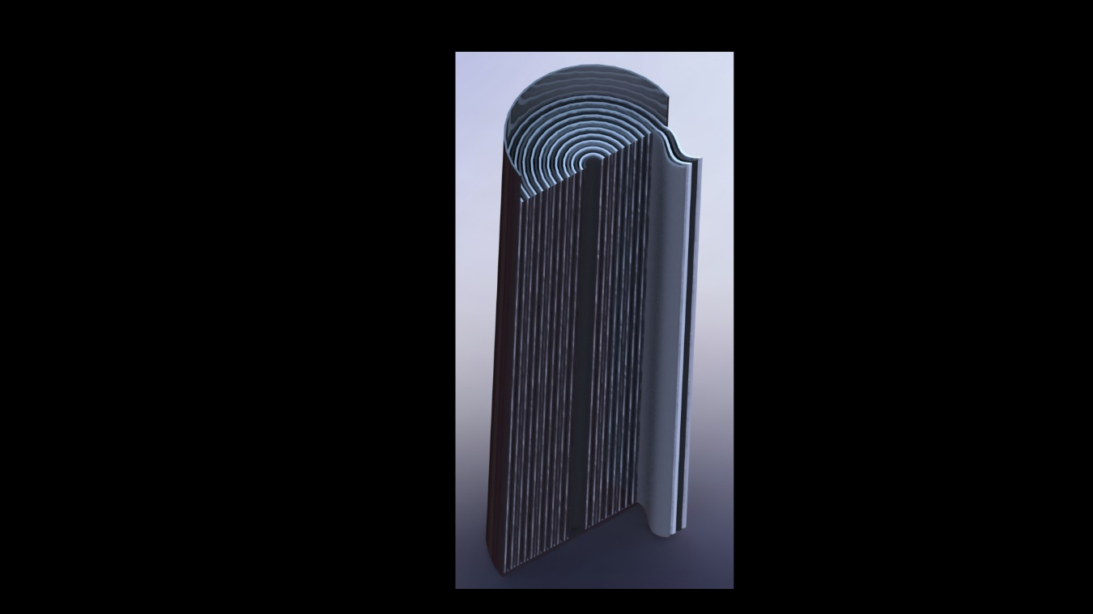
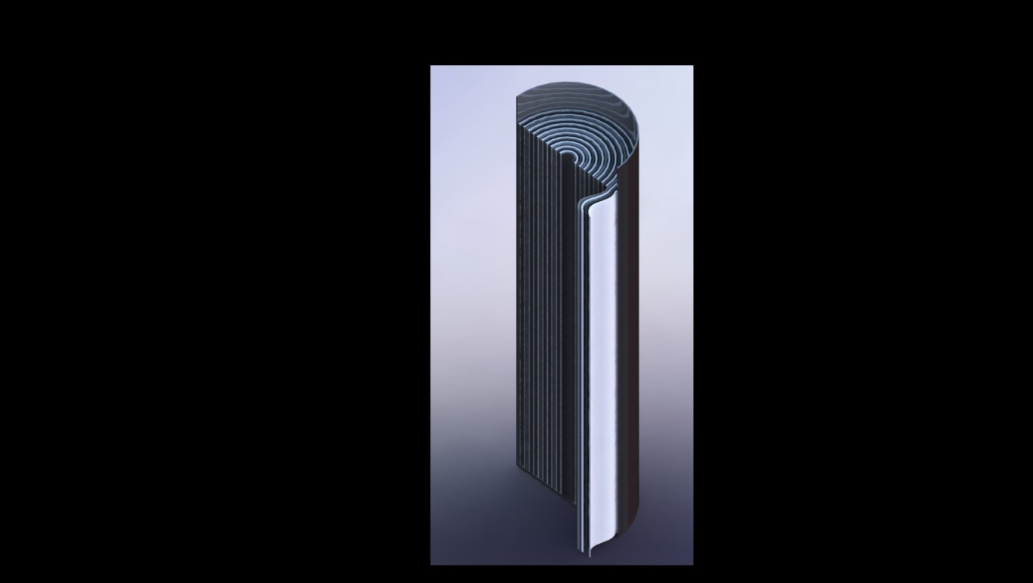
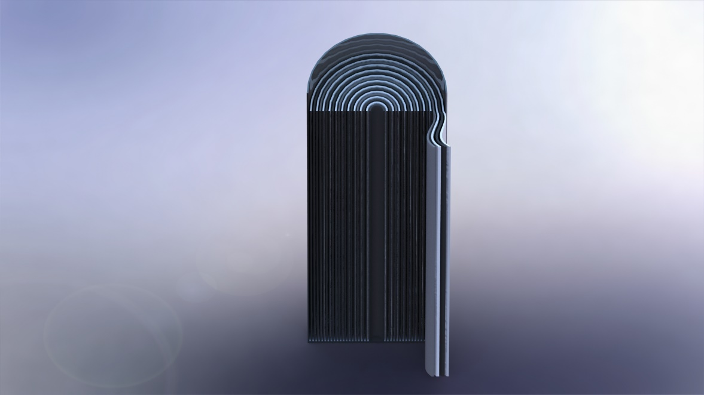
Figure 5 Longitudinal section of a lithium cell

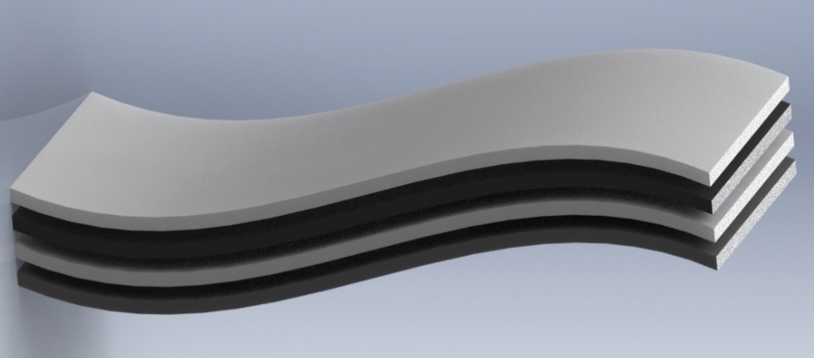

Figure 6 Layers of the cell interior

2.4 Lithium iron phosphate battery

Lithium iron phosphate batteries, also known as LFP batteries, are a type of rechargeable battery, specifically a lithium-ion battery which has a lithium iron phosphate cathode (${LiFePO}_{4}$).
The aforementioned material will be used for the simulation of this project.
The batteries ${LiFePO}_{4}$ they have a slightly lower energy density than common lithium cobalt oxide batteries (${LiCoO}_{2}$) frequently used in household appliances, but they offer greater durability, greater power and are much safer, making their use in electric vehicles optimal.

Lithium iron phosphate (${LiFePO}_{4}$), It is a natural mineral from the olivine family. Lithium iron phosphate (LFP) batteries are more stable, safer, and longer-lasting, but until now their use has been restricted by their lower energy capacity. Thanks to their greater reliability and the fact that they avoid the risk of combustion present in lithium cobalt oxide batteries, they are attractive for critical applications such as aeronautics, automotive, robotics, and medicine, where a failure can mean something much more serious than a missed call.

Several strategies have been tested to improve battery performance ${LiFePO}_{4}$, such as reducing the size of the compound particles to facilitate the transfer of ions, or coating them with a material with greater electrical conductivity to give an extra push to the lithium cations.
The batteries ${LiFePO}_{4}$ They have a very low internal resistance that allows them to deliver very high currents and they also have a fairly long lifespan, even when subjected to deep discharge cycles.

Conclusion

In the vast world of engineering, there have been great advances, but not as much as the impact lithium batteries have had today. These devices have transformed how we can store energy compactly, as they play a significant role in mobility, electronic devices, and energy storage.

Lithium-ion batteries are a type of rechargeable battery that uses lithium as a storage and energy generator.

These batteries work by transferring lithium ions between a cathode and an anode through an electrolyte, generating energy during discharge and storing lithium during charging. This process allows the battery to store and release electrical energy to power electronic and electrical equipment and devices.

The difference between lithium batteries and other energy sources is that they are not disposable. Lithium batteries are rechargeable, and therefore can last much longer, even if properly cared for, extending their lifespan until they need to be replaced with new ones.

DISCLAIMER (ARTIFICIAL INTELLIGENCE)

Author(s) hereby declare that NO generative AI technologies such as Large Language Models (ChatGPT, COPILOT, etc.) and text-to-image generators have been used during the writing or editing of this manuscript.

COMPETING INTERESTS DISCLAIMER:
Authors have declared that they have no known competing financial interests OR non-financial interests OR personal relationships that could have appeared to influence the work reported in this paper.

References

Armenta, R. E. (July 17, 2017). Discrete Mathematics. Patria.
Graphene Batteries. (n.d.). Retrieved from:
http://bateriasdegrafenopara.com/tipos-de-baterias/#Clases_de_baterias

Cabrera, S. (2012). Perspectives in Materials Processing - Electrodes for Lithium-Ion Batteries in Bolivia. Bolivian Journal of Chemistry, 24.

Cea, D. Á. (July 2017). Model for a Lithium-Ion Battery for an Electric Vehicle. Valladolid, Spain.

D'Ambra, R. B. (2007). Calculation of the Stress Intensity Factor Using the Discrete Element Method. South American Journal of Structural Engineering, 7-20.

D'Ambra, R. B. (2008). Calculation of fractomechanical parameters via integral using the discrete element method. Computational Mechanics Vol. XXVII, 1277-1291.

Durán, R. S. (July 8, 2013). Design and implementation of a data acquisition system for charging and discharging lithium-ion batteries. Santiago, Chile.
Unicrom Electronics. (n.d.). Retrieved from https://unicrom.com/historia-de-la-bateria-de-litio-ion/

Fonseca, L. J. (January 1, 2011). Lithium-ion cells, cells, and batteries: an alternative for…???. p. 8.

Garnica, A. G. (2015). Patenting, history, and characteristics of automotive batteries: the case of hybrid cars. Entreciencias DIALOGUE IN THE KNOWLEDGE SOCIETY, 17.

Garnica, A. G. (2015). Patenting, history, and characteristics of automotive batteries: The case of hybrid cars. Morelos: Autonomous University of the State of Morelos.

hybridstein group. (n.d.). Retrieved from hybridstein group: http://www.hybridsteingroup.com/caracteristicas-baterias-linadium/

Materials Science Institute of Madrid. (1995). Lithium-ion battery Li4/3Ti5/3O41 LiC1O2/LiMn2O4. BULLETIN OF THE SPANISH SOCIETY OF Ceramics and Glass, 8.

ITURBE, J. L. (March 2007). Deposition and characterization of thin films of materials with application in cathodes for rechargeable lithium microbatteries. Toluca de Lerdo, State of Mexico, Mexico.

Iznaga, A. L. (2014). Theoretical basis for simulating wear on working parts of agricultural implements using the Discrete Element Method (DEM). Journal of Agricultural Technical Sciences, 81-88.
Kosteski, L. (2008). Determination of static and dynamic factomechanical parameters using the Discrete Element Method composed of bars. International Journal of Numerical Methods for Engineering Design and Calculation, 323-343.
LOCTITE TEROSON. (n.d.). Retrieved from LOCTITE TEROSON:
https://blog.reparacion-vehiculos.es/evolucion-baterias-automoviles

Mendoza, G. A. (April 9, 2014). Reliability analysis of a storage silo unloading model using the Discrete Element Method (DEM). Bogotá, Colombia.
Navarra, E. O. (2005). Fracture mechanics analysis. Advances in the development of discrete element and finite element methods for the analysis of fracture problems. Barcelona, ​​Spain.
Navarra, E. O. (April 2005). Application of the discrete element method to wear problems. Barcelona, ​​Spain.
Ordóñez, C. P. (May 2011). Study of batteries for electric vehicles. Madrid, Spain.
Quispe, M. M. (November 6, 2013). Finite element and discrete element formulation.
Armenta, R. E. (July 17, 2017). Discrete Mathematics. Patria.
Graphene Batteries. (n.d.). Retrieved from Graphene Batteries: http://bateriasdegrafenopara.com/tipos-de-baterias/#Clases_de_baterias
Cabrera, S. (2012). Perspectives in materials processing - electrodes for lithium-ion batteries in Bolivia. Bolivian Journal of Chemistry, 24.
Cea, D. Á. (July 2017). Model for a lithium-ion battery for an electric vehicle. Valladolid, Spain.
D'Ambra, R. B. (2007). Calculation of the stress intensity factor using the discrete element method. South American Journal of Structural Engineering, 7-20.
D'Ambra, R. B. (2008). Calculation of fractomechanical parameters via j integral using the discrete element method. Computational Mechanics Vol XXVII, 1277-1291.
Durán, R. S. (July 8, 2013). Design and implementation of a data acquisition system for lithium-ion battery charge and discharge testing. Santiago, Chile.
Unicrom Electronics. (n.d.). Retrieved from https://unicrom.com/historia-de-la-bateria-de-litio-ion/
Fonseca, L. J. (January 1, 2011). Lithium-ion cells, cells, and batteries: an alternative for…???. p. 8.
Garnica, A. G. (2015). Patenting, history, and characteristics of automotive batteries: the case of hybrid cars. Entreciencias DIALOGUE IN THE KNOWLEDGE SOCIETY, 17.
Garnica, A. G. (2015). Patenting, history, and characteristics of automotive batteries: The case of hybrid cars. Morelos: Autonomous University of the State of Morelos.
hybridstein group. (n.d.). Retrieved from hybridstein group: http://www.hybridsteingroup.com/caracteristicas-baterias-linadium/
Materials Science Institute of Madrid. (1995). Lithium-ion battery Li4/3Ti5/3O41 LiC1O2/LiMn2O4. Bulletin of the Spanish Society of Ceramics and Glass, 8.
ITURBE, J. L. (March 2007). Deposition and characterization of thin films of materials with application in cathodes for rechargeable lithium microbatteries. Toluca de Lerdo, State of Mexico, Mexico.
Iznaga, Á. L. (2014). Theoretical basis for simulating wear on working parts of agricultural implements using the Discrete Element Method (DEM). Journal of Agricultural Technical Sciences, 81-88.
Kosteski, L. (2008). Determination of static and dynamic factomechanical parameters using the Discrete Element Method composed of bars. International Journal of Numerical Methods for Engineering Calculation and Design, 323-343.
LOCTITE TEROSON. (n.d.). Retrieved from LOCTITE TEROSON: https://blog.reparacion-vehiculos.es/evolucion-baterias-automoviles
Mendoza, G. A. (April 9, 2014). Reliability analysis of a storage silo unloading model using the Discrete Element Method (DEM). Bogotá, Colombia.
Navarra, E. O. (2005). Fracture mechanics analysis. Advances in the development of discrete element and finite element methods for the analysis of fracture problems. Barcelona, ​​Spain.
Navarra, E. O. (April 2005). Application of the discrete element method to wear problems. Barcelona, ​​Spain.
Ordóñez, C. P. (May 2011). Study of batteries for electric vehicles. Madrid, Spain.

Quispe, M. M. (November 6, 2013). Finite element and discrete element formulation.
Reyes, C. E. (November 2013). Parallelization of the Discrete Element Method for Damage Analysis After an Explosion. Guanajuato, Gto.

Velasco, A. C. (July 2018). Development and validation of a lithium-ion battery model. Application to the study of aging linked to the type of recharging.

