Custom Hiring Centre and Region-Specific Demand of Agriculture Machinery in Indore District

Abstract
Geographically, India accounts for 2.4 percent of the world’s total area and 4 percent of its water resources. While it is home for about 17 percent of world’s population and 15 percent of the livestock, the country has seen a steady growth in the population. Farm mechanisation in India stands at about 40-45 percent. This is still low when compared to countries such as the US (95 percent), Brazil (75 percent) and China (57percent). CRIDA has taken the lead and developed more than 151 Custom Hiring Centres of farm equipment throughout all ecological areas in India. The centre has a collection of farm machinery, implements, tools, and equipment that are rented out to small and marginal farmers, women and agricultural labourers. Farm mechanization has the potential to significantly revolutionize agriculture in India by providing a means of increasing farm output, bolstering livelihoods, and guaranteeing food security. The Sahkari Sheetgrah Sanstha, Rau is a society under which a Custom Hiring Centre was established by National Cooperative Development Corporation. A random sample of 10 farmers was selected to collect the data regarding the major crops cultivated in the area and the main agriculture implements required for farm operations. The farmers are mainly raising soybean, wheat, chickpea, potato and onion. The main agriculture implements in demand are Tractor, Cultivator, Seed drill, Combine harvester, Power thresher, Disc harrow, Rotavator and Mould board plough.

Key Words : Custom Hiring Centre, agriculture machinery, demand and Indore district.
Introduction
While India is now known as the services hub for the entire world, its agriculture sector plays a key role globally. Geographically, India accounts for 2.4 percent of the world’s total area and 4 percent of its water resources. While it is home for about 17 percent of world’s population and 15 percent of the livestock, the country has seen a steady growth in the population. India ranks third in farm and agriculture output globally. It is also the largest producer, consumer and exporter of spices and related products. Agricultural exports constitute 10 percent of the country’s exports, and is the fourth-largest exported principal commodity. During last decade, the overall workforce in agriculture and allied activities has dipped by 11 percentage points, indicating a rise in secondary and tertiary sectors, self-employment and regular jobs, which is also consistent with economic growth. Farm mechanisation in India stands at about 40-45 percent. This is still low when compared to countries such as the US (95 percent), Brazil (75 percent) and China (57percent). While the level mechanisation lags behind other developed countries, the level of mechanisation has seen strong growth through the last decade. The farm power availability on Indian farms has grown from 1.47 kW/ha in 2005-06 to 2.02 kW/ha in 2013-14 [Rahul et al 2015].
CHCs are basically a unit comprising a set of farm machinery, implements and equipment meant for custom hiring by farmers. Though certain implements and equipment are crop specific, the traction units like tractors, power tillers etc., and self-propelled machinery like combine harvesters etc., are used in common [Naushad and Prasad 2023]. Early in the 19th century, custom hiring of farm equipment was first used in Indian agriculture, when a steam thresher with a 30-inch (diameter) was employed for special hire. The devices were transported to around 10 different locations, where they operated for two to three days a piece. Midway through the 1960s, when Agro-Industries Corporation (AIC) was established in the states, organised custom hiring was made to encourage the usage of agricultural machinery across several farms. Under the National Innovations in Climate Resilient Agriculture (NICRA) initiative, an ICAR Flagship Platform, CRIDA has taken the lead and developed more than 151 Custom Hiring Centres of farm equipment throughout all ecological areas in India. These Custom Hiring Centres were developed and are being run by numerous State Government Agencies, NGOs, and other entrepreneurs throughout the nation [Bharathi et al 2022].
“It has been envisaged that farmers can benefit from technological developments in terms of large machines performing farm operations. But these machines being costly remain out of the farmers’ reach” (Sharma et al, 2005). “Proper utilization of farm machinery saves 20-30 per cent time, 15-20 per cent seeds, 20-25 per cent fertilizers, 10-20 percent labour and an increase in cropping intensity to about 10 per cent” (Singh, 2005). “The unique feature of custom hiring services is that the equipment ownership costs are dispersed over a greater area” (Bansal, and Mukesh 2005).
The centre has a collection of farm machinery, implements, tools, and equipment that are rented out to small and marginal farmers, women and agricultural labourers. CHCs enhance access to quality tools, implements and machinery services for ensuring quick response and timely operations such as land preparation, sowing, inter-cultivation, other crop management, harvesting and post harvesting specific to existing cropping pattern of the cluster (Uday et al., 2020). The study conducted by S. Yugender et al [2022] showed the status and functioning of four Custom Hiring Center Models Government based CHC Model, Non-Governmental Organisation based CHC Model, Krishi Vigyan Kendra based CHC Model and Farmer Producer Organisation based CHC Model in Telangana State. All four Custom Hiring Center models were viable as their B:C was more than 1. Among the four Custom Hiring Center Models, Farmer Producer Organisation based CHC Model is best model and viable on long run.
Farm mechanization has the potential to significantly revolutionize agriculture in India by providing a means of increasing farm output, bolstering livelihoods, and guaranteeing food security. Most of the respondents (48.75%) had favourable attitude towards CHCs, followed by 35.00 per cent of respondents who had neutral attitude towards CHC and only 16.25 per cent of respondents had unfavourable attitude towards CHC in Madhya Pradesh state [Suraji et al 2025].
Under these factual circumstances a study was conducted in Rau of Indore district of Madhya Pradesh to assess the demand of agriculture machinery.
Methodology
The study is a part of the Project report submitted by the coauthor in partial fulfilment of the MBA in Agri Business Management from JNKVV, Jabalpur. As a part of internship programme a small study was organized in purposively selected Indore district of Madhya Pradesh. The Sahkari Sheetgrah Sanstha, Rau is a society under which a Custom Hiring Centre was established by National Cooperative Development Corporation within its Sahkar Mitra scheme. A random sample of 10 farmers was selected to collect the data regarding the major crops cultivated in the area and the main agriculture implements required for farm operations. The primary data was collected by personal interview and focused group discussion which is presented with the help of tables and graphs in the subsequent sections.
Personal interview method requires a person known as the interviewer asking questions generally in a face-to-face contact to the other person or persons. (At times the interviewee may also ask certain questions and the interviewer responds to these, but usually the interviewer initiates the interview and collects the information.) This sort of interview may be in the form of direct personal investigation or it may be indirect oral investigation. In the case of direct personal investigation the interviewer has to collect the information personally from the sources concerned. He has to be on the spot and has to meet people from whom data have to be collected. This method is particularly suitable for intensive investigations. But in certain cases it may not be possible or worthwhile to contact directly the persons concerned or on account of the extensive scope of enquiry, the direct personal investigation technique may not be used. The method of collecting information through personal interviews is usually carried out in a structured way. As such we call the interviews as structured interviews. Such interviews involve the use of a set of predetermined questions and of highly standardized techniques of recording. Thus, the interviewer in a structured interview follows a rigid procedure laid down, asking questions in a form and order prescribed.
A Focus Group Discussion (FGD) is a qualitative research method and data collection technique in which a selected group of people discusses a given topic or issue in-depth, facilitated by a professional, external moderator. This method serves to solicit participants’ attitudes and perceptions, knowledge and experiences, and practices, shared in the course of interaction with different people (see Table 1). The technique is based upon the assumption that the group processes activated during an FGD help to identify and clarify shared knowledge among groups and communities, which would otherwise be difficult to obtain with a series of individual interviews. Yet, this method does not presume that A) all the knowledge is shared equally among a studied group, or that B) in each community there is a common, underlying, homogeneous knowledge. Rather, an FDG allows the investigator to solicit both the participants’ shared narrative as well as their differences in terms of experiences, opinions and worldviews during such ‘open’ discussion rounds.
Results :

Demand of equipment and machineries

The established selected society i.e., Sahakari Sheetgrah Sanstha, Rau is situated in Indore district. Indore district come under central plateau agroclimatic zone and very rich in agriculture. The farmers are mainly raising soybean, wheat, chickpea, potato and onion. For cultivation of these crops number of machineries are required for different operation of farming. Most of the farmer in the region/study area utilize owned/ hired basis equipment and machinery for the purpose. The coverage of major crops in Indore district is given in Table 1

Table 1- Area and productivity of important crop in Indore district

S.No | Crops | Area (000’hac) | Productivity (Kg/hac)
1 | Soybean | 219.8 | 1185
2 | Wheat | 127.2 | 2277
3 | Chickpea | 32.2 | 941
4 | Potato | 15.7 | 4712
5 | Onion | 1.9 | 581.7

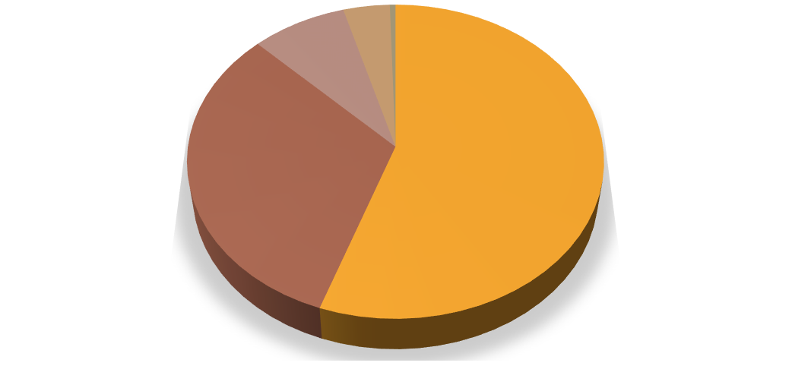
4%
Area (000’hac)
8%
1%
32%
55%
Soybean Wheat Chickpea Potato
Onion

Fig 1 Crops according to area in Indore district.


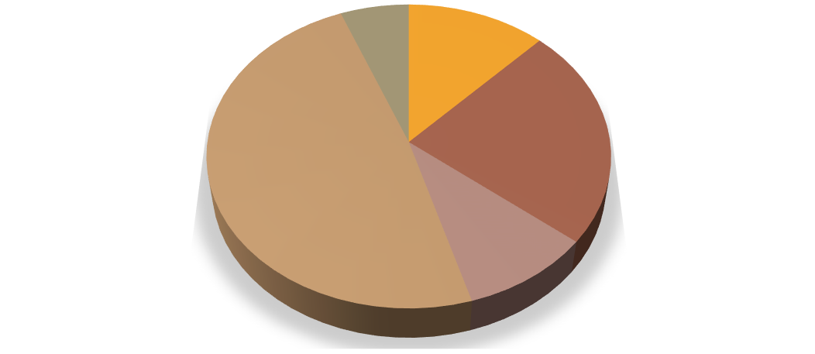










Productivity (Kg/hac)
6%
12%
23%
49%
10%
Soybean Wheat Chickpea Potato
Onion

Fig 2 Crops according to productivity in Indore district

Required Equipment/ Machinery
On the basis of interview conducted on 10 selected farmers belonging Rau, Rangwasa and Bijalpur, the major crops in the study area and the information regarding use of different equipment/machinery for the different purpose on owned or hired basis, the same was matched with organizing focused group discussion. As per coverage of major crops the following equipment/machinery are needed for different operation of farming and details are given in Table 2
Table 2- Equipment required for the major crop cultivated in the region.

S.No | Crops | Equipments/ Machinery
1 | Wheat | - Tractor  - Mould board plough  - Disc harrow  - Seed drill  - Rotavator  - Combine harvester
2 | Soybean | - Tractor  - Cultivator  - Mould board plough  - Disc harrow  - Seed drill  - Sprayer  - Rotavator
3 | Potato | - Tractor  - Cultivator  - Rotavator  - Potato planters
4 | Onion | - Tractor  - Cultivator  - Rotavator
5 | Chickpea | - Tractor  - Mould board plough  - Disc harrow  - Seed drill  - Sprayer  - Rotavator

Develop/Establishment of custom hiring centre
The new business plan related to custom hiring centre was developed for the society to expand their business and improve their profit through new venture. The society is well establishment and famous for their cold storage services. Consumers were satisfied with the reasonable price and services provided by the society. The area around the location of the society i.e., Rau is rich in agriculture and farmers are using agri machinery in most of the agricultural operation. Thus, keeping in mind the demand of Agri-machineries in the study area it will be beneficial to start a custom hiring centre. For establishing custom hiring centre of Agri machinery following basic information is needed.

Selected equipment for Custom Hiring Centre at Rau
Most of the farmers are interested to use agri-machinery for different operations like ploughing, sowing, harvesting and threshing purpose under different kharif and rabi crop in the study area. Due to demand of agri-machinery for agricultural purpose, it is required to develop a custom hiring centre in study area. For development of centre the details of equipment are required and this information is provided in Table 3

Table 3. List of equipment/machinery with their uses.

S.No | Equipment / Machinery | Remarks
1 | 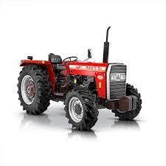  Tractor | Most demanded and required vehicle in farm operations. Used for transportation and for carrying various farm operations.
2 | Cultivator  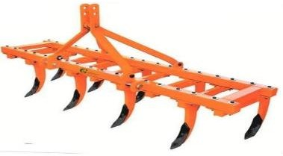 | Used for stirring soil and promote crop growth and decrease the weed growth.

3 | Seed drill  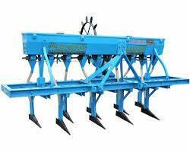 | Used for sowing seed at proper depth and optimum distance.
4 | Combine Harvester  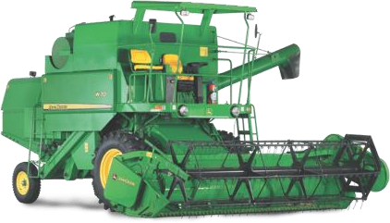 | It’s a versatile machine is used to harvest various crop mainly famous for wheat harvesting.
5 | Power Thresher  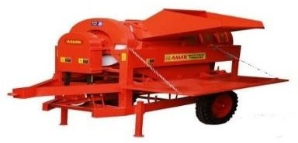 | Used for separating grains from straw and clean them.
6 | Rotavator  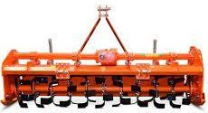 | Used for land preparation in vegetable and field crops. It improves the drainage and land structure.
7 | Mounted disc harrow  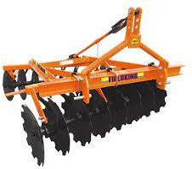 | It is used to till the soil where crops are planted. It is also used to remove the unwanted weeds and crop parts.

8 | Mould board plough  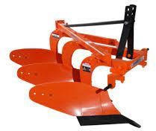 | It is a primary tillage implement used to disturb the soil.
Table 3. provides name of equipment/ machinery required in the study area for consideration of establishment of custom hiring centre.
Discussion
As we can see from the above findings that the most common farm implements preferred by the farmers for hiring agricultural implements for their own use were tractor, cultivator, rotavator, mould board plough, disc harrow, seed drill combine harvester etc. the above findings are in congruence with the findings of Hiremath et al (2015) and Kamboj et al (2012).
Suraji et al (2024) in their study have concluded that for effective functioning of Custom Hiring Centers, the Government, Extension officials, CHC personnel should work cooperatively with truth and equal justice and without bias and political inference. The government should improve the easy accessibility of farm machinery and road/transport facilities in the locality for easy and timely movement of machinery. Govt. officials should instruct the CHC owners to supply equipments as per registered order and his behavior should be closely monitored to avoid collusion between farmers. Entrepreneurs should make availability of more frequently used machinery in CHC. Machines with low demand should be replaced by machines with high demand.
Custom hiring service centres play a vital role in modernizing agriculture and supporting farmers, the problems associated with the functioning of custom hiring service centres and the challenges faced by farmers in utilizing custom hiring services are significant and multifaceted. These include issues such as insufficient infrastructure and equipment upkeep, financial constraints, limited awareness among potential users, and obstacles related to access, high expenses, as well as the insufficient availability and maintenance of equipment (Anil et al -2024).
Chitra Das and Patil (2024) reported that emphasis should be placed on enhancing those independent variables that positively and significantly correlate with the efficiency of custom hiring centres. Custom Hiring Centers (CHCs) facilitate the adoption of climate-smart agriculture technologies by offering agricultural equipment for rent at affordable prices. By providing access to costly machinery at reasonable rates, CHCs enable small-scale farmers to implement climate-resilient practices and technologies. By examining these influences through the comprehensive study, policymakers and agricultural extension services can more effectively customize their strategies to promote the widespread adoption of climate-smart agriculture (CSA) practices.
In their report Srishti et al (2025) have enumerated that in recent years, with significant support from the union and state governments, some CHCs have begun offering ex-situ CRM services to farmers, particularly for baling operations. Although the overall share of CHCs providing ex-situ services remains small, those engaged in such operations have adopted a range of service delivery mechanisms. In our sample, government-run CHCs were primarily providing baling services to farmers for personal use, such as for livestock fodder, or had subcontracted their balers to other aggregators. In contrast, privately run CHCs were typically engaged in large-scale ex-situ operations, conducting baling activities across multiple farms and supplying agricultural residue for industrial use at contracted rates.
Research findings of B.S. Ghanghas et al (2024) highlight that about 85 per cent of farmers utilized services of CHCs purely for hiring machinery for farm operations whereas, hardly more than 10 percent of respondents run own centres and only 4.44 per cent pool their machinery. High initial costs, no rate fixation by village committees and insufficient no. of machinery or implements at peak seasons were very serious constraints related to inputs of CHCs for their promotion.
Custom hiring of farm types of machinery has helped the farmers to ensure timely field operations which have ensured increased productivity, reduced crop losses and improved the quality of grain or produce, increased the use of land and other inputs such as seeds, fertilizers, and irrigation water more effectively and has increased labour productivity by using labour saving and drudgery reducing devices. Efforts may be made to create ability among the farmers by giving them proper guidance while providing them training for learning and having acquaintance with the implements and services. The Governmentʹs role in regulating proper hiring prices for farmers may be to increase the different farm machinery in varied regions of the country to ensure its affordability for all farmers (Upali and Amit- 2022).
The findings of Suraji et al (2025) reveal a high level of satisfaction among farmers with Custom Hiring Centers, which enabled farmers avail timely farm operations and efficient use of input resources available in CHC. This understanding can reassure policymakers to invest in such costly farm machinery. CHC promoted increase in cropping intensity wherever feasible facilitates crop residue recycling and prevents burning of residues. Policymakers can use this information to prioritize these factors in developing and promoting future farm mechanization technologies. Awareness need to be increased in order to spread the benefits of the programme among the farmers who wanted to establish CHCs. CHCs are highly useful in increasing the cultivable land, cropping intensity and yield. The outcomes of this study highlight the importance of effective technology promoters, such as KVK (Krishi Vigyan Kendra), Farmer Producer organizations (FPOs) and Non-Government Organisations (NGOs) in shaping farmers’ attitude and expectations. Policymakers can focus on strengthening and supporting these promoters to ensure the successful adoption of farm machinery available in Custom Hiring Centers.

Conclusion
From the above study it may be concluded that the important crops of the study area were soybean, wheat, chickpea, potato and onion. The main agricultural implements that were in demand by the farmers were Tractor, Cultivator, Seed drill, Combine harvester, Power thresher, Disc harrow, Rotavator and Mould board plough. Thus, a custom hiring centre with the availability of above implements may be profitably established at Rau in Indore district of Madhya Pradesh.
References
Anil K, Basavaprabhu Jirli and Nandini HM (2023) Custom hiring service centres in agriculture: Challenges on both sides of the plough in Tumakuru District of Karnataka, The Pharma Innovation Journal; SP-12(10): 920-925.
Anupama Verma and P. Shrivastava (2024) Digital marketing scenario & Customer Relationship Management in India, International Journal of Development Research, 15 (2), 67621-67623.
Anupama Verma and P. Shrivastava (2021) Scope and Challenges of Entrepreneurship in Agriculture in India. International Journal of Education, Modern Management, Applied Science & Social Science.03(2) (III):75-79.
Anupama Verma, Rishabh Patidar and P. Shrivastava (2025) Consumer Preferences for Dehydrated Vegetables, Archives of Current Research International, 24(12), 10-20.
Bansal, N. K., & Mukesh, S. (2005). Impact of Custom Hiring on Farm Mechanization in Haryana. Report of AICRP on Farm Implement and Machinery, CCSHAU, Hissar.
B. Chinnappa, Kiran Kumar R. Patil and H.S. Sowmya (2018) Economic Impact of Custom Hiring Service Centres in Maize Cultivation: A Case Study from Karnataka, Ind. Jn. of Agri. Econ., 73(4), 478-500.
B.S. Ghanghas, A.K. Rohila, P.K. Chahal and Ajay Kumar (2024) Constraints Faced by Farmers in Utilization of Services of Custom Hiring Centres in Haryana State, Journal of Community Mobilization and Sustainable Development, 19(4), 1203-1209.
Chitra Das and S. B. Patil (2024) Constraints of Custom Hiring Services Utilization & Suggestions for Advancing Farm Mechanization in Vijayapur District of Karnataka, India, Journal of Experimental Agriculture International, 46(9), 555-562. DOI: https://doi.org/10.9734/jeai/2024/v46i92853
Chitra Das and S. B. Patil (2024) Perception vs. Performance: Correlation Assessment of Custom Hiring Centres in the Era of Climate Smart Agriculture, International Journal of Environment and Climate Change; 14(9),519-523. DOI:https://doi.org/10.9734/ijecc/2024/v14i94435.
Hiremath GM, Lokesh GB, Maraddi GN, Patil SS. (2015) Accessibility of farm machinery services – CHSCs for Small and Marginal farmers. Int J Manag Soc Sci.;3(2):897 907.
Kamboj P, Khurana R, Dixit A. (2012) A study on farm machinery services provided by selected cooperative societies. Agric Eng Int CIGR J.;14(14):122-33.
Kiran Kumar Shyam, Lal Singh Patel and Dr. Dronak Kumar Sahu (2023) An analysis of the utilization pattern of custom hiring of agricultural machinery in paddy farm in Bilaspur district of Chhattisgarh state in India, International Journal of Statistics and Applied Mathematics; SP-8(6): 662-665.
Mo Naushad and Nivedita Prasad (2023) Custom Hiring Centre (CHC), Just Agriculture (multidisciplinary e-newsletter), 3(9), 69-71.
P Bharathi, M Anjugam, and D Suresh Kumar (2022) Impact of Custom Hiring Centres on farm profitability some evidences from Tamil Nadu, Agricultural Economics Research Review, 35 (Conference Number), 135-144 DOI: 10.5958/0974-0279.2022.00026.X
P. S. Ranjith Kumar and G. S. Mahadevaiah (2017) Economic Feasibility of Custom Hiring Service Models in Agriculture in Eastern Dry Zone of Karnataka, Mysore J. Agric. Sci., 51 (2) : 223-232.
Rahul Kapur, Swarnima Chouhan, Sukrit Gulati and Vinayak Saxena (2015) Transforming Agriculture through mechanisation - A Knowledge Paper on Indian farm equipment sector, FICCI.
Sharma, V. K., Singh, K., and Panesar, B. S. (2005). Custom hiring of agricultural machinery and its future scope. In Status Report on Farm Mechanization in India (pp. 127–132). Department of Agriculture and Cooperation, Ministry of Agriculture, Government of India, New Delhi.
Singh (2005) Scope, progress and constraints of farm mechanization in India. In Status of Farm Mechanization in India (pp. 48–56). Indian Agricultural Statistics Research Institute, New Delhi.
Srishti Jain, Kurinji Kemanth and Navjot Singh Sarao (2025) Custom Hiring Centres for Better Crop Residue Management: Insights from Punjab, The Council on Energy, Environment and Water (CEEW), New Delhi, Report.
Subhash Rawat1, Monika Jaiswal, Kunal Bhalave, D. K. Vani and C. P. Rahangdale (2024) Assessment Study on Custom Hiring Centers (CHCs) and Its Services for Farmers in Khandwa District of Madhya Pradesh, Asian Journal of Agricultural Extension, Economics & Sociology 38(12), 178-184. DOI: 10.9734/AJAEES/2020/v38i1230516.
Suraji Yugender Reddy, V. Sudha Rani, V. Ravinder Naik, M. Malla Reddy and A. Meena (2024) Strategy for effective functioning of Custom Hiring Centers (CHCs) Models in India, Agriculture Association of Textile Chemical and Critical Reviews Journal, 12(4), 506-509. DOI: https://doi.org/10.21276/AATCCReview.2024.12.04.506.
Suraji Yugender Reddy, V. Sudha Rani, V. Ravinder Naik, M. Malla Reddy and A. Meena (2025) Farmers’ Attitudes towards Custom Hiring Centers: Evidence from Madhya Pradesh and Telangana, India, Journal of Scientific Research and Reports, 31(6), 621-629.
S. Yugender Reddy, V. Sudha Rani, V. Ravinder Naik, M. Malla Reddy and A. Meena (2022) Custom Hiring Center Models for enhanced Farm Mechanization in Telangana state, The J. Res. PJTSAU, 50 (3) 117-123.
Uday, R. B., Tamhankar, M. B., Saha, K. P. and Bargale P. C. (2020). A business model of custom hiring of agricultural machinery for enhanced farm mechanization in Madhya Pradesh. Indian Farming. 70(01): 18–22.
Upali Kisku and Amit Kumar Singh (2022) A Review on Custom Hiring Services under Indian Conditions: Farmer’s Perception, Associated Factors, Constraints, and Suggestions, Asian Journal of Agricultural Extension, Economics & Sociology, 40(11), 8-27.

Vibha Gadpayle (2021) “Business development plan related to custom hiring centre for Sahakari Sheetgrah Sanstha, Rau, M.P under Sahakar Mitra scheme of National Cooperative Development Corporation” Unpublished Project Report of MBA(ABM) submitted to Jawaharlal Nehru Krishi Vishwa Vidyalaya, Jabalpur (M.P)
https://agritech.tnau.ac.in/banking/nabard_pdf/Farm%20mechanization/3.Custom_Hiring_Centre.pdf
https://asci-india.com/QP_MC/QP/Farm%20Mechanization%20&%20Precision%20Farming/Custom%20Hiring%20Centre%20In%20-charge%20%20(Agri%20machinery)/AGR_Q1112_v4.0%20Custom%20Hiring%20Center%20In%20-charge.pdf
https://agrimachinery.nic.in/Files/CHCAPP.pdf
https://www.nabard.org/auth/writereaddata/tender/0303201304Custom%20Hiring%20Centre_Model%20Project_FPO%20Financing.pdf
https://rkvy.da.gov.in/Uploads/SucessStory/KARNATAKA/2018/2018011106Krishi%20Yantra%20Dhare(CHSC).pdf
https://diragri.assam.gov.in/sites/default/files/swf_utility_folder/departments/diragri_medhassu_in_oid_4/menu/schemes/3%28E%29%28a%29.1.pdf
https://www.mitsui.com/mgssi/en/report/detail/__icsFiles/afieldfile/2024/04/16/2402i_nozaki_e.pdfhttps://www.mitsui.com/mgssi/en/report/detail/__icsFiles/afieldfile/2024/04/16/2402i_nozaki_e.pd
https://wbfarm21.matirkatha.net/assets/uploads/project_document/Project_Report_on_Custom_hiring_centre-converted.pdf

