PRECISION LIVESTOCK FARMING SYSTEMS IN INDIA: AI and ML in livestock farming

ABSTRACT
Precision Livestock Farming (PLF) is transforming traditional livestock management in India by integrating advanced technologies such as sensors, IoT, artificial intelligence, and automated systems. This review explores the current status, challenges, and technological advancements in PLF systems across the Indian livestock sector. It highlights the use of monitoring tools for animal health, behavior, reproduction, and productivity, with a focus on systems like RFID tags, rumination detectors, and automated milking. Special emphasis is given to disease detection, heat stress management, early pregnancy diagnosis, and real-time behavioral analysis. Applications of PLF in grazing systems using GPS/GIS technologies and early warning systems in poultry farming are also discussed. Despite infrastructural and economic challenges, PLF holds immense promise for improving animal welfare, reducing resource use, and enhancing sustainability in indian livestock farming. The review underscores the need for policy support, farmer awareness, and localized innovations to achieve scalable and effective PLF implementation in India.
Keywords: IoT in Livestock, Dairy Automation, Animal Welfare, Rumination Detection, Automated Milking Systems, Early Pregnancy Diagnosis
1. INTRODUCTION
The world population keeps growing and in several big countries the diets are changing since more people can afford animal products. The result is that the worldwide demand for meat and animal products could increase by 40% in the next 20 years (Berckmans, D and Norton, T., 2016; Berckmans, D. 2014). Livestock farming remains a bedrock of India’s agrarian economy, supporting the livelihoods of millions of rural households, contributing to nutritional security, and forming a significant component of the agricultural GDP.
In the past, livestock management decisions have been based almost entirely on the observation, judgment and experience of the farmer (Frost et al., 2003). Precision livestock farming (PLF) systems can replace the eyes and ears of the farmer and work 24 hours a day and 7 days a week to support him (Berckmans, D and Norton, T.,2016) .Precision Livestock Farming (PLF) emerges as a paradigm shift in animal production. PLF integrates advanced sensors (e.g., temperature, accelerometer, GPS), real-time monitoring systems, RFID tags, Internet of Things (IoT) infrastructure, and analytics based on Artificial Intelligence (AI) and Machine Learning (ML).
In the Indian context, adoption of PLF and AI/ML-enabled livestock management remains at a nascent stage. Nonetheless, conditions are becoming favourable: increasing smartphone penetration, expanding digital and mobile network infrastructure in rural areas, decreasing cost of sensors and IoT modules, and rising awareness among progressive farmers and agri-startups about smart livestock technologies. These trends present promising opportunities for wider implementation of PLF solutions tailored to Indian conditions.
As such, this review paper aims to provide a comprehensive overview of the current status of PLF systems in India, the role and application of AI and ML in livestock farming, the technologies and practical use-cases (for dairy, broiler, grazing systems, reproductive monitoring, disease detection), and the key challenges and future prospects for uptake in Indian conditions.
2. SCOPE AND STRUCTURE
We begin by outlining the technological components of PLF (sensors, IoT, AI/ML, automation) and their relevance to livestock systems. Next, we review applications of AI and ML in Indian livestock farming, including dairy (milk yield, mastitis detection), broiler and poultry management, grazing systems and pasture-based operations, reproductive monitoring and fertility, and disease detection and health monitoring. We then assess the status of adoption and identify limiting factors specific to India (cost, connectivity, data availability, farmer training, scale of operations). Finally, we discuss future directions, opportunities and recommendations for integrating intelligent PLF systems in Indian livestock farming for enhancing productivity, welfare and sustainability.
2.1 ADVANCES IN AI/ML FOR PLF
Over the last decade, PLF has evolved from basic monitoring systems to sophisticated AI-driven decision-support frameworks. Recent reviews highlight advances in sensing technologies (RGB-D cameras, 3D imaging), IoT-enabled platforms, and ML algorithms for real-time data capture and processing (e.g., activity classification, anomaly detection, predictive modelling). In one survey, the authors pointed out that ML in PLF is in an early stage of development and identified research gaps: hybrid models for diagnosis and prescription, combining grazing and animal health variables, meta-learning, and integration of pasture/soil variables.
Fig 1 : Predictive Agriculture System Architecture
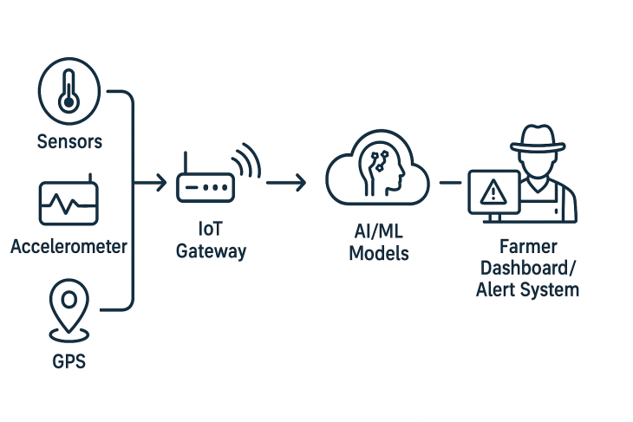
In India, while most literature still focuses on crop-based “precision agriculture”, recent works are beginning to address livestock. For example, an Indian review of AI in agriculture highlighted the potential of AI in livestock monitoring, behaviour tracking, feeding optimisation and health management. AI and ML have been cited as enabling technologies to optimise nutrition, improve reproduction, reduce environmental footprint, detect disease early, and improve welfare. For instance, biometric identification and continuous monitoring are being discussed as key enablers of automated livestock management in India.
2.2 RELEVANCE TO INDIAN LIVESTOCK FARMING
India’s livestock sector is characterised by smallholder farms, heterogeneous systems (dairy, buffalo, goat, poultry, grazing sheep/goats), variable infrastructure, and diverse agro-climatic zones. These features make bespoke PLF approaches essential: rather than large feedlot operations typical in developed countries, Indian systems often require low-cost, rugged, scalable solutions that align with smallholder realities. For example, monitoring of individual animal feeding behaviour and health status via low-cost sensors can yield substantial gains even in small herds. Moreover, smart dairy systems can help address mastitis, lameness, and reproductive inefficiencies which are major losses in Indian dairy operations.
Table 1 summarises key technologies of PLF and their typical applications in livestock, mapped with AI/ML capabilities.
Table 1. Technologies and AI/ML-enabled applications in Precision Livestock Farming
Technology | Key Data Collected | AI/ML Application | Typical Benefit | Technology | Key Data Collected
Accelerometers / motion sensors | Lying/standing behaviour, steps, rumination time | Behaviour classification (e.g., reduced rumination → mastitis) | Early disease detection, welfare improvement | Accelerometers / motion sensors | Lying/standing behaviour, steps, rumination time
Temperature / rumen sensors | Body/rumen temperature, pH | Anomaly detection (fever, metabolic stress) | Health monitoring, reduced veterinary costs | Temperature / rumen sensors | Body/rumen temperature, pH
RFID / GPS / geofencing | Location, grazing time, pasture use | Grazing pattern modelling, feed conversion optimisation | Better pasture management, lower cost | RFID / GPS / geofencing | Location, grazing time, pasture use
Computer vision / cameras | Video/images of gait, posture, body condition | Image/classification models (lameness, body‐condition scoring) | Welfare monitoring, productivity improvement | Computer vision / cameras | Video/images of gait, posture, body condition
Feed intake/automatic feeders | Intake quantity, feeding frequency | Predictive modelling of growth/yield based on feeding | Input efficiency, precision feeding | Feed intake/automatic feeders | Intake quantity, feeding frequency
IoT + Cloud + Big Data | Multi‐sensor, temporal data | Predictive analytics, decision support systems | Farm‐level optimisation, management automation | IoT + Cloud + Big Data | Multi‐sensor, temporal data
3. CURRENT STATUS AND CHALLENGES IN INDIA
Despite the promise, adoption of PLF and AI/ML in Indian livestock farming is limited. Key barriers include: high upfront cost of sensors and connectivity infrastructure in rural regions; limited technical know-how of farmers; absence of large annotated datasets for Indian livestock behaviour and health (which constrains ML model development); inconsistent internet/mobile connectivity in remote areas; and cultural/institutional inertia favouring traditional husbandry practices. Globally, authors have noted that data standardisation, connectivity in rural environments, and high implementation cost remain major challenges. In India, these constraints are magnified due to the smallholder nature of farms and resource constraints. There is also a lack of large-scale demonstration projects for PLF in India, which slows farmer confidence and scaling. Addressing these barriers will require public-private partnerships, farmer training, subsidised hardware models, and localised ML model development.

4. LITERATURE REVIEW AND METHODOLOGY
This review synthesizes peer-reviewed research articles, government reports, industry publications, and case studies published between 2015 and 2024. The literature search focused on databases including PubMed, Google Scholar, Science Direct, and Indian agricultural research databases. Key search terms included "precision livestock farming India," "IoT dairy farming," "livestock monitoring systems," "smart animal husbandry," and "digital agriculture livestock."
The methodology involved systematic review of more than 50 relevant publications, with particular emphasis on studies conducted in Indian contexts or addressing challenges specific to developing countries. Data extraction focused on technological innovations, implementation outcomes, economic analysis, and farmer adoption patterns. The review also incorporates insights from government initiatives, industry reports, and expert interviews to provide a holistic perspective on PLF development in India.

5. OVERVIEW OF PRECISION LIVESTOCK FARMING TECHNOLOGIES

5.1 SENSOR TECHNOLOGIES
Precision livestock farming relies heavily on various sensor technologies that enable continuous monitoring of animal health, behavior, and environmental conditions. In the Indian context, several sensor types have shown particular relevance
5.2 BIOMETRIC BASED IDENTIFICATION
The muzzle point image pattern is a primary animal biometric characteristic for the recognition of individual cattle. It is similar to human fingerprint (Kumar, S. 2017). In ruminants, the vascular pattern of the animal is unique to each animal. The eye is scanned and retinal image is recorded (Levalley, S.B. and Kaysen, B.L., 2009).

5.2.1 ANIMAL MONITORING
Understanding the adjustment mechanisms behind grazing behaviour is essential for successful pasture management and grazing, since it facilitates adaptation to grazing circumstances (Wang et al.,2024). Monitoring animal position, foraging, and other behaviours can help with accurate grazing management and provide significant benefits for animal health and welfare (Nóbrega et al. 2024) By continuously monitoring each animal in the flock, any slight departure from "normal" behaviour can be promptly detected and reported to the farmer (Umstatter, 2011). Characterising grazing behaviour, including grazing patterns, pathways, and preferred places, is made possible by the use of GNSS technology.

5.2.2 MONITORING OF DRINKING BEHAVIOR
The existence of a drinking pattern and the specificity of drinking behaviour are criteria that allow using drinking behaviour as a predictor for health or production problems de Mol et al.,1999 . Methods for monitoring cow drinking include using sensors like RFID readers, water flow meters, and accelerometers to track water intake and identify drinking bouts. Camera-based systems with AI, such as deep learning models, can also detect and analyze drinking behavior from video footage. Real time monitoring of growing pigs’ water consumption seems to be a possible way of improving management (Bird, N.; Crabtree, H.G.,2000) .

5.2.3 ACCELEROMETER-TYPE SENSORS TO DETECT HEAT OR OESTRUS
In order to detect oestrus in animals, accelerometer sensors are used to assess their physical activity in three different dimensions (Dulyala et al., 2014). The acceleration linked to the animal's head and neck moving horizontally when walking is detected by these sensors (Reith et al., 2014). Daily data collection usually occurs every two to three hours. A base station automatically receives the gathered data and forwards it to the PC program. In order to identify and differentiate oestrus animals from other types of animals, the raw data is processed to particular mathematical methods and then displayed graphically. Additionally, using this difference, animals that are prepared for artificial insemination (AI) can be detected (Madureira et al., 2015).
5.2.4 ACTIVITY MONITORING SENSORS
Detection of estrus is one of the most important factors impacting the reproductive efficiency in dairy cattle, especially in farms using artificial insemination (AI).
According to Stevenson et al. (2014), cows in oestrus show a greater percentage change in activity bouts on the day of oestrus than do cows who are not in oestrus. Additionally, according to sensors like IceQube and SensOor, oestrus cows exhibit a greater percentage rise in proprietary activity metrics like motion index and high activity (Benaissa et al., 2020). According to (Mayo et al.,2019), who used standing oestrus as a reference standard to evaluate various commercial precision dairy monitoring technologies in Holstein cows,
Another device called “Moocall Heat” is designed to monitor estrus in cows. According to Harty (2017), MOOMONITOR is a technical tool that allows for the real-time observation of cows in oestrus. It has an automatic heat detection rate of 82% with a 6.8% error rate. A different gadget known as "Moocall Heat" is intended to track cows' oestrus. The bulls wear a collar, while the cows wear ear tags with radio frequency identification (RFID) tags. Farmers may identify which cows are suitable for breeding by using the collar, which detects movement between the bulls and cows, and the ear tag to track and identify individual cows (Aleluia et al., 2022).
5.2.5 RUMINATION TIME MONITORING
Rumination, either by itself or in conjunction with activity assessment, can now be continually evaluated to identify oestrous cows. Dairy cattle spent 5.92 hours ruminating, with an average 17% decrease on the day of oestrus, according to Reith and Hoy (2012), who employed HR-Tag (SCR Engineers Ltd.) to identify RT. It is believe that one of the earliest outward signs of animal oestrus behaviour is increased locomotor activity, which is strongly associated with reduced RT (Adin et al., 2008). According to Strapák et al. (2021), the "Heatime RuminAct" gadget revealed that the minimal amount of daily RT was 482 min/24 h on day 0 and 543±85 min/24 h before to oestrus.

5.2.6 DETECTING CALVING TIME
The exact time the calf was expelled from the cow was determined by viewing closed-circuit television camera footage by using two sensors namely Afimilk Silent Herdsman (SHM) collars monitoring time spent in ruminating (RUM), eating (EAT) and the relative activity level (ACT) of the cow, and tail-mounted Acivity accelerometers to detect tail-raise events (TAIL) (Miller et al., 2020).
In order to minimise calf and cow mortality and maximise calf production, calving detection is essential. Numerous physiological changes are present during the physically demanding and precarious calving time (Jensen, 2012). Dystocia is more common in primiparous Holstein cows (prevalence range: 3–22.6%) than in pluriparous cows (range: 1.5–13.7%) (Mee, 2008).
5.2.7 SENSORS FOR POSTPARTUM DISEASE CONTROLLING

Precision technology will be crucial for postpartum care in order to attain precise early disease identification (Zhang et al., 2021). Rapid, economical, and accurate health threat detection has been made possible by the development of biosensor devices utilising cutting-edge technologies (Vidic et al., 2017). Precision technologies provide innovative diagnostic methods to identify livestock diseases early in their evolution, which is crucial given the rise of new diseases that pose a threat to animal health (Neethirajan et al., 2020). Reduced feed intake, energy imbalances, weight loss, hypocalcaemia, weakened immunity, and uterine infections are all signs of transition phases in cows. characterized by reduced feed intake, energy imbalances, weight loss, hypocalcemia, decreased immunity, and uterine infections after calving, can be monitored using these technologies (LeBlanc et al., 2010; Oetzel, 2011; Raboisson et al., 2015). Techniques such as measuring pH, milk analytes (e.g., DeLaval Herd Navigator, Lely Astronaut A4),

Table 2 Different types of sensors or technology to monitor and manage cattle calving time
Type of sensors | Breeds of cow | Application | Sensor position | Parameter | References
Accelerometer | HF | Tail inclinometer | Base of tail | Tail movement and contractions | Vob et al.,2017
Accelerometer | Brown Swiss, HF | Tail inclinometer | Tail base | Tail movement | Pfeffier et al.,2021
Intra-vaginal temperature sensors | HF | Intra-vaginal thermometer probe | Intra-vaginal | Temperature | Choukeir et al., 2020a
Intra-vaginal temperature sensors | HF | Intra-vaginal thermometer probe | Intra-vaginal | Temperature | Palombi et al.,2013; Rossie et al., 2020
Rumination time | HF | On nose band | Nose | Rumination | Pahl et al., 2014
Rumination time | HF | Neck collar | Neck | Rumination | Horvath et al., 2021

6. Continuous welfare monitoring by real-time image analysis
Ordinary cameras with an image speed of up to 25 pictures per second can now be used to monitor animals. Top-view cameras installed in operational livestock houses can also be used to create a wide variety of simple monitoring algorithms.
The eYeNamic system, for instance, was created to continuously and automatically monitor the activity of housed birds in grill chickens (Aydin et al., 2010). A grill farmer is required by the EU to visually monitor the birds at least twice a day, but the eYeNamic system accomplishes this continually.

6.1 COMPUTER VISION SYSTEMS
Applications of computer vision are growing in importance in livestock systems due to their ability to generate real-time, non-invasive, and accurate animal-level information. Deep learning algorithms for computer vision systems, such as Mask R-CNN, Faster R-CNN, YOLO (v3 and v4), DeepLab v3, U-Net and others have been used in Animal Science for monitoring animal body weight, biometric body measurements, animal behavior, feed bunk, and other difficult-to-measure phenotypes (Wang et al., 2023).
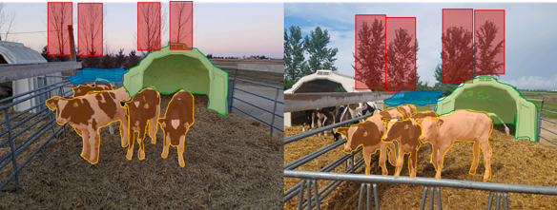
Figure 2. Group of four Holstein dairy calves housed in a super-hutch. Figure 2a (left side) winter period, trees without leaves, and clear sky. Figure 2b (right side) summer period, trees with green leaves, and cloudy sky. Source: Wang et al., 2023
Guarnido-Lopez et al., 2024 illustrate the use of cameras and the most utilized CV algorithms applied to cattle production, with a focus on their applicability in predicting key parameters such as individual feed consumption, feeding behavior, body weight (BW), body condition score (BSC), and the detection of prevalent cattle diseases including laminitis, mastitis, and heat stress (Figure 3).
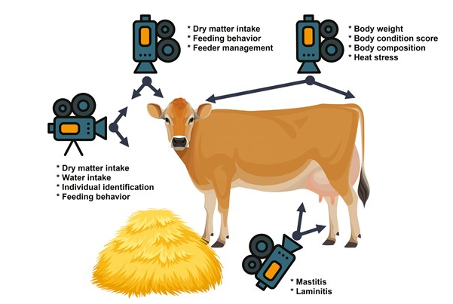
Figure 3. Computer vision algorithms in cattle prediction. Source:Guarnido-Lopez,et al., 2024
6.2 AI TECH IN DAIRY INDUSTRY

6.2.1 DEEP LEARNING IN DAIRY FARMING
Deep learning has proved to be a powerful tool in the detection of pathogens in dairy farming with prospects of early disease detection, enhanced milk quality, and enhanced animal health. Denholm et al.,2020 created a deep learning model that can identify dairy cow bovine tuberculosis bTB status from mid-infrared (MIR) spectral milk data with accuracy of 95%. This shows the capability of deep learning to realize highly accurate non-invasive disease detection in dairy farming.
Another one of the prominent applications is identification of mastitis, with Xudong, et al., 2020 suggesting a deep learning network, EFMYOLOV3, for the detection of dairy cow mastitis from thermal images automatically. The model demonstrated a classification accuracy of 83.33%, effectively identifying the salient regions of the cow, which can contribute significantly towards early detection and treatment.
Additionally Steenkiste et al., 2023 suggested a deep learning model for the detection of clinical mastitis by detecting clots in milk from images. The model was 100% accurate in detecting clots in the test images, indicating the potential for in-line detection of clinical mastitis in automated milking systems. The model is a deep learning model based on a convolutional neural network (CNN). The CNN is trained to detect clots in milk images. The model can be 100% accurate in detecting clots in the test images. This indicates the potential for in-line detection of clinical mastitis in automated milking systems (Figures 1)
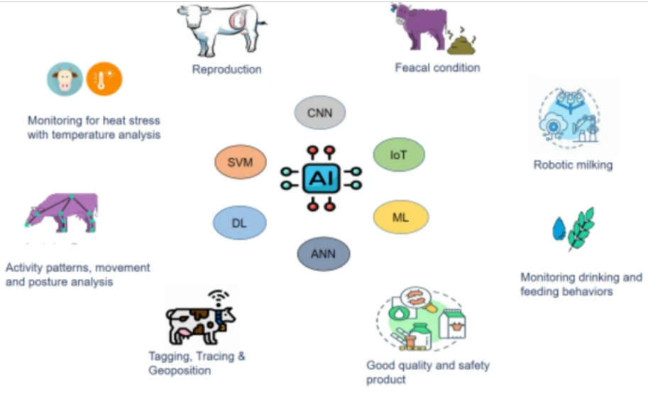
Figure 4. AI Tech in Dairy Industry. Source; Devi et al., 2025
Artificial Intelligence (AI) has become a transformative tool in the dairy industry, enabling precision management of animal health, productivity, and product quality. AI applications in dairy systems include reproduction management, disease diagnosis, robotic milking, and real-time monitoring of animal behaviour and environment (Devi et al., 2025).
AI-based reproductive monitoring tools employ sensors and data analytics to detect oestrus, predict optimal insemination timing, and support early pregnancy detection with high accuracy, reducing reproductive inefficiencies (Rutten et al., 2017; Salau et al., 2020). Similarly, image recognition and biosensor technologies are used to assess faecal characteristics and detect gastrointestinal disorders, improving herd health management (Zhou et al., 2022).
Robotic milking systems integrated with AI algorithms automate the milking process, ensuring precision, hygiene, and animal comfort while reducing labour requirements (Halachmi et al., 2019; Li et al., 2023). In addition, smart sensors monitor feeding and drinking behaviours to detect nutritional imbalances and early signs of illness, enabling timely intervention (Caja et al., 2016).
AI also enhances food safety by tracking hygiene, milk composition, and contamination during processing and storage. Furthermore, RFID, GPS, and computer vision systems support tagging, traceability, and posture analysis for health and welfare evaluation (Wathes et al., 2008; Werner et al., 2017). AI-based thermal imaging and temperature sensors are now widely used for detecting heat stress, ensuring animal comfort under changing environmental conditions (Gebremedhin et al., 2021). Collectively, these innovations ensure safe, high-quality dairy products while enhancing productivity, sustainability, and animal welfare (Devi et al., 2025).
6.2.3 AI TECH IN DAIRY QUALITY CONTROL
Artificial Intelligence (AI) is increasingly being integrated into the dairy industry to enhance product quality, safety, and process efficiency across the entire supply chain.
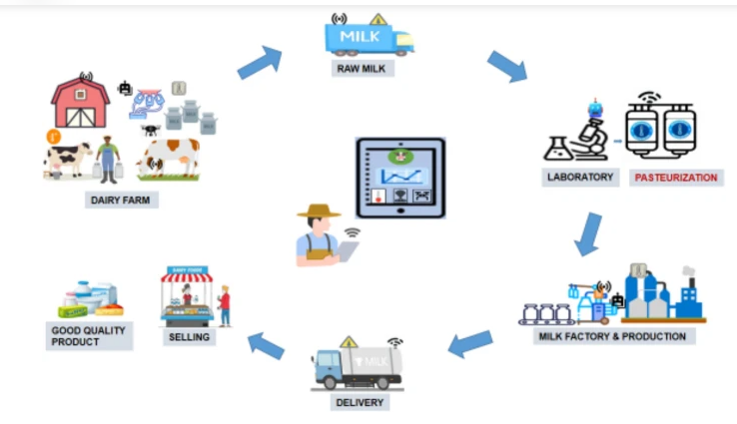
Figure 5. AI Tech in dairy quality control. Source; Devi et al., 2025
At the farm level, AI-powered sensors and machine learning models monitor key parameters such as animal health, milk yield, feed intake, and early detection of diseases like mastitis, thereby ensuring that the milk obtained is of high quality and free from contamination (Gupta et al., 2023; Sharma et al., 2024). During raw milk collection, smart AI-based detection systems are employed to identify microbial contamination, adulteration, and spoilage indicators in real time, helping to maintain freshness and prevent economic losses (Li et al., 2022).
In laboratory testing and pasteurization, AI algorithms facilitate automated analysis of microbial and chemical compositions, optimizing temperature and duration to eliminate pathogens while preserving essential nutrients (Devi et al., 2025; Singh & Yadav, 2024). Within milk processing facilities, the integration of AI, Internet of Things (IoT), and robotics enables automated sorting, mixing, packaging, and product tracking, which enhances operational accuracy and reduces human error (Kumar et al., 2023; Patel et al., 2024). AI-based predictive models also play a key role in logistics and distribution by maintaining cold chain integrity, ensuring that dairy products remain safe and of premium quality throughout transportation (Zhou et al., 2022).
Furthermore, AI contributes to quality assurance at the retail stage through blockchain-enabled QR codes and smart vending systems, allowing consumers to trace product origin, verify authenticity, and monitor freshness (Joshi et al., 2024; Wang et al., 2023). Collectively, these innovations not only enhance product safety and traceability but also promote sustainability, efficiency, and consumer confidence in the dairy sector (Devi et al., 2025; Sharma et al., 2024; Gupta et al., 2023).
7. PLF'S USES AND ADVANTAGES IN LIVESTOCK PRODUCTION
PLF primarily refers to the application of continuous, automated, and real-time livestock monitoring systems. These systems employ technologies such as cameras, wearable sensors, microphones, and other smart devices, all of which are increasingly integrated with artificial intelligence (AI) for pattern detection, predictive analytics, and decision support (Berckmans, 2017).
Through the continuous collection and analysis of individual animal data, PLF provides farmers with actionable insights to make informed decisions about feeding, reproduction, health, and welfare management. This real-time monitoring not only allows for early disease detection and intervention but also supports precision feeding, improved reproduction efficiency, and reduced antibiotic usage. (Wathes et al., 2008).
Overall, PLF represents a data-driven transformation in livestock management that improves productivity, promotes animal welfare, and supports environmentally sustainable farming systems (Figure 6).
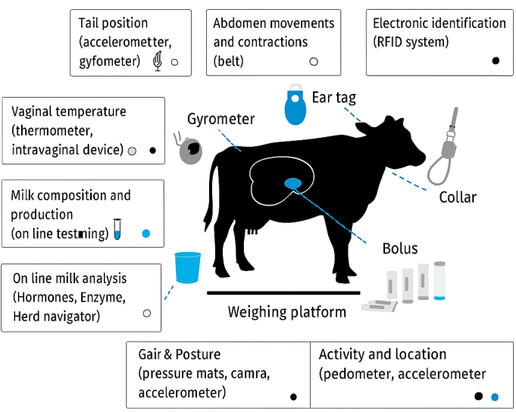
Figure 6. High-Tech Cow
Numerous technologies are used to track animal characteristics, such as cameras for image and sound analysis, sensors, or other tools like automated scales, and water/feed consumption monitors. In image analysis, no additional stress is caused since the devices are not placed directly on the animal; however, during prediction and interpretation, maintaining high precision can be challenging because the algorithms developed for weight or body condition estimation may be affected by illumination, orientation, or background variability (Azzaro et al., 2011).
Image-based monitoring is used to estimate body weight and body condition score (BCS), measure water and feed intake, evaluate gait and lameness, and identify animals exhibiting oestrus behaviour (Viazzi et al., 2013). Currently, electronic wearables are primarily used either independently or integrated with automated systems such as robotic milkers, automatic feeders, and inline milk sensors. Examples include active smart ear tags that collect data from individual animals—such as temperature, activity, or ingestion patterns—neck collars for rumination monitoring, leg sensors for activity tracking, and other biosensors used for disease prediction and welfare assessment (Halachmi et al., 2019).
To maximise data accuracy and management efficiency, many farmers now integrate image-based and sensor-based monitoring systems. These integrated platforms combine real-time visual data with physiological and behavioural sensors to improve health tracking, early disease detection, and performance optimization in dairy and beef systems (Caja et al., 2016). Figure 7 illustrates the main categories of biosensor-based monitoring devices used in modern livestock systems.
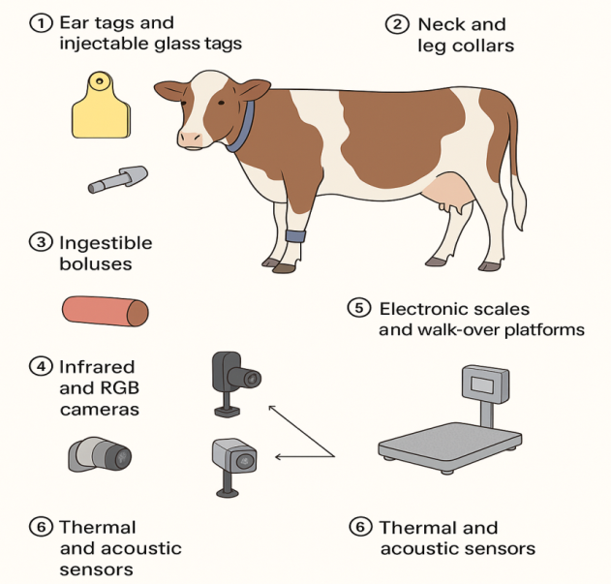
Figure 7. Biosensor-based monitoring devices modern livestock systems.

7.1 IOT IN PRECISION LIVESTOCK FARMING SYSTEMS
Cyber-PhysicalSystems (CPS), Web-of-Things (WoT), Internet-of-things (IoT), and machine-to-machine (M2M) connections are some of the technologies that connect the data collected by the monitoring tools. Machine-to-machine (M2M) communication is mostly linked to the Internet of Things, where cloud computing infrastructures are accessible through telecommunication services (4G, 4.5 G, 5G, satellite). IoT, on the other hand, encompasses a wider range of interactions between people, objects, and devices. IoT-based CPS systems include both digital and physical sensing devices, like biosensors. WoT uses popular tools like HTML, Java, PHP, and others to enable the resources. In order to improve the valuation of all livestock-related operations, IoT enables linking the data collected by all monitoring tools to the internet (Alonso et al., 2020).

8. CURRENT STATUS OF PLF IN INDIA
8.1 PLF IN GRAZING CATTLE
In addition to monitoring cardiovascular and respiratory patterns (i.e., heart and breathing rates and oxygen saturation) for health and welfare assessment (Salzer et al., 2022), a variety of precision livestock farming (PLF) technologies have been developed for grazing cattle, such as RFID tags, boluses, collars, and noseband sensors for measuring grazing behaviour (Werner et al., 2017). Injectable glass tags and ear tags are utilised for illness trajectory tracking (Vlad, 2012), individual data documentation (e.g., maternal pedigree), and unique identification (Trevarthen & Michael, 2008; Ruiz-Garcia & Lunadei, 2011; Wathes et al., 2008).
Additional PLF systems include electronic scales and walk-over-weigh platforms; thermal imaging systems for measuring body temperature; camera-based analysis models for detecting posture and estimating methane emissions (Coates, 2017); acoustic systems for classifying and analysing rumination (Chelotti et al., 2016); and video analysis technologies for early disease detection, classification of behavioural patterns, and monitoring of mating behaviour (Porto et al., 2015) .

8.2 RFID TECHNOLOGIES
Grazing cattle have made extensive use of Radio Frequency Identification (RFID) technology because it provides a cost-effective means of continuously identifying and monitoring animals in a remote, non-contact manner with high credibility (Halachmi et al., 2019; Wathes et al., 2008). Age, sex, breed, weight, and health status are just a few of the many important details that RFID tags may carry (Trevarthen & Michael, 2008). Based on their operating frequency, RFID technology can be classified as either low-frequency—mainly used for individual animal identification—or high-frequency, which is used to track groups or populations (Ruiz-Garcia & Lunadei, 2011). RFID tags can be further divided into two categories: passive tags, which reflect radio waves emitted by a reader, and active tags, which have their own power source.
9. Regional Case Studies and Implementation Examples
9.1 Kerala Mobile Milking Initiative
The state of Kerala has implemented an innovative door-to-door mechanized milking system that addresses the unique constraints of smallholder dairy production. This initiative combines mobile milking units with joint liability groups of dairy farmers, creating a sustainable service delivery model that enables technology access without individual capital investment requirements.
The program utilizes two-wheeler mounted milking equipment operated by trained technicians who visit individual farms on scheduled routes. Monthly service charges of ₹1,000 per farmer (with ₹750 paid by farmers and ₹250 subsidized by cooperatives) demonstrate the economic viability of shared technology services. The success in Alappuzha district has led to statewide expansion plans, potentially serving as a model for other regions with similar constraints (Chatterjee, S., and Kumar, V. p2023)..
Technical features include mechanized milking equipment, data collection systems for production monitoring, and integration with cooperative milk collection networks. The system maintains hygiene standards while reducing labor requirements for individual farmers, particularly addressing challenges related to skilled milker availability (Nair and Rajendran 2022).
REFERENCES
- Adin, G., Solomon, R., Shoshani, E., Flamenbaum, I., Nikbachat, M., Yosef, E. and Miron, J. (2008). Heat production, eating behavior and milk yield of lactating cows fed two rations differing in roughage content and digestibility under heat load conditions. Livestock Science, 119(1-3), 145-153.
- Aharwal, B., Roy, B., Meshram, S., & Yadav, A. (2023). Worth of Artificial Intelligence in the epoch of modern livestock farming: A review. Agricultural Science Digest, 43(1), 1–9.
- Aleluia, V. M., Soares, V. N., Caldeira, J. M., & Rodrigues, A. M. (2022). Livestock Monitoring: Approaches, Challenges and Opportunities. International Journal of Engineering and Advanced Technology, 11(4), 67–76.
- Alonso, R. S., Sittón-Candanedo, I., & García, Ó. (2020). An intelligent Edge-IoT platform for monitoring livestock and crops in a dairy farming scenario. Ad Hoc Networks, 98, 102047.
- Aydin, A., Cangar, Ö., Ozcan, S.E., Bahr, C., & Berckmans, D. (2010). Application of a fully automatic analysis tool to assess the activity of broiler chickens with different gait scores. Computers and Electronics in Agriculture, 73(2), 194–199.
- Arthur, G. H., Noakes, D. E., Pearson, H., & Parkinson, T. J. (1966). Reproduction in the Buffalo. Veterinary Reproduction and Obstetrics, WB Saunders, London, UK.
- Awad, A. I. (2016). From classical methods to animal biometrics: A review on cattle identification and tracking. Computers and Electronics in Agriculture, 123, 423–435.
- Azzaro, G., Caccamo, M., Ferguson, J. D., Battiato, S., Farinella, G. M., Guarnera, G. C., Puglisi, G., Petriglieri, R., & Licitra, G. (2011). Objective estimation of body condition score by computer vision analysis in dairy cows. Journal of Dairy Science, 94(10), 4681–4690.
- Bailey, D. W., Trotter, M. G., Knight, C. W., & Thomas, M. G. (2018). Use of GPS tracking collars and accelerometers for rangeland livestock production research. Translational Animal Science, 2, 81–88.
- Ball, P. J. H., & Peters, A. R. (2004). Parturition and lactation. In Reproduction in Cattle (3rd ed., pp. 68–78). Oxford: Blackwell.
- Benaissa, S., Tuyttens, F. A. M., Plets, D., Trogh, J., Martens, L., Vandaele, L., & Sonck, B. (2020). Calving and estrus detection in dairy cattle using a combination of indoor localization and accelerometer sensors. Computers and Electronics in Agriculture, 168, 105153.
- Berckmans, D. (2014). Precision livestock farming technologies for welfare management in intensive livestock systems. Rev. Sci. Tech. Off. Int. Epiz., 33(1), 189–196.
- Berckmans, D. (2017). General introduction to precision livestock farming. Animal Frontiers, 7, 6–11.
- Berckmans, D., & Norton, T. (2016). Precision livestock farming: Examples for poultry. Division M3-BIORES, Catholic University Leuven, Belgium.
- Bird, N., & Crabtree, H. G. (2000). Real-time production performance monitoring. Pig Journal, 45, 55–68.
- Brosh, A., Henkin, Z., Ungar, E. D., Dolev, A., Orlov, A., Yehuda, Y., & Aharoni, Y. (2006). Energy cost of cows’ grazing activity: Use of the heart rate method and the Global Positioning System for direct field estimation. Journal of Animal Science, 84, 1951–1967.
- Caja, G., Castro-Costa, A., & Knight, C. H. (2016). Engineering to support well-being of dairy animals. Journal of Dairy Research, 83(2), 136–147.
- Chang, K., Kim, Y. H., Kim, Y. J., & Yoon, Y. J. (2007). Functional antenna integrated with relative humidity sensor using synthesized polyimide for passive RFID sensing. Electronics Letters, 43, 259–260.
- Chatterjee, S., & Kumar, V. (2023). Digital transformation in India’s dairy cooperatives: Case examples and lessons learned. Asian Journal of Agriculture and Rural Development, 13(1), 22–31.
- Chelotti, J. O., Vanrell, S. R., Galli, J. R., Rufiner, H. L., & Giovanini, L. L. (2016). Automatic classification of cattle jaw movements using acoustic signals and machine learning. Computers and Electronics in Agriculture, 127, 64–75.
- Coates, C. J. (2017). Infrared thermography and machine vision for precision monitoring of cattle behaviour and methane emissions. Biosystems Engineering, 157, 157–166.
- Coates, T. W. (2017). Applications of the Eddy-Covariance Micrometeorological Technique for Estimating Methane Emissions from Grazing Cattle. Ph.D. Thesis, University of Melbourne, Australia.
- Cowie, T. A. (1948). Pregnancy Diagnosis Tests: A Review. Commonwealth Agricultural Bureaux, Oxford, UK.
- Crociati, M., Sylla, L., De Vincenzi, A., Stradaioli, G., & Monaci, M. (2022). How to predict parturition in cattle? A literature review of automatic devices and technologies for remote monitoring and calving prediction. Animals, 12(3), 405.
- de Mol, R. M., Keen, A., Kroeze, G. H., & Achten, J. M. F. H. (1999). Detection model for oestrus and diseases in dairy cattle based on time series analysis with a Kalman filter. Computers and Electronics in Agriculture, 22, 171–185.
- Department of Dairy Development, Government of Kerala. (2022). Kerala Mobile Milking Units: An innovative doorstep milking service for small dairy farmers. Thiruvananthapuram: Directorate of Dairy Development.
- Devi, P., Subburamu, K., Giridhari, V. A., Dananjeyan, B., & Maruthamuthu, T. (2025). Integration of AI based tools in dairy quality control: Enhancing pathogen detection efficiency. Journal of Food Measurement and Characterization, 1–12.
- Devi, R., Meena, P., & Singh, A. (2025). AI technology in dairy quality control: Ensuring safety and sustainability. Journal of Dairy Technology, 78(2), 115–123.
- Dumont, B., Carrère, P. D., & Hour, P. (2002). Foraging in patchy grasslands: Diet selection by sheep and cattle is affected by preferred species distribution. Animal Research, 51, 367–381.
- Halachmi, I., Guarino, M., Bewley, J., & Pastell, M. (2019). Smart animal agriculture: Application of real-time sensors to improve animal well-being and production. Annual Review of Animal Biosciences, 7, 403–425.
- Himu, H. A., & Raihan, A. (2024). An overview of Precision Livestock Farming (PLF) technologies for digitalizing animal husbandry toward sustainability. Global Sustainability Research, 3(3), 1–14.
- International Committee of Animal Recording (ICAR). (2018). Overview of Sensor Devices. Utrecht, The Netherlands.
- Jensen, M. B. (2012). Behaviour around the time of calving in dairy cows. Applied Animal Behaviour Science, 139(3–4), 195–202.
- Joshi, P., Verma, K., & Bansal, S. (2024). Blockchain and AI integration for dairy product traceability. Food Control, 158, 110123.
- Kumar, S., Sharma, V., & Singh, R. (2023). IoT and AI-based automation in milk processing plants. Computers and Electronics in Agriculture, 210, 107921.
- Madureira, A. M. L., et al. (2015). Factors affecting expression of estrus measured by activity monitors. Journal of Dairy Science, 98(10), 7003–7014.
- Mathrubhumi News. (2023). Kerala Dairy Development Department launches two-wheeler-based mobile milking service.
- Mineur, A., et al. (2020). Temporal relationships between milk MIR biomarkers and lameness events. Journal of Dairy Science, 103, 4475–4482.
- Monteiro, A., Santos, S., & Gonçalves, P. (2021). Precision agriculture for crop and livestock farming—Brief review. Animals, 11(8), 2345.
- Nair, S., & Rajendran, N. (2022). Adoption of mechanized milking technologies among smallholder dairy farmers in Kerala. Indian Journal of Dairy Science, 75(5), 540–546.
- National Dairy Development Board (NDDB). (2021). Innovations in Dairy Value Chains: Cooperative and Farmer-Centric Approaches in India. Anand: NDDB.
- Owens, M. K., Launchbaugh, K. I., & Holloway, J. W. (1991). Pasture characteristics affecting utilization by cattle. Journal of Range Management, 44, 118–123.
- Patel, M., Desai, A., & Rao, P. (2024). Role of robotics and machine learning in dairy quality assurance. International Journal of Dairy Research, 69(3), 245–253.
- Porto, S. M. C., Arcidiacono, C., Anguzza, U., & Cascone, G. (2015). Development of a video-based monitoring system for the automatic detection of dairy cow behaviours. Computers and Electronics in Agriculture, 118, 103–111.
- Purohit, G. N. (2010). Methods of pregnancy diagnosis in domestic animals: The current status. Indian Journal of Animal Reproduction, 31(2), 1–5.
- Reith, S., Brandt, H., & Hoy, S. (2014). Analysis of activity and rumination time of dairy cows. Livestock Science, 170, 219–227.
- Research*eu, European Commission. (2017). Precision Farming: Sowing the Seeds of a New Agricultural Revolution. CORDIS, Luxembourg.
- Resti, Y., Reynoso, G. G., Probst, L., Indriasari, S., Mindara, G. P., Hakim, A., & Wurzinger, M. (2024). A review of on-farm recording tools for smallholder dairy farming in developing countries. Tropical Animal Health and Production, 56(5), 168.
- Rutter, S. M. (2013). Can Precision Farming Technologies Be Applied to Grazing Management? XXII International Grassland Congress, Sydney, 15–19 Sept.
- Salzer, Y. (2022). A nose ring sensor system to monitor dairy cow cardiovascular and respiratory metrics. Journal of Animal Science, 100, 240.
- Simões Filho, L. M., et al. (2020). Robotic milking of dairy cows: A review. Semina: Ciências Agrárias, 41(6), 2833–2850.
- Szenci, O. (2021). Recent possibilities for early pregnancy diagnosis in dairy cows. Animals, 11(6), 1666.
- Taneja, M., et al. (2020). Machine learning-based fog computing for early lameness detection in dairy cattle. Computers and Electronics in Agriculture, 171, 105286.
- The Hindu. (2023, January 17). Kerala’s mobile milking units make dairy farming easier for smallholders.
- Umstatter, C. (2011). The evolution of virtual fencing: A review. Computers and Electronics in Agriculture, 75(1), 10–22.
- Vidic, J., Manzano, M., Chang, C. M., & Jaffrezic-Renault, N. (2017). Advanced biosensors for detection of pathogens related to livestock and poultry. Veterinary Research, 48(1), 1–22.
- Voulodimos, A. S., Patrikakis, C. Z., Sideritis, A. B., Ntafis, V. A., & Xylouri, E. M. (2010). Farm management system based on animal identification using RFID. Computers and Electronics in Agriculture, 70(2), 380–388.
- Wang, Y., Mücher, S., Wang, W., Guo, L., & Kooistra, L. (2023). A review of 3D computer vision used in precision livestock farming. Computers and Electronics in Agriculture, 206, 107687.
- Wathes, C. M., Kristensen, H. H., Aerts, J. M., & Berckmans, D. (2008). Is precision livestock farming an engineer’s daydream or a farmer’s nightmare? Computers and Electronics in Agriculture, 64(1), 2–10.
- Werner, J., Umstatter, C., Leso, L., Niederhauser, J., Kennedy, E., & Schick, M. (2017). Evaluation of precision technologies for monitoring grazing behaviour of dairy cows. Computers and Electronics in Agriculture, 136, 88–96.
- Zhou, Y., Wang, H., & Chen, T. (2022). AI-driven diagnostic models for animal fecal condition and health assessment. Animals, 12(4), 421

