Onion Markets in Chhattisgarh: Seasonal Arraival, Price Volatility and Market Dynamics

ABSTRACT
Onion is a crucial crop in Chhattisgarh, but the market faces sharp seasonal fluctuations and price instability. This study analysed monthly and yearly data from 2014 to 2024 from four major markets using CAGR, seasonal indices and trend analysis. Results show maximum prices ranged from ₹1,101/quintal and ₹2,939/quintal in year 2016 and 2024 respectively, while arrivals peaked at 55,655 tonnes in 2023.seasonal indices revealed arrivals highest in May-June (41,159 tonnes ) when prices fell to ₹909-1,134/quintal, and lowest in October-November (26,406-26,996 tonnes) when prices peaked at ₹2,493-3,049/quintal. Recommendations emphasized investment in storage, farmers cooperatives, digital marketing platforms like e-NAM, and buffer stock mechanisms to stabilize prices, safeguard farmers, and ensure consumer affordability.
Keywords: Agricultural market, Onion, Price, Arrival, Price volatility
INTRODUCTION
Onion (Allium cepa) is one of the most essential vegetable crops in India, both as a staple in household consumption and as a significant source of farm income. India ranks as the second largest producer of onion globally, with major production concentrated in states like Maharashtra, Karnataka, Madhya Pradesh and Gujarat; however, Chhattisgarh also plays an emerging role in regional supply chain (National Horticulture Board, 2022). Onion cultivation plays a crucial role in the agricultural economy of Chhattisgarh state. However, the marketing of onions is troubled with challenges, including price volatility, supply chain inefficiencies, and structural constraints. Understanding the behaviour of onion prices and the limitations within the marketing system is essential for devising effective interventions that can improve farmer profitability and stabilize consumer prices. Price fluctuations in onions are influenced by several factors, such as seasonal production patterns, inadequate storage facilities, transportation bottlenecks, and the role of intermediaries (Acharya & Agarwal, 2019). Due to their perishable nature, onions experience sharp price variations, often leading to distressed sales by farmers and price spikes for consumers (Patil & Kale, 2020). Moreover, limited access to direct markets forces small-scale farmers to rely on middlemen, reducing their share of market earnings and making them vulnerable to price manipulation (Ghosh, 2021). Another critical factor affecting onion marketing in Chhattisgarh is the inefficiency of government interventions. While price stabilization measures such as the Minimum Support Price (MSP) and market intervention schemes have been introduced, their effectiveness remains inconsistent due to logistical and administrative challenges (Kumar & Chand, 2020). Additionally, external shocks such as climate change, inflation, and trade policies further complicate the price structure, making it difficult for stakeholders to predict and manage price fluctuations effectively (Sharma & Singh, 2021). Price behaviour and market arrival of onions exhibit significant seasonal fluctuations due to their perishability, climate dependencies, and limited storage infrastructure. Typically, onion arrivals peak post-harvest in the rabi season, leading to a surplus and subsequent price drop, while lean period sees reduced arrivals and soaring prices (Gauraha and Dubey, 2017). In regions like Chhattisgarh, where the market infrastructure is still developing, and fluctuations are more pronounced and directly affected both producer’s profitability and consumer’s access. This study aims to understand the pattern of seasonal arrival trend and price dynamics of onions across major markets in Chhattisgarh for developing policy interventions for better availability and profitability.
METHODOLOGY
Sources of Data
The present study is based on monthly data generated from four major onion markets of Chhattisgarh. The period 2014 to 2024 was selected to collect and analyse the data. The secondary sources from AGMARKNET, Chhattisgarh Rajya Krishi Vipran Mandi Board, and related market official records. analysis is done by SPSS and excel software.
Trend in onion arrival and prices
The trend diagram of yearly index numbers of prices and arrival of onion in Chhattisgarh was drawn for the period of 2015 to 2024. The trend in annual prices has been analysed with the help of following models
$$P_{t}=β_{0}+β_{1}T+U$$
$P_{t}=β_{0}+β_{1}T+β_{2}T^{2}+U$ ... (1)
Where,
Pt = Yearly index numbers of wholesale prices,
T= Time (1,2,3,...,t)
U = Disturbance Term with usual assumption, and $β0,β1 and β2$ are parameters estimated
Multivariate Test
MANOVA
$Y=XB+E$ ...(2)
where,
Y=Matrix of dependent variable
X=Design matrix of preditors
B=Coefficient
E=Error term
Pillai’s Trace (V)
$V=trace[H(H+E)-1]$ ...(3)
Where,
E= Error term of square and cross-products matrix,
H= Hypothesis sum of square and cross-products matrix.

Hotelling’s T² Test (Two group mean comparison)
$T2=n(Xˉ-μ0​)'S-1(Xˉ-μ0​)$ ...(4)
Where,
$n$ = sample size
$Xˉ$ = Sample mean vector
$μ0$ = Hypothesized mean vector
S= Sample variance- covariance matrix.
Wilk’s Lambda ($Λ$)
$Λ=\frac{∣E∣}{E∣+H}​$ ..(5)
Where,
E= Error term of square and cross-products matrix,
H= Hypothesis sum of square and cross-products matrix.
Roy’s Largest Root ($Θ$)
$Θ=λmax​(E-1H)$ ...(6)
Where, λ (Lambda) max​ is the largest eigenvalue.
Mauchly’s Test
Null Hypothesis(H0): The variance of the difference are equal (Sphericity satisfied).
Alternate Hypothesis(H1): Variance of the difference are not equal (Sphericity Violated)
$W=\frac{∣S∣}{\left((tr(S)/m\right)m}​$ ...(7)
Where,
$S$=Sample Covariance Matrix of repeated measures,
$∣S∣$ = Determinant of covariance matrix
$tr (S)$ = Traces of the covariance matrix (sum of diagonal elements)
$m$= number of repeated measures

Compound Annual Growth Rate
The compound annual growth rate (CAGR) of onion was calculated by using the exponential function of the following specification:
$Y_{t}={ab}^{t}ut$ ...(8)
Where,
$Y_{t}$= Dependent Variable (Price and Arrival of the onion in the year ‘t’, etc.)
t = Time Variable in years taking the value of 1,2,3...,n
a = Intercept;
b= Regression coefficient(1+r)
ut= Error term
For the purpose of estimation, the equation was expressed in logarithmic form.

$Log Y_{t}=Log a+t Log b+Log e+ut$ ...(9)
The value of log b in equation (2) was computed using the formula

$Log b= \frac{(\sum{t Log Y-} (\sum{t Log Y-(\sum{t\sum{ Log Y/N)} }}}{\sum{t^{2} - (\sum_{t}{2}}/N)}$ ...(10)
Where,
N = Number of years.
subsequently, the compound growth rate (%) was computed using the formulation,
Compound growth rate (r) = [ (Antilog of log b) -1 ]* 100 ...(11)
Seasonal Index
Using the following procedure [10], 12-month moving averages for the monthly arrival and price data were first computed in order to estimate the seasonal index.
$M1=(Y1+Y2+ Y3+...+ Y12)/12$ ...(12)
$$M2 = (Y2+Y3+Y4+...+ Y13)/12$$
M1, M2....Mi is the centered moving averages
Y1, Y2.... Yn is the monthly arrivals or prices
The centered moving average is used for dividing the original series. The first estimate of the seasonal components (ST) is provided by this. There is no moving average for the first and last six months. The obtained values were arranged month-wise for each year. The average value of each month was calculated by adjusting their total to 1200 or averaging to 100. The seasonal index of each month is estimated and adjusted using the correction factor.
Adjusted Seasonal indices = Seasonal indices x correction factor
Correction factor = 1200 / Sum of seasonal indices

Result and discussion
Estimation of yearly arrivals and different prices
Estimation of yealy price and arrivals have changed over a given period of time, Table No. 1 shows the cumulative changes in Chhattisgarh prices and arrivals. The 2015-2025 dataset shows considerable variations in market conditions, specifically in terms of price and arrival quantity. Maximum Price Mean varied between Rs. 1,101.04/quintal in 2016 (minimum) to Rs. 2,939.80/quintal in 2024 (maximum), recording high volatility in markets. In a similar pattern, minimum price mean varied from Rs. 884.09/quintal in 2016 to Rs. 2,550.00/quintal in 2025, demonstrating a convincing upward movement in floor pricing. The modal price (i.e., the most common market rate) varied between Rs. 1,012.43/quintal in 2016 to Rs. 2,650.00/quintal in 2025, indicating increasing regularity in higher prices. Arrival quantity registered a maximum in 2023 (55,655.70 tonnes) but fell significantly in 2025 (33,452.90 tonnes). These changes indicate constricting supply with expanding demand possibly caused by weather conditions, policy changes, or market intervention. On a whole, the data shows considerable year-to-year changes in the behaviour of agricultural prices and supply patterns essential for modelling and policy-making.
Table 1. Average of arrivals, minimum, maximum and model prices of state.
Years  <20-11-2015 | Average of Max Price (Rs./Quintal) | Sum of Arrivals (t) | Average of Min Price (Rs./Quintal) | Average of Modal Price (Rs./Quintal) | Average of Min Price (Rs./Quintal)
2015 | 1569.31 | 11158.10 | 1394.80 | 1454.23 | 1394.80
2016 | 1101.04 | 17849.80 | 884.09 | 1012.43 | 884.09
2017 | 1509.68 | 43309.80 | 1308.72 | 1402.30 | 1308.72
2018 | 1660.98 | 30518.70 | 1498.26 | 1564.63 | 1498.26
2019 | 1741.48 | 29133.90 | 1558.15 | 1629.80 | 1558.15
2020 | 2470.11 | 36750.60 | 2208.40 | 2314.48 | 2208.40
2021 | 2610.83 | 43905.80 | 2234.62 | 2408.99 | 2234.62
2022 | 1856.80 | 51643.10 | 1481.58 | 1698.95 | 1481.58
2023 | 2040.72 | 55655.70 | 1721.62 | 1879.62 | 1721.62
2024 | 2939.80 | 46705.40 | 2497.99 | 2707.23 | 2497.99
2025 | 2850.00 | 33452.90 | 2550.00 | 2650.00 | 2550.00
Grand Total | 2010.71 | 400083.80 | 1725.41 | 1863.16 | 1725.41
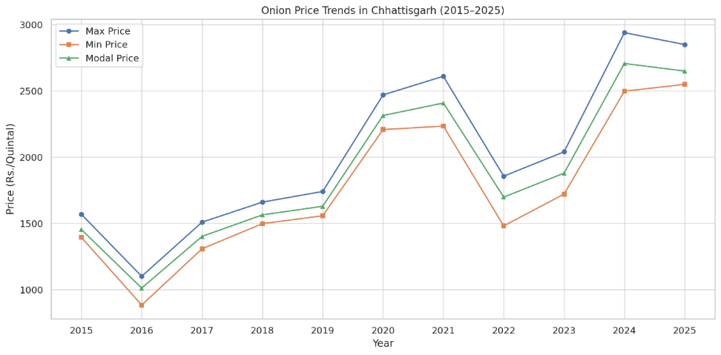
Figure 1. Onion price trends in chhattisgarh
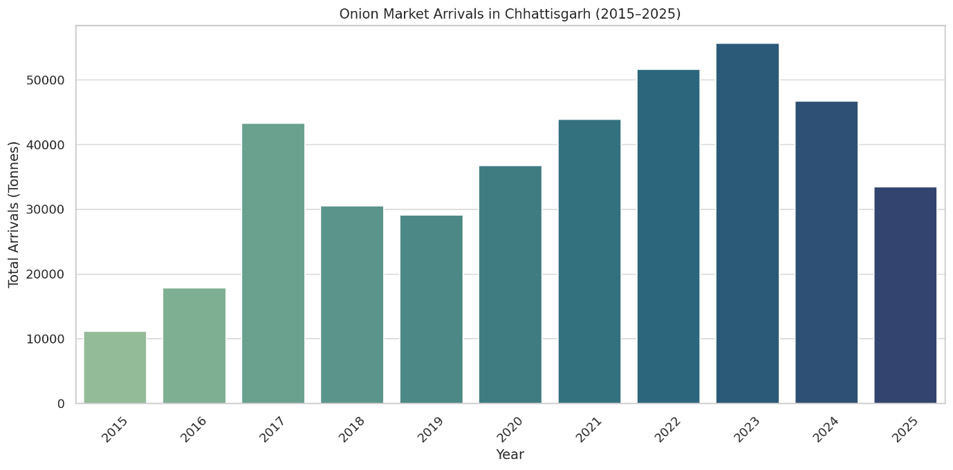
Figure 2. Onion Market Arrivals in Chhattisgarh
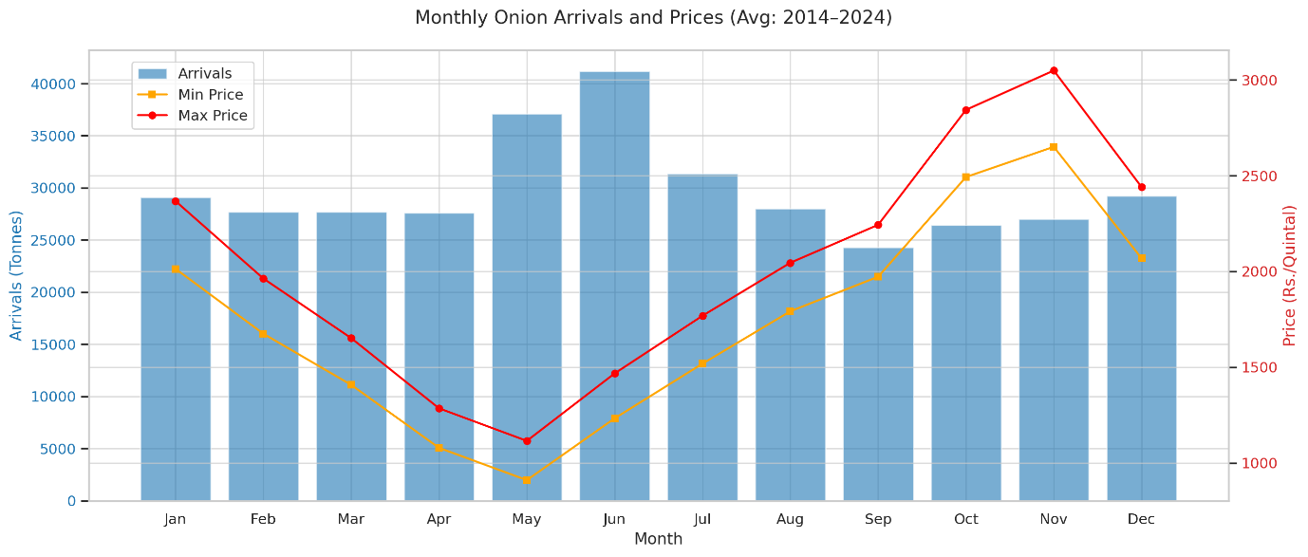
Figure 3. Monthly Onion arrivals vs Prices
figure 1 Shows a general increase in maximum, minimum, and modal prices over time, with sharp rises in 2020–21 and 2024. it is visible correlation with figure 2 that the arrival of onion in year 2021 and 2024 was less compared to the trend line in the time period. Depicts a strong upward trend in arrivals, peaking in 2023, indicating increasing production or market efficiency. figure 3, Confirms the inverse relationship: Arrivals peak in May–June, driving prices down. Prices peak in October–November, when arrivals are lower
Table 2. Descriptive statistics
Descriptive Statistics
 | Mean | Std. Deviation | N
Maximum Prices | 2030.12 | 574.222 | 12
Minimum Prices | 1755.30 | 512.434 | 12
Model Prices | 1882.15 | 531.125 | 12
Discriptive Statistics shows the maximum, minimum and model prices at ₹2030.12 and ₹1755.30 and ₹1882.15 per quintal,repectively. Standard deviations ranged between ₹512 and ₹574 indicating high market volatility. These variations in prices represent over-time changes, which necessitate more inferential analysis for the purpose of measuring statistical significance.

Table 3. Multivariate Tests
Multivariate Testsª
Effect |  | Value | F | Hypothesis df | Error df | Sig. | Partial Eta Squared
Time(Prices) | Pillai's Trace | .919 | 56.910^{b} | 2.000 | 10.000 | .000 | .919
Time(Prices) | Wilks' Lambda | .081 | 56.910^{b} | 2.000 | 10.000 | .000 | .919
Time(Prices) | Hotelling's Trace | 11.382 | 56.910^{b} | 2.000 | 10.000 | .000 | .919
Time(Prices) | Roy's Largest Root | 11.382 | 56.910^{b} | 2.000 | 10.000 | .000 | .919
a. Design: Intercept
Within Subjects Design: Time (Prices)
b. Exact statistic
Multivariate Test Result shows Multivariate tests confirm significant variation between price categories (Wilks’ Lambda = 0.081, F = 56.91, p = 0.000). A Partial Eta Squared value of 0.919 indicates a very high effect size. Maximum, minimum, and mode prices behave differently and need individual attention in pricing policy and analysis.

Table 4. Mauchly’s Test of Sphericity
Mauchly's Test of Sphericityª
Measure: MEASURE_1
Within Subjects Effect | Mauchly's W | Approx. Chi-Square | df | Sig. | Epsilon^{b}
 |  |  |  |  | Greenhouse-Geisser | Huynh-Feldt | Lower-bound
Time (Price) | .238 | 14.357 | 2 | .001 | .568 | .589 | .500
Tests the null hypothesis that the error covariance matrix of the orthonormalized transformed dependent variables is proportional to an identity matrix.
a. Design: Intercept
Within Subjects Design: Time (Prices)
b. May be used to adjust the degrees of freedom for the averaged tests of significance. Corrected tests are displayed in the Tests of Within-Subjects Effects table.
Mauchly’s Test of sphericity revealed (W = 0.238, P = 0.001) indicating a violation of sphericity.Greenhouse-Geisser (E = 0.568) and Huynh-Feldt (E = 0.589) corrections are required. This supports the finding that prices types have unequal variance, supporting the need for adjusted tests and dirrential interpretation of onion price behavior.

Seasonal Index of arrival and prices
Small onion is grown mostly in rabi season in Chhattisgarh. In all major markets, prices were lower during April-June, and also arrivals were high. The seasonal analysis is divided into two sub categories given below:

Monthly arrival and prices of Chhattisgarh

The Table No.5 Indicates the January-December arrivals of onions and their prices, and the total annual arrival is 356,630.90 tonnes. Month-to-month price change is evident. Average of minimum price, average of maximum price, and average of modal price are ₹1,725.23/quintal, ₹2,010.53/quintal and ₹1,862.99/quintal, respectively.

Arrivals varied, reaching a high during June (41,159.20 tonnes) and May (37,111.20 tonnes), indicating increased seasonal availability during the summer harvest. Yet, even with such a surfeit, May prices were the lowest price i.e. ₹909.84, ₹1,114.86, and ₹1,006.38 of minimum, maximum, and model price, respectively. Marking the effect of supply excess on prices in the market.

On the other hand, October and November observed the highest price values (November maximum: ₹3,049.22/quintal, October minimum: ₹2,492.84/quintal), around the same time of lower arrivals (October: 26,406.40 tonnes, November: 26,995.70 tonnes). This reflects a negative correlation between arrivals and prices, a common trend among agricultural markets subject to seasonal change and demand-supply.
Table 5. Month-wise Arrival and Prices
Months  <20-11-2015 | Sum of Arrivals (Tonnes) | Average of Min Price (Rs./Quintal) | Average of Max Price (Rs./Quintal) | Average of Modal Price (Rs./Quintal)
January | 29082.00 | 2013.41 | 2367.17 | 2196.66
February | 27696.40 | 1674.54 | 1962.80 | 1817.03
March | 27674.10 | 1407.35 | 1651.54 | 1518.10
April | 27586.20 | 1078.43 | 1284.84 | 1172.23
May | 37111.20 | 909.84 | 1114.86 | 1006.38
June | 41159.20 | 1232.60 | 1467.22 | 1334.32
July | 31369.30 | 1518.17 | 1768.29 | 1623.49
August | 28010.40 | 1791.64 | 2045.10 | 1911.02
September | 24293.60 | 1972.01 | 2243.28 | 2107.66
October | 26406.40 | 2492.84 | 2843.80 | 2673.02
November | 26995.70 | 2650.66 | 3049.22 | 2848.98
December | 29246.40 | 2068.06 | 2440.31 | 2258.45
Grand Total | 356630.90 | 1725.23 | 2010.53 | 1862.99

Figure 4. Month-wise Prices

Figure 5. Month-wise Arrivals
Quarterly arrival and prices of Onion in Chhattisgarh
The table no.6 The quarterly examination of onion markets presents seasonal variations of high intensity in prices and arrivals. Prices were the lowest during Qtr2 (₹1,191.16/quintal) when arrivals were highest at 105,856.6 tonnes, showing supply-driven depreciation of prices. On the contrary, Qtr4, with the highest prices (₹2,652.76/quintal), had the minimum arrivals (81,490.4 tonnes), which manifests the inverse behavior between quantity supplied and price. This demonstrates high seasonal volatility of the Onion market in chhattisgarh.
Table 6. Quarter-wise arrival and prices of onion in chhattisgarh
Quarter | Average Prices | Average of Min | Sum of Arrival | Average of Max
Qtr1 (January-March) | 1885.86 | 1743.79 | 84452.50 | 2037.86
Qtr2 (April-June) | 1191.16 | 1093.40 | 105856.60 | 1308.76
Qtr3 (July-September) | 1816.40 | 1699.41 | 83673.30 | 1951.00
Qtr4 (October-December) | 2652.76 | 2460.94 | 81490.40 | 2838.01

Figure 6. Quarter-wise Prices

Figure 7. Quarter-wise arrivals
Compound Annual Growth Rate
The table 7 analyses onion price trends and market arraival in Chhattisgarh. the minimum, maximum and model prices exhibit moderate CAGR (6.69 % - 7.22 %), indicating a steady increase. however, onion arrival show the highes growth (11.28% CAGR), reflacting a substraintial rise in supply.
The negative t-statistics for prices -9.61, -9.59,-9.60 respectively for minimum, maximum and model price . it suggests a potential downward trend in real terms, likely due to increase in supply. In contrast, the positive t-stat for arrivals (9.60) indicates growing market inflow. The R² values (0.233–0.292) reveal a weak to moderate relationship between time and price behavior, implying other influencing factors. The Pearson correlation (0.482–0.541) shows a moderate positive relationship, suggesting that higher arrivals do not always cause price drops, possibly due to strong demand.
With a p-value of 0.001, the results are statistically significant, confirming the observed trends. In summary, onion prices are gradually rising, but supply is increasing at a faster rate, hinting at changing market dynamics, improved production, or supply chain adjustments. Despite growing arrivals, prices remain stable, indicating a balanced demand-supply relationship.
Table 7. Compound annual growth rate and other statistics
Particulars | Mean | CAGR | R2 | t Stat | p Value | Pearson Correlation
Average of Min Price (Rs./Quintal) | 1710.38 | 6.69% | 0.23 | -9.61 | 0.001* | 0.482
Average of Max Price (Rs./Quintal) | 1992.38 | 7.22% | 0.29 | -9.59 | 0.001* | 0.541
Average of Modal Price (Rs./Quintal) | 1846.49 | 7.15% | 0.27 | -9.60 | 0.001* | 0.526
Arraival | 39496.98 | 11.28% | 0.27 | 9.60 | 0.001* | 0.526
*Significance at 1 Percent
The table 8 indicates onion arrival and their impact on model price behaviour in Chhattisgarh. A moderate positive correlation (r = 0.526) was found. The t-test showed statistically significant variation with p-value <0.001 (one-tail and two-tail), indication possible market inefficiencies or delayed price responses across seasons.
Table 8. Impact of arrival on model price
Particulars | Average of Modal Price (Rs./Quintal) | Arraival
Mean | 1846.49239 | 39496.97778
Variance | 289815.62 | 144839377
Observations | 9 | 9
Pearson Correlation | 0.52632721 | -
Hypothesized Mean Difference | 0 | -
df | 8 | -
t Stat | -9.6043162 | -
P(T<=t) one-tail | 0.001% | -
t Critical one-tail | 1.85954804 | -
P(T<=t) two-tail | 0.001% | -
t Critical two-tail | 2.30600414 | -

Comparative analysis of Onion arrival and prices
The comparative observation of monthly onion prices and arrivals indicates a distinct inverse correlation between supply volumes and price level, shown in Figure 8. During April-June, arrivals peak, reaching a maximum of 41,159 tonnes in June, which agrees with the lowest model prices (₹1,006–₹1,334/quintal). Conversely, in October-November, when arrivals are relatively low (26406-26996 tonnes), model prices escalate sharply, touching ₹2673-₹2849/quintal.
A progressive fall in arrival from July to September (31,369-24,294 tonnes) is accompanied by a steady increase in prices (₹ 1,623- ₹2,108/quintal) , reflecting seasonal tightening of supply. The data further indicates that even with moderate arrivals in January-March (27,674-29,082 tonnes), prices remain relatively high (₹ 1,518- ₹2,196/quintals), suggesting the influence of storage limitations and supply chain inefficiencies. By December, arrivals recover to 29,246 tonnes, resulting in partial price stabilization (₹2,258/quintal).
Overall, the comparative analysis reveals that price volatility is supply-driven, with higher arrivals consistently depressing market prices while lean months trigger sharp surges. This pattern underscores the need for improved storage infrastructure, staggered market release strategies, and efficient distribution channels to stabilize onion prices and protect both producers and consumers from seasonal shocks.

Figure 8. Month-wise comparative analysis of price and supply of onion in Chhattisagrh
Trend of Onion Prices (2010-2024)
The figure 9 shows the year wise movement of the price of onions, with minimum, maximum, and model values. Prices significantly vary throughout the duration, with a sudden peak during 2013 (Maximum ₹2960/quintal) and another during 2020-2024 (Maximum ₹2939/quintal). At its low, the minimum price reached during 2012(Minimum ₹576/quintal).
The fitted linear trend for maximum prices (green line) indicates a gradual upward movement, with an annual increase of about ₹92/quintal. However, the coefficient of determination (R² = 0.355) suggests that the linear trend explains only about 35% of the variation, highlighting that prices are highly volatile and influenced by seasonal and external shocks rather than following a smooth upward path.

Figure 9. Year-wise prices of Onion in Chhattisgarh
Trend of Onion Prices (2016-2024)
The figure 10 illustrates quarterly arrivals of onions (in tonnes) from 2016 to 2024 with large fluctuations of an upward trend. There are high seasonal fluctuations with quarters (e.g., Qtr1 of 2017 and 2023) exhibiting high peaks of over 17,000–19,000 tonnes with lows (e.g., Qtr2 of 2019 and 2021). Although this type of volatility remains high, the linear trend line presents a positive rising trend with arrivals increasing by approximately 211.68 tonnes per quarter. The coefficient of determination (R² = 0.3407) indicates that the linear model explains about 34% variability of arrival, with other factors remaining as a source of fluctuations of supply. The data present moderate and regular increments of onion arrival with time, with superimposed recurring cycles of seasonality that present supply-side management as a source of market stabilization. The trend presents production patterns as well as market arrival within the state.

Figure 10. Trend of onion prices

Conclusion
This analysis shows volatile onion market conditions in chhattisgarh with sharp seasonal variations in arrival and strong price-seasonal inverse correlation. High arrival seasons from April-june cuase price depression, where lean periods like October-November cause sudden price peaks. while compound annual price growth of onions remains moderate, compounded annual arrival growth remains much higher, signaling production advancements but ineffeciencies in market uptake. continued existence of volatility identifies structural issues like poor storage infrastructure, fragile distribution chains and reliance on middilemen as ongoing impediments to farm income as well as consumer statisfaction.
Policy recommendations are to invest in new-age storage infrastructure within warehouses and cold storage facilities will reduce post-harvest losses and allow staggered release to market. Second, strengthening of farmer-producer organizations (FPOs) and cooperative marketing systems will maximize bargaining powers and reduce reliance on middlemen. Adoption of digital market platforms and e-NAM linkages can allow transparent price discovery and expanded market access. Government support must come by way of timely market intervention by buffer stock building and rational price stabilization measures to control excessive fluctuations, and lastly, adoption of climate-resilient production practices and the facilitation of diversification within the production systems of onions will ensure sustainability and reduce risk. Those intervention strategies will stabilize price levels to ensure farmer profitability and deliver cheaper supply to consumers to strengthen the farm economy of the state.
References
Acharya, S. S., & Agarwal, N. L. (2019). Agricultural Marketing in India. Oxford & IBH Publishing Co.
Ghosh, P. (2021). Role of Intermediaries in Agricultural Markets: A Case Study of Onion Farmers in India. Indian Journal of Economics and Development, 17(3),pp. 78-91.
Kumar, P., & Chand, R. (2020). Market Price Stabilization in Indian Agriculture: Policy and Practice. Indian Journal of Agricultural Economics, 75(2),pp. 245-263.
Patil, S. R., & Kale, V. (2020). Seasonal Price Trends of Onions in Indian Markets: Challenges and Prospects. Journal of Agricultural Policy and Research, 9(1),pp. 34-50.
Sharma, R., & Singh, A. (2021). Climate Variability and Its Impact on Horticultural Crops in India: A Study on Onions. International Journal of Climate and Agricultural Research, 12(4), pp. 112-130.
Randhir Yadav,RR Kushwaha, Supriya, KK Singh. (2025). Seasonal Fluctuation and price dynamics in onion markets of Estern Uttar Pradesh.Int J Agric Extension Social Dev, 8(2), pp. 302-307.
National Horticulture Board. (2022). Horticultural Statistics at a Glance. Ministry of Agriculture and Farmers Welfare, Government of India.http://nhb.gov.in.
Gauraha, A.K.,& Dubey, V.K.(2017). Price behaviour and marketing of onion in Chhattisgarh. International Journal of Agirucultural Sciences, 9(42), pp. 4650-4653.

